Towson University Department of Economics Working Paper Series
Working Paper No. 2016-16

The Affordable Care Act and College Enrollment Decisions
by Juergen Jung and Vinish Shrestha

May 2017
© 2016 by Author. All rights reserved. Short sections of text, not to exceed two paragraphs, may be quoted without explicit permission provided that full credit, including
© notice, is given to the source.

The Affordable Care Act and College Enrollment Decisions∗

Juergen Jung† Towson University
Vinish Shrestha‡ Towson University

May 24, 2017

Abstract
We investigate the effect of the extension of the federal dependent coverage man- date for young adults under the Affordable Care Act (ACA) on the college enrollment decisions of young Americans. The ACA removes the conditionality that young indi- viduals need to be enrolled as full-time students in order to be able to remain on their parents’ health insurance past the age of 18 and extends the coverage mandate to age 26 irrespective of student status. This expansion of the coverage mandate changes the incentives for the full-time and part-time college enrollment decisions of young individ- uals. We use panel data from the Survey of Income and Program Participation (SIPP) for the years 2003–2013 and estimate that the dependent coverage expansion under the ACA decreases the probability to enroll as full-time student by 2 to 3 percentage points. Furthermore we find that part-time college enrollment is unaffected by the new policy. The results from a difference-in-differences model are robust to changes in the model specification and become stronger when we increase the sample overlap between treatment and control groups using trimming based on propensity scores.

JEL: C35, I23, I10, I18
Keywords: Affordable Care Act, dependent health insurance coverage, youth health insurance, occupational choice, educational choice, survey of income and program par- ticipation (SIPP).
∗We appreciate comments from Catherine Maclean, Sara Markowitz and Pinka Chatterji as well as par- ticipants of the economics research seminars at Towson University, Temple University, and SUNY at Albany, as well as conference participants of the 2017 Midwest Economics Association Annual Meeting in Cincinnati and the 43rd Annual Meeting of the Eastern Economic Association in New York.
†Corresponding Author: Department of Economics, Towson University, 8000 York Road, Towson, MD
21252-0001, USA, E-mail: jjung@towson.edu
‡Department of Economics, Towson University, USA, E-mail: vshrestha@towson.edu

Introduction
One of the earliest provisions of the Patient Protection and Affordable Care Act (ACA) of 2010 was the extension of the federal dependent coverage mandate starting in September 2010. Under this mandate young individuals are allowed to remain insured via their parents’ health insurance until the age of 26 irrespective of their living situation, degree of financial dependence, or marital or student status (see Collins and Nicholson (2010) for an overview of the legislation). Prior to the ACA, the dependent coverage mandate allowed children to stay on their parents’ health insurance until the age of 18. However, most group health insurance plans allowed dependent children to stay on a parent’s health insurance plan until the age of 23 to 25 if the child was enrolled as full-time student (e.g., Quinn, Schoen and Buatti (2000), Kronstadt, Mojerie and Schwartz (2007)). Upon graduation this type of health insurance coverage expired. According to the Government Accountability Office (GAO (2008)) in 2006 a majority of 67 percent of students aged 18−23 where insured via employer sponsored health plans, 7 percent through individual market plans, 6 through public plans and 20 percent were uninsured.
The restriction to age 18 and the conditionality of the prior mandate concerning full- time enrollment status lead to low health insurance participation rates among young adults. Estimates from early 2000 show that among almost 50 million Americans without health insurance, one of the largest groups were young adults between the age of 18 to 24 (28.1 percent according to DeNavas-Walt, Proctor and Hill-Lee (2005)). Health insurance coverage rates of young adults in the U.S. typically begin to drop significantly at the age of 19 except for those who attend college full-time (Kriss et al. (2008)). The Government Accountability Office (GAO (2008)) reports that those most likely to be uninsured include minority youth, part-time students and young individuals from low-income families who, as a consequence, have restricted access to health care (e.g., Callahan and Cooper (2005) and Callahan, Hickson and Cooper (2006)). Prior to the passing of the ACA, thirty six states attempted to expand the coverage mandate so that young individuals could stay longer on their parents’ insurance. However, the state level mandates were not very effective in reducing the number of uninsured young individuals so that policy makers have included a provision into the ACA that allows young adults to stay on their parents’ health insurance plans until they turn 26 irrespective of their student status.1 This federal expansion is effective (compare Antwi, Moriya and Simon (2013)) and very popular and even recent reform proposals under the Trump administration have not removed the expansion of the federal dependent coverage mandate.2
1One conditionality that the ACA left in place until January 2014 was that dependent coverage was not available if the young adult had a separate offer of employer-based coverage. However, after January 2014 even this restriction was removed. See Goldman (2013) for more details.
2Compare the recent reform proposal: H.R.1628 - American Health Care Act of 2017, passed on April 4,

In evaluating the dependent coverage expansion it is important to understand the incen- tives that are present. There are several potential channels through which the expansion of the federal dependent coverage mandate through the ACA can affect the full-time and part- time college enrollment decision of young adults. Before the ACA, the prior federal mandate provided an individual who was otherwise indifferent between enrolling as a full-time or a part-time student with an additional incentive to enroll as full-time student as this allowed her to remain covered under her parents’ health insurance. Children of parents with group health insurance therefore had an additional incentive to enroll as full-time students. Average monthly health insurance premiums for individuals below the age of 26 are around $550 with an employer contribution rate of approximately 75 percent according to a study by ADP (2013) based on estimates from a sample of 175 large employers. According to GAO (2008) annual premiums for college plans vary greatly from $30 to $2, 400 with an average of $850 in 2007. College plans also tend to have much lower lifetime caps and are less comprehensive than employer sponsored plans in order to keep the premiums low.3
Given that many young individuals tend to work for employers who do not offer health insurance and given average monthly earnings of $838 in our sample,4 being able to stay on a parent’s health insurance plan therefore provides a significant financial benefit especially since premiums of employer sponsored plans are tax deductible. This argument is even stronger for young individuals with chronic health conditions or other health issues that would make it more expensive for them to get insurance on their own. In this context, enrolling as a full-time student is incentivized by the prior mandate. A similar argument can be made for an individual who is indifferent between being a full-time student or not enrolling in college at all.
Through the expansion of the dependent coverage mandate under the ACA, young adults are allowed to stay on their parents’ health insurance until they turn 26 regardless of their college enrollment status. An individual who decides to enroll as a full-time student to obtain parental health insurance before 2010 no longer has to abide by such a constraint. This particular channel could reduce the full-time college enrollment rate.
Furthermore, several recent studies by Antwi, Moriya and Simon (2013), Depew and Bailey (2015) and Shrestha and Lenhart (2016) provide evidence that the expansion of the dependent coverage mandate increases the labor market flexibility of young adults and re- duces their hours worked. This mechanism is related to the concept of job-lock in the sense
2017 by the 115th Congress. https://www.congress.gov/bill/115th-congress/house-bill/1628
3In 2007/2008 about 30 percent of all colleges required all their full-time students to have health insurance but only 57 percent of these colleges did offer college health insurance plans. Only 30 percent of these colleges made the plans available to part-time students (compare GAO (2008)).
4Based on our sample of 19–23 year old individuals from the Survey of Income and Program Participation
(SIPP) from 2003–2013 .

that the expansion of the federal dependent coverage mandate increases the choice set of the individual at the margin.5
On the other hand, Antwi, Moriya and Simon (2013) and Barbaresco, Courtemanche and Qi (2015) provide evidence that the expansion of the federal dependent coverage man- date increases the insurance coverage rates among young adults. Antwi, Moriya and Simon (2015) link increased coverage to more inpatient and mental illness visits and Barbaresco, Courtemanche and Qi (2015) find that the mandate improves self-assessed health status and increases the probability of having a primary care doctor among young adults. Improve- ments in health status due to the mandate can increase the college enrollment rate for some marginal students. Brown, Kowalski and Lurie (2015) and Cohodes et al. (2016) show that children who benefited from the expansion of Medicaid and SCHIP in the 90s are more likely to graduate from high school and college in the long run.
Additionally, similar to financial aid and fellowships which positively impact the college enrollment decisions of young adults (e.g., Van Der Klaauw (2002), Linsenmeier, Rosen and Rouse (2006) and Cornwell, Mustard and Sridhar (2006)), the availability of parental health insurance coverage may serve as a tuition subsidy for young adults who are desiring to become full-time students. Many individuals who eventually become full-time students start as part-time students at local two-year colleges or are part-time students for some semesters during their college career. The unconditionality of the ACA mandate facilitates this path to becoming a full-time student and might therefore increase the probability to enroll as full-time student.
Due to these opposing forces the question of whether the extension of the federal depen- dent coverage mandate increases or decreases college enrollment of young adults becomes fundamentally an empirical one. We use a difference-in-differences estimator and panel data from the Survey of Income and Program Participation (SIPP) between 2003 and 2013 to estimate the effects of the ACA on student college enrollment.
We find that on average the ACA decreases the probability to enroll as a full-time student by roughly 3 percentage points among the 19–23 year olds whose parents do have health insurance. There is no significant difference of this effect by age within the group of 19–23 year olds. The part-time student enrollment decision is not negatively affected by the ACA. Estimates based on a more homogeneous sample based on propensity score methods confirm our results. Additional extensive sensitivity analyses confirm the robustness of our estimates.
5A similar expansion of the choice set of marginal employees who were “locked” in particular employment situations because the employer provided health insurance was achieved through the introduction of the Consolidated Omnibus Budget Reconciliation Act of 1985 (COBRA) and the Health Insurance Portability and Accountability Act of 1996 (HIPAA). Both regulations have provided more choice for the marginal employee as they provide mechanisms to remain insured during job switches and thus weaken the job-lock from employer provided health insurance as discussed in Madrian (1994).

Literature Review. Our paper contributes to the literature that investigates the effects of health insurance on labor supply. Gruber and Madrian (2002) provide an overview. The literature has both analyzed the effects of health insurance on the labor market decision of the old where the availability of health insurance typically leads to earlier retirement as documented in Gruber and Madrian (1995), Madrian (1994), Rogowski and Karoly (2000) and Hsieh (2008), and the young where health insurance affects the trifecta of leisure, schooling and work decisions. Whether the young have health insurance often depends on the parents’ income, employment and insurance status and, prior to the ACA, on the college enrollment status of the young individual (e.g., Quinn, Schoen and Buatti (2000), Collins et al. (2006), Kronstadt, Mojerie and Schwartz (2007), Kriss et al. (2008) and GAO (2008)). More recent studies by Antwi, Moriya and Simon (2013), Depew and Bailey (2015), Colman and Dave (2016) and Shrestha and Lenhart (2016) investigate the effects of the ACA on labor supply. Different from these studies we focus on the college enrollment decision.
Second, because financial aid and fellowships impact the college enrollment decisions of young adults (e.g., Van Der Klaauw (2002), Linsenmeier, Rosen and Rouse (2006) and Cornwell, Mustard and Sridhar (2006)), the availability of parental health insurance coverage may serve as a tuition subsidy for a young adult desiring to be a full-time student. While financial aid and grants provide essential funding and allow low income students to go to college, many low-income students still lack the funds to enroll in college, particularly as full-time students according to Ehrenberg (2007) and Tierney and Venegas (2009). Bozick (2007) finds that low-income students are more likely to contribute to college tuition through working and living at home with their parents than students from higher income families. These practices contribute to the inability of many low-income students to continue their studies after the first year of college leading to set-backs in attaining financial security in young adulthood. Because full-time students are much more likely to complete their college degree than part-time students (Chen (2007)), parental health insurance provides full-time students with a significant immediate benefits package and a better chance to complete their college degree and earn more income over their lifetime. The decoupling of the availability of parental health insurance from the full-time enrollment status could therefore have adverse effects on degree completion as well as enrollment itself. As far as we are aware, our paper is the first to address this question using exogenous variation provided by the implementation of the unconditional coverage mandate through the ACA in the second part of 2010.
Third, different from our study Brown, Kowalski and Lurie (2015) and Cohodes et al. (2016) provide evidence that expansions of public insurance programs increase the educational attainment and the earnings of individuals benefiting from these expansions when they were children. Access to health insurance is linked to better child health as well as improved family finances that allow for better schooling access as well as higher graduation rates from

high schools and colleges. Our study does not analyze the expansion of Medicaid as part of the ACA but focuses on how the ACA changes the incentives for young individuals who have access to health insurance through their parents without the ACA. Our study therefore does not contradict the earlier findings of increased college attainment of low income youth who benefited from having gained access to public health insurance. We specifically exclude this group from our analysis as we drop all Medicaid recipients from the analysis. We then focus on individuals whose parents have health insurance and find that the ACA provides a negative incentive to enroll as full-time student by removing the conditionality of the prior coverage mandate and thus removing a strong positive incentive for enrolling as full-time student.
Fourth, we contribute to the empirical literature that estimates the effects of the different components of the ACA. Courtemanche et al. (2016) analyze how the Medicaid expansion affects the health insurance status of low income individuals. Finkelstein, Hendren and Luttmer (2015) provide a study of a Medicaid expansion experiment in Oregon prior to the ACA including a thorough welfare analysis. Depew and Bailey (2015) analyze whether the extension of the dependent coverage provision increases insurance premiums of family plans relative to single coverage plans. Antwi, Moriya and Simon (2013), Colman and Dave (2016) and Shrestha and Lenhart (2016) analyze how the dependent coverage provision of the ACA affects insurance take-up and the resulting time allocation to various labor market and leisure time activities. Different from these studies we analyze how the dependent coverage mandate of the ACA affects college enrollment status.
Finally, the closest to our paper is our earlier work in Jung, Hall and Rhoads (2013) where we investigate whether the availability of parental health insurance has an effect on the college enrollment decision of the young. In that paper we establish a positive link between parents having health insurance and full-time enrollment status of their children. We extend this work and analyze how a specific provision of the ACA, the dependent coverage expansion up to age 26, does affect college enrollment.
The paper is structured as follows. The next section will introduce the empirical model. Section 3 describes the survey data. Section 4 presents the estimation results using a difference-in-differences estimator. We provide sensitivity analyses and robustness checks in section 5. We conclude in section 6. The Appendix contains all tables and figures. An Extended Appendix provides additional robustness checks and is available upon request from the authors.

The Empirical Model

Difference-in-Differences Framework
To identify the effect of the extension of the federal dependent coverage mandate on college enrollment we utilize two separate variations. First, we use the time variation before and after the federal dependent coverage mandate became effective in September 2010. The policy variable for our model is denoted ACA. It equals one for time periods starting with September 2010 and zero for time periods before September 2010. This variable is synonymous with the implementation of the expansion of the federal dependent coverage mandate because most other major elements of the ACA (i.e., Medicaid expansions, creation of subsidized health insurance exchanges, penalties for not having health insurance, etc.) that may affect working age individuals were implemented after 2013 and are thus not operational in our data.
Second, we form a treatment and control group focusing on individuals whose parents have health insurance that is not Medicare or Medicaid (PARENT_HI=1). Individuals whose parents do have health insurance are able to benefit from the expansion of the unconditional coverage mandate up to age 26, whereas individuals whose parents lack health insurance are not able to gain access to dependent coverage because of the ACA. This identification strategy is different from the one which is often used to identify the effect of the federal dependent coverage mandate on insurance coverage and labor market outcomes (see Antwi, Moriya and Simon (2013), Heim, Lurie and Simon (2015), Bailey and Chorniy (2016), Colman and Dave (2016) and Shrestha and Lenhart (2016)). These studies formulate a difference-in-differences (DD) model where 19–25 year olds are the treatment group and 27 to 29 year olds form a control group.6 Since our study investigates whether the expansion of the dependent coverage mandate increases or decreases college enrollment of young individuals, comparing these two age groups directly is inappropriate due to the severe difference in the college enrollment decision between individuals in their prime college age (19–23) and older individuals. We therefore concentrate on identifying a treatment and control group within the cohort of 19–23 year olds.
Given these two variations, we formulate a DD model where the treated group comprises individuals whose parents have health insurance (PARENT_HI=1) and the control group consists of individuals whose parents do not have any health insurance (PARENT_HI=0). The DD regression is presented as:
FULL-TIME-STUDENT_{ist} = β₀ + δ (PARENT_HI_{ist}×ACA_{t}) + β₁PARENT_HI_{ist} + β₂ACA_{t}
+ λ₁X_{ist} + λ₂P_{ist} + λ₃Z_{st} + τ_{t} + η_{s} + α_{i} + ε_{ist}, (1)

6Antwi, Moriya and Simon (2013) also add 17 to 18 year olds to their control group.

where FULL-TIME-STUDENT_{ist} is a binary variable and represents the college enrollment status of an individual i living in state s at time t. It equals one if an individual is enrolled full-time and zero otherwise.7 PARENT_HI is interacted with the ACA dummy so that the coefficient on the interaction term δ represents the DD estimate. This estimate represents the causal effect of the extensions of the dependent coverage mandate on the treatment group under the following assumption:
Assumption 1 (Parallel Trend Assumption). In absence of expansion of the federal depen- dent coverage mandate the trend in the college enrollment decisions between the treatment (individual’s parent has health insurance) and control group (individual’s parent does not have health insurance) is not systematically different.
Variable X_{ist} comprises individual controls such as age, age squared, race, gender, whereas P_{ist} is a vector that consists of parental characteristics such as age, age squared, education status, marital status, parental occupation status, mortgage payments and log of family in- come. Additionally, Z_{st} is a vector that includes state-specific controls such as unemployment rate, unemployment rate for 19–25 year olds, per capita income, and state level public and private tuition. Variables τ_{t} and η_{s} represent year and state level fixed effects, respectively and α_{i} are individual fixed effects.
We present results from specifications with and without individual level fixed effects. Model specifications excluding individual level fixed effects allow us to evaluate the effect of the mandate on college enrollment decision between individuals of similar age groups before and after the mandate. One concern regarding this setting is that the treatment and control groups differ substantially in both observed and unobserved characteristics. The inclusion of individual level fixed effects accounts for time invariant heterogeneity across individuals, which reduces the differences between treatment and control groups. However, in models with individual fixed effects identification stems from individuals moving from the treatment to the control group and vice versa so that observations from an individual i may serve both as a treatment and control unit observation over time.8
We next introduce a model with age interaction terms to estimate the relative size of the

7We also use PART-TIME-STUDENT as dependent variable in an alternative specification.
8Estimation results based on individual fixed effects models use a reduced panel dataset that contains only individuals that are observed at least once before and after the introduction of the ACA.

effect by age as follows:

23
, ( )
FULL-TIME-STUDENT_{ist} = β₀ + δ_{j} PARENT_HI_{ist} × ACA_{t}×1_{{AGE}ist=j} (2)
j=20
+ β₁PARENT_HI_{ist} + β₂ACA_{t} + β₃PARENT_HI_{ist} × ACA_{t}
23 23
+ , γ_{j} (PARENT_HI_{ist} × 1_{{AGE}ist=j}) + , ρ_{j} (ACA_{t}×1_{{AGE}ist=j})
j=20 j=20
+ λ1Xist + λ2Pist + λ3Zst + τt + ηs + εist,

where the age of 19 is the base category and expression 1_{{AGE}ist=j} is an indicator variable equal to one if the individual is j years old and zero otherwise. Parameter δ_{j} measures the effect of the ACA on full-time enrollment of a j year old individual relative to a 19 year old individual. The reported standard errors in all estimates are clustered at the individual level to control for the panel nature of the data.

An additional potentially attractive approach is to focus on states with state level depen- dent coverage mandates as the control group and states without a state level mandate as the treatment group. Thirty six states including the District of Columbia already had state level mandates that allowed young individuals to be insured on their parents’ health insurance regardless of their student enrollment status up to age 26 prior to the implementation of the federal dependent coverage mandate in 2010. However, Antwi, Moriya and Simon (2013) find no statistically significant difference in the effect of the federal dependent coverage mandate among individuals residing in states with or without some form of prior state-level mandate. The reason why state level mandates are less effective than federal mandates is that these prior state level mandates have been more restrictive in terms of dependent eligibility and partially conditioned on student enrollment status, marital status, residency and different age cut-offs. In addition, dependent coverage premiums were not tax deductible and the state mandates were also not as widely publicized as the federal mandate that was implemented through the ACA. In our primary specification we therefore do not distinguish between states that already had a prior dependent coverage mandate in place and those that did not. We do provide robustness checks where we directly control for states with prior mandates. In addition we estimate specifications that include the timing of the implementation of the state-level reform and also students’ age cutoff regarding eligibility in an effort to control for any potential prior state mandate effects.
Finally, another potentially attractive approach of identification would be to exploit the idea that parents with children younger than 18 before the federal mandate have lower marginal costs of insuring an additional newly eligible child that is older than 18 after the

federal mandate goes into effect. However, this identification strategy would not measure the treatment effect of the mandate but just the relative effect of the mandate between two very specific subgroups in the sample and sacrifice a significant portion of external validity.

Specification Tests
We next address three potential issues regarding the validity of our identification strategy. First, the parents’ decision to obtain health insurance coverage for themselves can itself be endogenous as the expansion of the dependent coverage mandate may create incentives for parents with children between 19–23 to obtain health insurance. Second, young adults with parents having parental health insurance are different from individuals whose parents lack health insurance coverage so that treatment and control groups may exhibit differential trends of college-enrollment prior to the federal provision. This would violate Assumption 1. Finally, the recovery from the Great Recession may have affected the labor market status of parents in the treatment and control groups differently, so that changes in student full-time enrollment numbers are not due to changes in the insurance status triggered by the ACA but due to general labor market effects.
Testing for Endogenous Treatment Groups. To address the first concern of whether parents’ decision to obtain health insurance coverage is endogenous, we present three different exercises. First, we estimate the auxiliary model:

PARENT_HI_{ist} = β₀ + λ₁X_{ist} + λ₂P_{ist} + λ₃Z_{st} + q_{t} + η_{s} + ε_{ist}, (3)

where PARENT_HI_{ist} is a binary variable indicating whether a parent has health insurance coverage. The specification includes individual covariates X_{ist} and parental covariates P_{ist}, state specific controls Z_{st} along with state fixed effects η_{s} and dummies q_{t} pertaining to quarters away from the base period of January to June 2010, which is used as the omitted category. The magnitude of the coefficient estimates of the quarters dummy indicates whether parental insurance-decisions have changed following the expansion of the mandate. If the ACA motivated parents with children between the age of 19–23 to obtain insurance, we should observe an increasing trend on coefficient estimates for the quarterly indicator variable q_{t} following the base period.
Second, we use individuals that belong to age groups that are unaffected by the expansion of the mandate (i.e., the 17, 18 and 27 year olds) as control group and those affected by the mandate (i.e., the 19–23 year olds) as treatment group and estimate a DD specification where

the dependent variable is parental health insurance status (Parent_HI):

PARENT_HI_{ist} = β₀ + δ (AGE_19–23_{ist}×ACA_{t}) + β₁AGE_19–23_{ist} + β₂ACA_{t}
+ λ₁X_{ist} + λ₂P_{ist} + λ₃Z_{st} + τ_{t} + η_{s} + ε_{ist}. (4)

If the expansion of the mandate causes parents to obtain health insurance, we would observe a positive and statistically significant estimate of the interaction term δ.
Third, even if the mandate does not change the fraction of parents with health insurance coverage, it may still be possible that the mandate changes the composition of this group in a way that is correlated with the college enrollment decision of their children. We therefore examine whether observed characteristics of parents with health insurance (PARENT_HI=1) change with the introduction of the ACA.
Finally, to account for differences between the treatment and control groups we use the extensive nature of the SIPP data set and control for individual and parental characteristics including family income, occupation and industry status, and mortgage payments of the par- ent. Some occupations are more likely to provide employer sponsored insurance than others. According to Janicki (2013) workers employed in the public administration sector are more likely to be offered health insurance (93.1 percent) compared to workers in construction (59.5 percent). Controlling for occupational status lessens the concern of differences in dependent coverage between treated and control groups due to differences in occupation.
Testing the Parallel Trend Assumption. The DD estimate relies upon Assumption 1 of a parallel time trend between treatment and control groups prior to the policy imple- mentation conditional upon the covariates. To provide suggestive evidence regarding the underlying assumption, we conduct an event study analysis by expanding equation (1) and estimate the following regression:

FULL-TIME-STUDENT_{ist} = β₀ + β₁PARENT_HI_{ist} + β₂ACA_{t} (5)
t=14
,

+
t=−24
δ_{t} (PARENT_HI_{ist} × Quarter_{t})

+ λ1Xist + λ2Pist + λ3Zst + τt + ηs + εist,

where all variables are identical to those in equation (1) except for the treatment indicator variable which is now interacted with quarterly dummies where January to June of 2010 serves as the omitted category. We include 24 quarters before the base period and 14 quarters after the base period spanning years 2003 to 2013. The estimates of δ_{t} represent the quarterly prevalence of dependent coverage on the treatment group compared to the base period.

Statistically significant estimates of δ_{t} in quarters prior to the base period would provide suggestive evidence of a differential trend in dependent coverage prior to the policy, which would invalidate Assumption (1).
Testing for External Factors. As shown in Figure 5, the timing of the mandate coincides with the recovery from the Great Recession. It would be problematic if the recovery affects the labor market activities of parents from treatment and control groups differently as then unobserved differences in these recovery effects between treatment and control groups could be driving the results in equation (1). Figure 5 shows the trend in non-farm payrolls in the U.S. from 2003–2013, which includes two recovery phases (2003–2007 and 2010–2013) and the period of the Great Recession (2008–2010). Using Figure 5 as a guideline, we reduce the sample and drop observations from the recession period. This focuses our analysis on the comparison of two recovery periods (i.e., period 2003–2007 before the ACA and period 2010–2013 after the ACA) and limits the direct effects of the recession on college enrollment.

Robustness Checks
Besides using a rich set of control variables, we utilize the panel nature of our data and include individual fixed effects in some of our models. The inclusion of individual fixed effects accounts for time invariant heterogeneity across individuals and thus lessens the concern regarding differences between treatment and control groups. Additionally, to increase the overlap between the treatment and control groups, we perform a series of conditional analyses with respect to the estimated propensity scores as suggested by Imbens and Wooldridge (2009). To assess whether the results of our analysis are being driven by systematic differences between the treatment and control groups we follow Slusky (2013) and perform a placebo test using data prior to the federal dependent coverage mandate and artificial timings for treatment years. If there are no systematic differences between treatment and control groups this test should result in insignificant DD estimates of the arbitrarily set policy intervention dates.

Data
The Survey of Income and Program Participation (SIPP) is a longitudinal survey where each household is re-interviewed every four months. A total of 12 waves of the SIPP 2004 panel and 16 waves of the SIPP 2008 panel is used in this study. The data cover the period from October 2003 to November 2013. There are four months missing from Jan-April 2008 as SIPP 2004 ends in December 2007 and SIPP 2008 only starts in May 2008.

Information collected in SIPP falls into two categories: core and topical. The core content includes questions asked at every interview and covers demographic characteristics, labor force participation, program participation, earned and unearned income, transfer payments, non-cash benefits from various programs, asset ownership and private health insurance. Most core data are measured on a monthly basis, although a few core items are measured only as of the interview date, once every four months. The topical questions produce more detailed information about certain categories such as assets and liabilities, school enrollment, marital history, fertility, migration, disability and work history. Topical questions are asked less frequently. We therefore use only data from the core survey.
We focus our analysis on young individuals between age 19–23 as this is the prime college age in the U.S.9 We merge parental information into the young persons’ data files. This is done by using information about the head of the household. We start with merging the father’s information into the young person’s data file. If the father is missing, we use the mother’s information. If the father does not have health insurance we check whether the mother has health insurance and if she does, we use the mother as the head of the household. We indicate these parental variables with the prefix PARENT_ in all results tables. We next drop all individuals that are on Medicaid. Medicaid recipients differ strongly from the treatment group along many socio-demographic measures and are therefore not suitable as a control group. Medicaid recipients are also not directly impacted by the ACA because the expansion of Medicaid as part of the ACA only started after 2013.10 Finally, we drop all individuals who already have a college degree as their college enrollment status is automatically zero in most cases.
The panel data is not balanced as not all individuals are observed over the entire time span. The main sample consists of 307, 994 individual-time observations of 18, 559 unique individuals between 2003–2013 with an average of 12 monthly observations per individual. Summary statistics of the whole sample are presented in the first column of Table 1.
Difference-in-Differences (DD) Indicator Variables. The treatment group in the DD specification are young individuals whose parents report having health insurance. Our assumption is that these individuals are affected by the extension of the coverage mandate of the ACA as they can now stay on their parents’ health insurance until the age of 26 as opposed to age 18 (or age 23–25 in case they are full-time students as they were allowed to stay in their parents’ insurance) before the ACA. The variable is denoted PARENT_HI which
9In robustness checks we also include 24 and 25 year old individuals. Results are available in an Extended Appendix upon request from the authors.
10In robustness checks we exclude California, Connecticut, D.C., Minnesota, New Jersey and Washington
as they expanded Medicaid prior to 2013 as analyzed in Sommers et al. (2013). In further robustness checks we also exclude Massachusetts as Massachusetts passed a very similar law to the ACA in 2006.

is equal to one if the parent reports having health insurance other than Medicare/Medicaid and zero otherwise. Summary statistics for the treatment group are presented in the second column of Table 1. Summary statistics for individuals in the control group whose parents do not have health insurance are presented in the third column of Table 1. There are 242, 282 individual/time observations from individuals whose parents report having health insurance (that is not Medicare or Medicaid) and 65, 712 observations from individuals whose parents do not have health insurance.
The policy variable, denoted ACA, is a binary variable equal to one if the federal mandate is in effect and zero otherwise. Since the expansion of the dependent coverage mandate became effective only at the end of year 2010, the variable ACA is equal to one for the months of September 2010 to November 2013 and zero otherwise.11 Out of the full sample
34.9 percent of the observations are from a period with the ACA being effective so that the expansion of the dependent coverage mandate is in place. In terms of the policy variable ACA, the percentage of the ACA being in place in the treated vs. control groups is 33.4 percent in the treatment group versus 40.5 percent in the control group.
Dependent Variable. The dependent variable is either FULL-TIME-STUDENT or PART-TIME-STUDENT. These are both binary variables equal to one if the individual is enrolled as a full-time or part-time college student, respectively. If a person is neither enrolled full-time nor part-time, then we assume the person is not a college student. The pooled sample consists of 56.7 percent students (49.6 percent are full-time students and 7.1 percent are part-time students). The remaining 43.3 percent are not enrolled in college. We plot the dependent variable by treatment status over time in Figure 1. Note that we observe a decrease in the fraction of full-time students in the treatment group after the introduction of the ACA whereas the control group does not indicate such a reduction in full-time enrollment. In the previous section we have argued that the ACA introduces a disincentive for in- dividuals in the treatment group to enroll as full-time student since they can now stay on their parents’ health insurance unconditionally. In order to show that individuals in the treatment group are much more likely to have health insurance from their parents we con- struct a variable DEPENDENT_COVERAGE from the indicator variable THIRD-PARTY- HEALTH-INSURANCE which measures whether individuals are covered by someone else’s plan. The survey asks whether an individual is covered by her own plan, someone else’s plan, both or neither. If the individual responds that her coverage is only via someone else’s plan then THIRD-PARTY-HEALTH-INSURANCE is set equal to one. This variable is not restricted to measure only the availability of parental health insurance but also includes un-
11We also analyze alternative cutoff dates and set the ACA policy variable equal to 1 starting with ei- ther October, November or December of 2010. Our results are robust with respect to these alternative implementation dates of the reform.

subsidized health insurance from other private health care plans. In order to measure whether the health insurance of an individual is from her parents, we create a binary variable DE- PENDENT_COVERAGE which is set equal to one whenever the variable THIRD-PARTY- HEALTH-INSURANCE indicates that the individual has health insurance through a third party. Also, we only assign a value of one to this variable if the young individual is not on Medicaid and is unmarried in order to exclude cases where young individuals get insurance from their spouses. The variable DEPENDENT_COVERAGE is a better proxy for the kind of government subsidized health insurance that full-time students get via their parents health insurance than the original variable THIRD-PARTY-HEALTH-INSURANCE. The difference in the reported DEPENDENT_COVERAGE between the treated and control group is very large, with 62.1 percent vs. 3.9 percent.12
The differences between treatment and control groups with respect to AGE and GENDER are negligible. We observe slightly more married individuals in the control group and a higher incidence of health problems. The control group also reports about half the household income of the treatment group but very similar earnings. This obviously has to do with the family background of the two groups. Comparing parental variables we find that the control group has lower income which is reflected in the fact that these parents do not have health insurance and therefore are more likely to not work or work in occupations where health insurance is not offered. The control group has a higher ratio of minorities and a higher ratio of parents with low educational levels. The control group also consists of individuals whose fathers are not present, whose parents report a higher incidence of health problems and whose parents are more likely to work in labor intensive sectors. Since large discrepancies between the treatment and the control group are problematic with respect to the identification assumptions of the DD specification, we estimate models with individual fixed effects and also provide extensive sensitivity analysis in Section 5 to highlight the robustness of our results. On the other hand, the treatment and control groups are very similar in terms of state level measures such as the percent of the population with health insurance, the state income per capita, the average state school tuition and the state unemployment rate.

Results

Difference-in-Differences Framework
Table 2 reports the effect of the expansion of the federal dependent coverage mandate on full-time college enrollment among 19–23 year olds estimating equation (1). Columns 1 and
12The ACA caused a significant increase in the dependent coverage ratio of young individuals. This has been documented in Antwi, Moriya and Simon (2013) and Barbaresco, Courtemanche and Qi (2015).

2 show results based on estimates using observations from 2003–2013, whereas columns 3–6 use a reduced data set from 2008–2013 that contains individuals that are observed at least once before and after the introduction of the ACA.
Column 1 includes state fixed effects. The DD estimate PARENT_HI×ACA in column
1 suggests that the federal dependent coverage mandate negatively affects full-time college enrollment among young adults. Specifically, the mandate is associated with a reduction in full-time enrollment of 3.6 percentage points and the coefficient is significant at the 1 percent level. Column 2 controls for linear time varying changes within states by including state- specific linear time trends. The results are very similar, a drop of 3.3 percentage points and a level of significance at the 1 percent level.
Columns 3 and 4 maintain a similar structure as columns 1 and 2 with the exception that we include individual level fixed effects and focus on observations from SIPP 2008 spanning the years 2008–2013. Accounting for individual level fixed effect absorbs time invariant unobserved heterogeneity across individuals which helps to minimize the differences between the treatment and control groups. In addition, individual fixed effects allow us to respect the panel nature of the data. Columns 5–6 includes state fixed effects instead of the individual fixed effects and column 6 additionally includes state-specific linear time trends. The findings are very similar to our earlier results shown in columns 1 and 2.
We also estimate the effect of the ACA on part-time enrollment but do not find a strongly significant effect.13 The data for part-time enrollment is noisy and fluctuates strongly over the years. From here onward we focus our analysis on full-time college enrollment as the dependent variable.

Back of the Envelope Calculation. Snyder, Dillow and Hoffman (2008) estimate that in the fall of 2007 there were approximately 10.6 million undergraduate students between 18–24 in the U.S. Approximately 8.3 million of these were full-time students and 2.3 million were part-time students. In addition, 19 million 18–24 year old individuals were not enrolled in college, which results in an overall number of roughly 30 million young adults between
the age of 18–24 and a full-time student rate of approximately 8.3 = 28 percent.14 Our
30
findings from Table 2 suggest that the probability to enroll as full-time student decreases by about 3 percentage points for individuals in the treatment group, which converts to a
13Detailed estimation tables are available in an Extended Appendix upon request from the authors.
14We calculated this number using data from Table 2 in the Annual Estimates of the Resident Population by Sex and Selected Age Groups for the United States: April 1, 2000 to July 1, 2008 (NC-EST2008-02), Population Division, U.S. Census Bureau, Release Date: May 14, 2009. The full-time student enrollment number in our sample is much larger because we do drop Medicaid recipients and SIPP itself is a somewhat skewed sample as it only captures young individuals that were still in a household with their parents at the start of the survey.

decrease of 6.05 percent −3.0 × 100 . In our overall sample the fraction of individuals whose parents have health insurance is 73 percent. Since we are working with a skewed sample (i.e., we dropped individuals on Medicaid, individuals who do not form a household with their parent, etc.),73 percent is an upper bound for the group of young individuals whose college enrollment decision will likely be negatively affected by the ACA. Overall our estimate would translate into an upper bound of approximately 8.3 million × 73% × 6.05% = 366, 570 fewer full-time students in any given year.
49.6
1
Age Effects and Alternative Choice Model. We next investigate whether the effect changes with an individual’s age and estimate equation (2). Figure 2 shows the results based on a DD estimate with state fixed effects and interaction dummy variables for the age groups of 20–23 year olds with the 19 year olds as the omitted category. Our results indicate that the effect of the ACA on full-time enrollment does not differ significantly by age group.
One question that arises from these results concerns the alternative choices that young individuals are making after the introduction of the ACA. To further analyze this question we introduce a new dependent variable: ALTERNATIVE_CHOICE. This categorical variable equals 1 if the individual is a full-time student, 2 if the individual is a part-time student, 3 if the individual is not a student and works full-time, 4 if the individual is not a student and works part-time and 5 otherwise. We then estimate a multinomial logit model and report average marginal effects from this regression in Table 3. We again find that the probability to enroll as full-time student decreases significantly. The probability to enroll as part-time student is not significantly affected by the ACA. However, young individuals have a higher probability to work-full time or choose the “other” category, that is they are not students and also do not work. This latter result is consistent with findings in Shrestha and Lenhart (2016) who report that the ACA leads to higher leisure demand by young individuals.

Specification Tests
Testing for Endogenous Treatment Groups. As previously mentioned, it is likely that the expansion of the federal mandate motivates parents to obtain health insurance. This would make our treatment group endogenous and invalidate our identification strategy. To investigate whether parental decisions of being insured is affected by the expansion of the federal mandate, we estimate expression (3) using the full set of covariates from the previous regression as well as a dummy variable for every quarter starting in May 2008. The omitted category is the quarter from January to June 2010. Figure 3 shows the coefficient estimates of the dummies along with the 95 percent confidence interval.
If the federal mandate provides parents with an incentive to obtain health insurance, there should be an increasing trend on coefficients following the base period. However,

according to Figure 3, the coefficient estimates of the dummies pertaining to quarters away from 2010 fluctuate around zero and are insignificant. There is no visible trend in parental insurance status with respect to the introduction of the expansion of the federal coverage mandate. Parents with children between 19 − 23 do not drastically change their insurance status following the expansion of the federal dependent coverage mandate. This supports our assumption that the assignment into treatment and control groups is exogenous.
We next estimate the DD specification given by expression (4) where the treated individ- uals are 19–23 year olds (those affected by the ACA) and the control group comprises 17, 18 and 27 year olds who are not affected by the expansion of the coverage mandate. The results are presented in Table 5. The DD estimates in all specifications are statistically in- significant and close to zero. This suggests that the value added to family insurance through the expansion of the dependent coverage mandate does not affect parents’ health insurance choices. Parents whose children would directly benefit from the expansion do not seem to pick up insurance at a significantly different rate after the expansion.
Although the fraction of parents with health insurance coverage does not change after the ACA, there is a possibility that changes may occur in the composition of individuals with parental health insurance (i.e., the treatment group) which may be correlated with college en- rollment decisions. We next provide summary statistics of individuals in the treatment group before and after the implementation of the ACA in Figure 3. The composition of parental characteristics in the treatment group (those whose parents have health insurance) such as the parent’s occupation, race, education, type of health insurance, and family income is very similar in pre- and post-ACA time periods. This suggests that the socio-demographic back- ground of the treatment group is not significantly altered by the expansion of the dependent coverage mandate.
Testing the Parallel Trend Assumption. The validity of the DD estimates pre- sented in Table 2 relies on the parallel time trend Assumption 1. Figure 1 shows uncon- ditional means of full-time enrollment between treatment (PARENT_HI=1) and control groups (PARENT_HI=0) from 2003–2013. We observe similar time trends between the two groups with full-time enrollment rising before the enactment of the expansion of the mandate in 2010. A slight drop in college enrollment is visible in the treated group after the federal dependent coverage mandate went into effect in 2010. We do not observe such a decrease within the control group. However, Figure 1 does not account for covariates.
To further examine the possibility of differential pre-existing trends between treatment and control groups we conduct an event study by estimating equation (5) where January to June of 2010 is used as the omitted category. The estimated coefficients of the quarterly interaction terms prior to the base period are close to zero and statistically insignificant at

any conventional levels as can be seen in Figure 4. Note that the magnitude of the coefficient estimates increases following the base quarters with all the estimates dropping below zero, which shows a clear break in trend. The joint F-test between these coefficients pertaining to years 2003 and 2010 results in an F-statistic of 0.04, which fails to reject the null hypothesis that the coefficients are jointly different from zero. This provides suggestive evidence that the pre-existing trends between the treatment and control groups are not systematically different before the mandate went into effect. On the other hand, the coefficients on the interaction terms for quarters away from the base period, when interacted with the treatment group, are negative and statistically significant (for several cases) at the conventional levels.15
Testing for External Factors. Next, we investigate whether the recovery from the Great Recession could be the driver of the results in Table 2 rather than the policy change from the ACA. As previously mentioned, it is problematic if the college enrollment decision of the treatment and control groups react in fundamentally different ways to the recovery from the recession. Figure 5 shows the fluctuation in non-farm payrolls from 2003–2013 and indicates two distinct recovery periods. We extend our analysis and re-estimate the model in equation (1) excluding observations from the recession years so that we essentially compare across two recession recovery phases, one pre-ACA from 2003–2007 and one post-ACA from 2010–2013. These two periods exhibit very similar labor market trends as shown in Figure 5 and thus limit the potential direct impact of the recession on college enrollment.
Column 1 of Table 4 presents the previous findings based on data from 2003–2013 in- cluding the recession years. Columns 2–5 present results where we drop the recession years. All our results are robust to these changes and the DD estimates obtained after dropping the recession years are very similar in magnitude to the estimates that include the recession years.
One potential mechanism through which the dependent coverage mandate may affect college enrollment decisions is through increases in insurance premiums which may negatively affect the financial well-being of a household. Depew and Bailey (2015) find that the federal dependent coverage increases total premiums for family plans by approximately $350–$400 on average. They hypothesize that given the relatively healthy population of young adults, increases in premiums are not likely to be substantial. Similarly, the authors find no evidence of firms directly shifting increases in premiums to employees in the form of higher contribution rates to their insurance plans. This piece of evidence indicates that the effect of the mandate on college enrollment decisions is unlikely to be driven by fluctuations in premiums following
15A weaker assumption is required in a difference-in-difference-in-differences (DDD) setting compared to a difference-in-differences (DD) specification. We provide estimates of such a model in an Extended Appendix that is available upon request. The results still hold in this setting. They are negative and of similar magnitude. However, estimates are imprecise and not significant in most specifications that we have tried.

the mandate.
Although the treatment and control groups are similar across several categories such as age, gender, employment status and health status, they differ in parental labor market outcomes such as income and occupation type. This raises the question of whether the results presented so far are driven by systematic differences between the treatment and control groups. As previously mentioned, including individual level fixed effects helps to account for time invariant differences across individuals (and thus differences between the treatment and control groups). Additionally, we use the extensive nature of the SIPP data to control for factors that might affect the probability of being in the treatment group. For instance, the availability of employer sponsored insurance can vary across occupation types, which then influences the treatment. We therefore control for occupation status of parents using the detailed categories shown in the summary statistics in Table 1. To further examine the validity of our findings, we next present a number of robustness exercises.

Robustness Checks

Trimming with Respect to Propensity Scores
One method to achieve a greater degree of sample homogeneity and therefore an increase in the overlap between treatment and control groups is trimming using estimated propen- sity scores (e.g., Rosenbaum and Rubin (1983), Crump et al. (2009)). We use a logistic regression to estimate the conditional probability of being in the treatment group given the pre-treatment (pre-policy) variables. PARENT_HI is the dependent variable in this first stage regression. The selection process of covariates used to estimate propensity scores in- cludes three stages as mentioned in Imbens and Rubin (2015): (i) basic covariate selection based on substantive knowledge; (ii) addition of other linear covariates based on a likelihood ratio statistic; and (iii) selection of quadratic and interaction terms. This process is de- scribed in more detail in an Extended Appendix.16 After estimating propensity scores from this specification we apply a trimming method to eliminate observations outside the range of a common support. The trimming method as suggested by Crump et al. (2009) and Imbens and Rubin (2015) increases the sample overlap between the treated and control groups by dropping observations with estimated propensity score values close to zero or one.
To illustrate how this method improves the alignment of treatment and control groups, we present summary summary statistics for the treatment and control groups using a sam- ple with estimated propensity scores between 0.1–0.9 in the first two columns of Table 6. In columns 3–4 we trim the sample further and limit the sample to observations with esti-
16This Extended Appendix is available upon request from the authors.

mated propensity scores between 0.2–0.8. This approach of trimming increases homogeneity in the conditional samples. Summary statistics are presented in Table 6. The mean of variables representing percentage of whites (RACE_WHITE), health problem (HEALTH PROBLEM), parents with college education (PARENT_COLLEGE), family income (PAR- ENT_FAM_INCOME), and marital status (MARRIED) are much more similar between the treatment and control groups compared to the respective averages of the untrimmed sample in Table 1.

Figure 7 plots the normalized difference
1 Xtreat−Xcontrol
+s
between the basic covariates

+s
which affect the probability of being in the treatment group (e.g., Full-Time-Student, Age, White, Black, Marital Status, Parental college, Log of household income, Parental health problem, Parent family income, and Parent’s marital status). The maximum value of the nor- malized difference in covariate means within the estimated propensity score between 0.1–0.9 is 0.67 (for Parent’s family income) and 0.5 (for household income) given the narrower window of propensity scores within 0.2–0.8. The majority of the variables have values of normalized differences less than 0.25 standard deviations. Trimming the sample based on propensity scores between 0.2–0.8 substantially improves the overlap between treatment and control groups.
(s
2
treat
2
control
)/2
Column 1 in Table 7 reports the DD estimates based on observations with estimated propensity scores between 0.05–0.95 and includes state fixed effects, whereas columns 2 and 3 present estimates based on trimming of propensity scores to the intervals 0.1–0.9 and 0.2–0.8, respectively. The DD estimates from these sub-samples are similar to the ones presented in Table 2. In fact the magnitudes of the estimates are slightly larger when treatment and control groups are more homogeneous. In summary, the process of trimming increases the overlap between the treatment and control groups as suggested by Crump et al. (2009) and Imbens and Rubin (2015) and results in estimates that are similar to the main findings in the previous section. This robustness check confirms that the expansion of the federal mandate leads to a reduction in full-time college enrollment among the affected individuals.

Placebo Test
Following Slusky (2013), we conduct placebo tests by using data from the pre-treatment years 2003–2009. We then estimate models similar to expression (1) but use artificial ACA policy implementation dates that we place in six months intervals between March 2004 and September 2009. The results from this placebo-treatment experiment are presented in Table
8. The estimates of the treatment effect of these placebo-treatments are small, close to zero and none of the placebo treatment is statistically significant at even the ten percent level. The magnitudes of the effects are significantly smaller than the estimates from our main

findings reported in Table 2. This provides more evidence that our main findings are not just driven by differences in pre-treatment trends between the treatment and control groups.

Further Robustness Checks
All results described in this section are presented in Table 9. We first re-estimate the models from Table 2 controlling for states with prior coverage mandates. This is shown in panel A. We still find significant negative effects of the ACA on full time enrollment across all models. The magnitude of the effect is similar to the results presented earlier in Section 4.1.
In order to exclude any crowding out effects that could be caused by Medicaid in States that adopted an early expansion of Medicaid (compare Sommers et al. (2013)) we re-estimate the core models after dropping observations from California, Connecticut, DC, Minnesota, New Jersey, Washington as well as Massachusetts. The results, presented in panel B, are robust to this exclusion.
Since full-time college enrollment rates could be affected by seasonal factors and since individuals in retroactive surveys may respond erroneously about their student status when asked during summer months when they may not be taking classes, we re-estimate the model dropping all observations from the months of June, July and August. The results are pre- sented in panel C and are again robust with respect to these changes.

Conclusion
We use a difference-in-differences estimator and panel data from the Survey of Income and Program Participation (SIPP) from 2003–2013 to estimate the effects of the ACA on student college enrollment. We find that the ACA decreases the probability to enroll as full-time student by roughly 3 percentage points among the 19–23 year olds whose parents have health insurance. There is no significant difference of this effect by age within the group of 19–23 year olds. The part-time student enrollment decision is not negatively affected by the ACA. Our results are robust to many specification changes and become even stronger when accounting for group heterogeneity between treatment and control groups using a trimming method based on propensity scores.
Our findings highlight an additional cost of the ACA that results from fewer individuals graduating with a college degree as full-time enrollment is linked to graduation rates. Chen (2007) finds that 43.7 percent of full-time students earn their bachelor’s degree within six years of first enrolling, while only between 7–25 percent of part-time students earn their degree in the same time frame. According to a recent study by the Pew Research Center (2014) young adults with a college degree earn $17,500 more annually than employed young adults

with only a high school diploma. Given that the removal of the student-status conditionality is permanent, the loss in income of a sizable group of young individuals over their lifetime is not negligible. We fully acknowledge that the ACA does also create positive welfare effects as it reduces the uncertainty connected to medical spending for young adults. However, we do maintain that in order to provide a more complete analysis of the effects of the ACA, potentially unintended consequences like the one we describe in this paper should not be ignored.
Finally, the ACA provides additional incentive changes for young adults that deal with the timing of enrollment and college graduation. Consequently a closely related question would be to estimate the effect of the ACA on the time it takes to complete a college degree. Prior to the ACA most group health insurance plans capped the dependent coverage age at 23–25 years conditional on full-time student status. After the ACA removes this conditionality and expands the dependent coverage age to 26 across the board, young individuals have now an incentive to postpone graduation which could further reduce the fraction of the workforce with a college education. In order to study this question in a meaningful way we would need at least 5 years of panel data before the implementation of the dependent coverage mandate and 5 years after. The length of the SIPP panel data is unfortunately too short to address this question.

References
ADP. 2013. “ADP Annual Health Benefits Report: 2013 Benchmarks and Trends for Large Organizations.”.
URL: http://www.adp.com/

Antwi, Yaa Akosa, Asako S Moriya and Kosali I Simon. 2015. “Access to Health Insurance and the Use of Inpatient Medical Care: Evidence from the Affordable Care Act Young Adult Mandate.” Journal of Health Economics 39:171–187.
Antwi, Yaa Akosa, Asako S Moriya and Kosali Simon. 2013. “Effects of Federal Policy to Insure Young Adults: Evidence from the 2010 Affordable Care Act Dependent Coverage Mandate.” American Economic Journal: Economic Policy 5(4):1–28.
Bailey, James and Anna Chorniy. 2016. “Employer-Provided Health Insurance and Job Mo- bility: Did the Affordable Care Act Reduce Job Lock?” Contemporary Economic Policy 34(1):173–183.
Barbaresco, Silvia, Charles J Courtemanche and Yanling Qi. 2015. “Impacts of the Affordable Care Act Dependent Coverage Provision on Health-related Outcomes of Young Adults.” Journal of Health Economics 40:54–68.
Bozick, Robert. 2007. “Making It Through the First Year of College: The Role of Stu- dents’ Economic Resources, Employment and Living Arrangements.” Sociology of Educa- tion 80:261–285.
Brown, David W, Amanda E Kowalski and Ithai Z Lurie. 2015. “Medicaid as an Investment in Children: What is the Long-Term Impact on Tax Receipts?” National Bureau of Economic Research, Working Paper No. 20835.
Callahan, Todd S., Gerald B. Hickson and William O. Cooper. 2006. “Health Care Access of Hispanic Young Adults in the United States.” Journal of Adolescent Health 39:627–633.
Callahan, Todd S. and William O. Cooper. 2005. “Uninsurance and Health Care Access Among Young Adults in the United States.” Pediatrics 116:88–95.
Chen, Xianglei. 2007. Part-Time Undergraduates in Postsecondary Education: 2003-04 (NCES 2007-165). Washington, DC: U.S. Department of Education, National Center for Education Statistics.

Cohodes, Sarah R, Daniel S Grossman, Samuel A Kleiner and Michael F Lovenheim. 2016. “The Effect of Child Health Insurance Access on Schooling: Evidence from Public Insurance Expansions.” Journal of Human Resources 51(3):727–759.
Collins, Sara R., Cathy Schoen, Jennifer L. Kriss, Michelle Doty and Bisundev Mahato. 2006. “Rite of Passage? Why Young Adults Become Uninsured and How New Policies Can Help.” Issue Brief The Commonwealth Fund.
Collins, Sara R. and Jennifer L. Nicholson. 2010. “Rite of Passage: Young Adults and the Affordable Care Act of 2010.” Issue Brief The Commonwealth Fund, May 2010.
Colman, Greg and Dhaval Dave. 2016. “It’s About Time: Effects of the Affordable Care Act Dependent Coverage Manadate on Time Use.” IZA Discussion Paper No. 9710.
Cornwell, Christopher, David B. Mustard and Deepa J. Sridhar. 2006. “The Enrollment Effects of Merit-Based Financial Aid: Evidence from Georgia’s HOPE Program.” Journal of Labor Economics 24(4):761–786.
Courtemanche, Charles, James Marton, Benjamin Ukert, Aaron Yelowitz and Daniela Zap- ata. 2016. “Impacts of and the Affordable and Care Act on Health Insurance Coverage in Medicaid Expansion and NonExpansion States.” NBER Working Paper Nr. 22182 .
Crump, Richard K, V Joseph Hotz, Guido W Imbens and Oscar A Mitnik. 2009. “Dealing with limited overlap in estimation of average treatment effects.” Biometrika p. asn055.
DeNavas-Walt, Carmen, Bernadette D. Proctor and Cheryl Hill-Lee. 2005. “Income, Poverty and Health Insurance Coverage in the United States: 2004.” U.S. Census Bureau Current Population Reports: Consumer Income.
Depew, Briggs and James Bailey. 2015. “Did the Affordable Care Act’s Dependent Coverage Mandate Increase Premiums?” Journal of Health Economics 41:1–14.
Ehrenberg, Ronald G. 2007. “How Governments Can Improve Access to College.” Chronicle of Higher Education 53(31):0.
Finkelstein, Amy, Nathaniel Hendren and Erzo FP Luttmer. 2015. “The Value of Medicaid: Interpreting Results from the Oregon Health Insurance Experiment.”.
GAO. 2008. “Health Insurance: Most College Students Are Covered Through Employer- Sponsored Plans and Some Colleges and States Are Taking Steps to Increase Coverage.” Government Accountability Office (GAO) Report to the Committee on Health, Education,

Labor and Pensions, U.S. Senate.
URL: Http://Waicu.Org/Upload/Articles/
Goldman, T.R. 2013. “Health Policy Brief: Young Adults and the Affordable Care Act.”
Health Affairs December 16.
Gruber, Jonathan and Brigitte C. Madrian. 1995. “Health-Insurance Availability and the Retirement Decision.” American Economic Review 85:938–948.
Gruber, Jonathan and Brigitte C. Madrian. 2002. “Health Insurance, Labor Supply and Job Mobility: A Critical Review of the Literature.” NBER Working Paper Series Working Paper No. 8817.
Heim, Bradley, Ithai Lurie and Kosali Simon. 2015. “The Impact of the Affordable Care Act Young Adult Provision on Labor Market Outcomes: Evidence from Tax Data.” Tax Policy and the Economy 29.
Hsieh, Hsin-Ling. 2008. “Do Adult Children Matter?-The Effects of National Health Insur- ance on Retirement Behavior: Evidence from Taiwan.” Contemporary Economic Policy 26(2):317–334.
Imbens, Guido M and Jeffrey M Wooldridge. 2009. “Recent Developments in the Econometrics of Program Evaluation.” Journal of Economic Literature 47(1):5–86.
Imbens, Guido W and Donald B Rubin. 2015. Causal inference in statistics, social, and biomedical sciences. Cambridge University Press.
Janicki, Hubert. 2013. “Employment-based health insurance: 2010.”.
Jung, Juergen, Diane M Harnek Hall and Thomas Rhoads. 2013. “Does the Availability of Parental Health Insurance Affect the College Enrollment Decision of Young Americans?” Economics of Education Review 32:49–65.
Kriss, Jennifer L., Sara R. Collins, Bisundev Mahato, Elise Gould and Cathy Schoen. 2008. “Rite of Passage? Why Young Adults Become Uninsured and How New Policies Can Help 2008 Update.” Issue Brief The Commonwealth Fund.
Kronstadt, Jessica, Safiya Mojerie and Sonya Schwartz. 2007. “State Efforts to Extend Dependent Coverage for Young Adults.” State Health Policy Monitor 1(5):1–6.
Linsenmeier, David M., Harvey S. Rosen and Cecilia Elena Rouse. 2006. “Financial Aid Pack- ages and College Enrollment Decisions: An Econometric Case Study.” Review of Economics and Statistics 88(1):126–145.

Madrian, Brigitte C. 1994. “Employment-Based Health Insurance and Job Mobility: Is There Evidence of Job-Lock?” Quarterly Journal of Economics 109:27–54.
Pew Research Center. 2014. “The Rising Cost of Not Going to College.” Pew Research Center Publication, February 2014.
URL: http://www.pewsocialtrends.org/2014/02/11/the-rising-cost-of-not-going-to- college/
Quinn, Kevin, Cathy Schoen and Louisa Buatti. 2000. On Their Own: Young Adults Living without Health Insurance. Vol. 391 Commonwealth Fund, Task Force on the Future of Health Insurance.
Rogowski, J. and L. Karoly. 2000. “Health Insurance and Retirement Behavior: Evidence from the Health and Retirement Survey.” Journal of Health Economics 19:529–539.
Rosenbaum, Paul R. and Donald B. Rubin. 1983. “The Central Role of the Propensity Score in Observational Studies for Causal Effects.” Biometrika 70(1):41–55.
Shrestha, Vinish and Otto Lenhart. 2016. “The Effect of Health Insurance Mandate on Labor Market Activity and Time Allocation: Evidence from the Federal Dependent Coverage Provision.” Towson University, Department of Economics, Working Paper 2016-10.
Slusky, David J.G. 2013. Revisiting the Labor Effects of the Affordable Care Act. Technical report Princeton University Working Paper.
Snyder, Thomas D., Sally A. Dillow and Charlene M. Hoffman. 2008. Digest Education Statistic 2008. U.S. Department of Education, NCES 2009020.
Sommers, Benjamin Daniel, Emily Kathryn Arntson, Genevieve Kenney and Arnold M Ep- stein. 2013. “Lessons from Early Medicaid Expansions under Health Reform: Interviews with Medicaid Officials.” Medicare & Medicaid Research Review 3(4):E1–E19.
Tierney, William G. and Kristan M. Venegas. 2009. “Finding Money on the Table: Informa- tion, Financial Aid and Access to College.” The Journal of Higher Education 80(4):363–388.
Van Der Klaauw, Wilbert. 2002. “Estimating the Effect of Financial Aid Offers on Col- lege Enrollment: A Regression-Discontinuity Approach.” International Economic Review 43(4):1249–1287.

Appendix

Tables

(1) (2) (3)
FULL-SAMPLE PARENT_HI=1 PARENT_HI=0
b/se b/se b/se
STUDENT 0.567 0.622 0.364
(0.001) (0.001) (0.002)
FULL-TIME-STUDENT 0.496 0.551 0.292
(0.001) (0.001) (0.002)
PART-TIME-STUDENT 0.071 0.071 0.073
(0.000) (0.001) (0.001)
PARENT_HI 0.787 1.000 0.000
(0.001) (0.000) (0.000)
ACA 0.349 0.334 0.405
(0.001) (0.001) (0.002)
PARENT_HI × ACA 0.263 0.334 0.000
(0.001) (0.001) (0.000)
PRIVATE HEALTH INSURANCE 0.693 0.829 0.189
(0.001) (0.001) (0.002)
DEPENDENT COVERAGE 0.496 0.621 0.039
(0.001) (0.001) (0.001)
AGE 20.548 20.519 20.655
(0.002) (0.003) (0.005)
RACE_WHITE 0.772 0.796 0.682
(0.001) (0.001) (0.002)
RACE_BLACK 0.135 0.114 0.212
(0.001) (0.001) (0.002)
RACE_HISPANIC 0.151 0.104 0.325
(0.001) (0.001) (0.002)
RACE_ASIAN 0.041 0.040 0.046
(0.000) (0.000) (0.001)
RACE_OTHER 0.052 0.050 0.060
(0.000) (0.000) (0.001)
FEMALE 0.443 0.450 0.418
(0.001) (0.001) (0.002)
MARRIED 0.022 0.017 0.039
(0.000) (0.000) (0.001)
NR OWN CHILDREN 2.147 2.100 2.320
(0.002) (0.002) (0.006)
HEALTH PROBLEM 0.041 0.037 0.052
(0.000) (0.000) (0.001)
EMPLOYED 0.572 0.586 0.523
(0.001) (0.001) (0.002)
HH-INCOME 8.373 9.542 4.061
(0.013) (0.015) (0.014)
EARNINGS 0.838 0.852 0.786
(0.003) (0.003) (0.005)
FAMILY INCOME 8.239 9.414 3.907
(0.013) (0.015) (0.014)
PARENT_HH_INCOME 8.373 9.542 4.061
(0.013) (0.015) (0.014)
PARENT_MORTGAGE 0.001 0.002 0.000

 | (1)  FULL-SAMPLE | (2) PARENT_HI=1 | (3) PARENT_HI=0
 | b/se | b/se | b/se
 | (0.000) | (0.000) | (0.000)
PARENT_JOINT MORTGAGE | 0.000 | 0.001 | 0.000
 | (0.000) | (0.000) | (0.000)
PARENT_HH_EARNINGS | 7.710 | 8.878 | 3.405
 | (0.013) | (0.015) | (0.014)
PARENT_FAM_INCOME | 8.240 | 9.418 | 3.897
 | (0.013) | (0.015) | (0.014)
PARENT_HIGH_SCHOOL | 0.594 | 0.596 | 0.586
 | (0.001) | (0.001) | (0.002)
PARENT_COLLEGE | 0.273 | 0.328 | 0.071
 | (0.001) | (0.001) | (0.001)
PARENT_RACE_BLACK | 0.137 | 0.117 | 0.210
 | (0.001) | (0.001) | (0.002)
PARENT_HISPANIC | 0.140 | 0.093 | 0.313
 | (0.001) | (0.001) | (0.002)
PARENT_FEMALE | 0.368 | 0.220 | 0.914
 | (0.001) | (0.001) | (0.001)
PARENT_MARRIED | 0.747 | 0.794 | 0.571
 | (0.001) | (0.001) | (0.002)
PARENT_HEALTH PROBLEM | 0.116 | 0.079 | 0.254
 | (0.001) | (0.001) | (0.002)
PARENT_AGE | 49.569 | 50.194 | 47.267
 | (0.012) | (0.013) | (0.026)
PARENT_EMPLOYED | 0.822 | 0.906 | 0.511
 | (0.001) | (0.001) | (0.002)
P_OCC_EXECUTIVE, ADMIN | 0.103 | 0.124 | 0.023
 | (0.001) | (0.001) | (0.001)
P_OCC_MATH/SCIENCE | 0.083 | 0.103 | 0.008
 | (0.000) | (0.001) | (0.000)
P_OCC_HEALTH - DOCTOR | 0.053 | 0.055 | 0.047
 | (0.000) | (0.000) | (0.001)
P_OCC_TEACHERS | 0.033 | 0.037 | 0.018
 | (0.000) | (0.000) | (0.001)
P_OCC_SOCIAL SCIENCE | 0.009 | 0.011 | 0.005
 | (0.000) | (0.000) | (0.000)
P_OCC_SOC. WORK & CLERGY | 0.015 | 0.018 | 0.005
 | (0.000) | (0.000) | (0.000)
P_OCC_LAWYERS & JUDGES | 0.008 | 0.010 | 0.000
 | (0.000) | (0.000) | (0.000)
P_OCC_ENTERTAIN, ATHLETES | 0.011 | 0.012 | 0.007
 | (0.000) | (0.000) | (0.000)
P_OCC_TECHNICIANS | 0.060 | 0.073 | 0.012
 | (0.000) | (0.001) | (0.000)
P_OCC_SALES | 0.073 | 0.079 | 0.054
 | (0.000) | (0.001) | (0.001)
P_OCC_ADMIN SUPPORT | 0.195 | 0.176 | 0.266
 | (0.001) | (0.001) | (0.002)
P_OCC_SERVICE | 0.012 | 0.010 | 0.022
 | (0.000) | (0.000) | (0.001)
P_OCC_FARM, FISHING | 0.060 | 0.072 | 0.017
 | (0.000) | (0.001) | (0.001)
P_OCC_PRECISION-PROD, REPAIR | 0.119 | 0.135 | 0.063

 | (1)  FULL-SAMPLE | (2) PARENT_HI=1 | (3) PARENT_HI=0
 | b/se | b/se | b/se
 | (0.001) | (0.001) | (0.001)
P_OCC_OPERATORS, LABORERES | 0.004 | 0.005 | 0.000
 | (0.000) | (0.000) | (0.000)
P_OCC_MILITARY | 0.161 | 0.081 | 0.454
 | (0.001) | (0.001) | (0.002)
STATE HEALTH INS. COVERAGE % | 68.942 | 69.527 | 66.787
 | (0.013) | (0.015) | (0.027)
STATE INCOME PER CAPITA | 44.145 | 44.329 | 43.468
 | (0.011) | (0.013) | (0.023)
STATE PUBLIC SCHOOL TUITION | 7.747 | 7.804 | 7.538
 | (0.004) | (0.005) | (0.009)
STATE PRIVATE SCHOOL TUITION | 25.341 | 25.440 | 24.974
 | (0.011) | (0.013) | (0.022)
STATE UNEMPLOYMENT % | 7.062 | 6.946 | 7.487
 | (0.004) | (0.005) | (0.009)
STATE EMPLOYMENT AGE 19-25 % | 63.116 | 63.452 | 61.878
 | (0.011) | (0.013) | (0.022)
Observations | 307,994 | 242,282 | 65,712
Table 1: Summary Statistics SIPP 2003–2013
Column 1 reports the whole sample of 19–23 year olds, column 2 reports the treatment group whose parents have health insurance (PARENT_HI=1) and column 3 reports the control sample whose parents do not have health insurance (PARENT_HI=0).

(0.012)
(1) | (2) | (3) | (4) | (5) | (6)
StateFE | StateFE-State/Time | IndFE | IndFE-State/Time | StateFE | StateFE-State/Time
PARENT_HI × ACA -0.036∗∗∗  PARENT_HI 0.135∗∗∗ (0.010)  ACA 0.005  (0.012)  AGE 0.426∗∗∗  (0.050)  Log(HH-INCOME+1) -0.007∗∗∗  (0.002)  FEMALE 0.117∗∗∗ (0.006)  RACE_WHITE 0.045∗∗∗ (0.016) | -0.033∗∗∗ (0.012)  0.135∗∗∗ (0.010)  0.003  (0.012)  0.427∗∗∗ (0.050)  -0.007∗∗∗ (0.002)  0.116∗∗∗ (0.006)  0.046∗∗∗ (0.016) | -0.033∗∗ (0.014)  0.029∗ (0.015)  0.006  (0.013)  0.086  (0.063)  -0.008∗∗∗ (0.003) | -0.031∗∗ (0.014)  0.028∗ (0.015)  0.004  (0.013)  0.097  (0.063)  -0.008∗∗∗ (0.003) | -0.041∗∗∗ (0.015)  0.139∗∗∗ (0.014)  0.010  (0.014)  0.474∗∗∗ (0.067)  -0.004  (0.003)  0.108∗∗∗ (0.009)  0.053∗∗ (0.023) | -0.037∗∗ (0.015)  0.137∗∗∗ (0.015)  0.007  (0.014)  0.482∗∗∗ (0.067)  -0.004  (0.003)  0.108∗∗∗ (0.009)  0.053∗∗ (0.023)
Observations 307994 | 307994 | 163077 | 163077 | 163077 | 163077
R² 0.170 | 0.173 | 0.657 | 0.658 | 0.167 | 0.170

Standard errors in parentheses
∗ p < 0.10, ∗∗ p < 0.05, ∗∗∗ p < 0.01
Table 2: DD Estimation of FULL-TIME-STUDENT
Column 1 includes state fixed effects (StateFE) and column 2 includes StateFE and linear State/Time trends using the full sample from 2003–2013. Column 3 includes individual fixed effects (IndFE), column 4 includes IndFE and linear State/Time trends, column 5 includes StateFE and column 6 includes StateFE and linear State/Time trends. Estiamtes in columns 3–6 are based on a smaller panel with individuals observed at least once before and after the ACA.
We control for household income, gender, race as well as parental characteristics such as education, race, gender, marriage status, age and mortgage payments, work sector, occupation type, and state characteristics such as state level unemployment, state level unemployment (for 19–25 year olds), state level public, private tuition, and state level per capita income. Additionally, all specifications control for year fixed effects and month dummies.

Standard errors in parentheses
 | (1)  FT-Student | (2)  PT-Student | (3)  FT-Work | (4)  PT-Work | (5)  Other
PARENT_HI × ACA | -0.045∗∗∗ (0.013) | -0.006  (0.006) | 0.018∗ (0.009) | 0.005  (0.006) | 0.028∗∗∗ (0.008)
Observations  R2 | 307994 | 307994 | 307994 | 307994 | 307994

∗ p < 0.10, ∗∗ p < 0.05, ∗∗∗ p < 0.01

Table 3: DD Estimation of ALTERNATIVE-CHOICE
The dependent variable is ALTERNATIVE_CHOICE a nominal variable taking on one of five values: (1) Full-Time-Student, (2) Part-Time-Student, (3) Full-Time-Work-only, (4) Part-Time-Work-only, (5) Other. We use a multinomial logit model and report average marginal effects of the interaction term PARENT_HI×ACA on the probability of choosing one of the five alternatives.
We control for household income, gender, race as well as parental characteristics such as education, race,
gender, marriage status, age and mortgage payments, work sector, occupation type, and state characteristics such as state level unemployment, state level unemployment (for 19–25 year olds), state level public and pri- vate tuition, and state level per capita income. Additionally, all specifications control for year fixed effects, month dummies, and state fixed effects.

(1) | (2) | (3) | (4) | (5)
2003-2013 | Drop 2008-2009 | Drop 2007-2009 | Drop 2008-2010 | Drop 2007-2010
PARENT_HI × ACA -0.036∗∗∗ | -0.038∗∗∗ | -0.035∗∗ | -0.040∗∗∗ | -0.037∗∗
(0.012) (0.013) (0.014) (0.016) (0.016)
Observations 307994 254278 238152 219041 202915
R² 0.170 0.169 0.169 0.172 0.172
Standard errors in parentheses
∗ p < 0.10, ∗∗ p < 0.05, ∗∗∗ p < 0.01

Table 4: DD Estimation of FULL-TIME-STUDENT (Dropping the Recession Periods)
We control for household income, gender, race as well as parental characteristics such as education, race, gender, marriage status, age and mortgage payments, work sector, occupation type, and state characteristics such as state level unemployment, state level unemployment (for 19–25 year olds), state level public, private tuition, and state level per capita income. Additionally, all specifications control for year fixed effects, month dummies, and state fixed effects.

(1) | (2) | (3) | (4) | (5) | (6)
StateFE | StateFE-State/Time | IndFE | IndFE-State/Time | StateFE | StateFE-State/Time
AGE 19–23 × ACA -0.007 | -0.008 | 0.004 | 0.005 | 0.007 | 0.008
(0.006) (0.006) (0.005) (0.005) (0.008) (0.008)
Observations 502930 502930 234684 234684 234684 234684
R² 0.470 0.471 0.857 0.858 0.481 0.483
Standard errors in parentheses
∗ p < 0.10, ∗∗ p < 0.05, ∗∗∗ p < 0.01

Table 5: DD Estimation of PARENT_HI (Testing for Endogenous Treatment Groups)
The dependent variable used is PARENT_HI. The treatment group comprises 19–23 year olds. It is the group that is affected by the expansion of the dependent coverage mandate. The comparison group consists of 17–18 year olds combined with 27 year olds.
Column 1 includes state fixed effects (StateFE) and column 2 includes StateFE and linear State/Time trends using the full sample from 2003–2013. Column 3 includes individual fixed effects (IndFE), column 4 includes IndFE and linear State/Time trends, column 5 includes StateFE and column 6 includes StateFE and linear State/Time trends. Estiamtes in columns 3–6 are based on a smaller panel with individuals observed at least once before and after the ACA.
We control for household income, gender, race as well as parental characteristics such as education, race, gender, marriage status, age and mortgage payments, work sector, occupation type, and state characteristics such as state level unemployment, state level unemployment (for 19–25 year olds), state level public, private tuition, and state level per capita income. Additionally, all specifications control for year fixed effects, month dummies, and state fixed effects.

 | (1) | (2) | (3) | (4)
 | P_HI=1 ps: 0.1-0.9 | P_HI=0 ps. 0.1-0.9 | P_HI=1 ps. 0.2-0.8 | P_HI=0 ps. 0.2-0.8
 | b/se | b/se | b/se | b/se
STUDENT | 0.533 | 0.356 | 0.516 | 0.349
 | (0.002) | (0.002) | (0.002) | (0.002)
FULL-TIME-STUDENT | 0.454 | 0.281 | 0.434 | 0.272
 | (0.002) | (0.002) | (0.002) | (0.002)
AGE | 20.640 | 20.723 | 20.683 | 20.730
 | (0.004) | (0.006) | (0.006) | (0.007)
RACE_WHITE | 0.676 | 0.672 | 0.650 | 0.654
 | (0.002) | (0.002) | (0.002) | (0.002)
RACE_BLACK | 0.207 | 0.221 | 0.235 | 0.238
 | (0.001) | (0.002) | (0.002) | (0.002)
RACE_HISPANIC | 0.163 | 0.336 | 0.187 | 0.324
 | (0.001) | (0.002) | (0.002) | (0.002)
RACE_ASIAN | 0.051 | 0.045 | 0.049 | 0.043
 | (0.001) | (0.001) | (0.001) | (0.001)
RACE_OTHER | 0.067 | 0.061 | 0.066 | 0.065
 | (0.001) | (0.001) | (0.001) | (0.001)
MARRIED | 0.022 | 0.042 | 0.023 | 0.044
 | (0.000) | (0.001) | (0.001) | (0.001)
HEALTH PROBLEM | 0.042 | 0.052 | 0.043 | 0.051
 | (0.001) | (0.001) | (0.001) | (0.001)
Log(HH-INCOME+1) | 8.490 | 7.921 | 8.355 | 7.935
 | (0.003) | (0.005) | (0.004) | (0.005)
STATE PUBLIC SCHOOL TUITION | 7.522 | 7.393 | 7.429 | 7.389
 | (0.008) | (0.010) | (0.010) | (0.011)
STATE PRIVATE SCHOOL TUITION | 25.170 | 24.839 | 25.104 | 24.747
 | (0.019) | (0.025) | (0.025) | (0.028)
STATE INCOME PER CAPITA | 43.761 | 43.297 | 43.774 | 43.181
 | (0.020) | (0.025) | (0.026) | (0.028)
STATE UNEMPLOYMENT % | 7.251 | 7.420 | 7.389 | 7.413
 | (0.008) | (0.011) | (0.010) | (0.012)
STATE EMPLOYMENT AGE 19-25 % | 62.611 | 62.187 | 62.225 | 62.242
 | (0.019) | (0.025) | (0.025) | (0.028)
PARENT_HIGH_SCHOOL | 0.760 | 0.579 | 0.787 | 0.593
 | (0.001) | (0.002) | (0.002) | (0.002)
PARENT_COLLEGE | 0.116 | 0.053 | 0.068 | 0.036
 | (0.001) | (0.001) | (0.001) | (0.001)
PARENT_FEMALE | 0.361 | 0.921 | 0.428 | 0.929
 | (0.002) | (0.001) | (0.002) | (0.001)
PARENT_MARRIED | 0.694 | 0.583 | 0.656 | 0.574
 | (0.002) | (0.002) | (0.002) | (0.002)
PARENT_HEALTH PROBLEM | 0.127 | 0.264 | 0.172 | 0.274
 | (0.001) | (0.002) | (0.002) | (0.002)
PARENT_AGE | 49.849 | 47.412 | 50.093 | 47.381
 | (0.023) | (0.030) | (0.033) | (0.034)
PARENT_FAM_INCOME | 5.978 | 3.744 | 5.267 | 3.640
 | (0.013) | (0.013) | (0.016) | (0.014)
P_OCC_EXECUTIVE, ADMIN | 0.043 | 0.014 | 0.021 | 0.007
 | (0.001) | (0.001) | (0.001) | (0.000)
P_OCC_MATH/SCIENCE | 0.010 | 0.002 | 0.008 | 0.001
 | (0.000) | (0.000) | (0.000) | (0.000)
P_OCC_HEALTH - DOCTOR | 0.074 | 0.050 | 0.083 | 0.053
 | (0.001) | (0.001) | (0.001) | (0.001)

 | (1) | (2) | (3) | (4)
 | P_HI=1 ps: 0.1-0.9 | P_HI=0 ps. 0.1-0.9 | P_HI=1 ps. 0.2-0.8 | P_HI=0 ps. 0.2-0.8
 | b/se | b/se | b/se | b/se
P_OCC_TEACHERS | 0.030 | 0.017 | 0.019 | 0.015
 | (0.001) | (0.001) | (0.001) | (0.001)
P_OCC_SOCIAL SCIENCE | 0.008 | 0.004 | 0.006 | 0.003
 | (0.000) | (0.000) | (0.000) | (0.000)
P_OCC_SOC. WORK & CLERGY | 0.010 | 0.004 | 0.005 | 0.002
 | (0.000) | (0.000) | (0.000) | (0.000)
P_OCC_LAWYERS & JUDGES | 0.000 | 0.000 | 0.000 | 0.000
 | (0.000) | (0.000) | (0.000) | (0.000)
P_OCC_ENTERTAIN, ATHLETES | 0.012 | 0.007 | 0.008 | 0.006
 | (0.000) | (0.000) | (0.000) | (0.000)
P_OCC_TECHNICIANS | 0.028 | 0.008 | 0.012 | 0.005
 | (0.001) | (0.000) | (0.000) | (0.000)
P_OCC_SALES | 0.088 | 0.052 | 0.072 | 0.049
 | (0.001) | (0.001) | (0.001) | (0.001)
P_OCC_ADMIN SUPPORT | 0.328 | 0.285 | 0.398 | 0.304
 | (0.002) | (0.002) | (0.002) | (0.002)
P_OCC_SERVICE | 0.019 | 0.023 | 0.022 | 0.027
 | (0.000) | (0.001) | (0.001) | (0.001)
P_OCC_FARM, FISHING | 0.039 | 0.012 | 0.015 | 0.005
 | (0.001) | (0.000) | (0.001) | (0.000)
P_OCC_PRECISION-PROD, REPAIR | 0.146 | 0.057 | 0.082 | 0.040
 | (0.001) | (0.001) | (0.001) | (0.001)
P_OCC_OPERATORS, LABORERES | 0.000 | 0.000 | 0.000 | 0.000
 | (0.000) | (0.000) | (0.000) | (0.000)
P_OCC_MILITARY | 0.164 | 0.464 | 0.248 | 0.482
 | (0.001) | (0.002) | (0.002) | (0.002)
Observations | 94207 | 50799 | 51737 | 40296

Table 6: Summary Statistics SIPP 2003–2013 after Trimming
Columns 1 and 2 report the sample of all individuals between 19–23 with estimated propensity scores between 0.1–0.9. Column 1 represents the treatment group and column 2 shows the control group. Columns 3 and 4 present the sample with estimated propensity scores between 0.2–0.8. Column 3 shows the treatment group and column 4 reports the control group.

 | (1) | (2) | (3)
 | StateFE: 0.05-0.95 | StateFE: 0.1-0.9 | StateFE: 0.2-0.8
PARENT_HI × ACA | -0.045∗∗∗ (0.016) | -0.039∗∗ (0.017) | -0.054∗∗∗ (0.021)
Observations | 191767 | 145006 | 92033
R² 0.134 0.130 0.124
Standard errors in parentheses
∗ p < 0.10, ∗∗ p < 0.05, ∗∗∗ p < 0.01
Table 7: DD Estimation of FULL-TIME-STUDENT (Robustness Check 1 - Trimming based on Propensity Scores)
Columns 1–3 are the DD estimates on the sample with propensity scores in interval [0.05, 0.95], [0.1, 0.9], and [0.2, 0.8] , respectively.
We control for household income, gender, race as well as parental characteristics such as education, race, gender, marriage status, age and mortgage payments, work sector, occupation type, and state characteristics such as state level unemployment, state level unemployment (for 19–25 year olds), state level public and private tuition, and state level per capita income. Additionally, all specifications control for year fixed effects, month dummies, and state fixed effects.

37

(0.018) (0.016) (0.015) (0.014) (0.014) (0.015) (0.015) (0.016) (0.016) (0.015) (0.015) (0.015)
(1) | (2) | (3) | (4) | (5) | (6) | (7) | (8) | (9) | (10) | (11) | (12)
March 2004 | Sept 2004 | March 2005 | Sept 2005 | March 2006 | Sept 2006 | March 2007 | Sept 2007 | March 2008 | Sept 2008 | March 2009 | Sept 2009
PARENT_HI × ACA -0.009 | -0.008 | -0.009 | -0.011 | -0.010 | 0.000 | -0.005 | -0.008 | -0.009 | -0.008 | -0.005 | -0.006

Observations 200475 200475 200475 200475 200475 200475 200475 200475 200475 200475 200475 200475
R² 0.178 0.178 0.178 0.178 0.178 0.178 0.178 0.178 0.178 0.178 0.178 0.178
Standard errors in parentheses
∗ p < 0.10, ∗∗ p < 0.05, ∗∗∗ p < 0.01

Table 8: DD Estimation of FULL-TIME-STUDENT (Robustness Check 2 - Placebo Test)
The columns present DD estimates with State FE with arbitrary policy dates for policy variable ACA set in two months intervals during the pre- treatment period of 2008–2010.
We control for household income, gender, race as well as parental characteristics such as education, race, gender, marriage status, age and mortgage payments, work sector, occupation type, and state characteristics such as state level unemployment, state level unemployment (for 19–25 year olds), state level public and private tuition, and state level per capita income. Additionally, all specifications control for year fixed effects, month dummies, and state fixed effects.

(1) | (2) | (3) | (4) | (5) | (6)
StateFE | StateFE-State/Time | IndFE | IndFE-State/Time | StateFE | StateFE-State/Time

Panel A: Controlling for Prior State Level Mandates
PARENT_HI ACA -0.036∗∗∗ -0.033∗∗∗ -0.033∗∗ -0.031∗∗ -0.041∗∗∗ -0.037∗∗ (0.012) (0.012) (0.014) (0.014) (0.015) (0.015)
×
Observations 307994 307994 163077 163077 163077 163077
R² 0.170 0.173 0.657 0.658 0.167 0.170

Panel B: Excluding Early Medicaid Expansion States
PARENT_HI ACA -0.032∗∗ -0.029∗∗ -0.040∗∗ -0.036∗∗ -0.042∗∗ -0.035∗∗ (0.014) (0.014) (0.016) (0.016) (0.018) (0.018)
×
Observations 232170 232170 121980 121980 121980 121980
R² 0.168 0.172 0.663 0.665 0.168 0.172

Panel C: Excluding Summer Months
PARENT_HI ACA -0.035∗∗∗ -0.032∗∗ -0.033∗∗ -0.030∗ -0.041∗∗ -0.036∗∗ (0.013) (0.013) (0.016) (0.016) (0.016) (0.016)
×
Observations 230107 230107 120687 120687 120687 120687
R² 0.172 0.175 0.666 0.667 0.167 0.170
Standard errors in parentheses
∗ p < 0.10, ∗∗ p < 0.05, ∗∗∗ p < 0.01

Table 9: DD Estimation of FULL-TIME-STUDENT (Additional Robustness Checks)
Column 1 includes state fixed effects (StateFE) and column 2 includes StateFE and linear State/Time trends using the full sample from 2003–2013. Column 3 includes individual fixed effects (IndFE), column 4 includes IndFE and linear State/Time trends, column 5 includes StateFE and column 6 includes StateFE and linear State/Time trends. Estiamtes in columns 3–6 are based on a smaller panel with individuals observed at least once before and after the ACA.
We control for household income, gender, race as well as parental characteristics such as education, race, gender, marriage status, age and mortgage payments, work sector, occupation type, and state characteristics such as state level unemployment, state level unemployment (for 19–25 year olds), state level public, private tuition, and state level per capita income. Additionally, all specifications control for year fixed effects and month dummies.
Panel A: Controlling for Prior State-Level Mandates
Additionally, we control for the timing of the state level dependent coverage mandate and students’ age eligibility criteria.
Panel B: Excluding Early Medicaid Expansion States
Dropped the six early Medicaid adoption states California, Connecticut, DC, Minnesota, New Jersey, Wash- ington as well as Massachusetts.
Panel C: Excluding Summer Months June–August

Figures

    - FULL-TIME-STUDENT
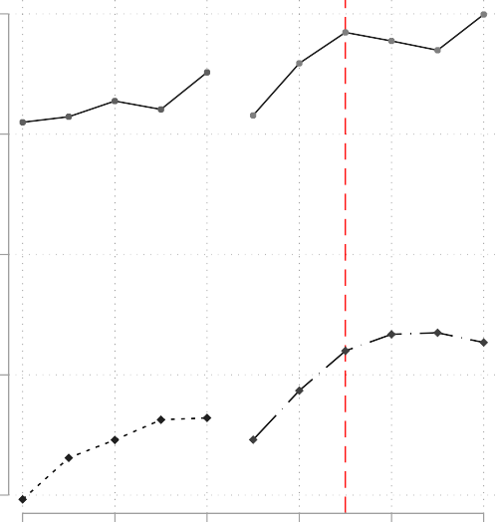
60

    - FULL-TIME-STUDENT
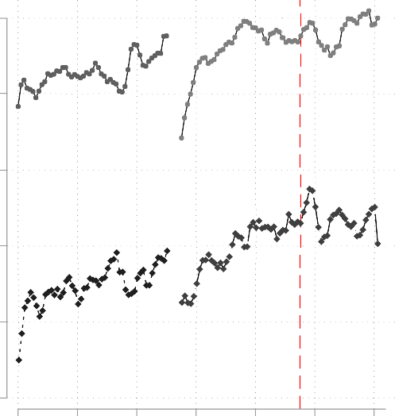
60

50
50

40

40
%
%

30

30
20 ACA

20 ACA
2003 2005 2007 2009 2011 2013
Year

10
1 21 41 61 81 101 121
Month

Source: SIPP 2003-2013
SIPP 2004 - PARENT_HI=1 SIPP 2008 - PARENT_HI=1 SIPP 2004 - PARENT_HI=0 SIPP 2008 - PARENT_HI=0

Figure 1: Full-Time-Student by Treatment Status and SIPP Survey Panel
Sample of 19–23 year old individuals broken into treatment (PARENT_HI=1) and control group (PAR- ENT_HI=0) by year in panel [1] and by month in panel [2].

.05

0
Coefficient Estimates

-.05

-.1

Coefficients on Interactions of: PARENT_HI x ACA x AGE
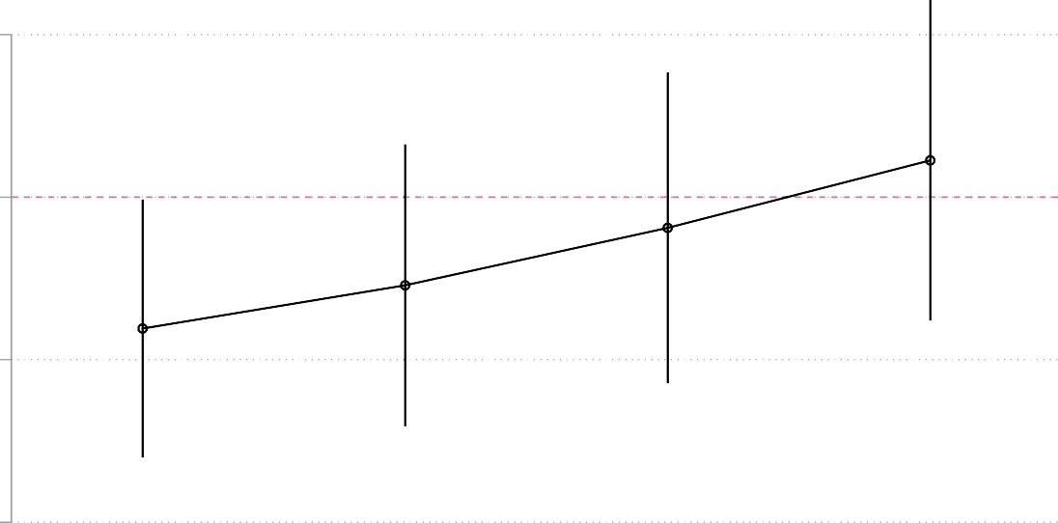

20 21 22 23
Age
Note 1: Vertical lines represent the 95% confidence interval Note 2: Dependent variable = FULL-TIME-STUDENT

Figure 2: DD Estimation of FULL-TIME-STUDENT (Age Effect of ACA)
We present coefficient estimates by year for the interaction terms:

23
j=20
δ_{j} (PARENT_HI

ist
× ACA_{t}×1_{{AGE}

ist=j
}) in the DD specification of expression (2).

Estimates are based on a DD estimate with State FE. We control for household income, gender, race
as well as parental characteristics such as education, race, gender, marriage status, age and mortgage payments, work sector, occupation type, and state characteristics such as state level unemployment, state level unemployment (for 19–25 year olds), state level public and private tuition, and state level per capita income. Additionally, all specifications control for year fixed effects and month dummies.

.06

.04
Coefficient Estimates

.02

0

-.02

-.04
Coefficients on Quarterly Indicator Variables
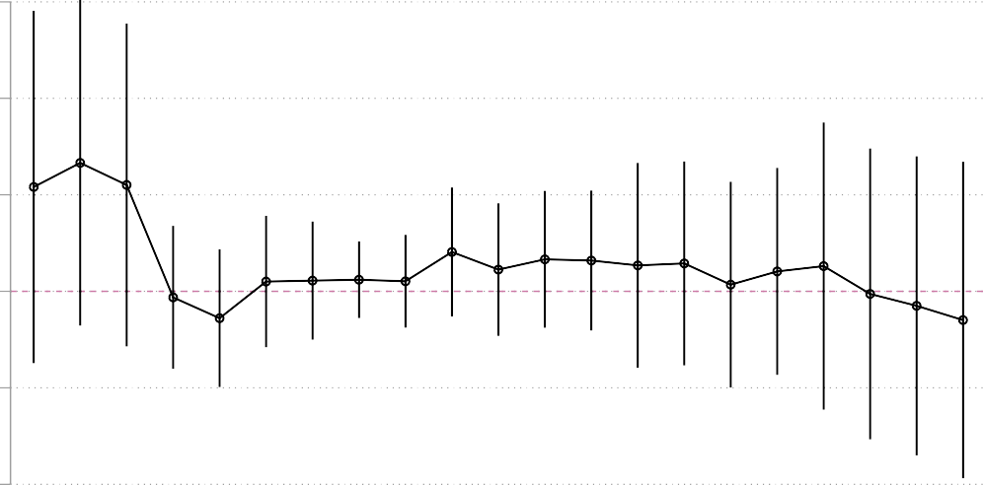

-7 -6 -5 -4 -3 -2 -1 1 2 3 4 5 6 7 8 9 10 11 12 13 14
Quarters Away from Jan to June of 2010
Note 1: Vertical lines represent the 95% confidence interval Note 2: Dependent variable = PARENT_HI

Figure 3: Testing for Endogenous Treatment Groups
The dependent variable is parental health insurance status, PARENT_HI. This variable determines whether an individual is in the treatment or control group. We report coefficient estimates of dummy variables q_{t} that are indicators for quarters away from the base period of January–June 2010 which is used as the omitted category as described in expression (3).
The sample consists of 19–23 year old individuals. If the expansion of the mandate motivated parents with children between the age of 19–23 to obtain insurance, we should see an increasing trend on coefficient estimates for the quarters indicator variable q_{t} following the base period.

.1

0
Coefficient Estimates

-.1
The Interaction between Quarters away from Jan to June 2010 and Treatment

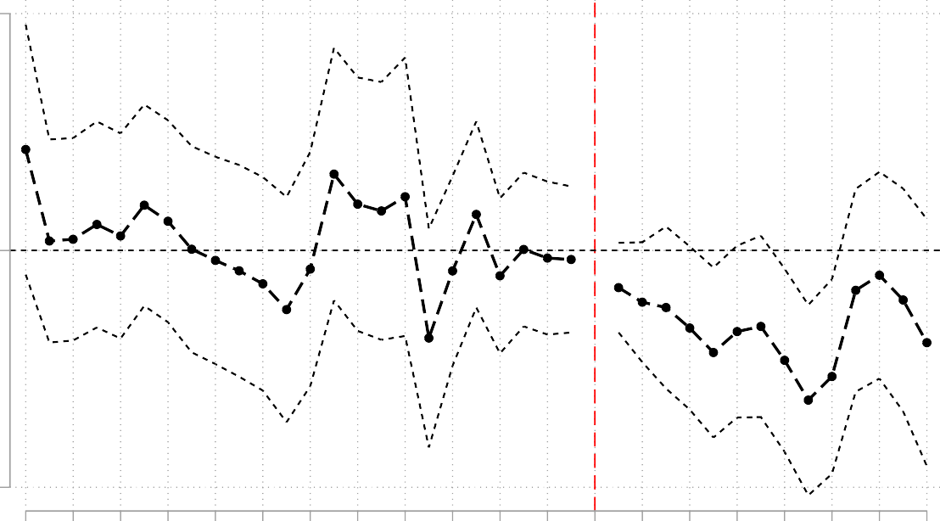
Centered Quarters
-24
-22
-20
-18
-16
-14
-12
-10
-8
-6
-4
-2
0
2
4
6
8
10
12
14

Figure 4: Testing the Parallel Time Trend Assumption
Dependent variable is FULL-TIME-STUDENT. We present coefficient estimates for

t=14 t=−24
δ_{t} (PARENT_HI

ist
× Quarter_{t}) of expression (5) .

We use data from the full sample from 2003–2013. We control for household income, gender, race as well as
parental characteristics such as education, race, gender, marriage status, age and mortgage payments, work sector, occupation type, and state characteristics such as state level unemployment, state level public and private tuition, and state level per capita income. Additionally, all specifications include year fixed effects, month dummies, and state level fixed effects. Base or omitted category is January to June 2010.

138000

136000

134000
Count

132000

130000
Total Non-Farm Payrolls (1000 persons) Monthly, Seasonally Adjusted

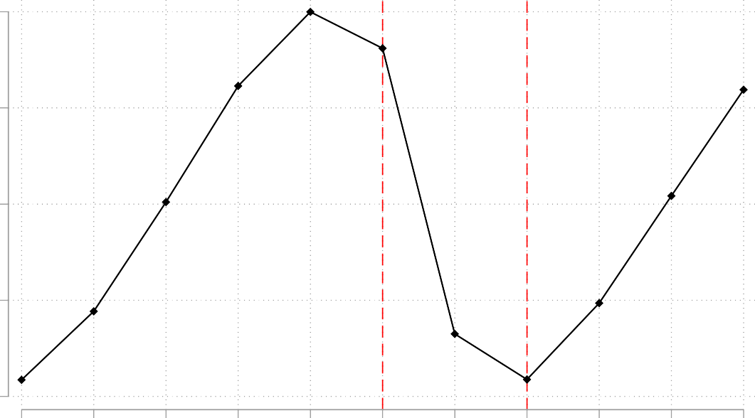
2003 2004 2005 2006 2007 2008 2009 2010 2011 2012 2013
Year Source: Federal Reserve Bank of St. Louis

Figure 5: U.S. Non-Farm Employment

Composition of Observed Characteristics (Pre-ACA and Post-ACA)

.2

.15

.1
%

.05

0
Parent's Occupation

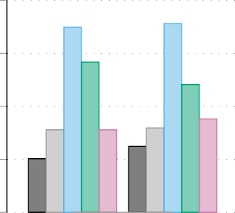
Pre-ACA Post-ACA

Health-Doctor Sales
Admin Repair Military
Race
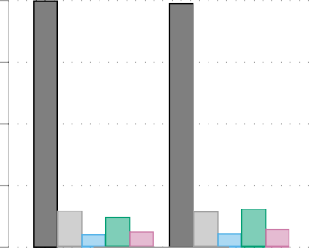
.8

.6

.4
%

.2
0
Pre-ACA Post-ACA

White Black Asian Hispanic Other

Parent's Education
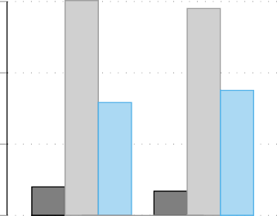
.6

.4
%
Health Insurance Type
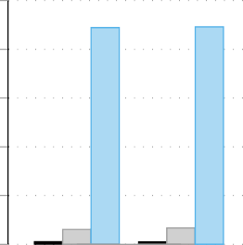
1

.8

.6
%

.2

0
Pre-ACA Post-ACA

<H.S H.S
College
.4

.2

0
Pre-ACA Post-ACA

Medicaid Individual
Employer Sponsored

Family Income
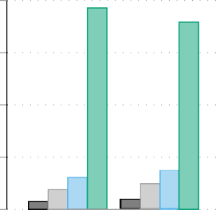
.8

.6

.4
%

.2
0
Pre-ACA Post-ACA

100% of FPL

>100-200% of FPL

>200-300% of FPL

>300% of FPL

Note: Sample includes parents with private health insurance (Parent_HI=1) Source: SIPP 2003-2013

Figure 6: Observed Characteristics of Treatment Group (Before and After the Dependent Coverage Mandate)
Sample consist of data from 2003–2013 and is restricted to the treatment group, i.e., individuals whose parents have health insurance (Parent_HI=1).

Normalized Difference
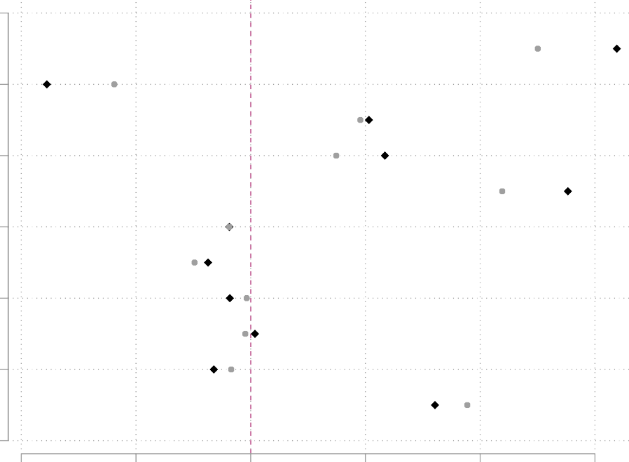
12

10

8
Covariate Label

6

4

2

0
-.4 -.2 0 .2 .4 .6
Normalized Difference of Covariates

Pscore 0.1-0.9
Pscore 0.2-0.8

Figure 7: Robustness Check 1 - Trimming based on Propensity Scores
This figure plots the normalized difference between the covariates of treatment and control groups within estimated propensity score windows of [0.1, 0.9] and [0.2, 0.8]. The covariate labels from top to bottom are: 1=FULL-TIME-STUDENT, 2=AGE, 3=WHITE, 4=BLACK, 5=MARRIED, 6=HEALTH-PROBLEM, 7=LOG-HH-INCOME, 8=PARENT_COLLEGE, 9=PARENT_MARRIED,
10=PARENT_HEALTH PROBLEM, 11=PARENT_FAM_INCOME.

