Integrating Palliative Care Screening into Primary Care

By Nalynn Holland

APPROVED BY:

_______________________________________________ _________________
Advisor/Chair Date

_______________________________________________ __________________
Committee Member Date

_______________________________________________ __________________
Committee Member Date

_______________________________________________ __________________
Graduate Program Director (if required) Date

Integrating Palliative Care Screening into Primary Care

By

Nalynn Holland

DNP Project submitted to the Department of Nursing
of Salisbury University in partial fulfillment of the requirements
for the degree of
Doctor of Nursing Practice
April 3, 2018

Copyright

By

Nalynn Holland

2018

Dedication
To my beautiful daughter, may you find fulfillment in the things you’re passionate about and never give up on your dreams!
Acknowledgments
I would like to thank my family and friends for the unconditional love and support you’ve provided through this journey of obtaining my doctoral degree. Thank you for always believing in me, none of my accomplishments would be possible without you!
I would also like to express my gratitude to the faculty of Salisbury University and my DNP Committee for their guidance in completing this project.
Abstract
Problem Statement: As patients with chronic, life-limiting conditions live longer, it is important to continuously evaluate quality-of-life. The lack of initiation of a palliative care consult at the time of diagnosis with a chronic, life-limiting condition results in an increase in disease burden and functional decline.
Purpose: The purpose of this project was to determine if the implementation of a palliative screening and referral process in the primary care setting as compared with usual care (subjective physician referrals without standard screening tool) would help to increase the number of palliative care referrals and patient access to palliative care service.
Methods: A multi-step exploratory project design was used with convenience sampling. This project encompassed: 1.) collection of aggregate data; 2.) development of a palliative care staff educational program; 3.) implementation of a palliative screening tool; 4.) development of a process for referring patients to palliative care; and 5.) provision of improved access to palliative care services for eligible patients.
Results: Descriptive and inferential statistics explored overall provider compliance with use of the palliative care screening tool and comparisons of the number of patients who met criteria for palliative care referrals to the number of actual referrals. A total of 410 patients were seen, which included 448 visit encounters. The majority were female (61%, n=252) and Caucasian/White (81%, n=331). Age ranged from 18 to 99 years. Screening compliance was 33% (goal of 100%). Twenty patients met criteria for a palliative care referral. However, only 9 referrals were actually made. Due to low yield of referrals, correlations between palliative care referrals and demographic variables such as: age, gender, insurance, and diagnosis were not possible.
Significance: The increased integration of palliative care knowledge into the primary care setting helped to facilitate palliative care referrals. Based on the literature reviewed and data collected from this DNP project, the recommendation remains for more studies to be conducted on the use of palliative care screening tools in the primary care setting.
Keywords: palliative care, palliative care referrals, primary care, chronic life-limiting conditions

Table of Contents

List of Tables iv

Project Overview 1

Introduction 1

Problem Statement 1

Significance of the Problem 2

Purpose 3

PICOT Question 4

Succinct Analysis of Supporting Literature 5

Review of Literature 5

Lack of Standardized Screening Tool 6

Early Implementation 7

Unmet Needs and Improved Patient Outcomes 8

Provider Education/Training 9

Conceptual Framework & QI/EBP Model 11

Project Design 13

Methodology 13

Participants 13

Setting 14

Instrument 14

Referral Process 15

Implementation Timeline 16

Pre-Intervention Data Collection 16

Staff Education 16

Go Live of Screening Process and Data Collection Period 17

Post-Intervention Data Collection 18

SWOT Analysis 19

IRB and Agency Approval 20

Project Implementation 21

Summative Evaluation of Implementation Process 21

Barriers and facilitators 22

Analysis and Discussion of Findings 23

Results 24

Discussion of Findings 24

Recommendations 27

Process and Outcome Recommendations 27

Economic Considerations 28

DNP Role Discussion 29

Dissemination Plan 32

References 33

Appendix A: PRISMA Diagram 43

Appendix B: Systematic Table of Evidence 43

Appendix C: Conceptual Framework 52

Appendix D: SWOT Analysis 54

Appendix E: Palliative Screening Tool 55

Appendix F: IRB Approval 57

Appendix G: Evidence of Collaboration 58

Appendix H: Patient Notice of Study 60

Appendix I: Staff Script for Consent 61

Appendix J: Informed Consent 62

Appendix K: Data Collection Spreadsheet 65

Appendix L: Timeline 66

List of Tables

Table 1. Demographic Characteristics of the Practice 38

Table 2. Demographic Characteristics of Patients Seen November 2017 39

Table 3. Patients Screened for Palliative Care Referrals by Physician 41

Table 4. Patients Screened for Palliative Care Referrals by Nurse Practitioner 42

Project Overview

Introduction
As patients with chronic, life-limiting conditions are living longer it is important to continuously evaluate disease burden, functional decline, and quality-of-life (QOL). “Living longer is not always synonymous with a greater number of healthy years” (Cleary, 2016, p. 42). In fact, as the years of living with chronic, life-limiting conditions increase, so does the number of emergency room visits and hospitalizations (Cleary, 2016). Approximately six million people in the United States could benefit from palliative care to manage chronic life-limiting conditions such as: cancer, stroke, diabetes, heart disease, renal disease, Parkinson’s, and Alzheimer’s disease (Center to Advance Palliative Care, 2014).

Problem Statement
The problem identified for this project was that providers were not initiating appropriate palliative care consults at the time of diagnosis, thus resulting in an increase in disease burden and functional decline for patients with chronic, life-limiting conditions. The integration of early palliative care referrals into primary care benefits both the patient and providers. In regards to patient benefits, early integration of palliative care leads to fewer emergency room visits, development of trusting relationships with family and providers, improvement of symptom management, increased satisfaction of care, and preparedness for the end-of-life (Owens et al., 2012).
Primary care providers are equally responsible for promoting effective patient-provider communication. The integration of palliative care helps to facilitate conversations about symptom management, prognosis, and treatment preferences (McCormick, Chai, & Meier, 2012). In addition to building trusting relationships and understanding the patient’s needs, values, and goals of care; primary care providers are knowledgeable about available community resources and are in a pivotal role to orchestrate such collaborations (McCormick et al., 2012).

Significance of the Problem
Palliative care is a specialty that is still in its infancy and often its definition/significance is misunderstood.
Palliative care is an approach that improves the quality of life of patients and their families facing problems associated with life-threatening illness, through the prevention and relief of suffering by means of early identification and impeccable assessment and treatment of pain and other problems, physical, psychosocial and spiritual (World Health Organization, 2017, para. 1).
It is important to emphasize that palliative care is not only appropriate for patients with cancer. Palliative care should be used as an approach to care for patients with any chronic, life-liming condition and should be integrated at all transitions of care (Gómez-Batiste et. al, 2014).
Over the past several years, research has shown that a growing need exists for integration of palliative care in ambulatory care settings (Hui et al., 2016). Literature supports the implementation of outpatient palliative care measures to reduce emergency room utilization, reduce health care costs, improve symptom management, quality-of-life (QOL), and quality of death (Hui et al., 2014; McCormick et al., 2012; Owens et al., 2012; Trout, Kirsh, & Peppin, 2012).
Although there is evidence supporting the benefits of palliative care, palliative care services remain underutilized. For example, uncertainty about when palliative care services should be implemented, who should implement palliative care services, and eligibility criteria are reasons for lack of use and physician referral (Hui et al, 2014; Hui et al, 2016). Uncertainty stems from the lack of definitive palliative care referral guidelines. Ideally any provider can initiate and even provide palliative care. Primary care providers (PCPs) have been thought to play a vital role in facilitating goals-of-care and end-of-life (EOL) discussions. It is recommended that initiation of palliative care begin early or at time of diagnosis of a chronic life-limiting condition (Hui et al., 2014). Additionally, PCPs are in an ideal position to initiate or refer patients to palliative care due to the history of long-standing trusting relationships they have with their patients and their families (McCormick et al., 2012). Most often the PCP knows the patient best and is the main person responsible for coordinating care.

Purpose of the Project
Literature supports that the implementation of outpatient palliative care measures help to reduce healthcare costs, reduce emergency room utilization, and to improve symptom patient outcomes (Owens et al., 2012). “The high utilization of healthcare services by people at the end-of-life has created a need for early and improved access to outpatient palliative care” (Owens et al., 2012, pg. 58). The purpose of this project was to implement a palliative care referral process. This process consisted of educating PCPs about palliative care, recognizing eligible patients, and referring them to a local hospice organization for appropriate care services. This project also aimed to determine whether or not the implementation of a palliative care screening tool (PCST) in the primary care setting helped to increase the utilization of palliative care by patients with chronic, life-limiting illness.

PICOT Question
The clinical question of interest was: In patients with chronic life-limiting conditions in a rural medically underserved population, did the implementation of a palliative care screening tool in a primary care practice, as compared with usual care (subjective physician referrals without standard screening tool), help to increase the number of palliative care referrals and patient access to palliative care services?

Succinct Analysis of Supporting Literature

Review of Literature
Research articles for the topic of interest were searched using the following databases: CINAHL, MEDLINE, and ProQuest. The search was conducted from September 2016 – February 2018. The following search terms were used: palliative care screening tool, palliative care referral tool, primary palliative care, palliative care in the outpatient setting, outpatient palliative care, primary care AND palliative care, palliative care AND screening tool. These search terms yielded both quantitative and qualitative research articles. Criteria applied during the search included a date range of 2012-2018, academic journals, and English language. Articles greater than 5 years old were also considered for inclusion, due to the limited amount of research available on palliative care in the primary care setting. Articles were excluded if they focused on inpatient referral processes, lacked discussion of referral criteria, or related to pediatric palliative care, pain management, opioid management, and outpatient pain clinics. The search terms above yielded a lot of information regarding palliative care in the inpatient setting and pilot studies of screening tools for outpatient settings. However, many articles were excluded because they did not relate to the target population and/or question of interest (see Appendix A).
The literature search resulted in a total of 14 research articles that were included in this review. The articles were assessed for strength and quality based on the Johns Hopkins Nursing Evidence Based Practice (JHNEBP) model and varied in type, strength, and quality (Dearholt & Dang, 2017). Of the articles included in the review, two were level II, five were level III, two were level IV, three were level V, and two were a mix of level IV/V. All of the articles were either good or high quality, which correlates clear objectives and methodology with reasonably consistent results (see Appendix B).
In general, limited evidence existed on palliative care referral and utilization in primary care. This was thought to be due to the relative youth of palliative care as a specialty with a limited evidence base as an approach to care as compared to more established specialties in medicine. For example, most evidence included either pilot studies or reviews of literature. The type of article or study greatly impacts the strength and quality of the literature. Experimental/ randomized control trials (RCTs) carry the most strength while non-experimental studies and literature reviews have less strength (Dearholt & Dang, 2017). As recommendations for outpatient palliative care continue to develop, it is predicted that more experimental/RCTs in this specialty will emerge. Several major themes were extracted from the review of literature (ROL): no standardized screening tool, early implementation on improved patient outcomes, and the need for improved provider education and training.
Lack of Standardized Screening Tool
The major finding of the ROL was that there were no standardized, universally accepted outpatient palliative care screening tools. The screening tools used in many of the pilot studies were developed based on recommendations of the National Comprehensive Cancer Network (NCCN). National guidelines recommended that patients with chronic life-limiting conditions should be screened for palliative care referrals at every visit (National Comprehensive Caner Network, 2017). Blanket referrals at time of diagnosis improved patient outcomes; however, a more efficient and effective approach would include referrals supported by the assessment of need (Glare, Semple, Stabler, & Saltz, 2011). Screening recommendations for palliative care included the following: unmanaged symptoms, moderate to severe distress, serious co-morbidities, psychiatric and psychosocial conditions, life expectancy of 6 months or less, metastatic disease, patient and/or family concerns about the course of disease and decision-making, and patient or family request for palliative care (NCCN, 2017). The evidence supported future development of a standardized screening tool or referral criteria. A standardized tool would eliminate barriers associated with the use of palliative care and increase the number of referrals and utilization of services.
Of the articles included in this review, the study by George and colleagues discussed the implementation of a palliative screening tool in the emergency room setting (2015). The goal of this study was to develop an evidenced-based palliative screening tool to increase the timeliness, consistency, and frequency of appropriate palliative referrals (George et al., 2015). The tool was consistent with recommendations from the NCCN and had high content and construct validity. Based on the literature available, this tool could easily be applied to the primary care setting. The researchers recommended future studies of this tool in the outpatient setting, which they claimed were underway.
Early Implementation
Another major theme related to early implementation of palliative care on patient outcomes. The literature supported the implementation of outpatient palliative care measures to reduce emergency room utilization, reduce health care costs, and to improve symptom management, quality-of-life (QOL), and quality of death (Hui et al., 2014; McCormick et al., 2012; Owens et al., 2012; Rabow et al., 2013, Trout, Kirsh, & Peppin, 2012). Although evidence supported the use and benefits of palliative care, outpatient palliative care services remained underutilized. Many providers failed to make palliative care referrals. This was mainly due to limited exposure and knowledge related to: (1) palliative care, (2) appropriate time for palliative care service implementation, (3) lack of understanding which provider should implement palliative care services, and (4) patient eligibility criteria (Ahluwalia & Fried, 2009; Glare & Chow, 2015; Hui et al., 2014; Hui et al., 2016).
Unmet Needs and Improved Patient Outcomes
As previously mentioned, a common misconception was that palliative care is only intended for patients with cancer. Despite many myths about palliative care, palliative care is intended for any patient with a chronic life-limiting illness and the goal is to alleviate pain and suffering while maximizing quality-of-life for the patient and their family (Prasad, Sarkar, Dubashi, & Adinarayanan, 2017; Hui et al., 2014; Hydeman, 2013). Of the studies reviewed, patients that utilized palliative care services had a reduction of emergency room utilization, improved symptom management, improved satisfaction of care, improved quality-of-life, and lengthened survival (McCormick et al., 2012; Owens et al., 2012; Rabow et al., 2013, Trout et al., 2012).
In a study of 52 patients conducted by Prasad and colleagues (2017), they investigated both inpatient and outpatient non-cancer patients with chronic life-limiting illnesses and their needs of palliative care services. On average 10% of the patients receiving care from a specialty department (Cardiology, Neurology, or Nephrology) were in need of palliative care services (Prasad et al., 2017). When assessing unmet needs of patients with chronic life-limiting illnesses it is important to obtain a comprehensive assessment of physical, psychosocial, and spiritual concerns. For example, in this sample, financial constraints were the most common concern, followed by emotional concerns, and limitations to activities of daily living (Prasad et al., 2017). In regard to physical symptoms, many patients with chronic life limiting illnesses struggle from poorly managed pain, fatigue, anxiety, and depression (Hydeman, 2013; Prasad et al., 2017).
As the need for palliative care services is increasing, it is important to consider patient preferences. The majority of patients prefer home-based or outpatient palliative care services rather than hospital-based palliative care services, thus reinforcing the need for increased access to outpatient palliative care services (Prasad et al., 2017). In a quasi-experimental study of five regions in Belgium on early implementation of palliative care in the primary care setting, the study discovered two primary outcomes: a reduction of hospital deaths from 50% to 35% and an increase of home deaths and utilization of high quality palliative care (Leysen et al., 2015).
Provider Education/Training
A major determinate of increased utilization of palliative care services was increased provider exposure (Ahluwalia & Fried, 2009). Increased palliative care education and increased the presence and visibility of palliative care programs in the outpatient setting helped providers to have a constant reminder of availability of services and established a level of comfort (Ahluwalia & Fried, 2009; Mason et al., 2015, Llobera et al., 2017). In addition, increased provider education/training improved utilization of outpatient palliative care along with the designation of palliative care leaders in the primary care setting. These leaders consisted of providers with additional training in palliative care. Establishing palliative care leaders in the primary care setting helped to facilitate early identification of patients eligible for palliative care and created a more comprehensive, community-oriented approach to palliative care (Llobera et al., 2017).
Although there remains a limited amount of literature available of palliative care, especially in the primary care setting, this is a significant problem that needs to be addressed to better the lives of patients with chronic-life limiting conditions that could benefit from palliative care services.

Conceptual Framework & QI/EBP Model
Conceptual or theoretical frameworks are essential components of any evidenced-based practice project. Such frameworks can be viewed as a map that helps to guide and identify important aspects of the project (Moran, Burson, & Conrad, 2017). Palliative care services are rapidly evolving and there is increasing support of early implementation of palliative care services (Bruera & Hui, 2012). However, barriers and issues remain that result in the underutilization of these services. A combination of two conceptual frameworks (Supportative, Palliative, and Hospice Care Model and Goals of Care Model) (Appendix C) and the ACE Star Model of Knowledge and Transformation (Appendix D) guided this project.
This project was provider driven and focused on changes to clinical practice. However, in order to promote such changes, it was essential to have buy-in of both patients and providers, and the best way of doing so was through education. The Conceptual Framework for Supportive, Palliative, and Hospice Care explained the various levels of care. Supportive care is the overarching concept of this model that included a variety of services through the various stages of disease and treatment (Bruera & Hui, 2012). Since this project involved a referral process to a palliative/hospice organization that provided various services this model was important in establishing the framework of the project. For example, the hospice organization provided a pathways service and hospice care. The pathways service was in line with the concept of supportive care. The pathways service identified patients that needed additional support but also potentially benefitted from progressive services such as palliative or hospice care. This model addressed the following components of the project: PCP and patient education, understanding and guiding the continuum of care, and integrating appropriate levels of care into primary care. The Goals of Care conceptual model was also applied to this project. The basis of palliative care implementation begins with establishing goals of care. The model, as described by Bruera and Hui, used the analogy of a car to help patients think of hypothetical situations and desires of care (2012). This model helped both the patient and provider to better understand the goals of care. The provider was responsible for coordinating plans of care (Bruera & Hui, 2012). This model allowed the provider to better explore the patient’s wishes, as well as developed a plan that was in line with those goals. The Goals of Care Model was a useful educational tool to help introduce the providers to supportive, palliative, and hospice care and introduce discussion of patient goals.
In regard to evidence-based practice models, the ACE Star Model of Knowledge Transformation was the framework used to guide this project and the desired practice change. It is a commonly used framework that systematically translates evidence into practice. The model consists of five categories: knowledge discovery, evidence summary, translation into practice, integration into practice, and evaluation (Stevens, 2012). The steps in this model were addressed in the progression of this project. Using the conceptual frameworks and EBP model mentioned above were most appropriate and helped to guide the success of this project.

Project Design
Methodology
This pilot project was designed as an exploratory EBP project with a pre-test, post-test design. The project consisted of data/medical record review of human participants, education of staff and healthcare providers in a primary care setting, implementation of a new standard of care in a primary care practice, screening for palliative care referral appropriateness, and review of patient follow-through with the palliative care referral.
Participants
A convenience sample of patients in a private primary care practice in Easton, MD was obtained. All adult patients (18 years and older) seen in the practice setting were included. Since this project included implementation of a screening tool into the standard of care for all patients seen in the practice, it was intended that all patients in the practice (with visits during the data collection phase) were screened. Inclusion criteria for the tracking and referral portion of the project included those patients who were deemed appropriate for a palliative care referral as indicated by the score on the PCST. Exclusion criteria for patients in the project (tracking patient referral and follow up) were patients with dementia or other cognitive disorders and patients who did not receive a palliative care referral as indicated by the screening tool. All patients received a notice prior to check-in informing them of a study taking place (Appendix F). However, consent to participate in the follow up portion of the project (tracking patient referral and follow up) took place at patient checkout (Appendix H), at that point patients consented to participating in the follow-up component of the project. The medical assistants were provided with a script to ensure all potential participants were approached the same way (Appendix G). Informed consent was given to all patients (that met the referral criteria) by medical assistant and was completed during the checkout process. Patients with dementia or cognitive disorders were excluded from the project. Although providers screened these patients for their need of a palliative care referral, they weren’t consented or included in the follow-up tracking. Participants were provided with a copy of the consent. If at any time the patient had questions about participation they were directed to contact the primary project investigator. The primary investigator and DNP student were available to take any questions.
Setting
The project was carried out in a private physician owned practice (Miles River Physicians) in Easton, MD. This primary care office serves a large percentage of Medicare patients and patients with chronic, life-limiting conditions. The practice consists of two physicians and three nurse practitioners. The practice has 2,986 patients, of which 1,002 (34%) are Medicare patients (Table 1).
Instrument
The screening tool selected for this project was previously implemented in the emergency room setting (George et al., 2015). The tool did not have a specific name, for the purposes of this project the tool will be referred to as the Palliative Care Screening Tool (PCST). The tool sought to increase the timeliness, consistency, and frequency of appropriate palliative referrals (George et al., 2015). With the lack of any consistent screening tool currently used in primary care to screen for palliative care, the DNP student, in consultation with her DNP committee and the physician in charge of the study practice setting, selected this tool as it was simplistic and synonymous with the goals of this project (see Appendix E).
The tool was incorporated into the electronic medical record, Intelligent Medical Software (IMS), of Miles River Physicians. Utilizing an electronic tool, the DNP student hoped to make the screening process and data collection more organized and systematic. The PCST had two steps. The first step involved identifying whether the patient had any life-limiting conditions (advanced dementia, central nervous systems diseases, cancer, renal disease, heart disease, liver disease and/or COPD) (George et al., 2015). If the patient did not have any of the listed conditions, the screening was complete. However, if the patient had one or more of the conditions listed the provider proceeded to the second part of the tool. Step two reviewed unmet palliative care needs (emergency room visits, hospitalizations, uncontrolled symptoms, functional decline, and surprise question – See Appendix E) (George et al., 2015). If there were two or more unmet palliative care needs identified, a palliative care referral was recommended (George et al., 2015). A data collection tool was created to collect the aggregate data (Appendix K).
Referral Process
After completion of the PCST, if appropriate, a palliative care referral was made. Collaboration was established and the project intended that patients would be referred to Talbot Hospice. Talbot Hospice was the local hospice organization that provided several levels of care and supportive services for patients with chronic life-limiting conditions. Talbot Hospice provided non-medical supportive care through the Pathways program. However, hospice services were available for patients with medically intensive needs. Patients were free to pursue any palliative care provider of his/her choice. Palliative and hospice care both focus on comfort. The difference is that palliative care can begin at the time of diagnosis and continue simultaneously with treatment (National Institute of Health [NIH], 2017). Whereas, hospice is for terminally ill patients who may have six months or less to live and the focus is strictly on comfort, not cure (NIH, 2017). At the time of patient contact, Talbot Hospice, would determine the appropriate care program (Pathways or Hospice) for the patient based on need.
Implementation Timeline
A detailed timeline was developed and strictly adhered to ensure project completion by May 2018 (Appendix L).
Pre-Intervention Data Collection
Prior to the start of the intervention phase of this project (September – October), information pertaining to practice size, current rate of referral to palliative care, and percentage of Medicare patients was collected in aggregate. This data was extracted in reports generated by the electronic medical record (IMS).
Staff Education
Prior to the implementation of the screening process portion of the study, face to face educational session was conducted with all the providers and staff to provide general education about palliative care and to review the goals of the project and to train staff and providers on the process of implementing the PCST and completing referrals. The 60-minute session was held with the providers and ancillary staff (medical assistants and practice manager). During the session, information related to the project including significance, screening tool implementation, data collection, and analysis were discussed. The staff was educated on goals of care and different levels of care (supportive, palliative, and hospice care). Another objective of the session was for the staff to verbalize a level of comfort with completing the PCST and having the patients sign consent to participate in the follow-up portion of this project. All trainees received handouts, a post-test, a survey, and had questions answered. The medical assistants who completed the referral process at checkout and provided the consent forms additionally completed Collaborative Institutional Training Initiative (CITI) training (Biomedical Research Investigators) and those certificates were provided to the IRB.
Go Live of Screening Process and Data Collection Period
The screening process and simultaneous data collection took place for four weeks in November 2017. As screenings were completed, data collection for the follow-up or referrals occurred simultaneously. Although data collection related to screenings concluded at the end of the four week period, data related to referral follow-up was collected for an additional four weeks beyond the screening data collection period to provide sufficient time for referrals to be made and capture patient follow-up.
During the go-live/screening period the DNP student was onsite weekly to offer support and was available any time via email and phone when not physically on site. While ongoing feedback and interaction with the practice staff occurred, upon completion of the data collection period the DNP student planned a meeting with staff representatives to assess staff satisfaction and feedback related to the implementation of the PCST and the referral process.
Post-Intervention Data Collection
Data was collected via the electronic medical record at Miles River Physicians. The DNP student reviewed the charts of all patients with visit encounters during the implementation phase. The following aggregate and/or de-identified information was collected from the electronic medical record at Miles Rivers Physicians after implementation of the PCST into the practice: total number of screenings completed, total number of referrals made, percent referrals made based on positive screenings (patient meets criteria for referral), provider status making referral (MD or NP). De-identified data (no patient names or medical record numbers) included: individual PCST scores, referral based on screening score (yes/no), age, race, diagnoses, insurance (including Medicaid status) and gender. This aggregate data was used to assess the effectiveness of the practice change, implementation, and utilization of the screening tool.
Subjects who consented to participate in the follow-up portion of the study had the following data collected from Miles Rivers Physicians medical records: demographics (age, race, and gender), medical diagnoses, Medicaid and insurance status, PCST score, provider completing tool, and whether or not a referral was made. From Talbot Hospice, the following data was collected: patient presented for referral, program suggested (Pathways or Hospice), and program enrollment.
No patient identifiers were included in the data set. Data was coded and entered into Microsoft Excel data analysis software. Descriptive statistics (frequencies and percents) were conducted. Descriptive statistics were used to explore the overall demographic profile of the sample, PCST scores, and percent of referrals made by providers. The Excel crosstabs function was used to compare frequencies of patients screened or not screened based on provider type. Correlations were used to explore the relationship between the demographic data and the PCST score. Provider compliance with screening tool utilization and the number of positive screens sent for referral were assessed.

SWOT Analysis
Easton was chosen as the demographic location of interest due to its classification as a rural, medically underserved area (Health Resources & Services Administration, 2018). Medically underserved populations (MUPs) are “federally designated locations or population groups that have a shortage of primary care resources” (Maryland Department of Health and Mental Hygiene, 2016, p. 11, para 2). In medically underserved populations, there is greater emphasis on utilizing available resources in the community. Therefore, this project helped to enhance collaborations of established community resources.
Since Miles River Physicians was the primary setting for this project, a SWOT analysis was performed (Appendix D). Within the organization there were many internal strengths noted. For example, there were five providers, two physicians and three nurse practitioners, in the practice. There were a reasonable number of providers to work with in order to implement the project. Another strength of the organization was that the main provider/owner was previously the medical director of a hospice organization. She had a great deal of previous experience and knowledge of palliative and hospice care to offer. Internal benefits for Talbot Hospice included the increase in patient referrals and patients utilizing their services. The collaboration of these two organizations offered a great opportunity for the community. This project presented the opportunity for similar processes to be implemented in other local primary care practices. One weakness noted was the use of the electronic medical record (EMR). The practice staff had limited access to making changes in the EMR system. It was most efficient to integrate the screening tool into the EMR. However, the organization’s lack of technology caused major weaknesses impacting system processes and data collection. Two threats to this project were patient and provider compliance. For example, there was a possibility that the providers may not comply with screening all eligible patients due to the fear of increased workload and/or denial of need. The other component of the project included patient follow through with the referral process. Although a referral was made, there was great potential that a percentage of patients may not follow through with the process. The strengths and opportunities outweighed the threats and weaknesses. This project posed potential great gains for the patients and both organizations.
IRB and Agency Approval
Since the project included human subjects, approval was first obtained through the Salisbury University Committee on Human Research (Appendix F). Letters of agreement were obtained with Miles River Physicians and Talbot Hospice (Appendix G).

Project Implementation
Summative Evaluation of Implementation Process
After four weeks of screening, project implementation was concluded. Throughout the implementation phase, preliminary reports were run to evaluate the screening process. During the four weeks of screening there were 448 visit encounters, of which, only 148 were screened. This translated to a 33% screening compliance rate. Although screening compliance improved weekly, compliance remained far from the goal of 100%. During the four weeks of screening, no consents for referral follow-up related to palliative care were obtained. This raised suspicion as to whether or not there were any patients identified to need a palliative care referral. Therefore, the charts of all visits during the implementation phase were viewed. After reviewing 448 charts, it was discovered that nine palliative care referrals were recommended/made. Further investigation into the providers’ documentation was done to determine if these referrals were actually made.
Based on the provider’s documentation, it was written that a palliative care referral was made. However, it was not done following the intended referral process. It was brought to my attention that the provider provided the patients with a Talbot Hospice brochure so that they could follow-up with them if desired. However, the question remains as to whether or not this can be truly identified as a provider referral. It was rather frustrating that after weekly conversations with the providers about the screening and referral process, it did not seem like providers were fully embracing the spirit of the project or following through with completing the screenings and referrals as the project intended. Despite the ongoing check-in/provider feedback, it was not discovered until after implementation was concluded that some of the providers had confusion as to how the referral process was supposed to work. Although, I wasn’t able to follow-up with the referral data for these patients, I facilitated an additional process to close the loop of communication. After discussion with the providers, the medical assistants, and my committee chair, it was decided that a list was created of the patients identified to need a referral and the office followed up with a phone call to see if the patients needed any further assistance with orchestrating the referral.
Overall this project partially achieved the intended goals. The project was successful in educating providers of the importance of palliative care and implementing an outpatient palliative care screening tool in the primary care setting. Identifying some patients in need of palliative care was the major benefit of this project. Although actual referral and tracking processes was not able to be evaluated (due to the lack of data), it was the original intention of the project to provide patients with access to the care they need. This issue was alleviated by the suggestion mentioned above.
Barriers and Facilitators
Many unexpected limitations and barriers were discovered as the project progressed. One limitation was the amount of time available to collect data. Implementation was pushed back due to technological issues, protocol resubmission to reflect change in services available, postponement of educational session, and the delay in office staff completing the CITI training. It was thought that if there were more time to collect data, provider screening compliance would have improved and patients might have participated in the follow-up component of the project. Provider compliance was a major hindrance. The most common theme reported was that they “forgot” to screen. Also, during the implementation phase the main provider had a family emergency which caused disorder throughout the practice. Another issue was with documentation. Access to accurate, real time documentation presented another threat to the accuracy of the data collected, this was due to the fact that not all providers charted immediately/during the patient encounter. The second physician that sees the majority of the patients was significantly behind in documenting. Therefore, accurate results of screening compliance and referrals couldn’t be captured until documentation was completed. Subsequently this postponed the data collection process. Data collection did not take place until January 2018, in hopes of providing enough time for the documentation to be completed.

Although this process had many high and low points, it was an invaluable learning experience. I learned more about myself, as a future advanced practice nurse, as well as ways of enhancing my research and interprofessional collaboration skills. After analyzing the data, it is the hope of this DNP student to have a better understanding of how translating evidence into practice impacted this particular population.

Analysis and Discussion of Findings

Results
The practice had 2,986 patients, of which 1,249 were female and 1,737 male (Table 1). The predominate races were Caucasian/White (83%) and African American/Black (14%) (Table1). Thirty-four percent of the practice was Medicare recipients. Due to limitations with electronic medical record, percents of patients with certain chronic life-limiting illnesses in the practice were not able to be extracted. Pre-intervention palliative referral rates were not captured due to lack of consistent documentation related to a palliative care referral in the EMR prior to the start of this project.
During the implementation phase 410 patients were seen. However, there were a total of 448 visit encounters. In regard to sample demographics: 61% (n=252) were female and 39% (n=158) male; 81% (n=331) Caucasian/White, 18% (n=75) African American/Black, and the remaining 1% (n=4) Asian and/or unreported (Table 2). The participants ages ranged from 18 – 99 years old (Table 3). Forty percent of the sample had Medicare as the primary insurance (Table 2). Of the patients seen (410 patients), the majority (371 patients) did not have chronic life-limiting illnesses. Thirty-nine patients had one or more chronic life-limiting illness (Table 2). Of those that had life-limiting illnesses, two were referred to palliative care.
Discussion of Findings
The main results of interest were the percent of patients screened, provider compliance with completing screenings, and the number of referrals made. Of the 448 visit encounters, palliative care screening was completed on 148 visits, resulting in a screening compliance of 33%. Individual provider rate of screening was evaluated (Table 4). However, in regard to type of provider (MD vs. NP), the physicians screened 29% of the time; whereas, the nurse practitioners screened 4% of the time. Based on the patients screened, PCST scores ranged from 0 – 3 (of possible total of 5). The mean PCST score was 0.05 with a standard deviation of ± 0.37. Of the patients screened, nine palliative care referrals were made. After reviewing all 448 visit encounters, the DNP student scored each encounter using the PCST. It was discovered that a total of 20 palliative care referrals should have been completed. Therefore, only 9/20 (45%) of actual referrals were made that should have been made. Due to the limited number of referrals yielded, correlations between palliative care referrals and demographic variables such as: age, gender, insurance, and diagnosis were not possible. These results are consistent with current literature that palliative care services remain underutilized (Ahluwalia & Fried, 2009; Hui et al, 2014; Hui et al, 2016). Based on the related literature, failure to make palliative care referrals is often due to provider limited exposure and knowledge related to palliative care, when to implement service, and patient eligibility (Ahluwalia & Fried, 2009; Glare & Chow, 2015; Hui et al., 2014; Hui et al., 2016). In regard to this project, the main factor was due to provider uncertainty of eligibility criteria for referral, evidenced by PCST scores and rate of referral. This information is consistent with themes extracted from the review of literature that link uncertainty of eligibility to the lack of a standardized screening tool and provider education/training (Glare et al., 2011; Ahluwalia & Fried, 2009). Increased palliative care education and exposure to available palliative care programs in the outpatient setting would help to increase referrals and improve provide level of competency with palliative care services (Ahluwalia & Fried, 2009; Mason et al., 2015, Llobera et al., 2017).

Recommendations

Process and Outcome Recommendations
As previously discussed, the ACE Star Model helped to guide the implementation of this project and the translation of evidence into practice (Stevens, 2012). After completion of the five steps various evaluation of outcomes and recommendations were concluded. Based on the data analyzed, an interesting observation was made: there was a drastic difference in the rate of PCST screening between physicians and nurse practitioners. This can be linked to the information provided in the ROL in regard to deficient provider education/training with palliative care (Ahluwalia & Fried, 2009; Mason et al., 2015, Llobera et al., 2017). In future studies, it would be interesting to explore whether the differences of screening among provider types were related to limitations in education and/or overall unfamiliarity with palliative care or other factors. Interestingly, advanced practice registered nurses (APRNs) are thought to have a prominent role in care across various settings and diseases and are proven to be a vital resource to the shortage of palliative care providers (Dahlin, Coyne, & Cassell, 2016). It is recommended that APRNs are equipped with primary palliative care skills that can be used in routine care, thus enhancing the care throughout the entire illness trajectory and reserving more difficult cases to be managed by the limited number of specialty providers (Dahlin et al., 2016).
It was anticipated that this project would result in an increase of palliative care referrals. Since there was no pre-intervention data to compare, overall implementation of the PCST resulted in palliative care referrals; however, one cannot say if that referral rate was improved. Future explorations should gather data over an extended period of time to capture potential for increased screening compliance, additional barriers or problems with the screening and referral process and potentially yield data that could hold statistical significance.
It was the hopes of this project to implement a practice change that would promote improved patient access and utilization of appropriate services as well as improve patient outcomes and quality-of-life. Based on the data collected and analyzed and overall usefulness of the PCST, the practice may adopt this screening process as a permanent practice change. Based on the literature reviewed and data collected from this project, the recommendation remains for more studies be conducted on the use of palliative care screening tools in the primary care setting.
Economic Considerations
There were no costs associated with the development and implementation of this project. However, if the project were to be replicated, the organization may wish to consider the cost of screening tool development/integration into the EMR, staff training, and whether the completion of the screening process increases the length of visit for the providers. Overall, implementing a PCST and referral process offers benefits for patients and providers. By utilizing palliative care services, patients may have reduced health care costs related to decreased utilization of emergency services. Due to increased screening and utilization of services, collaborating providers may experience an increase in patient flow.

DNP Role Discussion
As a future FNP-DNP, my goals are to expand my knowledge and understanding of evidence-based outpatient palliative care practices. This DNP project has helped me to further those goals as well as meet the requirements of several DNP Essentials. This project consisted of many intricate processes that encompassed various DNP Essentials. This discussion will elaborate on each DNP essential and how it was integrated within the project.
The basis of this project began with identifying a topic of interest and determining how I could most efficiently use my degree to greatly impact this area of care. In order to be most equipped to address this problem, I conducted a thorough review of literature to explore current evidence and/or recommendations of the population of interest. The review and critical appraisal of literature relates to DNP Essentials I (Scientific Underpinnings for practice) and III (Clinical Scholarship and Analytical Methods for Evidence-Based Practice), which focus on integrating nursing knowledge by appraising existing literature to develop and evaluate practice change (AACN, 2006). The critical appraisal of the literature has continued throughout this entire project, to ensure the information that is intended for dissemination is most accurate and current.
This project related to DNP Essentials II (Organizational and Systems Leadership for Quality Improvement and Systems Thinking) and IV (Information Systems/Technology and Patient Care Technology for the Improvement and Transformation of Health Care), “develop and evaluate care delivery approaches based on evidence-based findings that meet the needs of patient populations and ensure quality of care and patient safety” and “develop, implement, and evaluate programs used to monitor outcomes of care, care systems, and quality improvement” (AACN, 2006). After critically appraising the evidence available, the recommendations were translated into a practice change for a local primary care practice. Evidence was translated into practice by staff educational sessions and the development and implementation of an electronic screening tool into the electronic medical record. Educating the staff and integrating technological changes were the most challenging aspects of this project. However, they were most impactful in the success of the project.
DNP Essential VI (Inter-professional Collaboration for Improving Patient and Population Health Outcomes), “utilize effective communication and collaborative skills in the development and implementation of practice models and leadership of interprofessional teams” was most vital to the outcomes of this project (AACN, 2006). This project involved the collaboration of various health care organizations and providers. As previously discussed, the practice change was implemented in a primary care office and the referral process was set up with the local hospice organization servicing the community. As the DNP student it was my role to establish professional relationships with both practices and promote interprofessional collaboration. This was done through frequent organizational meetings and electronic or phone communications. Interprofessional collaboration was also displayed during the conduction of meetings with my DNP committee, as well as the Institutional Review Board to obtain approval for the study.

Lastly, this project met DNP essential VIII, which focused on advanced nursing practice and specialization of care (AACN, 2006). Conducting research and disseminating findings are essential skills for advanced practice nurses, which is exactly what this project has prepared me to do. The DNP also embraces the specialization of nursing in highly complex areas of care (AACN, 2006). Needless to say, palliative and hospice care is a rather complex and delicate specialty area of care. Overall, this project has helped to increase my knowledge of outpatient palliative care and has provided role preparation to enable me to embrace my future career as a practitioner in this specialty area of care.

Dissemination Plan
The findings of this project were disseminated via a two hour oral presentation to faculty, colleagues, and community members of Salisbury University; as well as submitted for publication in a palliative care journal. Through dissemination it is hoped that the findings of this project will greatly impact local and national practice and that findings add to the limited data/literature available on outpatient palliative care screening. As previously mentioned, the literature supports the implementation of outpatient palliative care measures to reduce emergency room utilization, reduce health care costs, improve symptom management, quality-of-life, and quality of death (Hui et al., 2014; McCormick et al.,2012; Owens et al., 2012; Trout et al., 2012). With the continued integration of evidence into practice, lives of patients living with chronic life limiting illnesses can be forever changed.

References
AACN. (2006). The essentials of doctoral education for advanced nursing practice. Retrieved from http://www.aacn.nche.edu/dnp/Essentials.pdf
Aluwalia, S., & Fried, T. (2009). Physician factors associated with outpatient palliative care referral. Palliative Medicine, 23(7), 608-615. doi:10.1177/0269216309106315
Bruera, E., & Hui, D. (2012). Conceptual models for integrating palliative care at cancer centers. Journal of Palliative Medicine, 15(11), 1261-1269. doi:10.1089/jpm.2012.0147
Center to Advance Palliative Care. (2014). Palliative care facts and stats. Retrieved from https://media.capc.org/filer_public/68/bc/68bc93c7-14ad-4741-9830-8691729618d0/capc_press-kit.pdf
Cleary, A. S. (2016). Integrating palliative care into primary care for patients with chronic, life-limiting conditions. Nurse Practitioner, 41(3), 42-49. doi:10.1097/01.NPR.0000480588.01667.58
Dahlin, C., Coyne, P. J., & Cassel, J. B. (2016). The advanced practice registered nurses palliative care externship: A model for primary palliative care education. Journal of Palliative Medicine, 19(7), 753-759. doi:10.1089/jpm.2015.0491
Dang, D., & Dearholt, S. (2017). Johns Hopkins nursing evidence-based practice: model and guidelines. 3rd ed. Indianapolis, IN: Sigma Theta Tau International.
George, N., Barrett, N., McPeake, L., Goett, R., Anderson, K., & Baird, J. (2015). Content validation of a novel screening tool to identify emergency department patients with significant palliative care needs. Academic Emergency Medicine, 22(7), 823-837. doi:10.1111/acem.12710
Glare, P. A., Semple, D., Stabler, S. M., & Saltz, L. B. (2011). Palliative care in the outpatient oncology setting: Evaluation of a practical set of referral criteria. Journal of Oncology Practice, 7(6), 366-370. doi:10.1200/JOP.2011.000367
Glare, P. A., & Chow, K. (2015). Validation of a simple screening tool for identifying unmet palliative care needs in patients with cancer. Journal of Oncology Practice, 11(1), 81-85. doi:10.1200/JOP.2014.001487
Gómez-Batiste, X., Martínez-Muñoz, M., Blay, C., Amblàs, J., Vila, L., Costa, X., & ... Mitchell, G. K. (2014). Prevalence and characteristics of patients with advanced chronic conditions in need of palliative care in the general population: A cross-sectional study. Palliative Medicine, 28(4), 302-311. doi:10.1177/0269216313518266
Health Resources & Services Administration (HRSA). (2018). MAU find results. Retrieved from https://datawarehouse.hrsa.gov/tools/analyzers/MuaSearchResults.aspx
Hui, D., Kim, S. H., Roquemore, J., Dev, R., Chisholm, G., & Bruera, E. (2014). Impact of timing and setting of palliative care referral on quality of end-of-life care in cancer patients. Cancer, 120(11), 1743-1749. doi:10.1002/cncr.28628
Hui, D., & Bruera, E. (2016). Integrating palliative care into the trajectory of cancer care. Nature Reviews. Clinical Oncology, 13(3), 159–171. http://doi.org/10.1038/nrclinonc.2015.201
Hui, D., Yee-Choon, M., Bruera, S., Yimin, G., Hutchins, R., Masanori, M., & ... Bruera, E. (2016). Referral criteria for outpatient palliative cancer care: A systematic review. Oncologist, 21(7), 895-901. doi:10.1634/theoncologist.2016-0006
Hydeman, J. (2013). Improving the integration of palliative care in a comprehensive oncology center: Increasing primary care referrals to palliative care. Omega: Journal of Death & Dying, 67(1/2), 127-134. doi:10.2190/OM.67.1-2.o
Leysen, B., Van den Eynden, B., Gielen, B., Bastiaens, H., & Wens, J. (2015). Implementation of a care pathway for primary palliative care in 5 research clusters in Belgium: Quasi-experimental study protocol and innovations in data collection (pro-SPINOZA). BMC Palliative Care, 14(1), 1-13. doi:10.1186/s12904-015-0043-x
Llobera, J., Sansó, N., Ruiz, A., Llagostera, M., Serratusell, E., Serrano, C., & ... Leiva, A. (2017). Strengthening primary health care teams with palliative care leaders: Protocol for a cluster randomized clinical trial. BMC Palliative Care, 17, 1-8. doi:10.1186/s12904-017-0217-9
Maryland Department of Health and Mental Hygiene. (2016). 2016 Primary care needs assessment. Retrieved from http://pophealth.dhmh.maryland.gov/Documents/Primary%20care/2016%20Maryland%20Needs%20Assessment.pdf
Mason, B., Buckingham, S., Finucane, A., Hutchison, P., Kendall, M., McCutcheon, H., & ... Murray, S. A. (2015). Improving primary palliative care in Scotland: Lessons from a mixed methods study. BMC Family Practice, 16, 1-8. doi:10.1186/s12875-015-0391-x
McCormick, E., Chai, E., & Meier, D. (2012). Integrating palliative care into primary care. Mount Sinai Journal of Medicine, 79(5), 579-585. doi:10.1002/msj.21338
Moher, D., Liberati, A., Tetzlaff, J., Altman, D., Moher, D., Liberati, A., & ... Altman, D. G. (2009). Preferred reporting items for systematic reviews and meta-analyses: the PRISMA statement. Plos Medicine, 6(7), e1000097. doi:10.1371/journal.pmed.1000097
Moran, K., Burson, R., & Conrad, D. (2017). The doctor of nursing practice scholarly project: A framework for success. (2nd ed). Burlington, MA: Jones & Bartlett Learning.
National Comprehensive Cancer Network (NCCN). (2017). Palliative care. Retrieved from https://www.nccn.org/professional/physician_gls/pdf/palliative.pdf
National Institutes of Health (NIH). (2017). What is palliative care? Retrieved from https://medlineplus.gov/ency/patientinstructions/000536.htm
Owens, D., Eby, K., Burson, S., Green, M., McGoodwin, W., & Isaac, M. (2012). Primary palliative care clinic pilot project demonstrates benefits of a nurse practitioner-directed clinic providing primary and palliative care. Journal of the American Academy of Nurse Practitioners, 24(1), 52-58. doi:10.1111/j.1745-7599.2011.00664.x
Prasad, P., Sarkar, S., Dubashi, B., & Adinarayanan, S. (2017). Estimation of need for palliative care among noncancer patients attending a tertiary care hospital. Indian Journal of Palliative Care, 23(4), 403-408. doi:10.4103/IJPC.IJPC_90_17
Rabow, M., Kvale, E., Barbour, L., Cassel, J. B., Cohen, S., Jackson, V., & ... Weissman, D. (2013). Moving upstream: A review of the evidence of the impact of outpatient palliative care. Journal of Palliative Medicine, 16(12), 1540-1549. doi:10.1089/jpm.2013.0153
Stevens, K. R. (2012). Star Model of EBP: Knowledge transformation. Retrieved from http://nursing.uthscsa.edu/onrs/starmodel/star-model.asp
Trout, A., Kirsh, K. L., & Peppin, J. F. (2012). Development and implementation of a palliative care consultation tool. Palliative & Supportive Care, 10(3), 171-175. doi:10.1017/S1478951511000848
World Health Organization (WHO). (2017). WHO definition of palliative care. Retrieved from http://www.who.int/cancer/palliative/definition/en

Table 1

Demographic Characteristics of the Practice (n=2,986)

Characteristic | n | %
Gender
Female | 1249 | 42
Male | 1737 | 58
Race/Ethnicity
African American/Black | 428 | 14
American Indian/Alaska Native | 1 | 0.0003
Asian | 13 | 0.004
Caucasian/White | 2484 | 83
Hispanic/Latino | 29 | 0.003
Pacific Islander | 1 | 0.0003
More than 1 Race | 1 | 0.0003
Declined to Answer | 19 | 0.016

Table 2

Demographic Characteristics of Patients Seen November 2017 (n=410)

Characteristic | n | % | Range (Low-High) | Mean (SD)
Age |  |  | 18 – 99 | 59.99 (±16.66)
Gender
Female | 252 | 61%
Male | 158 | 39%
Race/Ethnicity
African American/Black | 75 | 18%
American Indian/Alaska Native | 0 | -
Asian | 3 | 0.7%
Caucasian/White | 331 | 81%
Hispanic/Latino | 0 | -
Pacific Islander | 0 | -
Other | 0 | -
Declined to Answer | 1 | 0.3%
Insurance
Aetna | 9 | 2%
BC BS or Maryland | 93 | 23%
Blue Choice | 30 | 7%
Claims Bridge | 3 | 0.7%
Cigna | 14 | 3%
Core source | 2 | 0.5%
Federal BC | 2 | 0.5%
Humana | 1 | 0.2%
First Health | 1 | 0.2%
Medicare | 162 | 40%
Priority Partners | 21 | 5%
RIVER (UMMS MC A Dual) | 2 | 0.5%
SAVER | 3 | 0.7%
SELF | 4 | 1%
TriCare | 2 | 0.5%
United Healthcare | 50 | 12%
UHC Community Plan | 1 | 0.2%
UMA ( UHC Medicare Advantage) | 3 | 0.7%
UMMS (UMMS MC A Complete) | 3 | 0.7%
UMR | 1 | 0.2%
Unknown | 1 | 0.2%
Champ VA | 1 | 0.2%
HP | 1 | 0.2%
Chronic Life-Limiting Illnesses
Cancer | 2 | 0.5%
Chronic Obstructive Pulmonary Disease | 2 | 0.5%
Dementia/CNS Disease | 4 | 1%
Heart Disease/Failure | 7 | 1.7%
Human Immunodeficiency Virus | 1 | 0.2
End-Stage Renal Disease/Failure | 13 | 3%
Liver Failure | 0 | -
Multiple Chronic Illnesses | 10 | 2.4%

Table 3
Patients Screened for Palliative Care Referrals by Physician
Patients Screened | No | Yes | Total
Provider 1 | 10 | 24 | 34
Provider 2 | 4 | 104 | 108
Grand Total | 14 | 128 | 142

Table 4
Patients Screened for Palliative Care Referrals by Nurse Practitioner
Patients Screened | No | Yes | Total
Provider 3 | 72 | 4 | 76
Provider 4 | 89 | 14 | 103
Provider 5 | 125 | 2 | 127
Grand Total | 286 | 20 | 306

Appendix A

PRISMA Diagram

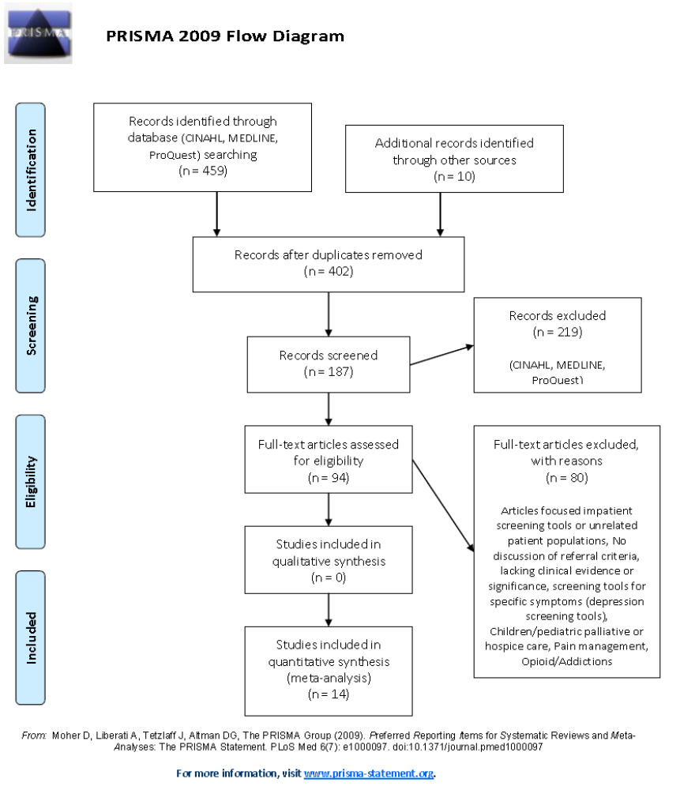

Appendix B
Systematic Table of Evidence
PICO question: In patients with chronic life-limiting conditions in a rural medically underserved population, would the implementation of a palliative care screening tool in a primary care practice as compared with usual care (subjective physician referrals without standard screening tool) help to increase the number of palliative care referrals and patient access to palliative care services

Databases: CINAHL, ProQuest, MEDLINE

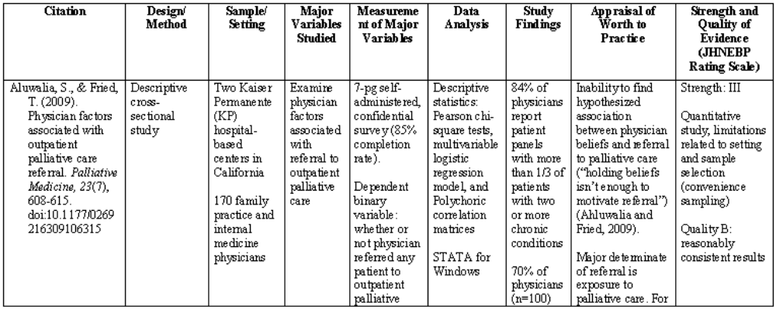

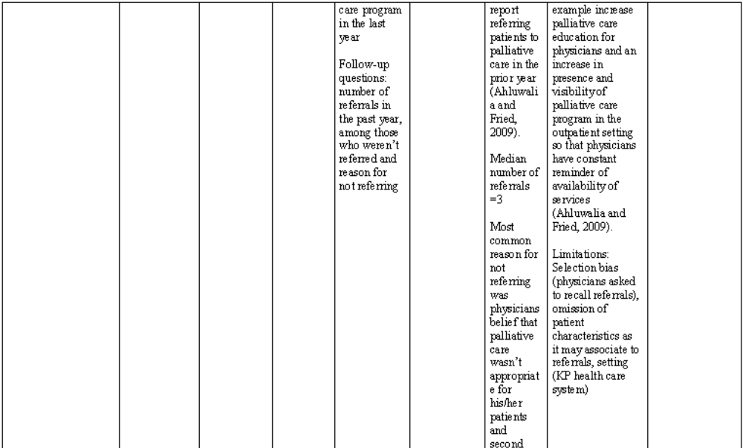
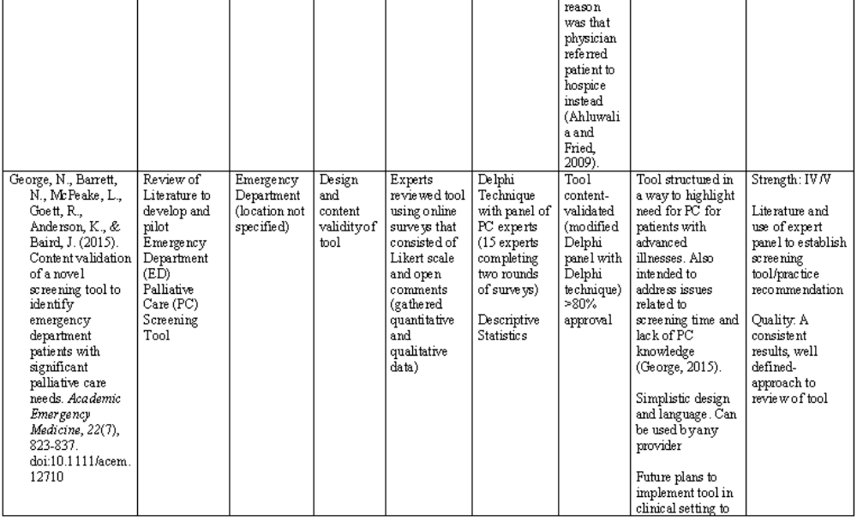

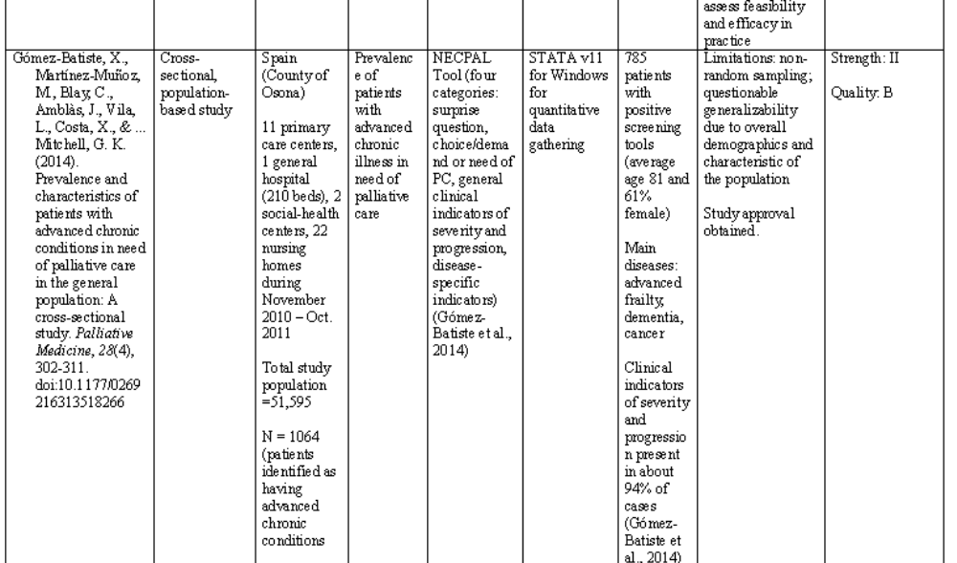
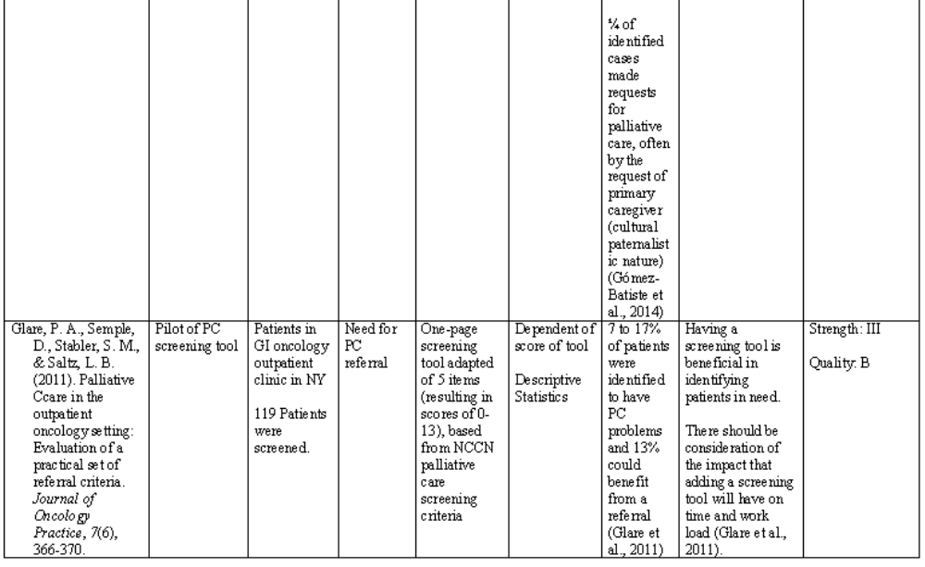

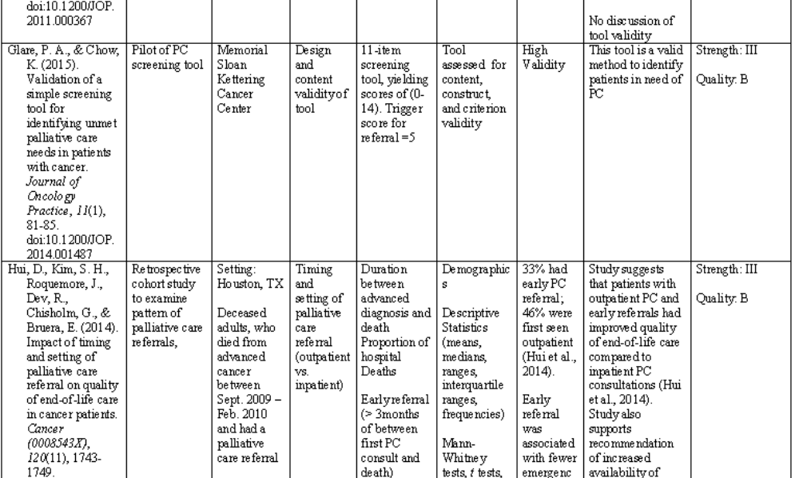
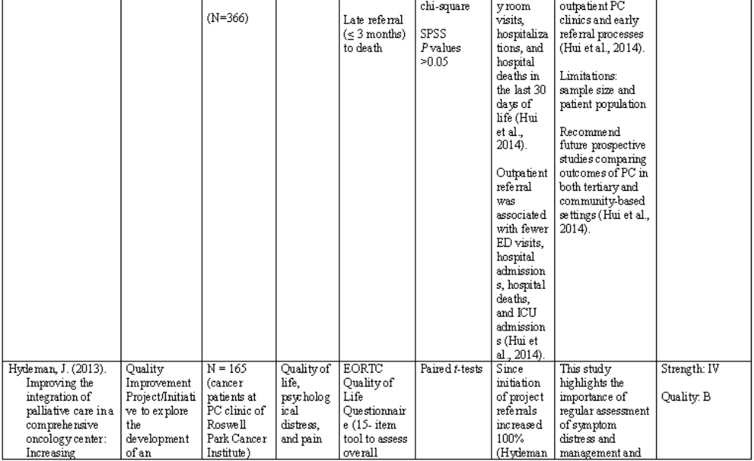

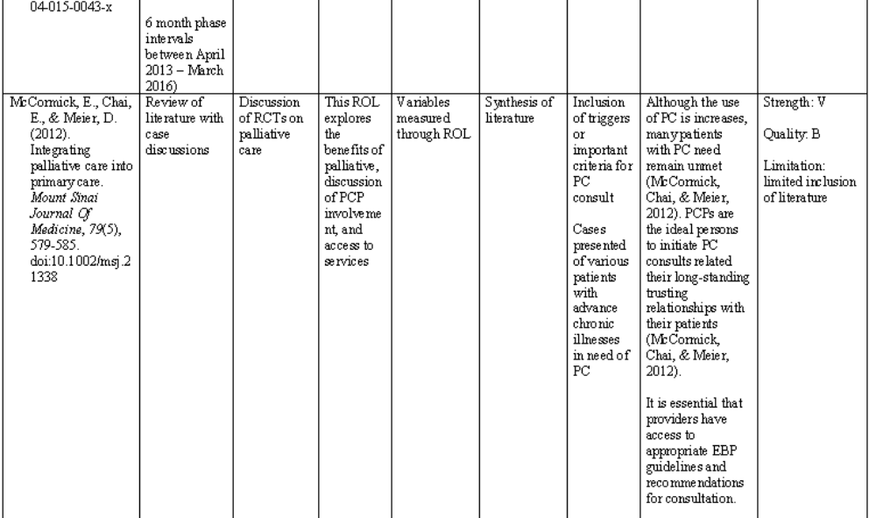
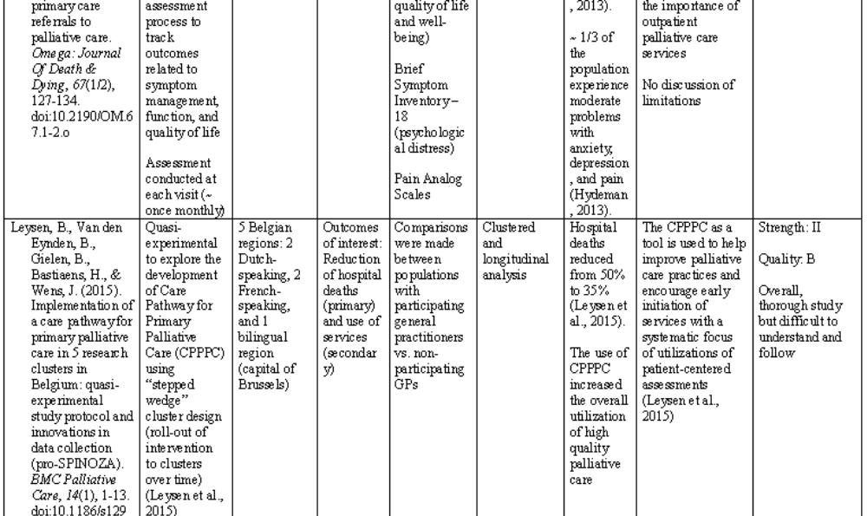

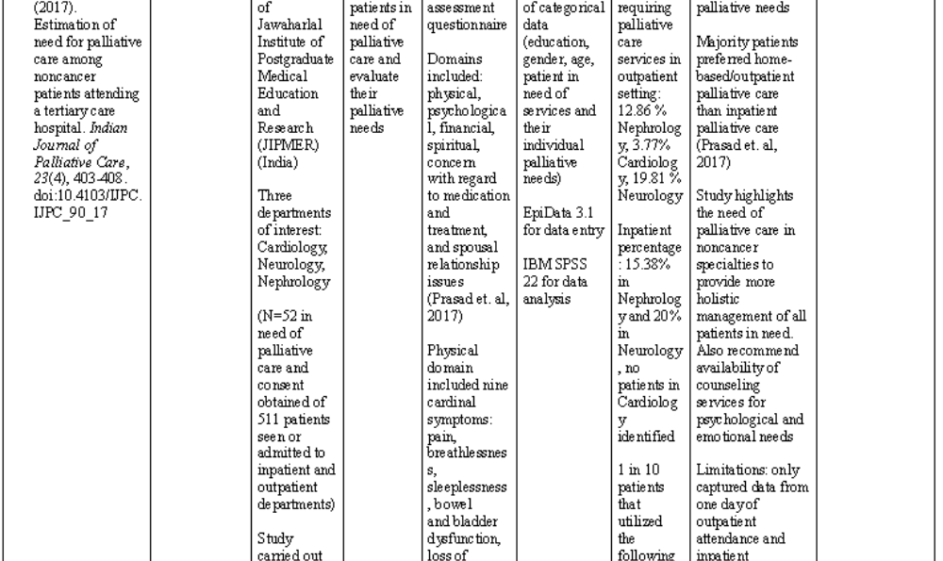
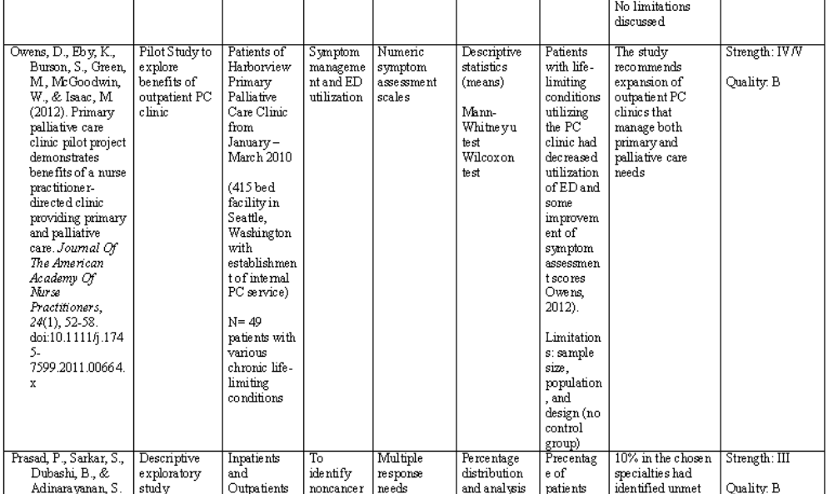

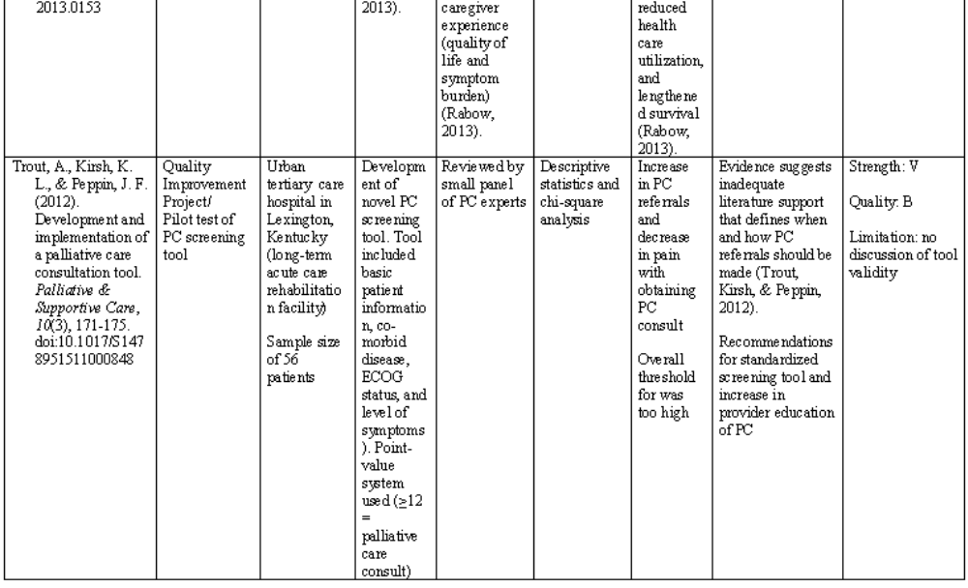
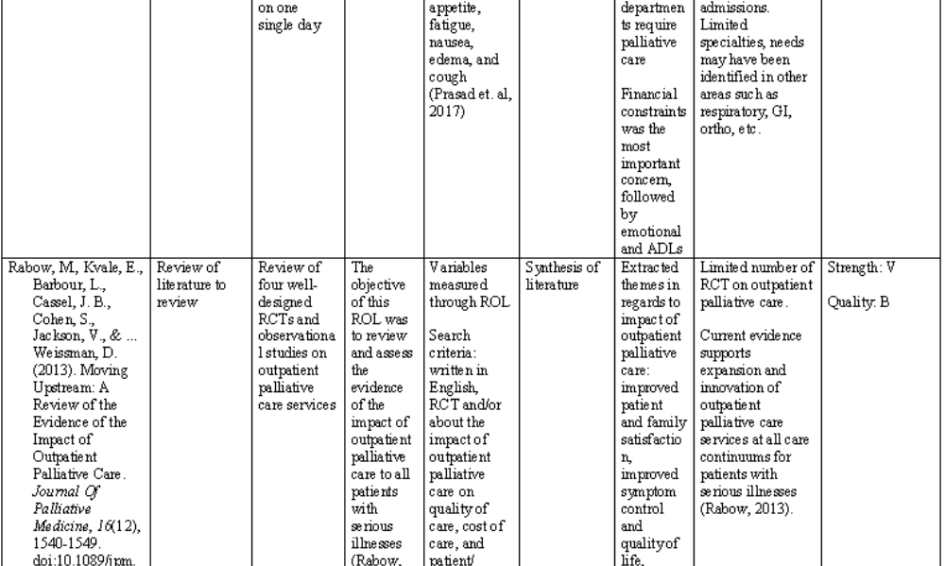


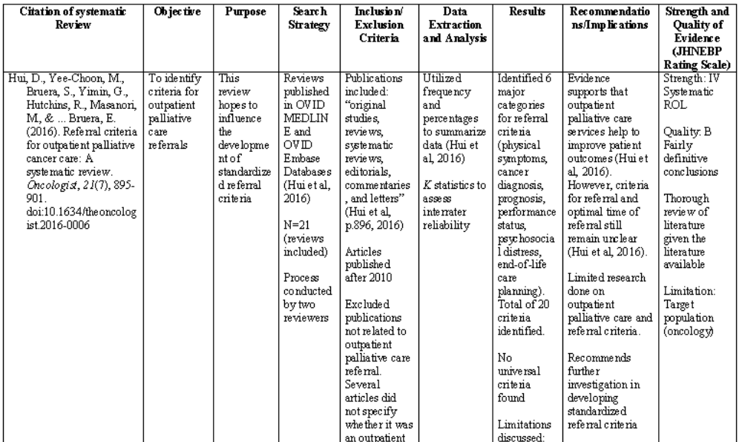
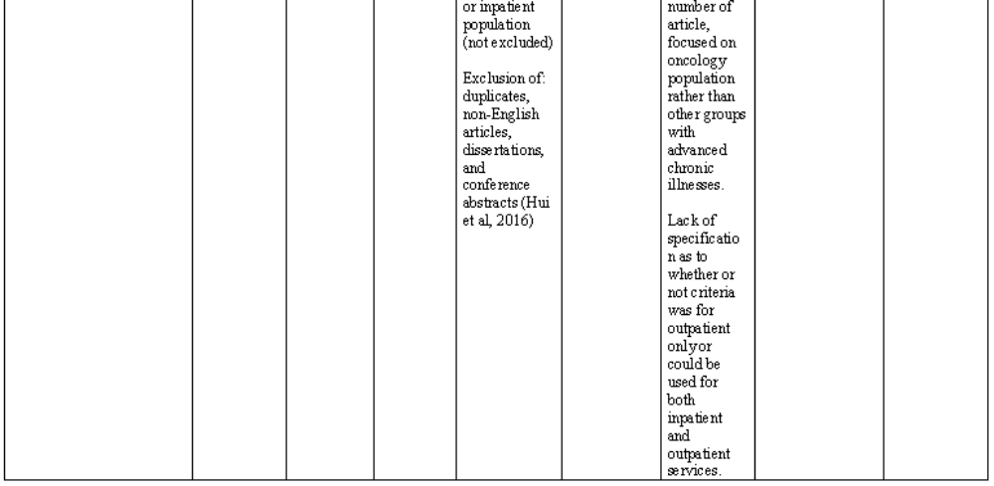

Appendix C

Conceptual Frameworks

Conceptual Framework for Supportive, Palliative, and Hospice Care
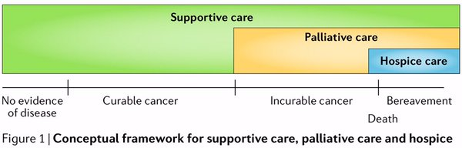

From “Integrating supportive and palliative care in the trajectory of cancer,” By E. Bruera and D. Hui, 2016. Nature Reviews Clinical Oncology, 13(3), 162. 2015 by Springer Nature. Reprinted with permission.

ACE Star Model

From “Star Model of EBP: Knowledge transformation,” by K. R. Stevens, 2012. 2012 by The University of Texas Health Science Center at San Antonio. Reprinted with permission.

ACE Star Model Application of Project
Discovery Research | - PICOT Question/ROL  - Survey of Practice Demographics
Evidence Summary | - ROL
Translation to Guidelines | - PCST
Integration to Practice | - Educational Module  - Implementation of PCST
Evaluation | - Data Analysis  - Dissemination

Appendix D

SWOT Analysis
STRENGTHS | WEAKNESSES
- Medically underserved population  - Small provider practice  - Provider with hospice experience  - Large Medicare population | - Electronic medical record (access and technological limitations)
OPPORTUNITIES | THREATS
- Increase in palliative care referrals and access to beneficial care services  - Improved management of care  - Community Collaboration  - Increase in referrals and utilization of Talbot Hospice Services | - Provider compliance  - Patient follow through with referral process

Appendix E

Palliative Screening Tool
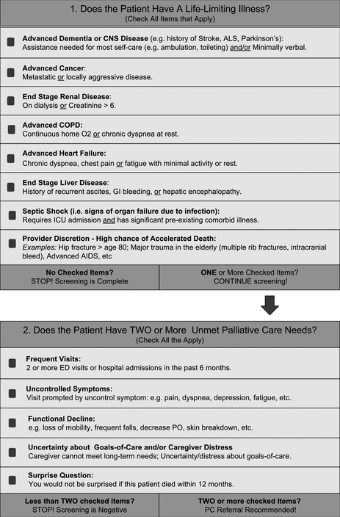

From “Content validation of a novel screening tool to identify emergency department patients with significant palliative care needs,” by N. George, N. Barrett, L. McPeake, R. Goett, K. Anderson, and J. Baird, 2015. Academic Emergency Medicine, 22(7), 829. 2015 by John Wiley and Sons. Reprinted with permission.

Appendix F

IRB Approval
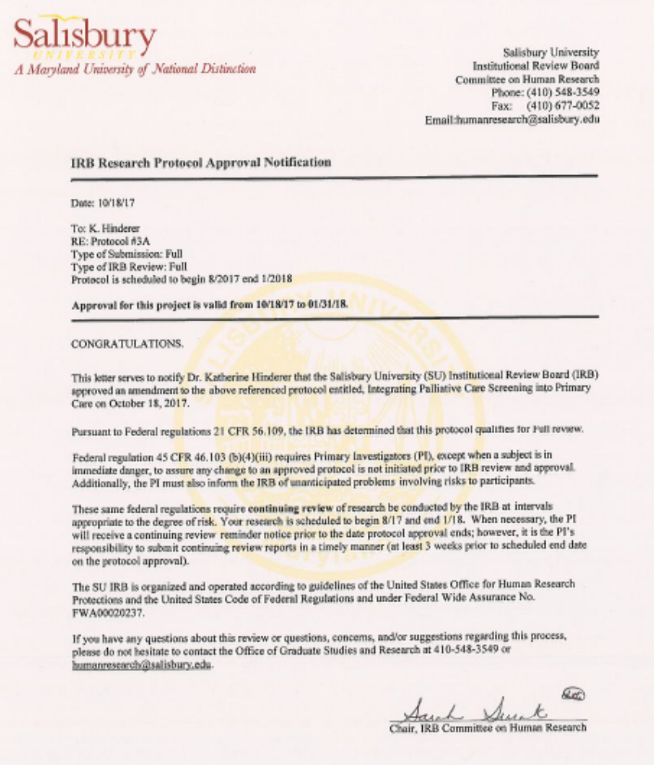

Appendix G

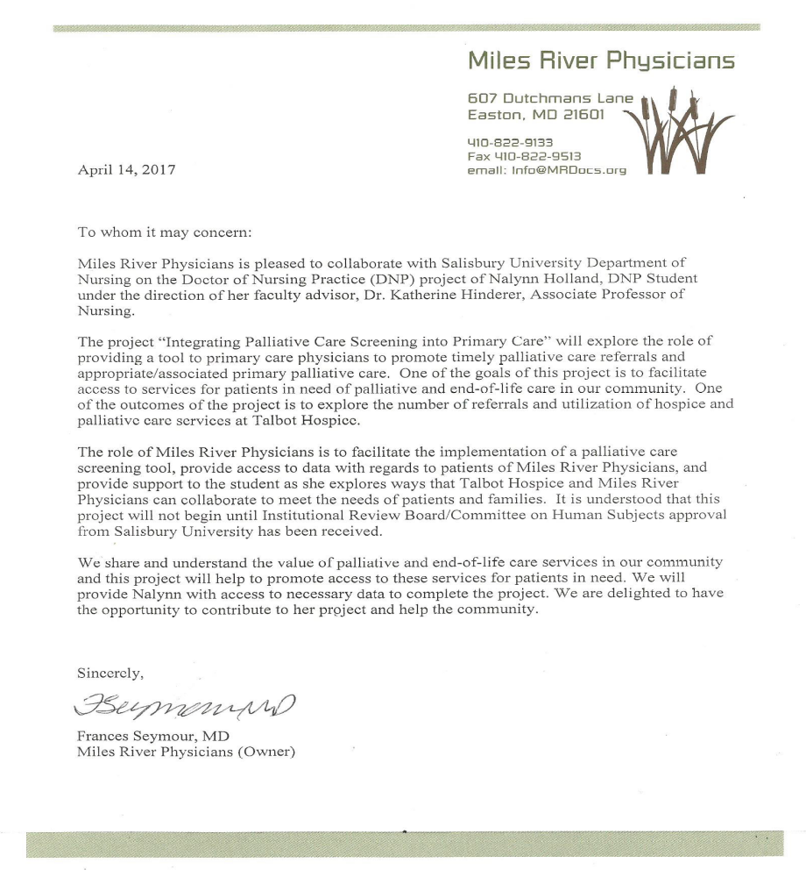
Evidence of Collaboration

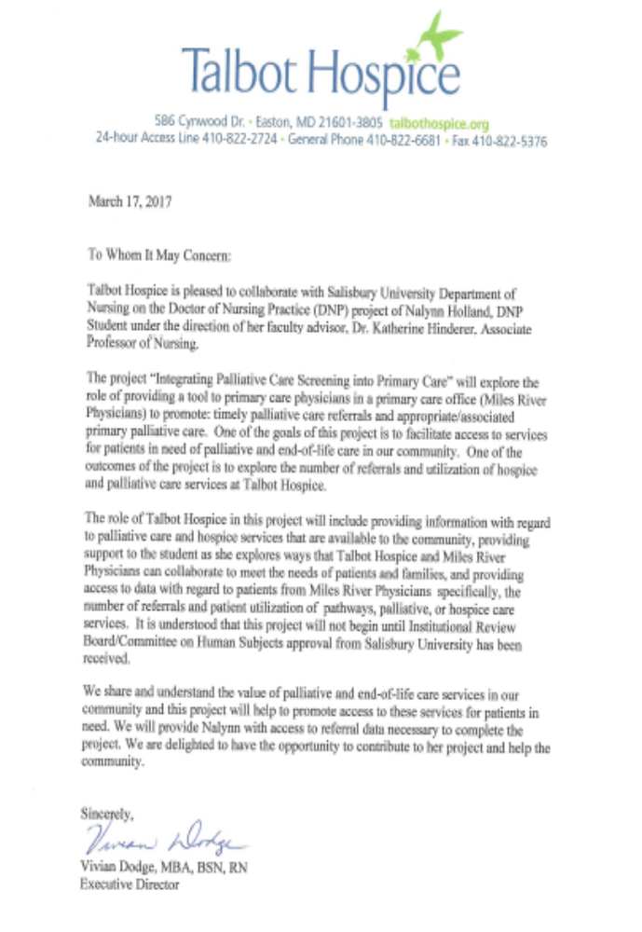

Appendix H

Patient Notice of Study
The providers of Miles River Physicians would like to inform you of a practice change taking place in November, 2017. During this time, the implementation of a new palliative care screening process will occur for patients in this practice. In response to this practice change, a study is taking place to track outcomes of patients who meet criteria for a referral to palliative care. This study involves the collection of referral to palliative care data and assessing if patient follow up was achieved. Inclusion criteria for the study include patients who are deemed appropriate for a palliative care referral as indicated by the score in the screening process. Patients who meet the criteria for inclusion in this study will be invited to participate in a voluntary research study that tracks patient follow-up with referral at check-out. At that time, those patients will be presented with more detailed information and consent to participate in the follow-up component of the study.

Appendix I

Staff Script for Consent

Medical assistant: “Today during your visit a palliative care screening tool was completed. The screening tool recommended that a palliative care referral be made. Your provider has ordered the referral to be made with Talbot Hospice. Would you be willing to participate in a voluntary research study that tracks patient follow-up with referral?”

Patient Response: Yes
Medical Assistant: “Please carefully read and sign this informed consent. You will be provided with a copy of the consent. If at any time you have any question or concerns feel free to contact the researcher at the contact information provided below. Thank you!”

OR

Patient response: No
Medical Assistant: Thank you for your consideration.

Appendix J

Informed Consent



Research Study: Integrating Palliative Care Screening into Primary Care
Researcher(s): Nalynn Holland, RN, BSN (Co-Primary Investigator/Doctor of Nursing Practice student); Katherine Hinderer, PhD, RN (Primary Investigator/faculty advisor), Department of Nursing, Salisbury University, Salisbury, MD

- Introduction
You are being asked to voluntarily participate in a research study which explores the use of a palliative care screening tool. The study includes identification of patients who are appropriate for palliative care as well as follow-up with patient follow-through with accessing palliative care services after the referral is made. Before agreeing to participate you must thoroughly read and understand this document, also known as informed consent. This document will review the risks and benefits of this study so that you can make an informed decision.
- Purpose and Procedures
The purpose of this project is to implement a palliative referral process in the primary care setting. You are being asked to voluntarily participate in this study because you are an adult older than 18 years old and under the care of a primary care provider. A palliative care screening tool has been used by your provider to identify your need of a palliative care referral. For the purposes of this study, the following health information is being collected: age, gender, race, insurance, medical diagnoses, palliative care screening tool score, and referral information: was referral made by provider, was referral completed by patient, enrollment in referral program, type of program enrolled.

Right to Withdraw from the Study
You may choose to stop participating in this study at any time. Withdrawing from the study will not result in any penalty or change the care you would normally receive at this medical practice. If you choose to withdraw from the study, your personal data will not be retained.
- Risks Associated with the Study
There are risks associated with participating in this research study. As with any type of medical care and medical-related services, there may be costs associated with services rendered. It is your responsibility to satisfy any financial obligation contracted between you and the provider. Secondly, exploring chronic life-limiting medical diagnoses and unmet needs/unmanaged symptoms may cause the participant to feel more upset or distressed than they felt prior to starting the study. If at any time during the study you become distressed or upset, you should notify your provider at Miles River Physicians immediately and appropriate care will be provided.
- Benefits
You may benefit from identification of conditions that may be eligible for additional services that may assist you in managing your health. Participation in this study may benefit future patients in a referral process. Participation in this study will not be compensated.
- Privacy/Confidentiality
Your privacy and confidentiality will be maintained at all times. Your name will not be included in the study or dissemination of findings, your personal information will be de-identified. Participants will be assigned a code for de-identification purposes. This study has been reviewed approved by the Salisbury University Committee on Human Research.
- Points of Contact
If you have any adverse effects or concerns about the research, please contact the primary investigator (Dr. Katherine Hinderer at kahinderer@salisbury.edu or 410-543-6417) or the Office of Graduate Studies and Research at Salisbury University at 410-548-3549 or toll free 1-888-543-0148.
Participant’s Printed Name: _________________________ Date: ___________________
Participant’s Signature: ____________________________ Date: ___________________

Appendix K
Data Collection Spreadsheet
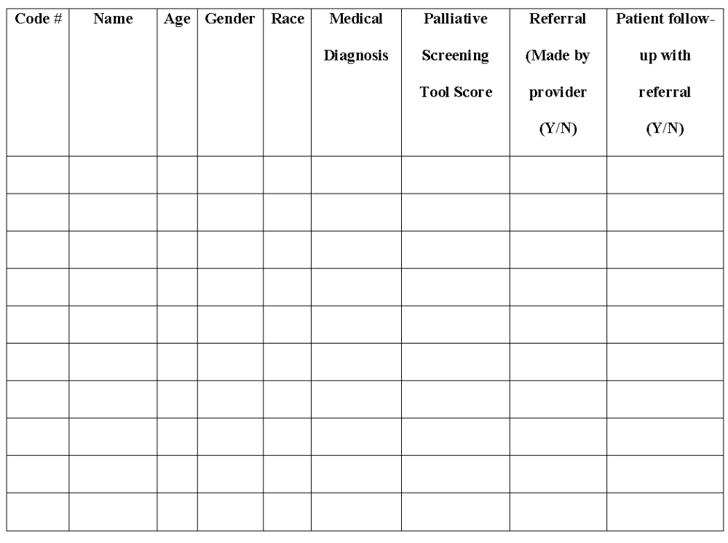

Appendix L
Projected Timeline of Completion

Fall 2016
- Topic Approval
- Committee Designation
- Executive Summary

Spring 2017
- Review of Literature
- Affirm collaborations with secondary organizations (local palliative/hospice agencies)
- Finalize Development of Screening Tool (including authorization of use of established tool and/or build into practice software)
- IRB Approval

Summer 2017
- Develop educational material for staff of practice (Physicians and medical assistant personnel) and screening tool development

Fall 2017
- Data Collection
  - Staff Meeting –October and as needed during Implementation phases
  - Implementation begins November (screening for 1 month)
  - November – December: data collected from screening tool (beginning review follow-up with Talbot Hospice synonymously)
  - January: data collected of referrals and follow-up
- Data Analysis
  - January: All data inputted into SPSS and statistical analysis test conducted

Spring 2018
- Dissemination of Findings
  - Final paper (prepared for publication)
  - DNP Project Presentation (April 3, 2018)

