Master of Arts in Digital Arts
2018 Capstone Project
Elizabeth Keiser
Goucher College
Table of Contents

Introduction 1
Initial Steps
Identifying Participants 2
Professional Experience
Identifying Need 4
Evaluation
Survey and Alterations 5
Conclusion 7
Appendices

Appendix A: Organization Summaries 9
Appendix B: User Experience Survey 14

Appendix C: Survey Results 18

Appendix D: Participant Userbase 24
Introduction
Chikkenstock.com was created for non-profit organizations and small local businesses. The goal of creating Chikkenstock was to provide a license-free stock website that focuses on assisting small, community-oriented organizations that are functioning with limited resources. The organizations that participated in the launch and trial of this site all had similar missions involving charity, conservation, and the community enrichment of the Lehigh Valley, a region comprised of the Pennsylvania metropolitan areas of Allentown, Bethlehem, and Easton.
Reflecting upon my own experience working as a designer in a non-profit setting, the marketing department often relied on license free websites for photos or other design-based needs. Stock website services such as Shutterstock, though useful, can be far too costly for a non-profit budget. This leads to seeking creative solutions such as knowing and following terms of use and licensing closely, and heavily searching the Internet for Creative Commons websites with robust asset databases. These solutions can be time consuming and overwhelming for anyone unfamiliar with licensing and terms of use. This is where the idea for a free, one-stop-shop stock website was born.
Chikkenstock provides license-free photographs, vector graphics, and templates for these organizations to utilize in their marketing efforts. The templates range from logos to flyers with a variety of themes, e.g. holidays, agriculture, wildlife, and conservation. Assets can be downloaded and dropped into Word documents or Acrobat PDF files, used for social media, or blown up for print items such as signs and labels. Chikkenstock also provides a list of other creative commons resources for license-free video, audio, and photo needs, as well as a how-to page for quick step-by-step directions that instruct non-designers on how to use each of the site’s asset file types.
The website provides these organizations, many of which have a small budget and no designer on staff, the opportunity for their message to thrive in a visually competitive market by providing them with free professional marketing materials and visual design assets. All Chikkenstock assets were generated by its creator, with the help of two local photographers to supply all the photographs in the galleries.

Initial Steps
Identifying Participants
Initial steps were taken to cultivate a target audience comprised of regional non-profits. These non-profits had similar missions and needs that fall within conservation, rehabilitation, or community enrichment. Out of twenty participants initially identified that fell under this criteria, ten organizations agreed to participate in the website’s trials. The participants (Appendix A) include Crooked Row Farm, Aark Wildlife Rehabilitation and Education Center, Pennsylvania Bat Rescue, Valley Youth House, Center Wildlife Care, LV Sustainability Network, Animals in Distress, Lehigh Career & Technical Institute, Youth Services Agency, and Lehigh Gap Nature Center. Out of these ten participants, five focused on animal welfare, three on rehabilitation and education, and two on agriculture and sustainability.
Each organization had its own place in the project’s overall purview. The participation of Lehigh Career & Technical Institute addressed a different need than the other organizations. This organization, a technical school with students in from grades 9-12, gave Chikkenstock the opportunity to gain the opinions and insight of young graphic designers. This provided input on the website’s content and capabilities that would not be received from the other non-designer users. Their participation benefitted the website’s overall look and functions.
Crooked Row Farm, a farmer’s market focused business that connects consumers, buyers, and local farmers, saw Chikkenstock as a learning exercise. Founder Liz Wagner was consulting on a grant in which one of the branches of study was how small farmers could collectively market and advertise more effectively. The trial run of Chikkenstock gave the organization the opportunity to troubleshoot their visual marketing tactics and grow from the experience.
PA Bat Rescue, a volunteer-based bat rehabilitation center in Mertztown, Pennsylvania, was relieved at the prospect of having ready-made material. Their newly hired fundraising director could utilize this type of asset when advertising some of the special events that would be occurring in 2019. Having fundraising materials and ways to easily market their events could expand the reach of their efforts. An organization of three employees could represent itself without taking away from what was important — the rescue and rehabilitation of wildlife.
Original designs and content generated for Chikkenstock were created to fit the needs of the ten organizations participating in this initial process of the website’s development. This process began in January and was ready for review in October that same year (2018). Feedback and fulfillment of needs would come at the end of the project once the site reached its soft launch and organizational representatives could interact with the content.
A directory of similar services was also compiled as a reference for more free content, widening the library of creative resources and removing the lengthy process of searching for assets that most non-profits do not have the time to conduct. Instructions and assets were uploaded onto the site. This content was held behind an invite-only login system, and invitations for account creation and content access were sent to participants. An email survey was later sent to the participants in order to collect user feedback on content, user experience, and overall utility.

Professional Experience
Identifying Need
As creator of this website, I drew upon my nine years of experience as a Creative Director for a non-profit organization. As a senior employee of Lehigh Valley Zoo, a four-million-dollar non-profit in the Lehigh Valley area, my job involves frequently engaging with small, local non-profits through business partnership interactions. As I consulted with these organizations and translated their information to my company’s website and general promotional materials, their need for graphic design assistance became readily apparent.
In my experience, most non-profits tend to make up for lack of funds with a passion for their cause. Many local non-profits in the Lehigh Valley have no budget for marketing, let alone a marketing department or an in-house designer. This can limit the growth and overall reach of these organizations. Without the functionality of a marketing department, an organization’s overall public presence and their online social engagement can suffer.
Social media has become a staple in modern marketing. This leaves non-profits, with their limited budgets and limited available labor, at a disadvantage. Time is a severely limited resource for these organizations, some of which function mostly on volunteer hours. The visual branding and reach of their efforts often go overlooked or pushed aside in order to tend to the core day-to-day functions of their mission. A weak visual impact can make a highly capable organization appear amateur. Competing with large organizations, many of which have a full marketing department at their disposal, can feel nearly impossible for non-profits.

Evaluation
Survey and Alterations
A survey (Appendices A, B, C, D) was generated through Google Forms and emailed to each participant in order to gauge user experience, ease of use, and overall utility of the website and its assets. The survey was anonymous with the option to write in personal comments as well as answer a user satisfaction Likert scale. From the feedback found in this survey, adjustments to content and page layouts were made.
For example, one-third of users responded that Chikkenstock’s goals and functions were not made clear enough. The “About Us” page, featuring an introduction and explanation of the site’s intent, was altered after this survey process to make the goal of the site more transparent. The main confusion about Chikkenstock’s goal stemmed from the name of the site itself, as users were not certain whether the name “Chikkenstock” meant that the website would only cater to organizations whose focus was on conservation, nature, or animal welfare.
An explanation of the name was also added to the “About Us” page, clarifying that the name of the site was broken into to parts “chicken” and “stock”. “Chikken” (“chicken”) refers to the site’s animal welfare and agricultural roots. While the site gives any non-profit or community-focused organization access to its free marketing assets, Chikkenstock had a strong footing based on the background of its founder (the Creative Director of the non-profit Lehigh Valley Zoo). The explanation goes on to emphasize on the “stock” ending of the name, highlighting the site’s community and conservation focused platforms for non-profits and small businesses. Its purpose is to be used to obtain free-to-use marketing and advertising assets to ease any non-designer involved with a non-profit.
Another discovery from the user survey was that one user felt that the “How To” instructions were too text-heavy and would perhaps be too difficult to follow for those who are not computer literate or intimately familiar with design software. In response to this, the “How To” page was overhauled, with core information condensed into a summary at the top of the page, and more in-depth technical instructions placed below for further reading. Plans for the “How To” section in the near future include video instructions and simple step-by-step directions in PDF format.
Most of the adjustments to the site’s content were minimal. The largest addition required after examination of survey results was the development of pre-sized social media content. This addition required creating industry standard sized designs that could easily be used for social media platforms. These social media assets were made to either be used without alteration, e.g. a generic “Happy Holidays” graphic, or were created with customizable options, e.g. “thank you” posts to followers. Much of these social media graphics focused on subjects such as holidays, volunteer outreach, and donations, as these were some of the most pressing needs initially communicated to me by the participating organizations.
While there were some clunky interface issues with the registration process, a message was added to the “Request Access” page to alleviate user anxiety. At the top of the screen the prompt “we will contact you within one week to confirm your account” was added due to the inability to make the registration process automated. This limitation stemmed from the screening process and was not a technical issue. There is a portion of the registration that requires an organization to be described and listed when signing up. This is to prevent the access of larger companies or freelance designers trying to score license free content.
This screening process also cut down on the registration attempts from bots. Some email bots from domains such as regmail, sendicar, and yandex mail were trying to automatically register. The installation of Wordfence, a WordPress firewall and SEO plugin, also helped to alleviate this issue. Examples of these bots can be seen on Appendix D: Participant Userbase.

Conclusion
Throughout the process of creating this website for my final capstone project, I gained proficiency in professional networking and was able to further hone my technical skills. From an academic perspective, I was now able to put into practice the skills necessary for structuring and maintaining a website. This involved troubleshooting errors, installing and testing plugins that I had not worked with before (such as automated mailers and registration), and applying coding adjustments (PHP and CSS) to get the clean layout that Chikkenstock ended up with. The construction of this project required me to become intimately familiar with WordPress and gave me the ability to maintain and grow the website I created.
From a professional standpoint, this capstone project got me to connect to organizations in my community and expand my reach as an artist. My studies at Goucher College opened my mind to the importance of social impact through art. This was a factor I had not taken into consideration previously when creating designs. Communal art can create incredibly powerful grassroots movements at the local level. This website opened my field of vision to organizations embarking on powerful missions that I was unaware of. It connected me with a variety people from different walks of life, all of whom were striving toward similar goals of bettering their communities, bettering the environment, and expanding the reach and efficacy of their stated missions.
I believe many of those goals can be facilitated through Chikkenstock. Chikkenstock was created to be shared, and the success of the website is contingent upon the reach it receives. The initial ten participating non-profits invited for the soft launch were told to keep the conversation and review process open-ended. Continued growth of the userbase is a crucial part of the fine-tuning process of the website. As new needs arise, new design possibilities can be created to accommodate those needs, and users will have access to lines of communication through which I can be reached for questions, comments, and design requests.
At surface level, Chikkenstock is a website that provides free designs, templates, and photographs for marketing needs. At its core, it is part of a much larger social change movement to counteract corporate giants. Similar to the “buy local movement”, this website empowers small businesses and allows them to express themselves on a digital platform without overexerting their limited staff. It facilitates valuable and often overlooked advocacies and activism campaigns that are generated by small non-profits with short budgets and big hearts. It saves on resources while giving the flexibility of customization. And above all, Chikkenstock is a tool for the community to use and grow to fit their own future plans.
Appendix A
Participant Organization Summaries
Crooked Row Farm CSA
Crooked Row Farm offers a 20-22-week CSA with various pick-up locations in Orefield, Slatington, Emmaus, Allentown and Bethlehem (Pennsylvania). Crooked Row Farm grows unique greens, kales, lettuces and mesclun mix, beans, peas, hard neck garlic and heirloom tomatoes, carrots, scallions, squash and zucchini, cucumbers, potatoes, beets, radishes, onions, melons, peppers, winter storage crops, herbs, flowers and much more.
Contact: Liz Wagner
www.farmerliz.com

Aark Wildlife Rehabilitation and Education Center
The Aark is a non-profit wildlife rehabilitation and education center located in Chalfont, Pennsylvania. The work of the Aark is divided into three major areas – rehabilitation, education and training; each with the common goal of fostering the care and understanding of wildlife. The Aark is staffed by a group of wildlife professionals and dedicated trained volunteers who provide service 24 hours a day, 7 days a week, 365 days a year.
Contact: Mary Jane Stretch
www.aark.org
Pa Bat Rescue
Founder and volunteers group together to rescue and rehabilitate injured bats and pups, in Mertztown, Pennsylvania. Their mission states that bat species throughout the world should be valued for their ecological, and environmental importance and services. Wildlife rehabilitation is a vital service that should be available to everyone. Education and dispelling common misconceptions are essential to the conservation and protection of bat species.
Contact: Steph Stronsick
www.pabatrescue.org

Valley Youth House
Valley Youth House is the catalyst for youth to achieve their desired future through genuine relationships that support families, ensure safe places, and build community connections. Valley Youth House provides a home for vulnerable, abused and homeless youth; partnering with thousands of individuals to build a solid foundation for young people and their families.
Contact: Emily Conners
www.valleyyouthhouse.org
Centre Wildlife Care
Centre Wildlife Care (CWC) is a 501c3 charity that is licensed by the Game Commission, the US Fish and Wildlife Service and the Fish and Boat Commission to care for compromised wild animals until they can be released into the wild. The Centre is a volunteer-based organization that is not state or federally funded but operates on donations. CWC also provides educational outreach with non-releasable wild animals in the form of educational programs at your location, social media, newsletters and TV.
Contact: Robyn Graboski
www.centrewildlifecare.org

LVSN - Lehigh Valley Sustainability Network
The Lehigh Valley Sustainability Network’s mission is to create the avenues for collaboration, education, and action that will facilitate the creation of a more sustainable Lehigh Valley. The Network provides the means for organizations and individuals from the private, public, and non- profit sectors to share resources and information on sustainability issues, concerns, and strategies in order to collaborate more effectively.
Contact: Andrea Wittchen
www.lvsustainabilitynetwork.org
Animals in Distress
Over the past 35 years, Animals in Distress has been blessed with the help of many caring people who have donated money and time to keep its doors open. AID is a no-kill cats and dogs sanctuary located in Coopersburg, Pennsylvania.
Contact: Lois Gadek
www.animalsindistresspa.org

Lehigh Career & Technical Institute
Lehigh Career & Technical Institute (LCTI), founded in 1971, is located in Schnecksville, Pennsylvania. This technical school is located 10 miles north of Allentown and serves students in grades 9-12 from nine Lehigh County school districts; Allentown School District, Catasauqua Area School District, East Penn School District, Northern Lehigh School District, and Northwestern Lehigh School District.
Contact: Patrick Maley (graphic/web design professor)
www.lcti.org
Youth Services Agency
Guided by the Balanced and Restorative Justice (BARJ) model and the Juvenile Justice Enhancement Strategy (JJSES), YSA’s ACT programs work to promote accountability and develop competencies in our students. YSA addresses victim awareness through group, individual, and family therapy, competency development through pro-social skills and vocational training, and restoration through restitution and community service projects that add to the preservation of public buildings and parks.
Contact: Jamie Leigh
www.youthservicesagency.org

Nature Gap Center
The Lehigh Gap Nature Center is a member-supported 501(c)3 non-profit conservation organization located in Lehigh Gap, PA, at the foot of the Kittatinny Ridge in Slatington. The Gap’s mission is to protect the wildlife and enhance the habitats of our Refuge and the neighboring Kittatinny Ridge and to promote conservation in the Lehigh River Watershed through education, research, and outdoor recreation for the benefit of present and future generations. The nature center includes the Osprey House, a “green” building used for indoor instruction and gatherings, and a 756-acre wildlife refuge. The refuge features approximately 400 acres of restored Superfund site in addition to other unaffected habitats.
Contact: Chad Schwartz (Program Specialist)
www.lgnc.org
Appendix B
User Experience Survey
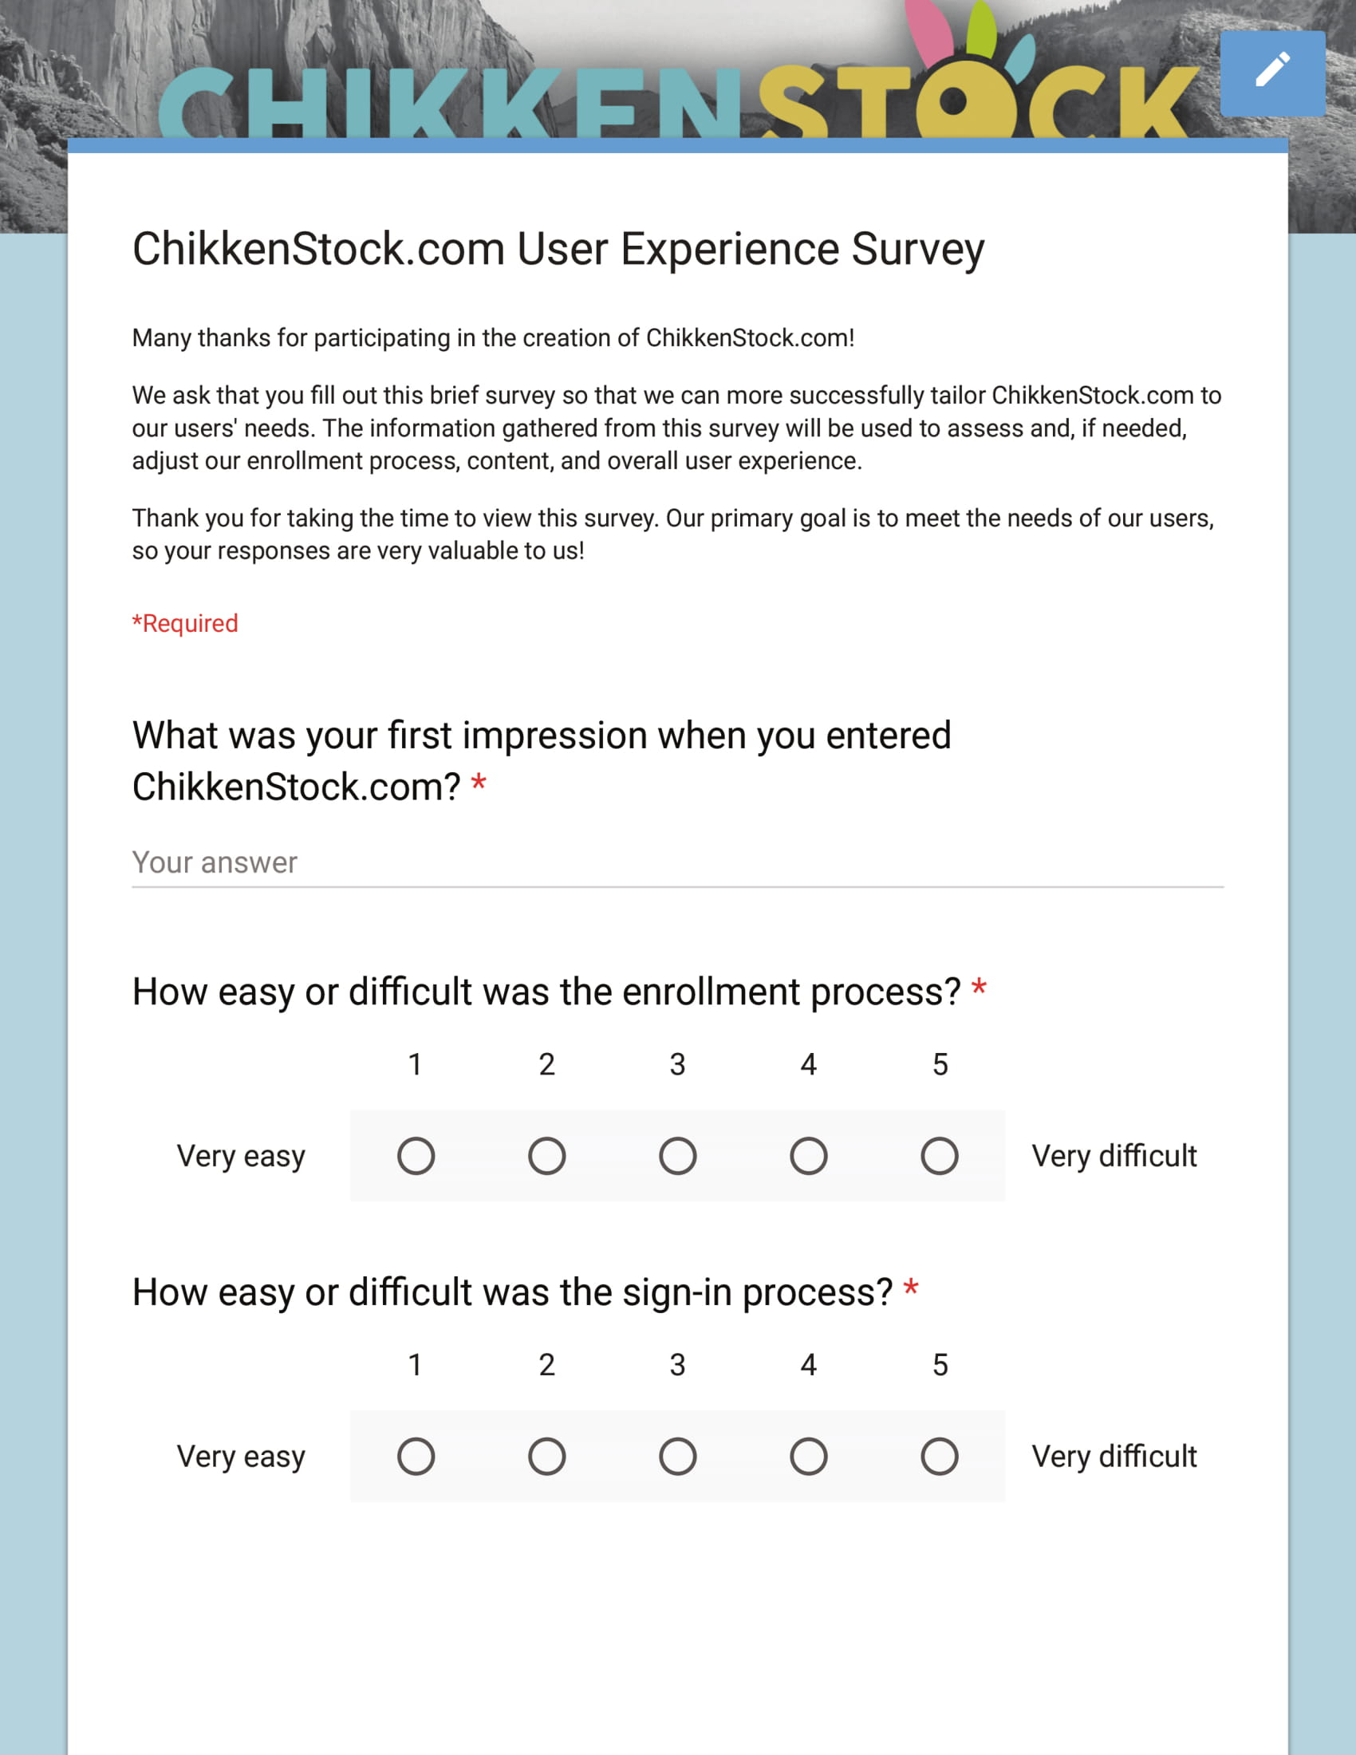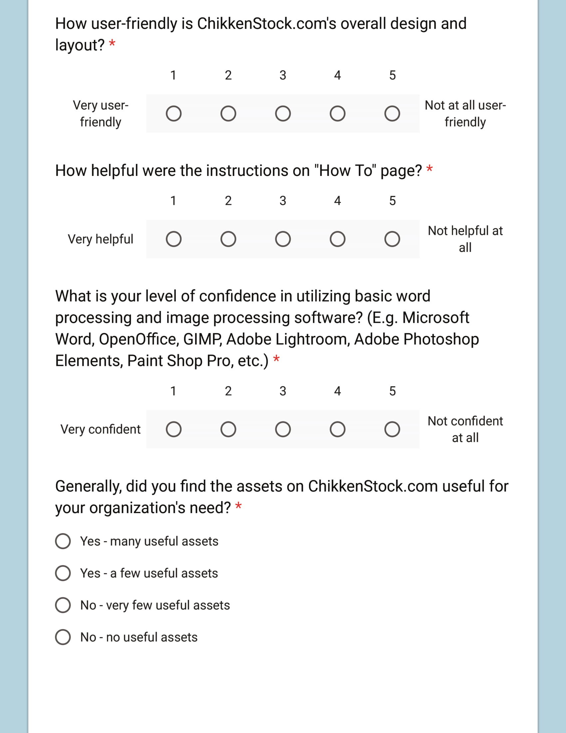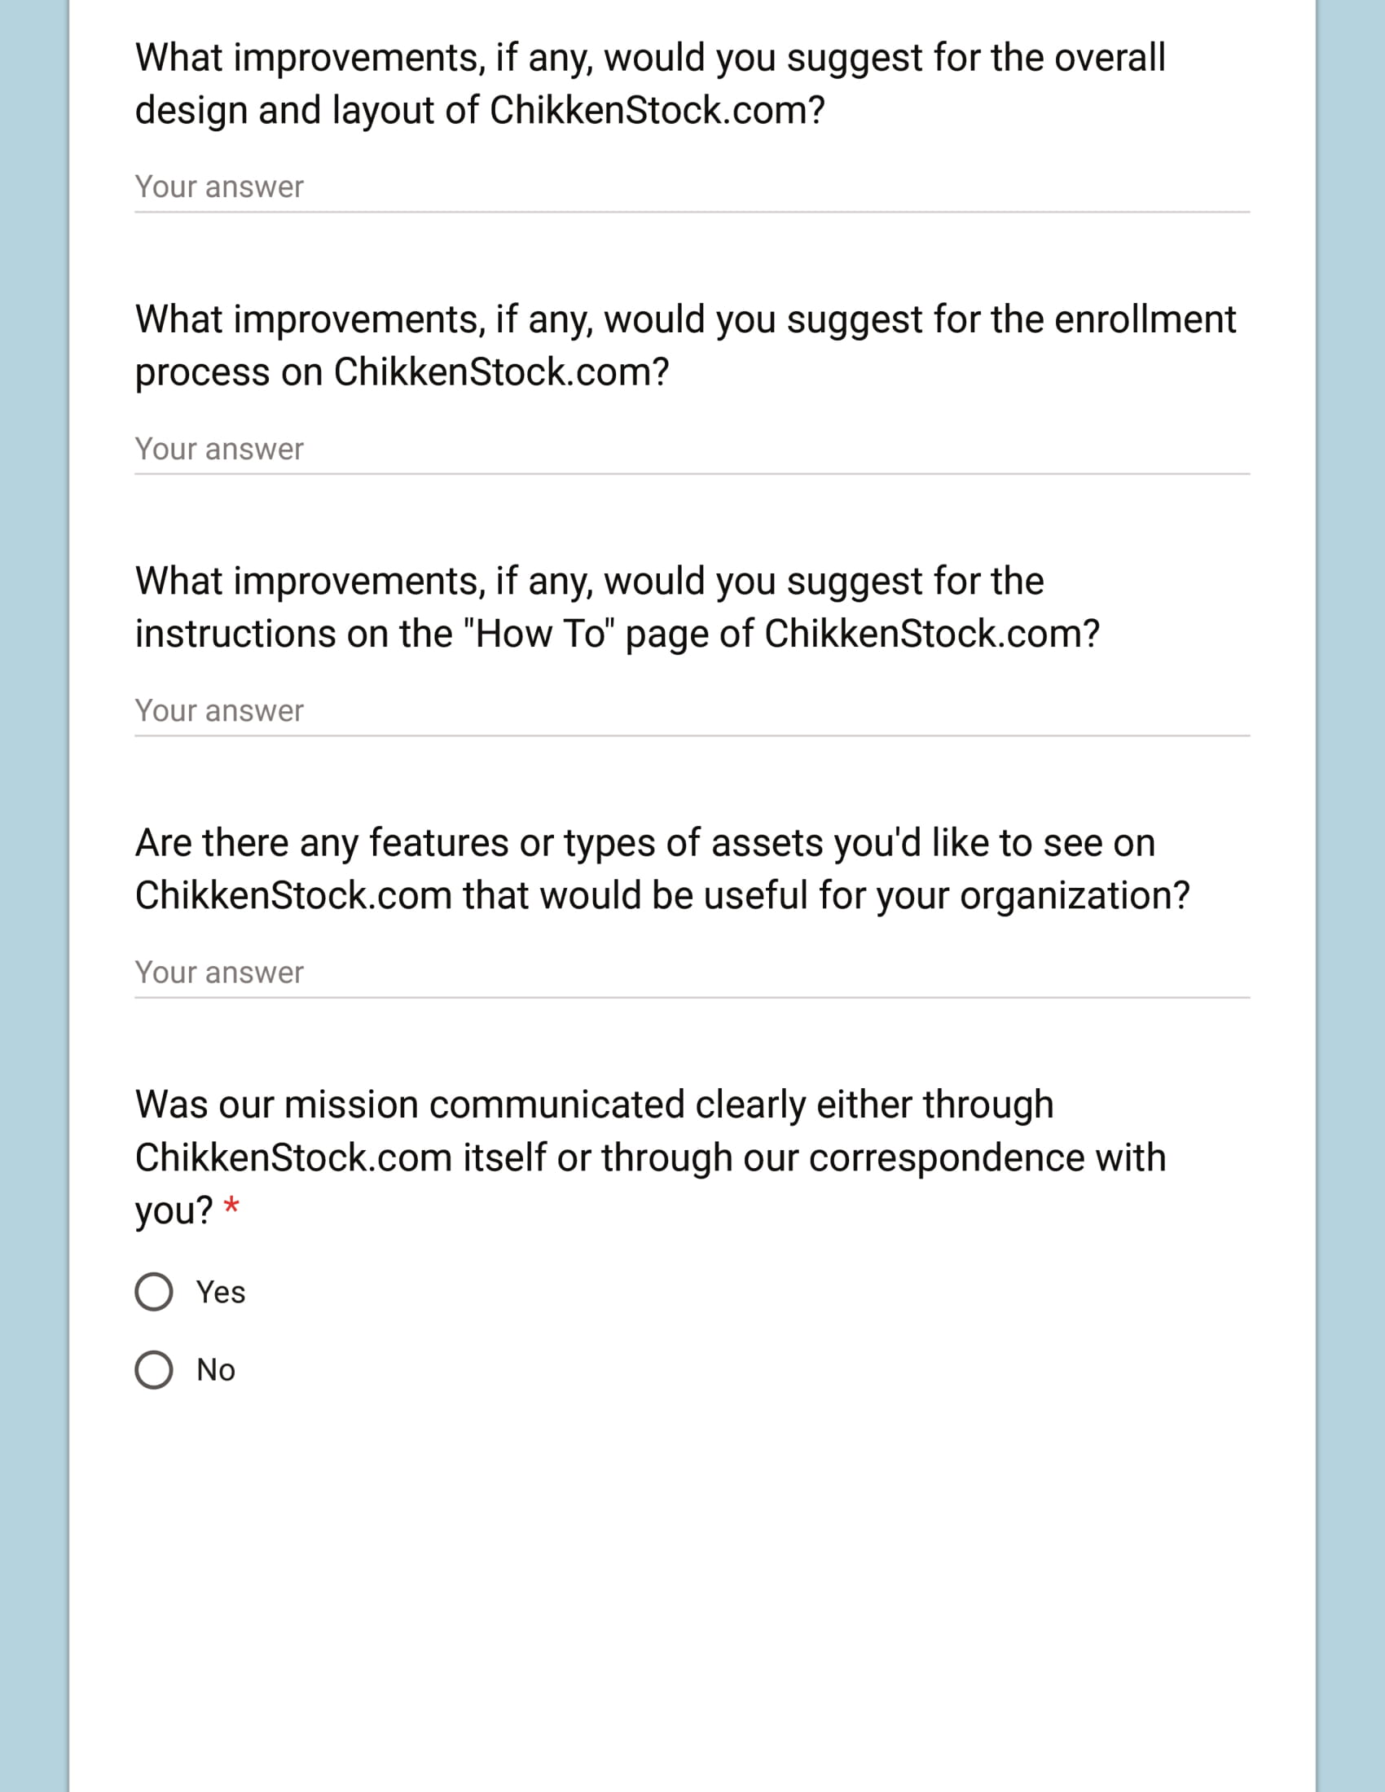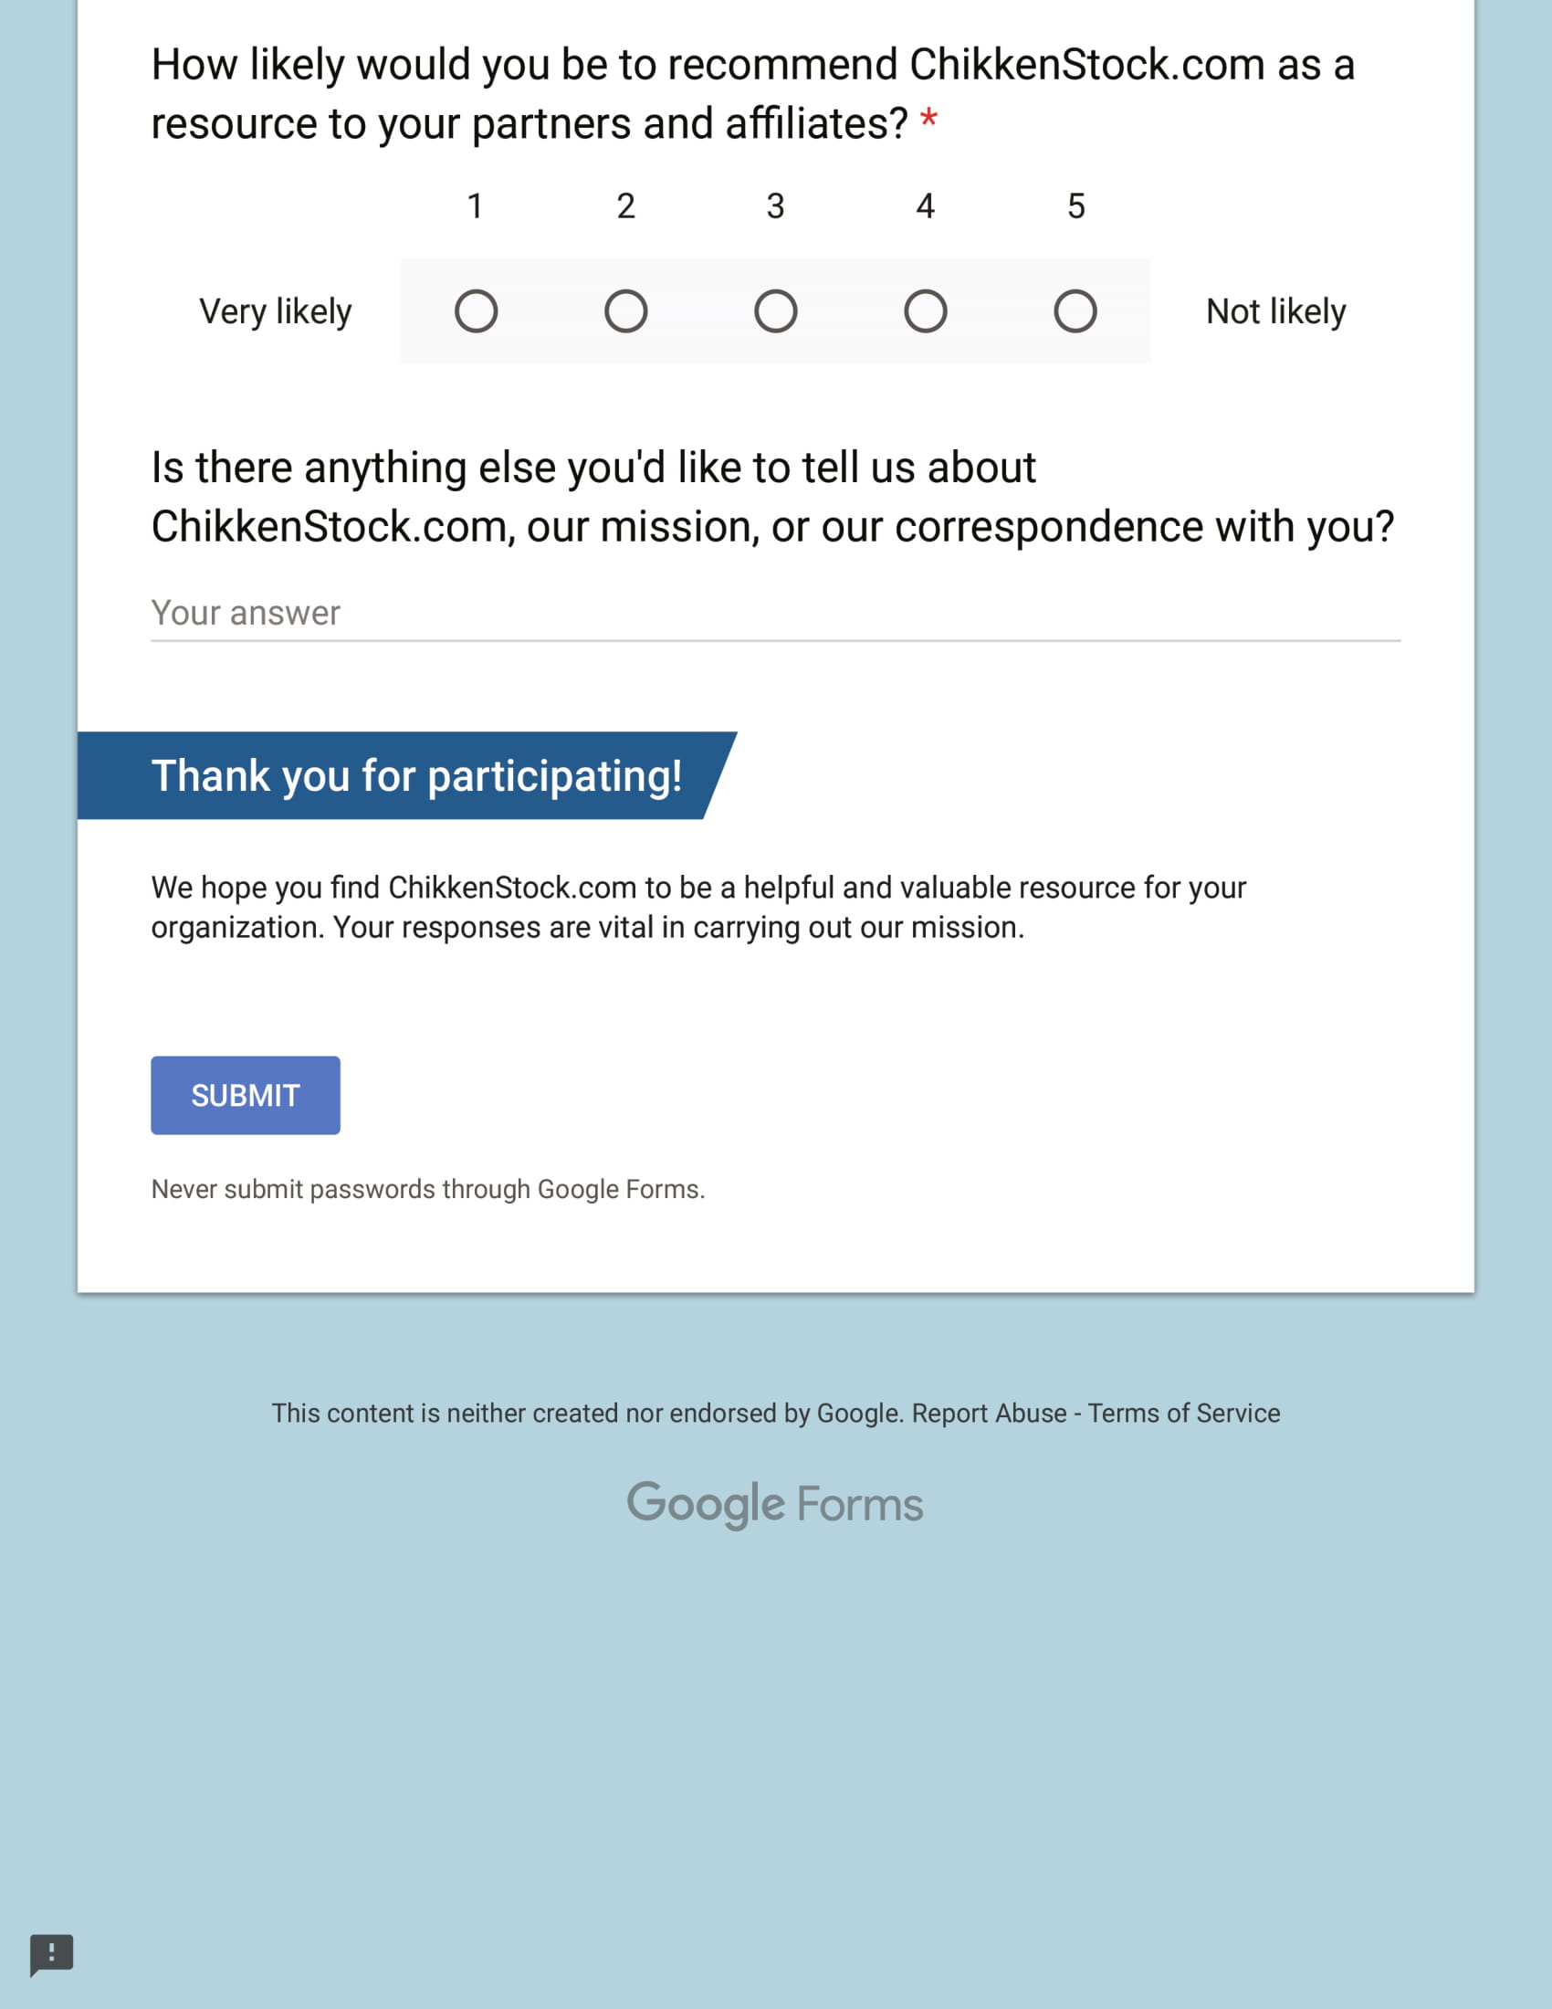
Appendix C
Survey Results
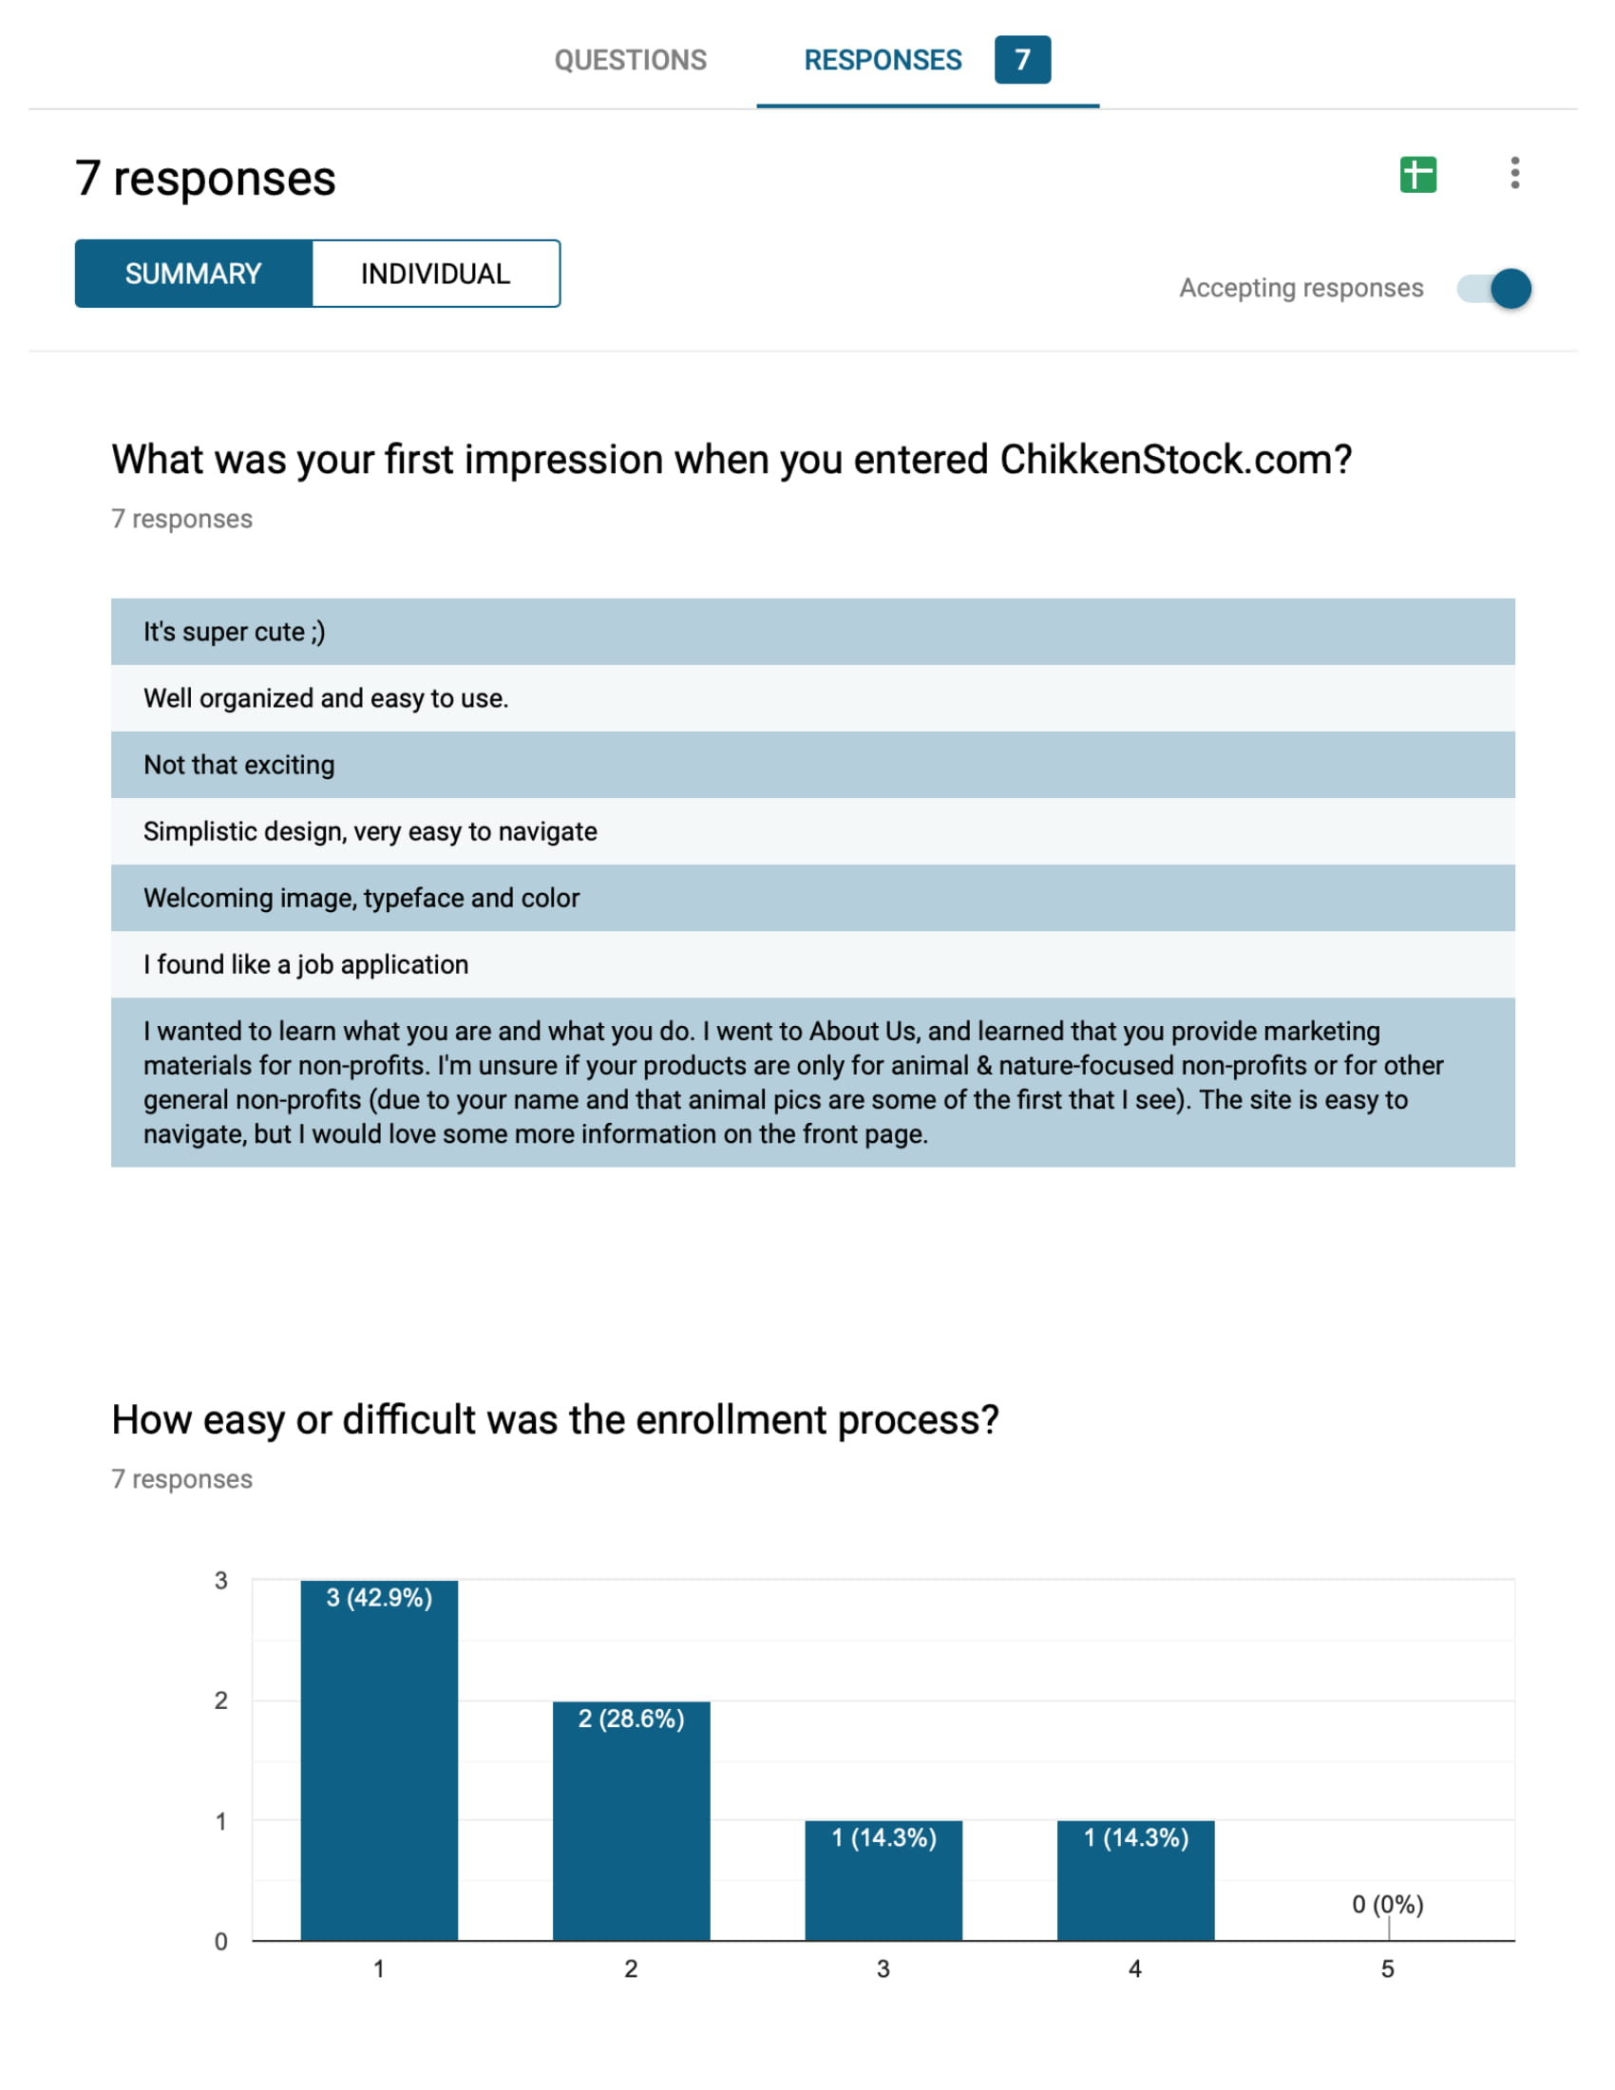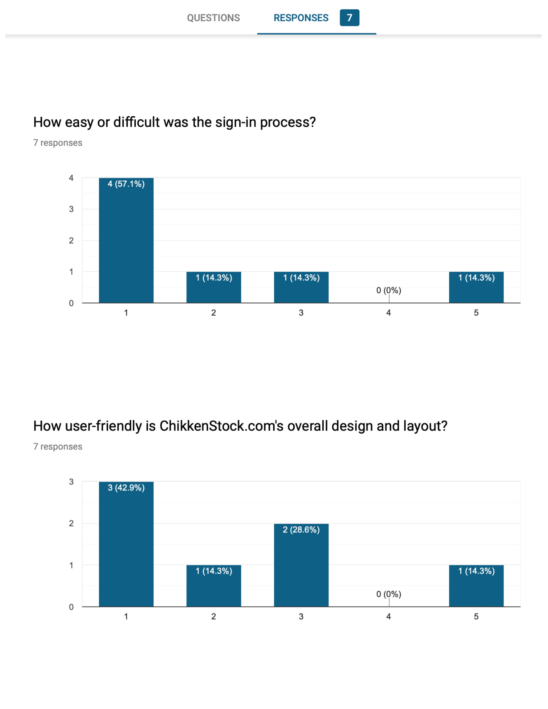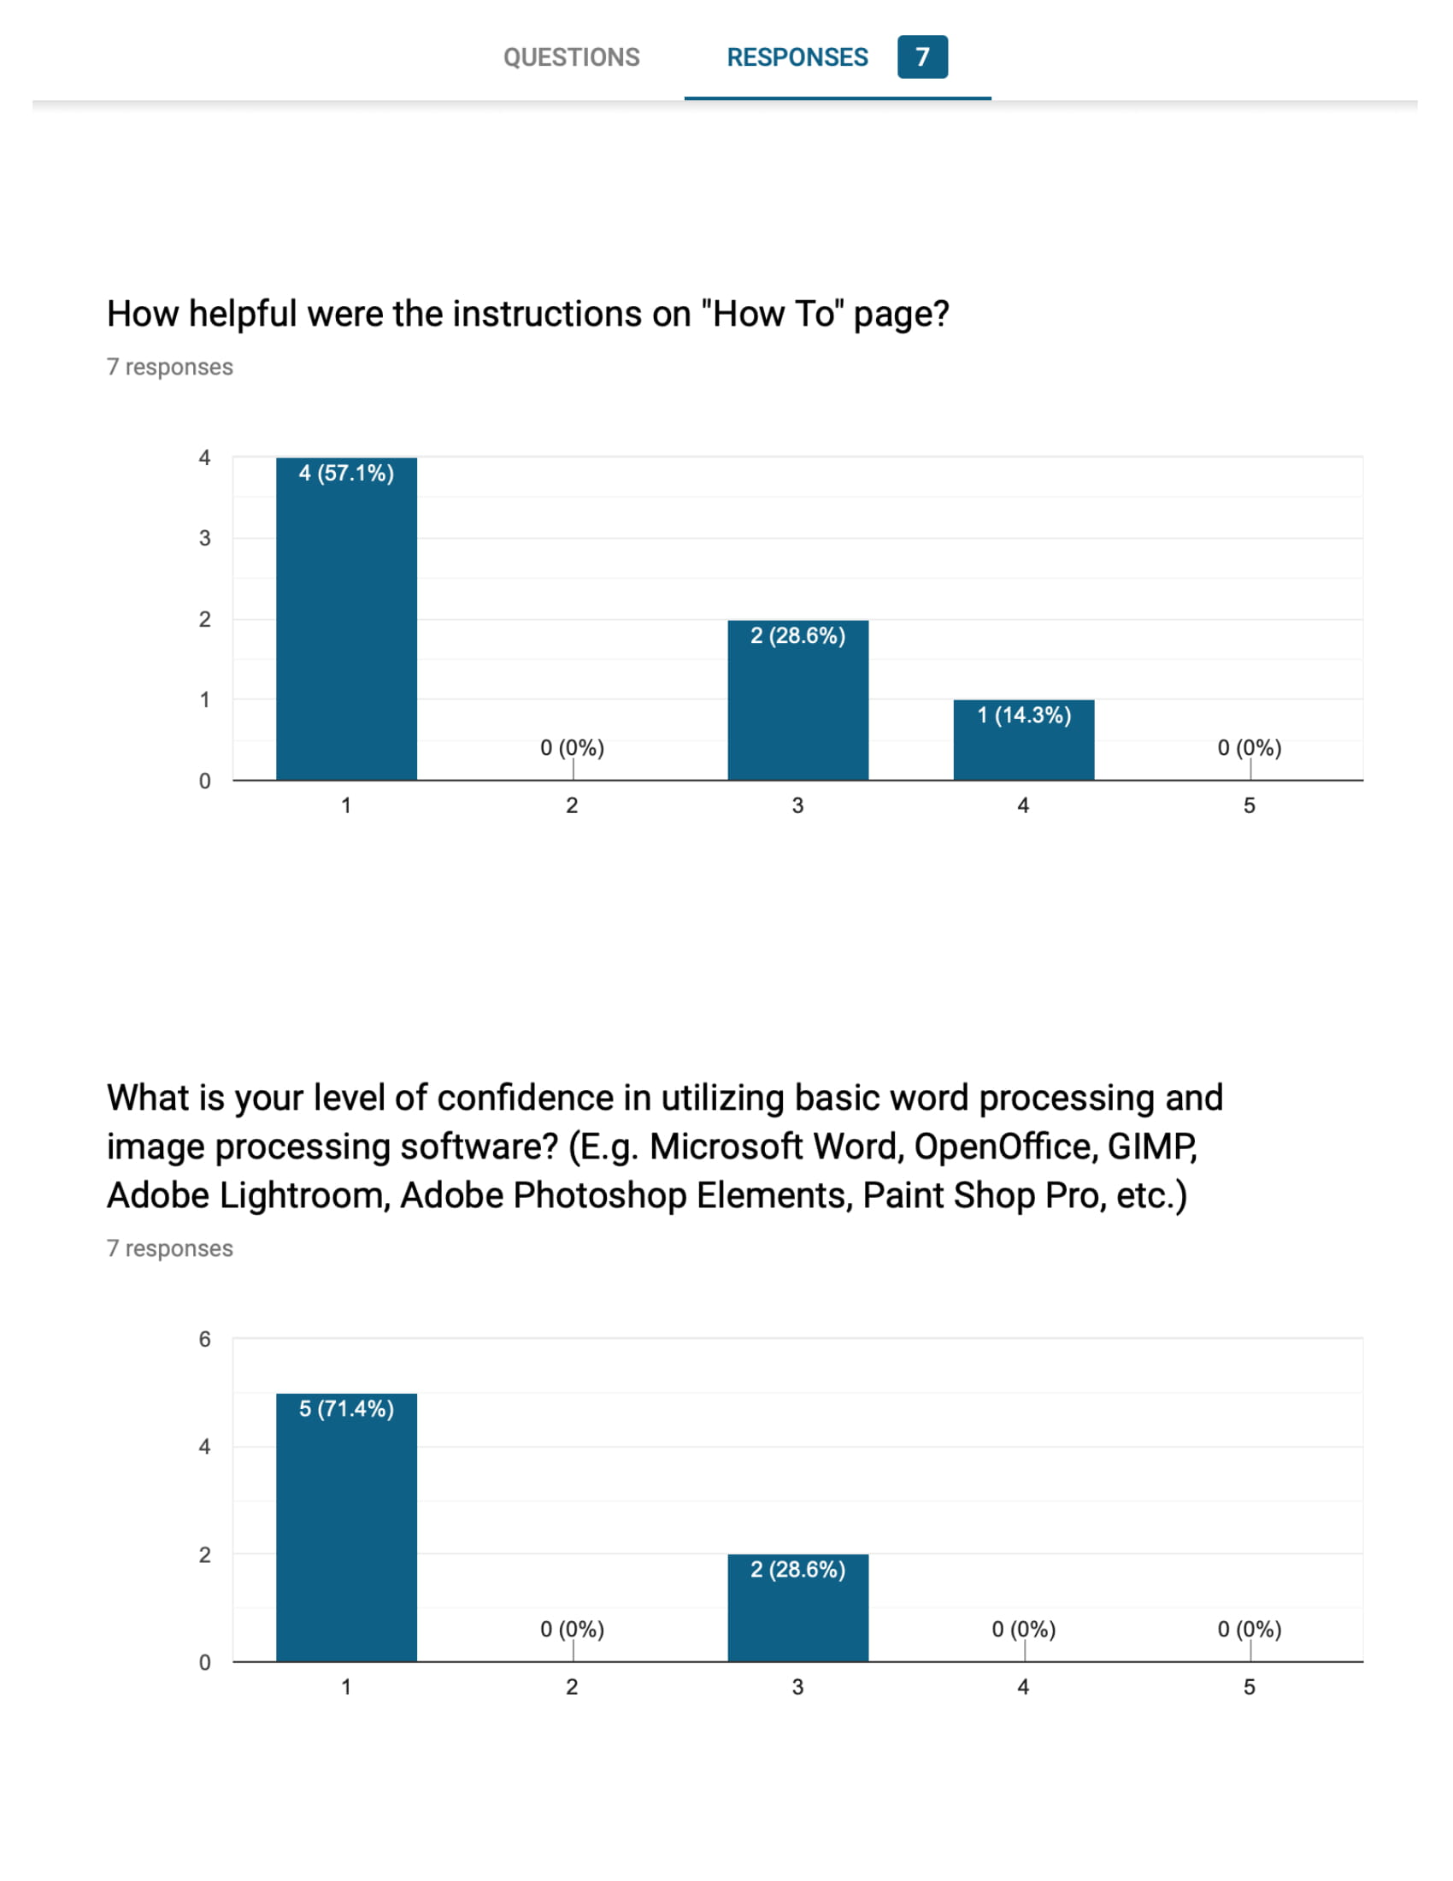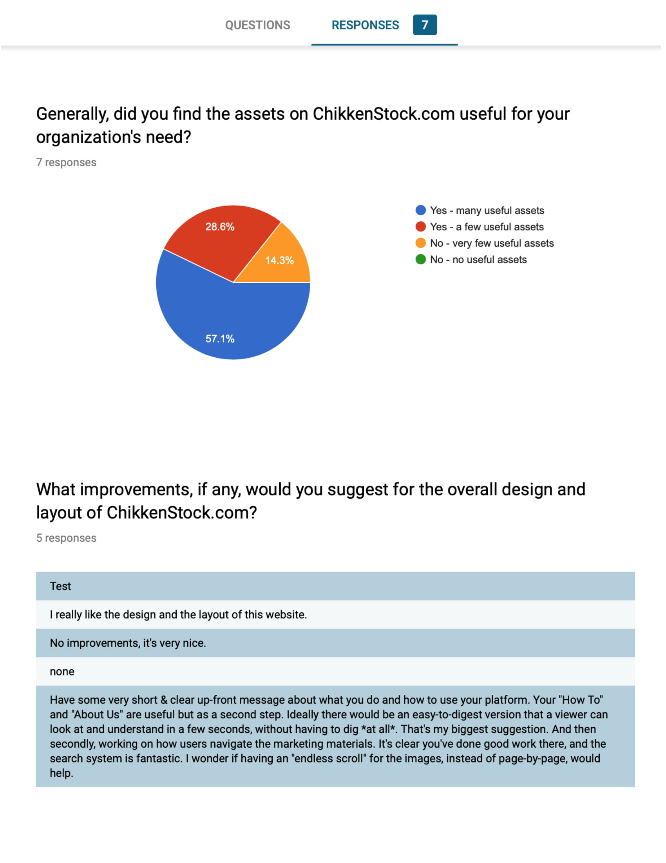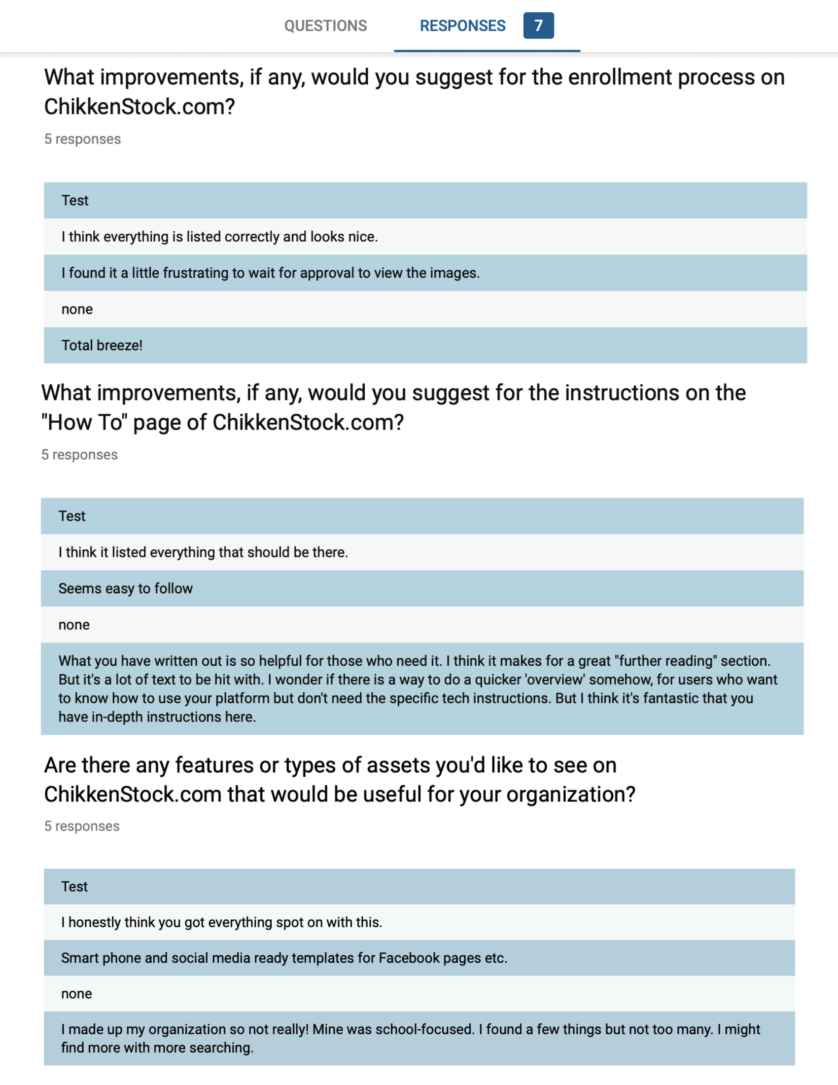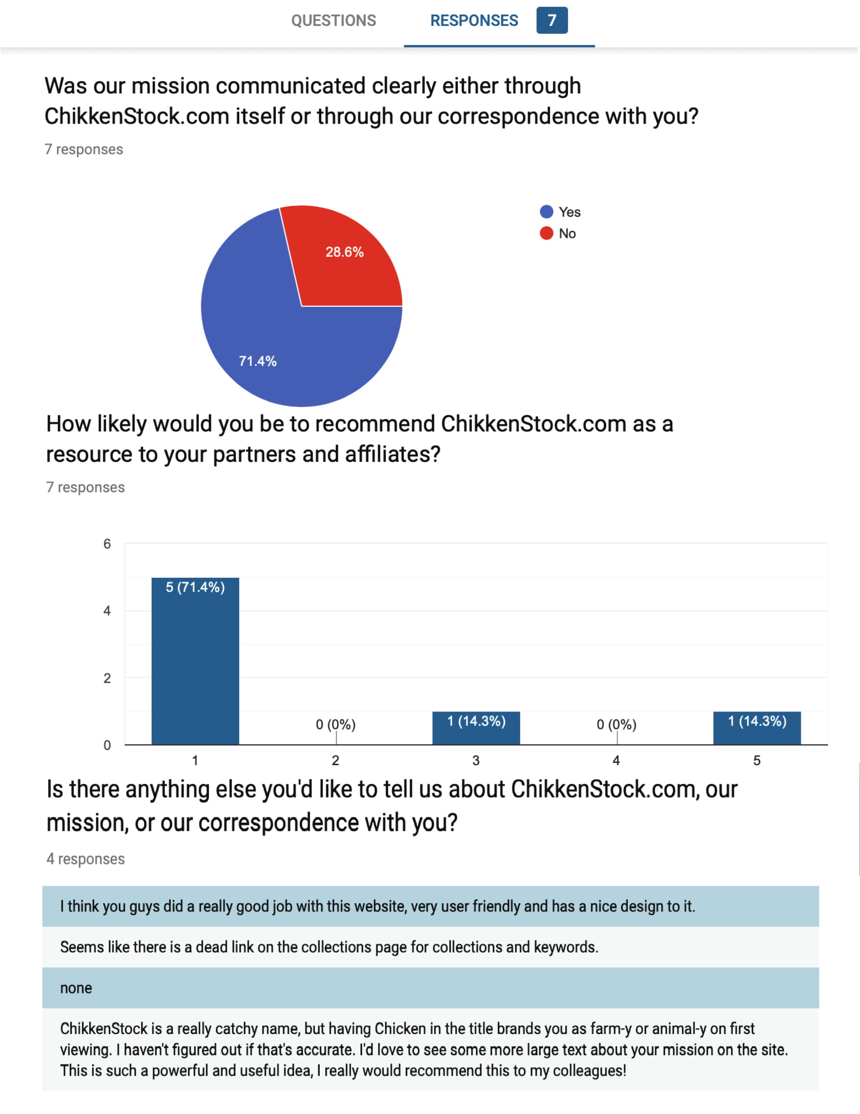
Appendix D
Participant Userbase


