Comparison of Cloud-Type Properties and Radiative Effect Decomposition in Tropical Convectively Active Regions Using CERES High-Resolution Data

Kuan-Man Xu¹, Moguo Sun² and Yaping Zhou³

- NASA Langley Research Center, Hampton, VA
- Analytical Mechanics Associates, Inc./NASA Langley Research Center, Hampton, VA
- University of Maryland, Baltimore County

Contents of this file
Table S1, Figures S1-S10 and a brief description of the results shown in selected figures.
Figures in this Supplementary Information (SI) file provides additional support for the discussions in the main text.

A brief discussion of selected figures in this file

Deviations in shortwave (SW) cloud radiative effect (CRE) from the tropical mean are generally less than 3 W m⁻² for most cloud types over tropical oceanic and land areas (Figures S5a and S5e). However, the magnitudes of these deviations are much larger in the chimney regions (Figures S5b, c, d, f, g). In particular, low-level clouds exhibit weaker cooling effects in the five chimney regions (except the East Pacific) and tropical land areas (Figure S6e). High-level and deep convective clouds show stronger cooling over oceans but weaker cooling over land regions. The weaker cooling effects of low-level clouds over land and the Atlantic region are associated with lower cloud liquid water path (LWP) values (Figures S2e-g and S5e-g) and influenced by increased surface reflection under clear-sky conditions over land.
Deviations in longwave (LW) CRE from the tropical mean (Figures S6a-g) are mostly negative, indicating reduced LW warming, except for a few optically thin cloud types over tropical lands and Africa. The tropical ocean area shows weak enhancement in LW warming particularly for mid- and high-level clouds. The overall reduction in LW warming for nearly all cloud types is linked to more humid environments outside of clouds compared to the relatively drier conditions over clear skies in less convectively active regions (Xu et al., 2024).
Deviations in net cloud cooling effects (Figures S7a-g) exhibit patterns similar to those of SW cloud cooling (Figures S5a-g). However, net cloud cooling effects are greater than SW cooling effects in all regions due to the weaker LW warming (Figure S6a-g). For instance, while SW cloud cooling over the Amazon is smaller than the tropical mean, net cloud cooling exceeds the tropical mean for most cloud types, except for a few low-level cloud types (Figures S6g and S7g).
The combined cloud fraction (CF) and CRE deviation component of LW CRE decomposition (Figure S8), which accounts for both CF and CRE deviations, exhibits smaller magnitudes overall but is comparable to the CRE deviation component in the TWP and Amazonia regions (Main Text Figure 3), where the maximum reduction in LW cloud warming is about 0.25 W m⁻². Overall, the reduction in total LW cloud warming is minimal across the five chimney regions, with the exceptions of the tropical western Pacific (TWP) (-0.8 W m⁻²) and Amazonia (-1.8 W m⁻²). The larger reduction in the Amazonia region compared to the TWP is attributed to the stronger cooling effects of optically moderate cloud types associated with positive CF deviations (Main Text Figure 1g).
The combined component of SW CRE decomposition (Figure S9) also shows relatively small effect. Most of cloud types, including anvil clouds and boundary-layer clouds, enhance cooling across all regions except the Amazon. Take together, the 42 cloud types change the total SW CRE by between -0.9 W m⁻² in the TWP and 0.6 W m⁻² in the Amazon, which are even smaller than those of the CRE deviation component presented in Main Text Figure 5.
The combined component of net CRE decomposition has a minimal effect (Figure S10). Exceptions to this are observed in anvil clouds in the TWP, East Pacific and Atlantic regions, as well as boundary-layer clouds over land regions (Figures S10e-g). The collective contributions from the 42 cloud types are cooling over all regions, ranging from less than -0.5 W m⁻² (tropical ocean, Atlantic and Africa) to approximately -1.0 W m⁻² (tropical land, the TWP and the Amazon).
References
Xu, K.-M., Sun, M., & Zhou, Y., (2024). Analysis of the influence of clear‐sky fluxes on the cloud‐type mean cloud radiative effects in the tropical convectively active regions with CERES satellite data. J. Geophys. Res. Atmos., 129, e2024JD041525. https://doi.org/10.1029/ 2024JD041525.
Table S1. Nineteen-year mean values of convective available potential energy (CAPE), convective inhibition (CIN), lower tropospheric stability (LTS), estimated inversion strength (EIS), lifting condensation level height (ZLCL), sea surface temperature (SST) and surface elevation across the African, Amazon, tropical western Pacific (TWP), east Pacific, Atlantic regions. MERRA-2 reanalysis data were used in the calculation.
Region | CAPE  (J kg⁻¹) | CIN  (J kg⁻¹) | LTS  (K) | EIS  (K) | ZLCL  (m) | SST  (C) | Elevation (m)
Africa | 546.6 | -11.2 | 10.1 | 5.1 | 2012.2 | 26.27 | 525.5
Amazon | 735.2 | -5.4 | 11.9 | 3.2 | 841.4 | 25.91 | 315.3
TWP | 958.9 | -3.1 | 12.8 | 3.6 | 764.9 | 28.46 | 42.4
East Pacific | 563.6 | -1.2 | 13.8 | 3.1 | 720.2 | 27.48 | 3.5
Atlantic | 591.1 | -7.7 | 13.4 | 3.1 | 741.9 | 27.52 | 0.1

+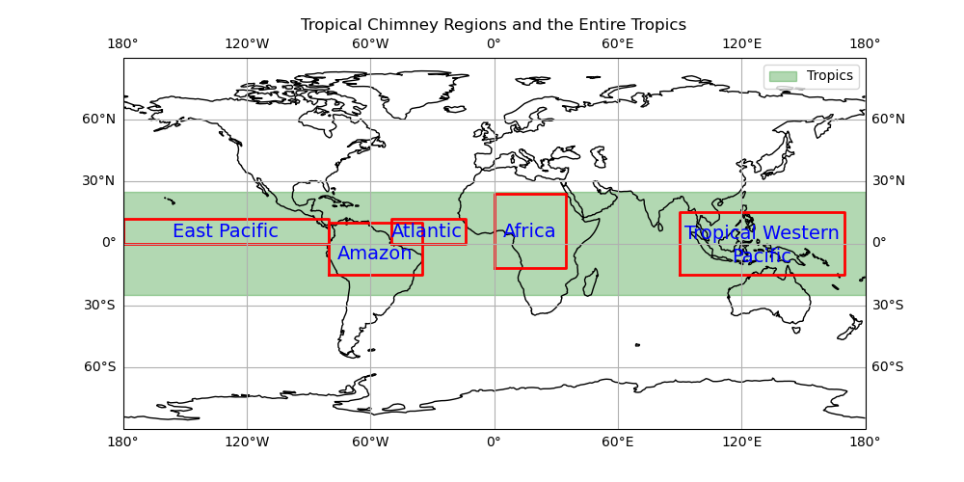
Figure S1. Map showing the five tropical chimney regions (highlighted with red boxes) and the entire tropical region (shaded in green).

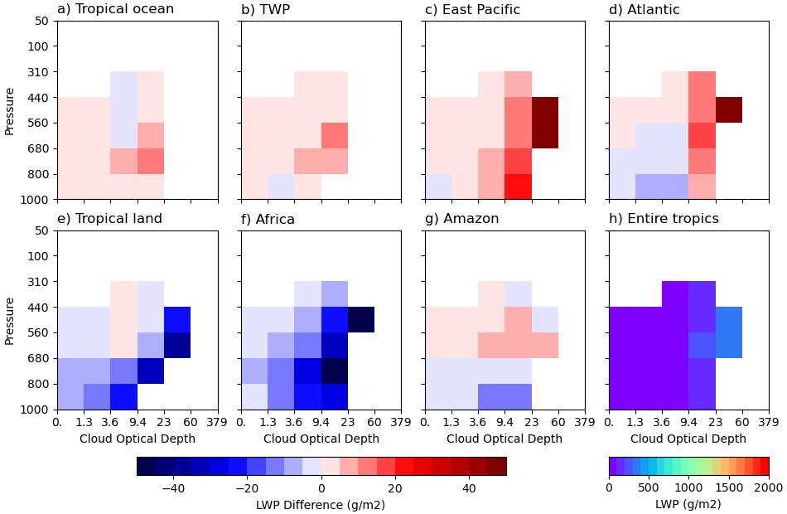
Figure S2. As in Figure 1, except for cloud-type mean cloud liquid water path (LWP). Unit is g m⁻².

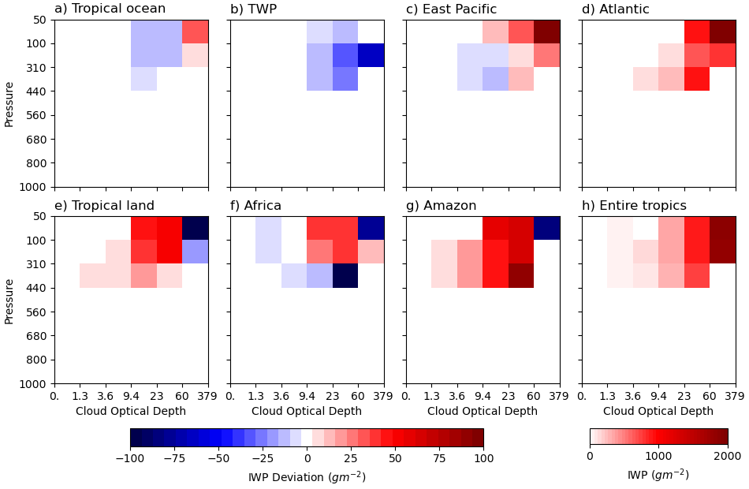
Figure S3. As in Figure 1, except for cloud-type mean cloud ice water path (IWP). Unit is g m⁻².

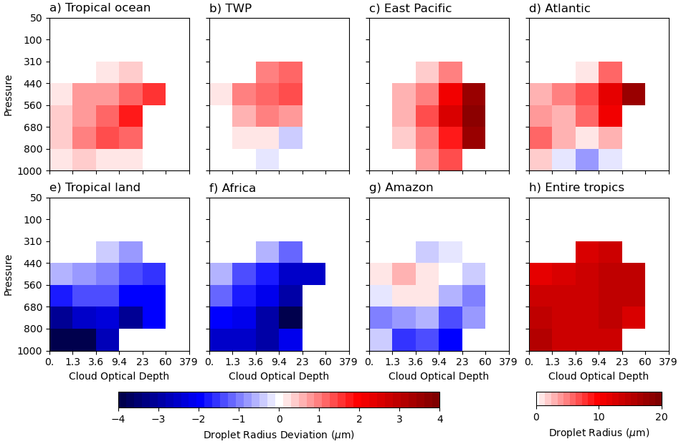
Figure S4. As in Figure 1, except for cloud-type mean liquid droplet radius. Unit is $μm$.

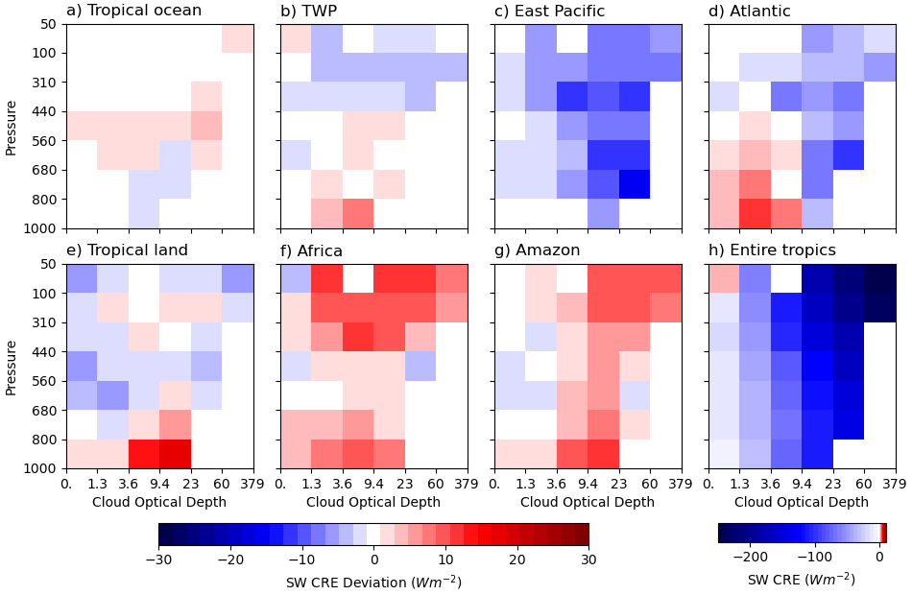
Figure S5. As in Figure 1, except for cloud-type mean shortwave cloud radiative effect (SW CRE). This figure is adapted from Xu et al. (2024). Unit is W m⁻².

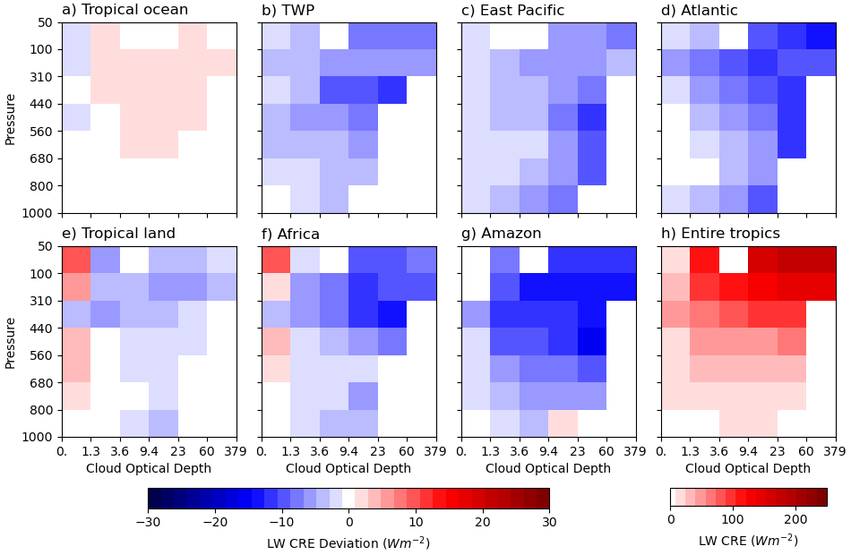
Figure S6. As in Figure 1, except for cloud-type mean longwave cloud radiative effect (LW CRE). This figure is adapted from Xu et al. (2024). Unit is W m⁻².

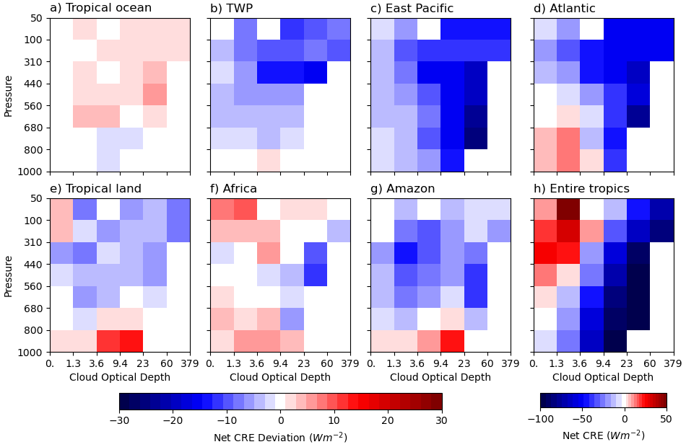
Figure S7. As in Figure 1, except for cloud-type mean net cloud radiative effect (net CRE). This figure is adapted from Xu et al. (2024). Unit is W m⁻².

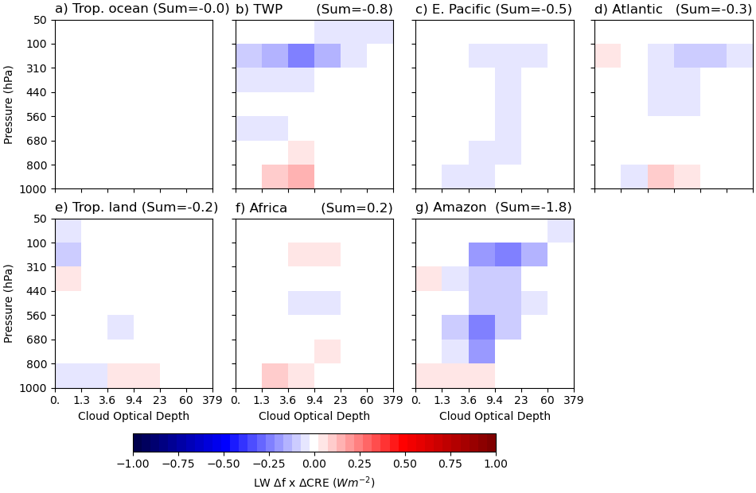
Figure S8. As in Figure 1a-g, except for the combined cloud fraction (CF) and cloud radiative effect (CRE) deviations component of longwave CRE decomposition. Numbers in the subtitles are the total CREs summarized across all 42 cloud types. Unit is W m⁻².

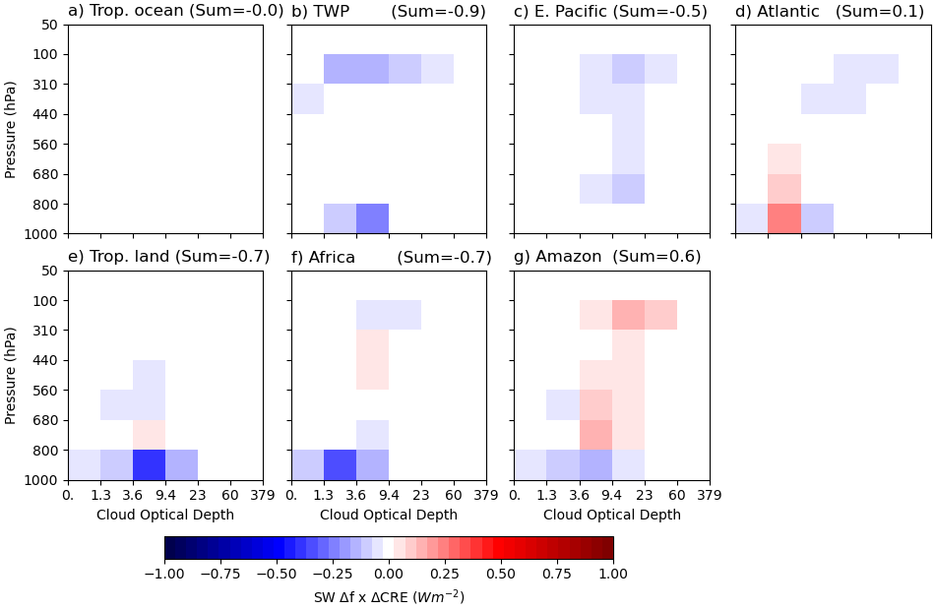
Figure S9. As in Figure S8, except for shortwave (SW) cloud radiative effect (CRE) decomposition. Unit is W m⁻².

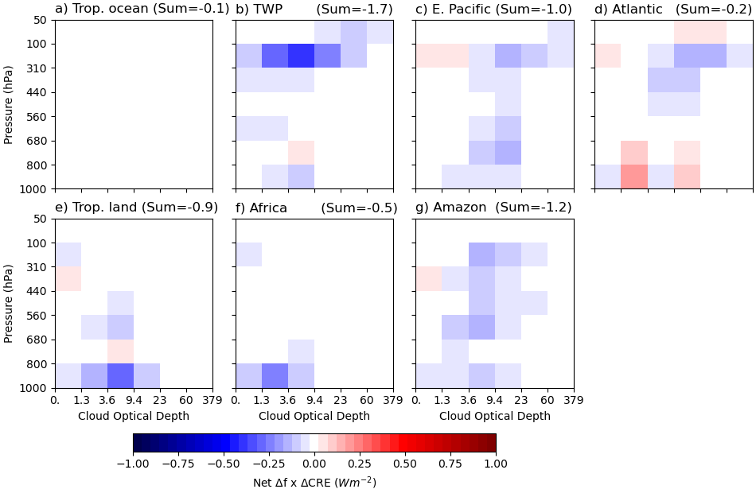
Figure S10. As in Figure S8, except for net cloud radiative effect (CRE) decomposition. Unit is W m⁻².

