A Collaborative Approach to Improving Adolescent eHealth Literacy
by
Bethany McGowan
December 2017

Presented to the
Division of Science, Information Arts, and Technologies
University of Baltimore

In Partial Fulfillment
of the Requirements for the Degree of
Master of Science

Approved by: ________________________________
Gregory Walsh, Thesis Advisor

________________________________
Lucy Holman, Committee Member

Abstract
Open Educational Resources (OERs) could provide relief for common issues related to the digital divide, particularly issues related to appropriate digital content for classroom use, teacher discomfort using digital content, and strategies for moving teachers to sustained digital content use. Librarians--already leaders in finding and sharing authoritative digital resources, familiar with copyright and Creative Commons licenses, and accustomed to using technology to deliver content--should lead in the creation, selection, and implementation of continuing education OERs, particularly literacy-related OERs. This research project will illustrate the potential for librarians in creating OER content that trains K-12 teachers to teach eHealth literacy competencies to adolescents. It will design a prototype for an open education resource that illustrates how librarian-teacher collaborations can lead to the creation of tools that alleviate three of the issues highlighted in the 2016 State of America’s Libraries Report: 1. difficulty locating appropriate digital content for classroom use, 2. teacher discomfort using digital content, and 3. unclear strategies for moving teachers to sustained digital content use in the classroom.
Acknowledgments
I would like to thank the friends and family who have supported me through my journey for a second graduate degree. I love and appreciate you all. And, thank you to the Interaction Design and Information Architecture program faculty at the University of Baltimore for providing me with a practical, hands-on learning experience. From working in the UB User Research Lab to field work on the streets of Baltimore and the beaches of Belize, I have learned so much from you all.

Table of Contents

List of Figures iii

Chapter 1: eHealth Literacy, the Digital Divide, and OERs 1

The State of America’s Libraries 1

The Digital Divide 2

Open Education Resources 3

Growth and Policy Support 4

Evaluating OERs 4

OER Barriers 5

Online and In-Person Learning 6

Cultivating Communities of Practice 6

Chapter 2: Designing Digital Learning Tools 9

The Transtheoritical Model 9

Design Considerations 11

Summary of Literature Review Findings 12

Chapter 3: Study Methodology 14

Audience Heuristics 14

Observation 15

Assessment 16

Methodology 16

Results 17

Sketches 20

Personas 22

Workflow Sketches 23

Wireframes 24

Prototypes 25

Final Design 26

Task Outcomes 29

Chapter 4: Findings 32

Discussion 32

Balsamiq Wireframe User Testing Analysis 33

Axure Prototype User Testing Analysis 33

Content Analysis 36

Chapter 6: Conclusion 37

References 38

Appendix A: Needs Assessment, eHealth Literacy Teaching Scale 45

Appendix B: Needs Assessment Results 49

Appendix C: Week 1 Content Prototypes 50

Appendix D: User Testing Tasks Script 66

Appendix E: Common Design Suggestions 67

Appendix F: Personas 68

List of Figures
Figure 1. The Transtheoretical Model, 5 Stages of Change 10
Figure 2. Confidence Rating Results 19
Figure 3. Learning Preference Results 20
Figure 4. Lepore’s Sketch to Design Continuum 21
Figure 5. Sample Idea Sketch 21
Figure 6. Sample Functional Flow 22
Figure 7. Sample Workflow, Felicity 23
Figure 8. Sample Workflow, Jamie 24
Figure 9. Sample Workflow, Sarah 24
Figure 10. Home Page Prototype, Axure 25
Figure 11. Final Marvel Prototype, Main Menu 26
Figure 12. Final Marvel Prototype, Week 1 27
Figure 13. Final Marvel Prototype, Start of Week 1 28

Chapter 1: eHealth Literacy, the Digital Divide, and OERs

The State of America’s Libraries
eHealth literacy--a person’s ability to find, evaluate, and apply health information from digital sources-- directly influences the success in which one is able to access health information, learn about disease prevention and health promotion, follow health care regiments, and communicate health messages with other people. When introduced in early adolescence, eHealth literacy competencies can have a life-long influence on informed health decision-making. In K-12 education, librarians have traditionally collaborated with teachers to provide students with information literacy training and often take the lead in integrating digital resources. They support teachers, administrators, and students in the training, resource management, and strategic outreach related to introducing new educational technologies. However, as information has shifted to become more electronically available, evidence shows that literacy education has struggled to keep up. The 2016 State of America’s Libraries Report notes significant increases, between 2010 and 2015, in the percentage of librarians experiencing challenges supporting the digital content needed to teach literacy skills ("School Libraries," 2016). These digital divide experiences include insufficient internet access, lack of student access to technology at school, difficulty locating appropriate digital content for classroom use, teacher discomfort using digital content, and unclear strategies for moving teachers to sustained digital content use in the classroom.
Open Educational Resources (OERs) could provide relief for common issues related to the digital divide, particularly issues related to appropriate digital content for classroom use, teacher discomfort using digital content, and strategies for moving teacher to sustained digital content use. Librarians—already leaders in finding and sharing authoritative digital resources, familiar with copyright and Creative Commons licenses, and accustomed to using technology to deliver content—should lead in the creation, selection, and implementation of continuing education OERs, particularly literacy-related OERs.

The Digital Divide
Digital divide research reveals disparities in eHealth literacy competencies. These issues are complicated in rural areas that experience additional barriers such as limited internet access and limited healthcare services (Paek, 2010). Several studies suggest that behavioral interventions that use innovative multimedia technology work well when designing health informatics tools for adolescent use. Such interventions can be used to teach and improve eHealth literacy (Roseman, Riddell, & Haynes, 2011). If these behavioral interventions could be designed for classrooms with limited internet access and across a range of platforms--desktops, laptops, tablets, mobile phones-- they would offer a reliable, interactive teaching platform for middle and high school health teachers, especially those in rural and low-income areas.
Access to computers, the internet, and mobile technologies in homes and schools has increased exponentially in recent years. A 2013 report from the U.S. Census Bureau found that nearly 90% of adolescents use the Internet, with computer usage and communications tools steadily rising; 97% of U.S. schools have computers, and 90% of those computers have internet access. In 2011, about ¾ of U.S. households had computers (File, 2013). In the early 2000s a digital divide existed, driven by socioeconomic status, race, area rurality, and age but as technology became more affordable and internet access more widespread, the divide was expected to close. Current research suggests that has not been the case and that, particularly amongst adolescents, with whom significant differences in digital literacy exist based on socioeconomic status, race, and gender (Ritzhaupt, Feng, Dawson, & Barron, 2013).
Communication technologies, especially mobile technologies, can be useful teaching tools for reaching adolescents and their prevalence has grown in the past five years, alleviating such issues as tobacco use, the transmission of sexually transmitted diseases, alcohol abuse, and teen pregnancy. These interventions have the advantages of quickly and reliably providing effective, standardized, and personalized information yet they remain underutilized in K-12 education, though they could be particularly impactful in middle and high school health education (Manganello & Sojka, 2016).
This research project will illustrate the potential for librarians in using OERs to create digital content that trains K-12 teachers in relaying eHealth literacy competencies for adolescents. It will design a prototype for an open education resource that illustrates how librarian-teacher collaborations can lead to the creation of such tools to alleviate three of the issues highlighted in the 2016 State of America’s Libraries Report: 1. difficulty locating appropriate digital content for classroom use, 2. teacher discomfort using digital content, and 3. unclear strategies for moving teachers to sustained digital content use in the classroom. This literature review seeks to answer two questions: 1. Are open education resources (OERs) an effective means for teacher training and 2. How can librarians engage teachers in creating eHealth literacy-related OER tools and interventions?You can find the style menu in Word 2007 by clicking on the Home tab on the standard toolbar; Styles is one of the choices you will see. Click on the arrow icon on the right side of the Styles bar, and the drop-down menu of styles will appear. In Word 2003, look in the upper left corner of your screen, on the formatting toolbar, for the drop-down style menu.

Open Education Resources (OERs)
Open Education Resources (OERs) became popularized after schools began adopting the Common Core State Standards (CCSS) in 2013, as a means to develop and disseminate free online training content and to provide teachers with standards-based material for CCSS-aligned instruction. OERs, as defined at a 2002 UNESCO Forum, serve as the “technology-enabled open provision of educational resources for consultation, use, and adaptation by a community of users for non-commercial purposes”. Digital libraries of OERs are available on the public domain and can include resources such as open access textbooks, videos, podcasts, teacher’s guides, continuing education opportunities, and lesson plans. OERs are a part of the Open Access movement and help make educational resources more accessible, affordable, and available than traditional, commercially-produced materials. They typically use Creative Commons licenses to allow for royalty-free, license-free access to materials. (Welz, 2017)
The aim of the proposed OER project is to produce an eHealth literacy OER training course that librarians can use to train teachers in either distance, face-to-face, or hybrid learning environments. This pilot model is intended to be freely adapted and revised. Teachers who have completed the pilot course will learn to create eHealth literacy content specifically for their student audiences. To make it more accessible for audiences with limited internet access, training material will be available for download as a PDF document for printing and as a Word Document to encourage adaptation. It will consist of 4 units that span a timeline of 1 week/unit and the entire course can be completed in four weeks.
OER Growth and Policy Support. The potential for OERs in revolutionizing access to educational resources has been recognized across local, state, and federal arenas. OERs, already becoming popular in 2013 with local school districts recognizing their potential to provide access to free, shareable instructional content, gained more traction in 2015 with the Obama administration’s bipartisan passage of the Every Student Succeeds Act, P.L. 114-95 (ESSA). ESSA permits states and local education agencies to dedicate grant money to OER technologies and provides OER funding with Student Support and Academic Enrichment Grants. In 2016, additional policy regulations required that all new intellectual property developed with federal grants from the U.S. Department of Education be freely available under an open license (Welz, 2017).
K-12 school districts across a number of U.S. states have developed control policies that guide teachers and administrators in the adoption and implementation of OERs by explaining advantages, exploring implementation strategies, and demonstrating exemplary OER examples. Considerations are being given for how OERs should accommodate special needs students and how OERs can provide professional development activities for teachers (Welz, 2017).
Evaluating OERs. A five-dimensional analysis could be used to evaluate the proposed OER (Joyce, 2007):
1. Scope. On what disciplines, education levels, and intended audiences does the OER project focus? Is the focus narrow or broad? A narrow focus provides material for one specific topic or subject area, while a broad focus provides material suitable for a range of topics.
2. Authorship. Was the OER created by a single author, or through a collaborative effort?
3. Licensing. Does the OER license allow it to be combined with other OER materials or to be used in other contexts?
4. Granularity. What is the resource size? The smaller a resource is, the more granular it is.
5. Teaching Duration. How much teaching time does the material require? Is the material intended for a full course or as a learning object in one class session?
OER Barriers. OER barriers include issues related to the aforementioned digital divide. OERs are digital resources and require access to a computer, tablet, or smart device. Most OER libraries are hosted on the internet and require access to reliable, high-speed internet. School districts in resource-poor communities could struggle to provide students and instructors with the technology and bandwidth needed to host OERs. Security concerns could prove an additional concern, as materials are accessed and downloaded through public contributions to open access libraries.
OER design, creation and sustainability requires funding and support from administrators; OER use relies on a commitment from teachers and students. Teachers and students, as users, are more likely to use an OER that is customized to their needs and is easy-to-use. The recommended level of customization—the creation of and or provision of community-specific content and the evaluation of materials—requires a significant time investment.
While contributions to OER libraries have predominantly stemmed from volunteer contributions, contributions from commercial publishers is growing and could also prove a barrier. The popularity of OERs has led to a decline in the need for physical materials and some publishers have responded by creating open resources as cheaper alternatives (Welz, 2017).

Online and In-Person Learning
OER learning opportunities can be presented online, in-person, or as a combination of both. As a web-based intervention, OERs probably have similar outcomes as when compared to in-person interventions; or web-based intervention might even perform better. This holds true, even for complex health-related issues, as described in a meta-analysis on the effectiveness of web-based and non-web based interventions on health-related behavioral change outcomes. The study concluded that web-based interventions produced such outcomes as “increased exercise time, increased knowledge of nutritional status, increased knowledge of asthma treatment, increased participation in healthcare, slower health decline, improved body shape perception, and 18-month weight loss maintenance” (Wantland, Portillo, Holzemer, Slaughter, & McGhee, 2004). Another study comparing internet and traditional interventions suggested that web-based interventions are superior to in-person interventions, particularly within rural and low-income audiences: “clients who have received web-based education are interested in and, in fact, prefer … education websites as a method of receiving … education. 83% of web-based participants also reported a willingness to use the website again”. The preference for web-based interventions is influenced by such factors as the convenience of completing learning modules in a home setting, reduced distraction by being in a familiar, comfortable environment, the reduced need for travel, and an appreciation of the breadth of electronically available information (Bensley, Anderson, Brusk, Mercer, & Rivas, 2011).

Cultivating Communities of Practice
Successful OER learning relies, in part, on successfully cultivating a community of practice. This pilot project research would rely on a community of librarians to manage and update OER content. Wenger, McDermott, and Snyder (2002) define a community of practice as “any community of practice which cannot rely on face-to-face meeting and interactions as its primary vehicle for connecting members’. Threats to such a community include distance, size, organizational affiliation, and cultural differences. These threats can be overcome, and a community cultivated with seven principles (Wenger et. al, 2002):
1. Design for evolution. The success of new community efforts rely on volunteer efforts and volunteers may have varying amounts of passion and time to commit to a project. To encourage accountability, focus on simple structures—provide lists of what tasks need to be completed and who will complete them and have as little governance as needed. Anticipate the departure of volunteers and be prepared to redistribute work to new talent. Throughout the life of the project, work to generate newcomers to balance off-boarding and so that work is always evenly distributed.
2. Open a dialogue between inside and outside perspectives. Communities consist of ‘insiders’ and ‘outsiders’. Insiders are experts in a given issue and serve as the core of the community. Outsiders have some domain knowledge and the enthusiasm to help. They offer new energy, novel ideas, and new perspectives. Successful communities use both insider and outsider contributions.
3. Invite different levels of participation. Communities often need to tackle difficult tasks that require expert or insider knowledge, but participation from experts can be difficult to acquire and their time commitment limited. Communities of practice require a process for creating experts and to allow new community participants to grow and gain expertise. To train new community members Wenger promotes legitimate peripheral participation, a type of apprenticeship under which the skill sets of new practitioners are identified and grown through work with members of the entire community of practice. Legitimate peripheral participation is particularly important in volunteer communities because it encourages investment from newcomers by allowing them to learn and do more, and build on existing skills and interests.
4. Develop both public and private community spaces. Transparency in an organization does not mean having every conversation in public but is a balance of public and private conversations. One-on-one, private communication can help build trust in a way that multiway communication does not, especially amongst new participants. Private conversations can also inform public conversations with insights from participants that might not be shared with a broader audience. Private conversations are especially useful in conflict resolution. Conversations that relate to actions that impact others should be part of a public forum.
5. Focus on value. Community members should feel that their work is valuable, and should be provided an outlet—for example, online forums or regularly scheduled meetings, to express and reflect on the value of their work. Ideas for new contributions, even experimental ones, should be encouraged.
6. Combine familiarity and excitement. Simple structures and working processes provide stability in the completion of daily tasks. However, new challenges and opportunities should be made available to energize established participants and attract new ones. The excitement stimulated by new opportunities helps keep volunteers motivated.
7. Create a rhythm for the community. Rhythm is an important consideration in a community of practice. It is a delicate balance—moving too quickly lead to participants feeling overwhelmed while moving too slowly could result in participants being bored and uninterested.

Chapter 2: Designing Digital Learning Tools

The Transtheoretical Model
The proposed OER focuses on eHealth literacy training. Ehealth literacy interventions should go beyond the simple provision of information and encourage actual behavior change. Behavior change models include careful consideration of information content and characteristics--such as the delivery of information, its appearance, message style, and information architecture (Ritterband, Thorndike, Cox, Kovatchev, & Gonder-Frederick, 2009). The Transtheoretical Model (TTM) provides a framework for developing interventions that help modify behavior. TTM has been successfully applied to the cessation of negative behaviors like smoking and delinquent behavior, and the acquisition of positive behaviors like safer sex practices and regular exercise. It consists of four key elements,
1. Stages of Change: an individual’s temporal readiness to modify health behavior
2. Decisional Balance: the perceived importance of the benefits and disadvantages of change
3. Situational Self-Efficacy: the confidence in self-ability to modify behavior across social, negative affect, and difficult situations
4. Processes of Change: the experiential and behavioral strategies used by individuals to progress through stages of change.
The Transtheoretical Model defines stages for a specific process leading to behavior change. This stage-tailored change approach promotes measurable, sustainable, and lasting improvements in behavior, decisional balance, and self-efficacy. Participants are distributed across five stages of change--Precontemplation, Contemplation, Preparation, Action, and Maintenance. Interventions include a staging measure to classify users into one of these five stages, then an individual’s classified stage is used to determines which intervention is appropriate.
Three dimensions help organize the constructs of TTM (Di Noia, Contento, & Prochaska, 2008):
1. The Temporal Dimension: Stages of Change
2. The Dependent Variable Dimension: Decisional Balance and Situational Self-Efficacy
3. Independent Variable Dimension: Processes of Change
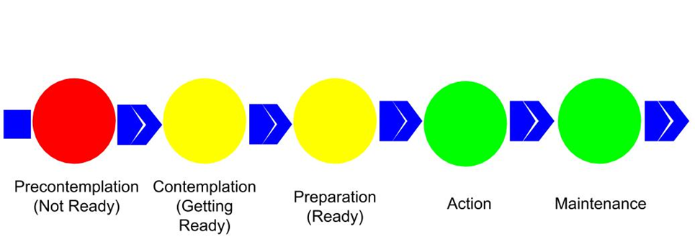
Figure 1. The Transtheoretical Model, 5 Stages of Change

The Precontemplation phase incorporates consciousness-raising interventions and environmental evaluation processes. An example of a consciousness awareness strategy is having participants complete an assessment providing feedback about their eating or exercise habits.
The Contemplation and Preparation phases focus on increasing confidence, encouraging commitment to act, and developing specific plans to modify behavior. Participants are exposed to actionable self-evaluation and self-liberation strategies, like setting a daily goal or developing a weekly plan to achieve a goal.
The Action and Maintenance phases focus on encouraging relationships, counterconditioning, and stimulus control processes. Particularly effective for adolescents is involvement in a buddy contact system.
The intervention in the Di Noia et al study provides an example of the TTM in action. The pilot program begins by providing participants with digital intervention content and with an introductory session that orients participants to the program and describes the benefits of eating fruits and vegetables. The orientation session included a staging measure that classified users into three stages: Precomtemplation, Contemplation/Preparation, or Action/Maintenance. Stage classifications were then used to determine which additional intervention participants would complete:
“Users in precontemplation completed sessions that incorporated consciousness raising, dramatic relief, and environmental reevaluation processes for enhancing awareness of lower-than recommended intakes and promoting acceptance of the need for dietary change. An example of a consciousness-raising change strategy included in this group of sessions was to increase users’ awareness of their intake by having them complete an assessment that provided personalized feedback regarding the number of daily servings of fruits and vegetables they were in the habit of eating” (Di Noia et. al, 2008, p. 5) .
“Users in contemplation/preparation were exposed to self-reevaluation and self-liberation strategies for increasing confidence in the ability to increase intake, resolve ambivalence regarding commitment to act, and facilitate the development of specific plans for modifying dietary behavior. An example of a self-liberation change strategy included in this group of sessions was to help users take steps toward increasing their intake by having them set a daily fruit and vegetable goal and develop a 1-week menu and action plan for reaching the goal” (Di Noia, et. al, 2008, p. 5).
“Reinforcement management, helping relationships, counterconditioning, and stimulus control processes for helping users sustain recommended intake levels were delivered in sessions for users in action/maintenance. An example of a helping relationships change strategy included in this group of sessions was to encourage users to team up with another person who was also interested in maintaining intake and to develop a “buddy contract” identifying strategies for giving each other support” (Di Noia et. al, 2008, p. 5).

Design Considerations
The proposed OER is intended for high school and middle school health teachers and librarians; teachers are students and librarians are instructors. It represents two distinct demographic groups--recent graduates/new teachers, age 21-25 and experienced teachers, aged 26-70. All groups are college educated, experienced computer users, and middle to upper-middle class. Common design suggestions, particularly Nielsen’s Ten Usability Heuristics (Nielsen, 1995) and Schneiderman’s Eight Golden Rules of Interface Design (Schneiderman, 1998) are considered in designing for the audience of experienced teachers. However, it is important to consider how young adults differ in their preferences for digital interfaces. A 2016 study from the Nielsen Norman Group, “Young Adults/Millennials as Web Users” (Meyers, 2016), found unique behaviors in millennials’ use of digital interfaces:
1. Young adults are confident in their ability to navigate digital interfaces
2. Young adults embrace new design patterns, but are error prone--’Click first, ask questions later’
3. Young adults see usability issues as design flaws and will criticize the organization, not themselves when things go wrong
4. Young adults will quickly turn to Google as a reference and as an example of a simple, easy to use interface
5. Young adults have different ideas of visual appeal and interpret flat designs as more attractive
6. When using social media, young adults prefer interesting, relevant posts that focus on building relationships over time
7. Multitasking is parallel--done linearly, not simultaneously. Like other users, young adults are less efficient when context-switching
8. Parallel browsing, or using tabs to support several, unrelated tasks is a popular habit amongst young adults
9. Page Parking, or using multiple tabs to support a single task, is also a popular practice amongst young adults

A Summary of Literature Review Findings

Teachers who can teach eHealth literacy in a way that encourages positive health behavior changes and provides standardized and personalized health information can be more successful in cultivating adolescents with strong eHealth literacy skills. Librarians play an important role in creating and designing eHealth literacy learning interventions for teachers and in OER management and implementation. Such OERs can help alleviate common issues that librarians experience, particularly difficulty locating appropriate digital content for classroom use, teacher discomfort using digital content, and unclear strategies for moving teachers to sustained digital content use in the classroom. Understanding and adjusting for the limitations of OER interventions in environments with limited internet and technology access, and providing sustainable, accessible solutions is a challenge that can be alleviated by providing printable and editable versions of OER course content.

Chapter 3: Study Methodology

Audience Heuristics
This study investigates and pilots a librarian-led, continuing education Open Educational Resource (OER) that high school and middle school health teachers can use to improve their confidence teaching eHealth literacy competencies. The pilot project is intended for two distinct demographic groups--new teachers and recent graduates, age 21-25 and experienced teachers, aged 26-70. All groups are college educated, experienced computer users, and middle to upper-middle class. Common design suggestions, particularly Nielsen’s Ten Usability Heuristics, Schneiderman’s Eight Golden Rules of Interface Design, and Nielsen Norman Group’s Design Suggestions for Millennial Users are considered in designing for this audience. See Appendix E for a detailed review of Schneiderman and Nielsen’s design suggestions.

Nine participants tested the prototype design, having the following characteristics:

Audience Type
New Teachers | 4
Experienced Teachers* | 3
Librarians | 2
TOTAL (participants) | 9

Computer Usage
0 to 10 hrs. wk. | 1
11 to 25 hrs. wk. | 3
26+ hrs. wk. | 5
TOTAL (participants) | 9

Age
18-25 | 5
26-39 | 2
40-59 | 2
60-74 | 0
TOTAL (participants) | 9

Gender
Women | 7
Men | 2
TOTAL (participants) | 9

* Teachers with more than 5 years of teaching experience.

Observation
To understand the tools, resources, and training currently available to Health teachers, the author subscribed to notices and monthly emails from the Healthy Teacher Network. The Healthy Teacher Network assists and empowers teachers to create healthy school environments by:
- creating a network where teachers, service providers, and health experts share ideas and best practices
- providing tools, resources, and training for teachers to implement activities to promote healthy lifestyles
- supporting teachers advocating for policies, curricula, and programs to create a healthy school environment
- sharing research that demonstrates the importance of healthy eating and physical activity as integral to student academic success
The Network offers workshops and professional development opportunities for teachers in the greater Chicago area--these opportunities are highly-rated by participants, with a 4.6 of 5 rating. Workshops cover a range of topics and teaching components include interactive presentations, guest speaker lectures, and resource fairs that encourage networking with organizations, programs, services. Workshop attendees earn professional development credit, meet and connect with service providers that offer free or low-cost programs to schools, and become leaders in school health and wellness promotion. To date, these highly-rated learning opportunities have only been offered in-person, but similar online experiences could be equally beneficial.

Assessment
A needs assessment survey was conducted to understand the confidence level of health teachers when teaching health literacy, technology literacy, and behavior change competencies and to understand how teachers prefer to receive continuing education. Assessment competencies were based on those from the eHEALS eHealth Literacy Scale, an accepted measure for assessing consumers’ perceived skills at using information technology for health and aiding in determining the fit between eHealth programs and consumers. An email invite on a jobs listserve for health teachers was used to recruit middle and high school health teachers to complete the needs assessment. The email included a link to the online survey. Qualtrics survey software was used to create the survey and manage responses. 17 teachers completed and submitted the survey. Results of the assessment were used to create a framework for instruction units that can be taught either online or in-person.

Methodology
The Needs Assessment consisted of three parts:
1. Confidence Ranking
2. Learning Preferences
3. Open-Ended Comments.
Three formats were used for questions—a matrix format, a question where users chose from a list, and a paragraph description. The survey was online—participants were provided with a link to a Qualtrics survey. Users were recruited through a jobs mailing list for new and experienced health and physical education teachers. The survey required participants to declare themselves as high school or middle school health teachers before participating. No incentives were provided to participants. 17 teachers completed and returned the assessment. Survey takers were told that information was being collected to understand high school and middle school health teacher confidence teaching health and technology literacy competencies and to understand learning preferences.
In Part 1 of the Needs Assessment, the Confidence Ranking, participants selected either Strongly Disagree, Disagree, Somewhat Disagree, Neither Agree nor Disagree, Somewhat Agree, Agree, or Strongly Agree for 9 queries. See Appendix A for a full list of questions and responses.
The second part of the Need Assessment asked participants to select how they most preferred to learn, given a choice of four options. Multiple selections were allowed.
The third, and final, part of the Needs Assessment was an open-ended question: Additional comments or suggestions?

Results
Results from the needs assessment show that participants are already confident in eHealth literacy competencies related to using the internet to find health information resources, but slightly less confident in competencies related to evaluating health resources. Findings suggest that teachers are interested in interventions that improve their confidence in teaching students to use the internet to answer questions about their health and evaluate the health resources they find on the internet. Full survey results are in Appendix B.
1. Over 88% of participants agreed that the internet was useful in helping them teach students to make decisions about their health; 12 participants strongly agreed, 1 participant agreed, and 2 participants somewhat agreed.
2. Over 94% of participants thought it was important for their students to be able to access health resources on the internet, with 13 participants strongly agreeing and 3 participants agreeing.
3. Over 88% of participants were confident in their ability to teach students to where to find helpful health resources on the internet, with 7 participants strongly agreeing, 5 participants agreeing, and 3 participants somewhat agreeing.
4. Over 88% of participants were confident in their ability to teach students how to find helpful resources on the internet, with 8 participants strongly agreeing, 4 participants agreeing, and 3 participants somewhat agreeing.
5. Over 88% of participants were confident in their ability to teach students how to use the internet to answer questions about their health, with 6 participants strongly agreeing, 5 participants agreeing, and 4 participants somewhat agreeing.
6. Over 76% of participants were confident in their ability to teach students how to use the health information they found on the internet to help them make decisions, with 6 strongly agreeing, 5 agreeing, and 2 somewhat agreeing.
7. Over 76% of participants were confident in their ability to teach students to evaluate the health resources they find on the internet, with 4 participants strongly agreeing, 8 participants agreeing, and 2 participants somewhat agreeing.
8. Over 76% of participants were confident in their ability to teach students how to tell high-quality health resources from low-quality health resources on the internet, with 6 participants strongly agreeing, 5 agreeing, and 2 somewhat agreeing.
9. Over 82% of participants were confident in their ability to teach students to feel confident in using information from the internet to make health decisions, with 8 strongly agreeing, 3 agreeing, and 3 somewhat agreeing.
The second part of the needs assessment asked participants to indicate how they would most prefer to learn about teaching and eHealth literacy, technology literacy, and behavior change communication. The most popular preferences were for live workshop series and self-paced modules, which received 11 votes each. Reading assigned academic articles received 6 votes and completing a series of hour-long videos received 2 votes. Full survey results are in Appendix B.
Three respondents left comments in Part 3 of the Needs Assessment. Those responses suggested that participants felt eHealth literacy skills were valuable and would prefer an online class or online training as a continuing education opportunity:
1. “These are important skills.”
2. “I would prefer this as an online training opportunity. Evaluating information sources on the internet is timely.”
3. “A Coursera class or something similar would be great!”

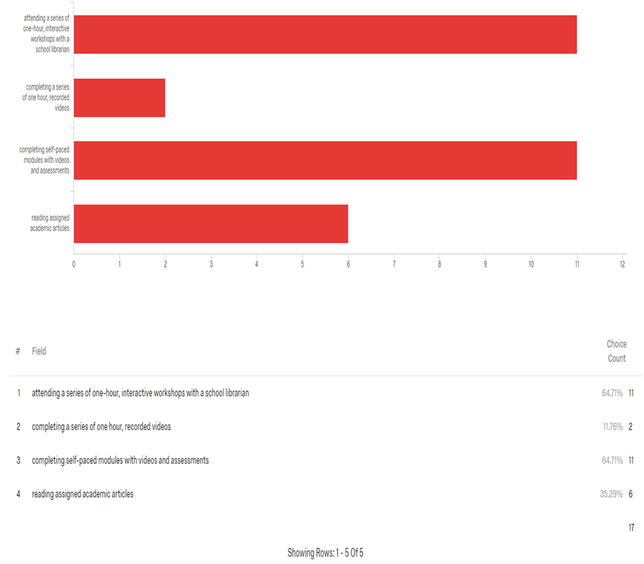
Figure 2. Confidence Rating Results

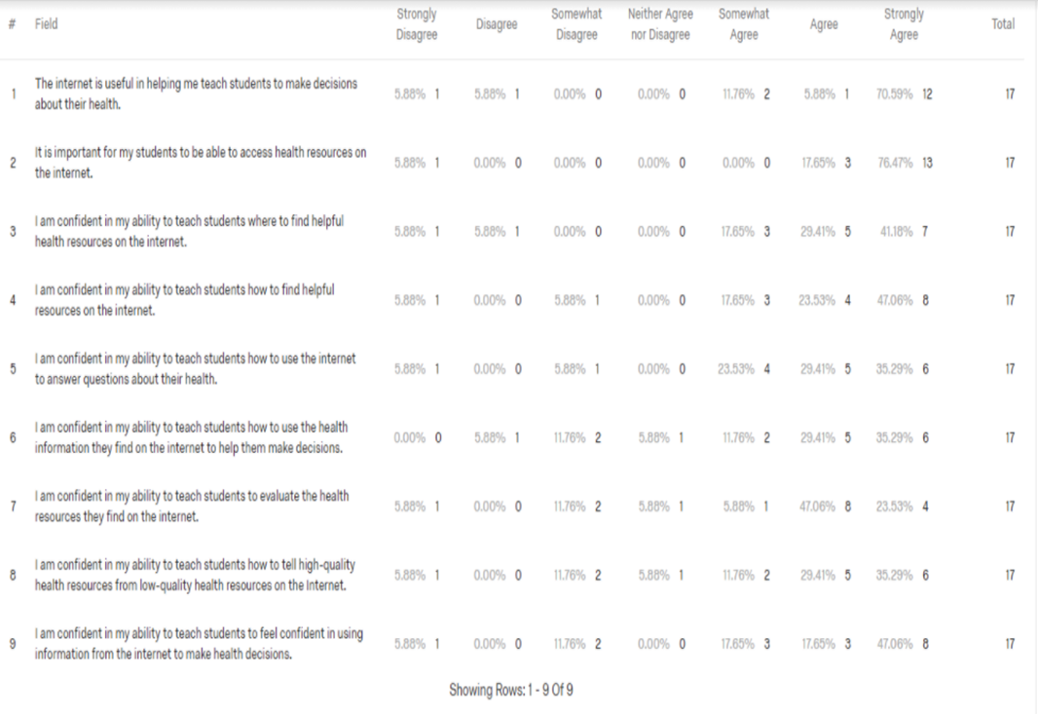
Figure 3. Learning Preference Results

Sketches
The creation of this course prototype followed Lepore’s sketch to design continuum (Lepore, 2010), which illustrates the relationship between design communication, level of fidelity, and iteration between phases. Following that model, the project design began with freehand sketches--ideas that served as the foundation for the wireframe and design work. Sketches help generate ideas and possibilities; they are low-stake, low-investment, quick, disposable, and minimally detailed. Figures 5 and 6 are examples of sketches. Figure 6 depicts a sample functional flow, a rough approximation of how a user would navigate through the course, while Figure 5 is an initial approximation of the course home page.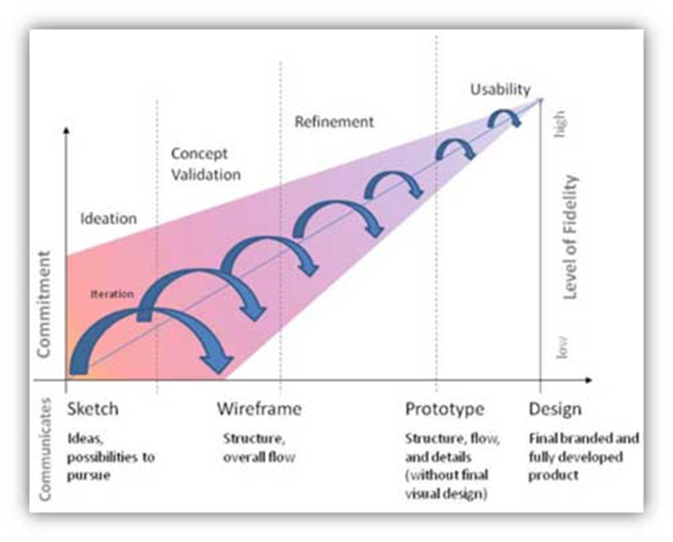
Figure 4. Lepore's Sketch to Design Continuum

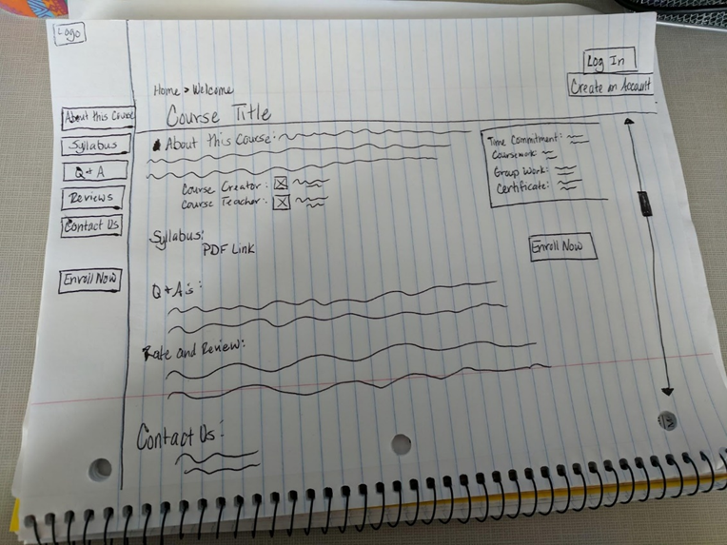
Figure 5. Sample Idea Sketch

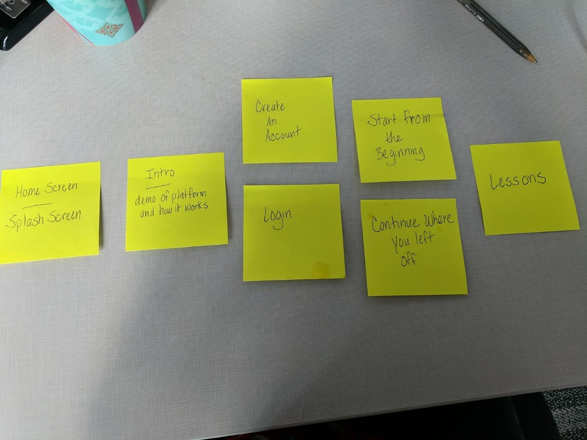
Figure 6. Sample Functional Flow

Personas

Personas are representations of key target audiences, based on qualitative and quantitative user research. Personas help define the purpose and vision for a resource, describe the user, and describe the user’s motivation. Personas generally include:
- a fictional name
- job title
- responsibilities
- demographics such as age, education, and ethnicity
- goals and tasks when using the resource
- physical, social, and technological environment
- a quote that summarizes the user’s goals for the resource

Three personas were designed for this project; one representing a new, inexperienced teacher—Felicity Mills, one representing an experienced teacher—Jamie Woodard, and one representing a school librarian—Sarah Slater. These personas can be found in Appendix F.

Workflow Sketches

Testing workflow usability is important because it helps to ensure a workflow process runs smoothly and that users feel in control throughout their use of an application. Testing a project’s workflow early in its design can reveal undiscovered errors in relatedness, can users connect screen A with screen B? It can also reveal issues surrounding abandonment, are users giving up because they don’t know what to do? And it can reveal areas of potential frustration, is the workflow time and task efficient (Nielsen, 2011).

This project tested three workflows:

1. The sample workflow for Felicity depicts how a user would navigate when starting at the home page, as a new or returning user.

2. The sample workflow for Jamie depicts how a user would navigate after logging in or creating an account.

3. The sample workflow for Sarah depicts how a user would navigate at the start of the first lesson.

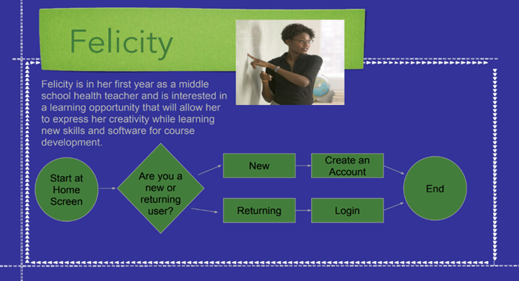
Figure 7. Sample Workflow, Felicity

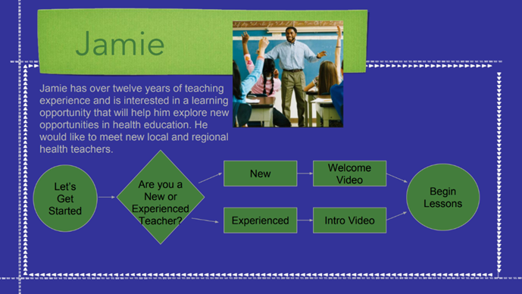
Figure 8. Sample Workflow, Jamie

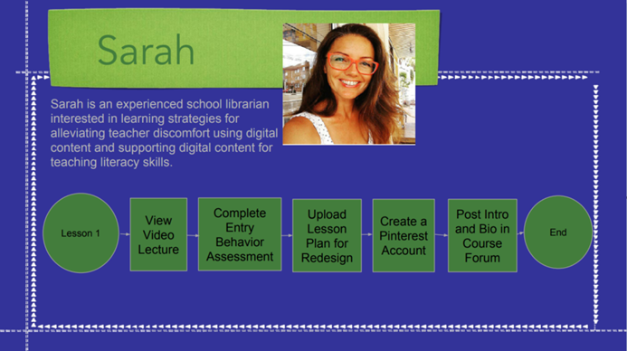
Figure 9. Sample Workflow, Sarah

Wireframes

Wireframes serve as visual guides for a website’s structure and the relationship between pages. They outline a site’s structure and flow. Wireframes are a response to the best ideas generated during the sketching phase; they are slightly refined sketches that should be quick and inexpensive to generate and minimally detailed (Lepore, 2010). Balsamiq was used to create the wireframes for this project, then prototypes were generated from the results.

Balsamiq is a rapid prototyping tool that allows for the quick creation and editing of mockups. In this preliminary approach, the designer drafted several prototypes for a course home page and a course content page. Then, one school librarian and one health teacher tested the prototypes and gave feedback. Participants were recruited from a local high school and were not compensated. Each prototype test was moderated by an experienced designer, was live and in-person, and the user’s navigation was recorded. These records, with user feedback, were used to select the most usable designs for prototyping testing in Axure.

Prototypes

The most usable Balsamiq prototypes, one for the home screen and one sample content page, served as the basis for Axure prototype designs. Axure is a wireframing and tool that creates highly functional, prototypes. Figure 10 illustrates an Axure prototype design for the initial enrollment page--the launch screen for the course. It is a refinement of the earlier Sample Idea Sketch, Figure 5, which was slightly edited in its Balsamiq wireframe.

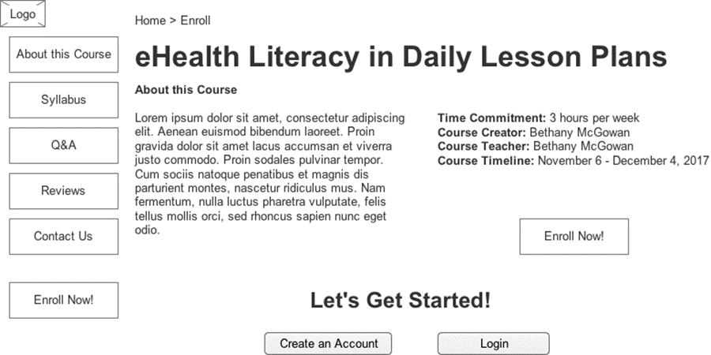
Figure 10. Home Page Prototype (Axure)

After the Axure prototypes were created, they were user tested. 9 participants were tested over a two-day time period using a Concurrent Think Aloud (CTA) technique that encouraged participants to think aloud while completing assigned tasks. The tests were moderated by an experienced facilitator who welcomed each participant, explained the user testing process, proved a written and verbal assignment of tasks, and took notes on participant behavior and success/failure of each task. The tests were conducted using a User Testing Tasks Script. See Appendix D for the full document. Data collected included task completion rates.

Final Design

The Axure prototypes and the results of the user tests, provided the structure, flow, and details needed for the final design. Marvel App was used to add elements of visual design, branding, and to more fully develop the course.

Figure 11 illustrates the final design for the course’s Main Menu. After users have logged in, the appropriate week is highlighted, so they can easily pick up where they left off. This page was created in response to the results of the user testing, where participants expressed a need for a page between the homepage and the beginning of the first lesson and they needed a means to more easily navigate between lessons. Finally, users desired a means to more easily distinguish between lessons, so leach lesson was given an icon and unique color scheme.

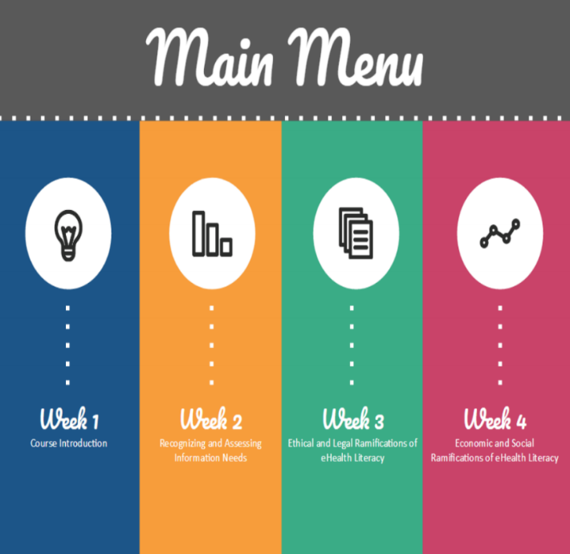
Figure 11. Final Marvel Prototype, Main Menu

Figure 12 illustrates what users see when they select Week 1 from Main Menu--a summary of the week’s required readings, assessments, assignments, and learning activities. From this point, users can return to the main menu, view their account, or start the lesson. Week 1 content includes behavior change strategies identified in the literature review; it includes a section that reviews course goals, objectives and expectations and includes an entry behavior assessment to help participants and instructors measure specific student needs. It also uses a course forum and social media, Pinterest, to engage participants and create a sense of community. 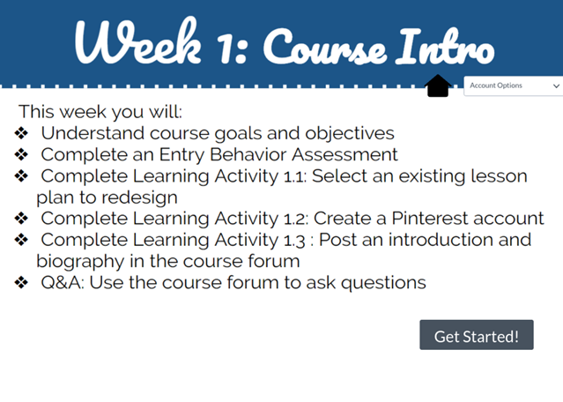
Figure 12. Final Marvel Prototype, Week 1

Figure 13 represents a content page of required coursework for Week 1. Content slides include information that introduces students to the course--for example, grading schemes, a code of conduct, and activities. They follow a consistent design and color scheme so users have a predictable experience while completing the unit. A Progress Bar is included in the upper right corner to help users track where they are in the process and keep them motivated by highlighting progress once they’ve completed a task; at the bottom of each page is a Back button so users can easily re-visit content on previous pages; a Main Menu button returns users to the course’s Main Menu, and a Next button allows users to proceed through the unit. In the final page of the unit, a ‘Complete’ button replaces the ‘Next’ button and users receive a check mark to indicate they have completed the unit. See Appendix C for a full synopsis of Week 1 content.

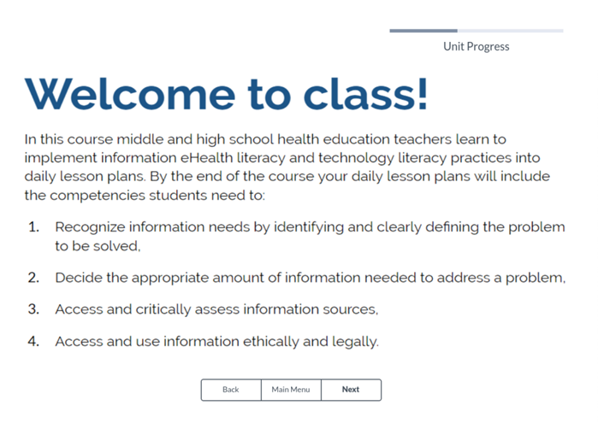
Figure 13. Marvel Final Prototype, Start of Week 1

Task Outcomes

To test the course prototype, 9 participants were given a prompt and a series of task to complete. The assigned tasks and results are below.

Your school librarian and several colleagues have been discussing how much they’ve enjoyed a new course training opportunity for health teachers on eHealth literacy. Before you enroll in the course, you want to know more about it.

How much of a time commitment will the course require?

Number of participants | 9
Percent successful | 9/9

Results
8 participants completed the task with ease (score of “2”) by finding the correct information.  1 participant needed prompting or had significant difficulty completing the task (score of “1”)  No participants did not complete the task (score of “0”) | Total Score: 17/18  7 participants found the information by reading the text on the home page. 1 participants used the Q&A button. 1 participant used the Syllabus button before returning to the home page to find the information.

Where would you go to find more specific information about coursework and assignments?

Number of participants | 9
Percent successful | 9/9

Results
9 participants completed the task with ease (score of “2”) by finding the correct information.  No participants needed prompting or had significant difficulty completing the task (score of “1”)  No participants did not complete the task (score of “0”) | Total Score: 18/18  9 participants found the information by using the Syllabus button.
Where would you go to find general information about the course?

Number of participants | 9
Percent successful | 9/9

Results
9 participants completed the task with ease (score of “2”) by finding the correct information.  No participants needed prompting or had significant difficulty completing the task (score of “1”)  No participants did not complete the task (score of “0”) | Total Score: 18/18  5 participants found the information by reading the text on the homepage. 3 participants used the About this Course button. 1 participant used the Q&A button.

You are a new user. How would you register for the course?

Number of participants | 9
Percent successful | 9/9

Results
9 participants completed the task with ease (score of “2”) by finding the correct information.  No participants needed prompting or had significant difficulty completing the task (score of “1”)  No participants did not complete the task (score of “0”) | Total Score: 18/18  9 participants found the information by selecting the Enroll Now! Button.

You are a returning user. How would you pick up where you last left off?

Number of participants | 9
Percent successful | 7/9

Results
1 participants completed the task with ease (score of “2”) by finding the correct information.  6 participants needed prompting or had significant difficulty completing the task (score of “1”)  2 participants did not complete the task (score of “0”) | Total Score: 8/18  7 participants found the information by selecting the Login Button. 2 participants could not complete the task.

Where would you find information about what previous course attendees have to say about the course?

Number of participants | 9
Percent successful | 6/9

Results
6 participants completed the task with ease (score of “2”) by finding the correct information.  No participants needed prompting or had significant difficulty completing the task (score of “1”)  3 participants did not complete the task (score of “0”) | Total Score: 12/18  6 participants found the information by using the Reviews Button. 3 participants selected the Q&A button.

Chapter 4: Discussion and Conclusion

Discussion
A review of the literature reveals evidence of a digital divide and disparities in eHealth literacy competencies amongst adolescents. As information shifts to become mostly electronically available, literacy education is struggling to keep up. Librarians in K-12 education, responsible for teaching information literacy competencies, struggle with issues that include difficulty locating appropriate digital content for classroom use, teacher discomfort using digital content, and unclear strategies for moving teachers to sustained digital content use in the classroom. Findings from research in behavior change communication suggest that the digital divide and eHealth literacy disparities can be alleviated with customizable, systemic interventions. The Transtheoretical Model provides an example of how such interventions can be designed. This research project focuses the development of an Open Educational Resource (OER) that educators, particularly librarians and high school & middle school health teachers, can use to design lesson plans that combat the digital divide, teach eHealth literacy competencies, and encourage behavior change.
This project included the execution of a needs assessment to determine teacher confidence in teaching health literacy competencies and to determine learning preferences. 17 surveys were completed and returned, and the results revealed that teachers are mostly confident in their ability to teach eHealth literacy competencies, but are interested in learning to improve their confidence in teaching students to use the internet to answer health-related questions and in evaluating health information. When asked how they would prefer to learn, nearly 65% of responses reported a preference for learning through self-paced modules, and over 35% responded with a preference to learn through reading assigned academic articles. The OER prototype design for this project utilized both self-paced modules and assigned readings of academic articles.

Balsamiq Wireframe User Testing Analysis

The findings from the initial user tests, the wireframe testing, revealed user confusion when navigating between lessons and when attempting to return to the home page once a lesson was started. These findings resulted in the creation of a Main Menu, a page that allowed users to more easily navigate between lessons and to return to the course home page; and also to the creation of a "Home" icon on each lesson page that navigated users back to the Home Page. After testing was completed, users were asked what might encourage them to register for the course; these verbal responses revealed a desire to see a rating system and results from colleagues who had previously completed the course. This led to the creation of a "Student Reviews" component, which allowed prospective students to see comments and ratings from users who completed the course. Finally, during the wireframe testing users expressed the need for one central place to find detailed information about the course. This led to the creation of a syllabus that users were able to access from the enrollment page prior to registering for the course, and from the Home page after they were enrolled in the course.

Axure Prototype User Testing Analysis

The results of the wireframe testing informed the design of an Axure prototype of the course, which was tested on 9 participants. Starting at the course Home Page, participants were asked to complete a series of tasks. Users were encouraged to verbalize questions or concerns as they encountered them in their completion of the assigned tasks.
- Task 1: How much of a time commitment will the course require?

With a completion rate of 100%, participants were successful in completing a task that required them to find general information, such as time commitment, about the course. The most direct method for finding the requested information was by reading the text on the home page, and 7 of the 9 participants used that approach. 1 participant used the Q&A button and 1 used the Syllabus button to retrieve the requested information. These results suggest that general information, such as time commitment, should be repeated throughout the site. 1 participant had difficulty completing the task, overlooking the requested information on both the home page and on the course syllabus, but ultimately finding it on the Q&A page.
- Task 2: Where would you go to find more specific information about coursework and assignments?

With a completion rate of 100%, participants were successful in completing a task that required them to find detailed course information. All 9 participants used the Syllabus button to find the requested information, without none having difficulty completing the task. The suggestion to include a course syllabus for potential students emerged during the paper prototype testing and the results of the Axure prototype tests suggest that students, particularly teachers, will navigate to a syllabus or similar resource for detailed course information.
- Task 3: Where would you go to find general information about the course?

This task, similar to Task 1, asked participants to find general course information. The findings from the results of Task 1—that general information should be repeated throughout the site, were confirmed as participants used a range of resources to find the information. 5 participants read the information on the home page, 3 participants used the About the Course button, and 1 participant used the Q&A button. All participants were able to complete the task without difficulty, for a completion rate of 100%
- Task 4: You are a new user. How would you register for the course?

Whereas previous tasks asked users to locate information that could be found in multiple places, Task 4 required users to find information only available on the Home Page. All 9 participants completed the task with ease by selecting one of the “Enroll Now” buttons on the Home Page. During Task 1, one participant overlooked the requested information on the Home Page, ultimately finding the information elsewhere, but that participant was able to complete Task 4 with ease. These findings suggested that some information on the Home Page needed to be more distinguished, and led to a change in the Home Page layout, where some general information such as course instructor, course timeline, and course time commitment was more clearly labeled and placed into a separate column.
- Task 5: You are a returning user. How would you pick up where you last left off?

Task 5 required participants to make an intuitive assumption that they would need to login to pick up where they last left off. 7 of the 9 participants completed the task, but 6 of those 7 needed prompting before being able to complete the task and 2 participants were not able to complete the task. The 7 participants who completed the task all used the Login button. To alleviate this issue buttons were relabeled; a New User button allowed participants to create an account, while a Returning User button allowed participants to log-in and pick up where they left off in a lesson.
- Task 6: Where would you find information about what previous course attendees have to say about the course?

Task 6 served as a test of the site’s architecture in testing user’s ability to interpret labels. In this task users were asked to find what previous course attendees said about the course, information that was located under a button labeled ‘Reviews’. This button could only be accessed from the course Home Page. 6 of the 9 participants completed the task with ease, but 3 participants could not find the requested information and failed to complete the task. To alleviate this issue, the access to course reviews were placed on other pages as informed by where participants looked for information in their completion of other tasks, including the Q&A page and the About the Course page.
- Task 7: Navigate through Lesson 1.

In this final task, users began at the start of Lesson 1 and were asked to navigate through the entire lesson, to the end. They were asked to verbalize each new action taken as they continued through the lesson and those verbal responses informed design changes. This feedback focused on implementing changes that helped users more easily track their progress through the lesson and resulted in the inclusion of a progress bar throughout each lesson page to allow participants to see how much of a lesson was completed and roughly how much was left. Feedback also led to the inclusion of a check mark and a ‘Complete’ status to indicate a lesson’s completion. Other feedback surrounded the ease in distinguishing lessons from one another and ultimately led to each lesson being color-coded, to allow users to more quickly and easily distinguish between lessons.

The results and modifications from the wireframe testing and the Axure prototype testing informed the design of an interactive Marvel Prototype. These Marvel prototypes are illustrated in Appendix C.

Content Analysis

Course content, activities, and flow utilize an active learning approach based on Jerome Bruner’s Constructivist Theory which suggests learning is “an active process in which learners construct new ideas or concepts based upon their current/past knowledge” (Bruner, 1966). The proposed activities work to engage learners in reflection activities that build on existing knowledge and help progress learners toward a greater understanding of new knowledge. This approach was particularly relevant as the needs assessment revealed that participants self-identified as feeling mostly confident in their ability to teach health literacy, technology literacy, and behavior change competencies but hoped to develop a greater expertise. Activities were designed to allow participants to interpret information, reflect, and build on their existing knowledge. One activity, the redesign of an existing lesson plan, threaded throughout the entire course and served to tie each of the four units together.

An entry behavior assessment in Week 1 provides the instructor a basis for measuring student need, and when paired with the exit assessment in Week 4, serves as a quantitative and qualitative means to measure student learning. Weeks 2 and 3 include quiz assessments to incrementally test student knowledge and measure learning throughout the course. Further qualitative assessments are provided through student use of the course forums.

Students are encouraged to participate in the creation of course content with a requirement to create a Pinterest account and, each week, contribute related content to a shared course Pinterest board. They are also required to leave a comment on at least two other pins. This approach utilizes social media to allow students to gather related course content on a platform that remains accessible after the course’s completion.
Several measures were implemented to cultivate a community of practice. The course structure is simple, with each week following a predictable layout that includes required readings, an assessment, two learning activities, and one assignment. Expectations are clearly established in Week 1. Students e-introduce themselves at the beginning of the course and are organized into groups. Each week, a group leads the class in a review of the assigned weekly readings. Throughout the week students are encouraged to use the course forum—a private forum and the course Pinterest board—a public forum, to ask questions and stimulate conversation. At the end of the course, alumni are added to a LinkedIn group, if desired, allowing them to remain connected.
Conclusion
The creation and testing of this open educational resource prototype focus on training high school and middle school health teachers to integrate eHealth literacy competencies into their curriculums using innovative multimedia technology. This focus on eHealth literacy aims to minimize the digital divide and to minimize eHealth literacy disparities by improving teacher confidence. It highlights the importance of collaboration between teachers, designers, and librarians in the creation of digital health interventions. User feedback for the need of such a resource was positive--both in the results of the literature review and in the user testing process. Potential next steps include collaborating with an instructional designer to design the curriculum for the course then finding a home for the course, on a home-grown platform or an existing one--such as OER Commons. Other steps might include the development of eHealth literacy training materials for adolescent use.

References
Bensley, R. J., Anderson, J. V., Brusk, J. J., Mercer, N., & Rivas, J. (2011). Impact of internet vs traditional Special Supplemental Nutrition Program for Women, Infants, and Children nutrition education on fruit and vegetable intake. Journal of the American Dietetic Association, 111(5), 749-755.

Bruner, J. S. (1966). Toward a theory of instruction. Harvard University Press.

Di Noia, J., Contento, I. R., & Prochaska, J. O. (2008). Computer-mediated intervention tailored on transtheoretical model stages and processes of change increases fruit and vegetable consumption among urban African-American adolescents. American Journal of Health Promotion, 22(5), 336-341.

File, T. (2013). Computer and Internet Use in the United States. Current Population Survery Reports, P20-568. US Census Bureau, Washington, DC.

Jacobson, R. E., & Jacobson, R. (Eds.). (2000). Information design. MIT press.

Joyce, A. (2007). OECD study of OER: forum report. Retrieved from https://www.researchgate.net/profile/Alexa_Joyce2/publication/265183257_OECD_study_of_OER_forum_report/links/564b064e08ae9cd9c827cf5a.pdf on January 09, 2018.

Lepore, T. (2010). Sketches and wireframes and prototypes! Oh my! Creating your own magical wizard experience. Retrieved from www.uxmatters.com/mt/archives/2010/05/sketches-and-wireframes-and-prototypes-oh-my-creating-your-own-magical-wizard-experience.php on January 09, 2018.

Manganello, J. A., & Sojka, C. J. (2016). An Exploratory Study of Health Literacy and African American Adolescents. Comprehensive Child and Adolescent Nursing, 39(3), 221-239.

McLuhan, M., & Fiore, Q. (1967). The medium is the message. New York.

Meyer, K. (2016). Designing for Young Adults (Ages 18–25). Retrieved from https://www.nngroup.com/articles/young-adults-ux/ on November 26, 2017.

Nielsen, J. (1995). 10 usability heuristics for user interface design. Nielsen Norman Group.

Nielsen, J. (2011). Workflow expectations: presenting steps at the right time. Retrieved from https://www.nngroup.com/articles/workflow-expectations/ on January 10, 2018.

Paek, H.J. (2010). Adolescent Ehealth Literacy in Rural and Limited Media Environments. Paper presented at the National Conference on Health Communication, Marketing and Media.

Pettersson, R. (2014). Information Design Theories. Journal of Visual Literacy, 33(1), 1-96.
Riff, D., Lacy, S., & Fico, F. (2014). Analyzing media messages: Using quantitative content analysis in research. Routledge.

Ritterband, L. M., Thorndike, F. P., Cox, D. J., Kovatchev, B. P., & Gonder-Frederick, L. A. (2009). A behavior change model for internet interventions. Annals of Behavioral Medicine, 38(1), 18.

Ritzhaupt, A. D., Liu, F., Dawson, K., & Barron, A. E. (2013). Differences in student information and communication technology literacy based on socio-economic status, ethnicity, and gender: Evidence of a digital divide in Florida schools. Journal of Research on Technology in Education, 45(4), 291-307.

Roseman, M. G., Riddell, M. C., & Haynes, J. N. (2011). A content analysis of kindergarten-12th grade school-based nutrition interventions: taking advantage of past learning. Journal of nutrition education and behavior, 43(1), 2-18.

Sapire, I., & Reed, Y. (2011). Collaborative design and use of open educational resources: a case study of a mathematics teacher education project in South Africa. Distance Education, 32(2), 195-211.

Schneiderman, B., & Plaisant, C. (1998). Designing the user interface.

School Libraries. (2016). American Libraries, 47, 9-11.

Spencer, R. A., Rehman, L., & Kirk, S. F. (2015). Understanding gender norms, nutrition, and physical activity in adolescent girls: a scoping review. International Journal of Behavioral Nutrition and Physical Activity, 12(1), 6

Wantland, D. J., Portillo, C. J., Holzemer, W. L., Slaughter, R., & McGhee, E. M. (2004). The effectiveness of Web-based vs. non-Web-based interventions: a meta-analysis of behavioral change outcomes. Journal of medical Internet research, 6(4).

Webb, T. L., Joseph, J., Yardley, L., & Michie, S. (2010). Using the internet to promote health behavior change: a systematic review and meta-analysis of the impact of theoretical basis, use of behavior change techniques, and mode of delivery on efficacy. Journal of medical Internet research, 12(1).

Welz, K. (2017). School Librarians and Open Educational Resources Aid and Implement Common Core Instructional Content in the Classroom. Knowledge Quest, 45(4), 62.

Wenger, E., McDermott, R., & Snyder, W. M. (2002). Seven principles for cultivating communities of practice. Cultivating Communities of Practice: a guide to managing knowledge, 4.

Wodtke, C., & Govella, A. (2011). Information architecture: Blueprints for the Web. Pearson Education.

Wurman, R. S., & Leifer, L., Dave, Whitehouse, Karen. (2001). Information anxiety 2. Que.

Appendix A: Needs Assessment, eHealth Literacy Teaching Scale
I would like to ask you for your opinion and about your experience using the Internet for health information. For each statement, tell me which response best reflects your opinion and experience right now.
1. The internet is useful in helping me teach students to make decisions about their health.
□ Strongly Disagree
□ Disagree
□ Undecided
□ Agree
□ Strongly Agree

2. It is important for my students to be able to access health resources on the internet.
□ Strongly Disagree
□ Disagree
□ Undecided
□ Agree
□ Strongly Agree

3. I am confident in my ability to teach students where to find helpful health resources on the internet.
□ Strongly Disagree
□ Disagree
□ Undecided
□ Agree
□ Strongly Agree

4. I am confident in my ability to teach students how to find helpful resources on the internet.
□ Strongly Disagree
□ Disagree
□ Undecided
□ Agree
□ Strongly Agree

5. I am confident in my ability to teach students how to use the internet to answer questions about their health.
□ Strongly Disagree
□ Disagree
□ Undecided
□ Agree
□ Strongly Agree

6. I am confident in my ability to teach students how to use the health information they find on the internet to help them make decisions.
□ Strongly Disagree
□ Disagree
□ Undecided
□ Agree
□ Strongly Agree

7. I am confident in my ability to teach students to evaluate the health resources they find on the internet.
□ Strongly Disagree
□ Disagree
□ Undecided
□ Agree
□ Strongly Agree

8. I am confident in my ability to teach students how to tell high-quality health resources from low-quality health resources on the Internet.
□ Strongly Disagree
□ Disagree
□ Undecided
□ Agree
□ Strongly Agree

9. I am confident in my ability to teach students to feel confident in using information from the internet to make health decisions.
□ Strongly Disagree
□ Disagree
□ Undecided
□ Agree
□ Strongly Agree

Thank you!

Appendix B: Needs Assessment Results
eHealth Literacy Needs Assessment for Teachers
Q1 - Click to select the appropriate response.

# | Question | Strongly Disagree |  | Disagree |  | Somewhat Disagree |  | Neither Agree nor Disagree |  | Somewhat Agree |  | Agree |  | Strongly Agree |  | Total
1 | The internet is useful in helping me teach students to make decisions about their health. | 5.88% | 1 | 5.88% | 1 | 0.00% | 0 | 0.00% | 0 | 11.76% | 2 | 5.88% | 1 | 70.59% | 12 | 17
2 | It is important for my students to be able to access health resources on the internet. | 5.88% | 1 | 0.00% | 0 | 0.00% | 0 | 0.00% | 0 | 0.00% | 0 | 17.65% | 3 | 76.47% | 13 | 17
3 | I am confident in my ability to teach students where to find helpful health resources on the internet. | 5.88% | 1 | 5.88% | 1 | 0.00% | 0 | 0.00% | 0 | 17.65% | 3 | 29.41% | 5 | 41.18% | 7 | 17
4 | I am confident in my ability to teach students how to find helpful resources on the internet. | 5.88% | 1 | 0.00% | 0 | 5.88% | 1 | 0.00% | 0 | 17.65% | 3 | 23.53% | 4 | 47.06% | 8 | 17
5 | I am confident in my ability to teach students how to use the internet to answer questions about their health. | 5.88% | 1 | 0.00% | 0 | 5.88% | 1 | 0.00% | 0 | 23.53% | 4 | 29.41% | 5 | 35.29% | 6 | 17
6 | I am confident in my ability to teach students how to use the health information they find on the internet to help them make decisions. | 0.00% | 0 | 5.88% | 1 | 11.76% | 2 | 5.88% | 1 | 11.76% | 2 | 29.41% | 5 | 35.29% | 6 | 17
7 | I am confident in my ability to teach students to evaluate the health resources they find on the internet. | 5.88% | 1 | 0.00% | 0 | 11.76% | 2 | 5.88% | 1 | 5.88% | 1 | 47.06% | 8 | 23.53% | 4 | 17
8 | I am confident in my ability to teach students how to tell high-quality health resources from low-quality health resources on the Internet. | 5.88% | 1 | 0.00% | 0 | 11.76% | 2 | 5.88% | 1 | 11.76% | 2 | 29.41% | 5 | 35.29% | 6 | 17
9 | I am confident in my ability to teach students to feel confident in using information from the internet to make health decisions. | 5.88% | 1 | 0.00% | 0 | 11.76% | 2 | 0.00% | 0 | 17.65% | 3 | 17.65% | 3 | 47.06% | 8 | 17
Q2 - Please indicate how you would most prefer to learn about teaching eHealth literacy, technology literacy, and behavior change communication.
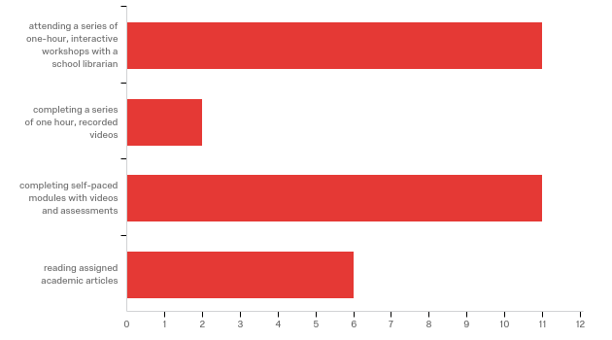

# | Answer | % | Count
1 | attending a series of one-hour, interactive workshops with a school librarian | 64.71% | 11
2 | completing a series of one hour, recorded videos | 11.76% | 2
3 | completing self-paced modules with videos and assessments | 64.71% | 11
4 | reading assigned academic articles | 35.29% | 6
 | Total | 100% | 17
Q3- Additional comments or suggestions?

Additional comments or suggestions?
These are important skills.
I would prefer this as an online training opportunity. Evaluating information sources on the internet is timely.
A Coursera class or something similar would be great!
Appendix C: Week 1 Content Prototypes
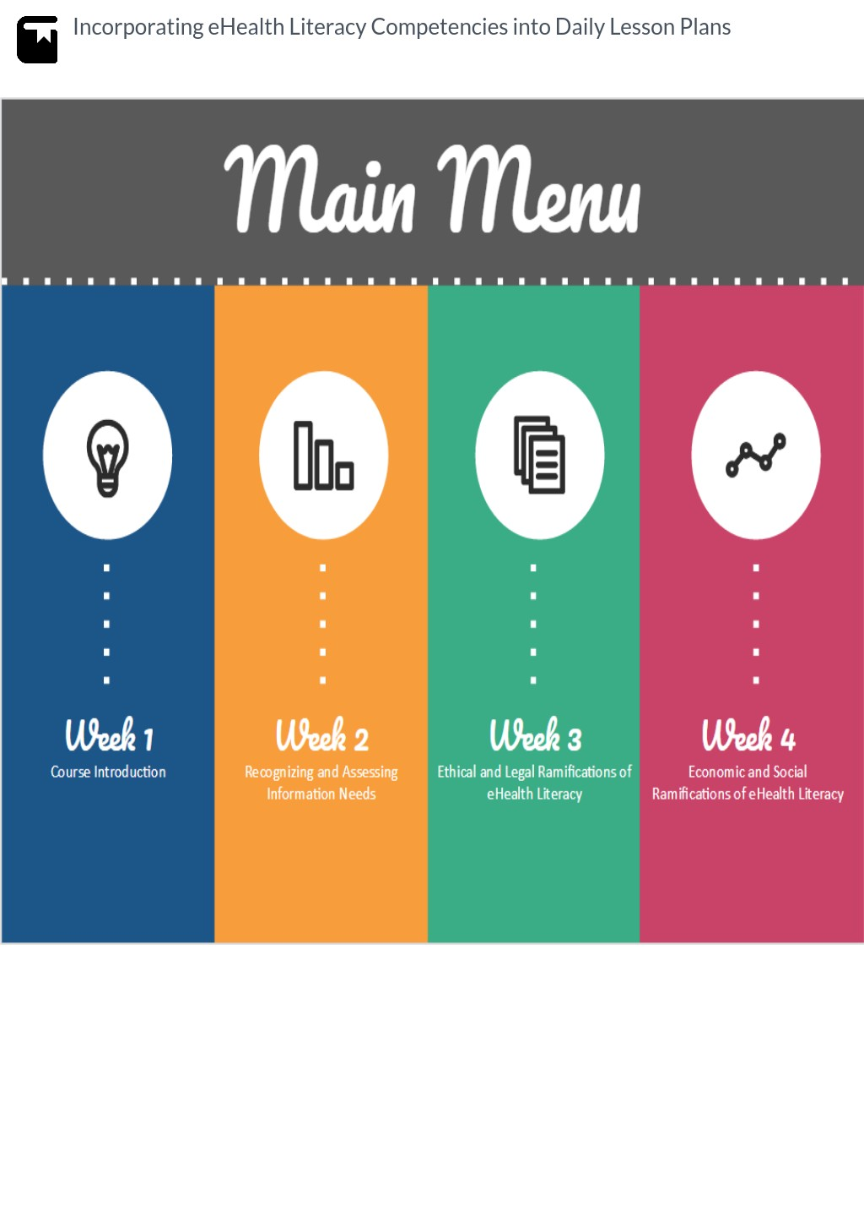

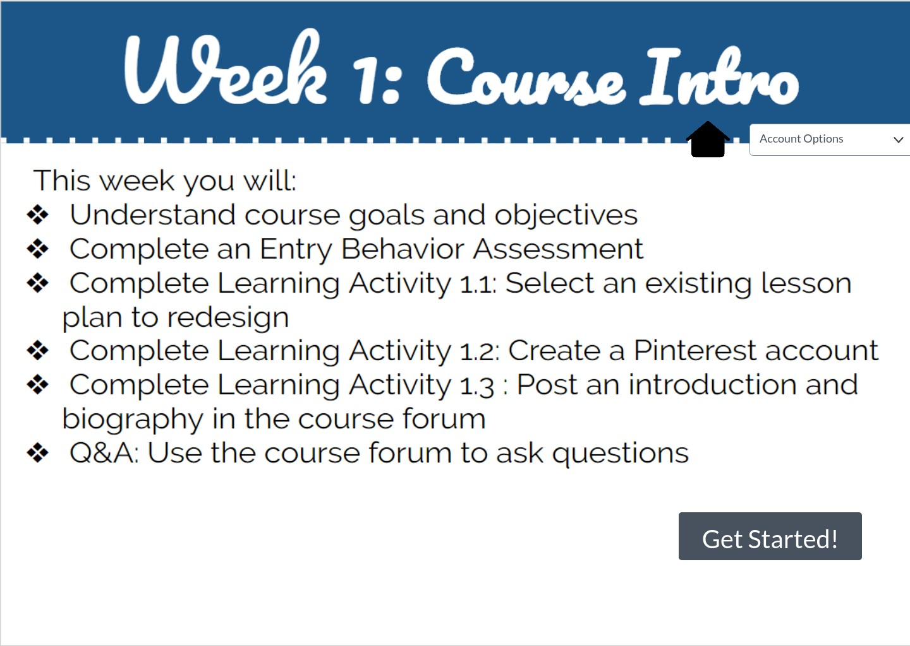

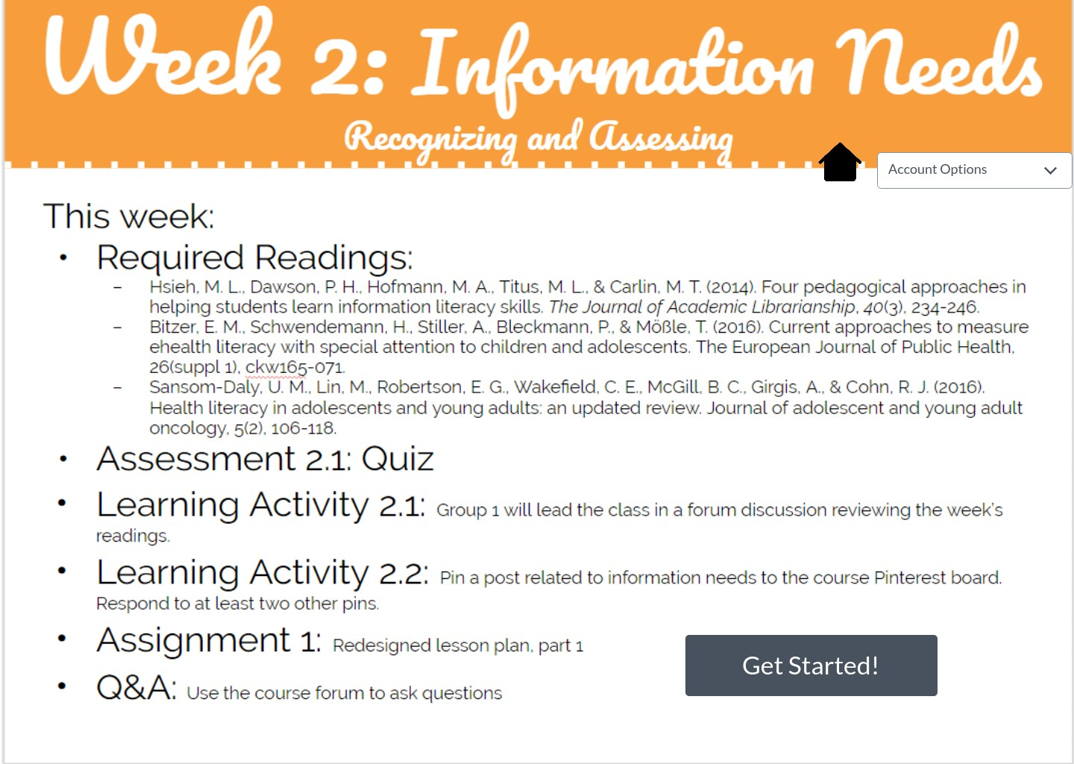

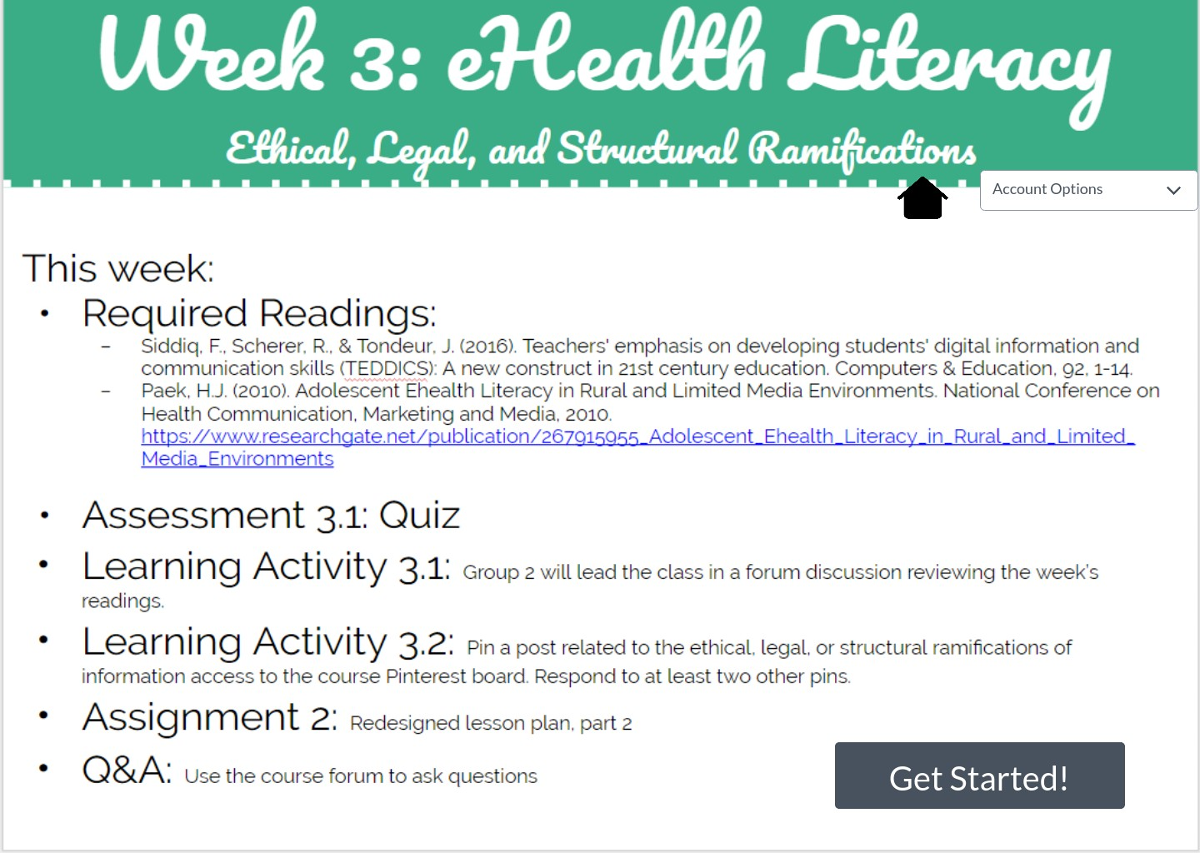

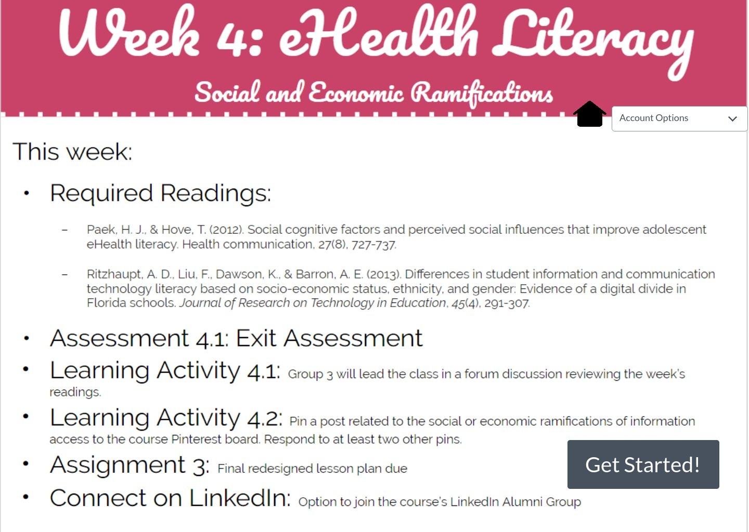

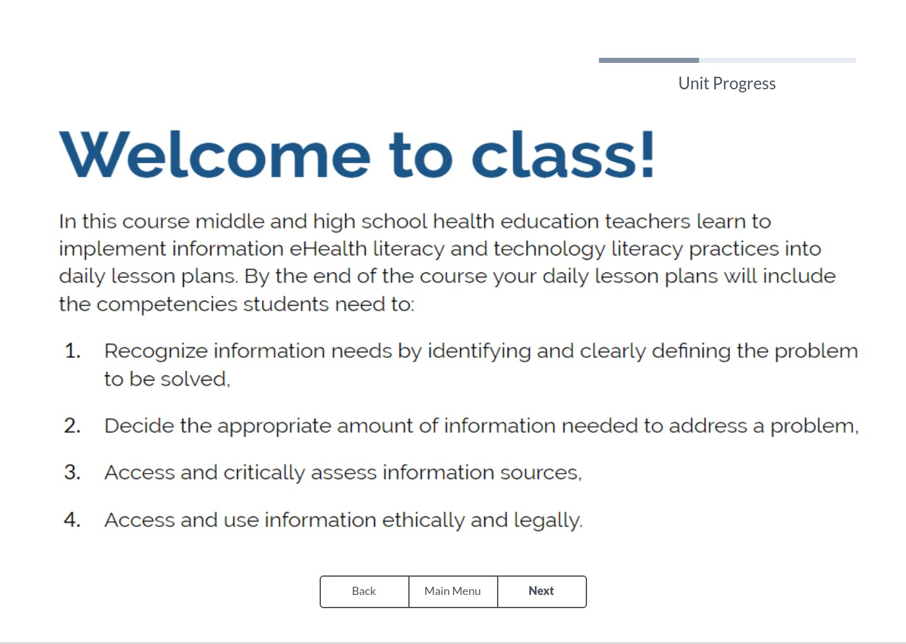

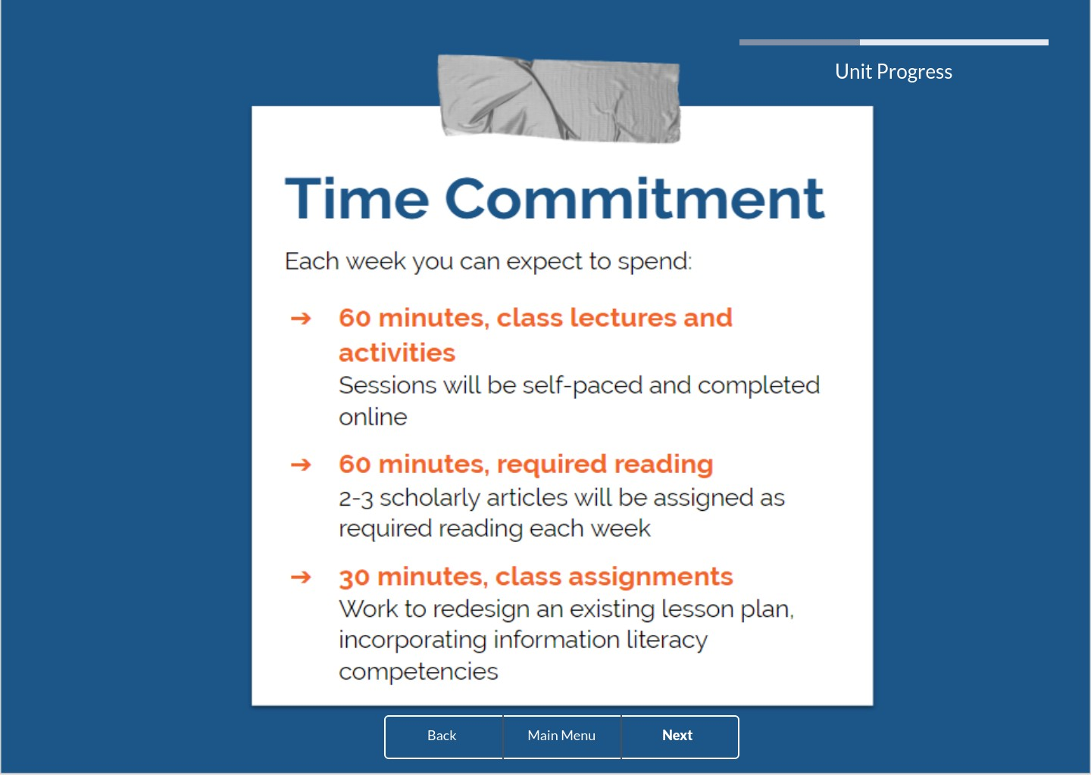

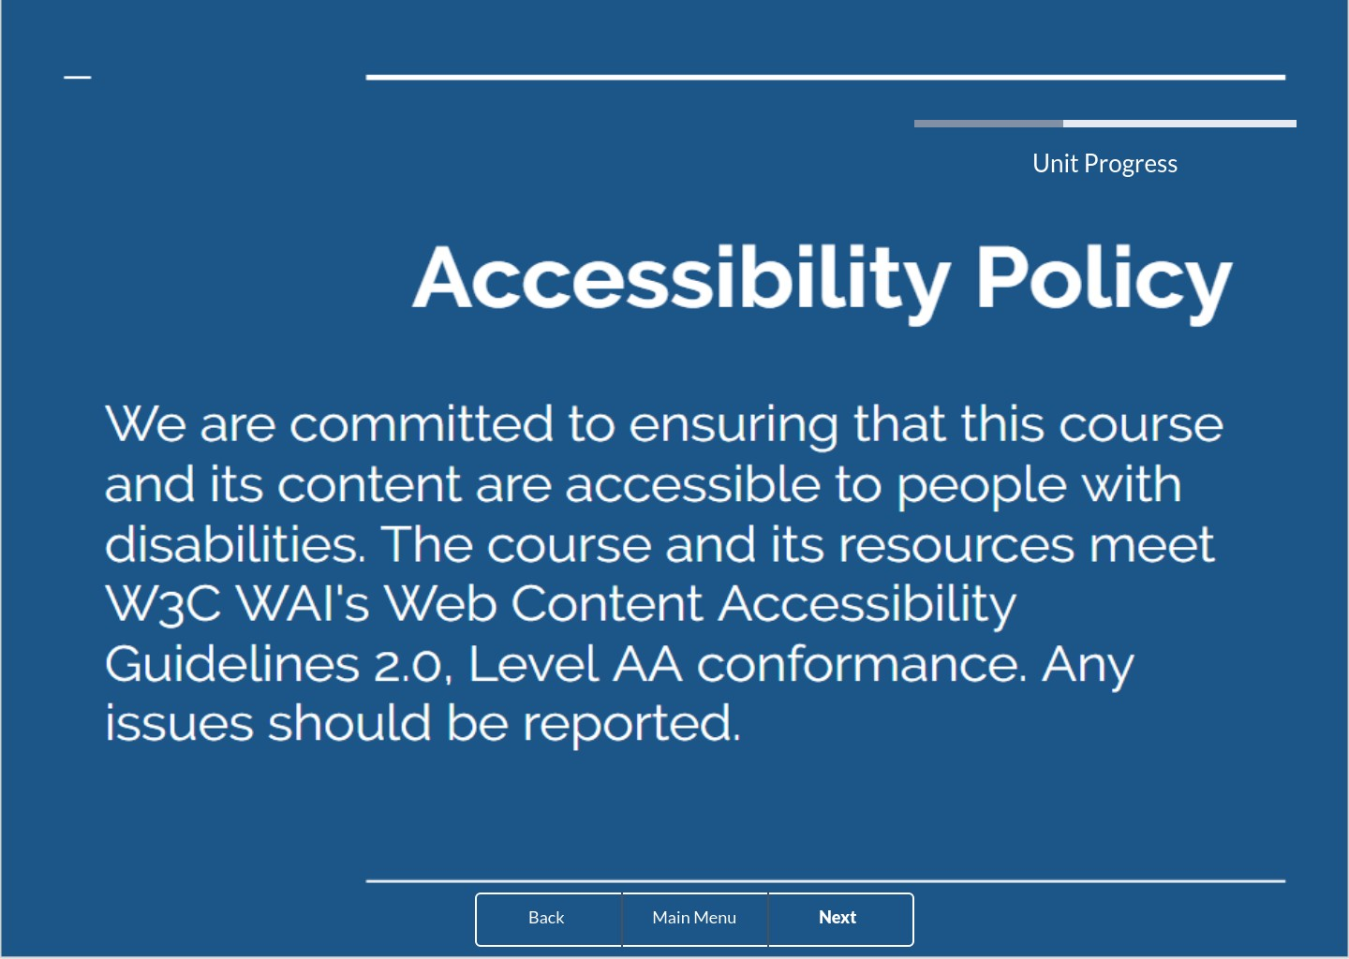

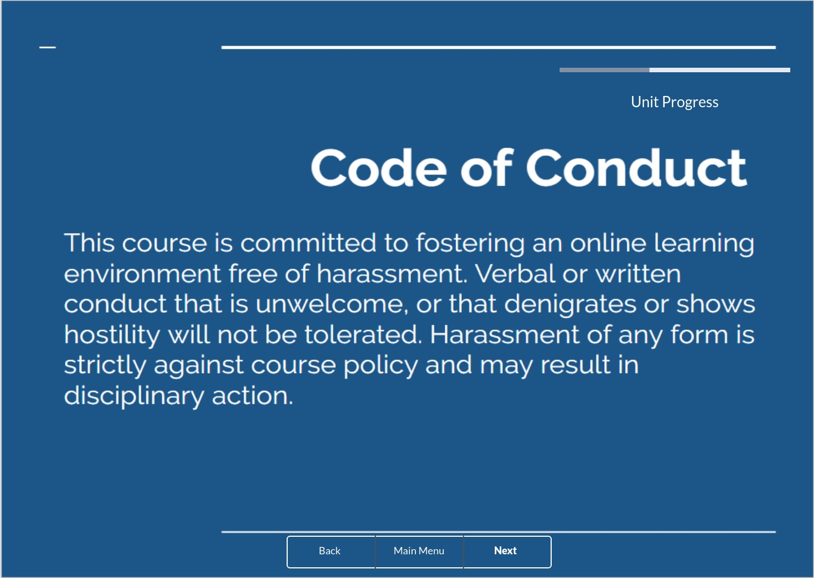

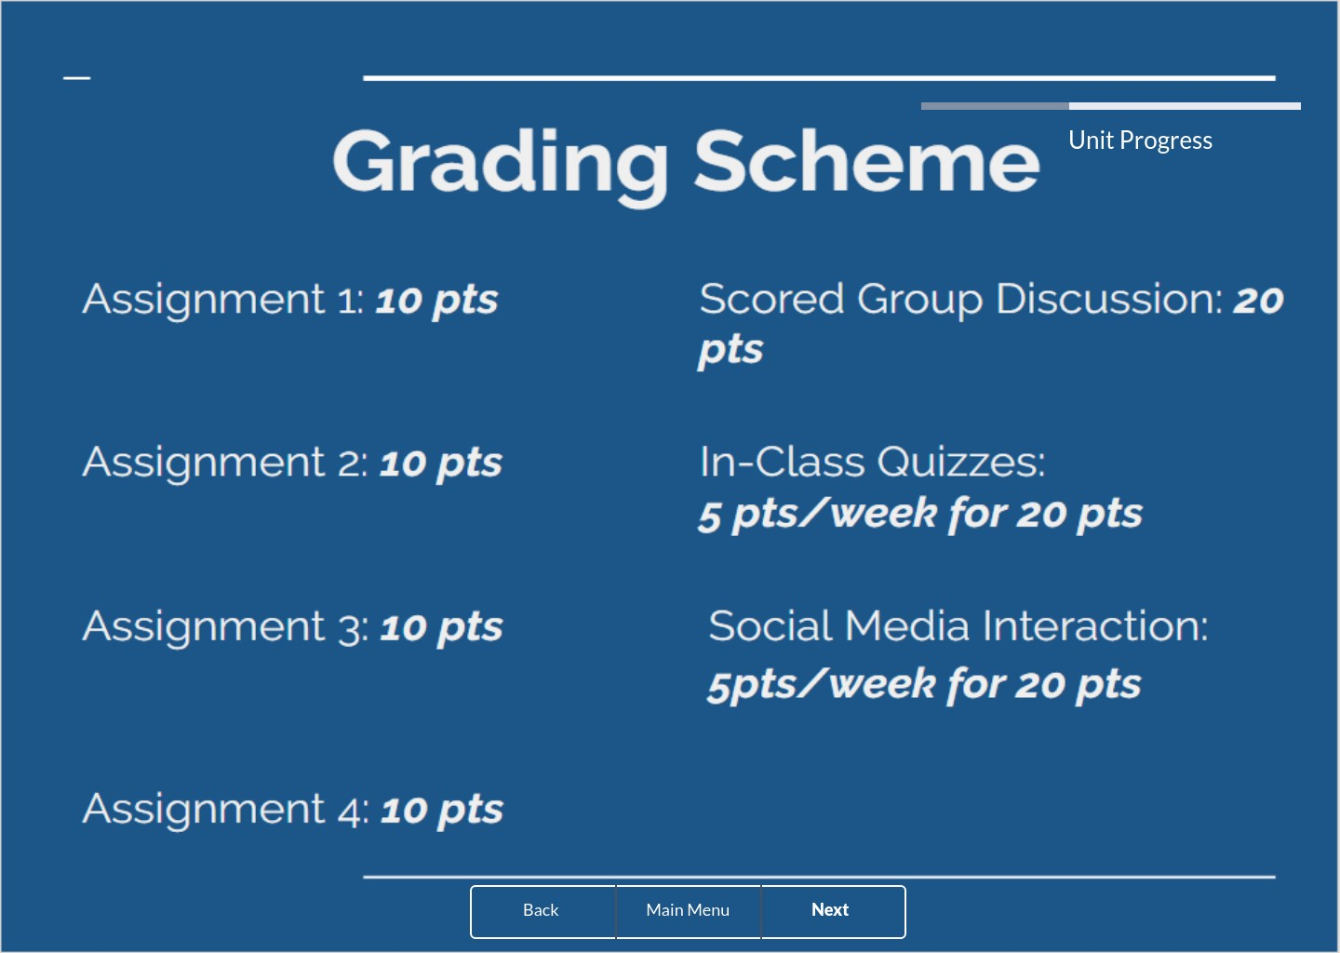

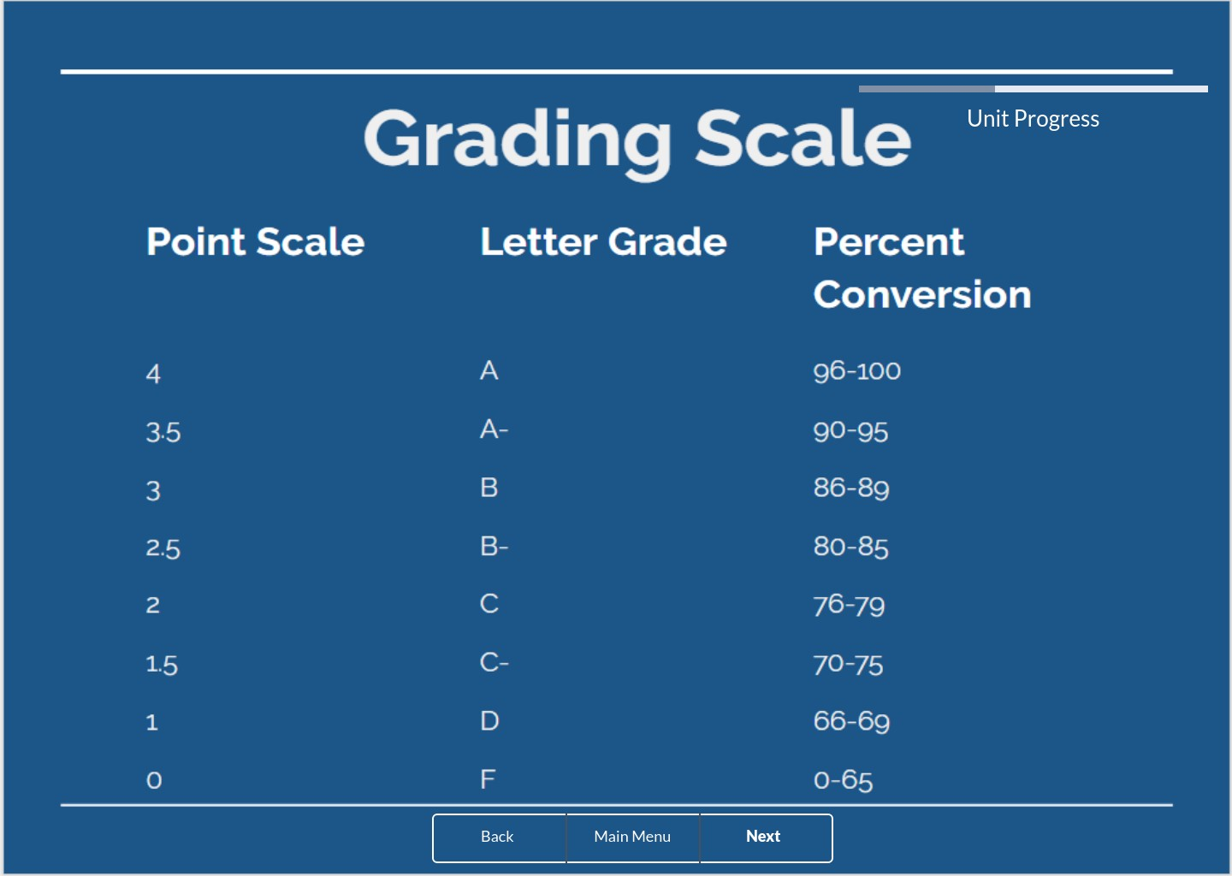

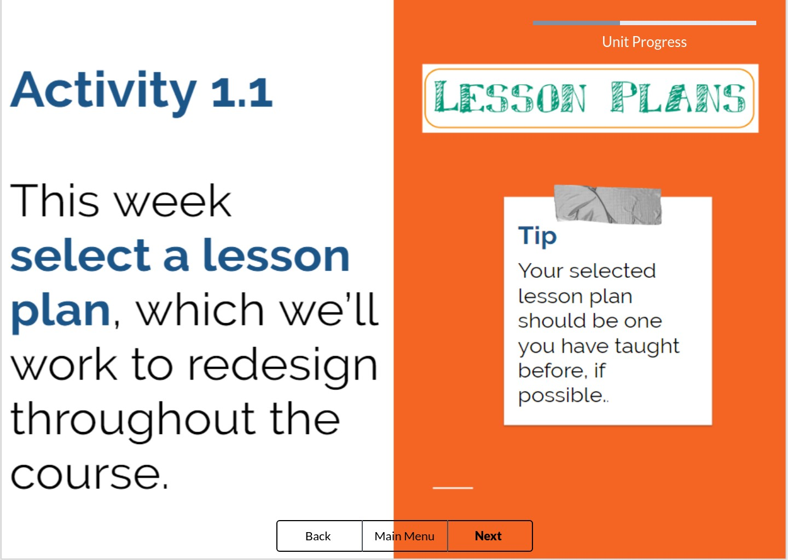

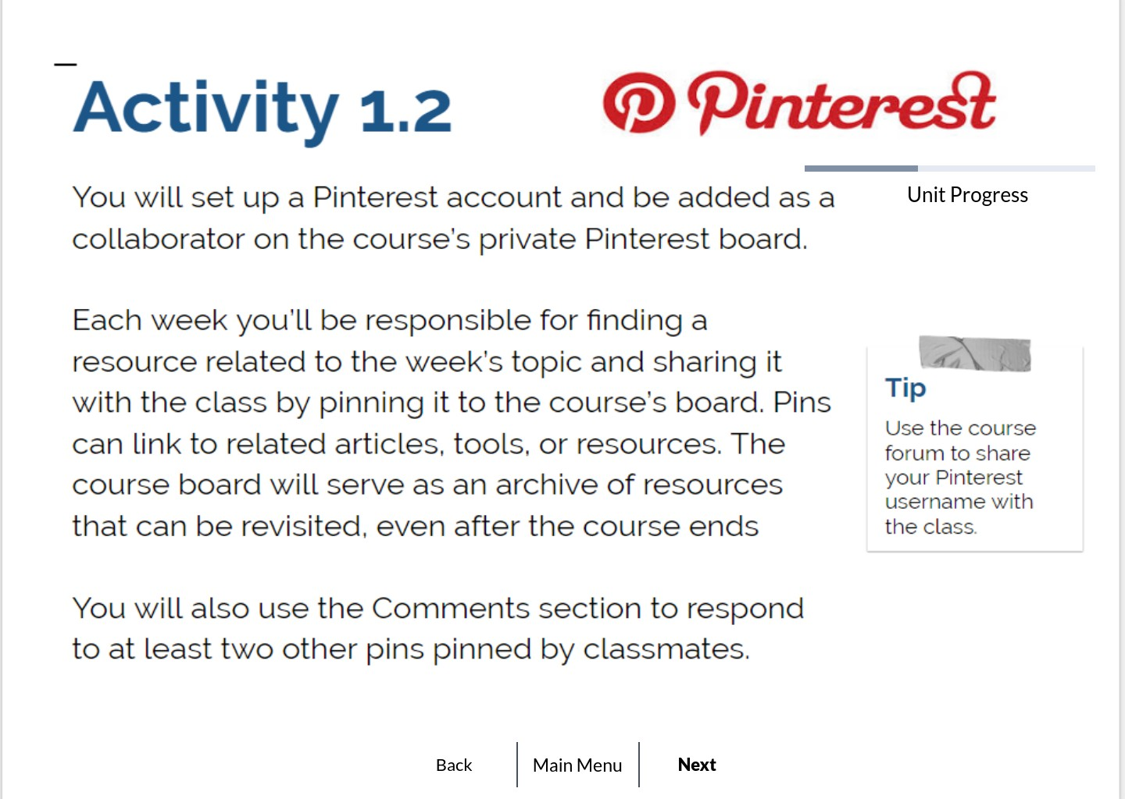

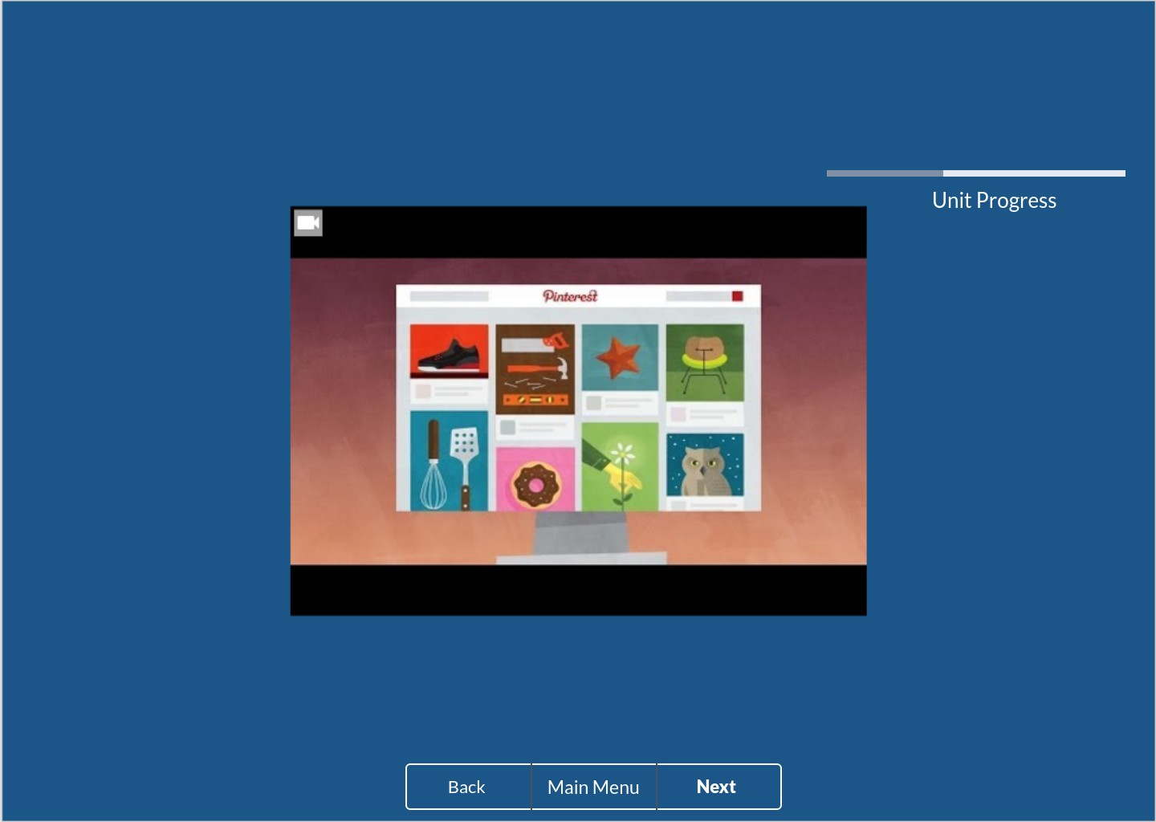
Video Tutorial for Using Pinterest

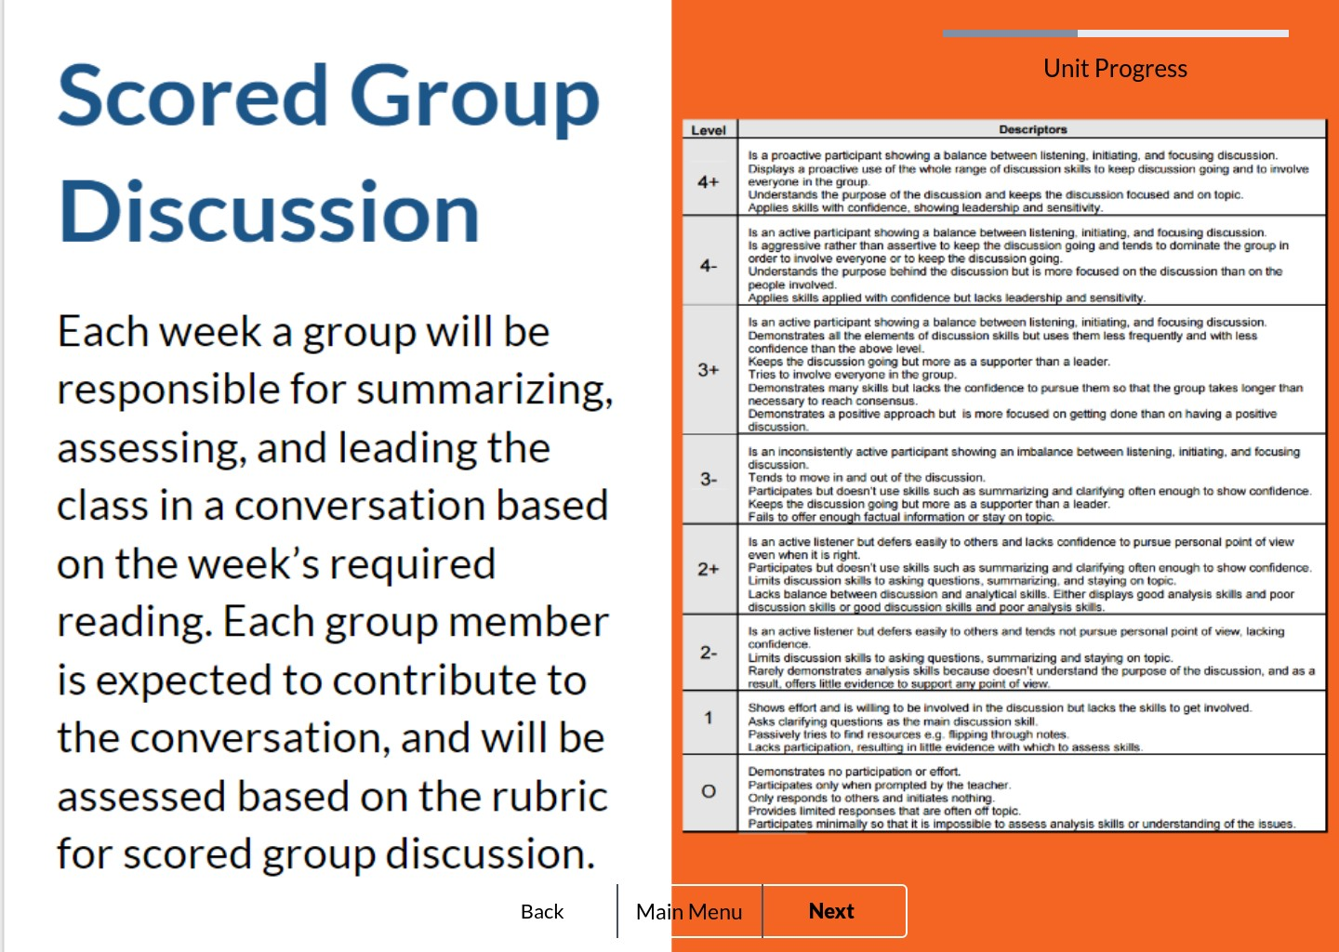

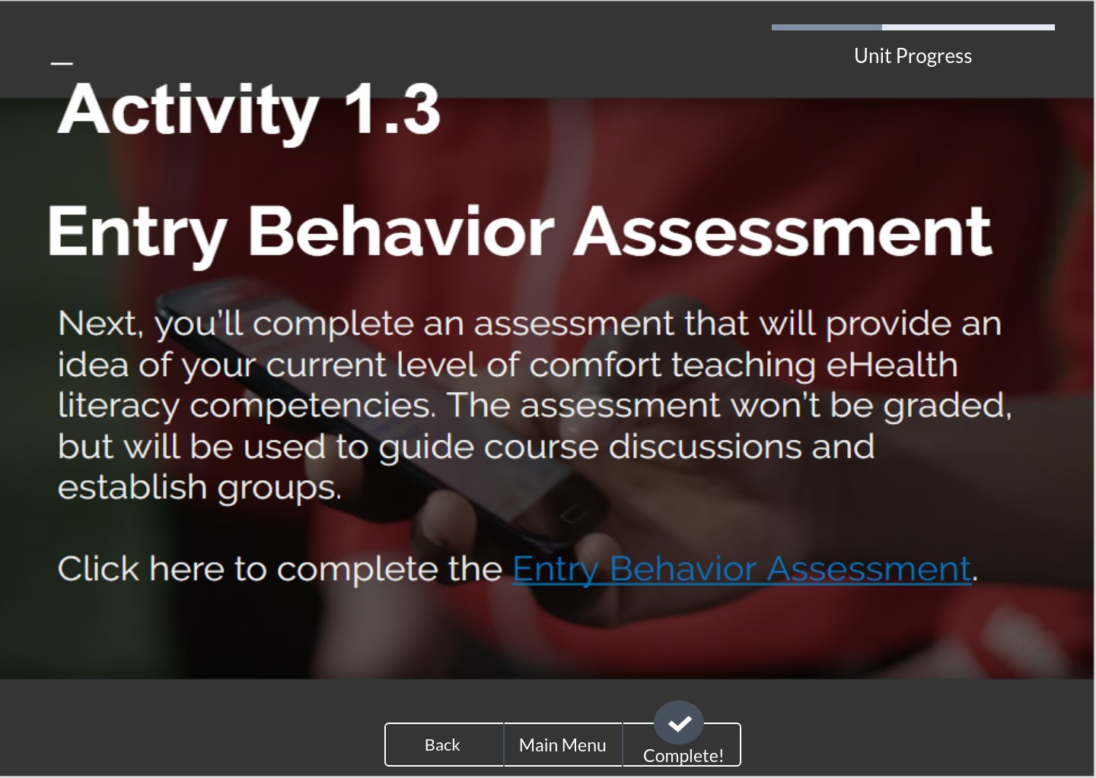

Appendix D: User Testing Tasks Script
Welcome and Purpose
Thank you so much for coming in today. I want to give you a little information about what you will be looking at and give you time to ask any questions you might have before we get started. Today we are asking you to serve as an evaluator of a course website and to complete a set of tasks. Our goal is to see how easy or difficult you find the site to use.

Test Facilitator’s Role
I am here to record your reactions and your successes and/or failures in completing tasks related to the website you will view. During this session, I would like you to think aloud as you work to complete the tasks. I will be able to offer suggestions or hints if needed. I may also ask you to clarify what you have said or ask you for information on what you were looking for or what you expect to have happened.

Test Participant’s Role
Today I am going to be asking you to look for some information on the site and tell me how easy or difficult it was to find the information. These activities are all about how easy we have made it for people to use the site. There is no right or wrong answer. If you have any questions, comments or areas of confusion while you are working, please let me know. If you ever feel that you are lost or cannot complete a task with the information that you have been given, please let me know. I will ask you what you might do in a real-world setting and then either put you on the right track or move you on to the next scenario. As you use the site, please do so as you would at home or your office. I would ask that you to try work through the tasks based on what you see on screen, but if you reach a point where you are not sure where or how to find something, please feel free to use ‘Search’.

I may ask you other questions as we go and we will have wrap-up questions at the end. Do you have any questions before we begin?
Tasks
1. Before you enroll in the course you want to learn more about it.
- How much of a time commitment will the course require?
- Where would you go to find more specific information about coursework and assignments?
- Where would you go to find general information about the course?
- You are a new user. How would you register for the course?
- You are a returning user. How would you pick up where you last left off?
- Where would you find information about what previous course attendees have to say about the course?

2. Please navigate through Week 1, Course Introduction.

Appendix E: Common Design Suggestions
Nielsen’s Ten Usability Heuristics (Nielsen, 1990)
- Visibility of system status. Keep users informed of what’s happening by providing actionable and timely feedback.
- Match between the system and the real world. Speak the user’s language by using familiar words, phrases, and concepts. Avoid system-oriented terms. Information should be natural and logically organized.
- User control and freedom. Users will inevitably choose a function by mistake. Provide an out that will allow users to avoid too much hassle. Undo and redo options work well.
- Consistency and standards. Follow conventions so users don’t question if different words or actions mean the same thing.
- Error prevention. Good design prevents problems from occurring. Get rid of situations that easily generate errors and allow users to confirm actions before they commit to them.
- Recognition rather than recall. People generally have trouble remembering things—make things easier by making actions and options clearly visible. Don’t force users to remember information across dialogs. Provide visible, easily retrievable instructions
- Flexibility and efficiency of use. Allow shortcuts, or accelerators, for expert users. Allow users to customize actions.
- Aesthetic and minimalist design. Get rid of any irrelevant or rarely used information.
- Help users recognize, diagnose, and recover from errors. Use plain language to express error messages. Tell the problem, directly, and provide a solution.
- Help and documentation. Design like you won’t need help documentation, but provide it anyway. Help guides should be searchable, task-oriented, and list concrete steps.

Schneiderman’s Eight Golden Rules of Interface Design (Schneiderman, 1998)
- Strive for consistency.
- Allow frequent users the option to use shortcuts.
- Offer informative feedback.
- Design dialog to yield closure.
- Offer simple error handling.
- Permit easy reversal of actions.
- Support internal locus of control.
- Reduce short-term memory load.

Appendix F: Personas

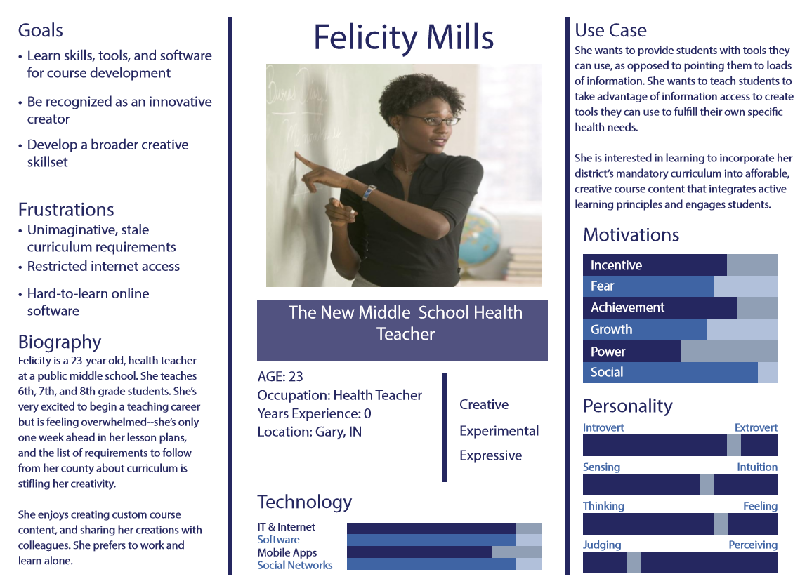
Persona 1. Felicity Mills

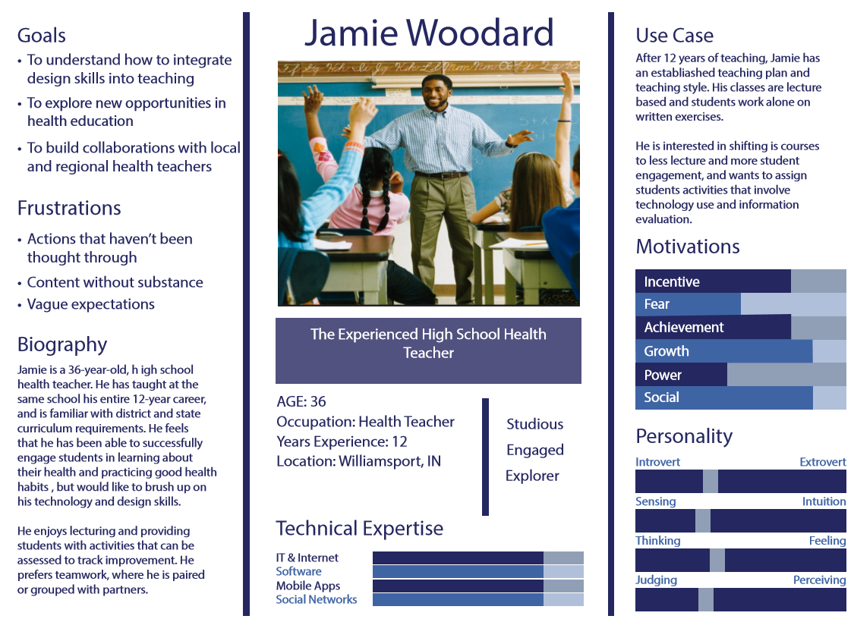
Persona 2. Jamie Woodard

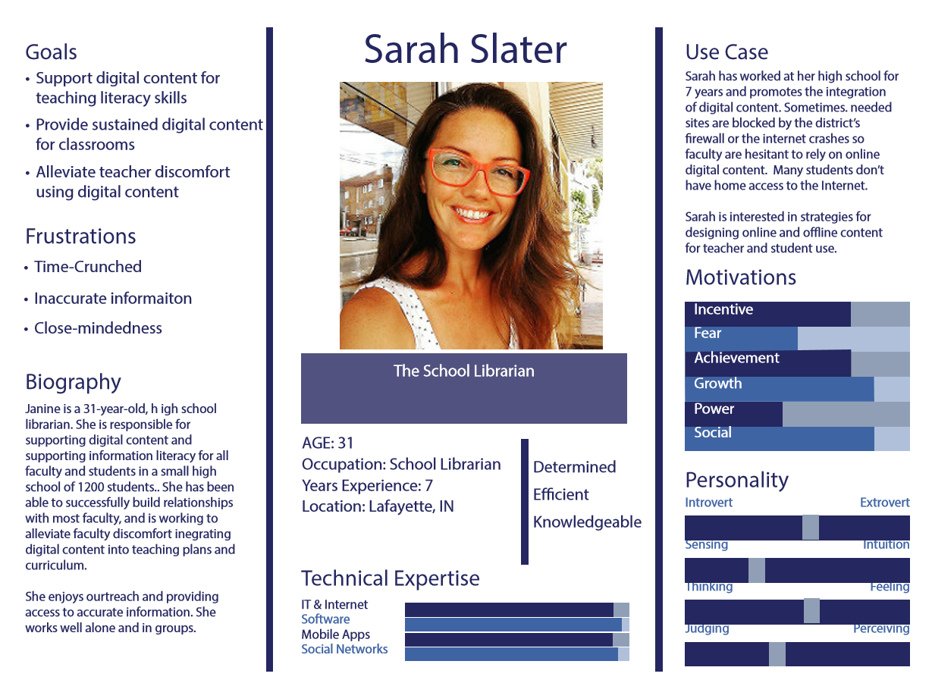
Persona 3. Sarah Slater

