Ephemeral Stream Network Extraction from Lidar-Derived Elevation and Topographic Attributes in Urban and Forested Landscapes

Marina J. Metes, Daniel K. Jones, Matthew E. Baker, Andrew J. Miller, Dianna M. Hogan, J.V. Loperfido, and Kristina G. Hopkins

U.S. Geological Survey, Maryland-Delaware-District of Columbia Water Science Center (Metes), Baltimore, Maryland, USA; U.S. Geological Survey, Utah Water Science Center (Jones), West Valley City, Utah, USA; Department of Geography and Environmental Systems, University of Maryland, Baltimore County (Baker, Miller), Baltimore, Maryland, USA; U.S. Geological Survey, Southeast Region (Hogan), Reston, Virginia, USA; Unaffiliated (Loperfido); and U.S. Geological Survey, South Atlantic Water Science Center (Hopkins), Raleigh, North Carolina, USA (Correspondence to Metes: mmetes@usgs.gov)

Supporting Information

Table S1: Metrics used to rank networks in how closely they resemble the field network. Omission (false negatives) and commission (false positives) were used to calculate sensitivity and reliability, respectively, with values closer to 1 ranking higher than values closer to 0. Ratios of length to network length were subtracted from 1, and values closest to 0 ranked highest. Sensitivity, reliability, and length were weighted equally, and the final rank is found in the Weight Rank column.

Openness Network | Number of Predicted Channel Heads (Shreve Magnitude) | Total Number of Matched Channel Heads | Omission | Commission | Network Length (km) | Sensitivity | Reliability | Absolute Value of  1 – Length / True Length | Weight Rank
psi91.5/phi84 | 253 | 72 | 113 | 181 | 20.9 | 0.39 | 0.28 | 0.075 | 6.327
psi91/phi84 | 368 | 91 | 94 | 277 | 24.5 | 0.49 | 0.25 | 0.084 | 6.66
psi90.5/phi82 | 209 | 69 | 116 | 140 | 19.7 | 0.37 | 0.33 | 0.129 | 6.993
psi92/phi88 | 206 | 63 | 122 | 143 | 20.8 | 0.34 | 0.31 | 0.08 | 7.326
psi91/phi82 | 193 | 67 | 118 | 126 | 19.1 | 0.36 | 0.35 | 0.155 | 7.992
psi91.5/phi88 | 327 | 85 | 100 | 242 | 26 | 0.46 | 0.26 | 0.15 | 7.992
psi91.5/phi86 | 317 | 82 | 103 | 235 | 24.9 | 0.44 | 0.26 | 0.102 | 7.992
psi92/phi86 | 206 | 63 | 122 | 143 | 20.5 | 0.34 | 0.31 | 0.093 | 7.992
psi90.5/phi84 | 452 | 97 | 88 | 355 | 26.1 | 0.52 | 0.21 | 0.155 | 8.658
psi91.4/phi88* | 381 | 89 | 96 | 292 | 27.8 | 0.48 | 0.23 | 0.23 | 9.99
psi91.5/phi82 | 159 | 56 | 129 | 103 | 17.4 | 0.30 | 0.35 | 0.23 | 9.99
psi92/phi84 | 194 | 60 | 125 | 134 | 18.7 | 0.32 | 0.31 | 0.173 | 9.99
psi92/phi82 | 133 | 49 | 136 | 84 | 16.2 | 0.26 | 0.37 | 0.283 | 10.323
psi91/phi86 | 565 | 106 | 79 | 459 | 31.1 | 0.57 | 0.19 | 0.376 | 10.656
psi91/phi88 | 651 | 110 | 75 | 541 | 35.9 | 0.59 | 0.17 | 0.588 | 10.989
psi90.5/phi86 | 865 | 116 | 69 | 749 | 37.8 | 0.63 | 0.13 | 0.673 | 11.322
psi90.5/phi88 | 1464 | 128 | 57 | 1336 | 60.9 | 0.69 | 0.09 | 1.695 | 11.655

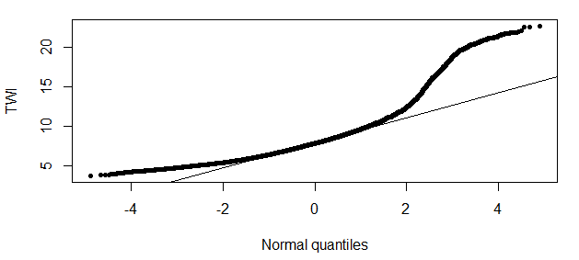
Figure S1: Quantile-quantile plot for the topographic wetness index (TWI) distribution and selected threshold of 9.6 based on deviation from the normal distribution.

A
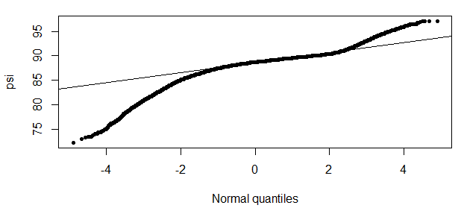
B
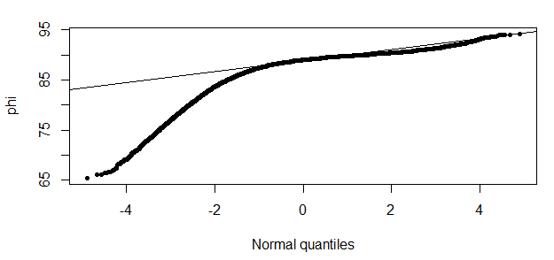
Figure S2: Quantile-quantile plots for (A) negative topographic openness (psi) showing the selected threshold of 91.4 at the upper tail of the deviation from the normal distribution and (B) positive topographic openness (phi) showing the selected threshold of 88 at the lower tail of the deviation from the normal distribution.
Figure S3. Distribution of drainage areas for each surveyed head in FOR and URB. Boxplot box bounds the 25% and 75% quantiles, solid line shows the median, and points indicate outliers.

