Safety and Efficacy of Autologous RNA Chimeric Antigen Receptor T-cell (rCAR-T) Therapy in Myasthenia Gravis
  - Supplementary Appendix

Table of Contents
MG-001 Study Team members 2
Supplementary Figures
Figure s1: Vaccine-associated antibody levels for individual participants who
received six once-weekly infusions of Descartes-08. 3
Supplementary Tables
Table s1: Baseline characteristics of participants who received retreatment
with Descartes-08. 4

MG-001 Study Team members
Volkan Granit MD¹, Michael Benatar MD PhD, ¹ Tahseen Mozaffar MBBS², Nizar Chahin MD³, James F. Howard Jr. MD⁴, Adam D. Slanksy MD⁵, Marc H. Feinberg MD⁶, Gregory Sahagian MD⁷, Tuan Vu MD⁸, Denise Pereira MD¹, Julie Steele RN¹, Maria Elena Paredes MD¹, Cara Benjamin PhD¹, Ali Aamer Habib MD², Julia Kimberly Fong CRC², Luis De La Cruz CRC, ² Diana Dimitrova PhD³, Manisha Chopra MBBS CCRP⁴, Kelly Holley CRC⁵, Gabrielle DeMaria MS⁶, April Tenorio CCRC⁷, Naraly Requena⁸, Beverly “Mackenzie” Brooks⁸, Niraja Suresh MD⁸, Jerrica Farias ARNP⁸, Miloš D. Miljković MD MSc⁹, Metin Kurtoglu MD PhD⁹, Minhtran Ngo Casi MD⁹, Adam Chowdhury MD⁹, C. Andrew Stewart PhD⁹, Mehmet Tosun MD⁹, Yufei Shang PhD⁹, Matthew T. Duverney PhD⁹, Maria Kireeva PhD⁹, Emily English PhD⁹, Christopher Jewell PhD⁹, Michael Singer MD PhD⁹, Murat Kalayoglu MD PhD⁹.
¹ University of Miami, Florida
² University of California Irvine
³ Oregon Health and Sciences University, Portland
⁴ University of North Carolina at Chapel Hill
⁵ Neurology Associates, Orlando, Florida
⁶ SFM Research, Boca Raton, Florida
⁷ Neurology Center of Southern California, San Diego, California
⁸ University of South Florida, Tampa
⁹ Cartesian Therapeutics, Fredrick, Maryland

Figure s1. Vaccine-associated antibody levels for individual participants who received six once-weekly infusions of Descartes-08. Early: Day 1, 8 or 15; Mid: Month 2, 3 or 4; Late: Month 12. Participant 2 was retreated and designated as “2R” after retreatment. Red X denotes time points for which a sample was not available.
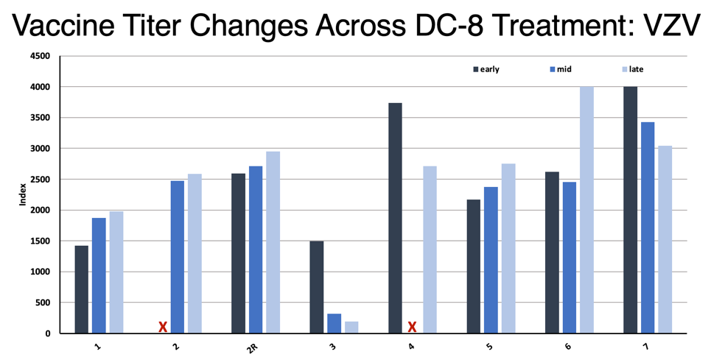
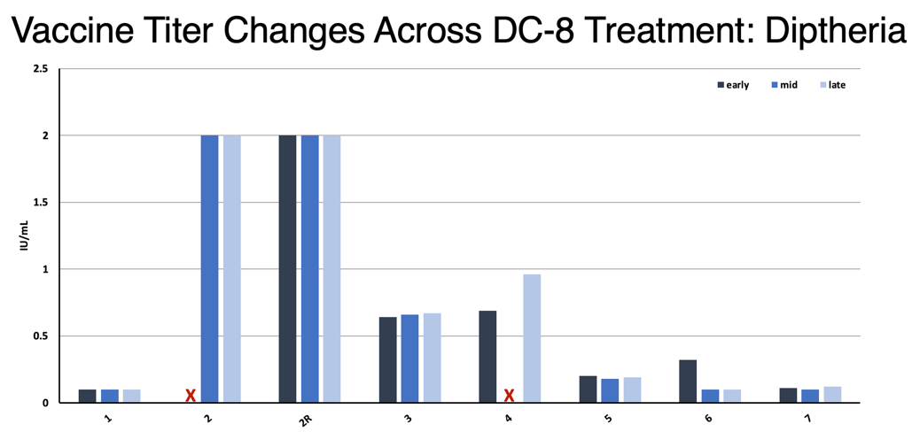
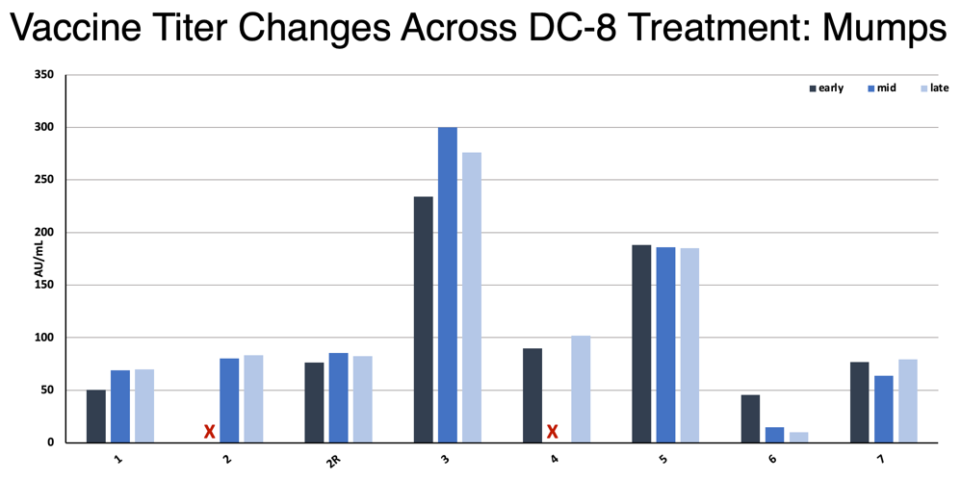
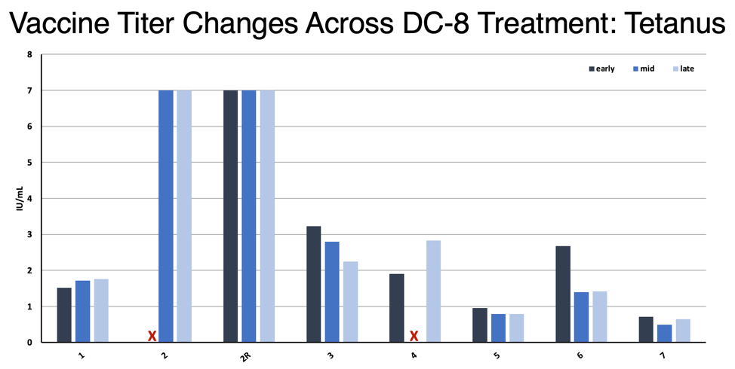

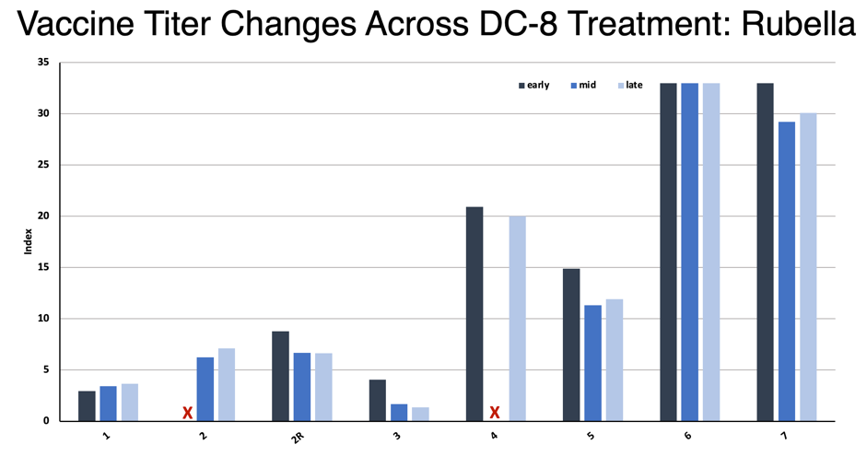
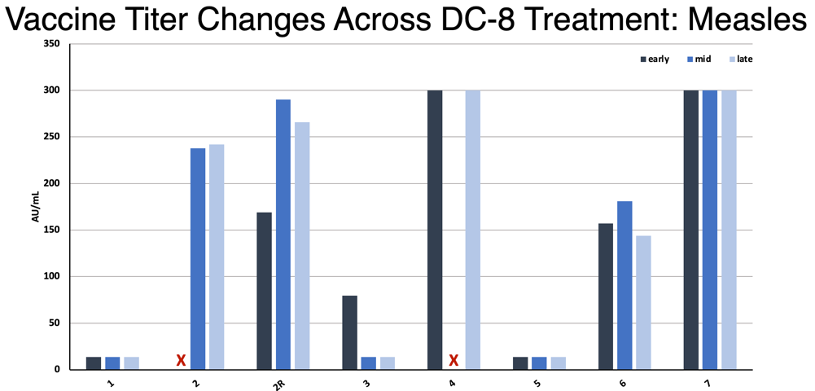
Table s1. Baseline characteristics of participants who received retreatment with Descartes-08.

No. | Age | Sex | Weight (kg) | Ab | MGFA Class | Age at onset | MG duration (years) | Baseline MG severity scores |  |  |  | Ongoing/ most recent treatment | Actual dose per infusion (CAR+ cells/kg,  ⨉ 10⁶) | Number of infusions | Total infused CAR+ cells  (⨉ 10⁹)
 |  |  |  |  |  |  |  | QMG | MGC | MG ADL | QoL 15r
1 | 52 | F | 110.0 | AChR | IIa | 36 | 16 | 16 | 27 | 13 | 26 | Pyr, Aza | 22.7* | 6 | 11.34
2 | 50 | F | 81.5 | AChR | IIIa | 26 | 23 | 23 | 26 | 12 | 22 | IVIg, MMF, Pyr, Aza | 63.1 | 6 | 30.85
3 | 66 | M | 88.0 | Other | IIa | 57 | 10 | 19 | 23 | 8 | 14 | Pyr, Pred | 30.0 | 6 | 15.62
*Actual dose was lower than the 52.5x10⁶±45% target

