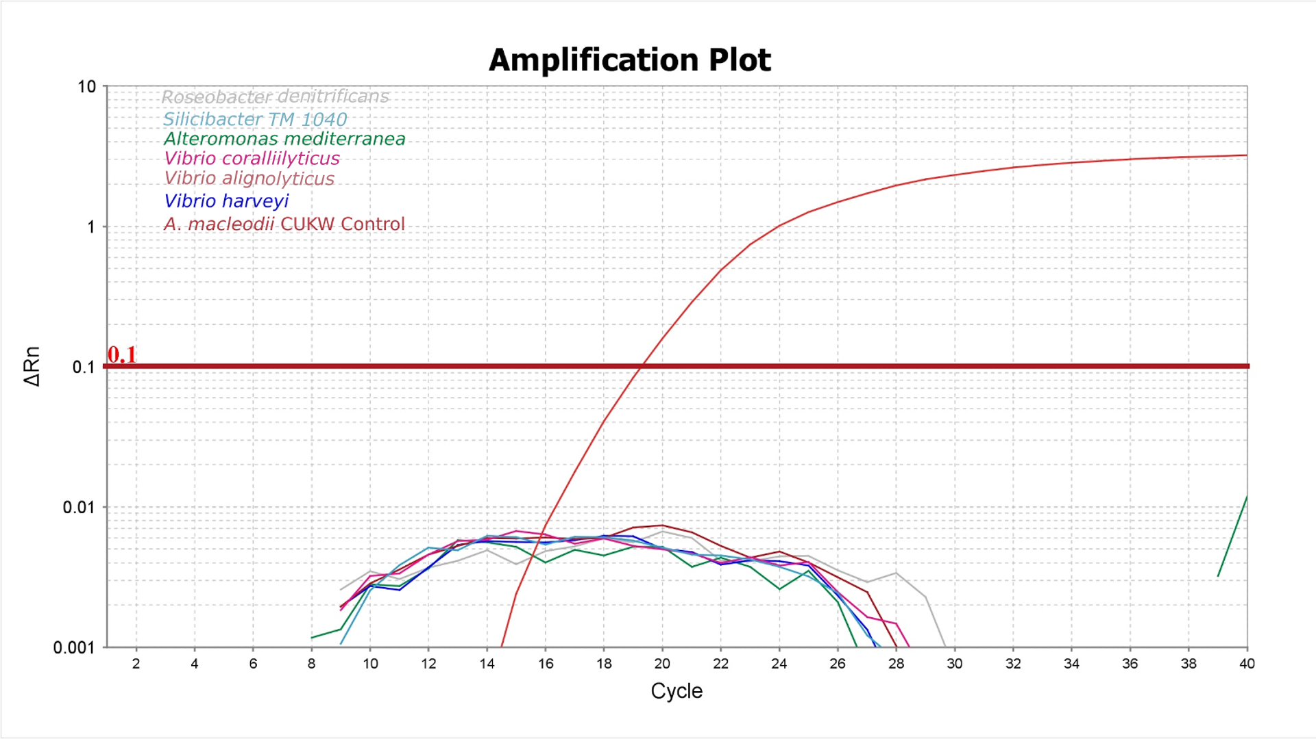
Supplemental Figure 1: Selectivity of the qPCR assay. The real time PCR assay showed no amplification of the gyrB gene in six common marine bacterial species. The red line shows the amplification of the gyrB gene using genomic DNA of A. macleodii CUKW as a template.
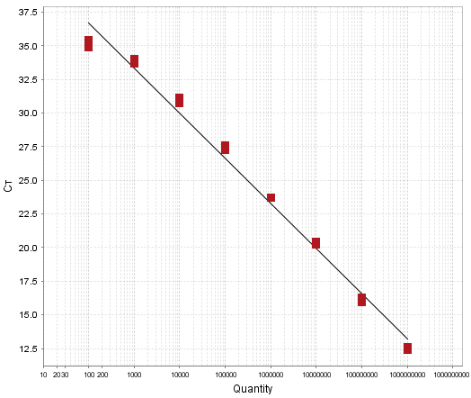
Supplemental Figure 2: Standard curve with serial dilutions of A. macleodii 16S rRNA gene equivalent to 1.0E+09 to 1.0E+01 full-length 16S rRNA gene fragment. The curve is made from the cycle threshold of triplicates corresponding to the 16S rRNA copies. The slope, Y-intercept, R², Efficiency, and error is shown in the figure.
Supplemental Table1: Amount of the biofilm collected from various locations
Source | Weight (g)
Telemark Bay Ship Surface | 0.2048
Orange Sponge Cudjoe Bay | 0.45
KW Marina A-LI Wood Pileag | 0.2004
Anne Bonny Canal Metal Ladder | 0.2006
Mangrove | 0.2023
KW Marina Boat Surface A-LI Fiberglass | 0.1695
Lawrence A-LI Sailboat | 0.1589
Key West Biomass | 0.2194
Cudjoe Bay Personal vessel | 0.2034
Anne Bonny Canal PVC Pipe | 0.2077
Lawrence A-LI Sailboat | 0.1948
Tarpon Marina KW Boat | 0.2055
Mangrove | 0.2346
Tarpon Marina A-LI Boat | 0.2012
Cape Canaveral FIT Biocorrosion Test Site Panel (proprieatory) | 0.2
Cape Canaveral FIT Biocorrosion Test Site Panel (proprieatory) | 0.037
Cape Canaveral FIT Biocorrosion Test Site Panel (proprieatory) | 0.109
Cape Canaveral FIT Biocorrosion Test Site Panel 1: BRA 640 I | 0.176
Cape Canaveral FIT Biocorrosion Test Site Panel 1: BRA 640 II | 0.2099
Cape Canaveral FIT Biocorrosion Test Site Panel 1: BRA 640 III | 0.1661
Cape Canaveral FIT Biocorrosion Test Site Panel 1: Inter900 (Cu-free) | 0.1077
Cape Canaveral FIT Biocorrosion Test Site Panel 2: BRA 1 I | 0.0886
Cape Canaveral FIT Biocorrosion Test Site Panel 2: BRA 1 II | 0.1348
Cape Canaveral FIT Biocorrosion Test Site Panel 2: Nature Coat white panel | 0.003
Cape Canaveral FIT Biocorrosion Test Site Panel 2: green panel | 0.0908
Cape Canaveral FIT Biocorrosion Test Site Panel 2: Epoxy panel | 0.0499
Cape Canaveral FIT Biocorrosion Test Site Panel 2: unknown | 0.0026
Harbortown Marine, recreational vessel | 0.2091
Indian River sediment | 0.2023
Indian River algae from mangrove | 0.2081
Indian River mangrove | 0.2009

