
Geophysical Research Letters
Supporting Information for
Hydrocarbon Removal in Power Plant Plumes Shows Nitrogen Oxide Dependence of Hydroxyl Radicals
J. A. de Gouw^{1,2}, D. D. Parrish^{1,3}, S. S. Brown^{2,3}, P. Edwards^{1,3,*}, J. B. Gilman³,
M. Graus^{1,3,†}, T. F. Hanisco⁴, J. Kaiser^{5,‡}, F. N. Keutsch⁵, S.-W. Kim^{1,3,#}, B. M. Lerner^{1,3,§}, J. A. Neuman^{1,3}, J. B. Nowak^{1,3,¡}, I. B. Pollack^{1,3,•}, J. M. Roberts³, T. B. Ryerson³,
P. R. Veres³, C. Warneke^{1,3}, G. M. Wolfe^{4,6}
¹ Cooperative Institute for Research in Environmental Sciences, University of Colorado, Boulder, CO; ² Department of Chemistry and Biochemistry, University of Colorado, Boulder, CO; ³ NOAA Earth System Research Laboratory, Boulder, CO; ⁴ NASA Goddard Space Flight Center, Greenbelt, MD; ⁵ Harvard University, Cambridge, MA; ⁶ Joint Center for Earth Systems Technology, University of Maryland Baltimore County, Baltimore, MD; * Now with: University of York, United Kingdom; † Now with: University of Innsbruck, Innsbruck, Austria; ‡ Now with: Georgia Institute of Technology, Atlanta, GA; # Now with: Yonsei University, Seoul, South Korea; § Now with: Aerodyne Research, Billerica, MA; ¡ Now with: NASA Langley Research Center, Hampton, VA; • Now with: Colorado State University, Fort Collins, CO

Contents of this file

Text S1 to S3
Figures S1 to S9
Table S1

Introduction
Figures S1 through S6 are referenced in the main body of the paper and provide additional evidence in support of the analysis. Text S1 through S3 also provides additional evidence to support the analysis; Figures S7 through S9 are referenced in Text S1 through S3. Finally, Table S1 shows a summary of the instrumentation used for the measurements.

Text S1: Results from Large-Eddy Simulations
Equation (1) of the paper describes the dependence of average isoprene concentration on average OH concentration. In the atmosphere, isoprene is turbulently mixed in the daytime boundary layer leading to a strong variability in time and location of both isoprene and OH. Kim et al. [2012] studied this interplay between turbulent mixing and chemistry using a large-eddy simulation (LES) model for conditions typical of the Southeast U.S. Figure S7 shows altitude profiles of the mean and variance in isoprene, and the mean NO₂ as calculated from the LES model. Nitrogen oxides in the model are introduced through surface emissions; the four NO scenarios in Figure S7 (very low, low, high and very high) represent runs with emissions of 5×10⁻¹², 5×10⁻¹¹, 5×10⁻¹⁰ and 2.5×10⁻⁹ kg m⁻² s⁻¹, respectively. Mean isoprene, isoprene variance and mean NO₂ all show strong gradients near the surface and a second decrease near the top of the boundary layer (~1200 m). Data from the June 16 flight have been added to Figure S7. Mean isoprene and NO₂ and isoprene variance were calculated for the Harllee Branch and Scherer plumes in Figure 1A (same data as the periods in white in Figure 1A), and the ranges in measured values are indicated by the black and grey horizontal bars, respectively. The same parameters were calculated for all the sampling periods outside of the plumes (indicated in black in Figure 1A) and averages are shown as the blue diamonds in Figure S7. Outside of the plumes, the mean isoprene and NO₂ and the isoprene variance are close to the results from the LES model runs with low and very low NO emissions. This suggests that the variability in measured isoprene outside of the plumes (Figure 1B) is real atmospheric variability and caused by the interplay between turbulent mixing and chemical removal of isoprene. The data obtained inside the Harllee Branch and Scherer plumes span the range in the LES model results with very high NO to very low NO. Observations at the highest NO (49 ppbv) downwind from Harllee Branch were indicative of ozone titration and a reduction in OH levels relative to transects further downwind. These particular conditions were not included in the LES model runs. We conclude that the LES model published previously [Kim et al., 2012] is representative of the conditions encountered during the flight on June 16, 2013.
The LES model can be used to check the validity of Equation (1). Figure S8 shows the mean isoprene as a function of mean OH at an altitude of 500 meter above ground, i.e. the flight altitude of the NOAA WP-3D in the boundary layer. The four symbols correspond to four different LES model runs with differently assumed surface emissions of NO. The data points are fit by an inverse relationship with OH, which describes the model results accurately. The fit parameter (0.164±0.004 ppbv²) is equal to ISOP_{em}/(BL_{height}×k_{OH}) according to Equation (1). Using a boundary layer height of 1200 m and a reaction rate coefficient of 1×10⁻¹⁰ cm³ molecule⁻¹ s⁻¹, the isoprene emission rate (ISOP_{em}) is calculated to be 3.8 mg m⁻² h⁻¹. This agrees within 15% with the assumed, mid-afternoon isoprene emission rate in the model (4.5 mg m⁻² h⁻¹; see Figure 1 in [Kim et al., 2012]). These results lend support for the validity of Equation (1) and show that the mean isoprene is inversely proportional to the mean OH. A similar relationship between OH and isoprene was derived from a global model [Spivakovsky et al., 2000].

Text S2: Other Chemical Differences Between the Power Plant Plumes and Surrounding Air Masses
Other species that react with isoprene (ozone, NO₃) were measured onboard the NOAA WP-3D, but cannot explain the observed depletion in isoprene within the power plant plumes. For ozone, the enhancement in the plume is too small, and the reaction is too slow, to explain the depletion in isoprene concentrations. Nitrate radicals (NO₃) were too low during this daytime flight to explain significant removal of isoprene.
The enhanced OH in the plume was not only caused by the enhancement in NO₂: ozone and formaldehyde built up in the intercepted power plant plumes (Figures 2 and S4) and provided a larger source of radicals through photolysis than outside the plume. Using measured photolysis rates, this enhancement in radical production in the plumes was calculated to be at most 30% higher than the radical source outside the plumes (Figure S9). This enhancement cannot explain the enhancements by more than a factor of 5 caused by the higher NO_{x} in the plume as inferred from the isoprene and monoterpene measurements.
Nitrous acid (HONO) was measured and slightly enhanced in the plumes [Neuman et al., 2016]. The highest HONO mixing ratios were observed during the first intercept of the Harllee Branch plume and were zero within the uncertainty during the 2nd through 5th intercepts of the Scherer plume and the 3rd through 5th intercepts of the Harllee Branch plume. Enhanced radical formation from HONO in the plumes can therefore not explain the OH enhancements described in this work, which did not occur during the nearest intercepts but further downwind. Radical formation from HONO is calculated using its concentration and measured photolysis rates and is shown in Figure S9. Enhanced HONO in the plumes can explain at most a 10-20% increase in OH.
The recent summary of OH measurements [Rohrer et al., 2014] was limited to those data sets with total OH reactivities of the combined hydrocarbons above 10 s⁻¹, which is not the case for all air masses described in this work. Nevertheless, a depletion of isoprene in power plant plumes was also observed in air masses that did have >10 s⁻¹ hydrocarbon reactivity. An example is shown in Figure S3.

Text S3: Emissions of the Scherer and Harllee Branch Power Plants
The emissions reported from continuous emissions measurement (CEM) systems operated at the power plants are shown in Figure S5. While the Scherer plant produced more power and emitted more CO₂, the emissions of NO_{x} and SO₂ were higher from Harllee Branch. On 16 June, the NO_{x} emissions from Scherer were relatively constant in time, while those from Harllee Branch showed a large afternoon peak. Based on the locations of the plume intercepts and the observed wind speeds, it is likely that the changing emissions from Harllee Branch played some role in the plume evolution downwind from this power plant, but these variations do not affect the analysis reported here.

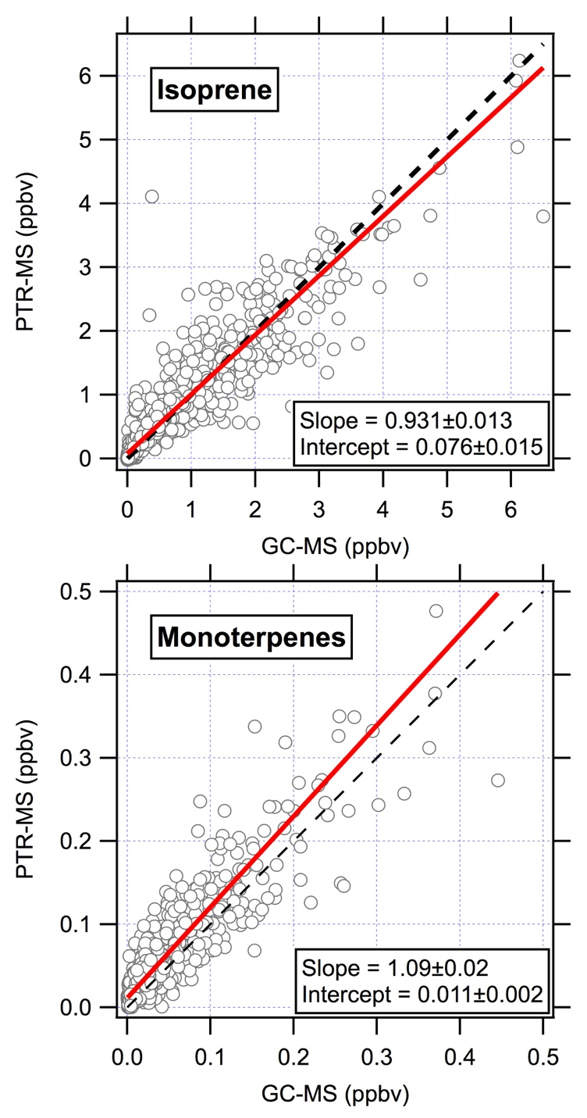

Figure S1. Inter-comparison between measurements of isoprene and monoterpenes by PTR-MS and from post-flight analyses of whole air samples by GC-MS. The PTR-MS measurements are determined from the signal at 137 amu and converted to a volume mixing ratio using an averaged calibration factor for different monoterpene species. The GC-MS measurement represents the sum of α-pinene, β-pinene, 3-carene and limonene. All of these four species were determined from a few samples only; the data in the figure are calculated from the sum of α-pinene and β-pinene scaled up by 7%, which is the average monoterpene fraction represented by limonene and 3-carene. For this inter-comparison, the PTR-MS data are averaged onto the sampling intervals of the whole air sample after broadening the averaging times to 15 s to ensure there is a PTR-MS data point closely aligned with most GC-MS data points.

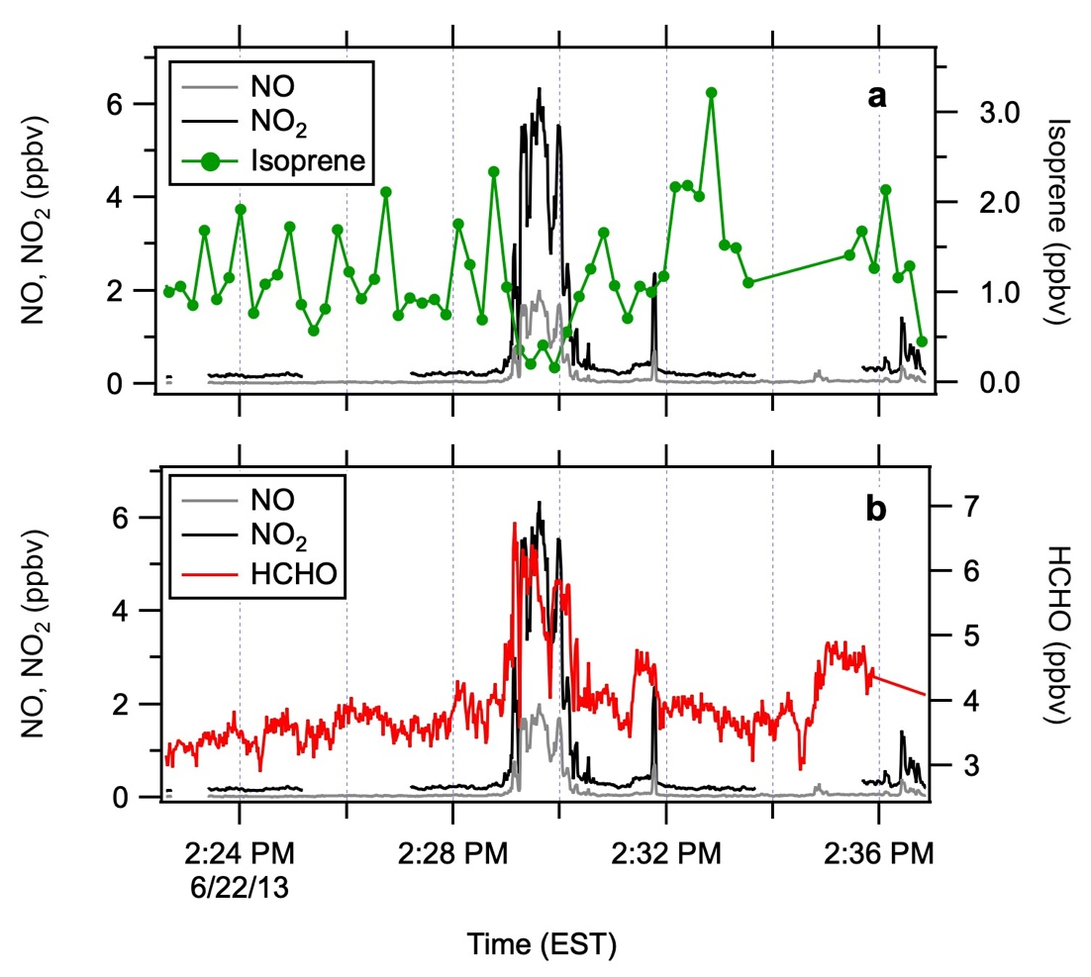

Figure S2. Observations 19 km downwind from the E.C. Gaston power plant in Alabama on 22 June 2013 showing (A) a depletion in isoprene, and (B) an enhancement in formaldehyde (HCHO) in the plume.

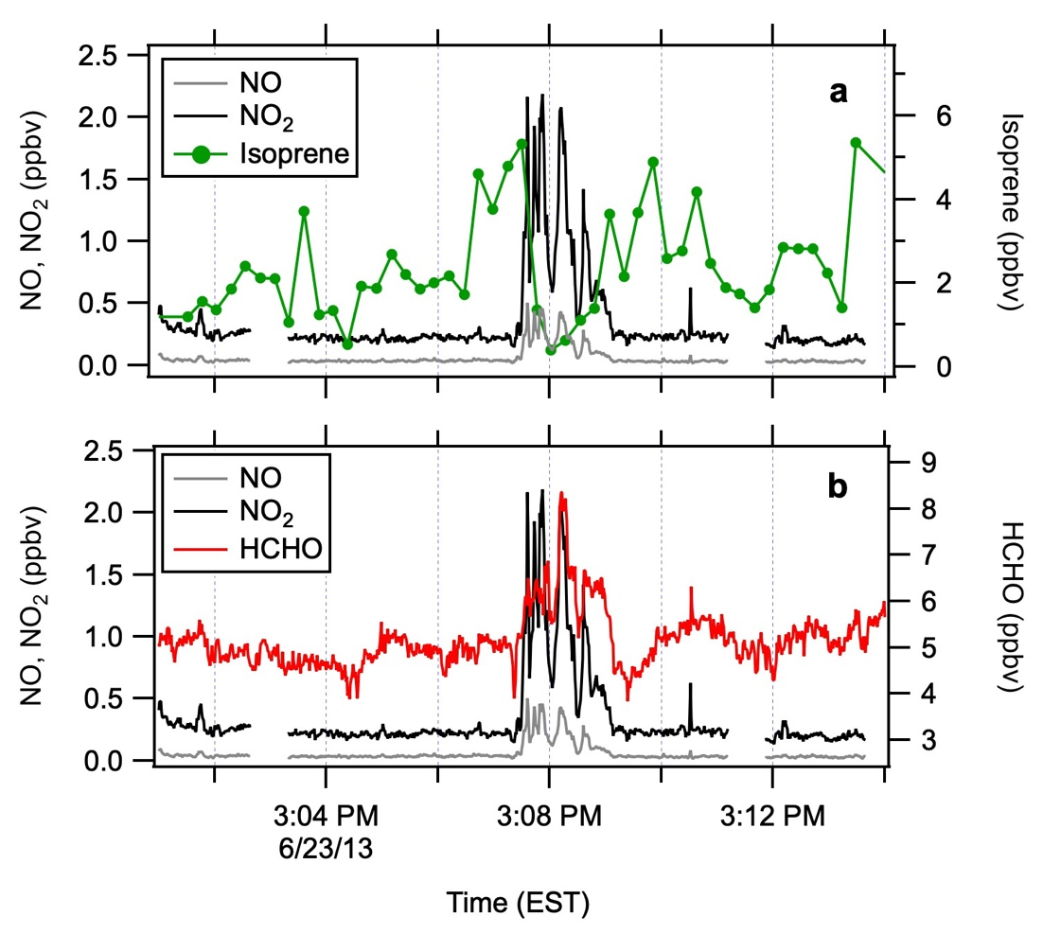

Figure S3. Observations 17 km downwind from the Johnsonville power plant in Tennessee on June 23 showing (A) a depletion in isoprene, and (B) an enhancement in formaldehyde (HCHO) in the plume. Total hydrocarbon reactivity with OH outside the plume was >10 s⁻¹.

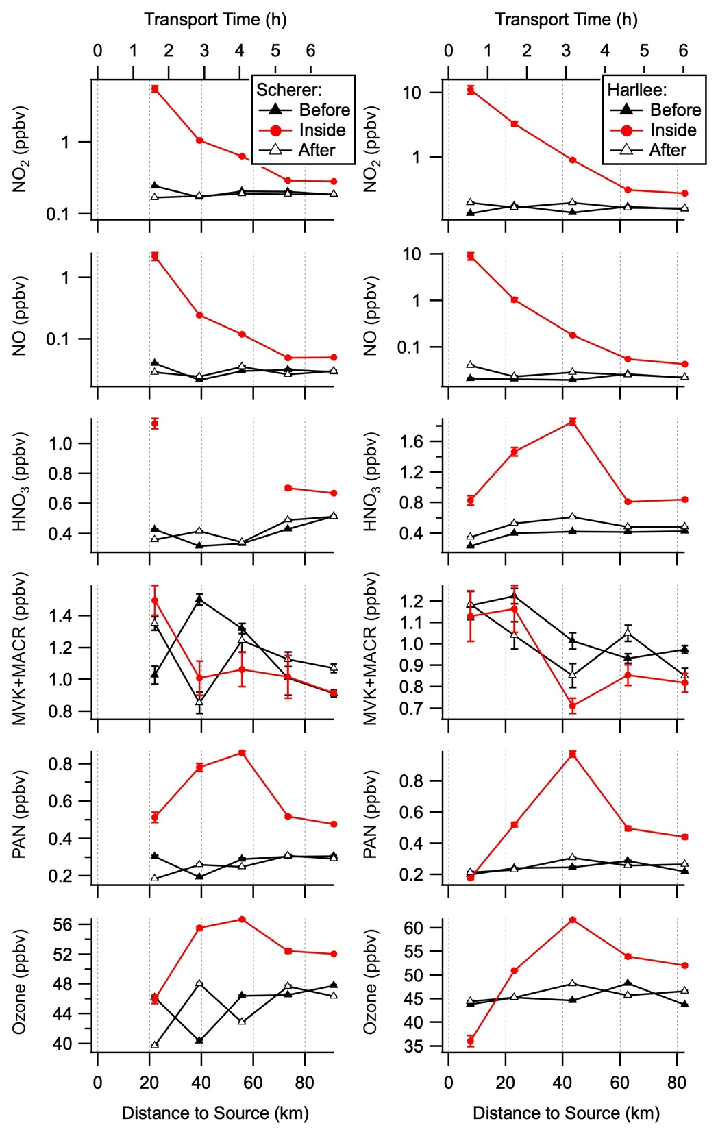

Figure S4. Evolution of NO₂, NO, nitric acid (HNO₃), the sum of methyl vinyl ketone (MVK) and methacrolein (MACR), peroxyacetyl nitrate (PAN) and ozone downwind from the Scherer and Harllee Branch power plants southeast of Atlanta during the flight on June 16, 2013.

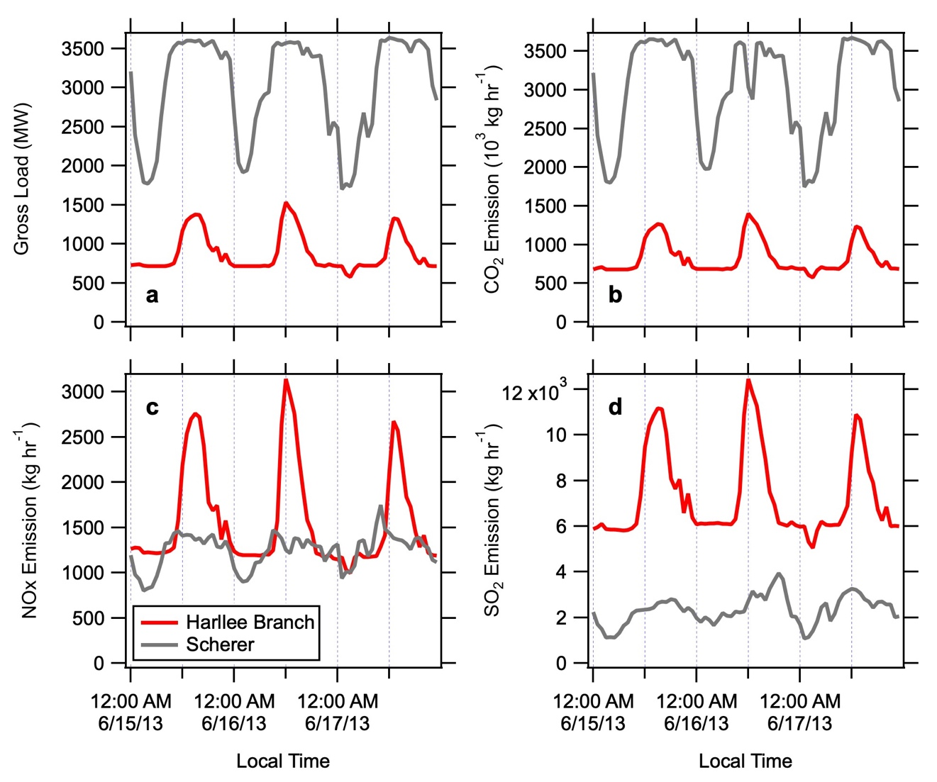

Figure S5. Continuous emission monitoring systems (CEMs) data for the Scherer (grey) and Harllee Branch (red) power plants during the June 15-17 period. Panel A shows the gross load, which is the sum of the net output of a power plant plus the energy consumption of the plant itself. Panels B-D show the reported emissions of CO₂, NO_{x} and SO₂. Data were downloaded from http://ampd.epa.gov/ampd.

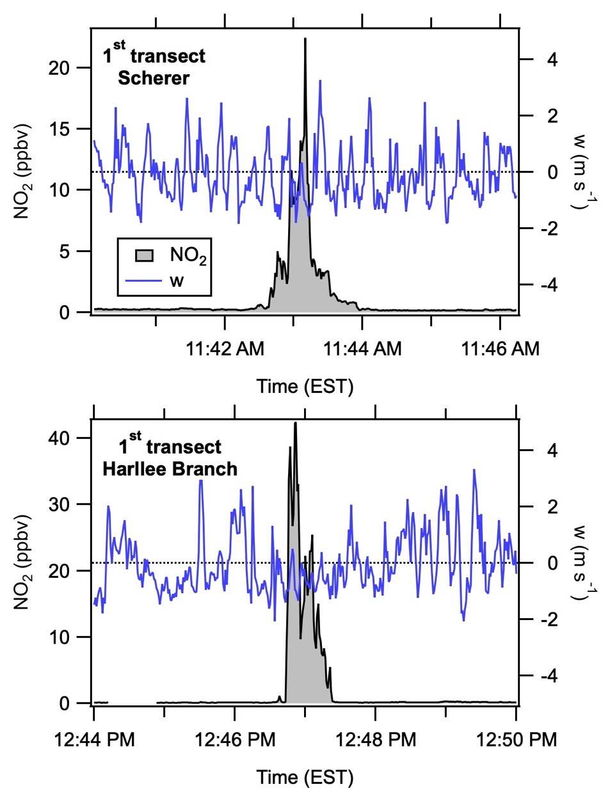

Figure S6. Measured vertical wind speeds (w) across the plume intercepts nearest to the Scherer and Harllee Branch power plants on 16 June 2013. The lack of a gradient across the plumes indicated by the high NO₂ illustrates that vertical mixing inside the plumes is not different from the surrounding air masses, one of the assumptions behind Equation (2).

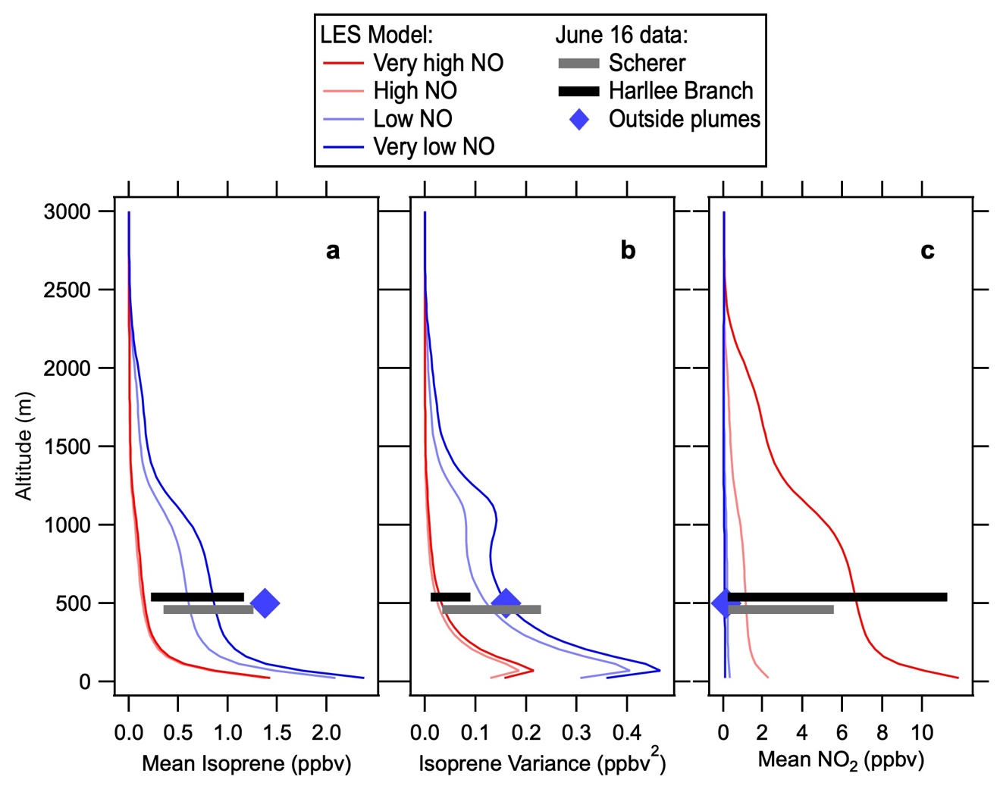

Figure S7. Mid-afternoon altitude profiles of (A) mean isoprene, (B) variance in isoprene, and (C) mean NO₂ calculated from the large eddy simulation (LES) model results published previously [Kim et al., 2012]. The diamonds show the mean isoprene, isoprene variance and mean NO₂ outside the power plant plumes, calculated from the data highlighted in black in Figure 1. The diamonds are near the low and very-low NO curves in all three panels. The horizontal bars represent the range in mean isoprene, isoprene variance and mean NO₂ inside the Harllee Branch and Scherer plumes, calculated from the data highlighted in white in Figure 1. The black and grey bars span the range from the very-high to very-low NO curves in all three panels.

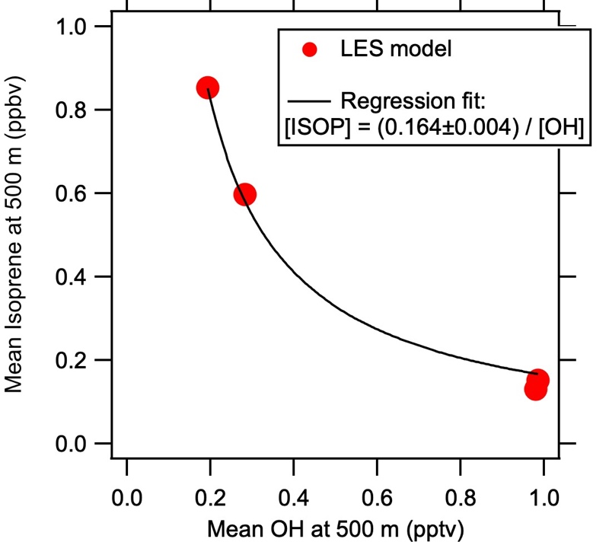

Figure S8. Dependence of mean isoprene mixing ratio on the mean OH mixing ratio at 500 m altitude in the mid-afternoon boundary layer calculated from the large eddy simulation (LES) results published previously [Kim et al., 2012].

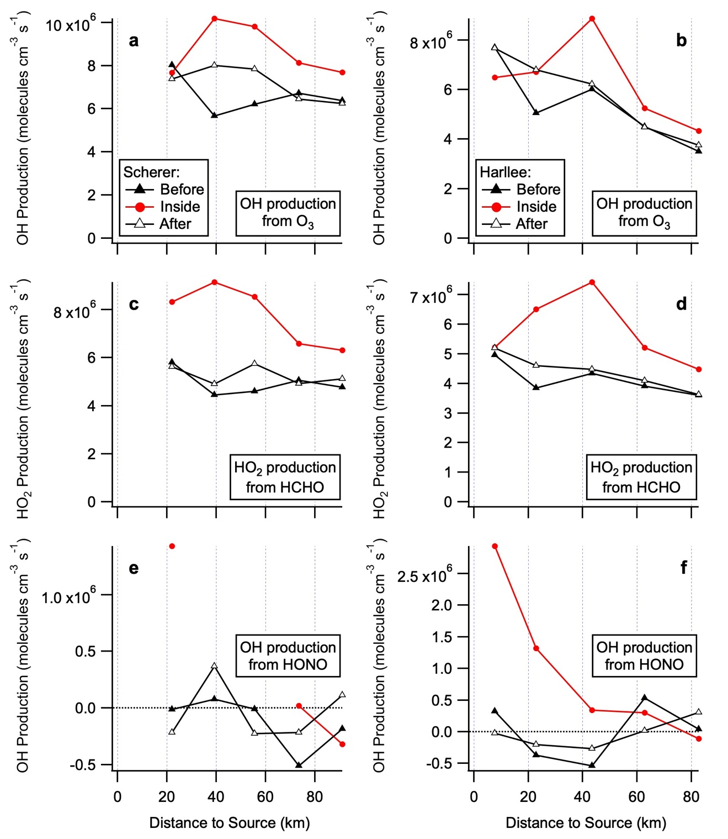

Figure S9. Enhancement in radical production from ozone (a+b), formaldehyde (c+d) and HONO (e+f) downwind from the Scherer (a+c+e) and Harllee Branch (b+d+f) power plants southeast of Atlanta during the flight on June 16, 2013. Hydroxyl production rates are calculated using measured O₃, formaldehyde and HONO concentrations, J values, and meteorological parameters.

Measurement | Method | Reference
NO, NO₂, NO_{y}, O₃ | Chemiluminescence | [Pollack et al., 2010]
NO₃ | Cavity ring-down | [Brown et al., 2002]
Biogenic and oxygenated VOCs | Proton-transfer-reaction mass spectrometry | [de Gouw and Warneke, 2007]
Hydrocarbons | Whole air sampling – GC-MS analysis | [Lerner et al., 2017]
Formaldehyde | Laser-induced fluorescence | [Cazorla et al., 2015]
HNO₃  HONO | Chemical ionization mass spectrometry | [Neuman et al., 2002; Neuman et al., 2016]
Peroxyacyl nitrates | Chemical ionization mass spectrometry | [Slusher et al., 2004]
J_{NO2}, J_{O3} | Filter radiometers | N/A

Table S1. Measurements onboard the NOAA WP-3D aircraft used in this analysis [Warneke et al., 2016].

References

Brown, S. S., H. Stark, S. J. Ciciora, R. J. McLaughlin, and A. R. Ravishankara (2002), Simultaneous in situ detection of atmospheric NO3 and N2O5 via cavity ring-down spectroscopy, Rev Sci Instrum, 73(9), 3291, doi:10.1063/1.1499214.
Cazorla, M., G. M. Wolfe, S. A. Bailey, A. K. Swanson, H. L. Arkinson, and T. F. Hanisco (2015), A new airborne laser-induced fluorescence instrument for in situ detection of formaldehyde throughout the troposphere and lower stratosphere, Atmos. Meas. Tech., 8, 541–552, doi:10.5194/amt-8-541-2015.
de Gouw, J. A., and C. Warneke (2007), Measurements of volatile organic compounds in the Earth’s atmosphere using proton-transfer-reaction mass spectrometry, Mass Spec. Rev., 26(2), 223–257, doi:10.1002/mas.20119.
Kim, S.-W., M. C. Barth, and M. Trainer (2012), Influence of fair-weather cumulus clouds on isoprene chemistry, J. Geophys. Res.-Atmos., 117(D10), D10302, doi:10.1029/2011JD017099.
Lerner, B. M. et al. (2017), An Improved, Automated Whole-Air Sampler and Gas Chromatography Mass Spectrometry Analysis System for Volatile Organic Compounds in the Atmosphere, Atmos. Meas. Tech., 10, 291–313, doi:10.5194/amt-10-291-2017.
Neuman, J. A. et al. (2002), Fast‐response airborne in situ measurements of HNO3 during the Texas 2000 Air Quality Study, J. Geophys. Res.-Atmos., 107, 4436, doi:10.1029/2001JD001437.
Neuman, J. A., et al. (2016), HONO emission and production determined from airborne measurements over the Southeast U.S. J. Geophys. Res.-Atmos., 121, 9237–9250. https://doi.org/10.1002/2016/JD025197.
Pollack, I. B., B. M. Lerner, and T. B. Ryerson (2010), Evaluation of ultraviolet light-emitting diodes for detection of atmospheric NO2 by photolysis - chemiluminescence, J. Atmos. Chem., 65, 111–125.
Rohrer, F. et al. (2014), Maximum efficiency in the hydroxyl-radical-based self-cleansing of the troposphere, Nature Geosci., 7, 559–563, doi:10.1038/ngeo2199.
Slusher, D. L., L. G. Huey, D. J. Tanner, F. M. Flocke, and J. M. Roberts (2004), A thermal dissociation-chemical ionization mass spectrometry (TD-CIMS) technique for the simultaneous measurement of peroxyacyl nitrates and dintrogen pentoxide, J. Geophys. Res.-Atmos., 109(D19), D19315, doi:10.1029/2004JD004670.
Spivakovsky, C. M. et al. (2000), Three-dimensional climatological distribution of tropospheric OH: Update and evaluation, J. Geophys. Res.-Atmos., 105, 8931–8980.
Warneke, C. et al. (2016), Instrumentation and measurement strategy for the NOAA SENEX aircraft campaign as part of the Southeast Atmosphere Study 2013, Atmos. Meas. Tech., 9, 3063–3093, doi:10.5194/amt-2015-388.

