DESIGN ARTICLE

Simulating religious faith
Aaron Oldenburg University of Baltimore (USA)

Abstract
This article surveys various differing approaches to religious simulation in gaming and interactive art, and reports on the design of a specific faith-based game from the designer’s perspective. It looks in-depth at one of a series of short experimental videogames that explore the use of game mechanics to simulate various aspects of religious faith. A number of serious and casual games have been produced over the years by companies catering to religious audiences. These often merely add religious themes to mechanics appropriated from popular games. An example of this would be Cougar Interactive’s Zoo Race (2008), which thinly drapes the narrative of Noah’s Ark over a racing game. Although there are a small number of independent games that have begun to approach religious and spiritual ritual, such as Ian Bogost’s Guru Meditation (2009), most religious games do not attempt to simulate the internal cognitive processes of faith. This article argues that there are opportunities that these games are missing in creating original gameplay that adds to a deeper understanding of their subject matter. The author demonstrates the idea that games, which through their rules have shown that they can provoke emotion and reflection in the player, can also simulate certain processes of faith.

Introduction
Religion and games often seem separate from the everyday world, as believers and players (by no means mutually exclusive categories) choose to follow agreed-upon sets of rules and narratives that distinguish them from non-believers and non-players. At the same time, however, there is a liminal blurring of this assumed boundary, as both players and believers bring their everyday experience and knowledge into the play of the game and into religious worship and reflection. Games and religion also influence the everyday world, through rules that guide and limit a believer’s actions. Particularly in the realm of pervasive games, players perform actions in games that have real-world consequences (Harvey 2006: 3). Both religion and games connect people to a common purpose, though believers and gamers have contrasting opinions as to the reality and importance of their respective purposes. It seems that we could benefit from putting them in dialog with one another. This article explores the potential of more intuitive, less rational game mechanics that attempt to simulate, non-didactically, the complex processes of religious faith. It also looks at the mechanics of traditional games and how they can be appropriated and altered to draw out underlying meaning.
Recently I have been creating a series of short experimental video games exploring religious actions. In designing gameplay for these, of which by now there are about ten, I choose certain rituals, activities or mental games that people play to reinforce their faith and attempt to simulate them through game mechanics. I look at game mechanics that attempt to provoke in a player the most basic form of faith, which is ‘a belief without evidence’ (Sickler 2009). This definition does not have belief in the supernatural as a prerequisite, but is a basic requirement for belief in most religious doctrines and stories. Some, however, may find this definition of faith as applied to religion problematic in that the manner in which many religious stories came into being, through the testimony of witnesses, could be considered evidence (Sickler 2009). Therefore, it may be useful to consider religion ‘a unified system of ideas and practices’ based around counter-intuitive beliefs, such as that in human immortality (Lawson 1998: 45-46), and the rituals—both physical and cognitive, individual and social—that reinforce these beliefs. These definitions of faith and religion are what guided me in the creation of gameplay and narrative.
The object of this series of experimental games is not reverence or irreverence, to be blasphemous or to proselytize. The games are the result of a deep interest in the many, sometimes contradictory, psychological and social aspects of religion. In a sense, most of these games are about human relationships and interior worlds, using religion as a starting point. This article will contrast the design of these games with recent trends in religious games, which often appropriate the mechanics of popular games and drape them with religious narratives, rather than creating original gameplay. It will also discuss the place of these among current independent games which are exploring the many other aspects of human experience that can be simulated through gameplay, such as grief and loss, love, mental illness, and sexuality, in ways that they are generally not simulated in mainstream games.

‘Spiritual, not religious’
The idea that games, through their rules as much as their narratives, can provoke emotion and reflection, is an idea being explored in recent independent and art games. Games like Jason Rohrer’s Passage (2007), which highlights the idea of human mortality through player choice and spatial metaphor, embody what videogame theorist Ian Bogost terms ‘The Proceduralist Style’ (2009). The assumption behind the design of games created in this style is that reflection can be provoked in the player by the performance of actions in an interactive system. He describes this type of game as valuing abstraction over realism, and leaving the player with questions rather than with the satisfaction of solving a problem. Passage uses the accessibility of treasure as a metaphor for life choices, regrets and alternate possibilities. According to Bogost, these games embody abstract ideas, ‘say something about how an experience of the world works’, and embrace ‘an ambiguity of both form and signification’ (Bogost 2009: 2).
These games can be said to be ‘simulations’ of their higher concepts. In Rules of Play, Katie Salen and Eric Zimmerman write that simulations are ‘procedural representations of aspects of reality’ (2003: 457). When looked at as simulations, games dynamically represent reality through play (Salen and Zimmerman 2003: 427), constructing representations through the player’s actions. Thus, one may look to words that represent actions or processes, particularly verbs, for inspiration as to aspects of reality that may be readily simulated. Warren Robinett, author of the early Atari VCS game Adventure (1979), proposed that ‘every verb in the dictionary suggests an idea’ for a game (cited in Salen and Zimmerman 2003: 431). Games can be constructed of many multiple small simulations, such as the simulations of movement, entropy, life and death. All of these can also be combined to form one larger metaphor, using the entire game to procedurally represent a particular subject. This representation emerges from ‘the combination of the formal system of game and the interaction of a player with the game’ (Salen and Zimmerman 2003: 457). In Proceduralist games, the player participates in the simulation of abstract ideas.
In creating The Marriage (2007), Rod Humble ‘wanted to use game rules to explain something invisible but real’ (Humble 2007: 2), without resorting to the representational, which he believes is best expressed in other, more linear narrative media. In his simulation of the fragility of marriage and the opposing needs of partners in a relationship, players bring their own experiences and interpretations in the same way that Duchamp’s viewer completes the work of art. Humble recalls how, in playtesting, ‘[m]any people immediately related to the game and in one case even used it to explain to their partner how they felt’(Humble 2007: 5). These stories demonstrate how the background the player brings to the game impacts how she interprets the experience.
Mine would not be the first video games with religious themes. In discussing games that have previously dealt with religion, however, I would like to make the distinction between games that illustrate religious stories and games where the player performs religion. Many serious and casual games have been made by companies catering to followers of specific religions, but rather than attempting to simulate religious practice, they tell or represent symbols of religious stories with game mechanics that are not directly related to the theme. Although there are a small number of independent game designers working with religious themes in a more abstract, Proceduralist style, religious games that appropriate the mechanics of popular games and layer them with religious narratives appear to make up the vast majority. There are interactive CD-ROM’s where the player takes the role of mythological Hindu figures (Rao 2002), and on the Internet one can find Islamic casual games (like the ones found in Islamic Free Games Online 2009). These games are often modeled on traditional shooting, fighting, strategy, puzzle and trivia games with narratives based on religious stories and teachings. In his book, Persuasive Games, Bogost writes of the secular company Color Dreams, who, seeing a new audience, simply renamed their company ‘Wisdom Tree’ and ‘reskinned’ their previous games with Christian themes (Bogost 2007: 288). Dharma Games teaches the tenets of Buddhism with a game similar to Pac-Man (Namco 1980). The Bible Game (Crave Entertainment 2006) for Playstation 2 is essentially a trivia quiz. For many players, though, it may not matter that their religious values and experience do not penetrate deeply into gameplay. One may simply want a religious narrative to be a common theme in every aspect of one’s life - similar to Henry Jenkins’ (2007: 1) transmedia storytelling, where the essential components of a narrative ‘get dispersed systematically across multiple delivery channels for the purpose of creating a unified and coordinated entertainment experience’–in this case, a religious experience. In playing these games, the player is keeping her mind in the world of her faith in a procedural way. Giving every activity in which one participates a religious coating, however shallow, may be meaningful to certain players. Oftentimes a practitioner of a religion considers her faith to not be ‘just’ a religion, but a ‘way of life’. The popularity of Christian rock seems to be a similar trend: take a cultural artifact that is considered sinful (Ehrenreich 2006: 222-23) and change its content to something more wholesome without changing the structure.
Are there mechanics, though, that can simulate the deep, ambiguous, internal processes of a believer, or the relationships between believers? There may still be opportunities that these games are missing in creating original gameplay more relevant to their subject matter. Bogost suggests that Christian game developers only hope to associate ‘isolated Bible facts with video game-playing target demographics rather than simulating interactions with systems of belief’ (Bogost 2007: 289). In keeping one in the narrative of the religion, the aforementioned games emphasize rote, linear familiarization with religious dogma. They engage in the process of religious education but do not analyze the processes by which the believer applies the significance of these teachings to their daily life. They themselves are a part of those processes and generally do not draw critical attention to that characteristic.
One aspect of religion that some games have been accused of successfully simulating, however, is intolerance. Although not necessarily the designers’ intention, controversy seems to follow religion-themed real-time strategy (RTS) games. LEFT BEHIND: Tribulation Forces (LB Games 2006) contains the common RTS mechanic of requiring players to grow their forces by acquiring a larger population and conquering other peoples. The difference between this and other RTS’s is that, in keeping with the apocalyptic Biblical narrative, this is accomplished by converting nonbelievers. Critics have noted that the requirement to convert or be wiped out was, effectively, punishing tolerance of other religions (Griffioen 2006). The player’s control of large groups of people in strategy games also unintentionally reinforces a stereotyped rhetoric of religious believers as brainwashed masses. The division in abilities between male and female player characters was also seen as sexist (Butts 2006).
To the game’s credit, though, putting the player in the role of proselytizer seems like a more specific simulation of an aspect of religious experience than putting the player in the role of a Pac-Man clone or quiz show guest. The requirement that the players pray to retain ‘morale’, a quantifiable substance necessary to win the game, appears to be at least bending traditional RTS gameplay to more procedurally reflect the spiritual struggle of individuals. Still, the game seems quick to sacrifice religious meaning to adhere to traditional gaming conventions. In the multiplayer mode, players are allowed to take the role of Satan and command his armies, and it is hard to fathom how this option to play devil’s advocate could reinforce one’s sense of faith.
Arabian Lords (Breakaway Games 2006) is a strategy game where players create a Muslim empire during the golden age of Islam. It seems to be primarily for an Arab Muslim audience, with a website that defaults to Arabic writing and a proud narrative of historic expansion of Muslim empires. Unfortunately, the game mechanics, which require the player to make use of thievery and disinformation, seem to suggest that Islam was spread through deceit (Megagamers 2007) and, for some, the game’s substitution of violent with economic conquest stereotypes Arabs as traders (Nunley 2007). It is difficult to gauge intent, though, in the often subtle language of game mechanics. In the case of the previously-mentioned Left Behind games, the accusations of intolerance are disputed by the company (Jenkins 2008). Rather than being overtly offensive, these games show the potential pitfalls in borrowing the mechanics of an established game genre without fully considering the many ways in which the mechanics may be interpreted through the narrative of religion and all of its potential controversies.
Molleindustria’s Faith Fighter (2008), by contrast, is an intentional provocation, as a browser-based fighting game involving battles between revered religious figures. The ironic tagline, ‘Give vent to your intolerance! Religious hate has never been so much fun’, suggests that it is intended as a critique of religiously motivated intolerance and violence. There is a breed of –usually casual– games that are antagonistic towards specific religions. Games like Annoy the Hindu (prank-ideas-central.com 2009), Muslim Massacre (Peckham 2008), and Moschee ba ba! (commissioned by Austrian Freedom Party in 2010, translating to ‘Bye-bye, Mosque!’) simulate offending, terrorizing or murdering members of their respective religions. Unfortunately, these games can also be said to reinforce the faiths of those who define their own religions in opposition to others. Faith Fighters can be seen as drawing attention to its own medium as a casual game, where there exist these examples of hate games, as well as drawing attention to violence caused by organized religion. A focus on the simulation of intolerance and violence, however, leaves many more peaceful, and arguably more common, aspects of faiths unexplored.
In Cosmology of Kyoto (SOFTEDGE 1995), a point-and-click adventure game that takes place in medieval Japan, there is a procedural representation of faith through ritual that is effective, even if it is accidental. As the player explores the city, she encounters its mythological history through ghosts and historical figures and when she dies (which happens often), is reincarnated. The amount of karma the player has collected through actions performed in the game decides how she is to be reincarnated, but it is never made clear exactly how much karma the player has or needs. In one play session I found myself, by choice, praying in a Buddhist monastery again and again, for quite some time. This was satisfying even though there was no immediately interesting feedback: the prayer ritual involved performing the same actions repeatedly, with no variation. Since the effect on my visible karma meter was difficult to distinguish, and the effect that this meter had on my experience in the afterlife was only mildly predictable, I developed a sort of faith that performing these rituals would affect my karma points and subsequent experience in the afterlife. Although it was difficult to ascertain if this experience was intentionally designed or accidental, it convinced me that game rules could simulate a sense of faith, in at least the most basic definition of the word. Not all religious simulation will have the same effect on all audiences. Mechanics alone are not generally enough to turn a feeling of faith in a game system into a belief in the supernatural, but must rely on the meta-aspects of play: how the player cognitively intersects the game with her life outside the game’s imaginary structure (Salen and Zimmerman 2003: 482).
As Cosmology of Kyoto uses game time and ritual to simulate religious experience, other religion-themed interactive multimedia from the mid-nineties use the player’s movement through game space. In Maurice Benayoun’s Is God Flat? (1994) and Is the Devil Curved? (1995) this first-person 3D interactive artwork involves the player spatially exploring the nature of God and the Devil, chasing the ephemeral representations of God or being seduced into approaching the devil. Osamu Sato’s Eastern Mind: The Lost Souls of Tong-Nou (1995) also involves spirituality experienced through spatial metaphor made tangible in gameplay, as the player searches for her lost soul in an attempt to reach higher spiritual planes. As movement through 2D or 3D space is a primary activity in videogames, spatial metaphor is a useful source of meaning.
Contemporary fine artists exhibiting in galleries have been modifying pre-existing commercial games, giving them new narratives or drawing attention to potentially mind-bending aspects of their mechanics. It is unsurprising, given that transcendence is also a theme of religious art, that art made by manipulating, and transcending the mundanity of, readymade video games would sometimes take on elements of religion. Brody Condon used a modified self-playing game engine to re-interpret Late Medieval Northern European religious paintings in his Judgment Modification (after Memling) (2008). In Cory Archangel’s Super Mario Clouds (2002), the Nintendo cartridge itself is hacked so that all that remains is the meditative image of white clouds on a blue sky. Eddo Stern’s Death Star (2004) video uses the subversiveness of machinima, which is cinema created with video games, to abstract the imagery of crass post-9/11 beat-up-Osama-bin-Laden-genre Flash games to make them beautiful and reverent, juxtaposing the soundtrack to Mel Gibson’s Passion of the Christ (2004) with close-ups of bin Laden’s pixilated wounds appearing and disappearing. These all draw attention to games as games, taking apart their seductive immersion.
There have been several recent, mostly independent, secular games that alter traditional game mechanics to take a critical look at religion, as well as a critical look at mechanics themselves. Jesse Venbrux’s platformer Pazzon (2009), like LEFT BEHIND, has conversion of nonbelievers as its core mechanic. However, Blogger TheDustin argues on the independent games site, Play This Thing, that the game uses these mechanics to make a critical point, comparing the structures of games to religious dogma, arguing procedurally that the agency players have in games is an illusion, as they are controlled by the system (April 2010). Players of Waco Resurrection (2004), by game artist collective C-Level, also experience being the controllers and the controlled, as they are required to wear ‘skins’ of David Koresh over their heads and recite his messianic texts. These games provoke players to examine the mechanics that other religious game creators may simply borrow.
Some games take advantage of player assumptions, turning them on their heads and, with this disorientation, simulating a transcendent religious experience. Bill Viola describes his video game The Night Journey (in preparation), a collaboration with the University of Southern California Game Innovation Lab, as ‘a video game/art project based on the universal story of an individual mystic's journey toward enlightenment’ (USC EA Game Innovation Lab 2008: 1). The visuals are inspired by the style of Viola’s video art, and its narrative is taken from ‘the lives and writings of great historical religious figures’ (USC EA Game Innovation Lab 2008: 1). As in Pazzon, there are points in the game that involve the player giving up control, a requirement of many religions, using gameplay to simulate a transcendent experience rather than using religious narrative to critique gameplay. Viola’s goal is to ‘slow people down and not speed them up’, and he seems to delight in the fact that hardcore gamers will rush through the game to their eventual ‘self-annihilation’ and miss everything (Viola 2002). Performance artist and web author Ze Frank plays with choice of restrictions in his brief, poignantly humorous Life Games (2008), which show, through gameplay, how one’s religion limits one’s choices and perspective. The first and only decision the player makes is how to leave the platform of life, and after is left to wonder if the game is really over. Implicit rules of a game, when broken, can open up a player to reflection.
Although it is arguably important to keep the definition of ‘game’ fluid, so as not to limit the potentials of the medium, there is a value for artists to learn the traditional language of games beyond creating interactive narrative. There is a tendency of artists to approach the medium of video games with the intention of changing it, of injecting it with a higher purpose, which is a noble and necessary task for advancing the artistic potential of a maturing medium. Therefore, many artists arrive from other media with preconceived narratives that hope to challenge the clichés of the genres that have become synonymous with games. Then, when we finally come to the task of learning the language of games, we find that applying this language makes our original high ideas feel compromised. We retreat back to more comfortable formats with which to express our ideas, such as interactive narrative, blaming the limitations of the formal video game structure of goals, obstacles, conflict, and rewards. Auriea Harvey and Michaël Samyn of Tale of Tales, in creating their interactive narrative The Graveyard (2008), began their design process with a more game-like idea and then reduced all of the game elements they felt distracted from the story, such as exploration and goals, until the only action left was to move an old woman in a straight line to her final resting spot in a graveyard (Harvey & Samyn 2008). In their ‘Real-time Art Manifesto’ they state that ‘the rule-based structure and competitive elements in traditional game design stand in the way of expressiveness’ (Harvey & Samyn 2006). It is often artists such as Rod Humble, who have worked in the entertainment videogame world–in his case, in charge of artificial intelligence for The Sims (Maxis 2000-2009)–and are already fluent in the language of game mechanics and their expressive potential, who create experimental, artistic games that do not retreat into the well explored artistic territory of interactive narrative. If what makes the art of game design unique is the expressive potential of the procedural mechanics, as Bogost (2009: 2) states in his description of the Proceduralist Style, then there is a language with a potential for poetry that may be neglected by focusing too much on narrative, which already has a strong history in other media. Rather than becoming a hindrance to communicating higher artistic concepts, the use of obstacles and goals in games create a process through which the player goes in order to feel and reflect on the theme of the work.

Design process: After
How does the play of games compare to the physical and cognitive actions performed in day-to-day religious life and ritual? One of the major conceptual challenges of faith-based games is that most games, even games of chance, require concrete responses to player actions in order for them to feel meaningful (Salen and Zimmerman 2003: 34), whereas actions performed in the practice of a religion, such as praying, either have no obvious effect or, as in the case of visible ‘miracles’, the cause is debatable. Often it is up to the follower of the religion to decide whether or not to perceive their actions as the cause of any subsequent event. In a game, the immediate feedback that the system produces–for example, a reward appearing when the player breaks a box–in response to player action all but forces the player to believe in cause and effect correlation. A player told to believe that their actions might have been the cause of seemingly random and delayed in-game consequences would likely accuse the designer of being lazy or inconsistent. Games, such as Chulip (2002) for Playstation 2, that appear to have too many arbitrary consequences for player action, are often seen as punishing the player for engaging in trial-and-error (Seff 2007). As I will detail below, in my series of experimental games I try to solve this using concrete procedural representations of cognitive processes of religion.
A major part of the creative process I use is finding verbs that have not been simulated with games, and creating an interface to simulate them. The majority of these are created in less than a week, with minor adjustments later on. There is a current trend among independent game designers to rapidly prototype games in 24- or 48-hour sessions, as individuals or in small teams. Often they are just polished enough to demonstrate the essential experiment, and take pride in primitive graphics and sound. In the case of my series of religious games, the verb I explore would be something like ‘baptize'. I come up with metaphors for the verb, such as the different contexts in which the verb is used in everyday language, and consider how one of these contexts could be expressed through a gestural interface that is limited to the 2D movement of the mouse. This series of experimental games was created under the assumption that the essential expressive power of a game is through the repetitive performance of an action, the process-intensive style described by Bogost (2009). Some games I design end up taking forms that do not obviously reference religion in content, but abstractly in form. There are also a few that succeed only at creating novel forms of gameplay, with little metaphorical meaning. Many, however, from their beginnings as simulations of religious experience became simulations of potentially more universal aspects of human experience: grief, fear, individual vs. group identity, etc.
After is a more personal video game about finding and then placing a loved one in the afterlife. Through the puzzles and gameplay I simulate an agnostic encounter with one’s own belief system in a situation involving the death of a loved one. The game begins with the player’s partner dying and, later, she encounters obstacles in her life that can be overcome only by incorporating the imagined presence of the departed into her life.
Rather than retreating to the world of interactive narrative to tell an emotional story, After uses the game language of obstacles and goals to communicate with the player. The mechanics create meaning through choice and encounter. They were inspired by a quote I once heard, stating that the reason why, when someone dies, we have trouble thinking of them as dead, is because when they are alive most of our conversations with them take place inside our heads. This imaginary presence then lives on after death. The experience of this continued presence will sometimes surprise a person, especially as it resembles a belief in the supernatural. It is this cycle of surprise and acceptance that is the core gameplay of After. It is an exploration of the human need for the imagined presence of a loved one after death in order to continue with life. The gameplay is a coping mechanism.
Solving puzzles requires the player to use multiple in-game camera views that appear under different contexts. The player forms an understanding of what these other view windows represent and interprets how to use them to her advantage. She discovers that she can see herself in these other windows. She finds that through literally looking at her situation through these other perspectives she finds the solutions to obstacles.
The game has three parts: In the beginning, the player is holding and interacting with her dying partner as her partner’s health status meter lowers and he eventually dies.

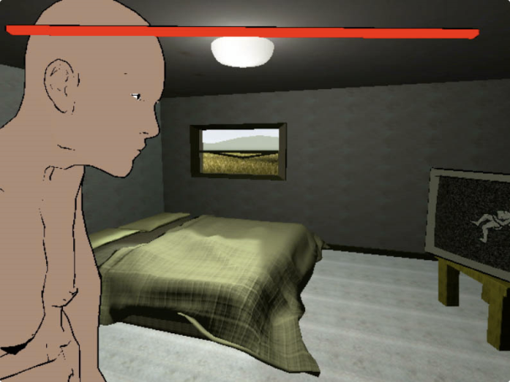

Figure 1: First person view with red health meter, assisting loved one to walk.

The human figure is roughly-drawn, broken. He collapses upon death. The environment is stark. In the second scene, the player is alone, wandering around an empty house. Outside, she is surrounded by a high wall with no visible way to escape. The player is intended to feel lost, trapped, separated from the rest of the world, which are common spatial metaphors for the isolating experience of grief. When she looks up at the sky, however, a window appears in the lower-right-hand corner of the screen, which shows the point of view of a camera looking down at her.
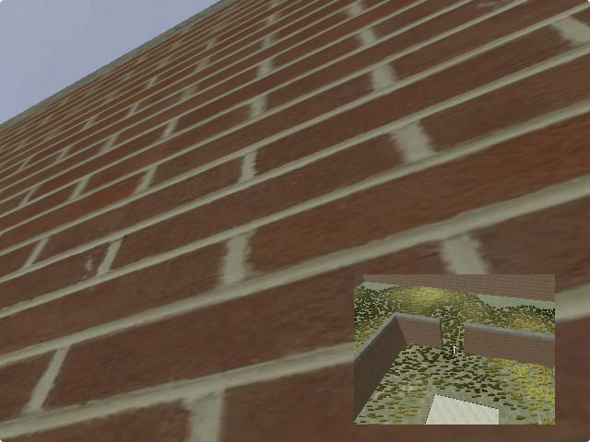
Figure 2: Seeing through eyes of imagined presence, lower right-hand corner.

This observing presence, coming from the imagined observation of a loved one, alerts her to an exit in the wall from which she can escape. Outside of the first wall, with more space to maneuver, the player is again imprisoned by another wall. On exploring the area, the player finds a grave and standing in front of it, another window appears in which she sees herself, as well as an exit in the second wall. This new presence is unexpected, and although it is represented as the imagination of the player character, it bears the same level of reality to the player as the rest of the game world. Through experimentation, the player figures out her relationship to this new presence, and finds out that it can help her escape.
The design process was iterative, involving several playtesting sessions. One session took place in person at a Dorkbot Baltimore meeting, with four testers. Here I did not explain the game before testing. Initially the first part, holding the player’s loved one while his life meter ran out, was too short for players to come to the conclusion that the person they were holding was dying, and although the subsequent puzzle was interesting to them, the metaphorical aspects were lost. This was corrected by lengthening the amount of time the player spent with the dying non-player character (NPC).
After the realization that the imagined presence of her loved one can assist to escape her prison, the player then takes control and puts her loved one where she wants him, creating a belief that makes sense to him. Upon leaving through the hole in the wall, the walls disappear, and a goal appears in the distance in the form of a colourful mass of light. This is the third and final part of the game. When the player tries to move toward the goal, however, she finds that she is prevented by invisible walls.
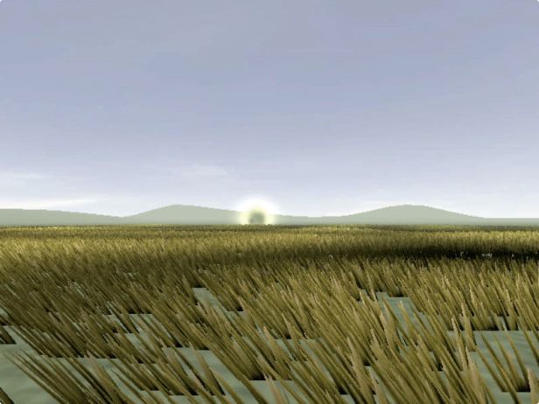
Figure 3: The glowing goal is seen in the distance; an invisible wall prevents player from approaching.

The player will likely turn around and return to the house in which she originated and encounter the memory of her lover again lying in bed.
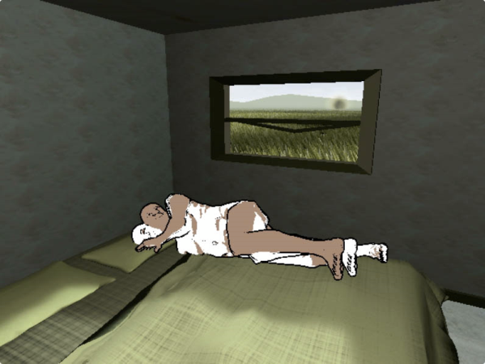
Figure 4: Memory or spirit of loved one encountered on return to the room.

She picks him up and, through another small window, begins seeing things through the eyes of her partner whom she is carrying. Through this window the player can see the invisible maze and how to escape through it. If the player intentionally or unintentionally lets go of her loved one while navigating the maze, the body disappears but the camera view remains, following the player’s movements.
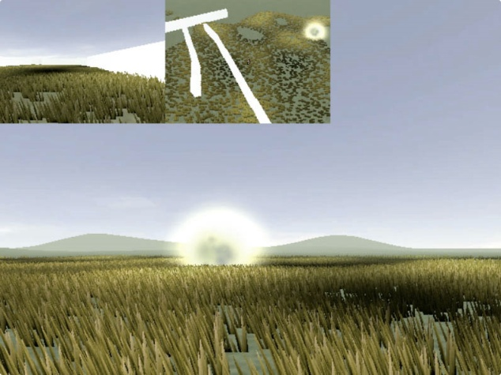
Figure 5: Multiple camera views follow the player, indicating the places where she has left the imagined presence of her loved one.

If she looks up, the camera floats into the sky, giving her an overhead view of the maze. She has essentially chosen a place for her loved one’s presence to reside, rather than accidentally stumbling upon it as she did previously. However, the player will likely perform this action accidentally by letting go of the mouse button. This is designed to simulate the idea that the need one might feel to put a loved one in a meaningful place in the afterlife may be unconscious and automatic rather than a rational, conscious choice. In this sense, accidental actions have significant results.
The entire field of view can then be covered with different cameras representing viewpoints from each of the imaginary presences by repeating the previous action.
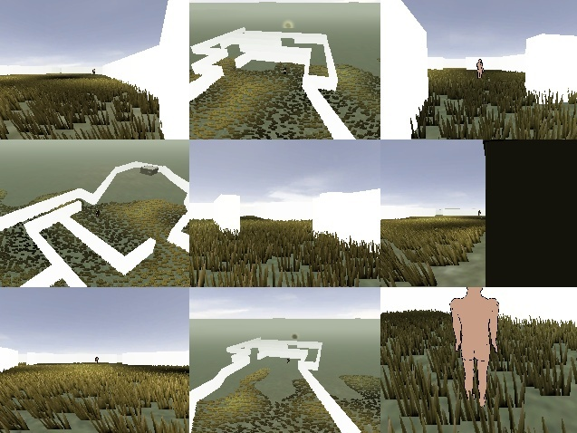
Figure 6: The player’s vision, entirely covered with camera views representing the imagined eye of the loved one.

The player can return to the house and pick up the body or spirit again, creating a second, third, fourth, etc., camera perspective. She can continue to do this until her entire view is covered by nine different windows, and she sees herself entirely through the eyes of her dead loved one. She needs the presence in order to reach the goal, but too much of it can make navigation difficult. There is a dramatic positive feedback loop: the more of the screen the player covers with other imaginary viewpoints and obscures the main view, the more different viewpoints she needs to successfully navigate the maze.
When carrying the NPC, the image in the new camera view was askew, as I thought it would be unrealistic to have their view pointing straight ahead like the player. This seemed to cause more frustration for playtesters than intended, although in general feelings of anger and frustration could be appropriate for the player to have. After correcting this and previously mentioned issues, I introduced the game on two Internet forums, one titled ☈♦☲ a private forum held by game designers Stephen Lavelle (a.k.a. Increpare) and Terry Cavanaugh with a name intentionally written with unreadable characters, and the semi-private Notgames forum, a project of designers Auriea Harvey and Michaël Samyn of Tale of Tales. These testers had access to an artist statement explaining my goals, although several chose to play before reading it. One tester with the screen name JordanMagnuson said it felt like an ‘existential/afterlife/out of body experience’ and that he did not feel like he ‘should know exactly what was going on.’ Some said that the NPC’s view should be facing backward when being carried, and suggested more meaningful view angles in the first scene. These comments emphasize the importance of the position of view cameras in the game to communicate the spatial metaphor. There were those who were interested in uncovering the puzzle behind the mechanics and played the game from beginning to end, and others who were satisfied with experiencing the strange ‘alienness’ of exploring the environment and relationship between the characters, and leaving the meaning ambiguous.

Conclusion
Religious-themed games that embrace the sensibility and techniques of Proceduralism could allow for more nuanced and meaningful religious games. The fact that this idea is beginning to be embraced by independent game designers, however, does not mean that all companies and organizations who create religious educational games will adopt these methods. Some may find the idea of creating game mechanics that analyze as much as promote a religion detracts from their didactic purpose. The open nature of these mechanics function more to look at spiritual beliefs rather than promote dogma. It is possible that the Proceduralist style works best from the perspective of personal expression, in this case the expression of one’s personal relationship and feelings towards religion, putting the individual feelings of the designer in dialogue with those of the player.
As games begin to procedurally represent complex emotions, they can and should endeavor to communicate through their mechanics deeper aspects of what it feels like to experience faith. There are thousands of verbs that have yet to be simulated in videogames, and many of these are verbs associated with religion. I believe that exploring these could not only make many religious games more thought-provoking, but would introduce to the wider world of game design new strategies for creating game mechanics that would emphasize nuance and abstraction over logical answers and rewards. Mainstream and independent game designers struggle to gain acceptance of videogames as a form of art, as exemplified by the thousands of attempts to rebut popular American film critic Roger Ebert’s blog entries stating that games could not be art (Ebert 2010). Art and religion both share an interest in the irrational and transcendent. Religion and games have rules and narratives that straddle the boundaries of the everyday world. In this way, religious-themed Proceduralist games could be a bridge between videogames and art.
References
Arcangel, C. (2002), Super Mario Clouds (Art Work), http://www.coryarcangel.com/things-i-made/supermarioclouds/. Accessed 11 September 2010.
Benayoun, M. (1994), Is God Flat?(Art work), Saint Denis, France: Artifice 3 [First Exhibition].
Benayoun, M. (1995), Is the Devil Curved? (Art work), Monte Carlo, Monaco: Imagina [First Exhibition].
Bogost, I. (2007), Persuasive Games: The Expressive Power of Videogames, Cambridge: MIT Press.
Bogost, I. (2009), Guru Meditation, Atlanta, GA: Atari VCS/iPhone.
Bogost, I. (2009), ‘Persuasive games: the Proceduralist style’, http://www.gamasutra.com/view/feature/3909/persuasive_games_the_.php. Accessed 31 January 2010.
Butts, S. (2006), ‘Left Behind: Eternal Forces - Review’, http://pc.ign.com/articles/745/745956p1.html. Accessed 11 September 2010.
Cougar Interactive (2007), Zoo Race, http://www.zoorace.com/. Accessed 11 September 2010.
Team Waco (2004), Waco Resurrection, Atlanta, GA: Endgames.
Condon, B. (2008), Judgment Modification (after Memling) (Art work), Santa Monica, US: Santa Monica Museum of Art [First Exhibition].
Crave Entertainment (2006), The Bible Game, Newport Beach, CA: Crave Entertainment.
DharmaGames, http://www.dharmagames.org. Accessed 10 September 2010.
Ebert, R. (2010), ‘Okay, kids, play on my lawn’, http://blogs.suntimes.com/ebert/2010/07/okay_kids_play_on_my_lawn.html. Accessed 18 November 2010.
Ehrenreich, B. (2006), Dancing in the Streets: A History of Collective Joy, New York: Henry Hold and Company, LLC.
Frank, Z. (2008), Atheist, http://www.zefrank.com/atheist/. Accessed 11 September 2010.
Frank, Z. (2008), Buddhist, http://www.zefrank.com/buddhist/index.html. Accessed 11 September 2011.
Frank, Z. (2008), Christian, http://www.zefrank.com/christian/index.html. Accessed 11 September 2011.
Gibson, M. (2004), The Passion of the Christ, Los Angeles, CA: 20th Century Fox.
Griffioen, J. (2006), ‘Video game where Jews and Atheists must be killed or converted due for Christmas’, http://www.parentdish.com/2006/10/30/video-game-where-jews-and-atheists-must-be-killed-or-converted-d/. Accessed 11 September 2010.
Harvey, Alison (2006), ‘The liminal magic circle: boundaries, frames, and participation in pervasive mobile games’, http://wi.hexagram.ca/?p=12. Accessed 12 November 2010.
Harvey, A. and Samyn, M (2006), ‘Realtime art manifesto’, http://www.tale-of-tales.com/tales/RAM.html. Accessed 18 April 2010.
Humble, R. (2007), The Marriage, http://www.rodvik.com/rodgames/marriage.html. Accessed 18 April 2010.
Islamic Free Games Online, http://games.muslimvideo.com/42/Arabic-online-Games. Accessed 10 September 2010.
Jenkins, H. (2007), ‘Confessions of an Aca/Fan: archives: transmedia storytelling 101’, http://henryjenkins.org/2007/03/transmedia_storytelling_101.html. Accessed 11 September 2010.
Jenkins, L. (2008), ‘Left Behind video game controversy’, http://www.leftbehind.com/05_news/viewNews.asp?pageid=1322&channelID=17. Accessed 18 November 2010.
Lawson, E. T. (1998), ‘Defining religion . . . going the theoretical way’, in T. Idinopulos and B. Wilson (eds), What is Religion?: Origin, Definitions and Explanations, Leiden, The Netherlands: Koninklijke Brill.
Lee, S. (2008), ‘Brody Condon’, Beautiful Decay, Issue W (April), pp. 42-45.
Left Behind Games (2006), LEFT BEHIND: Eternal Forces, Shakopee, MN: COKeM International.
Maxis (2000-2009), The Sims. Redwood City, CA: Electronic Arts.
Megagamers (2007), ‘Arabian Lords’, http://tbreak.com/megamers/1827/reviews/arabian-lords.html. Accessed 11 September 2010.
Molleindustria (2008), Faith Fighter, http://www.molleindustria.org/faith-fighter. Accessed 11 September 2010.
Moschee ba-ba! Site, http://www.moschee-baba.at/. Accessed 11 September 2010.
Namco (1980), Pac-Man. Tokyo: Namco.
Notgames.com, http:// http://notgames.org. Accessed 10 September 2010.
Nunley, L. (2007), ‘Golden era of Islam becomes video game’, http://inventorspot.com/articles/golden_era_islam_becomes_video_g_7092. Accessed 11 September 2010.
Peckham, M. (2008), ‘“Muslim massacre” game not parody, just tasteless’, http://blogs.pcworld.com/gameon/archives/007733.html. Accessed 11 September 2010.
Prank Ideas Central.com (2009-2010), Annoy the Hindu, http://www.prank-ideas-central.com/annoy-the-hindu.html. Accessed 11 September 2010.
Punchline (2002), Chulip, Tokyo: Natsume.
Quirkat (2006), Arabian Lords: The Empire of Ancient Islam, Hunt Valley, MD: Breakaway Games.
Rao, P. (2002), Ramayana – The Interactive Epic, Chennai: Image Infotainment, Ltd.
Robinett, W. (1979), Adventure, Sunnyvale, CA: Atari, Inc.
Robinett, W. (1984), Inventing the Adventure Game, [Unpublished manuscript].
Rohrer, J. (2007), Passage, Potsdam, NY: HC Games/Apple.
Salen K. and Zimmerman, E. (2003), Rules of Play, Cambridge: MIT Press.
Samyn, M. (2008), ‘Postmortem: Tale of Tales’ The Graveyard’, http://www.gamasutra.com/view/feature/3865/postmortem_tale_of_tales_the_.php. Accessed 12 September 2001.
Sato, O. (1995), Eastern Mind: The Lost Soul of Tong-nou, Santa Monica, CA: Sony Imagesoft.
Seff, M. (2007), ‘Chulip Review’, http://ps2.ign.com/articles/770/770523p2.html. Accessed 11 September 2010.
Sickler, B. (2009), ‘Conflicts between science and religion’, http://www.iep.utm.edu/sci-rel/. Accessed 12 December 2010.
Softedge (1995), Cosmology of Kyoto: A Visual Mindscape of Old Japan, Dynaware, US: Yano Electric.
Spiegel Online (2010), ‘Austrian anti-Muslim video game: “we’d rather have Sarrazin than a muezzin”’, http://www.spiegel.de/international/zeitgeist/0,1518,715278,00.html. Accessed 11 September 2010.
Stern, E. (2004), Death Star (Art work), Toronto: Art Gallery Ontario [First Exhibition].

Tale of Tales (2008), The Graveyard, http://tale-of-tales.com/TheGraveyard/#about. Accessed 11 September 2010.

TheDustin (2009), ‘Pazzon’, http://playthisthing.com/pazzon. Accessed 18 April 2010.
Venbrux, J. (2008-2010), Pazzon, http://www.yoyogames.com/games/44503. Accessed 11 September 2010.
USC EA Game Innovation Lab (2005-2008), The Night Journey, http://www.thenightjourney.com/statement.htm. Accessed 11 September 2010.
Viola, B. (2002), The Night Journey, http://www.gracecathedral.org/enrichment/forum/for_20021020.shtml. Accessed 4 March 2011.
Wisdom Tree (2006-2008), King of Kings, http://www.wisdomtreegames.com/arcadeking.html. Accessed 12 September 2010.
Wisdom Tree (1994), Super 3D Noah’s Ark, Kyoto, JP: Nintendo.

Contributor Details
Aaron Oldenburg teaches game design in the University of Baltimore’s Simulation and Digital Entertainment program. His new media art and experimental videogames have exhibited in festivals and galleries in New York, Berlin, São Paulo, and Los Angeles, including at SIGGRAPH and FILE Electronic Language International Festival. He currently works on physical computing projects, designing new interfaces and electronic sculptures. From 2001-2003 he served in Mali, West Africa, as a Peace Corps HIV Health Extension Agent.

Contact: University of Baltimore, AC 200, 1420 North Charles Street, Baltimore, MD 21201.
E-mail: aoldenburg@ubalt.edu
Figure 6: Player’s vision entirely covered with camera views representing the imagined eye of loved one.
Figure 5: Multiple camera views follow the player, indicating the places where he has left the imagined presence of his loved one.
Figure 4: Memory or spirit of loved one encountered on return to the room.
Figure 3: Glowing goal is seen in the distance, invisible wall prevents player from approaching.
Figure 2: Seeing through eyes of imagined presence, lower right-hand corner.
Figure 1: First person view with red health meter, assisting loved one to walk.

