Supplementary Material: Tracy et al.

Table S1. Number of quadrats at each site broken down by tributary zone, harvest status, and restoration status.
Name | Tributary Zone | Harvested: Yes/No | Restored: Yes/No | # of quadrats
Harris Creek | Upper | 0/9 | 9/0 | 9
Broad Creek | Upper | 12/0 | 0/12 | 12
Great Wicomico (harvested) | Middle | 10/0 | 0/10 | 10
Great Wicomico (not harvested) | Middle | 0/10 | 10/0 | 10
James | Lower | 11/0 | 0/11 | 11
Lynnhaven | Lower | 0/10 | 10/0 | 10
All |  |  |  | 62

Table S2. AIC Table comparing models of live oyster density (negative binomial, N=62)
 | Degrees of freedom | Delta AIC | AIC Weight | Log Likelihood
Restoration/ harvest status * habitat score | 7 | 0 | 0.85 | -359.83
Tributary * habitat score | 10 | 3.81 | 0.13 | -358.74
Habitat score | 4 | 7.2 | 0.02 | -366.43
null | 2 | 33.92 | 0 | -381.79

Table S3. Summary of the best model of live oyster density: Restoration status * habitat score
 | Estimate | Standard Error | z value | Pr(>|z|)
(Intercept) | 2.9704 | 0.285 | 10.423 | <2.00E-16
habitat score 2 (vs. 1- the reference) | 1.8961 | 0.3488 | 5.437 | 5.43E-08
habitat score 3 (vs. 1- the reference) | 2.8585 | 0.376 | 7.603 | 2.90E-14
Restored sanctuary (vs. unrestored harvest) | 1.5417 | 0.3859 | 3.995 | 6.48E-05
habitat score 2: restored sanctuary (vs. unrestored harvest) | -1.6615 | 0.5001 | -3.322 | 0.000892
habitat score 3: restored sanctuary (vs. unrestored harvest) | -1.5667 | 0.5189 | -3.019 | 0.002533

Table S4. Pairwise comparisons for the best model of live oyster density (R package emmeans) for restored (“rest”) and unrestored (“unrest”) at habitat scores 1, 2, and 3 (e.g. “rest2 is a score of 2 for restored reefs)
 | Estimate | Std. Error | z value | Pr(>|z|)
rest2-rest1 | 0.23459 | 0.3584 | 0.655 | 0.98656
rest3-rest1 | 1.29185 | 0.3576 | 3.613 | 0.00397
unrest1-rest1 | -1.54167 | 0.3859 | -3.995 | <0.001
unrest2-rest1 | 0.35443 | 0.3288 | 1.078 | 0.88953
unrest3-rest1 | 1.31687 | 0.3576 | 3.683 | 0.0032
rest3-rest2 | 1.05726 | 0.3477 | 3.041 | 0.02828
unrest1-rest2 | -1.77626 | 0.3768 | -4.715 | <0.001
unrest2-rest2 | 0.11984 | 0.318 | 0.377 | 0.99901
unrest3-rest2 | 1.08228 | 0.3477 | 3.113 | 0.02261
unrest1-rest3 | -2.83351 | 0.376 | -7.536 | <0.001
unrest2-rest3 | -0.93742 | 0.3171 | -2.956 | 0.03653
unrest3-rest3 | 0.02502 | 0.3468 | 0.072 | 1
unrest2-unrest1 | 1.89609 | 0.3488 | 5.437 | <0.001
unrest3-unrest1 | 2.85853 | 0.376 | 7.603 | <0.001
unrest3-unrest2 | 0.96244 | 0.3171 | 3.035 | 0.02877

Table S5. Confidence intervals for the best model of live oyster density (R package emmeans)
Habitat score | Reef type | restored | emmean | SE | Lower confidence limit | Upper confidence limit | group
1 | Unrestored harvested | N | 19.5 | 5.56 | 11.2 | 34.1 | unrest1
2 | Unrestored harvested | N | 129.9 | 26.11 | 87.6 | 192.6 | unrest2
3 | Unrestored harvested | N | 340 | 83.38 | 210.2 | 549.8 | unrest3
1 | Restored sanctuary | Y | 91.1 | 23.71 | 54.7 | 151.7 | rest1
2 | Restored sanctuary | Y | 115.2 | 28.39 | 71.1 | 186.7 | rest2
3 | Restored sanctuary | Y | 331.6 | 81.33 | 205 | 536.3 | rest3

Table S6. AIC Table comparing models of live oyster biomass (negative binomial, N=62)
 | Degrees of freedom | Delta AIC | AIC Weight | Log Likelihood
Restoration/ harvest status * habitat score | 7 | 0 | 0.98 | -378.79
Tributary * habitat score | 10 | 8.08 | 0.02 | -379.83
Habitat score | 4 | 12 | 0 | -387.8
null | 2 | 28.17 | 0 | -397.88

Table S7. Summary of the best model of live oyster biomass: Restoration status * habitat score
 | Estimate | Standard Error | z value | Pr(>|z|)
(Intercept) | 3.1728 | 0.2912 | 10.895 | <2.00E-16
habitat score 2 (vs. 1- the reference) | 2.0112 | 0.3572 | 5.63 | 1.80E-08
habitat score 3 (vs. 1- the reference) | 2.8236 | 0.3856 | 7.322 | 2.44E-13
Restored sanctuary (vs. unrestored harvest) | 1.9236 | 0.3952 | 4.867 | 1.13E-06
habitat score 2: restored sanctuary (vs. unrestored harvest) | -2.0668 | 0.5132 | -4.028 | 5.63E-05
habitat score 3: restored sanctuary (vs. unrestored harvest) | -1.9113 | 0.5329 | -3.586 | 0.000335

Table S8. Pairwise comparisons for the best model of live oyster biomass (R package emmeans) for restored (“rest”) and unrestored (“unrest”) at habitat scores 1, 2, and 3 (e.g. “rest2 is a score of 2 for restored reefs)
contrast | estimate | Standard Error | z.ratio | p.value
rest1-rest2 | 0.0556 | 0.368 | 0.151 | 1
rest1-rest3 | -0.9123 | 0.368 | -2.48 | 0.1299
rest1-unrest1 | 1.9236 | 0.395 | 4.867 | <.0001
rest1-unrest2 | -0.0876 | 0.338 | -0.259 | 0.9998
rest1-unrest3 | -0.9 | 0.368 | -2.447 | 0.1404
rest2-rest3 | -0.968 | 0.358 | -2.703 | 0.0745
rest2-unrest1 | 1.868 | 0.386 | 4.838 | <.0001
rest2-unrest2 | -0.1432 | 0.327 | -0.438 | 0.998
rest2-unrest3 | -0.9556 | 0.358 | -2.669 | 0.0816
rest3-unrest1 | 2.836 | 0.386 | 7.354 | <.0001
rest3-unrest2 | 0.8248 | 0.327 | 2.525 | 0.1168
rest3-unrest3 | 0.0124 | 0.358 | 0.035 | 1
unrest1-unrest2 | -2.0112 | 0.357 | -5.63 | <.0001
unrest1-unrest3 | -2.8236 | 0.386 | -7.322 | <.0001
unrest2-unrest3 | -0.8124 | 0.327 | -2.487 | 0.1279

Table S9. Confidence intervals for the best model of live oyster biomass (R package emmeans, df method = asymptotic)
Habitat score | Reef type | Response | Standard Error | Lower Confidence Limit | Upper Confidence Limit
1 | Unrestored harvested | 23.9 | 6.95 | 13.5 | 42.2
2 | Unrestored harvested | 178.4 | 36.91 | 118.9 | 267.6
3 | Unrestored harvested | 402 | 101.62 | 244.9 | 659.8
1 | Restored sanctuary | 163.4 | 43.68 | 96.8 | 276
2 | Restored sanctuary | 154.6 | 39.2 | 94.1 | 254.1
3 | Restored sanctuary | 407 | 102.89 | 248 | 668

Table S10: AIC Table comparing models of live oyster size variation (linear models, N=62)
 | Degrees of freedom | Delta AIC | AIC Weight | Log Likelihood
Restoration/ harvest status * habitat score | 7 | 0 | 0.81 | -205.88
null | 2 | 3.06 | 0.18 | -212.41
Tributary * habitat score | 10 | 8.77 | 0.01 | -207.26
Habitat score | 4 | 23.23 | 0 | -220.49

Table S11. Summary of best model of live oyster size variation | Estimate | Std. Error | z value | Pr(>|t|)
(Intercept) | 13 | 2.491 | 5.218 | 2.73E-06
habitat score 2 (vs. 1- the reference) | 2.533 | 3.085 | 0.821 | 0.415
habitat score 3 (vs. 1- the reference) | 4.4 | 3.342 | 1.316 | 0.1934
Restored sanctuary (vs. unrestored harvest) | 6 | 3.424 | 1.752 | 0.0852
habitat score 2: restored sanctuary (vs. unrestored harvest) | -2.433 | 4.472 | -0.544 | 0.5885
habitat score 3: restored sanctuary (vs. unrestored harvest) | 0.4 | 4.654 | 0.086 | 0.9318

Table S12. Pairwise differences in live oyster size variation (R package emmeans) for restored (“rest”) and unrestored (“unrest”) at habitat scores 1, 2, and 3 (e.g. “rest2 is a score of 2 for restored reefs)
Contrast | Estimate | Standard Error | T ratio | P value
rest1-rest2 | -0.1 | 3.24 | -0.031 | 1
rest1-rest3 | -4.8 | 3.24 | -1.483 | 0.6766
rest1-unrest1 | 6 | 3.42 | 1.752 | 0.5041
rest1-unrest2 | 3.47 | 2.97 | 1.167 | 0.8505
rest1-unrest3 | 1.6 | 3.24 | 0.494 | 0.9962
rest2-rest3 | -4.7 | 3.15 | -1.491 | 0.671
rest2-unrest1 | 6.1 | 3.34 | 1.825 | 0.4585
rest2-unrest2 | 3.57 | 2.88 | 1.24 | 0.8154
rest2-unrest3 | 1.7 | 3.15 | 0.539 | 0.9943
rest3-unrest1 | 10.8 | 3.34 | 3.231 | 0.024
rest3-unrest2 | 8.27 | 2.88 | 2.874 | 0.0605
rest3-unrest3 | 6.4 | 3.15 | 2.031 | 0.3384
unrest1-unrest2 | -2.53 | 3.08 | -0.821 | 0.9624
unrest1-unrest3 | -4.4 | 3.34 | -1.316 | 0.7748
unrest2-unrest3 | -1.87 | 2.88 | -0.649 | 0.9866

Table S13. Confidence intervals for live oyster size variation, response scale (R package emmeans)
Habitat score | Reef type | Response (emmean) | Standard error | Degrees of freedom | Lower Confidence Limit | Upper Confidence Limit
1 | Unrestored harvested | 13 | 2.49 | 56 | 8.01 | 18
2 | Unrestored harvested | 15.5 | 1.82 | 56 | 11.89 | 19.2
3 | Unrestored harvested | 17.4 | 2.23 | 56 | 12.94 | 21.9
1 | Restored sanctuary | 19 | 2.35 | 56 | 14.29 | 23.7
2 | Restored sanctuary | 19.1 | 2.23 | 56 | 14.64 | 23.6
3 | Restored sanctuary | 23.8 | 2.23 | 56 | 19.34 | 28.3

Table S14. AIC Table comparing models of reef height (negative binomial, N=60)
 | Degrees of freedom | Delta AIC | AIC Weight | Log Likelihood
Restoration/ harvest status * habitat score | 7 | 0 | 0.98 | -294.54
Habitat score | 4 | 7.99 | 0.02 | -301.54
Tributary * habitat score | 10 | 13.98 | 0 | -298.53
null | 2 | 24.98 | 0 | -312.03

Table S15. Summary of best model of reef height
 | Estimate | Std. Error | z value | Pr(>|z|)
(Intercept) | 3.3367 | 0.1904 | 17.527 | <2.00E-16
habitat score 2 (vs. 1- the reference) | 0.57 | 0.2335 | 2.441 | 0.014655
habitat score 3 (vs. 1- the reference) | 1.3334 | 0.2502 | 5.329 | 9.90E-08
Restored sanctuary (vs. unrestored harvest) | 0.9858 | 0.264 | 3.734 | 0.000188
habitat score 2: restored sanctuary (vs. unrestored harvest) | -0.7096 | 0.3434 | -2.066 | 0.038817
habitat score 3: restored sanctuary (vs. unrestored harvest) | -0.8085 | 0.3497 | -2.312 | 0.020779

Table S16. Pairwise comparisons of reef height across 6 groups (R package emmeans) for restored (“rest”) and unrestored (“unrest”) at habitat scores 1, 2, and 3 (e.g. “rest2 is a score of 2 for restored reefs)
contrast | ratio | SE | z.ratio | p.value
rest1/rest2 | 1.15 | 0.2895 | 0.554 | 0.9938
rest1/rest3 | 0.592 | 0.1445 | -2.149 | 0.2624
rest1/unrest1 | 2.68 | 0.7075 | 3.734 | 0.0026
rest1/unrest2 | 1.516 | 0.3448 | 1.828 | 0.4477
rest1/unrest3 | 0.706 | 0.1728 | -1.421 | 0.7143
rest2/rest3 | 0.515 | 0.122 | -2.803 | 0.0569
rest2/unrest1 | 2.331 | 0.5997 | 3.289 | 0.0129
rest2/unrest2 | 1.318 | 0.2896 | 1.257 | 0.8081
rest2/unrest3 | 0.614 | 0.1458 | -2.052 | 0.3127
rest3/unrest1 | 4.53 | 1.1321 | 6.044 | <.0001
rest3/unrest2 | 2.562 | 0.5405 | 4.458 | 0.0001
rest3/unrest3 | 1.194 | 0.2738 | 0.773 | 0.9721
unrest1/unrest2 | 0.566 | 0.1321 | -2.441 | 0.1423
unrest1/unrest3 | 0.264 | 0.066 | -5.329 | <.0001
unrest2/unrest3 | 0.466 | 0.0985 | -3.612 | 0.0041

Table S17. Confidence intervals for reef height across 6 groups (R package emmeans, response scale)
Habitat score | Reef type | Response (emmean) | Standard error | Lower Confidence Limit | Upper Confidence Limit
1 | Unrestored harvested | 28.1 | 5.35 | 19.4 | 40.8
2 | Unrestored harvested | 49.7 | 6.73 | 38.2 | 64.8
3 | Unrestored harvested | 106.7 | 17.33 | 77.6 | 146.7
1 | Restored sanctuary | 75.4 | 13.79 | 52.7 | 107.9
2 | Restored sanctuary | 65.6 | 11.35 | 46.7 | 92
3 | Restored sanctuary | 127.4 | 20.63 | 92.8 | 175

Table S18. Kruskal Wallis rank sum test and pairwise comparisons using Wilcoxon rank sum test for rugosity: habitat score vs. the null model (N= 60)

Kruskal Wallis rank sum test
chi-squared | Df | P value
15.732 | 2 | 0.0003836
Pairwise: Wilcoxon rank sum test
Score 1 vs. Score 2 | 0.24979
Score 3 vs. Score 1 | 0.00056
Score 2 vs. Score 3 | 0.00607

Table S19. Data for quadrats with habitat scores of 0
Quadrat ID | Habitat score | Live oyster density (#/pm2) | Biomass | Average Size (mm) | Size sd | Reef height (mm) | Rugosity ratio | harvested | restored
GR11 | 0 | 0 | 0 | No oysters | 0 | 0 | 1.00 | No | Yes
GR12 | 0 | 0 | 0 | No oysters | 0 | 0 | 1.00 | No | Yes

Table S20. Visibility: results of Likelihood ratio test (LRT)
 | #Df | LogLik | Df | Chisq | Pr(>Chisq)
1 | 3 | -148.69
2 | 9 | -138.81 | 6 | 19.8 | 0.00307 | **

Table S21. Summary of best model of visibility
Coefficients:
 | (Intercept) | Visibility Low | Visibility Medium
0 | -0.9157399 | 0.22040608 | -12.689166
1 | 0.00035949 | 1.94427826 | 0.1175082
2 | 0.64190308 | 0.04995125 | -0.1561705
Std. Errors:
 | (Intercept) | Visibility Low | Visibility Medium
0 | 0.5915379 | 1.3602598 | 225.02788
1 | 0.4472084 | 0.8779694 | 0.5639688
2 | 0.3907082 | 0.9497776 | 0.5036052
z values
 | Intercept) | VisibilityLow | VisibilityMedium
0 | -1.5480662 | 0.16203234 | -0.0563893
1 | 0.00080385 | 2.21451706 | 0.20835933
2 | 1.64292198 | 0.05259258 | -0.310105
p values
 | (Intercept) | VisibilityLow | VisibilityMedium
0 | 0.1216064 | 0.87128038 | 0.9550317
1 | 0.9993586 | 0.02679323 | 0.8349484
2 | 0.1003991 | 0.95805653 | 0.7564811

Table S22. Emmeans contrasts for visibility
Score | = | 3:00
 |  |  | contrast | estimate | SE | df | t.ratio | p.value
 | High | - | Low | 0.13717 | 0.0909 | 9 | 1.509 | 0.3317
 | High | - | Medium | -0.03411 | 0.0861 | 9 | -0.396 | 0.9178
 | Low | - | Medium | -0.17128 | 0.0858 | 9 | -1.996 | 0.1689
Score | = | 0:00
 |  |  | contrast | estimate | SE | df | t.ratio | p.value
 | High | - | Low | 0.04549 | 0.0642 | 9 | 0.709 | 0.7646
 | High | - | Medium | 0.09306 | 0.0443 | 9 | 2.101 | 0.1446
 | Low | - | Medium | 0.04757 | 0.0464 | 9 | 1.024 | 0.5811
Score | = | 1:00
 |  |  | contrast | estimate | SE | df | t.ratio | p.value
 | High | - | Low | -0.434 | 0.1214 | 9 | -3.576 | 0.0149
 | High | - | Medium | -0.06738 | 0.0875 | 9 | -0.77 | 0.7295
 | Low | - | Medium | 0.3666 | 0.1187 | 9 | 3.089 | 0.0314
Score | = | 2:00
 |  |  | contrast | estimate | SE | df | t.ratio | p.value
 | High | - | Low | 0.25135 | 0.1144 | 9 | 2.198 | 0.125
 | High | - | Medium | 0.00844 | 0.0991 | 9 | 0.085 | 0.996
 | Low | - | Medium | -0.24292 | 0.1069 | 9 | -2.272 | 0.1118

Table S23: RAP Time calculations: photo processing time (in minutes) for 66 RAP data points
 | GoPro labeling photos | Clip videos | Assign numbers to videos for blind scoring | Score videos (side A + side B)
Great Wicomico | 14 | 40.4 | (all together) | (all together)
James | 14.7 | 36.6 | (all together) | (all together)
Lynnhaven
Broad | 5.08 | 24 | (all together) | (all together)
Harris | 18.3 | 31.8 | (all together) | (all together)
TOTAL | 52.1 | 132.8 | 18.4 | 37
SUM of Totals | 240.3
Average per quadrat (SUM/66) | 3.6

Table S24: Total time (in minutes) for diver sampling and processing on the boat
Site | Dive prep + excavation + reef metrics time: non-GoPro and non-searching dive time | Counts + Measure time on boat
James | 84.5 | 109
Lynnhaven | 96 | 81.5
Broad | 73.5 | 154.5
Harris | 86 | 86
TOTAL | 476 | 672.6
Average per quadrat  (69 quadrats sampled) | 6.9 | 9.8

Table S25: Patent tong estimates
 | Sampling on boat | Processing on boat | # of people needed on boat | Organizing & scoring images | Data entry | Person minutes per replicate | Notes
Patent tong: high density | 7.2 |  | 3 | 0 | 0 | 21.6 | 50 processed in 6 hours
Patent tong: medium density | 4.8 |  | 3 | 0 | 0 | 14.4 | 75 processed in 6 hours
Patent tong: low density | 3.6 |  | 3 | 0 | 0 | 10.8 | 100 processed in 6 hours

Supplement S1
User Guide: Hybrid Approach

Allison M. Tracy and Matthew B. Ogburn
Smithsonian Environmental Research Center

Table of Contents

- Goals of the Hybrid Approach
- RAP Scores
- Conversion Tables
  - Comments applicable to all reefs
  - Restored sites
  - Unrestored/ harvested sites
- Comparing the RAP and Existing Metrics
  - Efficiency
  - Strengths & Seasonality
- Use Scenarios: Restoration
- Use Scenarios: Unrestored
- Recommendations
- Rapid Assessment Protocol (RAP): GoPro Camera System Specifications & Methods - A Synthesis of SERC and NOAA Operations

- Goals of the Hybrid Approach

Monitoring of subtidal reefs formed by the oyster Crassostrea virginica provides critical information supporting both fisheries management and environmental restoration in Chesapeake Bay. It is particularly relevant for the extensive restoration of oyster reefs that is underway to reverse two centuries of overharvesting, disease, habitat degradation, and other impacts to oyster reefs. SCUBA diving, patent tongs, and other methods are used to collect existing metrics that are important for monitoring the status of oyster restoration and the wild fishery in Maryland and Virginia. These metrics include densities of live oysters, biomass, and size distributions, for example. However, these methods are labor intensive, impact the reef habitat, and can be cost-prohibitive at large scales.

To address this challenge, we describe a Rapid Assessment Protocol (RAP) that uses underwater cameras and provides complementary information that can interface with existing methods (in this case diver surveys and patent tongs) to enhance oyster monitoring (Heggie & Ogburn 2021, Tracy et al. 2024). Qualitative assessments using the RAP method provided management-relevant information on oyster reef characteristics in a Chesapeake Bay-wide study (Tracy et al. 2023).

Together, the RAP, oyster collection by divers, and oyster collection by patent tong are three tools that in combination constitute a “Hybrid Approach” to oyster reef monitoring.

The goals of this User Guide are:

- To expand the toolkit for oyster monitoring by adding a 3rd method (the RAP) to complement two existing methods (oyster collection by divers and oyster collection by patent tong) in a Hybrid Approach to subtidal oyster reef monitoring in Chesapeake Bay

- To describe potential use scenarios of the Hybrid Approach to spur discussion of potential monitoring applications

- To incorporate initial stakeholder feedback about the most effective ways to integrate and apply the three methods together and separately

- To provide a framework for increasing the efficiency of oyster reef monitoring while considering important qualitative differences between the three methods

Standard Operating Procedure: Details on the RAP method is in Appendix 1 of this User Guide (below) and can be found here: GoPro Rapid Assessment Protocol Camera System Specifications & Methods: https://docs.google.com/document/d/140UJYSfjuL39s79dntGLkgkZWmN68Lsg/edit This document includes specific details on camera systems, positioning for photos, deployment methods, survey design, and image scoring and processing.

- RAP Scores

The habitat scores from images are based on qualitative criteria estimated from GoPro images. See Appendix 1 for more detail and representative images of each score.

Oyster Reef Habitat Score
If no video or video orientation is poor, use “null” to indicate ‘no data’
- No oysters: bare sand or mud
- Sand or mud with habitat structure (oysters, shell, granite, rock, tunicates*or hard substrate) covering <50% of the bottom
- Habitat structure (oysters, shell, granite, rock, tunicates*or hard substrate) covering >50% of the bottom, structure much less than the shell height of an individual oyster
- Habitat structure (oysters, shell, granite, rock, tunicates*or hard substrate) covering >50% of the bottom and structure height equal to or greater than the shell height of an individual oyster
* Often scores of 3 also have oysters growing vertically from the bottom and growing in clusters along with other species (e.g. barnacles, mussels, tunicates)

- Conversion Tables

A set of Conversion Tables was developed to summarize comparisons between the existing quantitative oyster metrics and the RAP made by Tracy et al. (2024). The tables were developed to guide a user’s application of the RAP (as part of the Hybrid Approach) to the existing oyster metrics in support of decision-making for restoration and oyster management. Separate Conversion Tables are included for Restored and Unrestored & Harvested reefs because of the different relationships in Tracy et al. 2024 between the qualitative video-based assessments of reefs under these different oyster management regimes and quantitative oyster metrics, such as oyster density. Data used to develop the Conversion Tables were collected by underwater video (RAP scores) and diver surveys conducted on the same quadrats to enable direction comparisons.

The existing metrics are described in Table i:

Table i. Restoration criteria for Chesapeake Bay oyster reefs based on 6 specific metrics from physical sampling, reproduced from MORIW 2021 with additional detail. Under existing methods in Chesapeake Bay, these measurements are taken from physical samples collected using patent tongs or diver hand collection. For more detail, see MORIW 2021.
Metric | Threshold | Target
Oyster density | 15 live oysters per m² over 30% of the reef area | 50 live oysters per m² over 30% of the reef area
Oyster biomass | 15 grams dry weight of live oysters per m² over 30% of the reef area: calculated by multiplying oyster shell height by a relationship between shell height and the dry weight of oyster tissue (i.e. biomass) based on previously calculated relationships (MORIW 2021, pg. 10) | 50 grams dry weight of live oysters per m² over 30% of the reef area: calculated by multiplying oyster shell height by a relationship between shell height and the dry weight of oyster tissue (i.e. biomass) based on previously calculated relationships (MORIW 2021, pg. 10)
Multiple year classes | Presence of multiple year classes on the reef, as defined by oysters in at least two of the following size classes: market size (shell height >76 mm); small adult oysters (shell height 40-75 mm); spat, or juvenile oysters (shell height <40 mm).
Shell budget: | Stable or increasing shell budget (total amount of shell from live and dead oysters) on the reef: shell volume per sample (diver or patent tong) is higher than the baseline shell volume taken for that reef in previous years. This metric is evaluated over time using multiple years of data.
Reef footprint: | Stable or increasing reef footprint compared to baseline.
Reef height: | Stable or increasing reef height compared to baseline.

The same RAP scoring system applies to restored, unrestored, and harvested reefs. However, the objectives for managing harvested and/or unrestored areas are different and may value scores differently. For example, 2s are more realistic for harvested reefs while still providing habitat while 3s are the objective for restored reefs.

a. Restored Reefs

The Conversion Table for restored sites (Fig. i) is based on the quadrats collected in the field study that were on restored reefs. For the purposes of the SERC comparison study, reefs were only considered “restored” 1 year or more after restoration activity. Scores of 1 and 2 are combined in the Restoration Conversion Table because associations between these scores and quantitative oyster metrics were similar in the field study (Tracy et al. 2024).

Figure i. Restoration Reef Conversion Table: X indicates that quadrats with the corresponding RAP score do not meet the physical metrics in the far-left column, while O indicates that they may (sometimes metrics are met), and a check-mark indicates that they consistently meet the metric.

b. Unrestored & Harvested Reefs

The Conversion Table for unrestored and harvested sites (Fig. ii) is based on the quadrats collected in the field study that were on unrestored or harvested reefs. Scores of 1 and 2 are separated in the Unrestored & Harvested Conversion Table because, unlike in the restored sites, they differed in their associations with oyster metrics.

Figure ii. Unrestored & Harvested Reef Conversion Table

c. Comments applicable to all reefs

- The RAP Score 0 is data-deficient, but it is likely that it does not meet density and biomass metrics. While it is possible that living oysters are buried in sediment and not visible, further research is needed to investigate how frequently this happens and how sustainable it is for an oyster population.
- “GoPro-based Reef Height” represents vertically growing oysters, a natural and undisturbed state. Therefore, “the metric” here is relative height of at least 1 adult oyster (equivalent 75 mm or so).
- The rugosity metric is based on the chain method. The chain method entailed draping a 50 cm metal chain over the center of the quadrat, measuring the horizontal distance covered by the chain, and dividing 50 by the horizontal distance covered (50 cm or less), such that higher rugosity ratios indicate more structurally complex reefs.

- Comparing the RAP and Existing Metrics: Trade-offs and Other Considerations

a. Efficiency

Efficiency comparisons were conducted by accounting for time to complete a task and the number of people needed for that task. Data on diving and the RAP (Figure iii) were timed directly and described in detail in Tracy et al. 2024. Patent tong data (Figure iii) are estimates based on personal communications with Oyster Recovery Partnership. Low, medium, and high densities are qualitative based on the range currently experienced in the Maryland portion of Chesapeake Bay.

Figure iii. Efficiency comparisons for the components of the Hybrid Approach

b. Strengths & Seasonality

The three tools in the Hybrid Approach offer alternatives that can help tailor monitoring to the goals of the study. Each of the methods brings its own strengths and seasonal limitations (Table 2).


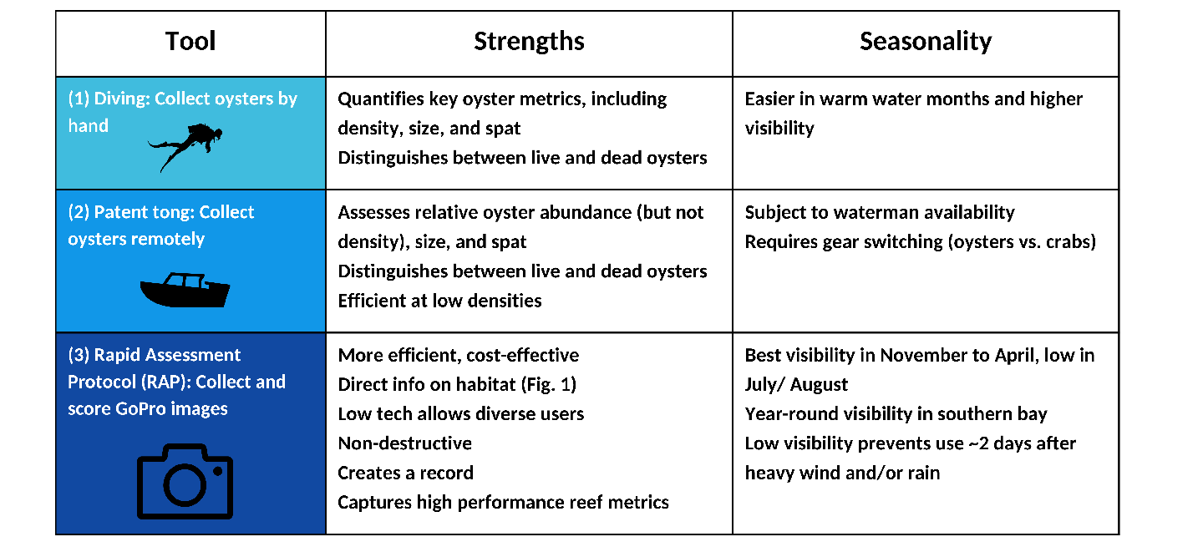
Table ii. Strengths and seasonality of three monitoring tools

- Use Scenarios: Restoration

Scenario #1: Post-restoration monitoring with prior quantitative data available
The goal for this scenario is to determine how the RAP can be used to reduce monitoring costs after an initial round of quantitative sampling has taken place. Scenario #1 is specific to monitoring of large-scale restoration in Chesapeake Bay, which currently involves quantitative monitoring of oyster metrics at 3- and 6-year timepoints after restoration. This scenario could be applied to reduce the sampling cost of a 6-year timepoint survey after quantitative metrics are collected for the 3-year timepoint.

For the first scenario, we consider Harris Creek monitoring as an example for applying the Hybrid Approach to restoration monitoring. We used the data from 307 sites at the 6-year timepoint to devise a plan for later years to determine whether sites are meeting the metrics. Although using the 6-year data, this is analogous to the process using the 3-year data when planning for future monitoring.

Figure iv. Scenario #1: Flow of decision-making for applying the Hybrid Approach to post-restoration monitoring

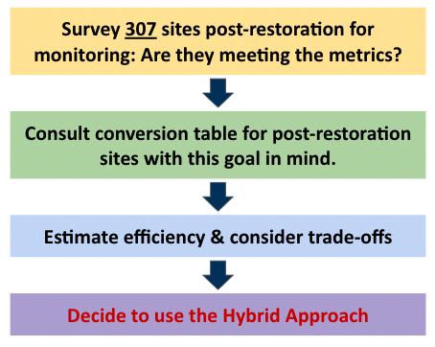
After articulating the goal of determining whether sites meet the metrics (yellow box, Fig. iv), the next step (green box, Fig. iv) is to consult the conversion table with the goal in mind. Consulting Fig. i, we see scores of 3 reliably meet the metrics in restored areas. Specifically, a score of 0 reliably denotes metrics are not met, 1 or 2 means more data are needed using the existing metrics, and 3 reflects that the metrics are met. This means that the RAP will complement existing tools well for the goal in question because the use of the RAP can discern whether the metrics are being met (for sites with scores of 3) or not (for sites with scores of 0). Use of existing tools can provide further detail if metrics are not clear, such as for sites with scores of 1 and 2.

The efficiency gains depend on how many sites are likely to be a score of 3 and can therefore use the RAP. Using the data from a previous sampling event, we can estimate how many sites are likely to be 3s based on data from patent tong, diving, or the RAP. For the Harris Creek data, patent tong data from the 6-year monitoring timepoint shows that 88 of the 307 (~29%) sites exceeded 80 oysters/m² and would likely score a 3. We used the threshold of 80 oysters/m² because it is a natural cutoff in the data between 3s and anything lower.

We can then assess whether using the hybrid approach saves time for oyster monitoring by looking at efficiency estimates for monitoring using only the two existing methods vs. monitoring where all three methods are options (the Hybrid Approach). For Harris Creek, there are enough high-density sites (88 of 307) that using the Hybrid Approach saves considerable time for monitoring: the estimate for person-minutes for 3-person patent tong and diving is 130 hours whereas it is 72 hours with the hybrid approach using the patent tong and RAP.

Scenario Take-aways
- It is effective and more efficient to use the RAP rather than divers at sites that are expected to be high density.
- It is more efficient to use the RAP at sites requiring divers at all densities if qualitative information is acceptable in exchange for greater efficiency.
- It is effective and more efficient to use the RAP at sites requiring patent tong that are expected to be high density.
- Data on expected oyster densities or reef habitat from prior sampling can inform application of the Hybrid Approach.

Scenario #2: Post-restoration monitoring with little or no prior data available

Scenario #2 focuses on how a Hybrid Approach could be applied when there is little prior information on restoration outcomes. In this case, the Hybrid Approach would involve an initial round of sampling at all sites using the RAP to determine oyster reef habitat scores, which track with oyster density and biomass (Figure i, ii). Then, follow-up sampling by divers or other quantitative methods could target sites that scored 1s and 2s to determine whether they meet restoration metrics or need addition attention. This method creates efficiencies by eliminating the need for expensive, time-consuming quantitative monitoring of restoration areas that are highly successful (scores of 3) or that likely failed (scores of 0). We recommend sampling a few sites scoring 3 using divers to obtain information on oyster size distributions, parasites, or other metrics as desired. The number of sites sampled by divers or other methods is a trade-off between the extent of quantitative data desired and the effort and cost of collecting it.

- Use Scenarios: Unrestored

The RAP can also be useful for pre-restoration monitoring, monitoring of unrestored oyster habitat in oyster sanctuaries, and monitoring of harvest bars. Monitoring in Maryland and Virginia tracks densities, spatfall, size classes, and disease status. Scenarios #3 explores example applications of the Hybrid Approach at pre-restoration sites. These sites that lack restoration behave differently with respect to the relationship between oyster habitat and existing metrics, such as density and size, based on the conversion table (Fig. ii).

Scenario #3: Pre-restoration ground-truthing

Scenario #3 is a general case of gathering baseline information from ground-truthing prior to restoration in a tributary. This ground-truthing is necessary to determine where the best sites are for planting various substrates and spat-on-shell, as well as where oyster densities are sufficiently high that restoration is not needed and may in fact bury existing habitat. Metrics related to habitat structure are not currently incorporated in ground-truthing because it focuses on density, biomass, sediment type, and the other existing metrics. Using the Hybrid Approach can address the goals of ground-truthing while also providing habitat information.

Figure v. Scenario #3: Flow of decision-making for applying the Hybrid Approach to pre-restoration ground-truthing offers a bifurcating path

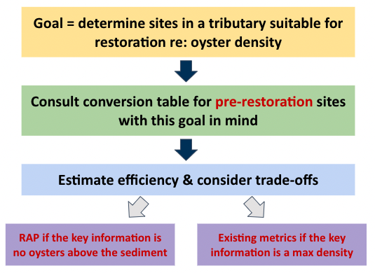

The starting goal here is to determine whether sites in a tributary are suitable for restoration. Here, the question is whether sites have a low enough oyster density to allow for restoration. The next step is to consult the conversion table for unrestored and harvested sites because the sites are not restored yet so that will be a more accurate guide to the relationship between the RAP scores and existing metrics. The relevant column of the conversion table in this case is the scores of 0, for which the RAP determines that no oysters are visible above the sediment.

There is an important decision point here: the RAP is appropriate if the goal is to find oysters above the sediment. If management decisions require knowing specific densities at low-density sites, or the presence of shell or other substrate that potentially lies below a layer of surface sediment, that will always require the existing tools/metrics. The RAP does not provide specific densities, does not distinguish unambiguously between low and high densities when vertical structure isn’t present, and can’t detect shell below the sediment surface. It also does not differentiate between live and dead oysters. While scores of 1 and 2 are reliable indicators of percent cover from the habitat-focused scoring of the RAP alone, they have overlapping density and biomass distributions (Tracy et al. 2024).

The management decision may also depend on efficiency. If many locations are expected to be 0s, a 3-person patent tong crew has similar efficiency to the RAP and also provides specific densities, making it an effective and equally efficient option.

Scenario Take-aways
- The requirements for management decisions can lead to different applications of the Hybrid Approach that depend on factors other than efficiency.
- The Hybrid Approach may take the form of a choice rather than applying both the RAP and existing methods for the same project.

- Hybrid Approach: Recommendations

Recommendation 1: Existing restoration and harvest monitoring should incorporate the RAP into a Hybrid Approach that leverages diving, patent tong, and RAP sampling to increase efficiency and enhance information for decision-making.

Recommendation 2: The RAP should be applied for post-restoration monitoring at sites that are expected to be high-density, where it is both effective and more efficient than patent tong and diver sampling (Scenario #1).

Recommendation 3: Applying the RAP and existing methods at overlapping sites is justified for post-restoration monitoring if there is little prior information or if additional information on high-density sites is valued (Scenario #2).

Recommendation 4: The Hybrid Approach offers a choice for pre-restoration monitoring that depends on efficiency and qualitative trade-offs. Existing methods should be applied at sites that are expected to have low or medium densities of oysters if it is important to have information beyond the fact that they are not likely to meet the existing metrics or have high-relief habitat. The RAP could enable low-cost pre-restoration monitoring if funds or access are not available for traditional methods using patent tong or divers (Scenario #3).

Recommendation 5: The RAP or a Hybrid Approach can be used to provide information on harvest bar status and guide decisions about bar replenishment (Scenario #4).

- Rapid Assessment Protocol (RAP): GoPro Camera System Specifications & Methods - A Synthesis of SERC and NOAA Operations (as of 1/24/2024)

The Smithsonian Environmental Research Center (SERC) and National Oceanic and Atmospheric Administration (NOAA) co-developed methods for monitoring subtidal oyster reefs in Chesapeake Bay. The method is qualitative and based on a combination of percent cover categories and relative reef height, which are associated quantitative reef metrics and biodiversity (Heggie & Ogburn 2021). In a study across 12 tributaries of Chesapeake Bay, qualitative habitat scores effectively identified differences in oyster reefs among management jurisdictions, restored and unrestored reefs, and across a salinity gradient (Tracy et al. 2023). To date, the method has been established for Chesapeake Bay Crassostrea virginica oyster reefs and we are beginning to apply the method in other locations and for other oyster species.

Camera System Design Specifications and Considerations

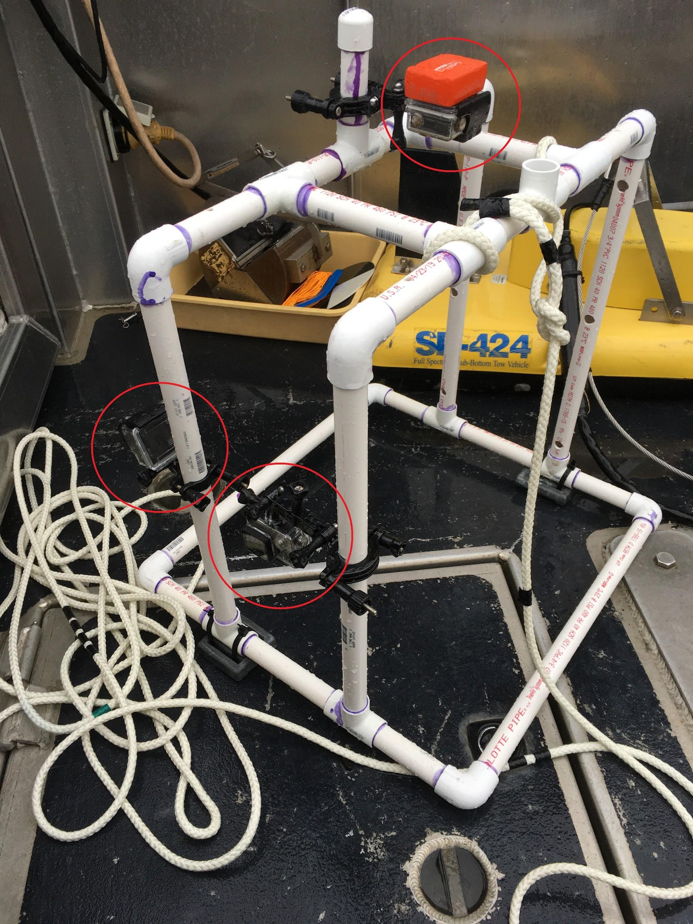
Two cameras are required for the RAP, placed along the bottom of the PVC frame and recording images laterally. The third camera at the top faces downward and is an optional addition. The dimensions of the RAP frame’s quadrat base are 0.5m x 0.5m. The approximate stand height is 0.55m. The system is weighted at the base. NOAA and SERC use similar approaches based on this core method, with some variations.
NOAA modified their rig with two “T” segments at the top of the rig (shown to the left) to bring water into the frame removing the buoyancy and allowing for fewer weights to be added. Holes were drilled into the bottom of the frame for the water to escape during recovery. The field of view in water is not the same as in air, be sure to adjust for in-water conditions. For the NOAA approach, two cameras are required at a minimum, a third is preferred: one down for capturing quantitative quadrat parameters (the “quadrat camera”) and one oblique for reef quality index scoring (“side camera”). The third camera adds a replicate for the oblique image habitat quality scoring (another “side camera”). The second “T” on the frame gives the operator the ability to adjust the height of the quadrat camera if needed.
Figure vi: NOAA orientation of GoPro cameras
The photo below shows SERC’s placement of the three cameras. The top camera faces downward and is placed to be completely flush with the top rectangle of the frame. The bottom two cameras are placed diagonal across from each other on two of the vertical parts of the stand approximately 5-10cm above the seabed. Each camera faces outward at a slight downward tilt of approximately 20 degrees off of vertical. This can be approximated as half of a 45-degree angle and may require some testing in the field. The SERC camera positioning on opposite legs is the preferred method.
The rig is attached to a 6m line with a buoy for deployment and this is sufficient for most sites with maximum ease of handling. An extension line is carried on board for dropping the rig at sites deeper than 6m and should also be considered for high-current sites. For each deployment, the RAP yields a video from each of the side cameras at a minimum. Replicate deployments are recommended for characterizing a study area given variability in oyster habitat.

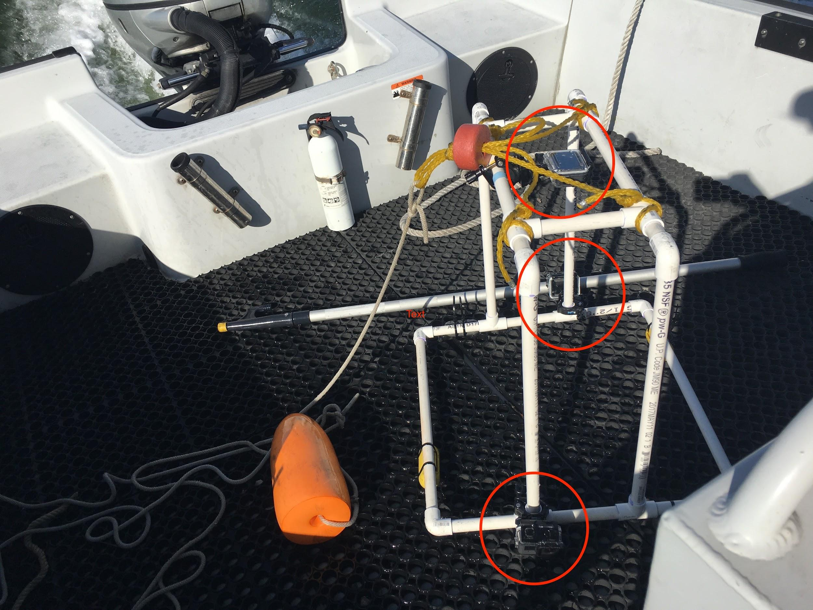
Figure vii. SERC orientation of GoPro cameras: The RAP uses the two bottom cameras that record video laterally. The top camera is an additional option that is not included in the RAP.

Photos from Different Camera Positions

The SERC method is the preferred camera position because it provides a clearer lateral view (Figure vii), which can be useful for estimating relative reef height, e.g. The NOAA method may be more appropriate depending on the study objectives.

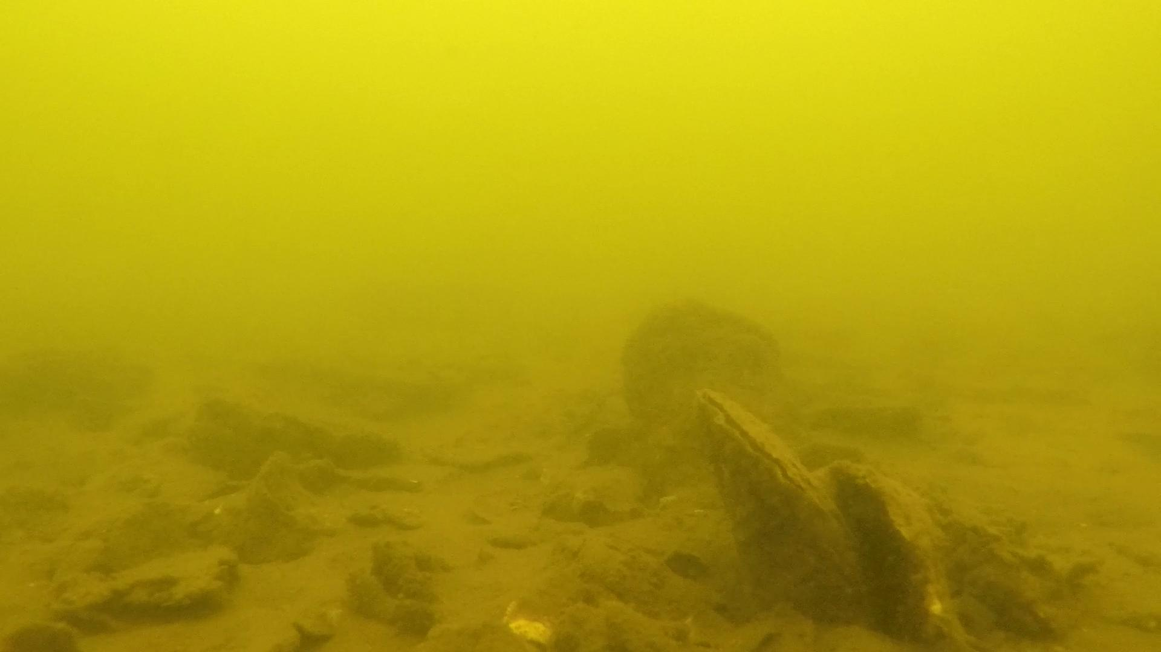
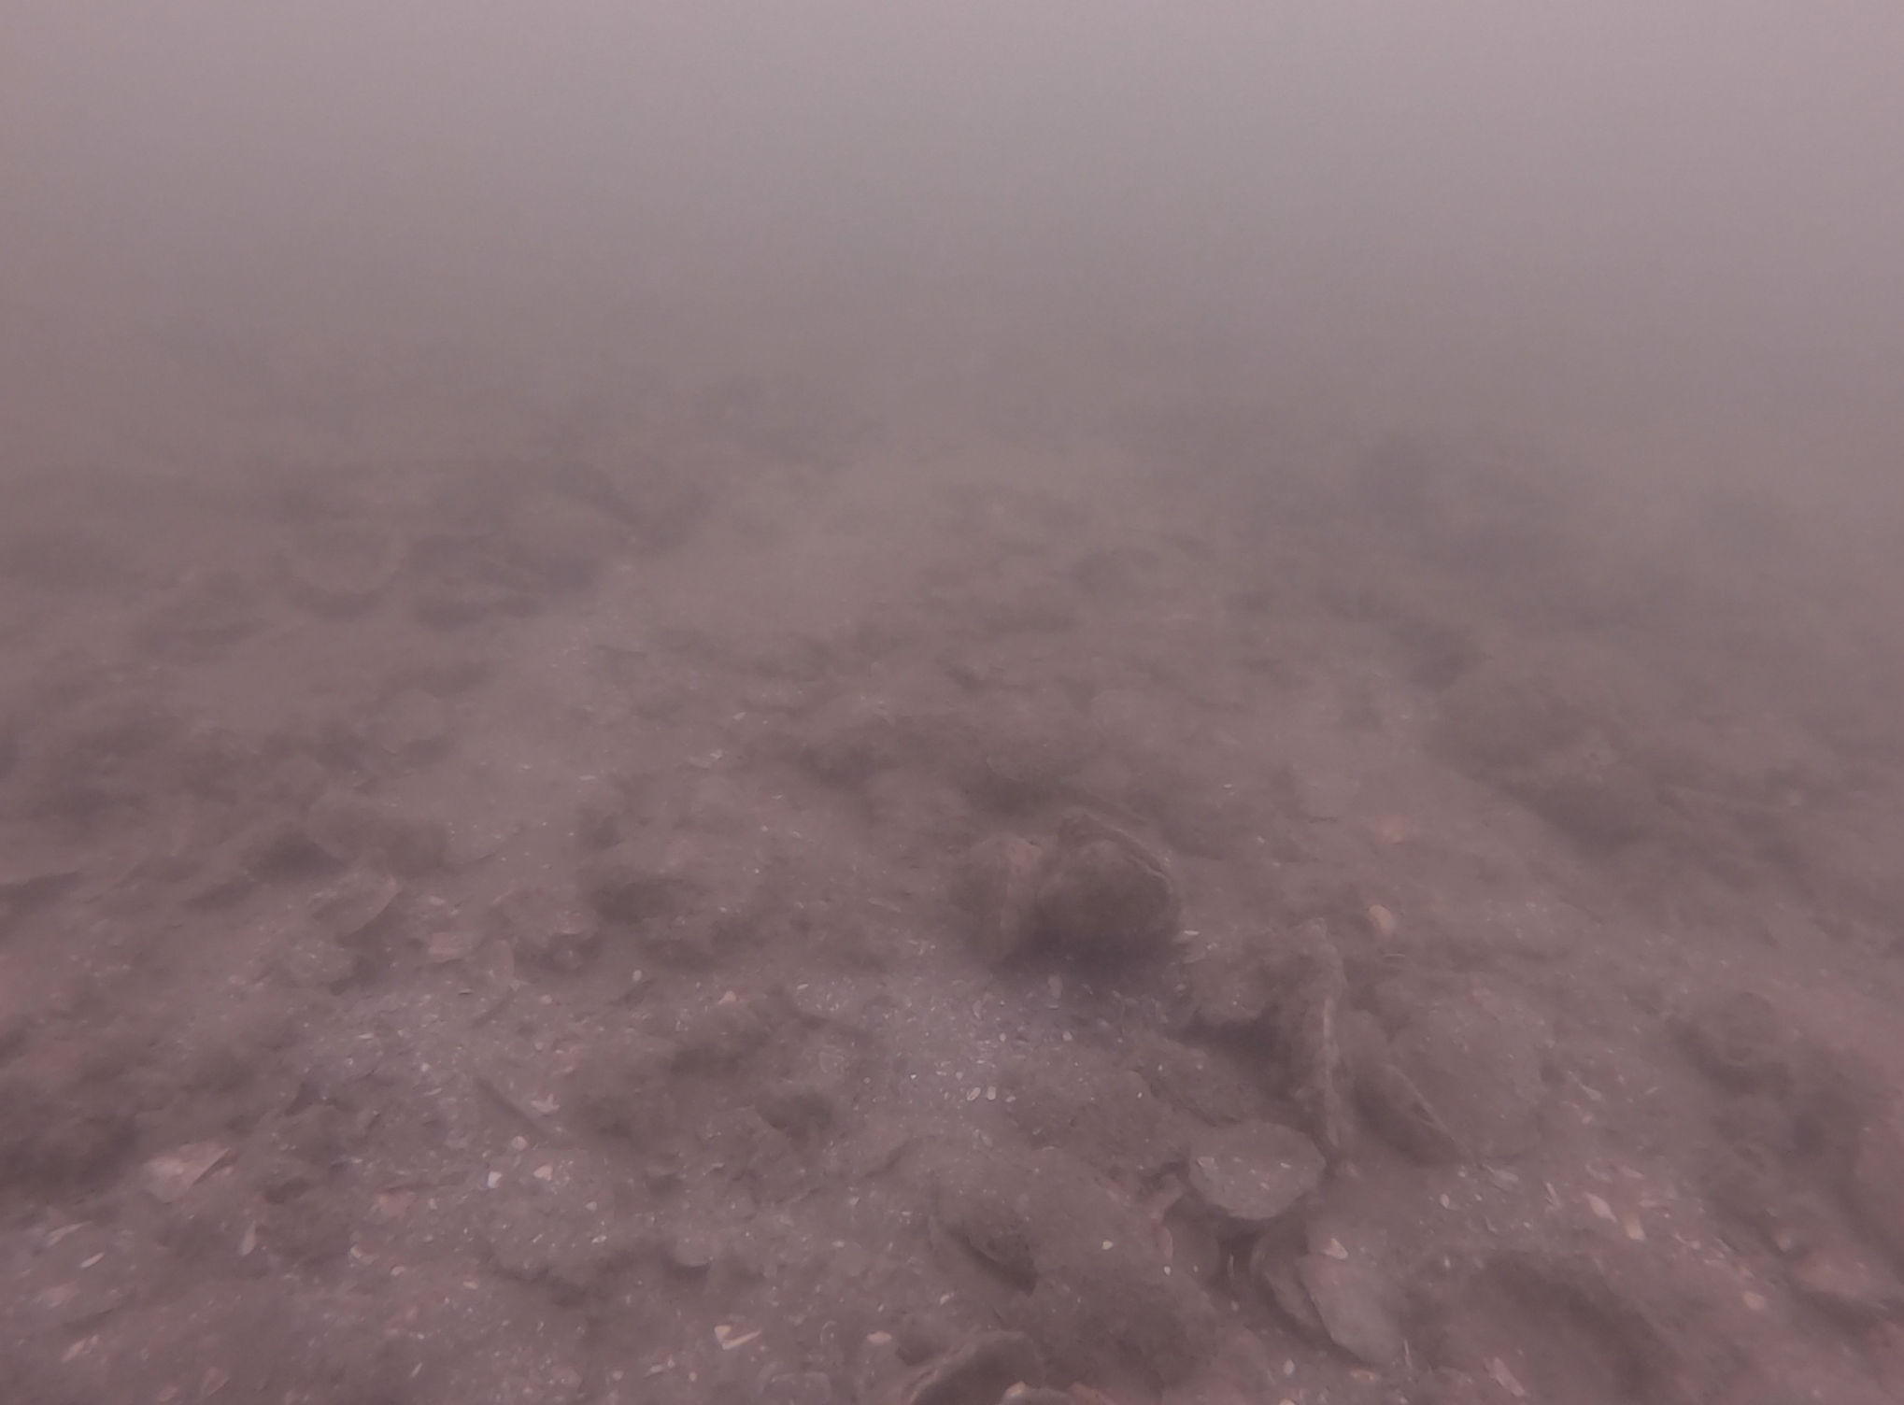
Figure viii: (A) Photo angle from higher position (NOAA) and (B) lower position (SERC)

Camera System: Pre-Deployment Considerations

Prior to deployment, batteries are fully charged, SD cards are cleared for data collection, and camera date/time settings are verified on the GoPro Hero4 and above models. 256 GB SD cards are best for the latest GoPro models given file size. Time is set to UTC to match our survey computer and navigation time tags. Camera settings are checked to ensure we have the correct resolution (1080, 64 frames per second, wide field of view), and two side cameras are set to video and quadrat camera is set to time lapse photo (collecting stills at 30 second intervals). Auto low light and video stabilization settings are both turned on. The video stabilization setting crops the wide field of view by 10 percent. Handy items to have with you include a towel, lens wipes, spare sd cards, spare batteries (2/ camera, especially in cold water conditions) and chargers and a slate/dry erase board for capturing site naming. It is redundant since your positions are getting recorded but if something is forgotten, it really helps to have site information in the image.

Camera System: Deployment Methods

Deployment methods can be adapted based on the number of people on board, weather/ water clarity, sedimentation, etc.

- NOAA Method: NOAA modified the deployment method by using GoPro cameras that are attached to the boat with a cable to provide a live feed. This increases speed and allows instantaneous checking of visibility, although it creates other logistical challenges in the field. Once on station, NOAA drops their system at a moderate speed (not too slow that you take too long and not too fast that you jar the system and overly disrupt the bottom). We don’t time exactly how long we hold the view, but long enough to allow sediment to move away and get a clear image (15-30s). Once on bottom, we record the “quick mark” position one time. We are often recording the vessel position continuously which is another redundancy in case something is off or missing with camera timing, etc. If holding position is difficult, we do our best to liveboat on position with our helm navigation and maintain contact with the camera rig. After the initial image recording, we lift the rig and set it back down within a few seconds to get another perspective. We repeat this for each site 3-4 times to provide a representative view of the bottom. We have not decided exactly how to use this, but thought that 3-4 views scored would generate more certainty for what the bottom looks like in that location and not solely on one drop. With two cameras this provides 6-8 images which may be more than is needed.
- SERC Method: SERC selects sites beforehand depending on the site type. For target polygons, 10 locations are haphazardly placed inside the polygon using GIS, avoiding sites very close to the boundary given the risk of sampling outside the polygon in the field. After navigating to a pre-selected GPS point, the rig is dropped (attached to a buoy) and the actual deployment location is recorded on the GPS. The rig is left for 2 minutes before it is recovered, during which the boat moves away from the location to allow sediment to settle in the area. This likely results in consistently clearer imagery, chance encounters with macrofauna and it eliminates the need to live boat in challenging conditions. For these reasons, we recommend adopting the SERC approach to deployment.

SERC Field Workflow

(Note: settings based on GoPro Hero 7)
- Turn camera on by pressing the side button once. The camera will beep twice.
  - It should be on the video setting by default (denoted by  in the bottom left of the screen). If it is on a different setting (e.g., photo, burst, or time lapse), then press the side button until “Video” appears.
  - Ensure the video settings are as follows: RES (Resolution) = 1440, FPS (Frames Per Second) = 60, and FOV (Field Of View) = WIDE.
- When you are ready to deploy the rig on the reef, press the button on top of the camera. The camera will beep once when you start recording and a red dot will appear at the top of the screen.
- After recording has started, place the whiteboard in front of the camera.
  - The whiteboard should have the date and the site written on it.
- When you pull the rig up onto the boat, you can stop recording by pressing the top button on the camera. The camera will beep once followed by three fast beeps.
- Check to make sure that the camera recorded a video. Do this by looking at the front of the camera (the side with the lens). There is a small screen to the left of the lens that will display a number. Check to make sure that the number increased by 1. If it didn’t, then the video did not record.
- To turn the camera off, hold the side button until it beeps. It will slowly turn off.

Survey Design

The survey design will depend on the study objectives. This document details how both NOAA and SERC have approached their data collection. NOAA has approached survey design by taking multiple drops per deployment location. The selected location has been based on collected patent tong samples. SERC has used 10 sites for relatively small polygons and 50 sites for tributary-wide sampling. Single images of the area of interest are unlikely to accurately represent the bottom which is why at least one replicate is useful for scoring. The survey design should be based on specific project requirements.

File Renaming for Video and Still Photos

There are several ways to record information to unambiguously link GoPro images with their GPS location. NOAA uses the time stamp to match the GoPro files with the GPS locations, and has also used whiteboards to display the site number at the beginning of each video. SERC records the order the sites were completed and the frame number at the beginning of each series of still photos. The site number is also announced at the beginning of each video before deploying, but whiteboards are more foolproof as the audio can be obscured. Using whiteboard labels for the quadrat camera requires starting the time lapse sequence when the whiteboard is already in the field of view of the camera so it is image #1 in the timelapse.

When downloading the files from the three cameras, the two side cameras will contain video files and the quadrat camera will contain still images. The videos from the two side cameras should be labeled to distinguish between the two (e.g. Side A and Side B in folders). The still images from the quadrat camera will include intervening images of the boat and water between images taken while on the reef bottom. The reef images can be labeled based on the order of sites.

GoPro files should be re-named to include the site (spelled out clearly and not abbreviated, e.g. Piankatank instead of “P” or “Pnk”), the location at that site (site number as a unique I.D.), the date, and the camera I.D.

An example file name: Piankatank11_2020195_b
Meaning: site #11 in the Piankatank on Julian Day 195 in 2020, camera side b

A metadata file should accompany the GoPro files that lists the GoPro file name, the site, the site number, the GPS location (latitude and longitude), the camera side, and the person collecting the data with a contact email.

Clipping Images from Videos

First create a clipped image from each side camera, either using the video viewer software or the command-shift-4 shortcut (creates a screenshot to the desktop, cropped to user boundaries). The frame selected from the video should be the clearest image of the reef available during the video filming on the single reef location. If there are multiple reef locations intentionally (NOAA design), label sub-images within the video by order using locations recorded in the field. If there are multiple reef locations UNINTENTIONALLY, choose the first location if it contains a clear enough image because it will be closest to the GPS location recorded on the boat. If that is not possible, a later location may be used. Use discretion in assigning a location if the rig moves considerably along the bottom during the video (this is uncommon).

A clear image often exists within the first second of the rig hitting the bottom before a sediment cloud emerges. Otherwise, the middle of the deployment video is often good for a clear clip. It is worth checking the entire video if a clear image is not available in these first two parts of the video because complex hydrology on the reef can lead to clear images occurring at any point in the video.

Carefully label the clipped images in accordance with the video name. Some video viewer software will automatically label the clipped image, which saves time.

QA/QC note: It is best to double check a subset of the clipped images visually to make sure they come from the video they are labeled as.

Scoring Images

It is recommended to score images blind to minimize researcher bias. For example, a treatment-control design with harvested and sanctuary sites could lead to bias for greater scores in the sanctuary, as this general trend is expected based on previous data.

Steps for blind scoring:
1. Label all images with their full names (e.g. Piankatank11_2020195_b, above)
2. Create a spreadsheet with one column listing the full image names and a second column listing the image name for blind scoring, which can be randomly assigned. For example, if there are 50 images, they can be randomly assigned #1-50 using a random number generator and avoiding repeats.
3. Assign random numbers to the rows in the spreadsheet while hiding the full image name column to minimize awareness of random assignments. This is less important if one person is randomizing and a second person is scoring.
4. Sort the spreadsheet by the random numbers: this creates a list of images that are not in the order of the full names or the order the sites were surveyed.
5. Assign image scores in a third column for both Side A images (one tab of spreadsheet) and Side B images (a second tab).
🡪 See next section for scoring methods
6. Sort both Side A and Side B tabs by the full image name (original name).
7. Create a combined spreadsheet (third tab) by copying the first two tabs into a single tab with the following columns: Side A full name, Side A randomized number, Side A score, Side B full name, Side B randomized number, Side B score.
8. Use the max() function in Excel to take the maximum of the Side A and Side B scores for each location. Alternative ways of combining the two scores can be used depending on study design.
9. Repeat the blind-scoring on another day or with another researcher to ensure repeatability is within reason.

Oyster Reef Habitat Score
If no video or video orientation is poor, use “null” to indicate ‘no data’
- No oysters: bare sand or mud
- Sand or mud with habitat structure (oysters, shell, granite, rock, tunicates*or hard substrate) covering <50% of the bottom
- Habitat structure (oysters, shell, granite, rock, tunicates*or hard substrate) covering >50% of the bottom, structure much less than the shell height of an individual oyster
- Habitat structure (oysters, shell, granite, rock, tunicates*or hard substrate) covering >50% of the bottom and structure height equal to or greater than the shell height of an individual oyster
* Often scores of 3 also have oysters growing vertically from the bottom and growing in clusters along with other species (e.g. barnacles, mussels, tunicates)

Tunicates need hard substrate to grow on, so if the photo is full of tunicates it is assumed the bottom is hard substrate.

Omit images that are not clear enough to score, but many images that are not “good pictures” are still scoreable based on the criteria. If in doubt, err on the side of omitting images. You can then see if the image from the same location was clear enough to use. If both Side A and Side B from a given location were omitted, you can revisit both of the images to see if it is truly not usable or if you can assign a score.

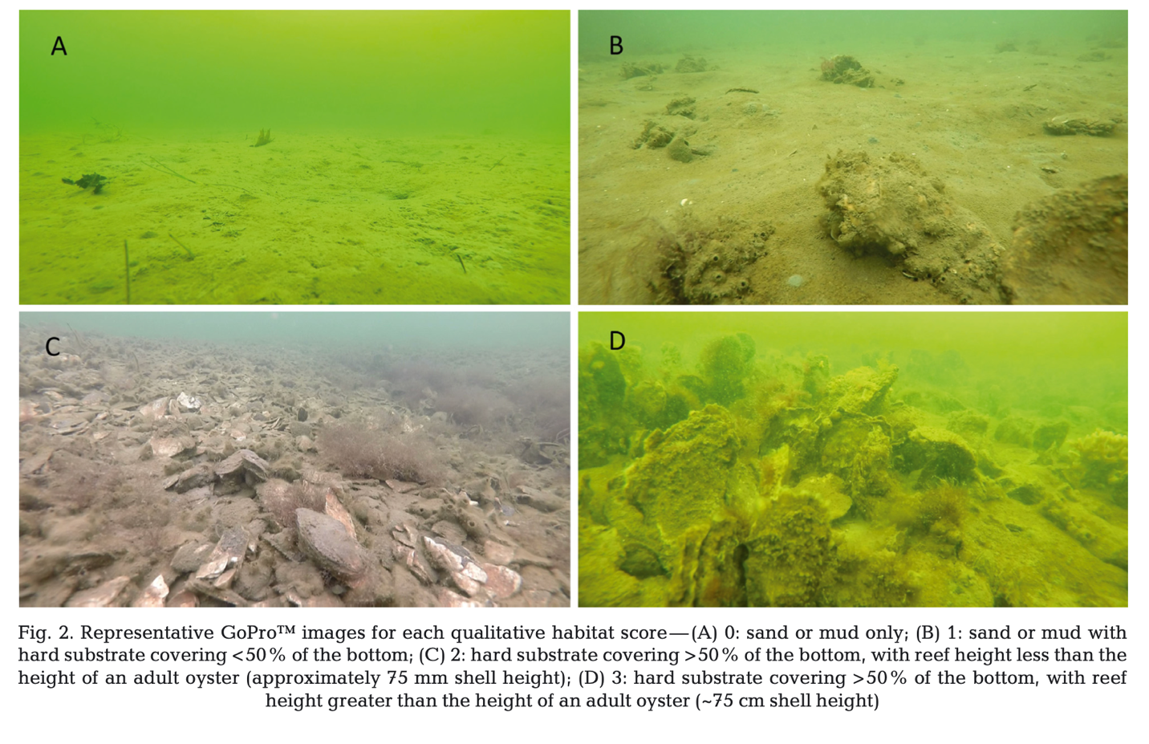
Figure ix: Representative images of RAP scored, reproduced from Heggie & Ogburn 2021. Note: RAP adjustments include specification of oyster shell/ oysters vs. hard substrate, and a score of 3 has a relative height of equal to or more than an adult oyster

References

Heggie K, Ogburn MB (2021). Rapid video assessment detects qualitative differences in oyster reef habitat. Marine Ecology Progress Series, 667, 219-224. http://dx.doi.org/10.3354/meps13708

MORIW (Maryland Oyster Restoration Interagency Workgroup under the Chesapeake Bay Program’s Sustainable Fisheries Goal Implementation Team) (2021) 2020 Oyster Reef Monitoring Report: Analysis of Data from the ‘Ten Tributaries’ Sanctuary Oyster Restoration Initiative in Maryland. Chesapeake Bay Program, Annapolis, MD. https://d38c6ppuviqmfp.cloudfront.net/documents/2020_Maryland_Oyster_Monitoring_Report_(2).pdf

Tracy AM, Heggie K, Ritter C, Norman D, Aguilar R, Ogburn MB (2023). Oyster reef habitat depends on environmental conditions and management across large spatial scales. Marine Ecology Progress Series, 721, 103-117. https://doi.org/10.3354/meps14426

Tracy AM, Aguilar R, Ritter C, Heggie K, Ogburn MB. The hybrid approach to monitoring: A remote Rapid Assessment Protocol (RAP) complements existing monitoring tools for oyster restoration and management. UPDATE

