The Effects of Social Media on Women’s Self-Image

Julia Haigley
Grace Timko
Justin Gabbard
Sean O’Ferrall
Salisbury University

Author’s Notes:
CMAT 297-001
Dr. Chrys Egan
Spring 2019
Contact: jhaigley1@gulls.salisbury.edu

Abstract
Understanding the correlation between social media and self-image is vital in today’s day and age, especially considering the pressure that is put on college students to display a picture-perfect life on their social media platforms. Data was gathered by having 100 different women attending Salisbury University complete an online survey, and by studying research by professionals in this field. The social media usage of the subjects was collected, and participants were also asked how social media has impacted their self-image as well as their friend’s self-images. Subject selection was restricted to undergraduate female students currently attending Salisbury University. All subjects were at least 18 years of age and no personal identifiers were attached to the information gathered. From the results of this study, it is evident that there is a correlation between social media and negative impact on a person’s self-image, although this relationship between social media and self-image is not a perfect correlation.

Keywords: Self-Image, Social Media, Women

Introduction
Background
The internet has a huge impact on society, and nowhere is this impact more apparent than social media. Nearly everyone uses social media in some shape or form to connect with others all over the word. No matter what social networking site people prefer, whether they like Twitter, Instagram, Snapchat, or Facebook, social media plays an integral part of almost everyone’s daily routine. This is especially true for college students, who may use social media to remain close to the friends and family they left behind when going away for school, or to make connections with people they meet in college. Social media allows students to get a glimpse into the lives of their peers and role models. This can have a serious impact on the self-image of college students everywhere if they decide to compare their peer’s portrayal of life to their own journey.
Rationale
As curious individuals, humans find themselves comparing who they are to others, often to measure one’s own worth as a person. Believing a person is “better” than one’s own self, especially in focusing on the lifestyles portrayed on social media, can negatively impact one’s self-image. One of the obvious ways people compare themselves to others is focusing on their body image, size, or weight, as appearance is the easiest and most superficial way to compare two people. While it might be difficult to tell how smart or rich someone is based on a picture posted on social media, it is very easy to judge others based on their size and appearance. It is important to study the possible negative effects social media can have on college-aged students, particularly female college students, especially if they try to use social media to depict a lifestyle revolving around acceptance from their peers.

Review of Literature
Developing social media literacy and learning about the profound effects social media can have is a fairly new concept, considering that popular social media platforms such as Facebook, Twitter, Instagram, Snapchat, and others have been on the rise within the past fifteen years. This study relies on published research on female self image and social media from a variety of academic communication journals. Studying social media and the effects it can have on its users is vital to this research and will be pertinent to further research conducted in the future as social media becomes even more central to modern communication, culture and society.
Often times research into the impacts of media on women’s body image focuses on the short term. Typically, researchers look into how brief exposure to media that promotes thinness impacts those who view it. However, exposure to these kinds of media usually happens over long periods of time. The research looked into how long-term exposure to magazine articles impacted the test subjects and, to test this, pages that promote thinness from the top 100 magazines were chosen. The test subjects would be given a survey asking various questions, including how they felt about their own weight (Knobloch-Westerwick, 2015, p. 1093). At the same time, they would be asked to view several magazine pages that promoted a thin lifestyle. After viewing these magazines, the subjects would be asked how they felt about the women in the magazines, about their own body image, and about their weight loss behavior. This was done daily, taking about 30 minutes each time. The study found that body image was improved by these magazine depictions of women, at least in the short-term. It led to women feeling that it is possible to achieve the ideal body type. However, they also found that it does not tend to lead to weight loss behaviors (Knobloch-Westerwick, 2015, p. 1098).
Many people seem to base their self-image on how they believe others perceive them. If they believe that someone thinks they are too fat or too skinny, they will likely view themselves that way. People also tend to compare themselves to those who are like them, as they believe that this would provide them with a potentially accurate comparison. Researchers investigated the idea that people’s self-image is impacted by fitness posts by their friends on social media (Arroyo & Brunner, 2016, p. 216). They performed their research at Southeastern University and students were given in-class credit to recruit people for the research. Within an online survey, participants were asked to identify the most common types of fitness posts their friends made on social media: pictures of healthy food, pictures of them working out, talking about working out, fitness inspiration quotes or images, before and after pictures, statistics about their exercise (Arroyo & Brunner, 2016, p. 221).
Survey participants were asked how often their friends make these types of posts and how often they compare their bodies to others. Researchers also asked subjects how frequently they engaged in negative body talk, how satisfied they were with their bodies, and how often they use social media. The study found a relationship between friends’ fitness posts and negative body talk, even if the individual was eating healthy and exercising (Arroyo & Brunner, 2016, p. 226). This is likely a cumulative process that increases in severity the longer a person views their friends’ social media posts. Even if the person posting is doing so with the intent to help others, their posts will likely still lead to an increase in negative body talk (Arroyo & Brunner, 2016, p. 226).
As social media becomes more popular, people begin to post about all aspects of their lives. There is a growing trend of “fitspiration” and posting about workout and dieting tips. A study focusing on fitspiration related content sampled 359 women from the ages of 18-28 to examine whether these fitspiration posts were negatively or positively impacting women. The researchers investigated four different types of fitspiration messages: fitness, healthy eating, weight loss, and mental well-being accounts. These messages relate to three different body image indicators, including body dissatisfaction, compulsive exercise, and situated optimism related to body goals (Sumter, Cingel, & Antonis, 2018, p. 1168-1169).
The researchers asked participants how often they visited these different pages and gave examples of images for clarity. They used a scale from 1-9, 1 being they visited a page daily and 9 meaning they never visited that page. Within their results, these researchers found that there are both positive and negative impacts of fitness-related messages on social media. The results showed that the monthly visiting of healthy eating, weight loss, and fitness pages was positively related to compulsive exercise and body dissatisfaction. It was also revealed that the visiting of healthy eating and fitness pages was positively correlated to situated optimism (Sumter, Cingel, & Antonis, 2018, p. 1170-1171). The researchers also noted that these results varied between individuals. These fitness-related posts positively impact some and negatively impact others whether they are conscious of this or not.
One important area of study to focus on is that of the psychological benefits of viewing and comparing one’s self to fashion models of diverse shapes and sizes. Research has been done on female undergraduate students to examine the effects of viewing fashion models of varying body types (Clayton, Ridgeway, & Hendrickse, 2017, p. 406). After seeing each model, participants categorized the model based on her body type, rated how attractive they believed each model to be, and gave social comparison and body satisfaction ratings (Clayton, Ridgeway, & Hendrickse, 2017, p. 411). Hypothesis 1 predicted that body satisfaction ratings will be greatest after seeing the plus-sized models, followed by average-sized models, and that body satisfaction will be lowest after viewing thin-sized models (Clayton, Ridgeway, & Hendrickse, 2017, p. 408).
This hypothesis was strongly supported in this study, as participants reported feeling the greatest amount of body satisfaction while viewing plus-sized models, and the least amount of body satisfaction when viewing thin models (Clayton, Ridgeway, & Hendrickse, 2017, p. 417). One of their most profound conclusions was that “these feelings indicate that in order to increase body-positivity and increase attention to and memory of a message, campaign producers should continue including more realistically sized fashion models in their media campaigns” (Clayton, Ridgeway, & Hendrickse, 2017, p. 419). If companies become more inclusive to different body shapes and sizes within their advertisements and marketing campaigns, college-aged women could feel better about their self-image and also develop positive associations with these companies.
While it is important to focus on perceptions of self-image and body positivity in advertisement campaigns, it is also relevant to look at how specific social media platforms can affect the self-image of college women. Social media plays a major role in the lives of many female undergraduate students, especially the photo-sharing platform of Instagram. A study of undergraduate women between the ages of 18-25 in the United States and Australia was done to determine whether Instagram usage was associated with young women’s self-image, especially body dissatisfaction and drive for thinness (Fardouly, Willburger, & Vartanian, 2018, p. 1383). Participants completed an online survey that included questions regarding Instagram usage, body image concerns, and their tendency to compare themselves to people they see on Instagram (Fardouly, Willburger, & Vartanian, 2018, p. 1385).
One of the major results of this study was that spending greater time using Instagram directly correlated with greater self-objectification and body dissatisfaction. From these results, the team of researchers concluded “that Instagram usage may negatively influence women’s appearance-related concerns and beliefs, particularly if they have internalized the beauty ideal and if they make appearance comparisons to others on Instagram” (Fardouly, Willburger, & Vartanian, 2018, p. 1392). Although it seems unrealistic to suggest to college-aged women to stop using Instagram completely, limiting one’s usage of this social media site could result in an increase in positive appearance-related beliefs for many women.
People tend to compare themselves to others in everyday situations, even places like the grocery store or in a parking lot. One study examined both men and women comparing themselves to others by measuring how much television they watch and if this has a direct impact on body satisfaction. The results revealed that there was not a significant relationship between social comparison and body satisfaction among men. However, during the women’s study, the results showed that unlike men, social comparison had a direct impact on female body-image and satisfaction.
One of the major conclusions from this study was that only women and their body satisfaction is being directly influenced through social comparison (Sohn, 2009, p. 29). This study shows that both men and women compare themselves to others, even to fictional characters, but that women are directly impacted by this process and are dissatisfied with their body image after doing so. This study depicts how a simple leisure activity, such as watching television, can negatively impact its viewers, specifically the female viewers, and the ways they view themselves.

Research Questions
- Is there a correlation between social media usage and negative perceptions of self-image in college women?
- Does increased social media usage lead to more comparison of one’s life to the social media posts of others online?

Methods
Participants
One hundred undergraduate female students at Salisbury University participated in this study. More specifically, the participant population was limited to the undergraduate population (freshman, sophomore, junior, and senior classes) and women who were at least 18 years of age.
Procedures
Participants were administered a survey with 9 items that took approximately 5-7 minutes to complete and reflected on their social media usage, views regarding self-image, and comparison to others on social media. The survey was strictly online and accessed through a link sent to the participants’ emails. It was distributed through the online survey tool SurveyMonkey. The course professor assisted in the distribution of the survey by sending the Consent and Disclosure forms with the survey link to the “All Student” email list.
- 4/5/2019 – survey was distributed
- 4/15/2019 – data was gathered and analyzed from the one hundred participants
Measurement
On the survey, there was a mixture of both quantitative and qualitative questions administered. Answers to quantitative questions are reported as percentages while answers to qualitative questions are analyzed based on content. By using this combined approach, researchers used both quantitative and qualitative data to look for insightful trends on the impacts of social media on the self-image of female undergraduate students.

Results
Figure 1: Class Level for Female Undergraduate Participants
Class | Results
Freshman | 27%
Sophomore | 20%
Junior | 23%
Senior | 30%

Figure 2: Social Media Usage for Female Undergraduate Participants
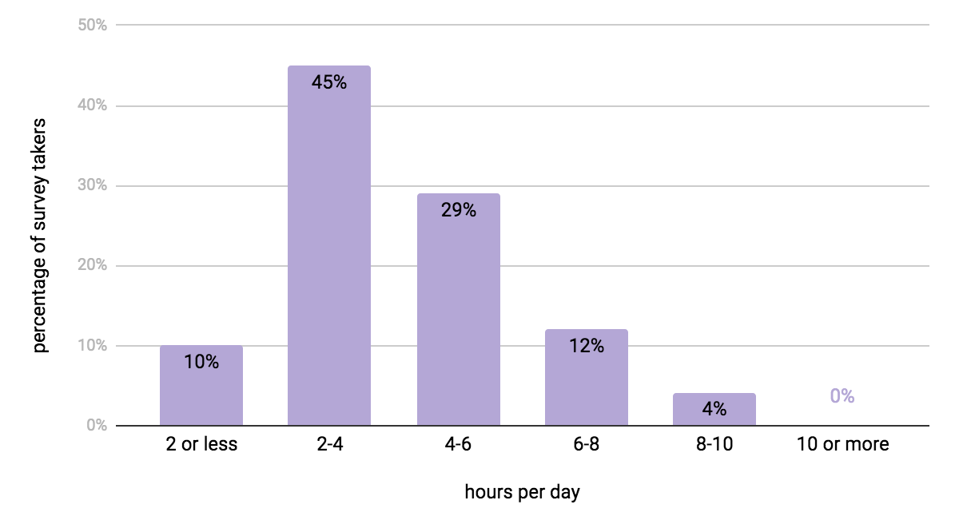

Figure 3: Ranking of Social Media Platforms (1=most used, 4=least used)
Social Media Platform | Ranking
Snapchat | 1st
Instagram | 2nd
Facebook | 3rd
Twitter | 4th

Figure 4: Does Social Media have (or used to have) an effect on your self-image, level of happiness, etc.?

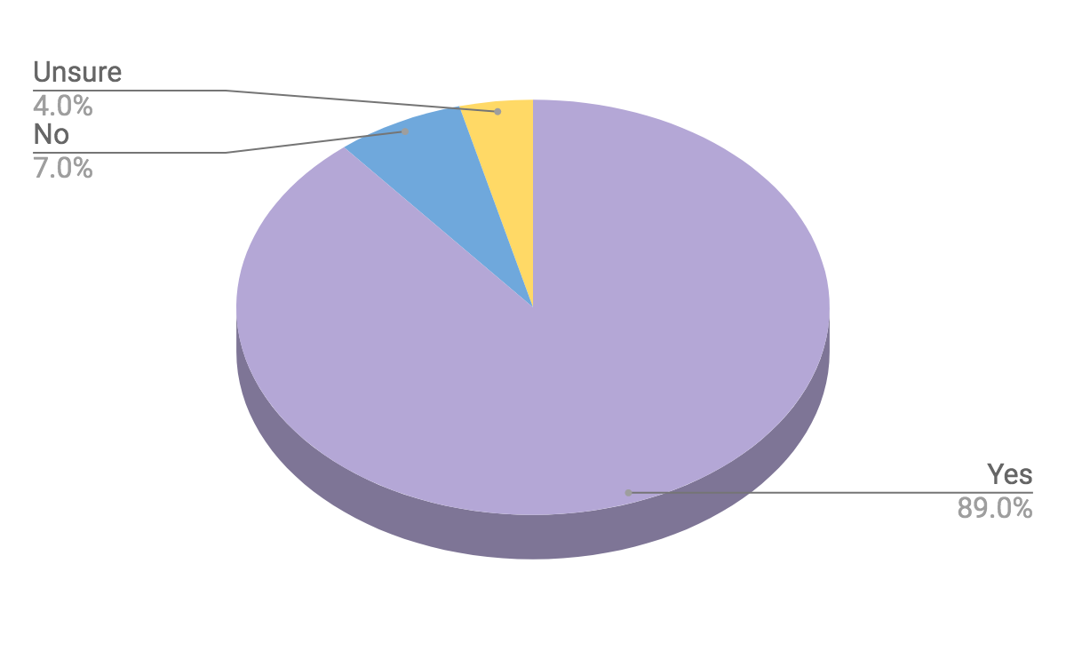
In examining the free response questions, researchers analyzed both the positive and negative responses as to social media’s impact on our sample (Q5). When asked to explain why social media has or has not affected their self-image, 35% of the respondents included the word “comparison.” Many responses included comparing one’s life to other people when they see their posts or pictures and that they feel jealous or less than. It was often discussed how “easy” it is to make these comparisons because social media is easily accessible. The word “body” was in 14% of responses and included ideas of having the perfect body type and criticizing themselves when they see other people’s pictures of their bodies on social media. One of the responses stated, “Social media tells you what body type you’re supposed to have and what is defined as beautiful and I don’t quite meet all the criteria for that.” However, several responses included positive feedback explaining that getting likes on a post can help build confidence, and two participants identified that they are not worried about what other people think of them and they are confident in who they are, with or without social media to confirm.
When asked the question “In your own opinion, does your personal social media use affect your self-image in a positive or negative way, or not at all?” it was discovered that 33% of responses stated that social media impacts them in a positive way, 63% of participants said that they are affected in a negative way, and 7% of this group included that they are impacted both positively and negatively by social media regarding their self-image. One student responded, “I'd say negative. I was going to say both because the positive is that when you post a selfie or a picture of yourself your friends hype you up about it, but then that leads to an expectation or hope that your friends will do that for all of your pictures so when they don't you're let down. Also, just like how you don't want to be put down by other people, you shouldn't be reliant on the validation of others to make yourself feel good.” She touches on the idea that friends are able to positively impact one’s self-image, but an expectation begins to occur and one begins not only to compare themselves to others, but also compares their social media posts and followings to others as well.
One result of this research was that 63% of the participants included statements that they noticed that social media affects the self-image of their friends and acquaintances in college (Q7). While almost all responses had a negative connotation, several were positive, “I have noticed one girl I know posts her weight loss progress. This seems to help her stay motivated and helps her stick to her end goals.” Only 26% of the survey-takers mentioned that they do not see effects of social media on their friends’ self-image, and 11% of the group responded that they were not sure or were not acquainted with friends that used social media. When asked, “Do you find yourself comparing your own life/self-image to others online?” (Q8), a majority of the survey takers, 75% of the participants, said that they do compare their lives to others. 15% responded that they do not compare themselves to others and 10% responded that they used to or only engage in comparison occasionally.
In the last question, when asked if participants believed social media use effects men and women differently, 58% of participants stated that they think it does impact each gender differently. Many argued that there was more pressure on women to uphold a certain expectation. Eighteen percent of participants stated that they do not see a difference of impact of self-image based on gender, and 5% of survey-takers were unsure, with several responses that did not answer the question. One response touched on an interesting idea of generalization, “I don't think we can generalize all women having the same self-image issues, and the same for men. Gender is a spectrum and we are all an individual with our own self-image and our own thoughts.”

Discussion
The purpose of this study was to dissect the relationship between college-aged female students and the impact of social media use. The results gave better insight into the lives of female students on campus and how their social media habits contribute to self-image. Of high importance was the discovery that 89% of surveyed female students believe social media has an impact on their self-image, which answers Research Question 1 (Figure 4). Although this survey question did not specify if this was positive or negative feedback, it exemplifies that social media does impact self-image in a conscious way. The open-ended responses address Research Question 2 on how social media use can lead people to compare their lives to the lives of others. The majority of survey takers, 74% of all the participants, reported spending 2 to 4 or 4 to 6 hours per day on social media. Participants indicate that they commonly compare their lives to other people when they see others’ posts or pictures, leading them to feel jealous or less than. Participants mentioned that making these comparisons is “easy” because social media is so accessible. Spending multiple hours per day on social media can make it easier for college students to constantly reflect on the online presence of their peers and wonder if they are portraying a life for others to admire through their social media posts.
Researchers found that most surveyed females were seniors, followed by freshman, juniors, and then sophomores (Figure 1). It was determined that the average student spends about 2-4 hours on social media per day, with 45% of participants falling into this category (Figure 2). It was discovered that out of the four selected social media platforms (Facebook, Snapchat, Twitter, Instagram) the majority of students ranked Snapchat as their most used social media platform. Instagram was found as the second most used social platform, followed by Facebook and then Twitter (Figure 3).
Snapchat and Instagram allow for instantaneous updates on one’s life, with photos, videos, and stories visible for 24 hours or longer periods of time. The instant gratification that comes with these platforms through views, likes, and comments could be a reason why college students favor these social media accounts over others. While many of the participants found social media as a way to compare themselves to others, it seems of vital importance to remind one another that social media portrays the best parts of life – rarely the hard and difficult times. Social media is a great tool to stay connected to friends and family, yet it should not be the only measure of success and happiness within the lives of college students. There are so many thoughts, memories and moments that happen beyond the reach of a phone screen. Trying to judge one’s life based on their social media posts should come with a caution warning that everything is not always as it seems.
Overall, it seems that there is a relationship between social media and negative perceptions of self-image, although this correlation is clearly not a perfect one. Increased social media use is not necessarily linked to comparison of others on social media. It can be assumed that subconsciously or consciously comparing one’s self to others is a process that is influenced by other external factors that just social media alone, like values, cultural upbringing, and levels of self-esteem.
Limitations
One of the most noticeable limitations to this study was the level of honesty participants had while answering these questions. There is no way for researchers to know if these inquiries were answered truthfully and some people decided to skip the qualitative short-answer questions. Participants also may not have been entirely truthful when saying how much time they spent on social media each day because they could be embarrassed about their habits and tendencies. Some participants may have felt inclined to answer that social media affects their self-image in a negative way because they subconsciously feel that this is the data the researchers want to receive. This could mean that these results focus on the negative impacts of social media on self-image when this is not, in fact, the case.
Future Research
This study opens up a whole new avenue for research because there is so much more to be explored regarding self-image and social media. In the future, it could be interesting to do a study on both young men and women see if social media affects the self-image of the sexes differently and examine the possible causes of this divergence. It would also be fascinating to see if the increased use of certain social media platforms result in higher or lower levels of self-image and if there are social media platforms that do a better job of facilitating higher-levels of self-image or vice versa. Social media and its effects on users is a topic that will not be going away any time soon, so it is of great importance for research to continue on social media for years to come.

References
Arroyo, A., & Brunner, S. R. (2016). Negative body talk as an outcome of friends’ fitness posts on social networking sites: body surveillance and social comparison as potential moderators. Journal of Applied Communication Research, 44(3), 216–235.
Clayton, R. B., Ridgeway J. L., & Hendrickse, J. (2017). Is plus size equal? The positive impact of average and plus-sized media fashion models on women’s cognitive resource allocation, social comparisons, and body satisfaction. Communication Monographs, 84 (3), 406-422.
Fardouly, J., Willburger, B. K., & Vartanian, L. R. (2018). Instagram use and young women’s body image concerns and self-objectification: Testing mediational pathways. New Media & Society, 20(4), 1380–1395.
Knobloch-Westerwick, S. (2015). Thinspiration: Self-Improvement Versus Self-Evaluation Social Media Comparisons with Thin-Ideal Media Portrayals. Health Communication, 30(11), 1089-1101.
Sohn, S. (2009). Body Image: Impacts of Media Channels on Men’s and Women’s Social Comparison Process, and Testing of Involvement Measurement. Atlantic Journal of Communication, 17(1), 19–35.
Sumter, S. R., Cingel, D. P., & Antonis, S. R. (2018). “To be able to change, you have to take risks #fitspo”: Exploring correlates of fitspirational social media use among young women. Telematics and Informatics, 35(5), 1166-1175.

Appendix A
SURVEY

1. What is your class status? Freshman Sophomore Junior Senior

2. On a regular basis, how often do you use social media? (Check ONE answer only)
❏ less than 2 hours a day
❏ 2-4 hours a day
❏ 4-6 hours a day
❏ 6-8 hours a day
❏ 8-10 hours a day
❏ more than 10 hours a day

3. Please rank your most often used social media sites: 1 being the one you use most, 4 being the one you use least often.
______ Facebook
______ Twitter
______ Instagram
______ Snapchat

4. Do you think social media has (or had) an effect on your self-image, level of happiness, etc.?
1. Yes
2. No
3. Unsure

5. Please explain your previous answer on why you think social media has (or has not) affected your self-image.
___________________________________________________________________________________________________________________________________________________________
______________________________________________________________________________

6. In your own opinion, does your personal social media use affect your self-image in a positive or negative way, or not at all? Please explain.
__________________________________________________________________________________________________________________________________________________________________________________________________________________________________________

7. Have you noticed that social media affects the self-image of your friends and acquaintances in college? Explain.
__________________________________________________________________________________________________________________________________________________________________________________________________________________________________________

8. Do you find yourself comparing your own life/self-image to others online?
__________________________________________________________________________________________________________________________________________________________________________________________________________________________________________

9. Does you believe using social media affect men and women differently? If so, why do you think this is the case?
__________________________________________________________________________________________________________________________________________________________________________________________________________________________________________

Appendix B

Human Subjects Approval and Consent Form

