Mindfulness Practices to Improve Stress Management and Motivation in the Secondary Classroom

By Rachael Owens

Submitted in Partial Fulfillment of the Requirements for the
Degree of Master of Education

May 2020

Graduate Programs in Education
Goucher College
Table of Contents
List of Tables | i
Abstract | ii
I. Introduction | 7
Overview | 7
Statement of Problem | 8
Hypothesis | 8
Operational Definitions | 8
II. Review of the Literature | 10
Introduction of Stress in the Classroom | 10
Definitions of Motivation in the Classroom | 11
How Stress and Motivation are Related | 11
Meditation to Reduce Stress and Increase Motivation | 13
Other Interventions to Reduce Stress and Improve Motivation | 14
Summary | 15
III. Methods | 17
Design | 17
Participants | 17
Instruments | 18
Procedures | 19
IV. Results | 21
Preliminary Survey Data | 21
Comparison of Stress and Motivation between Treatment and Control Groups Pre- and Post- Intervention Survey Items 1-5 | 23
Post Treatment Survey (Treatment Group Supplemental Items 5-9) | 28
V. Discussion | 31
Connection to the Literature | 31
Qualitative and Quantitative Data Analysis | 31
Implication of the Results | 32
Theoretical Consequences | 33
Threats to the Validity | 34
Implications for Future Research | 35
Conclusions | 35
References | 37
APPENDICES | 41

List of Tables
1. Item 4: Tally of Test plans | 21
2. Item 5: Tally of main sources of stress | 22
3. Item 6: Rank of motivation to complete schoolwork on any given school day | 23
4. Descriptive statistics of Pre- and Post-Intervention Stress total scored (total rating for survey items 1-3) | 24
5. Average of Items 1 to Item 3 | 25
6. Results of t-test for independent samples comparing mean total Pre- and Post-Intervention Stress and Motivation Scores between treatment and control groups | 27
7. Summary of effects felt from stress for total sample. | 28
8. Results of correlation between stress and motivation. | 29
9. Descriptive Statistics for responses to Post-intervention Survey items from Treatment group | 30

Abstract
The purpose of this study was to gain insight about how mindfulness practices and information sessions about stress and stress management affected self-reported stress and motivation levels of adolescent high school students. This study was intended to provide insight into how participants responded to stress management practices such as mindful meditation incorporated into their everyday life. As anticipated, the student participants reported high levels of everyday stress due to various factors such as school work, communication with peers, and planning for college. The majority of students found the mindful meditation practices helpful and realized a correlation between stress and motivation levels but did not see a long-term trend of being less stressed overall. The treatment group for the study consisted of 22 student participants enrolled in the elective Psychology of the Individual, who participated in three mental health seminars and mindful meditation every other day for three weeks. The control group included 19 students who were also enrolled in the elective Psychology of the Individual with the researcher as their teacher. The null hypothesis was retained as students in the treatment group did not report being significantly less stressed and more motivated than students in the control group after the intervention. However, observations and some student-reported feedback suggested the intervention was informative and further investigation of the correlation between stress and motivation are warranted, especially given today’s turbulent environment.

CHAPTER I
INTRODUCTION
Overview
The goal of a successful school is to promote a love of knowledge for all students as they grow into lifelong learners. Unfortunately, due to increased class sizes, crammed daily schedules, and increased academic workload and rigor, the positive goals of school are replaced by a desire for higher test scores and an increase of mental health concerns. This increased pressure can sometimes cause students to feel overwhelmed, detached, and unmotivated (Buchwald, 2006). This study explores how stress affects the motivation level of students in school, extracurriculars, and life, and whether mindful meditation can impact students’ stress and motivation levels.
Although many academic institutions are incorporating stress management knowledge throughout their building in the form of posters or clubs, there is no explicit instruction through any core class curriculum. Students often have to seek out help and strategies for dealing with stress management from already overworked guidance counselors. Additionally, students that are experiencing mental health issues often do not have the skills to label their emotions and therefore do not know how to get help (Frey, N., Fisher, D., & Smith, D., 2019).). Zwan, Vente, Huizink, Bogels & Bruin (2015) suggested that by making students aware of the symptoms as well as the resources and strategies for stress management, students will have a lesser chance of falling victim to mental health problems, as well as increasing their levels of achievement to become healthy and successful members of society. The literature related to these issues indicates that lifetime motivation can be improved by providing students with the education to identify their own stress, as well as resources, strategies, and coping mechanisms to manage stress.
This researcher’s interest in the effects of students’ stress on motivation came from her role as a high school Psychology, AVID, and Social Studies teacher. She observed that her students often spoke about feeling overwhelmed by school, work, sports, and the clubs they felt forced to be a part of. The same students also seemed to frequently shut down in class and very rarely completed assignments. They also showed very little enthusiasm for learning new concepts and almost never desired to expand their learning by taking their education into their own hands. The researcher became focused on the possible correlation between stress and motivation and how to foster a love for learning within her classroom.
Statement of Problem
Numerous students experience high levels of stress and/or other mental health concerns during their academic years. If the concerns are not addressed, the students’ academic and personal lives can be negatively impacted. This study sought to inspect the effect of mindful meditation and psychoeducation within a classroom environment in helping to promote higher motivation levels and decreased amount of unregulated stress.
Hypotheses
Stress level has no impact on the motivation level of students in school, extracurriculars, and life.
Mindful meditation will not have impacts on students’ stress and motivation levels for the treatment group.
The change of motivation levels for both the control and treatment groups are the same.
Operational Definitions
Webster’s dictionary (2016) defines stress as a physical, chemical, or emotional factor that causes bodily or mental tension that affect a person’s mood, thinking, or behavior in a negative way. For this study, examples of student manifestations of stress include anxiety, depression, eating disorders, addictive behaviors, and fear of failure. Webster’s dictionary (2016) defines motivation as the various needs or desires that causes a person to act to complete a goal or task. For the design of this study, examples of student manifestations of motivation will include completion of academic tasks, enjoyment of extracurriculars/hobbies, and the interest felt in school towards learning.

CHAPTER II
REVIEW OF THE LITERATURE
This literature review explores issues related to student levels of motivation and their effects on student achievement within the classroom setting at the secondary and collegiate levels. The review describes the definition of motivation and how stress relates to levels of motivation. The review also describes how motivation is addressed within school settings, and strategies for teachers to incorporate within their own learning environments with the intent of learning more about promoting meditation and exercise as ways to increase motivation in students. Because the classroom environment is a place where intrinsic and extrinsic motivation grow and occur, educators must be prepared and able to promote various strategies to lower stress levels and increase motivation throughout their instruction.
Section one introduces the reader to the different causes of stress that secondary students experience. Section two defines motivation and misconceptions of motivation. Section three addresses the connection between stress and motivation. Section four expresses the benefits of meditation on stress levels. Section five discusses the effective strategies to increase motivation through meditation. Section six expands upon intervention to improve motivation and reduce stress. And finally, section seven provides a summary of how meditation and exercise can create self-sufficient adults.
Introduction of Stress in the Classroom
Many adolescents at certain times during their long educational career are challenged by stress and anxiety. Stress can “keep learners motivated but excessive pressure can lead to stress which undermines performance in educational settings” (Buchwald, 2006, p. 326). The sources of the stress they experience include school day demands, homework, frustrations due to high expectations, negative thoughts and feelings about themselves, bullying, moving or changing institution). Increased amounts of worry or stress can be defined as the psychological disorder ‘anxiety’ (DSM-IV, 2017).
Definitions of Motivation in the Classroom
Motivation is something that all humans and animals experience. The three types of motivation covered in this literature review are intrinsic motivation, extrinsic motivation, and personal relevance. Oka (2005) defines motivation as a force that “influences what people do—meaning their choice of actions, as well as how they act; the intensity, persistence, and quality of their actions” (p. 331). Gottfried, Nylund-Gibson, Gottfried, Morovati, & Gonzalez (2017), in their latitudinal study of intrinsic motivation through adolescence state that “intrinsic motivation involves cognition and concerns pleasure inherent in learning” (p. 643). Chow & Yong (2013) go further to explain intrinsic motivation in students and explained that “intrinsic motivation is the true drive in human nature, which drives individuals to search for and to face new challenges. Their abilities are put to the test and they are eager to learn even when there are no external rewards to be won” (pp. 214). Another type of motivation is extrinsic motivation. Jen & Yong (2013) explain that unlike intrinsic motivation, extrinsic motivation drives students to engage in academic tasks for external reasons. Extrinsic motivators include parental expectations, expectations of other trusted role models, earning potential to enroll in a course later and good grades. An additional motivation type is personal relevance. Personal relevance is when a student is able to make a personal choice in their learning. This causes the student to feel invested in the task.
How Stress and Motivation are Related
Defining Stress
Stress is a biological instinct passed down through the generations to keep humans alive. Ultimately, stress is defined by the release of the chemical adrenaline that effects the nervous system of the body producing the increased heart rate, activated sweat glands as well as other symptoms of panic (Biegel & Corbin, 2018). Biegel & Corbin (2018) state in their book that “[w]hat causes you stress depends on how you (1) perceive or view and (2) appraise or value the person, place, thing, or situation as stressful. In turn, your body responds physically or emotionally- or both- to the stressor” (p. 16). The response to the stressor releases the adrenaline that focuses your body on a task: fight the stressor or flee. The release of adrenaline can assist in motivation and performance for some people because of the fact it heightens focus on a task. However, performance can only increase to an optimal point and if the stress continues, performance sharply decreases.
Consequences of Stress on Academic Motivation
Jahan, Siddiqui, Mitwally, Zubidi, and Zubidi, (2016) explain that academic stress is a normal part of a student’s every day, “[high levels of] stress are associated with depression, drug abuse, anxiety and suicide” (p.17). Students that are coping with high levels of stress and the associated negative consequences will be unable to focus on academic tasks. The authors maintain that dealing with bad mental health overwhelms students and can disrupt motivation in a classroom setting.
Conversely, Suldo et. al (2016) found in their cross-sectional study that students who reported having good mental health performed at a higher average than those that reported negative mental health. Specifically, the good mental health students scored higher on statewide achievement tests as well as “behavioral engagement (e.g., better school attendance, more attentive and compliant in class), and affective engagement (e.g., more positive attitudes about one’s academic abilities)” (p. 437). The studies suggest that implications of these findings for future studies are that as mental health issues arise, schools should consider implementing new ways to reach coping mechanisms that will reduce stress and anxiety while increasing motivation within the classroom.
Meditation to Reduce Stress and Increase Motivation
Studies suggest that humans who are able to introduce meditation in their everyday lives are better able to establish higher levels of emotional intelligence and manage stress, anxiety and other common mental health issues. According to a study by Chu (2010) that observed 351 full-time working adults with different amounts of experience in meditation found that those participants with greater meditation experience exhibited higher emotional intelligence, and less perceived stress and negative mental health than those who had no mediation experience. The study defined meditation as having at least 20 minutes of regular daily practice of either concentrative, mindfulness or integrated meditation. After an experimental period of four weeks, the results were found to be positive. The meditation group exhibited higher scores in relation to such aspects of emotional intelligence such as optimism, mood regulation and social skills than the control group in the post-test measures.
In order to introduce meditation to students, Zwan, Vente, Huizink, Bogels, & Bruin (2015) conducted a randomized controlled trial of 76 participants. Those that participated in the Mindful Meditation (MM) part of the trial completed a workshop on guided meditation including lessons on how mindfulness is helpful during stressful times. The participants received a CD of several guided meditations (e.g., awareness of breathing meditation, body scan, and mindful movements) for their daily meditations. Results indicated an overall beneficial effect consisting of reduced stress, anxiety and depressive symptoms, and improved psychological well-being and sleep quality. This study illustrated the benefits of meditation can have through self-guided instruction.
The study conducted by Erbe, Beckmeyer, Lohrmann, & Middlestadt (2019) stated that while meditation is an important health-enhancing behavior that few young people practice, it is imperative that schools and institutions include lessons explaining why meditation is a practice all students should adopt, instead of forcing students to participate. Specifically, they state:“[h]ealth programs for adolescents should first prioritize helping youth have a positive attitude towards meditation when encouraging them to adopt the behavior” (p. 6). When students understand the purpose behind an action, their intrinsic motivation improves. Once their motivation for an activity improves, the probability of completing the action increases as well.
In order to teach meditation in an efficient and relevant manner, Knepper (2015) suggest participating in a biophysical workshop for adolescents that teaches breathing practices, meditation and other mindful practices to regulate stress, emotions, and attentional focus on self-regulation, self-efficacy and academic performance. This workshop is known as Youth Empowerment Seminar (YES!). The main tools taught at this seminar include mindful meditation lessons that can be incorporated into classrooms and lifestyles. One of those lessons is Sudarshan Kriya®. “Sudarshan Kriya® is a powerful yet simple rhythmic breathing technique that incorporates specific natural rhythms of the breath, harmonizing the body, mind and emotions” (p. 31). The result of this intervention is both stress regulation and an increase in motivation.
Other Interventions to Reduce Stress and Improve Motivation
Goal Setting
Teaching students to set goals could be a key component to academic success. As studied by researchers Travers, Morisano and Locke (2015) who studied the effects on goal setting in an academic classroom setting. The students were instructed to reflect in diary-type entries to set goals for themselves. The results of study illustrated an improvement in three academic outcomes “self-reflection, growth goals, and academic outcomes” (p. 225). Specially, they state “Psychological growth (e.g. heightened self-esteem, or self-confidence) appeared to affect students’ beliefs in their own abilities, and this positively subsequently impacted on their studies” (p. 233-43). Therefore, it seems that students who are taught to set their own goals may show an increase in intrinsic motivation that will reflect within their academic tasks.
Another goal setting method to increase motivation in students is through teaching parents goal setting techniques to motivate their children. A seven-week quasi-experimental study conducted by Froiland (2011) taught 15 parents “autonomy supportive communication techniques” that included helping their children set learning goals for homework assignments (p. 19). The study results showed an increase in extrinsic motivation but children did not significantly improve on general measures of self-reported academic intrinsic motivation.
Nature Interventions
A study by Windhorst and Williams (2016) concluded that stress and anxiety levels could be lowered in students when they are introduced to nature-based management techniques. Specially, the researchers include strategies such as reading outdoors, spending quality time with animals, and nature walks to lower anxiety and increase focus during a lesson. Findings of the study state that students reported feeling less stress and more confidence, but they did not report feeling more academically motivated to complete tasks.
VII. Summary
In summary, the research suggests that there is a negative correlation between students’ levels of stress and their level of motivation within an academic setting. Various types of interventions can help students decrease their reported level of stress and increase their academic motivation as shown by Kuiper, Broer, van der Wouden (2018) and Chu (2010) (as well as many others). While definitions of motivation may differ from student to student, this literature review suggests that there are various strategies and coping mechanisms that can be introduced in a secondary classroom or institution to promote positive student mental health that will lead to a student-reported increase in motivation and a decrease in stress. Specially, students’ levels of motivation may increase and their stress levels may decrease with the introduction of mindful meditation interventions.

CHAPTER III
METHODS
The purpose of this study was to determine whether implementation of interventions in the form of mindful meditation for stress reduction would affect students’ self-perception and self-assessment of their motivation to complete academic tasks. The mindful meditation lessons included practice sessions during the first five minutes of Psychology of the Individual class every other day and three seminars regarding stress education and stress reduction in school. Students in the group that received the lessons rated their stress levels and motivation levels before and after the seminars. Students rated their levels using a Likert type, multiple choice, and open-ended questions. The survey was administered on Google Forms, an online format. The survey responses were examined to determine whether the interventions showed evidence of success in increasing academic motivation and lowering stress levels in comparison to the non-invention group.
Design
A quasi-experimental pre-test-post-test design was used to measure the effect of the intervention strategies (mindfulness) and seminars on students’ reported level of academic motivation as well as reported stressors in school.
Participants
Participants in this study included high school sophomores, juniors, and seniors from various backgrounds. These 41 students were enrolled in the elective Psychology of the Individual class and participated in the Preliminary Survey, 18 of whom identified their gender as male, 23 of whom identified as female. In terms of race or ethnicity, 32 participants reported that they were white, four reported they were African-American, one reported as Hispanic, one reported as Asian, and three reported as mixed race. After the Preliminary Survey, the two classes were divided into a control and treatment group. In the control group (made up of 19 students in one class), participants completed the surveys but did not participate in the mindfulness and stress and mental health seminars. Students in the other class (22 out of 41 students) served as the treatment group and did participate in the mindful meditation lessons as well as the mental health seminars. All treatment participants were chosen based upon their similarities in age, socioeconomic class, and Psychology of the Individual teacher, and were all enrolled in their sophomore or junior year. This similarity, combined with classroom observations, led the researcher to assume that the participating students would experience a similar level of stress on a daily basis.

Instruments
The instruments in this study were surveys containing Likert Scale-type questions and narrative responses which were administered through the online Google Forms process. Initially, all 41 Psychology of the Individual students were given the Preliminary Survey (see APPENDIX A) on which students were asked to record their basic demographic information, list school stressors, identify their level of stress, and rank their motivation levels during the academic school day. Students in both the control and treatment groups were also asked to complete a Pre-Intervention Survey (see Appendix B), on which each student identified their specific motivation level throughout the school day, list the aspects that they believed decreased their motivation levels, and the coping mechanism or strategies they know or they had already implemented to increase motivation in school. At the completion of the mindful meditation seminars, the treatment group completed a new survey (see Appendix C) which contained identical questions as the Pre-Intervention Survey, but also asked additional questions about the students’ perceptions surrounding mindfulness. For instance, the survey asked if the students could rate the growth of their academic motivation, if possible. The control group completed the Appendix B survey at the completion of the mindfulness seminars.
Procedures
Preliminary Survey
The Preliminary Survey was administered first to gather data about all participants’ prior knowledge surrounding coping mechanisms for stress management, as well as motivation levels. This survey was administered before the Pre-Intervention Survey and before the mindfulness or information seminars were conducted. In total, 41 students voluntarily completed the Preliminary Survey using a Google Form. Their responses were not anonymous but were not shared with anyone.
Pre-Intervention Survey
The Pre-Intervention Survey was then completed by all volunteers using Google Forms in order to assess student stress levels and motivation levels and their prior knowledge about using positive mental health strategies to assist with stress levels. The data compiled acted as data for comparison of initial and Post-Intervention stress levels between the control and treatment groups. A total of 41 students completed the Pre-Intervention Survey (22 in the treatment condition and 19 in the control condition).
Intervention
Before the intervention, students in the treatment group watched a video about Mindful Meditation. The video included instructions for rhythmic breathing and mantra usage as well as the importance of meditation. For three weeks, students in the treatment group participated in mindfulness lessons with the purpose of stress-reduction, introspection, and increase of motivation in a classroom setting. These included twelve sessions of meditation and rhythmic breathing for about five minutes before starting each Psychology of the Individual to promote consistency and set expectations (Meditation lessons and links to videos are located in Appendix D.). These also included three information sessions about understanding and labeling stress (one lesson per week). The lessons were taught in the Psychology of the Individual class with the purpose of teaching students about mental health awareness as well as providing resources to students to handle stress on their own (Contents of the sessions are summarized in Appendix E.).
Post Intervention Survey
After the treatment group participated in three weeks of the intervention, including the three mental health information seminars, the control and intervention groups completed identical versions of a Post-Intervention Survey to again assess their stress and motivation levels. As noted, the control group’s Pre- and Post-Interventions were the same. The treatment group’s Post-Intervention Survey included additional questions about the Mental Health Seminars. Participants’ scores were calculated by totaling the Likert scale rating compiled from items one to three to yield a total score for each student of up to 10 points possible per item and 30 points total. The rating for each of items one and three could range from (1) feeling more stress to (10) feeling less stress, as well as (1) feeling less motivated to (10) feeling more motivated. The calculated means were then compared for the control and treatment groups to establish if a difference existed between the two, especially after the intervention period.
Additionally, the treatment group’s responses to the Post-Interventions Survey items (Appendix C, items 5 to 10) were calculated to study if the participants found any value in the intervention or planned on using the strategies in the future to motivate and handle stress.

CHAPTER IV
RESULTS
The purpose behind this study was to determine whether implementation of mindful meditation practices and mental-health seminars would affect students' self-assessment of their motivation and stress levels. The tables and narrative descriptions below highlight the results from the Preliminary, Pre-Intervention, and Post-Intervention Surveys used to assess the effectiveness of the intervention.
Preliminary Survey Data
Of the 41 students enrolled in two Psychology of the Individual classes, all 41 students elected to complete the Preliminary Survey Google Form. The majority of the students, 32, identified as White/ Caucasian, which parallels the majority racial background of our school. All 41 students ranged in age between 16-17 and were sophomores (24) and juniors (17).
Table 1
Item 4: Tally of Test plans
Test Plans | N
SAT Only | 16
ACT Only | 0
Both SAT and ACT | 22
Neither | 3

Table 2
Item 5: Tally of main sources of stress
Primary Source of Stress | Number of Replies
My School Work | 13
Worrying about future and getting into college | 7
My friends | 6
My family | 2
Not Knowing What is Going On | 1
Not much stress except every day stuff | 1
All of the above | 3
Both my future and the people around me | 1
A lot of stuff | 1
Myself and what I want for myself | 1
Sports | 1
Medical health | 1
School work and worrying about the future | 1

Table 3
Item 6: Rank of motivation to complete schoolwork on any given school day
Ranking | N
1-Little to no motivation | 6
2 | 7
3 | 17
4 | 10
5- Very high levels of motivation | 1

Item 7 asked the students to define “Mindful Meditation.” As defined in this study, mindfulness meditation is a type of meditation that increases awareness of one’s own self through rhythmic breathing and/or mantras that allows participants to take the time to refocus their thoughts. 19 out of 41 students knew what mindful meditation was and could accurately describe ‘mindfulness meditation’ practices in their own words. 10 out of 41 students said “I don’t know” when responding and did not attempt to define it.12 out of 41 guessed incorrect definitions for mindful meditation or listed incorrect examples of mindful meditation.
Item 8 asked students if they ever use any mindful meditation and if so to explain. According to the replies, 22 students stated no, while 11 said yes. The remaining eight students either reported that they didn’t know, didn’t understand the question, or did not record a response. Of the 11 students who said yes, seven reported that they enjoy using breathing techniques, listening to music, yoga, spending time alone and sleeping.
Comparison of Stress and Motivation between Treatment and Control Groups
Pre- and Post- Intervention Survey Items 1-5
To test whether the intervention was perceived as effective, items 1-3 on the Pre- and Post-Intervention survey were totaled and the mean compared between the treatment and control groups. These items assessed student perceptions of their degree of stress faced daily in a school year, their motivation in school on a daily basis, and how well they think they handle their stress. Item 1 asked students, “On a scale from 1 to 10, how stressed do you feel during the school year (daily)? 1- Very stressed, 10- Rarely feel stressed.” Item 2 asked students, “ On a scale from 1-10, how motivated do you feel during the school year (daily) to complete tasks? 1-Not Motivated, 10- Very Motivated,” and Item 3 asked students, “On a scale from 1-10, how well do you think you handle your stress in school? 1-Not well, 10- Very well.” Statistics and results of the T-tests follow in tables 4 and 5. Due to the worldwide COVID-19 pandemic resulting in school closures, not all students were able to complete the post-intervention survey in the allowable time frame. Below are the survey results from those students who could access the survey at home within the given timeframe.

Table 4
Descriptive statistics of Pre- and Post-Intervention Stress total scored (total rating for survey items 1-3)
Stress Total Score Item 1 | Group | N | Mean | Std. Deviation | SEM
Pre Intervention | Treatment | 22 | 3.7273 | 1.88179 | .401201
 | Control | 19 | 4.5789 | 2.54549 | .58398
Post Intervention | Treatment | 12 | 3.58 | 2.065 | .596
 | Control | 5 | 3.80 | 2.775 | 1.241

Stress Total Score Item 2 | Group | N | Mean | Std. Deviation | SEM
Pre Intervention | Treatment | 22 | 5.273 | 1.887 | 0.789
 | Control | 19 | 5.263 | 1.802 | 0.81
Post Intervention | Treatment | 12 | 5.167 | 1.213 | 0.687
 | Control | 5 | 4.4 | 1.854 | 1.626

Stress Total Score Items 3 | Group | N | Mean | Std. Deviation | SEM
Pre Intervention | Treatment | 22 | 4.68 | 2.323 | 0.971
 | Control | 19 | 4.632 | 2.276 | 1.023
Post Intervention | Treatment | 12 | 3.5 | 1.708 | .966
 | Control | 5 | 4 | 1.414 | 1.24

Average of Items 1 to Item 3 | Group | N | Mean | Std. Deviation
Pre Intervention | Treatment | 22 | 4.5606 | 1.68839
 | Control | 19 | 4.8246 | 2.02261
Post Intervention | Treatment | 12 | 4.0833 | 1.12927
 | Control | 5 | 4.0667 | 1.51658

Table 5
Results of t-test for independent samples comparing mean total Pre- and Post-Intervention Stress and Motivation Scores between treatment and control groups
Mean Total  (Items 1-3) | T | df | Sig. (2-tailed) | Mean Difference | Std. Error of difference | 95% Confidence Interval of the Difference
 |  |  |  |  |  | Lower | Upper
Pre Intervention | 0.449 | 35.243 | 0.656 | 0.264 | 0.587 | -0.928 | 1.456
Post Intervention | -0.022 | 5.946 | 0.983 | -0.017 | 0.753 | -1.862 | 1.829

The results indicated that neither the Pre- (p =.656 > 0.05) nor Post- (p=.983 >0.05) interventions’ mean rating for items 1-3 differed significantly across the treatment or control groups, so null hypothesis 1 and 2 were both retained (ho1: mean initial stress and motivation levels for the treatment group = mean initial stress levels and motivation levels for the control group; ho2: mean post intervention stress and motivation levels for the treatment group = mean post intervention stress and motivation levels for the control group)
Responses to item 4 on the Pre- and Post- Intervention Surveys, which asked respondents, “What are the effects that you feel from stress? Select all that apply,” were tallied for the 41 who completed the Pre-Intervention and the 17 who completed the Post-Intervention Survey from home due to the COVID-19 virus. Results follow in Table 6.

Table 6
Summary of effects felt from stress for total sample
Effects of Stress | Pre n | Pre % | Post n | Post % | Change in %
Depression | 16 | 39% | 5 | 29% | -10%
Lower Motivation | 20 | 49% | 7 | 41% | -8%
Anxiety | 22 | 54% | 10 | 59% | 5%
Insomnia | 9 | 22% | 4 | 24% | 2%
Lower Grades | 15 | 37% | 6 | 35% | -2%
Over Eating or Not Eating Enough | 5 | 12% | 2 | 12% | 0%
Other:
 | Sleeping too much |  | A little of all of them

Responses from Item 5 on the Pre- and Post-Survey (“Do you think that there is a correlation (relationship) between your stress levels and your level of motivation in school?”) were tallied for the 41 who completed the Pre-Intervention and the 17 who completed the Post-Intervention Survey from home due to the COVID-19 virus. Results follow in Table 7.

Table 7
Results of correlation between stress and motivation
Relationship between your stress levels and motivation | Pre n | Pre % | Post n | Post % | Change in %
Yes | 29 | 71% | 15 | 88% | 17%
No | 2 | 5% | 0 | 0% | -5%
Maybe | 10 | 24% | 2 | 12% | -12%

Post Treatment Survey (Treatment Group Supplemental Items 5-9)
In addition to the Pre-Intervention survey items, which the control group answered twice, 22 students in the treatment group responded to 4 additional items (items 5-9) on their version of the Post-Intervention Survey (APPENDIX C). Due to the COVID-19 virus, only 12 were able to complete the Post-Intervention Survey. Ratings for Item 5 range from “1: Not at all” to “10: Definitely” to answer the question: “After participating in the mindfulness and stress awareness lessons, has your motivation in school increased?” Ratings for Item 6 range from: “1-Way more stressed and less motivated” to “4-A little less stressed and more motivated.” Ratings for Items 8, which asked students if they think incorporating the mindful meditation activities in their everyday life will have a positive impact on their motivation and stress levels in school, ranged from “1- not at all”, “5 somewhat” and, “10- absolutely.” Responses to Item 9 asked students if they found the mindful meditation sessions helpful (“1- no”, “5 somewhat” and, “10- yes”). Statistics of these responses for the supplemental Treatment Group follow below in Table 8.
Table 8
Descriptive Statistics for responses to Post-intervention Survey items from Treatment group
Item | N | Mean | Range | Standard Deviation
5. After participating in the mindfulness and stress awareness lessons, has your motivation in school increased?  (1- not at all, 5 somewhat, 10- definitely) | 12 | 5.416 | 1-10 | 2.019
6. How did you feel right after each of the Mindful Meditation Activities conducted in class?  1-Way more stressed and less motivated  2-A little more stress and a little less motivated  3-The exact same as before the activity  4-A little less stressed and more motivated | 12 | 2.916 | 1-4 | 0.953
8. Do you think incorporating the mindful meditation activities in your everyday life will have a positive impact on your motivation and stress levels in school? (1- not at all, 5 somewhat, 10- absolutely) | 12 | 5.666 | 1-10 | 2.013
9. Did you find the mindful meditation session valuable? (1- no, 5 somewhat, 10- yes) | 11 | 5.75 | 1-10 | 2.349

CHAPTER V
DISCUSSION
Connection to the Literature
The purpose of this study was to determine whether implementation of mindful meditation, as well as mental health awareness seminars, would affect students’ self-perceptions and self-assessment of their well-being and motivation levels in an academic setting. Similar to a study conducted by Chu (2010), this study aimed to identify the relationship between negative mental health and motivation. In the study conducted by Chu (2010), 351 full-time working adults with different amounts of experience in meditation were observed as they underwent 4 weeks of guided meditation for 20 minutes each day. The results found that those participants with greater knowledge of meditation and willingness to meditate experienced higher emotional intelligence and less perceived stress and negative mental health than those who had no mediation experience in the control group. The majority of students in this researcher’s study found the mediation to be useful and planned to incorporate meditation into their daily lives. Unfortunately, data gathering was interrupted due to the COVID-19 outbreak that closed schools. This researcher worked to compile all available research before schools were forced to shutter.
Qualitative and Quantitative Data Analysis
The narrative responses gathered at the start of the study suggested students were stressed due to their schoolwork requirements as well as planning for their futures. The majority of students reported that they planned on completing the SATs or ACTS in order to attend a postsecondary institution, such as a college or university, which added to their stress. Students also expressed low levels of motivation in school with a mean score of 5.273 (1- Little to no stress, 10- High levels of stress).
A comparison of ratings designed to assess stress indicated that the treatment and control groups’ total ratings for items 1-3 on the Pre-Intervention (p<0.656) and Post-Intervention Survey tests (p<0.983) did not differ that significantly, so null hypothesis 1 and 2 were retained.
Other responses provided insight as to what the treatment group students thought of the mindfulness meditation and the relation stress has towards motivation. The majority of students believed that incorporating the mindful meditation activities in everyday life would have a positive impact on motivation and stress levels in school. Similarly, a majority of students found mindful meditation valuable. Lastly, the percent of students who agreed that there is a correlation between stress and motivation increased by 17% in the Post-Intervention Survey.
While there was some insight gained as to why students experience stress and how their motivation levels are related, limitations of this study, including the major interruption caused by the COVID-19, affected the reliability of the findings.
Implication of the Results
The results of this study could have been very different without the interruption of the COVID-19 virus that closed schools and increased stress levels among students completing the Post-Intervention survey from home.
Students reported that the largest felt stress factors that they experienced were school (13 reported), worrying about the future (7), and friends (6). These reports appear to suggest that students feel a lack of support within the academic setting towards present tasks like homework, as well as future career planning. Additionally, students feel an emotional responsibility for their friends and the decisions they are making. Study results may indicate that schools as institutions may focus too much on federally mandatory academic testing and graduation rates and not enough on teaching students’ coping skills and emotional readiness to handle post-secondary life. Additionally, schools may need to reinforce the importance of healthy communication skills to lower the stress felt by students about their friends.
Overall, the majority students in the treatment group reported “feeling the same as before” the activity, being “a little more stressed,” or “a little less stressed” after the mindfulness activities. However, this researcher theorizes that the mindfulness lessons coinciding with the novel COVID-19 disease panic sweeping the nation might have had adverse effects on the data reported. Additionally, many students in the treatment group reported feeling that their motivation “somewhat” improved after the mindful meditation activities. Overall, students found some value (mean 5.75 on a scale 1: not valued to 10: value) in the sessions, but since the sessions were cut short a week by the closure of schools due to the COVID-19 pandemic, they might have experienced a long lasting effect if the sessions were permitted to continue throughout the remainder of the active school year.
When looking at how students self-reported how they handle their stress in the Pre- and Post-Intervention Survey, the treatment group reported a decrease in ability. In the Pre-Intervention survey, the treatment group reported a mean of 4.68 on a scale of 1: Not well at all to 10: Very well. In the Post-Intervention survey, the treatment group reported a mean of 3.5 on the same scale. This researcher's hypothesis is that this report illustrates the increase of stress and negative mental health felt by students due to the COVID-19. This report also suggests the importance of continuing mental health awareness and coping skill education upon the return to school.
Theoretical Consequences
The majority of students (13) self-reported on the Preliminary survey that they felt overwhelmed by the school assignments they were assigned throughout the week. It could be argued that teaching mindful meditation lessons and actively practicing meditation in school is wasting time students could use to complete the academic work. Additionally, students that find no value in meditation could argue that being forced to mindfully meditate increases the amount of stress felt. Lastly, by regulating breathing and heart rate, some students could feel less motivation to complete academic tasks as a result of feeling too relaxed. These possibilities deserve to be further investigated.
Threats to the Validity
When examining the reported stress levels between the Pre- and Post-Intervention Surveys for both the control and treatment groups, there is about a 10% reported increase in overall stress levels of students. This finding could be attributed to the closure of schools due to the COVID-19 pandemic that occurred in the middle of the intervention timetable. Teachers were informed about school closures at the same time as students and were given one school day to make preparations for all students. Therefore, many of the students left school feeling confused, unprepared, and most likely, more stressed. Some of the students within the treatment group were enrolled in Advanced Placement classes and were given little to no guidance about when and if Advanced Placement Exams would take place. This unique event and timing may have had some effect on the validity of student reporting stress and could be better controlled in future studies when a pandemic is not occurring.
Student reporting was voluntary and occurred through a Google Classroom platform both in and out of school. As a result, the number of students that completed surveys dwindled from 41 in the Preliminary and Pre Intervention Surveys to 17 in the Post-Intervention Survey. Additionally, due to the COVID-19 pandemic that occurred in the middle of the intervention time table, students were asked to complete the Post-Intervention at home via Google Classroom. Depending on the home availability of internet access and/or a computer, students may not be aware of the Post-Intervention survey. Additionally, students understand that there was no grade related to the completion of any survey, therefore many might have chosen not to complete the survey.
Other factors that threatened the validity of the study is the extremely small sample, non-random assignment to groups, and, as previously noted, the interrupted lessons due to the COVID-19 pandemic.
Implications for Future Research
This study suggests many implications for future research. For instance, it may be useful for researchers to examine the importance of assigning a heavy workload for students to complete after school hours. The majority of students reported feeling stressed about school and the work they felt forced to complete as homework. Additionally, the majority of these students felt little motivation to complete schoolwork. A correlation between homework and motivation in school might be one worthy of future study.
Additionally, many students reported feeling stressed over their friends. Future research might include conducting a longitudinal study that investigates the implementation of healthy communication and coping skills throughout high school to determine if these strategies lower reported stress over friends and other aspects outside of students’ control. Additionally, it would be interesting to study if students that receive education surrounding establishing healthy communication and coping skills achieve more post-secondary success than they control group peers.
Conclusions
This study revealed that high school students are stressed about various aspects, but most specifically, they are worried about succeeding in school, preparing for life after school, and their friends. This study also found that students believe there is a correlation between stress and motivation levels. These findings suggest that it is imperative educators need to refocus their goals to better prepare students to establish healthy coping skills to not only lower their stress levels, but to increase their academic motivation and emotional intelligence.
The results of this study also suggest that due to the COVID-19 pandemic, students could be experiencing higher levels of stress that should be addressed upon the healthy return to school. For example, schools could issue mandatory lessons to unpack the world-wide events and develop healthy goals moving forward. Because students reported feeling depressed, anxious, and having lowered motivation when stressed, it would be valuable for educators to encourage all students to seek help and advocate when feeling overwhelmed upon their return to school.

References:

American Psychiatric Association. (2017). Diagnostic and statistical manual of mental disorders: Dsm-5. Arlington, VA.

Biegel, G. M., & Corbin, T. H. (2018). Mindfulness For Student Athletes: a workbook to help teens reduce stress and enhance performance. New Harbinger Publications, Oakland, CA READHOWYOUWANT COM LTD. Retrieved from http://search.ebscohost.com.goucher.idm.oclc.org/login.aspx?direct=true&db=nlebk&AN=1840371&site=ehost-live&scope=site.

Buchwald, P. (2006). Stress and Anxiety : Application to Health, Work Place, Community and Education. Cambridge Scholars Publishing.

Chow, S. J., & Yong, B. C. S. (2013). Secondary school students' motivation and achievement in combined science. Distributed by ERIC Clearinghouse. https://eric.ed.gov/?id=ED542966.

Chu, L.-C. (2010). The benefits of meditation vis-à-vis emotional intelligence, perceived stress and negative mental health. Stress & Health: Journal of the International Society for the Investigation of Stress, 26(2), 169–180. https://doi-org.goucher.idm.oclc.org/10.1002/smi.1289

Erbe, G., Beckmeyer, J. J., Lohrmann, D. K., & Middlestadt, S. E. (2019). Examining Determinants of Adolescents’ Intention to Meditate. American Journal of Health Studies, 34(1), 1–10. Retrieved from http://search.ebscohost.com.goucher.idm.oclc.org/login.aspx?direct=true&db=a9h&AN=137302621&site=ehost-live&scope=site

Frey, N., Fisher, D., & Smith, D. (2019). All Learning Is Social and Emotional : Helping Students Develop Essential Skills for the Classroom and Beyond. ASCD.

Froiland, J.M. Parental Autonomy Support and Student Learning Goals: A Preliminary Examination of an Intrinsic Motivation Intervention. Child Youth Care Forum 40, 135–149 (2011). https://doi.org/10.1007/s10566-010-9126-2

Gottfried, A. E., Nylund-Gibson, K., Gottfried, A. W., Morovati, D., & Gonzalez, A. M. (2017). Trajectories from academic intrinsic motivation to need for cognition and educational attainment. Journal of Educational Research, 110(6), 642–652. https://doi-org.goucher.idm.oclc.org/10.1080/00220671.2016.1171199

Jahan, F., Siddiqui, M. A., Mitwally, M., Zubidi, J. A., & Zubiki, J.A. (2016). Perception of stress, anxiety, depression and coping strategies among medical students at oman medical college. Middle East Journal of Family Medicine, 14(7), 16-23. Retrieved from https://goucher.idm.oclc.org/login?url=http://search.ebscohost.com/login.aspx?direct=true&db=a9h&AN=118046394&site=ebhost-live&scope=site

Knepper, J. M., Rossier, S. of E., & Tobey, P. E. C. P. (2015). The impact of the mindful method youth empowerment seminar (yes!) on students' self-efficacy, self-regulation, and academic performance for becoming college- and career-ready (dissertation). University of Southern California.

Kuiper, J., Broer, J., & van der Wouden, J. C. (2018). Association between physical exercise and psychosocial problems in 96 617 Dutch adolescents in secondary education: A cross-sectional study. European Journal of Public Health, 28(3), 468–473. https://doi-org.goucher.idm.oclc.org/10.1093/eurpub/ckx230
Merriam-Webster. (n.d.). Stress in Merriam-Webster.com dictionary. Retrieved November 28, 2019 from https://www.merriam-webster.com/dictionary/citation

Oka, E. (2005). Motivation. In S. W. Lee (Ed.), Encyclopedia of school psychology (pp. 331-335). Thousand Oaks, CA: SAGE Publications, Inc. doi: 10.4135/9781412952491.n178

Suldo,S. M., Thalji-Raitana, A., Kiefer, S. M., & Ferron, J. M. (2016). Conceptualizing high school students mental health through a dual-factor model. School Psychology Review, 45(4), 434-457. Retrieved from https://goucher.idm.oclc.org/login?url=http://search.ebscohost.com/login.aspx?direct=true&db=a9h&AN=119789947&site=ehost-live&scope=site

Travers, C. J., Morisano, D., & Locke, E. A. (2015). Self-reflection, growth goals, and academic outcomes: A qualitative study. British Journal of Educational Psychology, 85(2), 224-241.

van der Zwan, J.E., de Vente, W., Huizink, A.C. et al. Physical Activity, Mindfulness Meditation, or Heart Rate Variability Biofeedback for Stress Reduction: A Randomized Controlled Trial. Appl Psychophysiol Biofeedback 40, 257–268 (2015). https://doi.org/10.1007/s10484-015-9293-x

Windhorst, E., & Williams, A. (2016). Bleeding at the roots: Post-secondary student mental health and nature affiliation. Canadian Geographer, 60(2), 232- 238.

APPENDIX A: Preliminary Survey
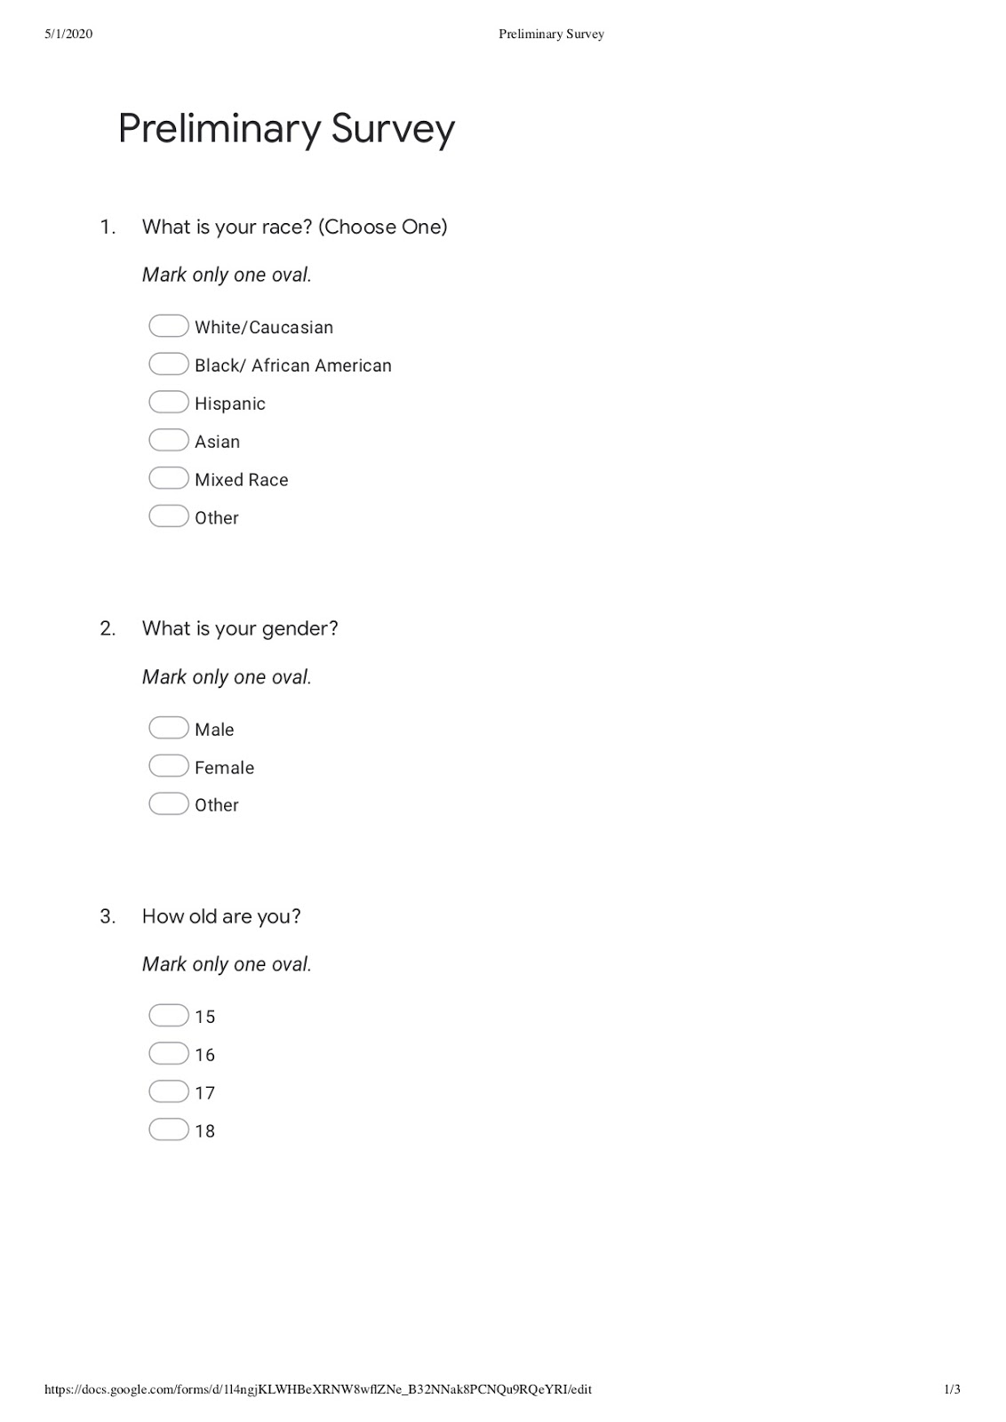
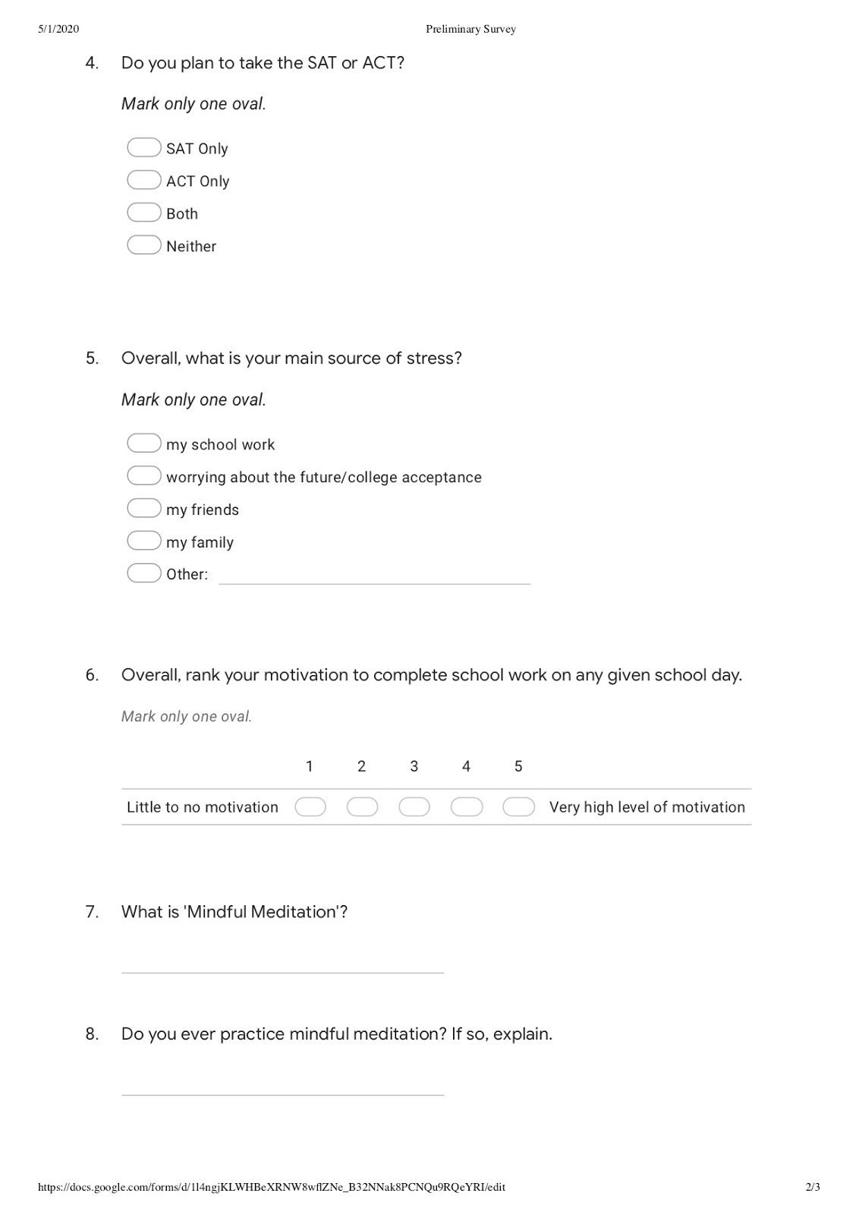

APPENDIX B:
Pre Intervention Survey for All Participants and
Post Intervention Survey for Control Group
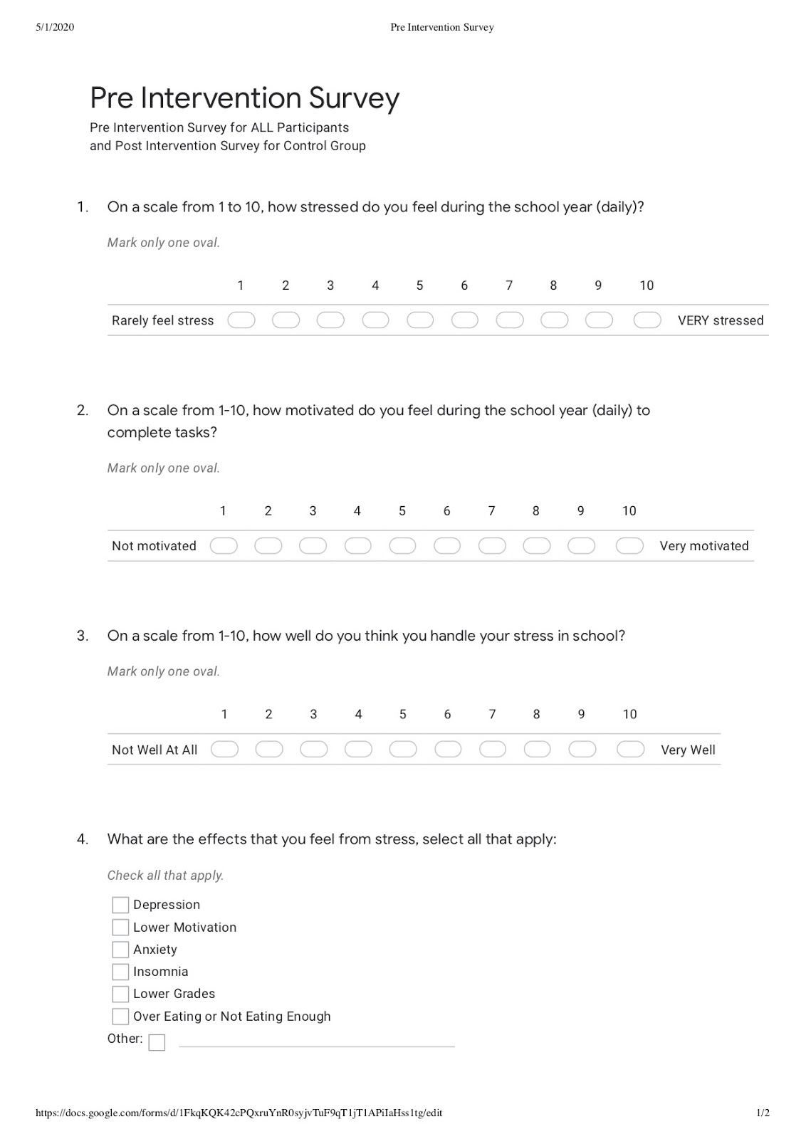

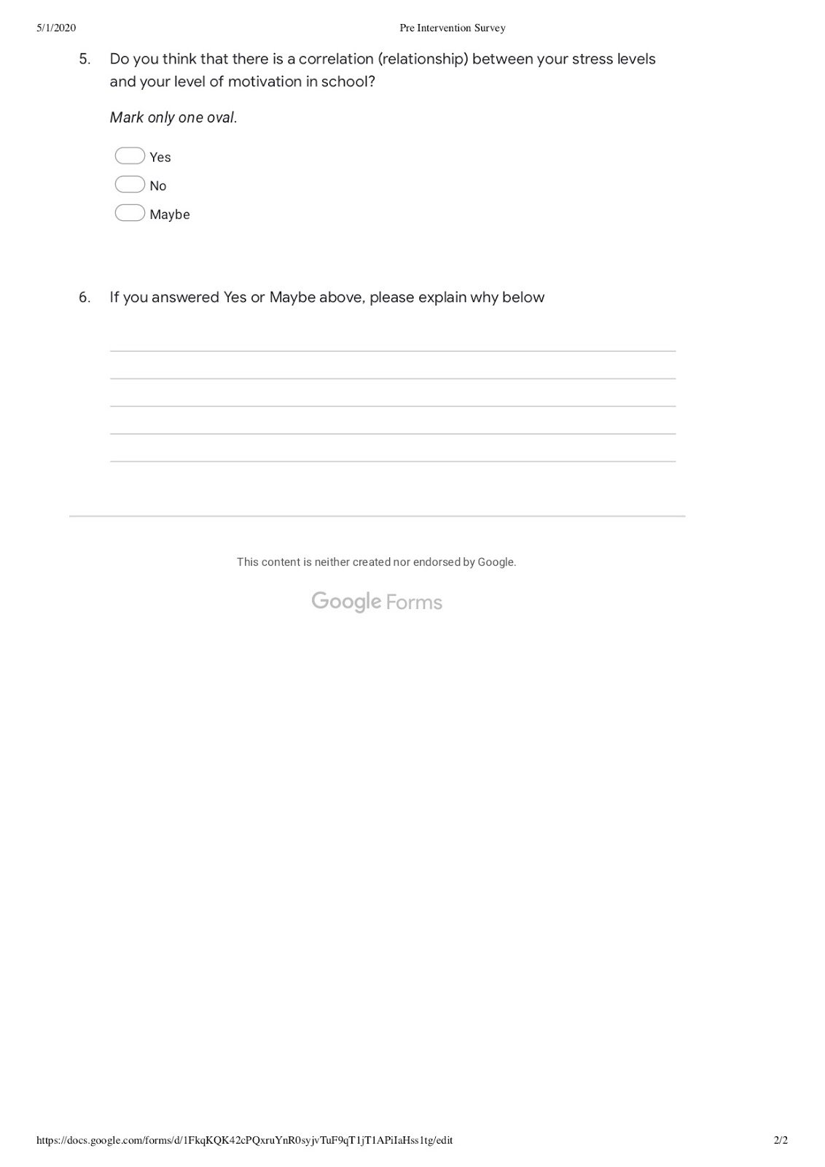APPENDIX C: Post Intervention Survey (Treatment)
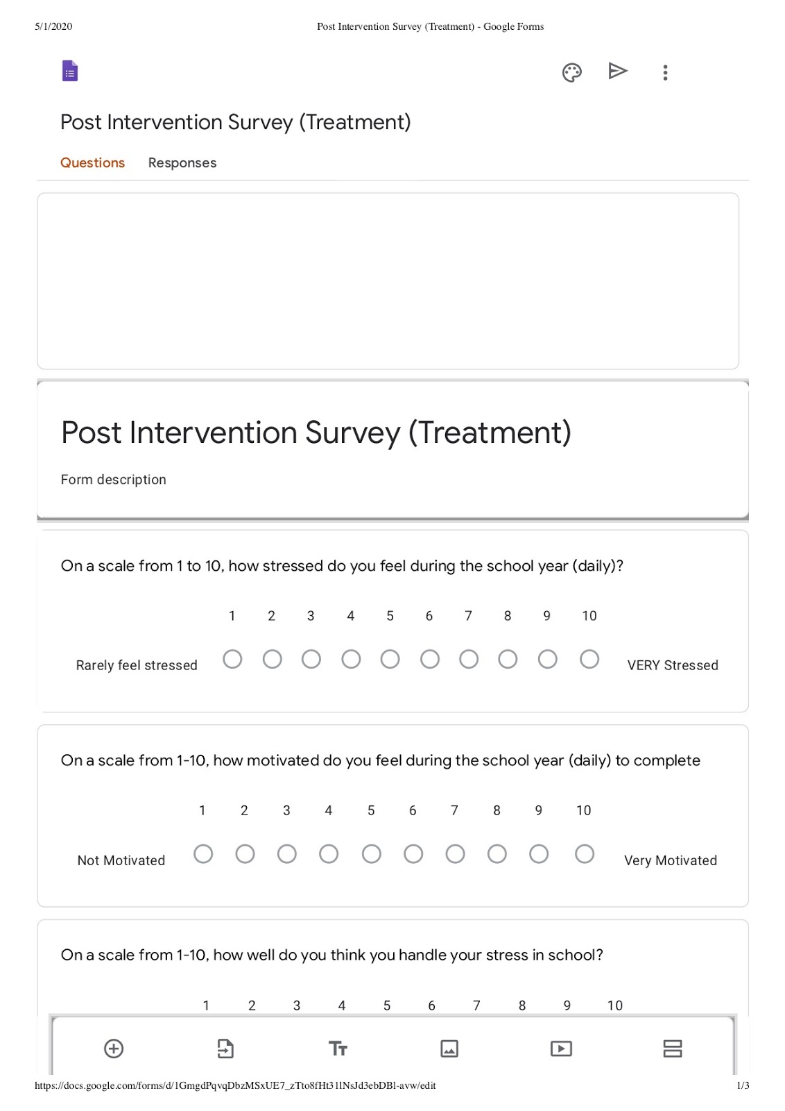
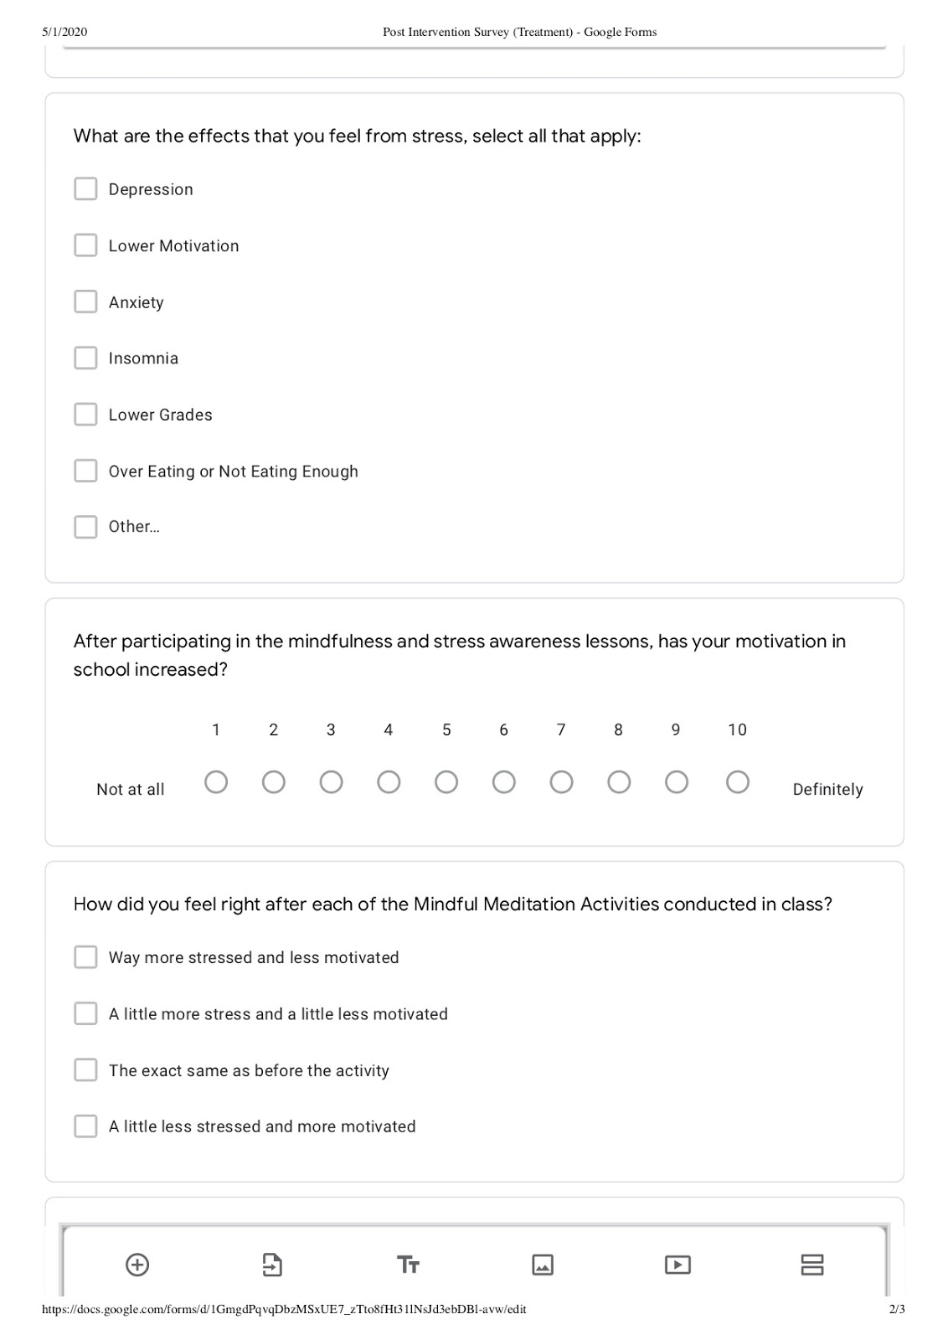
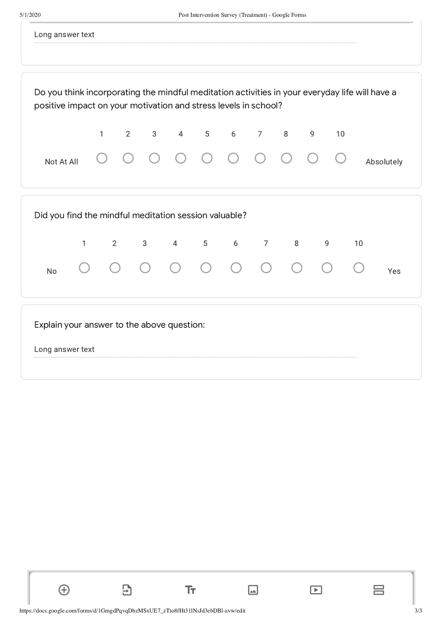

APPENDIX D “Mindfulness” Session Description
Mindfulness sessions occurred each time the classes met. Due to Block Scheduling, the classes met every other day. The sessions occurred over a three-week period and took up the first ten minutes of each Psychology Of the Individual class to focus their thinking and dissipate negative thoughts. The sessions included breathing exercises which are proven to regulate heart rate.
Before the first session, students in the treatment group watched an introductory video which modeled what mindful breathing looks like and had the students actively practice. The mindful video the students watched each class lasted for about 6 minutes. Soft music played in the background and a calm voice instructed the students when to breath in and when to breath out. The voice also instructed the students to clear their mind or focus on a mantra. A mantra was defined as a word or short sentence that set positive purpose to their meditation. At the end of each guided breathing session, students began the daily Psychology of the Individual warmup which implemented each class.

APPENDIX E: Stress Seminars
The treatment group participated in three mental health seminars with the purpose of informing students to recognize stress and various coping mechanisms to handle stress. In these sessions, students were encouraged to actively listen and participate by volunteering personal connections and stories. The overall hope behind these sessions was to give students the foundation of a healthy emotional intelligence that could follow them into adulthood. Below is a list of topics covered in each of the sessions presented by the researcher in class:
Session 1 Agenda:
- Stress and Health Introduction: Who has been stressed?
- What is Stress? What is a Stressor?
- Eustress versus Distress
Session 2 Agenda:
- Sources of Stress (everyday to life changes)
- Conflict Situations: What are they?
- Conflict Resolution: Let’s practice.
Session 3 Agenda:
- Reactions to Stress (everyone is different)
- Personality Types and Stress
- Coping With Stress: The Power of the Mind

