Supplementary Material
Motivation by Phase
Information on BART performance is presented in Tables S1 and S2. To ensure that participants adhered to the task (i.e., stayed motivated in maximizing their points) through all three phases, we investigated whether the number of pumps increased in proportion to the higher threshold of the balloons in later phases. Thus, we first computed the proximity to pump threshold scores by dividing the number of pumps the participants administered by the median threshold for each balloon color. We then conducted a repeated-measures analysis of variance (ANOVA) on the proximity scores with phase (Phase 1, Phase 2, Phase 3) as the predictor. The main effect of phase was significant, F(2, 136) = 127.87, p < .001, η_{p}² = .65. Specifically, the proximity score for Phase 3 was significantly lower than Phase 1, t(137) = 7.81, p < .001, and in Phase 2, t(137) = 12.86, p < .001. The proximity score was also significantly lower for Phase 2 than Phase 1, t(137) = 7.81, p < .001.

Table S1
Means (SDs) and Correlations with Depressive Symptoms (CES-D) of Task Performance by Phase on Trials with or without Punishment in the Previous Trial
 | Previous reward |  | Previous punishment
 | M (SD) of pumps | r_{pumps-CES-D} | M (SD) of pumps | r_{pumps-CES-D}
Learning | 8.66 (4.62) | -.12 | 8.05 (4.93) | -.03
Phase 1 | 2.64 (0.86) | .15 | 2.44 (0.76) | .09
Phase 2 | 4.48 (1.56) | .10 | 4.08 (1.65) | .21*
Phase 3 | 22.36 (12.85) | .13 | 19.34 (13.03) | .07
* p < .05

Table S2
Means (SDs) and Correlations with Depressive Symptoms (CES-D) of Task Performance by Phase
 | Pumps |  |  |  | Bursts
 | M (SD) of pumps | r_{pumps-CES-D} | M (SD) of proximity | r_{proximity-CES-D} | M (SD) of bursts | r_{bursts-CES-D}
Learning | 8.32 (4.16) | -.08 | 1.07 (0.54) | -.09 | 0.47 (0.13) | -.01
Phase 1 | 2.56 (0.71) | .13 | 0.69 (0.21) | .16 | 0.54 (0.18) | .16
Phase 2 | 4.31 (1.44) | .17 | 0.56 (0.19) | .17* | 0.40 (0.16) | .16*
Phase 3 | 21.43 (12.23) | .12 | 0.34 (0.19) | .11 | 0.20 (0.14) | .09
* p < .05

If the participants remained motivated throughout the task, we expected that the number of bursts in the balloons would remain consistent, despite the higher thresholds for bursts, at higher-level phases. To this end, we conducted a repeated-measures ANOVA on the number of bursts with phase (Phase 1, Phase 2, Phase 3) as the predictor. The main effect of phase was significant, F(2, 136) = 158.37, p < .001, η_{p}² = .70. Specifically, the number of bursts in Phase 3 was significantly lower than in Phase 1, t(137) = 17.76, p < .001, and in Phase 2, t(137) = 14.10, p < .001. The number of bursts was also significantly lower for Phase 2 than Phase 1, t(137) = 10.46, p < .001. In conclusion, these findings suggest that the participants were less motivated in Phase 3 than in earlier phases.

Learning Phase
We attempted to test the model containing the planned main analysis (conducted on Phase 1 data as reported in the main paper), in addition to the learning analysis, using the Learning Phase data. The planned main analysis tested whether risk taking was associated with previous punishment, the level of depressive symptoms, and the interaction at each trial. The learning analysis tested whether the participants learned to take fewer risks for riskier balloons (vs. more risks for less risky balloons) by investigating the association between the number of pumps with balloon color, time, and their interaction. The model failed to converge.
Phase 1
See original manuscript for Phase 1 results. For a visual representation re-scaled to facilitate comparison with Phase 2, see Figure S1.

Figure S1
Number of Pumps (Log Transformed) as a Function of Depressive Symptoms and the Presence of Punishment in a Preceding Trial in Phase 1
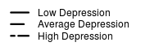
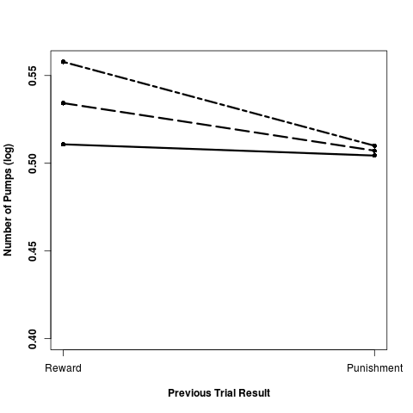
Note. Following a previous punishment, individuals at all levels of depressive symptoms pumped the balloon significantly fewer times. Average Depression = participants whose scores on the Center for Epidemiology Survey-Depression Scale (CES-D) were at the mean level. Low Depression = 1 standard deviation below the mean CES-D score (i.e., individuals with lower levels of depressive symptoms). High Depression = 1 standard deviation above the mean CES-D score. This figure is re-scaled from the one presented in the manuscript so that the y-axis is identical to the figure for Phase 2 (presented below) for easier comparison.
Phase 2
In Phase 2, the participants’ depressive symptoms marginally correlated with the number of pumps, and significantly with the proportion of trials ending in punishments (see Table S2). To investigate the interactive effect of depressive symptoms and previous loss on risk taking, we performed MLM on the Phase 2 data. The main effect of previous punishment was significant, t(136) = 4.70, p < .001, but the level of depressive symptoms was not significant, t(2208) = 1.00, p = .32. As expected, individuals pumped the balloon fewer times following a punishment trial (β = -0.06, SE = 0.01).
Importantly, the previous punishment x depressive symptom interaction was significant, t(2208) = 1.96, p = .049 (see Figure S2). Probing the interaction through the online tool provided by Preacher et al. (2006), we found that individuals with higher levels of depressive symptoms (i.e., 1 SD above the average) (β = -0.03, SE = 0.02), t(2208) = 1.96, p = .049; with average levels of depressive symptoms (β = -0.06, SE = 0.01), t(2208) = 4.71, p < .001; and with lower levels of depressive symptoms (β = -0.08, SE = 0.02), t(2208) = 4.74, p < .001, all pumped the balloon significantly less following a punishment trial. Although everyone pumped less following punishment, lower levels of depressive symptoms were associated with fewer pumps following punishment.

Figure S2
Number of Pumps (Log Transformed) as a Function of Depressive Symptoms and the Presence of Punishment in a Preceding Trial in Phase 2
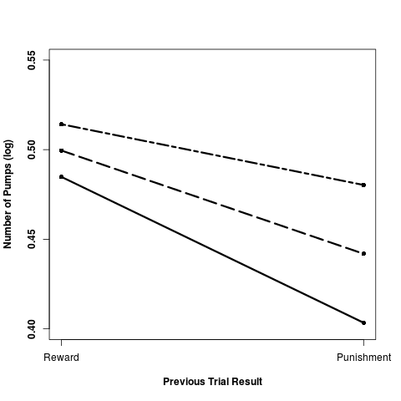
Note. Following a previous punishment, individuals at all levels of depressive symptoms pumped the balloon significantly fewer times. Average Depression = participants whose scores on the Center for Epidemiology Survey-Depression Scale (CES-D) were at the mean level. Low Depression = 1 standard deviation below the mean CES-D score (i.e., individuals with lower levels of depressive symptoms). High Depression = 1 standard deviation above the mean CES-D score.

Combined Phases 1 and 2
When phases 1 and 2 were combined, the participants’ depressive symptoms correlated with the number of pumps, r(137) = .17, p = .046, and with the proportion of trials ending in punishments, r(137) = .19, p = .02. To investigate the interactive effect of depressive symptoms and previous loss on risk taking, we performed MLM on the combined phases 1 and 2 data, controlling for the balloon color. The main effects of balloon color, t(136) = 11.82, p < .001, and previous punishment, t(136) = -3.90, p < .001, were significant, but not the level of depressive symptoms, t(4692) = 1.16, p = .25. As expected, individuals pumped the balloon more for yellow (vs. orange) balloons, which had a higher threshold for bursts (β = 0.24, SE = 0.01) and fewer times following a punishment trial (β = -0.05, SE = 0.01).
Importantly, the balloon color x previous punishment x depressive symptom interaction was significant, t(4692) = 2.59, p = .01. No other interaction effects were significant, ts < 1.60, ps > .11. To better understand the interaction, we conducted a balloon color x depressive symptom separately for the punishment and the reward trials using MLM. For the reward trials, the main effect for the balloon color was significant, t(135) = 9.33, p < .001, so that the participants pumped the yellow balloons more than the orange balloons, but not for the level of depressive symptoms, t(2393) = 0.71, p = .48. The balloon color x depressive symptoms interaction was not significant, t(2393) = 0.46, p = .65. For the punishment trials, the main effect for the balloon color was significant, t(136) = 11.25, p < .001, but not for the level of depressive symptoms, t(2029) = 1.39, p = .16. Importantly, the balloon color x depressive symptoms interaction was significant, t(2029) = 2.39, p = .02 (see Figure S3).
Probing the interaction through the online tool provided by Preacher et al. (2006), we found that individuals with higher levels of depressive symptoms (i.e., 1 SD above the average) (β = 0.30, SE = 0.03), t(2029) = 10.88, p < .001; average levels of depressive symptoms (β = 0.27, SE = 0.02), t(2029) = 11.24, p < .001; and lower levels of depressive symptoms (i.e., 1 SD below the average) (β = 0.23, SE = 0.03), t(2029) = 8.42, p < .001, all pumped the balloon significantly more for the yellow (vs. orange) balloons. Individuals with higher levels of depressive symptoms pumped both the orange balloons (β = 0.27, SE = 0.02), t(2029) = 11.24, p < .001, and the yellow balloons (β = 0.30, SE = 0.03), t(2029) = 11.41, p < .001, more than individuals with lower levels of depressive symptoms. Although everyone pumped more for the yellow balloons than the orange balloons, higher levels of depressive symptoms were associated with more pumps for the yellow balloons.

Figure S3
Number of Pumps (Log Transformed) as a Function of Depressive Symptoms and the Balloon Color in Trials Preceded by a Punishment in Combined Phases 1 and 2
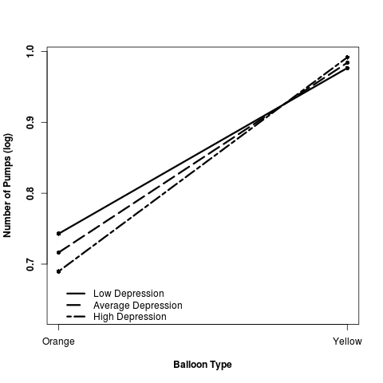
Note. Following a previous punishment, individuals at all levels of depressive symptoms pumped the balloon significantly more times for the yellow balloon, compared to the orange balloon with a lower threshold for bursts. Note that the orange balloons were presented in Phase 1, and the yellow balloons were presented in Phase 2. Average Depression = participants whose scores on the Center for Epidemiology Survey-Depression Scale (CES-D) were at the mean level. Low Depression = 1 standard deviation below the mean CES-D score (i.e., individuals with lower levels of depressive symptoms). High Depression = 1 standard deviation above the mean CES-D score.

Phase 3
In Phase 3, the participants’ depressive symptoms marginally correlated with the number of pumps and significantly with the proportion of trials ending in punishments (see Table S2). To investigate the interactive effect of depressive symptoms and previous loss on risk taking, we performed MLM on the Phase 3 data. The main effects of previous punishment, t(127) = 6.34, p < .001, and the level of depressive symptoms were significant, t(2226) = 2.14, p = .03. As expected, individuals pumped the balloon fewer times following a punishment trial (β = -0.12, SE = 0.02). Individuals with higher levels of depressive symptoms pumped the balloon more than individuals with lower levels (β = 0.01, SE = 0.004). Previous punishment x depressive symptoms interaction was not significant, t(2226) = 0.19, p = .85.
Combined Phases 1, 2, and 3
When phases 1, 2, and 3 were combined, the participants’ depressive symptoms correlated with the proportion of trials ending in punishments, r(137) = .20, p = .02, but not with the number of pumps, r(137) = .14, p = .10. To investigate the interactive effect of depressive symptoms and previous loss on risk taking, we performed MLM on the combined phases 1, 2, and 3 data, controlling for the balloon color. Only the main effect of balloon color, t(137) = 16.37, p < .001, but not previous punishment, t(136) = 0.99, p = .32, nor the level of depressive symptoms, t(7450) = 1.01, p = .31, were significant. The main effect of balloon color was qualified by balloon color x previous punishment interaction (β = -0.07, SE = 0.01), t(136) = 7.40, p < .001. No other interaction effects were significant, ts < 1.17, ps > .24.
To better understand the significant interaction, we tested the main effect of balloon color separately for the punishment and the reward trials using MLM. The main effect for the balloon color was significant for both the reward trials, t(137) = 12.18, p < .001, with the participants pumping more for the balloons with a greater threshold (β = 0.32, SE = 0.03), and for the punishment trials, t(137) = 14.93, p < .001, in the same direction (β = 0.39, SE = 0.03). We also tested the main effect of previous punishment separately for each balloon color using MLM. The main effect of previous punishment was significant for orange balloons (β = -0.03, SE = 0.01), t(136) = 2.48, p = .01; yellow balloons (β = -0.06, SE = 0.01), t(137) = 4.64, p < .001; and blue balloons (β = -0.12, SE = 0.02), t(128) = 6.34, p < .001. Thus, for all balloon colors, the participants displayed greater punishment sensitivity.

