Journal of Geophysical Research: Atmospheres
Supporting Information for
Correlated Modes of Spatiotemporal Variations between Light-Absorbing Aerosols and Tropospheric Temperature over the Indian Region
Lakhima Chutia^{1,2}*, Jun Wang^{1,2}*, Xi Chen^{1,2}, Zhendong Lu^{1,2}, Meng Zhou^{1,2} and Eric M. Wilcox³
¹Department of Chemical and Biochemical Engineering, University of Iowa
²Center for Global and Regional Environmental Research, University of Iowa
³ Division of Atmospheric Sciences, Desert Research Institute

Contents of this file

Figures S1 to S8

Introduction
This Supporting Information includes extended PCA results for modes 3 and 4 of AOD, BC AOD, OC AOD, CO, and day-night (D-N) temperature data from various satellite products and MERRA-2. It also presents additional scatter plots showing relationships among the principal components of BC AOD, OC AOD, and CO with D-N temperature during the pre-monsoon season (2003–2021). Figures on PCA results of BC AOD fraction; sulfate AOD fraction distributions along with their correlations with D-N temperature contrast are also included.

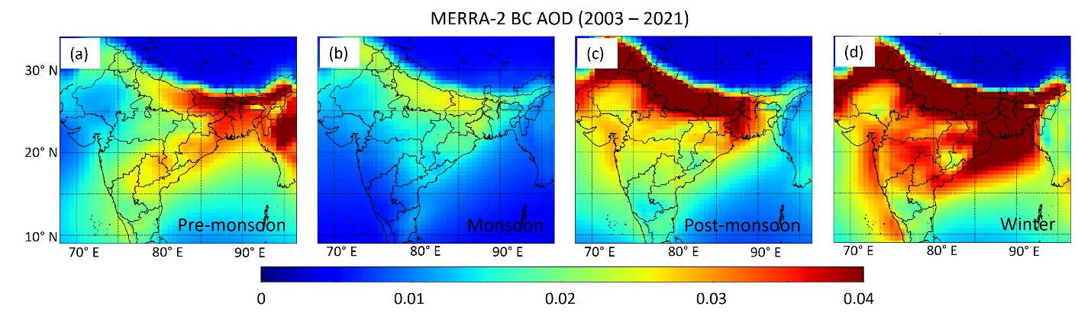
Figure S1 (a-d). Seasonal distribution of MERRA-2 BC AOD over the Indian region from 2003 to 2021.

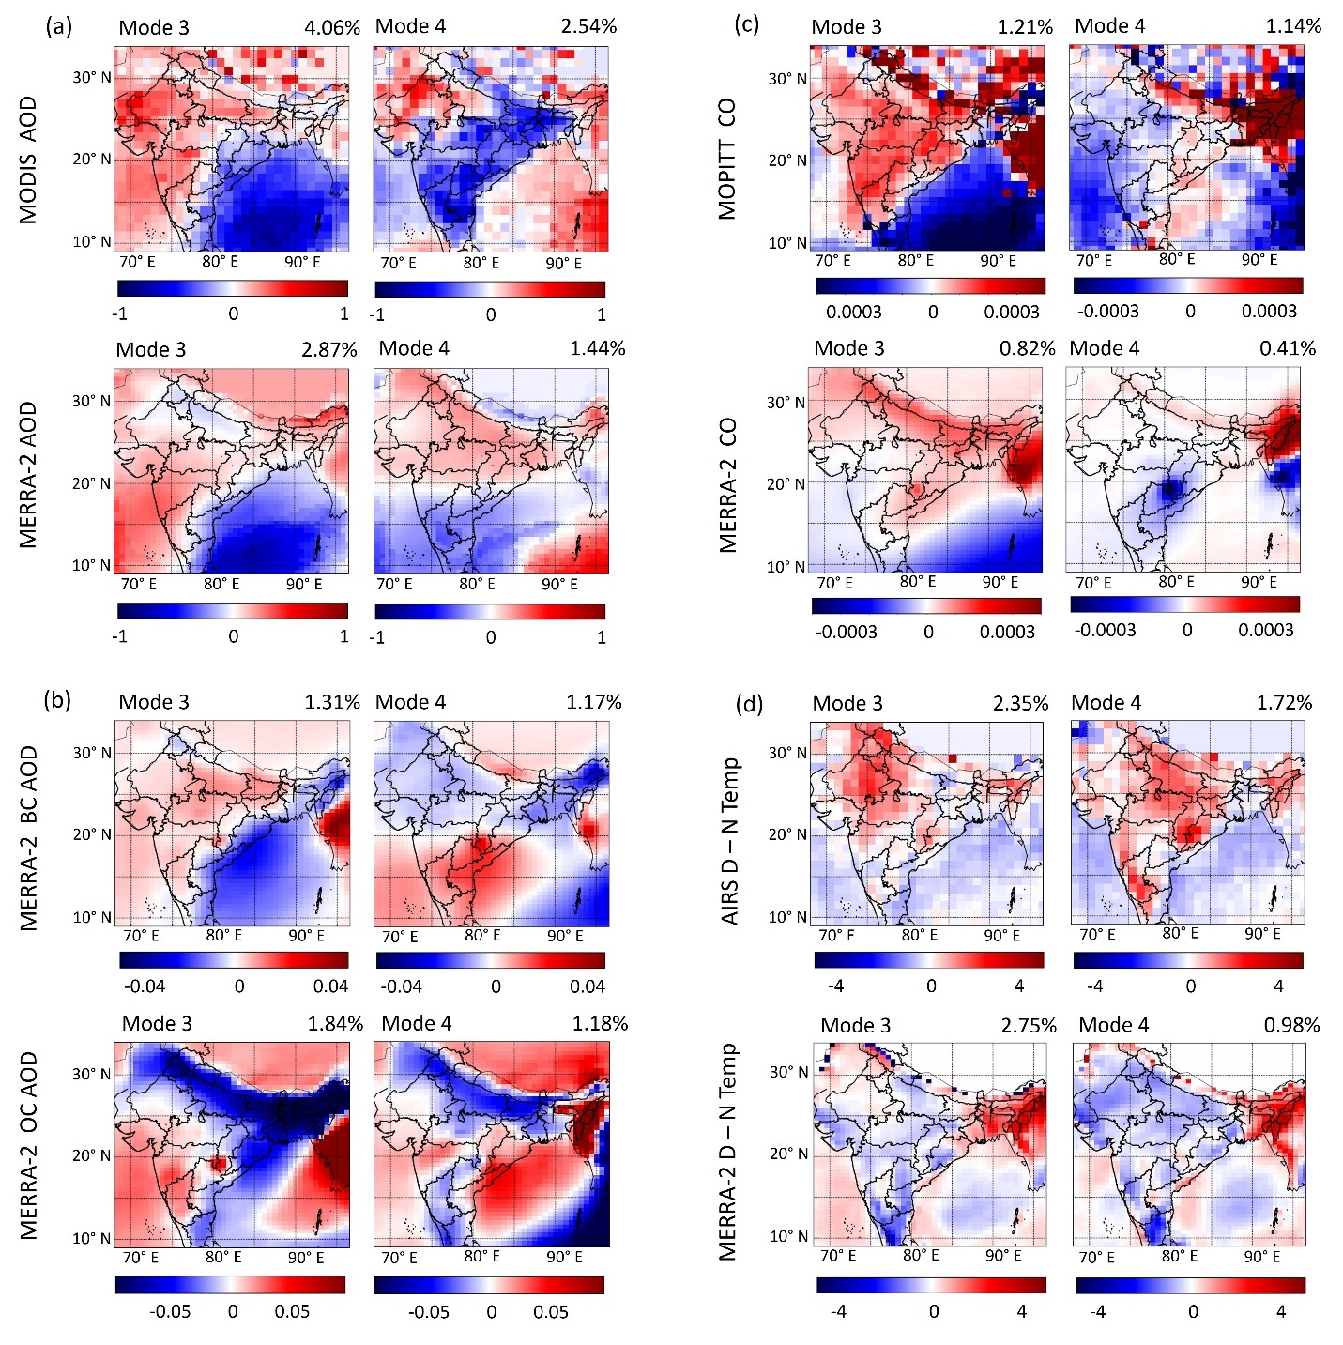
Figure S2. The 3rd and 4th modes of PC analysis for: (a) MODIS and MERRA-2 AOD, (b) MERRA-2 BC and OC AOD, (c) MOPITT and MERRA-2 CO column, and (d) AIRS and MERRA-2 D-N temperature data during pre-monsoon months (Mar-Apr-May) of 2003 – 2021 over the Indian region.

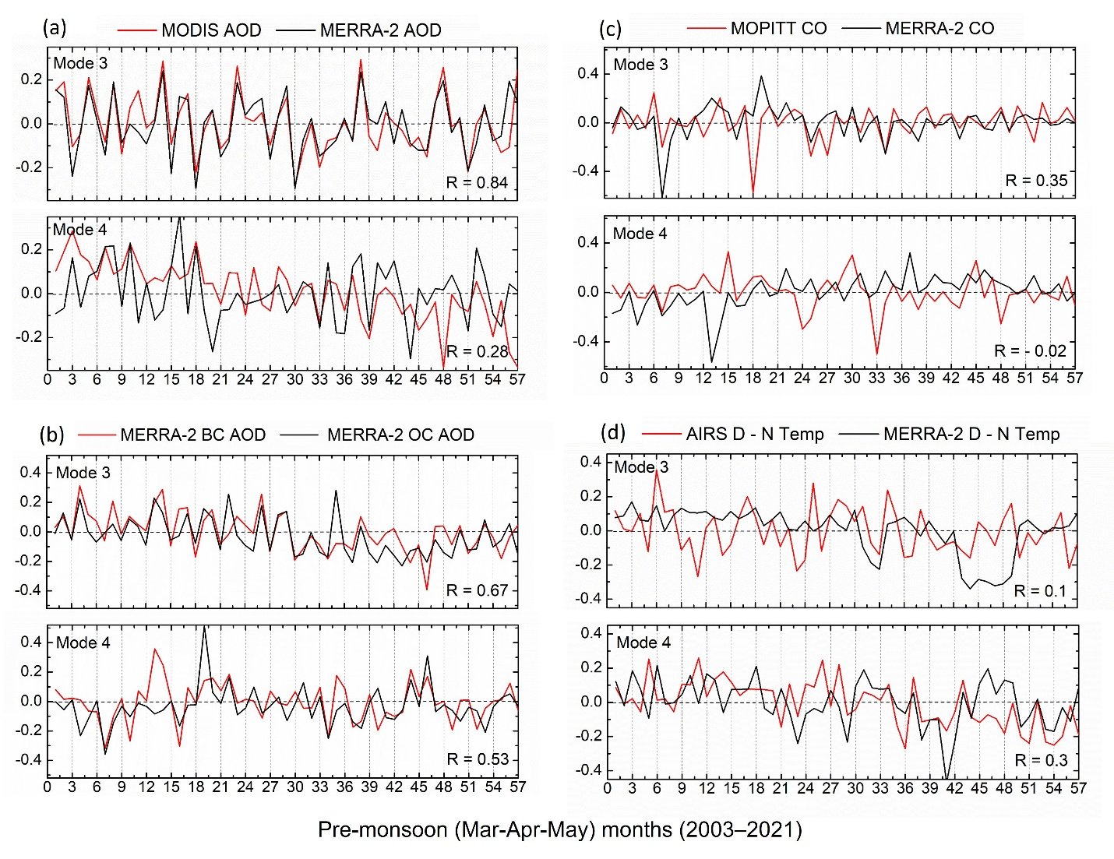
Figure S3. The PC time series of 3rd and 4th modes for: (a) MODIS and MERRA-2 AOD, (b) MERRA-2 BC and OC AOD, (c) MOPITT and MERRA-2 CO, and (d) AIRS and MERRA-2 D-N temperature data during pre-monsoon months (Mar-Apr-May) of 2003 – 2021 over the Indian region.

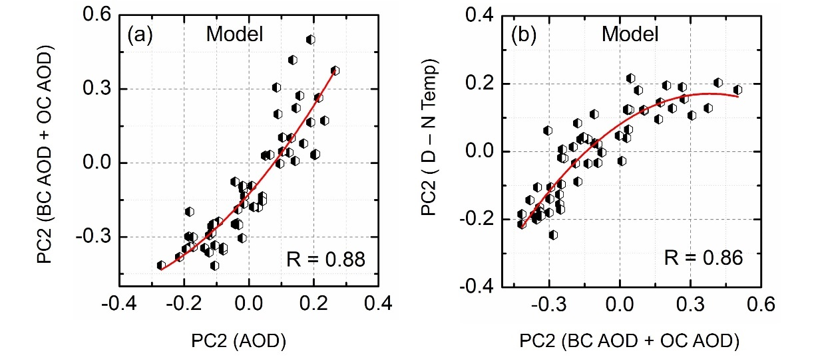

Figure S4. Scatter plots showing: (a) the relationship between PC2 (BC AOD + OC AOD) and PC2 AOD from MERRA-2, (b) the relationship between PC2 (BC AOD +OC AOD) and PC2 D-N temperature from MERRA-2 during the pre-monsoon period (2003–2021).

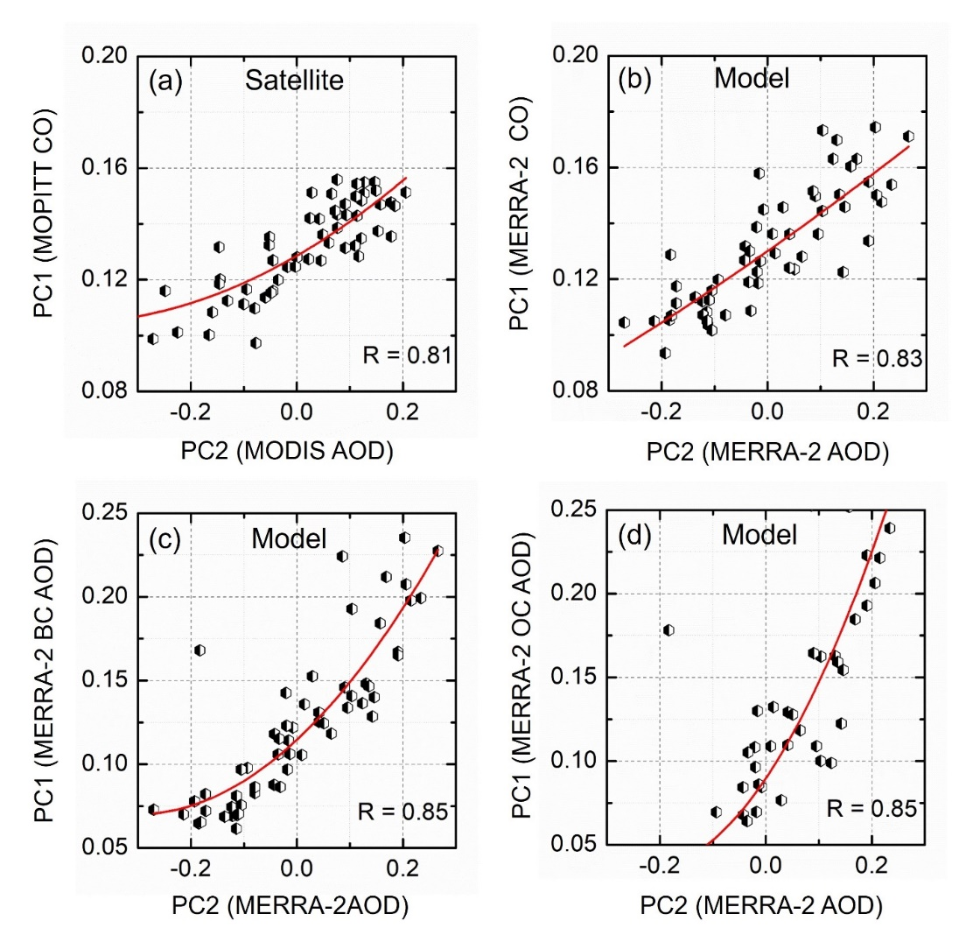

Figure S5. Scatter plots showing: (a) the relationship between PC2 AOD from MODIS and PC1 CO from MOPITT; (b) Same as figure (a) but using MERRA-2 AOD and CO data; and (c, d) the relationship between PC1 BC and PC1 OC AOD with PC2 AOD from MERRA-2 during the pre-monsoon period (2003–2021).
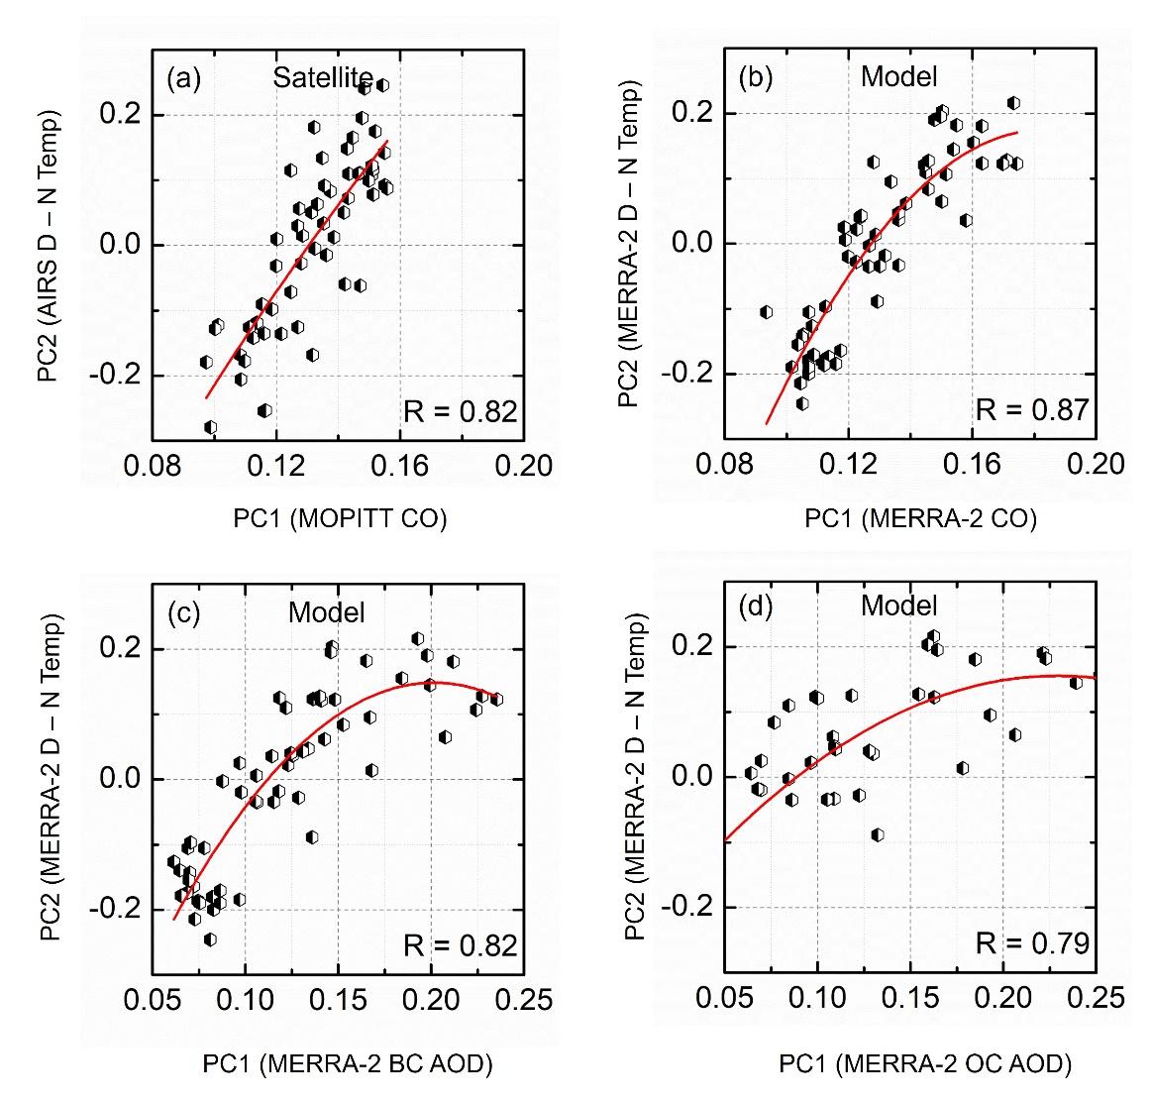
Figure S6. Scatter plots illustrating various relationships during the pre-monsoon period of 2003–2021: (a) Relationship between PC1 CO from MOPITT and PC2 day-night temperature from AIRS. (b) Same as (a) but using MERRA-2 CO and temperature data. (c, d) Relationship between PC1 BC and OC AOD with PC2 day-night temperature form MERRA-2.
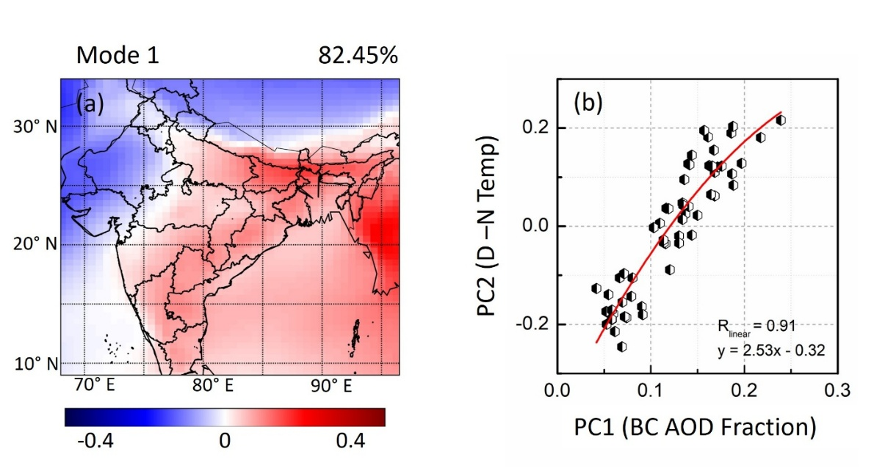
Figure S7 (a). The 1st mode of PC analysis for MERRA-2 BC AOD fraction during pre-monsoon months (Mar-Apr-May) of 2003 – 2021 over the Indian region. (b) Scatter plots showing the relationship between MERRA-2 PC1 BC AOD fraction and PC2 D-N temperature.

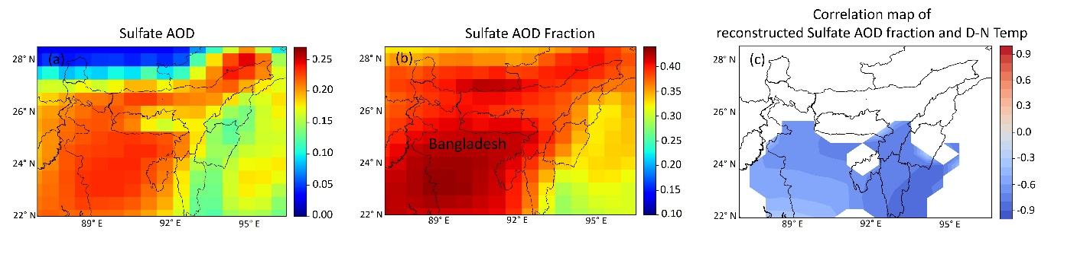
Figure S8. Distribution of (a) sulfate AOD and (b) the ratio of sulfate AOD to the total AOD from MERRA-2; (c) Correlation map showing the relationship between reconstructed sulfate AOD fraction (mode-1) and D-N temperature (mode-2) over the Northeast Indian region during the pre-monsoon period of 2003-2021.

