FOOD SCRAP SIZE INFLUENCE ON THE RECYCLING OF ORGANIC WASTE BY THE ANNELID WORM EISENIA FETIDA
by
Najeyah Altamimi
B.S. (Washington College) 2021
Independent Research Project
Submitted in partial satisfaction of the requirements
For the degree of
MASTER OF SCIENCE
in
ENVIRONMENTAL BIOLOGY
in the
GRADUATE SCHOOL
of
Hood College
November 2022

Accepted:
_______________________________
Eric C. Kindahl, Ph.D.
Project Adviser
_______________________________
Eric Annis, Ph.D.
Director, Environmental Biology Program
_______________________________
April M. Boulton, Ph.D.
Dean of the Graduate School
STATEMENT OF USE AND COPYRIGHT WAIVER
I authorize Hood College to lend this project report, or reproductions
of it, in total or in part, at the request of other institutions or
individuals for the purpose of scholarly research

ABSTRACT

The U.S. Department of Agriculture estimates that 30-40% of food is lost or wasted at the retail and consumer levels. Unfortunately, much of this waste is sent to landfills, requiring land, labor, and energy for disposal. Given the various benefits of managing waste through vermicomposting, it is evident that vermicomposting is an excellent alternative to traditional composting methods. To mitigate the lack of research on vermicomposting, this study investigates the influence of food scrap size on indoor vermicomposting by the annelid worm Eisenia fetida. The study used 16 vermicomposting units distributed among a control and three treatment groups. The treatment groups used food substrate that had been processed in a food chopper for varying lengths of time (either 5 seconds, 10 seconds, or 30 seconds). The control group used food substrate that was not processed by a food chopper. Overall, the study suggests that there is a significant difference (p < 0.05) in the rate of decomposition of food scraps in days between the control and the treatment groups. In general, this study suggests that processing food scraps is a more efficient approach to indoor vermicomposting.

ACKNOWLEDGEMENTS AND SPONSORSHIP

This work was supported by Hood College’s Graduate Research Fund

TABLE OF CONTENTS
Introduction .........................................................................................................................1
Materials and Methods ........................................................................................................5
Results .................................................................................................................................8
Discussion ..........................................................................................................................13
References ………..............................................................................................................14

LIST OF TABLES
Table 1. Observation on decomposition by Eisenia fetida earthworm species ..........................8
Table 2. Analysis of variance results ……………………………………………………11
Table 3. Tukey multiple pairwise-comparisons results …………………………………11

LIST OF FIGURES
Figure 1. Vermicomposting unit………………………………………………...............5
Figure 2. Nonlinear regression on the average food consumed (g/day) consumed by Eisenia fetida per treatment (P<0.0001). Equation: f = y0+a*(1-exp(-b*x))+c*(1-exp(-d*x)) where y0=2.84, a=3.05, b= 0.14, c=3.17, and d=0.08. Rsqr value: 0.83.…………..…….….....10
Figure 3. Distribution of decomposition time by Eisenia fetida in days according to treatment in which consisted of food processed for various time intervals in seconds. The boxes depict the interquartile range (IQR) and the error bars indicate the lower or upper quartile………10

INTRODUCTION

Food waste problem
Food waste is a rising concern due to the high demand a growing population places on our global food system (Hickey & Ozbay, 2014). Food waste can be defined as any food, including inedible parts, that is removed from the food supply chain to be recovered or disposed of (Aschemann-Witzel et al., 2015). Unfortunately, it is estimated that as much as 1.3 billion tons of food are lost or wasted annually (Davenport et al., 2019). In higher-income countries such as the United States, 50-60% of the total food waste is contributed from the household level (Stancu et al., 2016). Food that is wasted at the consumer level is often still edible, but disposed of due to being no longer desirable (Aschemann-Witzel et al., 2015).

Expanding agriculture to meet the increasing demand for food will contribute to greater environmental instability (Hickey & Ozbay, 2014). Supplying food requires significant input of energy in its production, processing, packaging, distribution, and ultimately, disposal; therefore, food waste should be avoided (Venkat, 2011). It is suggested that even a 15% reduction in food waste could provide enough food to support at least 25 million people (Hickey & Ozbay, 2014).

To prevent food waste at a household level, it is suggested that consumers better manage purchases and storage of perishable foods (Davenport et al., 2019). However, it is important to recognize that food waste will inevitably occur and therefore should be recycled responsibly. Recycling food waste through composting allows for the recycling of organic matter that can be used to improve soil structure and fertility (Li et al., 2013). Given that 25% of agricultural land is already high degraded, recycling organic matter is an important component of rebuilding soil resources (DeLong et al., 2015 & Lal et al., 2003). As the world population has just passed eight billion, the importance of recycling organic matter to rebuild our soil resources will only increase.

Vermicomposting
Composting and vermicomposting are both widely recommended for the recycling of organic matter (Tognetti et al., 2005). Both composting and vermicomposting at a household level reduce the energy needed for waste collection and disposal (Tognetti et al., 2005). However, vermicomposting may be a more viable option for households where space restrictions are a concern as it can be implemented in an indoor setting (Lleó et al., 2013). Since composting generally requires adequate space for the installation of composting bins and also requires more material than vermicomposting, vermicomposting can be a more attractive option (Lleó et al., 2013).

The process of vermicomposting facilitates the decomposition of organic matter through the joint action of microorganisms and earthworms under controlled conditions (Ali et al., 2015). More specifically, earthworms consume organic solid waste and convert it into castings referred to as vermicasts (Lleó et al., 2013). The vermicasts are rich in nutrients and free of pathogenic organisms, making them an excellent source of fertilizer (Lleó et al., 2013). Vermicomposting provides many advantages to traditional composting methods as it is odorless, cost-effective, produces a product with better nutrient availability, and results in low greenhouse gas emissions (Lleó et al., 2013).

Background on Eisenia fetida
Vermicomposting by annelid worms is a viable method for recycling food waste and results in many environmental benefits including the reduction of landfill waste (Othman et al., 2012). This study will focus on the vermicomposting potential of the annelid worm Eisenia fetida. This species, commonly known as the red wiggler, is identified by its reddish-brown color and rings around its body. It is well-suited for vermicomposting due to its worldwide distribution, short life cycle, and wide range of temperature and moisture tolerance (Domínguez et al., 2005). As a result, E. fetida is one of the most common earthworm species used for the management of organic waste through vermicomposting (Domínguez et al., 2005).

Current research suggests that the critical factors influencing vermicomposting efficiency include feeding, stocking density, pH, C/N ratio, temperature, and by inference, moisture (Ali et al., 2015). However, there is a lack of research on vermicomposting on a household scale (Lleó et al., 2013). Given that much of the food waste in the US is contributed from the household level, further research on vermicomposting at the household scale is vital (Stancu et al., 2016).

Objectives
The purpose of this study is to investigate the influence of food scrap size on indoor vermicomposting by E. fetida under household conditions. Consideration of surface area to volume ratios may suggest that chopping food scraps into smaller fragments will accelerate decomposition, but this has not been fully supported by the limited research that has been done. Moreover, it is unclear to what extent chopping up food scraps influences the decomposition process. The present research will explore the significance of food scrap size in the rate of decomposition through vermicomposting. Overall, this study could help identify more efficient approaches to indoor vermicomposting.

Hypothesis
H₀: There is no significant difference (p > 0.05) between un-chopped food scraps and chopped food scraps in vermicomposting by E. fetida as measured by decomposition over time (number of days to food scrap disappearance).

H_{A}: There is a significant difference (p < 0.05) between un-chopped food scraps and chopped food scraps in the vermicomposting by E. fetida as measured by decomposition over time (number of days to food scrap disappearance).

MATERIALS AND METHODS

The study was conducted for 3 weeks during late September to mid-October in a residential building using vermicomposting units shown in Figure 1. Each vermicomposting unit was created from a clear plastic container measuring 34.3 cm by 20.6 cm by 11.7 cm. To allow for ventilation, 27 holes, each 4 mm in diameter, were drilled in the lids of the vermicomposting units. In order to minimize variability, a template was used to create the same number and arrangement of holes in each vermicomposting unit.

In total, 16 vermicomposting units allowed for 4 replicates each for the control and three treatment groups. Each vermicomposting unit was numbered 1-16 and assigned a treatment group. The control group received food scraps that were not processed in a food chopper and are referred to as un-chopped. Each treatment group received food scraps that were processed in a food chopper for varying lengths of time (Treatment 1 – 5 seconds; Treatment 2 – 10 seconds; Treatment 3 – 30 seconds).

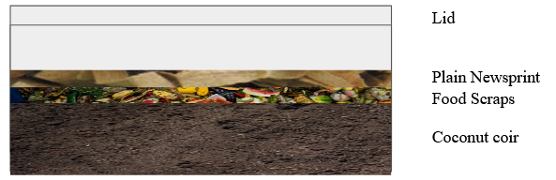
Figure 1. Vermicomposting unit

The vermicomposting units consisted of a base of coconut coir into which the worms were later introduced. In order to prepare the coconut coir substrate, each coconut coir block was soaked in 7 L of warm tap water. After allowing for the coconut coir block to expand and separate, approximately 2.4 L of coconut coir were measured and added to each unit

Each vermicomposting unit was inoculated with 180 worms or about 170 grams of E. fetida biomass. Worms were purchased from a worm farm (Meme’s Worms, Georgia). The number of worms used per vermicomposting unit followed the supplier’s recommendation of 0.488 g of worm biomass per square centimeter of bin surface area. Although each container was about
700 cm², only half this area was worm living space, the rest used for newsprint, food scraps, and aeration.

The worms were released to the unit as a heap on the coconut coir to minimize disturbances to the colony. As recommended, the worms were also given 24-48 hours to adapt to the new environment before adding any food waste. After allowing time for acclimatization,
non-acidic fruit and vegetable food scraps were added to each unit. To avoid variation of food type, the food scraps consisted of a mix of corn, green beans, banana peels, and tomatoes. Additionally, 9 grams of plain newsprint was added per unit as bedding to contain moisture and was sprayed with 0.5 mL of water. The bedding was monitored periodically for moisture using a SONKIR tensiometer and each unit was sprayed with 0.5 mL of water every other week. Additionally, temperature was monitored daily using a Taylor Tube Thermometer.
As recommended by Meme’s Worms, the vermicomposting units were kept at room temperature (23-25°C).

The rate of decomposition per treatment was measured as the number of days it took for the food scraps to be fully decomposed. Each vermicomposting unit was monitored daily until there was no evidence of food scraps remaining in each unit. Once a unit no longer contained any food scraps, an additional 9 grams of plain newsprint was added for additional feeding. No additional feeding cycles with food scraps were added to the experiment to prevent the potential variability in biomass after the first feeding.

Statistical Analysis
The data was analyzed using program R where an ANOVA test was used to identify if there is a significant difference (p < 0.05) among the un-chopped food scrap control group and chopped food scrap treatment groups in the decomposition by E. fetida. The data was further analyzed using a non-linear regression using SigmaPlot v14.5.

RESULTS
In general, the observed decomposition by E. fetida suggests that there were differences in the number of days for decomposition between the control and the treatment groups (Table 1). Overall, the control group was observed with the slowest rate of decomposition in days compared to all of the treatment groups (mean 14.5 days; S.D. 5.80 days). This corresponds to an average of 2.83 g (S.D. 1.48 g/day) of food scraps consumed per day. Compared to the control, all the treatments had shorter times to food disappearance and faster rates of food consumption. The 5 second treatment group had an average of 6.5 days for decomposition (S.D. 1.00 days) with E. fetida consuming an average of 5.46 g per day (S.D. 0.73). The 10 second treatment group showed faster decomposition with an average of 5.25 days for decomposition

Table 1. Observation on decomposition by Eisenia fetida earthworm species

Vermicompost Unit | Treatment (secs) | Food Input (g) | # of Days for Decomposition | g/day
1 | 0 | 35 | 21 | 1.67
2 | 0 | 35 | 16 | 2.19
3 | 0 | 35 | 7 | 5.00
4 | 0 | 35 | 14 | 2.50
5 | 5 | 35 | 6 | 5.83
6 | 5 | 35 | 6 | 5.83
7 | 5 | 35 | 8 | 4.37
8 | 5 | 35 | 6 | 5.83
9 | 10 | 35 | 5 | 7.00
10 | 10 | 35 | 5 | 7.00
11 | 10 | 35 | 7 | 5.00
12 | 10 | 35 | 4 | 8.75
13 | 30 | 35 | 4 | 8.75
14 | 30 | 35 | 4 | 8.75
15 | 30 | 35 | 4 | 8.75
16 | 30 | 35 | 4 | 8.75

(S.D. 1.26 days), and an average of 6.93 g of food scraps (S.D. 1.53 g/day) was consumed per day. The fastest rate of decomposition in days was observed in the 30 second treatment group (mean 4 days; S.D. 0.00 days). This corresponds to an average of 8.75 g (S.D. 0.00 g/day) of food scraps consumed per day.

Overall, it was evident that as the number of seconds the food scraps was processed for increased, the average number of grams of food scraps that were consumed per day by E. fetida overall increased. However, the non-linear regression model suggests that the rate of decomposition steadily increased from the control to the 10 second treatment and then slowed down as it reached the 30 second treatment (Figure 2). The non-linear regression suggests that the decomposition rates varied among the treatment groups (Figure 2).

Additionally, the distribution of the decomposition time by Eisenia fetida in days according to treatment was evidence of a potential difference in the decomposition time between the control and treatment groups (Figure 3). It is also suggested that as the number of seconds the food scraps are processed for increases, the variability in the number of days for decomposition decreases. For example, the number of days for decomposition in the control group ranged from 7 days to 21 days whereas, the number of days for decomposition for the 30 seconds treatment did not have a wide range as all of the units exposed to that treatment took 4 days to decompose.

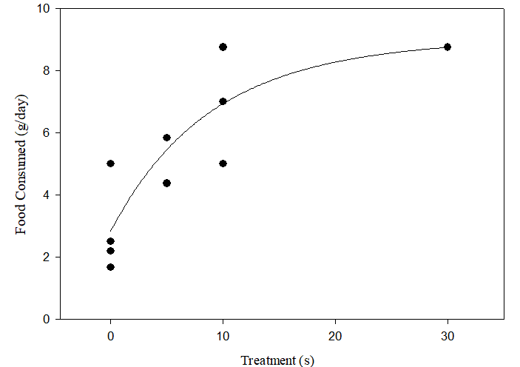

Figure 2. Nonlinear regression on food consumed (g/day) by Eisenia fetida per treatment (P<0.0001). Equation: f = y0+a*(1-exp(-b*x))+c*(1-exp(-d*x)) where y0=2.84, a=3.05, b= 0.14, c=3.17, and d=0.08. Rsqr value: 0.83.

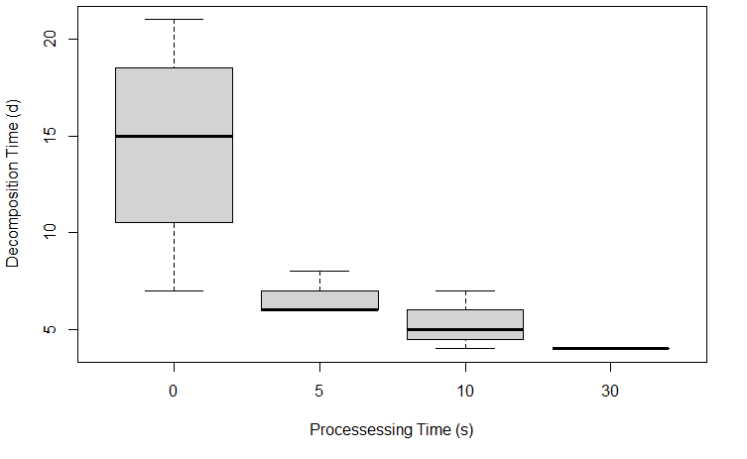
Figure 3. Distribution of decomposition time by Eisenia fetida in days according to treatment in which consisted of food processed for various time intervals in seconds. The boxes depict the interquartile range (IQR) and the error bars indicate the lower or upper quartile.

The data were further analyzed using ANOVA to identify if there was a significant difference (p < 0.05) among un-chopped and chopped food scrap treatment groups in the decomposition time by E. fetida. Given the findings, it is suggested that there is a significant difference among the four groups (p < 0.05) (Table 2). Therefore, the null hypothesis that there is not a significant difference (p > 0.05) between un-chopped food scraps and chopped food scraps in vermicomposting was rejected and the alternative hypothesis was accepted.

Table 2. Analysis of variance results

 | Degrees of Freedom | Sums of Squares | Means of Squares | F value | Pr(>F)
Treatment | 3 | 269.2 | 89.73 | 9.901 | 0.00144
Residuals | 12 | 108.8 | 9.06

As the ANOVA was significant, a Tukey HSD (Tukey Honest Significant Differences) analysis was used to perform multiple pairwise-comparisons between the means of groups (Table 3). The analysis indicated that there was a significant difference (p < 0.05) between each treatment group and the control group, but not a significant difference in comparisons between treatment groups.

Table 3. Tukey multiple pairwise-comparisons results
 | Difference | Lower | Upper | Adjusted p-value
5 secs treatment – Control | -8.00 | -14.32 | -1.68 | 0.013
10 secs treatment– Control | -9.25 | -15.57 | -2.93 | 0.005
30 secs treatment- control | -10.50 | -16.82 | -4.18 | 0.002
10 secs treatment – 5 secs treatment | -1.25 | -7.57 | 5.07 | 0.934
30 sec treatment – 5 secs treatment | -2.50 | -8.82 | 3.82 | 0.653
30 sec treatment- 10 sec treatment | -1.25 | -7.57 | 5.07 | 0.934

DISCUSSION
Given the results of the study, we reject the null hypothesis that there was not a significant difference (p > 0.05) among the four groups tested (control and three processing treatments) as measured by decomposition over time (number of days to food disappearance). We accept the alternative hypothesis that there was a significant difference (p < 0 .05) among the four groups tested. Moreover, the Tukey HSD analysis shows that each treatment differed from the control but not from the other treatments. However, the non-linear regression model suggests that the treatment groups could be distinguished from one another in regards to their decomposition rates. As previously mentioned, the study has found that the decomposition rate had the greatest increase from the control to the 10 second treatment and then slowed down as it reached the 30 second treatment. Overall, this finding suggests that processing food scraps for at least 5-10 seconds may be worth the effort to achieve a greater decomposition rate. Nevertheless, processing food scraps for 30 seconds was consistently found to yield the fastest rate of decomposition with the least variability in time to decomposition.

Intriguingly, it is estimated that E. fetida may consume 25-35% of their body weight per day (Sherman, 2022). However, in our study, E. fetida was found to have consumed less than 25-35% of their body weight per day. For example, our greatest average food consumed was seen for the 30 second treatment group with an average of 8.75 g of food consumed a day by 170 g of E. fetida. This translates to about 0.05 g of food consumed per individual per day. As it is estimated that each individual E. fetida weighed about a gram, when food scraps were processed for 30 seconds, E. fetida consumed about 20% of their body weight. It is unknown if there are factors that contributed to E. fetida consuming less than 25-35% of their body weight a day.

In relation to vermicomposting at a household level, the data suggests that it can be beneficial for residents to process their food scraps prior to inputting food scraps in vermicomposting bins. Processing food scraps prior to vermicomposting can be advantageous in regards to increasing the rate of decomposition and as a result can increase the amount of food that can be composted for a shorter period of time. Increasing the rate of decomposition can also potentially reduce the pests vermicomposting attracts and can increase the amount of vermicasts produced. Although the results do not suggest a statistically significant ideal length of time food scraps should be processed prior to vermicomposting, processing food scraps for 30 seconds may be recommended due this treatment having the fastest rate of decomposition with the least variability.

Furthermore, there may be several other advantages in processing food scraps to increase the consumption of E. fetida considering that feeding has been found to be influential on the growth and reproduction of E. fetida (Reinecke & Viljoen, 1990). By increasing the feeding of E. fetida we can potentially increase their growth and reproduction (Reinecke & Viljoen, 1990). Therefore, in addition to increasing the amount of vermicasts produced, an increase in the population of E. fetida would allow for several other uses of the worms such as for fish bait and fish feed (Musyoka et al., 2019). Overall, the uses of E. fetida are still expanding as recently they have been found to serve as an economic alternative source of feed for poultry (Gunya & Masika, 2022).

In conclusion, the study suggests that using chopped-up food scraps is a more efficient approach to indoor vermicomposting than using un-chopped food scraps. More specifically, food scraps should be processed for at least 5 seconds to yield a greater rate of decomposition. Further studies in this area should be done using varying waste and substrate types.

REFERENCES

Ali, U., Sajid, N., Khalid, A., Riaz, L., Rabbani, M. M., Syed, J. H., & Malik, R. N. (2015). A review on vermicomposting of organic wastes. Environmental Progress & Sustainable Energy, 34(4), 1050-1062.

Aschemann-Witzel, J., De Hooge, I., Amani, P., Bech-Larsen, T., & Oostindjer, M. (2015). Consumer-related food waste: Causes and potential for action. Sustainability, 7(6), 6457-6477.

Davenport, M. L., Qi, D., & Roe, B. E. (2019). Food-related routines, product characteristics, and household food waste in the United States: A refrigerator-based pilot study. Resources, Conservation and Recycling, 150, 104440.

DeLong, C., Cruse, R., & Wiener, J. (2015). The soil degradation paradox: Compromising our resources when we need them the most. Sustainability, 7(1), 866-879.

Domínguez, J., Velando, A., & Ferreiro, A. (2005). Are Eisenia fetida (Savigny, 1826) and Eisenia andrei (Oligochaeta, Lumbricidae) different biological species?. Pedobiologia, 49(1), 81-87.

Gunya, B., & Masika, P. J. (2022). Eisenia fetida worm as an alternative source of protein for poultry: a review. International Journal of Tropical Insect Science, 42(1), 1-8.

Hickey, M. E., & Ozbay, G. (2014). Food waste in the United States: A contributing factor toward environmental instability. Frontiers in Environmental Science, 2, 51.

Lal, R., Iivari, T., & Kimble, J. M. (2003). Soil degradation in the United States: Extent, severity, and trends. CRC Press.

Li, Z., Lu, H., Ren, L., & He, L. (2013). Experimental and modeling approaches for food waste composting: A review. Chemosphere, 93(7), 1247-1257.

Lleó, T., Albacete, E., Barrena, R., Font, X., Artola, A., & Sánchez, A. (2013). Home and vermicomposting as sustainable options for biowaste management. Journal of Cleaner Production, 47, 70-76.

Musyoka, Sonnia Nzilani, David Mbeva Liti, Erick Ogello, and Herwig Waidbacher. "Utilization of the earthworm, Eisenia fetida (Savigny, 1826) as an alternative protein source in fish feeds processing: A review." Aquaculture Research 50, no. 9 (2019): 2301-2315.

Othman, N., Irwan, J. M., & Roslan, M. A. (2012). Vermicomposting of food waste. International Journal of Integrated Engineering, 4(2), 39-48.

Reinecke, A. J., & Viljoen, S. A. (1990). The influence of feeding patterns on growth and reproduction of the vermicomposting earthworm Eisenia fetida (Oligochaeta). Biology and Fertility of Soils, 10(3), 184-187.

Sherman, R. (2022). Wormy facts and interesting tidbits. NC State Extension News. Retrieved December 4, 2022.

Stancu, V., Haugaard, P., & Lähteenmäki, L. (2016). Determinants of consumer food waste behaviour: Two routes to food waste. Appetite, 96, 7-17.

Tognetti, C., Laos, F., Mazzarino, M. J., & Hernandez, M. T. (2005). Composting vs. vermicomposting: a comparison of end product quality. Compost Science & Utilization, 13(1), 6-13.

Venkat, K. (2011). The climate change and economic impacts of food waste in the United States. International Journal on Food System Dynamics, 2(4), 431-446.

Korobushkin, D. I., Garibian, P. G., Pelgunova, L. A., & Zaitsev, A. S. (2020). The earthworm species Eisenia fetida accelerates the decomposition rate of cigarette butts on the soil surface. Soil Biology and Biochemistry, 151, 108022.

Wani, K. A., & Rao, R. J. (2013). Bioconversion of garden waste, kitchen waste and cow dung into value-added products using earthworm Eisenia fetida. Saudi journal of biological sciences, 20(2), 149-154.

