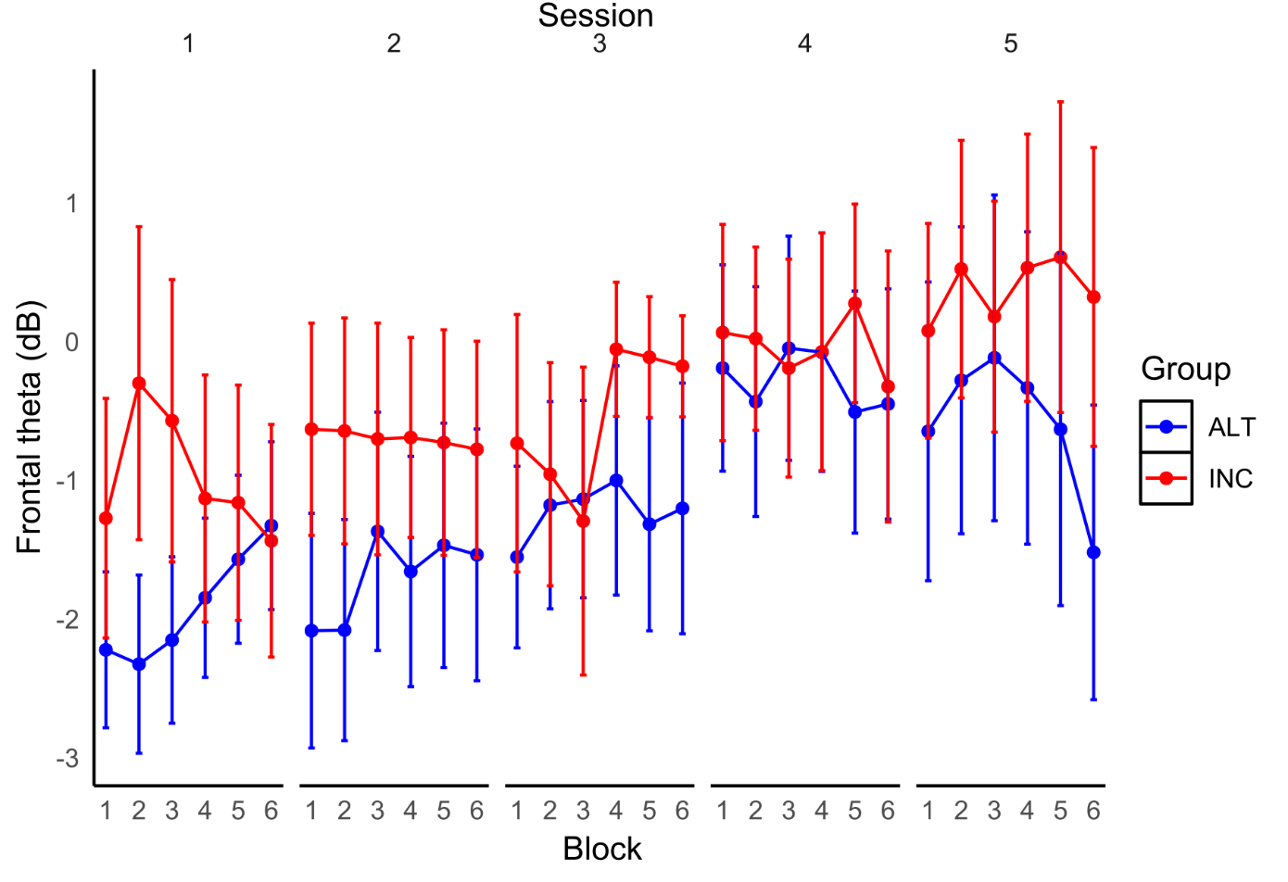
S1A Fig. Changes in Fmθ over blocks and sessions of NF training for each Group in Responders-Only analysis. Changes in frontal theta power over blocks and sessions of NF training for each Group using responders-only (error bars are SE).

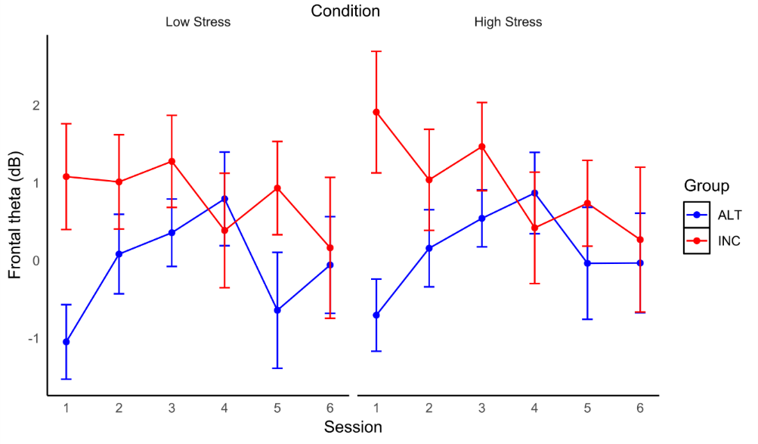
S1B Fig. Fmθ changes across Sessions in Low and High time-stress conditions for each Group during SH in Responders-Only analysis. Changes in Fmθ over Sessions during Go-NoGo shooting task in Low (left) and High (right) time-stress conditions for each Group using responders-only (error bars are SE).

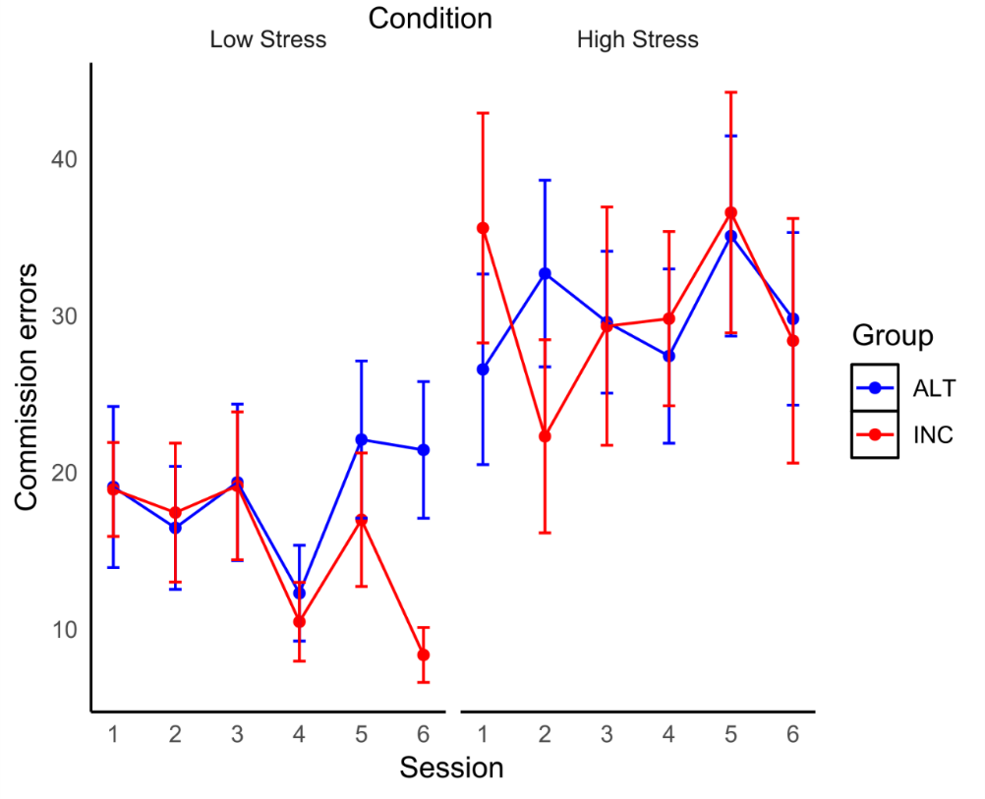
S1C Fig. Changes in errors of commission across Sessions in Low and High time-stress conditions for each Group in Responders-Only analysis. Percentage errors of commission over Sessions in the Low (left) and High (right) time-stress conditions for each Group using responders-only (error bars are SE).

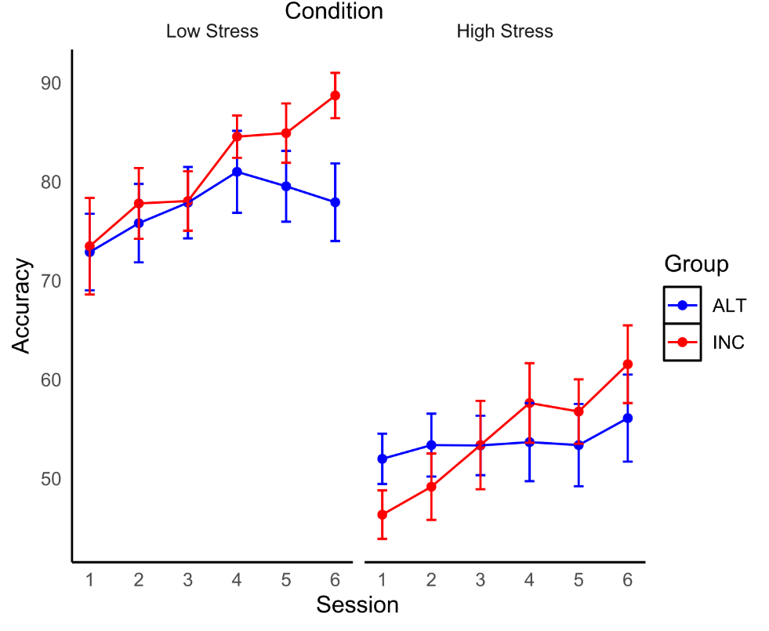
S1D Fig. Changes in shooting accuracy across Sessions in Low and High time-stress conditions for each Group in Responders-Only analysis. Percentage of enemy targets hit in the Low (left) and High (right) time-stress conditions by session for each group using responders-only.

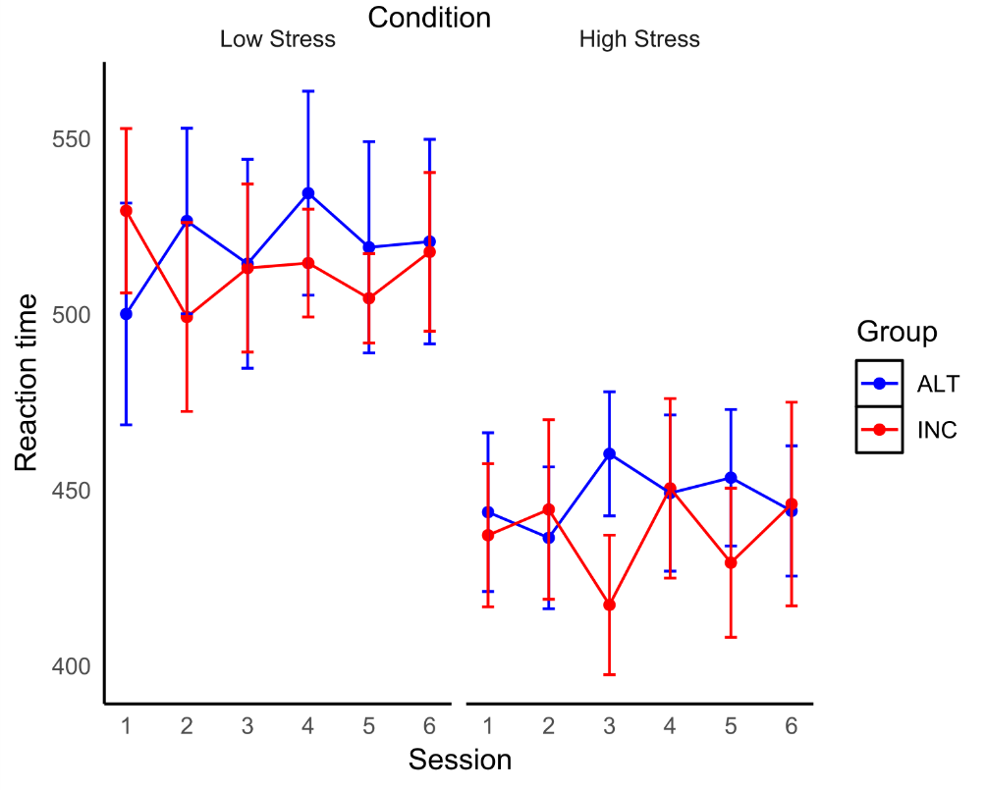
S1E Fig. Changes in RTs across Sessions in Low and High time-stress conditions for each Group in Responders-Only analysis. RTs to enemy targets in the Low (left) and High (right) time-stress conditions by session for each group using responders-only.

