Journal of Geophysical Research: Atmosphere
Supporting Information for
VIIRS Version 2 Deep Blue Aerosol Products
Jaehwa Lee^{1,2}, N. Christina Hsu², Woogyung V. Kim^{1,2}, Andrew M. Sayer^{2,3}, and Si-Chee Tsay²
¹Earth System Science Interdisciplinary Center, University of Maryland, College Park, MD 20740, USA
²NASA Goddard Space Flight Center, Greenbelt, MD 20771, USA
³Goddard Earth Sciences Technology and Research II, University of Maryland, Baltimore County, Baltimore, MD 21250, USA

Contents of this file

Figure S1

Introduction
The supporting information contains the identical analyses as shown in Figure 9, except for NOAA-20 VIIRS AOD (Figure S1), which was excluded due to its similarity to Figure 9, making it redundant.

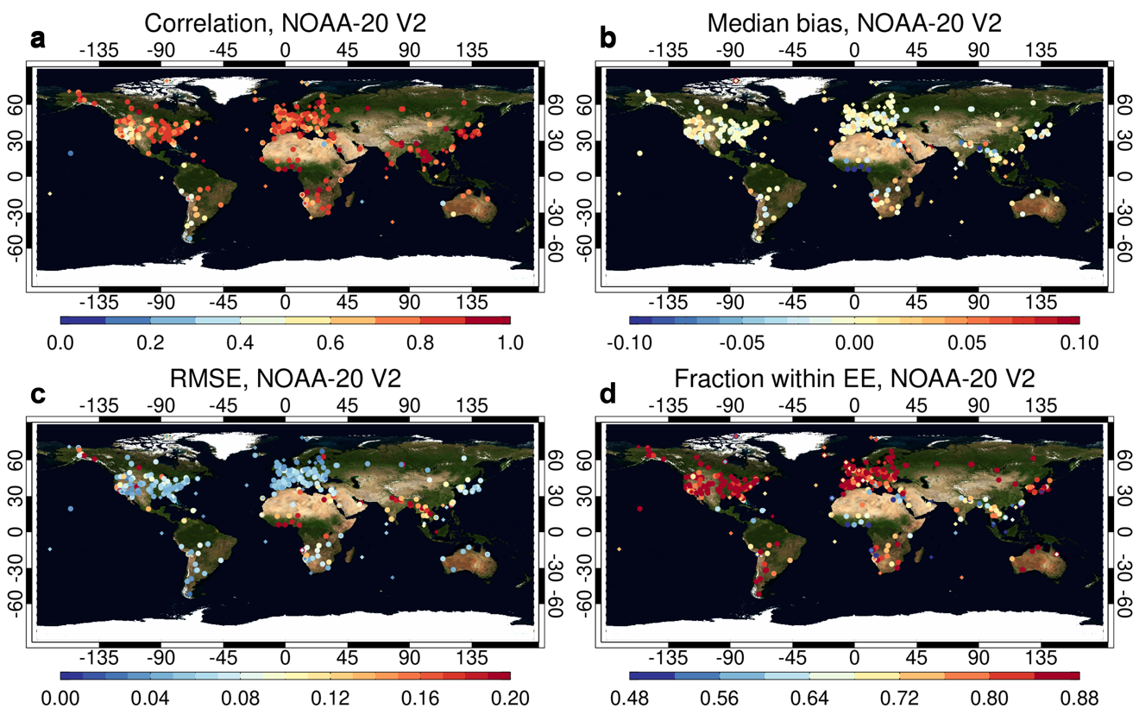

Figure S1. Comparison statistics of NOAA-20 VIIRS Version 2 AOD at 550 nm against AERONET at individual AERONET sites. Shown are (a) the Spearman rank correlation coefficient, (b) MB, (c) RMSE, and (d) fraction of data points within the diagnostic expected error of ±(0.05+15%) over land and ±(0.03+10%) over water. Sites with more than 50 matchups are shown.

