Chapter 10: Enhancing Information Literacy Instruction with Google Drive
Laksamee Putnam
Published and shared with permission from Smallwood, C. (Ed.), The complete guide to using Google in libraries (Volume 2): Research, user applications, and networking (pp. 89-97). Lanham, MD: Rowman & Littlefield.

Abstract
By using the various tools available through Google Drive (forms, spreadsheets, presentations), librarians can increase student participation and provide more interactive instruction sessions. This chapter will profile how one academic librarian integrates Google tools into lesson plans, and provide examples of in-class activities for a range of topics, from citation style to database practice.

Introduction
Within academia, library instruction can involve lessons on keyword creation, proper database usage or understanding plagiarism. These lessons often take place in a computer lab allowing students to move from lecture to practical application. For example, they can test if their keywords work or explore various databases. In addition library instruction should help move students beyond practical skills to developing critical thinking, and motivate students to become truly information literate in any situation, whether it is for academic research, everyday life or their future careers. However, academic library instruction usually means a single one-shot session within a semester long class. Realistically, making the most of minimal time can mean librarians are more focused on convincing students the library is a useful and reliable resource (LaGuardia 2012). It can be easy for librarians to lose sight of the bigger picture as we struggle to adapt to a decentralized information environment. The ACRL’s Information Literacy Competency Standards for Higher Education, approved in 2000, are being revised, in part, because the standards do not “recognize students as content creators as well as consumers and evaluators and do not address ongoing challenges with student learning in a multi-faceted, multi-format, media-rich environment” (“The Future of the Standards” 2014). There is a push within academia to “connect the dots” and move from learning singular skills toward a continuum of education. One such way to encourage a collaborative learning environment and engage students, faculty, and librarians is through the use of Google Drive.

Google Drive provides a toolbox of cloud based, same-time programs which can allow librarians to digitize numerous aspects of their instruction. Integrating Google Drive programs such as Google forms, or Google spreadsheets, can help librarians integrate peer-to-peer instruction, guide the critical thinking process and provide tangible evidence of the need for information literacy instruction. Technology and online environments hold the potential to improve cooperative learning and their ubiquity has made access possible for most students. However, it is not necessary for instruction librarians to reinvent the wheel in order to innovate their classrooms (Koury and Jardine 2013). This chapter will highlight the benefits and challenges of digital worksheets used for a variety of library instruction sessions, all created with Google Drive.

Background
Google Drive is a file storage and synchronization service which allows users with a Google account to upload files, collaborate on projects, and access and edit those items from a variety of devices such as computers, smart phones, and tablets (“Google Drive” 2014). The productivity applications are similar to Microsoft Office applications, allowing users to create documents, spreadsheets, forms and presentations. A single account user has the ability to create any of these files and then share with other users (additional accounts not required). The documents can then be edited in real-time; any user logged into the document at the same time can observe changes as they occur. After creating items in Google Drive, users can also send out the documents to interact with an audience. For example, a user creating a form can construct a fairly comprehensive survey, with various question types including multiple choice, short answer, check boxes and scales. When a form is shared, users’ answers are automatically filled into a spreadsheet, and the creator can make the results accessible, or keep them private.
It is worth noting that Google Drive was created in 2012, adapted from a previous application, Google Docs, which had been around since 2007. Along the way, Google has fairly regularly made updates, added new features and changed the interface (“Google Drive Blog” 2014). My experience with these changes has been positive, with most updates improving features such as word count. Updates have also increased mobility by creating more access points to the applications and improved the tools through the use of add-ons, for example a thesaurus. So, the following classroom examples could be outdated by the time the reader takes a look at them. The activities are adaptable to any synchronous file sharing service (Dropbox, iCloud), but the best way to stay current is to choose a service, stick with it, and be ready to change along with the tide of technology updates.

Google Spreadsheets: Interactive worksheets to encourage hands-on practice
The majority of digital worksheets I create for library instruction utilize Google Spreadsheets. The spreadsheet is made available to the class through a simple URL and students are asked to follow a lecture and then fill in a row from the various instructions provided across the top of each column (Image 1).

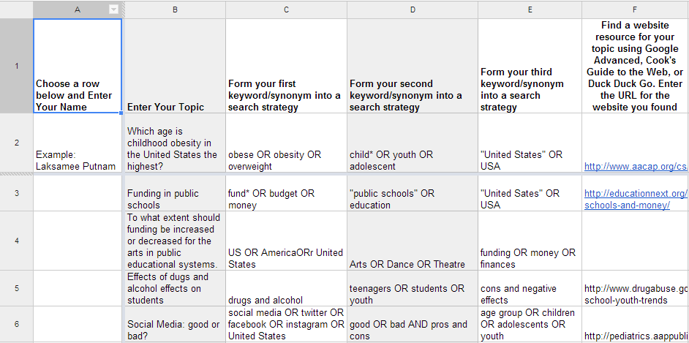
Image 1. Sample spreadsheet from an instruction session. Please view the full spreadsheet here:
http://bit.ly/spreadsheetsample

The class structure is typically a series of brief lectures, then in-class work repeated until completion. This incremental process allows me to clarify each step and encourages students to discuss their research method. Students first fill out the spreadsheet with their name and research topic (it is most effective if students have already chosen their research topics before the library instruction session). This initial step is important, as it allows the students to view the spreadsheet and understand how to enter their work. Students frequently need time to claim a row as their own, and understand that as other students input responses, the worksheet updates. It also establishes time to troubleshoot any students with technical issues. Problems could include the need to use a different browser; frequently an outdated version of Internet Explorer prevents the spreadsheet from working properly. Google Chrome is the recommended browser choice. Another frequent problem occurs when the privacy settings of the spreadsheet are not adjusted to allow students to view and edit. When creating Google Drive documents always double check the share settings to be sure the correct audience has access and permissions to edit.
After establishing a structure for the students to enter their work into the spreadsheet, there is a plethora of ways to organize the column instructions. In Image 1, students are being asked to break their research topic into separate keywords and then use Boolean search terms to create a search strategy. Providing an example row across the top allowed me to demonstrate what I expected their answers to look like. As the students work, they are motivated to keep up, as they view peer rows being filled in. Typically, I have observed a cascade effect where a few students fill in thorough answers, sparking the thought process of other students. Pausing student work to discuss various entries and clarify common questions also allows the instructor to actively correct common mistakes and assess the students’ level of understanding. While this is possible with standard paper worksheets, the digital spreadsheet creates an environment which showcases all the student work in a single location, speeding up the assessment process and perhaps reaching students who do not ask direct questions, or do not realize they are making mistakes. A colleague working with a similar digital worksheet observed that spreadsheets benefit the classroom by creating transparency, allowing the instructor to provide feedback during class rather than adjusting the curriculum afterword (Simpson 2012).
After filling in keywords, the students are asked to search for a website resource on their topic and evaluate for currency, reliability, authority and purpose. The lecture I provide on evaluating sources describes the criteria by highlighting a number of hoax websites, such as the Pacific Northwest Tree Octopus, to spark student interest (2014). As students fill in their website resources and evaluations, discussions frequently arise from a website missing critical information. The spreadsheet provides easy access to the URL the student has entered and then the entire class can analyze the website. Often, these discussions center around student uncertainty over an information format, prompting the class to deliberate over a brochure, a website or an embedded YouTube video, but these conversations can still revolve around evaluation. Librarians can touch on a number of relevant questions as long as they are prepared to briefly deviate from planned content. Allowing these examples to be discussed as they are discovered provides ample evidence for the need to critically think about the source of information, while also integrating new media formats students often uncover while navigating a search. In addition to convincing students to evaluate their information, the spreadsheet also serves as a showcase for faculty, providing data on their students’ information literacy skills. If the faculty is present during the library session the spreadsheet can help them know when to step in to help clarify the research needs for the class, and emphasize the importance of learning research skills. Also, after viewing the student work faculty often realize why library sessions beyond basic bibliographic instruction are so important.
One example of moving beyond bibliographic instruction can be found in Image 2. This spreadsheet asks students to use a specific database to find a book and an article on their research topic. Students are placed into small groups and asked to critique the database while finding the book and article. Instead of beginning the session with a lecture pointing out the various features of a database, I flipped the class and integrated peer instruction. Prior to class students were asked to watch two instructional videos outlining how to locate books and articles, class time then focused on practicing those skills. Instead of a lecture about how to use the database, students worked together on their own. Basic information literacy instruction benefits from peer assisted learning by allowing students to use language they understand to describe processes librarians are prone to overcomplicate (Bodemer 2014).

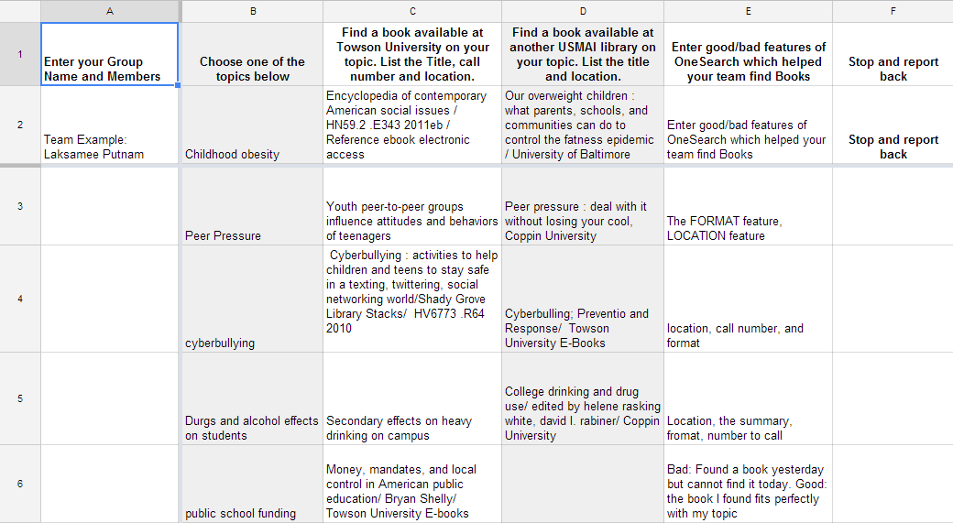
Image 2. Sample spreadsheet showing student group work. Please view the full spreadsheet here: http://bit.ly/spreadsheetsample2

As the spreadsheet is filled, I moved between groups, clarifying questions about call numbers, interlibrary loan requests, and other common issues. Once groups have had a chance to reflect and critique the database, they are asked to present their groups’ thoughts. With the contents of the spreadsheet available I was able to quickly skim and prepare for each presentation. As groups bring up various features which aided their search, or point out problems they had, the critiques can be used as a jumping point for teaching research skills. This flexible class structure can potentially backfire; with discovery services improving, students can often enter their search terms and all the results seem relevant, leaving the impression that the entire search process is easy. However, with the students in groups and with multiple groups all entering data onto a single spreadsheet, it quickly becomes clear that research is not a straightforward process. Class discussions can create a cohesive lecture, as long as the instructor is prepared to interject with questions about elements which might be missing from student critiques. I found most students struggled with a large number of results but a lack of relevance, this situation mirrors current research which points blame toward the globalization of information and a shift to Googlized search results (Fu and Thomes 2014). Frustration with this part of the research process can cause students to give up. The spreadsheet activity allows students to peer-teach the basic bibliographic skills, but also provides the instructor with a way to teach advanced database skills from a point-of-need perspective. Overall, students can begin to comprehend the need to practice using databases and how to narrow results in order to find the right content.

Google Forms: Assessing student knowledge
Google forms is a survey application. There are numerous free survey tools available, including Typeform, Survey Monkey and Poll Daddy. Additionally, more advanced features and improved analytics can usually be purchased through most online survey tools. Google forms is part of the Google Drive suite and does not offer any premium features. Consequently, Google forms is not as robust as most of the other tools on the market. However, for simple information gathering, Google forms is a convenient way to collect basic data.
I use Google forms as a way to gather pre and post-class evaluations. Understanding what students know, or think they know, can help the instructor prepare session content. After class, hearing what students enjoyed, or disliked, can benefit the next iteration of that class. Since most academic library instruction occurs as an integrated part of a semester long course, course evaluations often do not specifically survey student satisfaction with the library session. Building in your own evaluations can be a useful way to showcase library value and support the need for library instruction.
A slightly more complex use of Google forms can be found in Image 3. After a lecture detailing various citation rules, students are asked to copy the book and article reference from a built-in database citation creator and then correct the mistakes.
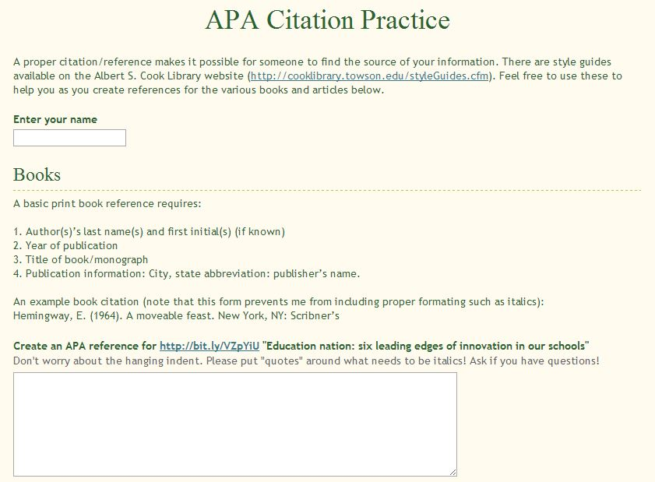
Image 3. Sample Google Form used for library instruction. Please view the full survey here: http://bit.ly/apaformsample

After submitting their answers, the correct versions of the references are shown, and any student questions are addressed. Unfortunately, the form limits the ability to format the entry (e.g italics). This may be a feature which is added to Google forms later; however, with some features not available, readers may want to explore other survey options if their needs are complex. Instructors who create a form can view all the responses in an online spreadsheet, simplifying the grading process. It also makes recognizing trends in the answers easier, clarifying what might need to be emphasized. For example, if most students are forgetting to convert author first names to initials, this concept can be quickly brought to the class’ attention. Whether using Google forms to evaluate instruction or to gather student work, the application provides an innovative way to digitize instruction, especially in a computer lab environment where students are sometimes more focused on a monitor than the teacher.

Conclusion
Google forms and Google spreadsheets are both simple to make and easy to integrate into a library instruction session. The activities shown in this chapter enabled collaborative learning by making library instruction less lecture based and more active. Higher education is embracing the merits of collaborative technology, especially as research has shown it to increase student learning (Zhou, Simpson, and Domizi 2012). Information literacy skills are an integral part of critical thinking, and students can best learn those lessons when faculty and librarians work closely together. Google Drive can be a great way to show faculty how to embed librarians into the curriculum (Midler 2012). Additionally, it can open the way for integrating other technologies and teaching styles. The lessons here began with Google Drive replacing paper worksheets; however through the past two years, the lessons have evolved into a flipped classroom where students watch basic instruction videos or read various articles before class, and then come to class prepared to practice. Along with Google Drive, other web-based technologies such as Poll Everywhere and SlideShare are used to benefit the classroom by including universal design aspects, addressing multiple learning styles, and increasing accessibility. As the technology improves, or better collaborative tools are designed, librarians must be ready to adapt their teaching. For example, Google Drive also includes a Google Slides application, which allows users to create a basic presentation similar to Microsoft PowerPoint. However, because Google Drive is integrated with other various Google resources, a user can search within the Google slides interface for pictures or possible references to pull into the presentation. An example lesson plan integrating this feature can be found on the Free Technology for Teachers website, which compares Google slides to index cards used to help students study or organize their thoughts (Byrne 2014). More advanced integration may be possible; perhaps in addition to Google results, the search could also include local library resources, or subscription access to peer-reviewed materials, making research more seamless. This also emphasizes the importance of teaching critical thinking skills, preventing students from accepting results out of convenience.
Of course, just because a new technology becomes available does not mean it is suited for educational purposes. While library instruction should be adaptable, it remains important to focus on learning outcomes rather than using the new technology just because it is available. Using technology “properly” to teach has moved many disciplines away from lecture, and brought hands-on activities to the forefront of positive pedagogy. Information literacy instruction can follow this same path, adapting to help students navigate today's media rich environment. The use of Google Drive is just one example of how a librarian can increase class participation and also help student develop vital research skills.
Reference List

Bodemer, Brett B. 2014. "They can and they should: Undergraduates providing peer reference and instruction." College & Research Libraries 75(2): 162-78. http://crl.acrl.org/content/75/2/162.full.pdf+html

Byrne, Richard. 2014. “How to use Google slides to organize research.” Free Technology for Teachers, http://www.freetech4teachers.com/2014/02/using-google-slides-to-organize-research.html#.U3-yb_ldWSo

Fu, Li, and Cynthia Thomes. 2014. "Implementing discipline-specific searches in EBSCO Discovery Service." New Library World 115(3): 102-15. doi: 10.1108/NLW-01-2014-0003

“The Future of the Standards.” Framework for Information Literacy for Higher Education. Accessed May 27, 2014. http://acrl.ala.org/ilstandards/?page_id=19

“Google Drive.” google.com. Accessed May 27, 2014. https://www.google.com/drive/index.html

“Google Drive Blog.” blogspot.com. Accessed May 27, 2014. http://googledrive.blogspot.com/

“Help Save the Pacific-Northwest Tree Octopus.” zapatopi.net. Accessed May 30, 2014. http://zapatopi.net/treeoctopus/

Koury, Regina and Spencer J. Jardine. 2013. “Library instruction in a cloud: Perspectives from the trenches.” OCLC System & Services 29(3): 161-69. doi: 10.1108/OCLC-01-2013-0001

LaGuardia, Cheryl. 2012. "Library instruction in the digital age." Journal of Library Administration. 52(6): 601-08. doi: 10.1080/01930826.2012.707956

Milder, Zoe. 2012. “Case profile: Zoe Midler and Google docs.” Library Technology Reports: Embedded Librarianship: Tools and Practices. 48(2): 12-15. http://www.alatechsource.org/ltr/index

“Polldaddy” Accessed May 30, 2014. http://polldaddy.com/

“Polleverywhere” Accessed May 30, 2014. http://www.polleverywhere.com/

Simpson, Shannon. R. 2012. "Google spreadsheets and real-time assessment: Instant feedback for library instruction." College & Research Libraries News 73(9): 528-30+549. http://crln.acrl.org/content/73/9/528.full

“Slideshare” Accessed May 30, 2014. http://www.slideshare.net/

“Surveymonkey” Accessed May 30, 2014. https://www.surveymonkey.com/

“Typeform” Accessed May 30, 2014. http://www.typeform.com/

Wenyi, Zhou, Elizabeth Simpson, and Denise Pinette Domizi. 2012. "Google docs in an out-of-class collaborative writing activity." International Journal of Teaching & Learning in Higher Education 24(3): 359-75. http://www.isetl.org/ijthe

