Supporting Information for
Infrasound signal detection and back-azimuth estimation using ground-coupled airwaves on a seismo-acoustic sensor pair
Kathleen McKee¹, David Fee¹, Matthew Haney², Robin S. Matoza³, John Lyons²

¹Alaska Volcano Observatory, Geophysical Institute, University of Alaska Fairbanks, Fairbanks, Alaska, ²Alaska Volcano Observatory, U. S. Geological Survey Volcano Science Center, Anchorage, Alaska, ³Department of Earth Science and Earth Research Institute, University of California, Santa Barbara, California

Contents of this file
1. Distinguishing the infrasonic contribution to a seismic record and Figure S1
2. Map View of Seismic Waves Passing PGBF for Synthetic Data, Figure S2
3. Mount Pagan Results Figures S3 to S5
4. Discussion of sensor spacing and sample rate requirements and Figure S6
5. Datasets S1 to S19 (files uploaded separately)

1. Distinguishing the infrasonic contribution to a seismic record
Here we describe the method for distinguishing the infrasonic component of the seismic record (i.e. GCA) and identifying the 90° phase shift. Given the geometry of a source and nearly collocated seismometer and microphone, we can identify the signal from a specific source direction by correcting the phase due to the apparent sensor separation [Matoza and Fee, 2014]. We refer to this process as the “forward problem” and Figure S1 shows a schematic of the six necessary steps, as outlined in Matoza and Fee [2014]. In this example, a plane wave arrives from a volcanic source to the southeast. To find the additional phase shift, we need to find the apparent distance between the two sensors. We define azimuth as the angle measured clockwise from north (0°) from one location to another and back-azimuth as the direction from which a wave originated, again measured clockwise from north. In step 1 we measure the azimuth from the seismometer (orange square) to the microphone (green circle),$β$, and in step 2 we determine the azimuth to the source,$α$ (Fig. S1). Then we find the difference in these two azimuths, $θ$, which is the angle between the inter-sensor distance, d, and the apparent distance, d₀. We apply trigonometry to find d₀, one of the legs of a right-angled triangle (Fig. S1, Step 3). The apparent distance is used to calculate the travel time difference from the microphone to seismometer, which appears as a time shift, $Δt$. $Δt=d_{0}/c$, where c is the speed of sound assuming a plane wave traveling near parallel to the surface (Fig. S1, Step 4). Next, we shift the acoustic data by the calculated $Δt$ (Fig. S1, Step 5), which effectively collocates the sensors relative to the incident wave and minimizes the phase offset due to sensor separation. $Δt$ is related to phase through the equation $φ=2πfΔt$, where $φ$ is phase and $f$ is frequency. Once $Δt$ is applied to the acoustic data and the phase is calculated, the 90° phase should be present in the phase spectrogram (Fig. S1, Step 6). The presence of the 90° phase indicates the coherent wave is from the back-azimuth,$α$, which is equivalent to $β+θ$.

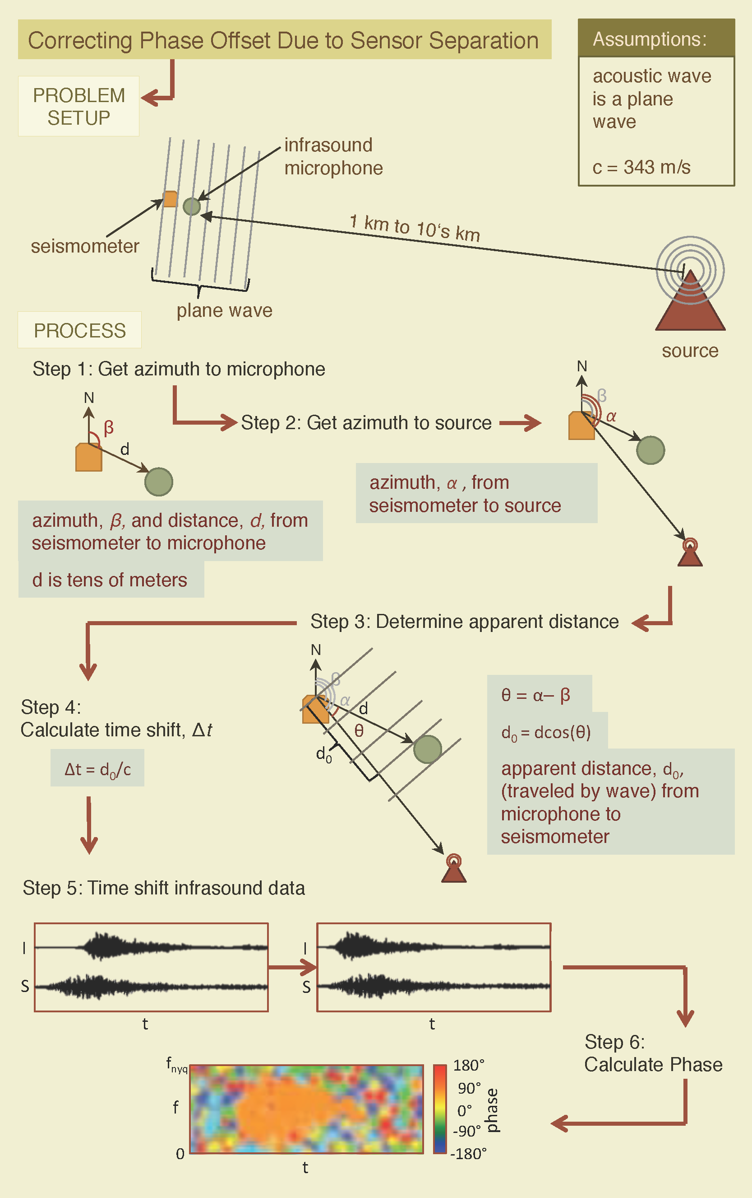
Figure S1 Infographic illustrating the steps to correct the phase offset between infrasound and seismic data for a recorded airwave due to sensor separation. Method is from Matoza and Fee [2014]. See text for more details.
2. Map View of Seismic Waves Passing PGBF for Synthetic Data
Figure S2 Map view time slices from 0.5 s to 6.0 s at 0.5 s intervals for the synthetic Pagan dataset. The panels show the passing of a Rayleigh wave by station PGBF (red circle). The wave is diffracting off the caldera wall and the white arrows point to the Rayleigh wave packet.
3. Mount Pagan Results Figures
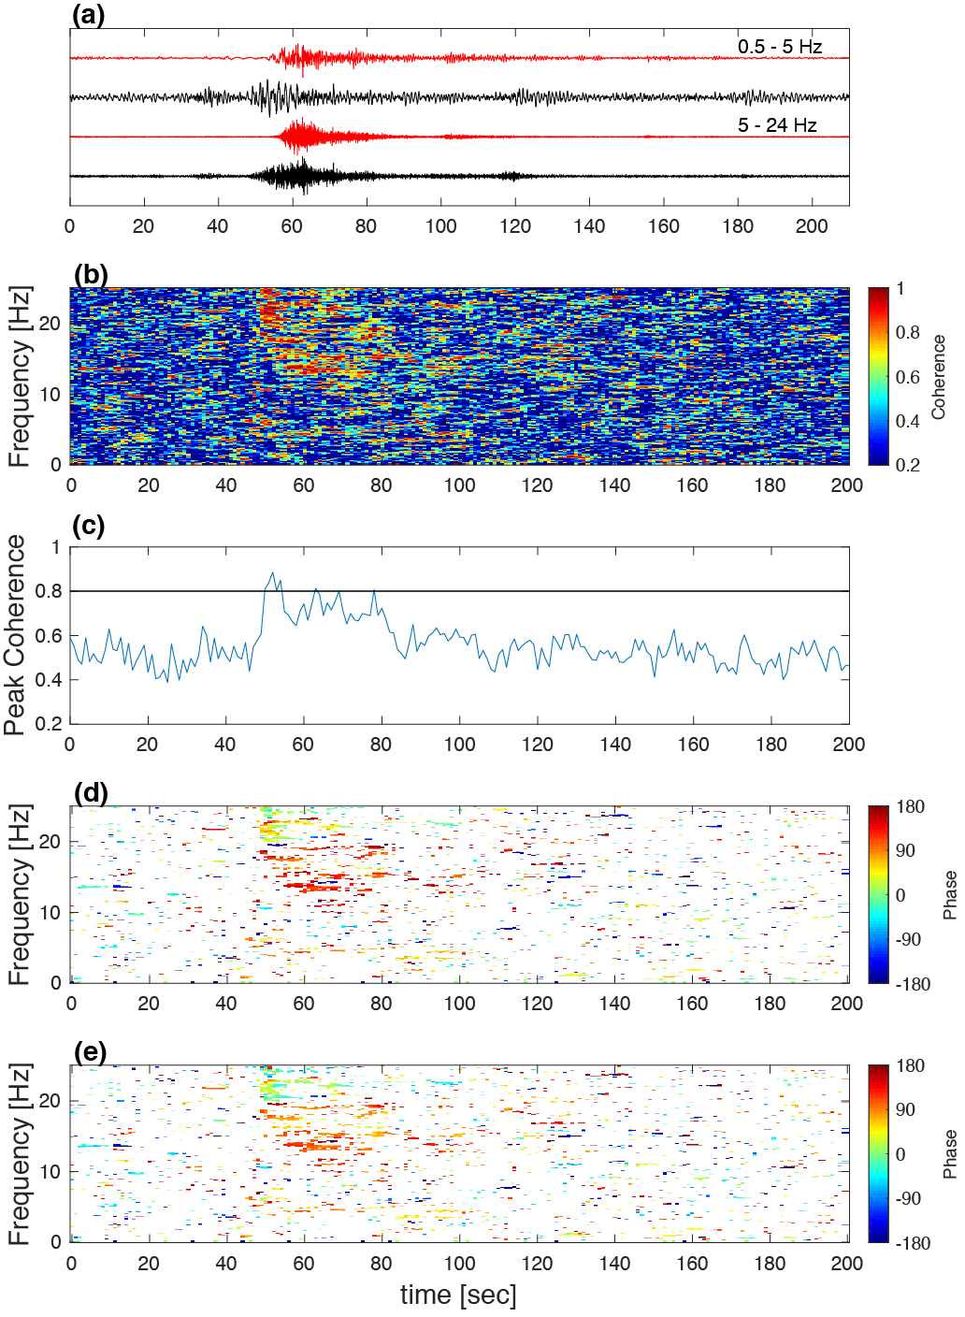
Figure S3 Pagan PGBF Coherence and Phase a) Infrasound (red) and vertical seismic (black) traces filtered from 0.5 – 5 Hz (top) and 5 – 24. Hz (bottom); b) Coherence of infrasound and seismic data. c) Peak coherence through time; d) Phase between same high-pass filtered infrasound and seismic data as in b; e) Phase found from time shifting the infrasound data until the majority of highly coherent data have a phase of 90°. For the coherence and phase calculations, we used a window length of 10 seconds with a 1 second step (90% overlap).

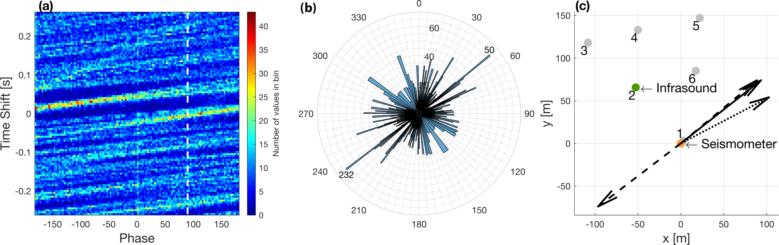
Figure S4 Pagan PGBF search and rose diagram result, similar to Figures 4 and 7. a) Image of histogram values from each time shift. b) Rose diagram of the two possible back-azimuths and the number of phase values near 90° for each time shift. c) The arrangement of the seismometer (orange) and infrasound microphone (green); the solid arrow shows the actual azimuth to the source while dashed and dotted lines show the back-azimuths from the phase search (also shown in b) and the back-azimuth from the particle motion analysis, respectively. The gray circles show the other infrasound array element locations. Note one of the two back-azimuth results in b) is consistent with the actual back-azimuth in c).

Figure S5 Particle motion for 1 second of a GCA recorded on PGBF seismometer. Time is noted by the color of the circles. a) North versus East displacement; b) Vertical versus East displacement; c) Vertical versus North displacement; d) Vertical versus North versus East displacement.

4. Sensor spacing and sample rate requirements
To further illustrate our recommendation to separate the seismometer and infrasonic microphone by at least a 𝑑𝑡 equivalent distance, we explore the relationship between the sample rate and the sensor spacing. The delay time, $T$, for a plane wave crossing two sensors is $T=\left(d∙\cos{θ}\right)/c$, where $d$ is the interstation spacing and $c$ is the speed of sound. $θ$ is the difference between the back-azimuth of the plane wave, $α$, and the azimuth from seismometer to microphone, $β$, such that $θ=α-β$, (shown in Fig. S1, steps 3 and 4). It then follows that, to have the sensors separated by at least a $dt$-equivalent distance, $T/dt$ must be $>1$. Following this relationship, $(d∙cos⁡θ)/(c∙dt) >1$. This inequality will never hold when the plane wave is exactly broadside to the two sensors, since in that case $\cos{θ}=0$. At the very least, $dt$ should be chosen such that $d/(c∙dt)>1$ such that the inequality is satisfied for some angles. In this situation, there will be an angular zone where the criterion is not met. This angular zone is bound by the critical angle, $θ_{c}$, defined as $θ_{c}=\cos^{-1}\left(\left(c∙dt\right)/d\right)$. This angular zone relative to a given sensor geometry is $β±θ_{c}$. Figure S2a illustrates these relationships and sensor spacing limitations with $d$ plotted along the x-axis and sample rate (or $1/dt$) along the y-axis. The colors indicate the angle $θ_{c}$ for a given sensor separation and sample rate. The white area towards the lower left is where the criterion fails and the boundary where is changes to white should be viewed as the absolute minimum spacing and sample rate necessary for our technique. Figure S2b shows how the critical angle relates to the seismo-acoustic sensor geometry. Note with increasing sensor separation and sample rate the critical angle increases, thus decreasing the angular zone highlighted by the red arrows in Figure S2b. The circles plotted in Figure S2a show the sensor spacing versus sample rate for the three different datasets evaluated. PGBF-1 falls in the area where the criterion fails, but the PGBF-2, -6 and MSH sensor geometries and sample rates are more ideal, which is reflected in their accurate back-azimuth results.
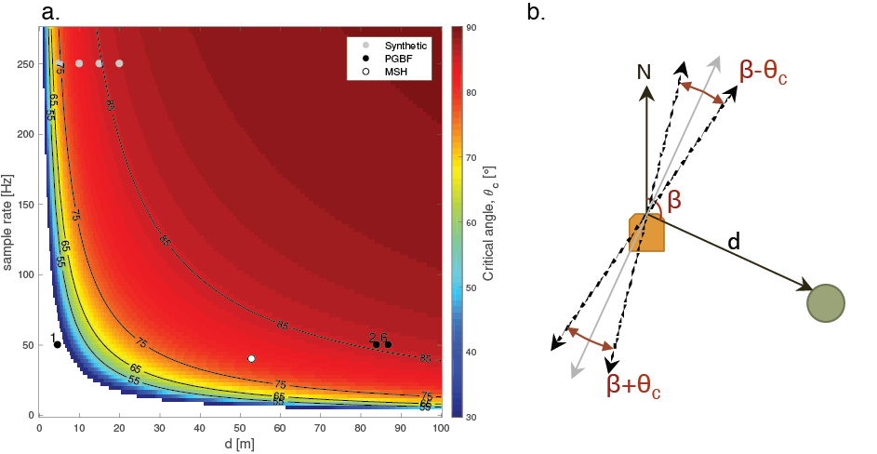
Figure S6 Analysis of sensor spacing, sample rate, and the critical angle for the GCA BAD method. a) The white area of the figure is where the sample rate and sensor spacing are too small and the GCA method fails. The color scale indicates how the critical angle changes with sensor geometry and sample rate. As sensor spacing and sample rate increase the resolvable back-azimuth resolution improves. The gray, black and white dots show the sensor spacing and sample rates for the synthetic, PGBF and MSH, respectively, cases evaluated. b) Shows the angular zone where the criteria are not met relative to seismometer (orange square) and infrasonic microphone (green circle) geometry. The dashed lines are β±θ_{c} and β+180°± θ_{c} and the solid gray line is β±90°. Between the two dashed lines is the angular zone where the criterion fails defined by the critical angle and highlighted by the red arrows extending out from the gray line.

5. Mount Pagan and Mount Cleveland data used in GCA BAD method
Data Set S1. These are vertical-component seismic data in counts from station PGBF located on Mount Pagan, Commonwealth of the Northern Mariana Islands (CNMI) at 18.12379° latitude, 145.76440° longitude. The data are from 26 July 2013 from 02:52:11 to 02:55:31 UTC as shown in Figure 8. These are 210 seconds of data at 50 Hz sample rate in a single column text format with 10,500 samples. The conversion factor to velocity (m/s) from counts is 2.326×10⁻¹⁰ m/s/count.

Data Set S2. These are north-component seismic data in counts from station PGBF located on Mount Pagan, Commonwealth of the Northern Mariana Islands (CNMI) at 18.12379° latitude, 145.76440° longitude. The data are from 26 July 2013 from 02:52:11 to 02:55:31 UTC as shown in Figure 8. These are 210 seconds of data at 50 Hz sample rate in a single column text format with 10,500 samples. The conversion factor to velocity (m/s) from counts is 2.326×10⁻¹⁰ m/s/count.

Data Set S3. These are east-component seismic data in counts from station PGBF located on Mount Pagan, Commonwealth of the Northern Mariana Islands (CNMI) at 18.12379° latitude, 145.76440° longitude. The data are from 26 July 2013 from 02:52:11 to 02:55:31 UTC as shown in Figure 8. These are 210 seconds of data at 50 Hz sample rate in a single column text format with 10,500 samples. The conversion factor to velocity (m/s) from counts is 2.326×10⁻¹⁰ m/s/count.

Data Set S4. These are infrasound data in counts from station PGBF-1 located on Mount Pagan, Commonwealth of the Northern Mariana Islands (CNMI) at 18.12382° latitude, 145.76443° longitude. The data are from 26 July 2013 from 02:52:11 to 02:55:31 UTC. These are 210 seconds of data at 50 Hz sample rate in a single column text format with 10,500 samples. The conversion factor to pressure (Pa) from counts is 2.3842×10⁻⁴ Pa/count.

Data Set S5. These are infrasound data in counts from station PGBF-2 located on Mount Pagan, Commonwealth of the Northern Mariana Islands (CNMI) at 18.12438° latitude, 145.76390° longitude. The data are from 26 July 2013 from 02:52:11 to 02:55:31 UTC as shown in Figure 8. These are 210 seconds of data at 50 Hz sample rate in a single column text format with 10,500 samples. The conversion factor to pressure (Pa) from counts is 2.3842×10⁻⁴ Pa/count.

Data Set S6. These are infrasound data in counts from station PGBF-3 located on Mount Pagan, Commonwealth of the Northern Mariana Islands (CNMI) at 18.12485° latitude, 145.76337° longitude. The data are from 26 July 2013 from 02:52:11 to 02:55:31 UTC. These are 210 seconds of data at 50 Hz sample rate in a single column text format with 10,500 samples. The conversion factor to pressure (Pa) from counts is 2.3842×10⁻⁴ Pa/count.

Data Set S7. These are infrasound data in counts from station PGBF-4 located on Mount Pagan, Commonwealth of the Northern Mariana Islands (CNMI) at 18.12499° latitude, 145.76392° longitude. The data are from 26 July 2013 from 02:52:11 to 02:55:31 UTC. These are 210 seconds of data at 50 Hz sample rate in a single column text format with 10,500 samples. The conversion factor to pressure (Pa) from counts is 2.3842×10⁻⁴ Pa/count.

Data Set S8. These are infrasound data in counts from station PGBF-5 located on Mount Pagan, Commonwealth of the Northern Mariana Islands (CNMI) at 18.12512° latitude, 145.76460° longitude. The data are from 26 July 2013 from 02:52:11 to 02:55:31 UTC. These are 210 seconds of data at 50 Hz sample rate in a single column text format with 10,500 samples. The conversion factor to pressure (Pa) from counts is 2.3842×10⁻⁴ Pa/count.

Data Set S9. These are infrasound data in counts from station PGBF-6 located on Mount Pagan, Commonwealth of the Northern Mariana Islands (CNMI) at 18.12456° latitude, 145.76456° longitude. The data are from 26 July 2013 from 02:52:11 to 02:55:31 UTC. These are 210 seconds of data at 50 Hz sample rate in a single column text format with 10,500 samples. The conversion factor to pressure (Pa) from counts is 2.3842×10⁻⁴ Pa/count.

Data Set S10. These are infrasound data in counts from station CLCO-1 located on Chuginadak Island, Alaska at 52.7864125° latitude, -169.722925° longitude. The data are from 13 December 2017 from 13:21:00 to 13:22:00 UTC. These are 60 seconds of data at 50 Hz sample rate in a single column text format with 3,000 samples. The conversion factor to pressure (Pa) from counts is 2.3842×10⁻⁴ Pa/count.

Data Set S11. These are infrasound data in counts from station CLCO-2 located on Chuginadak Island, Alaska at 52.78718667° latitude, -169.7244333° longitude. The data are from 13 December 2017 from 13:21:00 to 13:22:00 UTC. These are 60 seconds of data at 50 Hz sample rate in a single column text format with 3,000 samples. The conversion factor to pressure (Pa) from counts is 2.3842×10⁻⁴ Pa/count.

Data Set S12. These are infrasound data in counts from station CLCO-3 located on Chuginadak Island, Alaska at 52.78746° latitude, -169.7210167° longitude. The data are from 13 December 2017 from 13:21:00 to 13:22:00 UTC. These are 60 seconds of data at 50 Hz sample rate in a single column text format with 3,000 samples. The conversion factor to pressure (Pa) from counts is 2.3842×10⁻⁴ Pa/count.

Data Set S13. These are infrasound data in counts from station CLCO-4 located on Chuginadak Island, Alaska at 52.78612667° latitude, -169.7203967° longitude. The data are from 13 December 2017 from 13:21:00 to 13:22:00 UTC. These are 60 seconds of data at 50 Hz sample rate in a single column text format with 3,000 samples. The conversion factor to pressure (Pa) from counts is 2.3842×10⁻⁴ Pa/count.

Data Set S14. These are infrasound data in counts from station CLCO-5 located on Chuginadak Island, Alaska at 52.78518667° latitude, -169.7250067° longitude. The data are from 13 December 2017 from 13:21:00 to 13:22:00 UTC. These are 60 seconds of data at 50 Hz sample rate in a single column text format with 3,000 samples. The conversion factor to pressure (Pa) from counts is 2.3842×10⁻⁴ Pa/count.

Data Sets S15 – S19. These are infrasound data in counts from station CLCO-1 to CLCO-5 located on Chuginadak Island, Alaska in the same locations as S10 – S14, respectively. The data are from 2 March 2018 from 14:56:50 to 14:58:20 UTC. These are 140 seconds of data at 50 Hz sample rate in single column text format with 7,001 samples. The conversion factor to pressure (Pa) from counts is 2.3842×10⁻⁴ Pa/count.

