THE EFFECTS OF LONG-TERM ANTIHERPETIC TREATMENT IN HERPES SIMPLEX VIRUS-1 & -2 THROUGH DRUG RESISTANCE AND CELL TOXICITY
by
Kaitlyn Arthur
B.S. (Towson University) 2015
MOCK GRANT PROPOSAL
Submitted in partial satisfaction of the requirements
for the degree of
MASTER OF SCIENCE
in
BIOMEDICAL SCIENCE
in the
GRADUATE SCHOOL
of
HOOD COLLEGE
May 2019
Accepted:

________________________________ ________________________________
Ricky R. Hirschhorn, Ph.D. Ann Boyd, Ph.D.
Committee Member Director, Biomedical Science Program

________________________________
Georgette Jones, Ph.D.
Committee Member

________________________________ ________________________________
Ann Boyd, Ph.D. April Boulton, Ph.D.
Project Adviser Dean of the Graduate School

STATEMENT OF USE AND COPYRIGHT WAIVER

I do authorize Hood College to lend this mock grant proposal, or reproductions of it, in total or in part, at the request of other institutions or individuals for the purpose of scholarly research.

DEDICATION

This is dedicated to my husband, son, and family. For without their patience and support, none of this would have been possible.

ACKNOWLEDGEMENTS

Thank you to the reading committee Drs. Ann Boyd, Ricky R. Hirschhorn, and Georgette Jones. I would also like to thank the rest of the graduate faculty at Hood College for making this degree so enjoyable to obtain.

LIST OF ABBREVIATIONS
ACV Acyclovir
CNS Central nervous system
CPE Cytopathic effect
DMEM Dulbecco’s modified Eagle’s medium
DPBS Dulbecco’s phosphate-buffered saline
FCV Famciclovir
HIV Human immunodeficiency virus
HSV Herpes Simplex Virus
LAT Latency associated transcript
PCL Polycaprolactone
PNS Peripheral nervous system
SEM Skin, eye, and/or mouth disease
VACV Valacyclovir
VASE Volatile acid solvent evaporation

Mock Grant Application  Modeled after Department of Health and Human Services  Public Health Services  (based on Form PHS 398) |  |  |  |  |  |  |  |  |  |  |  | LEAVE BLANK—FOR OFFICIAL USE ONLY.
 |  |  |  |  |  |  |  |  |  |  |  | Type |  |  |  |  | Activity |  |  |  |  | Version – HCBMS.011712
 |  |  |  |  |  |  |  |  |  |  |  | Review Group |  |  |  |  |  |  |  |  |  | Formerly
 |  |  |  |  |  |  |  |  |  |  |  | Council/Board (Month, Year) |  |  |  |  |  |  |  |  |  | Date Received
1. TITLE OF PROJECT (Do not exceed 81 characters, including spaces and punctuation.)
The Effects of Long-Term Antiherpetic Treatment in Herpes Simplex Virus-1 & -2 through Drug Resistance and Cell Toxicity

2. RESPONSE TO SPECIFIC REQUEST FOR APPLICATIONS OR PROGRAM ANNOUNCEMENT OR SOLICITATION NO YES
(If “Yes,” state number and title)
Number: |  |  |  |  | Title:
3. PROGRAM DIRECTOR/PRINCIPAL INVESTIGATOR |  |  |  |  |  |  |  |  |  |  |  | New Investigator No Yes
3a. NAME (Last, first, middle) |  |  |  |  |  |  |  |  |  |  |  | 3b. DEGREE(S) |  |  |  |  |  |  |  |  | 3h. eRA Commons User Name
Arthur, Kaitlyn, Ashley |  |  |  |  |  |  |  |  |  |  |  |  |  |  | BS |  |  |  |  |  | N/A
3c. POSITION TITLE  Graduate Student |  |  |  |  |  |  |  |  |  |  |  | 3d. MAILING ADDRESS (Street, city, state, zip code)  401 Rosemont Ave.  Frederick, MD 21201
3e. DEPARTMENT, SERVICE, LABORATORY, OR EQUIVALENT
Department of Biology
3f. MAJOR SUBDIVISION
Biomedical Science Program
3g. TELEPHONE AND FAX (Area code, number and extension) |  |  |  |  |  |  |  |  |  |  |  | E-MAIL ADDRESS:
TEL: | 443-528-8552 |  |  |  |  | FAX: |  | N/A |  |  |  | kaitlynbiles@yahoo.com
4. HUMAN SUBJECTS RESEARCH |  |  |  |  |  |  |  |  | 4a. Research Exempt
No Yes |  |  |  |  |  |  |  |  | N/A
4b. Federal-Wide Assurance No. |  |  |  |  |  |  |  |  | 4c. Clinical Trial |  |  |  |  |  |  |  |  | 4d. NIH-defined Phase III Clinical Trial
N/A |  |  |  |  |  |  |  |  | No Yes |  |  |  |  |  |  |  |  | No Yes
5. VERTEBRATE ANIMALS No Yes |  |  |  |  |  |  |  |  |  |  |  | 5a. Animal Welfare Assurance No.
6. DATES OF PROPOSED PERIOD OF  SUPPORT (month, day, year—MM/DD/YY) |  |  |  |  |  |  |  |  |  |  | 7. COSTS REQUESTED FOR INITIAL  BUDGET PERIOD |  |  |  |  |  |  |  |  | 8. COSTS REQUESTED FOR PROPOSED  PERIOD OF SUPPORT
From |  |  |  | Through |  |  |  |  |  |  | 7a. Direct Costs ($) | 7b. Total Costs ($) |  |  |  |  |  |  |  | 8a. Direct Costs ($) |  |  |  | 8b. Total Costs ($)
06/01/2019 |  |  |  | 06/30/2021
9. APPLICANT ORGANIZATION |  |  |  |  |  |  |  |  |  |  |  | 10. TYPE OF ORGANIZATION
Name |  |  | Kaitlyn Arthur |  |  |  |  |  |  |  |  | Public: → Federal State Local
Address |  |  | Department of Biology  Hood College  401 Rosemont Ave  Frederick, MD 21701 |  |  |  |  |  |  |  |  | Private: → Private Nonprofit
For-profit: → General Small Business
Woman-owned Socially and Economically Disadvantaged
 |  |  |  |  |  |  |  |  |  |  |  | 11. ENTITY IDENTIFICATION NUMBER
 |  |  |  |  |  |  |  |  |  |  |  | DUNS NO. |  |  |  | N/A |  |  |  |  | Cong. District |  |  |  |  | N/A
12. ADMINISTRATIVE OFFICIAL TO BE NOTIFIED IF AWARD IS MADE |  |  |  |  |  |  |  |  |  |  |  | 13. OFFICIAL SIGNING FOR APPLICANT ORGANIZATION
Name |  |  | Kaitlyn Arthur |  |  |  |  |  |  |  |  | Name |  | Kaitlyn Arthur
Title |  |  | Graduate Student |  |  |  |  |  |  |  |  | Title |  | Graduate Student
Address |  |  | Hood College  401 Rosemont Ave  Frederick, MD 21701 |  |  |  |  |  |  |  |  | Address |  | Hood College  401 Rosemont Ave  Frederick, MD 21701
Tel: | N/A |  |  |  |  |  | FAX: |  |  | N/A |  | Tel: | N/A |  |  |  |  |  |  |  |  |  | FAX: |  | N/A
E-Mail: |  |  | kaitlynbiles@yahoo.com |  |  |  |  |  |  |  |  | E-Mail: |  | kaitlynbiles@yahoo.com
14. APPLICANT ORGANIZATION CERTIFICATION AND ACCEPTANCE: I certify that the statements herein are true, complete and accurate to the best of my knowledge, and accept the obligation to comply with Public Health Services terms and conditions if a grant is awarded as a result of this application. I am aware that any false, fictitious, or fraudulent statements or claims may subject me to criminal, civil, or administrative penalties. |  |  |  |  |  |  |  |  |  |  |  | SIGNATURE OF OFFICIAL NAMED IN 13.  (In ink. “Per” signature not acceptable.)  N/A |  |  |  |  |  |  |  |  |  |  |  |  |  |  | DATE  03/21/2019
Face Page

PROJECT SUMMARY (See instructions):

Herpes simplex virus (HSV) type-1 and -2 infections are a global epidemic, with 90% of the population worldwide being infected and developing countries suffering a near 100% infection rate. Human immunodeficiency virus (HIV) acquisition is three times more likely if an HSV-2 infection is already established. While there are current treatments for HSV, a life-long infection, there is much improvement to be made using more efficient treatments.
Rod-shaped implants would be created in varying ratios of drug:polymer (polycaprolactone) for three antiherpetics: acyclovir, valacyclovir, and famciclovir. These implants would be used in an in vitro drug release study to determine the most effective ratio. A long-term drug treatment experiment, using these implants, would determine if/when drug resistant viral strains develop and to evaluate cell toxicity. The caspase and MTT assay are cell viability assays that will be used for the evaluation of cell toxicity. If drug resistant strains develop, they will be selected to be sequenced and repeated experimentally to compare to the initial strain used.

RELEVANCE (See instructions):
Current antiherpetic treatment methods are not sufficient and many populations are being heavily impacted, including those who are immune compromised, those with many sexual partners, victims of sexual abuse, and pregnant women. Without treatment, neonates are at an increased risk of suffering harmful side effects, including death. Implantable drug delivery devices provide a way to deliver a more effective drug dosage, and can potentially be given long-term to prevent reactivation of the virus. This could lead to a decrease in the spread of the virus, a decreased risk of contracting other infections, and overall better patient compliance and patient satisfaction.
PROJECT/PERFORMANCE SITE(S) (if additional space is needed, use Project/Performance Site Format Page)
Project/Performance Site Primary Location
Organizational Name: |  |  |  | Department of Biology, Hood College
DUNS:
Street 1: |  | 401 Rosemont Ave |  |  |  |  |  |  | Street 2:
City: | Frederick |  |  |  |  |  |  | County: | Frederick |  |  | State: | MD
Province: |  |  |  |  | Country: |  | United States |  |  |  | Zip/Postal Code: |  | 21702
Project/Performance Site Congressional Districts: |  |  |  |  |  | 6th Congressional District
Additional Project/Performance Site Location
Organizational Name:
DUNS:
Street 1: |  |  |  |  |  |  |  |  | Street 2:
City: |  |  |  |  |  |  |  | County: |  |  |  | State:
Province: |  |  |  |  | Country: |  |  |  |  |  | Zip/Postal Code:
Project/Performance Site Congressional Districts:
Page 2

BIOGRAPHICAL SKETCH
Provide the following information for the key personnel and other significant contributors in the order listed on Form Page 2.
Follow this format for each person. DO NOT EXCEED FOUR PAGES.
NAME  Kaitlyn Arthur |  | POSITION TITLE  Graduate Student
eRA COMMONS USER NAME (credential, e.g., agency login)

EDUCATION/TRAINING (Begin with baccalaureate or other initial professional education, such as nursing, and include postdoctoral training.)
INSTITUTION AND LOCATION | DEGREE  (if applicable) |  | YEAR(s) | FIELD OF STUDY
Towson University | BS |  | 2015 | Biology
Hood College, Frederick, MD | M.S. |  | 2019 | Biomedical Science
 |  |  | (anticipated)

- Positions and Honors

2016-Present Leidos Biomedical Research Research Associate I
2012-2015 Towson University Beta Beta Beta Biological Honors Society
2012-2015 Towson University Dean’s List

Program Director/Principal Investigator: Arthur, Kaitlyn

RESOURCES
FACILITIES: Specify the facilities to be used for the conduct of the proposed research. Indicate the project/performance sites and describe capacities, pertinent capabilities, relative proximity, and extent of availability to the project. If research involving Select Agent(s) will occur at any performance site(s), the biocontainment resources available at each site should be described. Under “Other,” identify support services such as machine shop, electronics shop, and specify the extent to which they will be available to the project. Use continuation pages if necessary.
Laboratory:
This study will be conducted at both Hood College and the NIH at Fort Detrick. Dr. Newton’s laboratory at Leidos will be used for assays, cell maintenance, and viral infections. Hood College laboratory will be used for assays which require the equipment available at the location.
Clinical:
N/A
Animal:
N/A
Computer:
All locations have computers with internet access available. Imaging software is available at Leidos.
Office:
General office equipment is available at both locations.

Other:
Laboratory space with appropriate safety equipment for radioactive materials is available at Hood College.

MAJOR EQUIPMENT: List the most important equipment items already available for this project, noting the location and pertinent capabilities of each.

The following major equipment is available on site:  Plate rocker  Biosafety cabinet  Cellometer  Microscope  -80$°$C Freezer  General laboratory glassware  Centrifuges  Incubators  Hot plate  Speed vacuum  Hot water bath  Olympus IX71 inverted microscope  Luminometer  •  •  • | The following consumables will be purchased  with grant funding:  Polycaprolactone  Acyclovir  Valacyclovir  Famciclovir  PBS  Trypsin  DMEM media  Crystal violet  Acetonitrile  Formic acid  Caspase-glo  Fetal Bovine serum  L. glutamine  Penicillin-Streptomycin  Adenine  Hydrocortisone

BACKGROUND AND SIGNIFICANCE

Herpes Simplex Virus (HSV):

Viral Infection and Replication

HSV-1 and HSV-2 are alpha-herpes viruses which have a four-layer structure consisting of a linear double-stranded DNA genome encased by an icosahedral capsid that is made up of capsomers. This capsid is surrounded by a proteinaceous layer called the tegument which is encased by the lipid bilayer envelope. The envelope surface is interspersed with glycoproteins that mediate attachment and entry into the host cells. Characteristics of these viruses include short replicative cycles, which allows the virus to replicate in short time periods, the ability for the virus to remain latent, and a broad host range (Reviewed in Emmert 2000). Each subfamily of herpesviruses (alpha, beta, and gamma) establishes latent infection in a specific cell type (Sparza et al. 2011). The alpha herpesviruses remain able to reactivate and re-establish infection, but in a latent state, in neurons of essentially all peripheral nervous system (PNS) ganglia (Sparza et al. 2011). Gamma herpesviruses target B- and T-cells, and beta herpesviruses target monocytes and macrophage precursors (Sparza et al. 2011).
Both viruses establish primary infection in the epithelial cells, where the incubation period is approximately four days, but can range anywhere from 2-12 days. Then the virus travels via retrograde transport along nerve axons to the dorsal root ganglia, where latency is established. The neuronal cells provide the reservoir for HSV to remain a latent virus (Figure 2) (Reviewed in Koyuncu et al. 2013).
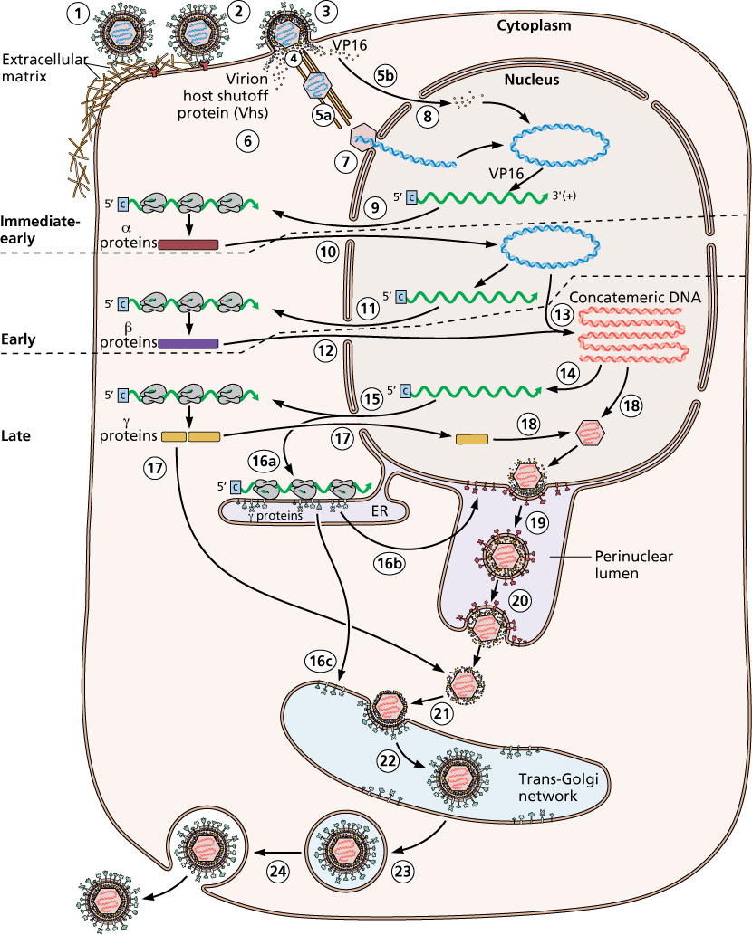
Figure 1: Viral life cycle of HSV-1 (Principles of Virology 2015). With written permission from the American Society for Microbiology. (1) Virions bind to the extracellular matrix (heparin sulfate or chondroitin sulfate proteoglycans) via gB and gC. (2) Another viral membrane protein (gD) interacts with a second cellular receptor. (3) Particles can enter cells via a pH-independent fusion of viral envelope with the plasma membrane. (4) Some tegument proteins and the nucleocapsid are released into the cytoplasm. (5a) Viral nucleocapsids attach to microtubules and are transported to the nucleus. (5b) Certain tegument proteins are transported to the nucleus independently of the nucleocapsids. (6) Other proteins remain in the cytoplasm. (7) Viral nucleocapsids dock at the nuclear pore, releasing DNA into the nucleus. (8) VP16 interacts with host transcription proteins to stimulate transcription of immediate early genes by host cell RNA polymerase II. (9) Some immediate early mRNAs are spliced and transported to the cytoplasm and then translated. (10) The immediate early proteins are transported to the nucleus and activate transcription of early genes and regulate transcription of immediate early genes. (11) Early gene transcripts are transported to the cytoplasm where they are translated. (12) Some early proteins function in the cytoplasm, and some are transported to the nucleus. (13) Viral DNA synthesis is initiated. (14) DNA replication and recombination produce long, concatemeric DNA. (15) Late mRNAs are transported to the cytoplasm and translated. (16a) Some late proteins are made on membranes of the rough endoplasmic reticulum. (16b) Some membrane proteins are modified by glycosylation. (16c) Precursor glycoproteins are transported to the golgi for modification and processing. (17) Some late proteins are transported to the nucleus for assembly of the nucleocapsid and DNA cleavage. (18) Newly replicated viral DNA is packaged into nucleocapsids. (19) DNA-containing nucleocapsids bud from the inner nuclear membrane into the perinuclear lumen, gaining an envelope. (20) Immature enveloped particles fuse with the outer nuclear membrane, releasing the nucleocapsid into the cytoplasm. (21) The structure is transported to the trans-golgi network. (22) Nucleocapsids bud and acquire an envelope containing mature viral envelope proteins and the complete tegument layer. (23) The enveloped virus particle buds into a vesicle that is transported to the plasma membrane for (24) release by exocytosis.

The reproductive life cycle of HSV-1 (Figure 1) begins when the virion binds to the extracellular matrix (heparin sulfate or chondroitin sulfate proteoglycans) via viral membrane proteins gB and gC. Another viral membrane protein, gD, interacts with the cellular receptor nectin-1 and particles then enter the cells through fusion of the viral envelope and plasma membrane thereby releasing nucleocapsid into the cytoplasm. The glycoproteins responsible for cell entry are gB, gD, gH, and gL, which also mediate viral and plasma membrane fusion (Principles of Virology 2015). Cellular proteins attach to microtubules and go to the nucleus, some go to the nucleus without the help of nucleocapsids, and some remain in the cytoplasm. The nucleocapsids that reach the nucleus dock at the nuclear pore and release the DNA into the nucleus to be circularized. Viral protein 16 (VP16) interacts with RNA polymerase II to stimulate transcription of immediate early genes, and these mRNAs go to the cytoplasm to be translated. The immediate early proteins get transported to the nucleus to activate transcription of early genes and regulate the transcription of immediate early genes. ICP4 down-regulates all of the immediate early genes, and upregulates the expression of all the early and late genes. DNA replication occurs through a rolling circle mechanism that produces long, concatemeric DNA for new viral genome and late gene expression. Late proteins are translated in the cytoplasm, and many are modified by glycosylation. Some late proteins are made on and inserted into the rough endoplasmic reticulum, and then receive further modification and processing once transported to the golgi. Some late proteins are transported to the nucleus for assembly of the nucleocapsid, which is where viral DNA is packed into the capsid. These DNA-containing nucleocapsids bud from the inner nuclear membrane into the lumen to acquire the envelope. These immature enveloped particles fuse with the outer nuclear membrane and release the nucleocapsid into the cytoplasm. The nucleocapsid then makes its way to the golgi, the virus particles acquire an envelope with mature viral envelope proteins and the complete tegument layer (the secondary envelope). This now enveloped virus particle buds into a vesicle, which is transported to the plasma membrane for release through exocytosis (Principles of Virology, 2015).
In the lytic infection, virion protein 16 (VP16) is a tegument protein that drives gene expression through the complexing with host cell proteins (Oct-1 and HCF1) (Principles of Virology 2015). This complex recruits the transcription factors to the immediate early gene promoters, which induces lytic gene expression. This induction further aides DNA synthesis and nucleocapsid assembly in the nucleus. Afterwards, the virion assembles and matures in the cytoplasm. By contrast, during latent infection, initial replication in the epithelial cells result in cytokine secretion and viral spread (Figure 2). These virions then enter the sensory nerve terminals and undergo long-distance retrograde transport to the neuronal cell body. Once in the nucleus, the viral latency genes are activated, and the HSV-1 genome is repressed. This latency is maintained by continuous retrograde nerve growth factor (NGF)-PI3K-mTOR signaling from distal axons (Camarena et al. 2010). When this latency state is disrupted, the genome reactivates gene expression, and the virus replicates. These newly replicated virions traffic back by anterograde axonal transport mechanisms, to reestablish infection at epithelial tissues (Reviewed in Koyuncu et al. 2013).
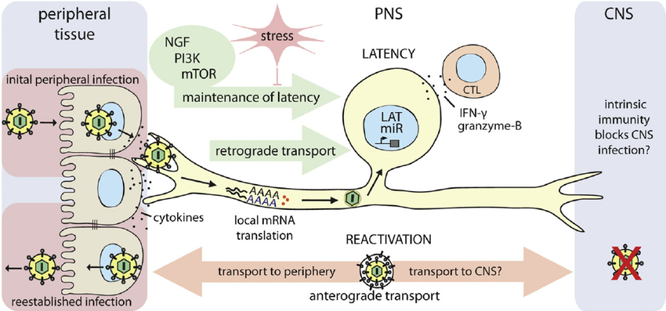
Figure 2: Alpha herpesvirus latency in peripheral nervous system (PNS) neurons. HSV-1 enters the host through epithelial/mucosal surfaces. Initial replication in epithelial cells results in cytokine secretion and viral spread. Newly replicated virions enter the sensory nerve terminals and travel by retrograde transport to the neuronal cell body. Once in the nucleus, viral latency genes are activated and the HSV-1 genome is repressed. Continuous retrograde NGF-PI3K-mTOR signaling from distal axons contribute to maintaining this latent state of infection. If this balance is disrupted by environmental or nutritional stress, the HSV-1 genome reactivates lytic gene expression, leading to virus replication. The newly replicated virions traffic back to the epithelial tissues, by anterograde axonal transport, to reestablish infection. Central nervous system invasion is rare after reactivation of latency, but is not fully understood at this time. (Koyuncu et al. 2013).

Normally, the dormant herpesvirus genome is not integrated into the host genome. Instead, it exists as either a non-replicating, quiescent histone-covered molecule, or as a replicating extra “chromosome.” The infected neuron is not recognized or eliminated by the immune system (Umbach et al. 2008c). After primary infection, the virus remains latent in the neurons, where it persists for the lifetime of the host. The virus expresses a latency-associated transcript RNA (LAT) which prevents cell death and maintains a reservoir of the virus (Kramer et al. 2003). In doing so, this allows the virus to have periodic outbreaks, where the virus can actively replicate and infect others. These viral reactivations occur when the nerve cell is activated and viral DNA proteins are transported using the neuronal axon, and once reaching the skin, viral replication and shedding occurs resulting in a blister or sore forming (symptomatic) or no symptoms may appear (asymptomatic). These periodic reactivations can be caused by various physical or emotional stressors, including: illness, fever, ultraviolet light, stress, trauma or immunodeficiency. In those individuals who are infected with HSV and are also immunocompromised, the outbreaks occur more frequently, are harder to control, and can be life-threatening (Whitley 2014). Reactivation of HSV-1 occurs on average in 33% of infected individuals, and amongst those individuals, 5% have at least one outbreak per month, 34% have at least one outbreak every two to eleven months, and 61% have at least one outbreak per year (Stegman et al. 2018).
Although the purpose is unknown, a non-coding RNA (LAT) is expressed during latency. This RNA is spliced and yields an intron that accumulates in the neurons and is thought to aide in maintaining latency (Farrell et al. 1991). In addition, micro-RNAs (miRNAs) are another viral gene product, which target the viral lytic cycle to help stabilize latency. These noncoding RNAs have a role in blocking apoptosis of the infected neuron, as well as in the control of reactivation from latency Infection with HSV-2 provides partial protection against HSV-1, but the reverse does not apply – which introduces the possibility of cross-reactive immunity (Umbach et al. 2008b).
Direct contact is required for transmission of HSV from person to person. In order for a person to transmit the virus to another person, the infected individual must be actively shedding virus – which most often happens during sexual intercourse or close intimate contact (Reviewed in Sauerbrei 2016). The virus is not stable outside its host, and therefore can only remain infectious for a period of days on moist surfaces. If proper bodily hygiene is maintained, modes of transmission other than oral/sexual intercourse are not relevant. This then leaves only perinatal and intrauterine transmission. If primary or recurrent HSV infection occurs in a pregnant woman, intrauterine viral transmission and congenital HSV infection can occur in the newborn. HSV transmission occurs through exposure of the virus to skin or mucous membranes, and can be transferred from mother to child during delivery, resulting in an increased risk to the fetus if the primary infection occurs late in the pregnancy.
Clinical Features
HSV-1 is commonly known by the presence of oral labial sores, while HSV-2 is commonly recognized by the presence of genital sores. However, both viruses can display either symptom, since the structure of both HSV-1 and HSV-2 share approximately 50% homology across the entire genome (Mandell et al. 2010). Amongst those infected with these viruses, it is more common that these individuals are asymptomatic, leading many to remain unaware that they are infected with this virus.
Primary infection can present in the form of genital lesions, but often are asymptomatic. These lesions typically present as erythematous papules that quickly become vesicular lesions filled with clear fluid that, when burst open, release virus. Once ruptured, the lesions appear as shallow ulcers, which are grey/white in color and approximately 1-3 mm in diameter. The total process to healing can range anywhere from 8 – 21 days (Reviewed in James et al. 2014). Viral reactivation can be either symptomatic or asymptomatic, but both involve active shedding of virus.
Neonatal HSV infection acquired in the peripartum or postpartum period can be categorized as skin, eye, and/or mouth (SEM) disease, central nervous system (CNS) disease, or disseminated disease (Reviewed in James et al. 2014). During the years of 1981-1997, when effective antiviral therapies had become available to neonates, the changes and outcomes were documented on the infected neonates. The data showed that SEM disease accounted for approximately 45% of neonatal HSV infections and by definition does not involve the CNS or other organ systems. Infants with CNS disease made up about 30% of neonatal HSV infections (Kimberlin et al. 2001; Brown et al. 1991). These infants may have mucocutaneous involvement, but lack evidence of other organ system involvement. Disseminated disease accounts for the remaining 25% of neonatal HSV infections and may involve the CNS along with multiple other organ systems including the liver, lungs, adrenals, gastrointestinal tract, and the skin, eyes, or mouth. Approximately two thirds of infants with disseminated HSV infection will also have CNS involvement. The presentation of SEM and disseminated disease usually occurs earlier (9-11 days) than that of CNS disease (two weeks) (Whitley et al. 1996). Disseminated neonatal HSV infections may present with a septic appearance, including respiratory failure, hepatic failure, and disseminated intravascular coagulopathy. When present, vesicular skin lesions are a key component in recognizing the clinical presentation of HSV disease, but up to 40% of infants with disseminated disease never present with a rash (Reviewed in James et al. 2014).
Demographics

HSV-1 and -2 have infected about 90% of the population worldwide, and in developing countries, the prevalence is almost universal (Xu et al. 2002). In the United States, the seroprevalences of HSV-1 and HSV-2 were 57.7% and 17%, respectively, in persons 14–49 years old during the period spanning 1999–2004. A follow-up study from 2005 to 2010 showed that HSV-1 seroprevalence had decreased to 53.9%, whereas HSV-2 seroprevalence had not significantly changed (15.7%) (Xu et al. 2002). Secondary analysis of this study population demonstrated that the largest decline in HSV-1 seroprevalence occurred in the 14–19-year-old age group, meaning that an increasing number of adolescents are without protective HSV-1 antibodies at the time of their sexual debut. This finding comes at a time when HSV-1 has become the predominate virus causing genital herpes, responsible for 60%–80% of genital herpetic infections in certain populations of young women (Xu et al. 2006). Seroprevalence of HSV-2 is twice as high in women as in men, and increases with age. HSV-2 is widespread regardless of sexual activity level; for example, 18.8% of American women with 2-4 lifetime sexual partners are HSV-2 seropositive (Johnston et al. 2012).
There is significant risk to a fetus who is delivered by an HSV-positive, as transmission can occur through the birth canal, in addition to the increased sensitivity of the newborn fetus. Neonates infected with HSV (either HSV-1 or HSV-2) can have severe long-term consequences, and are even more critical if the central nervous system is involved. Neonatal acquisition of HSV infection occurs in an estimated 1 in 3200 deliveries in the United States (US). Mother-to-child transmission can occur in utero (5%), during the peripartum period (85%), or postnatally (10%) (Brown 2003). Since HSV cannot be transferred in breast milk, the 10% of infections acquired postnatally are the result of coming into direct contact with a person who is shedding the virus.
Recurrent infections pose less of a risk to a neonate compared to a primary infection, due to the transplacental passage of protective antibodies. In a US study population, Brown et al. (1997), demonstrated an increased transmission risk of 57% in women with first-episode primary genital infections, versus a 2% risk increase in those with recurrent genital lesions. Other factors associated with increased risk of mother-to-child HSV transmission include detection of HSV-1 or HSV-2 from the cervix or external genitalia via viral culture or polymerase chain reaction (PCR), duration of rupture of membranes, disruption of the neonate's cutaneous barrier by the use of a fetal scalp electrode or other invasive instrumentation, and vaginal delivery.
HSV-2 infection rates in heavily exposed populations, such as commercial sex workers, are nearly 100%, suggestive of near-universal susceptibility (Johnston et al. 2012). Sex workers, whether by choice or forced into this lifestyle, are at high risk for contracting sexually transmitted diseases – of which HSV and human immunodeficiency virus (HIV) are examples. The high number of sexual partners makes transmission of diseases more likely without any intervention. The development of an implant would benefit these women who either choose to make their living in this manner or who don’t have a choice – neither should be forced to suffer from diseases because of it. HSV-2 is associated with a 3-fold increased risk for HIV acquisition, and according to WHO, 60-90% of HIV-infected people have HSV-2. In populations with 80% seroprevalence, nearly 50% of HIV infections are attributable to prevalent HSV-2 (Johnston et al. 2012). This increased risk stems from the increase in HIV target cells as a response to HSV-2 replication in the genital mucosa. Antiviral therapy doesn’t negate the increased risk to HIV infection or transmission in HSV infected persons (Johnston et al. 2012).
Antiviral Treatments
Acyclovir
Most therapies to treat HSV infections focus on acute symptoms or long-term suppression in order to prevent reactivation. The most common antivirals used are nucleoside analogues, such as Acyclovir (ACV). (Figure 4) These nucleoside analogues are effective treatments, but require a high level of patient compliance in combination with a poor oral bioavailability. This means patients must take several doses daily to maintain constant levels of drug within the bloodstream. Data has shown a lower toxic effect of ACV on uninfected cells in vitro, since ACV is only taken up by infected cells. ACV needs to be phosphorylated by a viral enzyme called thymidine kinase, which ACV is attracted to. The attraction that ACV has for a specific viral kinase facilitates the selection of only the cells infected with HSV. Normally, this ensures healthy, uninfected cells remain untouched. This does not account for possible mutations of the kinases, which can cause resistance to ACV. There are several shortcomings of ACV, in that the drug has a poor oral bioavailability (approximately 20% of the drug is absorbed) and has an elimination half-life in the bloodstream of approximately three hours (Berkower et al. 2013).
ACV and other acyclic guanosine analogues function by competing with the dGTP of viral DNA polymerases to inhibit viral DNA synthesis (Gnann et al. 2015). Acyclovir, for example, is selectively converted to its active form (acyclovir triphosphate) in HSV-infected cells, by viral thymidine kinase, and is preferentially taken up by these cells. The antiviral inhibits the DNA polymerase which is responsible for nucleotides assembling into a large DNA chain. However, DNA polymerase cannot tell the difference between guanine-deoxyribose and acyclovir. Therefore, when DNA polymerase grabs an acyclovir and attaches it to the growing DNA chain, the chain terminates and cannot be extended since the hydroxyl groups in the 3’ position is missing. For the chain to continue, hydroxyl groups in the 3’ position are required. (Figure 3)

Figure 3: On the left: Guanine (blue circle) is bound to deoxyribose (green circle). On the right: Structure of Acyclovir. Differences between the two are highlighted in red. The ribose in Acyclovir is only a fraction of the amount in the natural substrate. Acyclovir is missing the 3’hydroxyl group, which is where the next DNA unit would attach to. Once Acyclovir has been incorporated into a growing chain, the chain terminates and growth is halted (Bloom, 2016).

Other Drugs

Other nucleoside analogues commonly used for treatment are penciclovir, or their more orally bioavailable derivatives valacyclovir and famciclovir (Stegman et al. 2018). These antivirals penetrate most body tissues, including passing the blood-brain barrier and the placenta. While these drugs have been effective in viral suppression, they have their drawbacks. These include low oral bioavailability and half-life, which require multiple doses to be taken daily. Only 10-20% of ACV makes it out of the intestines, while less than 5% of PCV makes it out of the intestines. If delivered intravenously, concentrations of these drugs can be delivered 10-fold higher than the oral dose. ACV has an elimination half-life in the bloodstream of approximately three hours (Wood et al. 1992).
Valacyclovir (Figure 4) is a prodrug of acyclovir, and once ingested, is converted to acyclovir by the hepatic enzyme valacyclovir hydrolase (Pasternak 2010). Due to the increased oral bioavailability (54%), dosing intervals are able to be increased, which leads to better patient compliance (Reviewed in Sauerbrei 2016). Currently, this drug is not licensed for treatment in young children, adolescents, or pregnant women, since its efficacy and safety profiles haven’t been studied well enough in these populations (Pasternak 2010).
Famciclovir (Figure 4) is the inactive diacetyl ester prodrug of penciclovir, which cleaves two ester groups in the small bowel and liver. The oral bioavailability is higher than both acyclovir and valacyclovir at 77%, but is not licensed for use with small children, adolescents, pregnant women, or immunocompromised individuals. Rare side effects of famciclovir include headaches, nausea and confusion (Kang et al. 2011).
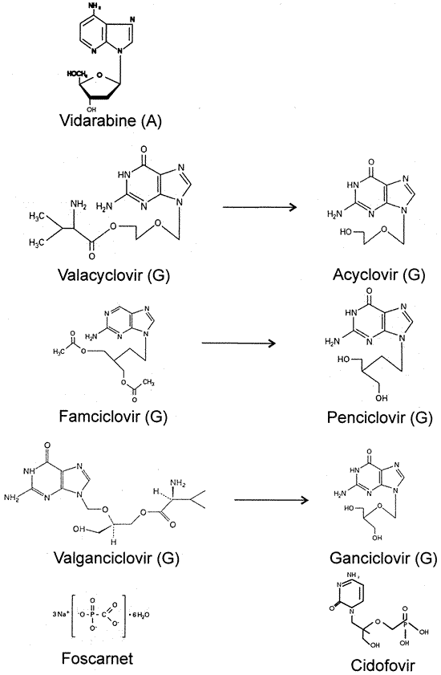
Figure 4: Chemical structures of current drugs used for treatment of alpha herpesviruses. Valacyclovir is the prodrug of acyclovir. Famciclovir is the prodrug of penciclovir. Valganciclovir is the prodrug of Ganciclovir. Cidofovir and Foscarnet are antivirals used to treat human herpesviruses. (Coen et al. 2014).

Dosages, Side Effects and Efficacy

Prior to antivirals, neonatal HSV infections resulted in a significantly high morbidity. (Kimberlin et al. 2011). After the use of intravaneous acyclovir (60 mg/kg/day in 3 divided doses), 1-year mortality rates are at 29% and 4% for disseminated and CNS diseases. Of these survivors with disseminated disease, 83% had normal neurodevelopmental outcomes. However, only 31% of those with CNS disease had normal neurodevelopmental outcomes (Kimberlin et al. 2011). Oral suppressive acyclovir treatment has been given at a dose of 300 mg/m²/dose, 3 times a day, for six months and resulted in better neurodevelopmental outcomes with less frequent recurrences compared to those in the placebo group who didn’t receive suppressive antiviral therapy (Kimberlin et al. 2011).
Women who are actively shedding virus and have a genital lesion, while pregnant, are frequently given acyclovir or valacyclovir at 36 weeks of gestation (Table 1) in order to reduce viral replication (detectable by PCR or viral culture) and reduce the need for a cesarean delivery. Even though this treatment is recommended by the American College of Obstetricians and Gynecologists (ACOG), valacyclovir is not officially licensed for use in pregnant women, and women who do receive it must be informed about the limited evidence of use on pregnant women (Pasternak 2010). The reasoning is because the effects haven’t been studied well enough to determine if it prevents neonatal HSV disease. It is unclear what benefit combination antiviral therapies would have for neonates and infants as it has not been well-studied.

Table 1: Antiviral treatment drugs and dosages for genital herpes (Sauerbrei 2016)
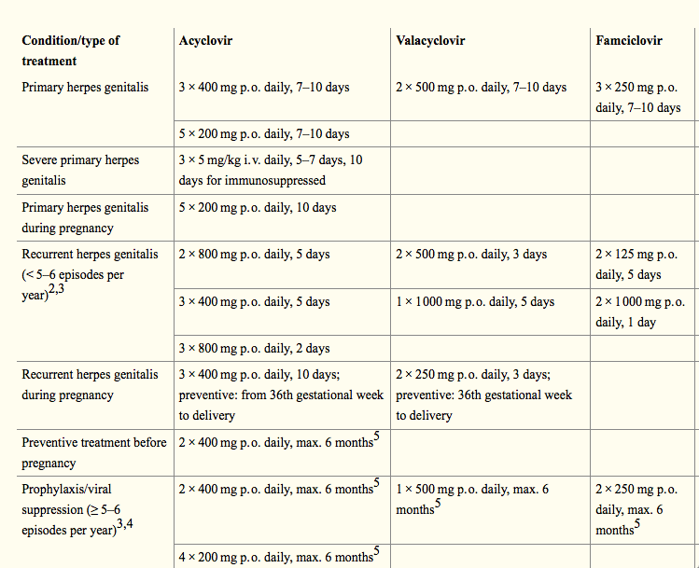

HSV infections in immunocompromised individuals are generally treated with intravenous acyclovir, but valacyclovir is also shown to be an efficacious alternative. Some factors that go into determining the dosage for treatment include status of infection, immune competence, and whether the patient is pregnant or not. Topical acyclovir is used in certain circumstances: herpes labialis, herpes keratoconjunctivitis, and symptomatic herpes genitalis (mild) (Reviewed in Sauerbrei 2016).

Implantable Drug-Delivery Devices
Implants can be classified into two main groups: passive and active. Passive includes biodegradable and non-biodegradable, while active deals with energy dependent methods to release the drug. Non-biodegradable implants use polymers such as silicone, polyurethane, polyacrylates, or co-polymers. Non-biodegradable implants are frequently used in contraceptive implants. Advantages of this type of implant include long-lasting and resilient, but the drawback is that they require a removal procedure. Biodegradable implants negate the removal procedure, because the polymer breaks down into fragments that can be excreted or absorbed by the body. Polymers for biodegradable devices include polycaprolactone, polylactic acid (PLA) or polylactic-co-glycolic acid (PLGA). The drawbacks to a biodegradable device include the limitations on selection, the regulatory requirements are more strict, and the polymeric matrix that drives the drug release can vary in each person (Reviewed in Stewart et al. 2018).
The ability for an implant to release a constant level of drug would negate the problems mentioned– patient compliance issues would be eliminated and a constant delivery of antiviral would suppress reactivation of the virus. In turn, a reduction in reactivation would reduce the spread of virus, prevent unnecessary pain and stress inflicted on the patient, and reduce emergence of antiviral mutants.
Implantable drug delivery devices allow for site-specific delivery, directing the drug where it is needed most, and increasing the speed of clearance through the liver. In other words, a sustained drug concentration is achieved while also providing a convenience factor for its users. In addition, the maintenance of a sustained therapeutic level of drug will reduce the likelihood that individuals infected will transmit and infect others, reducing the spread of infection and the population impacted by the disease. Implantable drug devices offer a variety of options in terms of shape and size, and the polymer selection offers different levels of flexibility and allows for an adjustable release rate.
An antiviral implant, that currently exists today, is called Vitrasert, and is a polyvinyl alcohol-ethylene vinyl acetate polymer-copolymer device impregnated with ganciclovir (Musch et al. 1997). This device is implanted intravitreously for the purpose of treating cytomegalovirus retinitis in AIDS patients. Cytomegalovirus retinitis can lead to retinal necrosis and loss of vision, unless treated. However, this implantable device must be removed and replaced every 5 to 8 months. A study conducted, using these implants, explored the overall outcome of the progression of cytomegalovirus retinitis. The implants (delivering either 1 μg or 2μg of ganciclovir per hour) were compared with an intravenous treatment of ganciclovir (Musch et al. 1997). The results of this study were that the median time to progression of retinitis was 221 days with the 1μg/hr implant, 191 days with the 2μg/hr implants and 71 days with the intravenous dosage. The vitreous concentration of drug in the intravenous group was 0.8 to 0.9μg/ml which was below the level that would achieve 50 percent inhibition of viral plaque formation.
The 1 μg/hr implant group had a vitreous drug concentration of 4.1μg/ml, which surpassed the 50 percent plaque inhibition level. The conclusions of the study were that the sustained release implant was a more effective antiviral delivery system compared to intravenous drug and oral drug delivery. However, those who only received the implant were at a greater risk for development of cytomegalovirus outside of the treated eye (Musch et al. 1997). A shortcoming of this intraocular implant is the price associated with the implant – a 4.5 mg implant costs approximately $17,004. This price reflects only what the cost would be if no insurance was used – although it should be noted that a large portion of the United States population are without insurance. In fact, according to Forbes and the Affordable Care Act Tracking Survey, as of May 2018 the number of people uninsured in the United States rose to 15.5% (meaning an increase of four million people uninsured) (Affordable Care Act Tracking Surveys, 2018).
While not an antiviral implant, the commonly used contraceptive implant, 68 mg Nexplanon, lasts for three years and costs approximately $801-$850 per implant depending on the pharmacy being used. At the current time, there is no generic version available to consumers, which is why there are patient assistance programs for those who are uninsured or under-insured low-income families. Depending on the insurance plan the patient has, it is possible in the United States, to get this implant for free.
Since Acyclovir is the generic drug for Zovirax, the cost of prescriptions are cheaper. The average price for 60 tablets (400 mg) is between $12.55-$53.33, which can last between 12-20 days if taken between 3-5 times a day. The cost of Zovirax for the same dosage and quantity is $553.53. Acyclovir has been proven to be an effective antiviral, and using this drug to create a biodegradable implant wouldn’t drive prices up. In addition, the implant would only require an initial implantation process without a subsequent removal process. Having the same drug in an implant would reduce the cost of frequent oral prescriptions and costs associated with doctor visits. Sigma Aldrich (Milwaukee, WI) offers polycaprolactone in 500g quantities for a price of $212, which could make many implants with that quantity. For example, an 15mg (drug) and 35 mg (polymer) would make 14,285 implants using a 500g bottle of polycaprolactone. This number will vary slightly depending on the drug:polymer ratio that is selected.

PRELIMINARY REPORT

In vitro

Initially, the Towson University of Herpes Virus Lab in Towson, MD, using an in vitro system, developed a silicone implant (disk and rod-shaped) that was impregnated with ACV (Figure 5). These implants were found to be unaltered by different temperatures or pH levels. This study showed an initial burst of drug release from the implants, followed by a more consistent release over time. It was also found that having an implant that was not covered by a layer of only silicone on the outside had better release kinetics compared to implants with those that are only an ACV-silicone mixture. The release per unit time ranged from 1.10 ± 0.610 μg/day to 1.73 ±0.920 μg/day and a total release of 66.1 ± 4.86 g to 221 ± 17.3 g from the implant, which is only a fraction of the drug in the implant (Johnson et al. 2007).
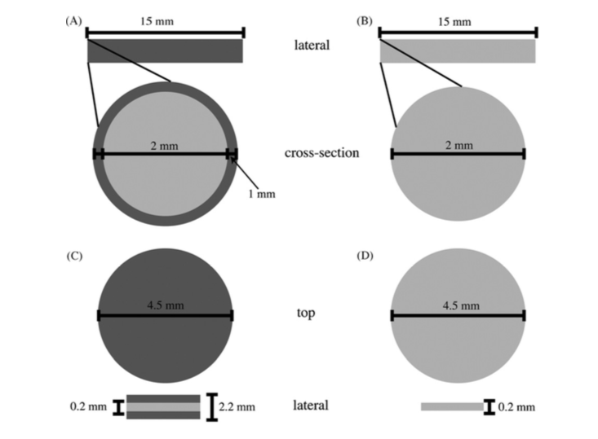
Figure 5: Schematic representation of the ACV implants – not shown to scale. Covered implants have an inner mixture of silicone and ACV (lighter grey) followed by an outer layer of drug-free silicone (darker grey areas). (A) Lateral and cross-section view of a covered rod. (B) Lateral and cross-section view of an uncovered rod. (C) Top and lateral views of a covered disk. (D) Top and lateral views of an uncovered disk.
Vaccines
To date, there are no FDA-approved vaccines for HSV. There have been various vaccine candidates for implantation in the vaginal wall in animal models (mouse and guinea pig), but the results have not been convincing enough to be licensed (de Bruyn et al. 2006; Casanova et al. 2002). The mouse model is useful for assessing primary genital infection and dorsal root ganglia infection (latency), and antibody and T-cell immune responses. The limitations of this animal model is that genital infections do not recur in mouse models (Khanna et al. 2003). The guinea pig model is useful for evaluating primary and recurrent disease, genital shedding of virus, and antibody responses. The limitations of this animal model are the availability of the reagents for measuring HSV-specific T-cell immune responses (Bourne el al. 2005; Awasthi et al. 2011). Another drawback in the development of vaccines, is that HSV-1 and HSV-2 virulence is much stronger in animal models than in humans. Animal models have a very small window between the HSV dose required to produce infection versus lethality, making it difficult to adjust challenge doses to allow the unimmunized animals to survive for comparison to the immunized animals (Reviewed in Awasthi and Friedman 2014). The main difficulty has been the ability to reduce the number of recurrences and the prevention of primary genital infection (Reviewed by Sauerbrei 2016). An effective vaccine would require cellular immunity be stronger than the cellular response of a natural HSV-infection. It is also worth exploring whether the constant prophylactic release of antiviral drug is more effective compared to treatment only when an outbreak occurs, with the aim of reducing the duration and severity of disease. Constant prophylactic release would ensure the presence of drug before and during the early hours where the virus has its peak shedding episode (Berkower et al. 2013).
Drug Delivery Devices
In many drug delivery systems, silicone-based materials are used, which are not biodegradable and require the removal/re-implantation after the cycle is complete. Polycaprolactone (PCL) is a biodegradable polymer that would be ideal for the delivery of the proposed drugs. It is FDA-approved for other human health applications (suture coatings and bioadhesives), long-lived, melts at a temperature that would not destroy the drugs being used with a low-melting point of 59-64°C (Stegman et al.2018). When comparing to other polymers, PCL degrades at a slower rate than PGA or PDLA and has low solubility in acetonitrile, which is important when making the implant. A study conducted with rats showed the PCL implant lasts approximately three years, with the option to last even longer with the addition of other polymers (Woodruff et al. 2010). Due to the many benefits found in PCL, this project will use PCL as the polymer for the implants.
The Towson University Herpes Virus Lab developed a rod-shaped implant made of acyclovir and biodegradable polymer (PCL) via a novel method called VASE (volatile acid-solvent evaporation) (Stegman et al. 2018). This method is important as it ensures a homogenous mixture of the drug and polymer. These implants are compared to implants using the suspension of insoluble drug (SID) method (Figure 6). SID implants contained chunks of drug throughout the implant, while VASE implant contained drug evenly distributed throughout (Figure 6). This lab was able to use these implants, made with formic acid, in vitro without any negative impact to the cells or the implants. Since this lab was able to ensure the homogeneity of the drug:polymer in the implants devised from this method, this project will use the same method to create the proposed implants in aim one.
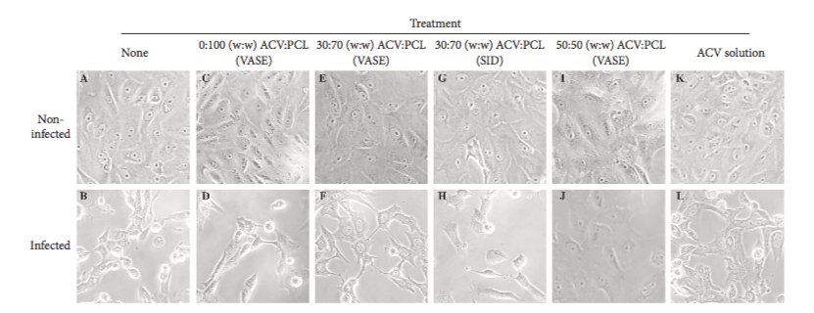
Figure 6: HSV-1 infected Vero cells (at an MOI of 1) compared with non-infected Vero cells. (A-B) non-treated controls; (C-D) implants comprised of 0:100 (w:w) ACV:PCL made through the VASE method. (E-F) implants comprised of 30:70 (w:w) ACV:PCL made through the VASE method. (G-H) implants comprised of 30:70 (w:w) ACV:PCL created through the SID method (suspension of insoluble drug). (K-L) ACV solution at 25 μg/mL (Stegman et al. 2018).
In vivo:
A study implementing the ACV impregnated implants, in female SKH-1 mice (Figure 6), where the mice, surgically implanted with silicone-implants and infected with HSV-1, were tested for viral reactivation and viral DNA isolation. HSV-1 reactivation occurred in 27 of the 34 mice that received an implant without drug, while 12 of 37 mice presented with reactivation when receiving the implant with ACV (Johnson et al. 2007). The results demonstrate that ACV can effectively be released from a rod-shaped device using silicone as a polymer and that higher release rates are achieved from implants that are not covered in an additional coating of silicone (Johnson et al. 2007). Additionally, the rod- shaped implant is preferred over a disk-shaped implant due to less damage of the structure, more pliability in a rod design, and its ability to remain intact longer. Additionally, research estimates the device will last up to five years, but needed a long-term in vivo study to confirm (Johnson et al. 2007).
SPECIFIC AIMS
The aims of this study are to determine the long-term effect of antiherpetics [Acyclovir (ACV), Valacyclovir (VACV), and Famciclovir (FCV)] on HSV infected cells, in order to determine if long-term therapy will benefit more than treatment given only during reactivation. Drug release will be studied, using implants created through the VASE method, to ensure homogeneity of the compounds. Toxicity of the cells will be evaluated through cell viability assays, while monitoring for the development of drug resistant viral strains.
- Develop rod-shaped implants for three antiherpetics (Acyclovir, Famciclovir, and Valacyclovir) with a polycaprolactone polymer, and evaluate in vitro drug release.

- Evaluate the viability of cells for toxicity during long-term drug treatment through the caspase assay and MTT assay.

- Determine how long viral drug can be used against infected cells without resistance, and if resistance occurs, analyze for any differences.

RESEACH DESIGN / METHODS

Aim One: Develop implants for three antiherpetics and evaluate in vitro drug release
ACV, FCV, and VACV were chosen based on previous data showing which drugs were most efficacious to reduce viral replication in HSV-1 and -2: ACV, FCV and VACV. Varying concentrations of drug:polymer from 0:100 to 50:50 (w:w) in 5% increments will be made and tested to determine drug release and efficacy. Implants to be used according to the Volatile Acid-Solvent Evaporation (VASE) method (patent pending from Towson University Herpes Virus Laboratory). PCL and acetonitrile are mixed in a beaker, and placed on a hot plate (65°C) with a spinner until dissolved. The appropriate calculated amount of drug (ACV, FACV, or VACV), based on the drug:polymer ratio selected, is then added, followed by formic acid. The mixture is then returned to a hot plate with a spinner and left overnight for the acid to evaporate. This process leaves the mixture in a solid form, which is then placed into a speed-vacuum for 72 hours to ensure that the formic acid had been completely removed. Once this is complete, the mixture is frozen in liquid nitrogen and ground down using a mortar and pestle, ensuring no clumps are present.
The mixture is then melted at 75C and extruded into a 10-guage hollow stainless steel needle, which has a 2.38 mm thick outer diameter, a 1.98 mm thick inner diameter, and a 2-inch length body (note that higher concentrations of drug require longer melting times). The needles containing the mixture are left overnight to cool and solidify. Afterwards, they are removed from the needle and cut down to 7mm long and then stored for later use. Each pair of 2mm x 7mm implants weighed 0.050g; therefore, implants with 30:70 (w:w) devices contain 15 mg ACV and 35 mg PCL.
The implants are surface sterilized before use in any cell culture experiments. This involves submerging the implants in 10 ml of 70% ethanol for five minutes, twice, followed by submerging in 10 ml of Dulbecco’s phosphate-buffered saline without calcium or magnesium (DPBS) for 10 minutes, three times, and then for 5 minutes for a fourth time. This process is done immediately before adding the implants to ensure that the experiment begins without any contaminants or debris.
Each drug is tested in varying drug:polymer ratios for each virus (HSV-1 and HSV-2). This requires six separate experiments. African green monkey kidney cells (Vero cells) are grown to confluency in two T-75 vented flasks at 37°C;5% CO₂ (approximately 90% confluent). In combination with Dulbecco’s modified Eagle’s medium (DMEM), the following components are added to the media: 10% Fetal Bovine Serum (FBS), L. Glutamine, 1% Penicillin-Streptomycin, Adenine, and hydrocortisone. Once confluent, the Vero cells are plated onto 24-well plates at a concentration of 5.0 x 10⁶ cells/mL (Govorkova et al. 1996), and incubated at 37°C;5% CO₂ for 24 hours to allow the cells to attach to the surface of the wells.
A negative control (consisting of PCL implant with no drug), and a positive control (consisting of a PCL implant with HSV infection) are included in each plate (two replicates per control). Drug:Polymer implants in varying drug ratios are assayed in triplicate in a 24-well plate with HSV-infected vero cells (1 x 10⁵ Vero cells per well) in 2 ml complete DMEM in a 37∘C incubator at 5% CO2. Note that three plates are required for each experiment for the full range of ratios. Cells are plated on day one with DMEM media. The appropriate implants, after sterilization, are introduced to their designated wells. The plate is then incubated for 24 hours to allow cells time to take up a portion of the available drug, followed by either infection with HSV-1 or HSV-2 on day three. Based on previous research, infection of HSV-2 is 95 plaque forming units and infection with HSV-1 is 100 plaque forming units. Another incubation for 24-hours will then take place to allow the virus to enter the target cells (Berkower et al. 2013; Dargan and Subak-Sharpe, 1997).
Starting day 1, post-infection, the medium from each sample is collected, placed in a vial, and stored at -80°C for later analysis. The media is replaced with fresh media and placed back into the incubator, where the process is repeated until the end of the study. Pictures with an Olympus IX71 inverted microscope (Center Valley, PA) are taken initially on day 3 post-infection and then every 10th day afterward, to record any cytopathic effect and morphology changes. The types of changes that indicate cytopathic effect are morphology/structural changes (rounding of the cell, formation of syncytia, or the appearance of inclusion bodies) or lysis of the host cell.
Aim Two: Evaluate the viability of cells for toxicity during long-term drug treatment

To determine whether the most effective ratio at reducing viral replication is also the most effective ratio to prevent toxicity of healthy cells while releasing drug, the same drug:polymer ratios examined in aim one, are also examined in aim two.
These drug:polymer ratios, for each drug, would be plated on a 96-well plate, in triplicate. Additional wells would be plated for the purpose of evaluating the cells and resistance (see aim three). Positive and negative controls would be included in the plate set up. The negative control, consisting of cells with medium, infected with virus, where a response is expected. The cell viability will be examined concurrent with long-term drug resistance (aim three), using both HSV-1 and HSV-2, requiring multiple experiments to be conducted.
A 96-well plate is coated with Vero cells and seeded at a density of 1.6 x 10⁴ cells/well in 200 μl, and incubated for 24 hours at 37°C in 5% CO₂ to allow the cells to adhere to the plate. The cells are then infected with the appropriate virus (HSV-1 or HSV-2) using the same method from aim one. Next, the appropriate drug (ACV, FCV, or VACV) is added to their respective columns. Every 3-4 days (or whenever the cells become confluent), the cells will be passaged by harvesting the cells and re-plating them onto a new 96-well plate for the purpose of maintaining the cells in order to continue the experiment. Using a pipette, PBS is added to rinse the cells by gently rocking the plate. The PBS is then removed and a dissociating agent (Accutase or 0.05% trypsin) is applied. The plate, with the dissociating agent, is placed into the incubator for 1-2 minutes. A microscope is then used to visually determine if the cells have completely come off the surface. If needed, the plate is gently tapped to ensure all cells have lifted from the surface. The cells and dissociating agent are combined with fresh media to neutralize the dissociating agent. A 20μl sample is collected and placed into a cell counting chamber. The total live cell count is used to determine the proper seeding density on the new plate. The cells are then plated on a new 96-well plate.
Once weekly, two wells from the evaluation column (for each drug/virus) are harvested from the set -up for cell viability determination – ACV:HSV-1, ACV:HSV-2, PCV:HSV-1, PCV:HSV-2, VCV:HSV-1, VCV:HSV-2. One cell viability assay that is used is the caspase assay, which provides high-throughput screening of caspase activity or apoptosis. After the caspase-glo reagent is added to the cells, the plate is sealed. The contents are gently mixed for those wells, and the plate will incubate for thirty minutes to three hours. The luminescence is then measured for each sample using a plate-reading luminometer. Controls will be included in the test to be able to account for the sensitivity due to the serum alone. Maximum sensitivity is achieved within one hour, once the caspase and luciferase activities reach a steady state.
A MTT [3-(4,5-dimethylthiazol-2-yl)-2,5-diphenyl tetrazolium bromide; Sigma] assay is performed to analyze cell viability. This assay is a colorimetric assay that assesses the cell metabolic activity. One well from the evaluation column, from each virus, is used. Afterwards, 10 μl of complete media containing MTT (0.5 mg/ml) is added to each well, and then incubated at 37°C;5% CO₂ for four hours. The supernatant is removed, and 200 μl of ethanol is added to each well to solubilize the crystals. After shaking, absorbance is measured using a microplate reader at 490 nm. The MTT reagent yields low background absorbance values in the absence of cells. For this reason, to measure the effect of media absorbance, a blank will be included, consisting of media and MTT. A positive control, consisting of the active compound, cells, and MTT will be included. A negative control will have cells and MTT, but no drug.
Aim Three: Determine how long antiviral drug can be used on infected cells without viral resistance.
Aim three runs concurrent with aim two, in that the plate set up allows for analysis of both long-term drug treatment while observing for toxicity in the cells. The continual passaging of cells will proceed until a resistant virus is discovered by cytopathic effect, which is observed through constant monitoring by microscopy.
In order to determine if a resistant virus has developed, a sample is collected at the time of immediate infection, and then once every week, for the plaque assay. Cells, grown the same way as above, are seeded into a 6-well plate, and incubated at 37°C;5% CO₂ until confluent. Afterwards, each collected sample is added to their designated wells, allowing 3 replicates per sample. The plate is rocked every ten minutes, for an hour, to disperse the sample thoroughly. Methyl cellulose in distilled water is added, to limit the spread of the virus, and then an incubation of 72 hours at 37°C;5% CO₂. The plate is stained with crystal violet, incubated for 30 minutes, followed by washing the plate. The individual wells are then analyzed for countable plaques, in order to calculate the viral titer. If the sample has a viral titer that is too high to count, a 10-fold dilution series will be conducted, re-plaqued, and analyzed. This process requires numerous plates in order to analyze all samples, and multiple plates are run simultaneously.
The plaque assays from the weekly samples will be compared to the initial plaque assay from the original sample after immediate infection, in order to evaluate for outliers or differences between colonies/plaques. The colony selected for evaluation is picked and used to grow virus. One well, in a 6-well plate, is coated with cells. The picked plaque is placed in the well and allowed to grow in the incubator at 37°C;5% CO_{2.} The virus will be expanded to a T25 vented culture flask through the passage technique described above. A sample of this virus is also sent to Genewiz (South Plainfield, NJ) for sequencing, in order to compare the sequential differences between viruses. Findings that would suggest resistance include frameshift mutations, extra stop codons, and non-synonymous nucleotide substitutions in conserved gene regions (Reviewed in Sauerbrei 2016; Reviewed in Sauerbrei et al. 2016). A portion of this virus will be used to repeat this drug screening assay described in aim one. The results from the assay are evaluated for differences in inhibition compared to the results of the initial assay.
All experimental work conducted will be done using aseptic technique, using sterile materials, in a biological safety cabinet. Before any assays will be conducted, the cytopathic effect would be observed via microscopy, and photographed using an Olympus IX71 inverted microscope. Once the point at which resistance to the drug is acquired, the study is terminated in terms of longevity – this includes both aim two and three since they are conducted together.
It is possible that the drug:polymer ratio that provides the most viral inhibition in aim one, is not the same as the drug:polymer ratio that is least likely to develop viral resistance in aim three. It is possible that there is a different drug:polymer ratio for each aim that will be examined. The system used to deliver the drug could be changed, and compared to each other. For example, it could be better to use a system based on controlled swelling, where solvent penetration into the matrix controls the rate of release, providing a much slower release compared to diffusion of drug (Reviewed in Jacob et al. 2018; Stewart et al. 2018).
If it is discovered that these drugs are inhibitory, based on the results from these assays, then ACV, FCV, and VACV should all be tested to ensure that viral inhibition is taking place, rather than senescence of the cells. Both viral inhibition and cell senescence appear similar under a microscope: formation of PML bodies and morphologic alterations (Baz-Martinez et al. 2016). Senescent cells have characteristic enlarged and flattened morphology of the cells, enlarged and multinucleated nuclei, and secrete various factors into the extracellular environment, called senescence-associated secretory phenotype (SASP). The SASP components are mainly proinflammatory cytokines and chemokines, growth factors, and extracellular matrix remodeling enzymes (Baz-Martinez et al. 2016). The cells could be observed for characteristic morphology of senescence, and could also be analyzed for the expression of the senescence marker senescence-associated beta-galactosidase (SA-beta-gal) (Baz-Martinez et al. 2016). The observed viral inhibition in the lower drug concentration implants could instead be cell senescence, and thereby not indicative of drug effectiveness. The characteristic stable cell cycle arrest would also be useful in determining whether viral inhibition or cell senescence is taking place.
When looking at the data evaluating toxicity of the cells, specifically for the MTT assay, it could be beneficial to perform an additional viability assay for comparison (ex: Neutral red test or an ATP-based assay) to ensure that there are no false positives. In the MTT assay, the cells that are destined to die, but still metabolically active, are register as live. If the cells undergo apoptosis, they can still reduce the MTT compound and form crystals, and will be counted as alive, when the are really dying. If the drugs being tested (ACV, FCV, and VACV) delay the growth of cells, the MTT dye can detect this and interpret these cells as cytotoxic, when instead it is cell reduction due to inhibited proliferation.
This experiment determined which of the three antiherpetics (acyclovir, valacyclovir, pencyclovir), in an implant with a biodegradable polymer, successfully reduced viral replication through the evaluation of a drug release study. These same antiherpetics, using the most effective drug:polymer ratio, were evaluated for long-term drug use and development of drug-resistant viral strains. If drug-resistant strains did develop, they were sequenced and compared to the original strain. During the long-term drug treatment experiment, the cells were continuously evaluated for signs of toxicity, via caspase and MTT assays. Successful development of this implant, with no toxic effects to the healthy cells and the ability to treat over a long period of time without resistant viral strains, would propose an ideal treatment for the most vulnerable populations. These populations include individuals in developing countries, sex workers, sexual abuse survivors, neonates, pregnant women, and the immune compromised. The successful repression of HSV reactivation could have a crucial impact on the number of individuals who acquire HIV, due to the increased risk from HSV infection.
Future studies can use this data to conduct experiments to determine if a multi-drug regimen would prevent development of resistance. These implants could be implanted into an animal model (mice or guinea pigs) to determine what the best location is – whether it’s at the site of reactivation or closer to where the virus lays dormant. In addition to implant placement, it’s worth exploring whether implants could be given only to women or whether a site could be determined to efficaciously implant into men. Vaginal rings, as drug delivery vehicles, are currently being explored for HSV, by the Towson University Herpes Virus Lab, and targets only the female gender. This lab has also explored implants surgically placed in the vaginal wall in female cotton rats. This leaves out an entire population of men who can still acquire and transmit the virus. A universal implant for all genders could reduce viral transmission.

REFERENCES
Awasthi S, Friedman HM. 2014b. Status of prophylactic and therapeutic genital herpes vaccines. Current Opinion in Virology. 6:6–12. doi:10.1016/j.coviro.2014.02.006.

Awasthi S, Lubinski JM, Shaw CE, Barrett SM, Cai M, Wang F, Betts M, Kingsley S, DiStefano DJ, Balliet JW, et al. 2011. Immunization with a Vaccine Combining Herpes Simplex Virus 2 (HSV-2) Glycoprotein C (gC) and gD Subunits Improves the Protection of Dorsal Root Ganglia in Mice and Reduces the Frequency of Recurrent Vaginal Shedding of HSV-2 DNA in Guinea Pigs Compared to Immunization with gD Alone. Journal of Virology. 85(20):10472–10486. doi:10.1128/JVI.00849-11.

Bahuguna A, Khan I, Bajpai VK, Kang SC. 2017. MTT assay to evaluate the cytotoxic potential of a drug. Bangladesh Journal of Pharmacology. 12(2):8. doi:10.3329/bjp.v12i2.30892.

Baz-Martínez M, Da Silva-Álvarez S, Rodríguez E, Guerra J, El Motiam A, Vidal A, García-Caballero T, González-Barcia M, Sánchez L, Muñoz-Fontela C, et al. 2016. Cell senescence is an antiviral defense mechanism. Scientific Reports. 6(1). doi:10.1038/srep37007. [accessed 2019 Apr 3]. http://www.nature.com/articles/srep37007.

Berkower CL, Johnson NM, Longdo SB, McGusty-Robinson SO, Semenkow SL, Margulies BJ. 2013. Silicone-Acyclovir Controlled Release Devices Suppress Primary Herpes Simplex Virus-2 and Varicella Zoster Virus Infections In Vitro. Advances in Pharmacological Sciences. 2013:1–9. doi:10.1155/2013/915159.

Bourne N, Milligan GN, Stanberry LR, Stegall R, Pyles RB. 2005. Impact of Immunization with Glycoprotein D2/AS04 on Herpes Simplex Virus Type 2 Shedding into the Genital Tract in Guinea Pigs That Become Infected. The Journal of Infectious Diseases. 192(12):2117–2123. doi:10.1086/498247.

Brown ZA. 2003. Effect of Serologic Status and Cesarean Delivery on Transmission Rates of Herpes Simplex Virus From Mother to Infant. JAMA. 289(2):203. doi:10.1001/jama.289.2.203.

Brown ZA, Selke S, Zeh J, Kopelman J, Maslow A, Ashley RL, Watts DH, Berry S, Herd M, Corey L. 1997. The Acquisition of Herpes Simplex Virus during Pregnancy. New England Journal of Medicine. 337(8):509–516. doi:10.1056/NEJM199708213370801.

Camarena V, Kobayashi M, Kim JY, Roehm P, Perez R, Gardner J, Wilson AC, Mohr I, Chao MV. 2010. Nature and Duration of Growth Factor Signaling through Receptor Tyrosine Kinases Regulates HSV-1 Latency in Neurons. Cell Host & Microbe. 8(4):320–330. doi:10.1016/j.chom.2010.09.007.

Casanova G, Cancela R, Alonzo L, Benuto R, Magana M del C, Hurley DR, Fishbein E, Lara C, Gonzalez T, Ponce R, et al. 2002. A double-blind study of the efficacy and safety of the ICP10deltaPK vaccine against recurrent genital HSV-2 infections. Cutis. 70(4):235–239.

Coen N, Duraffour S, Snoeck R, Andrei G. 2014. KSHV Targeted Therapy: An Update on Inhibitors of Viral Lytic Replication. Viruses. 6(11):4731–4759. doi:10.3390/v6114731.

Dargan DJ, Subak-Sharpe JH. 1997. The Effect of Herpes Simplex Virus Type 1 L-Particles on Virus Entry, Replication, and the Infectivity of Naked Herpesvirus DNA. Virology. 239(2):378–388. doi:10.1006/viro.1997.8893.

Datta AK, Colby BM, Shaw JE, Pagano JS. 1980. Acyclovir inhibition of Epstein-Barr virus replication. Proceedings of the National Academy of Sciences. 77(9):5163–5166. doi:10.1073/pnas.77.9.5163.

de Bruyn G, Vargas-Cortez M, Warren T, Tyring SK, Fife KH, Lalezari J, Brady RC, Shahmanesh M, Kinghorn G, Beutner KR, et al. 2006. A randomized controlled trial of a replication defective (gH deletion) herpes simplex virus vaccine for the treatment of recurrent genital herpes among immunocompetent subjects. Vaccine. 24(7):914–920. doi:10.1016/j.vaccine.2005.08.088

Emmert DH. 2000. Treatment of Common Cutaneous Herpes Simplex Virus Infections. AFP. 61(6):1697–1704.

Farrell MJ, Dobson AT, Feldman LT. 1991. Herpes simplex virus latency-associated transcript is a stable intron. Proceedings of the National Academy of Sciences. 88(3):790–794. doi:10.1073/pnas.88.3.790.

Fernandez CG. 1960. Persistence of Herpes Simplex Virus in HeLa Cells. Nature. 185(4708):268–268. doi:10.1038/185268a0.

Flint SJ, Racaniello VR, Rall GF, Skalka AM, Enquist LW. 2015. Principles of virology. 4th edition. Washington, DC: ASM Press.

Gnann JW, Sköldenberg B, Hart J, Aurelius E, Schliamser S, Studahl M, Eriksson B-M, Hanley D, Aoki F, Jackson AC, et al. 2015. Herpes Simplex Encephalitis: Lack of Clinical Benefit of Long-term Valacyclovir Therapy. Clinical Infectious Diseases. 61(5):683–691. doi:10.1093/cid/civ369.

Govorkova EA, Murti G, Meignier B, de Taisne C, Webster RG. 1996. African green monkey kidney (Vero) cells provide an alternative host cell system for influenza A and B viruses. J Virol. 70(8):5519–5524.

Hooper DJ. 2010. Attitudes, awareness, compliance and preferences among hormonal contraception users: a global, cross-sectional, self-administered, online survey. Clin Drug Investig. 30(11):749–763. doi:10.2165/11538900-000000000-00000.

Jacob J, Haponiuk JT, Thomas S, Gopi S. 2018. Biopolymer based nanomaterials in drug delivery systems: A review. Materials Today Chemistry. 9:43–55. doi:10.1016/j.mtchem.2018.05.002.

Johnson TP, Frey R, Modugno M, Brennan TP, Margulies BJ. 2007. Development of an aciclovir implant for the effective long-term control of herpes simplex virus type-1 infection in Vero cells and in experimentally infected SKH-1 mice. International Journal of Antimicrobial Agents. 30(5):428–435. doi:10.1016/j.ijantimicag.2007.07.003.

Johnston C, Saracino M, Kuntz S, Magaret A, Selke S, Huang M, Schiffer JT, Koelle DM, Corey L, Wald A. 2012. Standard-dose and high-dose daily antiviral therapy for short episodes of genital HSV-2 reactivation: three randomised, open-label, cross-over trials. The Lancet. 379(9816):641–647. doi:10.1016/S0140-6736(11)61750-9.

Kang S-H, Chua-Gocheco A, Bozzo P, Einarson A. 2011. Safety of antiviral medication for the treatment of herpes during pregnancy. Can Fam Physician. 57(4):427–428.

Karasneh GA, Shukla D. 2011. Herpes simplex virus infects most cell types in vitro: clues to its success. Virology Journal. 8(1). doi:10.1186/1743-422X-8-481. [accessed 2019 Mar 29]. https://virologyj.biomedcentral.com/articles/10.1186/1743-422X-8-481.

Khanna KM, Bonneau RH, Kinchington PR, Hendricks RL. 2003. Herpes simplex virus-specific memory CD8+ T cells are selectively activated and retained in latently infected sensory ganglia. Immunity. 18(5):593–603.

Kimberlin DW, Lin CY, Jacobs RF, Powell DA, Frenkel LM, Gruber WC, Rathore M, Bradley JS, Diaz PS, Kumar M, et al. 2001. Natural history of neonatal herpes simplex virus infections in the acyclovir era. Pediatrics. 108(2):223-229.

Kimberlin DW, Whitley RJ. 2007. Antiviral therapy of HSV-1 and -2. In: Arvin A, Campadelli-Fiume G, Mocarski E, Moore PS, Roizman B, Whitley R, Yamanishi K, editors. Human Herpesviruses: Biology, Therapy, and Immunoprophylaxis. Cambridge: Cambridge University Press. [accessed 2019 Mar 29]. http://www.ncbi.nlm.nih.gov/books/NBK47444/.

Kimberlin DW, Whitley RJ, Wan W, Powell DA, Storch G, Ahmed A, Palmer A, Sánchez PJ, Jacobs RF, Bradley JS, et al. 2011. Oral Acyclovir Suppression and Neurodevelopment after Neonatal Herpes. New England Journal of Medicine. 365(14):1284–1292. doi:10.1056/NEJMoa1003509.

Koyuncu OO, Hogue IB, Enquist LW. 2013. Virus Infections in the Nervous System. Cell Host & Microbe. 13(4):379–393. doi:10.1016/j.chom.2013.03.010.

Kramer MF, Cook WJ, Roth FP, Zhu J, Holman H, Knipe DM, Coen DM. 2003. Latent Herpes Simplex Virus Infection of Sensory Neurons Alters Neuronal Gene Expression. Journal of Virology. 77(17):9533–9541. doi:10.1128/JVI.77.17.9533-9541.2003.

Kramer SM, Ford KM, York MK. 1988. Comparison of HSV-1 and HSV-2 Isolation in Vero, Primary Rabbit Kidney, and MRC-5 Cells. Laboratory Medicine. 19(1):30–31. doi:10.1093/labmed/19.1.30.

Mandell GL, Bennett JE, Dolin R, editors. 2010. Mandell, Douglas, and Bennett’s principles and practice of infectious diseases. 7th ed. Philadelphia, PA: Churchill Livingstone/Elsevier.

Mhlanga A, Bhunu CP, Mushayabasa S. 2015. A Computational Study of HSV-2 with Poor Treatment Adherence. Abstract and Applied Analysis. 2015:1–15. doi:10.1155/2015/850670.

Musch DC, Martin DF, Gordon JF, Davis MD, Kuppermann BD. 1997. Treatment of Cytomegalovirus Retinitis with a Sustained-Release Ganciclovir Implant. New England Journal of Medicine. 337(2):83–90. doi:10.1056/NEJM199707103370203.

Pasternak B. 2010. Use of Acyclovir, Valacyclovir, and Famciclovir in the First Trimester of Pregnancy and the Risk of Birth Defects. JAMA. 304(8):859. doi:10.1001/jama.2010.1206.

Pergam SA, Limaye AP, the AST Infectious Diseases Community of Practice. 2009. Varicella Zoster Virus (VZV) in Solid Organ Transplant Recipients. American Journal of Transplantation. 9:S108–S115. doi:10.1111/j.1600-6143.2009.02901.x.

Sauerbrei A, Bohn-Wippert K, Kaspar M, Krumbholz A, Karrasch M, Zell R. 2016. Database on natural polymorphisms and resistance-related non-synonymous mutations in thymidine kinase and DNA polymerase genes of herpes simplex virus types 1 and 2. Journal of Antimicrobial Chemotherapy. 71(1):6–16. doi:10.1093/jac/dkv285.

Sauerbrei A. 2016. Herpes Genitalis: Diagnosis, Treatment and Prevention. Geburtshilfe und Frauenheilkunde. 76(12):1310–1317. doi:10.1055/s-0042-116494.

Sauerbrei A, Schmitt S, Scheper T, Brandstädt A, Saschenbrecker S, Motz M, Soutschek E, Wutzler P. 2011. Seroprevalence of herpes simplex virus type 1 and type 2 in Thuringia, Germany, 1999 to 2006. Euro Surveill. 16(44).

Semenkow SL, Johnson NM, Maggs DJ, Margulies BJ. 2014. Controlled release delivery of penciclovir via a silicone (MED-4750) polymer: kinetics of drug delivery and efficacy in preventing primary feline herpesvirus infection in culture. Virology Journal. 11(1):34. doi:10.1186/1743-422X-11-34.

Stegman JR, Badin JK, Biles KA, Etienne T, Fartash-Naini S, Gordon AD, Greeley ZW, Harding BW, Mack RJ, Masica D, et al. 2018. Volatile Acid-Solvent Evaporation (VASE): Molecularly Homogeneous Distribution of Acyclovir in a Bioerodable Polymer Matrix for Long-Term Treatment of Herpes Simplex Virus-1 Infections. Journal of Drug Delivery. 2018:1–13. doi:10.1155/2018/6161230.

Stewart S, Domínguez-Robles J, Donnelly R, Larrañeta E. 2018. Implantable Polymeric Drug Delivery Devices: Classification, Manufacture, Materials, and Clinical Applications. Polymers. 10(12):1379. doi:10.3390/polym10121379.

Szpara ML, Tafuri YR, Parsons L, Shamim SR, Verstrepen KJ, Legendre M, Enquist LW. 2011. A Wide Extent of Inter-Strain Diversity in Virulent and Vaccine Strains of Alphaherpesviruses. Baines JD, editor. PLoS Pathogens. 7(10):e1002282. doi:10.1371/journal.ppat.1002282.

Thellman NM, Triezenberg SJ. 2017. Herpes Simplex Virus Establishment, Maintenance, and Reactivation: In Vitro Modeling of Latency. Pathogens. 6(3):28. doi:10.3390/pathogens6030028.

Tyring SK, Baker D, Snowden W. 2002. Valacyclovir for Herpes Simplex Virus Infection: Long‐Term Safety and Sustained Efficacy after 20 Years’ Experience with Acyclovir. The Journal of Infectious Diseases. 186(s1):S40–S46. doi:10.1086/342966.

Umbach JL, Kramer MF, Jurak I, Karnowski HW, Coen DM, Cullen BR. 2008b. MicroRNAs expressed by herpes simplex virus 1 during latent infection regulate viral mRNAs. Nature. 454(7205):780–783. doi:10.1038/nature07103.

Umbach JL, Kramer MF, Jurak I, Karnowski HW, Coen DM, Cullen BR. 2008c. MicroRNAs expressed by herpes simplex virus 1 during latent infection regulate viral mRNAs. Nature. 454(7205):780–783. doi:10.1038/nature07103.

Vidarabine therapy of neonatal herpes simplex infection. 1982. Journal of Infection. 4(2):184. doi:10.1016/S0163-4453(82)93910-X.

Whitley RJ. 1996. Herpesviruses. In: Baron S, editor. Medical Microbiology. 4th ed. Galveston (TX): University of Texas Medical Branch at Galveston. [accessed 2019 Mar 29]. http://www.ncbi.nlm.nih.gov/books/NBK8157/.

Whitley RJ, Roizman B. 2001. Herpes simplex virus infections. The Lancet. 357(9267):1513–1518. doi:10.1016/S0140-6736(00)04638-9.

Wood AJJ, Whitley RJ, Gnann JW. 1992. Acyclovir: A Decade Later. New England Journal of Medicine. 327(11):782–789. doi:10.1056/NEJM199209103271108.

Woodruff MA, Hutmacher DW. 2010. The return of a forgotten polymer—Polycaprolactone in the 21st century. Progress in Polymer Science. 35(10):1217–1256. doi:10.1016/j.progpolymsci.2010.04.002.

Xu F, Schillinger JA, Sternberg MR, Johnson RE, Lee FK, Nahmias AJ, Markowitz LE. 2002. Seroprevalence and Coinfection with Herpes Simplex Virus Type 1 and Type 2 in the United States, 1988–1994. The Journal of Infectious Diseases. 185(8):1019–1024. doi:10.1086/340041.

Xu F, Sternberg MR, Kottiri BJ, McQuillan GM, Lee FK, Nahmias AJ, Berman SM, Markowitz LE. 2006. Trends in Herpes Simplex Virus Type 1 and Type 2 Seroprevalence in the United States. JAMA. 296(8):964. doi:10.1001/jama.296.8.964.

