Effects of Chat-based Interface on User Engagement

by
Kayo Lisa Rusin
June 2017

Presented to the
Division of Science, Information Arts, and Technologies
University of Baltimore

In Partial Fulfillment
of the Requirements for the Degree of
Master of Science

Approved by: ________________________________
[Greg Walsh, Thesis Advisor, Program Director]

Abstract
Chat-based User Interfaces (UI) have become popular in transactional applications such as in the finance and news industry. Although this trend has been noted, the effects this has on user engagement have not been well documented. After completing a literature review to better understand the appeal chat-based UI has on users, a result from a theoretical framework will be extrapolated in an attempt to examine how interactivity was affected when translating a traditional game (Neko Atsume) into a chat-based game (The Dog Lover's Yard).
Acknowledgments

I thank Greg Walsh for guiding the development of the project. I would also like to thank all of the participants who have assisted for no compensation except for the joy of playing the games. I would like to thank all developers out there who are dedicated in creating heartwarming games that involve household pets. Lastly but not least, I want to thank my husband for his never ending support and understanding.

Table of Contents

List of Tables 4

List of Figures 5

Chapter 1: Introduction 6
Background 6

Chapter 2: Lit Review 11
Theoretical Framework 11
Source Interactivity 11
Modality Interactivity 12
Message Interactivity 12
Application to the Chat-Based UI 13
Neko Atsume 14
Strategy 15

Chapter 3: First User Engagement 17
Method 17
Results. 17
Collector 18
Customizer 19
Novice vs. Expert 20
Personas 21
Novice.. 22

Collector 22
Customizer 22
Discussion 22
Source Interactivity 23
Modality Interactivity 24
Message Interactivity 26
Summary 27

Chapter 4: Second User Engagement 28
Method 28
Results.. 30
Notifications 31
User Interface 31
Visual… 32
Discussion 33
Source interactivity 33
Modality interactivity 33
Message interactivity 33
Summary 34

Chapter 5: Third User Engagement 35
Method 35
Results.. 38
Notification 40
User Interface 40
Discussion 41
Source Interactivity 41
Modality Interactivity 42
Message Interactivity 44
Summary 44

Chapter 6: Findings 45
Lessons Learned 45
Question 1 47
Question 2 47
Question 3 47
Question 4 48

Chapter 7: Limitations and Conclusions 49
Constraints 49
Software Factors 49
Audience Factors 50
The Cat Factor 51
Conclusion 51

References 52

List of Tables
Table 1 User Rating for Neko Atsume 18
Table 2 Source Interactivity Checklist Breakdown for Neko Atsume 24
Table 3 Modality Interactivity Checklist Breakdown for Neko Atsume 25
Table 4 Message Interactivity Checklist Breakdown for Neko Atsume 26
Table 5 Results of the Paper Prototype 30
Table 6 User Rating for the Dog Lover’s Yard 39
Table 7 Results of the Dog Lover’s Yard 39
Table 8 Source Interactivity Checklist Breakdown of the Dog Lover’s Yard 42
Table 9 Modality Interactivity Checklist Breakdown of the Dog Lover’s Yard 43
Table 10 Message Interactivity Checklist Breakdown of the Dog Lover’s Yard 44

List of Figures
Figure 1. Screenshot from WhatsApp 2
Figure 2. Screenshot from Penny 3
Figure 3. Screenshot from Quartz 3
Figure 4. Facebook Messenger Platform examples 4
Figure 5. CNN chatbot created on the Facebook Messenger Platform 5
Figure 6. Screenshot of Neko Atsume 11
Figure 7. Novice users can opt out of the customization functionalities 14
Figure 8. Collectors aim to complete their Catbook 15
Figure 9. Cats are predefined in the game 18
Figure 10. The game uses various modalities to engage the users 19
Figure 11. Paper Prototype Example 1 22
Figure 12. Paper Prototype Example 2 23
Figure 13. Paper Prototype Example 3 23
Figure 14. Paper Prototype Notification Example 25
Figure 15. Paper Prototype Widget Example 26
Figure 16. The Dog Lover’s Yard’s Application page 29
Figure 17. The Dog Lover’s Yard’s notification 30
Figure 18. The Dog Lover’s Yard’s screenshot 31
Figure 19. Final Message from The Dog Lover’s Yard 32
Figure 20. The option to view the Collection is not persistent 35
Figure 21. Gifs were used to engage the users 37
Figure 22. Quartz’ Menu Option 40
Figure 23. The Dog Lover’s Yard’s example notification 42
Figure 24. Bugs often interrupted the game flow 43
Figure 25. A bug has preloaded the collection 44

Chapter 1: Introduction

Background
It has been over two decades since the world started text messaging. It began with Short Messaging Service (SMS), which allowed devices to receive 160 character text messages over the network for a fee. In later years, the updated standard, now called Multimedia Messaging Service (MMS), supported audio and visual content. Even today, billions of users around the world use these services, but the services also share the space with Mobile Instant Messaging (MIM) applications (Church 2013). With the advent of technological advances, these new applications allow more flexibilities in modalities and functionalities than ever before.
An example of MIM application is WhatsApp (Figure 1), a popular instant messaging application that was released in 2009. It is available on multiple platforms – Android, iPhone, Windows Phone, Mac or Windows PC – and supports a secure connection for users to communicate freely. They support multimedia content, such as video and audio, like MMS. As a MIM application, it does not have the same 160 character limitations that SMS had. MIM applications contain interactive features that are not available in older services, such as attaching documents and location sharing. According to a recent study, users tend to have different goals when using the different kinds of applications. WhatsApp is often utilized in a more intimate setting. The users have described the experience as being more "fluid" and "natural." On the other hand, they mentioned that SMS felt more "secure" and something they used specifically for business occasions (Church 2013).
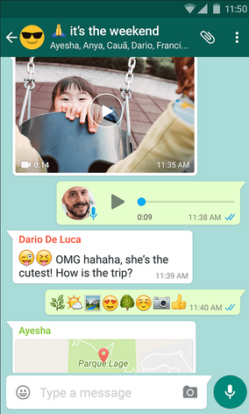
Figure 1: Screenshot from WhatsApp

Text messaging is not going away. In fact Kyle Vanhemert (2015), the author of the web article, "The Future of UI Design? Old-School Text Messages," noted that many companies are leveraging this sense of familiarity that the user experience when using an MIM application by creating chatbots that would interact in a similar setting. Two such examples are Penny and Quartz; both released last year. Penny is a finance tracking application (Figure 2), and Quartz is a news application (Figure 3). They both have a custom chat screen as their main user interface. Instead of free typing a response, users provide their input by selecting one of the predefined options.
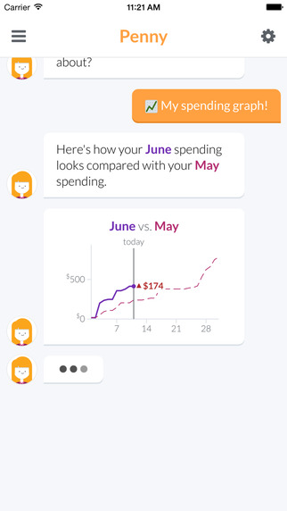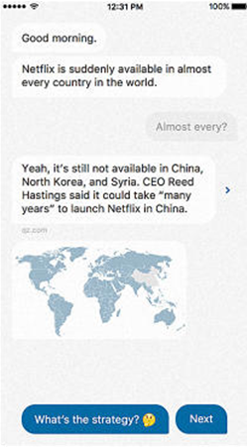
Figure 2: Screenshot from Penny Figure 3: Screenshot from Quartz

Both companies attempt to provide a conversational experience to the user. David Lee, the lead designer of Quartz, said that the application was "intimate because it's a one-on-one conversation with somebody" (Rhodes, 2016). Similarly, Penny focused on simplifying the tedious process of linking bank accounts through their interactive chat user interface. In both cases, the predefined responses were used to drive the conversation. A representative at Penny explained that they plan on leveraging natural language processing in the future, but the predefined solution is effective for new users who might not know what question to ask (Tepper, 2015).
Today, technology is rapidly progressing, and network latency is becoming less of an issue when designing a dynamic set of features for users (Kim 2016). Companies such as IBM (Watson) and Init.ai provide services that allow developers to leverage natural language processing capabilities and machine learning with less overhead. Additionally, there are an increasing number of services that assist in creating chatbots for existing platforms such as Facebook Messenger. In 2015, Matt Galligan, co-founder of a news app, Circa, had offered a dream in which the multitude of application collapse into a single chat-based user interface. Less than a year later with the announcement of Facebook Messenger, this dream is within the realm of the possibilities (Figure 4 and 5).

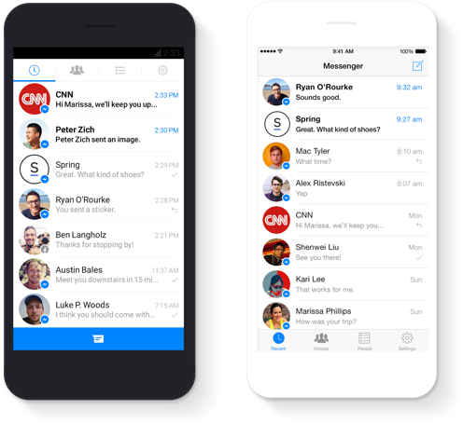
Figure 4: Facebook Messenger Platform examples

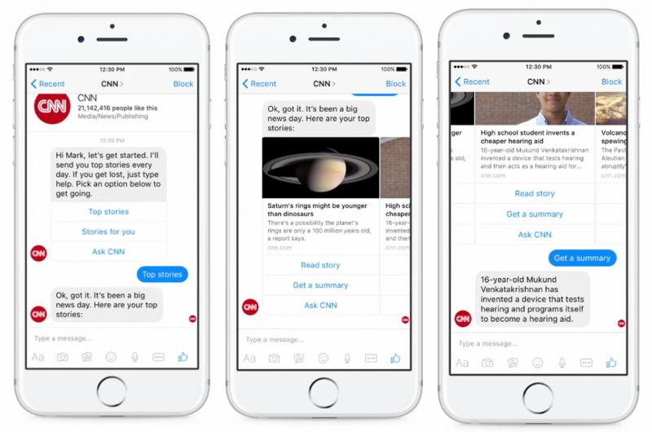
Figure 5: CNN chatbot created on the Facebook Messenger Platform

Chapter 2: Lit Review

Theoretical Framework
Although Chat-based UI is a relatively new field, there are already various implementation studies done on the topic. For instance, the University of Regensburg had created a health tracking chatbot called Nombot. Examining the user's motivations, they were able to create a chatbot that outperformed MyFitnessPal, a popular fitness and food tracking application with a traditional user interface (Graf 2015). Two researchers in Stanford have also set up a framework to study the effects chatbots have on processing medical information (Fischer, 2016). However, there are still limited resources involving chatbots as a whole. A theoretical framework on interactivity that was created by three researchers at Penn State University can address this gap by shedding light on the appeal chat-based UI has for users (Sundar 2010).
Interactivity allows the user to communicate with the system and produce a response, whether in cognition, attitude, or behavior. In the research, through a thorough compilation of past studies of different user interfaces and their effects on the users, the researchers have identified three variables that contribute to the user engagement: source, modality, and message (Sundar 2010).

Source Interactivity
Source interactivity indicates the effect the content originator has on the user. The user tends to like content that is vetted or created by other users (Sundar 2001), which explains the popularity of the "Sharing" feature in Facebook and "Retweeting" feature on Twitter. The study also indicates that the level of customization impacts user engagement, although whether they want more or less customization is heavily dependent on whether they are a power user or not. Power users or those with high cognitive capacity tends to prefer user-tailorable options. Non-power users or those with low cognitive capacity tend to prefer a passive, system-tailored option (Vorderer 2001). Another important aspect to keep in mind is that there is a difference between real and perceived effects, and if the user does not perceive the customization option, it does not increase the source interactivity (Kalyanaraman, 2006).

Modality Interactivity
With the capability to support multimedia content, users can now compose a comment, view a video, read other's comments, browse related videos, and search for new videos, using one user interface, for instance, the YouTube mobile application. More isn't always better, however. Although there are studies that show how increasing the types of modality can increase the user's attention and understanding of the content (Paivio 1986), there are also studies highlight the opposite: too much content or content types can detract from the message (Sundar 2000). For the study, five different news website were created ranging in modalities from being text-only to supporting multimedia content such as video and audio. Each participant consumed three articles off of one of the news website and was asked questions about them. The result indicated that, though advertisements are made more memorable through the use of multimedia, the overall memory on the content itself decreases with the inclusion of such content.

Message Interactivity
Message interactivity represents the level in which the user interaction dictate the content. Even with the same content, this can perceptually be achieved by releasing information in increments depending on user's input rather than providing all the information up front. Many Frequently Asked Questions (FAQ) pages use this structure to garner more user involvement without having to modify the content. Alternatively, another way one can increase the message interactivity is by allowing alternative content to appear only when necessary. For instance, an option to chat with a human representative will provide this mechanism. Having these contingencies in the content is shown to increase user engagement (Sundar 2003). When two political candidates' websites were created with different levels of contingency, those with more contingencies elicited more user engagement from both users who are politically savvy and those who are not. Physiologically, increasing the message-based interactivity by adding more contingencies in the content resulted in higher heart-rate within participants which triggered a better memory. (Sundar 2004) This contingency method can also make the content more accessible to users by breaking down the content into chunks. Amongst the three types of interactivity, the message interactivity demands the most user involvement and should be dealt with carefully. The same principle of more is not better applies here and going over the threshold limit can have a negative impact on the user experience (Sundar 2010).

Application to the Chat-Based UI
Using the theoretical framework, one can explain the popularity behind the chat-based user interface as a result of increasing the different types of interactivity. For instance, the design of the Chat-based UI allows the result to be tailored to the user feedback and for the information to release incrementally. All of this can increase the contingency effect and lower the entry of barrier for new users, which leads to increase in message interactivity. Similarly, the Chat-based UI can support various media as part of the conversation which increases the modality interactivity, and chatting to the chatbot may feel more familiar to a user increasing the trustworthiness of the content which increases the source interactivity.
Quartz was designed to make the user feel as though they are talking to a friend. Although there are limited customization options, a user notes that the "comfortable, visceral familiarity" made him want to come back for more (Popomaronis 2016), highlighting the case in which the user perceived a higher source interactivity despite the lack of tailored functionality. Similarly, amongst the preselected articles, the user can skip or drill down through the selections. If necessary, the user can also access the original article. All of these contingencies make this app a very beginner friendly application. The number of messages is never overwhelming either. The user can choose how and when they would like to be notified, and usually, an average session takes no longer than a few minutes – enough for the modern user on-the-go (Seward 2016).

Neko Atsume
Neko Atsume: Kitty Collector is a popular cat collecting game released in 2014, with an aim to please users of all ages and to cater towards users who want to "just look and enjoy" when playing a game. The game is not overly complex. During gameplay, the user maintains their yard as neighborhood cats come to visit. The type of cats that visit the yard and the quantity of them depend upon the food and toys that are available in the yard. More food and toys can be bought using the "sardine" currencies, which are left behind as gifts from visiting cats. Users often keep track of the cats that have visited their yards by taking pictures of them. As the game progresses, the user can buy an expansion to the yard, remodel the yard, and unlock new cats and toys. The game was originally released in Japanese, but the English version quickly followed due to its overwhelming popularity. By 2015, the game was downloaded more than 4 million times across the Android and iOS platforms, giving it the status as one of the Top 5 Mobile Games of 2015 by GameSpot. There are even plans to make the game into a live-action movie.
Neko Atsume sports a very traditional mobile game user interface. Our hypothesis is that by translating the game into a chat-based user interface, we can increase the interactivity level of the game (Figure 6).
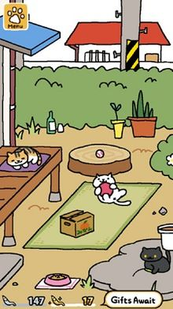
Figure 6: Screenshot of Neko Atsume

Strategy
Relevant variables to be studied in Neko Atsume were derived from the description of each type of interactivity. Not all of the variables will be explored because some are more affected by the game logic than the user interface, which is outside the scope of the study. Below, the derived checklist is listed with the selected criteria underlined.

Source Interactivity Checklist:
- Content that feels like it has been vetted by a community
- Tailor the level of customization to the type of user
- Include “identity-enhancing devices”

Modality Interactivity Checklist:
- Include different modalities

Message Interactivity Checklist:
- Engage the uninitiated
- The input dictates the output
- Release the information hierarchically

During the first user engagement, 18 users were surveyed regarding their experience with the game. The level of expertise ranged from users who have used it for months to users who have only used it for a week. From this, the current games' interactivity level for each category were captured as a baseline. During this session, different types of users were identified, and personas were created. The persona would ensure that all user types are accounted for even in the smaller sample size. For the second user engagement, a paper prototyping session was performed with a smaller group to develop the Chat-based interface. Finally, the seven sample users were surveyed during the third user engagement to see how those identified key factors were affected by the change in the user interface.

Chapter 3: First User Engagement

Method
For the first user engagement, 18 users were surveyed on their experience with playing Neko Atsume. The game's seven main functionalities were identified (Appendix A), and the users were asked to rate the functionalities' engagement level and provide an explanation. The user's experience ranged from those who have been playing the game for close to a year to those who have been playing for a week. Half the users were interviewed in person and notes were collected by the interviewer, and the other half were interviewed virtually through the service, Survey Monkey. The interviews took 20 minutes on average for those who were interviewed in person. The interviewer and the interviewee met at the mutually-designated location. The location ranged from the interviewer's house to a local game store. For those who responded virtually, the survey was open for two weeks. The responder provided a rating between 1 and a 5 for each of the seven functionalities and was provided with a section to submit a response to the question "Why?" for each one of them (Appendix B). All but two users had provided an answer for the open-ended inquiry, and all but two users in person were able to participate in the in-depth interview. Those who were not able to partake did not do so due to time constraints.

Results
When examining the results, a few things bubble up. For instance, purely transactional functionalities like Q5 ("Receiving Sardines") has the lowest average score of 2.67 when it comes to user engagement. The highest scores are those that relates to cats such as Q1 ("Viewing Cats") and Q3 ("Collecting Cat Pictures"), which scored 4.06 and 4.03 respectively. Amongst them, the standard deviation for "Viewing Cats" was the lowest at 0.87 indicating that there was not much variance to this sentiment (Table 1). When deep diving into the user feedback behind this highest score, many users indicated that they are entertained by how the cats interact with the toys they had arranged in the yard. When asked further, some noted that the placement of the toys is just as important as the collection itself. When asked about it, one user stated that placing and arranging toys allow them "to get better use and pictures," and that they like the ability to buy other yards and expansion because of its capacity to customize the background of the game. Although collecting is an important part of the game, this indicates that the ability of customization should not be underrated. From the analysis of the user surveys, two types of users emerge -- the Collector and the Customizer. They are not mutually exclusive. In fact, all users who play this game are Collectors to some degree as indicated by the fact that "Collecting cat pictures" ranked as the highest user engagement functionality, but understanding the other motivating factor for users – the customization – is also vital to note in our understanding of user engagement.

Table 1
User Rating for Neko Atsume
 | Q1 | Q2 | Q3 | Q4 | Q5 | Q6 | Q7
Average | 4.06 | 3.44 | 4.03 | 3.89 | 2.67 | 3.00 |  | 2.83
Std. Dev. | 0.87 | 1.46 | 1.12 | 0.96 | 1.14 | 1.75 |  | 1.54

Collector
The functionalities geared toward understanding the users' qualification as a Collector are Q2 ("Collecting mementos"), Q3 ("Collecting cat pictures"), and Q4 ("Collecting toys"). Both toys and mementos are not nearly as valued as a collection item compared to cat pictures. In fact, out of the 13 users who have provided a comprehensive textual response, 38.5% had said that they like collecting toys. The same percentage agreed with the mementos. Although 100% of the users had stated that they collected cat photos, one user had commented that the experience is not inherently gratifying and the task was only being completed because the "Pokédex" did not auto-populate the picture. The appeal mementos and toys had on a user are highly individualized. For instance, collecting mementos garnered responses from "80% of the reason I play the game" to "useless."

Customizer
Responses from Q1 ("Viewing cats in the yard"), Q6 ("placing/arranging toys"), and Q7 ("buying other yards/expansion) helps us shed light on those who are heavily invested in customizing in the game. Unlike the Collection user type, only five users deemed the customization feature as important, others opting for features such as "auto set" instead (Figure 7). Those who are not Customizers tend to buy the yard expansion for its utility (more cats in the yard) and tend to not care about the arrangement of toys. Those who are Customizers tend to value memories that are evoked from their personalized collection. One user stated that they liked taking cat pictures because they can "share them with friends"). 30.8% of the responding users had identified as a Customizer.


Figure 7: Novice users can opt out of the customization functionalities

Novice vs. Expert
As mentioned in the academic articles, the interaction of the novice players with the game is necessary. Novice players can be identified from the responses from Q2 ("Collecting mementos") and Q7 ("Buying other yards/expansion"). Those who are new have not usually collected many mementos yet since they are more difficult to accumulate than the other collectible items. Similarly, those who are novice players have not had the option to buy other yards or get a yard expansion since those features come into play later in the game. Two novice players have been identified through their responses. Expert players can be determined through the responses they have provided in Q2 ("Collecting mementos"), Q3 ("Collecting cat pictures"), and Q4 ("Collecting toys"). Those who have a near complete collection can be safely assumed to have played long enough to be considered an expert ("I currently have all the toys […]"). Three expert players have been identified through their responses (Figure 8).

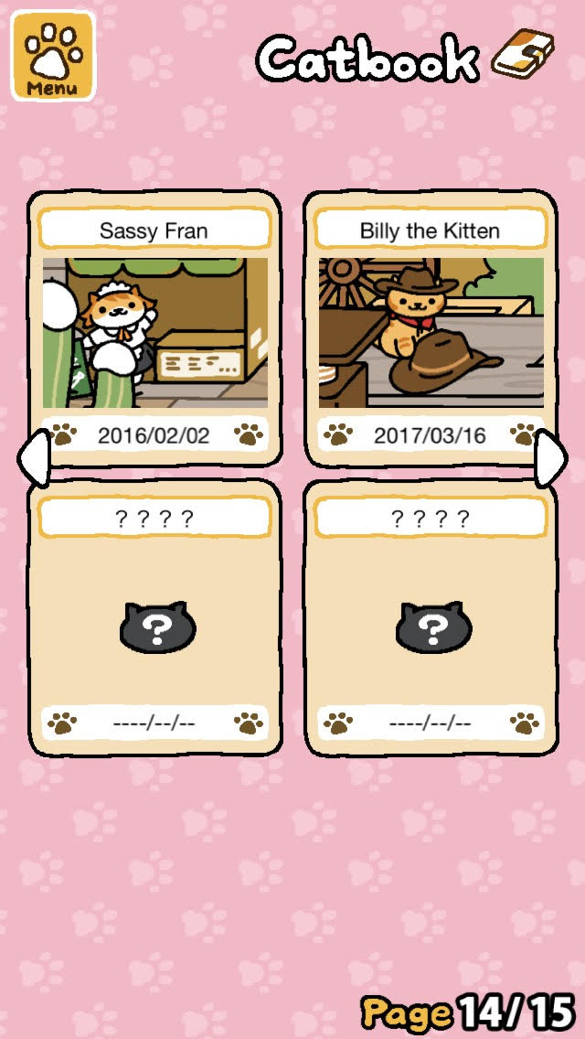
Figure 8: Collectors aim to complete their Catbook

Personas
Given the analysis of the data, three different types of personas emerge: the Novice, the Collector, and the Customizer.

Novice
Jane is 36 years old and a mother of three. She has been working in the same job for 23 years and appreciates stability. Whenever she is free – during her lunch break or at home between chores – she likes playing quick sessions of Candy Crush and Farm Ville. "It does not take long," she says, "but it's rewarding to see the progress." Recently, she heard about the game Neko Atsume and had downloaded and decided to give it a try. She uses Facebook Messenger to keep in touch with her friends but is not familiar with other functionalities of Facebook.

Collector
Bob is an 18 years old college student. He has social media accounts on most platforms. He especially likes to use Snapchat. He says he "snaps" at least five times a day with his friends. He had been playing Neko Atsume for a few months. "It's just a number game really," he says. He had not bothered with buying different yards but instead focused on getting all the toys. Even if it does not have a different interaction with the cats. "I just like to check the boxes."

Customizer
Kevin is a 24 years old systems engineer. He has been working for the company since he graduated from college three years ago. He has an account on Facebook, Twitter, and Instagram, and checks them throughout the day. He had been playing Neko Atsume for a few months. "I like collecting all the cats, but I do not bother with the toys unless the cats play with them differently." He had bought two different yard expansions and decided he likes the Western theme better. When he buys toys, he likes to take a moment to arrange the other toys in his yard.

Discussion
The results indicated that the users rate the current game with high source and modality interactivity, and medium message interactivity. The main issues the users had with the game were in user initiation and disclosing necessary information for power users. The previously identified key criteria are indicated by a bracket.

Source Interactivity
The users do not get to choose the type of cats that are in the game. They are created as stock characters in the game (Figure 9). The game does not make any attempt to hide the fact, but there are ways that users can "filter" the cats by providing a select combination of food and a toy. In this respect, the game is highly customizable, providing the user with full control of the choice of food and toys in their yard. When they are taking a picture, the user can maneuver the screen to choose what the shot should contain. They can also choose the pictures highlighted in their album. In this way, the power users of the game who prefers to tailor the content have full access to a swath of customization options while those who are non-power users can opt out by not using the functionalities. In the end, many users use their collections – whether it's their toy, cats, or memento – as their "identity-enhancing devices" or a mechanism in which a user can have a sense of identity or ownership within the game. One user described collecting mementos as "80% of the reason I kept playing." The overall effectiveness of the source interactivity is high (Table 2). During the transition to a chat-based UI, the "identity-enhancing device" is set as a key variable to measure since it is a large part of the reasons user's play and it will most likely be affected by the change in the user interface.

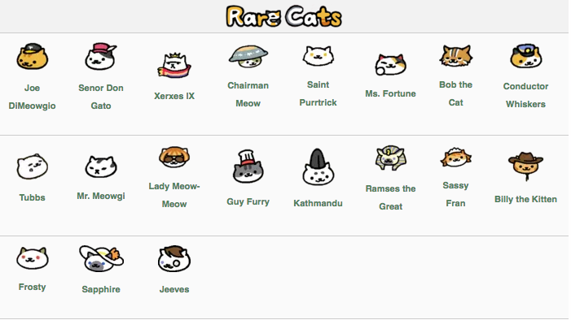
Figure 9: Cats are predefined in the game

Table 2
Source Interactivity Checklist Breakdown for Neko Atsume
 | User vetted content | Tailored/customized information | Identity-enhancing devices
Low
Medium | x
High |  | x | [x]

Modality Interactivity
Like most mobile games, Neko Atsume features many visual elements such as pictures and animations. They also utilize sound and text to provide users with more immersive experience (Figure 10). The overall effectiveness of the modality interactivity is high (Table 3). In a chat-based UI, the application is expected to have a different set of modalities since the representation of the data would change drastically during the shift in the UI.

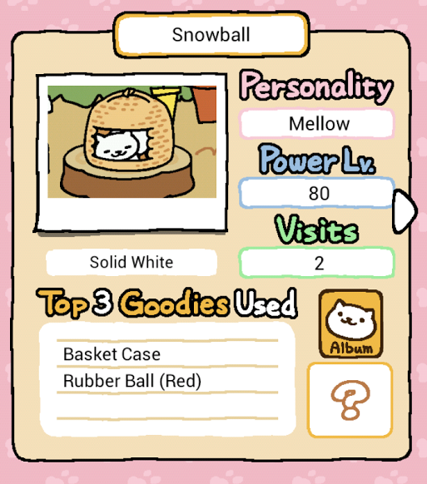
Figure 10: The game uses various modalities to engage the users

Table 3
Modality Interactivity Checklist Breakdown for Neko Atsume
 | Use of different modalities
Low
Medium
High | [x]

Message Interactivity
Neko Atsume has a tutorial for newcomers; however, some had stated that it was not enough. More than one user indicated that they were faced with an empty yard upon booting up the game after the completion of the tutorial and felt lost as to what they were supposed to do next. Similarly, although there is plenty of information on Neko Atsume that makes the game immersive, some found that the relevant information was not transparent to them. One user stated, "I have to go to the wiki site to figure out which toy/food combination will get me [a rare cat]." There are countless pages dedicated to the possible combinations that will provide a user with the most elusive of the cats, and the criticism was that this information should be transparent in the game. The resulting cats that visit the yard may also seem rather random to some users. The information that is available to the users is presented to them hierarchically so as to not overwhelm them. The overall effectiveness of the modality interactivity is medium (Table 4). Because chatbots are meant to be easy to use and to disseminate information incrementally, "Engage the uninitiated" and "Release information hierarchically" were marked as key variables.

Table 4
Message Interactivity Checklist Breakdown for Neko Atsume
 | Engage the uninitiated | The input dictates the output | Release information hierarchically
Low |  | x
Medium | [x]
High |  |  | [x]

Summary
Given the result, the level of perceived source interactivity is already high even without the community-vetted content. The area that can most benefit will be the message interactivity, especially with engaging new users and showcasing how the user action correlates with the visiting cats. Also, changing to a chat-based user interface may decrease the interactivity level in those areas such as source and modality where the original is already rated high.

Chapter 4: Second User Engagement

Method
For the second user engagement, five representative users were identified who fit the persona: one novice, two collector, and two customizers. The users were used to gather feedback through a paper prototype sessions. Each session lasted 15 to 30 minutes, and the users were walked through specific scenarios that would highlight six of the seven functionalities. The functionality regarding expanding the yard was left out since it is not a routine functionality and it is one of the lowest ranking functionality next to receiving sardines as a source of currency.
The paper prototype was created a week before the interview session through a pen, paper, and tape. The modular, visual components of the interface helped mimic the interaction of an actual working system. For instance, when the user was given the option of "No" or a "Yes" (Figure 11). They both appeared as an option initially to the user by placing the paper with the "No" message bubble written on it next to that with the "Yes" message bubble. They both had a double sided tape on the back which enabled easy peeling on and off so when the user selects an option, in this case, by touching the option with their finger, the unselected option can be removed from the sheet. Each of these bubbles is placed on a laminated piece of paper that represents the screen interaction.

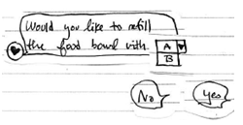
Figure 11: Paper Prototype Example 1
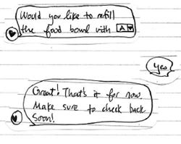
Figure 12: Paper Prototype Example 2

Initially, the user is presented with a blank laminated paper representing an unpopulated chat screen. Then, the screen will begin populating with a salutation, the status update of the visiting cats, and additional information (Figure 13). When the user is prompted for a response, usually two options present itself as a bubble. When one is selected, the other option fades away, and the conversation continues.

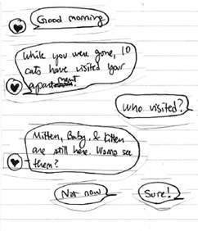
Figure 13: Paper Prototype Example 3
During the user engagement, the user was not given guidance on how to interact with the paper prototype. Instead, they were simply given a narrative on the context behind the screen, and the interviewer observed and noted any confusion or comments on the screen presentation. These were gathered in longhand on a notepad and later documented digitally.

Results
During the interaction, all users indicated that the chat user interface was indeed intuitive; although, one user, a Collector, asked, "so am I supposed to click on these?" Some comments that were captured indicated that different choices of color could help distinguish the choice bubbles from the rest of the conversation.
Though intuitive, three main concerns were brought up for this chat based interface prototype: (1) how to tackle the notification, (2) how to make certain components of the user interface flow better, and (3) dealing with the lack of visuals (Table 5).

Table 5
Results of the Paper Prototype
 | Notifications | User Interface | Visual
Collector 1 | x | x | x
Collector 2 | x | x
Customizer 1 |  |  | x
Customizer 2 | x |  | x
Novice |  |  | x

Notifications
Traditional games approach notifications differently than the current chat-based application. Traditional games want the users to open the application as the main method to check the status. The current chat-based application would rather the user wait for the application to notify them of an event. This different approach came about from the need the chat-based application filled involving users wanting a type of user interface that requires less of their time. The users of current chat-based applications are passive users who would not engage with the application unless they were notified. For example, Quartz notifies the users 2 to 3 times a day with vital headlines allowing users to customize the frequency in its settings.
During the paper prototyping, the notification was signified by a block that appeared on the screen triggered when a cat was playing with a particular toy (Figure 14). The users worried whether the triggers happened too frequently. "I don't want to have, notifications on the screen," a Collector said, "maybe they can lump into one." Some suggested that the notifications be time sensitive and disappear when a specific time threshold has passed.

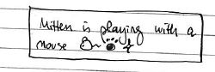
Figure 14: Paper Prototype Notification Example

User Interface
Although the general chat-based user interface was relatively natural for users to use, some components were hard to represent in such a way. One such instance is choosing toys and putting it at a location, which is something that is easier to do with a graphical user interface.
In the paper prototyping, this task was done through a graphical widget that appeared as part of the return message from the chatbot, but two users felt as though this broke away from the general flow of the conversation (Figure 15). "It feels awkward," one Collector stated. 2 other users were confused when they reached the section. One suggestion was to swap the widget into series of messages instead to better integrate the task into the chatting paradigm.

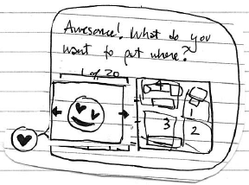
Figure 15: Paper Prototype Widget Example

Visual
By far, the biggest concern was in regards to whether the users will get enough "cat" through their experience with the game. In the original game, the user was able to go to their virtual yard to visually see the cats if any were in the yard. During the paper prototype, 80% of the selected users felt as though the amount of face time they had with the cats were minimal. Two of the four users who had felt this way suggested that cats "should be the first thing [users] see when [users] log in to the system and should be the last thing [users] see when they log out." The Collectors expressed the need to see their progress and to see how close they are to completing their collection visually. Another suggestion was to include a cat picture or a gif as part of the experience.

Discussion
The results indicate that there are factors that are introduced in the conversion from the traditional game UI to a chat-based UI. Mitigating the adverse effects of these factors would be key since all three factors affect the level of interactivity the users have with the system.

Source interactivity
Because most of the information that the user receives is visual, lacking compelling visual content diminishes the overall value the user perceives from the game severely. Since curating various collections is one of the main techniques the game utilize as an identity-enhancement device, making sure that there are enough visual components to make the functionality accessible and appealing is vital to maintaining a positive user experience. Being able to see, access, and analyze their collection quickly is necessary to increase the source interactivity.

Modality interactivity
In the result, the users highlighted not only the need for more modalities but also the right ones. For instance, in the paper prototype, there was a widget that helps place a toy in a specified location, but the user thought the widget was "awkward" in the overall flow of the application. On the same token, many users suggested that the use of more imagery such as gifs to "see" their cats more is vital for them to keep on playing the game.

Message interactivity
The "awkward" widget will also affect the message interactivity since it increases the complexity for novice users. Although the Novice that took part in the paper prototyping found the prototype "intuitive" to use, the widget still posed a bit of confusion. To maintain a high message interactivity, the UI must keep a streamlined flow without much clutter.
Notifications also play a key part in this since too many alerts can decrease the user's sensitivity. For instance, if there were 20 unread notifications from an application, the user will more likely ignore them or block the application altogether, than return (or play).

Summary
Although the Chat-based UI is said to be intuitive by all of the users, capturing the necessary tasks at hand in the restrained UI might be difficult. Also, users were showing dissatisfaction with the lack of visual stimuli or indication of their pets and an inability to keep track of their collections. Mitigating these factors would be key in creating a successful Chat-based UI for Neko Atsume.

Chapter 5: Third User Engagement

Method
For the third user engagement, seven users were surveyed on their experiences with playing the prototype chatbot game, The Dog Lover's Yard. The game was created leveraging Chatfuel as a platform to help build a Facebook Messenger application. The server side code is stored in a web-based service called Glitch. The overall development time took 3 and a half weeks. The premise of the game is to include the key functionalities that were present in Neko Atsume in a chat-based format. Instead of cats, dogs were used as the animal of choice.

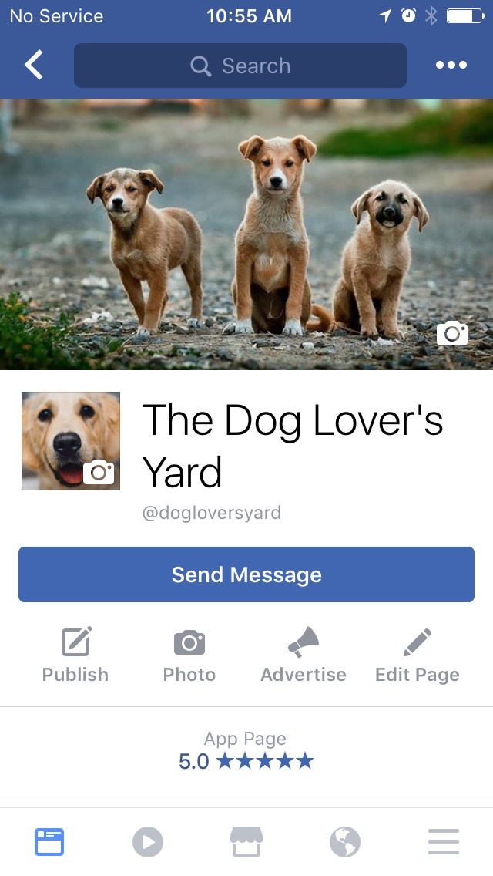
Figure 16: The Dog Lover’s Yard’s Application page

The user testing spanned a week. All users had a preexisting Facebook account, and they were each invited to the Facebook application page and were given the instruction on how to initiate the game by sending a message. During the first interaction phase, the game walked the user through a tutorial step in which the user sets up the food and toys in the yard, much like the original game. The user was then notified a total of 4 times during the day – at 9:30 am, at noon, at 2 pm, and at 6 pm – by the application to check on the status of the yard (Figure 17).

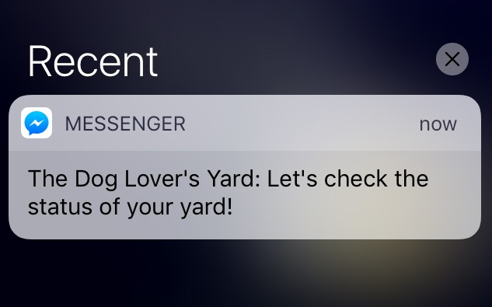
Figure 17: The Dog Lover’s Yard’s notification

Each notification began the core engagement session in which the user was displayed prompts and options in order to complete the following tasks: (1) collect mementoes if any, (2) view the dogs who have visited the yard, (3) collect the currency, (4) buy a toy, (5) place a toy, (6) buy and refill the food bowl if it's close to being empty. The game supported 3 types of food ("Meh food", "Yummy food", and "Super food"), 5 mementos (dice, headphones, pair of eyeglasses, pen, and a sock), 5 different dogs (Bailey, Max, Charlie, Buddy, and Rocky), and 5 toys (hammock, pet rock, dandelion, tennis ball, and a stuffed animal). The odd of the user receiving a memento was 1/3. The dogs who visited the yard is randomly generated at the time of the event, and the toys and food are at a fixed price. The users had at least three days to experience the game providing them with at least 12 interaction points with the game.

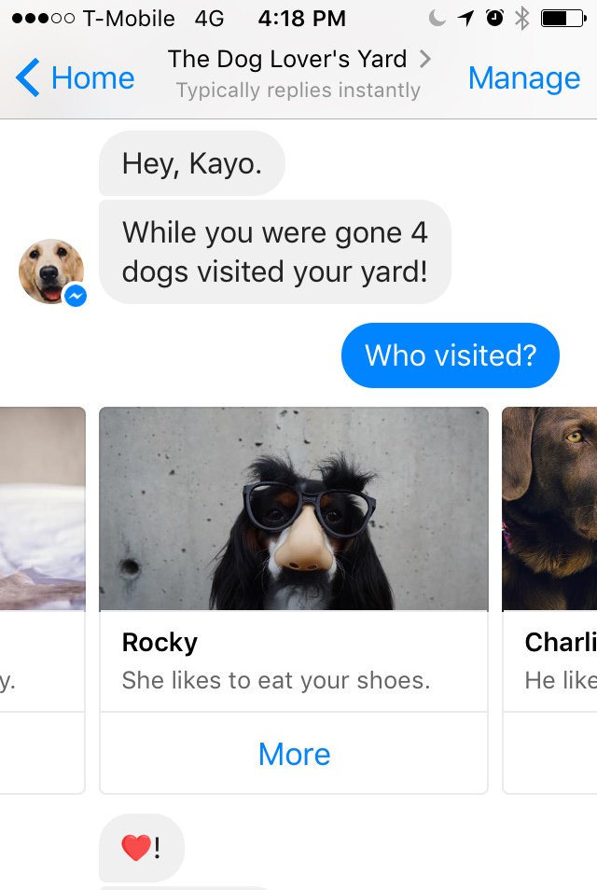
Figure 18: The Dog Lover’s Yard’s screenshot

Out of the seven users, six users are a repeat from the First User Engagement, and one user was new. There were 3 Collectors, 2 Customizers, and 2 Novices. Two of the user responses were collected in person, and five of the responses were gathered online. When received in person, the interviewer and interviewee decided on a time and location and spent a minimum of fifteen minutes going through the questions and capturing the comments. Survey Monkey was used as a tool for responses that were collected virtually. After all the responses had been received, the final message was sent out notifying the user of the experiment’s end, and all triggers from the game turned off so that the user will not receive any further messages from the Facebook page (Figure 19).

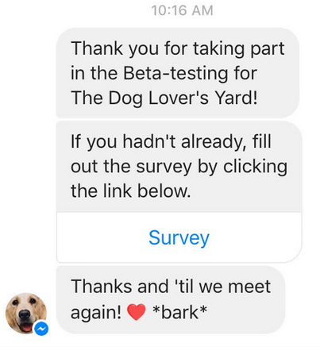
Figure 19: Final Message from The Dog Lover’s Yard

The users were asked to rate a set of functionalities between 1 and 5 with an opportunity to include an explanation (Appendix C). Additional open-ended questions were provided to get their overall impression of the game. All users have completed the open-ended questions.

Results
The average scores were 2.49 with tiny standard deviation. The highest was for the currency, and the two lowest were arranging toys and viewing the dogs that were in the yard. The responses were similar across the different personas (Table 6).
Table 6
User Rating for the Dog Lover’s Yard
 | Q1 | Q2 | Q3 | Q4 | Q5
Average | 2.43 | 2.14 | 2.57 | 3.14 | 2.14
Std. Dev. | 1.40 | 1.46 | 1.27 | 1.35 | 1.46

Although all users had agreed that chatbot was intuitive and easy to operate requiring less training or time between sessions, they also found that it didn’t meet all of their needs. The two most important points that affected their experience the most were: (1) inability to play on “[their]” own terms, and (2) failure to keep track of the collection effectively. Each of these points can be traced back to the comments made back in the Second User Engagement, where the related primary points were: Notification and User Interface respectively.
It’s also important to note that due to the time constraints, many limitations had negatively impacted the user experience. This topic will be covered in Chapter 7: The Limitations.

Table 7
Results of the Dog Lover’s Yard
 | Notifications | User Interface
Collector 1 |  | x
Collector 2 | x | x
Collector 3 |  | x
Customizer 1 | x | x
Customizer 2
Novice 1 | x | x
Novice 2 |  | x

Notification
Although proactively notification as the primary application trigger is a standard feature in chatbot, it can introduce a dissatisfaction amongst the users when implemented incorrectly. In this case, 42.9% of the users – one representative from each user category – had said that they were dissatisfied with how the notification system was implemented. “I can’t play on my own terms, only when the game decides I’m allowed to,” said a Collector. In the original game, the user could open the application at any given time to see the status of the yard.

User Interface
85.7% of the users have stated that the user interface was limiting. The main complaints were that the user interface does not allow the users to access and track the progress of their collections quickly. One user blatantly states that the chat-based UI “prohibits” the completion of the collections. In the original game, the user had dedicated on-screen menu button that they can use to access their collections whenever they want to. In the case of The Dog Lover’s Yard, the users can view the collection as one of the options presented to them, but it is not a persisting choice.

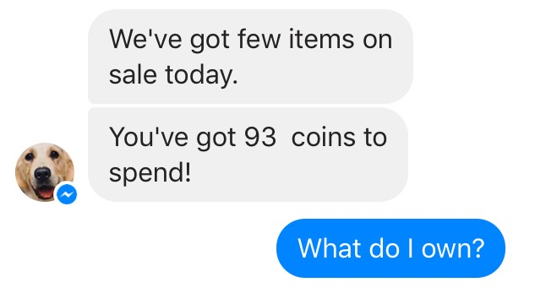
Figure 20: The option to view the Collection is not persistent

Discussion
The results indicated that out of the four criteria that were selected as strongly affected by the chat-based UI transition, only two scored high. The two remaining scored low. This result is counter to the hypothesis that using a chatbot would increase the level of interactivity by affecting the criteria positively. Below, the key selected criteria were updated from the original checklist results. The updated values are represented within brackets.

Source Interactivity
In the original gameplay, there were various means for the user to create a collection, which aided the users in having a sense of identity within the game. This functionality was thoroughly lacking in the chat-based UI (Table 8). The users did not like the lack of a persistent button to access their collections nor did they feel as though the representation of the collection – either listing of its names or displaying in a gallery – was an effective method to represent their collection.
Although having a chat bubble that showcases the completion percentage – such as 80% complete – might ease the burden for a smaller set of collection, it might not be as effective as a larger one. Having a different means to organize items is crucial for a game that emphasizes collecting like the original game with over 50 collectible items.

Table 8
Source Interactivity Checklist Breakdown for the Dog Lover’s Yard
 | User vetted content | Tailored/customized information | Identity-enhancing devices
Low |  |  | [x]
Medium | x
High |  | x

Modality Interactivity
The chatbot game mixed different modalities by interspersing texts with images and gifs to engage the users. The users did appreciate the gifs, and many had commented that it was one of the features they looked forward to (Figure 21).

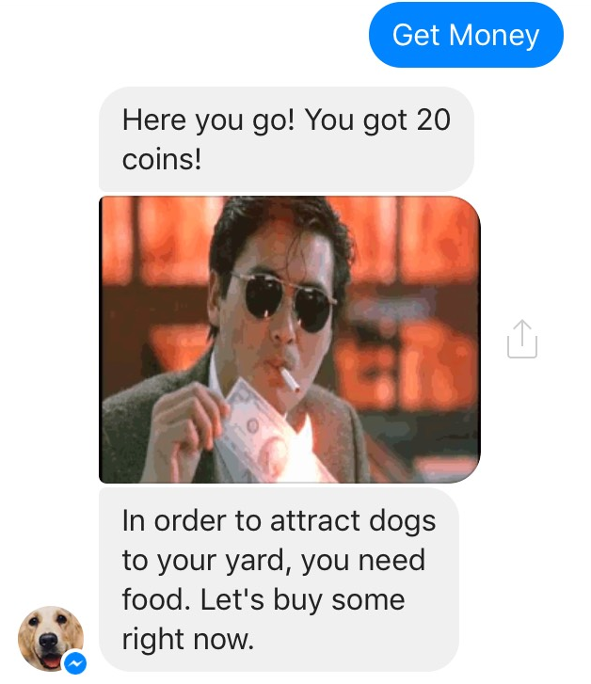
Figure 21: Gifs were used to engage the users

Table 9
Modality Interactivity Checklist Breakdown for the Dog Lover’s Yard
 | Use of different modalities
Low
Medium
High | [x]

Message Interactivity
The Dog Lover’s Yard walked a user through buying the user’s first toy and food, much like the Neko Atsume game. All had said that it was easy and straightforward to get started; however, more than half had stated that they were not provided with enough information to enjoy the game. This result shows that it may be difficult to capture all of the information in a chat-based UI (Table 3).

Table 10
Message Interactivity Checklist Breakdown for the Dog Lover’s Yard
 | Engage the uninitiated | The input dictates the output | Release information hierarchically
Low |  | x | [x]
Medium
High | [x]

Summary
Users had pointed out that the Chat-based UI contained several short falls such as keeping track of collections and playing on the users’ terms. Although 100% said that they find chatbot to be seamless and easy to use, 71.4% stated that they would play a Chat-based game again.

Chapter 6: Findings

Lessons Learned
Chat-based UI has key benefits. All users agreed, whether they were a novice or an expert user, the application is easy and straightforward to use. Also, many of the visual elements in a traditional game can be supplemented through the use of alternative media such as gifs and emojis in the flow of the conversation. All users reacted very positively to them, and the modality interactivity remained high during the conversion.
However, converting all of the key tasks and functionalities from the original application may be more difficult in a chat-based UI given its constraints and recommended guidelines. The scores that suffered are all of those that are related to a specific functionality that relies on user’s autonomy and collections. One user flat out disliked the current paradigm of chat-based UI which revolved around proactive notification. The user stated that she wants to play when she felt like playing instead of waiting for an important event to happen. Also, various collections are harder to represent in a chat-based UI since the chat-based apps that had existed thus far have been transactional – once you perform an action (buy shoes, check your bank balance), there was no persistence in the old record. It was for grab-and-go usage. This result meant one of two things. Either (1) the technology being considered for a chat-based UI should be changed so that it’s only performing transactional transient requests or (2) the current chat-based paradigm is not flexible enough to accommodate for the vast array of applications out there and should be changed.
Another idea is to take the middle ground. There already exists several persistent features in other apps such as Penny and Quartz. Penny showcases the custom buttons on the bottom, and Quartz shows them on a separate hidden screen that the user would need to swipe left to access it. These might be a way to provide persistency for the users (Figure 22).

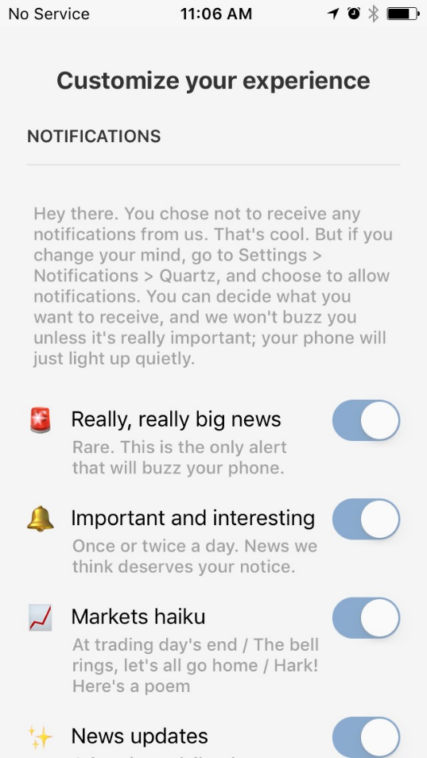
Figure 22: Quartz’ Menu Option

Regardless of implementation, there is a major disconnect between the execution of Chat-based UI and non-transactional applications. When considering implementing one into a chatbot, several questions should be asked:

- How will this affect the game play?
- Is this an important component of why the users play the game?
- How can the Designer counteract the negative effects?
- What are the positive strategies the Designer can add through this new medium?

Question 1
Whenever there is a significant UI change, there is a possibility that it will affect gameplay. In the case of transitioning a traditional application to a chat-based application, the Designer must keep in mind ways in which all of the functionalities can be accessible through a conversation. In the Dog Lover’s Yard’s case, because there were no buttons for users to explore and access their collections freely, all of the transactions must become a seamless part of the conversation. For that, various sample conversation flows have been developed during the creation of the paper prototyping. When creating this conversation flow, consider the branching decision points. In the case of the Dog Lover’s Yard, there was a special case for when the user had received a memento and also when user’s food was low.

Question 2
When primary gameplay is affected, it is important to consider how important that functionality is to the user’s interactivity. Less important functionality can be cut altogether if adding it will increase complexity without significant value. If the functionality is important, proper considerations should be taken through reflections in Question 3 and Question 4.

Question 3
The main functionalities in Neko Atsume that were impacted were (1) collection functionality and (2) the lack of visuals. The users had commented that the collection was more challenging to access through the new user interface and that the lack of the imagery prevented them from bonding with the visiting animals. To counteract this effect, an option to view the collection appeared as part of the conversation and various media was introduced to engage the users. The latter was adequately addressed, and the users took no issues with it when gifs, emojis, images, and galleries were used to supplement the otherwise text-heavy game. However, the former was not able to deliver to user’s satisfaction causing frustration.

Question 4
Aside from transforming all of the existing functionalities into a chat-based interface, the Designer can test introducing new features that are unique to the chat-based interface to increase user engagement. One example is to make use of proactive notifications by finding new and innovative ways to interact with the users. Instead of the standard notification, the Designer may consider making their notification more chat-like to increase user engagement. For instance, the notifications that were sent out to the users were meant to simulate a normal chat, some going as casual as “*poke*” to get the user’s attention.


Figure 23: The Dog Lover’s Yard’s example notification

Chapter 7: Limitations and Conclusions

Constraints
Three factors should be considered when considering the results. They are software factors, audience factors, and the cat factor.

Software Factors
Due to the experimental nature of the interface, many software malfunctions frustrated the users. The most common bug encountered were the options reaching a dead end and the gallery of pictures not showing up, which prevented the user from progressing in the game. In the Figure below, the glitch failed to display the gallery of the dog’s profile who has visited. Additionally, some messages are duplicated.

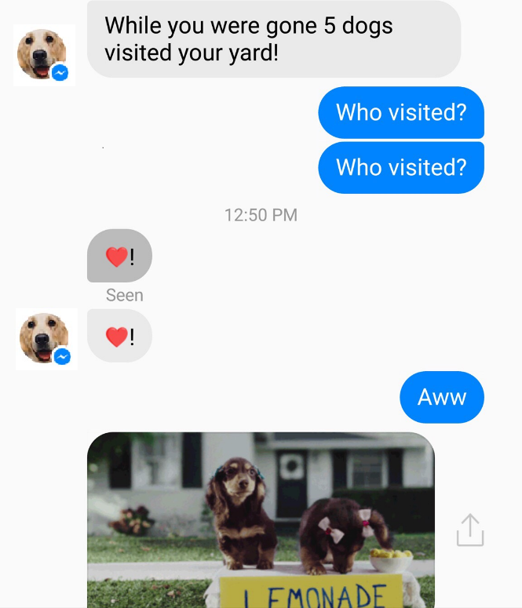
Figure 24: Bugs often interrupted the game flow

Similarly, the game came preloaded with the standard number of toys which decreased the point of buying toys (Figure 25). The user showed frustration in not understand the value of the currency. “I don’t see the correlation between having toys and the number of dogs visiting,” a user had said.

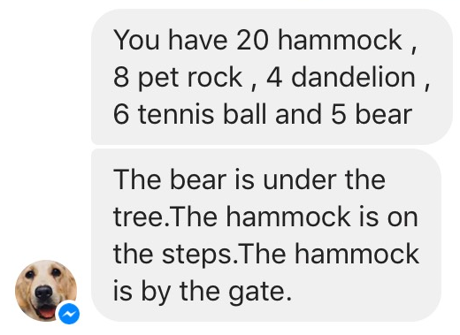
Figure 25: A bug has preloaded the collection

The limited development time meant that the game logic was simplified compared to the original game which negatively impacted the user’s experience for those users who wanted just as much variety as the original game.

Audience Factors
The sample size that was chosen was fairly small. In a future study, pooling data from a larger sample size will help account for any outliers. Also, only English speakers who have used the English version of Neko Atsume were interviewed. Having a separate study that took into account, other language speakers may help unravel any cultural differences. Because some users who participated in evaluating The Dog Lover’s Yard also participated in its paper prototyping, the previous knowledge may have tainted their opinions of the app they were evaluating.

The Cat Factor
The users were adamant that the number one reasons they played the game were because of “CATSSSSSSSSSSSSSSSSSSS.” Changing the target animal to dogs may have impacted their user engagement.

Conclusion
In future research, some areas that can be looked into are ways in which one can provide a level of persistence in a chat-based UI without it looking unnatural. Because persistent data such as collected items and goal-tracking are one of the key components of a game, having a way to effectively present the types of data would be vital to target the chat-based UI for non-transaction based applications. When designing any chat-based user interface, gifs and images are a great way to increase modality interactivity; however, too much of it can lower the level of interactivity. Understanding the recommended level of media in a conversation to optimize user engagement is another area that would greatly enhance the field of study.

References

Church, K & Oliveira, R. (2013). What's up with whatsapp?: comparing mobile instant messaging behaviors with traditional SMS. Proceedings of the 15th international conference on Human-computer interaction with mobile devices and services, 352-361. doi: 10.1145/2493190.2493225
Fischer, M & Lam, M. (2016). From Books to Bots: Using Medical Literature to Create a Chat Bot. Proceedings of the First Workshop on IoT-enabled Healthcare and Wellness Technologies and Systems, 23-28. doi: 10.1145/2933566.2933573
Galligan, M. (2015, June 9). Imaging MessageKit: Apple’s path to turning iMessage into a platform. Medium. Retrieved from https://medium.com/@mg/there-s-a-chat-for-that-apple-s-biggest-platform-opportunity-yet-19d5b1870857#.6kh4b62u0
Graf, B., Krüger, M., Müller, F., Ruhland, A., & Zech, A. (2015). Nombot: simplify food tracking. Proceedings of the 14th International Conference on Mobile and Ubiquitous Multimedia, 360-363. doi: 10.1145/2836041.2841208
Kalyanaraman, S., & Sundar, S. S. The psychological appeal of personalized online content in Web portals: Does customization affect attitudes and behavior? Journal of Communication, 56(2006), 110-132.
Kim, J., Wu, C., Chiang, A., Ko, J., & Lee, S. (2016). A Picture is Worth a Thousand Words: Improving Mobile Messaging with Real-time Autonomous Image Suggestion. Proceedings of the 17th International Workshop on Mobile Computing Systems and Applications, 51-56. doi: 10.1145/2873587.2873602
Paivio, A. (1996). Mental representations: A dual-coding approach. Oxford University Press, New York.
Popomaronis, T. (2016). Why Quartz’s news app is so much bigger than news. Tech Crunch. Retrieved from https://techcrunch.com/2016/03/22/why-quartzs-news-app-is-so-much-bigger-than-news/
Rhodes, Margaret. (2016, February 11). With Quartz’s app, You Don’t Read news. You Chat With It. WIRED. Retrieved from https://www.wired.com/2016/02/with-quartzs-app-you-dont-read-the-news-you-chat-with-it
Seward, Z. (2016, February 11). It’s here: Quartz’s first news app for iPhone. Quartz. Retrieved from https://qz.com/613700/its-here-quartzs-first-news-app-for-iphone/
Sundar, S. S. (2000). Multimedia Effects on Processing and Perception of Online News: A Study of Picture, Audio, and Video Downloads. Journalism and Mass Communications Quarterly, 77(3), 480-499.
Sundar, S. S., & Nass, C. (2001). Conceptualizing sources in online news. Journal of Communication, 51(1), 52-72
Sundar, S. S., Kalyanaraman, S., & Brown, J. (2003). Explicating Web Site Interactivity: Impression Formation Effects in Political Campaign Sites. Communication Research, 30(1), 30-59. doi: 10.1177/0093650202239025
Sundar, S. S., & Constantin, C. (2004). Does interacting with media enhance news memory? Automatic vs. controlled processing of interactive news features. 54th Annual Conference of the International Communication Association. New Orleans, LA.
Sundar, S. S., Xu, Q., & Bellur, S. (2010). Designing interactivity in media interfaces: a communications perspective. Proceedings of the SIGCHI Conference on Human Factors in Computing Systems, 2247-2256. doi: 10.1145/1753326.1753666
Tepper, F. (2015, October 15). Penny is a Chat-based Personal Finance Coach. Tech Crunch. Retrieved from https://techcrunch.com/2015/10/15/penny-is-a-chat-based-personal-finance-coach/
Vanhemert, K. (2015, June 26). The Future of UI Design? Old-School Text Messages. WIRED. Retrieved from https://www.wired.com/2015/06/future-ui-design-old-school-text-messages/
Volderer, P., Knobloch, S., and Schramm, H. Does entertainment suffer from interactivity? The impact of watching an interactive TV movie on viewers’ experience of entertainment. Media Psychology, 3, 4(2001), 343-363.
Appendix A: Main Functionalities of Neko Atsume

- Viewing cats in the yard
- Collecting mementoes
- Collecting cat pictures
- Collecting toys
- Receiving sardines
- Placing/arranging toys
- Buying other yards/expansion

Appendix B: Neko Atsume Survey

On a scale of 1-5, how important are the following action in terms of getting you to come back to the game? (1 for least important; 5 for most important). For each, respond with an explanation for the rating.

- Viewing cats in the yard
- Collecting mementoes
- Collecting cat pictures
- Collecting toys
- Receiving sardines/currency
- Placing/arranging toys
- Buying other yards/expansion

Appendix C: The Dog Lover’s Yard Survey

On a scale of 1-5, how important are the following action in terms of getting you to come back to the game? (1 for least important; 5 for most important). For each, respond with an explanation for the rating.

- Collecting mementoes
- Seeing which dogs visited the yard
- Collecting toys
- Receiving currency/coins
- Placing/arranging toys

Answer the following question:

- Overall, what do you like about the game?
- Overall, what do you dislike about the game?
- Was it more or less enjoyable than Neko Atsume? Why or why not?
- Did you enjoy interacting with the chatbot? Do you see yourself playing more games involving chatbots?

