SUPPORTING INFORMATION FOR

A fusion of the Bacteroides fragilis ferrous iron import proteins reveals a role for FeoA in stabilizing GTP-bound FeoB

Alex E. Sestok^{1,2}, Janae B. Brown^{1, 2}, Juliet O. Obi³, Sean M. O’Sullivan¹, Elsa D. Garcin^{1, 4}, Daniel J. Deredge³, and Aaron T. Smith¹*

From the ¹Department of Chemistry and Biochemistry, University of Maryland, Baltimore County, Baltimore, Maryland, 21250 USA; ²These authors contributed equally to this work; ³Department of Pharmaceutical Sciences, University of Maryland School of Pharmacy, Baltimore, Maryland, 21201 USA; ⁴Laboratoire d’Information Génomique et Structurale, UMR7256, Aix-Marseille Université, Campus de Luminy, 13288 Marseille, France

Running title: Characterization of B. fragilis NFeoAB

*To whom correspondence should be addressed: Aaron T. Smith: Department of Chemistry and Biochemistry, University of Maryland, Baltimore County, Baltimore, Maryland, 21250; Tel: 410-455-1985; E-mail: smitha@umbc.edu

Keywords: Feo, iron, protein-protein interactions, SAXS, SH3, iron transport

Table 1
Data Collection and Refinement Statistics for BfFeoA (1-74)
Data Collection
Beamline | APS 21-ID-G
Wavelength (Å) | 0.97856
Space group | C₁₂₁
Cell Dimensions
a, b, c (Å) | 92.58, 29.55, 67.43
α, β, γ (˚) | 90, 128.89, 90
Resolution (Å) | 46.18-1.50 (1.53-1.50)
R_{merge} | 0.122 (1.185)
I/σ(I) | 8.1 (1.5)
Completeness (%) | 99.7 (97.8)
Refinement
Resolution (Å) | 36.03-1.50 (1.55-1.50)
No. reflections | 23,079
R_{work} | 0.192
R_{free} | 0.236
No. atoms
Protein | 1,214
Glycerol | 12
Phosphate | 10
Water | 154
Average B-factors (Å²) | 24.00
R.m.s. deviations
Bond lengths (Å) | 0.006
Bond angles (˚) | 0.878
Ramachandran plot
Favored | 72 (97.22%)
Allowed | 2 (2.78%)
Outlier | 0 (0%)
Table S1. BfFeoA data collection and refinement statistics.

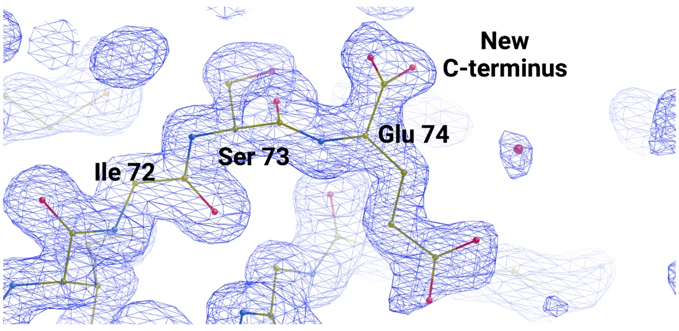

Fig. S1. The 2F_{o}-F_{c} electron density map (blue) of BfFeoA contoured to 1σ indicates the location of proteolytic cleavage. Glu 74 (shown here for chain B, but consistent throughout the ASU) forms the C-terminus of the polypeptide after proteolytic cleavage between residues 74 and 75 in the crystallization drop. Figure created with Biorender.

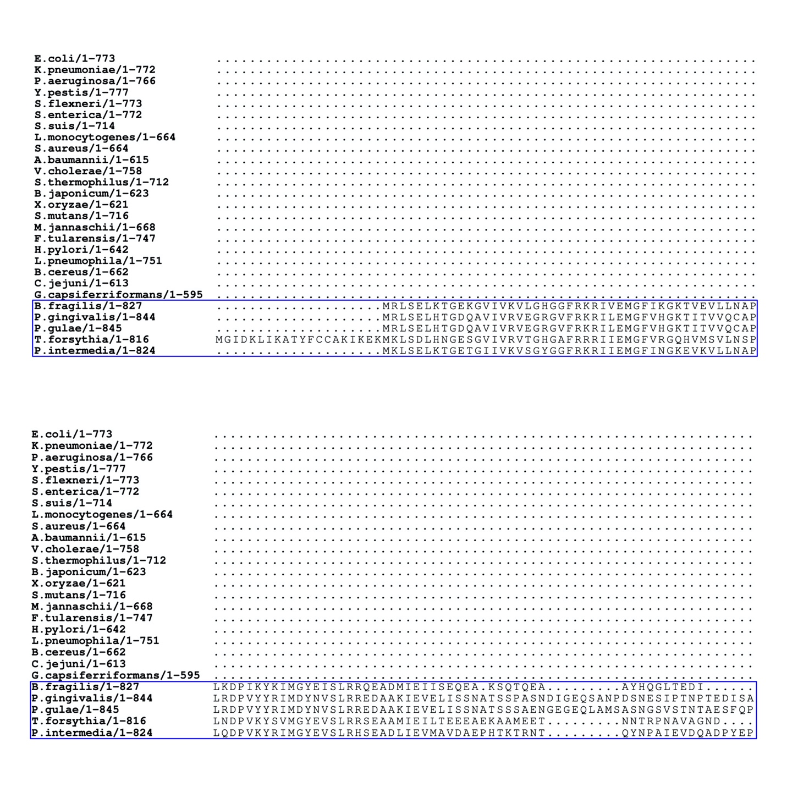

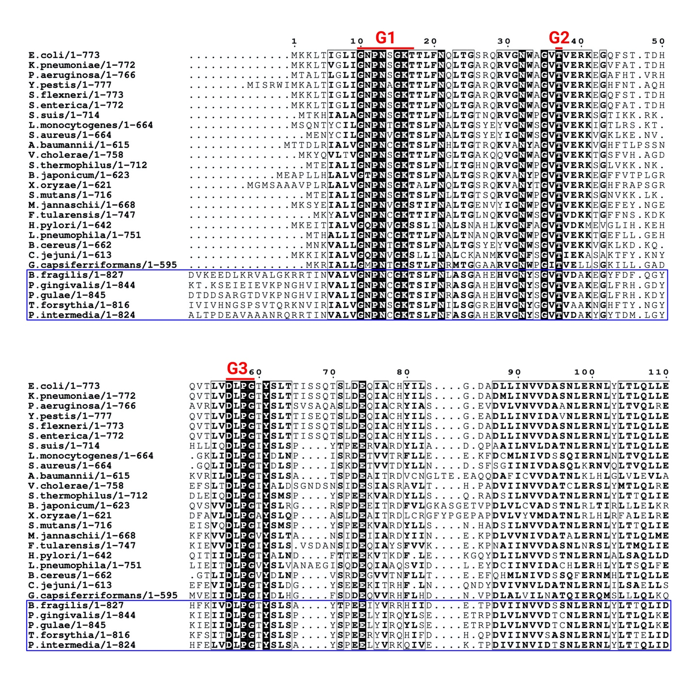

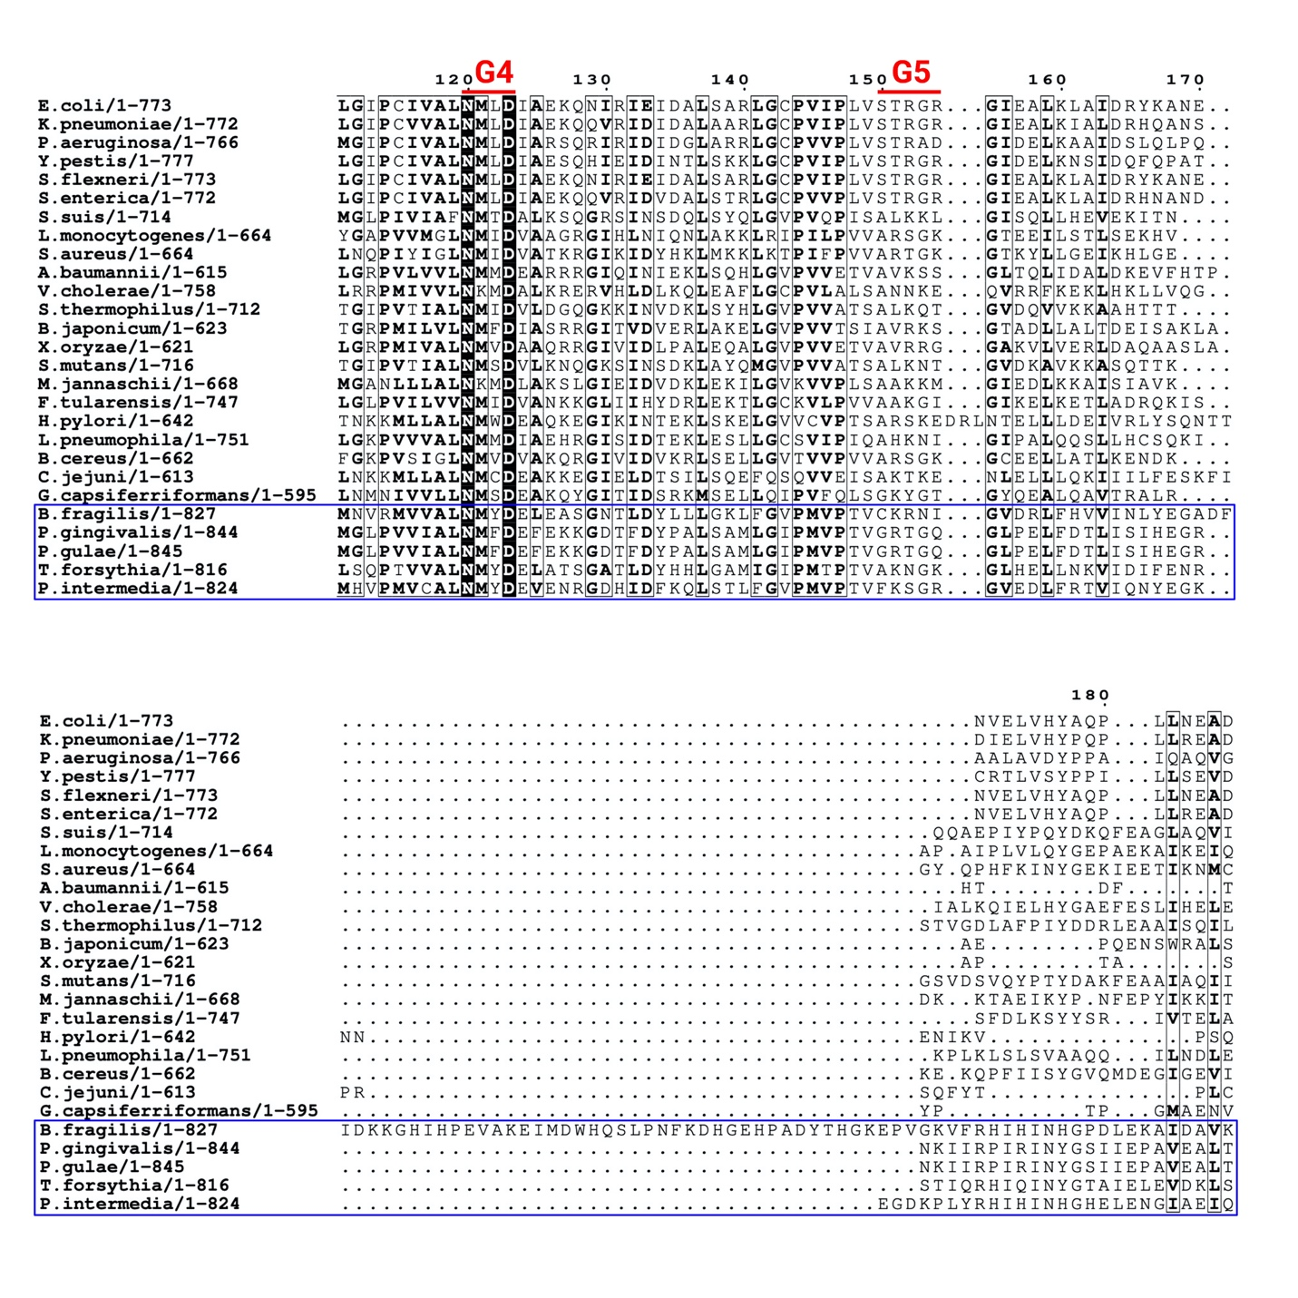

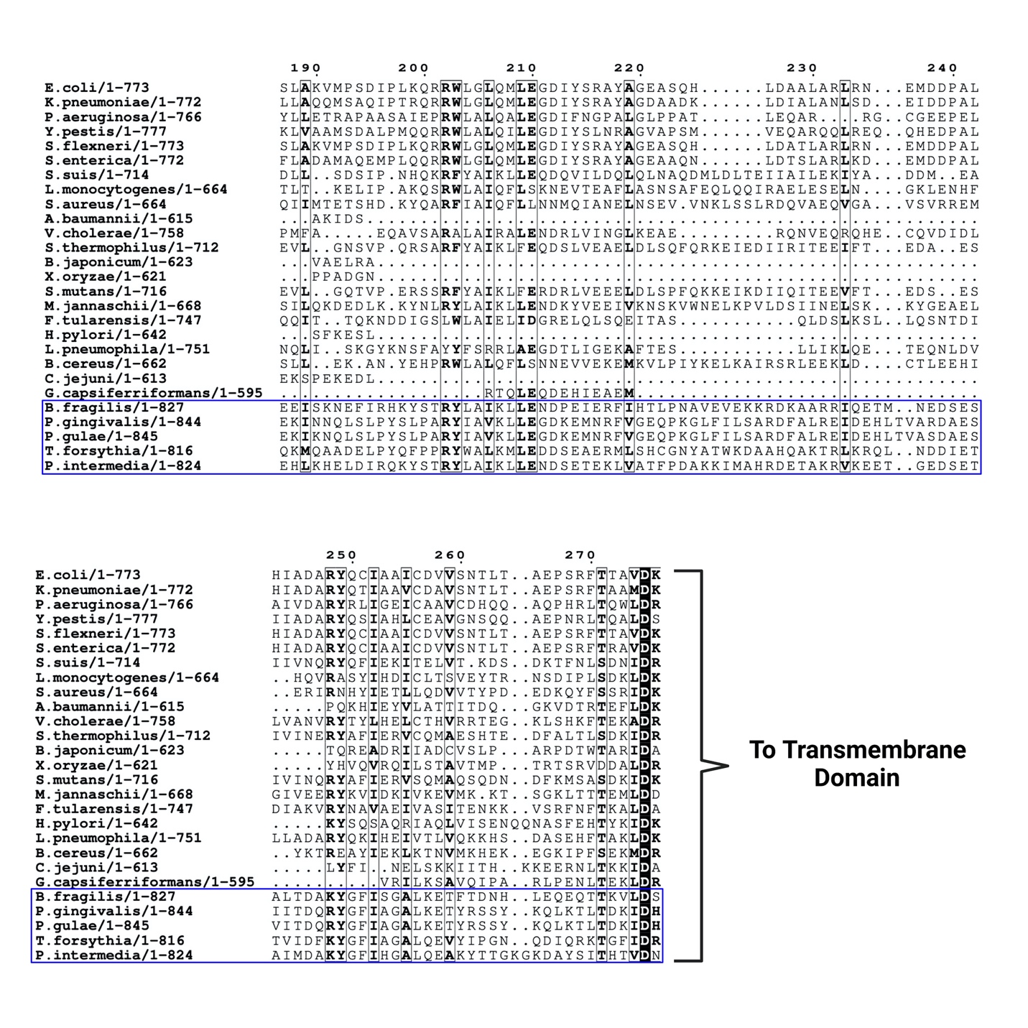
Fig. S2. Partial multiple sequence alignments (MSAs) of the soluble, N-terminal domains of non-fused FeoB proteins and select FeoAB fusion proteins (blue box). The top numbering is relative to E. coli FeoB (Uniprot ID P33650). The G motifs (G1-G5) are highlighted above the aligned sequences in red. MSAs were generated using ClustalW (1) and visualized in the JalView Suite (2) and the ESPript 3.0 online server (3). Figure created with Biorender.

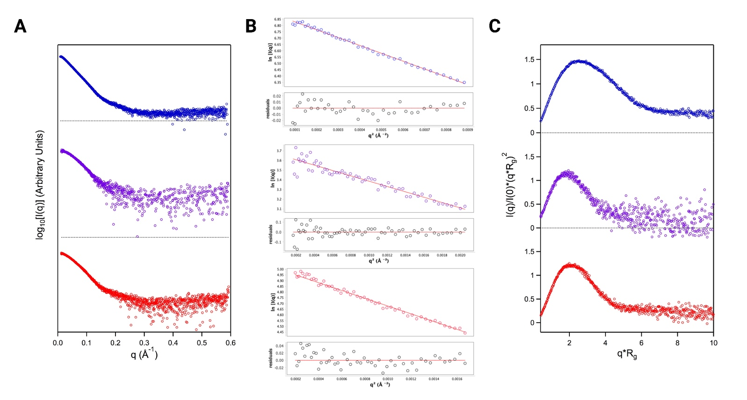
Fig. S3. Experimental high-throughput (HT) SAXS data for apo- and nucleotide-bound BfNFeoAB. A. log₁₀ plots derived from experimental SAXS data of apo BfNFeoAB (top, blue), GMP-PNP- (middle, purple), and GDP-bound (bottom, red) BfNFeoAB. B. Guinier fittings (solid red lines) and their respective fitted residuals (black circles) of apo BfNFeoAB (top, blue), GMP-PNP- (middle, purple), and GDP-bound (bottom, red) BfNFeoAB demonstrating negligible aggregation in our HT-SAXS samples. C. The normalized Kratky plot of apo BfNFeoAB (top, blue) suggests an elongated, flexible conformation while the normalized Kratky plots of GMP-PNP- (middle, purple) and GDP-bound (bottom, red) BfNFeoAB suggest more compact, less flexible structures.

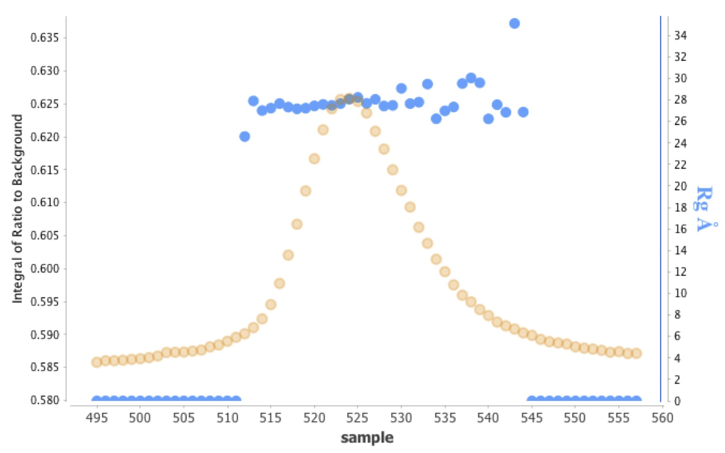
Fig. S4. SEC-R_{g} profile for apo BfNFeoAB. The SEC profile for apo BfNFeoAB (orange circles) shows a homogenous, monodisperse sample. At the peak maximum, the R_{g} values (blue circles) remain effectively constant at ca. 28 Å, further indicating homogeneity.

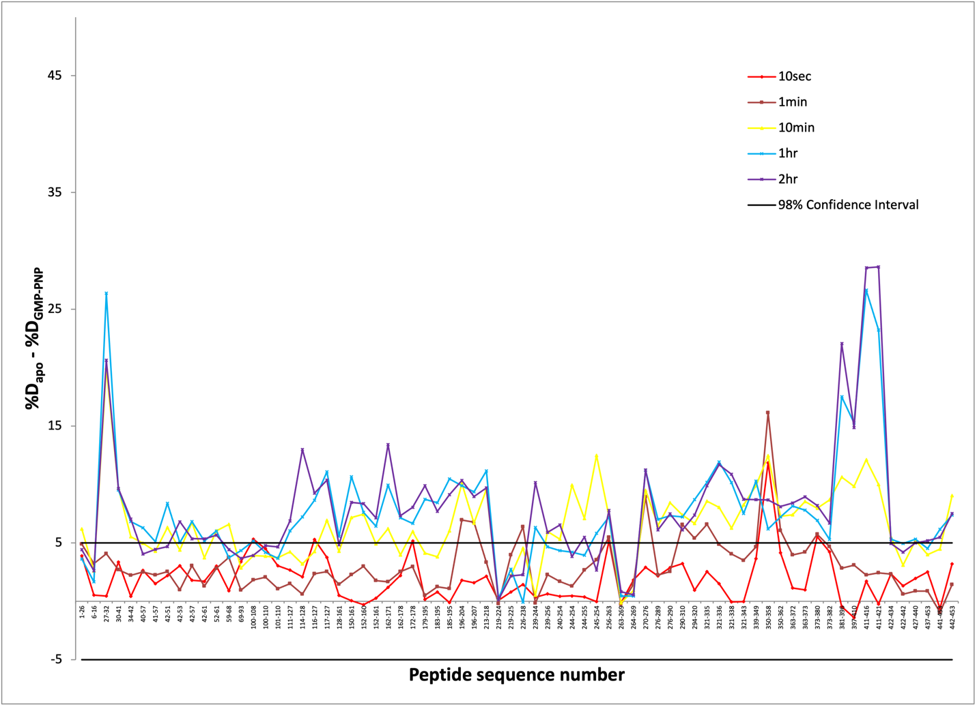

Fig. S5. Difference plots of apo BfNFeoAB percent deuterium uptake (%D_{apo}) minus GMP-PNP-bound BfNFeoAB percent deuterium uptake (%D_{GMP-PNP}). Individual peptic segments are plotted on the x-axis according to sequence number from N- to C- terminus. The time intervals represent the data after 10 s (red), 1 min (brown), 10 min (yellow), 1 hr (blue), and 2 hr (purple) of hydrogen-deuterium exchange reaction in each state. A 98% confidence interval (black line) was used for the determination of significance in the percent deuterium uptake difference.

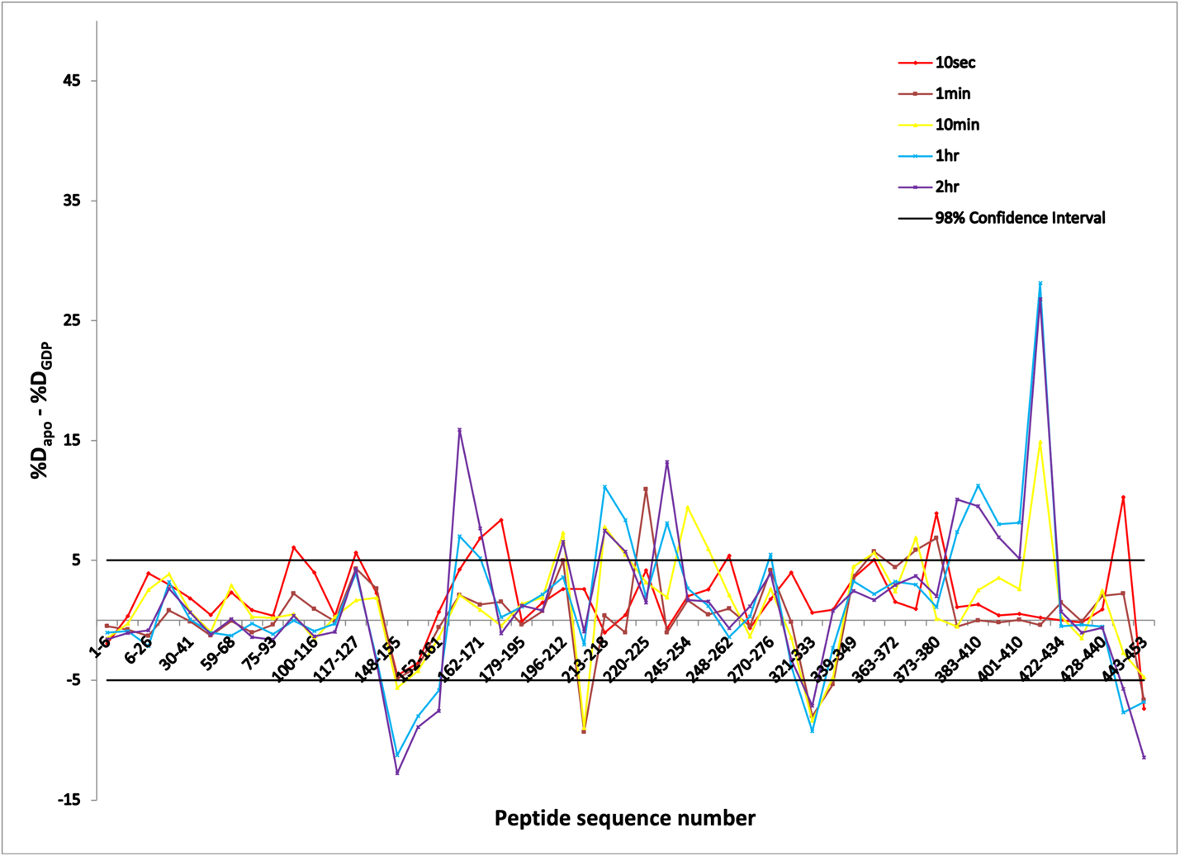

Fig. S6. Difference plots of apo BfNFeoAB percent deuterium uptake (%D_{apo}) minus GDP-bound BfNFeoAB percent deuterium uptake (%D_{GDP}). Individual peptic segments are plotted on the x-axis according to sequence number from N- to C- terminus. The time intervals represent the data after 10 s (red), 1 min (brown), 10 min (yellow), 1 hr (blue), and 2 hr (purple) of hydrogen-deuterium exchange reaction. A 98% confidence interval (black line) was used for the determination of significance in the percent deuterium uptake difference.

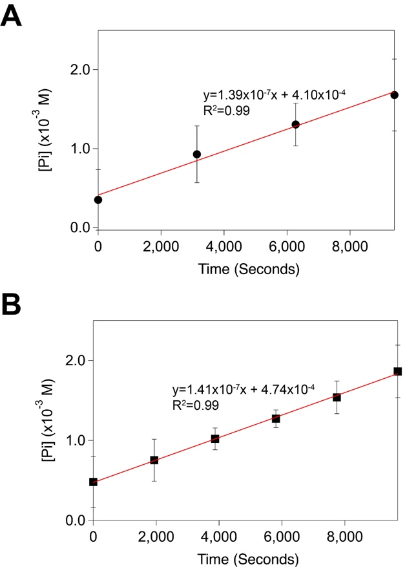

Fig. S7. The rate of BfNFeoAB GTP hydrolysis is not increased by the presence of K⁺. A. The reaction rate of BfNFeoAB hydrolysis in the presence of 3.5 mM GTP was determined by plotting data collection time points against the area under the P_{i} signal in each 1D ³¹P-NMR spectrum. Sample conditions were: 100 mM Tris, pH 7.5, 300 mM NaCl, 100 mM MgSO₄, 2% (v/v) glycerol, 1 mM TCEP, and 10% (v/v) D₂O. Under these conditions, the rate of GTPase activity was linear and measured to be 0.14 ± 0.011 µM/s. B. To determine the influence of K⁺ on GTP hydrolysis, the assay was carried out as described in panel A except that NaCl was replaced with KCl. The rate of GTP hydrolysis was measured to be 0.14 ± 0.003 µM/s, indicating that K⁺ does not affect BfNFeoAB activity on GTP.

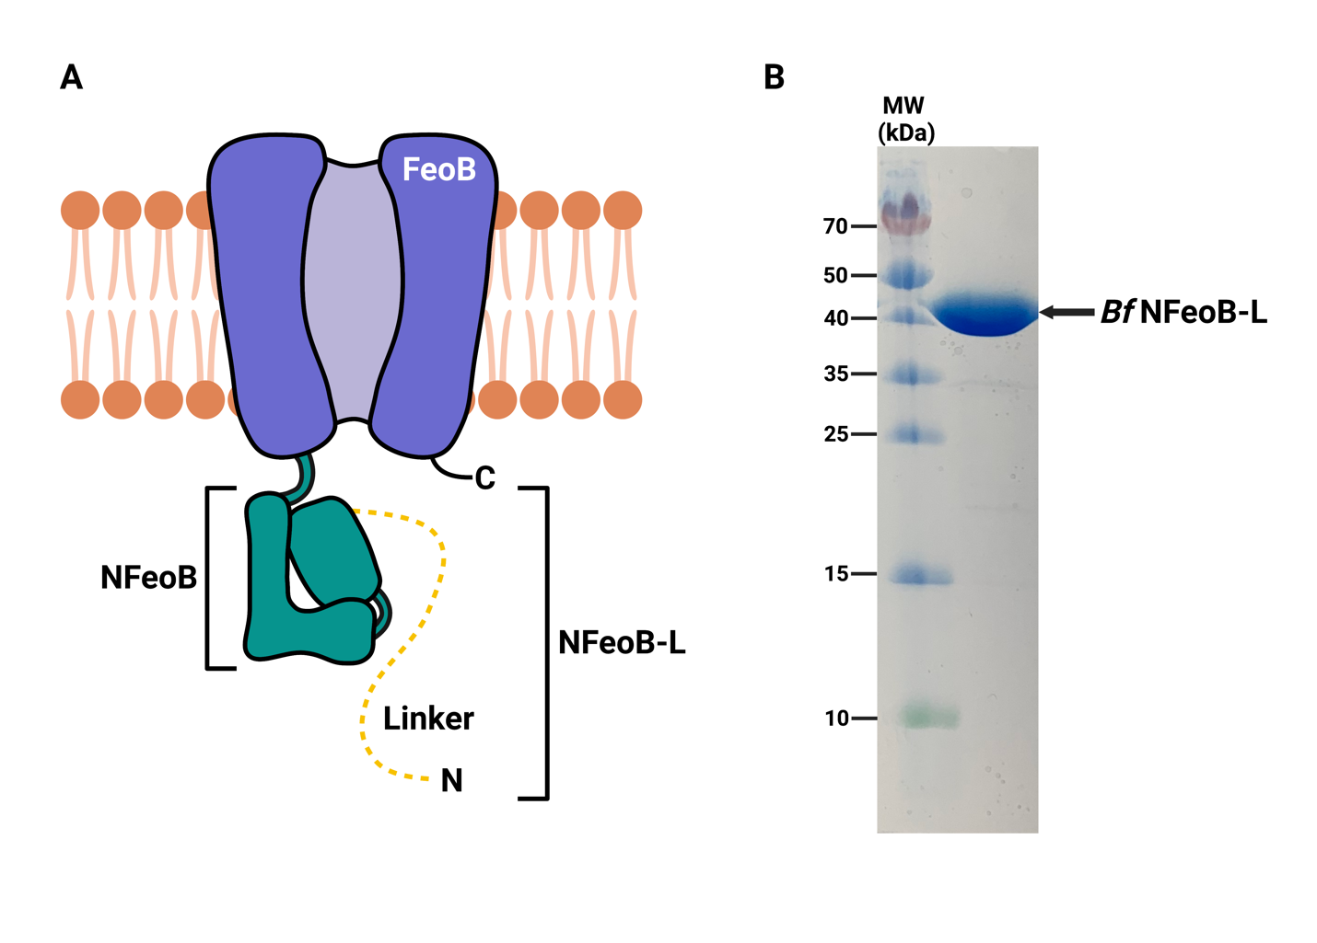
Fig. S8. Design and purification of the BfNFeoB-linker construct (BfNFeoB-L). A. Cartoon representation of the FeoAB fusion protein from Bacteroides fragilis with FeoA truncated. The BfNFeoB-linker construct (BfNFeoB-L) consists of the BfNFeoB domain (teal) and the linker region (yellow) but lacks the FeoA domain. Labels ‘N’ and ‘C’ refer to the N- and C-termini, respectively. B. BfNFeoB-L was expressed and purified similarly to BfNFeoAB, and 15% SDS-PAGE analysis indicates high (>95%) purity. Figure created with Biorender.

REFERENCES

1. Larkin, M. A., Blackshields, G., Brown, N. P., Chenna, R., McGettigan, P. A., McWilliam, H., Valentin, F., Wallace, I. M., Wilm, A., Lopez, R., Thompson, J. D., Gibson, T. J., and Higgins, D. G. (2007) Clustal W and Clustal X version 2.0. Bioinformatics 23, 2947-2948
2. Waterhouse, A. M., Procter, J. B., Martin, D. M., Clamp, M., and Barton, G. J. (2009) Jalview Version 2--a multiple sequence alignment editor and analysis workbench. Bioinformatics 25, 1189-1191
3. Robert, X., and Gouet, P. (2014) Deciphering key features in protein structures with the new ENDscript server. Nucleic Acids Res 42, W320-324

