Supporting Material

Text S1. LiDAR data are a summary of reflective returns of coherent light emitted from a device often fixed to an aircraft as it passes over a geographical area of interest. The timing of returns corresponds to distance to the device and can be deduced into a 3-dimensional map of vegetation matter, a rendering of which is shown in Fig. S2A.

Figure S1. Map of the eight forest study sites (yellow polygons) across the Baltimore metropolitan area. Landscape composition was assessed inside 1-km radius buffers around the site perimeters (delineated in blue). Buffers were categorized as ‘more developed’ (dashed black) and ‘less developed’ based on the proportion of urban development.

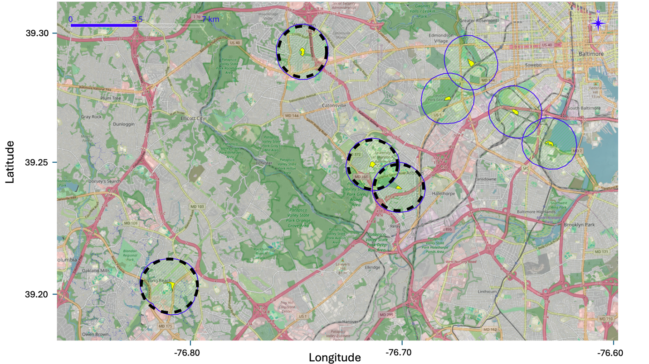

Figure S2. LiDAR data at a nest site. A) 3D rendering of LiDAR returns in a 15-meter horizontal radius around a nest (red dot). Return heights are in a blue (lowest) through red (highest) gradient. B) Density plot of LiDAR return heights from the same nest site after ground returns were removed.
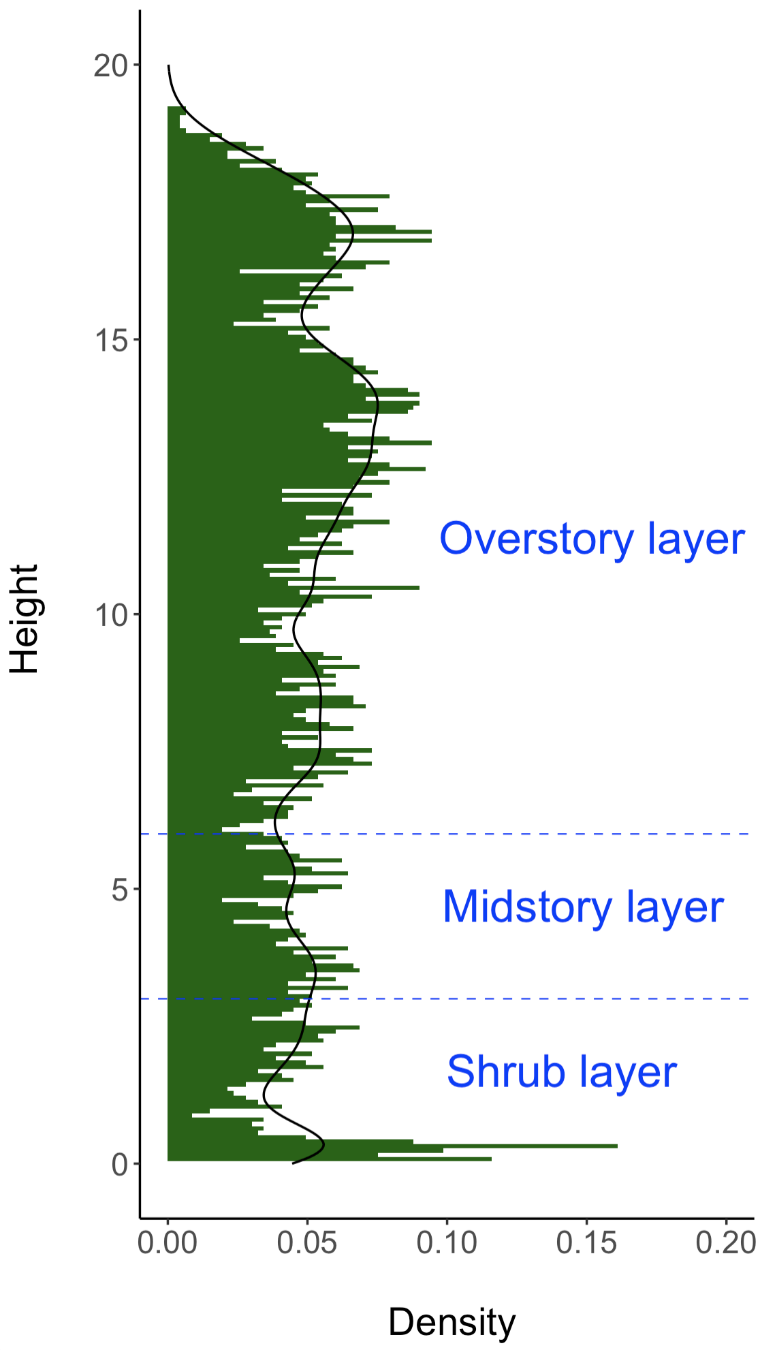
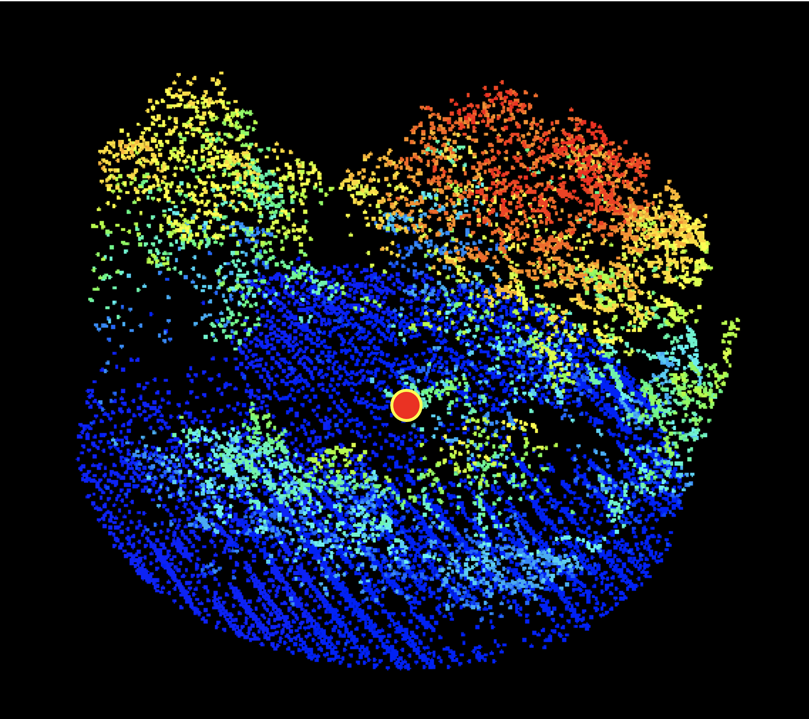
A
B

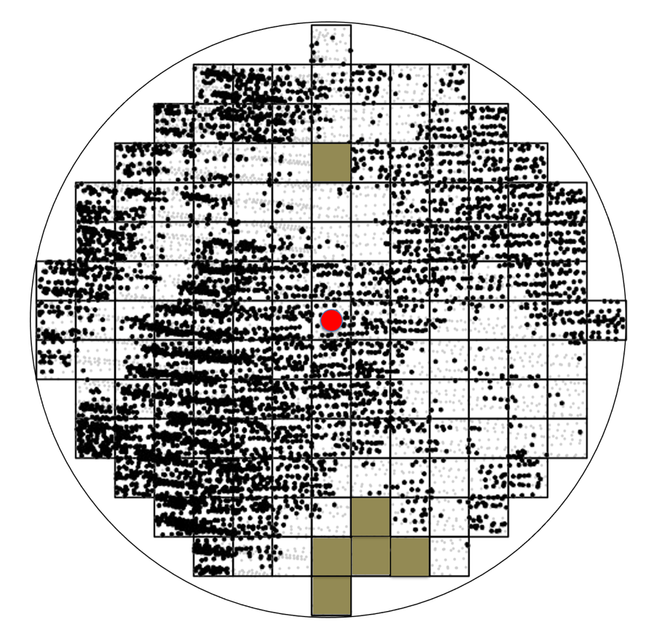
Figure S3. An example of LiDAR data analysis to construct per-nest site digital elevation model (DEM) and to detect ground-to-canopy gaps. A 15-m radius buffer surrounds a nest point (red dot), and a 2x2 meter grid is placed within it. Small black dots are LiDAR returns classified as vegetation, and light gray dots are ground. Grid cells marked in brown are ground-to-canopy gaps. Unlike the group of brown cells on the bottom, the single brown cell towards the top was not considered as a gap because only two or more adjacent cells qualified as a sufficiently large gap in this study.

Figure S4. Correlation matrix for independent variables calculated to explain nest success of northern cardinal in eight urban forest patches in Maryland, USA. Strong correlation coefficients are shown in darker colors and larger circles, going from positive (blue) to negative (red). Variable definitions are given in Table S1.

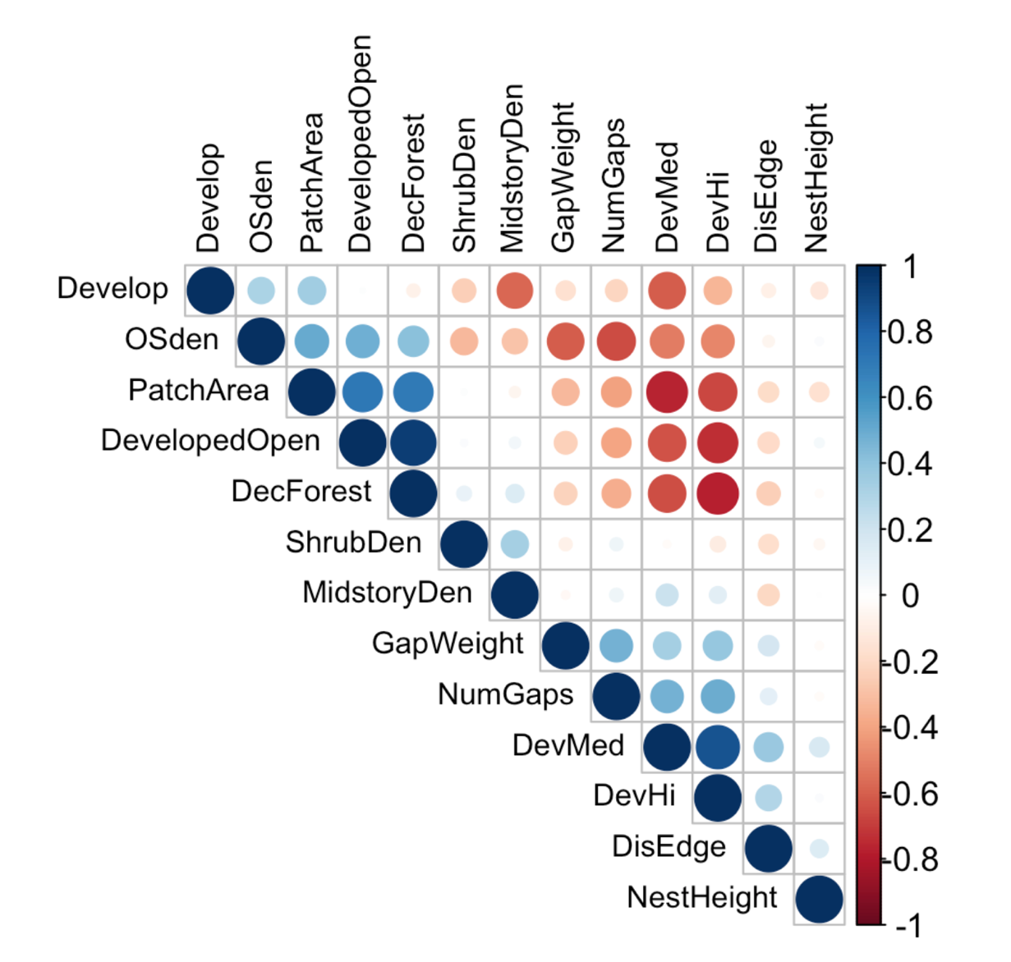

Table S1. Description of independent variables tested in generalized linear models to explain northern cardinal nest success in eight urban forest patches in Maryland, USA.

Spatial Scale | Variable | Description
Local, vegetation structure | OSden,  MSden,  ShrubDen | The vegetation density in the overstory (>6 m), midstory (3-6 m), and shrub (0-3 m) layers of the vegetation column of each 15 m radius nest site. Calculated from the proportion of returns in each layer out of the total returns in the point cloud including ground returns.
Local, vegetation structure | NumGaps | The number of gaps in a nest site, where gaps are defined as two or more adjacent 2x2 m cells free of vegetation.
Local, vegetation structure | GapWeight | Distance-weighted area of gaps calculated as:
Local, vegetation structure | GapWeight | Gap Weight = $\sum_{i}^{n}{\frac{area}{\sqrt{distance}}}$
Local, vegetation structure | NestHeight | The height of the nest above the ground, in meters.
Patch | DisToEdge | Distance from nest point to patch edge, in meters.
Patch | PatchArea | Area of the forest patch in m².
Landscape | UrbanDev | The proportion of NLCD low-intensity development land cover class.
Landscape | DecForest | The proportion of NLCD deciduous forest land cover class.
Landscape | DevMed | The proportion of NLCD medium-intensity development land cover class.
Landscape | DevHi | The proportion of NLCD high-intensity development land cover class.
Landscape | DevelopedOpen | The proportion of NLCD open space development land cover class.

Table S2. Summary statistics for independent variables (not scaled) tested in generalized linear models to explain northern cardinal nest success in eight urban forest patches in Maryland, USA.
Variable | Mean | SE | Min | Max
OSden | 0.32 | 0.01 | 0 | 0.69
NumGaps | 0.90 | 0.10 | 0 | 6
UrbanDev(n=8) | 0.26 | 0.04 | 0.15 | 0.52
DisEdge (m) | 18.5 | 1.15 | 0.10 | 83.4
PatchArea (m²) (n=8) | 4.03 | 0.32 | 2.18 | 4.66
ShrubDen | 0.15 | 0.01 | 0.04 | 0.41
MSden | 0.10 | 0.00 | 0.10 | 0.27
GapWeight (m^{1.5}) | 22.4 | 4.13 | 0 | 315
NestHeight (m) | 1.89 | 0.08 | 0.60 | 6.0
DecForest | 0.10 | 0.01 | 0.01 | 0.17

OSden = Overstory density, NumGaps = Number of internal gaps, UrbanDev= Proportion of NLCD low-intensity development in the landscape, DisEdge = Distance of nest to patch edge, PatchArea = Area of the patch, ShrubDen = Shrub density, MSden = Midstory density, GapWeight = Cumulative distance weighted gap area, NestHeight = Nest Height.

Model | K | AIC_{c} | $∆$AIC_{c} | w_{i} | LL
OSden + NumGaps + DisEdge *UrbanDev | 7 | 319.58 | 0.00 | 0.65 | -152.41
OSden + NumGaps + DisEdge | 5 | 323.68 | 4.10 | 0.08 | -156.64
OSden + NumGaps + DisEdge + UrbanDev | 6 | 324.21 | 4.64 | 0.06 | -155.83
OSden + NumGaps * UrbanDev+ DisEdge | 7 | 324.82 | 5.25 | 0.05 | -155.04
OSden + NumGaps + DisEdge + DecForest | 6 | 325.84 | 6.26 | 0.03 | -155.64
OSden + NumGaps * DisEdge +UrbanDev | 7 | 326.26 | 6.69 | 0.02 | -155.76
OSden * DisEdge + NumGaps +UrbanDev | 7 | 326.26 | 6.69 | 0.02 | -155.76
OSden + NumGaps + PatchArea | 5 | 327.09 | 7.51 | 0.02 | -158.35
OSden + NumGaps | 4 | 327.51 | 7.94 | 0.01 | -159.62
OSden + NumGaps +UrbanDev | 5 | 328.13 | 8.55 | 0.01 | -158.87
OSden + NumGaps + DecForest | 5 | 329.25 | 9.67 | 0.01 | -159.43
OSden | 3 | 330.65 | 11.07 | 0.00 | -162.25
GapWeight | 3 | 330.93 | 11.35 | 0.00 | -162.39
OSden + GapWeight | 4 | 331.33 | 11.75 | 0.00 | -161.53
OSden + NestHeight | 4 | 332.59 | 13.01 | 0.00 | -162.16
OSden + ShrubDen | 4 | 332.60 | 13.03 | 0.00 | -162.17
OSden + MSden | 4 | 332.65 | 13.07 | 0.00 | -162.19
Null | 2 | 334.29 | 14.71 | 0.00 | -165.11
MSden | 3 | 334.84 | 15.26 | 0.00 | -164.34
ShrubDen | 3 | 335.90 | 16.32 | 0.00 | -164.87
NestHeight | 3 | 336.17 | 16.60 | 0.00 | -165.01
NumGaps | 3 | 336.35 | 16.77 | 0.00 | -165.10
NumGaps + NestHeight | 4 | 338.26 | 18.69 | 0.00 | -165.00
Table S3. All candidate models for nest success of northern cardinals in eight urban forest patches in Maryland, USA, 2018-2021. Models were ranked using Akaike’s Information Criterion corrected for small sample sizes (AICc). Models with interaction terms included those main effects. All 23 candidate models included a crossed site and year random intercepts. The top model is highlighted in boldface. K = the number of model parameters, LL = model log-likelihood, $∆$AICc = difference from the top model, and w_{i} = Akaike weight.
OSden = Overstory density, NumGaps = Number of internal gaps, UrbanDev= Proportion of NLCD low-intensity development in the landscape, DisEdge = Distance of nest to patch edge, PatchArea = Area of the patch, ShrubDen = Shrub density, MSden = Midstory density, GapWeight = Cumulative distance weighted gap area, NestHeight = Nest Height.

