The Relationship between Public Transportation and HSPD-5
Are Public Transportation Agencies the Forgotten Element in NIMS?

Conrad L. Sullivan

A dissertation submitted in partial fulfillment
For the degree of
Doctor of Public Administration

School of Public Affairs

University of Baltimore
Baltimore, Maryland

November 12, 2018

The Relationship between Public Transportation and HSPD-5
Are Public Transportation Agencies the Forgotten Element in NIMS

A Dissertation

Submitted to
College of Public Affairs,
University of Baltimore
In partial fulfillment of the requirement for the degree
of

Doctor of Public Administration

by

Conrad L. Sullivan

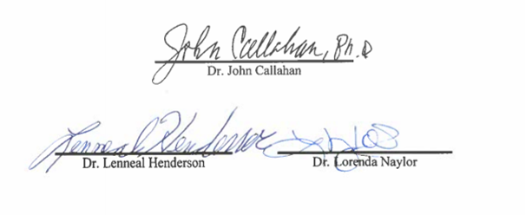
School of Public Affairs
University of Baltimore
Baltimore, Maryland 21212

November 12, 2018

Dedication
This dissertation is dedicated to my wonderful children, Christopher, Courtney, Conrad (CJ), Braeden, and Chanely, with a message to never give up. All dreams come true for those who have faith in God, dedicate themselves to hard work, and persevere, even in the face of the harshest adversity. I love each of you with all my heart and soul. A special dedication is made to CJ, my magnificent son who daily battles Leukodystrophy, a severe condition that leads to the abnormal development of the myelin sheath; you are always in my thoughts and prayers.

Acknowledgements
There are so many who I would like to thank, who have stood by me and had faith that I could somehow achieve the impossible. This has literally been a lifelong journey, and I owe so much credit to God, who blessed me with the capability, and my wonderful mother, Norma Sullivan, who has always stood by my side and believed in me. I would also like to thank my wife Diana for her patience and support, for enduring my neglect as I spent countless hours conducting research and writing.
God blessed me with a wonderful committee who absolutely exemplify the very essence of academic excellence and achievement. Dr. John Callahan, Dr. Lenneal Henderson, and Dr. Lorenda Naylor, I have the utmost level of respect for each of you and the contributions you have made to Public Administration and the University of Baltimore. I was humbled and remain exceedingly thankful for Dr. Callahan, who offered to chair my committee and helped put together a great team to assist me in realizing this dream; you have been a magnificent mentor in guiding me through this process, a consummate professional in the service of our nation, and I am exceedingly grateful for all you have done for me personally. Dr. Henderson, in addition to supporting me fully in this process, you also once made it possible for me to personally meet an actual King, Peggielene Bartels, King of Tantum, located in the Mfantsiman Municipal District of Ghana. Your professionalism is astounding; thank you for all the wisdom you’ve shared and your invaluable guidance. Dr. Naylor, you have been an extraordinary leader. We use a quote in one of our leadership programs that Tom Landry once defined leadership as “inspiring a group of men to do something that they do not want to do, to achieve something that they have always wanted to achieve.” Dr. Naylor, you have stood by me and inspired me to put in the hard work to achieve something I have always wanted to achieve, and I will be eternally grateful. I would not have realized this success without the genuine care and mentoring that you provided, and the manner in which you stood by me each step of the way; you gave me strength and inspiration to continue on this path of success. To my entire committee, your patience and guidance lifted me, and I will have a never-ending appreciation for each of you. Thank you!!!
I also thank and will forever keep in memory Dr. Phyllis McDonald, a former Professor at Johns Hopkins University, and also a valued member of my dissertation committee who passed away on June 28, 2018. Dr. McDonald was a personal friend who I have known for two decades. I once visited Dr. McDonald to inquire whether her program at Hopkins had a Doctoral program that would be a good fit for me. Dr. McDonald informed me that they did not yet have a program, but then offered me an invaluable recommendation; “check with the University of Baltimore” she advised, “they have a magnificent Doctoral program in Public Administration.” Thank you, Dr. McDonald, for your friendship; I have always enjoyed our conversations, and you will always hold a special part within my heart.

Abstract
The tragic events that transpired on September 11, 2001 (9/11), resulted in a myriad of changes within the United States that reshaped government agencies and created the Department of Homeland Security (Russell, Forest, & Moore, 2006, p. 112). A series of Homeland Security Presidential Directives (HSPD) were issued, including HSPD-5, Management of Domestic Incidents (GPO, 2008). HSPD-5 was implemented in phases and included the formulation of the National Incident Management System (NIMS), which is a new methodology that addresses and standardizes the manner in which emergency responders respond to and mitigate various types and levels of emergencies. Implementation included the financing needed for training, equipment, and exercises (FEMA, 2006).
Public transportation agencies are utilized as major elements in emergency planning within regions across the country, and are relied upon to be evacuation mechanisms for safety in time of turmoil and disaster; they have also been instrumental components in the mitigation of major incidents (APTA, 2007). Public transportation agencies have likewise been vulnerable to terrorist attacks over the past two decades (Council on Foreign Relations, 2006). Considering the vulnerability of public transportation to terrorism, and the fact they have been relied upon to aid in the preservation of life by evacuating citizens out of harm’s way, it would be natural to assume they would be key partners in the NIMS process. Utilizing a survey questionnaire, this evaluative research examines the attitudes and perceptions of transportation agency managers regarding how well they have been provided equipment, training, and financing needed for NIMS participation. It further examines collaboration efforts among public transportation agencies have to assess the integration as a NIMS partner. Key findings include the need for increased funding and training opportunities, along with the need for agencies to be more proactive in seeking funding and funding sources. Policy recommendations are identified to elevate NIMS participation and enhance national security.

Table of Contents

Dedication |  |  |  |  |  |  |  |  |  |  |  |  |  |  |  |  |  |  |  |  |  |  |  |  |  |  |  |  |  |  |  |  |  |  |  | ii
Acknowledgements |  |  |  |  |  |  |  |  |  |  |  |  |  |  |  |  |  |  |  |  |  |  |  |  |  |  |  |  |  |  |  |  |  |  |  | iii
Abstract |  |  |  |  |  |  |  |  |  |  |  |  |  |  |  |  |  |  |  |  |  |  |  |  |  |  |  |  |  |  |  |  |  |  |  | v
Table of Contents |  |  |  |  |  |  |  |  |  |  |  |  |  |  |  |  |  |  |  |  |  |  |  |  |  |  |  |  |  |  |  |  |  |  |  | vii
Chapters
1. Introduction |  |  |  |  |  |  |  |  |  |  |  |  |  |  |  |  |  |  |  |  |  |  |  |  |  |  |  |  |  |  |  |  |  |  |  | 1
 | Problem Statement |  |  |  |  |  |  |  |  |  |  |  |  |  |  |  |  |  |  |  |  |  |  |  |  |  |  |  |  |  |  |  |  |  |  | 3
 | Hypothesis |  |  |  |  |  |  |  |  |  |  |  |  |  |  |  |  |  |  |  |  |  |  |  |  |  |  |  |  |  |  |  |  |  |  | 5
2. Review of the Literature
 | Culture & NIMS Creation |  |  |  |  |  |  |  |  |  |  |  |  |  |  |  |  |  |  |  |  |  |  |  |  |  |  |  |  |  |  |  |  |  |  | 06
 | Public Transportation as an Important Element of NIMS |  |  |  |  |  |  |  |  |  |  |  |  |  |  |  |  |  |  |  |  |  |  |  |  |  |  |  |  |  |  |  |  |  |  | 13
 | Threats Against Public Transportation |  |  |  |  |  |  |  |  |  |  |  |  |  |  |  |  |  |  |  |  |  |  |  |  |  |  |  |  |  |  |  |  |  |  | 18
 | Uses of Public Transportation to Mitigate Regional Emergencies |  |  |  |  |  |  |  |  |  |  |  |  |  |  |  |  |  |  |  |  |  |  |  |  |  |  |  |  |  |  |  |  |  |  | 23
 | Transit Agency Funding & Size |  |  |  |  |  |  |  |  |  |  |  |  |  |  |  |  |  |  |  |  |  |  |  |  |  |  |  |  |  |  |  |  |  |  | 31
 | Logic Model |  |  |  |  |  |  |  |  |  |  |  |  |  |  |  |  |  |  |  |  |  |  |  |  |  |  |  |  |  |  |  |  |  |  | 33
 | Resilience & Coordination |  |  |  |  |  |  |  |  |  |  |  |  |  |  |  |  |  |  |  |  |  |  |  |  |  |  |  |  |  |  |  |  |  |  | 34
 | Importance of Public Transportation to American Infrastructure |  |  |  |  |  |  |  |  |  |  |  |  |  |  |  |  |  |  |  |  |  |  |  |  |  |  |  |  |  |  |  |  |  |  | 37
 | Crisis Leadership and the Importance to Public Transportation |  |  |  |  |  |  |  |  |  |  |  |  |  |  |  |  |  |  |  |  |  |  |  |  |  |  |  |  |  |  |  |  |  |  | 44
3. Methodology
 | Theory & Design |  |  |  |  |  |  |  |  |  |  |  |  |  |  |  |  |  |  |  |  |  |  |  |  |  |  |  |  |  |  |  |  |  |  | 57
 | Research Questions |  |  |  |  |  |  |  |  |  |  |  |  |  |  |  |  |  |  |  |  |  |  |  |  |  |  |  |  |  |  |  |  |  |  | 59
 | Mixed Methods Research |  |  |  |  |  |  |  |  |  |  |  |  |  |  |  |  |  |  |  |  |  |  |  |  |  |  |  |  |  |  |  |  |  |  | 59
 | Challenges |  |  |  |  |  |  |  |  |  |  |  |  |  |  |  |  |  |  |  |  |  |  |  |  |  |  |  |  |  |  |  |  |  |  | 60
 | Research Timeline |  |  |  |  |  |  |  |  |  |  |  |  |  |  |  |  |  |  |  |  |  |  |  |  |  |  |  |  |  |  |  |  |  |  | 61
 | Survey Design |  |  |  |  |  |  |  |  |  |  |  |  |  |  |  |  |  |  |  |  |  |  |  |  |  |  |  |  |  |  |  |  |  |  | 61
 | Critique of Survey Methodology |  |  |  |  |  |  |  |  |  |  |  |  |  |  |  |  |  |  |  |  |  |  |  |  |  |  |  |  |  |  |  |  |  |  | 64
 | Instrumentation |  |  |  |  |  |  |  |  |  |  |  |  |  |  |  |  |  |  |  |  |  |  |  |  |  |  |  |  |  |  |  |  |  |  | 66
 | Variables |  |  |  |  |  |  |  |  |  |  |  |  |  |  |  |  |  |  |  |  |  |  |  |  |  |  |  |  |  |  |  |  |  |  | 70
 | Methods for Establishing Validity & Reliability |  |  |  |  |  |  |  |  |  |  |  |  |  |  |  |  |  |  |  |  |  |  |  |  |  |  |  |  |  |  |  |  |  |  | 74
 | Ethical Considerations |  |  |  |  |  |  |  |  |  |  |  |  |  |  |  |  |  |  |  |  |  |  |  |  |  |  |  |  |  |  |  |  |  |  | 78
4. Results
 | Data Analysis Introduction |  |  |  |  |  |  |  |  |  |  |  |  |  |  |  |  |  |  |  |  |  |  |  |  |  |  |  |  |  |  |  |  |  |  | 80
 | Descriptive Analysis |  |  |  |  |  |  |  |  |  |  |  |  |  |  |  |  |  |  |  |  |  |  |  |  |  |  |  |  |  |  |  |  |  |  | 81
 | Descriptive Analysis Summary |  |  |  |  |  |  |  |  |  |  |  |  |  |  |  |  |  |  |  |  |  |  |  |  |  |  |  |  |  |  |  |  |  |  | 147
 | Inferential Statistics Analysis |  |  |  |  |  |  |  |  |  |  |  |  |  |  |  |  |  |  |  |  |  |  |  |  |  |  |  |  |  |  |  |  |  |  | 150
 | Summary of Quantitative Findings |  |  |  |  |  |  |  |  |  |  |  |  |  |  |  |  |  |  |  |  |  |  |  |  |  |  |  |  |  |  |  |  |  |  | 210
 | Qualitative Analysis |  |  |  |  |  |  |  |  |  |  |  |  |  |  |  |  |  |  |  |  |  |  |  |  |  |  |  |  |  |  |  |  |  |  | 225
 | Summary of Qualitative Analysis |  |  |  |  |  |  |  |  |  |  |  |  |  |  |  |  |  |  |  |  |  |  |  |  |  |  |  |  |  |  |  |  |  |  | 244
 | Qualitative Case Study |  |  |  |  |  |  |  |  |  |  |  |  |  |  |  |  |  |  |  |  |  |  |  |  |  |  |  |  |  |  |  |  |  |  | 245
 | Overall Data Analysis Summary |  |  |  |  |  |  |  |  |  |  |  |  |  |  |  |  |  |  |  |  |  |  |  |  |  |  |  |  |  |  |  |  |  |  | 271
5. Discussion
 | General Review |  |  |  |  |  |  |  |  |  |  |  |  |  |  |  |  |  |  |  |  |  |  |  |  |  |  |  |  |  |  |  |  |  |  | 275
 | Limitations & Weaknesses of the Study |  |  |  |  |  |  |  |  |  |  |  |  |  |  |  |  |  |  |  |  |  |  |  |  |  |  |  |  |  |  |  |  |  |  | 279
 | Implications of Findings |  |  |  |  |  |  |  |  |  |  |  |  |  |  |  |  |  |  |  |  |  |  |  |  |  |  |  |  |  |  |  |  |  |  | 280
 | Suggestions for Future Research |  |  |  |  |  |  |  |  |  |  |  |  |  |  |  |  |  |  |  |  |  |  |  |  |  |  |  |  |  |  |  |  |  |  | 281
 | Conclusion |  |  |  |  |  |  |  |  |  |  |  |  |  |  |  |  |  |  |  |  |  |  |  |  |  |  |  |  |  |  |  |  |  |  | 285
References |  |  |  |  |  |  |  |  |  |  |  |  |  |  |  |  |  |  |  |  |  |  |  |  |  |  |  |  |  |  |  |  |  |  |  | 286
Appendices
 | Appendix 1 – List of Figures |  |  |  |  |  |  |  |  |  |  |  |  |  |  |  |  |  |  |  |  |  |  |  |  |  |  |  |  |  |  |  |  |  |  | 298
 | Appendix 2 – Listing of Urbanized Transit Agencies |  |  |  |  |  |  |  |  |  |  |  |  |  |  |  |  |  |  |  |  |  |  |  |  |  |  |  |  |  |  |  |  |  |  | 305
 | Appendix 3 – Survey Analysis Tables |  |  |  |  |  |  |  |  |  |  |  |  |  |  |  |  |  |  |  |  |  |  |  |  |  |  |  |  |  |  |  |  |  |  | 323
 | Appendix 4 – Survey Questions |  |  |  |  |  |  |  |  |  |  |  |  |  |  |  |  |  |  |  |  |  |  |  |  |  |  |  |  |  |  |  |  |  |  | 360
 | Appendix 5 – Survey Results |  |  |  |  |  |  |  |  |  |  |  |  |  |  |  |  |  |  |  |  |  |  |  |  |  |  |  |  |  |  |  |  |  |  | 363
 | Appendix 6 – University of Baltimore IRB Exemption Letter |  |  |  |  |  |  |  |  |  |  |  |  |  |  |  |  |  |  |  |  |  |  |  |  |  |  |  |  |  |  |  |  |  |  | 385

Introduction
Thick, black clouds of smoke engulfed the morning skies of September 11, 2001, in arguably two of the most powerful cities in the world: Washington DC and New York City. Ashes rained high above from the raging fire and explosions caused by the crash of four commercial airliners, which were converted to weapons by the brutality of modern-day terrorism. Thousands of victims died during the events of 9/11, such as two and half year old Christine Lee Hanson, a beautiful two year old girl aboard United Flight 175. A stuffed animal that once belonged to Christine has since been donated by her family to the Federal Law Enforcement Training Centers (FLETC) campus in Brunswick, GA, and is encased in a memorial, along with a portrait of young Christine, inside the mock airport used by Transportation Security Administration (TSA), Federal Air Marshals (FAM), and other federal, state and local agencies that might train at the FLETC facility.
America was attacked on her homeland soil by an enemy in an event rivaled only by the December 7, 1941, attack on Pearl Harbor that ushered America into World War II (Russell, Forest, & Moore, 2006, p. 5). America was served notice that her ideals of freedom and democracy were hanging in the balance by a ruthless foe with barbaric and brutal strategies and complete disregard for civilian human life. With the exception of the Pentagon, which was in fact a military target, the enemy had also struck two high-rise business towers used for finance, law, transportation, television, and a myriad of other types of civilian business (Wall Street Journal, 2001). The World Trade Center was simply a symbolic target without regard to the civilian human life utilizing the facilities, nor the civilian human life, such as that of young Christine, on the four jet-liners used in the attacks, which includes the one foiled attempt in Pennsylvania.
The attack on Pearl Harbor led to American involvement in World War II (History, 2015). Following the war, the United States experienced a reorganization of the military with the adoption of the National Security Act of 1947 which created the Department of Defense (DoD) and the establishment of the United States Air Force (Department of Defense, 2015). Whereas the attack on Pearl Harbor and the subsequent entry into World War II seemingly impacted the creation of the DoD, the attacks of 9/11 led to a government re-organization with the adoption of the Homeland Security Act (Public Law 107-296) which later created the Department of Homeland Security. Several Executive Orders were created as a result, in the name of Homeland Security Presidential Directives, which included one such policy (implemented on February 28, 2003) mandating the Management of Domestic Incidents, better known as Homeland Security Presidential Directive 5 (HSPD-5) (Government Printing Office 2003, 229).
This evaluative research, through a mixed methods approach, evaluates the “trends, attitudes, and opinions” (Creswell, 2009, p. 12) of public transportation managers y to answer the hypothesis, in the attitudes of public transportation managers, whether their agencies have been included in the HSPD-5 implementation plans at various governmental levels ( State or local: county, city, or township). This research measures whether public transportation manager’s perceptions on agency funding, training, and equipment, and exercising necessary to be a recognized regional element within HSPD-5. Training in this context is the learning of a skill whereas exercise participation is the practice of the skills learned or previously acquired. Specifically, this research tested the hypothesis if public transportation agencies, in the attitudes of their managers, have been, 1) appropriately included (in regards to collaboration, training and exercises), and 2) appropriately funded (in regards to receiving the funds and equipment necessary), to be a recognized element within the NIMS program, as mandated by HSPD-5. This question is critical given the significance of national security and the lack of research on this issue in public administration. The terms “appropriately funded” and “appropriately included” are defined later in the Hypothesis section.
The audience for this research includes professionals within the public transportation industry who act in an emergency management, security, and/or safety role, government law-makers, emergency managers within federal, state, county, city, or township settings, and students and scholars of emergency management, safety and security. The hope is that this research will create and/or foster forward thinking for emergency management professionals to look through a different lens at HSPD-5, if they are not already doing so, to ensure public transportation agencies within their jurisdiction are afforded the attention and funding required to ensure full HSPD-5 compliance. The indispensable essence of this research is to ensure that public transportation agencies in the United States are fully prepared, educated and equipped to handle natural and manmade disasters, intentional and unintentional (accidental and natural disasters), that they may encounter in today’s environment. The hypothesis, tests whether or not public transportation agencies are the forgotten element in NIMS.
Problem Statement
Public transportation agencies are critical in national security and emergency management. This includes: 1) emergency planning; 2) evacuation of residents and area employees to safety in times of disaster; 3) transportation of victims to medical facilities during mass casualty events; 4) use of buses as blockades during demonstrations or as prisoner processing vessels during mass arrest situations; 5) a myriad of other uses; , which may not be fully regarded as important elements of the NIMS process within their corresponding region. The literature review section will illustrate examples of how public transportation has been widely attacked in other areas of the globe by terrorists, and targeted within the United States as evidenced by arrests in New York City and Washington, DC, which highlights the need for public transportation agencies to be fully prepared and integrated within the NIMS planning and preparation, and Incident Command Structure (ICS) of major events.
HSPD-5 included a requirement for federal funding to ensure the implementation and ongoing success of the program. HSPD-5 was created to ensure the mass of nationwide emergency responders, including fire, medical, law enforcement, public health, and utilities, are appropriately prepared to handle a myriad of natural and manmade disasters. Public transportation agencies, considering their vulnerability, should be considered within regional planning funding requirements and collaboration in terms of training, equipping, and overall preparedness.
Public transportation agencies, many of which house their own police and/or emergency management departments, are crucial elements in a city, township, or even a state’s emergency management operations and plans and should be considered full, active partners in regards to HSPD-5 (APTA, 2007). They are key components in the evacuation of citizens in cities, counties, and regions across the country (APTA, 2007) during natural disasters such as hurricanes, flooding, fires, tornadoes or national security. They are used as vessels to evacuate zones of danger and move personnel out of harm’s way to areas of safety (APTA, 2007). Additionally, they have themselves been targets of terrorist attacks over the past two decades, thus illustrating their vulnerabilities and the risks of which they are exposed to on a daily basis (Council on Foreign Relations, 2006). Finally, public transportation agencies have repeatedly been utilized to assist in the mitigation of major events across the country, and could have been used in the hurricane Katrina disaster in New Orleans, in which the absence of public transportation utilization added to the failures of that overall response (Olsen, 2005).
Hypothesis
The hypothesis of this research is that the attitudes and perceptions of public transportation manager, their respective agencies have not been appropriately included and funded as a recognized element within HSPD-5. The term “appropriately funded” is defined as how well the agency has been funded to either prevent, or be fully prepared for, and be active participants in an Incident Command Structure to respond to, and assist with the mitigation of a myriad of emergency situations that could arise in today’s environment. Funding includes training and equipment to participate in real world events and exercises. The term “appropriately included” is defined as how well other agencies, such as law enforcement, fire & rescue, public health, emergency management, and other agencies, collaborate with public transit and how well they are included within emergency plans, mandates, procedures, training, and exercises.

Review of the Literature
A literature review was conducted using the following methodology. The University of Baltimore, Langsdale Library databases ABI/INFORM Global and JSTOR were accessed and the following terms were inserted into the query: “culture”, emergency management, FEMA, HSPD-5, FIRESCOPE, and crisis management. The following dates were included: 2000 to 2018. In addition, fugitive or gray literature (government reports, fact sheets, etc.) were included and accessed utilizing the following search engines: Department of Homeland Security, Federal Emergency Management Agency, Government Accountability Office, Transportation Security Administration, Federal Transit Administration, and Department of Transportation. The literature review below represents a synthesis of these articles and reports. The literature review is organized by the following subjects: culture; creation of NIMS; the importance of public transportation to American infrastructure; importance of public transportation within NIMS; threats against public transportation; uses of public transportation to mitigate various types and levels of emergencies; transit agency funding and size; logic model; resilience and coordination; and crisis leadership.
Culture & NIMS Creation
Although mostly invisible, culture is critical to an organization. Schein defines it as “the accumulated shared learning of [a] group as it solves its problems of external adaptation and internal integration; which has worked well enough to be considered valid and, therefore, to be taught to new members as the correct way to perceive, think, feel, and behave in relation to those problems…this accumulated learning is a pattern or system of beliefs, values, and behavioral norms that come to be taken for granted as basic assumptions and eventually drop out of awareness” (Schein, 2017, p. 6). This definition suggests that culture absorbs into and becomes the character of the organization, with a deeply developed root structure. Anne Khademian, author of Working with Culture, describes culture as the “common understandings held by people working together in an organization or program as commitment…together, commitments and the numerous ways in which they are manifest form a culture [which gives] a sense of how the job gets done” (Khademian, 2002, p. 3).
Khademian describes the essence, or “bedrock” of culture being formulated by a three-layer theoretical framework established by Edgar Schein, consisting of artifacts, values and beliefs, and basic assumptions (Khademian, 2002, p. 18). Artifacts consist of the first layer of this framework, and are those tangible articles and observable elements of an organization, described as “language used, stories told, ceremonies performed, rewards given, symbols displayed, heroes remembered, and history recalled” (Khademian, 2002, p. 19). The second layer consists of the values and beliefs of the organization. Just as individuals have personal values and beliefs, the same holds true of organizations. It is these values and beliefs that determines the belief system of the organization and how the organization will actually behave in given circumstances. Khademian describes this “middle” layer as “what members believe ought to be in the work of the organization and that ideologies, attitudes, and philosophies are found within this layer” (Khademian, 2002, p. 19). The innermost layer, at the core of this framework, consists of the basic assumptions of the organization, the deepest beliefs that “motivates behavior” and at which you arrive and understand only after having already traversed through the other two outermost layers (Khademian, 2002, p. 19).
The culture of emergency response organizations had differences in their basic assumptions prior to the events of 9/11, which required change. Agencies had over time worked in silo type of environments, in which collaboration and sharing of responsibilities was not common. Regarding the events of 9/11, this will be described further within the literature review, from information contained within the 9/11 Commission Report. One such example prior to 9/11, as described by Khademian, James Lee Witt was appointed by President Clinton to head the Federal Emergency Management Agency (FEMA). Witt was instrumental in formulating change within FEMA, but only after he discovered via various methods that the agency “had a lot of little agencies internally [that] did not work together…. they did not coordinate together [which] was a tremendous waste of time and talent [that] Witt referred to as stove piping” (Khademian, 2002, p. 69). Donahue and Zecherhauser describe within their book Collaborative Governance the need for collaboration and the breaking down of this stove piping tendency. They describe two “motives for collaboration” by stating that even though there are “many reasons to pursue a collaborative approach to government’s missions…most of them can be summarized as the search for better outcomes, or more resources, or both” (Donahue & Zeckhauser, 2011, p. 35). It is of dire importance during a critical incident that emergency responders collaborate, and that all responding entities look upon the task at hand as a unified problem with which they all share a responsibility. Breaking down this stove piping tendency of working in silos, and changing the mindset that the problem at hand belongs within the responsibility of another governmental body or entity, is crucial to creating better outcomes. It is furthermore crucial to the integration of emergency managementpersonnel, and the sharing of resources, and is therefore crucial to the preservation of property and lives.
There is a divide, however, in the literature on culture. Proponents argue that culture can be changed while opponents argue culture cannot be changed. Khademian explains that skeptics argue organizational culture is not “manageable” and that it is the “numerous factors outside of an organization or program [that] can influence the way the job gets done” (Khademian, 2002, pp. 24-25). Khademian illustrates a cultural roots model in how cultural change can take place under sound leadership. The implementation of HSPD-5 was in fact an outside influence that changed the way emergency responders around the country would eventually respond to emergency situations, and it deeply changed the culture of those organizations as it pertains to emergency response. Law enforcement arguably had the largest void to fill, considering the framework for such response was taken from a proven fire department strategy (Jamieson, 2005), and this change within law enforcement had to be a top-down effort change effort. The fire department, which had already been utilizing a NIMS type of modal, likewise had to become acquainted with working alongside law enforcement and other agencies as Incident Command Structures were formulated under the HSPD-5, NIMS mandates (Jamieson, 2005).
Absent a nationally standardized plan, with no formalized federal guidance to aid in the preparation and response to critical incidents or the training of first responders to act in an orchestrated manner (prior to the implementation of HSPD-5), the terrorist attacks of September 11, 2001, illustrated the weaknesses and deficiencies of our emergency responders during times of turmoil. The 9/11 Commission stated that the first responders in New York City, “Did their best to cope with the effects of an unimaginable catastrophe – unfolding furiously over a mere 102 minutes – for which they were unprepared in terms of both training and mindset” (9/11 Commission, 2004, p. 315). The events of 9/11 uncovered a critical problem of responders not being appropriately prepared, and lack of interoperability. Homeland Security Presidential Directive 5 (HSPD-5), Management of Domestic Incidents, was intended as the resolution to confront those types of hindrances to incident management.
A Homeland Security Presidential Directive (HSPD) is similar in scope to an executive order and is primarily directed toward the Department of Homeland Security (DHS). HSPDs come with the endorsement and recommendations of the Homeland Security Council (HSC) to implement Homeland Security orders of the President. President George W. Bush “issued the first instrument in a new series denominated Homeland Security Presidential Directives (HSPDs) that shall record and communicate presidential decisions about the homeland security policies of the United States.” (Relyea 2003, 9). It was, however, an Executive Order (E.O. 13228) that first established the Office of Homeland Security, which obviously later became the DHS, and it was the same Executive Order that eventually led to the creation of the HSC (Federation of American Scientists 2001).
HSPD-5 was adopted and implemented in an effort to simplify and organize incident command structures during emergency management situations, whether they are natural or manmade disasters or ongoing incidents or events. The Federal Emergency Management Agency (FEMA) describes that the purpose of HSPD-5 is to accomplish the following mandates:
“prevent, prepare for, respond to, and recover from terrorist attacks, major disasters, and other emergencies, the United States Government shall establish a single, comprehensive approach to domestic incident management. The objective of the United States Government is to ensure that all levels of government across the Nation have the capability to work efficiently and effectively together, using a national approach to domestic incident management” (Federal Emergency Management Agency 2003).
The Federal Emergency Management Agency (FEMA) noted that prior to 9/11 there had “been no standards for domestic incident response that reached across all levels of government and response agencies” (FEMA 2004, 1-3). Thus, a nationally coordinated framework among emergency responders had never been established preceding the brutal attacks of 9/11. Emergency responders were never before given federal guidance on how to collaborate with one another before an incident and then respond together as one team in the mitigation of natural and man-made disasters.
The closest resemblance to HSPD-5 that existed prior to 9/11 was the existence of “FIRESCOPE” which was formed in the 1970’s as a result of “devastating wildfires in California” which later progressed into a nationwide strategy within the firefighting industry (Jamieson 2005). Coincidently, the FIRESCOPE model and framework was used to create the HSPD-5, NIMS Incident Command System (Jamieson 2005). Therefore, it was an ideology of firefighters that eventually changed the culture in how emergency and disaster scenes are managed by emergency responders of all categories in the United States.
Prior to the events of 9/11, there were individual jurisdictions which had collaborated with one another and coordinated various plans among their first responders. Two such locations that had begun collaboration efforts among emergency responders, to include public transportation agencies, were New York City and Washington, DC. Within these areas, interoperability and incident command policies and training were already underway prior to 9/11. The 9/11 Commission points out that Mayor Giuliani revised the “Direction and Control of Emergencies in the City of New York” directive to designate “for different types of emergencies, an appropriate agency as Incident Commander…responsible for the management of the city’s response to the emergency” (9/11 Commission 2004, 319).
Likewise in Washington, DC, which contains a wide array and large number of federal, state and local agencies, there had also been established criteria and collaboration brought about through the local Council of Governments (COG) on the manner in which agencies respond to emergencies within the region. The 9/11 Commission commended the DC region in their response and mitigation efforts toward the Pentagon attack by stating “it overcame the inherent complications of a response across jurisdictions because the Incident Command System, a formalized management structure for emergency response, was in place in the National Capital Region on 9/11” (9/11 Commission 2004, 314). The Commission further pointed out that “the emergency response at the Pentagon represented a mix of local, state, and federal jurisdictions and was generally effective” (9/11 Commission 2004, 314), but it is unclear whether those specific actions were largely voluntary and uncoordinated, or preplanned contingency responses.
Agencies such as those in DC and New York had reached and achieved such outcomes through memorandums of understanding, joint training, and/or other modes of collaboration. As pointed out by FEMA, however, no national plan had ever been put into place to incorporate and include agencies from different disciplines, as well as agencies from the various levels of government. FIRESCOPE was earlier mentioned as the framework used to develop the Incident Command Structure requirement of HSPD-5, but it is likely New York City and Washington, DC, were also used as models for other characteristics of HSPD-5.
Public Transportation as an Important Element of NIMS
HSPD-5 was primarily directed toward the major fire, public health, and police agencies in the metropolitan cities, counties, and townships across the country, to include federal and state agencies. However, many public transportation agencies which employ their own police and emergency management staff are critical elements in the emergency preparedness plans of a state, county, city, town, or region. As an example of this argument, the Washington Metropolitan Area Transit Authority (WMATA), Washington, DC, stated in December 2001 that on the day of the 9/11 attacks "MetroBus, MetroRail and MetroAccess operated a near flawless, back-to-back rush hour when Washington, DC was evacuated” and continued “with the specter of terrorism a continuing reality, the Metro system is a crucial element in the region’s emergency preparedness" (WMATA, 2001). The Washington Post additionally stated in a published timeline, in regards to the events of 9-11:
“District of Columbia government shut down and ordered nonessential personnel to leave, and many private firms closed and sent employees streaming home, jamming the subway and roads….The federal government closed all of its facilities around Washington at 10:30 a.m. and told the region's 340,000 federal employees they could leave at their discretion….The Metro system remained open except for the Pentagon stop” (Vobejda, 2011).
WMATA helped ensure that Washington, DC, was effectively evacuated on a terrifying day in our nation’s capital, even when requested to “shut down operations” by the Metropolitan Police Department Command Center due to “hijacking threats” (911 Digital Archive).
The WMATA example is one of success, describing a public transportation agency that was well trained and prepared prior to the events of 9/11 and prior to the implementation of HSPD-5. After the implementation of HSPD-5, during the infancy stages of development that consisted of the training and equipping stages, New Orleans endured the devastating forces of Hurricane Katrina. New Orleans officials failed their own emergency plans to utilize public transportation during the eve of Katrina, and failed to move public transportation conveyances to higher ground from known flood areas, which was a pre-arranged plan. According to the Houston Chronicle,
“City officials had 550 municipal buses and hundreds of additional school buses at their disposal but made no plans to use them to get people out of New Orleans before the storm, said Chester Wilmot, a civil engineering professor at Louisiana State University and an expert in transportation planning, who helped the city put together its evacuation plan. Instead, local buses were used to ferry people from 12 pickup points to poorly supplied "shelters of last resort" in the city. An estimated 50,000 New Orleans households have no access to cars, Wilmot said” (Olsen, 2005).
These two examples illustrate the importance of a public transportation agency in the emergency management plans of a state, county, city, or a local township. As the article above illustrates, 50,000 New Orleans households had no access to a car. Across our country there are those who have no access to personal transportation and rely completely on public transportation. When regions fall under emergency situations, these are the many that will rely fully on the aid of public transportation to get them out of harm’s way and into an envelope of safety. Henderson explains in his article concerning the emergency and disaster risk in developing nations that, “in 1998, some 96% of disaster related deaths occurred in developing counties, were the poorest of the poor are hit hardest (Henderson, 2004, pp. 103-104). Similarly, as in New Orleans, those who rely mostly on public transportation for evacuation are seemingly those who are the poorest of the poor in our American cities and regions.
As illustrated in the book Managing Crisis, in regards to the emergency planning for hurricanes in the State of Louisiana, “the state plan assumed that the primary means of hurricane evacuation will be personal vehicles, although school and municipal buses and other government owned vehicles may be used to evacuate those who had no means of transportation” (Howitt & Leonard, 2009, p. 20). Adding to the Henderson comment above regarding the poorest of the poor being hit during an emergency, Cigler similarly stated stat “if you are poor, sick, disabled, elderly, homeless, confined to a nursing home or prison, unmarried with children, or a tourist, you have special needs and are nearly always hit harder than other segments of society by a disaster (Cigler, 2007, p. 67).
The New Orleans ill-prepared evacuation strategies and failure to use public transportation, and the force of Hurricane Katrina, together provided the perfect storm to strand thousands of needy residents. The city had a plan, an annex, as illustrated by Howitt and Leonard, which included a “Hurricane Evacuation Standard Operating Procedure” (Howitt & Leonard, 2009, p. 20). However, not all plans are as concrete as they should be, as was the case in New Orleans. Howitt and Leonard continued “the annex itself, provided few specifics on how it would achieve its ends” and stated that “special arrangements would have to be made to evacuate people unable to transport themselves or who require specific life-saving assistance….but was silent on what those arrangements would be” (Howitt & Leonard, 2009, p. 22). This is what makes NIMS so important in times of emergency and crisis management, and why transportation is so critical to the mitigation efforts. Had NIMS been appropriately implemented, with the inclusion of public transportation, the planning, training, exercising, and equipping, needed to evacuate needy residents of New Orleans would have been extremely valuable. The transit agency in New Orleans, the Regional Transit Authority, was included in the city plan to supply “transportation as needed and dispatching evacuation buses, but [the plan] provided no further details” (Howitt & Leonard, 2009, p. 22). The results of an ill-prepared city in their failure to use its’ public transportation resources to evacuate a city facing a ferocious storm were simply devastating.
Public transportation can be used by police personnel to transport cops and hospital staff to the scenes of destruction and victims away from such areas and buses can also be used as barricades to block streets or other passages to assist in crowd control. Henderson explains that “the stockpiling of emergency supplies, the training of medical, security, and transportation personnel, and the conduct of drills or disaster simulations are examples of mitigation activities (Henderson, 2004, p. 107). According to the American Public Transportation Association (APTA), “terrorism response in major evacuations of urban areas, only public transportation has the capacity to move millions of people quickly and to give critical support to first responders by delivering emergency equipment and transporting emergency response personnel” (APTA, 2007, p. 8). This writer can personally illustrate an additional scenario in which WMATA parking garages were used to temporarily house flood victims after a major flood in Alexandria, VA, on June 25-26, 2006, as well as the Command Post to keep the police and firefighters out of the elements while managing the crisis. According to the Fairfax County, Huntington Flood Damage Reduction Study, 160 of the homes within the Huntington area, nearest the Potomac River, sustained flood damages (Engineers, 2009). APTA also points out several other events in which Public Transportation was used as emergency vessels, such as in New York and Shanksville, PA, during the 9-11 attacks where “transit buses shuttled police, fire and construction workers to emergency sites” and following the 1989 Loma Prieta earthquake in San Francisco in which “the Bay Bridge was closed for a month….BART carried 75 percent of trans-bay commuters—up from 35 percent before the bridge closed—helping avert a major economic disruption” (APTA, 2007, p. 8).
Transportation, however, did not just fall into a mode of need in regards to emergency management and mitigation. Transportation was an element recognized from the start in the National Response Plan. Per the National Response Plan of 2004, the Department of Transportation is the Emergency Support Function (ESF) Coordinator and Primary Agency in the Transportation ESF, and a Support Agency in several others, to include the Emergency Management and Resource Support ESFs (Department of Homeland Security, 2004, p. ESF vi). Falling within the Department of Transportation is the Federal Transit Administration, which oversees the public transportation network within the country. The specifics of the FTA and their role in public transportation safety, security and emergency preparedness will be covered in more detail later within this literature review.
Threats Against Public Transportation
Threats can be directed toward public transportation in two different approaches, from either intentional or unintentional danger. The FTA Transportation Safety Institute (TSI) defines security as “freedom from intentional danger for passengers, employees, and the system” and distinguishes it from safety which is the “freedom from unintentional danger” (FTA/TSI, 2017, pp. 2-3). The TSI Transit System Security course in which this description is found, describes that intentional danger includes terrorism, crime, and/or any type of danger that is intentionally inflicted upon a transit agency, it’s patrons, or resources. The program further explains that those dangers that are not intentionally inflicted, such as industrial accidents, traffic accidents, natural disasters, etc., are in lieu of being security issues, rather considered unintentional dangers and therefore more in the realm of safety and emergency preparedness issues. This research and the accompanying survey looked through the lenses of both, intentional and unintentional dangers and the ability of public transportation agencies to mitigate each.
Terrorism against public transportation remains a worldwide issue and concern. The Washington Post published a story in September 2017 asking the very specific question “is it even possible to protect a public transit system from terror?” (Erickson, 2017). The story was written in response to yet another attack against public transportation in London, two of which will be highlighted. The Washington Post story vividly asks the question if it is even possible to protect a public transit system from terror, which should be at the forethought of every security expert responsible for the safety and security of public transit venues across the country, and around the world. It is absolutely prudent for security experts to consider the fact that it may not be possible while they in-turn take on the enormous challenge of discovering creative techniques which do just that, protect public transit infrastructure, personnel and patrons against the ever changing and brutal acts of terrorism. As important, is the question whether or not the agency and region is prepared to mitigate an act of terrorism in those times that they may fail to prevent such an act from occurring.
The vulnerability of public transportation agencies also indicates another reason in which public transportation agencies should be primary partners in the NIMS process. Over the past two decades, there have been attacks against public transportation in Tokyo (March 20, 1995), Madrid (March 11, 2004), London (July 7, 2005), Mumbai (November 26, 2011 and July 11, 2006), and several incidents in Russia during 2003, 2004, and 2010. The Tokyo attack, in which the “highly toxic nerve gas sarin was released…resulted in the deaths of 13 people and some 5,500 others injured” (Encylopaedia Britannica). The 2004 Madrid train bombings, which were “coordinated near-simultaneous attacks [left] 191 dead and more than 1800 injured” (Encyclopaedia Britannica). The 2005 London train bombings were also “coordinated suicide bomb attacks….killing 39. An hour later 13 people were killed when a bomb detonated on the upper deck of a bus…..more than 700 people were injured in the four attacks” (Encyclopaedia Britannica). These are only a few of the most recognized events which received worldwide exposure, and only include attacks primarily against rail. Attacks against bus service around the globe have also been concerning and will also be more fully described during the literature review portion of the research. These attacks signify not only to the possibility, but the probability of public transportation being targeted worldwide. Considering such, it would potentially be a disastrous error to ignore public transportation in emergency and crisis management, and mitigation plans of a city, county or region.
Terrorism and violence has not only been pointed at public transit rail modes of service, but also bus services. The Times of Israel published an article in February 2016 that suggested “in recent months, Hamas officials have openly called for a resurgence of suicide bombings against Israelis….specifically on buses” (The Times of Israel, 2016). Buses, in fact, have been popular targets of choice for a very long time not only in Israel, but many other places around the world, as has been demonstrated repeatedly by various news stories and events. Bombings are not the only form of attack seen on buses. Buses operating within El Salvador have recently fallen victim to gangs, most notably MS-13, to extortion and murder. According to the NY Times, “Among Salvadoran businesses, transportation companies, whose vehicles crisscross gang territory, have proved especially vulnerable to extortion. Over the last five years, it has been more dangerous to drive a bus than to fight gang crime: The gangs have killed 692 transportation workers — and 93 police officers” (Martinez, Lemus, E., Martinez, & Sontag, 2016). According to the article, many transportation agencies have assigned roles to employees to actually negotiate with these gangs because the extortion and accompanying payments have become so unexceptional. In one particular case, a rival gang of MS-13, the 18th Street Gang, sent a note to a transportation agency that stated, “look, we’re not joking around….get something together. If not, we are going to burn one of your new minibuses” (Martinez, Lemus, E., Martinez, & Sontag, 2016). Terrorism is a tremendous threat to public transportation in general, but in many places such as El Salvador and surrounding countries in Central America, there are other violent criminal threats taking place just as costly and deadly as terrorism.
There have been other recent events, not directly targeting public transportation, but which have impacted public transportation. The Dallas, TX, police ambush shooting that occurred on July 7, 2016, is one of those cases. The shots of an assault rifle put into chaos a peaceful Black Lives Matter protest on that day which claimed the life of a Dallas Transit Police Officer. According to a CBS News timeline of events, just before 9:00pm, Micah Xavier Johnson parked his SUV and “stepped out and put on a body armor vest [and was] armed with a semi-automatic assault rifle along with a handgun” (New, 2017). According to the news report, Dallas Police Chief David Brown said, “The suspect said he was upset at white people [and] he wanted to kill white people, especially white officers” (New, 2017). The article and general information reported about the shooting from multiple news outlets indicated that the shooter was upset over recent police incidents in which minorities died by the deadly force used by police. Johnson, after shooting several other officers, managed to maneuver himself into a position where he was able to shoot Dallas Area Rapid Transit (DART) Police Officer Brent Thompson in the back. Video illustrated that Johnson, after shooting Officer Thompson, then stood over the slain officer and shot him several other times (Associated Press, 2016). Five police officers total were killed in the shooting, along with seven additional officers who survived gunshot wounds. Four of the twelve officers shot, including Officer Thompson, were from the DART Police Department.
DART Police, according to their website, “was established in 1989 as part of the transit agency’s mission to operate a safe system….DART Police officers are licensed peace officers of the State of Texas who have all the rights, privileges, obligations, and duties of any other peace officer in the state of Texas while on the property of under the control of DART or in the actual course and scope of the officer’s employment” (Dallas Area Rapid Transit, 2018). DART’s website also describes the purpose of the DART Police to “safeguard DART, its customers, and employees by providing police services throughout DART's transportation system” (Dallas Area Rapid Transit, 2018).
The night of July 7, 2016, DART Police officers were on duty and protecting the interests of the DART transportation system during the peaceful demonstration of the Black Lives Matter movement. DART Police, however, were not the only DART employees engaged during and after the event. According to Fox 4 News, a DART Bus Operator, Donald Washington, observed the assailant park his SUV prior to the first shots taking place, and investigators have taken video recordings from the bus “to help piece together a timeline of the suspect’s movements” (Rabb & Chen, 2016). The news report further stated that Washington and other DART employees reported to area later as “DART scrambled to organize transportation to get people out of the area” (Rabb & Chen, 2016). Washington stated that after the shooting, he reported to a “tense scene at the 7-11 [where] it was a very tense situation….tempers were boiling” but he completed “several trips” (Rabb & Chen, 2016) to help bring a sense of calm to the area.
The Dallas Police Shooting ambush was just another of a long list of examples of a public transportation agency working alongside emergency first responders in mitigating a dangerous situation. DART Police personnel were severely, and in one case fatally injured while attempting to protect not only DART resources, but life and property in general. DART bus services were instrumental in responding during the aftermath to clear out rioters to help police bring about the restoration of peace in a scene of chaos, and as described by Bus Operator Washington, one in which rioters were “taunting at officers….officers [who were] just standing there with their rifles [not] blinking or winking” (Rabb & Chen, 2016).
Uses of Public Transportation to Mitigate Regional Emergencies
There have been many instances in which public transportation has been used to help in the mitigation of emergencies, whether it is by virtue of actually being included in regional plans and being called upon out of simplistic heuristic thinking, or otherwise called upon by local emergency responders out of a more systematic critical thinking occurrence. More will be covered later regarding the differences between the two, along with four foundations of crisis leadership. A couple of examples have already been provided, to include the use of WMATA resources in Washington, DC, during the events of 9/11 and the use of DART resources after the active shooter situation in Dallas. A couple other well-known incidents will be covered here to again illustrate what most people do not realize; public transportation is often instrumental in the mitigation of emergency incidents, whether they be from intentional or unintentional danger.
Las Vegas became the scene of one of the bloodiest shootings in American history on October 01, 2017. The shooter, Stephen Paddock, positioned himself in a room on the 32nd floor of the Mandalay Bay Hotel, overseeing the South Las Vegas Boulevard. Paddock, after breaking out the windows of the hotel, began to fire numerous rounds from both automatic and semi-automatic rifles into a crowd of concert spectators of the Route 91 Harvest Music Festival which was taking place across the street along the boulevard. According to Fox News, Paddock “fired more than 1,100 rounds when he killed 58 people and injured more than 500 others [in the] deadliest mass shooting in modern history” (Associated Press, 2017). The story further stated that the shooter had within the hotel suite approximately 4,000 rounds that were not fired. According to the Las Vegas Review-Journal, “first responders descended on the scene….civilians did their part too, taking truckloads of wounded to local trauma units” (Crosby, Brean, H., Hassan, A., Munks, J., & Bekker, J., 2017); public transportation, as illustrated below, also did their part.
Local citizens and first responders were not, however, the only ones to jump into action. Bus Operators from the Regional Transportation Commission of Southern Nevada (RTC) also assisted in the evacuation of injured to local hospitals. Art Marroquin of the Las Vegas Review-Journal wrote two articles in regards to RTC efforts. Marroquin was telephonically interviewed for this study by this writer, and verified the written account of his articles, but could not provide any information in regards to whether RTC was used in any official capacity, per actual emergency planning guidelines and mandates, in the area evacuation. An anonymous source at RTC was later telephonically interviewed by this writer who stated that RTC personnel were called out immediately to assist in staffing the Multi-Agency Command Center, where RTC has a permanent and fixed seat at the table, for real world events and exercises alike. The source stated that RTC assisted in not only transporting injured victims to hospitals, but non-injured out of harm’s way to other temporary facilities for transportation and police services. RTC was also instrumental in fueling emergency response vehicles, to include SWAT vehicles, such as the Police Bearcats (Ballistic Engineered Armored Response Counter Attack Trucks). According to the source, RTC is responsible via emergency management plans in providing as much as 70% of their fleet to mitigate the myriad of emergency situations that might arise in the Las Vegas/Clark County area.
Marroquin, in two Las Vegas Review-Journal articles, credited RTC Bus Operators for their roles in evacuating the shooting scene. Richard Kuna, according to one of the articles, was on duty and stopped at a red light when shooting victims began to pound “on the door of his bus, begging to get in” (Marroquin, 2017). Kuna reportedly transported approximately 50 concert patrons to an area on Tropicana Avenue where he was directed to drop the passengers off. A second Bus Operator, Antonio McLandau, a new employee with only two months of service time, became involved “when his public bus was transformed into an oversize ambulance” (Marroquin, Bus driver ferried Las Vegas shooting victims to the hospital, 2017). McLandau was not even aware, according to the story, that a shooting had even taken place when he came up on a group of people in the roadway that he assumed were intoxicated, which is a normal occurrence in Las Vegas. After discovering what was occurring, McLandau, at the request of Metropolitan Police and after notifying bus dispatch, “with no sirens or flashing red lights….calmly drove about 20-30 people suffering from gunshot wounds from the Route 91 Harvest Festival to Desert Springs Hospital Center” (Marroquin, Bus driver ferried Las Vegas shooting victims to the hospital, 2017).
The Las Vegas shooting was another situation in which public transportation was needed and used in the mitigation of a deadly situation, and the preservation of life. Buses were used to transport uninjured patrons out of harm’s way, and were also used as ambulances to transport actual shooting victims to local hospitals. According to Marroquin, even though he was unsure whether it was due to an actual emergency plan, did report that “Keolis and MV Transportation, which operate the RTC buses, dispatched more than 20 drivers to help evacuate people from the area surrounding the concert venue [and according to] Keoplis spokesman Bill Marion, everybody remained cool and collected and did their job” (Marroquin, 2 bus drivers praised for helping people flee Las Vegas shooting, 2017).
As illustrated in other events across the country, such as Washington, DC, and Boston, MA, which are illustrated within this study, buses have been used on numerous occasions for both the treatment and transport of various types of victims, from natural disasters, industrial accidents, and/or man-made types of disasters and attacks. Regarding the Las Vegas shooting, General Manager Tina Quigley of RTC commended the drivers and commented that they were “the very definition of Vegas Strong” (Marroquin, 2 bus drivers praised for helping people flee Las Vegas shooting, 2017).
April 15, 2013, brought about a day in which intentional danger was brought on the spectators and participants of the Boston Marathon. In the early afternoon, two homemade backpack bombs were detonated that killed three spectators and injured another 264, with “16 survivors suffering traumatic amputations” (Massachusetts Emergency Management Agency, 2014, p. 4). The After Action Report for the Response to the 2013 Boston Marathon Bombings (AAR) described that “At 2:49 p.m. the first of two bombs was detonated at 671 Boylston Street; the second bomb was detonated thirteen seconds later 180 yards up course at 755 Boylston Street. It was later determined that explosions were caused by homemade improvised explosive devices (IEDs) hidden in backpacks and placed on the ground level in these viewing areas just seconds before they were detonated” (Massachusetts Emergency Management Agency, 2014, p. 4). The AAR illustrated that “It was quickly evident to many on scene first responders that this was an intentional act of violence” (Massachusetts Emergency Management Agency, 2014, p. 37), and that “moments” after the bombing, agencies were able to quickly form to create a unified command structure (Massachusetts Emergency Management Agency, 2014, p. 5). This unified command structure, according to the AAR, included numerous agencies and officials, including the Mayor, Boston Chief of Police, and the Chief of Police from the Massachusetts Bay Transportation Authority (MBTA) Transit Police Department.
Throughout the AAR, the MBTA was instrumental in providing support. In fact, according to the AAR, not only was the MBTA instrumental in assisting in the mitigation of the critical incident, but they were even instrumental in developing the AAR. The report specifically states, “the After Action Report for the Response to the 2013 Boston Marathon Bombings was guided and developed by a multi-agency, multi-disciplinary Project Management Team” which included the Police Chief of the MBTA Transit Police (Massachusetts Emergency Management Agency, 2014, p. 16). Furthermore, the MBTA was instrumental and active from the very beginning of the Boston Marathon, as was illustrated in the timeline chronological order of events as reported by the AAR. The MBTA was assigned with seats at the table in both the The City of Boston (the City) Law Enforcement Coordination Center (LECC), which was operational at Boston Police Department (BPD) Headquarters, and the Multi-Agency Command Center (MACC), which was activated at the Massachusetts Emergency Management Agency (MEMA) Headquarters in Framingham (Massachusetts Emergency Management Agency, 2014, p. 19). After the explosions, at 2:52pm, the MBTA Transit Police provided Explosive Ordnance Disposal teams to assist in the response (Massachusetts Emergency Management Agency, 2014, p. 20).
Not only were the MBTA Transit Police called upon to assist with the Boston Marathon bombing. As is the case with many emergency responses, buses were also requested to assist in the mitigation of the incident. According to the AAR timeline of events, “Boston, Brookline and Newton police [requested] buses from MBTA to evacuate spectators, and move police into the area” at 3:56pm, and later at 4:32pm, the Governor and command center leadership, considering shutting down the transit system due to the threat, made a decision to “keep much of the system open so that remaining spectators [could] travel home” (Massachusetts Emergency Management Agency, 2014, p. 22).
After the bombings and the mitigation of the immediate scene, MBTA continued to be proactive partners with local law enforcement, as the manhunt ensued to catch the two perpetrators responsible for the blasts. The AAR timeline illustrated on page 24 of the report, that the MBTA Transit Police continued to provide support as a mutual aid law enforcement agency, and that on April 19, several days later, an MBTA Transit Police Officer was “severely wounded” as police attempted to capture both suspects in which the terrorists threw bombs at the police and in which gunshots were exchanged. The MBTA Officer, Richard Donohue, according to a local news story, almost bled to death after being shot, most likely from friendly fire by other responding local law enforcement officers, and has since retired because the “chronic pain he still battles daily makes it impossible to deal with the rigors of the profession” (Allen, 2016). According to the article, Officer Donohue became involved in the pursuit of the suspects after they murdered Massachusetts Institute Technology police officer Sean Collier, as he sat inside his police cruiser. Donohue has since “accepted an adjunct professorship at Fisher College, teaching criminal justice, and he is often a speaker at law enforcement and community functions” (Allen, 2016).
The MBTA continued to be active within the command structure of the incident, as they assisted with the eventual shutting down of the MBTA for several hours, along with the reopening after the suspects were killed and captured. The MBTA was also present at the 9:32pm press conference with the Governor, Mayor of Boston, and other high level dignitaries, when they announced “the apprehension of the second suspect” (Massachusetts Emergency Management Agency, 2014, p. 32). They were also instrumental throughout the event and assisted in the MBTA being considered critical infrastructure, in the need of added protection. According to the AAR, “given the concern for ancillary attacks and potential on-going threats, law enforcement officials designated resources to create lists of critical infrastructure within and around the City of Boston...MBTA facilities were identified as one of the most important assets in need of heightened security measures” (Massachusetts Emergency Management Agency, 2014, p. 44).
The MBTA Transit Police Chief was also instrumental when discussion to shut down the system, after the bombings, instead turned to a decision to keep the system open “because the transit system was essential to getting people out of the impact area as quickly as possible, the closing of the transit system was not a feasible option” (Massachusetts Emergency Management Agency, 2014, p. 44). Instead, therefore, of shutting down the MBTA immediately following the event, the MBTA Transit Police requested and received support from other law enforcement agencies, as well as the Massachusetts Air National Guard (MANG) to assist in the protection of their resources. The MBTA Transit Police received 1,000 troops from the MANG to assist in that endeavor (Massachusetts Emergency Management Agency, 2014, p. 44).
A lot of effort has been made describing the MBTA event in this literature review. One reason is that it is one of the latest examples from a very high profile event. Additionally, it is an event in which the AAR lists as a best practice the way in which many agencies collaborated and were involved, from the beginning to end, to mitigate such an in-depth and deadly scenario. The AAR mentioned that a “large number of mutual aid assets remained in the City in the days following the bombings…these mutual aid assets continued to be well managed and well-coordinated” and furthermore, “these resources were deployed for a variety of missions including protecting critical infrastructure and high-value targets such as hospitals, government buildings, and hotels, assisting with securing the crime scene perimeter, and bolstering police in and around the City of Boston in the days following the bombings” (Massachusetts Emergency Management Agency, 2014, p. 104). The MBTA Transit Police was listed among the agencies identified and recognized as being cogs within that structure. Public transportation further solidified that the industry was not only instrumental in being “Vegas Strong” but “Boston Strong” as well.
Transit Agency Funding & Size
In some cases, agencies such as WMATA in Washington, DC, the Southeastern Pennsylvania Transportation Authority (SEPTA), New Jersey Transit, and the Utah Transit Authority (UTA) in Utah, are multi-jurisdictional, meaning they serve jurisdictions over numerous counties, cities, townships, etc., making these agencies important to several entities over an entire region. WMATA, for example, serves the entire Washington, DC, metropolitan area, which includes areas within three states (including the District of Columbia). As thus, there exists an additional need to ensure public transportation personnel and organizations are well versed in HSPD-5 mandates and are appropriately trained, equipped and funded. It would seem reasonable to think that the larger agencies in major metropolitan cities have likely received an appropriate level of funding to support HSPD-5, from a variety of funding sources. This research helps determine if this is the case in the attitudes and perceptions of managers within those agencies. However, what about the smaller, possibly forgotten agencies? Are public transportation agencies across the country, in the attitudes and perceptions of their managers, appropriately funded and included?
Billions of dollars of federal funding have been spread throughout the country to ensure implementation and HSPD-5 success. In fact, the United States Government Accountability Office (GAO) reported in 2006 that $11Billion in grants had been awarded to “improve emergency preparedness, response and recovery” (GAO 2006, 13). This suggests that not only was there funding available to implement HSPD-5, but those resources were actually allocated during the implementation of HSPD-5. Those funds were meant to ensure program development across the country as well as the appropriate level of training, disbursement of equipment, and the completion of training exercises, to help prepare emergency responders. During research, an exploration of funding was undertaken in an effort to gauge a more clear and accurate picture of overall funding. The question remains, however, was that funding distributed evenly, and have public transportation agencies, in the attitudes and perceptions of their managers, been included? “Evenly” is defined not as equal in dollar for dollar terms, but evenly based on a fair and equitable basis as determined by need and threat. For instance, Washington, DC, would arguably require more funding than another major metropolitan city based on the fact that it is the nation’s capital, and that it houses critical infrastructure to the security and well-being of the entire country. Also pertaining to this research, has funding been disbursed fairly to include public transportation agencies which remain critical cogs in the emergency preparedness and mitigation efforts of a jurisdictional entity? The criteria within the research to determine the funding issues has been the viewpoints of public transportation managers and staff in regards to the funding that they have requested, as compared to what they have received, and their opinions if that amount of funding has been satisfactory in implementing the mandates of HSPD-5.
Several questions arise from the above paragraph that this research has attempted to answer. First, have public transportation agencies, in the attitudes and perceptions of their managers, received the funding needed to support HSPD-5 implementation to be major players in mitigation efforts that impact public transportation, and second, in the attitudes and perceptions of public transportation managers, have their agencies been included in the funding plans to be NIMS partners? Public transportation agencies with their own police department and emergency management staff largely receive funding directly; however, agencies that depend on their local law enforcement and emergency management personnel largely depend on those agencies to include them in the funding for training, exercises, collaboration, equipment, etc. It could be assumed, without verifying research, that agencies with their own police and emergency management staff have in fact received adequate funding for HSPD-5 implementation; however, as stated earlier, is this in fact true, and in the attitudes and perceptions of smaller agency managers, have their agencies been appropriately funded? Finally, what are the trends, attitudes, and perceptions, regarding HSPD-5 funding at the public transportation component, at the other levels of government emergency management preparedness?
Logic Model
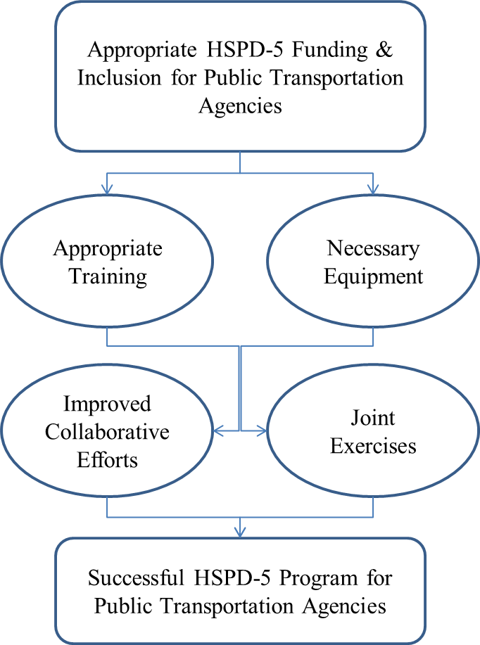
As illustrated in the logic model in Figure 1, the appropriate level of HSPD-5 funding for public transportation agencies would allow those agencies to receive and train personnel responsible for emergency management activities within the agency, while also acquiring the equipment needed to comply with HSPD-5 mandates. This would open up communication lines to allow those agencies to have an improved collaboration effort with local jurisdictional emergency responders while also being able to participate more successfully in realistic regional exercises to test their capabilities in the face of an emergency crisis. These efforts would lead to a sucessful HSPD-5 program for public transportation agencies, which is defined as agencies better prepared and ready to handle contingencies, which is the spirit of HSPD-5. As an example of this level of collaboration and readiness, WMATA is very proactive with not only local emergency responders, but those from across the country, as stated in this study by the Center for Urban Transportation Research (CUTR) at the University of South Florida:
“WMATA’s Emergency Response Training Facility is the only transit facility of its kind in the nation that is available 24 hours per day, seven days a week to train emergency personnel. The facility includes a mock train tunnel that allows regional emergency responders to train for disasters such as smoke/fire, collisions and potential terrorist incidents in a transit/tunnel environment. WMATA’s emergency management team trains an estimated 2,000 federal, state and local emergency personnel each year” (Center for Urban Transportation Research).
Resilience & Coordination
One element of NIMS is the coordination & collaboration of various government entities as they prepare for and respond to various emergency incidents, regardless of size and scope. FEMA lists the primary goal of National Preparedness as “A secure and resilient nation with the capabilities required across the whole community to prevent, protect against, mitigate, respond to, and recover from the threats and hazards that pose the greatest risk” (FEMA, 2015). Within the NIMS Training Program manual, FEMA discusses the importance of coordination and collaboration of agencies, as they are the framework that makes the program successful. FEMA states the program is designed as a “national approach for Federal, State, tribal, and local governments, the private sector, and nongovernmental organizations, to work together to prepare for, respond to, recover from, and mitigate domestic incidents, regardless of cause, size, or complexity” (FEMA, 2011).
It is clear that a major component of NIMS is the collaboration and coordination of various governmental (at all levels), non-governmental, non-profit, and the private sector, to work together as a team in their planning, practicing, responding, mitigation, and recovery efforts. As pointed out already, public transportation is vital in these efforts. Coordination in this sense has been described by Comfort as,
“a means aligning one’s actions with those of other relevant actors and organizations to achieve a shared goal. Again, the capacity for coordination depends on effective communication. If the communication processes do not elicit sufficient shared understanding among the parties to align their priorities for action, the likelihood of achieving a common action framework among multiple actors will be seriously diminished. Coordination…assumes that the participating actors align their activities voluntarily” (Comfort, 2007, p. 194).
Cigler additionally points out the general opinion of first responders in regards to response and preparation, “those who respond together should prepare together” (Cigler, 2007, p. 71).
Resiliency is a vital component of emergency management. Resiliency is the capability of an organization, neighborhood, town, city, region, etc., to recover from any form of disaster or emergency, whether natural or manmade, and whether accidental or intentional. During the Cold War, the United States Air Force required Survival, Recovery, and Reconstitution (SRR) plans for Air Force units to survive a nuclear event and continue their mission. According to Air Force Instruction (AFI) 10-208, “Since the end of the Cold War, and especially following the terrorist attacks of 11 September 2001, increased potential for terrorist use of weapons of mass destruction….all organizations must be prepared to respond to a wide range of potential emergencies” (United States Air Force, 2011). This AFI is the Air Force COOP (Continuity of Operations Plan) which has become the replacement to their SRR program. To ensure resiliency, organizations across the country have implemented COOP plans so that they may not only prepare, respond, and mitigate in an all-hazards environment, but also recover, reconstitute, rebuild, or whatever it takes to continue their mission of the organization.
What exactly is resilience? In the book Designing Resilience, it is the “organization’s capacity to continue its existence, or to remain more or less stable, in the face of surprise, either a deprivation of resources or a physical threat…..the flipside of vulnerability” (Comfort, Boin, & Demchak, 2010, p. 13). Resilience is further described in the book as an “ability” to survive in the face of an emergency or crisis, not just as the “motion” of doing so (Comfort, Boin, & Demchak, 2010, p. 20). This is intriguing when looking at the “ability” of New Orleans in the face of Katrina, and the failures in preparation and response pertaining to that event, as analyzed with a similar event, Hurricane Sandy. According to NPR, the successes experienced in the Sandy storm were, “in part…due to lessons learned from Hurricane Katrina” (Naylor, 2012). FEMA called the Sandy response “one of the largest and most diverse personnel deployments in FEMA history” (FEMA, 2013, p. 30). From a transportation standpoint, New York residents were able to get to various city shelters, prior to the storm, “by public transportation” in which the “transportation of [evacuees] demonstrated remarkable cooperation by public agencies and the MTA to ensure the safety of evacuees” (Kaufman, Qing, Levenson, & Hanson, 2012, p. 12). The transportation report also illustrated the importance of both public transportation, and that of preparation, by explaining that “Hurricane Sandy demonstrated the vital and central role of the Metropolitan Transportation Authority (MTA)” and the fact that “10 million people rely on the MTA’s regional network” and then pointing out that, “as a result of MTA’s preparations, the storm caused no damage to the rolling stock” which includes both rail vehicles and buses (Kaufman, Qing, Levenson, & Hanson, 2012, pp. 12-13).
Importance of Public Transportation to American Infrastructure
So far, a lot of effort has been placed on the creation of NIMS, the importance of having a framework in existence that promotes the coordination of various disciplines of emergency responders, from various levels of government and the private sector, to train, prepare and exercise for, respond to, and mitigate emergencies in an all-hazards approach, and then see the resiliency of those impacted organizations to continue their respective missions. However, what about the importance of public transportation in general? What exactly does public transportation offer our country in terms of importance to our infrastructure? Sure, we’ve seen above the fact that 10 million New York residents, tourists, visitors, etc. use MTA on a daily basis. WMATA also reports that 40-45% of those working in the center core of the DC Metropolitan Area, use mass transit, and reported 209 million rail and an additional 136 million ridership trips in 2013 (WMATA). Considering that the federal government is the largest employer in the DC Metropolitan Area, this means public transportation ensures our federal workforce gets to work in the nation’s capital (Cooper, 2015). Similar types of statistics could be shown by agencies in all major cities, and regions that rely on transportation. But what other types of benefit does mass transit provide?
According to APTA, public transportation offers a myriad of benefits to the infrastructure of our country. Continuing with our theme above, APTA reports that “in 2005, Americans took 9.7 billion trips on public transportation—15 times the number of trips they took on domestic airlines” (APTA, 2007, p. 2). An interesting figure when we consider the level of security provided at our numerous airports as compared to the security we see at our mass transit public facilities. This research will explore those figures more closely. APTA also reports that, “from 1995 through 2005, public transportation ridership increased by 25 percent, a growth rate higher than the 11 percent increase in U.S. population, and higher than the 22 percent growth in use of the nation’s highways over the same period (APTA, 2007, p. 2). Public transportation usage is outgaining the national growth rate, as well as the rate of residents using public highways. It is possible that fuel prices could be driving those numbers, and a myriad of other possible reasons, but the facts as reported by APTA speak volumes in regards to the public’s usage of mass transit. APTA also reports the fact that public transportation offers a cleaner transportation choice than automobile, by stating that “Public transportation produces 95 percent less carbon monoxide (CO), 90 percent less in volatile organic compounds (VOCs), and about half as much carbon dioxide (CO2) and nitrogen oxide (NOx), per passenger mile, as private vehicles” (APTA, 2007, p. 3). It is assumingly the minority that will take public transportation merely due to environmental concerns, but it is obviously a choice by some for that reason.
APTA continues that public transportation is vital to providing transportation freedom to those who elect not to use a personal vehicle, or those in need who cannot use personal transportation due to various underlying reasons. APTA illustrates that “there are more than 6,400 providers of public and community transportation offering Americans freedom, opportunity and the choice to travel by means other than a car” (APTA, 2007, p. 2). These 6,400 providers include not only the 780 governmental public transportation agencies, but also a multitude of private sector services. APTA reports that there was a large percentage jump in those who use mass transit out of need. APTA reported that “Public transportation offers mobility for residents of rural America, particularly people without cars….from 2002 through 2005, ridership for small urban and rural public transportation systems jumped nearly 20 percent” but continued that, based on need, “access to public transportation in these areas needs to be greatly expanded” (APTA, 2007, p. 9). APTA also points out that there are those who are elderly, and those who suffer various disabling conditions which require the use of public transportation. “According to a national survey of individuals age 65 or older, conducted by Harris Interactive in November 2005, more than four in five seniors believe public transportation is a better alternative to driving alone, especially at night, and 83 percent agree that public transit provides easy access to the things that older adults need in everyday life” (APTA, 2007, p. 13). A society without public transportation is a society in which many of the elderly have no means of independently traveling to fulfill basic needs such as grocery shopping, doctor’s appointments, pharmacy visits, or any form of entertainment or self-fulfillment. APTA further points out that our disabled are similarly dependent upon public transportation, by stating that public transportation is a “vital link for citizens with disabilities…public transportation systems provide a vital link to the more than 51 million Americans with disabilities (APTA, 2007, p. 14). Many elderly and disabled may have family who assist in the caring for their needs. However, what about those who do not have family and friends who are willing and/or able to do so, or those who simply wish to be independent and care for themselves? Public transportation provides that crucial level of service to ensure this independence.
APTA lastly points out the economic vitality that public transportation provides. APTA writes that “public transportation is critical to our nation’s transportation system and is essential to the economic and social quality of life of our citizens” (APTA, 2007, p. 2). APTA states that public transportation “spurs the economy….enhances local rural economic growth in many ways, increasing the local customer base for a range of services—shopping malls, medical facilities and other services (APTA, 2007, p. 9). The Metro in Washington, DC, connects public transportation to a myriad of various business entities, to include large shopping venues such as Pentagon City Mall and The Galleria in Tysons Corner, VA. APTA also states that “residents and community leaders across the nation are recognizing that fully functional, high-capacity, regional public transportation services are essential to grow America’s communities in a way that enhances and promotes real estate development” (APTA, 2007, p. 10). This writer has personally witnessed the development that has taken place around newly constructed rail facilities. The Pentagon City Station once exited into an open field, but is now surrounded by high valued businesses, hotels, and federal agencies and contractors. Similarly, the Columbia Heights and Georgia Avenue-Petworth stations, which were constructed in DC areas that were still suffering from the destruction of 1960 riots, are now surrounded by new businesses, condominiums, and other high dollar real estate property. A current project, a new Street Car system that will soon begin service in the H’ Street, NE, corridor known as the Atlas District, is seeing that once riot ravaged neighborhood, also from the 1960’s, experience radical renovation. Public transportation seemingly has the same impact that is spoken in the movie Field of Dreams, “if you build it, he will come” (IMDb, 2015).
Safety, security and emergency management is not just a desire for public transportation; these elements are also mandated by the Code of Federal Regulations (CFR) specifically 49 CFR 659. According to 49 CFR 659, the FTA gives oversight responsibility to each individual state, via a state oversight agency. According to Subpart C, paragraph 659.13, “the state oversight agency is responsible for establishing standards for rail safety and security practices and procedures to be used by rail transit agencies within its purview” (DOT/FTA, 2005, p. 22579). 49 CFR 659 also mandates all rail agencies, and those bus agencies that accept funding, develop a system safety plan, a system security plan, and an emergency preparedness plan. Agencies may elect to combine the security and emergency preparedness plan into a Security an Emergency Preparedness Plan (SEPP), This writer has extensive experience in the review, development and re-writing of a SEPP, and has several years of experience in teaching these topics to public transportation managers across the country.
Currently, a concerning development has arisen which requires the phasing out of 49 CFR 659, and the implementation of 49 CFR 674. This development was in response to a concept known as MAP-21 which was mandated on July 6, 2012, when “President Obama signed Moving Ahead for Progress in the 21st Century (MAP-21), reauthorizing surface transportation programs through fiscal year 2014. Each reauthorization amends the Federal Transit Laws codified in 49 USC Chapter 53. MAP-21 took effect on October 1, 2012” (FTA, 2012). The new 49 CFR 674 was published on March 16, 2016, with 49 CFR 659 scheduled to rescind within 3 years after that date. What is concerning with the new 49 CFR 674, is that State Oversight Agencies will no longer have the same leverage regarding security under 674 as they currently do under 659. The new 674 specifically states,
“With regard to the omission of the System Security Plan from today's rulemaking, the Transportation Security Administration (TSA), an agency of the United States Department of Homeland Security (DHS), has the prerogative and responsibility for all rulemakings on security in public transportation. Specifically, under the Implementing the Recommendations of the 9/11 Commission Act of 2007 (Pub. L. 110-53), and the September 2004 Memorandum of Agreement between DOT and DHS and the September 2005 modal annex between FTA and TSA, DHS is tasked with the responsibility for carrying out a national strategy for public transportation security to minimize security threats and to maximize the ability of public transportation agencies to mitigate damage from terrorist attacks and other major incidents.” (DOT/FTA, 2016).
This is concerning because 659 has been a successful program and it is argued within the industry that security for mass transit should remain under the umbrella of the FTA.
The TSA approach to public transportation security is more of an antiterrorism methodology, when anti-crime programs are as important in protecting the lives and ensuring the security of public transit patrons, employees, and resources. The FTA already has an established program, the Transit Safety Institute (TSI) Transit System Security Course, to teach transit managers how to safeguard and protect their properties, personnel and employees. This course teaches a Threat and Vulnerability Assessment (TVA) methodology with hazard matrix to score the seriousness of vulnerabilities, which arguably should be the primary methodology used by public transportation agencies (FTA/TSI, 2017). TSA has a Baseline Assessment for Security Enhancement (BASE) assessment that is “a voluntary security assessment of national mass transit and passenger rail systems and is performed by TSA’s Transportation Security Inspectors” (TSA, 2015). The BASE is a great tool offered by the TSA, but as illustrated, it is voluntary. A full TVA that was once required under the mandate of 49 CFR 659 is a much more in-depth analysis of a public transportation system’s vulnerabilities to specific criminal and terroristic threats, and had state oversight to ensure they were completed no less than every three years. Unless somehow mandated in a different manner, public transportation loses that mandate when 659 is rescinded.
Additionally, it appears at the time of this writing, that the current administration may be considering cutting the funding for the TSA VIPR program. The New York Post wrote that Senator Chuck Schumer, at a press conference in front of Penn Station in New York, stated that the Trump Administration is “proposing to eliminate the $12.6-million Visible Intermodal Prevention and Response (VIPR) program from the Transportation Safety Administration’s 2019 budget” (Daidone, 2018) which would be yet another blow to public transit security when security should be on the rise and not the fall. At the time of this writing DHS funding for FY2019 is still in the balance and facing a potential Continuing Resolution in December. Therefore, the VIPR program is still in existence. However, it has been the experience of this writer specifically the importance of the TSA VIPR program. This writer used the TSA VIPR teams extensively as the Commander of the Metro Transit Police Department Antiterrorism Team for various functions. The latest was the 2016 Nuclear Summit which at times included more than 50 foreign heads of state at the Washington, DC, Convention Center. This writer had to convince the United States Secret Service that the rail tunnel underneath the convention center was secured, even with trains running underneath. This was partially accomplished with the use and partnership with TSA and the VIPR teams that were assigned for that critical and high profile event. The VIPR teams have been invaluable and instrumental to public transportation and should not be terminated in today’s terrorist threat environment.
The above paragraphs should not be interpreted as an opinion that FTA is better suited to control security for mass transit. Those paragraphs should, however, be interpreted that FTA is the best venue to ensure compliance to security standards for public transportation agencies, through state oversight. TSA is a wonderful partner to FTA in this regard, and according to their website and under the leadership of sound experts and industry giants such as Sonya Proctor, the TSA Surface Division Director, “TSA incorporates the needs and capability gaps of surface transportation owners and operators into our work to influence and stimulate the development of new security technologies in the marketplace. Our approach is designed to make more readily available innovative and advanced technologies useful for public area security” (Proctor & Pryor, 2018).
Crisis Leadership and the Importance to Public Transportation
This literature review segment will conclude with a segment on crisis leadership and the importance of communication, collaboration, critical thinking, and decision making, during the mitigation of a critical incident (FLETC, 2017). Not only are these the four foundations taught by the Federal Law Enforcement Training Centers (FLETC) to federal, state, local, and tribal agencies in the country, but also critical to the mitigation of public transportation emergencies considering these principles are universal. These are also being reviewed because they support many of the questions that were included within the survey that was distributed to public transportation managers. These four foundations primarily support the collaboration efforts the agencies have with their local emergency response counterparts, but they also are vitally needed to support the other efforts and research variables such as funding, training, equipment, and exercises. Each of the four foundations will be discussed separately, and their importance in how they relate to this research, and will conclude this chapter.
The first of the four foundations of crisis leadership, as taught in the Leadership in a Crisis Training Program (LICTP) at FLETC, is Communication. Communication is covered within the program to include not only the verbal communication between critical incident participants, and the noise that oftentimes acts as hurdles and barriers to effective communication, but also the technological drawbacks that sometimes stands in the way. The program teaches that communication is the number one complaint usually criticized in After Action Reports. Many of these complaints include professional jargon that is not always understood by all, considering many different types of agencies may respond. It is this reason that the country has developed, as stated earlier within this review section, common language interoperability policies, to assist in this communication breakdown and failure. Egos, or the perceptions of egos, and the problems they bring to communication are also included as issues within communication. Professionalism is usually the key to combating egos discovered in an incident command setting. Technology has often been the culprit of communication failures, which has led to the development of shared frequencies for emergency response. One example used in the FLETC LITCTP program in a case study analysis, is the shooting down of a civilian Iranian airline by the USS Vincennes in 1983. The accident which resulted in “torn aluminum and 290 bodies from the shattered airliner raining down on the waters off Qeshm Island” was largely due to communications failures, including personal communication, egos and previous problems between two Naval Captains, and technological issues, even though the USS Vincennes was a superior vessel with immense technological advancements (Evans, 1993).
Communication is vital to not only the response and mitigation of an emergency, and critical to the collaboration with other agencies, but also an important facet in attaining funding, receiving equipment, and participating in training and exercises related to NIMS. Written and verbal communication skills must be strong and articulate for agency representatives seeking the funding they need to support NIMS efforts. The agency must have a persuasive spokesperson to articulate clearly and in a compelling manner the funding, equipment, and training required, along with the worst case scenarios of the consequences if that funding, equipment, and training is not received. The agencies must communicate their desire to be included when local first responders host exercises to strengthen their mitigation efforts. Finally, when these agencies are included and are participants, they must communicate when needed their expertise to the matter at hand. One PowerPoint slide within the LICTP program simply illustrates, “If you Think Something, Say Something” as a way to illustrate that the agency representative may have the one piece of the puzzle needed to help realize the vision of success in the crisis mitigation (FLETC, 2017).
The second of the four foundations of crisis leadership, is Collaboration. The LICTP program discusses two facets critical to collaboration. The first is that collaboration should occur prior to an event taking place. The first time emergency responders meet others in different agencies, should not be at the command post of a major event. Course participants are challenged to think of the stakeholders they may work alongside at a major crisis, and then determine if they’ve made the efforts to reach out and meet those personnel and develop a relationship on a first name basis. The second facet is, therefore, developing a relationship with those others with whom an agency representative may have to work alongside during an emergency. Learning who these personnel are and developing a professional relationship assists in the different agencies learning the strengths and challenges of one another, and also helps alleviate the problems with ego, and perceptions of ego, that were discussed in the communication section.
Collaboration is also critical to receiving the funding, equipment, training, and being involved with various exercises. Agencies desiring to receive the funding, equipment, training, and exercise opportunities must learn to collaborate with regional, state, and federal partners, to ensure these critical elements to successful crisis mitigation are met. Once an agency feels they have mastered the communication skills necessary to share their needs, they need partners to work with and to whom to establish relationships. Agencies that do not have personnel with the skillset to write grants requests should develop the relationships with those agencies who do, who can provide assistance. Agencies that need more training and exercise participation must reach out and collaborate with those agencies needed to develop those relationships, and just as with any relationship, public transportation agencies can also provide assistance in return, such as knowledge and expertise known only to subject matter experts within the transit agency.
Critical Thinking is the third foundation covered in the FLETC LICTP program. The LICTP program illustrates the two methods of thinking during a critical incident, systematic and heuristic thinking. The program discusses the way the brain naturally thinks when faced with a critical decision, which is to look first for similarities familiar from a past event for a resolution. This type of heuristic thinking blocks sound systematic thinking efforts and will likely prevent better options from being manifested. Much of this module of facilitation in LICTP is based on the book, Thinking, Fast and Slow, by Daniel Kahneman, in which he compares the dichotomy between System 1 (Fast) thinking and how it relates to the more analytical and methodical System 2 (Slow) form of thinking (Kahneman, 2011).
Kahneman illustrates the System 1 and System 2 thinking with various exercises, two of which will be shared here. In one exercise he prints the words “banana” followed immediately by the word “vomit” and explains how the reader likely experienced an immediate uneasy feeling because the brain immediately associated vomit with banana (Kahneman, 2011, p. 50). He also illustrates a simple math problem in which he states that a baseball bat and a baseball has a total cost of $1.10. If the bat costs $1 more than what the ball costs, what is the cost of the ball (Kahneman, 2011, p. 44)? Kahneman then explains how our System 1, heuristic thinking, immediately gives us an answer of .10 cents, which he describes as “intuitive, appealing, and wrong” (Kahneman, 2011, p. 44). A more analytical and deliberate thought process will reveal that the correct answer is actually .05 cents. This writer, who is not only the program manager for the LICTP program, but has also facilitated this program numerous times, has used this example many times to prove Khaneman’s theory, and the majority of course participants immediately answer .10 cents just as Khaneman suggests. Some participants have actually become argumentative, insisting that that answer is .10 until the problem is actually drawn out on a dry erase board. It is amusing to then watch those participants stare in amazement, still not totally trusting their System 2 thought process, and the actual numbers and math problem that has been drawn on the board.
There are obviously moments when heuristic thinking is in fact the preferred method, such as when life and death circumstances are present in which an immediate and quick decision must be made. Police often train repetitively in these types of emergency situations, in which they do the same things over and over again to train the brain to think quickly and subconsciously in given circumstances. Police refer to this as “muscle memory” but the correct term should be procedural learning or procedural memory. Another form of heuristic thinking is when checklists, standard operating procedures, or other types of written rules or mandates are simply followed in a given situation. These situations do not require critical thinking at all, but simply a following of rules already established, in which critical thinking was likely used to create them in the first place. Howitt and Leonard, in a similar context, describe in the book Managing Crisis, the dichotomy between routine and crisis emergencies (Howitt & Leonard, 2009).
Howitt and Leonard present case studies that “describe a wide range of emergency situations [and] looking across the wide array of examples, made a fundamental distinction between those events that are routine emergencies and those that are crisis emergencies involving significant elements of novelty” (Howitt & Leonard, 2009, p. 611). Many emergency situations faced by first responders, and public transportation agencies, involve scenarios that are experienced on a routine basis. Very little changes in the ways these events play out, and in many circumstances responders rely on written mandates and checklists to assist them in their mitigation strategies. Howitt and Leonard refer to these events as “Mode R” or “Routine Emergencies” which they describe as a “more familiar” emergency “when a particular type of emergency happens frequently in a location where people have the resources to organize and prepare” (Howitt & Leonard, 2009, pp. 611-612). They further state that even though these are considered “routine” events, they are not implying that the events are unimportant. In fact, they state these events could be “quite severe” but are considered routine due to the fact that “regularity creates the opportunity for organized preparation and practiced responses” (Howitt & Leonard, 2009, p. 612).
Compared to the Mode R, or Routine Emergency responses, Howitt and Leonard discuss the more outside the box Mode C, or Crisis Emergencies. They describe that some of the case studies they cover in the book are “not like those previously experience” in which emergency responders will have “no executable script that provides a comprehensive, reliable, and fully adequate response [and that] existing routines will be inadequate” (Howitt & Leonard, 2009, p. 614). Comparing these two response modes, the authors explain that in Mode R, leadership will be “trained, practiced, and selected for prior training and performance” whereas in Mode C, leadership has to be “adaptive, comfortable sharing authority, skilled in eliciting ideas from the team, and innovative” (Howitt & Leonard, 2009, p. 620).
Kouzes and Posner describe in their text The Leadership Challenge, a list of five exemplary practices for leaders. One of those practices includes the practice of challenging the process, in which they state that “leaders are pioneers willing to step out into the unknown [and they] don’t sit idly by waiting for fate to smile upon them; they venture out, taking risks” (Kouzes & Posner, 2017, p. 16). There is no more of an important time when leaders may be confronted with the opportunity to challenge the process, than during an emerging crisis or critical incident. This exemplary practice, like each of the five included in the Kouzes and Posner text, are universal in all forms of leadership in every profession, around the world as illustrated by in-depth research conducted by the authors over the course of several decades, but the exemplary practices are magnified during a critical incident or crisis.
Dr. Lorenda Naylor, University of Baltimore, discusses a similar perspective termed street-level bureaucracy, in which public service representatives, such as “social workers, teachers, police officers, and fire fighters” and other governmental employees of various disciplines, “are significant because they have become policy makers as a result of their level of decision….bureaucrats are given discretion in carrying out their duties due to the high complexity of their jobs” (Naylor L. , 2018). Naylor cites two reasons, from the work of author Michael Lipsky, as to why bureaucrats are afforded this high level of discretion: “1) the work environment is too complicated to reduce to manuals and instructional formats; 2) the work environment demands responses to human dimensions of situations” (Lipksy, 2010). Lipsky states that “public service workers occupy a critical position in American society….the actions of most public service workers actually constitute the services delivered by government [and] when taken together the individual decisions of these workers become, or add up to, agency policy” (Lipksy, 2010, p. 3). This is especially true during the mitigation of a critical incident, especially those of the Mode C type as defined by Howitt & Leonard. Not only Incident Commanders at major incident scenes, but the street officers working the incident at the lowest levels, have tremendous discretion with far reaching consequences. This writer personally teaches new recruits that once they take their oath of office and walk out the gates of the academy, they instantly become leaders in society. When responding to a critical incident, citizens of society will care less that they are a rookie officer, or a seasoned veteran; they will expect the officer to lead them to safety and to mitigate the scene to a safe resolution. This is why they must act prudently in the sense of street level bureaucracy, because their sphere of influence is great.
Howitt and Leonard describe that execution during a Mode R response “aims for precision through repeated opportunities for application of routine practices” but accurately distinguishes this execution from Mode C responses in that these responses execution “must be fault-tolerant because solutions have been improvised and are thus not fully tested or practiced” (Howitt & Leonard, 2009, p. 620). In other words, leaders must be adept at challenging the process during a critical incident and/or emergency crisis, because it is the challenging of prescribed mandates and checklists, created from known and routine responses, that may save lives during unknown and non-routine events that are occurring outside the box in the unknown world of possibilities.
The preferred method of thinking in a critical incident or crises is that of systematic or critical thinking. Instructors in LICTP often challenge course participants to define critical thinking and speak openly what critical thinking entails. The entire program is developed around putting the participants in uncomfortable situations in which they must think outside the box to form decisions regarding issues that might occur outside the box of comfort. Participants are reminded that every crisis is different, and that no two critical incidents are the same; therefore, it is impossible to write mandates and checklists that cover every possible event that might be faced. It is, therefore, important to think critically, outside the proverbial box, to develop alternatives to issues that are being faced. It is important to first develop a list of symptoms that that are being experienced, in an effort to define the precise underlying problem that needs addressing. Although this can be done individually, it is preferred that a diverse group of experts be gathered to ensure a comprehensive divergent thought process.
The Critical Thinking component taught by FLECT in the LICTP program, also discusses the many cognitive biases that often provide blockades to the critical thinking that may be needed to address an issue. Biases are discussed, such as jump to solutions bias, in which participants choose the first heuristic thought that comes to mind, and self-serving bias, in which participants choose a solution that is self-serving, without regard to other likely better options. The program teaches there are over 100 potential cognitive biases to consider, but only teaches 12 of the most common. Others include the IKEA effect (in which a participant gives more weight to a project they’ve personally completed), competency bias (in which a participant feels more competent than they are in a given situation), availability cascade bias (in which a participant feels the more something is done, the more correct it might be), and authority bias (in which a participant gives more weight to the opinions of someone in authority, whether that person is knowledgeable in the subject matter or not). Exercises are conducted and the participants are secretly observed to see if they are falling into any of the biases covered in class, when confronted with various challenges.
The importance of critical thinking for public transportation agencies, in their pursuit of funding, training, equipment, collaboration, and exercise participation is enormous. As is illustrated later in the data analysis section, many of the agencies surveyed are experiencing issues in many of these areas. It is imperative that these agencies develop a diverse group of agency professionals to create solutions to the problems they are facing in their mitigation capabilities and resources. According to the aforementioned 49 CFR 659, public transportation rail agencies, and bus agencies that have accepted FTA funding, have been required to have a Security and Emergency Preparedness Plan in which a security committee has been identified. This committee should be a diverse group consisting of various disciplines such as, but not limited to, finance, engineering, security, power department, local police, rail and/or bus operations, legal, safety, and emergency management. This committee should be the focal point in discussing how the agency attains funding, equipment, training, and how the agency improves their collaboration efforts with local first responders and becomes more engaged in local exercises. The mere fact that an agency may not be fully capable of mitigating emergencies, or assisting in the mitigation of regional emergencies, arguably creates vulnerability for the agency and region.
The last of the four foundations of Crisis Leadership, as identified by FLETC in the LICPT program, is Decision Making. Within this module, which works hand-in-hand with critical thinking, the program illustrates a FLETC developed model for decision making called IDWAE, cleverly pronounced I’d Weigh (FLETC, 2017). The IDWAE modal and process is an acronym for Identify, Define, Weigh, Act, and Evaluate. Participants are challenged in the course to discuss and determine what determines, as a measuring stick, a good and/or bad decision, and the answers usually surround whether the outcomes are good or bad. Examples are then shared in which bad outcomes have been derived from good decisions and a solid decision-making process, whereas the opposite is also true; bad decisions have luckily resulted in good outcomes. The teaching point is that it is the process that is employed that should be the measuring stick for good decisions. The first two elements of the IDWAE modal are a review from critical thinking, as it involves identifying symptoms and then defining a problem, while brainstorming in a divergent environment, and overcoming cognitive biases, which were illustrated in earlier paragraphs. The final three aspects of the IDWAE model include developing and weighing alternatives, acting one the best choice, and later evaluating that choice, each which are basic elements of most problem-solving models.
Decision making is the final piece of the four foundations that is critical to an agency receiving the funding, equipment, and training needed, and the collaboration necessary to be a good NIMS partner with local responders during exercises and real-world events. An agency must make sound decisions, based on critical thinking skills, to assist them in overcoming the problems and issues that many of them identified from the survey. Even those agencies that strongly agreed with many of the survey questions should still continue their proven strategies in communication, collaboration, critical thinking, and decision making, to eliminate the dangers of falling into paradigms, because even perfection can always be improved upon.

Methodology

Theory & Design
This evaluative research was based on an implementation theory with a mixed-methods design. The goal of the research was to determine if public transportation agencies, in the attitudes and perceptions of their managers, have been appropriately and satisfactorily funded and fully embraced as NIMS partners within their town, city, county, and/or region. As critical components in the emergency management plans of a town, city, county and/or region, they should be funded, trained, equipped, and prepared, to respond and assist in the preparation and/or mitigation of a natural disaster or emergency, or a manufactured event whether accidental or intentional. The reason for combining both quantitative and qualitative data was to better understand this research problem by converging both quantitative (broad numeric trends) and qualitative (detailed views) data (Creswell, 2009).
Quantitative data was collected to establish statistical trends in the attitudes and perceptions of public transportation managers in regards to whether their agencies have been funded, equipped, and trained, and what levels of collaboration they have experienced with local first responders to implement and partake in HSPD-5 programs. 1) Quantitative data was collected through surveys to capture the attitudes of public transportation managers in regards to their perceptions regarding emergency preparation funding, training, and possession of needed equipment, and overall collaboration and inclusion. 2) Qualitative data was collected to describe shortcomings, as well as measures of success over funding, training, and equipment issues, to include historical narrative information in how their respective agencies have requested and/or received funding, training and equipment, as well as their overall collaboration and inclusion by regional partners. 3) Qualitative data was also captured in an attempt to produce tendencies shared across the industry so that best practices and lessons learned could be formulated into an official study. 4) Qualitative data was also collected through an extensive case study to describe the practices of the Washington Metropolitan Area Transit Authority, which has been recognized (as evidenced by the CUTR article referenced in the literature review), for their efforts in emergency management and transit system security, not only regionally and nationally, but globally. Any number of agencies could have been considered for the case study; however, due to the researcher’s familiarity with the agency and players, as well as documentation such as that referenced above by the University of South Florida, WMATA was selected. WMATA’s selection is further documented in the case study, located in Chapter 4, Data Analysis. It is also within the attitude and perception of the researcher, based on personal knowledge as well as literature review, that New York is likely the only other area with a program as robust and recognized as that of WMATA, although Boston, Dallas and others have established robust programs as well to rival any agency worldwide.
Implementation theory was selected due to the desire to determine whether NIMS has been fully implemented to include transportation to the degree it needs to be included, and if that implementation has been sustained over time. The research used the NIMS framework as it was designed and intended for successful preparation, response, mitigation, and recovery, as the desired outcome and structure, which appropriately incorporates all functions of government that are needed within that framework for success. The research included an analysis to determine if public transportation agencies have received those components of funding, training, equipment, and collaboration, which are deemed necessary within the realm of planning, design and implementation, to realize the desired outcome. The attitudes and perceptions of public transportation managers will be the measures used to evaluate this relationship.
Research Questions
- Have public transportation agencies, in the attitudes and perceptions of their managers, been included in the HSPD-5 implementation plans at the various governmental levels, and is there a satisfactory collaboration effort that allows public transportation to participate in both exercises and real-world events?
- Have public transportation agencies, in the attitudes and perceptions of their managers, received the funding, training and equipment necessary to satisfactorily implement the mandates of HSPD-5?
Mixed Methods Research
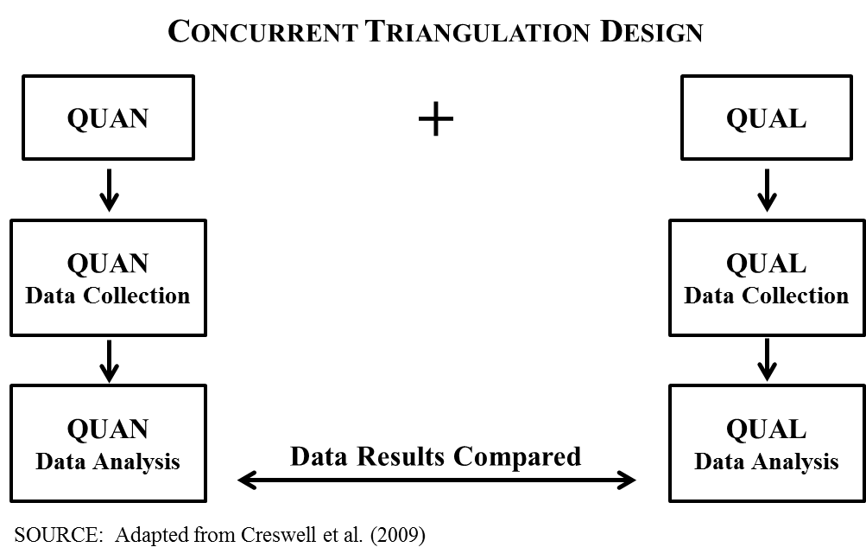
Mixed methods research is defined by Creswell (2009) as “An approach to inquiry that combines or associates both qualitative and quantitative forms of research…it involves philosophical assumptions, the use of qualitative and quantitative approaches, and the mixing of both approaches in the study” (p. 230). This research focused on a pragmatic worldview and acquired an interpretation of the data received in a concurrent triangulation design format received from both quantitative and qualitative sources. Therefore, this research employed a concurrent, mixed-methods triangulation design methodology. This particular strategy is defined by Creswell (2009) as “an approach in which the researcher collects both quantitative and qualitative data concurrently, and then compares the two databases to determine if there is convergence, differences, or some combination” (p. 228).
Challenges
There were significant challenges in this research. . First was the formidable task of contacting numerous mass transit properties around the country. An explanation on how those agencies were selected is discussed later in the Survey Design section. Although face to face meetings are always preferred, this was simply impossible due to cost prohibitions based on the number of agencies and numerous locations across the country that were needed to ensure generalizability. Due to the nature of the targeted population sample, the use of the online survey entity known as Survey Monkey was used for both the quantitative and qualitative survey questionnaires. Each property was contacted by email through Survey Monkey, with follow-up email reminders, with an online link.
Establishing a true inference of mass transit personnel and overall generalization was not as challenging, as only mass transit agencies were selected to participate, and they were selected from agencies across the country in four different agency size categories, which are explained in more detail in the Survey Design later. Another challenge was the efforts needed to establish credibility with survey recipients, especially in today’s environment of survey fatigue, and a conspiracy theory perception that surveys may be some form of marketing scheme or cybersecurity threat. This writer, in an attempt to overcome these challenges, reached out via LinkedIn, to all recipients who had a LinkedIn account, as an electronic introduction along with a message to consider completing the survey. LinkedIn provided a venue that allowed recipients to study this writer’s resume’ history and historical public transportation service, in an effort to build trust and credibility. It is unknown the level of success this effort provided.
Research Timeline
The timeline to complete the study was first estimated to be six months, over the Fall and Spring semesters, with the hopes that a dissertation defense would be completed during the Spring Semester. The timeline eventually took more than six months to complete the survey phase with an additional 4 months to complete the research analysis. Four months were used to reach out to each of the agencies selected, in the first wave of survey requests. Two additional months were needed to send out reminder emails to agencies due to return levels being low. This is covered in more detail in the Data Analysis chapter. Three months were needed to complete the written analysis illustrating the final results and complete dissertation.
Survey Design
Purpose: The purpose of the survey design was to determine, from the managers of a desired 250+ public transportation agencies, their perceptions and attitudes concerning public transportation inclusion, funding, training, and equipment, in regards to HSPD-5. A cross-sectional study consisting of agencies from rail, bus, and multi-modal agencies, from across the country, provided an inference to the public transportation industry as a whole while also capturing those specifically with emergency management sections, in regards to their attitudes and perceptions as they relate to the aforementioned hypothesis.
Survey Preference: The survey instrument was selected due to the ease of use and quick turnaround of results. The survey also allows confidentiality to the participants via informed consent forms and a Survey Monkey feature that ensures confidentiality. The survey design incorporated a cross-sectional, one-time approach, with data collected during a period of 6 total months. A full detailed description on the number of agencies and how they were individually selected follows.
The Population Sample: The targeted population was primarily the General Managers/Chief Executive Officers within the randomly selected public transportation agencies. Properties of various sizes were selected for the study, and categorized as small, medium, large, or major agency sizes. Selection of property size for categorization was determined by the number of unlinked passenger trips annually for property patrons, as established by the American Public Transportation Association (APTA). According to the 2014 APTA Fact Book, there were 798 transportation agencies in the country (Association, 2014). Using a computerized sample size calculator, 258 agencies were desired to participate in the study to reach a full 95% Confidence Level with a Confidence Interval of 5. Unfortunately, even after multiple reminders, the survey only received a total of 121 agencies who replied, and only 113 completed the entire survey.
Random Selection: Public transportation agencies were selected by using a Research Randomizer. The agencies were numbered from one to ever how many existed in a given state, and two-thirds of those agencies were selected using the number generator. The selections were completed in this manner to ensure an equal percentage of agencies in each state were selected, to ensure generalizability across the country. Only the 50 recognized states were chosen; territories, such as Puerto Rico, were excluded. Research was conducted on properties whether or not they have an official emergency management office or dedicated police department. It is an assumption that each agency has identified representatives to act on behalf of emergency management efforts, and that each agency has some form of identified security component, whether it be a dedicated police force, unsworn security force, contracted security, or simply relying on the local police jurisdiction for security and police services. Cluster sampling was multi-stage, using various mass transit agencies of geographic location and size. Stratification was by agency size, as determined by unlinked passenger trips annually, and included and differentiated between rail agencies, bus agencies, or multi-modal agencies. As stated, two-thirds of the agencies were targeted for both the quantitative and qualitative surveys, from the 798 APTA recognized agencies that exist throughout the country. The stratification strategy of using three different agency size classifications, among several geographic locations throughout the country, of various transportation modal types (rail, bus, multi modal), ensures the study is generalizable across the public transportation industry.
Forms of Data Collection: Three forms of data collection will be employed.
- Self-Administered Likert Scale Questionnaires will be used to gauge the attitudes and perceptions of public transportation managers in regards to HSPD-5 funding, training, and equipment received by the agency, and the level of collaboration experienced by those agencies with local emergency responders. The questionnaires will provide the attitudes and perceptions of the General Manager/CEO of the organization, or his/her designee, regarding the hypothesis. The questionnaires, which were delivered in an online format, were relatively low in cost to produce, and was a convenient approach to gather the data. The Likert Scale was designed, as written by Rensis Likert, as a “technique for the measurement of attitudes” (Edmondson, 2005) and are “widely used in social and educational research” (Susan Jamieson).
- Open ended questionnaires were also included in the Likert Scale survey, to develop a qualitative element. Follow-up telephone interviews were conducted with several participants on an as needed basis, for clarification on open-ended questionnaires in which the respondent was known by foregoing confidentiality. The cost of the open ended questionnaires were likewise low in cost to produce, and was a convenient approach to gather the data.
- Structured Record Reviews were used sparingly in this study, and were only taken from open source information. Extensive structured record reviews were considered during the proposal for research, but were not needed to measure the attitudes and perceptions of the public transportation agency managers. It will be noted during the recommendations for future research that these types of records could be highly useful in future research.
Critique of Survey Methodology
- Weaknesses to the survey approach remain the challenges to ensure generalizability across the total public transportation industry. This weakness was considered during the research design phase, and is the reason agencies in every geographical area of the country were chosen, as well as agencies of varying sizes and transportation modals.
- The weakness with attaining the qualitative data was that physical travel to the many property sites was just not feasible due to cost restraints; therefore, in the place of interviews, Survey Monkey was used with open-ended questions. Survey Monkey has the capability of asking open-ended questions, with the character space allowed for narrative answers. According to Sage Publications, “every respondent should have the same interview experience and be asked the same questions in the same way by the same type of person” (Sage Publications, p. 174). Based on this information, in-person interviews with some respondents, while interviewing others over the telephone or via other electronic means, and others being given an on-line qualitative survey, would not be treating each respondent the same way, or giving each respondent the same experience. The weakness here is that this mode takes away a large component of the communication process, which includes the ever important nonverbal elements experienced during a face-to-face interview. As aforementioned, telephone interviews were eventually also conducted with recipients who elected to not remain anonymous, but still requested their identity be anonymous within the dissertation.
- A conspiracy theory mentality component may be encountered with some personnel and some properties, which could skew true measures of fact. Some transit managers may be of the opinion that the research will bring discredit to the agency, or paint the agency as being ill-prepared for contingencies. The strategy for managing and overcoming this mentality will be to give the assurances that the surveys are confidential. Not only will the surveys not require the name of the respondent, but will also not require the name of the transportation agency. Other demographics will be collected, such as the geographical area and size of the property in terms of unlinked passenger trips annually, but the actual name of the property will not be requested. However, as mentioned, respondents will be given the choice to forego the confidentiality if they choose, with the assurance that their responses and identity will only be known by the researcher and will not be shared.
Instrumentation
A Likert Scale questionnaire was used in the research to measure quantitative data, along with additional open-ended questions to measure qualitative data; therefore, the survey instrument consisted of both quantitative and qualitative questions. A copy of the questions used is listed in the appendix, along with the results.
- Questionnaires were used to gather quantitative information regarding attitudes and perceptions of public transportation personnel in relation to the hypothesis.
  - Questionnaires created by the researcher were made available via an online link through Survey Monkey.
  - Scales used to measure the items on the Questionnaires were a combination of nominal value Likert Item responses (Yes/No), as well as a points-based ordinal value Likert Scale, using the following responses: Strongly Agree; Agree; Disagree; and Strongly Disagree. Some responses, pertaining to demographics, will have set responses pertaining to those questions, with a few having an open answer choice.
- Questionnaires were also be used to gather qualitative information regarding attitudes and perceptions of public transportation personnel in relation to the hypothesis.
  - The questions helped gain insight to support the quantitative information, using carefully crafted open-ended questions that support the quantitative element. The qualitative element of the study had a constructivist worldview flavor, and narrative research was the qualitative strategy used.
  - Questions engaged the participants to describe their attitudes and perceptions in regards to potential disparity in funding, training, equipment, and collaboration, and in their attitudes and perceptions, if their agencies received an adequate level of funding, training, equipment, and collaboration, to satisfy HSPD-5 mandates and preparing the agency for emergency contingencies. Participants were also asked to describe their attitudes and perceptions in regards to the experiences they have had in regards to their agencies being included, as well as the past and current collaboration experiences, with other regional partners. Precisely, the following information was sought during qualitative interviews to gain an overall understanding of a transit agency’s HSPD-5 funding:
    - What role/aspect does your agency play in the security grant request process, precisely for NIMS, and who performs this role (emergency management, safety, police, operations, etc.)?
    - How would you describe your agency’s funding experience, over time, in regards to NIMS funding?
    - What area(s) in your opinion is your agency sufficiently funded, and which areas are not sufficiently funded to fulfill the mandates of HSPD-5 (training, exercises, & equipment)?
    - What has been your agency’s experience working with local emergency responders in regards to training, participating in exercises, receiving equipment, and/or performing in real world events, as they pertain to HSPD-5?
    - In what areas, if any, do you feel your agency needs the greatest assistance in being able to mitigate threats, accidents, and major criminal events?
- A Single Case Study was conducted using the history of WMATA and their activities to receive the necessary level of funding, equipment, training, and collaboration to fulfill HSPD-5 mandates and be fully prepared for a myriad of emergency situations, including natural, accidental, and manufactured disasters. WMATA has been commended for their activities in training, not only the training they conduct within their own organization and region of emergency responders, but transit agencies and emergency responders nationwide at all levels of government who seek their assistance in training and participating in realistic scenario exercises. Considering this research to be more of an evaluative study into the public transportation agency’s attitudes and perceptions regarding HSPSD-5 funding and inclusion, the need for a case study seemed prudent. According to Robert Yin, “case studies have a distinctive place in evaluation research…..and finally, yes, case studies can be conducted and written with many different motives” (Yin, 2009, pp. 19-20). One such motive here is to illustrate a model to be studied by other agencies that may be deficient in the funding, training, equipment, and/or collaboration and inclusion categories for HSPD-5, while also explaining “the presumed causal links in real-life interventions that are too complex for the survey or experimental strategies” (Yin, 2009, p. 20). The WMATA model is a very complex system that cannot be fully enveloped into the study more effectively than by the use of a case study regarding their emergency management programs and their use and seeking of federal funding. The case study will additionally help determine whether WMATA itself was deficient in their funding, and if not, what types of funding obstacles they had to overcome and how they succeeded.
Both the quantitative and qualitative questions were reviewed by a selected panel of industry experts, again a constructivist worldview strategy. According to Sage Publications, “forming a panel of experts to review the questions can also help….. [a] review of questions by an expert panel identifies the greatest number of problems with questions” (Sage Publications, p. 163). Additionally, the completed survey will be field tested with personnel within the Transportation Safety Institute, the training arm of the Federal Transit Administration, as well as research professionals within the American Public Transit Association (APTA), to determine the practicability of the questions. Problems and concerns with the survey and interview questions were corrected and a final product was produced before contacting the first transit property.

Variables
As stated above, the survey instrument consisted of both Likert Scale quantitative and open-ended qualitative questions. Below is a description of the dependent variable and independent variable questions within the quantitative portion of the questionnaire.
Dependent Variables:
As illustrated earlier in the chapter, the following are the two research questions for this study. The dependent variables and supporting survey questions are listed underneath each research question.
- Research Question 1 – Have public transportation agencies, in the attitudes and perceptions of their managers, been included in the HSPD-5 implementation plans at the various governmental levels, and is there a satisfactory collaboration effort that allows public transportation to participate in both exercises and real world events?
- Research Question 2 - Have public transportation agencies, in the attitudes and perceptions of their managers, received the funding, training and equipment necessary to satisfactorily implement the mandates of HSPD-5?
Dependent Variable – Preparedness
Preparedness is the bottom line of what this research is measuring, in the attitudes and perceptions of public transportation managers. Preparedness is measured in how well the agency has improved since the implementation of HSPD-5, how well the agency handles emergencies caused by unintentional dangers, how well the agency handles emergencies caused by intentional dangers, and how well the agency assists local emergency response agencies with regional critical incidents and crises. As illustrated in the logic model earlier, preparedness is impacted by funding, training, equipment, participation in exercises, and collaboration. The following survey questions were designed and included to measure this dependent variable.
- Survey Question 4 – My agency is better prepared for contingencies since the implementation of HSPD-5 than prior to the implementation of HSPD-5.
- Survey Question 5 – My agency is well prepared to handle natural disasters and major industrial and transportation related accidents that are common to our region.
- Survey Question 6 – My agency is prepared to handle terrorist attacks that could be faced in today’s environment.
- Survey Question 7 – My agency is prepared to assist with regional contingencies as requested by local first responders.
- Survey Question 11 – I am satisfied with my agency’s preparedness level to handle the wide array of emergency contingencies that potentially exist.
Independent Variables:
As illustrated above, there are five independent variables that impact the dependent variable, preparedness. These five variables are funding, training, equipment, participation in exercises, and collaboration with inside and outside agencies. Each of these is listed below, with the corresponding survey questions to support each of the independent variables.
Independent Variable 1 – Funding
- Survey Question 9 - My agency has received the assistance needed from local, state, and federal agencies in our overall preparedness efforts.
- Survey Question 10 - My agency has received the funding needed from local, state, and federal agencies in our overall preparedness efforts.
- Survey Question 18 - My agency has received a satisfactory level of funding, whether from local, State or Federal agencies, in regards to overall preparedness as it pertains to NIMS mandates.
- Survey Question 19 - My agency has been proactively instrumental since HSPD-5 implementation in seeking funding sources to fully prepare our agency as it pertains to NIMS mandates.
Independent Variable 2 – Collaboration
- Survey Question 8 - Written plans exist that mandate and describe the mitigation efforts my agency must take in regional level contingencies.
- Survey Question 9 - My agency has received the assistance needed from local, state, and federal agencies in our overall preparedness efforts.
- Survey Question 15 - My agency is considered a NIMS partner by local agencies in regards to emergency response and mitigation.
- Survey Question 16 - Collaboration efforts are satisfactory between my agency and the regional police, fire, rescue, and emergency management agencies.
- Survey Question 17 - My agency has been included within the region’s Emergency Response Plan (or similar nomenclature), for the purpose of providing public transportation support during the response, mitigation, and/or crisis management, of potential emergencies faced by our local area.
Independent Variable 3 – Training
- Survey Question 9 - My agency has received the assistance needed from local, state, and federal agencies in our overall preparedness efforts.
- Survey Question 12 - Members of my agency, who may be required to be NIMS participants during the mitigation of a natural disaster, industrial/transportation related accident, or serious criminal/terrorist event, have received the appropriate levels of NIMS training as outlined within the NIMS Training Program.
Independent Variable 4 – Exercises
- Survey Question 9 - My agency has received the assistance needed from local, state, and federal agencies in our overall preparedness efforts.
- Survey Question 13 - My agency has conducted and/or been invited by outside local agencies to participate in various operational and/or table top exercises, such as drills, functional exercises, and full-scale exercises, to train and prepare personnel both within and outside our agency, in regards to incident command structures, to ensure well-coordinated and structured responses in real-world events.
Independent Variable 5 – Equipment
- Survey Question 9 - My agency has received the assistance needed from local, state, and federal agencies in our overall preparedness efforts.
- Survey Question 14 - My agency is prepared in terms of equipment needed and required to handle a myriad of contingencies that could be faced in our region (natural disasters, industrial or transportation related accidents, terrorist/major criminal events).

Methods for Establishing validity & Reliability
Primary Constructs
- Overall Agency Preparedness – Measured using Likert Item and Scale Survey Questionnaires, with Open Ended Questions.
  - Reliability: Internal Consistency Model; Cronbach’s Alpha.
  - Validity: An expert panel consisting of Federal Transit Administration personnel, American Public Transportation Association personnel, and WMATA Emergency Management experts, were used to review both quantitative and qualitative questions to determine if the questions were in fact measuring the true intent of the survey. A Qualitative survey was extended to all respondents wishing to participate, with telephone interviews for clarification with agency staff members who elected not to remain anonymous.
- Funding Acquired to Support Preparedness - Measured using Likert Item and Scale Survey Questionnaires, with Open Ended Questions.
  - Reliability: Internal Consistency Model; Cronbach’s Alpha.
  - Validity: An expert panel consisting of Federal Transit Administration personnel, American Public Transportation Association personnel, and WMATA Emergency Management experts, were used to review both quantitative and qualitative questions to determine if the questions were in fact measuring the true intent of the survey. A Qualitative survey was extended to all respondents wishing to participate, with telephone interviews for clarification with agency staff members who elected not to remain anonymous.
- Emergency Management Equipment Acquisition - Measured using Likert Item and Scale Survey Questionnaires, with Open Ended Questions.
  - Reliability: Internal Consistency Model; Cronbach’s Alpha.
  - Validity: An expert panel consisting of Federal Transit Administration personnel, American Public Transportation Association personnel, and WMATA Emergency Management experts, were used to review both quantitative and qualitative questions to determine if the questions were in fact measuring the true intent of the survey. A Qualitative survey was extended to all respondents wishing to participate, with telephone interviews for clarification with agency staff members who elected not to remain anonymous.
- Emergency Management/NIMS Training Received – Measured using Likert Item and Scale Survey Questionnaires, with Open Ended Questions.
  - Reliability: Internal Consistency Model; Cronbach’s Alpha.
  - Validity: An expert panel consisting of Federal Transit Administration personnel, American Public Transportation Association personnel, and WMATA Emergency Management experts, were used to review both quantitative and qualitative questions to determine if the questions were in fact measuring the true intent of the survey. A Qualitative survey was extended to all respondents wishing to participate, with telephone interviews for clarification with agency staff members who elected not to remain anonymous.
- Agency Inclusion & Collaboration Efforts and Successes with Internal & External Organizations - Measured using Likert Item and Scale Survey Questionnaires, with Open Ended Questions.
  - Reliability: Internal Consistency Model; Cronbach’s Alpha.
  - Validity: An expert panel consisting of Federal Transit Administration personnel, American Public Transportation Association personnel, and WMATA Emergency Management experts, were used to review both quantitative and qualitative questions to determine if the questions were in fact measuring the true intent of the survey. A Qualitative survey was extended to all respondents wishing to participate, with telephone interviews for clarification with agency staff members who elected not to remain anonymous.
- Inclusion and Participation in Local Exercises - Measured using Likert Item and Scale Survey Questionnaires, with Open Ended Questions.
  - Reliability: Internal Consistency Model; Cronbach’s Alpha.
  - Validity: An expert panel consisting of Federal Transit Administration personnel, American Public Transportation Association personnel, and WMATA Emergency Management experts, were used to review both quantitative and qualitative questions to determine if the questions were in fact measuring the true intent of the survey. A Qualitative survey was extended to all respondents wishing to participate, with telephone interviews for clarification with agency staff members who elected not to remain anonymous.
Intended Causal Claims
- A satisfactorily funded agency that has collaborated successfully with internal and external stakeholders and partners, and has acquired the needed equipment, training, and has participated regularly in local and regional exercises, will result in a public transportation agency that is well prepared to be a viable partner in the mitigation of a myriad of critical incidents and emerging crises, that might be experienced in today’s environment.
  - Selection bias could possibly threaten internal validity. This was considered when selecting the research randomization method, choosing equally among four different size categories of transportation agencies across the country, representing three different modal types of transportation, to ensure a wide variety of public transportation demographics are targeted.
  - Researcher bias is a possibility in the interpretation of qualitative results, and the formation of the questionnaires, due to the researcher being a public transportation law enforcement administrator. An independent panel of industry experts and methodologists was selected to assist in the development of the questionnaire to aid in this potential bias and to ensure a satisfactory level of content validity is utilized within the questionnaire.

Ethical Considerations
Several ethical considerations were adhered to during the research. First and foremost, consent for participation in the research was adhered to by providing each participant a “Consent for Participation form, fully denoting the purpose, procedures, risks, benefits, and confidentiality of the research. Each respondent was informed that the survey was designed in such a way through Survey Monkey that responses were fully anonymous, and that IP Addresses would not be tracked. The respondents were notified that the only identifiable information collected, other than what would be solely volunteered by the respondent in the qualitative portion of the survey, would be geographical location, categorical size, and modal type of their agency. Respondents were also notified that any information learned and collected from this study in which they might be identified through self-disclosure, would remain confidential and disclosed ONLY if they give permission. They were further notified that all information collected in the study would be stored in a locked file cabinet in a locked room and that only the researcher would have access to those records. Lastly, they were notified that if information learned from the study is published, they, nor their agency, would be identified by name. The respondents were given this writer’s name and contact information, as well as the contact information for the University of Baltimore Institutional Review Board.
Additionally, a significant level of care was utilized to ensure classified information, and information deemed as Sensitive Security Information (or its’ equivalent), was not sought after or used in this study. All resources used were from open source materials attainable by internet or other open research methods. Due to the care taken not to use sensitive materials, there were no Freedom of Information requests made to any agency during the course of this study.
Questionnaires were anonymous, specifically designed and programmed within the Survey Monkey so that IP Address would not be attainable by this writer or any other party. The only surveys which were not anonymous were those in which the respondents self-identified, and that information has now been destroyed to ensure the private nature of the questionnaires and the privacy of the respondents. Additionally, questionnaires were not and will not be shared with any personnel within the Chain of Command at any of the known property sites, which was only known by those who self-identified. All other surveys were fully anonymous, so only certain agency demographics are known. Again, an exception to the confidentiality statement was those respondents who elected not to remain anonymous, in efforts to follow up with telephone interviews if needed for clarification. In those circumstances, however, the confidentiality will still remain intact as only the researcher will review and maintain knowledge of that information.
Prior to engaging in this research, this writer prepared and submitted to the University of Baltimore Institutional Review Board a request for the research to be exempt from a full board review. That request was approved on June 1, 2016, signed by Matthew D. Poland, Coordinator, Institutional Review Board, and authorized by Dr. P. Ann Cotten, Chair, Institutional Review Board. A copy of the letter is included in the appendix.

Results
Introduction to Data Analysis

This research, as previously discussed in the Methodology section, is a mixed-methods design approach, measuring both quantitative and qualitative data. The survey instrument was created in September 2017 using Survey Monkey, and the link was sent to one transportation manager in each of the targeted agencies over the course of 90 days, from September 2017 to December 2017. A total of 689 local transit agencies were originally selected. Overall, 168 invitations were opened, 109 bounced back as undeliverable, and 30 respondents declined the survey. Agencies were selected using a number generator to choose various agencies in each of the 50 states in the country.
After experiencing an original low response rate, a reminder was sent in December 2017 via Survey Monkey, and approximately two weeks later a personal email was sent to each agency transportation manager. After the initial request, and two reminders, a total of 64 responses were received. The results at this stage of collection were captured and are being used within this study as a comparison to the overall findings. A third reminder was sent in January 2018. Additionally, an email from an anonymous associate within the Federal Transit Administration (FTA) was sent to assist in verifying the researcher’s identity and validating the authenticity of the survey. This extra effort resulted in an increased return generating 57 additional survey responses, bringing the total response rate to 121.
This section will first provide an in-depth descriptive analysis of the survey results. Responses to each question will be analyzed in detail, exploring the responses from a myriad of different approaches in regards to the collected demographics. Following the descriptive analysis of each question is a section regarding the quantitative analysis, and finally a section discussing qualitative findings from both the survey and telephone interviews. Concluding this chapter is an overall discussion on the quantitative and qualitative findings.
Descriptive Analysis
Materials available to the public by the American Public Transportation Association (APTA) were used in this research to identify participants for the survey. Select urbanized area agencies were taken from the listing illustrated in Appendix B, of the 2014 APTA Fact Book, that identified the 789 urbanized area agencies in the country. Overall, according to APTA, “more than 7,100 organizations ranging from large multi-modal systems to single-vehicle special demand response service providers” (APTA, 2014, p. 7) provided transportation to folks in the United States in 2012. APTA further explains there are “more than 1,700 [that] operate in rural areas and 815 transit agencies provide service in urbanized areas” (APTA, 2014, p. 7). This study only targets the urbanized area agencies, since they are the agencies most likely to be impacted by the parameters identified and discussed in the literature review, and throughout this document. Although APTA does not directly provide a definition of an urbanized agency, the Federal Transit Administration (FTA) does define an urbanized area as “an incorporated area with a population of 50,000 or more that is designated as such by the U.S. Department of Commerce, Bureau of the Census” (FTA, 2015).
This research generated 121 total responses from a different agency of various sizes and modes of service from across the continental United States. The survey instrument was designed to allow respondents to skip questions, which resulted in some questions not being answered by all 121 respondents. The most responses to any one question were 119, with a typical response rate of 112-113 for most questions. The survey was designed to allow respondents to skip questions so that they would not become frustrated with a question that might not apply, or that they might not completely understand, and then quit the survey. Considering the Likert Scale was purposely designed as only a 4-Point scale, not allowing a “Neutral” response, the survey was designed to allow respondents to skip questions they perceive might not apply. Although it may be construed to be a weakness in the instrument, the thought process behind this method was strictly to enforce the idea that by allowing respondents to skip questions, they perceive may not apply, it would result in a better overall collection of information.
The first three questions within the survey were designed to collect demographic information pertaining to the agency. There was no demographic information collected on the individual contributor, which may have been worthwhile, but simply the individual agency. Although the survey is measuring the attitudes of the contributor in regards to the questions asked, the questions are meant to more identify characteristics of the agency and how agencies within those categories are faring in regards to the overall research topic. Future research could certainly be conducted to determine how individual employees within these agencies might be influenced by various demographic information (in regards to the same research topic), but that is not within the scope of this research.
Question #1: Question 1 of the survey simply asked what mode of service was employed by the agency. The categories from which the participants could choose were Commuter Rail/Heavy Rail/Light Rail (hereafter referred to as simply Rail), Bus (including Trolley Bus, and hereafter only referred to as Bus), and Multi-Modal. Multi-Modal agencies are those agencies that operate a system that offers more than one mode of transportation, such as both Bus and Rail transportation systems, such as the Metro in Washington, DC. In SPSS, Rail was coded as 1, Bus was coded as 2, and Multi-Modal was coded as 3. The Mean was 2.13 with a Standard Deviation of .530.
Commuter Rail is defined by APTA as the “mode of transit service characterized by an electric or diesel propelled railway for urban passenger train service consisting of local short distance travel operating between a central city and adjacent suburbs” (APTA, 2014, p. 67). Examples of Commuter Rail include the Virginia Railway Express (VRE) and the Maryland Area Regional Commuter (MARC). Heavy Rail, as defined by APTA, is the “mode of transit service operating on an electric railway with the capacity for a heavy volume of traffic” (APTA, 2014, p. 67). Examples of Heavy Rail include the popular subway type of systems seen in New York City, Washington, DC, Chicago, Boston, Los Angeles, and San Francisco. Light Rail is defined as the “mode of transit service operating passenger rail cars singly or in short two or three car trains, on fixed rails in the right-of-way that is often separated from other vehicular traffic” (APTA, 2014, p. 67). The first phase of one of the country’s newest Light Rail systems, the DC Streetcar, was recently opened in Washington, DC, in February 2016. Bus Transportation is “characterized by roadway vehicles powered by diesel, gasoline, battery, or alternative fuel engines contained within the vehicle” while a Trolley Bus “is a mode of transportation using vehicles propelled by a motor drawing current from overhead wires via connecting poles” (APTA, 2014, pp. 67-68). There are other modes of transportation offered by various public transportation agencies, such as an aerial tramway, ferryboat, inclined plane, etc. However, for the scope of this research, only bus, rail, and multi modal agencies are being measured. Others, such as ferries, have been used in the past to mitigate emergencies, and have been discussed in the literature review section, but were not targeted for this study unless they are part of a multi-modal agency.
There were 119 total participants who answered this question. Ten responses indicated they were from a Rail agency (8%), 84 were Bus (71%) and 25 were Multi-Modal (21%). It is unknown why the other two respondents failed to answer this question. It might have been that these agencies did not fall into one of the above listed categories, or maybe they feared that answering the question would threaten the anonymous nature of their responses.
Question #2: Question 2 asked the participants what size agency they represented as determined by unlinked passenger trips annually. This is only one of the means of measuring agency size by both the FTA and APTA. Other methods used by these two organizations include number of vehicles and number of vehicle miles. Unlike APTA and FTA, however, which normally only classify agencies by “Small” or “Large” in terms of agency size, this survey used four categories in hopes of getting a deeper understanding from the information the survey would provide.
The APTA 2014 Public Transportation Fact Book, Appendix B: Transit Agency and Urbanized Area Operating Statistics (APTA, 2014), as well as the National Transit Database (NTD) of the FTA (FTA, 2018), both illustrate various ways of measuring agency size. APTA, in fact, specifically states within Appendix B of their Fact Book, “Data presented in this publication are based on data published in the National Transit Database….Federal Transit Administration” (APTA, 2014, p. 2); therefore, APTA heavily relies on the FTA NTD statistics for their own research. A National Academies of Science survey, appearing as Appendix B of their study, “Public Transportation Emergency Mobilization and Emergency Operations Guide” (The National Academies, 2004), measured agencies as Small, Medium or Large, and used total number of vehicles as a measuring standard.
This study, however, uses the unlinked passenger trips annually, taken from the APTA 2014 Fact Book, Appendix B (APTA, 2014, pp. 54-78), as the measuring standard. According to the APTA 2014 Fact Book, these are defined as actual boardings of transit passengers, or, “the numbers of times passengers board public transportation vehicles…passengers are counted each time they board vehicles no matter how many vehicles they use to travel from their origin to their destination” (APTA, 2014, p. 67). The reason this standard was selected over others was due to the fact that a catastrophe impacting an agency, whether being a natural disaster or man-made, would result in the ridership becoming victims within that event, and it is agency ridership that directly correlates with unlinked passenger trips, not the number of agency vehicles, total number of agency miles, etc.
The four categories that were created and used in this survey were, 1) Less than 250,000 (hereafter referred to as Small; 2) 250,000 – 999,999, hereafter referred to as Medium; 3) 1 Million – 9,999,999, hereafter referred to as Large; and finally, 4) 10 Million or Greater, hereafter referred to as Major. 111 participants answered this question. 20 participants reported they represented Small agencies (18%), 28 represented Medium agencies (25%), 45 represented Large agencies (41%), and 18 represented Major agencies (16%). This descriptive analysis would suggest that the research is generalizable in terms of agency size. In SPSS, Small was coded as 1, Medium was coded as 2, Large was coded as 3, and Major was coded as 4. The Mean was 2.55 with a Standard Deviation of .970.
Question #3: Question 3 asked the participants the geographic location of their agency. There were five categories within this question from which to choose. The Midwest included Iowa, Illinois, Indiana, Kansas, Michigan, Minnesota, Missouri, North Dakota, Nebraska, Ohio, South Dakota, and Wisconsin. The Northeast region included Connecticut, District of Columbia, Delaware, Massachusetts, Maryland, Maine, New Hampshire, New Jersey, New York, Pennsylvania, Rhode Island, and Vermont. The Southeast region included Alabama, Florida, Georgia, Kentucky, Louisiana, Mississippi, North Carolina, South Carolina, Tennessee, Virginia, and West Virginia. The West region included Alaska, California, Colorado, Hawaii, Idaho, Montana, Nevada, Oregon, Utah, Washington, and Wyoming. The Southwest region included Arizona, Arkansas, New Mexico, Oklahoma, and Texas.
There were 112 participants who answered Question #3. 18 replied they were located in the Midwest region (16%), 15 replied they were located in the Northeast region (13%), 41 replied they were in the Southeast region (37%), 10 replied they were located in the Southwest region (9%), and 28 replied they were within the West region (25%).
Table 1, Demographics, offers an overall illustration of each of the demographics. The next several paragraphs and associated tables will further analyze and offer a cross-comparison of the agency demographics and their relationship with one another. This descriptive analysis would suggest that the research is generalizable in terms of geographical location based on the numbers received from each region of the country. In SPSS, Midwest was coded as 1, Northeast was coded as 2, Southeast was coded as 3, Southwest was coded as 4, and West was coded as 5. The Mean was 3.13 with a Standard Deviation of 1.366.
Demographics | Number | Percentage
Heavy Rail/Light Rail | 10 | 8
Bus/Trolley | 84 | 71
Multi-Modal | 25 | 21
Small (>250K) | 20 | 18
Medium (250-1Mil) | 28 | 25
Large (1Mil-10Mil) | 45 | 41
Major Metropolitan (>10Mil) | 18 | 16
Midwest | 18 | 16
Northeast | 15 | 13
Southeast | 41 | 37
Southwest | 10 | 9
West | 28 | 25
Table 1 - Demographics

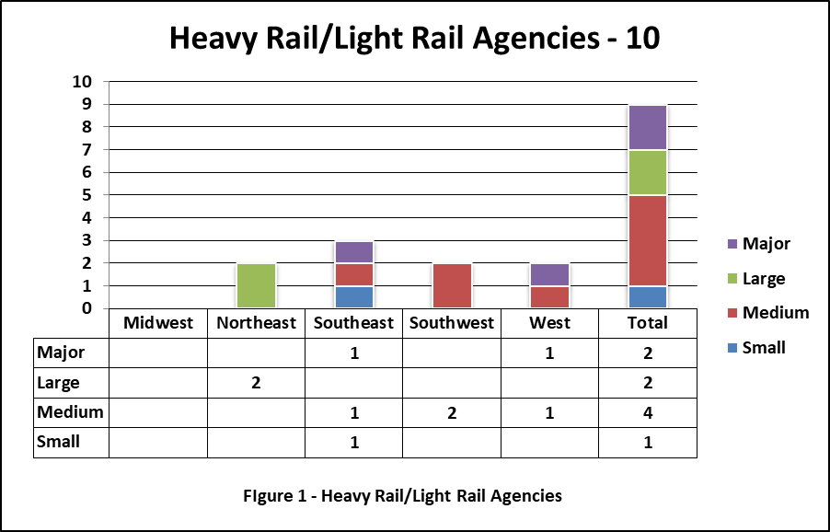
Cross-Referencing the Demographics: The above table illustrates there were 10 Rail agencies. Three of the ten Rail Agencies were from the Southeast (1 Small, 1 Medium, and 1 Major), two were from the Southwest (both Medium), two were from the Northeast (Large), and two agencies were from the West (1 Medium, 1 Major). One Rail agency respondent skipped this question and for an unknown reason did not specify the size of their agency. Cross-referencing the data illustrates that not all size categories of Rail were represented in every geographical area, but every geographical area of the country was represented by at least 1 Rail only agency (regardless of size), with the exception of the Midwest. According to the survey results, there were no “Rail Only” agencies represented from the Midwest.
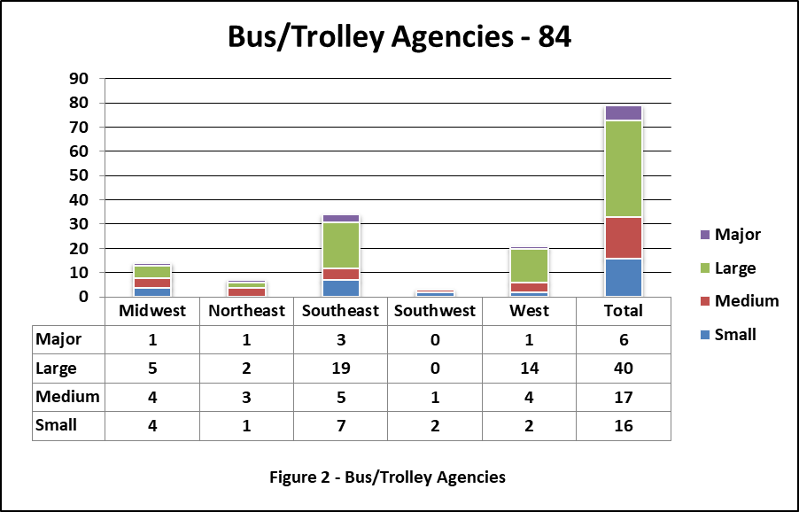
The above table illustrates there were 84 Bus agencies. 14 of the Bus agencies were from the Midwest (4 Small, 4 Medium, 5 Large, and 1 Major). Seven of the Bus agencies were from the Northeast (1 Small, 3 Medium, 2 Large, and 1 Major). 33 of the Bus agencies were from the Southeast (7 Small, 5 Medium, 19 Large, and 2 Major). Three of the Bus agencies were from the Southwest (2 Small, 1 Medium), and 20 Bus agencies were from the West (2 Small, 4 Medium, 13 Large, and 1 Major). Cross-referencing the data illustrates that there was Bus representation from across the country in each category other than the Southwest, where there were no Large or Major Bus agency responses from within that region. Five of the reporting agencies did not answer any questions beyond the first question; therefore, there was no demographic information to discover regarding those agencies. One agency did not answer the remaining demographic questions, but did answer questions throughout the questionnaire.
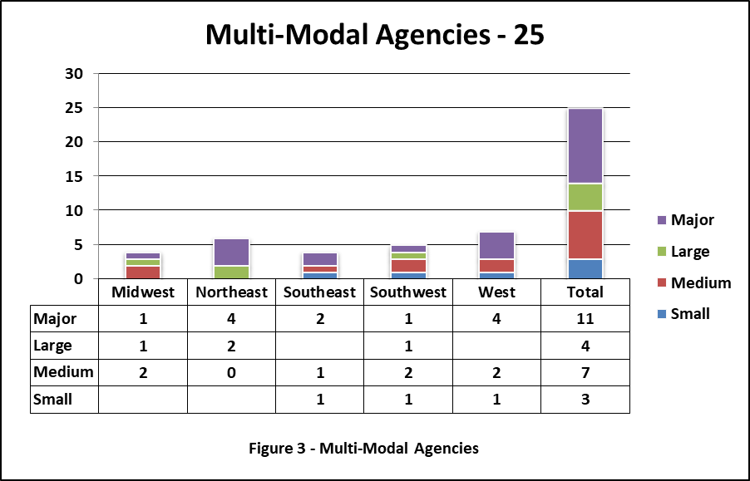
The above table illustrates there were 25 Multi-Modal agencies. Four of the agencies were from the Midwest (2 Medium, 1 Large, and 1 Major). Six of the agencies were from the Northeast (2 Large, 4 Major). Four of the agencies were from the Southeast (1 Small, 1 Medium, and 2 Major). Five agencies were from the Southwest (1 Small, 2 Medium, 1 Large, and 1 Major). Six agencies were from the West (1 Small, 2 Medium, and 3 Major). Cross-referencing the data illustrates that there was Multi-Modal representation from across the country in each category other than the Midwest (no Small agencies), Northeast (no Small or Medium agencies), Southeast (no Large agencies), and West (no Large agencies). Otherwise, every geographic area had representation of at least one of the different sized agencies. One Multi-Modal agency answered the first question, but failed to answer any other questions within the questionnaire.
Table 2, Cross Referenced Demographics, provides a table view of the breakdown by demographic information. Other than the information specifically provided there was one other agency that provided no demographic information whatsoever, but did complete the quantitative survey questions. Based on the information provided, although there are some categories not represented, it can certainly be argued that there is satisfactory generalizability across the industry of urbanized transit agencies, in terms of size, modes of service and geography.
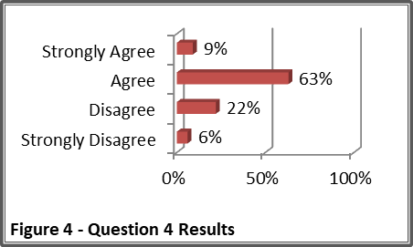
Question #4: My agency is better prepared for contingencies since the implementation of HSPD-5 than prior to the implementation of HSPD-5.
It was important during this survey to determine whether agencies felt they were better prepared now than before HSPD-5 was implemented. There has been time; a decade and a half has passed since HSPD-5 implementation. There have been numerous major emergencies, some discussed in the literature review section, that have provided both “lessons learned” and “best practices” in various reports. There have also been major agencies in the country, one in which the case study contained in this research is based (Washington, DC), that have developed models worthy of being copied. However, agencies may have not been as successful in this effort due to the absence of one or more of the variables being discussed as vital in this study; funding, training, equipment, and collaboration.
There were 109 contributors who answered this question. Ten Strongly Agreed, 69 Agreed, 24 Disagreed, and six Strongly Disagreed. Taking the results from this final report and comparing them to the midway report that was described earlier (64 responses), it illustrates that the percentages only slightly move in each of these responses and are identical in the Disagree and Strongly Disagree categories. Strongly Agree increased from 6 to 9% while Agree decreased from 67% to 63%. Disagree remained 22% and Strongly Disagree remained 6% in each version. In SPSS, Strongly Agree was coded as 1, Agree was coded as 2, Disagree was coded as 3, and Strongly Disagree was coded as 4. The Mean was 2.24 with a Standard Deviation of .693. The following paragraphs explain the complete breakdown between each response and it compares with each of the demographics.
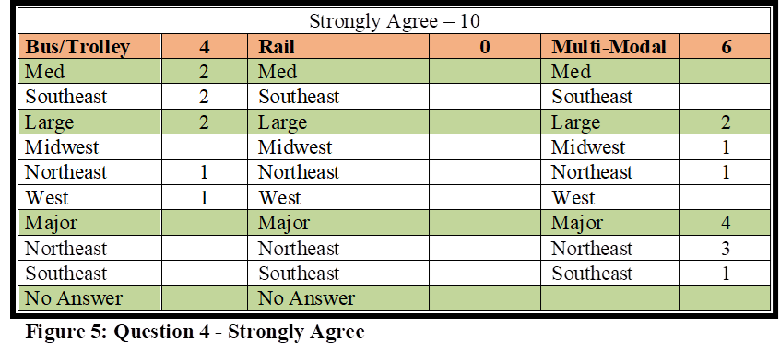
Strongly Agree Responses - Ten agencies overall strongly agreed to this question. Six of these agencies were Multi-Modal, 1 from the Midwest (Large), four from the Northeast (one Large, three Major), and one from the Southeast (Major). Four Bus agencies strongly agreed, with two from the Southeast (Medium), one from the Northeast (Large), and one agency from the West (Large). The Strongly Agree responses are illustrated in Figure 5.
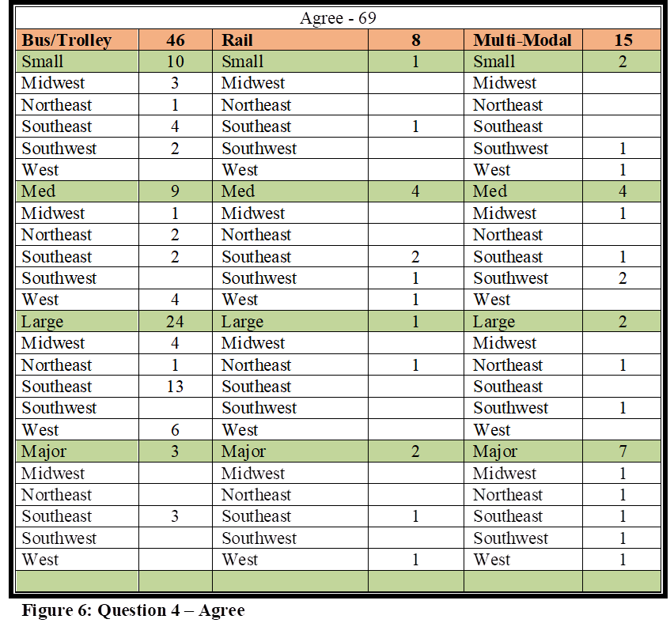
Agree Responses: The much larger reply category was Agree, in which 69 total agencies (63%) responded. Eight of these 69 were Rail agencies. Four agencies were from the Southeast (one Small, two Medium, one Major), one from the Northeast (Large), one from the Southwest (Medium), and two from the West (Medium & Major). Forty-six Bus agencies replied in the Agree category. There were 10 Small agencies (three from the Midwest, one from the Northeast, four from the Southeast, and two from the Southwest), nine Medium agencies (one from the Midwest, two from the Northeast, two from the Southeast, and four from the West), 24 Large agencies (four from the Midwest, one from the Northeast, 13 from the Southeast, and six from the West), and three Major agencies (Southeast). Fifteen Multi-Modal agencies agreed. Two were Small agencies (Southwest & West), four were Medium agencies (one Midwest, one Southeast, and two Southwest), two were Large agencies (Northeast & Southwest), and seven were Major agencies (one Midwest, one Northeast, one Southeast, one Southwest, and two West). The Agree responses are illustrated in Figure 6.
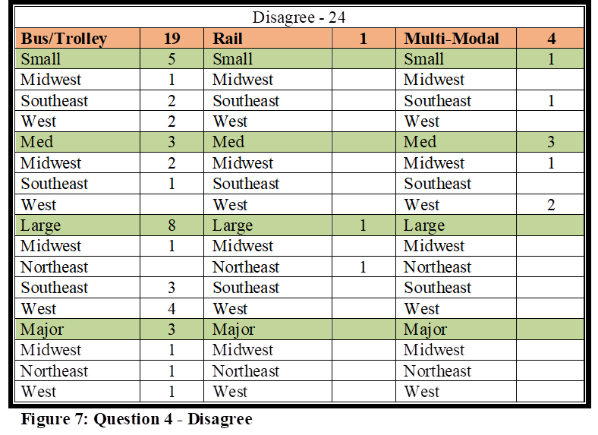
Disagree Responses – Twenty-four agencies disagreed with this question. Rail had only one agency that disagreed (Northeast), and there were four Multi-Modal agencies who replied in the Disagree category. One Multi-Modal agency was a Small agency (Northeast), and three were Medium agencies (one Midwest, two West). Nineteen Bus agencies disagreed. Five agencies were Small (one Midwest, two Southeast, two West), three were Medium (two Midwest, one Southeast), eight were Large (one Midwest, three Southeast, four West), and three were Major (Midwest, Northeast, West). Disagree responses are illustrated in Figure 7.
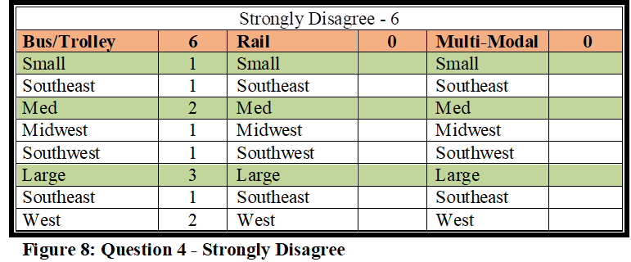
Strongly Disagree Responses – Six total agencies strongly disagreed, and all six were Bus agencies. There was one Small (Southeast), two Medium (Midwest, Southwest), and three Large agencies (one Southeast, two West). Strongly Disagree responses are illustrated in Figure 8.
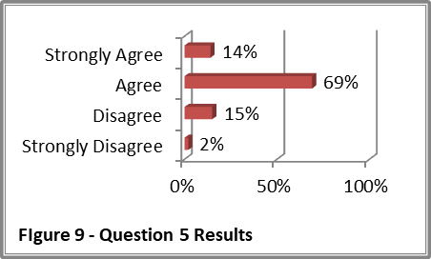
Question 4 Analysis – It is notable that 72% of the respondents either Strongly Agreed or Agreed with this question. This means the overwhelming majority of these agencies perceive there has been improvement in their overall preparation to handle contingencies. It is not surprising that those agencies that chose Strongly Agree for this question were primarily from Large or Major agencies with six being Multi-Modal. Larger agencies seemingly have more resources to pursue such efforts. However, even with the positive number of agencies who perceive they are better prepared now than prior to the implementation of HSPD-5, there were still nearly 30% who either disagreed or strongly disagreed with the question. No Multi-Modal agencies above Medium chose either of the “Disagree” responses, while only one Rail agency (Large agency in the Northeast) disagreed. However, Bus agencies were represented fairly well in all demographics in both of the disagree options. This significant element illustrates there is a potential issue that Bus agencies across all demographics need an increased level of HSPD-5 preparation.
Question #5: My agency is well prepared to handle natural disasters and major industrial and transportation related accidents that are common to our region.
This question was created to determine whether agencies perceive they are prepared to handle the natural disasters and major industrial/ transportation related accidents that they already handle, or may realistically confront in their region, regardless of their attitude regarding HSPD-5 preparation and compliance. These types of events are those that are not intentionally caused, such as those we see in crime and terrorism. These events would include natural disasters such as storms (hurricanes, earthquakes, snow events, etc.) whereas industrial/transportation related accidents would include derailments, passengers struck by trains (non-criminal), train accidents, tunnel fire incidents, collapsed bridges, etc. These events could be mass casualty, or incidents that cause major crises without death and/or injury. These are events seen long before HSPD-5 implementation; therefore, the expectation was to see some improvement here over Question 4.
There were 112 contributors who answered this question. Sixteen Strongly Agreed, 77 Agreed, 17 Disagreed, and two Strongly Disagreed. If we take the results from this final report and compare them to the midway report that was described earlier (64 responses), it would illustrate that similar to Question 4, the percentages only slightly moved in each of these responses, and are identical in the Disagree and Strongly Disagree categories. Strongly Agree increased from 11 to 14% while Agree decreased from 73 to 69%. Disagree remained 15% and Strongly Disagree remained 2% in each version. In SPSS, Strongly Agree was coded as 1, Agree was coded as 2, Disagree was coded as 3, and Strongly Disagree was coded as 4. The Mean was 2.04 with a Standard Deviation of .606. The following paragraphs explain the complete breakdown between each response and it compares with each of the demographics.
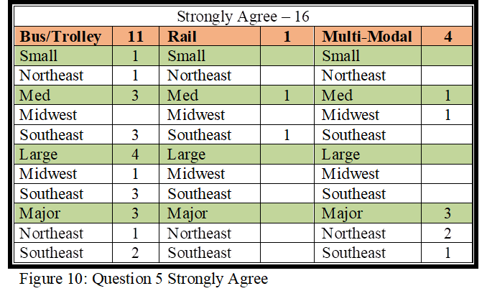
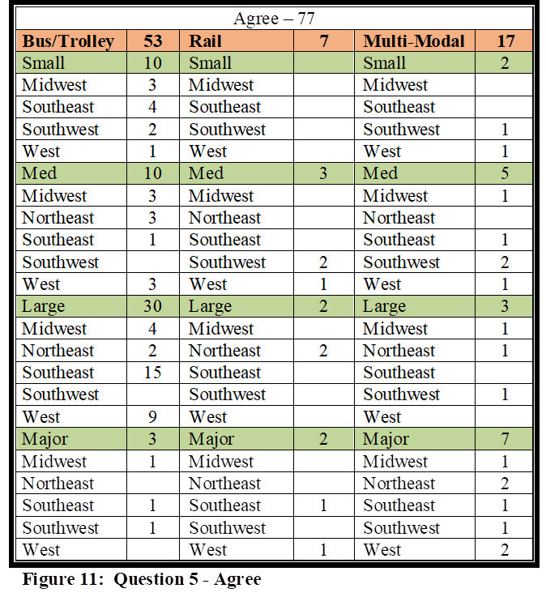
Strongly Agree Responses – Sixteen agencies strongly agreed with this question. Rail had one Medium agency that strongly agreed (Southeast), while there were four Multi-Modal agencies that strongly agreed. One Multi-Modal agency was a Medium agency (Midwest), and three were Major agencies (two Northeast, one Southeast). Eleven Bus agencies strongly agreed. One agency was a Small agency (Northeast), three were Medium (Southeast), four were Large (one Midwest, three Southeast), and three were Major (one Northeast, two Southeast). Strongly Agree responses are illustrated in Figure 10.
Agree Responses: Similar to Question 4, the much larger reply category was Agree, in which 77 total agencies (69%) answered. Seven of these 77 agencies were Rail agencies. Three of the Rail agencies were Medium (two Southwest, one West), two were Large (Northeast), and two were Major (Southeast, West). Seventeen Multi-Modal agencies agreed with the question. Two were Small agencies (Southwest, West), Five were Medium agencies (one Midwest, one Southeast, two Southwest, and one West), three were Large agencies (Midwest, Northeast, Southwest), and seven were Major agencies (1 Midwest, two Northeast, one Southeast, one Southwest, and two West). Fifty-three respondents were from Bus agencies. Ten agencies were Small (three Midwest, four Southeast, two Southwest, and one West). Ten agencies were Medium (three Midwest, three Northeast, one Southeast, and three West). The greatest response area was Large Bus agencies (four Midwest, two Northeast, 15 Southeast, and nine West). Three Major Bus agencies agreed (Midwest, Southeast, Southwest). Agree responses are illustrated in Figure 11.
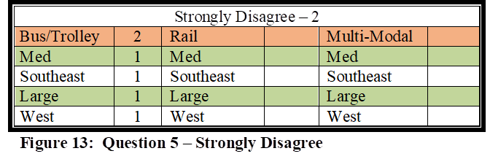
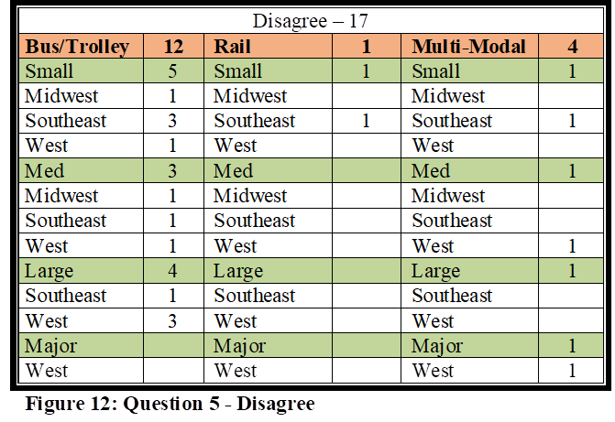
Disagree Responses – There were 17 agencies that disagreed with this question. Rail had one Small agency that disagreed (Small), while there were four Multi-Modal agencies that disagreed. One Multi-Modal agency was a Small agency (Southeast), one Medium (West), one Large (Northeast), and one Major agency (West). Twelve Bus agencies disagreed. Five agencies were Small (one Midwest, three Southeast, one West), three were Medium (Midwest, Southeast, West), four were Large (one Southeast, three West), and there were no Major Bus agencies. Disagree responses are illustrated in Figure 12.
Strongly Disagree Responses – Only two agencies strongly disagreed with this question. Rail and Multi-Modal had zero. There were two Bus agencies that Strongly Disagreed. One Bus agency was Medium (Southeast) while the other was Large (West). Strongly Disagree responses are illustrated in Figure 13.
Question 5 Analysis – A higher percentage of agencies strongly agreed or agreed with Question 5 (83%) than with Question 4 (72%). This indicates that 10% of the agencies who perceive they are well prepared to handle an incident of this magnitude do not perceive they are better now than prior to the implementation of HSPD-5. Does that mean they perceive they were already competent prior to HSPD-5 implementation? One theory, which will have to be verified through qualitative interviews, is that agencies indeed prepared themselves well before HSPD-5 as they faced a wide array of emergencies, and that education, training, and experience over time, has greatly increased their confidence in mitigating these types of crises, with or without aid.
Unlike Question 4, not all agencies that chose Strongly Agree for this question were primarily from Large or Major agencies. Six of the agencies were Small and Medium agencies. The one Rail agency that disagreed was a Small agency, whereas Multi-Modal agencies had one response in all four of the size categories.
The responses received in Question 5 are promising, but even with the high number of agencies who perceive they are confident in their abilities to mitigate these types of emergencies there were still 19 agencies, 14 of which were Bus, who either disagreed or strongly disagreed with this statement. If we are to feel confident with the generalizability of this study and reliability that these numbers represent the whole, it should be somewhat concerning that 17% of our urbanized transit agencies do not perceive they are prepared to handle the emergencies that are common for their agency and region.
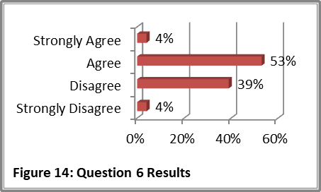
Question #6: My agency is prepared to handle terrorist attacks that could be faced in today’s environment.
This question was created to determine whether agencies perceive they are prepared to handle the man-made disasters that could potentially come about due to terrorism. As illustrated in the literature review, public transportation has been a major target around the world and even more increasingly so over the past couple of decades. Just the wide-open nature of public transportation makes our transit systems across the country soft targets to terrorism whether from international or domestic actors. Considering the recent events our country has faced in just the past year alone should be concerning to public transit security experts considering that buses and trains are wide open opportunities for an active shooter to quickly murder dozens of citizens in only a very short timeframe. As argued in the literature review section, Major agencies are, and have been, deeply concerned about terrorism, and most have taken proactive steps in protecting their property, patrons and employees. However, this concern should be at the forethought of agency heads at all levels of public transportation. As argued in the literature review, a sovereign citizen, a mentally deranged lone wolf, a religious zealot, someone angered by current political arguments, and this list goes on and on of potential reasons a citizen in any area of the country, regardless of population, could easily target their transit system as an active shooter or as an act of terrorism, depending on the circumstances. Our agencies need to be well prepared not only to prevent this type of incident from happening, but within the scope of this study, to be able to mitigate through that crisis in a NIMS structure.
There were 112 contributors who answered Question 6. Five Strongly Agreed, 59 Agreed, 43 Disagreed, and five Strongly Disagreed. If we take the results from this final report and compare them to the midway report that was described earlier (64 responses), it would illustrate that the percentages again only slightly moved in each of these response categories. Strongly Agree increased from 0 to 4% while Agree decreased from 58 to 53%. Disagree increased from 35 to 39% and Strongly Disagree decreased from 7 to 4% in each version. In SPSS, Strongly Agree was coded as 1, Agree was coded as 2, Disagree was coded as 3, and Strongly Disagree was coded as 4. The Mean was 2.43 with a Standard Deviation of .654. The following paragraphs explain the complete breakdown between each response and it compares with each of the demographics.
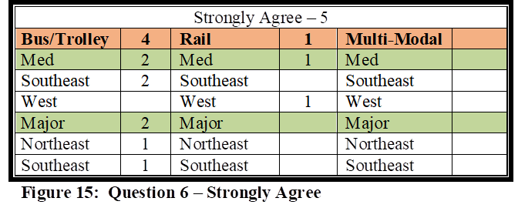
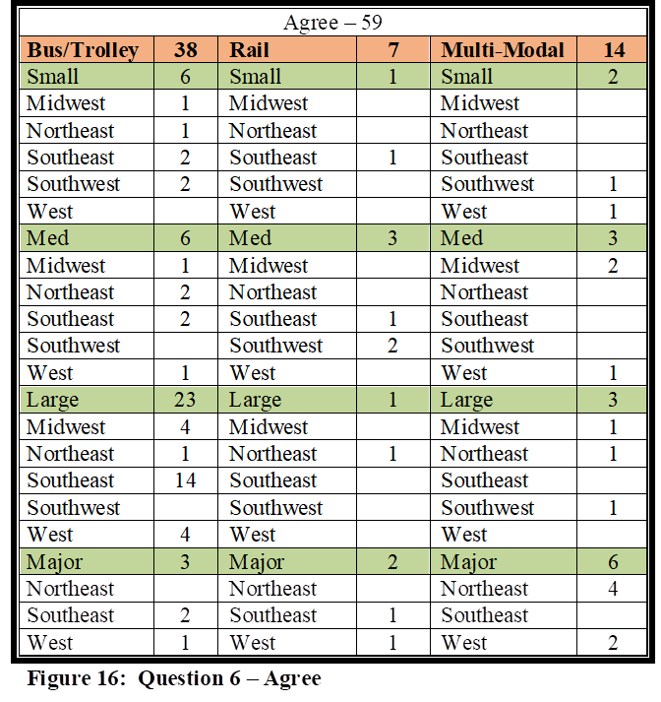
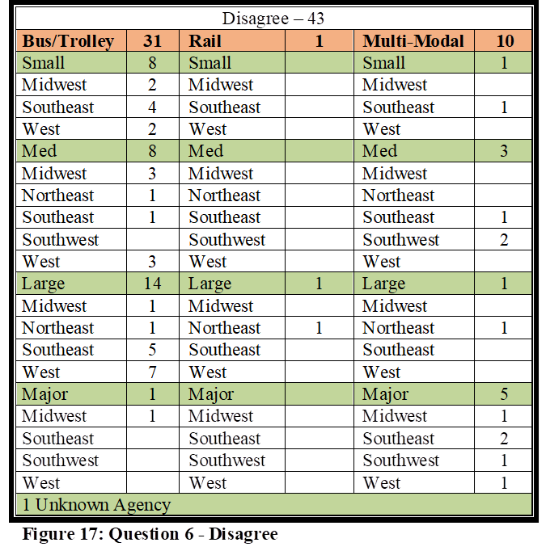
Strongly Agree Responses – Five agencies strongly agreed with this question. Rail had one Medium agency that strongly agreed (West), while four Bus agencies strongly agreed. Two Bus agencies were Medium (Southeast) and two were Major (Northeast, Southeast). There were no Multi-Modal agencies that strongly agreed. The Strongly Agree responses are illustrated in Figure 15. Agree Responses: Fifty-nine agencies agreed. Seven of the 77 agencies were Rail agencies. One was a Small agency (Southeast) while three were Medium (one Southeast, two Southwest), one was Large (Northeast), and two were Major (Southeast, West). Fourteen Multi-Modal agencies agreed with Question 6. Two of the 14 were Small agencies (Southwest, West), three were Medium agencies (two Midwest, one West), three were Large agencies (Midwest, Northeast, Southwest), and six were Major agencies (four Northeast, two West). Thirty-eight respondents were Bus agency representatives. Six Bus agencies were Small (one Midwest, one Northeast, two Southeast, and two Southwest), six agencies were Medium (one Midwest, two Northeast, two Southeast, and one West). The greatest Agree response category, with 23 responses, was Large Bus agencies (four Midwest, one Northeast, 14 Southeast, and four West), and there were three Major Bus agencies that agreed (Southeast, West). The Agree responses are illustrated in Figure 16.
Disagree Responses – Forty-two agencies disagreed with this question. Rail had one Large agency that disagreed (Northeast), while there were ten Multi-Modal agencies that disagreed. One Multi-Modal agency was a Small agency (Southeast), three were Medium (one Southeast, two Southwest), one Large (Northeast), and five Major agencies (one Midwest, two Southeast, one Southwest, one West). Thirty-one Bus agencies disagreed. Eight agencies were Small (2 Midwest, 4 Southeast, 2 West), eight were Medium (three Midwest, one Northeast, one Southeast, three West), 14 were Large (one Midwest, one Northeast, five Southeast, sevem West), and one Major Bus agency (Midwest). There was one Disagree response from an agency of unknown size or location. Disagree responses are illustrated in Figure 17.
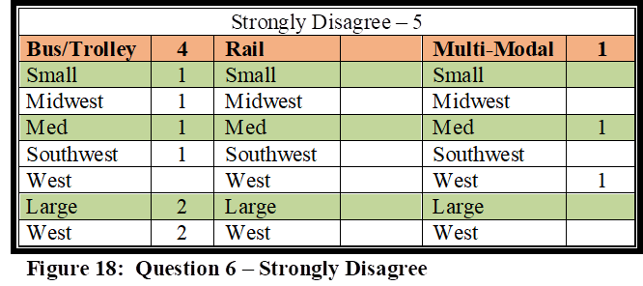
Strongly Disagree Responses – Five agencies strongly disagreed with this question. Rail had no Strongly Disagree responses. There was one Medium Multi-Modal agency (West), and four total Bus agencies. One Bus agency was Small (Midwest, one was Medium (Southwest), and two were Large (West). Strongly Disagree responses are illustrated in Figure 18.
Question 6 Analysis - Nearly half of the agencies that completed the survey (43%) either disagreed or strongly disagreed that their agency is prepared to handle a terrorist attack that could be faced in today’s environment. Not all of these agencies were bus agencies either; there were 11 Multi-Modal agencies from all size groups, including 5 Major agencies that disagreed or strongly disagreed.
This is concerning in that this study is measuring the attitudes of contributors in regards to public transit agencies and their preparedness to respond to and mitigate a crises during, or after they might occur. If nearly half do not perceive they are prepared to handle these events during or after an event, how many of our agencies do not perceive they have the ability to thwart an attack in the first place? How many are prepared and active in “See Something, Say Something” and other programs that are available? How many are receiving the assistance they need in preventative efforts? These focuses are out of the scope of this study, but certainly raise questions for future research.
Question #7: My agency is prepared to assist with regional contingencies as requested by local first responders.
This question was created to determine whether our agencies feel prepared to assist with the regional contingencies as requested by local first responders. As illustrated in the literature review, regional first responders have relied on public transportation to assist in a myriad of emergencies in our country. Considering agencies may be called upon any given day, it is important they feel prepared to assist with whatever contingency local first responders may encounter.
There were 113 respondents who answered this question. Thirty-five Strongly Agreed, 70 Agreed, 8 Disagreed, and 0 Strongly Disagreed. If we take the results from this final report and compare them to the midway report (64 responses), it would illustrate the percentages only slightly moved in each of the response categories. Strongly Agree increased 30 to 31% while Agree declined 64 to 62%. Disagree increased 5 to 7% and Strongly Disagree remained at 0. In SPSS, Strongly Agree was coded as 1, Agree was coded as 2, Disagree was coded as 3, and Strongly Disagree was coded as 4. The Mean was 1.76 with a Standard Deviation of .571. The following paragraphs explain the complete breakdown between each response and it compares with each of the demographics.
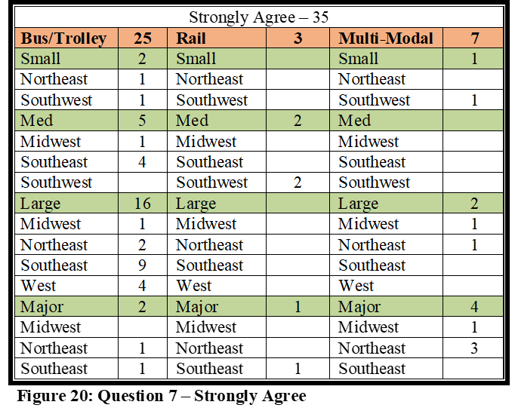
Strongly Agree Responses – Thirty-five agencies strongly agreed. Rail had three total with two Medium (Southwest) and one Major (Southeast). Seven Multi-Modal agencies strongly agreed, with one Small (Southwest), two Large (Midwest, Northeast), and four Major (one Midwest, three Northeast). Twenty-five Bus agencies strongly agreed. Two were Small (Northeast, Southwest), five were Medium (one Midwest, four Southeast), 16 were Large (one Midwest, two Northeast, nine Southeast, four West), and two were Major (Northeast, Southeast). Strongly Agree responses are illustrated in Figure 20.
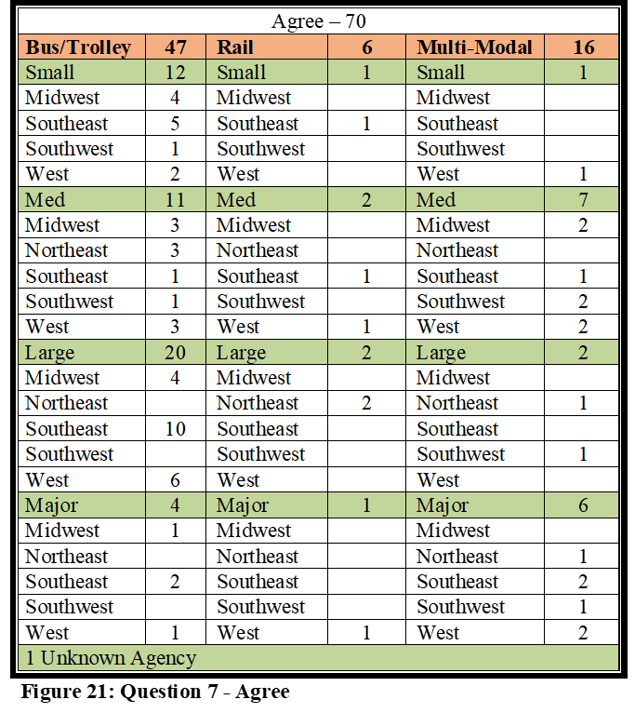
Agree Responses: 70 total agencies (69%) agreed. Six agencies were Rail, with one Small (Southeast), two Medium (Southwest, West), two Large (Northeast), and one Major (West). 16 Multi-Modal agencies agreed. One was Small (West), seven Medium (two Midwest, one Southeast, two Southwest, and two West), two Large agencies (Northeast, Southwest), and six Major (one Northeast, two Southeast, one Southwest, and two West). Forth-seven respondents were from Bus agencies. Twelve agencies were Small (four Midwest, five Southeast, one Southwest, and two West). Eleven agencies were Medium (three Midwest, three Northeast, one Southeast, one Southwest, three West). There were 20 Large Bus agencies (four Midwest, 10 Southeast, six West). Four Major Bus agencies agreed (one Midwest, two Southeast, one West). Agree responses are illustrated in Figure 21.
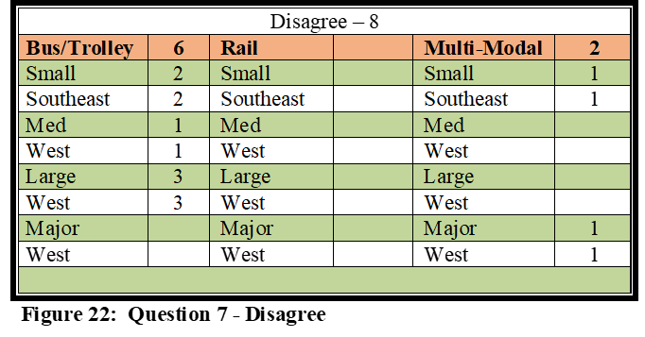
Disagree Responses – 8 agencies disagreed with this question. There were zero Rail agencies. Two Multi-Modal agencies disagreed. One Multi-Modal agency was a Small agency (Southeast) and one was a Major agency (West). Six Bus agencies disagreed. Two agencies were Small (Southeast), one Medium (West), and three Large (West). Disagree responses are illustrated in Figure 22.
Strongly Disagree Responses – There were zero Strongly Disagree responses.
Question 7 Analysis – It is impressive that 93% of the agencies replied that they were prepared to assist with regional contingencies as requested by local first responders. This is the first of the questions that analyze the collaboration efforts that local first responders have with our public transportation agencies, and as illustrated in the literature review, collaboration is one of the cornerstones of successful crisis management. The fact that 93% of the respondents to this study feel their agencies are prepared to respond to the needs of their communities by supporting emergency responders when crises arise, is especially noteworthy. Looking back at question 4, where nearly 73% felt better prepared now than prior to the implementation of HSPD-5, and comparing it to the results here in question 7, the early indication is that HSPD-5 has had a positive impact on agency’s abilities to assist local first responders.
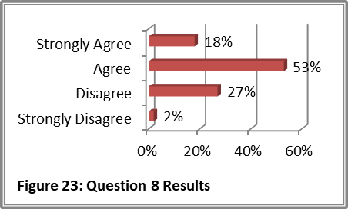
Question #8: Written plans exist that mandate and describe the mitigation efforts my agency must take in regional level contingencies.
This question was created to determine how many agencies are operating under specific mandates in their region that outline what level of assistance they will provide during a crisis in their area. One of the arguments laid out in the literature review section is that public transit agencies are expected to assist with the mitigation of emergencies, not just as a societal expectation, but also by mandate. At the very least, as explained during literature review, all Rail agencies, and Bus agencies that have accepted FTA funding, per 49 CFR 659, must have a combined Security and Emergency Preparedness Plan (SEPP), or two separate plans that would still cover both security and emergency management. This mandate would apply to all Rail agencies in this study, and any of the other agencies that have accepted FTA funding.
There were 113 contributors who answered this question. Twenty Strongly Agreed, 60 Agreed, 31 Disagreed, and 2 Strongly Disagreed. If we take the results from this final report and compare them to the midway report that was described earlier (64 responses), it would illustrate that the percentages only slightly moved in each of these responses. Strongly Agree stayed the same at 18% while Agree decreased from 55 to 53%. Disagree increased from 23 to 27% while Strongly Disagree decreased from 4 to 2%. In SPSS, Strongly Agree was coded as 1, Agree was coded as 2, Disagree was coded as 3, and Strongly Disagree was coded as 4. The Mean was 2.13 with a Standard Deviation of .713. The following paragraphs explain the complete breakdown between each response and it compares with each of the demographics.
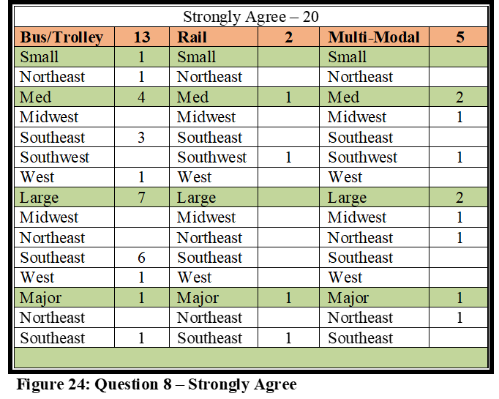
Strongly Agree Responses – Twenty agencies (18%) strongly agreed. Rail had one Medium agency that strongly agreed (Southwest) and one Major agency (Southeast) for two total agencies. Multi-Modal agencies had two Medium agencies that strongly agreed (Midwest, Southwest), two Large agencies (Midwest, Northeast), and one Major agency (Northeast). Thirteen Bus agencies strongly agreed. One agency was a Small agency (Northeast), four were Medium (three Southeast, one West), seven were Large (six Southeast, one West), and one Major (Southeast). Strongly Agree responses are illustrated in Figure 24.
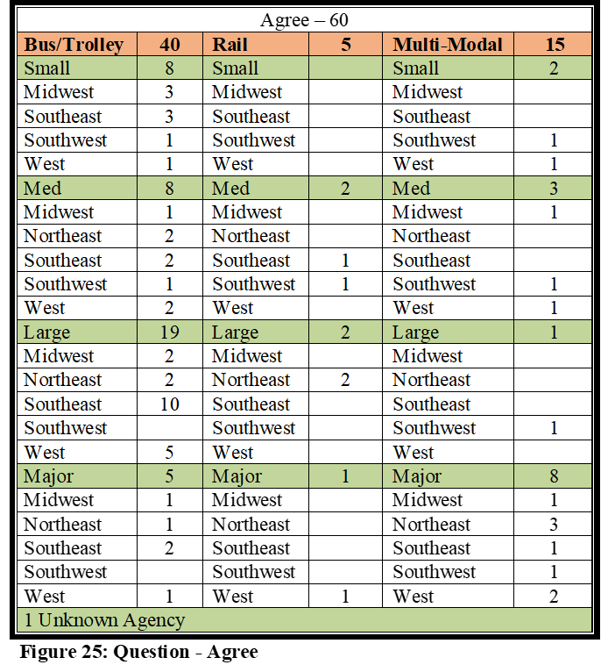
Agree Responses: Sixty total agencies (53%) agreed. Five of the 60 agencies were Rail agencies. Two of the Rail agencies were Medium (Southwest, Southwest), two were Large (Northeast), and one was Major (West). Fifteen Multi-Modal agencies agreed. Two were Small agencies (Southwest, West), three were Medium agencies (Midwest, Southwest, West), one was Large (Southwest), and eight were Major agencies (one Midwest, three Northeast, one Southeast, one Southwest, and two West). Forty respondents were from Bus agencies. Eight agencies were Small (three Midwest, three Southeast, one Southwest, one West). Eight agencies were Medium (one Midwest, two Northeast, two Southeast, one Southwest, two West). There were 20 Large Bus agencies (two Midwest, two Northeast, 10 Southeast, and five West), and five Major Bus agencies (one Midwest, one Northeast, two Southeast, one West). There was one agency of unknown location and size. Agree responses are illustrated in Figure 25.
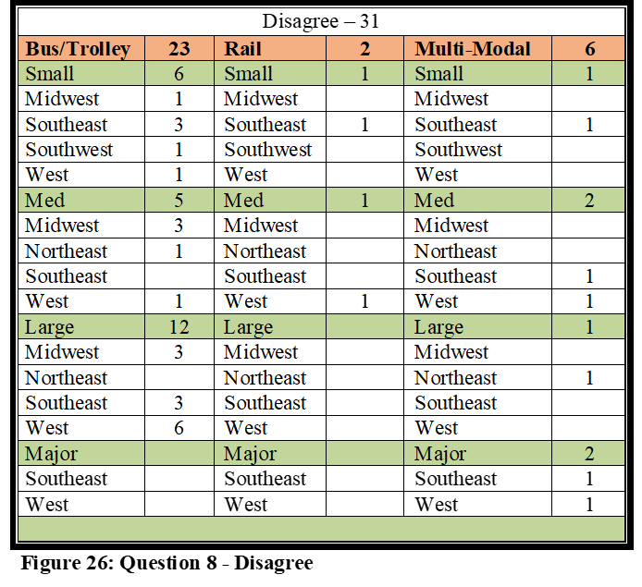
Disagree Responses – Thirty-one agencies disagreed. Rail had one Small (Southeast) and one Medium agency (West) for two total agencies. Six Multi-Modal agencies disagreed. One Multi-Modal agency was a Small agency (Southeast), two were Medium (Southeast, West), one Large (Northeast), and two were Major agencies (Southeast, West). Twenty-three Bus agencies disagreed. Six agencies were Small (one Midwest, three Southeast, one Southwest, one West), five were Medium (three Midwest, one Northeast, one West), and 12 were Large (three Midwest, three Southeast, six West). The Disagree responses are each illustrated in Figure 26.
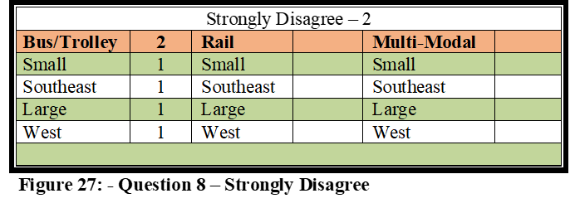
Strongly Disagree Responses – Only two agencies strongly disagreed with this question. Rail and Multi-Modal had zero. Two Bus agencies, one Small (Southeast), and one Large (West) Strongly Disagreed. Strongly Disagree responses are illustrated in Figure 27.
Question 8 Analysis – As expected, all but eight combined Rail and Multi-Modal agencies either agreed or strongly agreed. Agencies would likely see their SEPP as at least one form of emergency preparedness and response mandate. More agencies than expected, however, especially in the Large and Metro categories (15 total), either disagreed or strongly disagreed. This study measures the attitudes of transit managers in regards to the questions asked. Future research would certainly be beneficial to verify how accurate the numbers are in the Disagree and Strongly Disagree response categories, and whether 29% of the urbanized public transportation agencies truly are not guided by any mandate for regional emergency mitigation. It is difficult to imagine there are no agency mandates for Midwest and Northeast agencies during snow emergencies, and nothing mandating response to agencies in the Southeast in the event of Hurricanes. The same could be said for any of the geographical areas pertaining to events they are likely to confront. However, nearly 30% disagreed or strongly disagreed with this question, and only executive level personnel were targeted for the survey. If the 29% is in fact actual, this is concerning for the public transportation industry, and does subtract from the overall collaboration efforts which should include public transportation in mitigation efforts.
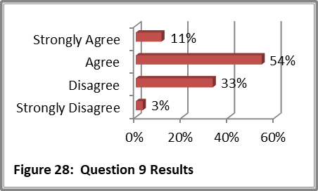
Question #9: My agency has received the assistance needed from local, state, and federal agencies in our overall preparedness efforts.
This question was created to determine if agencies felt they have received, in general, the assistance needed from local, state, and federal agencies in their overall preparedness efforts. Overall preparedness would include funding, training, equipment, and collaboration, as described during the literature review. Some agencies may feel fully prepared in all areas, but there should be some differences among the agencies in how they perceive they have been assisted by various levels of government in this effort, and in what areas they perceive they have or have not been sufficiently aided. Other questions will examine the attributes of funding, equipment, training, and collaboration, in further detail, but this question examines aid for preparedness as a whole.
There were 113 contributors who answered this question. Twelve Strongly Agreed, 61 Agreed, 37 Disagreed, and three Strongly Disagreed. If we take the results from this final report and compare them to the midway report that was described earlier (64 responses), it would illustrate that the percentages only slightly moved in each of these responses. Strongly Agree increased from 7 to 11% while Agree decreased from 55 to 54%. Disagree decreased from 34 to 33% and Strongly Disagree decreased from 4 to 3%. In SPSS, Strongly Agree was coded as 1, Agree was coded as 2, Disagree was coded as 3, and Strongly Disagree was coded as 4. The mean was 2.27 with a Standard Deviation of .685. The following paragraphs explain the complete breakdown between each response and it compares with each of the demographics.
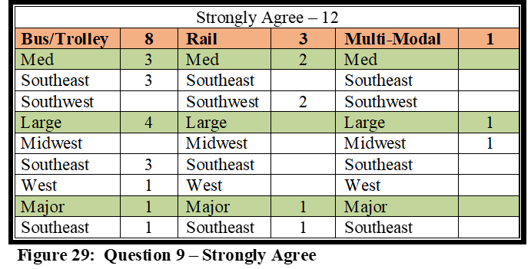
Strongly Agree Responses – Twelve agencies strongly agreed. Rail had two Medium agencies (Southwest), and one Major agency (Southeast), for three total. One Large Multi-Modal agency (Midwest) strongly agreed. Eight Bus agencies strongly agreed. Three were Medium (Southeast), four Large (three Southeast, one West), and one was Major (Southeast). Strongly Agree responses are illustrated in Figure 29.
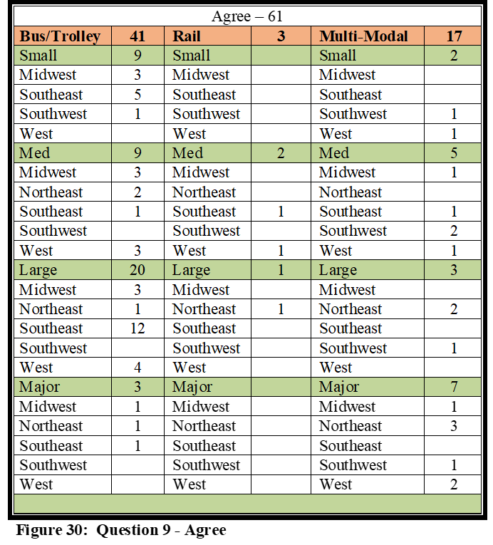
Agree Responses: Sixty-one total agencies (54%) agreed. Three of the 61 agencies were Rail agencies. Two of the Rail agencies were Medium (Southwest, West) and one was Large (Northeast). Seventeen Multi-Modal agencies agreed with the question. Two were Small agencies (Southwest, West), five were Medium agencies (one Midwest, one Southeast, two Southwest, and one West), three were Large agencies (two Northeast, one Southwest), and seven were Major agencies (one Midwest, three Northeast, one Southwest, two West). Forty-one respondents were from Bus agencies. Nine agencies were Small (three Midwest, five Southeast, one Southwest). Nine agencies were Medium (three Midwest, two Northeast, one Southeast, and three West), 20 were Large (three Midwest, one Northeast, 12 Southeast, four West), and three were Major (Midwest, Northeast, Southeast). The Agree responses are illustrated in Figure 30.
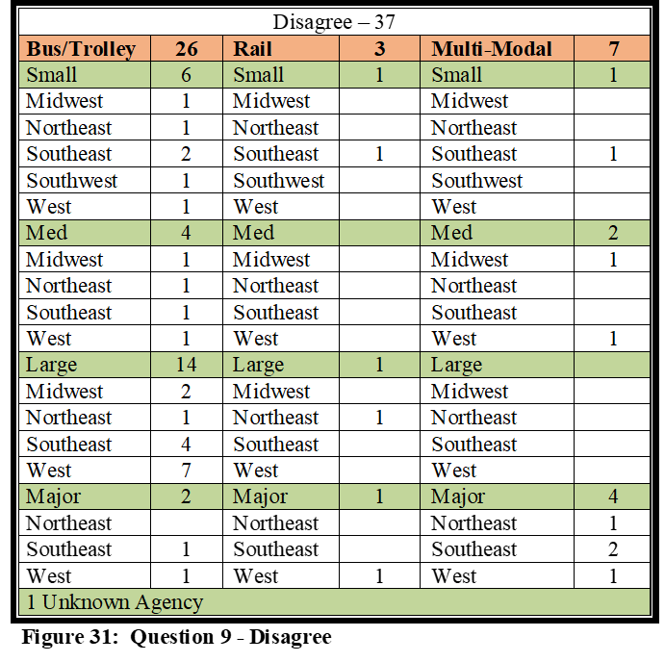
Disagree Responses – Thirty-seven agencies disagreed. Rail had three total agencies, including one Small (Southeast), one Large (Northeast) and one Major (West). Seven Multi-Modal agencies disagreed. One Multi-Modal agency was a Small agency (Southeast), two were Medium (one Midwest, one West), and four were Major (one Northeast, two Southeast, one West). Twenty-six Bus agencies disagreed. Six were Small agencies (one Midwest, one Northeast, two Southeast, one Southwest, one West), four were Medium (Midwest, Northeast, Southeast, West), 14 were Large (two Midwest, one Northeast, five Southeast, seven West), and two Major (Southeast, West). There was one Disagree response from an agency of unknown size or location. Disagree responses are illustrated in Figure 31.
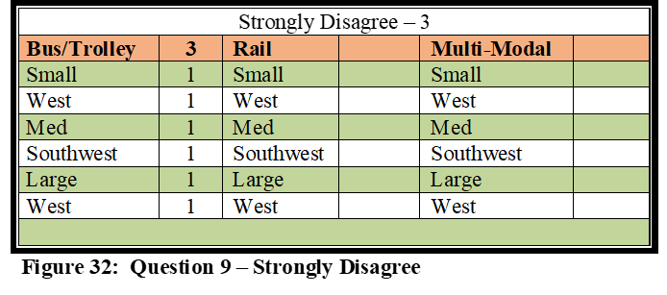
Strongly Disagree Responses – Only three agencies strongly disagreed with this question. Rail and Multi-Modal had zero. The three Bus agencies who strongly disagreed were one Small (West), one Medium (Southwest), and one Large (West). Strongly Disagree responses are illustrated in Figure 32.
Question 9 Analysis – Even though 83% of the agencies feel well prepared to handle natural disasters and major industrial/transportation related accidents (Question 5), and 93% perceive their agency is prepared to assist with regional contingencies (Question 7), the numbers are lower here with only 64% who perceive they have received the assistance needed from local, state, and federal agencies in the overall preparedness efforts. 36% of the reporting agencies perceive they have not received the assistance they need to help them prepare for contingencies, and 23 of the 40 who replied Disagree or Strongly Disagree, were either Large or Major size agencies. These are agencies that transport more than 1Million passengers per year, and for the seven Major agencies, more than 10 million passengers, in unlinked passenger trips annually.
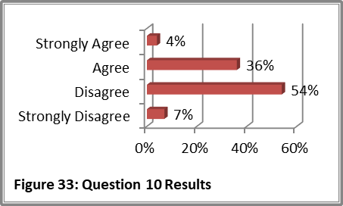
Question #10: My agency has received the funding needed from local, state, and federal agencies in our overall preparedness efforts. This question was created as a follow-up to the previous question to determine if agencies perceive they have received, the funding needed from local, state, and federal agencies in their overall preparedness efforts, and also to complement Question 18 in regards to funding needed to be NIMS compliant. As illustrated in the literature review, transportation agencies are mostly tax-supported agencies, and do not earn the revenue needed from fares to be self-sufficient. Major agencies in the country, in the largest metropolitan areas, are often the first to receive grant funding, which leaves the smaller agencies often dependent on the funding that is first funneled through state and local agencies.
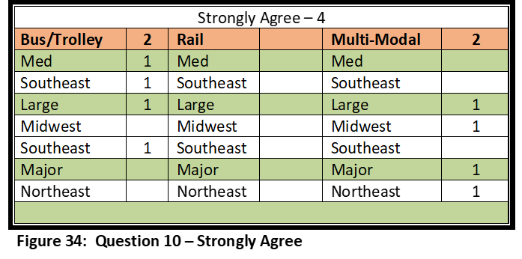
There were 112 contributors who answered this question. Four Strongly Agreed, 40 Agreed, 60 Disagreed, and eight Strongly Disagreed. If we take the results from this final report and compare them to the midway report that was described earlier (64 responses), it would illustrate that the percentages only slightly moved in each of these responses. Strongly Agree increased from 2 to 4% while Agree remained the same at 36%. Disagree increased from 52 to 54% and Strongly Disagree decreased from 11to 7%. In SPSS, Strongly Agree was coded as 1, Agree was coded as 2, Disagree was coded as 3, and Strongly Disagree was coded as 4. The Mean was 2.64 with a Standard Deviation of .669. The following paragraphs explain the complete breakdown between each response and it compares with each of the demographics.
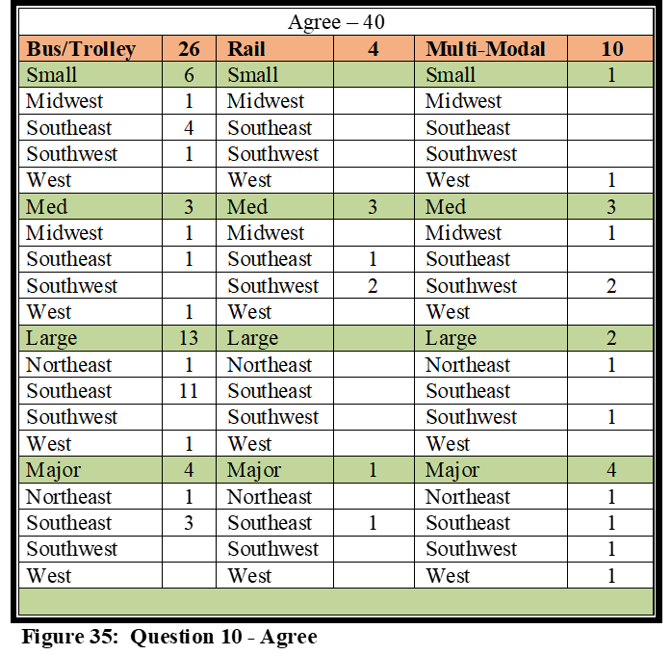
Strongly Agree Responses – Four agencies strongly agreed with this question. Rail had no responses, while Multi-Modal had one Large (Midwest) and one Major (Northeast), for two total responses. There were two Bus agencies, Medium (Southeast) and Large (Southeast). Strongly Agree responses are illustrated in Figure 34.
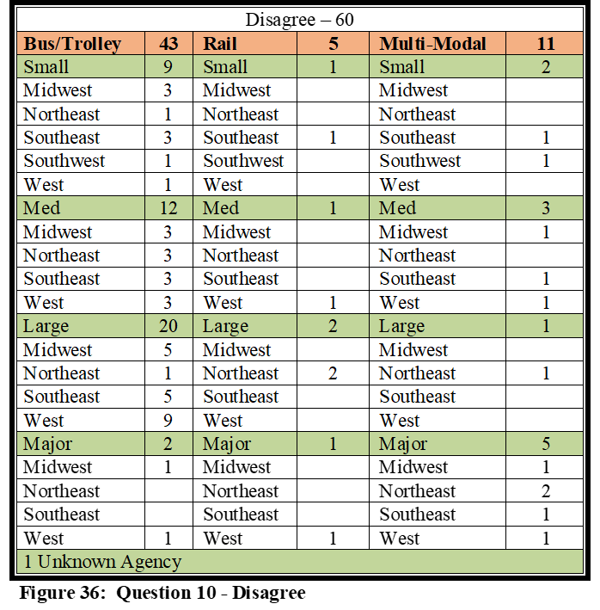
Agree Responses: Forty total agencies agreed. Four were Rail agencies. Three Rail agencies were Medium (one Southeast, two Southwest), and one was Major (Southeast). Ten Multi-Modal agencies agreed. One was Small (West), three were Medium (one Midwest, two Southwest), two were Large (Northeast, Southwest), and four were Major (Northeast, Southeast, Southwest, West). Twenty-six Bus agencies agreed. Six agencies were Small (one Midwest, four Southeast, one Southwest), three were Medium (Midwest, Southeast, West), 13 were Large (one Northeast, 11 Southeast, one West), and four were Major (one Northeast, three Southeast). Agree responses are illustrated above in Figure 35.
Disagree Responses – Sixty disagreed. Five Rail included one Small (Southeast), one Medium (West), two Large (Northeast), and one Major (West). Eleven Multi-Modal included two Small (Southeast, Southwest), three Medium (Midwest, Southeast, West), one Large (Northeast), and five Major (one Midwest, two Northeast, one Southeast, one West). Forty-three Bus included nine Small (three Midwest, one Northeast, three Southeast, one Southwest, one West), 12 Medium (three Midwest, three Northeast, three Southeast, three West), 20 Large (five Midwest, one Northeast, five Southeast, nine West), and two Major (Midwest, West). Disagree responses are illustrated above in Figure 36.
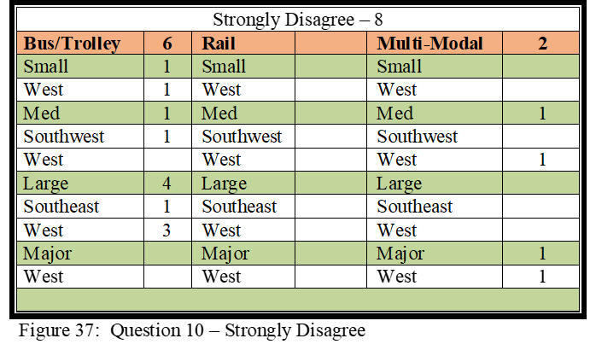
Strongly Disagree Responses – Eight agencies strongly disagreed. Rail had zero. Multi-Modal had two, which included one Medium agency (West) and one Major agency (West). Six Bus agencies strongly disagreed. One was Small (West), one Medium (Southwest), and four Large agencies (one Southeast, three West). Strongly Disagree responses are illustrated in Figure 37.
Question 10 Analysis – The responses in question 10 may provide some explanation to the results of Question 9, in regards to whether agencies perceive they have been provided sufficient overall aid by federal, state and local agencies. 61% of the responses indicate the agencies perceive they have not received the funding needed in their overall preparedness efforts, and 7% strongly feel this way.
The problem doesn’t just exist with the smaller agencies either, as almost half of those who disagreed or strongly disagreed (35) were from agencies classified as either Large or Major, which is 31% of the total number of responses. This suggests that, if the responses in this study are deemed to be generalizable and reliable, 31% of our urbanized Large/Major public transit agencies feel underfunded as it pertains to their emergency preparedness efforts. Again, as highlighted earlier, these are agencies that have an annual ridership, as measured by unlinked passenger trips, of more than 1 million passengers per year, in FTA defined urbanized areas.
Question #11: I am satisfied with my agency’s preparedness level to handle the wide array of emergency contingencies that potentially exist.
This question was created as a follow-up to previous questions regarding overall preparedness to handle a variety of different crises. Earlier questions regarded the ability to handle industrial accidents, transportation related accidents, terrorist events, and the ability to assist local first responders. This question is one to measure the attitudes of transportation managers in regards to their overall ability to handle this wide array of emergency contingencies. The Question 11 Analysis section will compare the results from this question and how these results measure against those from the earlier related questions.
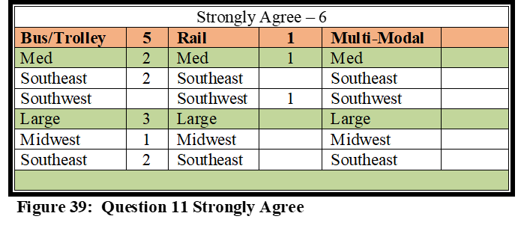
There were 113 contributors who answered this question. Six Strongly Agreed, 64 Agreed, 40 Disagreed, and three Strongly Disagreed. If we take the results from this final report and compare them to the midway report that was described earlier (64 responses), it would illustrate that the percentages only slightly moved in each of these response categories. Strongly Agree increased from 4 to 5% while Agree decreased from 64 to 57%. Disagree increased from 29 to 35% while Strongly Disagree decreased from 4 to 3%. In SPSS, Strongly Agree was coded as 1, Agree was coded as 2, Disagree was coded as 3, and Strongly Disagree was coded as 4. The Mean was 2.35 with a Standard Deviation of .626. The following paragraphs explain the complete breakdown between each response and it compares with each of the demographics.
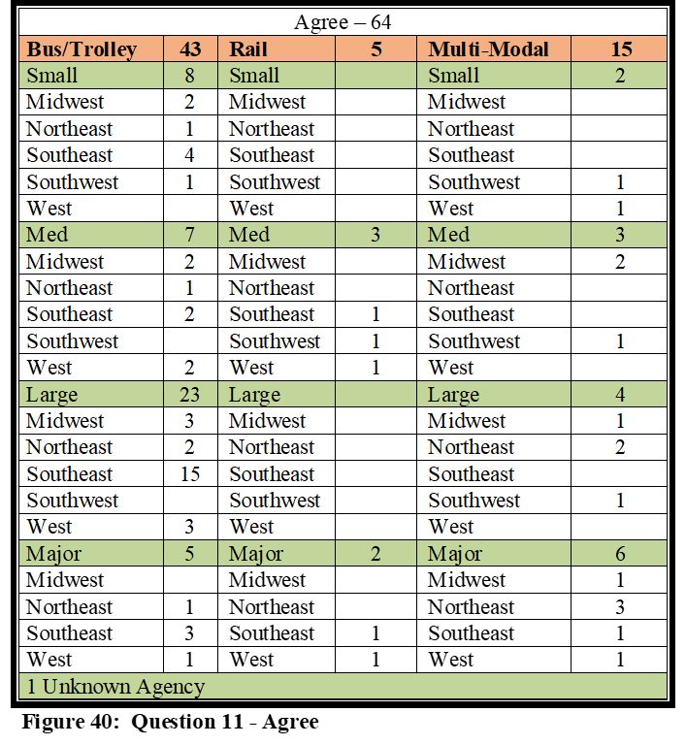
Strongly Agree Responses – Six agencies strongly agreed. Rail had only one, a Medium agency (Southwest), and Multi-Modal had zero. Five Bus agencies strongly agreed. Two were Medium (Southeast), and three were Large (one Midwest, three Southeast). Strongly Agree responses are illustrated in Figure 39.
Agree Responses: Sixty-four total agencies agreed. Five agencies were Rail. Three of the Rail agencies were Medium (Southeast, Southwest, West), and two were Major (Southeast, West). Fifteen Multi-Modal agencies agreed. Two were Small agencies (Southwest, West), three were Medium (two Midwest, one Southwest), four were Large (one Midwest, two Northeast, one Southwest), and six were Major (one Midwest, three Northeast, one Southeast, one West). Forty-three respondents were from Bus agencies. Eight agencies were Small (two Midwest, one Northeast, four Southeast, one Southwest), seven Medium (two Midwest, one Northeast, two Southeast), 23 Large (three Midwest, two Northeast, 15 Southeast, three West), and five Major (one Northeast, three Southeast, one West). Agree responses are illustrated above in Figure 40.
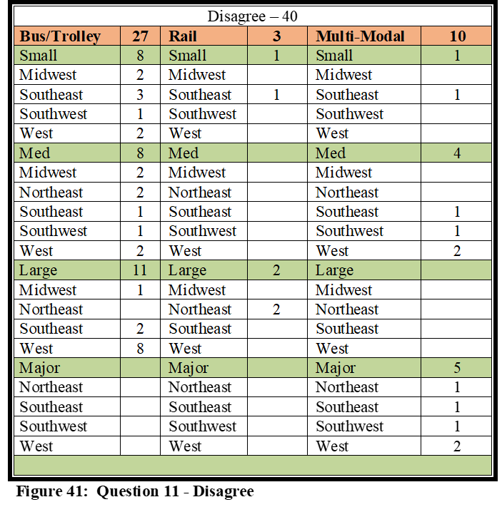
Disagree Responses – Forty agencies disagreed. Rail had three agencies that disagreed, including one Small (Southeast), and two Large (Northeast). There were ten Multi-Modal agencies that disagreed. One Multi-Modal agency was a Small agency (Southeast), four were Medium (one Southeast, one Southwest, two West), and five Major agencies (one Northeast, one Southeast, one Southwest, two West). Twenty-seven Bus agencies disagreed. Eight agencies were Small (two Midwest, three Southeast, one Southwest, two West), eight were Medium (two Midwest, two Northeast, one Southeast, one Southwest, two West), and 11 Large (one Midwest, two Southeast, 8 West). Disagree responses are illustrated in Figure 41.
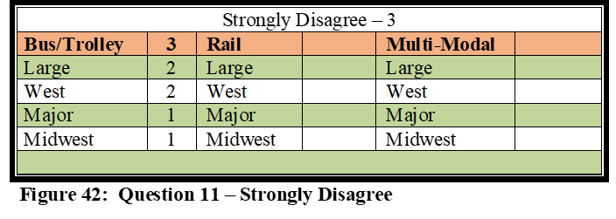
Strongly Disagree Responses – Only three agencies strongly disagreed. There were zero Rail and Multi-Modal agencies. The three Bus agencies included two Large (West), and one Major (Midwest). The Strongly Disagree responses are illustrated in Figure 42.
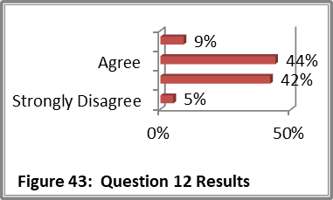
Question 11 Analysis – 62% of agencies either strongly agreed or agreed with Question 11. 38% of the agencies either disagreed or strongly disagreed. Looking back to Questions 5 and 6, we asked whether agencies felt prepared for industrial & transportation related accidents (Question 5) and terrorist type of events (Question 6). 83% were in the agree categories for Question 5, and 57% were in the agree categories for Question 6. Question 11, which is a general question regarding ability to respond to “any” of the wide array of emergency situations, is between the two others at 62%, but has just a slightly higher agree/strongly agree percentage than Question 6, which regards terrorism. When we compare these three questions, and also take into account Question 7, in which 93% of the agencies either agreed or strongly agreed that they were prepared to assist with regional contingencies as requested by local first responders, we see that transportation agencies are confident in their abilities to handle commonly confronted issues and crises, as well as assisting first responders when requested, but their confidence fades when faced with a potential act of terrorism.
Question #12: Members of my agency, who may be required to be NIMS participants during the mitigation of a natural disaster, industrial/transportation related accident, or serious criminal/ terrorist event, have received the appropriate levels of NIMS training as outlined within the NIMS Training Program.
This question was created as a follow-up to Question 4 regarding NIMS preparedness. It is vital that emergency responders, and those who may be expected to me participants in a NIMS Incident Command Structure (ICS), be trained to at least the basic knowledge level of NIMS. As illustrated in the literature review section, NIMS training is provided by FEMA and various other FEMA approved entities. NIMS training is available not only via face-to-face traditional classroom format, but is also available for online instruction.
There were 111 contributors who answered this question. Ten Strongly Agreed, 49 Agreed, 47 Disagreed, and 5 Strongly Disagreed. If we take the results from this final report and compare them to the midway report that was described earlier (64 responses), it would illustrate that the percentages only slightly moved in each of these response categories. Strongly Agree increased from 7 to 9% while Agree decreased from 45 to 44%. Disagree decreased from 45 to 42% while Strongly Disagree increased from 4 to 5%. In SPSS, Strongly Agree was coded as 1, Agree was coded as 2, Disagree was coded as 3, and Strongly Disagree was coded as 4. The Mean was 2.42 with a Standard Deviation of .720. The following paragraphs explain the complete breakdown between each response and it compares with each of the demographics.
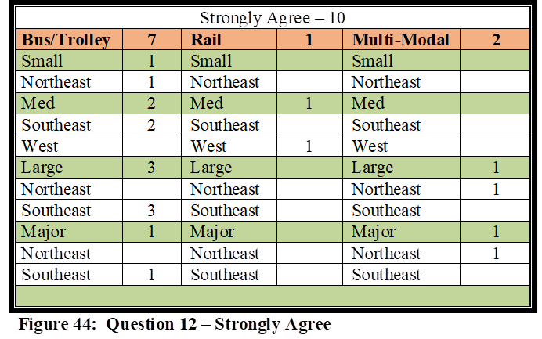
Strongly Agree Responses – Ten agencies strongly agreed. Rail had only one, a Medium agency (West), while Multi-Modal had two, one Large agency (Northeast), and one Major (Northeast). Seven Bus agencies strongly agreed, which included one Small agency agreed (Northeast), two Medium (Southeast), three Large (Southeast). and one Major (Southeast). Strongly Agree responses are illustrated in Figure 44.
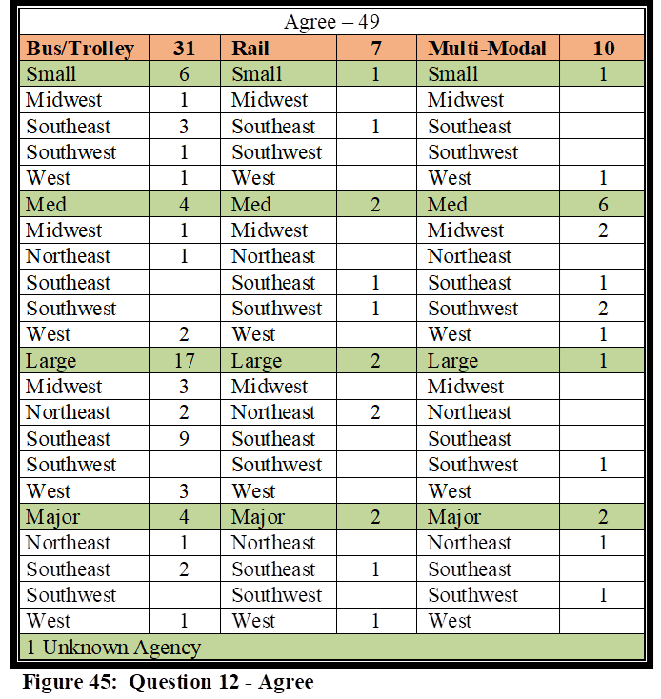
Agree Responses: Forty-nine total agencies agreed. Seven agencies were Rail. One of the Rail agencies was Small (Southeast), two Medium (Southeast, Southwest), two Large (Northeast), and two Major (Southeast, West). Ten Multi-Modal agencies agreed. One was a Small agency (West), six were Medium (two Midwest, one Southeast, two Southwest, one West), one was Large (Southwest), and two were Major (Northeast, Southwest). Thirty-one respondents were from Bus agencies. Six agencies were Small (one Midwest, three Southeast, one Southwest, one West), four Medium (one Midwest, one Northeast), 17 Large (three Midwest, two Northeast, nine Southeast, three West), and four Major (one Northeast, two Southeast, one West). Agree responses are illustrated below in Figure 45.
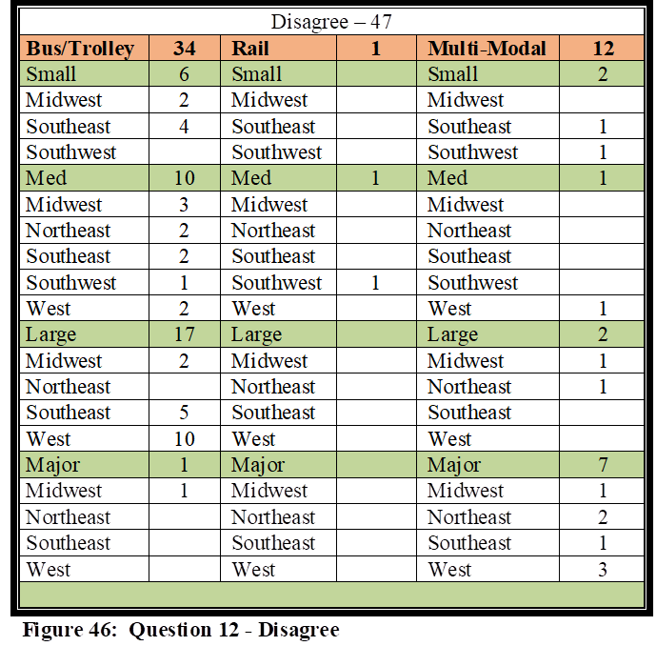
Disagree Responses – Forty-seven agencies disagreed. Rail had one Medium agency (Southwest), while 12 Multi-Modal agencies disagreed. Multi-Modal agencies included two Small (Southeast, Southwest), one Medium (West), two Large (Midwest, Northeast), and seven Major (one Midwest, two Northeast, one Southeast, three West). Thirty-four Bus agencies disagreed. Six agencies were Small (two Midwest, 4 Southeast), 10 were Medium (three Midwest, two Northeast, two Southeast, one Southwest, two West), 17 Large (two Midwest, five Southeast, 10 West), and one Major (Northeast). Disagree responses are illustrated in Figure 46.
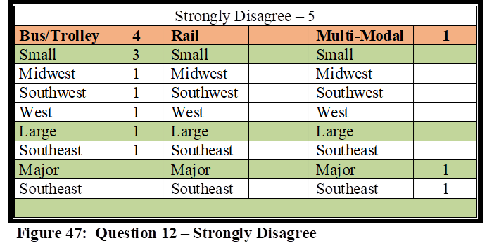
Strongly Disagree Responses – Five agencies strongly disagreed. There were zero Rail agencies and only one Multi-Modal, a Major agency in the Southeast. Four Bus agencies strongly disagreed, including three Small (Midwest, Southwest, West), and one Large (Southwest). The Strongly Disagree responses are illustrated in Figure 47.
Question 12 Analysis – Bus agencies were divided equally, 38 agencies either agreed or strongly agreed, while 38 also either disagreed or strongly disagreed. Not surprisingly, only 13 of those who agreed or strongly agreed were Medium or Small agencies. Rail & Multi-Modal agencies tended to agree at a higher rate than Bus with a 58/42 ratio in favor of agreeing; However, even though Rail maintained a similar ratio with Bus, in that more
Large & Major agencies were agreeance more so than those who disagreed (Rail had no Large or Major agencies disagree or strongly disagree), Multi-Modal surprisingly had a larger ratio of Large and Major agencies disagree than agree (66/33% ratio in favor of disagreeing), whereas there were more Medium and Small agencies that agreed than those that disagreed (70/30% ratio in favor of agreeing). A common thought might be that small agencies would find it more difficult to assure NIMS training is taking place as needed, and that seems to be the case with Bus and Rail agencies. However, that is not the case with the Multi-Modal agencies, those which would seemingly have more resources available and more of a support structure.
Question #13: My agency has conducted and/or been invited by outside local agencies to participate in various operational and/or table top exercises, such as drills, functional exercises, and full-scale exercises, to train and prepare personnel both within and outside our agency, in regards to incident command structures, to ensure well-coordinated and structured responses in real-world events.
This question was created to compliment other collaboration related questions. As illustrated in the literature review, collaboration is one of the foundations of crisis management, and one of the reasons HSPD-5 was implemented. The NIMS/ICS model is meant to bring together various emergency responders, prior to an event actually taking place, to communicate, collaborate, and train together. Training, also pointed out during the literature review, includes various levels of exercises to test the preparedness level of responding and/or participating agencies, again, prior to a crisis. This question is meant to measure what percentage of public transportation agencies have actually been invited by their first responder counterparts to take part in these exercises. It is vital that when police or fire personnel recommend bringing in public transportation buses, a public transportation representative is presently and physically at the table to answer to their available resources and capabilities.
There were 113 contributors who answered this question. Thirty-one Strongly Agreed, 61 Agreed, 20 Disagreed, and 1 Strongly Disagreed. If we take the results from this final report and compare them to the midway report that was described earlier (64 responses), it would illustrate that the percentages only slightly moved in each of these response categories. Strongly Agree decreased from 30 to 27% while Agree decreased from 55 to 54%. Disagree increased from 13 to 18% while Strongly Disagree decreased from 2 to 1%. In SPSS, Strongly Agree was coded as 1, Agree was coded as 2, Disagree was coded as 3, and Strongly Disagree was coded as 4. The Mean was 1.92 with a Standard Deviation of .696. The following paragraphs explain the complete breakdown between each response and it compares with each of the demographics.
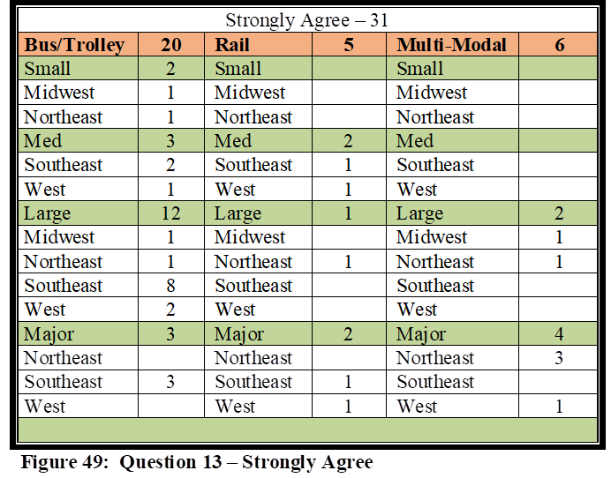
Strongly Agree Responses – Thirty-one agencies strongly agreed. Rail had five agencies including two Medium (Southeast, West), one Large (Northeast), and two Major (Southeast, West). Six Multi-Modal agencies strongly agreed, including two Large (Midwest, Northeast), and four Major (3 Northeast, 1 West). Twenty Bus agencies strongly agreed, which included two Small agencies (Midwest, Northeast), three Medium (2 Southeast, 1 West), 12 Large (1 Midwest, 1 Northeast, 8 Southeast, 2 West), and three Major (Southeast). Strongly Agree responses are illustrated in Figure 49.
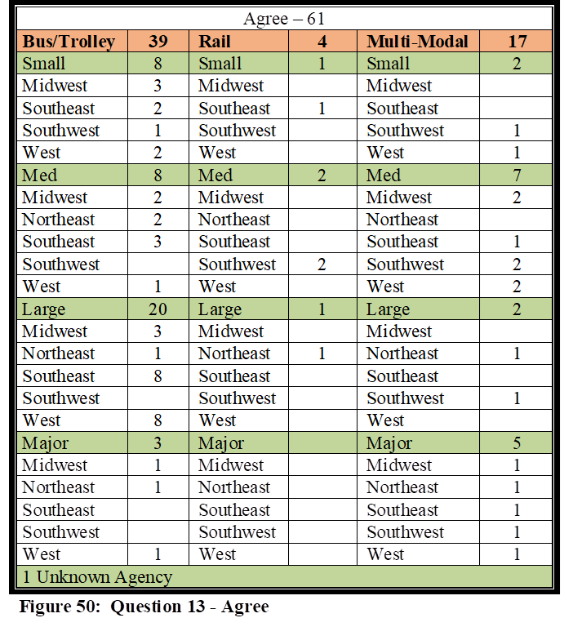
Agree Responses: Sixty-one total agencies agreed. Four agencies were Rail. One of the Rail agencies was Small (Southeast), two Medium (Southwest), and one Large (Northeast). Seventeen Multi-Modal agencies agreed. Two were Small agencies (Southwest, West), seven were Medium (2 Midwest, 1 Southeast, 2 Southwest, 2 West), two were Large (Northeast, Southwest), and five were Major (Midwest, Northeast, Southeast, Southwest, West). Thirty-nine respondents were from Bus agencies. Eight agencies were Small (3 Midwest, 2 Southeast, 1 Southwest, 2 West), eight Medium (2 Midwest, 2 Northeast, 3 Southeast, 1 West), 20 Large (3 Midwest, 1 Northeast, 8 Southeast, 8 West), and three Major (Midwest, Northeast, West). There was one agency that agreed from an unknown size agency and geographic location. Agree responses are illustrated in Figure 50.
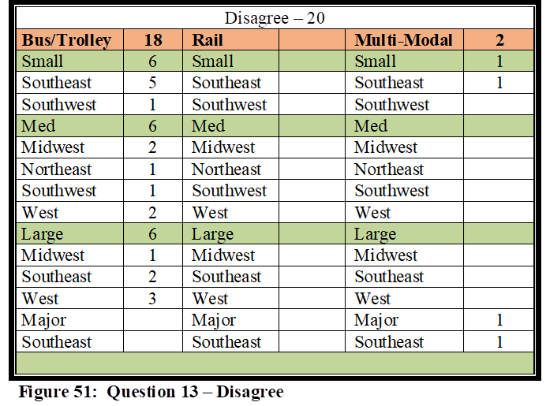
Disagree Responses – Twenty agencies disagreed. Rail had zero agencies while Multi-Modal agencies included one Small (Southeast) and one Major (Southeast). Eighteen Bus agencies disagreed. Six agencies were Small (5 Southeast, 1 Southwest), six were
Medium (2 Midwest, 1 Northeast, 1 Southwest, 2 West), and six Large (1 Midwest, 2 Southeast, 3 West). Disagree responses are illustrated in Figure 51.
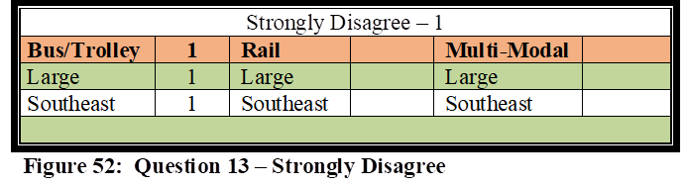
Strongly Disagree Responses – Only 1 agency disagreed. There were zero Rail and Multi-Modal agencies and only Bus agency. The Bus agency was a Large agency in the Southeast. The Strongly Disagree responses are illustrated in Figure 52.
Question 13 Analysis – The results here are promising and certainly support and illustrate the correlation with Question 7. 93% of agencies, per Question 7, felt they were prepared to assist local agencies with regional contingencies when requested. One reason such a high number of agencies own such a high level of confidence is due to them being included in local exercises as part of an overall training effort. The counterfactual is impossible to know, but it would seem probable that if this level of collaboration was not taking place with exercises, agencies would not have such a high level of confidence in their abilities to assist local first responders. 90% of those who disagreed or strongly disagreed were Bus agencies, and 63% of those were either Small or Medium size agencies.
Question #14: My agency is prepared in terms of equipment needed and required to handle a myriad of contingencies that could be faced in our region (natural disasters, industrial or transportation related accidents, terrorist/major criminal events).
This question was created to compliment other overall preparation related questions. As illustrated in the literature review, having an appropriate level and type of equipment is one of the goals of NIMS. This question is meant to measure how well equipped our agencies perceive they are in terms of the equipment needed to mitigate a crisis.
There were 113 contributors who answered this question. Six Strongly Agreed, 67 Agreed, 38 Disagreed, and two Strongly Disagreed. If we take the results from this final report and compare them to the midway report that was described earlier (64 responses), it would illustrate that the percentages only slightly moved in each of these response categories. Strongly Agree decreased from 7 to 5% while Agree increased from 54 to 59%. Disagree decreased from 38 to 34% while Strongly Disagree stayed the same at 2%. In SPSS, Strongly Agree was coded as 1, Agree was coded as 2, Disagree was coded as 3, and Strongly Disagree was coded as 4. The Mean was 2.32 with a Standard Deviation of .602. The following paragraphs explain the complete breakdown between each response and it compares with each of the demographics.
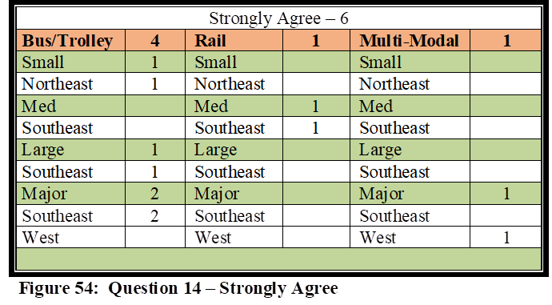
Strongly Agree Responses – Six agencies strongly agreed. Rail had one Medium agency (Southeast), while there was also only one Major Multi-Modal agency in the West. Twenty Bus agencies strongly agreed, which included one Small agency (Northeast), one Large (Southeast), and two Major (Southeast). Strongly Agree responses are illustrated in Figure 54.
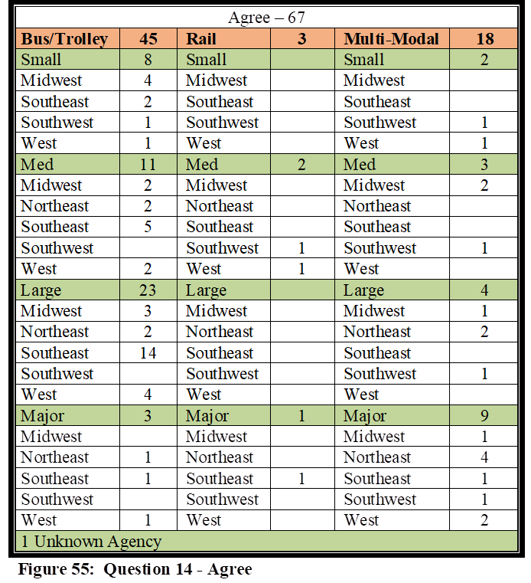
Agree Responses: Sixty-seven total agencies agreed. Three agencies were Rail. Two Rail agencies were Medium (Southwest, West), while one was Major (Southeast). Eighteen Multi-Modal agencies agreed. Two were Small agencies (Southwest, West), three were Medium (two Midwest, one Southwest), four were Large (one Midwest, two Northeast, one Southwest), and nine were Major (one Midwest, four Northeast, Southeast, Southwest, two West). Forty-five respondents were from Bus agencies. Eight agencies were Small (four Midwest, two Southeast, one Southwest, one West), 11 Medium (two Midwest, two Northeast, five Southeast, two West), 23 Large (three Midwest, two Northeast, 14 Southeast, four West), and three Major (Midwest, Northeast, West). There was one agency that agreed from an unknown size agency and geographic location. Agree responses are illustrated above in Figure 55.
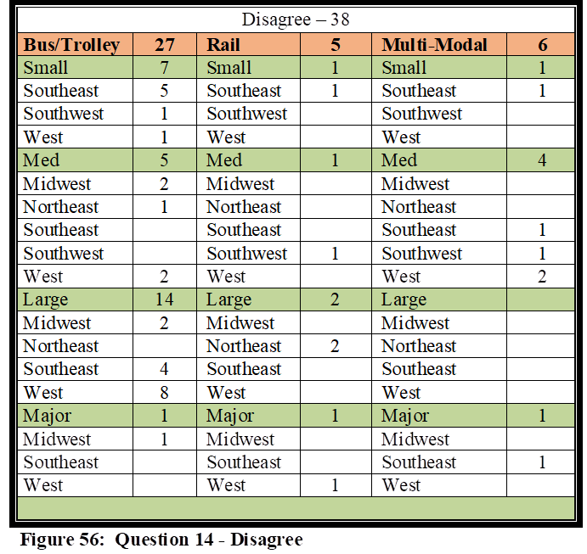
Disagree Responses – Thirty-eight agencies disagreed. Rail had five agencies that disagreed, including one Small (Southeast), one Medium (Southwest), two Large (Northeast), and one Major (West). Multi-Modal agencies included one Small (Southeast), four Medium (Southeast, Southwest, two Wests) and one Major (Southeast). Twenty-seven Bus agencies disagreed. Seven agencies were Small (five Southeast, one Southwest, one West), five were Medium (two Midwest, one Northeast, two West), 14 were Large (two Midwest, four Southeast, eight West), and one was Major (Midwest). The Disagree responses are each illustrated in Figure 56.
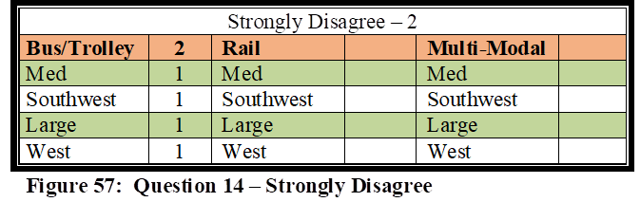
Strongly Disagree Responses – Only two agencies strongly disagreed. There were zero Rail and Multi-Modal agencies and two Bus agencies. One Bus agency was a Medium agency in the Southwest, and one was a Large agency in the West. Strongly Disagree responses are illustrated in Figure 57.
Question 14 Analysis – 68% of Rail and Multi-Modal agencies combined agreed with this comment, with only four of the Large or Metro size agencies disagreeing. The results here are, however, only promising for Multi-Modal agencies. 75% of the Multi-Modal agencies agreed with the question, with only 1 agency larger than Medium disagreeing. However, there are concerns for Small and Medium size Multi-Modal agencies, in that half of those agencies disagreed. Rail only agencies also did not do so well, with only four out of nine agreeing, and with three of those four being either Small or Medium agencies, and only one being an agency larger than Medium.
63% of all Bus agencies combined agreed with the comment, but as illustrated in the literature review, the costs associated with equipment for Bus agencies is significantly cheaper to purchase than equipment needed to mitigate a Rail emergency. Also noteworthy is that the results illustrate the Large and Major agencies only make up 59% of those agencies that agree with Question 14, which means the numbers are distributed fairly equally across all categories of agency size.
Overall it appears agencies perceive they are equipped fairly well, but those numbers, as illustrated above, do not portray that to be an accurate statement. When comparing this question to Questions 9 and 10, it would seem to indicate that lack of funding is having an adverse impact on agencies attaining the needed equipment to mitigate various emergencies.
Question #15: My agency is considered a NIMS partner by local agencies in regards to emergency response and mitigation.
This question was created to compliment other collaboration related questions, in regards to how local emergency responders view their public transportation counterparts in the NIMS process.
There were 113 contributors who answered this question. Sixteen Strongly Agreed, 79 Agreed, 17 Disagreed, and one Strongly Disagreed. If we take the results from this final report and compare them to the midway report that was described earlier (64 responses), it would illustrate that the percentages only slightly moved in each of the response categories. Strongly Agree decreased from 20% to 14% while Agree increased from 68% to 70%. Disagree increased from 11 to 15% while Strongly Disagree decreased from 2 to 1%. In SPSS, Strongly Agree was coded as 1, Agree was coded as 2, Disagree was coded as 3, and Strongly Disagree was coded as 4. The Mean was 2.03 with a Standard Deviation of .574. The following paragraphs explain the complete breakdown between each response and it compares with each of the demographics.
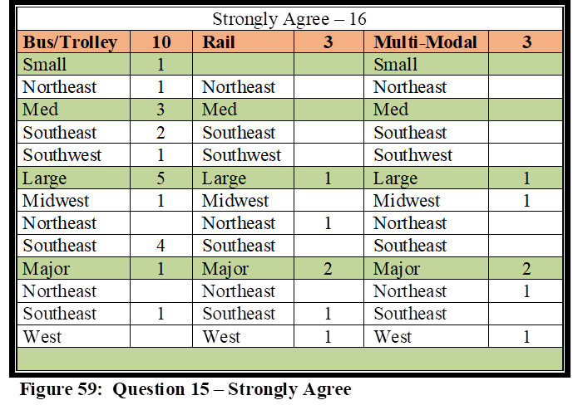
Strongly Agree Responses – Sixteen agencies strongly agreed with this question. Rail included one Large agency (Northeast), and two Major (Southeast, West). Three Multi-Modal agencies strongly agreed, including one Large (Midwest) and two Metro (Northeast, West). Ten Bus agencies strongly agreed. One agency was a Small agency (Northeast), three were Medium (two Southeast, one Southwest), five were Large (one Midwest, four Southeast), and one was Major (Southeast). Strongly Agree responses are illustrated in Figure 59.
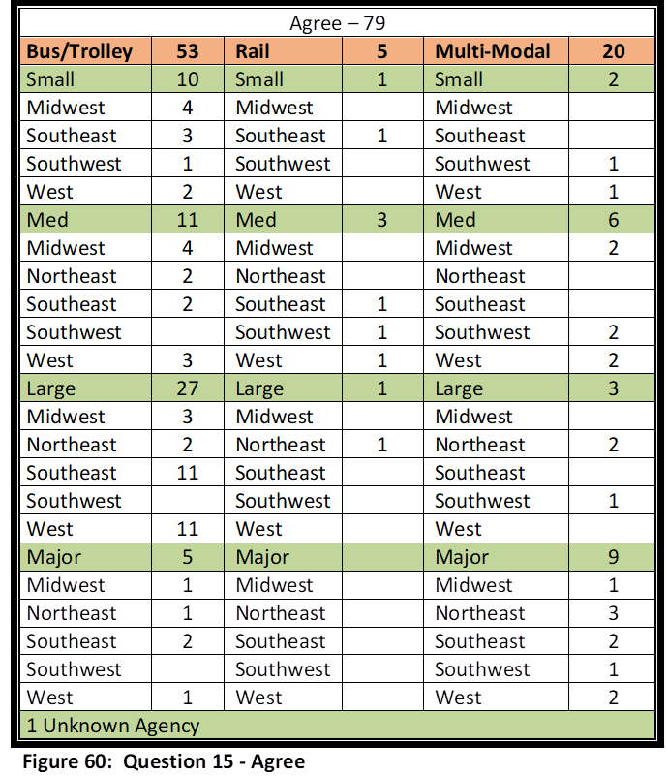
Agree Responses: Seventy total agencies agreed. Five of the 79 agencies were Rail agencies. One of the Rail agencies was Small (Southeast), three were Medium (Southwest, Southwest, West), and one was Large (Northeast). Twenty Multi-Modal agencies agreed. Two were Small agencies (Southwest, West), six were Medium (two Midwest, two Southwest, two West), three were Large (two Northeast, one Southwest), and nine were Major (one Midwest, three Northeast, two Southeast, one Southwest, and two West). Fifty-three respondents were from Bus agencies. Ten agencies were Small (three Midwest, four Southeast, two Southwest, and one West). Ten agencies were Medium (four Midwest, three Southeast, one Southwest, two West). There were 27 Large Bus agencies (three Midwest, two Northeast, 11 Southeast, 11 West), and five Major Bus agencies (one Midwest, one Northeast, two Southeast, one West). Agree responses are illustrated in Figure 60.
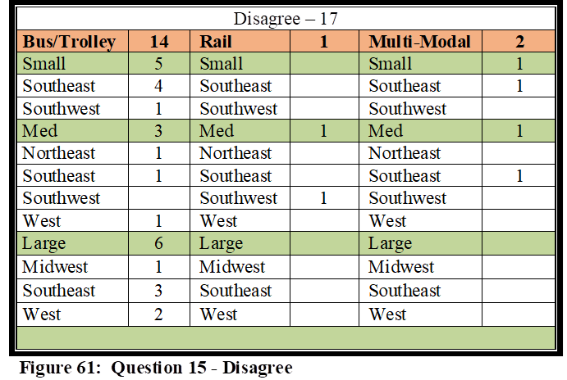
Disagree Responses –Seventeen agencies disagreed. Rail had one Medium agency (Southwest). Two Multi-Modal agencies disagreed, which included one Small (Southeast) and one Medium agency (Southeast). Fourteen Bus agencies disagreed. Five agencies were Small (four Southeast, one Southwest), three were Medium (Northeast, Southeast, West), and six were Large (one Midwest, three Southeast, two West). The Disagree responses are each illustrated in Figure 61.
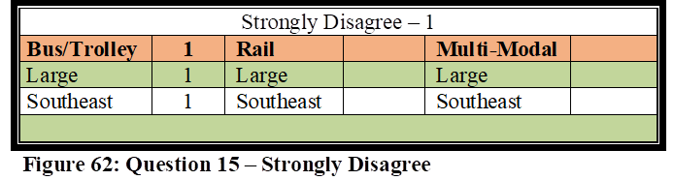
Strongly Disagree Responses – Only one Large bus agency in the Southeast strongly disagreed. Rail and Multi-Modal had zero. Strongly Disagree responses are illustrated in Figure 62.
Question 15 Analysis – The results from Question 7 illustrated that 93% of the respondents agreed or strongly agreed that they were prepared to assist with regional contingencies as requested by local first responders. Question 9 further illustrated that 65% either agreed or strongly agreed that they had received the assistance needed from federal, state, and/or local agencies, in their overall preparedness efforts. 81% of the agencies, according to Question 13, agreed or strongly agreed they had been invited by outside local agencies to participate in various operational and/or table top exercises. The results from Questions 7, 9 and 13, support the results seen here with Question 15, in that 84% either agreed or disagreed that they were seen as a NIMS partner by local agencies in regards to emergency response and mitigation, even though they may not have universally received the full support needed to ensure their preparation. The greatest quantity of those agencies that did not perceive they were considered a NIMS partner was Small and Medium agencies, and only two of those were Rail or Multi-Modal. Noteworthy is the fact that no Major agencies, whether Bus, Rail or Multi-Modal, disagreed with Question 15.
Question #16: Collaboration efforts are satisfactory between my agency and the regional police, fire, rescue, and emergency management agencies.
This question was created to compliment other collaboration related questions, specifically Question 15. It is not only important to feel like an integral part of the NIMS process, it is equally important to have good collaboration efforts with regional first responders. This question is expected to determine how well agencies perceive they collaborate with their regional first responders.
There were 112 contributors who answered this question. Twenty-three Strongly Agreed, 72 Agreed, 17 Disagreed, and zero Strongly Disagreed. If we take the results from this final report and compare them to the midway report that was described earlier (64 responses), it would illustrate that the percentages only slightly moved in each of the response categories other than Disagree, in which the percentage doubled. Strongly Agree remained the same at 21% while Agree decreased from 71 to 64%. Disagree doubled from 7 to 15% while Strongly Disagree remained at zero. In SPSS, Strongly Agree was coded as 1, Agree was coded as 2, Disagree was coded as 3, and Strongly Disagree was coded as 4. The Mean was 1.95 with a Standard Deviation of .598. The following paragraphs explain the complete breakdown between each response and it compares with each of the demographics.
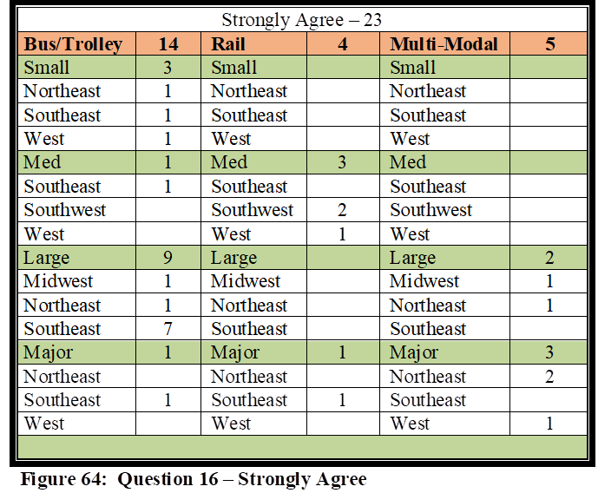
Strongly Agree Responses – Twenty-three agencies strongly agreed with this question. Rail had four agencies strongly agree which included three Medium agencies (two Southeast, one West), and one Major agency (Southeast). Five Multi-Modal agencies strongly agreed, including two Large agencies (Midwest, Northeast) and three Metro (two Northeast, one West). Fourteen Bus agencies strongly agreed. Three agencies were Small (Northeast, Southeast, West), one was Medium (Southeast), nine were Large (one Midwest, one Northeast, seven Southeast), and one was Major (Southeast). Strongly Agree responses are illustrated in Figure 64.
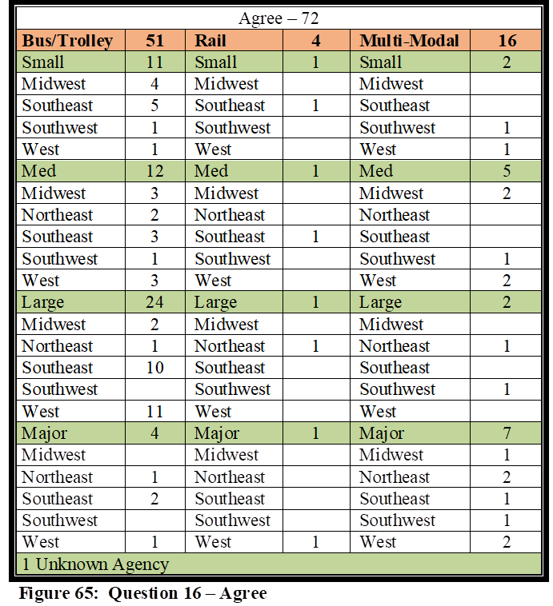
Agree Responses: Seventy-two total agencies agreed. Four of the 72 agencies were Rail agencies. One of the Rail agencies was Small (Southeast), one was Medium (Southeast), one was Large (Northeast), and one was Major (West). 16 Multi-Modal agencies agreed. Two were Small agencies (Southwest, West), five were Medium (two Midwest, one Southwest, two West), two were Large (Northeast, one Southwest), and seven were Major (one Midwest, two Northeast, one Southeast, one Southwest, two West). Fifty-one respondents were from Bus agencies. Eleven agencies were Small (four Midwest, five Southeast, one Southwest, one West), and 12 agencies were Medium (three Midwest, two Northeast, three Southeast, one Southwest, three West). There were 24 Large Bus agencies (two Midwest, one Northeast, 10 Southeast, 11 West), and four Major Bus agencies (one Northeast, two Southeast, one West). Agree responses are illustrated in Figure 65.
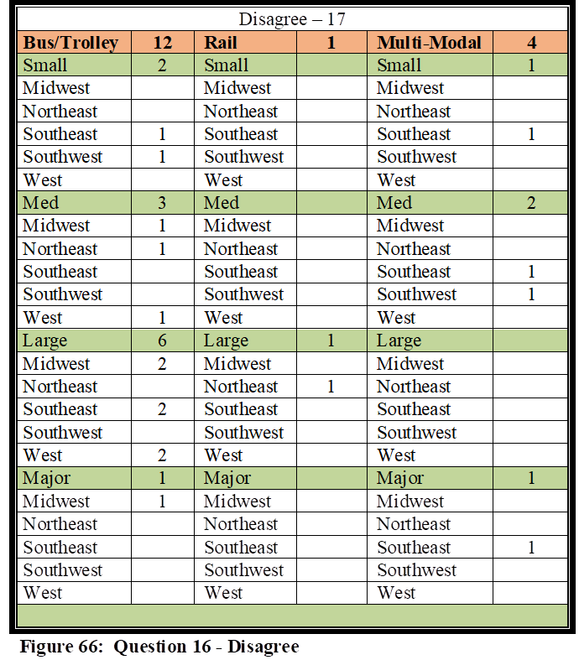
Disagree Responses – Seventeen agencies disagreed. Rail had one Large agency (Northeast) and four Multi-Modal agencies disagree. Multi-Modal had one Small (Southeast), two Medium (Southeast, Southwest), and one Major (Southeast). Twelve Bus agencies disagreed. Two agencies were Small (Southeast, Southwest), three were Medium (Midwest, Northeast, West), six Large (two Midwest, two Southeast, two West), and one Major (Midwest). Disagree responses are illustrated in Figure 66.
Strongly Disagree Responses – There were zero responses.
Question 16 Analysis – This question was meant to complement Question 15, with the results expected to be similar. If we take the results from Question 15 and compare those to Question 16, it would illustrate that the percentages only slightly moved. Strongly Agree and Agree combined for Question 15 was 84% and was 85% for Question 16. Likewise, there was only a 1% difference in the combined Disagree and Strongly Disagree responses.
Question #17: My agency has been included within the region’s Emergency Response Plan (or similar nomenclature), for the purpose of providing public transportation support during the response, mitigation, and/or crisis management, of potential emergencies faced by our local area.
This question was created to compliment Question 8. It is important for agencies to not only be integrated into a region’s emergency response plans, but also have written mandates that describe their roles and responsibilities during the mitigation of a critical incident. This question is expected to determine if agencies have been included in regional emergency response plans.
There were 113 contributors who answered this question. Thirty-one Strongly Agreed, 65 Agreed, 17 Disagreed, and zero Strongly Disagreed. If we take the results from this final report and compare them to the midway report that was described earlier (64 responses), it would illustrate that the percentages only slightly moved in each of the response categories. Strongly Agree decreased from 30 to 27% while Agree increased from 55 to 58%. Disagree increased from 14 to 15% while Strongly Disagree remained at zero. In SPSS, Strongly Agree was coded as 1, Agree was coded as 2, Disagree was coded as 3, and Strongly Disagree was coded as 4. The Mean was 1.88 with a Standard Deviation of .643. The following paragraphs explain the complete breakdown between each response and it compares with each of the demographics.
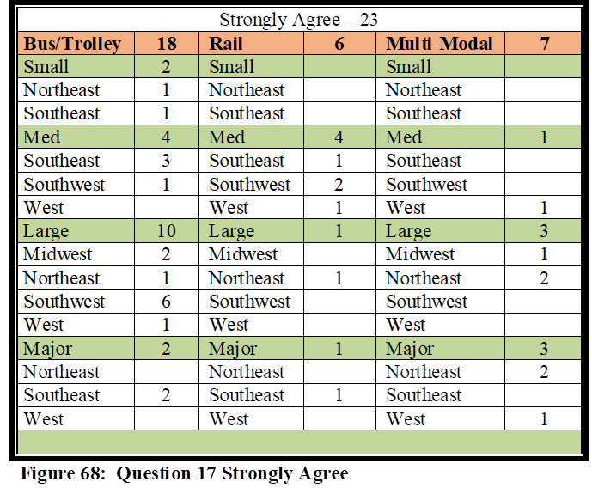
Strongly Agree Responses – Thirty-one agencies strongly agreed with this question. Rail had six agencies strongly agree which included four Medium agencies (one Southeast, two Southwest, one West), one Large agency (Northeast), and one Major agency (Southeast). Seven Multi-Modal agencies strongly agreed, including one Medium (West), three Large (one Midwest, two Northeast), and three Major (two Northeast, one West). Eighteen Bus agencies strongly agreed. Two agencies were Small (Northeast, Southeast), four were Medium (three Southeast, one Southwest), Ten were Large (two Midwest, one Northeast, six Southwest, one West), and two Major (Southeast). Strongly Agree responses are illustrated in Figure 68.
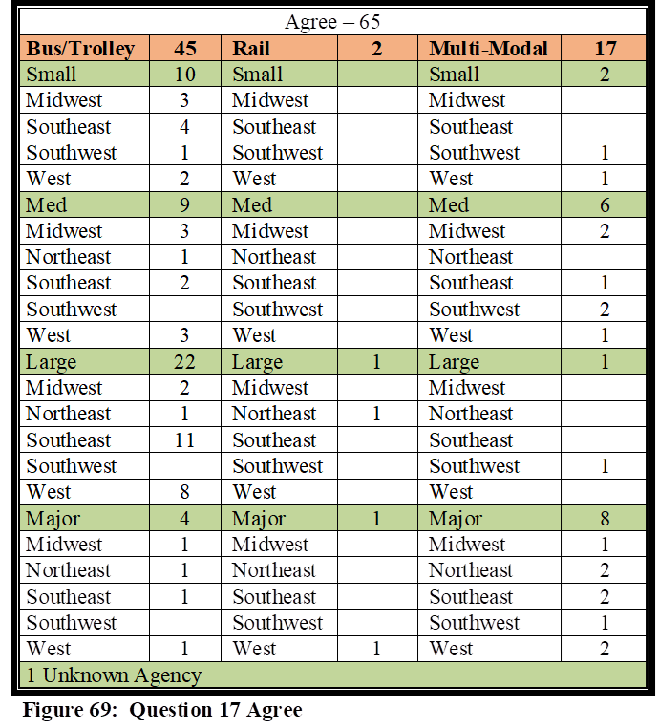
Agree Responses: Sixty-five total agencies agreed. Two of the 72 agencies were Rail agencies. One of the Rail agencies was a Large (Northeast) agency and one was Major (West). Seventeen Multi-Modal agencies agree. Two agencies were Small (Southwest, West), six were Medium (two Midwest, one Southeast, two Southwest, one West), one was Large (Southwest) and eight were Major (one Midwest, two Northeast, two Southeast, one Southwest, two West). Forty-five respondents were from Bus agencies. Ten agencies were Small (three Midwest, four Southeast, one Southwest, two West), and nine agencies were Medium (three Midwest, one Northeast, two Southeast, three West). There were 22 Large Bus agencies (two Midwest, one Northeast, 11 Southeast, eight West), and four Major Bus agencies (one Midwest, one Northeast, one Southeast, one West). Agree responses are illustrated in Table 54.
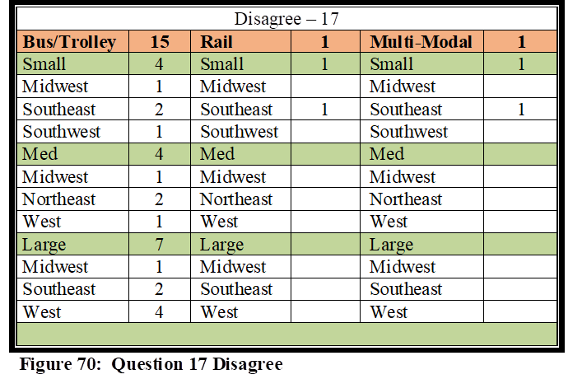
Disagree Responses –Seventeen agencies disagreed. Rail had one Small agency (Southeast) and one Small Multi-Modal agency disagree (Southeast). Fifteen Bus agencies disagreed. Four agencies were Small (one Midwest, two Southeast, one Southwest), four were Medium (one Midwest, two Northeast, one West), and seven Large (one Midwest, two Southeast, four West). Disagree responses are illustrated in Table 55.
Strongly Disagree Responses – There were no Strongly Disagree responses.
Question 17 Analysis – This question was meant to complement Question 8, with the results expected to be similar. However, 85% of respondents Strongly Agreed/Agreed that they were included in regional plans, but only 71% Strongly Agreed/Agreed that they had written mandates that described their mitigation efforts. As explained in the Question 8 descriptive analysis, the disagree responses are surprising; these numbers would be expected to be very close to what is reported here in Question 17.
Question #18: My agency has received a satisfactory level of funding, whether from local, State or Federal agencies, in regards to overall preparedness as it pertains to NIMS mandates.
This question was created to compliment Question 10, which inquired to whether agencies were satisfactorily funded in their overall preparedness efforts. It is important for agencies to not only have the necessary funding to enable them to mitigate various crises, but also have the funding to meet the expected mandates to be a viable NIMS partner.
There were 112 contributors who answered this question. Three Strongly Agreed, 38 Agreed, 64 Disagreed, and 7 Strongly Disagreed. If we take the results from this final report and compare them to the midway report that was described earlier (64 responses), it would illustrate that the percentages only slightly moved in each of the response categories. Strongly Agree increased from 2 to 3% while Agree remained the same at 34%. Disagree remained the same at 57% while Strongly Disagree decreased from 7 to 6%. In SPSS, Strongly Agree was coded as 1, Agree was coded as 2, Disagree was coded as 3, and Strongly Disagree was coded as 4. The Mean was 2.67 with a Standard Deviation of .635. The following paragraphs explain the complete breakdown between each response and it compares with each of the demographics.
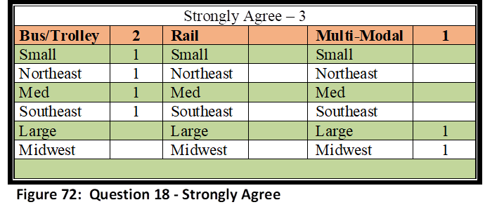
Strongly Agree Responses – Three agencies strongly agreed with this question. There were no Rail agencies, and there was only one Large Multi-Modal agency (Midwest). There were two Bus agencies. One Small (Northeast) and one Medium (Southeast) were in this category. Strongly Agree responses are illustrated in Figure 72.
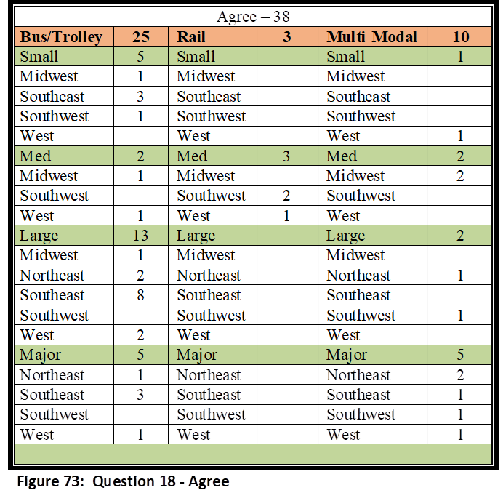
Agree Responses: Thirty-eight total agencies agreed. Three of the 38 agencies were Medium Rail agencies (Southwest, West). Ten Multi-Modal agencies agree. one agency was Small (West), two were Medium (Midwest), two were Large (Northeast, Southwest), and five were Major (two Northeast, one Southeast, one Southwest, one West). Twenty-five respondents were from Bus agencies. Five agencies were Small (one Midwest, three Southeast, one Southwest), and two agencies were Medium (one Midwest, one West). There were 13 Large Bus agencies (one Midwest, two Northeast, 8 Southeast, two West), and five Major Bus agencies (one Northeast, three Southeast, one West). Agree responses are illustrated in Figure 73.
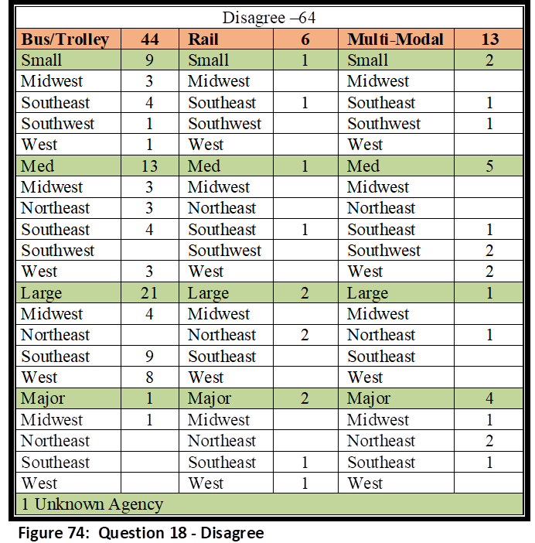
Disagree Responses – Sixty-four agencies disagreed. Rail had six agencies disagree. One agency was a Small agency (Southeast), one was Medium (Southeast), two were Large (Northeast), and two were Major (one Southeast, one West). Thirteen Multi-Modal agencies disagreed. There were two Small (Southeast, Southwest), five Medium (one Southeast, two Southwest, two West), one Large (Northeast), and four Major (one Midwest, two Northeast, one Southeast. Forty-four Bus agencies disagreed. Nine agencies were Small (three Midwest, four Southeast, one Southwest, one West), 13 Medium (three Midwest, three Northeast, four Southeast, three West), 21 Large (four Midwest, nine Southeast, eight West), and one Major agency (Midwest). Disagree responses are illustrated in Figure 74.
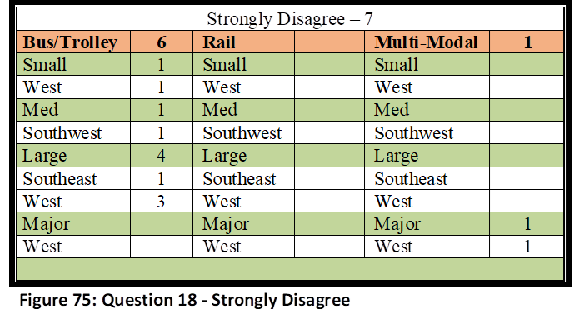
Strongly Disagree Responses – Seven agencies strongly disagreed. Rail had zero agencies strongly disagree. One Major Multi-Modal agency strongly disagreed (West). Six Bus agencies strongly disagreed. One agency was a Small agency (West), one was Medium (Southwest), and four were Large (one Southeast, three West). Strongly Disagree responses are illustrated in Figure 75.
Question 18 Analysis – This question was meant to complement question 10, with the results expected to be similar. There was only a 3% difference in the combined Strongly Agree/Agree categories, and only a 2 % difference in the combined Strongly Disagree/Disagree categories. Between the two questions, 61-63% of transit managers surveyed felt they had not received satisfactory funding needed in their overall preparedness efforts, or to meet the mandates needed to be fully compliant NIMS partners. The results from Question 10 and Question 18, likely have an impact on overall preparedness questions, such as Question 9, in which 36% of the agencies disagree or strongly disagree that they have received the assistance needed in their overall preparedness efforts.
Question #19: My agency has been proactively instrumental since HSPD-5 implementation in seeking funding sources to fully prepare our agency as it pertains to NIMS mandates.
This question was created to compliment Questions 10 and 18, which inquired as to whether agencies were satisfactorily funded in their overall preparedness efforts, and to meet the mandates necessary to become fully compliant NIMS partners. As stated in the previous question, it is important for agencies to not only have received the necessary funding to enable them to mitigate various crises, but also have the funding to meet the expected mandates to be a viable NIMS partner. However, it is also necessary for agencies to seek funding sources to aid in their own cause.
There were112 contributors who answered this question. Six Strongly Agreed, 41 Agreed, 63 Disagreed, and two Strongly Disagreed. If we take the results from this final report and compare them to the midway report that was described earlier (64 responses), it would illustrate that the percentages only moderately changed in each of the response categories. Strongly Agree remained the same at 5%, while Agree increased from 29 to 37%. Disagree decreased from 63 to 56% and Strongly Disagree decreased from 4 to 2%. In SPSS, Strongly Agree was coded as 1, Agree was coded as 2, Disagree was coded as 3, and Strongly Disagree was coded as 4. The Mean was 2.54 with a Standard Deviation of .628. The following paragraphs explain the complete breakdown between each response and it compares with each of the demographics.
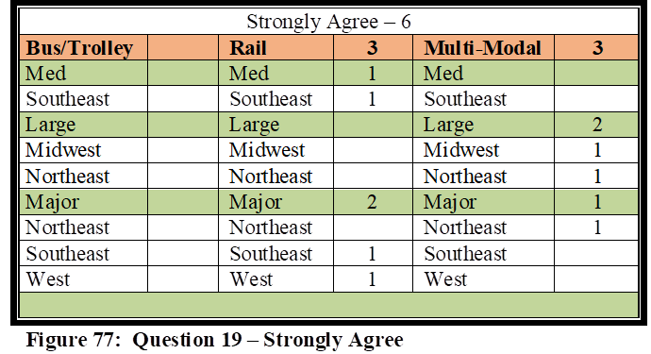
Strongly Agree Responses – Six agencies strongly agreed with this question. There were three Rail agencies with one Medium (Southeast) and two Major (Southeast, West). Three Multi-Modal agencies were in this category with two Large (Midwest, Northeast), and one Major (Northeast). There were no Bus Agencies. Strongly Agree responses are illustrated in Figure 77.
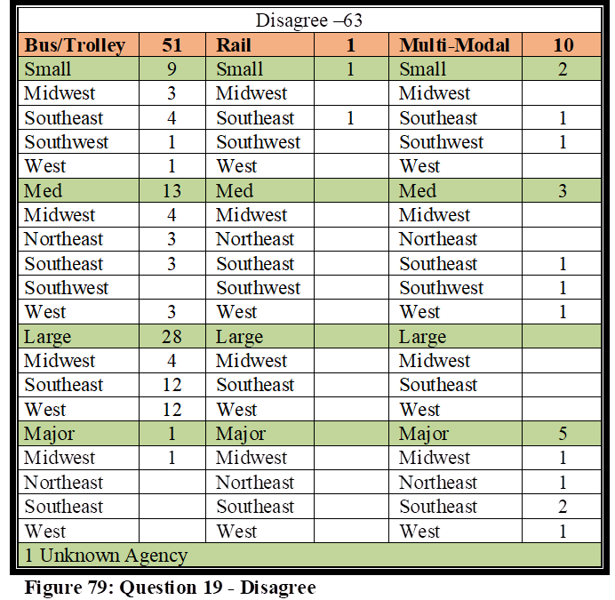
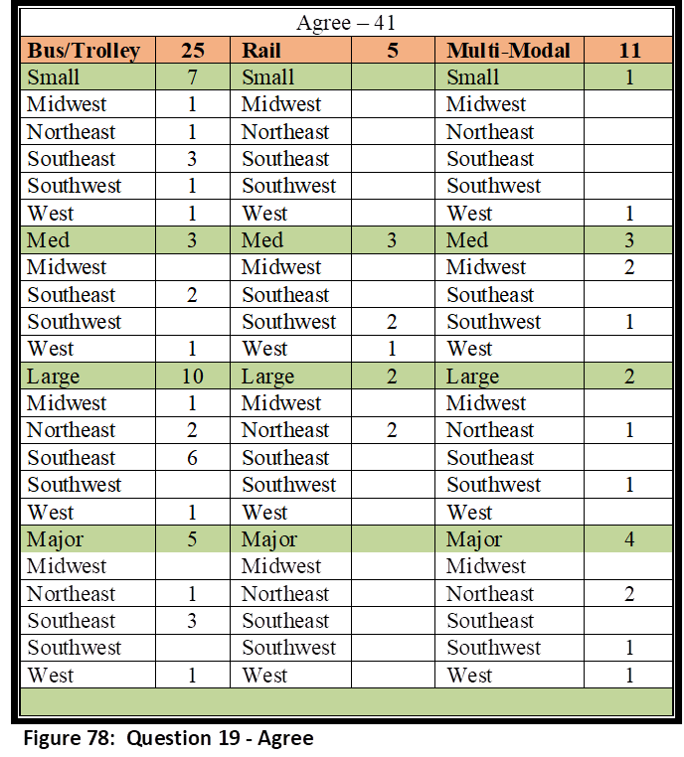
Agree Responses: Forty-one total agencies agreed. Five of the 41 agencies were Rail, with three Medium (two Southwest, one West), and two Large (Northeast). Eleven Multi-Modal agencies agree. One agency was Small (West), three were Medium (two Midwest, one Southwest), two were Large (Northeast, Southwest), and four were Major (two Northeast, one Southwest, one West). Twenty-five respondents were from Bus agencies. Seven agencies were Small (one Midwest, one Northeast, three Southeast, one Southwest, one West), and three agencies were Medium (two Southeast, one West). There were 10 Large Bus agencies (one Midwest, two Northeast, six Southeast, one West), and five Major Bus agencies (one Northeast, three Southeast, one West). Agree responses are illustrated in Figure 78.
Disagree Responses – Sixty-three agencies disagreed. Rail had one Small (Southeast) agency disagree, and there were 10 Multi-Modal agencies. Two Multi-Modal agencies were Small (Southeast, Southwest), three were Medium (Southeast, Southwest, West), and five were Major (one Midwest, one Northeast, two Southeast, one West). Fifty-one Bus agencies disagreed. Nine agencies were Small (three Midwest, four Southeast, one Southwest, one West), 13 Medium (four Midwest, three Northeast, three Southeast, three West), 28 Large (four Midwest, 12 Southeast, 12 West), and one Major agency (Midwest). Disagree responses are illustrated in Figure 79.
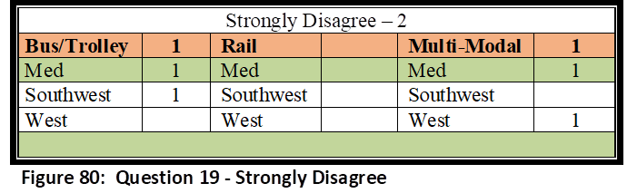
Strongly Disagree Responses – Two agencies strongly disagreed. Rail had zero agencies strongly disagree. One Medium Multi-Modal agency (West) strongly disagreed, and one Medium Bus agency (Southwest) strongly disagreed. Strongly Disagree responses are illustrated in Figure 80.
Question 19 Analysis – The purpose of this question was to, after comparing Question 10 and Question 18 (with those results expected to be similar), verify if agencies were seeking funding, but not receiving funding. Unfortunately, the numbers from all three are very similar. Between questions 10 and 18, 61-63% of transit managers surveyed felt they had not received satisfactory funding needed in their overall preparedness efforts, or to meet the mandates needed to be fully compliant NIMS partners. A comparison with Question 19 revealed similarly that 58% had not been proactively instrumental in seeking funding. It is impossible to determine the counterfactual of whether more agencies had received funding if they had sought it, but it would seem logical that the numbers of agencies not receiving funding would have slightly improved at worst. Similar to the results from Question 10 and Question 18 likely having an impact on overall preparedness, it can be argued that agencies not seeking funding have also had a negative impact on overall preparedness efforts.
Descriptive Analysis Summary
Dependent Variable - Preparedness
Almost 73% of all the respondents either Strongly Agreed or Agreed that they improved in their preparedness since the implementation of HSPD-5, signifying that the effort has been successful for public transportation. An even higher number of agencies, 83% have illustrated confidence in their ability to handle unintentional dangers, such a natural disaster or other major industrial and/or transportation related accident, and a very high 93% have agreed that they are well prepared to assist local emergency responders with regional contingencies when requested. Agencies were more skeptical on their ability to handle an act of terrorism, with 43% disagreeing that they are prepared to handle this type of event. Overall, however, this would suggest that the majority of agencies have a perception that there has been improvement in their overall preparation to handle contingencies since the implementation of HSPD5, which has seemingly had an impact on each of these response types. However, even with the positive number of agencies who perceive that they are better prepared now than prior to the implementation of HSPD-5, there were still nearly 30% who either disagreed or strongly disagreed that they are better off now than before. Even though 93% are confident in assisting other agencies, 43% still are not confident in mitigating the events of a terrorist attack, and 17% are not confident even in the mitigation of emergencies that are common for their agency. Question 11 asked about their ability to handle the wide array of emergency contingencies, which includes all possible intentional and unintentional dangers, and the respondents disagreed at a 39% rate. The potential for terrorism likely had a negative impact on this response. The only evident trends illustrated were that, 1) Bus only agencies were largely represented from all demographics in the disagree options, and 2) Rail and Multi-Modal were largely represented in the agree options, especially those of Large and Major system sizes.
Independent Variables – Funding, Training, Equipment, Exercise Participation,
Collaboration: According to Question 8, 29% of the agencies disagreed that plans existed which mandated and described efforts their agencies must take in regional contingencies. All but eight of the Rail and Multi-Modal agencies agreed with this question, which means the higher percentage of agencies which disagreed, were Bus agencies. Regional plans were included in the survey because it is one venue in determining overall collaboration efforts. Question 9 impacts each of the independent variables as it discusses overall assistance obtained by the agencies in their preparedness efforts. It is unfortunate that 36% of the agencies perceive they have not received the overall assistance they need, and 23 of the 40 who disagreed were either Large or Metro size agencies. These are agencies that transport more than one million passengers per year, and for the seven Major agencies that disagreed, they transport more than 10 million passengers, in unlinked passenger trips annually. Even though 29% of the agencies disagreed that they had not been included in regional plans, 84% did perceive themselves as being a NIMS partner by local agencies in their area in regards to emergency response and mitigation, and 85% perceived their collaboration efforts as satisfactory. Surprisingly, even though 29% of the agencies disagreed that written mandates existed to describe their roles in a contingency, 85% agreed that their agency was included within the region’s emergency response plan (or similar nomenclature) for the purpose of providing public transportation support during a critical incident. Overall, it would seem that the agencies that participated in this survey were largely successful in their collaboration efforts with local first responders and emergency managers.
Funding: This is the area which illustrates the largest weakness among the independent variables, and is likely a major factor in the results of Question 9, which illustrates that 36% of the agencies perceive they have not received the overall assistance they need. Funding also impacts other variables as well, such as equipment and training. Question 10 illustrates that 61% of the agencies disagreed that they had received the level of funding needed in their preparedness efforts, and almost half of those agencies were from the Large and Major size categories. Question 18 is more tailored in that it asks if the agencies have received the funding needed specifically as it pertains to NIMS mandates, and the percentages were very similar to Question 10, with only a 2% difference, in that 63% of the agencies perceived a shortage in funding. Interestingly, however, is the fact that 58% of the agencies disagreed that they had been proactive in seeking funding for these purposes. As illustrated earlier in the text, although the counterfactual cannot be proven one way or the other, it would seem logical that if a higher percentage had sought funding, then a higher percentage would have possibly received a satisfactory level of funding.
Training, Equipment, Exercise Participation: Agencies that are expected to assist in real world events, must be equipped and trained to do so, and should also be afforded the opportunity to test their capabilities in an exercise environment before they are expected to perform in the real world. Regarding NIMS training, which was the training type chosen for this survey, nearly half of all agencies disagreed that their personnel, responsible for emergency preparedness and response, had received NIMS training. However, it is promising to learn that 84 % of the agencies have in fact been invited to participate in local and regional exercises, and 64% are confident they have the equipment needed to handle a myriad of contingencies that could be faced in their region. The 36% that disagreed with Question 14 regarding equipment are likely negatively impacted in this category by the lack of funding. Overall, from the descriptive analysis, agencies should seek more training so that they are more understanding of their roles and how NIMS operates when they respond to assist with local emergencies. Having a better understanding of the terminology and process ensures a smoother response effort, and improves credibility and collaborative efforts.
Inferential Statistics Analysis
Tests
The Pearson Chi-Square test was “used to describe the strength of the linear relationship” (Warner, 2013, p. 261) between the variables, and Fisher’s Exact test was used in those instances in which cells had “frequencies less than five” (Warner, 2013, p. 331). Cronbach’s Alpha, “the most popular form of reliability assessment for multiple item scales” (Warner, 2013, p. 931) was completed to test internal consistency reliability. SPSS software was used to input the data and run each of the tests. Multi-Regression was not conducted due to the data containing discrete data as opposed to continuous (Newton & Rudestam, 1999). It will be noted in the recommendations section that future research should consider at least a 5-7 point Likert Scale or sliding scale to produce more of a continuous variable argument.
The survey instrument for this study was a 4 Point Likert Scale survey, consisting of Strongly Disagree, Disagree, Agree, and Strongly Agree. Upon completion of inputting data into SPSS, it was discovered that the data had to be re-coded into a 2x2 format for each of the variables. Survey responses revealed that every question from the survey had responses of less than 5 in either or both of the Strongly Agree and Strongly Disagree categories, which violates the assumption in Chi-Square tests that each category will have an expected count of at least 5. Due to the need to recode the date, all Strongly Disagree and Disagree responses were combined and coded as “0” in SPSS, and all Strongly Agree and Agree responses were combined and coded as “1” in SPSS.
Dependent Variables
This study used 5 separate dependent variables, measured by survey questions 4, 5, 6, 7, and 11. Question 4 measures the respondent’s attitude regarding their agencies preparedness since the implementation of HSPD-5. Question 5 measures the respondent’s attitude regarding their agencies preparedness to handle natural disasters and major industrial and transportation related accidents that are common to their region. Question 6 measures the respondent’s attitude regarding their agencies preparedness to handle terrorist attacks that could be faced in today’s environment. Question 7 measures the respondent’s attitude regarding their agencies preparedness to assist with regional contingencies as requested by local first responders. Question 11 measures the respondent’s attitude regarding their agencies overall preparedness to handle the wide array of emergency contingencies that potentially exist.
Independent Variables
Each of the above dependent variables was compared with 11 separate independent variables to determine correlation. The independent variables consisted of Question 8, 9, 10, 12, 13, 14, 15, 16, 17, 18, and 19. Question 8 measured the relationship between the dependent variable and the respondent’s attitude regarding whether written plans exist that mandate and describe mitigation efforts the agency must take in regional level contingencies. Question 9 measured the relationship between the dependent variable and the respondent’s attitude regarding whether their agency had received the assistance needed from local, state, and federal agencies in their overall preparedness efforts. Question 10 measured the relationship between the dependent variable and the respondent’s attitude regarding whether their agency had received the funding needed from local, state, and federal agencies in their preparedness efforts. Question 12 measured the relationship between the dependent variable and the respondent’s attitude regarding whether members of their agency, who may be required to be NIMS participants during the mitigation of a critical incident, had received the appropriate levels of NIMS training as outlined within the NIMS training programs. Question 13 measured the relationship between the dependent variable and the respondent’s attitude regarding whether their agency had conducted and/or been invited by outside local agencies to participate in various operational and/or table top exercises, to ensure well-coordinated and structured responses in real-world events. Question 14 measured the relationship between the dependent variable and the respondent’s attitude regarding whether their agency was prepared in terms of the equipment needed and required to handle a myriad of contingencies that could be faced in their region. Question 15 measured the relationship between the dependent variable and the respondent’s attitude regarding whether their agency was considered a NIMS partner by local agencies in regards to emergency response and mitigation. Question 16 measured the relationship between the dependent variable and the respondent’s attitude regarding whether collaboration efforts were satisfactory between their agency and regional first responders. Question 17 measured the relationship between the dependent variable and the respondent’s attitude regarding whether their agency has been included within the region’s Emergency Response Plan (or similar nomenclature) for the purpose of providing public transportation support during a critical incident. Question 18 measured the relationship between the dependent variable and the respondent’s attitude regarding whether their agency had received a satisfactory level of funding for their agency’s overall preparedness as it pertains to NIMS mandates. Question 19 measured the relationship between the dependent variable and the respondent’s attitude regarding whether their agency has been proactively instrumental since HSPD-5 implementation in seeking funding sources to fully prepare their agency as it pertains to NIMS mandates.
Dependent Variable 1 (Survey Question 4)
The question “My agency is better prepared for contingencies since the implementation of HSPD-5 than prior to the implementation of HSPD-5” was important to determine an agency’s preparation level since the implementation of HSPD-5, and if there is correlation between that preparation level and each of the independent variables. Pearson Chi-Square, Fisher’s Exact Test, and Phi Coefficient, were completed for this question against all 11 independent variables. The Case Processing Summary is listed in Figure 81.
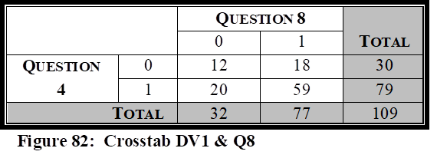
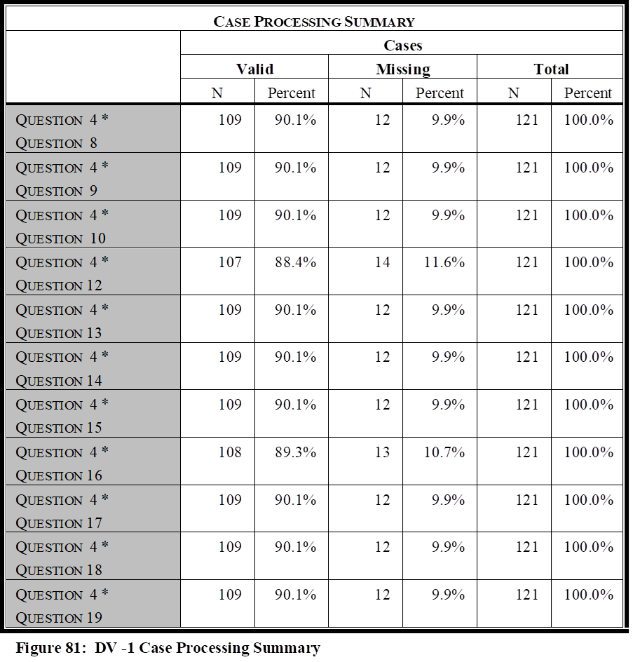
The first independent variable tested against Question 4, was Question 8, “Written plans exist that mandate and describe the mitigation efforts my agency must take in regional level contingencies.” It is important to measure the relationship between the respondent’s attitude pertaining to overall preparedness and the relationship to whether written plans exist that describe their agency’s role in mitigation efforts during regional contingencies.
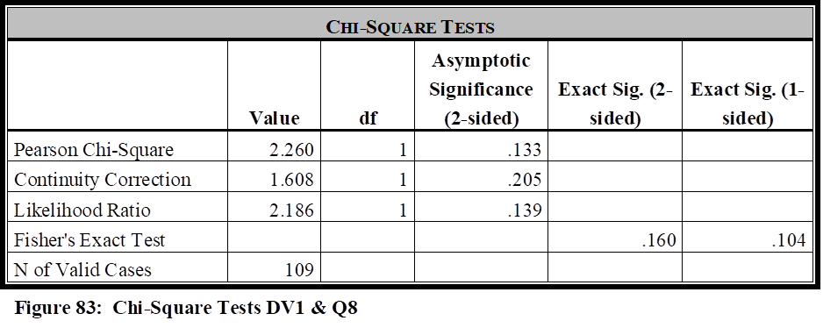
The correlation test revealed there was no evidence of a relationship between these two variables (Pearson’s Chi-Square Value = 2.260; df = 1; p value of .133). The Fisher’s Exact Test showed a significant score of .160, and the Phi Coefficient illustrated a negligible value of .144.
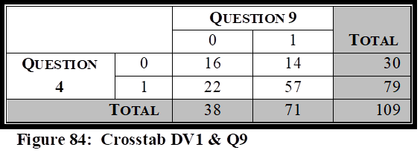
The second independent variable tested against Question 4, was Question 9, “My agency has received the assistance needed from local, state, and federal agencies in our overall preparedness efforts.” It is important to measure the relationship between the respondent’s attitude pertaining to overall preparedness and the relationship to whether their agency has received the assistance needed in their overall preparedness efforts.
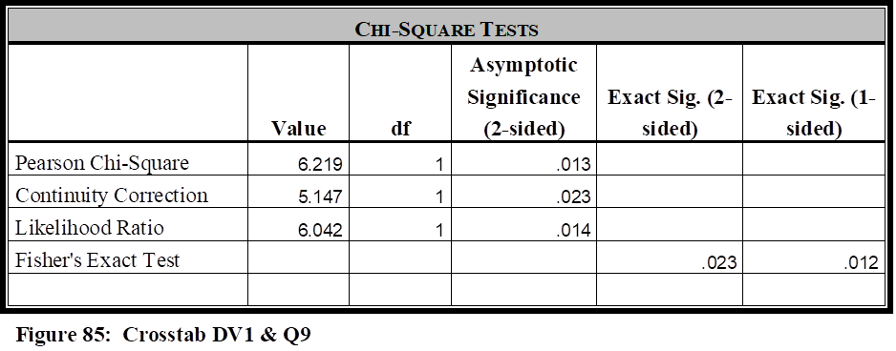
The correlation test revealed there was strong evidence of a relationship between these two variables (Pearson’s Chi-Square Value = 6.219; df = 1; p value of .013). The Fisher’s Exact Test had a significance score of .023, and the Phi Coefficient illustrated a weak strength value of .239.
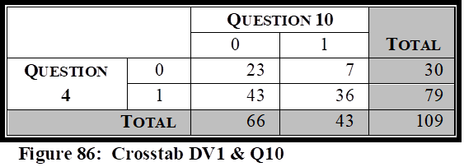
The third independent variable tested against Question 4, was Question 10, “My agency has received the funding needed from local, state, and federal agencies in our overall preparedness efforts.” It is important to measure the relationship between the respondent’s attitude pertaining to overall preparedness and the relationship to whether their agency has received the funding needed in their overall preparedness efforts.
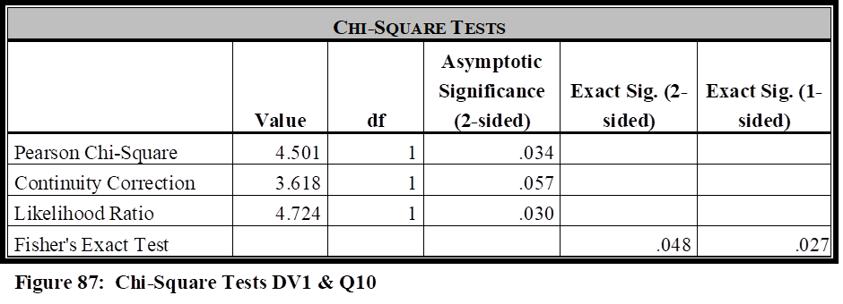
The correlation test revealed there was strong evidence of a relationship between these two variables (Pearson’s Chi-Square Value = 4.501; df = 1; p value of .034). The Fisher’s Exact Test had a significance score of .048, and the Phi Coefficient illustrated a weak strength value of .203.
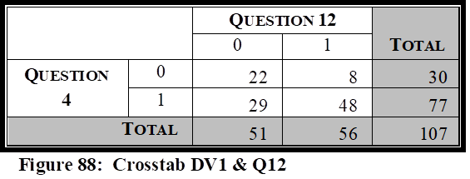
The fourth independent variable tested against Question 4, was Question 12, “Members of my agency, who may be required to be NIMS participants during the mitigation of a natural disaster, industrial/transportation related accident, or serious criminal/ terrorist event, have received the appropriate levels of NIMS training as outlined within the NIMS Training Program.” It is important to measure the relationship between the respondent’s attitude pertaining to overall preparedness and the relationship to whether members of their agency, who may be required to be NIMS participants during a critical incident, have received the appropriate levels of NIMS training.
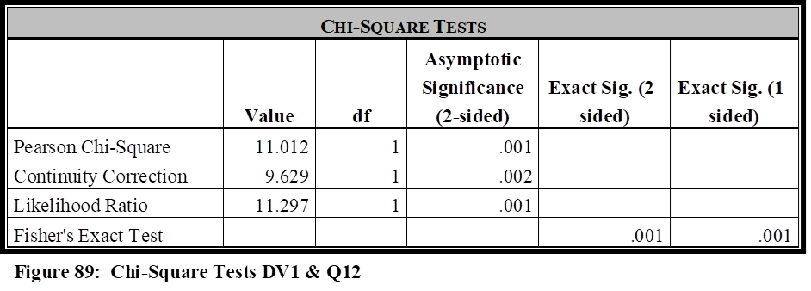
The correlation test revealed there was strong evidence of a relationship between these two variables (Pearson’s Chi-Square Value = 11.012; df = 1; p value of .001). The Fisher’s Exact Test had a significance score of .001, and the Phi Coefficient illustrated a moderate strength value of .321.
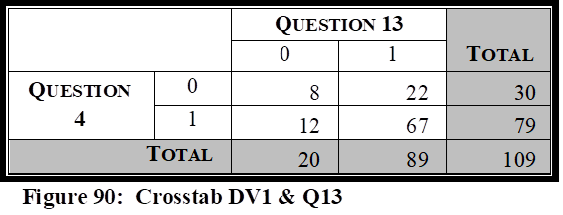
The fifth independent variable tested against Question 4, was Question 13, “My agency has conducted and/or been invited by outside local agencies to participate in various operational and/or table top exercises, such as drills, functional exercises, and full-scale exercises, to train and prepare personnel both within and outside our agency, in regards to incident command structures, to ensure well-coordinated and structured responses in real-world events.” It is important to measure the relationship between the respondent’s attitude pertaining to overall preparedness and the relationship to whether their agency has been invited and/or participated in table top and/or real world exercises, to better prepare them for real-world events.
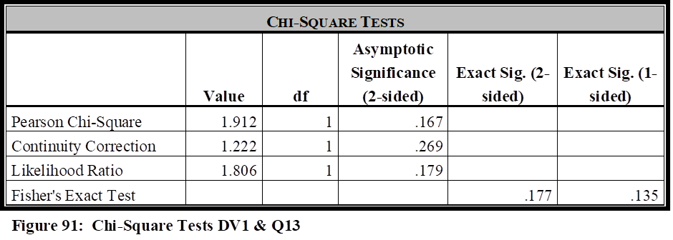
The correlation test revealed there was no evidence of a relationship between these two variables (Pearson’s Chi-Square Value = 1.912; df = 1; p value of .167). The Fisher’s Exact Test had a significance score of .177, and the Phi Coefficient illustrated a negligible value of .132.
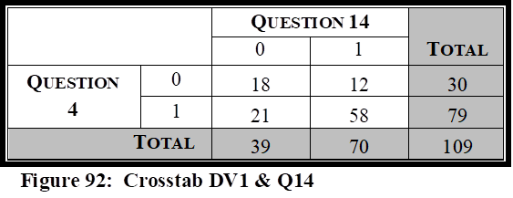
The sixth independent variable tested against Question 4, was Question 14, “My agency is prepared in terms of equipment needed and required to handle a myriad of contingencies that could be faced in our region (natural disasters, industrial or transportation related accidents, terrorist/major criminal events).” It is important to measure the relationship between the respondent’s attitude pertaining to overall preparedness and the relationship to whether their agency has received, or possesses the equipment needed to handle a myriad of contingencies that their agency could face within the region.
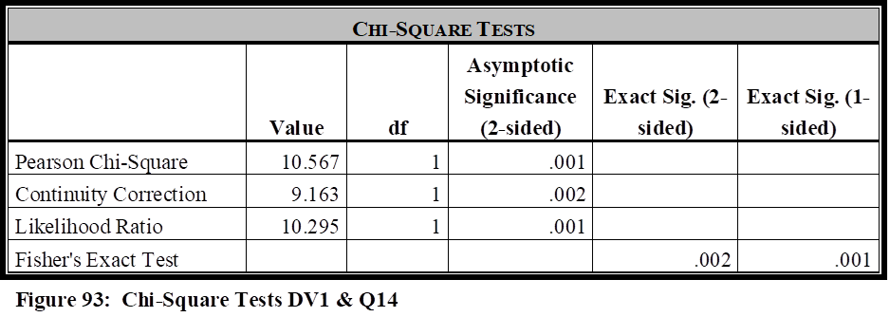
The correlation test revealed there was strong evidence of a relationship between these two variables (Pearson’s Chi-Square Value = 10.567; df = 1; p value of .001). The Fisher’s Exact Test had a significance score of .002, and the Phi Coefficient illustrated a moderate strength value of .311.
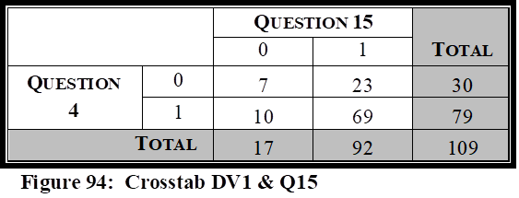
The seventh independent variable tested against Question 4, was Question 15, “My agency is considered a NIMS partner by local agencies in regards to emergency response and mitigation.” It is important to measure the relationship between the respondent’s attitude pertaining to overall preparedness and the relationship to whether their agency is considered a regional NIMS partner.
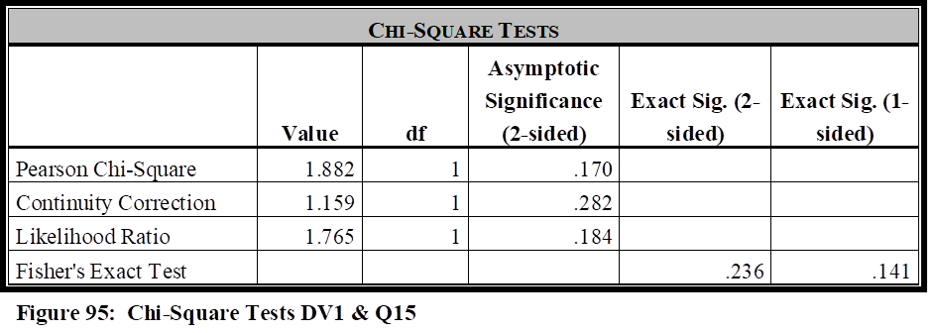
The correlation test revealed there was no evidence of a relationship between these two variables (Pearson’s Chi-Square Value = 1.882; df = 1; p value of .170). The Fisher’s Exact Test had a significance score of .236, and the Phi Coefficient illustrated a negligible value of .131.
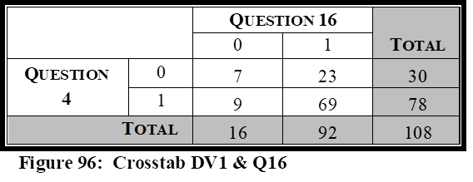
The eighth independent variable tested against Question 4, was Question 16, “Collaboration efforts are satisfactory between my agency and the regional police, fire, rescue, and emergency management agencies.” It is important to measure the relationship between the respondent’s attitude pertaining to overall preparedness and whether collaboration efforts are satisfactory between their agency and the regional first responders.
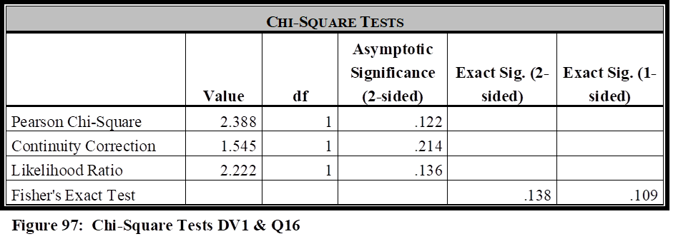
The correlation test revealed there was no evidence of a relationship between these two variables (Pearson’s Chi-Square Value = 2.388; df = 1; p value of .122). The Fisher’s Exact Test had a significance score of .138, and the Phi Coefficient illustrated a negligible value of .149.
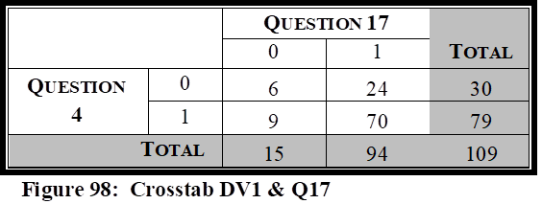
The ninth independent variable tested against Question 4, was Question 17, “My agency has been included within the region’s Emergency Response Plan (or similar nomenclature), for the purpose of providing public transportation support during the response, mitigation, and/or crisis management, of potential emergencies faced by our local area.” It is important to measure the relationship between the respondent’s attitude pertaining to overall preparedness and whether their agency has been in included in mandates that delineates their role during a critical incident.
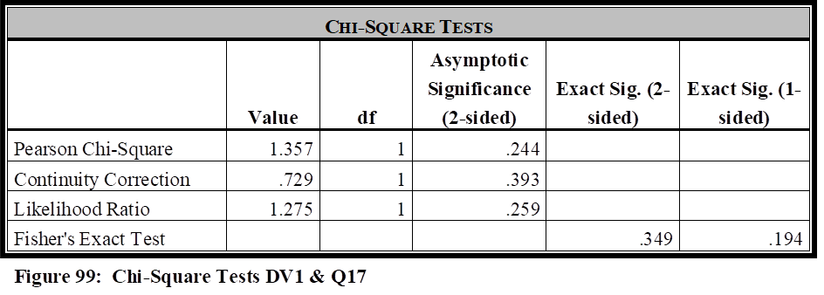
The correlation test revealed there was no evidence of a relationship between these two variables (Pearson’s Chi-Square Value = 1.357; df = 1; p value of .244). The Fisher’s Exact Test had a significance score of .349, and the Phi Coefficient illustrated a negligible value of .112.
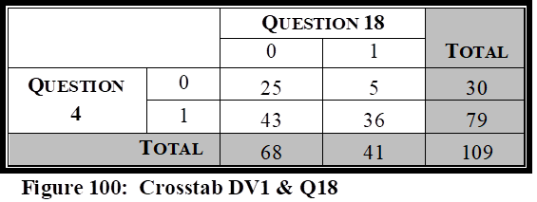
The tenth independent variable tested against Question 4, was Question 18, “My agency has received a satisfactory level of funding, whether from local, State or Federal agencies, in regards to overall preparedness as it pertains to NIMS mandates.” It is important to measure the relationship between the respondent’s attitude pertaining to overall preparedness and whether their agency has received the funding needed in regards to NIMS mandates.
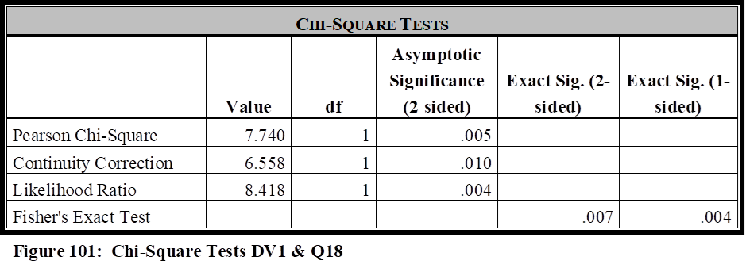
The correlation test revealed there was strong evidence of a relationship between these two variables (Pearson’s Chi-Square Value = 7.740; df = 1; p value of .005). The Fisher’s Exact Test had a significance score of .007, and the Phi Coefficient illustrated a value of .266.
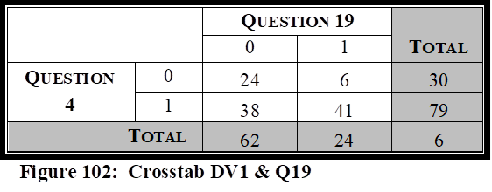
The eleventh independent variable tested against Question 4, was Question 19, “My agency has been proactively instrumental since HSPD-5 implementation in seeking funding sources to fully prepare our agency as it pertains to NIMS mandates.” It is important to measure the relationship between the respondent’s attitude pertaining to overall preparedness and whether their agency has proactively sought funding sources to assist in their preparation efforts as it pertains to NIMS mandates.
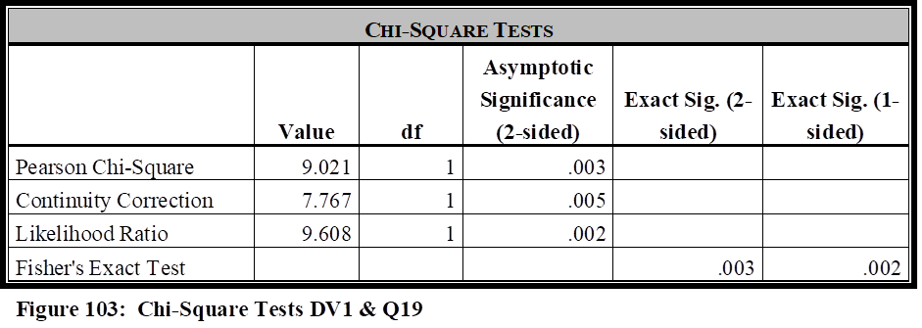
The correlation test revealed there was strong evidence of a relationship between these two variables (Pearson’s Chi-Square Value = 9.021; df = 1; p value of .003). The Fisher’s Exact Test had a significance score of .003, and the Phi Coefficient illustrated a weak strength value of .288.
Analysis of Question 4
Looking back at the hypothesis and literature review for this study, it is argued that public transportation agencies must have the funding, collaboration, equipment, training, written guidance, and be involved as exercise participants, to be fully prepared to meet the myriad of critical incidents they may face in today’s environment. The hypothesis is that public transportation agencies, per the attitudes of public transportation managers, are not given this level of support across the country. Question 4 of the survey measures whether agency managers perceive their agencies as better prepared now, since the implementation of HSPD-5, than before the implementation of the directive.
Question 4 did not illustrate a relationship with Question 8 as it pertains to written mandates, or with Question 17, which specifically identifies the inclusion in regional Emergency Response Plans. Due to the close relationship of these two independent variables, they are being analyzed together. More than double the agencies stated they disagreed or strongly disagreed with the question in Question 8 than in Question 17, which suggests they are included in regional plans, but many perceive there are no written plans that describe their mitigation effort roles. Both Question 8 and Question 17 fail to illustrate a statistical significance with Question 4, which indicates there is no relationship in between the written mandates and improvement since the implementation of HSPD-5. This may be due to the fact that the many agencies that are included in regional plans, may have already been included prior to HSPD-5 implementation. However, the descriptive analysis does indicate that more work is needed to ensure mandates describe the responsibilities and roles the agencies are expected to play. The lack of correlation with this question may have been impacted by the recension of 49 CFR 659, which was discussed in the literature review section, which would also indicate the need for more TSA guidance in terms of transportation system security.
Question 4 did illustrate a statistical significance with Questions 10, Question 18, and Question 19, each of which are related to funding, and will be analyzed together to determine how each has impacted agency preparedness since HSPD-5 implementation. 68 respondents in the survey either disagreed or strongly disagreed that they have received the funding needed in their overall preparedness levels (Question 10), while 71 either disagreed or strongly disagreed that they had received a satisfactory level of funding as it pertains to NIMS mandates. Question 19 specifically pertains to whether the agencies have been proactive in seeking funding. 58% of the respondents either disagreed or strongly disagreed that they had been proactively instrumental in seeking funding sources, so it is not surprising that more than 60% of the agencies perceive they have not received the funding needed in their overall preparedness efforts. The three questions had p values of .034 (Question 10), .005 (Question 18), and .003 (Question 19), thus indicated a strong correlation between funding and the overall preparedness levels of agencies since HSPD-5 implementation.
Question 4 illustrated a statistical significance with Question 12, but not Question 13. Question 12 pertains to NIMS training of personnel within the agency who may be required to participate in a NIMS related crisis, and Question 13 pertains to being invited by outside local agencies to participate in a variety of drills or tabletop exercises to prepare for a variety of critical incidents, to prepare for real-world events. Nearly 47% of the agencies either disagreed or strongly disagreed with Question 12, that their personnel had been trained within the appropriate level of NIMS. However, more than 80% of the agencies agreed, or strongly agreed with Question 13, that their agency had been invited to participate in regional exercises. Question 12 had a p value of .001, illustrating a statistical significance between NIMS training and preparedness since HSPD-5, but not a statistical significance between preparedness since HSPD-5 and the invitation by local agencies in regards to exercises. The correlation between Question 4 and Question 12 would indicate that NIMS training has played a part in the overall success of agency improvement since HSPD-5 implementation, but the lack of training has been detrimental to those who haven’t enjoyed that same level of improvement. The lack of statistical significance with Question 13, however, might indicates that agencies were already involved in exercises prior to HSPD-5 (discussed in more detail in the qualitative section) thus not having an impact on improvements in their preparedness level.
Question 4 illustrated a statistical significance with Question 14 in regards to the equipment needed and required to handle a critical incident in which their agencies may face within the region. This indicates that the acquisition of equipment has impacted improvement in readiness since the implementation of HSPD-5.
Question 4 was not statistically significant with either Question 15, which asked whether the agency was considered a NIMS partner by local agencies, or Question 16, which asked if collaboration efforts were satisfactory between their agencies and local first responders. 84% of the agencies agreed or strongly agreed they were viewed as a NIMS partner (Question 15), and 84% of the agencies also agreed or strongly agreed that collaboration efforts were satisfactory between their agencies and local first responders. There were p values of .170 (Question 15) and .122 (Question 16), thus indicating that there was no correlation between these two questions and their relationship to overall agency preparedness since HSPD-5 implementation (Question 4). As illustrated in the literature review, communication and collaboration is critical in the NIMS framework and crisis leadership; therefore, it is refreshing that such a large number of agencies have developed this level of collaboration and partnerships with their local first responders. There was no correlation here (discussed in more detail in the qualitative section) due to agencies perceiving that they already had good collaboration prior to HSPD-5, and were already considered mitigation partners even before it was called NIMS.
Question 4 was statistically significant with Question 9, in terms of overall assistance and the impact it plays on overall preparedness levels since the implementation of HSPD-5. This category was saved for last in the Question 4 analysis, as it will in each of the other dependent variable sections, because it analyzes the attitude of the respondents in regards to the overall assistance they have received to reach appropriate readiness levels for NIMS and critical incident mitigation. The correlation here indicates that overall assistance received has had an impact on whether their overall preparedness level have improved since HSPD-5. This would also indicate that more work is needed to seek out those agencies still in need of assistance and fulfill whatever areas of need those agencies require, to ensure public transportation agencies across the country are fully prepared to handle contingencies they may be required to face.
Dependent Variable 2 (Survey Question 5)
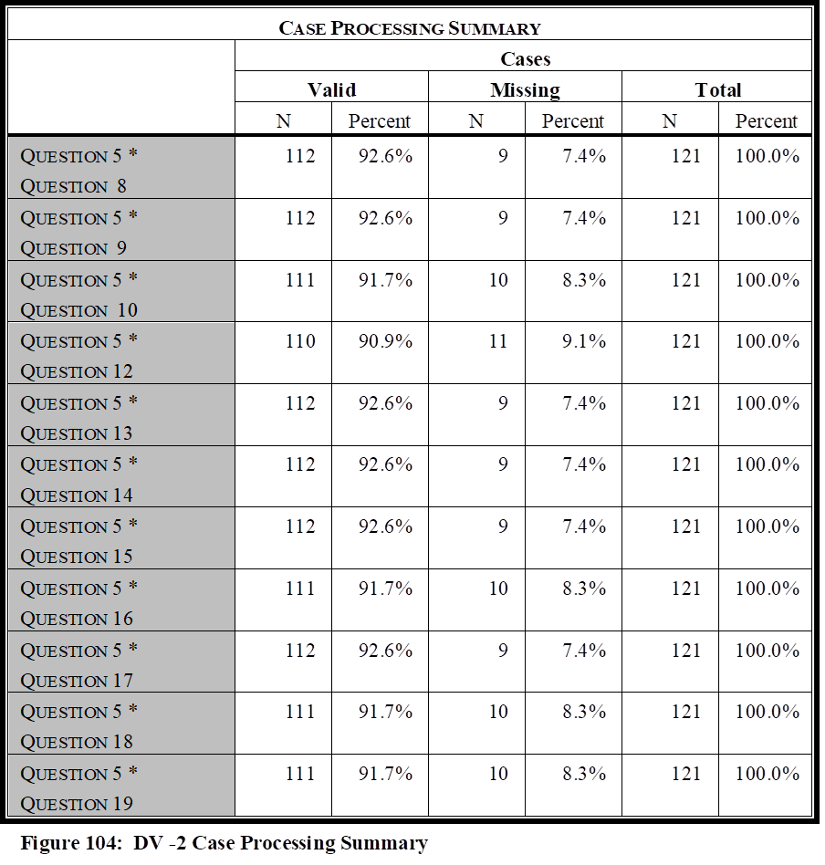
The survey question “My agency is well prepared to handle natural disasters and major industrial and transportation related accidents that are common to our region.” is important to determine an agency’s preparation level regarding those natural disasters and major industrial and transportation related accidents that they are most likely to encounter, and determine if there is correlation between that preparation level and each of the independent variables. Pearson Chi-Square, Fisher’s Exact Test, and Phi Coefficient, were completed for this question against all 11 independent variables. The Case Processing Summary is listed in Figure 104.
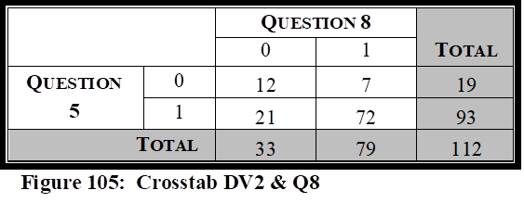
The first independent variable tested against Question 5, was Question 8, “Written plans exist that mandate and describe the mitigation efforts my agency must take in regional level contingencies.” It is important to measure the relationship between the respondent’s attitude pertaining to their ability to mitigate contingencies they are likely to encounter and whether written plans exist that describe their agency’s role in these mitigation strategies.
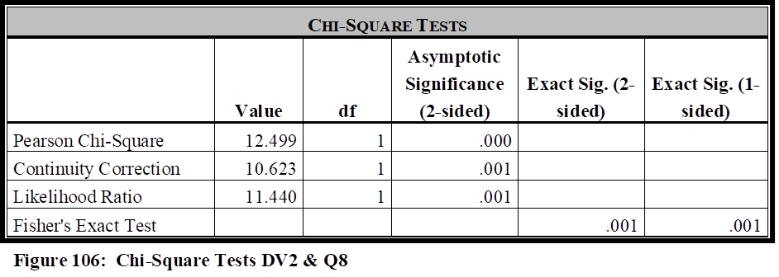
The correlation test revealed there was strong evidence of a relationship between these two variables (Pearson’s Chi-Square Value = 12.499; df = 1; p value of .000). The Fisher’s Exact Test showed a significant score of .001, and the Phi Coefficient illustrated a moderate value of .334.
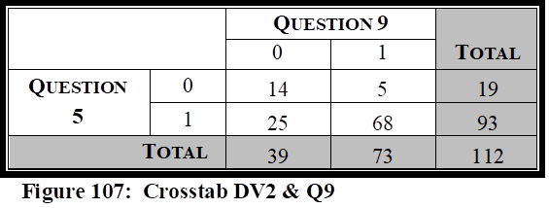
The second independent variable tested against Question 5, was Question 9, “My agency has received the assistance needed from local, state, and federal agencies in our overall preparedness efforts.” It is important to measure the relationship between the respondent’s attitude pertaining to their ability to mitigate contingencies they are likely to encounter to whether their agency has received the assistance needed in their overall preparedness efforts.
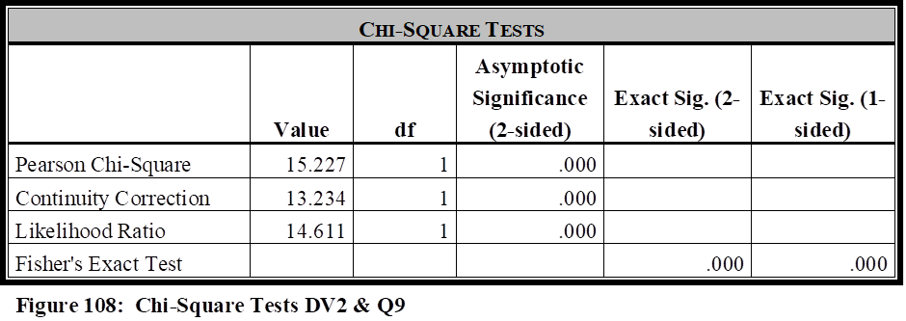
The correlation test revealed there was strong evidence of a relationship between these two variables (Pearson’s Chi-Square Value = 15.227; df = 1; p value of .000). The Fisher’s Exact Test had a significance score of .000, and the Phi Coefficient illustrated a moderate value of .369.
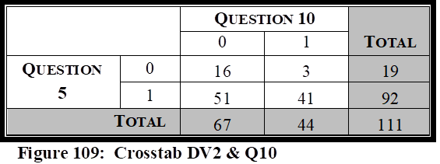
The third independent variable tested against Question 5, was Question 10, “My agency has received the funding needed from local, state, and federal agencies in our overall preparedness efforts.” It is important to measure the relationship between the respondent’s attitude pertaining to their ability to mitigate contingencies they are likely to encounter, to whether their agency has received the funding needed in their overall preparedness efforts.
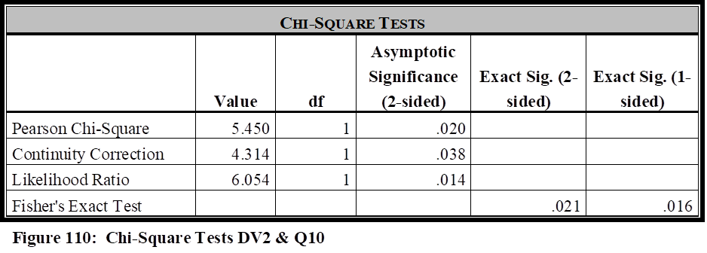
The correlation test revealed there was strong evidence of a relationship between these two variables (Pearson’s Chi-Square Value = 5.450; df = 1; p value of .020). The Fisher’s Exact Test had a significance score of .020, and the Phi Coefficient illustrated a weak strength value of .222.
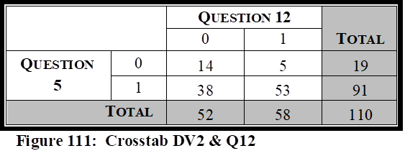
The fourth independent variable tested against Question 5, was Question 12, “Members of my agency, who may be required to be NIMS participants during the mitigation of a natural disaster, industrial/transportation related accident, or serious criminal/ terrorist event, have received the appropriate levels of NIMS training as outlined within the NIMS Training Program.” It is important to measure the relationship between the respondent’s attitude pertaining to their ability to mitigate contingencies they are likely to encounter to whether members of their agency, who may be required to be NIMS participants during a critical incident, have received the appropriate levels of NIMS training.
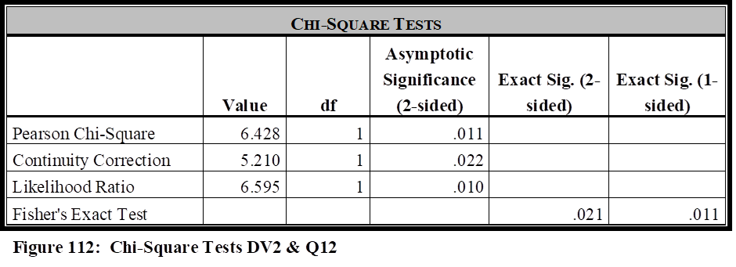
The correlation test revealed there was strong evidence of a relationship between these two variables (Pearson’s Chi-Square Value = 6.428; df = 1; p value of .011). The Fisher’s Exact Test had a significance score of .021, and the Phi Coefficient illustrated a weak strength value of .242.
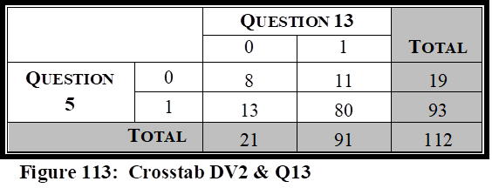
The fifth independent variable tested against Question 5, was Question 13, “My agency has conducted and/or been invited by outside local agencies to participate in various operational and/or table top exercises, such as drills, functional exercises, and full-scale exercises, to train and prepare personnel both within and outside our agency, in regards to incident command structures, to ensure well-coordinated and structured responses in real-world events.” It is important to measure the relationship between the respondent’s attitude pertaining to their ability to mitigate contingencies they are likely to encounter and the relationship to whether their agency has been invited and/or participated in table top and/or real world exercises, to better prepare them for real-world events.
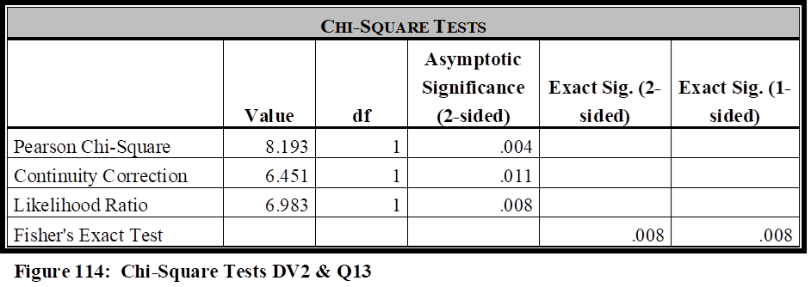
The correlation test revealed there was strong evidence of a relationship between these two variables (Pearson’s Chi-Square Value = 8.193; df = 1; p value of .004). The Fisher’s Exact Test had a significance score of .008
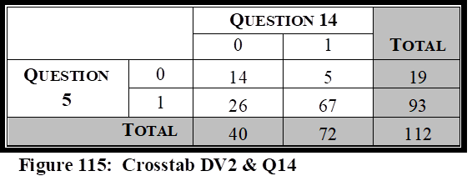
The sixth independent variable tested against Question 5, was Question 14, “My agency is prepared in terms of equipment needed and required to handle a myriad of contingencies that could be faced in our region (natural disasters, industrial or transportation related accidents, terrorist/major criminal events).” It is important to measure the relationship between the respondent’s attitude pertaining to their ability to mitigate contingencies they are likely to encounter and the relationship to whether their agency has received, or possesses the equipment needed to handle a myriad of contingencies that their agency could face within the region.
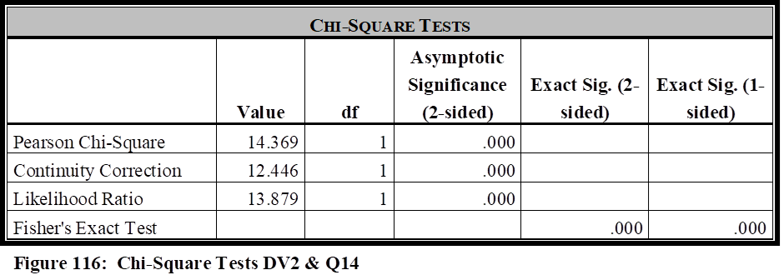
The correlation test revealed there was strong evidence of a relationship between these two variables (Pearson’s Chi-Square Value = 14.369; df = 1; p value of .000). The Fisher’s Exact Test had a significance score of .000, and the Phi Coefficient illustrated a moderate strength value of .358.
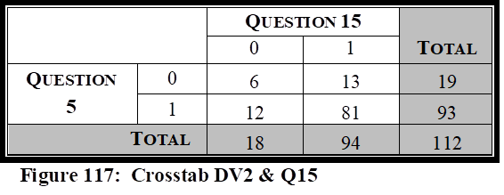
The seventh independent variable tested against Question 5, was Question 15, “My agency is considered a NIMS partner by local agencies in regards to emergency response and mitigation.” It is important to measure the relationship between the respondent’s attitude pertaining to their ability to mitigate contingencies they are likely to encounter and the relationship to whether their agency is considered a regional NIMS partner.
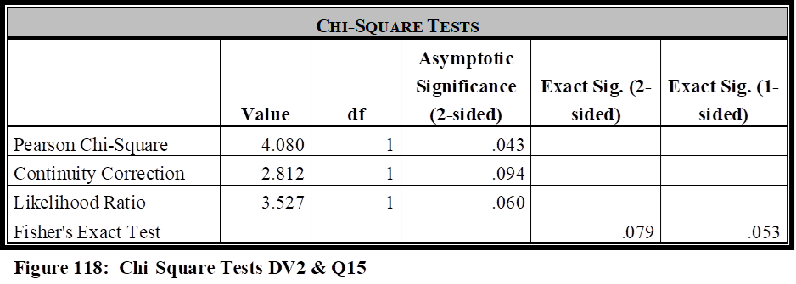
The correlation test revealed there was evidence of a relationship between these two variables (Pearson’s Chi-Square Value = 4.080; df = 1; p value of .043). The Fisher’s Exact Test, however, had a significance score of .079, illustrating no relationship between these two variables, and will be the measurement used. The Fisher Exact Test is being used over the Chi-Square here because there was 1 cell (25.0%) that has expected count less than five, thus violating the Chi-Square assumption. The minimum expected count is 3.05. The Phi Coefficient illustrated a negligible value of .191.
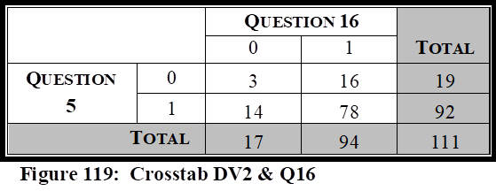
The eighth independent variable tested against Question 5, was Question 16, “Collaboration efforts are satisfactory between my agency and the regional police, fire, rescue, and emergency management agencies.” It is important to measure the relationship between the respondent’s attitude pertaining to their ability to mitigate contingencies they are likely to encounter and whether collaboration efforts are satisfactory between their agency and the regional first responders.
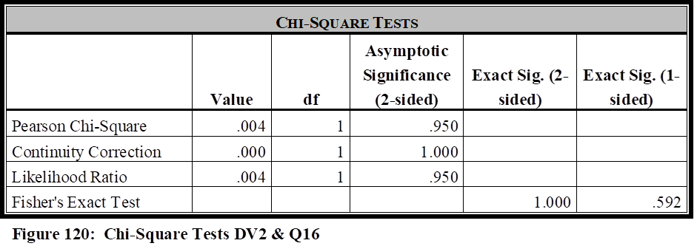
The correlation test revealed there was no evidence of a relationship between these two variables (Pearson’s Chi-Square Value =.004; df = 1; p value of .950). The Fisher Exact Test is being used over the Chi-Square here because there was 1 cell (25.0%) that have expected count less than 5, thus violating the Chi-Square assumption. The Fisher’s Exact Test had a significance score of 1.000, and the Phi Coefficient illustrated a negligible value of .006.
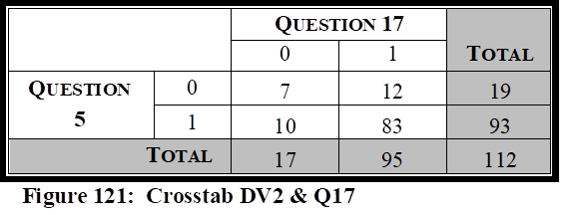
The ninth independent variable tested against Question 5, was Question 17, “My agency has been included within the region’s Emergency Response Plan (or similar nomenclature), for the purpose of providing public transportation support during the response, mitigation, and/or crisis management, of potential emergencies faced by our local area.” It is important to measure the relationship between the respondent’s attitude pertaining to their ability to mitigate contingencies they are likely to encounter and whether their agency has been in included in regional mandates that delineates their role during a critical incident.
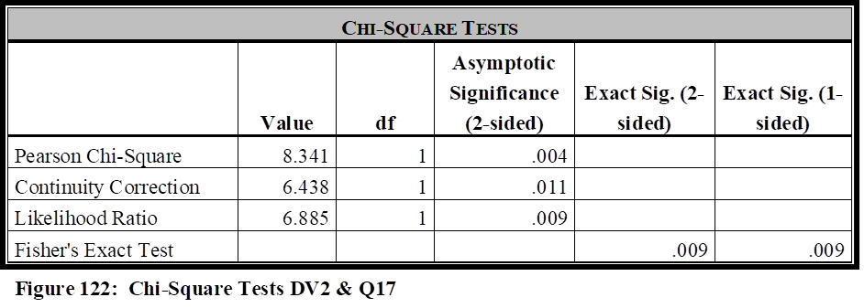
The correlation test revealed there was strong evidence of a relationship between these two variables (Pearson’s Chi-Square Value = 8.341; df = 1; p value of .004). The Fisher Exact Test is being used over the Chi-Square here because there was 1 cell (25.0%) that has expected count less than 5, thus violating the Chi-Square assumption. The minimum expected count is 2.88. The Phi Coefficient illustrated a weak value of .273.
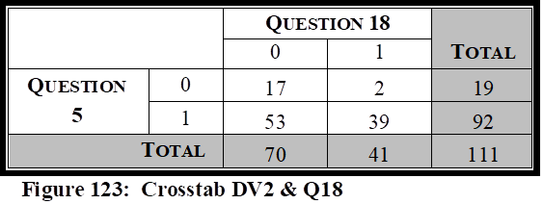
The tenth independent variable tested against Question 4, was Question 18, “My agency has received a satisfactory level of funding, whether from local, State or Federal agencies, in regards to overall preparedness as it pertains to NIMS mandates.” It is important to measure the relationship between the respondent’s attitude pertaining to their ability to mitigate contingencies they are likely to encounter and whether their agency has received the funding needed in regards to NIMS mandates.
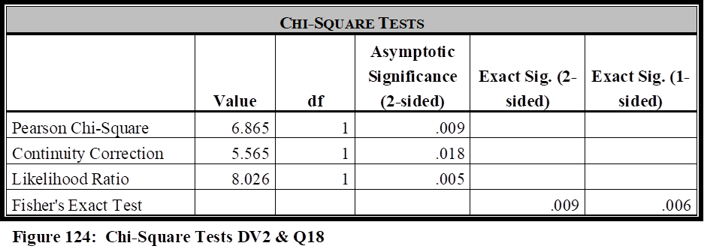
The correlation test revealed there was strong evidence of a relationship between these two variables (Pearson’s Chi-Square Value = 6.865; df = 1; p value of .009). The Fisher’s Exact Test
had a significance score of .009, and the Phi Coefficient illustrated a weak strength value of .249.
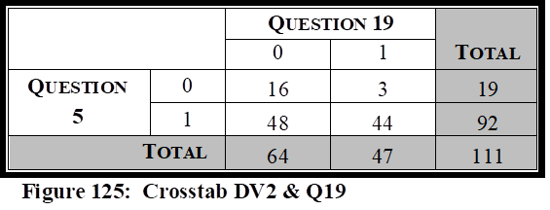
The eleventh independent variable tested against Question 4, was Question 19, “My agency has been proactively instrumental since HSPD-5 implementation in seeking funding sources to fully prepare our agency as it pertains to NIMS mandates.” It is important to measure the relationship between the respondent’s attitude pertaining to their ability to mitigate contingencies they are likely to encounter and whether their agency has proactively sought funding sources to assist in their preparation efforts as it pertains to NIMS mandates.
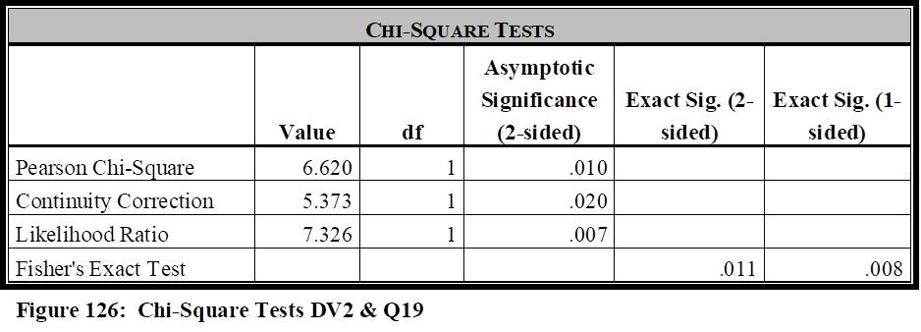
The correlation test revealed there was strong evidence of a relationship between these two variables (Pearson’s Chi-Square Value = 6.620; df = 1; p value of .010). The Fisher’s Exact Test had a significance score of .011, and the Phi Coefficient illustrated a weak strength value of .244.
Analysis of Question 5
Looking back at the hypothesis and literature review for this study, it is argued that public transportation agencies must have the funding, collaboration, equipment, training, written guidance, and be involved as exercise participants, to be fully prepared to meet the myriad of critical incidents they may face in today’s environment. The hypothesis is that public transportation agencies, per the attitudes of public transportation managers, are not given this level of support across the country. Question 5 of the survey measures whether agency managers perceive their agencies are prepared to handle natural disasters and major industrial and transportation related accidents that are common to their region.
Question 5 did illustrate a relationship with Question 8 as it pertains to written mandates, and with Question 17, which specifically identifies their inclusion in regional Emergency Response Plans. Due to the close relationship of these two independent variables, they are being analyzed together. 70% of the agencies stated they agreed or strongly agreed with survey Question 8 that written plans exist that mandate and describe mitigation efforts their agencies must take, and nearly 85% agreed or strongly agreed that they were included in their region’s Emergency Response Plan (or similar). Considering that p < .05 for both Question 8 and Question 17 with Question 5, it illustrates correlation in a way that indicates an agency’s ability to mitigate natural disasters and accidents that are common to their environment, are impacted by them being included in regional plans, and having mandates that delineate their roles and responsibilities.
Question 5 illustrated a statistical significance with Questions 10, Question 18, and Question 19, each of which are related to funding, and will be analyzed together to determine how funding has impacted the agency’s abilities to handle natural disasters and accidents that are common to the agency and their region. 68 respondents in the survey either disagreed or strongly disagreed that they have received the funding needed in their overall preparedness levels (Question 10), while 71 either disagreed or strongly disagreed that they had received a satisfactory level of funding as it pertains to NIMS mandates. Question 19 specifically pertains to whether the agencies have been proactive in seeking funding. 58% of the respondents either disagreed or strongly disagreed that they had been proactively instrumental in seeking funding sources, so it is not surprising that more than 60% of the agencies perceive they have not received the funding needed in their overall preparedness efforts. The three questions had p values of .002 (Question 10), .009 (Question 18), and .010 (Question 19), thus indicating that funding, whether it be receiving or seeking, does impact readiness as it pertains to Question 5. This correlation also indicates that a lack of funding has negatively impacted the readiness and ability for some of the agencies to mitigate through a natural disaster or accident common to their agency.
Question 5 illustrated a statistical significance with both Question 12 and Question 13. Question 12 pertains to NIMS training of personnel within the agency who may be required to participate in a NIMS related crisis, and Question 13 pertains to being invited by outside local agencies to participate in a variety of drills or tabletop exercises to prepare for a variety of critical incidents, to prepare for real-world events. The correlation noted between these variables indicates that NIMS training, and participation in exercises, does have an impact on the agency’s overall readiness to respond to those events described by Question5.
Question 5 illustrated a statistical significance with Question 14 in regards to the equipment needed and required to handle a critical incident in which their agencies may face within the region. More than 35% of the agencies surveyed stated they either disagreed or strongly disagreed that they had the equipment needed in this type of situation. This correlation indicates that the acquisition of equipment has had an impact on the agency’s ability to handle those events described by Question 5.
Question 5 was not statistically significant with either Question 15, which asked whether the agency was considered a NIMS partner by local agencies, or Question 16, which asked if collaboration efforts were satisfactory between their agencies and local first responders. 84% of the agencies agreed or strongly agreed they were viewed as a NIMS partner (Question 15), and 84% of the agencies also agreed or strongly agreed that collaboration efforts were satisfactory between their agencies and local first responders. This lack of correlation between these variables might be explained better in the qualitative section, in which agencies perceive they are prepared to handle those incidents in which they are most familiar, regardless of collaboration efforts with other agencies. As explained by one manager, they feel confident their abilities to fulfill their roles in these scenarios, while local first responders fulfill their own roles.
Question 5 was statistically significant with Question 9, in terms of overall assistance and the impact it plays on preparedness levels for natural disasters and accidents. This category was saved for last in the Question 5 analysis, as it will in each of the other dependent variable sections, because it analyzes the attitude of the respondents in regards to the overall assistance they have received to reach appropriate readiness levels for NIMS and critical incident mitigation. The correlation illustrated here indicates that overall assistance given to a public transportation agency does impact their ability to handle the natural disasters and accidents that are common for their agency
Dependent Variable 3 (Survey Question 6)
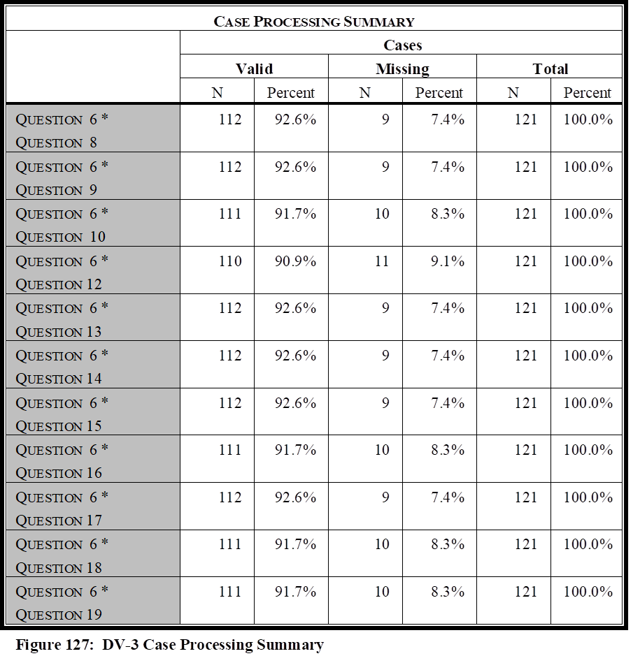
The survey question “My agency is prepared to handle terrorist attacks that could be faced in today’s environment” is important to determine an agency’s preparation level regarding potential terrorism types of attacks that their agency may face, and determine if there is correlation between that preparation level and each of the independent variables. Pearson Chi-Square, Fisher’s Exact Test, and Phi Coefficient, were completed for this question against all 11 independent variables. The Case Processing Summary is listed in Figure 127.
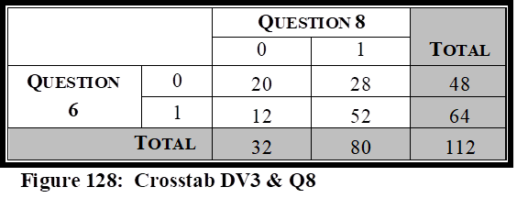
The first independent variable tested against Question 6, was Question 8, “Written plans exist that mandate and describe the mitigation efforts my agency must take in regional level contingencies.” It is important to measure the relationship between the respondent’s attitude pertaining to terrorist attacks, that could be faced in today’s environment, and whether written plans exist that describe their agency’s role in these mitigation strategies.
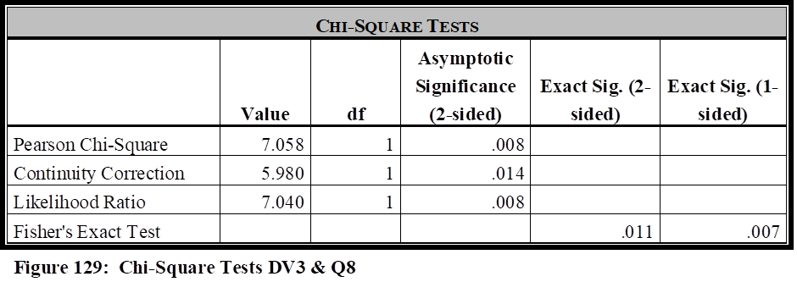
The correlation test revealed there was strong evidence of a relationship between these two variables (Pearson’s Chi-Square Value = 7.058; df = 1; p value of .008). The Fisher’s Exact Test showed a significant score of .011, and the Phi Coefficient illustrated a weak value of .251.
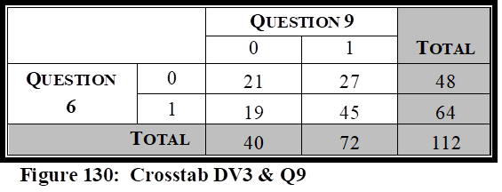
The second independent variable tested against Question 6, was Question 9, “My agency has received the assistance needed from local, state, and federal agencies in our overall preparedness efforts.” It is important to measure the relationship between the respondent’s attitude pertaining to terrorist attacks, that could be faced in today’s environment, to whether their agency has received the assistance needed in their overall preparedness efforts.
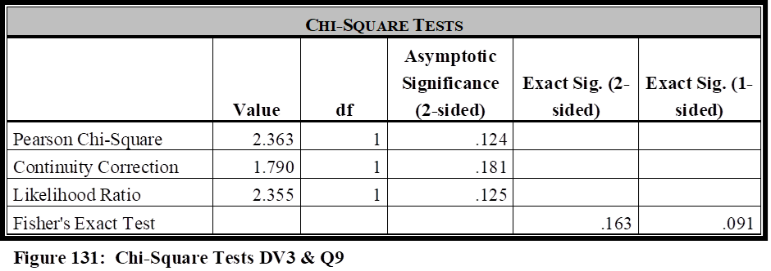
The correlation test revealed there was no evidence of a relationship between these two variables (Pearson’s Chi-Square Value = 2.363; df = 1; p value of .124). The Fisher’s Exact Test had a significance score of .163, and the Phi Coefficient illustrated a negligible value of .145.
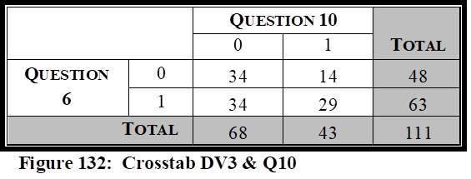
The third independent variable tested against Question 6, was Question 10, “My agency has received the funding needed from local, state, and federal agencies in our overall preparedness efforts.” It is important to measure the relationship between the respondent’s attitude pertaining to terrorist attacks, that could be faced in today’s environment, to whether their agency has received the funding needed in their overall preparedness efforts.
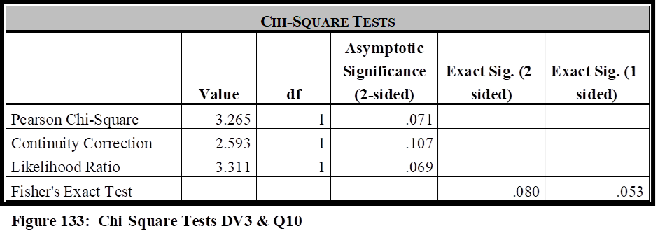
The correlation test revealed there was no evidence of a relationship between these two variables (Pearson’s Chi-Square Value = 2.265; df = 1; p value of .071). The Fisher’s Exact Test had a significance score of .080, and the Phi Coefficient illustrated a negligible value of .172.
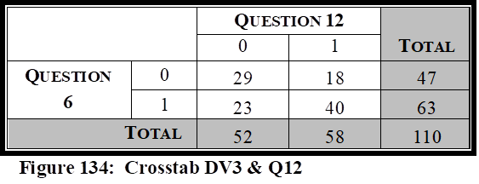
The fourth independent variable tested against Question 6, was Question 12, “Members of my agency, who may be required to be NIMS participants during the mitigation of a natural disaster, industrial/transportation related accident, or serious criminal/ terrorist event, have received the appropriate levels of NIMS training as outlined within the NIMS Training Program.” It is important to measure the relationship between the respondent’s attitude pertaining to terrorist attacks, that could be faced in today’s environment, to whether members of their agency, who may be required to be NIMS participants during a critical incident, have received the appropriate levels of NIMS training.
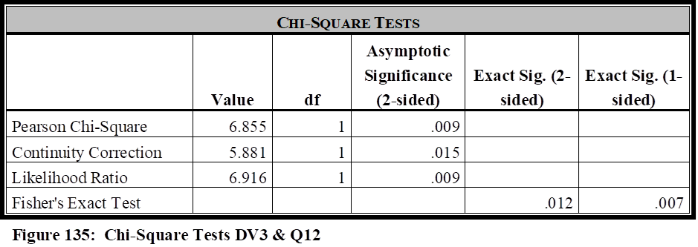
The correlation test revealed there was strong evidence of a relationship between these two variables (Pearson’s Chi-Square Value = 6.855; df = 1; p value of .009). The Fisher’s Exact Test had a significance score of .012, and the Phi Coefficient illustrated a weak strength value of .250.
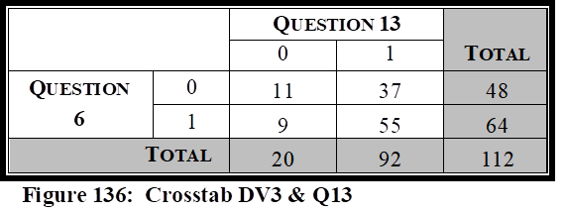
The fifth independent variable tested against Question 6, was Question 13, “My agency has conducted and/or been invited by outside local agencies to participate in various operational and/or table top exercises, such as drills, functional exercises, and full-scale exercises, to train and prepare personnel both within and outside our agency, in regards to incident command structures, to ensure well-coordinated and structured responses in real-world events.” It is important to measure the relationship between the respondent’s attitude pertaining to terrorist attacks, that could be faced in today’s environment, and the relationship to whether their agency has been invited and/or participated in table top and/or real world exercises, to better prepare them for real-world events.
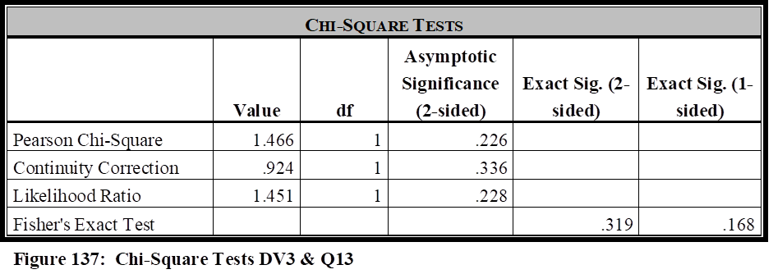
The correlation test revealed there was no evidence of a relationship between these two variables (Pearson’s Chi-Square Value = 1.466; df = 1; p value of .226). The Fisher’s Exact Test had a significance score of .319, and the Phi Coefficient illustrated a negligible value of .114.
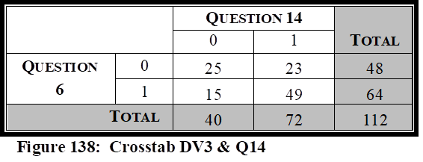
The sixth independent variable tested against Question 6, was Question 14, “My agency is prepared in terms of equipment needed and required to handle a myriad of contingencies that could be faced in our region (natural disasters, industrial or transportation related accidents, terrorist/major criminal events).” It is important to measure the relationship between the respondent’s attitude pertaining to terrorist attacks, that could be faced in today’s environment, and the relationship to whether their agency has received, or possesses the equipment needed to handle a myriad of contingencies that their agency could face within the region.
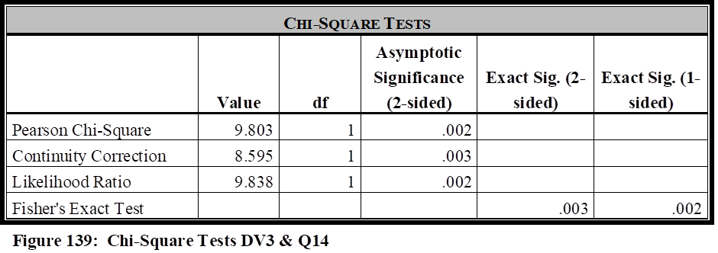
The correlation test revealed there was strong evidence of a relationship between these two variables (Pearson’s Chi-Square Value = 14.369; df = 1; p value of .002). The Fisher’s Exact Test had a significance score of .003, and the Phi Coefficient illustrated a moderate strength value of .296.
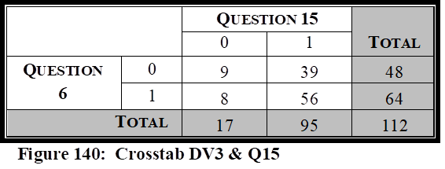
The seventh independent variable tested against Question 6, was Question 15, “My agency is considered a NIMS partner by local agencies in regards to emergency response and mitigation.” It is important to measure the relationship between the respondent’s attitude pertaining to terrorist attacks, that could be faced in today’s environment, and the relationship to whether their agency is considered a regional NIMS partner.
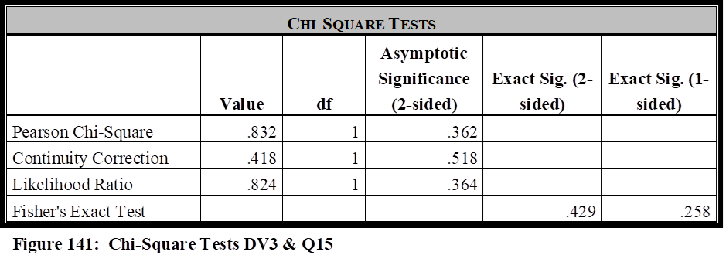
The correlation test revealed there was no evidence of a relationship between these two variables (Pearson’s Chi-Square Value = .832; df = 1; p value of .362). The Fisher’s Exact Test had a significance score of .429, and the Phi Coefficient illustrated a negligible value of .086.
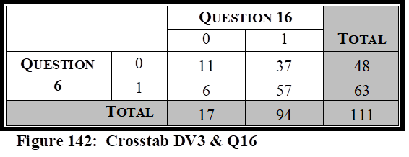
The eighth independent variable tested against Question 6, was Question 16, “Collaboration efforts are satisfactory between my agency and the regional police, fire, rescue, and emergency management agencies.” It is important to measure the relationship between the respondent’s attitude pertaining to terrorist attacks, that could be faced in today’s environment, and whether collaboration efforts are satisfactory between their agency and the regional first responders.
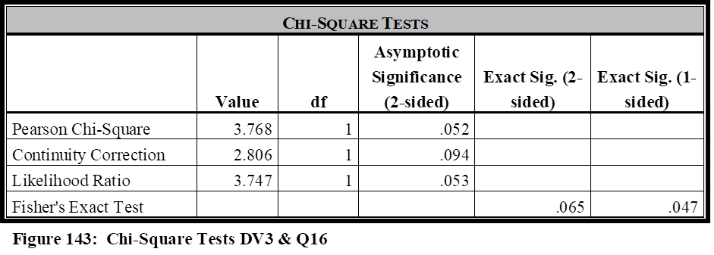
The correlation test revealed there was no evidence of a relationship between these two variables (Pearson’s Chi-Square Value = 3.768; df = 1; p value of .052). The Fisher’s Exact Test had a significance score of .065, and the Phi Coefficient illustrated a negligible value of .184.
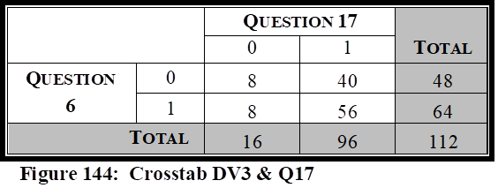
The ninth independent variable tested against Question 6, was Question 17, “My agency has been included within the region’s Emergency Response Plan (or similar nomenclature), for the purpose of providing public transportation support during the response, mitigation, and/or crisis management, of potential emergencies faced by our local area.” It is important to measure the relationship between the respondent’s attitude pertaining to terrorist attacks, that could be faced in today’s environment, and whether their agency has been in included in regional mandates that delineates their role during a critical incident.
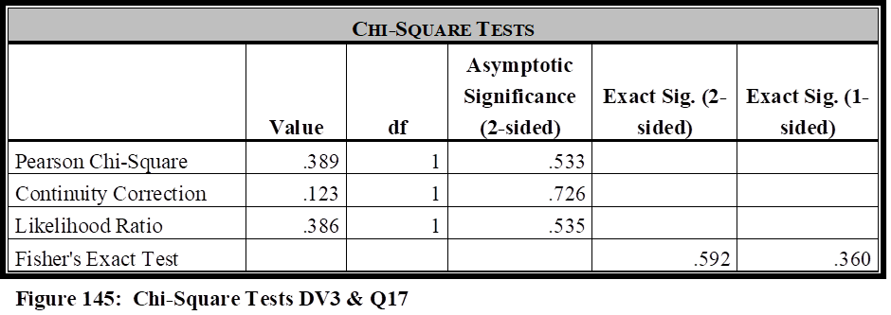
The correlation test revealed there was no evidence of a relationship between these two variables (Pearson’s Chi-Square Value = .389; df = 1; p value of .533). The Fisher’s Exact Test had a significance score of .592, and the Phi Coefficient illustrated a negligible value of .059.
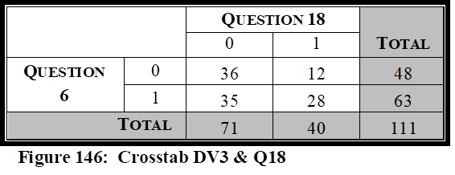
The tenth independent variable tested against Question 4, was Question 18, “My agency has received a satisfactory level of funding, whether from local, State or Federal agencies, in regards to overall preparedness as it pertains to NIMS mandates.” It is important to measure the relationship between the respondent’s attitude pertaining to terrorist attacks, that could be faced in today’s environment, and whether their agency has received the funding needed in regards to NIMS mandates.
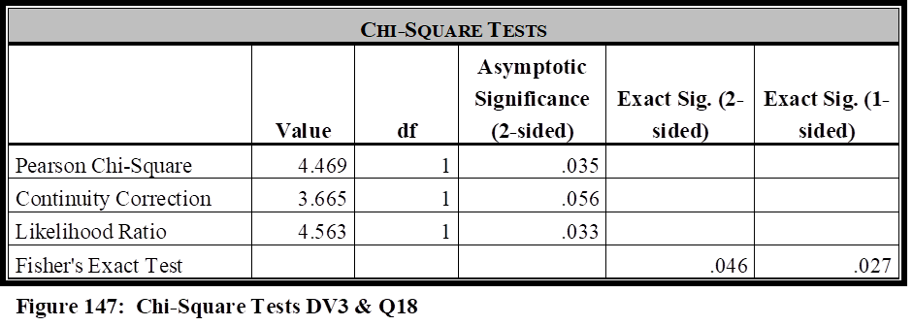
The correlation test revealed there was strong evidence of a relationship between these two variables (Pearson’s Chi-Square Value = 4.469; df = 1; p value of .035). The Fisher’s Exact Test
had a significance score of .046, and the Phi Coefficient illustrated a weak strength value of .201.
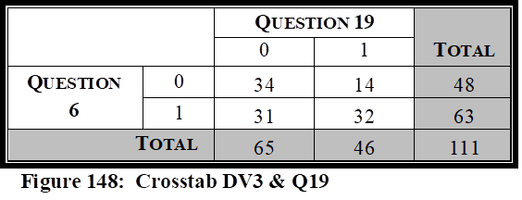
The eleventh independent variable tested against Question 4, was Question 19, “My agency has been proactively instrumental since HSPD-5 implementation in seeking funding sources to fully prepare our agency as it pertains to NIMS mandates.” It is important to measure the relationship between the respondent’s attitude pertaining to terrorist attacks, that could be faced in today’s environment, and whether their agency has proactively sought funding sources to assist in their preparation efforts as it pertains to NIMS mandates.
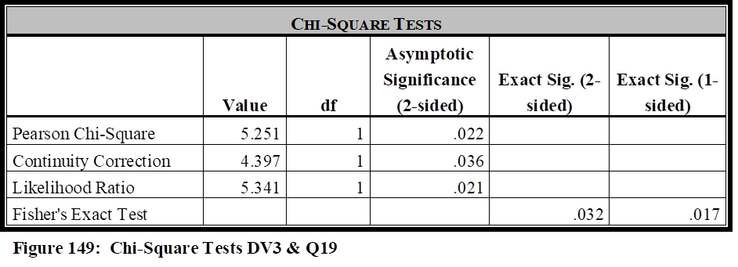
The correlation test revealed there was strong evidence of a relationship between these two variables (Pearson’s Chi-Square Value = 5.251; df = 1; p value of .022). The Fisher’s Exact Test had a significance score of .032, and the Phi Coefficient illustrated a weak strength value of .217.
Analysis of Question 6
Looking back at the hypothesis and literature review for this study, it is argued that public transportation agencies must have the funding, collaboration, equipment, training, written guidance, and be involved as exercise participants, to be fully prepared to meet the myriad of critical incidents they may face in today’s environment. The hypothesis is that public transportation agencies, per the attitudes of public transportation managers, are not given this level of support across the country. Question 6 of the survey measures whether agency managers perceive their agencies are prepared to handle a terrorist attack that could be faced in today’s environment. It is notable that 43% of the agencies surveyed disagreed/strongly disagreed with survey Question 6 in regards to their readiness to respond to a terrorist incident.
Due to the close relationship of Question 8 and Question 17, with both being related to the agency having written mandates and directives, these two independent variables will be analyzed together with Question 6 in how they correlate with agency readiness levels regarding terrorism. Question 6 did show a strong correlation with Question 8 as it pertains to written mandates, but not with Question 17, which specifically identifies their inclusion in regional Emergency Response Plans. 29% of the agencies disagreed/strongly disagreed with survey Question 8 in regards to having written plans describing mitigation efforts their agencies must follow. Question 17, however, shows that only 15% of the agencies disagreed/strongly disagreed that they were part of a regional plan. Question 17 (p > .05) illustrates that there is no correlation regarding an agency being part of a regional plan, and the readiness level of an agency to handle a terrorist incident. This may be explained by the fact that even though the agencies are included in regional plans, they still do not feel ready to handle this type of incident. Explained later in the qualitative section, agencies are included in regional plans, but they perceive they are not prepared in other capacities. The correlation with Question 8 does illustrate that written mandates, delineating an agency’s actual role and list of responsibilities, does impact the readiness level for mitigating acts of terrorism toward public transportation.
Question 6 shows a statistical significance with Questions 10, Question 18, and Question 19, each of which are related to funding, and will be analyzed together to determine how funding has impacted the agency’s readiness levels to handle a terrorism related event. 61% of survey respondents disagreed/strongly disagreed that they have received the funding needed in their overall preparedness levels (Question 10), while 63% disagreed/strongly disagreed that they had received a satisfactory level of funding as it pertains to NIMS mandates. Question 19 specifically pertains to whether the agencies have been proactive in seeking funding. 58% of the respondents disagreed/strongly disagreed that they had been proactively instrumental in seeking funding sources, so it is not surprising that more than 60% of the agencies perceive they have not received the funding needed in their overall preparedness efforts. Due to the correlation between Question 6 and Question 10 (p < .05), Question 18 (p < .05), and Question 19 (p < .05), we can see that a lack of funding for overall preparedness, lack of funding to meet NIMS related mandates, and the lack of agencies seeking funding, have all impacted public transportation readiness in terms of their ability to respond to a terrorist related event.
Question 6 illustrated a statistical significance with Question 12, but not Question 13. Question 12 pertains to NIMS training of personnel within the agency who may be required to participate in a NIMS related crisis, and Question 13 pertains to being invited by outside local agencies to participate in a variety of drills or tabletop exercises to prepare for a variety of critical incidents, to prepare for real-world events. Nearly 47% of the agencies disagreed/strongly disagreed with Question 12, that their personnel had been trained within the appropriate level of NIMS. However, more than 80% of the agencies agreed/strongly agreed with Question 13, that their agency had been invited to participate in regional exercises. Question 12 (p < .05) suggests there is an issue with public transportation employees not receiving the appropriate level of training, and this has negatively impacted 43% of the public transportation agencies surveyed in their ability to respond to a terrorism related event. Question 13 (p > .05) illustrates that 81% of agencies surveyed have been invited, or have participated, in operational and/or table top exercises. The analysis shows that the exercises, at least from a quantitative standpoint, have no correlation with the readiness level of the agencies (per the attitudes of the public transportation managers surveyed), in regards to their readiness level to respond to an act of terrorism. This will be discussed in further detail in the final research analysis, but is likely attributed to the agency’s still feeling unprepared for acts of terrorism, even though they participate regularly with outside agencies in regards to exercises.
Question 6 shows strong statistical significance with Question 14 (p < .05) in regards to the equipment needed and required to handle a critical incident which their agencies may face within the region. More than 35% of the agencies surveyed stated they disagreed/strongly disagreed that they had the equipment needed to handle a myriad of contingencies. This fact, coupled with the 43% who perceive they are not prepared to handle an act of terrorism, is certainly concerning.
Question 6 was not statistically significant with either Question 15, which asked whether the agency was considered a NIMS partner by local agencies, or Question 16, which asked if collaboration efforts were satisfactory between their agencies and local first responders. 84% of the agencies agreed/strongly agreed they were viewed as a NIMS partner (Question 15), and 84% of the agencies also agreed/strongly agreed that collaboration efforts were satisfactory between their agencies and local first responders. This lack of correlation is likely attributed to agencies not feeling prepared for terrorism against their agency, even though they perceive there is a strong sense of collaboration and partnership with outside agencies.
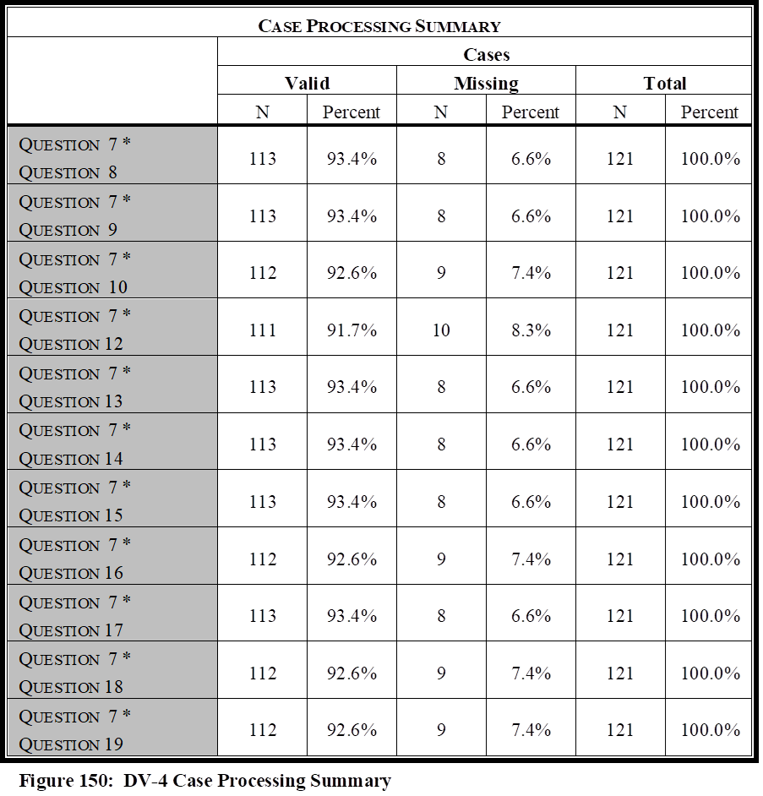
Question 6 was not statistically significant (p > .05) with Question 9, in terms of overall assistance and the impact it plays on overall preparedness levels for terrorism response. This category was saved for last in the Question 6 analysis, as it will in each of the other dependent variable sections, because it analyzes the attitude of the respondents in regards to the overall assistance they have received to reach appropriate readiness levels for NIMS and critical incident mitigation. More than 35% of the agencies surveyed either disagreed/strongly disagreed that they had received the assistance needed in their overall preparedness levels, and 43% perceive they are not ready to handle an act of terrorism, but there does not seem to be a correlation, at least in the attitudes of public transportation managers, between overall assistance received and preparation to handle an act of terrorism. This will be discussed in further detail in the final analysis section. However, the qualitative analysis section will discuss that managers perceive that an act of terrorism against their agency would be devastating, and that it is difficult to gauge just how much “overall assistance’ would be considered enough to ensure a satisfactory level of readiness for such a devastating event.
Dependent Variable 4 (Survey Question 7)
The survey question “My agency is prepared to assist with regional contingencies as requested by local first responders” is important to determine if public transportation agencies feel prepared to assist with regional contingencies, other than those related solely to their transportation properties, when requested by local police, fire, etc. Pearson Chi-Square, Fisher’s Exact Test, and Phi Coefficient, were completed for this question against all 11 independent variables. The Case Processing Summary is in Figure 150.
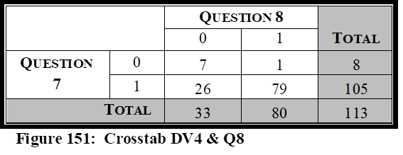
The first independent variable tested against Question 7, was Question 8, “Written plans exist that mandate and describe the mitigation efforts my agency must take in regional level contingencies.” It is important to measure the relationship between the respondent’s attitude regarding their agency’s ability to respond to regional contingencies, and whether written plans exist that describe their agency’s role in these mitigation strategies.
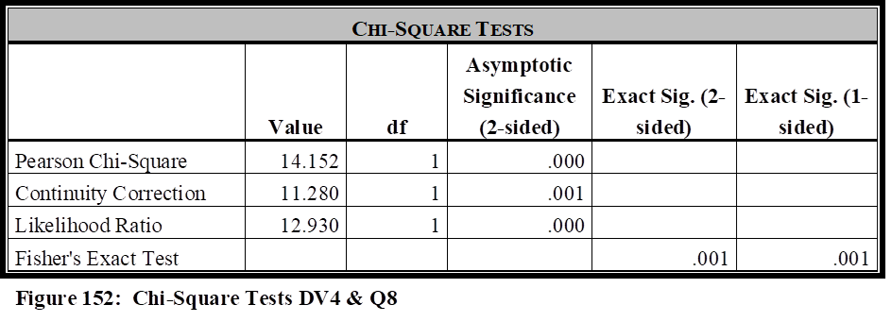
The correlation test revealed there was strong evidence of a relationship between these two variables (Pearson’s Chi-Square Value = 14.152; df = 1; p value of .00). The Fisher’s Exact Test showed a significance score of .001, and the Phi Coefficient illustrated a moderate value of .354.
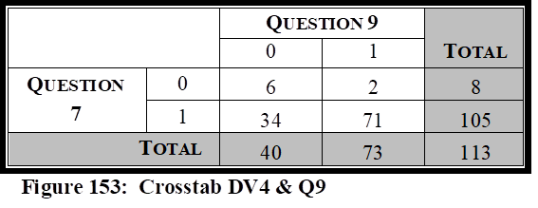
The second independent variable tested against Question 7, was Question 9, “My agency has received the assistance needed from local, state, and federal agencies in our overall preparedness efforts.” It is important to measure the relationship between the respondent’s attitude regarding their agency’s ability to respond to regional contingencies, to whether their agency has received the assistance needed in their overall preparedness efforts.
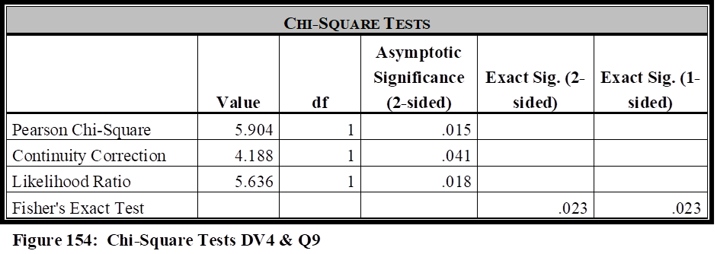
The correlation test revealed there was strong evidence of a relationship between these two variables (Pearson’s Chi-Square Value = 5.904; df = 1; p value of .015). The Fisher’s Exact Test had a significance score of .023, and the Phi Coefficient illustrated a weak value of .229.
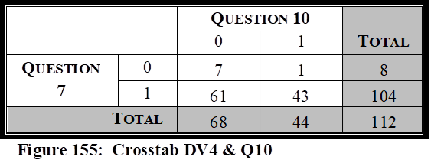
The third independent variable tested against Question 7, was Question 10, “My agency has received the funding needed from local, state, and federal agencies in our overall preparedness efforts.” It is important to measure the relationship between the respondent’s attitude regarding their agency’s ability to respond to regional contingencies, to whether their agency has received the funding needed in their overall preparedness efforts.
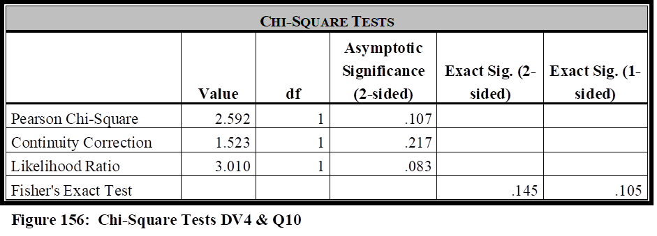
The correlation test revealed there was no evidence of a relationship between these two variables (Pearson’s Chi-Square Value = 2.265; df = 1; p value of .107). The Fisher’s Exact Test had a significance score of .145, and the Phi Coefficient illustrated a negligible value of .152.
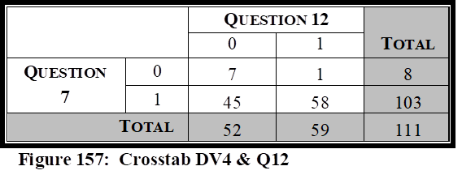
The fourth independent variable tested against Question 7, was Question 12, “Members of my agency, who may be required to be NIMS participants during the mitigation of a natural disaster, industrial/transportation related accident, or serious criminal/ terrorist event, have received the appropriate levels of NIMS training as outlined within the NIMS Training Program.” It is important to measure the relationship between the respondent’s attitude regarding their agency’s ability to respond to regional contingencies, to whether members of their agency, who may be required to be NIMS participants during a critical incident, have received the appropriate levels of NIMS training.
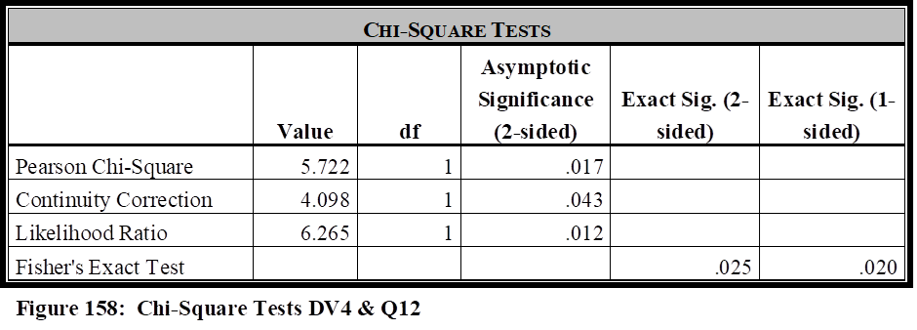
The correlation test revealed there was strong evidence of a relationship between these two variables (Pearson’s Chi-Square Value = 5.722; df = 1; p value of .017). The Fisher’s Exact Test had a significance score of .025, and the Phi Coefficient illustrated a weak strength value of .227.
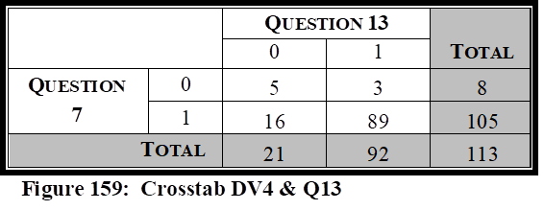
The fifth independent variable tested against Question 7, was Question 13, “My agency has conducted and/or been invited by outside local agencies to participate in various operational and/or table top exercises, such as drills, functional exercises, and full-scale exercises, to train and prepare personnel both within and outside our agency, in regards to incident command structures, to ensure well-coordinated and structured responses in real-world events.” It is important to measure the relationship between the respondent’s attitude regarding their agency’s ability to respond to regional contingencies, and the relationship to whether their agency has been invited and/or participated in table top and/or real world exercises, to better prepare them for real-world events.
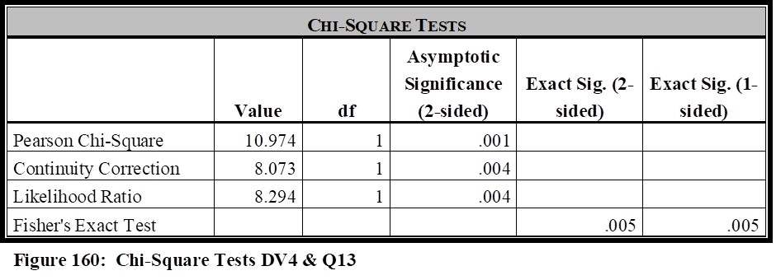
The correlation test revealed there was strong evidence of a relationship between these two variables (Pearson’s Chi-Square Value = 10.974; df = 1; p value of .001). The Fisher’s Exact Test had a significance score of .005, and the Phi Coefficient illustrated a moderate value of .312.
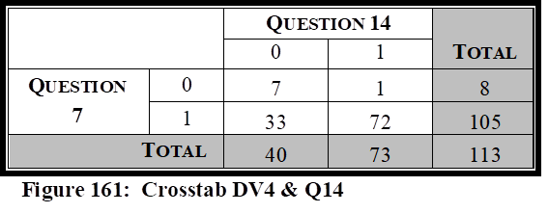
The sixth independent variable tested against Question 7, was Question 14, “My agency is prepared in terms of equipment needed and required to handle a myriad of contingencies that could be faced in our region (natural disasters, industrial or transportation related accidents, terrorist/major criminal events).” It is important to measure the relationship between the respondent’s attitude regarding their agency’s ability to respond to regional contingencies, and the relationship to whether their agency has received, or possesses the equipment needed to handle a myriad of contingencies that their agency could face within the region.
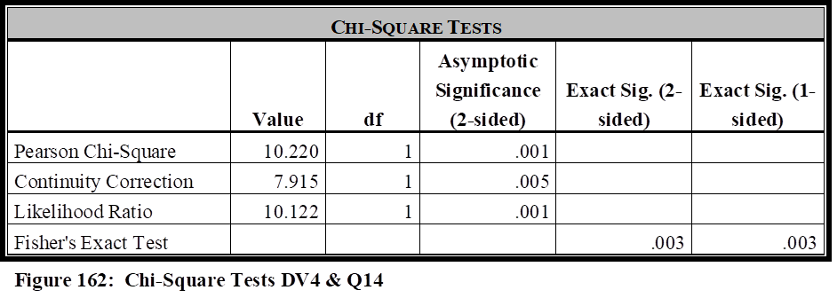
The correlation test revealed there was strong evidence of a relationship between these two variables (Pearson’s Chi-Square Value = 10.220; df = 1; p value of .001). The Fisher’s Exact Test had a significance score of .003, and the Phi Coefficient illustrated a moderate strength value of .301.
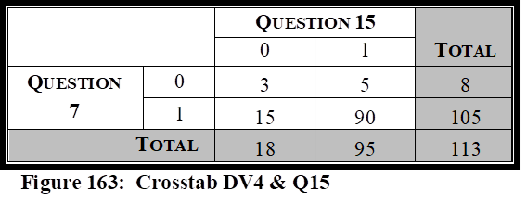
The seventh independent variable tested against Question 7, was Question 15, “My agency is considered a NIMS partner by local agencies in regards to emergency response and mitigation.” It is important to measure the relationship between the respondent’s attitude regarding their agency’s ability to respond to regional contingencies, and the relationship to whether their agency is considered a regional NIMS partner.
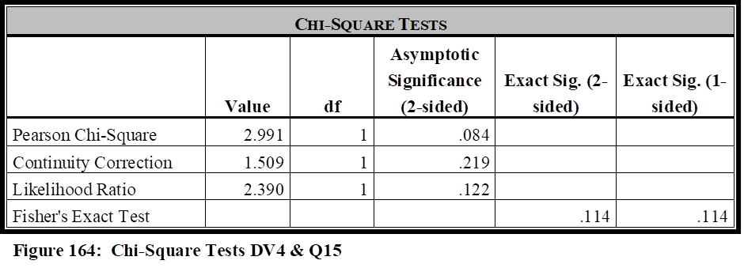
The correlation test revealed there was no evidence of a relationship between these two variables (Pearson’s Chi-Square Value = 2.991; df = 1; p value of .084). The Fisher’s Exact Test had a significance score of .114, and the Phi Coefficient illustrated a negligible value of .163.
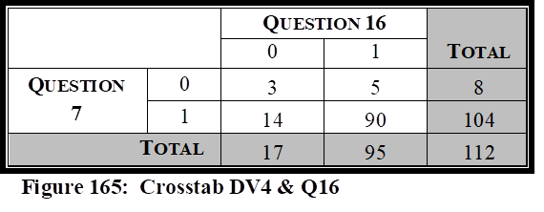
The eighth independent variable tested against Question 7, was Question 16, “Collaboration efforts are satisfactory between my agency and the regional police, fire, rescue, and emergency management agencies It is important to measure the relationship between the respondent’s attitude regarding their agency’s ability to respond to regional contingencies, and whether collaboration efforts are satisfactory between their agency and the regional first responders.
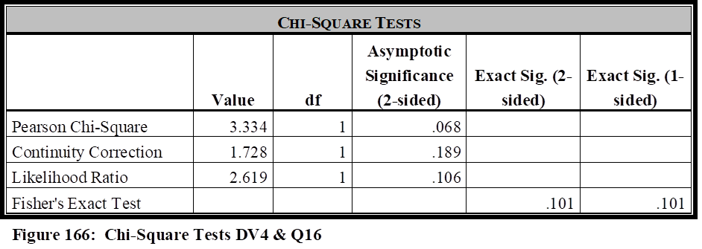
The correlation test revealed there was no evidence of a relationship between these two variables (Pearson’s Chi-Square Value = 3.334; df = 1; p value of .068). The Fisher’s Exact Test had a significance score of .101, and the Phi Coefficient illustrated a negligible value of .173.
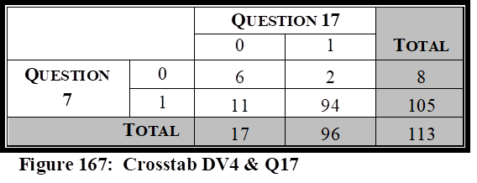
The ninth independent variable tested against Question 7, was Question 17, “My agency has been included within the region’s Emergency Response Plan (or similar nomenclature), for the purpose of providing public transportation support during the response, mitigation, and/or crisis management, of potential emergencies faced by our local area.” It is important to measure the relationship between the respondent’s attitude regarding their agency’s ability to respond to regional contingencies, and whether their agency has been in included in regional mandates that delineates their role during a critical incident.
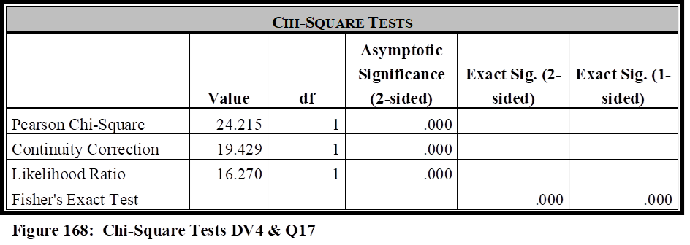
The correlation test revealed there was a strong evidence of a relationship between these two variables (Pearson’s Chi-Square Value = 24.215; df = 1; p value of .000). The Fisher’s Exact Test had a significance score of .000, and the Phi Coefficient illustrated a strong positive relationship value of .463.
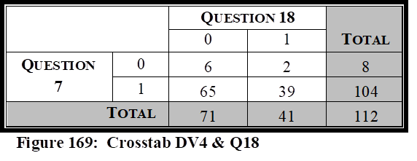
The tenth independent variable tested against Question 7, was Question 18, “My agency has received a satisfactory level of funding, whether from local, State or Federal agencies, in regards to overall preparedness as it pertains to NIMS mandates.” It is important to measure the relationship between the respondent’s attitude regarding their agency’s ability to respond to regional contingencies, and whether their agency has received the funding needed in regards to NIMS mandates.
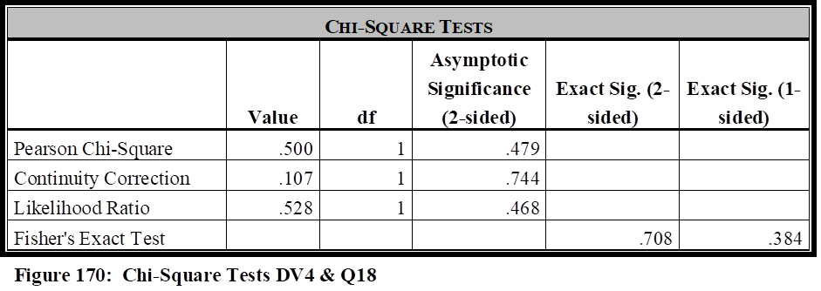
The correlation test revealed there was no evidence of a relationship between these two variables (Pearson’s Chi-Square Value = .500; df = 1; p value of .479). The Fisher’s Exact Test
had a significance score of .708, and the Phi Coefficient illustrated a negligible strength value of .067.
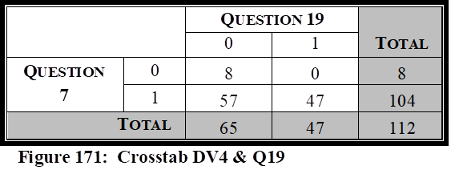
The eleventh independent variable tested against Question 7, was Question 19, “My agency has been proactively instrumental since HSPD-5 implementation in seeking funding sources to fully prepare our agency as it pertains to NIMS mandates.” It is important to measure the relationship between the respondent’s attitude regarding their agency’s ability to respond to regional contingencies, and whether their agency has proactively sought funding sources to assist in their preparation efforts as it pertains to NIMS mandates.
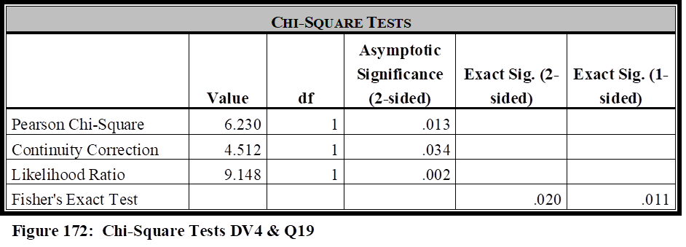
The correlation test revealed there was strong evidence of a relationship between these two variables (Pearson’s Chi-Square Value = 6.230; df = 1; p value of .013. The Fisher’s Exact Test had a significance score of .020, and the Phi Coefficient illustrated a weak strength value of .236.
Analysis of Dependent Variable 4 (Question 7)
Looking back at the hypothesis and literature review for this study, it is argued that public transportation agencies must have the funding, collaboration, equipment, training, written guidance, and be involved as exercise participants, to be fully prepared to meet the myriad of critical incidents they may face in today’s environment. The hypothesis is that public transportation agencies, per the attitudes of public transportation managers, are not given this level of support across the country. Question 7 of the survey measures whether agency managers perceive their agencies are prepared to assist with regional contingencies as requested by local first responders. A very high 71% of the agencies surveyed agreed/strongly agreed with survey Question 7 in regards to their readiness to respond to regional contingencies as requested by local first responders.
Due to the close relationship of Question 8 and Question 17, with both being related to the agency having written mandates and directives, these two independent variables will be analyzed together with Question 7 in how they correlate with agency readiness levels regarding regional emergencies. Question 7 showed a strong correlation with Question 8 as it pertains to written mandates, as it also did with Question 17, which specifically identifies their inclusion in regional Emergency Response Plans.
Question 7 fails to show a statistical significance with Questions 10 or Question 18, but does with Question 19, each of which are related to funding, and will be analyzed together to determine how funding has impacted the agency’s readiness levels to handle regional contingencies when requested. 61% of survey respondents disagreed/strongly disagreed that they have received the funding needed in their overall preparedness levels (Question 10), while 63% disagreed/strongly disagreed that they had received a satisfactory level of funding as it pertains to NIMS mandates. Question 19 specifically pertains to whether the agencies have been proactive in seeking funding. There has been strong correlation between these three independent variables and the previously listed dependent variables, but not with the dependent variable covered by Question 7. Statistics suggest that, in the opinions of transit managers, funding is directly correlated with their abilities to handle terrorist incidents, natural disasters and industrial accidents common to the agency, and their overall preparedness, but there is no correlation between funding and their ability to assist local first responders with regional contingencies. This is likely attributed to the fact that the agencies feel very confident in their abilities to assist with regional contingencies (71% agreeing to their ability to handle these events), despite the lack of funding they have received as indicated by the survey results.
Question 7 illustrated a statistical significance with both Question 12 and Question 13. Question 12 pertains to NIMS training of personnel within the agency who may be required to participate in a NIMS related crisis, and Question 13 pertains to being invited by outside local agencies to participate in a variety of drills or tabletop exercises to prepare for a variety of critical incidents, to prepare for real-world events. Public Transportation managers have thus indicated that members of their agency being NIMS trained, and their ability to participate in regional exercises, certainly impacts their ability to respond and assist with regional contingencies when requested by local first responders.
Question 7 shows strong statistical significance with Question 14 in regards to the equipment needed and required to handle a critical incident which their agencies may face within the region. Public transportation managers have thus indicated that having equipment on hand, to handle regional contingencies, is important in their readiness level to assist their local first responders when they receive those requests.
Question 7 was not statistically significant with either Question 15, which asked whether the agency was considered a NIMS partner by local agencies, or Question 16, which asked if collaboration efforts were satisfactory between their agencies and local first responders. 84% of the agencies agreed/strongly agreed they were viewed as a NIMS partner (Question 15), and 84% of the agencies also agreed/strongly agreed that collaboration efforts were satisfactory between their agencies and local first responders. It would seem the high numbers of agencies agreeing in each of these categories would illustrate a strong correlation. However, it might be better described in the qualitative section that the agencies feel confident in providing services requested by local first responders, regardless whether or not they are considered a NIMS partner.
Question 7 was statistically significant with Question 9, in terms of overall assistance and the impact it plays on overall preparedness levels for regional contingency response. This category was saved for last in the Question 7 analysis, as it will in each of the other dependent variable sections, because it analyzes the attitude of the respondents in regards to the overall assistance they have received to reach appropriate readiness levels for NIMS and critical incident mitigation. Public transportation managers indicate from the survey responses that there is a correlation between the overall assistance they receive and their ability to assist with regional contingencies when requested.
Dependent Variable 5 (Survey Question 11)
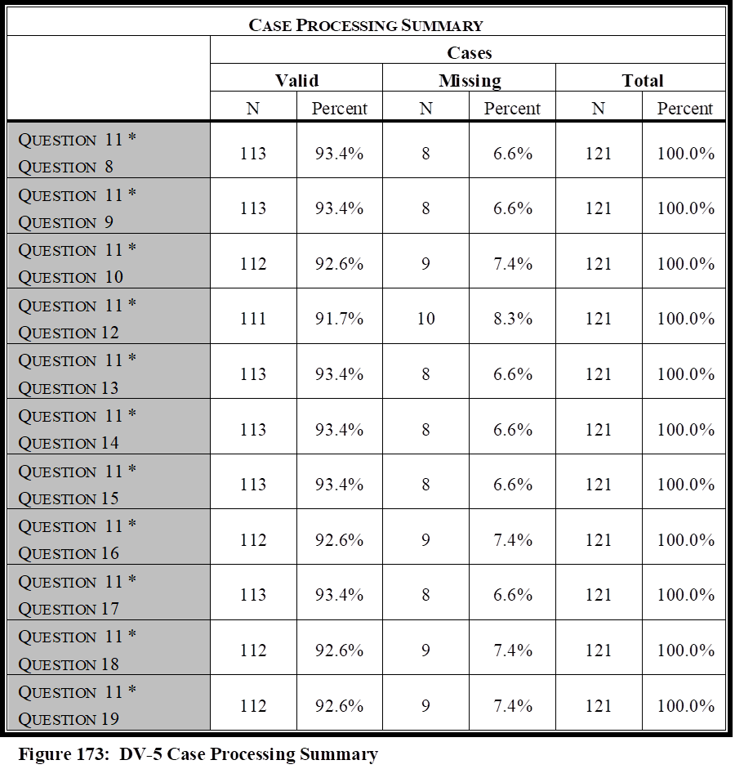
The survey question “I am satisfied with my agency’s preparedness level to handle the wide array of emergency contingencies that potentially exist” is important to determine if public transportation agencies feel prepared to handle the wide array of emergency contingencies that potentially exist, including all of the dependent variables already discussed. The previous dependent variables were meant to be subcategories of this overall question. This question would include the agency’s ability to handle terrorist events, natural disasters, industrial and transportation related accidents, regional emergencies, etc. This question differs from Question 4 in that this one measures the agency’s ability to handle all contingencies in general, whereas Question 4 only measured the attitude toward improvement since the implementation of HSPD-5. This question measures the agency manager’s attitude toward overall preparedness to handle any incident that that agency may face. Pearson Chi-Square, Fisher’s Exact Test, and Phi Coefficient, were completed for this question against all 11 independent variables. The Case Processing Summary is listed in Figure 173.
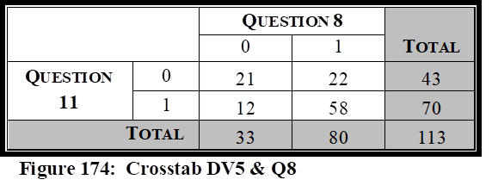
The first independent variable tested against Question 11, was Question 8, “Written plans exist that mandate and describe the mitigation efforts my agency must take in regional level contingencies.” It is important to measure the relationship between the respondent’s attitude regarding their agency’s ability to handle the wide array of emergency contingencies that the agency could potentially experience, and whether written plans exist that describe their agency’s role in these mitigation strategies.
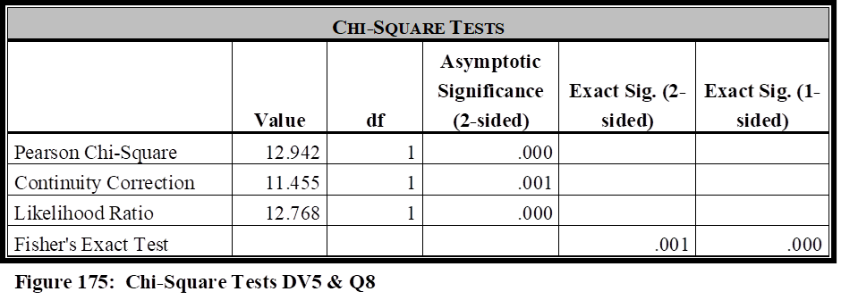
The correlation test revealed there was strong evidence of a relationship between these two variables (Pearson’s Chi-Square Value = 12.942; df = 1; p value of .000). The Fisher’s Exact Test showed a significance score of .001, and the Phi Coefficient illustrated a moderate value of .338.
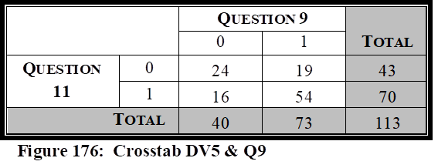
The second independent variable tested against Question 11, was Question 9, “My agency has received the assistance needed from local, state, and federal agencies in our overall preparedness efforts.” It is important to measure the relationship between the respondent’s attitude regarding their agency’s ability to handle the wide array of emergency contingencies that the agency could potentially experience, to whether their agency has received the assistance needed in their overall preparedness efforts.
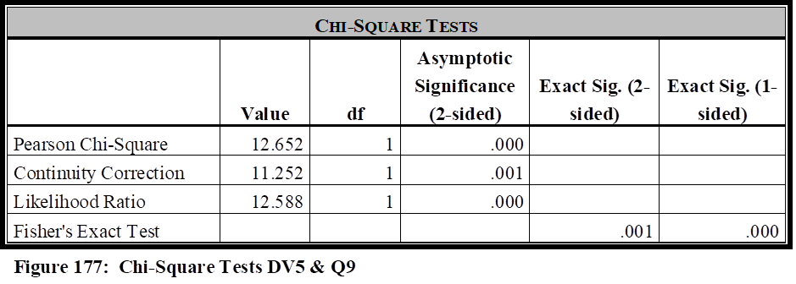
The correlation test revealed there was strong evidence of a relationship between these two variables (Pearson’s Chi-Square Value = 12.652; df = 1; p value of .000). The Fisher’s Exact Test had a significance score of .001, and the Phi Coefficient illustrated a moderate strength value of .335.
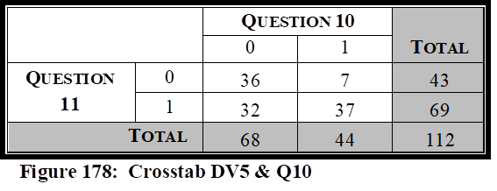
The third independent variable tested against Question 11, was Question 10, “My agency has received the funding needed from local, state, and federal agencies in our overall preparedness efforts.” It is important to measure the relationship between the respondent’s attitude regarding their agency’s ability to handle the wide array of emergency contingencies that the agency could potentially experience, to whether their agency has received the funding needed in their overall preparedness efforts.
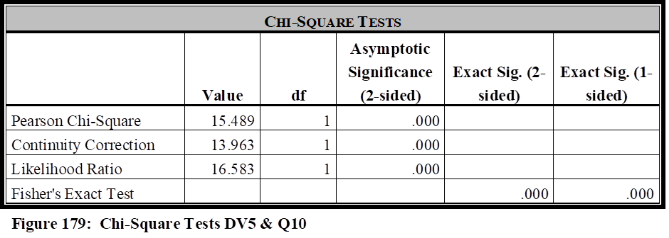
The correlation test revealed there was strong evidence of a relationship between these two variables (Pearson’s Chi-Square Value = 15.489; df = 1; p value of .000). The Fisher’s Exact Test had a significance score of .000, and the Phi Coefficient illustrated a moderate value of .372.
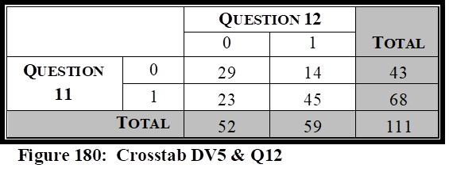
The fourth independent variable tested against Question 11, was Question 12, “Members of my agency, who may be required to be NIMS participants during the mitigation of a natural disaster, industrial/transportation related accident, or serious criminal/ terrorist event, have received the appropriate levels of NIMS training as outlined within the NIMS Training Program.” It is important to measure the relationship between the respondent’s attitude regarding their agency’s ability to handle the wide array of emergency contingencies that the agency could potentially experience, to whether members of their agency, who may be required to be NIMS participants during a critical incident, have received the appropriate levels of NIMS training.
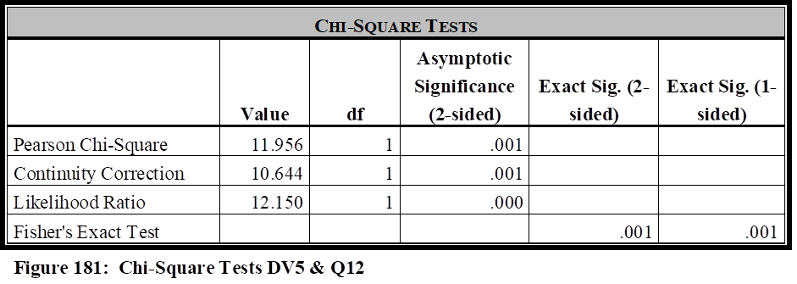
The correlation test revealed there was strong evidence of a relationship between these two variables (Pearson’s Chi-Square Value = 11.956; df = 1; p value of .001). The Fisher’s Exact Test had a significance score of .001, and the Phi Coefficient illustrated a moderate value of .328.
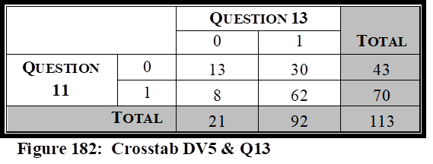
The fifth independent variable tested against Question 11, was Question 13, “My agency has conducted and/or been invited by outside local agencies to participate in various operational and/or table top exercises, such as drills, functional exercises, and full-scale exercises, to train and prepare personnel both within and outside our agency, in regards to incident command structures, to ensure well-coordinated and structured responses in real-world events.” It is important to measure the relationship between the respondent’s attitude regarding their agency’s ability to handle the wide array of emergency contingencies that the agency could potentially experience, to whether their agency has been invited and/or participated in table top and/or real world exercises, to better prepare them for real-world events.
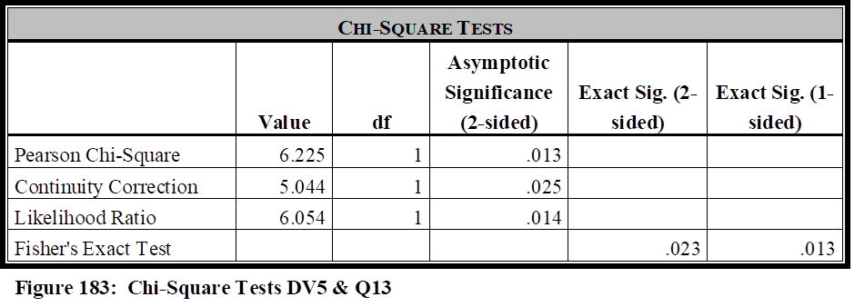
The correlation test revealed there was evidence of a relationship between these two variables (Pearson’s Chi-Square Value = 6.225; df = 1; p value of .013). The Fisher’s Exact Test had a significance score of .023, and the Phi Coefficient illustrated a weak value of .235.
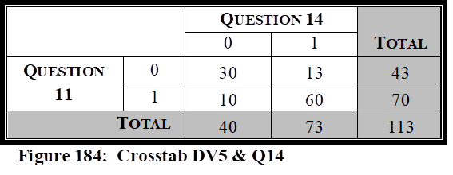
The sixth independent variable tested against Question 11, was Question 14, “My agency is prepared in terms of equipment needed and required to handle a myriad of contingencies that could be faced in our region (natural disasters, industrial or transportation related accidents, terrorist/major criminal events).” It is important to measure the relationship between the respondent’s attitude regarding their agency’s ability to handle the wide array of emergency contingencies that the agency could potentially experience, to whether their agency has received, or possesses the equipment needed to handle a myriad of contingencies that their agency could face within the region.
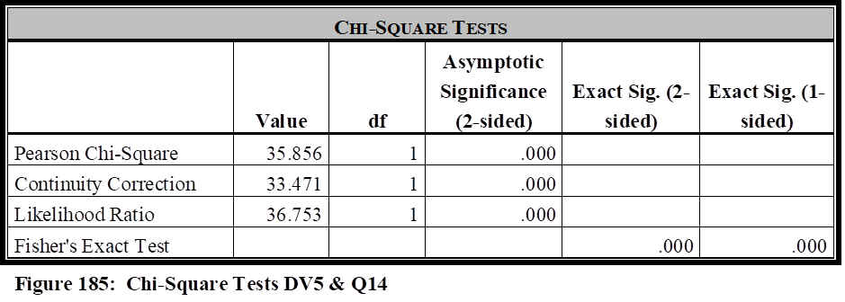
The correlation test revealed there was strong evidence of a relationship between these two variables (Pearson’s Chi-Square Value = 35.856; df = 1; p value of .000). The Fisher’s Exact Test had a significance score of .000, and the Phi Coefficient illustrated a strong positive relationship of .563.
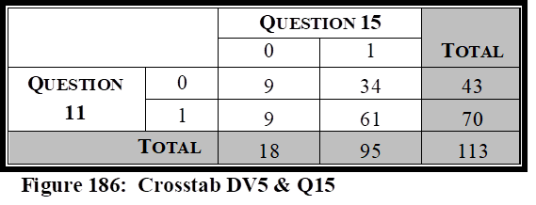
The seventh independent variable tested against Question 11, was Question 15, “My agency is considered a NIMS partner by local agencies in regards to emergency response and mitigation.” It is important to measure the relationship between the respondent’s attitude regarding their agency’s ability to handle the wide array of emergency contingencies that the agency could potentially experience, to whether their agency is considered a regional NIMS partner.
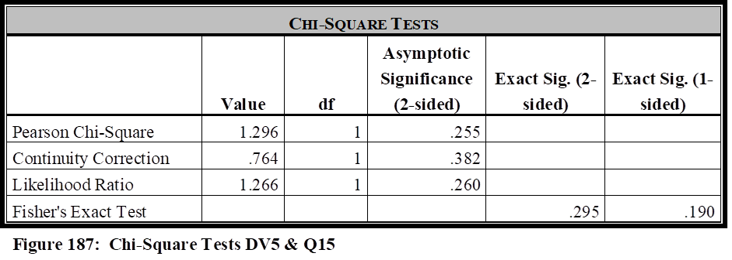
The correlation test revealed there was no evidence of a relationship between these two variables (Pearson’s Chi-Square Value = 1.296; df = 1; p value of .255). The Fisher’s Exact Test had a significance score of .295, and the Phi Coefficient illustrated a negligible value of .107.
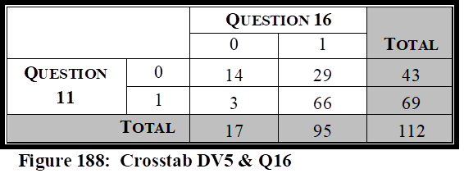
The eighth independent variable tested against Question 11, was Question 16, “Collaboration efforts are satisfactory between my agency and the regional police, fire, rescue, and emergency management agencies.” It is important to measure the relationship between the respondent’s attitude regarding their agency’s ability to handle the wide array of emergency contingencies that the agency could potentially experience, to whether collaboration efforts are satisfactory between their agency and the regional first responders.
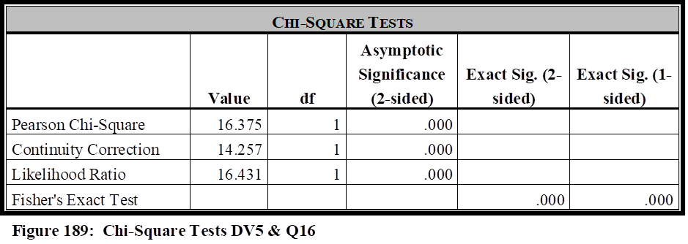
The correlation test revealed there was strong evidence of a relationship between these two variables (Pearson’s Chi-Square Value = 16.375; df = 1; p value of .000). The Fisher’s Exact Test had a significance score of .000, and the Phi Coefficient illustrated a value of .382.
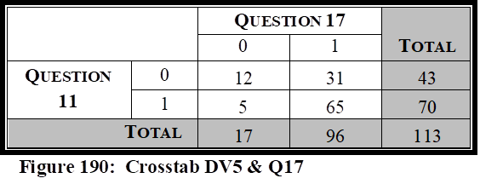
The ninth independent variable tested against Question 11, was Question 17, “My agency has been included within the region’s Emergency Response Plan (or similar nomenclature), for the purpose of providing public transportation support during the response, mitigation, and/or crisis management, of potential emergencies faced by our local area.” It is important to measure the relationship between the respondent’s attitude regarding their agency’s ability to handle the wide array of emergency contingencies that the agency could potentially experience, to whether their agency has been in included in regional mandates that delineates their role during a critical incident.
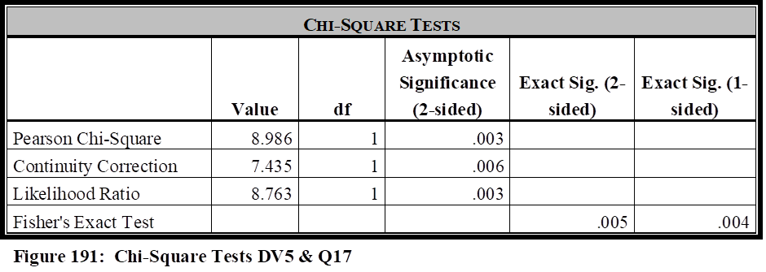
The correlation test revealed there was evidence of a relationship between these two variables (Pearson’s Chi-Square Value = 8.986; df = 1; p value of .003). The Fisher’s Exact Test had a significance score of .005, and the Phi Coefficient illustrated a moderate value of .282.
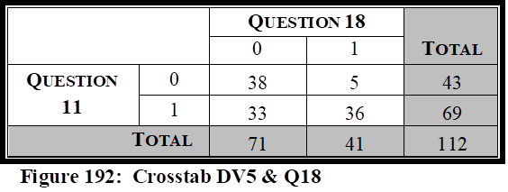
The tenth independent variable tested against Question 11, was Question 18, “My agency has received a satisfactory level of funding, whether from local, State or Federal agencies, in regards to overall preparedness as it pertains to NIMS mandates.” It is important to measure the relationship between the respondent’s attitude regarding their agency’s ability to handle the wide array of emergency contingencies that the agency could potentially experience, to whether their agency has received the funding needed in regards to NIM
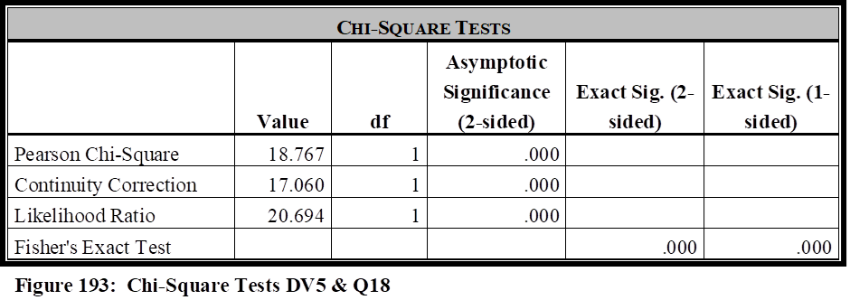
The correlation test revealed there was strong evidence of a relationship between these two variables (Pearson’s Chi-Square Value = 18.767; df = 1; p value of .000). The Fisher’s Exact Test had a significance score of .000, and the Phi Coefficient illustrated a strong positive relationship value of .409.
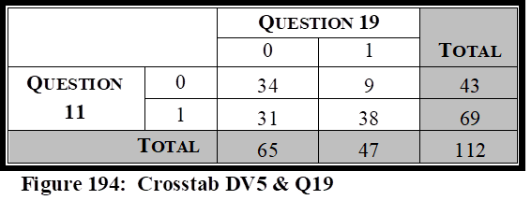
The eleventh independent variable tested against Question 11, was Question 19, “My agency has been proactively instrumental since HSPD-5 implementation in seeking funding sources to fully prepare our agency as it pertains to NIMS mandates.” It is important to measure the relationship between the respondent’s attitude regarding their agency’s ability to handle the wide array of emergency contingencies that the agency could potentially experience, to whether their agency has proactively sought funding sources to assist in their preparation efforts as it pertains to NIMS mandates.
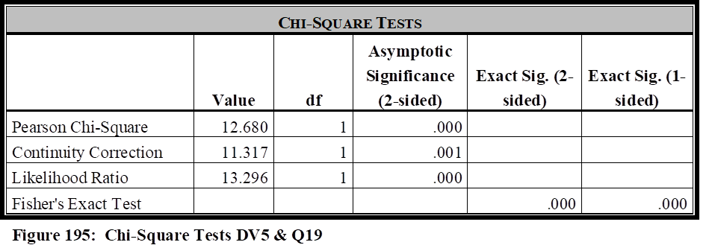
The correlation test revealed there was strong evidence of a relationship between these two variables (Pearson’s Chi-Square Value = 12.680; df = 1; p value of .000. The Fisher’s Exact Test had a significance score of .000, and the Phi Coefficient illustrated a moderate value of .336.

Analysis of Dependent Variable 4 (Question 11)
Looking back at the hypothesis and literature review for this study, it is argued that public transportation agencies must have the funding, collaboration, equipment, training, written guidance, and be involved as exercise participants, to be fully prepared to meet the myriad of critical incidents they may face in today’s environment. The hypothesis is that public transportation agencies, per the attitudes of public transportation managers, are not given this level of support across the country and industry. Question 11 of the survey measures whether public transportation agency managers perceive their agencies are prepared to handle the wide array of contingencies that their agency may face on any given day. This would include transportation related accidents, industrial accidents, natural disasters, acts of terrorism, major criminal activity, critical incidents within the region in which they may be requested to provide assistance, mass casualty mitigation of any realistic form, or any other type of similar crisis. As illustrated in the literature review, public transportation agencies have historically assisted with a wide array of critical incidents, and any agency could be called upon to respond and provide a high level of assistance with great importance. 38% of the agencies surveyed disagreed/strongly disagreed with survey Question 11 in regards to their readiness to respond to this wide array of potential emergency situations.
Due to the close relationship of Question 8 and Question 17, with both being related to the agency having written mandates and directives, these two independent variables will be analyzed together with Question 11 in how they correlate with this level of overall agency readiness. Question 11 showed a strong correlation with both Question 8 and Question 17 as it pertains to written mandates, and the agency’s inclusion in regional Emergency Response Plans. This illustrates a strong correlation, in the attitude of transit managers surveyed, between the readiness of their agency and the formulation of written mandates that include the roles and responsibilities of their agency.
Question 11 shows a very strong correlation with Question 10, Question 18, and Question 19, all of which are related to funding. These are being analyzed together to determine how funding has impacted the agency’s overall readiness levels to meet a wide array of emergency events. The results of the survey and statistical tests has illustrated that public transportation managers perceive funding has a strong correlation to their preparedness and ability to respond to a wide array of emergency situations. The issues here include that more than 60% do not perceive they have been appropriately funded, but nearly 60% have not sought funding either since the implementation of HSPD-5.
Question 11 illustrated statistical significance with both Question 12 and Question 13. Question 12 pertains to NIMS training of personnel within the agency who may be required to participate in a NIMS related crisis, and Question 13 pertains to being invited by outside local agencies to participate in a variety of drills or tabletop exercises to prepare for a variety of critical incidents, to prepare for real-world events. Public Transportation managers have thus indicated that members of their agency being NIMS trained, and their ability to participate in regional exercises, certainly impacts their ability to respond and assist with the wide array of incidents they may be tasked to mitigate or provide assistance.
Question 11 shows a very strong statistical significance with Question 14 in regards to the equipment needed and required to handle a wide array of critical incidents. Public transportation managers have thus indicated that having the appropriate type and level of equipment on hand, to handle the wide array of emergency situations in which they may be faced, is important in their overall readiness level.
Question 11 was not statistically significant with either Question 15, which asked whether the agency was considered a NIMS partner by local agencies, but showed strong correlation to Question 16, which asked if collaboration efforts were satisfactory between their agencies and local first responders. Public transportation managers apparently do not perceive it is of importance to be considered a NIMS partner, but feel collaboration with outside agencies is of importance in maintaining their ability to mitigate or assist in the mitigation of various emergency situations.
Question 11 was statistically significant with Question 9, in terms of overall assistance and the impact it plays on overall preparedness in responding to the wide array of emergencies in which the agency may face, or in which they may be requested to assist. This category was saved for last in the Question 11 analysis, as it has been in each of the other dependent variable sections, because it analyzes the attitude of the respondents in regards to the overall assistance they have received to reach appropriate readiness levels for NIMS and critical incident mitigation. Public transportation managers indicate from the survey responses that there is a strong correlation between the overall assistance they receive and their overall abilities.
Summary of Quantitative Findings
The research was a multi-faceted approach to study different variables to measure the readiness of a public transportation agency, and determine which independent variables impacted that readiness in the opinions and attitudes of public transportation managers.
The hypothesis of this research is that it is the attitudes and opinions of public transportation managers that their respective agencies have not been appropriately included and funded as a recognized element within HSPD-5. Appropriately funded in this research is defined as how well the agency has been funded to fully prepare for and be active participants in an Incident Command Structure to respond to, prepare for, and assist with the mitigation of a myriad of emergency situations that could arise in today’s environment. Funding would include the funds needed for training and equipment to participate in real world events and exercises. Appropriately included is defined as how well other agencies, such as law enforcement, fire & rescue, public health, emergency management, and other agencies, collaborate with public transit and how well they are included within emergency plans, mandates, procedures, training, and exercises.
There are five separate dependent variables involved in this research, to measure the components described in the hypothesis, each measured against eleven different independent variables. An analysis of each of the five dependent variables, measured against the eleven independent variables, was briefly described in each of their respective quantitative analysis sections. This section will summarize and analyze all five dependent variables together with each of the independent variables. The five dependent variables include the following:
- Dependent Variable 1 (DV1) - Agency preparedness since the implementation of HSPD5 (Survey Question 4)
- Dependent Variable 2 (DV2) - Agency preparedness for natural disasters and industrial/transportation related accidents (Survey Question 5)
- Dependent Variable 3 (DV3) - Agency preparedness to respond and mitigate terrorism related events (Survey Question 6
- Dependent Variable 4 (DV4) - Agency preparedness to assist with regional contingencies when requested by local first responders (Survey Question 7)
- Dependent Variable 5 (DV5) - Agency preparedness to respond to a wide array of contingencies that potentially exist (Survey Question 11)
Each of the five dependent variables was measured against each of the following eleven independent variables:
- Independent Variable 1 (IV1) - The existence of written mandates outlining the agency’s roles and responsibilities in a critical incident (Survey Question 8)
- Independent Variable 2 (IV2) - Overall assistance received for preparedness (Survey Question 9)
- Independent Variable 3 (IV3) - Funding for overall preparedness (Survey Question 10)
- Independent Variable 4 (IV4) - Completion of NIMS training for agency personnel (Survey Question 12)
- Independent Variable 5 (IV5) - Inclusion in tabletop and/or operational exercises (Survey Question 13)
- Independent Variable 6 (IV6) - Equipment needed to mitigate or assist in the mitigation of emergency situations (Survey Question 14)
- Independent Variable 7 (IV7) - Considered a NIMS partner by outside agencies (Survey Question 15)
- Independent Variable 8 (IV8) - Collaboration efforts with outside agencies (Survey Question 16)
- Independent Variable 9 (IV9) - Inclusion in regional emergency response plans (Survey Question 17)
- Independent Variable 10 (IV10) - Funding to meet NIMS mandates (Survey Question 18)
- Independent Variable 11 (IV11) - Has the agency proactively sought funding (Survey Question 19)
Written Mandates & Guidelines
IV1 & IV9 are being analyzed together with the dependent variables due to their relationship regarding written mandates. IV1 has correlation with all the dependent variables with the exception of DV1. IV9 has correlation with all the dependent variables with the exception of DV1 and DV3. Overall, the research would suggest that written mandates that includes and delineates an agency’s roles and responsibilities during an emergency situation, are considered by public transportation managers as important to an agency’s preparation to respond to and assist in the mitigation of a wide variety of emergency situations. It is likely that there was no correlation between DV3 and IV9 due to the agencies high percentage opinion that they were not prepared for an act of terrorism, but were in fact included in regional emergency response plans.
Considering the correlations in this category, it is important to analyze which agencies do not perceive they have written mandates that delineate these roles. There were 25 bus agencies (7 small, 5 medium, 13 large) from each of the five geographical areas that disagree, and 8 Rail and Multi-Modal agencies (2 small, 3 medium, 1 large, and 1 metro) from the southeast, northeast, and west, who disagree with IV1. There were 15 bus agencies (4 small, 4 medium, 7 large) from the Midwest, southeast, southwest, and mid-west, that disagree, and only 2 rail and multi-modal agencies (both small) from the southeast, that disagree with IV9.
Contemplating the fact that there are FTA mandates in place for rail and multimodal agencies regarding written guidelines and plans, as illustrated in the literature review, it is surprising there are agencies who disagreed with these two questions. This might suggest either that the respondents did not fully understand the question, they are not fully knowledgeable, or that they answered truthfully but are not in full compliance with FTA guidance. Revisiting the correlation results between DV5 and both IV1 and IV9, both of which had a result of p < .05, and the totality and consideration of all the results for IV1 and IV9, The study suggests that written mandates are in fact important to the preparation level of transit agencies, and the overall preparation of transit agencies.
Funding
IV3, IV10 and IV11 were all analyzed together with each of the dependent variables due to their association overall with funding. There was correlation between all dependent and independent variables regarding funding except the relationship between IV3 and IV10 to DV4, in which there was not statistical significance. This can possibly be explained that the agencies have a very high agreement response to DV4 in their preparedness level to respond to regional contingencies when requested, in spite of their disagreement to being satisfactorily funded. However, overall the agencies perceive funding does negatively impact their preparedness level when analyzing DV5 with each of these independent variables.
Reviewing the descriptive analysis for these three funding questions, it is illustrated that 49 bus agencies (7 small, 4 medium, 17 large, and 4 metro), from all geographical areas, disagree with IV3, whereas 18 rail and multi-modal agencies disagree (3 small, 4 medium, 3 large, 7 metro), from all geographical areas. Very similar numbers are illustrated for IV10 and IV11. This illustrates that the funding issues seem to be common in each geographical area, among each size and modal agency.
Considering the above information, and the relationship between DV5 and each of the independent variables regarding funding, in which the correlation in each of those relationships has a value of p < .05, the research suggests that agency managers perceive funding is vital to their success in preparing, responding, and assisting in the mitigation of a wide array of responses. The only exception to this would be in those circumstances regarding the assistance with regional contingencies when requested by local first responders.
Two thoughts can be illustrated from the funding category. First, the fact that the majority of agencies, from all categories within the survey, perceive they are underfunded is concerning. Second, however, is the fact that almost the same percentages of agencies disagree that they have actually sought funding to assist them in these preparation efforts. More effort is arguably needed in both of these areas to ensure our public transportation agencies are funded to a satisfactory level, to ensure they are fully prepared to respond and assist in the mitigation of emergencies that society expects.
Training
IV4 and IV5, which is related to NIMS training of agency personnel, and the inclusion in table top and operational exercises by local first responders, correlates with most of the dependent variables. The only dependent variables which did not illustrate a statistical significance, was the relationship between DV1 and IV5, and DV3 and IV5. In each case, transit agency managers have indicated that NIMS training is important for their agency personnel in regards to being prepared for a wide array of emergency situations. They have also illustrated correlation between table top/operational exercises and readiness, with the exception of terrorism events. This is likely due to the survey results that most have been invited to table top and operational exercises, but the majority does not perceive they are ready in terms of helping mitigate a terrorist incident. The relationship between DV1 and IV5 simply illustrates that the agencies do not perceive any more prepared now than before the implementation of HSPD-5.
Reviewing the descriptive statistics, bus agencies at the small, medium and large levels, from each of the geographical areas, require improvement in terms of IV4. Also, surprisingly, multi-modal agencies also require improvement, primarily at the metro level, in terms of personnel needing NIMS training. Reviewing the results of the correlation study, especially the results of DV5 in this training category, reveals that transit managers have indicated a correlation between NIMS training and table top/operational exercises and their overall preparedness level.
Equipment
IV6, which involves the equipment needed to mitigate and assist in the mitigation of various emergencies, has illustrated a strong statistical significance with all five dependent variables. However, 36% of the agencies surveyed disagreed that they are prepared in terms of equipment needed and required to handle a myriad of contingencies that they could face. Considering the nature of the dependent variables, these agencies feel ill-prepared in terms of terrorism events, natural disasters, industrial and transportation related accidents, regional contingencies, and any other type of major incident. Bus agencies account for 29 of the agencies that disagree, from each size and geographical area, and multi-modal and rail account for 11 such agencies, also representing each geographical area and size.
Based on the results of this collaboration study, transit managers have indicated that equipment plays a vital role in their preparedness levels. The lack of funding discussed earlier may be having a negative impact on this category; however, an effort must be made to see where and why the shortfalls exist, and action taken to ensure the public transportation agencies are appropriately equipped to handle the events that they reasonably could face.
Collaboration
IV7 and IV8, which is related to collaboration and being considered a NIMS partner, only illustrated correlation with one dependent variable. All of the dependent variables failed to show correlation with IV7 (NIMS Partner), and only DV5 illustrated correlation with IV8. Transit managers indicated no correlation with collaboration in regards to terrorism, regional response, and accident mitigation individually, but did indicate correlation with overall preparedness. It should be noted, however, that 84-85% of the agencies felt they had good collaboration with outside agencies, and that they were in fact considered a NIMS partner by outside agencies.
Overall Assistance
IV2, which is related to the overall assistance received by agencies, had statistical significance with each of the dependent variables except DV3. Notable is the fact that there is correlation between DV5 and IV2, which suggests that the overall assistance received by transit agencies does in fact impact their overall readiness. The lack of correlation between DV3 and IV2 might be impacted by the fact that 65% of the agencies agree they have received the assistance needed, but 42% of the agencies disagree that they are prepared to handle a terrorist event; therefore, they are ill-prepared to handle an event such as this, regardless of the satisfactory level of assistance they’ve received.
Agencies that disagreed with the level of assistance received included 29 bus agencies, representing each size group and geographical area, and 10 rail and multi-modal agencies also spread somewhat equally among size and geography. Noteworthy from descriptive statistics is that there were 4 metro size multi-modal agencies that disagreed with this statement, from the northeast, southeast and west.
Size & Geography
This study was designed to review the relationships between the independent and dependent variables regarding readiness and to evaluate whether there was correlation between size, modal and geography of agencies with each of the variables. Interesting facts have been collected from the survey and corresponding quantitative analysis, but one hypothesis of this study is that agencies have not been funded and included equally across the country in all categorical sizes, modals, and geographical areas. Therefore, a Pearson Chi-Square analysis was conducted between all variables with agency size, geographical location of the agency, and the transportation modal of the agencies surveyed.
The correlation study between each of the variables and the demographic categories revealed that in many of the cases, there failed to be a correlation. The correlation value of p > .05 was found in most of the cases, whether in regards to size, geographical location, or transportation modal type, as analyzed with each of the variables in the study. Due to the correlation value of p > .05, the null cannot be rejected in most instances. The results from this Pearson Chi-Square analysis are included below.
Question 1: Agency Mode of Service:
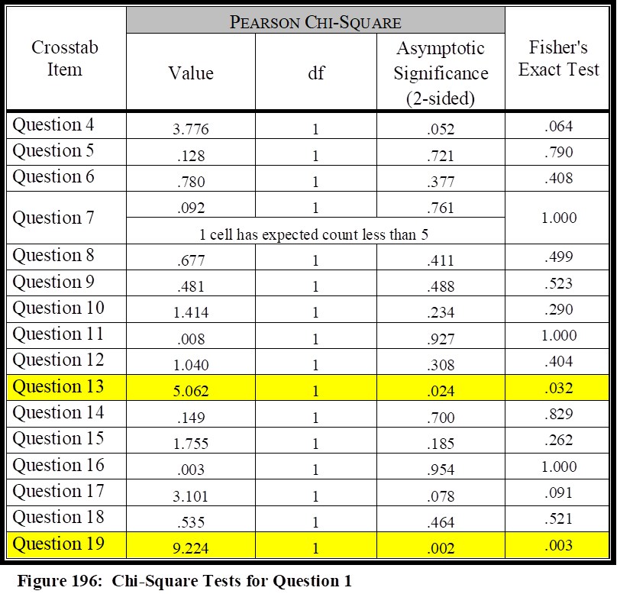
It was discovered during this analysis that the data in Question 1 had to be re-coded into a 2x2 format similar to each of the crosstab questions. Survey responses revealed that every question from the survey had responses of less than 5 in at least one category, which violates the assumption in Chi-Square tests that each category will have an expected count of at least 5. Due to the need to recode the data, all Multi-Modal agencies were combined with Rail and coded as “1” while all Bus agencies remained coded as “2” in the SPSS table. Multi-Modal agencies are normally larger agencies (only 2% of the overall agencies in the study were small multi-modal), and since these agencies contain a Rail segment, it was natural to combine Multi-Modal with Rail.
Question 1, regarding agency mode of service, failed to illustrate significance with all but two of the other variables within the survey. Question 7, even by recoding the data, still violated the assumption in Chi-Square tests by having 1 cell (25%) with an expected count less than 5. Therefore, for Question 7, the Fisher’s Exact Test was used which still illustrated a p value more than .05. Question 1 (Mode of Agency) did illustrate significance with Question 13 and Question 19. This would suggest that agency mode of service does in fact correlate with the attitudes of transit managers to how well they have been invited to participate in exercises with local emergency responders, as well as how well agencies actively seek funding to assist them in their emergency response preparedness. Figure 196 illustrates the results of the Chi-Square tests between Question 1 and the other variables.
Question 2: Size of Agency
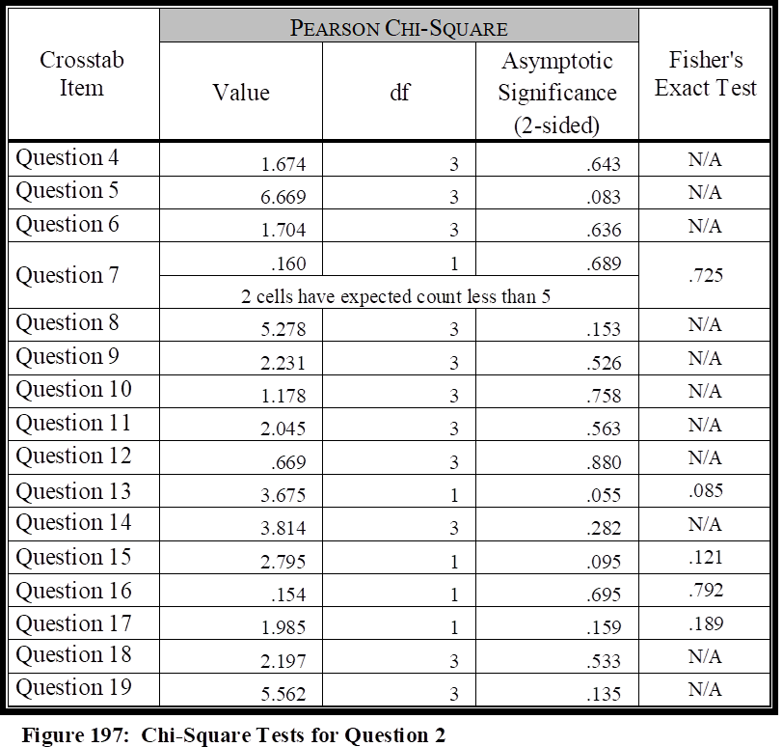
It was discovered during this analysis that some of the data in Question 2 had to be re-coded into a 2x2 format similar to each of the crosstab questions. Survey responses revealed that Questions 7, 13, 15, 16, and 17, had responses of less than 5 in at least one category, which violates the assumption in Chi-Square tests that each category will have an expected count of at least 5. These five questions were recoded to form a 2x2 and the Fisher’s Exact Test was added to the Pearson Chi-Square for these questions. Due to the need to recode the data for these five questions, all agencies with less than 1 Million were coded with a “1” while all agencies with 1 Million or more were coded with a “2” in the SPSS table. This resulted in almost an equal division of agencies in terms of agency size. Question 7 still violated the Chi-Squares assumption, therefore the Fisher’s Exact Test score was used for Question 7. The results of this analysis revealed that none of the variables within the survey illustrated significance with Question 2, size of agency; each of the crosstabs had a p value more than .05, whether by Pearson’s Chi-Square, or Fisher’s Exact Test for Question 7. This analysis suggests that there does not seem to be any correlation between the variables within the study and the actual size of the transportation agencies, when they are divided into the two groups as they were with the recoding into a 2x2 table. Figure 197 illustrates the results of the Chi-Square tests between Question 2 and the other variables.
Question 3: Geographical Area of Agency
It was discovered during this analysis that the data in Question 3 had to be re-coded into a 2x2 format similar to each of the crosstab questions. Survey responses revealed that every question from the survey had responses of less than 5 in at least one category, which violates the assumption in Chi-Square tests that each category will have an expected count of at least 5.
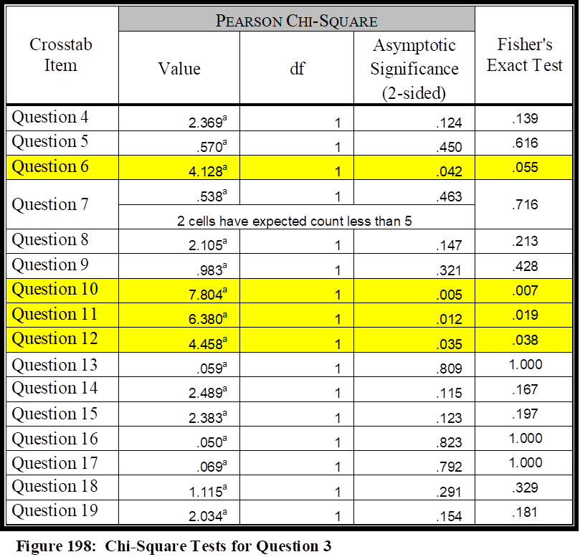
Due to the need to recode the data, agencies were divided by East and West, combining all agencies in the West, Southwest, and Midwest into one category, while Southeast and Northeast agencies were placed into another category. The West agencies were coded as “1” while East agencies were coded as “2” SPSS table. This resulted in an equal division of agencies in terms of agency geography.
Figure 198 illustrates the results of the Chi-Square tests between Question 3 and the other variables. Results of the Chi-Square tests reveal that no significance was illustrated between Question 3 and 12 of the variables, however, there was a significance illustrated between Question 3 and Questions 6, 10, 11, and 12.
The Pearson’s Chi-Square test illustrated significance between Question 3 (agency geography) and Question 6, whether agency managers felt their agencies were prepared to handle a terrorist attack in today’s environment. This question resulted in 43% of all agencies saying they either disagreed or strongly disagreed with this question, with 25% of the agencies being from the recoded West (Midwest, West, Southwest) and 16% of the agencies being from the recoded East (Southeast, Northeast). This would suggest there is some discrepancy in the attitudes of managers from a geographic standpoint in regards to preparedness to handle a terrorist event.
The Pearson’s Chi-Square test illustrated significance between Question 3 (agency geography) and Question 10, whether agency managers felt their agencies had received funding needed in their overall preparedness efforts. 61% of the overall respondents either disagreed or strongly disagreed in regards to Question 10. 38% of the agencies were from the recoded West (Midwest, West, Southwest), while 23% of the agencies were from the recoded East (Southeast, Northeast). This would suggest there is some discrepancy in the attitudes of managers from a geographic standpoint in regards to the funding received in their overall preparedness efforts.
The Pearson’s Chi-Square test illustrated significance between Question 3 (agency geography) and Question 11, whether agency managers felt satisfied in their agency’s preparedness level to handle the wide array of emergency contingencies that potentially exist. Only 38% of the overall respondents either disagreed or strongly disagreed in regards to Question 11. 25% of the agencies were from the recoded West (Midwest, West, Southwest), while 13% of the agencies were from the recoded East (Southeast, Northeast). This would suggest there is some discrepancy in the attitudes of managers from a geographic standpoint in regards to whether agency managers perceive their agencies can handle the wide array of emergency contingencies that potentially exist.
The Pearson’s Chi-Square test illustrated significance between Question 3 (agency geography) and Question 12, whether agency managers felt that members of their agency who may be required to be NIMS participants during an emergency, had received the appropriate levels of NIMS training as outlined within the NIMS program. 48% of the overall respondents either disagreed or strongly disagreed in regards to Question 12. 29% of the agencies were from the recoded West (Midwest, West, Southwest), while 18% of the agencies were from the recoded East (Southeast, Northeast). This would suggest there is some discrepancy in the attitudes of managers from a geographic standpoint in regards to whether their members had received appropriate NIMS training.
This study has indicated that there is little overall statistical significance between the level and type of assistance agencies receive, or their preparedness level, as compared to the size or modal type of agency. The statistical analysis fails to reject the null in these categories, with the following exception; the modal type of agencies does seem to have significance with being invited to exercises, and the agencies that actively seek funding. 63% of the agencies disagreed that they had actively sought funding, with 46% of the Bus agencies disagreeing with Question 19 as opposed to 11% of the recoded Rail agencies (Rail, Multi-Modal). This suggests there is a large discrepancy between the Bus and Rail agencies in regards to which ones that are proactively seeking funding in regards to preparedness. Regarding agencies that are invited to partake in various exercises, only 19% overall disagreed with Question 13; however, 17% of those agencies were Bus agencies, indicating a large discrepancy between Bus and Rail agencies.
There were more areas of significance between geographical location and the different variables. Already discussed within each area was the correlation between geographical area and the ability to respond to acts of terrorism, funding received by agencies, overall preparedness levels, and NIMS training. Each of these variables showed a significance and discrepancy in regards to geographical location, as recoded into the 2x2 model.
This study has rejected the null in regards to overall preparation, the ability to respond to acts of terrorism, funding, and NIMS training, as it pertains to geographical location. This study can also reject the null in regards to agencies that actively seek funding, and agencies that are invited to exercises, as those two items pertain to agency modal type.
This study cannot reject the null, however, in regards to the remaining items within the survey. According to the survey analysis, the null cannot be rejected that there is a correlation between agency size and modal type in regards to funding, equipment, training, or collaboration. This study also cannot reject the null that there is a correlation between geography and training, equipment received (although, as will be discussed in the qualitative section, equipment may be tied into funding which does have statistical significance), exercises, or collaboration.
Qualitative Analysis
As illustrated within the methodology chapter, this research included a qualitative portion that was conducted concurrently with the quantitative element. Qualitative data is especially useful for social science research, as it helps to determine in many cases the “why” in which the quantitative data may not clearly describe. In fact, Remler and Van Ryzin state that “numbers do not make a study good or scientific” which is the reason many researchers use “a process referred to as triangulation” (Remler & Van Ryzin, 2011, p. 12). Robert Yin describes that you would use qualitative data as a means to “explore, describe, or explain events at [a] higher level” (Yin R. , 2009, p. 133). John Creswell likewise describes qualitative research in a way in which the “researcher seeks to establish the meaning of a phenomenon from the views of participants” (Creswell, Research Design: Qualitative, quantitative, and mixed methods approaches, 2009, p. 16).
The survey included five open ended qualitative questions for agencies that elected to participate in the qualitative portion of the survey. Each of these questions was designed as a follow –up to the quantitative questions to provide a deeper understanding. The qualitative questions consisted of the following:
- Question #21: What role/aspect does your agency play in the security grant request process, precisely for NIMS, and who performs this role (emergency management, safety, police, operations, etc.)?
- Question #22: How would you describe your agency’s funding experience, over time, in regards to NIMS funding?
- Question #23: What area(s) in your opinion is your agency sufficiently funded, and which areas are not sufficiently funded to fulfill the mandates of HSPD-5 (training, exercises, & equipment)?
- Question #24: What has been your agency’s experience working with local emergency responders in regards to training, participating in exercises, receiving equipment, and/or performing in real world events, as they pertain to HSPD-5?
- Question #25: In what areas, if any, do you feel your agency needs the greatest assistance in being able to mitigate threats, accidents, and major criminal events?
Question 21 Analysis
Question 21 asked what role(s) does each agency play in the security grant request process, precisely for NIMS, and who performs that role (emergency management, safety, police, operations, etc.)? 45 agencies answered this question.
An analysis revealed the responses could be coded and classified into four categories. Those four categories consisted of 1) External Agencies, 2) Internal Departments, 3) Don’t Know, and 4) No Role. 14 of the agencies stated that an outside agency handled the security grant process, 17 stated a department within their own agency handled this duty, 7 did not know, and 7 stated this question was not applicable.
External Agency Responses
There were 14 agencies that replied security grants were conducted by an external agency on behalf of the transit agency. 11 of these agencies stated this was accomplished by either their region’s emergency management or homeland security departments. In two responses, the agency stated this was accomplished at the State level, whereas the remainder stated it was more regional (city, county, etc.). One agency stated they have not been included in the planning or request, and another stated they are allocated “some” funds for transit security through the State, while another stated this was limited through the State and they were lumped together with airports and a nuclear power plant.
The remaining three agencies that replied within this category stated this was accomplished through the local public safety, sheriff’s department, and police, with one stating they were sub-recipients of funding. One stated the Sheriff’s department handles this function, while the third stated they had received security grant money the previous two years through their public safety division.
Internal Department Responses
There were 17 agencies that responded they had internal departments that handled the requesting of grants within their agency. 7 agencies stated this was a joint effort of departments and/or they had single departments handling multiple roles. The responses indicated that most agencies listed this as a joint effort between safety, security, and/or emergency management. However, a couple agencies also listed, in addition the three above, logistics support, operations, engineering, and planning & development, as departments that also played a role. Two agencies stated this was specifically a safety department role while two additional agencies stated it was specifically an emergency management role. Three agencies indicated this was an executive level effort, while one each stated this was accomplished by their transportation operations branch, risk management, and tribal planning office.
Don’t Know
Seven agencies replied that they did not know what role was played in regards to security grants requests. Six stated specifically that they did not know, while the seventh stated that as a transit agency none, but was unsure whether this was accomplished by their regions’ Department of Emergency Services.
No Role
Seven agencies replied they played no role in the security grants process. Six specifically stated they did not have a role, while the seventh stated they could not receive grant funding due to their agency tier. This agency followed up with the comment they thought this was unfair when their agency is “geographically in the line of fire of agencies that get funded.”
Overall Analysis
69% of the respondents to this question stated that this was accomplished by either internal or external sources. 31% of the agencies replied an outside agency aids them with this function while 38% do this from within. 24% of the agencies are aided by their region’s emergency management or homeland security office, while 16% of the agencies reported they have multiple internal departments that handle this function. 31% of the agencies reported they either did not know, or that they were not a part of this effort.
Reviewing the quantitative analysis, only 42% of the agencies responded that they were proactively instrumental in seeking funding sources, and only 39% felt as if they were satisfactorily funded in their overall preparedness efforts. There are 31% of the respondents to Question 21 who either do not know, or, state they are not a part of the security grants process. If this is a common issue across the industry, that may suggest that the 31% of the agencies who are not participating in a security grants process possibly makes up the 61% of the agencies who are not satisfactorily funded, as well as the 58% of agencies who are not seeking funding sources. If those agencies made a proactive effort to seek security grants, to aid them in their overall response and protection efforts, there could possibly be a marked improvement in the attitudes of agency managers who perceive their agencies are satisfactorily funded.
Question 22 Analysis
Question 22 asked how the agencies would describe their agency’s funding experience, over time, in regards to NIMS funding. 42 agencies answered this question.
An analysis revealed the responses could be coded and classified into three categories. Those three categories consisted of 1) Received Funding, 2) Never/Rarely Received Funding, and 3) Do Not Know. 12 of the agencies stated that they had received funding, and seemed mostly positive about the funding they had received. 26 stated they had never received funding, or rarely received funding and were more negative about the levels they had received. Four agencies did not know the answer to this question.
Received Funding
There were 11 agencies that replied they had received funding. Six of these agencies stated their funding experience was sufficient, fair, moderate, or adequate, with one agency stating it has been “ok [with] nothing standing out as great or horrible.” One additional agency stated they had received good initial funding when their facilities were constructed, but nothing for updates or increases.
27 agencies stated they had never or rarely received funding. 11 of these agencies stated they had never received funding. 13 agencies stated they had received funding but it was, as in the words of one respondent, “weak, they do not fully understand the relationship.” One agency stated they had experienced “one successful application” while another stated “due to the small size of our agency, it has been disappointing that funding is almost always denied.” Four agencies simply described their funding experiences as poor.
Don’t Know
Four agencies replied that they did not know the experiences they had regarding funding.
Overall Analysis
26% of the respondents to this question seemed to have a positive view regarding the level of funding they had received. However, four of those 12 stated this funding was specific to training, with one agency stating they had not received any funding for updates or increases. 64% of the agencies were more negative regarding their experiences, with specific remarks noted above illustrating their dissatisfaction. Only 10% did not have knowledge regarding their funding experiences.
While some of the same comments could be applied from Question 21, regarding the quantitative information from those agencies who had failed to seek funding, there are other issues here that should be noted. Specifically, most of the agencies that received funding mentioned they had only received funding for training and exercises. This supports the quantitative statistics from Question 13 that 81% of the agencies perceive they have been invited by outside local agencies to participate in various operational and/or table top exercises. However, 36% of the agencies do not perceive they are prepared in terms of equipment needed and required to handle a myriad of contingencies they could face in their region. This would seem to suggest that public transportation agencies who receive funding, are receiving it primarily for training and exercise purposes, most likely to support local first responders, but not so much for the equipment needed to be fully prepared. Additional noteworthy comments included one agency that stated “we have only been successful once in receiving funds…..all other NIMS training/activities have been provided using local funds when available.” Yet another agency stated, “myself and a colleague trained all of the city employees as part of our jobs, without any special funding or compensation.” These types of comments illustrate that some transit agencies are conducting training, and doing what they need to do to prepare for the mitigation of critical incidents, without receiving the funding they need to be successful. There may be many instances where public transportation agencies are only being funded to ensure local first responders receive what they need, and not so much in regard to what the public transportation agency needs to be successful. This should be evaluated in each region.

Question 23 Analysis
Question 23 asked what area(s) did the agency managers perceive they were sufficiently funded, and which areas they felt they were not sufficiently funded to fulfill the mandates of HSPD-5 (training, exercises, & equipment). 43 agencies answered this question.
An analysis revealed the responses could be coded and classified into five categories. Those five categories consisted of 1) Sufficiently Funded in All Areas, 2) Areas Sufficiently Funded, 3) Areas Insufficiently Funded, 4) Insufficiently Funded in All Areas, and 4) Do Not Know.
There were six responses that agencies felt sufficiently funded in all areas. There were 10 responses to areas in which agencies stated they were sufficient, and 16 responses indicating areas in which agencies were not sufficient. 13 agencies stated they were not sufficient in any areas, and seven agencies replied that they did not know.
Sufficiently Funded In All Areas
Six agencies stated they were satisfactorily funded in all areas. One agency stated that they felt they were well equipped, but added that training is probably the best use of everyone’s time and resources. This respondent further stated, “Conducting exercises is also a great way to find deficiencies and areas to improve.”
Areas Sufficiently Funded
Ten areas were reported as areas an agency were sufficiently funded. Eight of those 10 were related to training and exercises, with one agency representative stating “I do not see any shortcomings in investing in preparation.” The other two areas were both equipment. These do not include the six agencies that reported they were sufficiently funded in all areas.
Areas Insufficiently Funded
20 areas were identified as areas receiving insufficient funding. Nine responses indicated that training and/or exercises were insufficiently funded, with one agency stating “it becomes a challenge to fund operations and training with the same dollars.” Eight responses indicated that their agencies were insufficient in receiving equipment, with one agency stating, “we have not seen any funding for equipment” and another stating, “we currently do not have funding allocated for equipment.”
There were four responses from agencies indicating areas that were not specifically asked about in the question. One agency stated they had not been appropriately funded for personnel and staffing, with a second indicating they were not allotted the funding needed to backfill positions for training. One agency stated they were not provided sufficient funding for facility upgrades, while another did not perceive they were funded enough for plan preparation. These numbers do not include the 13 agencies that reported they were insufficiently funded in all areas.
Insufficiently Funded in All Areas
There were 13 agencies that did not feel sufficiently funded in any areas, with one agency stating, “we are not funded and are not yet able to fulfill the mandates” while another similarly stated, “we are still quite underfunded to sufficiently meet the mandates.” Another agency stated “there is a disconnect between federal and transit…there is a time lag in receiving approval in scope adjustments; it is almost more work than it is worth to request TSGP funds.” Surprisingly, one agency stated they were still awaiting the Department of Transportation of their specific State to push out policy and procedure.
Don’t Know
Seven agencies replied that they did not know which areas they were sufficient and which areas in which they were insufficient.
Overall Analysis
There were 43 respondents providing responses for three different funding categories (equipment, training, exercises). 14% of the respondents felt their agency was sufficiently funded in all of the areas noted within the question, and 30% of the agencies felt that they were insufficiently funded in all of the areas noted. 21% of the agencies specifically annotated a shortage in funding for both training and exercises, while 19% specifically annotated a shortage in funding for equipment. 19% of the agencies stated they were sufficiently funded for training, in addition to the 14% who reported they were sufficient in all areas, while only 5% reported they were sufficiently funded in regards to equipment, in addition to the same 14% reporting they were sufficient in all areas.
The responses from Question 23 support the findings from Question 22, as well as quantitative Question 14 in regards to equipment, in which 36% of the agencies perceive they are not prepared in terms of equipment needed and required to handle a myriad of contingencies that could be faced in their region. These responses also, however, illustrate that even though 85% of the agencies perceive they have been invited to participate in local exercises (quantitative Question 13), the agencies do perceive they require more funding for training and exercises, as 51% of the agencies from this question revealed they have received an insufficient level of funding for training and exercises.
Question 24 Analysis
Question 24 asked what experiences have the agencies had working with local emergency responders in regards to training, participating in exercises, receiving equipment, and/or performing in real world events, as they pertain to HSPD-5. 46 agencies answered this question.
An analysis revealed the responses could be coded and classified into four categories. Those four categories consisted of 1) Overall Collaborative Relationship, 2) Training/Exercises, 3) Equipment, and 4) None.
There were 11 responses that agencies felt they had no experiences in these areas. 20 agencies felt they had a good overall collaborative relationship with local first responders. The remaining 15 had an assortment of experiences between equipment, training and exercises, but did not express experiences otherwise.
Overall Collaborative Relationship
20 agencies indicated they had a good overall collaborative relationship with local first responders, with three expressing their relationship was excellent. One agency stated they had a seat at the Emergency Operations Center, and that they receive training to support their responsibilities. This was annotated not only within the survey, but was also verified via a telephone interview, with a full description of the agency’s role in a nationally known tragic sniper shooting incident, which was described in deeper detail within the literature review. Another agency stated their first real world situation was during Hurricane Irma, and another indicated that their agency consistently works with local emergency responders. One agency stated their Director for Safety and Security and Chief Operations Officer had each received All-Hazards Incident Management Team training, and that they participate in tabletop exercises, special events, protests, and emergencies. Another agency stated they participate in full-scale disaster drills that are conducted quarterly, and a telephone interview indicated they also respond accordingly when the region faces a critical incident, but that they have not participated in a major event. All others briefly described their relationships as good, but with one stating there could be improvement.
Training, Exercises & Equipment
15 agencies indicated they had experiences regarding training and exercises, but none of these indicated they had received equipment, or had any deeper collaborative relationship such as those described in the category discussed above. One agency stated they have taken it upon themselves to begin working with local entities, and have been included in some training exercises; however, they are currently working on Memorandums of Understanding with local emergency response agencies. Another agency stated they are involved with the city police department, but have not participated or been invited to the table with State or County agencies. Three agencies stated they conduct annual or bi-annual exercises with local first responders, while two others stated they’ve only conducted “a handful over the years” and has “only done two table top exercises.” Pertaining to equipment, five agencies in this category specifically stated they do not receive equipment, with three indicating that they actually “provide” the equipment during critical incident mitigation, with telephone interviews indicating this equipment is in the form of buses.
Five agencies in this category indicated they have only received training, with one agency stating, “some joint training has been performed” and “we work with each agency in our county to participate in their training programs.” One respondent indicated that their agency receives training due to the value the agency has within the region.
None/Limited
11 agencies indicated they had either limited or no experiences in regards to training, exercises, equipment, or participating in real world events with other local agencies within in their regions. One agency indicated “there is no collaborative emergency planning” with another stating “we want to participate in tabletop exercises.” An additional agency stated, “they [local agencies] have been receptive when we propose the idea of joint training….we have yet to receive an unsolicited invitation.” Others simply stated “none” with one positive response indicated that “it is still a work-in-progress based on the way transit has been looked upon in the past.”
Overall Analysis
There were 46 respondents answering within the four different collaboration-related categories (equipment, training, exercises, and real world events). 43% of the respondents indicated their agency had satisfactory experiences with their first responder counterparts within their region, in all regards pertaining to exercises, training, equipment, and real world responses. 24% related they had no experiences within these categories of collaboration. The remaining 33% indicated they had an assortment of experiences, with the majority of those participating in training and exercises, but not participating in real world events.
When compared to Question 13, regarding agencies that have been invited to participate in exercises by outside agencies, the percentages here within the qualitative section support fully the quantitative results from Question 13. 24% of the agencies who participated in the qualitative portion of this survey indicated they had not participated in exercises, or had limited participation. Two of the agencies indicated limited participation, meaning that only 9 had not partaken in any exercises, dropping the percentage from 24 to 20%, with is within 1% of the respondents in Question 13 who stated they had not participated in training exercises (19%).
When compared to Question 16, regarding collaboration efforts with regional first responders, there was only a 5% difference between the qualitative and quantitative results. While it may be true that only 44% of the agencies indicated they had full collaboration, the results of the qualitative responses indicate that 80% has reached at least a satisfactory level, with some of those still improving. The results from Question 16 revealed that 85% felt they had satisfactory collaboration efforts with local first responders.
Question 25 Analysis
Question 25 asked in what areas did the respondents perceive their agency needed the greatest assistance in being able to mitigate threats, accidents, and major criminal events. 44 agencies answered this question.
An analysis revealed the responses could be coded and classified into four categories. Those four categories consisted of 1) Training/Exercises, 2) Funding, 3) Equipment/Resources, and 4) Miscellaneous.
There were two agencies that felt they had no needs. One agency stated they were “well set up” while the other stated they have “great assistance from local PD and Fire.” Three other agencies indicated they did not know. The remaining agencies indicated an assortment of needs that have been placed in the above listed categories. Overall, five agencies indicated they were experiencing equipment and/or resources needs, 19 indicated training/exercise needs, 11 listed funding, and nine suggested miscellaneous items not included in the survey.
Training/Exercises
43% of the agencies indicated they had a need for training and/or exercises. Responses, and follow up interviews indicated that the majority of the responses regarded the need and desire for more consistent and continuous training and exercises pertaining to real world events such as major criminal activity, terrorism, and active shooter scenarios. One agency stated they needed additional assistance in developing curriculum and training materials, while another stated they needed staff support to build, develop and implement exercises; a telephone interview revealed a “train-the-trainer” type of methodology would be beneficial to assist agencies in their internal training efforts.
Specific areas of training specified included major criminal activity, terrorism, and active shooter scenarios as indicate above. Other areas of training need included evacuation procedures, as well as policy and procedure development for emergency mitigation. Training on the use of security equipment was also a concern, as well as ongoing training regarding new security and emergency management and mitigation techniques.
Funding
58% of the agencies indicated funding was one of the greatest needs within their agency. Many of the agencies 55% of those agencies tied funding to the need for more training and/or exercises. Other responses indicated there was a need for funding to finance more personnel, surveillance systems, cyber security, generators, data storage and backup, fueling, readiness assessments and consultations, etc. One response indicated that the agency needed assistance in many of these areas, however, they have experienced “there is no funding available to help with this shortfall.”
Equipment/Resources
26% of the agencies indicated that equipment and resources were their greatest need, although many agencies simply listed this need as a “funding” issue since it is the lack of funding that prevents them from attaining the equipment and resources that they need. Equipment and resources cited included increased staffing, better communications equipment, and physical assets specifically for emergency mitigation. Physical assets included the lack of buses, which as described in one of the interviews, hinders the agency’s ability to both respond to emergencies while still being able to maintain the customer service element associated with being a public transportation company. Other physical assets, as described above, included generators for power outages, portable lighting units, and personal protective equipment. Agencies also listed communications equipment for interoperability purposes, or to at least have monitoring access to emergency response frequencies.
Miscellaneous
Agencies listed 6 additional areas of concern not covered specifically by the three categories above. One agency listed prevention as a mitigating tool by stating, “being able to stop the unknown threat before it happens” to describe acts of terrorism, active shooter, and major criminal activity. Two agencies considered planning as an area of need requiring assistance, in terms of plan development and implementation. Three agencies stated their greatest need was collaboration itself, with “the presence of law enforcement” and “coordinated response protocol” being specifically identified. One of the three agencies suggested that there was a need for improved internal collaborative dialogue. An unsuccessful attempt was made to gather more information on this specific comment. However, questioning others in a telephone interview revealed that some transit agencies may experience a lack of communication between their operations staff, safety, security, and emergency management, if they are large enough to have these functions operating as separate entities.
Two other agencies listed project design and intelligence as areas of concern. Project design might be considered as security effort and not a mitigation concern, but new and significant reconstruction projects should be designed with mitigation of critical incidents as a consideration. Many of these areas of concern are the responsibility of the Fire Department, but safety and security departments should also be looking over these type plans with mitigation of critical incidents in mind. This was covered in more detail in the literature review section. Intelligence is a collaboration issue, as well as a staffing issue, and could be placed under equipment and resources. An unsuccessful attempt was made to follow up with the agency representative making this comment to determine exactly what was needed for their agency to receive a higher level of intelligence sharing.
Overall Analysis
There were 44 respondents answering within the four different categories indicating where they required the greatest assistance. 43% of the respondents who answered the qualitative questions indicated their agency had training and/or exercise needs. This aligns with Question 12 within the quantitative section of the survey, in which 47% of the agencies did not agree that their personnel had received the necessary level of NIMS training. Additionally, nearly half of the qualitative respondents (47%), either within the qualitative written answers or via telephone interviews, indicated that funding was directly tied to their lack of training. 42% of these agencies stated that the lack of collaboration with regional counterparts was a reason that their training needs were not being met, while 26% of these agencies indicated both lack of funding and lack of collaboration were hindering their efforts. One of the comments received was that “safety and security is rarely taken as a priority unless the agency is a large [metropolitan agency] or after an event happens.” This agency representative stated his/her agency had a need for a department that truly understands, trains, educates, and builds relationships with local, state and federal levels.”
Similar to what was indicated above regarding the fact that training shortfalls were a result of lack of funding, slightly more than half (55%) of the agencies who cited funding as a greatest need stated that this requirement was directly related to training and exercises. The remaining agencies cited that funding requirements were more related to the need for equipment, resources and personnel, while only three agencies cited the need for funding for each of the areas. Telephone interviews indicated only 27% did not have a mechanism for seeking grant funding, which was much lower than the 58% of agencies that did not agree they had proactively sought funding sources in Question 19. Several of those interviewed were directly responsible for seeking grant funding.
Compared to Question 14, in which 36% of the respondents illustrated they disagreed they were prepared in terms of equipment needed and required to handle contingencies, only 26% of the respondents illustrated equipment as one of the areas of greatest need. However, as stated above, many agencies listed “funding” as their greatest need, since it was a lack of funding in general that prevented them from attaining equipment sorely needed in their emergency mitigation efforts. This was verified via telephone interviews.
Even though many of the agencies listed either training/exercises or equipment/resources as areas of greatest need, many of them felt it was funding in general that prevented them from receiving assistance where they needed it most. For example, during one telephone interview, a respondent stated he had listed both training and equipment in his written response, but specifically stated that additional funding, via grants or some other funding venue, would allow his agency to receive both the needed equipment and training that is holding them back from having a viable program. After saving all the written responses to a word document, a word search illustrated that out of the 44 total responses, respondents used the word “funding” 15 times, and funding was specifically mentioned in some capacity in each of the telephone interviews that was conducted.
After reviewing and comparing Question 10 to the results in the qualitative section of the research, the 61% of negative responses on Question 10 is actually low as compared to the qualitative information that was received. Telephone interviews indicated that some agency representatives indicated satisfactory levels of funding on Question 10 simply because, as one agency representative indicated, “was as good as it was going to get anyway” and as another indicated, “we do what we have to do to get by.” 100% of those interviewed felt they should “realistically receive more funding” when asked specifically.
Summary of Qualitative Findings
The qualitative portion of the study revealed that the two areas requiring the greatest level of need for transit agencies, per the managers who participated in this qualitative segment, are funding and training. Regarding funding, as illustrated in the earlier analysis, only 14% of the respondents felt their agency was sufficiently funded in all of the areas studied (equipment, training, exercises) while 30% of the agencies felt that they were insufficiently funded in all of the areas noted. It was somewhat surprising that 31% of the respondents indicated that they did not take part in a security grants process, and/or that they were unknowledgeable if that had taken place on behalf of their agency. As illustrated in the text, out of 44 total qualitative responses, respondents used the word “funding” 15 times, and funding was specifically mentioned in some capacity in each of the telephone interviews that was conducted.
Considering that funding was one of the greatest needs, it was essential to review the material to determine what areas were of greatest need. Many of the managers perceived they needed increased funding specifically for training. Slightly higher than half (55%) of the agencies who cited funding as a greatest need, stated that this requirement was directly related to training and exercises, with 43% of those specifically mentioning training; only 26% of the agencies mentioned equipment. It was learned, however, that some agencies who did not mention equipment, did not do so because they grouped equipment with funding, and perceived that if they had allocated a higher level of funding, it would have satisfied their equipment needs.
Finally, collaboration remained the surprising element in this study. Although less than half stated that they had full collaboration with their regional counterparts in all aspects of mitigation (43%), another 33% stated they had collaboration in some of those areas, and there was a positive message that collaboration was improving. Collaboration was seemingly the most promising element reviewed in the qualitative segment.
Qualitative Case Study
Washington Metropolitan Area Transit Authority
Purpose of The Case Study
This research includes a mixed-methods approach that has incorporated both quantitative and qualitative analysis, stemmed from a survey consisting of both Likert Scale responses for quantitative measurement, and opened ended questions for a qualitative description. Although the quantitative and qualitative responses provide an important aspect to the overall research project, the case study is designed, within this methodology, as an explanatory tool to give an in-depth view and understanding of the totality of the research project. Robert Yin, an expert on case study analysis, warns that there is a “common misconception that the various research methods should be arrayed hierarchically” and that case studies are “only appropriate for the exploratory phase of an investigation” but he continues with an argument that the “hierarchical view may be questioned” and finally that “case studies are far from being only an exploratory strategy” (Yin R. , Case Study Research, 2009, p. 6).
The purpose of this case study is to provide an explanatory method in how the Metro Transit Police Department (MTPD), the police agency of the Washington Metropolitan Area Transit Authority (WMATA), designed and chose a certain model for public transportation emergency management, why the agency chose that specific model, and an illustration to the overall results. Yin describes the “how” and “why” questions as being “more explanatory” than exploratory or descriptive, and that “such questions deal with operational links needing to be traced over time, rather than mere frequencies or incidence” (Yin R. , Case Study Research, 2009, p. 9). In other words, it provides the much needed details often missed in survey tools. Case studies rely on interviews, document retrieval, and fugitive literature to triangulate evidence. It is expected that the case study for this research will provide answers to the how and why questions to help demonstrate how the MTPD model can benefit other agencies wishing to emulate a story of success in mitigating emergencies, and that the case study will complement the results of the quantitative and qualitative data.
The MTPD was selected for this case study for several reasons. First, as will be illustrated within this this study, WMATA transports approximately 40% of the federal workforce and is in close proximity of the United States Capitol, the White House, and other high level components of our federal government. Second, due to the simple nature of serving the nation’s capital city, WMATA is one of the most attractive terrorist targets in our country. The WMATA General Manager, Paul Wiedefeld, in an August 2017 news story, stated that the vulnerability of public transportation is “one of the biggest things that keeps [him] up at night” (Smith, 2017). Third, is because of the fact that the MTPD works closely with “federal and other local law enforcement” as explained by current MTPD Police Chief Ronald Pavlik (Smith, 2017). According to Pavlik, the MTPD is “definitely engaged, whether it’s daily or weekly briefings….anytime there’s an event overseas or elsewhere, those tactics and strategies are brought back” in an MTPD effort to take away any lessons learned (Smith, 2017). Finally, MTPD was chosen simply due to the fact that it was the agency selected by then Chief of Police Michael Taborn, who previously headed the Federal Transit Administration Office of Safety and Security, to test a new model for emergency management within public transportation.
Yin defines cases studies as a research method by suggesting they cite “cases of decisions as the major focus…other common cases include individuals, organizations, processes, programs, neighborhoods, institutions, and even events” and quotes an observer as stating, “the essence of a case study, the central tendency among all types of case study, is that it tries to illuminate a decision or set of decisions: why they were taken, how they were implemented, and with what result” (Yin R. , Case Study Research, 2009, p. 17). These are precisely the questions this case study will seek to answer in regards to the model that was developed originally within the Federal Transit Administration, and then implemented by the MTPD.
WMATA History & Demographics
The Washington Metropolitan Area Transit Authority (WMATA) was created on February 20, 1967 by Public Law 89-774 (WMATA Compact), and opened the first doors to Metrorail on March 27, 1976. After six years of planning and construction, the first five subway stations on the Metro Red Line were opened that included the Farragut North, Metro Center, Judiciary Square, Union Station, and Rhode Island Avenue stations. Later in the year, WMATA opened the Gallery Place station in Chinatown (WMATA, 2018). Prior to 1967, the Washington Metropolitan Area (District of Columbia, Maryland and Virginia) was serviced by DC Transit and a variety of other bus companies, controlled by the 1952 National Capital Planning Act, and also included a trolley system that incorporated underground tunnels beneath present day Dupont Circle. (WMATA, 2018).
WMATA currently advertises itself as the “second largest heavy rail transit system and sixth largest bus network” in the United States (WMATA, 2018). WMATA services the Washington Metropolitan Area of over 1500 square miles, and uses 1,648 buses to service 10,687 bus stops, and 1,144 railcars and 118 miles of track to service 91 subway stations on six color coded (Red, Green, Yellow, Blue, Orange, and Silver) rail lines (WMATA, 2018). Metro transports approximately 40% of the Federal workforce (33% of the peak period commuters), and the total 2017 ridership totaled 301 million trips, with 178 million by rail, and 123 million by bus (WMATA, 2018).
The upcoming WMATA budget for Fiscal Year 19 is $3.2 billion, consisting of an operating budget of $1.8 billion and a capital budget of $1.2 billion. The federal government funds 36% while local jurisdictions fund 62% of the budget, and 2% comes from other sources (WMATA, 2018). According to the Congressional Research Service (CRS) Report Washington Area Transit Authority (WMATA) Issues and Options for Congress, “Although WMATA is a regional body, Congress played an instrumental role in its creation, and continues to play an ongoing role in the financing of the system. It is not a stretch to say that Metro, especially Metrorail, would not exist but for the extensive funding and support that Congress has provided the system over the last 40-some years and continues to provide” (Congressional Research Service, 2010).
Significant WMATA Incidents
It is essential to discuss some of the more significant issues and incidents that have plagued WMATA since its inception, considering that these types of incidents have required the emergency response of the transit agency, along with regional emergency responders, to mitigate these types of events. Although the counterfactual of not having been introduced to NIMS training cannot be proven, there is strong argument that NIMS training and the entire ICS concept aided greatly in each of the incidents that have been mitigated since the implementation of HSPD-5.
Over the course of the next 42 years, Metro had been “viewed by many as the model U.S. metropolitan transit operation” (Congressional Research Service, 2010) but has experienced major accidents over the past few years, and has experienced a plethora of negative activity in just the past decade. The first of such major accidents happened on Wednesday, January 13, 1982, which is more popularly known as the date of the crash of Air Florida Flight 90, also in Washington, DC, which occurred approximately 28 minutes prior to the WMATA accident. 74 passengers perished when Air Florida Flight 90 crashed into the 14th Street Bridge, and then into the icy Potomac River. As rescue crews responded to the plane crash, a Metrorail Orange Line train derailed near the Metro Center Station, crashing into a concrete pillar, killing three passengers and injuring 25 others (Stabley, 2009).
The past decade, Metro has experienced other fatal accidents ranging from train crashes to industrial accidents. The deadliest of all accidents occurred during a train collision on June 22, 2009, between the Fort Totten and Takoma Stations on the Red Line in Northeast, Washington, DC. Eight passengers and a Train Operator perished in the crash, and approximately 80 others were injured. A faulty track circuit was later deemed to be the cause of the crash, which resulted when one train “plowed into the back of another…an unbelievable nightmare for the people on board according to DC’s Mayor” (Stabley, 2009).
On the snowy night of January 6, 1996, a four-car train over-ran the Shady Grove Station and crashed into a parked train that was unoccupied. The accident resulted in $2.6 million in damages and the death of the Train Operator, but no passengers were injured (NTSB, 1996). It is ironic that the two rail cars that were involved in this collision, have since been moved to the WMATA Emergency Management Training Center, at the Carmen Turner Building in Landover, MD, and is used for various emergency responders from within and outside Metro to train. A mock-up of the Shady Grove collision is set-up inside a tunnel replica, and incorporates audio recordings of screams, and simulated fire (using lighting) and smoke (using a fog machine).
Similar to the June 2009 accident, Metro experienced an incident in which a train crashed into another, causing one railcar to come to a final rest on top of another. The striking train was out of service and had rolled backwards striking a revenue train that was picking up passengers at the Woodley Park Station. Unlike the June 2009 accident, this one did not result in any deaths, but approximately 20 passengers were injured. The accident resulted in $3.5 million dollars in damages (NTSB, 2004).
There have been several accidents in which track workers or passengers have been killed, by either a passing train or other equipment, or in one case, an explosion. On November 30, 2006, two employees were killed in the same incident when they were struck by a train outside the Eisenhower Station, and only a year prior (October 2005) an employee died when he was struck outside the Braddock Road Station, only two stops away on the Yellow Line. Another employee was struck in 2009, also between Braddock Road and National Airport on the Yellow Line, and died several days later in the hospital. In an unusual accident, in which this writer actually performed the duties as the Incident Commander in the Incident Command Structure, a contractor was struck in the chest by a large piece of rail after an explosion occurred, as a result of hydraulic fluid dripping onto and ignited by welding equipment during construction inside the tunnel of Union Station. Employees reported a loud explosion and a fire ball immediately afterwards. The contractor was first thought to only have minor injuries, but died in the ambulance on the way to the hospital (Hedgpath & Lazo, 2013).
Workers have not been the only victims killed by Metrorail trains. A George Mason University student, and “world class athlete” who played volleyball for the university, was struck and killed outside the East Falls Church Station during the early morning hours of August 18, 2013. The victim had reportedly been with a group of friends at a Clarendon, VA, bar establishment and had later boarded an Orange Line train (Pow, 2013). After apparently realizing he had missed his stop, the victim had gotten off the train and for an unknown reason, began walking down the tracks back toward the Ballston Station. Moments later, a train struck the victim. It is unclear whether the victim was already deceased, from having fallen on and electrocuted by the powered third rail, or whether he was killed after being struck by the train.
This writer was the second unit to arrive on scene and performed duties as the Incident Commander in the Unified Incident Command Structure. Many agencies responded to mitigate that emergency, which included a crime scene (in rain) that covered more than a half mile, since the train continued to move approximately a half mile further before the train operator fully realized that a person may have been struck, and brought the train to a stop. This was likely the hardest scene psychologically handled by this writer. Upon arrival and seeing the body of the deceased jammed between the running rail and third rail, it was first believed the deceased was a military member due to the haircut and physical physique of the victim. The sensory experiences from that scene (appearance of the victim’s condition, the odor resonating from the burning of the body due to the third rail, etc.), coupled with the fact that this was a young kid who had so much promise in life, still impacts this writer negatively several years later.
The last major rail incident in which this writer actually worked, was the smoke incident at the L’Enfant Plaza Station on January 12, 2015. The incident occurred just prior to afternoon rush hour when police communications reported to police units that an explosion had occurred on the Green Line outside of L’Enfant Plaza. Moments later, as recalled by this writer who was on duty and in response, Police Communications announced a similar incident on the upper Red Line, which proved to be unfounded, but caused some panic that the system may have been under an attack. Units responded to L’Enfant Plaza station and an Incident Command Structure was set up. Smoke had filled the tunnel and station with a revenue train stranded within the tunnel occupied with choking passengers. The cause of the smoke was due to a faulty and arcing insulator on the third rail that supplies 750 volts of electricity to the trains. This writer, along with several other police and fire personnel, responded into the station and either assisted, or personally carried passengers to safety. One passenger unfortunately died, which this writer watched being carried out by fire department and police personnel. 13 police personnel, two who were on the stranded train, were taken to the hospital later that evening with smoke inhalation problems. 84 passengers were transported to area hospitals with various injuries and over 200 people were evaluated (Jaffe, 2015).
Metro has also suffered aging symptoms at both the Farragut North and Rhode Island stations, two of the first five to open in 1976. In 2005, “a 24 by 30 foot section of ceiling collapsed in an entrance way” (Grass, 2011) of the Farragut North station. The aging station has also fallen victim to natural events, such as the August 23, 2011, 5.8 magnitude earthquake that shook Washington, DC, that “may have caused some panels to shift slightly” and a 2010 accident in which street construction crews “broke through Farragut North’s station ceiling, sending debris to the station platform” (Grass, 2011). The Rhode Island Station temporarily closed on an August 2016 evening “after a piece of metal and concrete fell from the ceiling” (Miller, 2016). This writer was once again the on-duty Watch Commander and responded to assist in the decision-making process to temporarily shut down the station. According to General Manager Paul Wiedefield, to WUSA 9 News, “the debris that fell onto the mezzanine level….was a spacer related to the escalator” (Miller, 2016).
Metro has over the past decade experienced structural issues that have caused grave concern regarding the reliability and safety of its’ system. One such issue, arcing insulators, caused the aforementioned incident at L’Enfant Plaza that resulted in the death of one passenger, and the hospitalization of many more. According to the Traction Power Electrification System Investigation (WMATA), completed by the Federal Transit Administration (FTA),” WMATA has experienced a sharp increase in the number of TPE system related failures and incidents” (Federal Transit Administration, 2016). The FTA continued to comment that within the past year of the report, “WMATA has reported 70 safety events resulting from electrical arcing in the TPE system at insulators, cables, connector assemblies, and track fastening components. Each of these 70 events required emergency response, and some of these events resulted in the partial or full shutdown of a station or the evacuation or off-loading of a passenger train” (Federal Transit Administration, 2016). The last sentence is noteworthy due to it specifically stating that the issues involved required emergency response.
Suicide and attempted suicide has hampered the system over the years, to the point that WMATA submitted to the WMATA Board of Directors in September 2010, and later implemented a Suicide Prevention Program. The program was designed to incorporate the collaboration between WMATA Human Resources, along with WMATA Safety, to raise “employee and rider awareness and training in the best practices in suicide prevention, based on the latest supporting research evidence….will integrate several strategies – awareness, training and evaluation, all of which will help reduce suicide incidents and promote safety” (WMATA, 2010). In 2012, the first phase of the program had already been implemented with identified “next steps” such as the implementation of a Crisis Hotline, as reported at the 2012 Right of Way (ROW) Trespassing Workshop (WMATA, 2012). According to the presentation, WMATA experienced 64 suicides/attempted suicides from 2005-2012.
WMATA has also experienced its’ fair share of violent crime. As reported in the Metro Transit Police Department Five Year Crime Report, the agency experienced 8,202 Part 1 Crimes from 2013-2017, but the Part 1 crime rate had dropped drastically in 2017 (1,282) as compared to what it was in 2013 (2,125). Most troubling were the 7 homicides that were reported in 2015-2016. The 2016 calendar year was especially troubling, with 5 homicides, 148 aggravated assaults, six rapes, and 336 robberies (Metro Transit Police Department, 2018). One of the most heinous crimes reported in the history of the system, was a July 4, 2015, afternoon robbery aboard a Red Line train, in which the victim “suffered 35 knife wounds during the attack” (Murillo & Augenstein, 2018). The victim entered the system at the Rhode Island Station and was followed by the assailant. After stabbing and killing the victim for a wireless telephone, the perpetrator then robbed others on the train “before fleeing….he was arrested two days later” (Murillo & Augenstein, 2018).
Metro Transit Police Department History
Illustrated at the beginning of this study, WMATA was created by Public Law 89-774, also known as the WMATA Compact, on February 20, 1967. Just over nine years later, on June 4, 1976, the Metro Transit Police Department was created by Public Law 94-306, signed by President Gerald Ford.
“The Authority is authorized to establish and maintain a regular police force, to be known as the Metro Transit Police, to provide protection for its patrons, personnel, and transit facilities. The Metro Transit Police shall have the powers and duties and shall be subject to the limitations set forth in this section. It shall be composed of both uniformed and plainclothes personnel and shall be charged with the duty of enforcing the laws of the signatories, the laws, ordinances, and regulations of the political subdivisions thereof in the Transit Zone, and the rules and regulations of the Authority. The jurisdiction of the Metro Transit Police shall be limited to all the transit facilities owned, controlled, or operated by the Authority, but this shall not limit the power of the Metro Transit Police to make arrests in the Transit Zone for violations committed upon, to, or against such transit facilities committed from within or outside such transit facilities while in hot or close pursuit, or to execute traffic citations and criminal process in accordance with subsection (c)” (94th Cnogress, 1976).
The Metro Transit Police Department (MTPD) describes itself as the only tri-state agency in the country, covering the WMATA transit zone throughout the Washington Metropolitan Area in the District of Columbia, State of Maryland, and the Commonwealth of Virginia. According to the MTPD website, the agency has “490 sworn police officers, 64 security special police, and 91 civilian personnel” (Metro Transit Police Department, 2018). Jurisdiction of the police agency is limited by Public Law 94-306, as described above, but the MTPD jurisdiction and arrest powers stretches “throughout the 1500 square mile transit zone” (Metro Transit Police Department, 2018). The organizational structure of the MTPD is topped by the Chief of Police followed by a vacant position for Assistant Chief of Police, which has only been briefly filled over the past half-decade. The agency has three Deputy Chiefs of Police who head the Patrol Operations Bureau (POB), Administrative Services Bureau (ASB), and the Homeland Security, Investigations, and Intelligence Bureau (HSIIB), and a civilian Director who oversees the Office of Emergency Management. The Chief of Police directly oversees the Office of Professional Responsibility and Inspections, which has direct report to the Chief and conducts investigations into accusations of police wrongdoing.
The agency has many of the same functions of any ordinary police agency. The basic police functions fall within the Patrol Operations Bureau, where officers are assigned a variety of duties, to include foot patrol, mobile patrol, motorcycle patrol, bicycle patrol, and police K9 units. Some patrol members are also trained in specialties such as Crime Scene Technician and Field Training Officer. POB also incorporates a MetroBus Enforcement Division, which contains teams of casual clothes (undercover) police officers and investigators, who ride the buses in efforts to curb bus crime. The HSIIB contains the Criminal Investigations Division which includes Detectives who investigate a variety of major crime. Also within the HSIIB are the Special Response Team (SRT), Antiterrorism Team (ATT), K9 Bomb Dog program and teams, Explosive Ordnance Disposal (EOD) program and teams, Special Police program and personnel, the agency intelligence analysts, the Warrant Squad, and the Security Operations Control Center, that contains the Police Dispatchers and Video Technicians. The Administrative Services Bureau contains the Records Division, finance and budget analysts, strategic and business planners, and all associated Human Resources personnel.
The MTPD has had six Chiefs of Police in the history of the agency. The fifth Chief of Police in the legacy of the agency, and the Chief of Police who was most influential in the implementation of the current Emergency Management structure, was Police Chief Michael Taborn. Chief Taborn began his career with the MTPD and rose through the ranks of the department to the rank of Captain, and held many roles within the department during his 25+ year career. Chief Taborn, then a Captain with the agency, retired from the MTPD and took a position with the Federal Transit Administration as the Director of Safety and Security, a position he held from August 2002 – March 2008. Chief Taborn would then, after serving the FTA for five and a half years, return to the MTPD as Chief of Police, following the retirement of his predecessor, Chief Polly Hanson. Chief Hanson was certainly instrumental in initial collaboration efforts to bring the MTPD within the framework of local DC area emergency responders, and would remain employed with WMATA for a short time after the re-hiring of Chief Taborn, to oversee safety and security efforts. During the events that unfolding on 9/11, Chief Hanson was a Deputy Chief, serving under the leadership of Chief of Police Barry McDevitt, and Chief Taborn was at the time still a Captain in the agency. All three were instrumental in the direction of the agency immediately following 9/11, before Chief McDevitt retired, handing the reins over Chief Hanson, and with Captain Taborn accepting the position within the FTA.
Interview
A narrative interview with Chief Taborn was completed on September 6, 2018, in which he detailed much of the historical information regarding the transition of the MTPD into incorporating the Office of Emergency Management. The interview was conducted telephonically and lasted approximately an hour and a half. Chief Taborn was not provided a copy of questions prior to the interview, but was familiar with the survey and survey questions, and the nature of the topic. Chief Taborn was briefed prior to his acceptance of the interview that the nature of the information sought would be in regards to his recollection of the MTPD bringing the Office of Emergency Management underneath the umbrella of the police department, and the overall strategies that were employed in improving the MTPD response in a post 9/11 environment. There were very few questions prepared for the interview. The interview strategy was to allow Chief Taborn to tell his story in how he was instrumental in bringing about change within the agency in regards to the mitigation of public transportation related emergencies. Questions desired to be answered included, what was the environment like prior to change, what actions were taken to develop and implement change, and what were the results of those changes.
Chief Taborn verified that prior to the events of 9/11, the MTPD was, like many other law enforcement agencies throughout the United States, working in a stovepipe type of environment within WMATA. The police, safety and operations often worked independently during the mitigation strategies of major events. The true partnerships that have developed since the implementation of HSPD-5, between law enforcement and other emergency response agencies, were just not as prevalent before 9/11, which was one of the primary reasons HSPD-5 was implemented. Chief Taborn verified much of the same was occurring within WMATA during the period of time prior to 9/11 (Taborn, 2018).
Chief Taborn, while with the FTA, oversaw a research project conducted in concert between the FTA, the Transportation Security Administration (TSA), and the Office of Grant and Training (OGT), titled Transit Agency Security and Emergency Management Protective Measures. The 2006 report was prepared by the contractors Battelle, TotalSecurity.US, and Transportation Resource Associates. According to the document, the study was designed to “provide an approach that integrates a transit agency’s entire security and emergency management programs with the Department of Homeland Security (DHS), Homeland Security Advisory System (HSAS) threat conditions as an organizational framework. It should be noted that the HSAS has since been replaced with the National Terrorism Advisory System, but it was during the HSAS era that the FTA Safety and Security department, under the direction of Chief Taborn, developed the model that was eventually implemented within the MTPD.
The model that was being developed by Taborn’s team not only included terrorism, but was, and is still a living “All Hazards” approach to mitigation, meaning “an approach for prevention, protection, preparedness, response, and recovery that addresses a full range of threats and hazards, including domestic terrorist attacks, natural and manmade disasters, accidental disruptions, and other emergencies” (Battelle , 2006). Taborn, in fact, included within the FTA Office of Safety and Security Five-Year Strategic Plan, an All-Hazards Integrated Management Approach which included “all aspects of crisis management, including prevention, protection, response, and recovery” and also pointed out that the original “all-hazards concept focused only on emergency response” (FTA, 2007).
Taborn’s strategic plan introduced a model that defined all-hazards by “fully integrating safety, security, and emergency management into its programs and activities” (FTA, 2007, p. 8) in a way that the three activities noted are fully integrated with one another and not just related. The plan stated that by integration, it “means regular communication and coordination of common concerns, strategies, and effective practices for all safety, security, and emergency management activities to ensure that improvements in one area do not duplicate or diminish functionalities in another area” (FTA, 2007, p. 8). The Taborn approach included an implementation plan, beginning with Milestone Level 1, in which “program managers recognize the interrelatedness of programs and the need for better coordination and communication” with the realization that ”safety, security, and emergency management activities are typically performed independently with little or no management integration or coordination” (FTA, 2007, p. 10). The final milestone, Level 4, was designed to illustrate when the “all-hazards management approach to safety, security, and emergency management is fully implemented; the all-hazards concept at this stage is embodied and supported by management and staff” (FTA, 2007, p. 10).
According to Taborn, the efforts of FTA, with the assistance of the National Transit Institute at Rutgers, and the long hours and hard work that went into developing the strategic plan, was very instrumental in him taking his all-hazards approach to WMATA when he became the Chief of Police. Taborn acknowledged that there was intent to develop the model within the public transportation industry, and WMATA was already a leading candidate to pilot the model. The selection of Taborn to become the next Chief of Police made it all but certain that the MTPD would experience an organizational change and see a new philosophy regarding the all-hazards approach that was being designed within the FTA. This is not to suggest the MTPD was not already fully engaged in meeting HSPD-5 requirements. The MTPD immediately, upon the announcement of the requirement for police and fire agencies to receive NIMS training, had MTPD Academy Instructors attend “train-the-trainer” programs to teach NIMS to all sworn MTPD personnel (Taborn, 2018).
MTPD, already staffed with knowledgeable fire and rescue personnel, and personnel already fully knowledgeable with subject matter expertise in disaster preparedness and emergency management, were already doing great things to increase their communication and collaboration within the region, under the hard work and attention of Chief Hanson, who had worked with Chief Taborn extensively and had paved the way for an easier transition. Chief Hanson should be credited for continuing the legacy of the MTPD after taking over from Chief McDevitt in July 2002, and becoming the first woman at Metro to serve as Chief of Police, and only the second to hold such a position at a major transit agency. Chief Hanson stated early in her tenor as Chief of Police, “it is my responsibility to serve and protect our customers, employees, and the entire transit system…each day, our officers serve a variety of functions with the sole purpose of serving the community, and protecting our transit system” (WMATA, 2004). The June 2004 Metro Press Release illustrated many of the items the MTPD was achieving during that era, such as a Rail Anti-Crime Target Squad (RATS) focused on public conduct ordinances, an auto theft unit, increased public address announcements asking patrons to be vigilant, and other crime prevention efforts.
John Kotter, world renowned for his expertise in organizational change, lists an 8-Step process for leading change within an organization. The second step within the 8-Step process is to form a powerful coalition (Kotter, 1996). Chief Taborn was well-tuned to the need to form a coalition to bring about the change he desired to implement the all-hazards approach that integrated safety, security and emergency management. He had a powerful change agent still within WMATA, retired Chief Polly Hanson, who had taken on an Assistant GM position under the General Manager to create a department within WMATA that would combine and put her in charge of safety, security and emergency management (SSEM). The SSEM concept never stuck, and Chief Hanson eventually moved on to a significant policy role within the DC Metropolitan Police, working directly under Chief of Police Cathy Lanier. Chief Taborn, however, was able to implement his model nonetheless, and was able to re-organize the MTPD organizational structure and bring the Office of Emergency Management under the leadership and umbrella of the police department. Safety remained a separate stand-alone entity, but in those areas that require an all-hazards approach, they became and remain a full-fledged partner with the MTPD. The effort also brought into the proverbial sandbox, both the operations of Metro Rail and Metro Bus, and today each of these entities work hand-in-hand during the mitigation of an emergency, with all having a seat and a voice within the Emergency Operations Center during events and emergencies.
One of the first accomplishments to make his plan work, Taborn brought in Mr. Peter LaPorte, who has a Juris Doctorate from the New England School of Law, to lead the new Office of Emergency Management. Mr. LaPorte is a proven and recognized subject matter expert in the field of emergency management and has held impressive positions within his career at both the state and local levels. He was known at the time of his selection to have extensive knowledge and experience in seeking and receiving the much needed grant funding to purchase equipment and implement programs. He had previously served as the Executive Director of the Massachusetts Emergency Management Agency, the Executive Director of the District of Columbia Emergency Management Agency, and had also once served under Police Commissioner William “Bill” Bratton as the Deputy Police Commissioner and Chief of Staff of Administration for the New York City Police Department (Michigan, 2018). Mr. LaPorte was working with the National Transit Institute at Rutgers and assisted with the aforementioned report completed during Taborn’s time at the FTA.
Under the direction of LaPorte, the Office of Emergency Management (OEM) became what it is today. Upon the announcement of his hiring, the OEM had few employees and resources. During the tenure of LaPorte, the MTPD and WMATA was able to attain the funding to hire industry experts, purchase a vehicle fleet and much needed equipment, design and open two Emergency Operations Centers (one at the main headquarters building and the second at the Carmen Turner Facility above the Rail Operations Control Center), purchase a mobile Command Post to be used during emergencies and events, develop much needed training, bring in a “Roll-Over Rig” rail car to be used for training by emergency responders, and the creation of a mock rail tunnel equipped with two crashed rail cars for training. The program built by LaPorte continues to grow, but he is certainly credited for planting the seeds and growing the forest.
Taborn, realizing the need for a professional grants writer within the agency, once again reached out to and brought in a subject matter expert to assist in that critical area of funding. The person brought in, whose name won’t be revealed here out of respect for privacy, was a four year employee of the TSA, who was responsible for evaluating proposals for grants funding. What is one way to ensure your own packages are correctly written and submitted? Hire away one of the representatives responsible for reviewing packages. The new Homeland Security Grants Specialist “became responsible for nearly $100 million in DHS grants for capital, technological and operational security enhancements and oversight of $31.1 million in operating grants” per her own description on LinkedIn. She absolutely became the go-to person within the agency for questions regarding grants of all types and was instrumental in ensuring police officials were appropriately trained in grants verbiage and requirements.
Taborn also enlisted the services Johns Hopkins University to assist in much of the training needed for his staff. Lieutenants received in-depth leadership training, and select officials received training such as “Terrorism for Transit Managers” both of which were attended by this writer. Taborn was working with Johns Hopkins while also still assigned with the FTA. During one such event, “Dr. Phyllis McDonald, research and evaluation professor, at Johns Hopkins University’s Division of Public Safety Leadership brought some twenty chiefs of major transit police forces together in Baltimore, MD to discuss their issues with homeland security and local cooperation. The concept of Transit Watch was discussed at the meeting and became a topic for subsequent biannual roundtables conducted jointly by JHU, FTA and TSA” (Shaw, 2011). Dr. Shaw, who wrote the aforementioned article, acknowledges her thanks to the late Dr. Phyllis McDonald and Michael Taborn, among others, for their support. Dr. McDonald was a regular visitor to the MTPD during the tenure of both Michael Taborn and Polly Hanson, and was instrumental in the leadership development and promoting of police officials. She also helped the agency develop performance measurement templates used by the agency, terrorism training and preparedness, and the eventual creation of MetroStat (the MTPD version of Compstat).
The interview with Chief Taborn was both eye opening and educational. Many of the items discussed were things that were just not openly known during his tenure which makes more sense now in retrospect. After a full year within his tenure as Chief of Police, he formulated an annual report that illustrated many of the achievements of the agency during that year. He discussed the Presidential Inauguration for President Obama and the fact that it was the busiest day in the history of WMATA. He was instrumental in bringing in transit police from agencies all over the country to assist in that historic day. He discussed the fact the MTPD, due to their expertise in crowd control and handling large events, was invited by the Pittsburgh Police Department to assist in the 2009 G20 summit. He discussed within the report the fact that a $10 million dollar DHS grant was received to create the first ever Antiterrorism Team, an effort in which this writer was chosen to be the first commander, to select the team members and ensure their duties and responsibilities were developed and that they were properly trained and equipped.
Taoborn’s annual report also illustrated the Office of Emergency Management and the importance that the development of that entity was already bringing to WMATA. The report states, in almost a prophetic way, “emergency management may be needed more so at this stage than at any other time during WMATA’s history. WMATA is at a time in its 30+ year lifespan where infrastructure and vehicles are being increasingly stressed, ridership has been increasing over the years, and funding for capitol and operational improvements is challenging. After one year, the Office of Emergency Management (OEM) has learned a great deal and realizes the positive impact it can have in helping WMATA be the best ride in the nation” (MTPD, 2010). The report also graphed the tremendous effort that had been placed in training and exercises for the year. According to the report, there were 195 total times through the year that training and exercises were offered, and there were 2241 participants who participated. These included two large scale exercises, 59 classes on ICS/Emergency Management, 28 Drills/Simulations, 38 classes on Metro Familiarity to local first responders, and 42 Right of Way (ROW) classes to first responders.
Two other programs managed by the OEM were the Program for Response Options and Technological Enhancements for Chemical-Biological Terrorism (PROTECT) and Chemical/Biological Emergency Management Information System (CB-EMIS). These were programs that enlisted local fire and rescue agencies in helping mitigate an incident involving a chemical or biological attack. The details of these programs are sensitive, but are openly described as programs that allow “for the continual monitoring of WMATA facilities for the harbingers of a chemical or biological agent attack, thus allowing for appropriate procedures to be followed in emergency situations. The continuing implementation of these programs by OEM allows first responders to make informed decisions in the event of a chem-bio incident and better protect both themselves and the general public” (MTPD, 2010).
Another program monitored by OEM was the Biowatch Program, another program that contains sensitive information, but openly described by DHS as a program that “provides air-monitoring, analysis, notification procedures, and risk assessment to 30+ jurisdictions. This program can substantially minimize the catastrophic impact of a biological attack. BioWatch involves a large network of stakeholders from public health, emergency management, law enforcement, laboratory, scientific, and environmental health organizations around the country who collaborate to detect and prepare a coordinated response to a bioterrorism attack” (DHS, 2018). This writer was the BioWatch liaison for approximately 2 years between the MTPD and DHS, and oversaw the collection of air samples from select areas within the WMATA rail system, to be analyzed by laboratory personnel.
The aforementioned Antiterrorism Team (ATT) was another success made possible by the $10 million in grant funding received from DHS. As mentioned, this writer was selected by Chief Taborn to be the first commander of that team. The members were selected, vehicles, computers, mobile explosive detection units, and other equipment were purchased for the team. Members received a variety of training to include counter surveillance techniques, and each member was sent to New Mexico Tech for the Incident Response to Terrorist Bombings course. A wide variety of duties and responsibilities were established for the team to include, random baggage checks, train and bus inspections, threat and vulnerability surveys, covert investigation into suspicious activity reports, counter surveillance efforts, and various operations. One such operation was a program created by this writer loosely based on a New York City effort. This writer created the Blue TIDE (Terrorism Identification and Deterrence Effort) operation, that was designed to saturate a given station or segment of the rail system with a team of police representatives from of the impacted jurisdictions. The Antiterrorism Team would participate along with the SRT Team, as well members from the local jurisdiction. TSA was also invited and sent personnel from the airport to assist in package scanning, as well as their Visible Intermodal Prevention and Response (VIPR) teams, and Behavior Detection personnel. Many times the ATT would implement a Blue TIDE to support the AMTRAK program on the East Coast called RAILSAFE (Regional Alliance Including State, Local And Federal Efforts). During RAILSAFE, agencies up and down the east coast would have similar operations taking place at the same time in a concerted and coordinated effort (Washington Post, 2010). According to Security Magazine, regarding just one of the Blue TIDE operations, “In D.C., while there was no current threat to the transit agency or elevated threat level, the presence of the uniformed officers and some with patrol dogs served as a visible reminder to riders and the public that Metro remains vigilant against terrorist activity. Blue TIDE included a number of security sweeps and patrols at the Union Station Metrorail station and Metrobus boarding area outside of Union Station” (DC trains, buses get security check in Blue TIDE Exercise Yesterday, 2010). Several news organizations also covered each of the events.
The MTPD, also during the Taborn era, supported the Federal Transit Administration, Transportation Safety Institute (TSI) associate staff program by supplying instructors to travel and assist in the teaching of the Transit System Security course and the Effectively Managing Transit Emergencies course. By supplying instructors, it assured WMATA the opportunities to host these classes on a regular basis for WMATA personnel and other transit and first responder personnel within the region. OEM also developed later a Joint Supervisors course which taught emergency response and incident command strategies to supervisors throughout WMATA, with each class including an exercise for the participants inside the simulated training tunnel. At the time of retirement of this writer, those classes were being offered once a month and each were fully rostered.
Interview Summary
Chief Taborn was elated to share his information and the extraordinary achievements of the MTPD during his tenure as Chief of Police. It is possible that without Chief Taborn that the MTPD may have achieved the same level of readiness and credibility; however, that counterfactual just can’t be proven. Even though correlation may not imply causation, it can surely be soundly argued that Chief Michael Taborn played a key role in the Metro Transit Police Department achieving the level of expertise and preparedness that it enjoys today. Chief Taborn stated that it was his goal to build a program for other agencies to emulate. Taborn, in fact mentioned, that since the model was so successful with the MTPD, other agencies around the country have in fact emulated the model for themselves, and he mentioned four or five off the top of his head (Taborn, 2018). He stated the agency had sure come a long way, from the day that he and the General Manager worked the train collision that killed nine passengers from the trunk of a police car, to the present day which includes a lot of resources to handle these events such as a state-of-the-art Mobile Command truck (Taborn, 2018).
In closing, as the Chief of Police in the 2009 MTPD Annual Report, Chief Taborn stated, “It has been my honor to lead this Department as it meets the challenges of today and the future head on. The MTPD is second to none and has achieved this standard of excellence through the hard work and dedication of its officers and civilian staff. It would also not have been possible
without the continuing commitment and support of the General Manager and the WMATA Board, who have consistently provided the MTPD with the resources necessary to fully protect our community” (MTPD, 2010).
Case Study Conclusion
The reason for this case study was to illustrate the success of the MTPD in regards to the items within this research and contained within the survey. The MTPD has illustrated success in each of the variables presented. The MTPD has illustrated success regarding both training and exercises, with the way they have built their OEM program. The MTPD has illustrated success with collaborating with key emergency response agencies within the region, by hiring OEM personnel who speak their language, and by also providing the training that they need. The MTPD has illustrated a level of success in funding. An anonymous source stated that it wasn’t as glorious as they’d like or that has been reported, that much of the funding still comes “out of hide” from other areas of the budget, but it should not be understated the level of equipment, personnel, different antiterrorism measures, etc., which amounts in the millions of dollars, that they’ve received from grant funding over the years. The technique Taborn used, bringing in experts to handle those areas, should certainly be considered a best practice. Not all agencies are capable of all these things; however, attempting to emulate just a few could bring about significant improvement and change in their agency preparedness efforts.
Data Analysis Summary
Collaboration
As a reminder, 84% and 85% of the agencies perceived they had satisfactory collaboration with outside agencies, per the quantitative survey, and that they were considered a NIMS partner by outside agencies. This was also corroborated in the qualitative portion in which 76% stated they had either full or partial collaboration with outside agencies regarding the areas being researched in this study. Correlation was also shown between collaboration and overall agency preparedness, illustrating that transit managers perceive collaboration as important in the overall preparedness of their agency. The case study also illustrated the high level of success enjoyed by the MTPD in regards to collaboration, especially in terms of training and exercises.
Equipment
Quantitative data analysis indicated that there was correlation between equipment and preparedness; however, 36% of the agencies surveyed disagreed that they are prepared in terms of equipment needed and required to handle a myriad of contingencies that they could face, even though 75% of those agencies were bus only agencies; only 25% of the negative responses were rail or multi-modal agencies. Analysis did indicate, however, that managers do perceive equipment as integral to overall preparedness. The qualitative data was a little less illustrative regarding equipment, with only 26% of the agencies demonstrating that experienced equipment shortfalls. However, interviews did indicate that some managers didn’t specifically mention equipment because they had already listed funding which they tied directly to equipment. The case study supports this as well in that the MTPD received the much needed equipment by first attaining the grant funding needed to make those purchases.
Training & Exercises
Quantitative data analysis indicated transit agency managers perceive that NIMS training is important for their agency personnel in regards to being prepared for a wide array of emergency situations, as well as the participation in table top/operational exercises. Similarly, managers perceive the need increased funding for training. Slightly higher than half (55%) of the agencies who cited funding as a greatest need, per the qualitative responses, stated that their funding requirement was directly related to training and exercises.
As shared earlier, some noteworthy qualitative comments included comments such as “we have only been successful once in receiving funds…..all other NIMS training/activities have been provided using local funds when available” while another agency representative stated, “myself and a colleague trained all of the city employees as part of our jobs, without any special funding or compensation.” These types of comments illustrate that some transit agencies are conducting training, and doing what they need to do to prepare for the mitigation of critical incidents, without receiving the funding they need to be successful. There may be many instances where public transportation agencies are only being funded to ensure local first responders receive what they need, and not so much in regard to what the public transportation agency needs to be successful. This should be evaluated in each region.
The case study illustrated a model used by WMATA, facilitated by the MTPD Office of Emergency Management (OEM). OEM provides numerous courses for agency employees as well as outside partners. Much of this training is paid for and/or provided by the use of grants. However, just as mentioned by some of the agency representatives in this study, the MTPD also provides training for outside agencies out of their own budget, all in a collaboration effort.
Funding
Two thoughts were summarized during the quantitative analysis. First, the fact that the majority of agencies, from all categories within the survey, who perceive they are underfunded is concerning, and second, is the fact that almost the same percentages of agencies disagreed that they have actually sought funding to assist them in their preparation efforts. Likewise, the qualitative portion of the study revealed that one of the areas requiring the greatest level of need is funding. Likewise, the qualitative portion of the study revealed that one of the areas requiring the greatest level of need is funding. As illustrated, only 14% of the respondents perceived their agency was sufficiently funded in all of the areas studied (equipment, training, exercises) while 30% of the agencies felt that they were insufficiently funded in all of the above listed areas.
Similar to the quantitative measurement, 31% of the respondents indicated that they did not take part in a security grants process, or they were unknowledgeable if that had taken place on behalf of their agency. Telephone interviews indicated that some agency representatives may have indicated satisfactory levels of funding on Question 10 simply because, as one agency representative indicated, “was as good as it was going to get anyway” and as another indicated, “we do what we have to do to get by.” Of those interviewed, 100% perceived that they should “realistically receive more funding” when asked specifically. However, the study illustrates that many of these agencies might receive more funding, if they had a venue in which to request funding, especially in terms of security grants.
After reviewing the case study, it is evident one of the strategies that the MTPD employed to receive much needed funding to protect and mitigate emergencies in the Washington, DC, area. The inferential analysis also supports this argument, in that there was a relationship shown between funding and the dependent variable, which suggests that agency managers perceive funding as vital to their success in preparing, responding, and assisting in the mitigation of a wide array of incidents. The MTPD was proactive with the grants request process by hiring a subject matter expert to handle that duty, which was instrumental in the MTPD and WMATA engaging in a cutting edge manner in the transportation industry.

Discussion
General Review:
This study illustrated the importance that public transportation plays in most regions of our country. Public transportation not only is a vital government component within the critical infrastructure of major cities, towns, counties, and overall regions during normal or ordinary business operations, but the significance of public transportation is vastly magnified during the mitigation of a critical incident or some other level of crisis.
Entities across the country rely on public transportation during normal operations. The elderly rely on public transportation because they can no longer operate a motor vehicle. The poverty-stricken do not have the economic capacity to afford their own mode of transportation, there they depend on public transportation. The youth are not yet old enough to legally operate a vehicle on state and local roadways, therefore they resort to bus and/or train type of services. Workers in large metropolitan cities rely on public transportation to ease congestion of rush-hour traffic, which also usually aids in monetary savings from not using expensive downtown parking venues. Public transportation is used for sporting events, concerts, and other large scale events in which privately owned vehicle use is not advised, or when parking is not available at the venue. Public transportation is available for those with physical and/or cognitive disabilities to aid in their accessibility to much needed and/or desired mechanisms of life. Public transportation provides tourists, and other visitors to our cities, towns and regions, a vessel in which to travel while within the confines of the locale we call home.
Public transportation provides these services with a stellar customer service attitude, seeking to provide that ride in a quality means of transportation, with helpful, friendly and professional employees, while forever challenged with the task of providing consistent on-time service. Public transportation agencies seek to continuously do this safely in an environment with which the patrons and employees have a feeling of security. Public transportation agencies do this not only on a daily basis, but are striving for this perfection every second, of every minute, of every hour, during normal and/or extended business hours each day. There is no room for error; the public has an arguable expectation of perfection when considering the services provided by their local or regional public transportation agencies, and they ought to have this extraordinary level of service.
All of the above occurs prior to the critical incident, or moment that changes history, or as has been stated in various ways and many times by a colleague instructor, “when the biological fecal matter hits the rotary air oscillator.” It is this side of the event when preparedness planning, training, exercise participation, and collaboration take place. Right of the bang is when critical incident mitigation and/or crisis management and leadership begins to play a crucial role. These are the events and occasions in which public transportation agencies, and the areas and regions in which they reside, must be knowledgeable, skilled and prepared to handle any level of catastrophic event they may realistically face. These agencies must also have the forethought and vision to realize that no two events are identical, and that it is impossible to mandate precise actions to take in every conceivable incident. During a critical incident or crisis, public transportation still provides services to all those listed above, but the level of service is increasingly magnified, because the need is increasingly magnified.
The research consisted of a mixed methods methodology using quantitative and qualitative data, along with a qualitative case study. The hypothesis was that public transportation managers did not perceive their agencies as being appropriately included and funded as a recognized element within HSPD-5. The hypothesis is accepted in the element that transit managers perceive their agencies and underfunded, but the null must be accepted in regards to overall inclusion and collaboration. A brief summary on both is included below.
As illustrated in Chapter 4, both quantitative and qualitative data reveal strong indications in regard to the perceptions that agencies require more funding. This not a surprising discovery, but one which is now quantified by research where little research had previously been conducted. Surprisingly, however, research also showed that there was no correlation between funding and the size, location, and/or modal type of the agencies. The thought prior to research was that funding issues would be focused primarily with smaller bus agencies, but there would be little issues found at larger bus and/or rail agencies. Funding was illustrated to be an issue at even large and major level bus and/or rail agencies. Qualitative data supported this funding issue, with one major agency, who answered quantitatively and qualitatively that they had received satisfactory funding, stating that they still fund many things “out of hide” and that they still have a need for increased security and preparedness funding. Equipment was another area which was impacted and grouped into the funding category. Equipment however, did not have the same level of negative response as funding in general, even though nearly 40% still felt their level of equipment was insufficient. This quantitative percentage may have a higher negative response, but as was illustrated in a couple of qualitative interviews, some managers may have agreed to the quantitate question regarding preparedness in terms of equipment, simply because they viewed the lack of equipment more of a funding issue.
Collaboration, or inclusion, surprisingly held high regard with the survey recipients, both quantitatively and qualitatively. Prior to research, it was thought that collaboration would have scored negatively, especially for smaller bus agencies. It just wasn’t considered that all transportation venues, regardless of demographics, would have perceived collaboration efforts with local, regional, state, and federal agencies, to be satisfactory. Indeed, some areas within this element of inclusion, specifically training, requires attention. As illustrated in Chapter 4, many agencies felt a need for increased training, but a very high percentage perceived a satisfactory level of exercise participation. Training, however, was grouped by many of the transit agency managers with funding. Many felt they needed increased funding specifically for training, with the thought process that training would have been improved with increased funding. It was also hinted by a couple, and outright claimed by one agency, that claimed collaboration was so successful from a training standpoint, because local emergency responders needed the training; therefore, the training was not specifically meant to be a value for the transit agency, but more so for the local emergency responders.
The case study was conducted and used as a means to illustrate the success of one transit agency, and how that agency realized the success to which they’ve been recognized. The case study was also used to provide a model for which other agencies might want to emulate partially, if not wholly. The case study sheds a spotlight on the agency acknowledged, and they vision of success that was evident from the Chief of Police who implemented the strategy that ensured success. The case study viewed how the MTPD confronted problems with funding, as well as inclusion, and some specific actions that were undertaken to be a successful, model worthy agency.
Limitations and Weaknesses of the Study
The greatest weakness of the study was that, as the research progressed, it became apparent that the area of research was possibly too wide-ranging. Instead of an all-encompassing study reviewing all the independent variables, a much deeper understanding may have been realized by only studying one of the variables, and maybe only studying that variable in how it related to one of the modal types of agencies. The attempt to review all of the independent variables, across the entire spectrum of modal types, became an enormous tasking, which somewhat diluted the attention level the researcher desired to place on each of the independent variables and the industry as a whole. This will be discussed more in the recommendations for future research section.
Limitations of the study include the fact that face-to-face interviews could not be conducted during the qualitative portion of the exercise, and were substituted with open-ended survey questions and follow-up telephone calls. Although this was defended in the text as permitted, it is not the most recognized or suggested manner in which to discover qualitative findings. The study could have instead only researched a specific region to generalize issues within that regions alone, as opposed to the entire country.
The use of the 4-Point Likert Scale provided some challenges within the inferential statistics analysis, as illustrated in Chapter 4, even though this was overcome with some recoding strategies to help appreciate the value in the quantitative results that were received. The survey instrument may have arguably provided a more comprehensive understanding of the results had a sliding scale with six or more response choices been utilized instead of the 4-Point Likert Scale. For instance, instead of using Strongly Agree, Agree, Disagree, Strongly Disagree, it may have provided more value in asking participants to rank their satisfaction in the given areas from one through 6 (or higher) with one being not at all satisfied, and the highest number being fully satisfied. The sliding scale may have provided a deeper understanding, and may have provided greater meaning into the perceptions of the survey participants.
Implications of Findings
The proposal for this research illustrated that there were hopes that this study would provide meaningful data to the practitioners in the fields of emergency management and public transportation, at federal, state, and local levels of government, as well as the academic community relating, but not limited to, pubic administration, emergency management, and criminal justice.
As stated, it was not surprising to discover there were funding issues in relation to public transportation and incident management. It would seem plausible that people, if asked, would likely say that public transportation is underfunded in security and emergency preparedness. When the idea was floated about regarding a topic for research, it was hinted by experts in the field that “we already know this” when lack of funding was specified as an idea. However, without research to actually demonstrate the attitudes and perceptions of public transit managers, or a deep financial analysis that funnels all the FEMA funding to determine how much is actually received by public transit agencies, the opinions of others is simply subjective. In fact, the same experts who hinted that underfunding was something at we already knew, also had the opinion that collaboration was also sorely lacking with public transportation agencies. However, research has shown, at least with this study, that 85% of public transportation agencies perceive that collaboration efforts are in fact satisfactory.
After completion of this research, it certainly provides a more objective viewpoint, especially in the absence of other studies, that public transportation managers perceive their agencies are underfunded in their preparedness and mitigation efforts. Hopefully, those practitioners in the field will heed these facts, and look to agencies such as WMATA, and/or other federal, state and/or local agencies, for guidance and expertise in seeking the funding their agency needs in this area. This is especially true for those agencies in the 63% category who have not been proactively instrumental in seeking funding to assist them with preparedness, security and emergency preparedness.
Suggestions for Future Research
As stated above in the weaknesses and limitations section, the study was too wide-ranging, but it does serve as an introductory study and may provide a solid starting point for future research. It is suggested that each of the variables that were presented, which had an impact on preparedness, funding & equipment, collaboration, and training & exercises, be studied at deeper levels to determine exact shortfalls in each, and if collaboration is truly as successful as indicated in this study. Study on each of the variables independently would provide a much more thorough understanding into the needs of the agencies. Has training, for instance, been conducted to better prepare transit agency employees and responders, or has training and exercise participation been solely for the benefit of the outside stakeholders. Training and exercise participation should be a collaborative effort in which all participants take home a learning experience so that each performs in better capacity in a real-world event, and that a more divergent thought process takes place in the Joint Operations Command Center, or other type of planning group such as, but not limited to, executive steering committees, working groups, sub-committees, etc.
Future research may also deem to be important at a more local regional level, than on a nationwide level as illustrated by this study. This research was an optimistic attempt to gauge national perceptions to illustrate generalizable data pertaining to the attitudes and perceptions of public transportation managers universally. Regions in the country need research conducted to determine precisely what shortfalls they may experience, and where exactly those shortfalls exist. This regional approach should also use mixed methods research, but include a qualitative study that uses face-to-face interviews so that more comprehensive understanding can be obtained.
Additionally, the types of disasters experienced varies drastically from region to region. In California for instance, agencies are challenged with wildfires. The east coast and southeast areas have been ravaged by hurricanes over the course of the past decade. The Midwest experiences some of the strongest tornadoes in the country. Earthquakes that have shaken California have recently found their way to other regions, such as the east coast and Washington, DC. Preparedness for these events fluctuates. A region may have two weeks to prepare for a hurricane, and neighborhoods can monitor wildfires to determine when to evacuate. A region might have days to plan for heavy snowfall, allowing them to prepare snowplows and gather equipment and resources to battle the elements of the event. A major tornado, however, might provide an area only a matter of minutes to seek shelter from the dangerous turbulence of the spinning and shifting monstrosity that has devasted entire communities. Earthquakes and volcanic eruptions, can occur with little to no warning, leaving victims with no place to seek refuge. These are all reasons within which a regional study, as opposed to a national study, would be highly beneficial.
Future research should be conducted in which specific data be obtained, from various sources, to determine if there truly has been an actual lack of funding for public transportation agencies in regards to security and emergency preparedness. There seemingly has been an over-abundance of funding provided to the airline industry. What level, if any, has there been a discrepancy or disparate treatment between funding received by the airline industry compared to that of surface transportation, specifically public transportation. This would require an in-depth financial analysis, along with a survey to measure attitudes and perceptions of various professionals in the industry.
This research targeted on the general managers or chief executive officers of transportation agencies, and it is known from the qualitative segment that some of those personnel delegated the survey to someone within their agency who performs the duties discussed within the survey. It is a recommendation that future research consider surveying other personnel within the agency to also gauge their perceptions. It has been learned through the process of personally conducting threat and vulnerability assessments, that the staff within an agency will give a more accurate picture as to the true condition of the agency than will upper management.
It was suggested in the case study that some agencies within the country have emulated the model used today by WMATA for security and emergency preparedness, and the organization structure of placing the Office of Emergency Management underneath the umbrella of the police department, and many of those agencies were named. These comments were not added to the case study because they would need to be verified, not only through word of mouth, but also in a review of records to see when those agencies implemented certain policies, and how close in comparison they are to WMATA policies and procedures. These are items that could be targeted for future research in an effort to develop best practices that not only WMATA implemented, but many other agencies may have implemented whether or not they emulated those practices from WMATA, or if there were simply in-house recommendations.
This research focused on the urbanized agencies recognized by the FTA and APTA. Future research should look at agencies within rural areas to determine what the attitudes and opinions are of those transportation agencies in regards to the level of support they receive in terms of NIMS and overall readiness. It is conceivable that agencies within the rural areas of the country could have very different attitudes and perceptions, and could be treated differently if not unfairly, from their counterparts in urbanized locations. Are these agencies under the same level of threat from intentional harm as urbanized areas? It would seem they would certainly experience the same unintentional dangers. Are these agencies also included within their regional mitigation plans as their urban partners? Are they called upon to assist in the mitigation of emergencies at the same rate as those agencies within urbanized areas? These are all questions that should be explored.
Finally, it is recommended that a study of this nature be conducted in intervals of every three-four years. This would give administrators time to digest the concerns and shortfalls that are being experienced, and formulate an action plan of corrective action. It would be, for example, interesting to determine in three-four years if some form of action has taken place to not only increase funding for transit agencies for preparedness, but also if transit agencies have improved in their proactive strategies to seek funding. More in-depth research is not only needed, but research conducted in intervals to track trend data and emerging patterns, so that the safety of the riding public might improve.
Conclusion
This research was extremely difficult to complete, but enjoyable nonetheless. This writer has enjoyed and dedicated an entire career protecting the infrastructure, patrons and employees of a public transportation agency. Understanding the dangers faced by the transit industry are concerning, but the hard work, loyalty and dedication personally observed by transit professionals is both inspiring and encouraging. In a personal sense and in my own words, it has been a sincere honor to complete this study regarding an industry that is near and dear to my heart, and in a small way allows me to give back to an industry that has helped cultivate the expertise that has helped shape my current career. I sincerely hope this work will provide some level of aid to those seeking an improvement in their preparedness to mitigate modern day crises of any nature.

References

9/11 Commission. (2004, July 22). National Commission on Terrorist Attacks Upon the United States. Retrieved February 10, 2013, from http://www.9-11commission.gov/report/911Report.pdf

9/11 Commission. (2004, July 22). National Commission on Terrorist Attacks Upon the United States. Retrieved February 10, 2013, from http://www.9-11commission.gov/report/911Report.pdf

911 Digital Archive. (n.d.). 911 Digital Archive. Retrieved December 05, 2013, from 911 Digital Archive: http://old.911digitalarchive.org/crr/documents/5141.pdf

94th Congress. (1976). Public Law94-306. Washington, DC: Congress.

Allen, E. (2016, February 09). Richard ‘Dic’ Donohue to retire from Transit Police. Retrieved October 7, 2018, from Boston Globe: https://www.bostonglobe.com/metro/2016/02/09/richard-dic-donohue-retire-from-transit-police/cdiRR4P1zHpS6QcL0AVqiO/story.html

APTA. (2007). Public Transportation: Benefits for the 21st Century. Washington, DC: American Public Transportation Association.

APTA. (2014). 2014 Public Transportation Fact Book Appedix B. Washington, DC: American Pubilc Transportation Association.

APTA. (2014). 2014 Public Transportation Fact Book, 65th Edition. Washington, DC: American Public Transportation Association.

Associated Press. (2016, July 08). Dramatic footage shows Dallas Officer shot. Retrieved from YouTube: https://www.youtube.com/watch?v=tpb-mtjN9q8

Associated Press. (2017, November 23). Las Vegas massacre gunman fired more than 1,00 rounds, Sheriff says. Retrieved from FoxNews : http://www.foxnews.com/us/2017/11/23/las-vegas-massacre-gunman-fired-more-than-1100-rounds-sheriff-says.html
Association, A. P. (2014). 2014 Public Transportation Fact Book. Washington, DC: American Public Transportation Association.

Battelle . (2006). Transit agency security and emergency management protective measures. Washington, DC: FTA.

Center for Urban Transportation Research. (n.d.). Case Study WMATA. Retrieved December 05, 2013, from University of South Florida: http://www3.cutr.usf.edu/security/documents/UCITSS/WMATA.pdf

Cigler, B. A. (2007). The big questions of Katrina and the 2005 great flood of New Orleans. Public Administration Review, 64-76.

Comfort, L. (2007). Crisis management in hindsight: Cognition, communication, coordination, and control. Public Administration Review, 189-197.

Comfort, L. K., Boin, A., & Demchak, C. C. (2010). Designing Resilience. Pittsburgh, PA: University of Pittsburgh Press.

Congressional Research Service. (2010). Washington Metropolitan Area Transit Authority (WMATA): Issues and Options for Congress. Washington, DC: Congressional Research Service .

Cooper, R. (2015). Largest Employers in the Washington, DC Area. Retrieved October 23, 2015, from About Travel: http://dc.about.com/od/jobs/a/LargestEmploy.htm

Council on Foreign Relations. (2006, July 13). Target for Terrorism: Ground Transportation. Retrieved October 23, 2015, from Council on Foreign Relations: http://www.cfr.org/homeland-security/targets-terrorism-ground-transportation/p10198

Creswell, J. W. (2009). Research Design: Qualitative, quantitative, and mixed methods approaches. Thousand Oaks, CA: Sage.

Creswell, J. W. (2009). Research Design: Qualitative, Quantitative, and Mixed Methods Approaches. Thousand Oaks, CA: SAGE Publications.

Crosby, R., Brean, H., Hassan, A., Munks, J., & Bekker, J. (2017, October 1). It was a horrow show: Mass shooting leaves at least 59 dead, 527 wounded on Las Vegas Strip. Retrieved from Las Vegas Review-Journal: https://www.reviewjournal.com/local/the-strip/it-was-a-horror-show-mass-shooting-leaves-at-least-59-dead-527-wounded-on-las-vegas-strip/

Daidone, G. (2018, April 15). Schumer: Feds want to take bomb sniffing dogs out of transit hubs. Retrieved October 8, 2018, from New York Post: https://nypost.com/2018/04/15/schumer-warns-against-proposed-canine-security-cuts/

Dallas Area Rapid Transit. (2018, January 24). About DART Police. Retrieved from DART: https://www.dart.org/about/dartpolice/dartpolice.asp

DC trains, buses get security check in Blue TIDE Exercise Yesterday. (2010, February 3). Retrieved from Security Magazine: https://www.securitymagazine.com/blogs/14-security-blog/post/80355-d-c-trains-buses-get-security-check-in-blue-tide-exercise-yesterday-1

Department of Defense. (2015). About the Department of Defense (DoD). Retrieved October 23, 2015, from U.S. Department of Defense: http://www.defense.gov/About-DoD

Department of Homeland Security. (2004). National Response Plan. Washington, DC: Department of Homeland Security.

DHS. (2018, September 9). Detecting Bioterrorist Attacks. Retrieved from Department of Homeland Security: https://www.dhs.gov/biowatch-program

Donahue, J., & Zeckhauser, R. (2011). Collaborative Governance. Woodstock,Oxfordshire: Princeton University Press.

DOT/FTA. (2005, April 29). 49 CFR Part 659. Rail Fixed Guideway Systems; State Safety Oversight; Final Rule. 2005: Federal Register.

DOT/FTA. (2016, March 16). Federal Register. Retrieved October 8, 2018, from State Safety Oversight: https://www.federalregister.gov/documents/2016/03/16/2016-05489/state-safety-oversight

Edmondson, D. R. (2005). Likert Scales: A history. Retrieved October 23, 2015, from Quinnipiac University: http://learn.quinnipiac.edu/charm/CHARM%20proceedings/CHARM%20article%20archive%20pdf%20format/Volume%2012%202005/127%20edmondson.pdf

Encyclopaedia Britannica. (n.d.). London bombings of 2005. Retrieved October 23, 2015, from Encylopaedia Britannica: http://www.britannica.com/event/London-bombings-of-2005

Encyclopaedia Britannica. (n.d.). Madrid train bombings of 2004. Retrieved October 23, 2015, from Encyclopaedia Britannica: http://www.britannica.com/event/Madrid-train-bombings-of-2004

Encylopaedia Britannica. (n.d.). Tokyo subway attack of 1995. Retrieved October 23, 2015, from Encyclopaedia Britannica: http://www.britannica.com/event/Tokyo-subway-attack-of-1995

Engineers, U. A. (2009). Huntington Flood Damage Reduction Study. Baltimore, MD: US Army Corps of Engineers.

Erickson, A. (2017, September 15). Is it even possible to protect a public transit system from terror. Retrieved from Washington Post: https://www.washingtonpost.com/news/worldviews/wp/2017/09/15/is-it-even-possible-to-protect-a-public-transit-system-from-terror/?utm_term=.52059cd97e8e

Evans, D. (1993, August). USS Vincennes: A Case Study. Retrieved October 7, 2018, from US Naval Institute: https://www.usni.org/magazines/proceedings/1993-08/vincennes-case-study

Federal Emergency Management Agency. (2003, February 28). Directive on Management of Domestic Incidents. Retrieved February 10, 2013, from http://training.fema.gov/EMIWeb/IS/ICSResource/assets/HSPD-5.pdf

Federal Transit Administration. (2016, December 9). Traction Power Electrification System Investigation WMATA. Washington, DC: Federal Transit Administration. Retrieved from Federal Transit Administration.

Federation of American Scientists. (2001, October 8). Executive Order 13228. Retrieved February 10, 2013, from http://www.fas.org/irp/offdocs/eo/eo-13228.htm

FEMA. (2004, August). IS-700 Study Guide. National Incident Management System (NIMS). Washington, DC: FEMA.

FEMA. (2006, October). NIMS Implemenation Activity Schedule. Retrieved October 23, 2015, from FEMA: https://www.fema.gov/pdf/emergency/nims/nims_imp_act.pdf

FEMA. (2011, September). National Incident Management System Training Program. Retrieved October 23, 2015, from FEMA: https://www.fema.gov/pdf/emergency/nims/nims_training_program.pdf

FEMA. (2013). Hurricane Sandy FEMA After-Action Report. Washington, DC: FEMA.

FEMA. (2015, October 02). National Preparedness Goal. Retrieved October 23, 2015, from FEMA: http://www.fema.gov/national-preparedness-goal

FLETC. (2017, October). Lesson Plan: Leadership in a Crisis Training Program. Brunswick, GA: Federal Law Enforcement Training Centers.

FTA. (2007). Office of Safety and Security five-year strategic plan. Washington, DC: FTA.

FTA. (2012). MAP-21. Retrieved October 8, 2018, from Federal Transit Administration: https://www.transit.dot.gov/regulations-and-guidance/legislation/map-21/map-21

FTA. (2015, November 15). Urbanized Area Formula Grants (5307). Retrieved February 22, 2018, from Federal Transit Administration: https://www.transit.dot.gov/funding/grants/urbanized-area-formula-grants-5307

FTA. (2018, February 20). The National Transit Database (NTD). Retrieved February 20, 2018, from Federal Transit Administration: https://www.transit.dot.gov/ntd
FTA/TSI. (2017, October). Transit System Security: Participant Guide. Oklahoma City, OK: Federal Transit Administration.

GAO. (2006). Emergency preparedness and response: Some issues and challenges associated with major emergency incidents. Testimony Before the Little Hoover Commission, State of California (pp. 1-22). Washington, DC: GAO.

Government Printing Office. (2003, February 28). The administration of George W. Bush, 2003. Retrieved February 10, 2013, from http://www.gpo.gov/fdsys/pkg/PPP-2003-book1/pdf/PPP-2003-book1-doc-pg229.pdf

GPO. (2008, January). Compilation of Homeland Seucrity Presidential Directives. Retrieved October 22, 2015, from Government Printing Office: http://www.gpo.gov/fdsys/pkg/CPRT-110HPRT39618/pdf/CPRT-110HPRT39618.pdf

Grass, M. (2011, November 08). Post-Earthquake, Metro confident underground stations' panels are safely anchored. Retrieved from Huffington Post: https://www.huffingtonpost.com/2011/11/08/metro-earthquake-ceiling-panels_n_1081424.html

Hedgpath, D., & Lazo, L. (2013, October 6). Metro contractor killed, 2 workers injured in Red Line fire. Retrieved from Washington Post: https://www.washingtonpost.com/local/trafficandcommuting/metro-shutdown-of-core-red-line-stations-goes-smoothly/2013/10/05/4abed1fa-2de0-11e3-8ade-a1f23cda135e_story.html?utm_term=.bc0952cb3140

Henderson, L. J. (2004). Emergency and disaster: Pervasive risk and public bureaucracy in developing nations. Public Organization Review, 103-119.

History. (2015). Pearl Harbor. Retrieved October 23, 2015, from History: http://www.history.com/topics/world-war-ii/pearl-harbor

Howitt, A. M., & Leonard, H. B. (2009). Managing Crisis: Responses to large-scale emergencies. Washington, DC: CQ Press.

IMDb. (2015). Field of Dreams Quotes. Retrieved October 23, 2015, from IMDb: http://www.imdb.com/title/tt0097351/quotes

Jaffe, A. (2015, January 13). 1 dead after smoke shuts down DC Metro station. Retrieved from CNN: https://edition.cnn.com/2015/01/12/politics/smoke-lenfant-plaza/

Jamieson, G. (2005, February). NIMS and the Incident Command System. Retrieved April 26, 2013, from The Police Chief: http://www.policechiefmagazine.org/magazine/index.cfm?fuseaction=print_display&article_id=517&issue_id=22005

Kahneman, D. (2011). Thinking, Fast and Slow. New York: Farrar, Straus, Giroux.

Kaufman, S., Qing, C., Levenson, N., & Hanson, M. (2012, November). Transportation During and After Hurricane Sandy. Retrieved October 23, 2015, from NYU Wagner Graduate School of Public Service: http://wagner.nyu.edu/files/rudincenter/sandytransportation.pdf

Khademian, A. M. (2002). Working with Culture. Washington, DC: CQ Press.

Kotter, J. (1996). Leading Change. Boston: Harvard Business School Press.

Kouzes, J., & Posner, B. (2017). The leadership challenge, 6th Ed. Hoboken, NJ: Wiley.

Lipksy, M. (2010). Street-Level Bureaucracy: Dilemmas of the individual in public services. New York, NY: Russell Sage Foundation.

Marroquin, A. (2017, October 12). 2 bus drivers praised for helping people flee Las Vegas shooting. Retrieved from Las Vegas Review-Journal: https://www.reviewjournal.com/crime/shootings/2-bus-drivers-praised-for-helping-people-flee-las-vegas-shooting/

Marroquin, A. (2017, November 4). Bus driver ferried Las Vegas shooting victims to the hospital. Retrieved from Las Vegas Review-Journal: https://www.reviewjournal.com/crime/shootings/bus-driver-ferried-las-vegas-shooting-victims-to-hospital/

Martinez, O., Lemus, E., Martinez, C., & Sontag, D. (2016, November 20). Killers on a shoestring: Inside the gangs of El Salvador. Retrieved from NY Times: https://www.nytimes.com/2016/11/21/world/americas/el-salvador-drugs-gang-ms-13.html

Massachusetts Emergency Management Agency. (2014). After Action Report for the Response to the 2013 Boston Marathon Bombings. Boston: Massachusetts Emergency Management Agency.

Metro Transit Police Department. (2018, September 9). About Metro Transit Police Department. Retrieved from WMATA: https://www.wmata.com/about/transit-police/about.cfm

Metro Transit Police Department. (2018, February 1). Five Year Crime Report. Retrieved from WMATA: https://wmata.com/about/transit-police/upload/Five-Year-Crime-Report-2013-2017.pdf

Michigan. (2018, September 9). PeterLaPorte. Retrieved from Michigan: www.michigan.gov/documents/LaPorte,_Peter_129070

Miller, L. (2016, August 31). Metro GM explains falling ceiling depbris at Rhode Island Station. Retrieved from WUSA 9 News: https://www.wusa9.com/article/news/local/dc/metro-gm-explains-falling-ceiling-debris-at-rhode-island-station/65-312134752

MTPD. (2010). 2009 MTPD Annual Report. Washington, DC: MTPD.

Murillo, M., & Augenstein, N. (2018, February 9). 35-Year sentence in July 4 Metro murder. Retrieved from WTOP News: https://wtop.com/dc/2018/02/prosecutors-seek-35-year-sentence-in-july-4th-metro-murder/slide/1/

Naylor, B. (2012, November 03). Lessons from Katrina Boost FEMA's Sandy Response. Retrieved October 23, 2015, from NPR: http://www.npr.org/2012/11/03/164224394/lessons-from-katrina-boost-femas-sandy-response

Naylor, L. (2018, September 9). Administrative Discretion & the Consititution. Lecture Book Summary.

New, B. (2017, July 7). Timeline of July 7 Dallas Police Ambush. Retrieved from CBS DFW: http://dfw.cbslocal.com/2017/07/07/timeline-july-7-dallas-police-ambush/

Newton, R., & Rudestam, K. E. (1999). Your statistical consultant: Answers to your data analysis questions. Thousand Oaks, CA: Sage.

NTSB. (1996). Railroad Accident Report. Washington, DC: National Transportation Safety Board.

NTSB. (2004). Collision between two WMATA trains at the Woodley Park Station in Washington, DC. Washington, DC: National Transportation Safety Board.

Olsen, L. (2005, September 8). New Orleans Strayed from Evacuation Plan. Retrieved December 10, 2013, from Houston Chronical: http://www.chron.com/news/hurricanes/article/New-Orleans-strayed-from-evacuation-plan-1491205.php

Pow, H. (2013, August 20). College volleyball star, 21, is killed by subway train after he runs down tracks to the next station on way home from bar. Retrieved from Daily Mail: https://www.dailymail.co.uk/news/article-2398413/Patrick-Sibley-dies-College-volleyball-star-killed-subway-train-running-tracks.html

Proctor, S., & Pryor, R. (2018, January 30). Securing Our Surface Transportation Systems: Examining the Department of Homeland Security’s Role in Surface Transportation Technologies. Retrieved October 8, 2018, from Transportation Security Administration : https://www.tsa.gov/news/testimony/2018/01/30/securing-our-surface-transportation-systems-examining-department-homeland

Rabb, S., & Chen, V. (2016, July 13). DART bus driver moved people away from danger after Dallas shooting. Retrieved from Fox 4 News: http://www.fox4news.com/news/dart-bus-driver-moved-people-away-from-danger-after-dallas-shooting

Relyea, H. C. (2003). Report for Congress: Presidential Directives background and overview. Washington, DC: The Library of Congress.

Remler, D. K., & Van Ryzin, G. G. (2011). Research methods in practice: Strategies for description and causation. Thousand Oaks, CA: Sage.
Russell, H., Forest, J., & Moore, J. (2006). Homeland Security and Terrorism. New York: McGraw-Hill.

Sage Publications. (n.d.). Survey Research. Retrieved December 19, 2013, from Sage Publications: http://www.sagepub.com/upm-data/43589_8.pdf

Schein, E., & Schein, P. (2016). Organizational culture and leadership. Hoboken, NJ: Wiley.

Shaw, J. (2011). Security Awareness Campaigns. New Brunswick: Rutgers.

Smith, M. (2017, April 13). Metro GM: Terror threat keeps me up at night. Retrieved from WTOP: https://wtop.com/tracking-metro-24-7/2017/04/metro-gm-terror-keeps-me-up/

Stabley, M. (2009, June 23). At Least 7 killed in deadliest collision in DC Metro history. Retrieved from NBC Washington: https://www.nbcwashington.com/news/local/Metro-Trains-Collide-Between-Takoma-Fort-Totten.html

Susan Jamieson. (n.d.). Likert Scale. Retrieved October 23, 2015, from Encylopaedia Britannica: http://www.britannica.com/topic/Likert-Scale

Taborn, M. (2018, September 7). Retired, Chief of Police. (C. Sullivan, Interviewer)

The National Academies. (2004). Public Transportation Emergency Mobilization and Emergency Operations Guide: Appendix B - Survey of US Public Transportation Systems. Washington, DC: The National Academies Press.

The Times of Israel. (2016, February 7). Hamas calls for suicide bombings in Israeli buses. Retrieved from The TImes of Israel: https://www.timesofisrael.com/hamas-calls-for-suicide-bombings-in-israelis-buses/

TSA. (2015, September 21). Transit agencies earn high ratings through BASE program. Retrieved October 8, 2018, from Transportation Security Administration: https://www.tsa.gov/news/top-stories/2015/09/21/transit-agencies-earn-high-ratings-through-base-program

United States Air Force. (2011, December 15). AFI 10-208: Continuity of Operations Program (COOP). Retrieved October 23, 2015, from Air Force Publishing: http://static.e-publishing.af.mil/production/1/af_a3_5/publication/afi10-208/afi10-208.pdf

Vobejda, B. (2011, September 11). Extensive Casualties' in Wake of Pentagon Attack. Retrieved December 10, 2013, from Washington Post: http://www.washingtonpost.com/wp-srv/metro/daily/sep01/attack.html

Wall Street Journal. (2001, September). A Look at Former World Trade Center Tenants. Retrieved October 23, 2015, from The Wall Street Journal Online: http://www.wsj.com/public/resources/documents/Tenant-List.htm

Warner, R. (2013). Applied Statistics: From bivariate through multivariate techniques 2nd Ed. Thousands Oaks, CA: Sage.

Washington Post. (2010, October). Arrest in Metro terror sting. Retrieved from Dr. Gridlock: http://voices.washingtonpost.com/dr-gridlock/2010/10/arrest_in_alleged_metro_terror.html

WMATA. (2001, December). Metro Core Capacity Study. Retrieved December 05, 2013, from WMATA: http://www.wmata.com/pdfs/planning/CoreCapacity_ExecSum.pdf

WMATA. (2004, June 25). Metro News Release - Metro's JUne safety spotlight issue of the month. Retrieved from WMATA: https://www.wmata.com/about/news/pressreleasedetail.cfm?ReleaseID=3074

WMATA. (2010). Suicide Prevention Program. Washington, DC: WMATA.

WMATA. (2012, August 15). Suicide Prevention Program - 2012 ROW Trespassing Workshop. Retrieved from Federal Railroad Administration: https://www.fra.dot.gov/conference/trespass2012/pdf/Presentations/Session%206%20Intentional%20Deaths-Acts/Louis%20Brown%20WMATA%20Suicide%20Prevention%20Program.pdf

WMATA. (2018, September 6). Metro History. Retrieved from WMATA: https://www.wmata.com/about/upload/History-090418.pdf

WMATA. (2018, September 6). Metro Snapshot. Retrieved from WMATA: https://www.wmata.com/about/upload/Metro-Snapshot-April-2018.pdf

WMATA. (n.d.). Metro Facts. Retrieved October 23, 2015, from WMATA: http://www.wmata.com/about_metro/docs/Metro%20Facts%202014.pdf

Yin, R. (2009). Case study research: Design and methods, 4th Ed. Thousand Oaks, CA: Sage.

Appendix 1
List of Figures
Chapter 4
- Heavy Rail/Light Rail Agency Demographics
- Bus Trolley Agency Demographics
- Multi-Modal Agency Demographics
- Question 4 Results
- Question 4 – Strongly Agree Results
- Question 4 – Agree Results
- Question 4 – Disagree Results
- Question 4 – Strongly Disagree Results
- Question 5 Results
- Question 5 – Strongly Agree Results
- Question 5 – Agree Results
- Question 5 – Disagree Results
- Question 5 – Strongly Disagree Results
- Question 6 Results
- Question 6 – Strongly Agree Results
- Question 6 – Agree Results
- Question 6 – Disagree Results
- Question 6 – Strongly Disagree Results
- Question 7 Results
- Question 7 – Strongly Agree Results
- Question 7 – Agree Results
- Question 7 – Disagree Results
- Question 8 Results
- Question 8 – Strongly Agree Results
- Question 8 – Agree Results
- Question 8 – Disagree Results
- Question 8 – Strongly Disagree Results
- Question 9 Results
- Question 9 – Strongly Agree Results
- Question 9 – Agree Results
- Question 9 – Disagree Results
- Question 9 – Strongly Disagree Results
- Question 10 Results
- Question 10 – Strongly Agree Results
- Question 10 – Agree Results
- Question 10 – Disagree Results
- Question 10 – Strongly Disagree Results
- Question 11 Results
- Question 11 – Strongly Agree Results
- Question 11 – Agree Results
- Question 11 – Disagree Results
- Question 11 – Strongly Disagree Results
- Question 12 Results
- Question 12 – Strongly Agree Results
- Question 12 – Agree Results
- Question 12 – Disagree Results
- Question 12 – Strongly Disagree Results
- Question 13 Results
- Question 13 – Strongly Agree Results
- Question 13 – Agree Results
- Question 13 – Disagree Results
- Question 13 – Strongly Disagree Results
- Question 14 Results
- Question 14 – Strongly Agree Results
- Question 14 – Agree Results
- Question 14 – Disagree Results
- Question 14 – Strongly Disagree Results
- Question 15 Results
- Question 15 – Strongly Agree Results
- Question 15 – Agree Results
- Question 15 – Disagree Results
- Question 15 – Strongly Disagree Results
- Question 16 Results
- Question 16 – Strongly Agree Results
- Question 16 – Agree Results
- Question 16 – Disagree Results
- Question 17 Results
- Question 17 – Strongly Agree Results
- Question 17 – Agree Results
- Question 17 – Disagree Results
- Question 18 Results
- Question 18 – Strongly Agree Results
- Question 18 – Agree Results
- Question 18 – Disagree Results
- Question 18 – Strongly Disagree Results
- Question 19 Results
- Question 19 – Strongly Agree Results
- Question 19 – Agree Results
- Question 19 – Disagree Results
- Question 19 – Strongly Disagree Results
- Dependent Variable 1 Case Processing Summary
- Crosstab Dependent Variable 1 & Question 8
- Chi-Square Dependent Variable 1 & Question 8
- Crosstab Dependent Variable 1 & Question 9
- Chi-Square Dependent Variable 1 & Question 9
- Crosstab Dependent Variable 1 & Question 10
- Chi-Square Dependent Variable 1 & Question 10
- Crosstab Dependent Variable 1 & Question 12
- Chi-Square Dependent Variable 1 & Question 12
- Crosstab Dependent Variable 1 & Question 13
- Chi-Square Dependent Variable 1 & Question 13
- Crosstab Dependent Variable 1 & Question 14
- Chi-Square Dependent Variable 1 & Question 14
- Crosstab Dependent Variable 1 & Question 15
- Chi-Square Dependent Variable 1 & Question 15
- Crosstab Dependent Variable 1 & Question 16
- Chi-Square Dependent Variable 1 & Question 16
- Crosstab Dependent Variable 1 & Question 17
- Chi-Square Dependent Variable 1 & Question 17
- Crosstab Dependent Variable 1 & Question 18
- Chi-Square Dependent Variable 1 & Question 18
- Crosstab Dependent Variable 1 & Question 19
- Chi-Square Dependent Variable 1 & Question 19
- Dependent Variable 2 Case Processing Summary
- Crosstab Dependent Variable 2 & Question 8
- Chi-Square Dependent Variable 2 & Question 8
- Crosstab Dependent Variable 2 & Question 9
- Chi-Square Dependent Variable 2 & Question 9
- Crosstab Dependent Variable 2 & Question 10
- Chi-Square Dependent Variable 2 & Question 10
- Crosstab Dependent Variable 2 & Question 12
- Chi-Square Dependent Variable 2 & Question 12
- Crosstab Dependent Variable 2 & Question 13
- Chi-Square Dependent Variable 2 & Question 13
- Crosstab Dependent Variable 2 & Question 14
- Chi-Square Dependent Variable 2 & Question 14
- Crosstab Dependent Variable 2 & Question 15
- Chi-Square Dependent Variable 2 & Question 15
- Crosstab Dependent Variable 2 & Question 16
- Chi-Square Dependent Variable 2 & Question 16
- Crosstab Dependent Variable 2 & Question 17
- Chi-Square Dependent Variable 2 & Question 17
- Crosstab Dependent Variable 2 & Question 18
- Chi-Square Dependent Variable 2 & Question 18
- Crosstab Dependent Variable 2 & Question 19
- Chi-Square Dependent Variable 2 & Question 19
- Dependent Variable 3 Case Processing Summary
- Crosstab Dependent Variable 3 & Question 8
- Chi-Square Dependent Variable 3 & Question 8
- Crosstab Dependent Variable 3 & Question 9
- Chi-Square Dependent Variable 3 & Question 9
- Crosstab Dependent Variable 3 & Question 10
- Chi-Square Dependent Variable 3 & Question 10
- Crosstab Dependent Variable 3 & Question 13
- Chi-Square Dependent Variable 3 & Question 13
- Crosstab Dependent Variable 3 & Question 13
- Chi-Square Dependent Variable 3 & Question 13
- Crosstab Dependent Variable 3 & Question 14
- Chi-Square Dependent Variable 3 & Question 14
- Crosstab Dependent Variable 3 & Question 15
- Chi-Square Dependent Variable 3 & Question 15
- Crosstab Dependent Variable 3 & Question 16
- Chi-Square Dependent Variable 3 & Question 16
- Crosstab Dependent Variable 3 & Question 17
- Chi-Square Dependent Variable 3 & Question 17
- Crosstab Dependent Variable 3 & Question 18
- Chi-Square Dependent Variable 3 & Question 18
- Crosstab Dependent Variable 3 & Question 19
- Chi-Square Dependent Variable 3 & Question 19

- Dependent Variable 4 Case Processing Summary
- Crosstab Dependent Variable 4 & Question 8
- Chi-Square Dependent Variable 4 & Question 8
- Crosstab Dependent Variable 4 & Question 9
- Chi-Square Dependent Variable 4 & Question 9
- Crosstab Dependent Variable 4 & Question 10
- Chi-Square Dependent Variable 4 & Question 10
- Crosstab Dependent Variable 4 & Question 14
- Chi-Square Dependent Variable 4 & Question 14
- Crosstab Dependent Variable 4 & Question 13
- Chi-Square Dependent Variable 4 & Question 13
- Crosstab Dependent Variable 4 & Question 14
- Chi-Square Dependent Variable 4 & Question 14
- Crosstab Dependent Variable 4 & Question 15
- Chi-Square Dependent Variable 4 & Question 15
- Crosstab Dependent Variable 4 & Question 16
- Chi-Square Dependent Variable 4 & Question 16
- Crosstab Dependent Variable 4 & Question 17
- Chi-Square Dependent Variable 4 & Question 17
- Crosstab Dependent Variable 4 & Question 18
- Chi-Square Dependent Variable 4 & Question 18
- Crosstab Dependent Variable 4 & Question 19
- Chi-Square Dependent Variable 4 & Question 19
- Dependent Variable 5 Case Processing Summary
- Crosstab Dependent Variable 5 & Question 8
- Chi-Square Dependent Variable 5 & Question 8
- Crosstab Dependent Variable 5 & Question 9
- Chi-Square Dependent Variable 5 & Question 9
- Crosstab Dependent Variable 5 & Question 10
- Chi-Square Dependent Variable 5 & Question 10
- Crosstab Dependent Variable 5 & Question 15
- Chi-Square Dependent Variable 5 & Question 15
- Crosstab Dependent Variable 5 & Question 13
- Chi-Square Dependent Variable 5 & Question 13
- Crosstab Dependent Variable 5 & Question 14
- Chi-Square Dependent Variable 5 & Question 14
- Crosstab Dependent Variable 5 & Question 15
- Chi-Square Dependent Variable 5 & Question 15
- Crosstab Dependent Variable 5 & Question 16
- Chi-Square Dependent Variable 5 & Question 16
- Crosstab Dependent Variable 5 & Question 17
- Chi-Square Dependent Variable 5 & Question 17
- Crosstab Dependent Variable 5 & Question 18
- Chi-Square Dependent Variable 5 & Question 18
- Crosstab Dependent Variable 5 & Question 19
- Chi-Square Dependent Variable 5 & Question 19
- Chi-Square Tests for Question 1
- Chi-Square Tests for Question 2
- Chi-Square Tests for Question 3

Appendix 2

Listing of Urbanized Transit Agencies
Per the APTA 2014 Public Transportation Fact Book, Appendix B

State | Agency | City | Unlinked Passenger Trips  (Thousands)
AK | Municipality of Anchorage - Public Transportation Department(People Mover) | Anchorage | 4,035.9
AK | vRide, Inc. - Anchorage | Anchorage | 232.8
AK | Alaska Railroad Corporation(ARRC) | Anchorage | 164.7
AK | Fairbanks North Star Borough Transit(MACS) | Fairbanks | 544.2
AL | Birmingham-Jefferson County Transit Authority(MAX) | Birmingham | 3,343.7
AL | The Wave Transit System(WTS) | Mobile | 1,273.7
AL | Wiregrass Transit Authority(WTA) | Dothan | 156.2
AL | Northwest Alabama Council of Local Governments(NACOLG) | Muscle Shoals | 90.7
AL | Regional Planning Commission of Greater Birmingham(RPCGB) | Birmingham | 96.1
AL | City of Huntsville, Alabama - Public Transportation Division | Huntsville | 646.6
AL | City of Montgomery-Montgomery Area Transit System(MATS) | Montgomery | 941.6
AL | East Alabama Regional Planning and Development Commission(EARPDC) | Anniston | 295.1
AL | Morgan County Area Transportation System(MCATS) | Decatur | 137.0
AL | Lee-Russell Council of Governments(LRCOG) | Opelika | 106.3
AL | Gadsden Transportation Services - City of Gadsden(GTS) | Gadsden | 121.3
AL | Autauga County Commission(ACRT) | Prattville | 21.4
AL | Tuscaloosa County Parking and Transit Authority(TMT) | Tuscaloosa | 319.2
AR | Central Arkansas Transit Authority(CATA) | N. Little Rock | 2,914.5
AR | Ozark Regional Transit(ORT) | Springdale | 302.8
AR | University of Arkansas, Fayetteville(Razorback Transit) | Fayetteville | 1,978.6
AR | Fort Smith Transit(FST) | Fort Smith | 273.0
AR | Jonesboro Economical Transportation System(JETS) | Jonesboro | 97.3
AR | Intracity Transit(Intracity Transit) | Hot Springs | 173.9
AR | Pine Bluff Transit(PBT) | Pine Bluff | 84.7
AZ | City of Phoenix Public Transit Department dba Valley Metro(Valley Metro) | Phoenix | 40,850.1
AZ | Regional Public Transportation Authority, dba: Valley Metro(RPTA) | Phoenix | 18,230.8
AZ | vRide, Inc. - Valley Metro | Phoenix | 1,068.1
AZ | City of Tucson(COT) | Tucson | 20,273.0
AZ | vRide, Inc. - Tucson | Tucson | 85.0
AZ | Valley Metro Rail, Inc.(VMR) | Phoenix | 14,331.5
AZ | Northern Arizona Intergovernmental Public Transportation Authority(NAIPTA) | Flagstaff | 1,861.7
AZ | Yuma County Intergovernmental Public Transportation Authority(YCAT) | Yuma | 472.8
AZ | Town of Oro Valley - Transit Services Division(SunShutDNR) | Oro Valley | 39.2
AZ | City of Scottsdale - Scottsdale Trolley(COS) | Scottsdale | 890.4
AZ | City of Glendale Transit | Glendale | 194.3
AZ | City of Sierra Vista | Sierra Vista | 171.4
AZ | City of Lake Havasu(HAT) | Lake Havasu City | 81.6
AZ | Peoria Transit | Peoria | 25.1
CA | Los Angeles County Metropolitan Transportation Authority dba: Metro(LACMTA) | Los Angeles | 479,654.3
CA | San Francisco Municipal Railway(MUNI) | San Francisco | 228,748.5
CA | Orange County Transportation Authority(OCTA) | Orange | 51,783.4
CA | San Diego Association of Governments(SANDAG) | San Diego | 2,145.4
CA | Access Services(AS) | El Monte | 3,751.6
CA | San Diego Metropolitan Transit System(MTS) | San Diego | 91,869.9
CA | Santa Clara Valley Transportation Authority(VTA) | San Jose | 44,539.3
CA | Alameda-Contra Costa Transit District(AC Transit) | Oakland | 56,765.0
CA | San Francisco Bay Area Rapid Transit District(BART) | Oakland | 125,784.2
CA | California Vanpool Authority(CalVans) | Hanford | 1,844.1
CA | LACMTA - Small Operators(LACMTA) | Los Angeles | 12,000.9
CA | San Mateo County Transit District(SamTrans) | San Carlos | 13,562.3
CA | City of Los Angeles Department of Transportation(LADOT) | Los Angeles | 25,585.0
CA | Foothill Transit | West Covina | 14,522.2
CA | North County Transit District(NCTD) | Oceanside | 12,528.5
CA | Sacramento Regional Transit District(Sacramento RT) | Sacramento | 26,376.0
CA | Victor Valley Transit Authority(VVTA) | Hesperia | 2,369.7
CA | Long Beach Transit(LBT) | Long Beach | 28,532.6
CA | Southern California Regional Rail Authority dba: Metrolink(Metrolink) | Los Angeles | 13,429.4
CA | Golden Gate Bridge, Highway and Transportation District(GGBHTD) | San Francisco | 8,865.1
CA | Santa Monica's Big Blue Bus(Big Blue Bus) | Santa Monica | 18,841.6
CA | Central Contra Costa Transit Authority(County Connection) | Concord | 3,487.2
CA | Paratransit, Inc. | Sacramento | 381.6
CA | Peninsula Corridor Joint Powers Board dba: Caltrain(PCJPB) | San Carlos | 18,701.9
CA | Montebello Bus Lines(MBL) | Montebello | 7,978.6
CA | Fresno Area Express(FAX) | Fresno | 12,266.4
CA | Santa Cruz Metropolitan Transit District(SCMTD) | Santa Cruz | 5,610.1
CA | San Joaquin Regional Transit District(RTD) | Stockton | 4,457.9
CA | Monterey-Salinas Transit(MST) | Monterey | 4,259.5
CA | Santa Clarita Transit(SCT) | Santa Clarita | 3,541.0
CA | Santa Barbara Metropolitan Transit District(SBMTD) | Santa Barbara | 7,623.8
CA | Torrance Transit System(TTS) | Torrance | 4,070.6
CA | Golden Empire Transit District(GET) | Bakersfield | 6,103.2
CA | SunLine Transit Agency(SunLine) | Thousand Palms | 4,823.3
CA | Antelope Valley Transit Authority(AVTA) | Lancaster | 3,632.7
CA | The Eastern Contra Costa Transit Authority(Tri Delta Transit) | Antioch | 2,963.7
CA | Livermore / Amador Valley Transit Authority(LAVTA) | Livermore | 1,695.9
CA | Sonoma County Transit(SCT) | Santa Rosa | 1,361.5
CA | Gold Coast Transit(GCT) | Oxnard | 3,900.3
CA | Marin County Transit District | San Rafael | 827.2
CA | Modesto Area Express(MAX) | Modesto | 3,744.5
CA | Anaheim Transportation Network(ATN) | Anaheim | 9,010.5
CA | Transit Joint Powers Authority for Merced County(The Bus) | Merced | 939.9
CA | City of Elk Grove(etran) | Elk Grove | 1,043.9
CA | City of Gardena Transportation Department(GMBL) | Gardena | 3,717.2
CA | Yolo County Transportation District(YCTD) | Woodland | 1,723.7
CA | Culver City Municipal Bus Lines(Culver CityBus) | Culver City | 6,064.1
CA | Butte County Association of Governments(BCAG) | Chico | 1,518.2
CA | Western Contra Costa Transit Authority(WestCAT) | Pinole | 1,356.5
CA | City of Fairfield - Fairfield and Suisun Transit(FAST) | Fairfield | 1,093.7
CA | Ventura Intercity Service Transit Authority(VISTA) | Ventura | 1,012.6
CA | Napa County Transportation and Planning Agency(NCTPA) | Napa | 878.7
CA | City of Visalia - Visalia City Coach(Visalia Transit) | Visalia | 1,744.1
CA | San Luis Obispo Regional Transit Authority(SLORTA) | San Luis Obispo | 1,087.4
CA | Solano County Transit(SolTrans) | Vallejo | 1,472.6
CA | Unitrans - City of Davis/ASUCD(Unitrans) | Davis | 3,939.1
CA | Chula Vista Transit(CVT) | Chula Vista | 3,141.1
CA | Placer County Department of Public Works(PCDPW) | Auburn | 815.8
CA | Yuba-Sutter Transit Authority(YSTA) | Marysville | 1,279.6
CA | City of Santa Rosa(Santa Rosa CityBus) | Santa Rosa | 2,379.5
CA | El Dorado County Transit Authority(EDCTA) | Diamond Springs | 403.2
CA | Redding Area Bus Authority(RABA) | Redding | 881.9
CA | Stanislaus County Public Works - Transit(StaRT) | Modesto | 398.5
CA | Santa Maria Area Transit(SMAT) | Santa Maria | 924.7
CA | Norwalk Transit System(NTS) | Norwalk | 1,764.7
CA | Imperial County Transportation Commission(ICTC) | El Centro | 893.7
CA | City of Lompoc - Lompoc Transit(COLT) | Lompoc | 323.4
CA | Thousand Oaks Transit(TOT) | Thousand Oaks | 320.7
CA | City of Riverside Special Transportation(City of Riverside) | Riverside | 174.7
CA | Easy Lift Transportation | Goleta | 54.4
CA | Altamont Corridor Express(ACE) | Stockton | 1,075.6
CA | Roseville Transit | Roseville | 402.4
CA | Laguna Beach Municipal Transit(CLB) | Laguna Beach | 677.8
CA | Kings County Area Public Transit Agency(KART) | Hanford | 794.8
CA | City of Union City Transit Division(UCT) | Union City | 422.2
CA | City of Lodi - Transit Division(Grapeline) | Lodi | 244.9
CA | Simi Valley Transit(SVT) | Simi Valley | 433.0
CA | City of Arcadia Transit(Arcadia Transit) | Arcadia | 130.1
CA | City of Vacaville(City Coach) | Vacaville | 523.4
CA | City of Redondo Beach - Beach Cities Transit(BCT) | Redondo Beach | 410.6
CA | City of Petaluma(Petaluma Transit) | Petaluma | 384.9
CA | City of Irvine(COI) | Irvine | 261.2
CA | City of Corona(CCTS) | Corona | 238.6
CA | City of Madera(MAX/DAR) | Madera | 180.4
CA | City of Commerce Municipal Buslines(CBL) | Commerce | 648.9
CA | City of Porterville(COLT) | Porterville | 636.5
CA | City of Tracy(TRACER) | Tracy | 139.1
CA | Camarillo Area Transit(CAT) | Camarillo | 107.2
CA | City of San Luis Obispo(SLO Transit) | San Luis Obispo | 1,142.7
CA | City of Tulare(TIME) | Tulare | 463.0
CA | San Francisco Bay Area Water Emergency Transportation Authority(WETA) | San Francisco | 1,925.6
CA | City of Delano(DART) | Delano | 189.5
CA | City of Turlock(BLAST and DART) | Turlock | 117.0
CA | City of Folsom(FSL) | Folsom | 92.2
CA | City of Lincoln(COL) | Lincoln | 49.6
CA | City of Manteca | Manteca | 75.4
CA | City of La Mirada Transit(LMT) | La Mirada | 52.0
CA | Paso Robles Transit Services(PE) | Paso Robles | 146.9
CA | City of Atascadero | Atascadero | 45.5
CA | Davis Community Transit(DCT) | Davis | 17.0
CA | Riverside Transit Agency(RTA) | Riverside | 9,568.8
CA | Omnitrans(OMNI) | San Bernardino | 15,616.1
CO | Denver Regional Transportation District(RTD) | Denver | 104,291.4
CO | Mountain Metropolitan Transit(MMT) | Colorado Springs | 3,265.9
CO | vRide, Inc. - Denver | Denver | 197.7
CO | North Front Range Metropolitan Planning Organization(NFRMPO) | Fort Collins | 143.4
CO | Transfort | Fort Collins | 2,646.2
CO | Pueblo Transit System(PT) | Pueblo | 1,064.1
CO | City of Greeley - Transit Services(GET) | Greeley | 556.0
CO | Mesa County(GVT) | Grand Junction | 919.3
CO | City of Loveland Transit(COLT) | Loveland | 139.2
CT | Connecticut Department of Transportation - CTTRANSIT - Hartford Division(CTTransit) | Hartford | 14,621.3
CT | Connecticut Department of Transportation - CTTRANSIT New Haven Division(CTTRANSIT) | Hartford | 9,526.7
CT | Greater Hartford Ridesharing Corporation - The Rideshare Company(GHRC) | Bloomfield | 624.2
CT | Greater Hartford Transit District(GHTD) | Hartford | 443.6
CT | Norwalk Transit District | Norwalk | 2,036.3
CT | The Greater New Haven Transit District(GNHTD) | Hamden | 280.1
CT | Connecticut Department of Transportation- CTTransit Waterbury- NET | Waterbury | 2,870.6
CT | Greater Bridgeport Transit Authority(GBT) | Bridgeport | 6,185.5
CT | Connecticut Department of Transportation(CDOT) | Newington | 1,150.4
CT | Connecticut Department of Transportation - CTTRANSIT Stamford Division(CTTransit) | Hartford | 3,537.1
CT | Housatonic Area Regional Transit(HARTransit) | Danbury | 899.9
CT | Southeast Area Transit(SEAT) | Preston | 1,170.9
CT | Connecticut Department of Transportation - CTTransit New Britain -Dattco | New Britain | 380.8
CT | Milford Transit District(MTD) | Milford | 466.0
CT | Middletown Transit District(MTD) | Middletown | 410.5
CT | Valley Transit District(VTD) | Derby | 74.9
CT | Connecticut Department of Transportation -CTTRANSIT New Britain | Berlin | 851.2
CT | State of Connecticut - CTTransit - Nason - Torrington-Winsted(Nason Partners) | Torrington | 19.8
DC | Washington Metropolitan Area Transit Authority(WMATA) | Washington | 411,323.8
DC | National Capital Region Transportation Planning Board(MWCOG/TPB) | Washington | 22.1
DE | Delaware Transit Corporation(DTC) | Dover | 10,952.1
FL | Miami-Dade Transit(MDT) | Miami | 110,771.0
FL | Central Florida Regional Transportation Authority(LYNX) | Orlando | 30,141.2
FL | Broward County Transit Division(BCT) | Plantation | 38,785.7
FL | Board of County Commissioners, Palm Beach County, PalmTran, Inc.(PalmTran) | West Palm Beach | 12,359.1
FL | Pinellas Suncoast Transit Authority(PSTA) | St. Petersburg | 14,503.7
FL | Miami Lakes - vRide, Inc. | Miami Lakes | 583.0
FL | Hillsborough Area Regional Transit Authority(HART) | Tampa | 15,482.7
FL | Space Coast Area Transit(SCAT) | Cocoa | 2,921.6
FL | Gainesville Regional Transit System(RTS) | Gainesville | 10,865.7
FL | County of Volusia, dba: VOTRAN(Votran) | South Daytona | 4,012.5
FL | Sarasota County Area Transit(SCAT) | Sarasota | 3,050.3
FL | Lee County Transit(LeeTran) | Fort Myers | 4,095.0
FL | Tampa Bay Area Regional Transportation Authority(TBARTA) | Tampa | 205.3
FL | City of Tallahassee(StarMetro) | Tallahassee | 4,348.3
FL | Pasco County Public Transportation(PCPT) | Port Richey | 1,031.4
FL | Broward County Community Bus Service(BCT) | Plantation | 2,692.2
FL | South Florida Regional Transportation Authority(TRI-Rail) | Pompano Beach | 5,402.0
FL | Polk County Transit Services Division (PCTS) | Bartow | 322.7
FL | Lake County Board of County Commissioners(LCBOCC) | Tavares | 461.0
FL | Escambia County Area Transit(ECAT) | Pensacola | 1,573.3
FL | Okaloosa County Board of County Commissioners | Fort Walton Beach | 251.5
FL | Lakeland Area Mass Transit District(Citrus Connection) | Lakeland | 1,596.9
FL | Manatee County Area Transit(MCAT) | Bradenton | 1,914.9
FL | Collier Area Transit(CAT) | Naples | 1,267.5
FL | Charlotte County Transit Division | Punta Gorda | 124.3
FL | Council on Aging of St. Lucie, Inc.(CT) | Fort Pierce | 289.5
FL | Bay County Transportation Planning Organization(BTT) | Panama City | 778.1
FL | Central Florida Commuter Rail(SunRail) | Sanford | 169.9
FL | Tri-County Community Council, Inc.(TCCC) | Bonifay | 55.4
FL | Indian River County(IRC) | Vero Beach | 1,112.7
FL | St Johns County, Florida, Board of County Commissioners(St Johns County) | St. Augustine | 278.4
FL | Martin County | Stuart | 45.2
FL | Hernando County Board of County Commissioners(The Bus) | Brooksville | 105.8
FL | City of Ocala, Florida(SunTran) | Ocala | 453.9
FL | City of Fort Lauderdale | Fort Lauderdale | 14.8
FL | Jacksonville Transportation Authority(JTA) | Jacksonville | 12,596.1
GA | Metropolitan Atlanta Rapid Transit Authority(MARTA) | Atlanta | 129,123.3
GA | vRide, Inc. - Atlanta | Atlanta | 719.1
GA | Cobb County Department of Transportation Authority(CCT) | Marietta | 3,555.7
GA | Georgia Regional Transportation Authority(GRTA) | Atlanta | 1,692.5
GA | Enterprise Rideshare | Atlanta | 222.0
GA | Chatham Area Transit Authority(CAT) | Savannah | 4,407.9
GA | Gwinnett County Board of Commissioners(GCT) | Lawrenceville | 1,718.2
GA | Douglas County Rideshare(Rideshare) | Douglasville | 156.4
GA | University of Georgia Transit System(UGA) | Athens | 10,653.5
GA | City of Rome Transit Department(RTD) | Rome | 1,067.8
GA | Macon-Bibb County Transit Authority(MTA) | Macon | 1,037.7
GA | Athens Transit System(ATS) | Athens | 1,649.5
GA | Metra Transit System (Columbus, GA)(Metra) | Columbus | 1,137.0
GA | Henry County Transit(HC) | McDonough | 93.9
GA | Augusta Richmond County Transit Department(APT) | Augusta | 806.0
GA | Hall Area Transit(HAT) | Gainesville | 171.5
GA | Albany Transit System(ATS) | Albany | 1,050.7
GA | Cherokee County Board of Commissioners(CATS) | Canton | 80.9
GA | Buckhead Community Improvement District(BCID) | Atlanta | 115.5
GA | Liberty Transit(LT) | Hinesville | 16.3
HI | City and County of Honolulu Department of Transportation Services(DTS) | Honolulu | 67,449.2
HI | County of Maui - Dept. of Transportation(MDOT) | Wailuku | 2,810.5
IA | Des Moines Area Regional Transit Authority(DART) | Des Moines | 4,703.4
IA | Ames Transit Agency dba CyRide | Ames | 6,619.8
IA | River Bend Transit(RBT) | Davenport | 178.2
IA | Cedar Rapids Transit(CRT) | Cedar Rapids | 1,302.6
IA | University of Iowa(Cambus) | Iowa City | 4,720.7
IA | Sioux City Transit System(SCTS) | Sioux City | 1,113.8
IA | Metropolitan Transit Authority of Black Hawk County(MET Transit) | Waterloo | 493.6
IA | City of Dubuque(The Jule) | Dubuque | 475.5
IA | Johnson County SEATS(SEATS) | Iowa City | 133.0
IA | Iowa City Transit(ICT) | Iowa City | 1,874.8
IA | Davenport Public Transit(CITIBUS) | Davenport | 1,532.4
IA | Bettendorf Transit System(BT) | Bettendorf | 223.8
IA | Coralville Transit System(CTS) | Coralville | 589.5
ID | Valley Regional Transit(VRT) | Meridian | 1,466.1
ID | City of Pocatello - Pocatello Regional Transit(PRT) | Pocatello | 393.9
ID | Targhee Regional Public Transit Authority(TRPTA) | Idaho Falls | 38.7
ID | Kootenai County(KC) | Coeur d'Alene | 231.8
ID | Coeur d'Alene Tribe dba Citylink Transit(Citylink) | Worley | 211.9
ID | Lewiston Transit System(LTS) | Lewiston | 42.8
IL | Chicago Transit Authority(CTA) | Chicago | 514,216.8
IL | Pace - Suburban Bus Division(PACE) | Arlington Hgts | 34,793.9
IL | Northeast Illinois Regional Commuter Railroad Corporation dba: Metra Rail(Metra) | Chicago | 74,382.1
IL | Pace-Suburban Bus Division, ADA Paratransit Services(PACE) | Arlington Hgts | 4,068.9
IL | Madison County Transit District(MCT) | Granite City | 2,898.9
IL | Champaign-Urbana Mass Transit District(C-U MTD) | Urbana | 13,289.1
IL | Rides Mass Transit District(RMTD) | Harrisburg | 636.0
IL | Greater Peoria Mass Transit District(CityLink) | Peoria | 3,476.8
IL | Springfield Mass Transit District(SMTD) | Springfield | 1,896.1
IL | Rock Island County Metropolitan Mass Transit District(MetroLink) | Moline | 3,605.8
IL | Rockford Mass Transit District(RMTD) | Rockford | 1,881.5
IL | Bloomington-Normal Public Transit System(Connect Transit) | Normal | 2,587.3
IL | Decatur Public Transit System(DPTS) | Decatur | 1,497.2
IL | Voluntary Action Center(VAC) | Sycamore | 228.2
IL | River Valley Metro Mass Transit District(RVMMTD) | Bourbonnais | 963.1
IL | City of Danville/Danville Mass Transit(DMT) | Danville | 632.2
IL | Jackson County Mass Transit District(JCMTD) | Carbondale | 35.6
IL | Boone County Council on Aging(BCCA) | Belvidere | 27.8
IN | Indianapolis and Marion County Public Transportation(IndyGo) | Indianapolis | 10,577.2
IN | Northern Indiana Commuter Transportation District(NICTD) | Chesterton | 3,614.3
IN | Greater Lafayette Public Transportation Corporation(CityBus) | Lafayette | 5,274.2
IN | South Bend Public Transportation Corporation(Transpo) | South Bend | 2,189.4
IN | Fort Wayne Public Transportation Corporation(Citilink) | Fort Wayne | 2,051.0
IN | Metropolitan Evansville Transit System(METS) | Evansville | 2,117.0
IN | City of Kokomo(COK) | Kokomo | 559.5
IN | North Township of Lake County Dial-A-Ride | Hammond | 45.8
IN | Muncie Indiana Transit System(MITS) | Muncie | 1,922.1
IN | Bloomington Public Transportation Corporation(BT) | Bloomington | 3,539.6
IN | Central Indiana Regional Transportation Authority(CIRTA) | Indianapolis | 111.8
IN | Gary Public Transportation Corporation(GPTC) | Gary | 757.9
IN | Michiana Area Council of Governments(MACOG) | South Bend | 486.7
IN | City of Anderson Transportation System(CATS) | Anderson | 240.3
IN | Opportunity Enterprises, Inc.(OE) | Valparaiso | 74.5
IN | South Lake County Community Services, Inc.(SLCCS) | Crown Point | 42.9
IN | Hancock Area Rural Transit(HART) | Greenfield | 18.8
IN | Terre Haute Transit Utility(THTU) | Terre Haute | 427.6
IN | ColumBUS Transit(ColumBUS) | Columbus | 219.0
IN | City of Valparaiso | Valparaiso | 193.7
IN | Porter County Aging and Community Services, Inc.(PCACS) | Valparaiso | 22.4
IN | Michigan City Transit(MC Transit) | Michigan City | 160.9
IN | TransPorte(Our Citys Wheels) | Laporte | 44.5
IN | East Chicago Transit(ECT) | East Chicago | 192.2
KS | Wichita Transit(WT) | Wichita | 2,125.2
KS | Johnson County Kansas, aka: Johnson County Transit(The JO) | Olathe | 613.6
KS | City of Lawrence | Lawrence | 3,101.6
KS | Topeka Metropolitan Transit Authority(TMTA) | Topeka | 1,268.2
KS | Sedgwick County Transportation - Dept. on Aging(SCT) | Wichita | 21.7
KS | Flint Hills Area Transportation(aTa Bus) | Manhattan | 297.9
KS | Unified Government Transit Department(UGT) | Kansas City | 181.3
KS | Butler County Department on Aging(BCDoA) | Augusta | 16.5
KS | City of Derby | Derby | 9.5
KY | Lexington Transit Authority(LexTran) | Lexington | 4,993.1
KY | Transit Authority of Northern Kentucky(TANK) | Fort Wright | 3,580.9
KY | Kentuckiana Regional Planning and Development Agency(KIPDA) | Louisville | 220.5
KY | Transit Authority of Central Kentucky(TACK Transportation) | Elizabethtown | 167.4
KY | The City of Bowling Green/Community Action of Southern Kentucky(CASK) | Bowling Green | 117.1
KY | Owensboro Transit System(OTS) | Owensboro | 457.8
KY | Ashland Bus System(ABS) | Ashland | 139.1
KY | Henderson Area Rapid Transit(HART) | Henderson | 149.0
KY | Transit Authority of River City(TARC) | Louisville | 15,031.9
KY | Oldham's Public Bus | LaGrange | 24.0
LA | New Orleans Regional Transit Authority(NORTA) | New Orleans | 19,467.6
LA | Capital Area Transit System(CATS) | Baton Rouge | 3,962.5
LA | Shreveport Area Transit System(SporTran) | Shreveport | 3,222.0
LA | Jefferson Parish Department of Transit Administration(Jet) | Gretna | 2,176.3
LA | Lafayette Transit System(LTS) | Lafayette | 1,371.2
LA | City of Monroe Transit System(MTS) | Monroe | 1,201.4
LA | Terrebonne Parish Consolidated Government(GET) | Houma | 168.7
LA | Plaquemines Parish Government(PPG) | Belle Chasse | 906.4
LA | City of Alexandria(Atrans) | Alexandria | 724.6
LA | St. Tammany Parish Government(goSTAT) | Mandeville | 59.0
LA | St. Martin, Iberia, Lafayette Community Action Age(SMILE) | Lafayette | 15.4
LA | Lake Charles Transit System(LCTS) | Lake Charles | 273.6
LA | Louisiana Department of Transportation & Development(LA DOTD) | Baton Rouge | 1,283.7
LA | St. Bernard Urban Rapid Transit(SBURT) | Chalmette | 86.9
LA | River Parishes Transit Authority(RPTA) | LaPlace | 17.3
MA | Massachusetts Bay Transportation Authority(MBTA) | Boston | 409,248.4
MA | Greater Attleboro-Taunton Regional Transit Authority(GATRA) | Taunton | 1,195.7
MA | MetroWest Regional Transit Authority(MWRTA) | Framingham | 589.7
MA | Montachusett Regional Transit Authority(MART) | Fitchburg | 1,205.9
MA | Cape Cod Regional Transit Authority(CCRTA) | Hyannis | 1,211.3
MA | Worcester Regional Transit Authority(WRTA) | Worcester | 3,885.3
MA | Brockton Area Transit Authority(BAT) | Brockton | 3,044.1
MA | Southeastern Regional Transit Authority(SRTA) | New Bedford | 2,409.8
MA | Lowell Regional Transit Authority(LRTA) | Lowell | 1,599.6
MA | Merrimack Valley Regional Transit Authority(MVRTA) | Haverhill | 2,160.9
MA | Berkshire Regional Transit Authority(BRTA) | Pittsfield | 597.3
MA | Cape Ann Transportation Authority(CATA) | Gloucester | 222.7
MA | Plymouth & Brockton Street Railway Company(pbsr) | Plymouth | 483.6
MA | Worcester Regional Transit Authority COA(WRTA COA) | Worcester | 41.9
MA | Berkshire Regional Transit Authority Council on Aging(BRTA) | Pittsfield | 58.2
MA | Pioneer Valley Transit Authority(PVTA) | Springfield | 11,729.5
MD | Maryland Transit Administration(MTA) | Baltimore | 113,995.7
MD | Ride-On Montgomery County Transit | Rockville | 26,391.6
MD | Prince George's County Transit(TheBus) | Largo | 3,931.5
MD | The Tri-County Council for the Lower Eastern Shore of Maryland(Shore Transit) | Salisbury | 430.3
MD | Howard Transit(HT) | Ellicott City | 1,133.6
MD | Transit Services of Frederick County | Frederick | 839.3
MD | Harford Transit(HT) | Abingdon | 353.7
MD | Carroll County Department of Citizen Services(CATS) | Westminster | 118.9
MD | County Commissioners of Charles County, MD(DCS VanGO) | Port Tobacco | 768.7
MD | Cecil County Government - SSCT | Elkton | 69.2
MD | Annapolis Department of Transportation(Annapolis Transit) | Annapolis | 752.9
MD | St. Mary's Transit System -Dept. of Public Works and Transit(STS) | California | 379.9
MD | Allegany County Transit(ACT) | Cumberland | 204.4
MD | Washington County Transit(County Commuter) | Hagerstown | 450.2
ME | Western Maine Transportation Services, Inc.(WMTS) | Auburn | 269.6
ME | York County Community Action Corporation(YCCAC) | Sanford | 192.7
ME | Regional Transportation Program, Inc.(RTP) | Portland | 92.2
ME | Greater Portland Transit District(METRO) | Portland | 1,489.1
ME | Northern New England Passenger Rail Authority(NNEPRA) | Portland | 536.5
ME | City of Bangor - BAT Community Connector(BAT) | Bangor | 954.0
ME | Lewiston-Auburn Transit Committee(LATC) | Auburn | 383.2
ME | Biddeford-Saco-Old Orchard Beach Transit Committee Shuttle Bus(ShuttleBus) | Biddeford | 160.9
ME | South Portland Bus Service(SPBS) | South Portland | 258.6
ME | Casco Bay Island Transit District(CBITD) | Portland | 962.6
MI | VRide, Inc. - Michigan | Farmington Hills | 1,240.3
MI | City of Detroit Department of Transportation(DDOT) | Detroit | 25,405.1
MI | Suburban Mobility Authority for Regional Transportation(SMART) | Detroit | 9,906.7
MI | Interurban Transit Partnership(The Rapid) | Grand Rapids | 12,524.8
MI | Blue Water Area Transportation Commission(Blue Water Area Transit) | Port Huron | 1,570.0
MI | Mass Transportation Authority(MTA) | Flint | 5,620.3
MI | Capital Area Transportation Authority(CATA) | Lansing | 11,584.8
MI | Kalamazoo Metro Transit System(Metro Transit) | Kalamazoo | 3,169.3
MI | Ann Arbor Area Transportation Authority(AAATA) | Ann Arbor | 6,736.3
MI | Bay Metropolitan Transit Authority(Bay Metro) | Bay City | 548.8
MI | University of Michigan Parking and Transportation Services(UMTS) | Ann Arbor | 7,298.4
MI | Saginaw Transit Authority Regional Service(STARS) | Saginaw | 988.4
MI | City of Jackson Transportation Authority(JTA) | Jackson | 588.7
MI | Twin Cities Area Transportation Authority(TCATA) | Benton Harbor | 213.6
MI | Livingston Essential Transportation Service(LETS) | Howell | 145.4
MI | Midland County Board of Commissioners | Midland | 83.1
MI | Muskegon Area Transit System(MATS) | Muskegon Hgts | 708.5
MI | Battle Creek Transit(BCT) | Battle Creek | 570.9
MI | Macatawa Area Express Transportation Authority(MAX) | Holland | 488.7
MI | Harbor Transit Multi-Modal Transportation System(Harbor Transit) | Grand Haven | 186.1
MI | Midland Dial-A-Ride(Midland DART) | Midland | 107.2
MI | Detroit Transportation Corporation(Detroit People Mover) | Detroit | 2,150.1
MI | Niles Dial-A-Ride(DART) | Niles | 36.7
MN | Metro Transit | Minneapolis | 84,535.5
MN | Metropolitan Council | St. Paul | 11,161.8
MN | Metro Mobility | St. Paul | 1,905.6
MN | Duluth Transit Authority(DTA) | Duluth | 3,135.3
MN | St. Cloud Metropolitan Transit Commission(Metro Bus) | St. Cloud | 2,334.2
MN | City of Rochester Public Transportation(RPT) | Rochester | 1,709.8
MN | Greater Mankato Transit System(MTS) | Mankato | 744.8
MN | City of Moorhead, DBA: Metropolitan Area Transit(MATBUS) | Moorhead | 490.5
MO | Bi-State Development Agency d.b.a.(St. Louis) Metro(METRO) | St. Louis | 48,133.4
MO | Kansas City Area Transportation Authority(KCATA) | Kansas City | 16,313.5
MO | City of Columbia(COMO) | Columbia | 2,233.9
MO | Cape Girardeau County Transit Authority(CTA) | Cape Girardeau | 175.4
MO | City Utilities of Springfield(CU Transit) | Springfield | 1,773.6
MO | City of Jefferson(JeffTran) | Jefferson City | 328.1
MO | St. Joseph Transit(The Ride) | St. Joseph | 423.6
MO | Southeast Missouri State University | Cape Girardeau | 332.5
MO | City of Independence(IndeBus) | Independence | 298.3
MO | City of Joplin Metro Area Public(MAPS) | Joplin | 131.9
MS | Ms Coast Transportation Authority(CTA) | Gulfport | 1,027.5
MS | City of Jackson, Transit Services Division(JATRAN) | Jackson | 672.3
MS | Hub City Transit(HCT) | Hattiesburg | 99.8
MT | Billings Metropolitan Transit(Billings MET Transit) | Billings | 671.9
MT | Missoula Urban Transportation District(Mountain Line) | Missoula | 922.8
MT | Great Falls Transit District(GFTD) | Great Falls | 468.0
MT | The University of Montana - ASUM Transportation(ASUM OT) | Missoula | 395.7
NC | Charlotte Area Transit System(CATS) | Charlotte | 29,438.4
NC | Research Triangle Regional Public Transportation Authority | Research Triangle Park | 2,182.8
NC | Chapel Hill Transit(CHT) | Chapel Hill | 6,968.5
NC | Durham Area Transit Authority(DATA) | Durham | 6,524.6
NC | Greensboro Transit Authority(GTA) | Greensboro | 4,656.0
NC | Piedmont Authority for Regional Transportation(PART) | Greensboro | 744.9
NC | Winston-Salem Transit Authority - Trans-Aid of Forsyth County(WSTA) | Winston-Salem | 3,443.8
NC | Western Piedmont Regional Transit Authority (WPRTA) | Conover | 209.5
NC | Cape Fear Public Transportation Authority(Wave) | Wilmington | 1,515.1
NC | Buncombe County(Mountain Mobility) | Asheville | 162.1
NC | Fayetteville Area System of Transit(FAST) | Fayetteville | 1,639.1
NC | North Carolina State University Transportation Department(NCSU) | Raleigh | 2,917.4
NC | Cabarrus County Transportation Services(CCTS) | Kannapolis | 87.1
NC | Iredell County Area Transportation Services(ICATS) | Statesville | 73.2
NC | Gaston County | Gastonia | 138.3
NC | Craven County(CARTS) | New Bern | 95.9
NC | Mecklenburg County DSS(MCTS) | Charlotte | 69.9
NC | Union County Transportation(UCT) | Monroe | 83.0
NC | Town of Cary(CTRAN) | Cary | 342.9
NC | Alamance County Transportation Authority(ACTA) | Burlington | 72.2
NC | Tar River Transit(TRT) | Rocky Mount | 398.8
NC | Goldsboro-Wayne Transportation Authority(GWTA) | Goldsboro | 292.7
NC | Davidson County Transportation(DCTS) | Lexington | 217.7
NC | Guilford County Transportation(GCTAMS) | Greensboro | 139.3
NC | High Point Transit(Hi tran) | High Point | 903.9
NC | Rowan Transit System(RTS) | Salisbury | 98.6
NC | Mountain Projects, Inc.(MPI) | Waynesville | 37.4
NC | ART (Asheville Redefines Transit)(ART) | Asheville | 1,431.0
NC | Onslow United Transit System(OUTS) | Jacksonville | 77.6
NC | Pitt Area Transit System(PATS) | Greenville | 39.4
NC | Greenville Area Transit(GREAT) | Greenville | 558.0
NC | City of Jacksonville(Jacksonville Transit) | Jacksonville | 118.0
NC | Hoke County(HATS) | Raeford | 33.9
NC | City of Gastonia | Gastonia | 291.5
NC | Orange Public Transportation(OPT) | Hillsborough | 63.5
NC | Concord Kannapolis Area Transit(Rider Transit) | Concord | 470.0
NC | Cumberland County(CTP) | Fayetteville | 37.4
NC | Capital Area Transit(CAT) | Raleigh | 6,596.0
NC | Henderson County/ Apple Country Public Transit | Hendersonville | 108.3
NC | City of Salisbury - Salisbury(Salisbury Transit) | Salisbury | 166.0
ND | City of Fargo, DBA: Metropolitan Area Transit(MAT) | Fargo | 1,795.4
ND | Fargo Park District/ Valley Senior Services dba Valley Senior Services | Fargo | 81.2
ND | Bis-Man Transit Board(CAT) | Bismarck | 303.3
ND | Cities Area Transit(CAT) | Grand Forks | 401.0
NE | Transit Authority of Omaha(Metro) | Omaha | 4,163.9
NE | StarTran | Lincoln | 2,495.7
NE | Senior Citizen Industries | Grand Island | 32.5
NH | Jalbert Leasing, Inc. dba C&J | Portsmouth | 660.4
NH | University Of New Hampshire - University Transportation Services(UNH UTS) | Durham | 1,242.3
NH | Boston Express Bus, Inc.(BX) | Concord | 583.5
NH | Manchester Transit Authority(MTA) | Manchester | 498.3
NH | Cooperative Alliance for Seacoast Transportation(COAST) | Dover | 484.3
NH | Nashua Transit System(NTS) | Nashua | 514.0
NH | Greater Derry Salem Cooperative Alliance for Regional Transportation(CART) | Londonderry | 14.1
NH | Flight Line, Inc. | Salem | 6.5
NJ | Port Authority Trans-Hudson Corporation(PATH) | Jersey City | 84,168.2
NJ | Academy Lines, Inc. | Hoboken | 3,873.8
NJ | Hudson Transit Lines, Inc.(Short Line) | Mahwah | 4,577.3
NJ | Suburban Transit Corporation(Coach USA) | New Brunswick | 2,793.3
NJ | Middlesex County Area Transit(MCAT) | New Brunswick | 483.5
NJ | Port Authority Transit Corporation(PATCO) | Lindenwold | 10,007.3
NJ | Rockland Coaches, Inc. | Westwood | 2,614.2
NJ | Bergen County Community Transportation(BCCT) | Lodi | 459.4
NJ | Port Imperial Ferry Corporation dba NY Waterway | Weehawken | 7,168.4
NJ | Lakeland Bus Lines, Inc. | Dover | 1,569.2
NJ | DeCamp Bus Lines | Montclair | 1,873.9
NJ | Orange-Newark-Elizabeth, Inc.(Coach USA) | Elizabeth | 9,752.4
NJ | Senior Citizens United Community Services of Camden County, Inc.(SCUCS) | Audubon | 160.5
NJ | New Jersey Transit Corporation-45(NJTC-45) | Newark | 5,661.8
NJ | Cape May County Fare Free Transportation(Fare Free) | Cape May Court House | 130.2
NJ | County of Atlantic(ACTU) | Northfield | 111.6
NJ | Meadowlands Transportation Brokerage Corporation, dba Meadowlink(Meadowlink) | Wood Ridge | 266.6
NJ | County of Mercer(TRADE) | Trenton | 112.7
NJ | Gloucester County Division of Transportation Services(DTS) | West Deptford | 58.3
NJ | County of Morris(MAPS) | Morristown | 51.2
NJ | Community Transit, Inc.(Community Transit) | Paramus | 547.8
NJ | County of Hunterdon(HCLink) | Flemington | 147.6
NJ | South Jersey Transportation Authority(sjta) | Camden | 140.9
NJ | Cumberland Area Transit System(CATS) | Bridgeton | 77.3
NJ | Olympia Trails Bus Company, Inc.(Coach USA) | Elizabeth | 609.8
NJ | County of Burlington(BurLink) | Mt. Holly | 124.2
NJ | Essex County Division of Training and Employment(ECDTE) | East Orange | 198.4
NJ | County of Cumberland(CCET) | Bridgeton | 67.9
NJ | East Windsor Township(EW) | East Windsor | 12.3
NJ | TransOptions, Inc. | Cedar Knolls | 1.0
NJ | New Jersey Transit Corporation(NJ TRANSIT) | Newark | 270,958.0
NM | City of Albuquerque Transit Department(ABQ Ride) | Albuquerque | 13,253.7
NM | Rio Metro Regional Transit District(RMRTD) | Albuquerque | 1,252.3
NM | Santa Fe Trails - City of Santa Fe(SFT) | Santa Fe | 1,110.1
NM | Las Cruces Area Transit(RoadRUNNER Transit) | Las Cruces | 789.6
NM | City of Farmington dba: Red Apple Transit(COF) | Farmington | 139.3
NV | Regional Transportation Commission of Southern Nevada(RTC) | Las Vegas | 60,964.7
NV | Regional Transportation Commission of Washoe County(RTC) | Reno | 8,568.9
NV | Las Vegas Monorail Company(LVMC) | Las Vegas | 4,548.3
NV | Carson Area Metropolitan Planning Organization(CAMPO) | Carson City | 202.3
NY | MTA New York City Transit(NYCT) | New York | 3,545,170.6
NY | Metro-North Commuter Railroad Company/MTA Metro-North Railroad(MTA-MNCR) | New York | 84,976.5
NY | MTA Bus Company(MTABUS) | New York | 125,581.2
NY | MTA Long Island Rail Road(MTA LIRR) | Jamaica | 97,869.6
NY | Niagara Frontier Transportation Authority(NFT Metro) | Buffalo | 26,402.9
NY | Nassau Inter County Express(NICE) | Garden City | 28,744.2
NY | Suffolk County Department of Public Works - Transportation Division(ST) | Yaphank | 6,224.3
NY | Regional Transit Service, Inc. and Lift Line, Inc.(R-GRTA) | Rochester | 17,373.8
NY | CNY Centro, Inc.(CNY Centro) | Syracuse | 9,430.1
NY | Hampton Jitney, Inc. | Southampton | 836.2
NY | Transport of Rockland(TOR) | Pomona | 3,014.4
NY | Tompkins Consolidated Area Transit(TCAT) | Ithaca | 4,363.9
NY | Broome County Department of Public Transportation(Broome County) | Vestal | 2,452.5
NY | Staten Island Rapid Transit Operating Authority(SIRTOA) | Staten Island | 8,301.8
NY | Dutchess County Division of Mass Transportation(Loop Bus) | Poughkeepsie | 483.3
NY | Monsey New Square Trails Corporation | Spring Valley | 638.6
NY | Centro of Oneida, Inc.(Centro of Oneida) | Syracruse | 1,274.0
NY | New York City Department of Transportation(NYCDOT) | New York | 21,638.6
NY | Adirondack Transit Lines, Inc,(Adirondack Trailways) | Hurley | 601.5
NY | C-TRAN(C TRAN) | Elmira | 671.6
NY | Huntington Area Rapid Transit(HART) | Huntington Station | 190.0
NY | Ulster County Area Transit(UCAT) | Kingston | 431.1
NY | Putnam County Transit(PART) | Carmel | 144.2
NY | Tioga County(Tioga County Transit) | Owego | 58.8
NY | Monroe Bus Corporation | Brooklyn | 321.4
NY | Centro of Oswego, Inc.(Centro of Oswego) | Syracuse | 547.3
NY | Centro of Cayuga, Inc.(Centro of Cayuga) | Syracuse | 412.1
NY | Clarkstown Mini-Trans | Nanuet | 124.7
NY | Westchester County Bee-Line System(The Bee-Line System) | Mount Vernon | 31,683.0
NY | City of Long Beach(Long Beach Bus) | Long Beach | 423.0
NY | Newburgh Beacon Bus Corporation(NBBC) | New Windsor | 126.4
NY | BillyBey Ferry Company, LLC | New York | 1,462.5
NY | Private Transportation Corporation | Brooklyn | 633.7
NY | City of Poughkeepsie | Poughkeepsie | 364.5
NY | Greater Glens Falls Transit System(GGFT) | Queensbury | 341.6
NY | Hendrick Hudson Bus Lines, Inc.(HHBL) | Newburgh | 44.3
NY | Town of Warwick Dial A Bus(Warwick DAB) | Warwick | 33.6
NY | Town of Monroe Dial-A-Bus(Monroe DAB) | Monroe | 29.5
NY | Watertown CitiBus | Watertown | 152.6
NY | City of Kingston Citibus | Kingston | 82.4
NY | Village of Kiryas Joel(KJ) | Monroe | 112.8
NY | Kaser Bus Service(Kaser) | Monsey | 36.9
NY | City of Mechanicville | Mechanicville | 8.1
NY | Town of Newburgh | Newburgh | 4.8
NY | Village of Spring Valley Bus(Spring Valley Jitney) | Spring Valley | 7.0
NY | Town of Highlands Dial-A-Bus | Highland Falls | 3.7
NY | Capital District Transportation Authority(CDTA) | Albany | 16,412.2
OH | The Greater Cleveland Regional Transit Authority(GCRTA) | Cleveland | 49,245.9
OH | Southwest Ohio Regional Transit Authority(SORTA / Metro) | Cincinnati | 16,624.3
OH | METRO Regional Transit Authority(METRO) | Akron | 5,458.3
OH | Toledo Area Regional Transit Authority(TARTA) | Toledo | 3,224.1
OH | Greater Dayton Regional Transit Authority(GDRTA) | Dayton | 10,718.4
OH | Laketran | Grand River | 728.0
OH | Stark Area Regional Transit Authority(SARTA) | Canton | 2,804.5
OH | Portage Area Regional Transportation Authority(PARTA) | Kent | 1,534.2
OH | Western Reserve Transit Authority(WRTA) | Youngstown | 1,610.2
OH | Clermont Transportation Connection(CTC) | Batavia | 152.0
OH | Butler County Regional Transit Authority(BCRTA) | Hamilton | 547.1
OH | Licking County Transit Board(LCTB) | Newark | 165.7
OH | Greene County Transit Board(Greene CATS) | Xenia | 178.5
OH | Mid-Ohio Regional Planning Commission(MORPC) | Columbus | 87.7
OH | Lima Allen County Regional Transit Authority(LACRTA) | Lima | 441.5
OH | Delaware County Transit Board(DATA) | Delaware | 68.3
OH | Medina County Public Transit(MCPT) | Medina | 64.8
OH | Trumbull County Transit Board(TCTS) | Warren | 48.2
OH | Warren County Transit Services(WCTS) | Lebanon | 45.1
OH | Miami County Public Transit(MCPT) | Troy | 41.1
OH | Springfield City Area Transit(SCAT) | Springfield | 268.9
OH | Richland County Transit(RCT) | Mansfield | 280.2
OH | Lawrence County Port Authority(LCPA) | Ironton | 31.9
OH | Central Ohio Transit Authority(COTA) | Columbus | 19,327.2
OH | Steel Valley Regional Transit Authority(Steel Valley RTA) | Steubenville | 153.5
OH | Washington County Commissioners(CABL Bus lines) | Marietta | 20.6
OH | City of Middletown - Middletown Transit System(MTS) | Middletown | 168.8
OH | Lorain County Transit(LCT) | Elyria | 56.6
OH | Brunswick Transit Alternative(BTA) | Brunswick | 32.7
OH | City of Shelby | Shelby | 7.1
OK | Metropolitan Tulsa Transit Authority(MTTA) | Tulsa | 3,288.2
OK | Central Oklahoma Transportation and Parking Authority(COTPA) | Oklahoma City | 2,927.0
OK | Cleveland Area Rapid Transit(CART) | Norman | 1,034.9
OK | The Lawton Area Transit System(LATS) | Lawton | 462.6
OK | City of Edmond(Citylink) | Edmond | 277.5
OR | Tri-County Metropolitan Transportation District of Oregon(TriMet) | Portland | 99,493.6
OR | Lane Transit District(LTD) | Eugene | 11,620.0
OR | Central Oregon Intergovernmental Council(Cascades East Transit) | Bend | 618.4
OR | Rogue Valley Transportation District(RVTD) | Medford | 1,456.1
OR | South Metro Area Regional Transit(SMART) | Wilsonville | 374.4
OR | Benton County(BCSTF) | Corvallis | 90.5
OR | Josephine County(JCT) | Grants Pass | 201.4
OR | City of Portland(PBOT) | Portland | 6,182.9
OR | City of Albany(ATS) | Albany | 230.4
OR | City of Corvallis(CTS) | Corvallis | 1,128.6
OR | City of Milton-Freewater | Milton Freewater | 14.2
OR | Salem Area Mass Transit District(Cherriots) | Salem | 3,927.1
PA | Southeastern Pennsylvania Transportation Authority(SEPTA) | Philadelphia | 347,177.5
PA | Port Authority of Allegheny County(Port Authority) | Pittsburgh | 63,650.3
PA | Erie Metropolitan Transit Authority(the e) | Erie | 3,441.8
PA | Westmoreland County Transit Authority(WCTA) | Greensburg | 771.3
PA | Cumberland Dauphin-Harrisburg Transit Authority - (DBA Capital Area Transit)(CAT) | Harrisburg | 2,862.3
PA | Berks Area Regional Transportation Authority(BARTA) | Reading | 3,474.1
PA | Lehigh and Northampton Transportation Authority(LANTA) | Allentown | 5,438.2
PA | York County Transportation Authority(rabbittransit) | York | 1,968.6
PA | Centre Area Transportation Authority(CATA) | State College | 7,599.6
PA | Red Rose Transit Authority(RRTA) | Lancaster | 2,188.7
PA | Cambria County Transit Authority(CamTran) | Johnstown | 1,283.5
PA | Luzerne County Transportation Authority(LCTA) | Kingston | 1,362.6
PA | Washington Rides | Washington | 258.9
PA | County of Lackawanna Transit System(COLTS) | Scranton | 1,249.2
PA | Southwestern Pennsylvania Commission(SPC) | Pittsburgh | 269.1
PA | Trans-Bridge Lines, Inc. | Bethlehem | 1,223.8
PA | Martz Trailways | Wilkes Barre | 974.7
PA | Pennsylvania Department of Transportation(PENNDOT) | Harrisburg | 1,170.6
PA | Beaver County Transit Authority(BCTA) | Rochester | 952.0
PA | Monroe County Transportation Authority(MCTA) | Scotrun | 323.8
PA | Altoona Metro Transit | Altoona | 642.5
PA | Fayette Area Coordinated Transportation(FACT) | Lemont Furnace | 310.8
PA | Shenango Valley Shuttle Service(SVSS) | Hermitage | 197.9
PA | Williamsport Bureau of Transportation(RVT) | Williamsport | 1,318.3
PA | County of Lebanon Transit Authority(Lebanon Transit) | Lebanon | 355.2
PA | Mid Mon Valley Transit Authority(MMVTA) | Charleroi | 340.4
PA | City of Hazleton -- Hazleton Public Transit(HPT) | Hazleton | 229.4
PA | City of Washington(City Transit) | Washington | 71.8
PA | Borough of Pottstown - Pottstown Area Rapid Transit(PART) | Pottstown | 258.7
RI | Rhode Island Public Transit Authority(RIPTA) | Providence | 20,448.5
SC | Charleston Area Regional Transportation Authority(CARTA) | Charleston | 4,919.6
SC | Santee Wateree Regional Transportation Authority(SWRTA) | Sumter | 221.9
SC | Central Midlands Transit(CMRTA) | Columbia | 1,585.5
SC | Spartanburg County Transportation Services(sctsb) | Spartanburg | 146.0
SC | Waccamaw Regional Transportation Authority(The Coast RTA) | Conway | 466.9
SC | Berkeley Charleston Dorchester RTMA(RTMA) | Moncks Corner | 103.9
SC | Greenville Transit Authority(GTA) | Greenville | 1,005.0
SC | City of Clemson/ Clemson Area Transit(CAT) | Clemson | 1,594.4
SC | Pee Dee Regional Transportation Authority(PDRTA) | Florence | 229.1
SC | Aiken Area Council on Aging, Inc. | Aiken | 79.1
SC | Lancaster County Council on Aging(Lancaster Area Ride Service) | Lancaster | 26.7
SC | York County Council on Aging(YCCOA) | Rock Hill | 28.1
SC | Spartanburg Transit System(SPARTA) | Spartanburg | 487.6
SC | Anderson Transit Authority(Electric City Transit) | Anderson | 337.9
SD | Su Tran LLC dba: Sioux Area Metro(SAM) | Sioux Falls | 1,087.7
SD | Rapid Transit System | Rapid City | 366.9
TN | Metropolitan Transit Authority(MTA) | Nashville | 9,619.3
TN | Memphis Area Transit Authority(MATA) | Memphis | 9,354.6
TN | East Tennessee Human Resource Agency, Inc.(ETHRA) | Knoxville | 276.9
TN | Mid-Cumberland Human Resource Agency(MCHRA) | Nashville | 266.7
TN | Knoxville Area Transit(KAT) | Knoxville | 2,833.9
TN | Regional Transportation Authority(RTA) | Nashville | 619.6
TN | Chattanooga Area Regional Transportation Authority(CARTA) | Chattanooga | 3,075.3
TN | Knoxville-Knox County Community Action Committee(Knox County CAC Transit) | Knoxville | 166.3
TN | Johnson City Transit System(JCT) | Johnson City | 722.9
TN | Clarksville Transit System(CTS) | Clarksville | 733.8
TN | The Transportation Management Association Group(TMA) | Franklin | 62.7
TN | Cleveland Urban Area Transit System Division(CUATs Div) | Cleveland | 123.0
TN | Jackson Transit Authority(JTA) | Jackson | 606.4
TN | Kingsport Area Transit System(K.A.T.S.) | Kingsport | 181.6
TN | Franklin Transit Authority(FTA) | Franklin | 75.6
TN | Bristol Tennessee Transit System(BTTS) | Bristol | 72.4
TN | City of Murfreesboro(Rover Public Transit) | Murfreesboro | 265.3
TX | Metropolitan Transit Authority of Harris County, Texas(Metro) | Houston | 85,369.6
TX | Dallas Area Rapid Transit(DART) | Dallas | 70,863.3
TX | Capital Metropolitan Transportation Authority(CMTA) | Austin | 34,178.5
TX | VIA Metropolitan Transit(VIA) | San Antonio | 44,012.7
TX | Fort Worth Transportation Authority(The T) | Fort Worth | 8,016.3
TX | Mass Transit Department - City of El Paso(Sun Metro) | El Paso | 12,524.9
TX | Texoma Area Paratransit System, Inc(TAPS) | Sherman | 608.3
TX | Dallas - vRide, Inc. | Arlington | 514.3
TX | Brazos Transit District(The District) | Bryan | 1,307.9
TX | Hill Country Transit District(The Hop) | San Saba | 948.1
TX | Corpus Christi Regional Transportation Authority(The B) | Corpus Christi | 5,927.3
TX | City Transit Management Company, Inc.(Citibus) | Lubbock | 4,067.0
TX | Denton County Transportation Authority(DCTA) | Lewisville | 2,907.7
TX | vRide, Inc. - El Paso | El Paso | 221.8
TX | Golden Crescent Regional Planning Commission(VICTORIA TRANSIT) | Victoria | 360.8
TX | Concho Valley Transit District(CVTD) | San Angelo | 312.3
TX | STAR Transit(STAR) | Terrell | 145.2
TX | Laredo Transit Management, Inc.(El Metro) | Laredo | 3,236.1
TX | Alamo Area Council of Governments(Alamo Regional Transit - ART) | San Antonio | 113.2
TX | Fort Bend County Public Transportation(Fort Bend Transit) | Sugar Land | 389.3
TX | City of Brownsville - Brownsville Metro(BMetro) | Brownsville | 1,780.8
TX | The Gulf Coast Center(Connect Transit) | Texas City | 334.2
TX | Lower Rio Grande Valley Development Council(LRGVDC) | Weslaco | 398.0
TX | Public Transit Services(PTS) | Mineral Wells | 79.4
TX | City of Tyler(COT) | Tyler | 190.8
TX | Special Programs for Aging Needs(SPAN) | Denton | 66.6
TX | CityLink Transit(CityLink) | Abilene | 605.6
TX | Waco Transit System, Inc.(WTS) | Waco | 1,095.6
TX | Handitran Special Transit Division - City of Arlington(Handitran) | Arlington | 124.1
TX | Midland-Odessa Urban Transit District(EZ RIDER) | Midland | 409.3
TX | Island Transit(I T) | Galveston | 862.3
TX | Harris County Community Services Department(Harris County Transit) | Houston | 172.9
TX | Amarillo City Transit(ACT) | Amarillo | 408.4
TX | Beaumont Municipal Transit System(BMT) | Beaumont | 558.4
TX | City of Cleburne(City/County Trans.) | Cleburne | 41.0
TX | City of Mesquite(MTED) | Mesquite | 29.1
TX | San Marcos Urban Transit District(CARTS) | Austin | 144.9
TX | City of McAllen - McAllen Express Transit(Metro McAllen) | McAllen | 755.1
TX | Port Arthur Transit(PAT) | Port Arthur | 143.5
TX | Wichita Falls Transit System | Wichita Falls | 453.2
TX | Longview Transit(LTMI) | Longview | 257.3
TX | City of Grand Prairie Transportation Services Department(Grand Connection) | Grand Prairie | 42.3
TX | Texarkana Urban Transit District(T Line) | Texarkana | 314.9
TX | City of Round Rock(CoRR) | Round Rock | 14.6
TX | McKinney Avenue Transit Authority(MATA) | Dallas | 505.1
UT | Utah Transit Authority(UTA) | Salt Lake City | 46,279.4
UT | Cache Valley Transit District(CVTD) | Logan | 1,971.2
UT | City of St. George(SunTran) | St. George | 464.6
VA | Potomac and Rappahannock Transportation Commission(PRTC) | Woodbridge | 3,557.2
VA | Transportation District Commission of Hampton Roads(HRT) | Hampton | 17,499.4
VA | Greater Richmond Transit Company(GRTC Transit System) | Richmond | 9,272.4
VA | Fairfax Connector Bus System(Fairfax Connector) | Fairfax | 10,655.0
VA | City of Alexandria(DASH) | Alexandria | 4,297.9
VA | Virginia Railway Express(VRE) | Alexandria | 4,431.7
VA | Loudoun County Commuter Bus Service (LC Transit) | Leesburg | 1,756.9
VA | Arlington Transit - Arlington County(ART) | Arlington | 2,942.3
VA | JAUNT, Inc. | Charlottesville | 306.4
VA | Greater Roanoke Transit Company(Valley Metro) | Roanoke | 2,436.5
VA | Williamsburg Area Transit Authority(WATA) | Williamsburg | 2,488.2
VA | Blacksburg Transit(BT) | Blacksburg | 3,685.0
VA | City of Harrisonburg Department of Public Transportation(Harrisonburg Transit) | Harrisonburg | 2,800.5
VA | Greater Lynchburg Transit Company(GLTC) | Lynchburg | 2,511.3
VA | Charlottesville Area Transit(CAT) | Charlottesville | 2,275.5
VA | Fredericksburg Regional Transit(FRED) | Fredericksburg | 495.5
VA | Martz Group, National Coach Works of Virginia(NCW) | Fredericksburg | 255.4
VA | Petersburg Area Transit(PAT) | Petersburg | 422.5
VA | City of Fairfax CUE Bus(CUE) | Fairfax | 826.7
VA | Central Shenandoah Planning District Commission(CSPDC) | Staunton | 71.9
VA | City of Winchester(WinTran) | Winchester | 120.8
VA | Bristol Virginia Transit(BVT) | Bristol | 84.5
VT | Chittenden County Transportation Authority(CCTA) | Burlington | 2,593.7
WA | King County Department of Transportation (King County Metro) | Seattle | 125,340.4
WA | Snohomish County Public Transportation (Community Transit) | Everett | 9,810.3
WA | Pierce County Transportation Benefit Area Authority(Pierce Transit) | Tacoma | 11,510.6
WA | Ben Franklin Transit(BFT) | Richland | 4,148.2
WA | Spokane Transit Authority(STA) | Spokane | 12,045.9
WA | Central Puget Sound Regional Transit Authority(ST) | Seattle | 32,942.6
WA | Intercity Transit(I.T.) | Olympia | 5,374.2
WA | Kitsap Transit | Bremerton | 3,808.2
WA | Clark County Public Transportation Benefit Area Authority(C-Tran) | Vancouver | 6,365.3
WA | Whatcom Transportation Authority(WTA) | Bellingham | 6,190.3
WA | Skagit Transit | Burlington | 1,026.0
WA | Yakima Transit(YT) | Yakima | 1,295.2
WA | Everett Transit(ET) | Everett | 2,091.9
WA | Link Transit | Wenatchee | 1,042.6
WA | RiverCities Transit(RCT) | Longview | 451.8
WA | Valley Transit(VT) | Walla Walla | 838.0
WA | Washington State Ferries(WSF) | Seattle | 22,850.7
WA | Asotin County PTBA(PTBA) | Clarkston | 92.6
WA | City of Seattle - Seattle Center Monorail Transit(SMS) | Seattle | 2,162.6
WA | King County Ferry District(KCFD) | Seattle | 467.1
WA | Pierce County Ferry Operations(Pierce County Ferry) | University Place | 191.2
WA | The Tulalip Tribes of Washington(TTT) | Tulalip | 9.0
WI | Milwaukee County Transit System(MCTS) | Milwaukee | 41,493.4
WI | Metro Transit System(Metro) | Madison | 15,492.3
WI | City of Appleton - Valley Transit | Appleton | 1,271.3
WI | Kenosha Transit(KT) | Kenosha | 1,325.6
WI | Eau Claire Transit(ECT) | Eau Claire | 1,043.9
WI | City of Waukesha Transit Commission(Waukesha Metro Transit) | Waukesha | 1,145.5
WI | Green Bay Metro(GBM) | Green Bay | 1,484.7
WI | Belle Urban System - Racine(The Bus) | Racine | 1,474.7
WI | GO Transit | Oshkosh | 1,000.9
WI | Washington County Transit | West Bend | 205.9
WI | Ozaukee County Transit Services(OCTS) | Port Washington | 224.4
WI | Shoreline Metro | Sheboygan | 576.2
WI | LaCrosse Municipal Transit Utility(La Crosse MTU) | La Crosse | 1,223.2
WI | Fond du Lac Area Transit(Fond du Lac Area Transit) | Fond du Lac | 201.5
WI | Wausau Area Transit System(Metro Ride) | Wausau | 657.4
WI | Janesville Transit System(JTS) | Janesville | 446.5
WI | City of West Bend | West Bend | 113.4
WI | City of Beloit Transit System(BTS) | Beloit | 243.7
WI | Onalaska Shared Ride Taxi City of Onalaska | Onalaska | 76.7
WI | Chippewa Falls General Public Shared-Ride Taxi System(CFTN) | Chippewa Falls | 68.0
WI | City of Stoughton | Stoughton | 30.1
WI | City of Hartford | Hartford | 20.5
WV | Kanawha Valley Regional Transportation Authority(KVRTA) | Charleston | 2,741.2
WV | West Virginia University - Morgantown Personal Rapid Transit | Morgantown | 2,341.7
WV | The Tri-State Transit Authority(TTA) | Huntington | 927.9
WV | Monongalia County Urban Mass Transit Authority(MLTA) | Morgantown | 1,226.8
WV | Ohio Valley Regional Transportation Authority(OVRTA / EORTA) | Wheeling | 444.2
WV | Eastern Panhandle Transit Authority(EPTA) | Martinsburg | 155.2
WV | Mid-Ohio Valley Transit Authority(Easy Rider) | Parkersburg | 516.2
WV | Weirton Transit Corporation(WTC) | Weirton | 57.9
WY | The City of Cheyenne Transit Program(CTP) | Cheyenne | 294.0
WY | City of Casper | Casper | 217.9

Appendix 3
Tables - Quantitative Survey Analysis
Demographics |  | Number |  | Percentage
Heavy Rail/Light Rail |  | 10 |  | 8
Bus/Trolley |  | 84 |  | 71
Multi-Modal |  | 25 |  | 21
Small (>250K) |  | 20 |  | 18
Medium (250-1Mil) |  | 28 |  | 25
Large (1Mil-10Mil) |  | 45 |  | 41
Major Metroolitan (>10Mil) |  | 18 |  | 16
Midwest |  | 18 |  | 16
Northeast |  | 15 |  | 13
Southeast |  | 41 |  | 37
Southwest |  | 10 |  | 9
West |  | 28 |  | 25
Bus/Trolley | Number | Heavy Rail/Light Rail | Number | Multi-Modal | Number
Small | 16 | Small | 1 | Small | 3
Midwest | 4 | Midwest |  | Midwest
Northeast | 1 | Northeast |  | Northeast
Southeast | 7 | Southeast | 1 | Southeast | 1
Southwest | 2 | Southwest |  | Southwest | 1
West | 2 | West |  | West | 1
Med | 17 | Med | 4 | Med | 7
Midwest | 4 | Midwest |  | Midwest | 2
Northeast | 3 | Northeast |  | Northeast | 0
Southeast | 5 | Southeast | 1 | Southeast | 1
Southwest | 1 | Southwest | 2 | Southwest | 2
West | 4 | West | 1 | West | 2
Large | 39 | Large | 2 | Large | 4
Midwest | 5 | Midwest |  | Midwest | 1
Northeast | 2 | Northeast | 2 | Northeast | 2
Southeast | 19 | Southeast |  | Southeast
Southwest | 0 | Southwest |  | Southwest | 1
West | 13 | West |  | West
Major | 05 | Major | 2 | Major | 10
Midwest | 1 | Midwest |  | Midwest | 1
Northeast | 1 | Northeast |  | Northeast | 4
Southeast | 2 | Southeast | 1 | Southeast | 2
Southwest | 0 | Southwest |  | Southwest | 1
West | 1 | West | 1 | West | 2
No Answer | 0 | No Answer | 1 |  | 1

Question #4: My agency is better prepared for contingencies since the implementation of HSPD-5 than prior to the implementation of HSPD-5.
Strongly Agree – 10
Bus/Trolley | 4 | Heavy Rail/Light Rail | 0 | Multi-Modal | 6
Med | 2 | Med |  | Med
Southeast | 2 | Southeast |  | Southeast
Large | 2 | Large |  | Large | 2
Midwest |  | Midwest |  | Midwest | 1
Northeast | 1 | Northeast |  | Northeast | 1
West | 1 | West |  | West
Major |  | Major |  | Major | 4
Northeast |  | Northeast |  | Northeast | 3
Southeast |  | Southeast |  | Southeast | 1
No Answer |  | No Answer
Agree - 69
Bus/Trolley | 46 | Heavy Rail/Light Rail | 8 | Multi-Modal | 15
Small | 10 | Small | 1 | Small | 2
Midwest | 3 | Midwest |  | Midwest
Northeast | 1 | Northeast |  | Northeast
Southeast | 4 | Southeast | 1 | Southeast
Southwest | 2 | Southwest |  | Southwest | 1
West |  | West |  | West | 1
Med | 9 | Med | 4 | Med | 4
Midwest | 1 | Midwest |  | Midwest | 1
Northeast | 2 | Northeast |  | Northeast
Southeast | 2 | Southeast | 2 | Southeast | 1
Southwest |  | Southwest | 1 | Southwest | 2
West | 4 | West | 1 | West
Large | 24 | Large |  | Large | 2
Midwest | 4 | Midwest |  | Midwest
Northeast | 1 | Northeast |  | Northeast | 1
Southeast | 13 | Southeast |  | Southeast
Southwest |  | Southwest |  | Southwest | 1
West | 6 | West |  | West
Major | 3 | Major |  | Major | 7
Midwest |  | Midwest |  | Midwest | 1
Northeast |  | Northeast |  | Northeast | 1
Southeast | 3 | Southeast |  | Southeast | 1
Southwest |  | Southwest |  | Southwest | 1
West |  | West |  | West | 1
Disagree - 24
Bus/Trolley | 19 | Heavy Rail/Light Rail | 1 | Multi-Modal | 4
Small | 5 | Small |  | Small | 1
Midwest | 1 | Midwest |  | Midwest
Southeast | 2 | Southeast |  | Southeast | 1
West | 2 | West |  | West
Med | 3 | Med |  | Med | 3
Midwest | 2 | Midwest |  | Midwest | 1
Southeast | 1 | Southeast |  | Southeast
West |  | West |  | West | 2
Large | 8 | Large | 1 | Large
Midwest | 1 | Midwest |  | Midwest
Northeast |  | Northeast | 1 | Northeast
Southeast | 3 | Southeast |  | Southeast
West | 4 | West |  | West
Major | 3 | Major |  | Major
Midwest | 1 | Midwest |  | Midwest
Northeast | 1 | Northeast |  | Northeast
West | 1 | West |  | West
Strongly Disagree - 6
Bus/Trolley | 6 | Heavy Rail/Light Rail | 0 | Multi-Modal | 0
Small | 1 | Small |  | Small
Southeast | 1 | Southeast |  | Southeast
Med | 2 | Med |  | Med
Midwest | 1 | Midwest |  | Midwest
Southwest | 1 | Southwest |  | Southwest
Large | 3 | Large |  | Large
Southeast | 1 | Southeast |  | Southeast
West | 2 | West |  | West

Question #5: My agency is well prepared to handle natural disasters and major industrial and transportation related accidents that are common to our region.
Strongly Agree – 16
Bus/Trolley | 11 | Heavy Rail/Light Rail | 1 | Multi-Modal | 4
Small | 1 | Small |  | Small
Northeast | 1 | Northeast |  | Northeast
Med | 3 | Med | 1 | Med | 1
Midwest |  | Midwest |  | Midwest | 1
Southeast | 3 | Southeast | 1 | Southeast
Large | 4 | Large |  | Large
Midwest | 1 | Midwest |  | Midwest
Southeast | 3 | Southeast |  | Southeast
Major | 3 | Major |  | Major | 3
Northeast | 1 | Northeast |  | Northeast | 2
Southeast | 2 | Southeast |  | Southeast | 1
Agree – 77
Bus/Trolley | 53 | Heavy Rail/Light Rail | 7 | Multi-Modal | 17
Small | 10 | Small |  | Small | 2
Midwest | 3 | Midwest |  | Midwest
Southeast | 4 | Southeast |  | Southeast
Southwest | 2 | Southwest |  | Southwest | 1
West | 1 | West |  | West | 1
Med | 10 | Med | 3 | Med | 5
Midwest | 3 | Midwest |  | Midwest | 1
Northeast | 3 | Northeast |  | Northeast
Southeast | 1 | Southeast |  | Southeast | 1
Southwest |  | Southwest | 2 | Southwest | 2
West | 3 | West | 1 | West | 1
Large | 30 | Large | 2 | Large | 3
Midwest | 4 | Midwest |  | Midwest | 1
Northeast | 2 | Northeast | 2 | Northeast | 1
Southeast | 15 | Southeast |  | Southeast
Southwest |  | Southwest |  | Southwest | 1
West | 9 | West |  | West
Major | 3 | Major | 2 | Major | 7
Midwest | 1 | Midwest |  | Midwest | 1
Northeast |  | Northeast |  | Northeast | 2
Southeast | 1 | Southeast | 1 | Southeast | 1
Southwest | 1 | Southwest |  | Southwest | 1
West |  | West | 1 | West | 2
Disagree – 17
Bus/Trolley | 12 | Heavy Rail/Light Rail | 1 | Multi-Modal | 4
Small | 5 | Small | 1 | Small | 1
Midwest | 1 | Midwest |  | Midwest
Southeast | 3 | Southeast | 1 | Southeast | 1
West | 1 | West |  | West
Med | 3 | Med |  | Med | 1
Midwest | 1 | Midwest |  | Midwest
Southeast | 1 | Southeast |  | Southeast
West | 1 | West |  | West | 1
Large | 4 | Large |  | Large | 1
Southeast | 1 | Southeast |  | Southeast
West | 3 | West |  | West
Major |  | Major |  | Major | 1
West |  | West |  | West | 1
Strongly Disagree – 2
Bus/Trolley | 2 | Heavy Rail/Light Rail |  | Multi-Modal
Med | 1 | Med |  | Med
Southeast | 1 | Southeast |  | Southeast
Large | 1 | Large |  | Large
West | 1 | West |  | West

Question #6: My agency is prepared to handle terrorist attacks that could be faced
in today’s environment.
Strongly Agree – 5
Bus/Trolley | 4 | Heavy Rail/Light Rail | 1 | Multi-Modal
Med | 2 | Med | 1 | Med
Southeast | 2 | Southeast |  | Southeast
West |  | West | 1 | West
Major | 2 | Major |  | Major
Northeast | 1 | Northeast |  | Northeast
Southeast | 1 | Southeast |  | Southeast
Agree – 59
Bus/Trolley | 38 | Heavy Rail/Light Rail | 7 | Multi-Modal | 14
Small | 6 | Small | 1 | Small | 2
Midwest | 1 | Midwest |  | Midwest
Northeast | 1 | Northeast |  | Northeast
Southeast | 2 | Southeast | 1 | Southeast
Southwest | 2 | Southwest |  | Southwest | 1
West |  | West |  | West | 1
Med | 6 | Med | 3 | Med | 3
Midwest | 1 | Midwest |  | Midwest | 2
Northeast | 2 | Northeast |  | Northeast
Southeast | 2 | Southeast | 1 | Southeast
Southwest |  | Southwest | 2 | Southwest
West | 1 | West |  | West | 1
Large | 23 | Large | 1 | Large | 3
Midwest | 4 | Midwest |  | Midwest | 1
Northeast | 1 | Northeast | 1 | Northeast | 1
Southeast | 14 | Southeast |  | Southeast
Southwest |  | Southwest |  | Southwest | 1
West | 4 | West |  | West
Major | 3 | Major | 2 | Major | 6
Northeast |  | Northeast |  | Northeast | 4
Southeast | 2 | Southeast | 1 | Southeast
West | 1 | West | 1 | West | 2
Disagree – 42
Bus/Trolley | 31 | Heavy Rail/Light Rail | 1 | Multi-Modal | 10
Small | 8 | Small |  | Small | 1
Midwest | 2 | Midwest |  | Midwest
Southeast | 4 | Southeast |  | Southeast | 1
West | 2 | West |  | West
Med | 8 | Med |  | Med | 3
Midwest | 3 | Midwest |  | Midwest
Northeast | 1 | Northeast |  | Northeast
Southeast | 1 | Southeast |  | Southeast | 1
Southwest |  | Southwest |  | Southwest | 2
West | 3 | West |  | West
Large | 14 | Large | 1 | Large | 1
Midwest | 1 | Midwest |  | Midwest
Northeast | 1 | Northeast | 1 | Northeast | 1
Southeast | 5 | Southeast |  | Southeast
West | 7 | West |  | West
Major | 1 | Major |  | Major | 5
Midwest | 1 | Midwest |  | Midwest | 1
Southeast |  | Southeast |  | Southeast | 2
Southwest |  | Southwest |  | Southwest | 1
West |  | West |  | West | 1
Strongly Disagree – 5
Bus/Trolley | 4 | Heavy Rail/Light Rail |  | Multi-Modal | 1
Small | 1 | Small |  | Small
Midwest | 1 | Midwest |  | Midwest
Med | 1 | Med |  | Med | 1
Southwest | 1 | Southwest |  | Southwest
West |  | West |  | West | 1
Large | 2 | Large |  | Large
West | 2 | West |  | West
1 Unknown Agency

Question #7: My agency is prepared to assist with regional contingencies as requested by local first responders.
Strongly Agree – 35
Bus/Trolley | 25 | Heavy Rail/Light Rail | 3 | Multi-Modal | 7
Small | 2 | Small |  | Small | 1
Northeast | 1 | Northeast |  | Northeast
Southwest | 1 | Southwest |  | Southwest | 1
Med | 5 | Med | 2 | Med
Midwest | 1 | Midwest |  | Midwest
Southeast | 4 | Southeast |  | Southeast
Southwest |  | Southwest | 2 | Southwest
Large | 16 | Large |  | Large | 2
Midwest | 1 | Midwest |  | Midwest | 1
Northeast | 2 | Northeast |  | Northeast | 1
Southeast | 9 | Southeast |  | Southeast
West | 4 | West |  | West
Major | 2 | Major | 1 | Major | 4
Midwest |  | Midwest |  | Midwest | 1
Northeast | 1 | Northeast |  | Northeast | 3
Southeast | 1 | Southeast | 1 | Southeast
Agree – 70
Bus/Trolley | 47 | Heavy Rail/Light Rail | 6 | Multi-Modal | 16
Small | 12 | Small | 1 | Small | 1
Midwest | 4 | Midwest |  | Midwest
Southeast | 5 | Southeast | 1 | Southeast
Southwest | 1 | Southwest |  | Southwest
West | 2 | West |  | West | 1
Med | 11 | Med | 2 | Med | 7
Midwest | 3 | Midwest |  | Midwest | 2
Northeast | 3 | Northeast |  | Northeast
Southeast | 1 | Southeast | 1 | Southeast | 1
Southwest | 1 | Southwest |  | Southwest | 2
West | 3 | West | 1 | West | 2
Large | 20 | Large | 2 | Large | 2
Midwest | 4 | Midwest |  | Midwest
Northeast |  | Northeast | 2 | Northeast | 1
Southeast | 10 | Southeast |  | Southeast
Southwest |  | Southwest |  | Southwest | 1
West | 6 | West |  | West
Major | 4 | Major | 1 | Major | 6
Midwest | 1 | Midwest |  | Midwest
Northeast |  | Northeast |  | Northeast | 1
Southeast | 2 | Southeast |  | Southeast | 2
Southwest |  | Southwest |  | Southwest | 1
West | 1 | West | 1 | West | 2
1 Unknown Agency
Disagree – 8
Bus/Trolley | 6 | Heavy Rail/Light Rail |  | Multi-Modal | 2
Small | 2 | Small |  | Small | 1
Southeast | 2 | Southeast |  | Southeast | 1
Med | 1 | Med |  | Med
West | 1 | West |  | West
Large | 3 | Large |  | Large
West | 3 | West |  | West
Major |  | Major |  | Major | 1
West |  | West |  | West | 1
Strongly Disagree – 0

Question #8: Written plans exist that mandate and describe the mitigation efforts my agency must take in regional level contingencies.
Strongly Agree – 20
Bus/Trolley | 13 | Heavy Rail/Light Rail | 2 | Multi-Modal | 5
Small | 1 | Small |  | Small
Northeast | 1 | Northeast |  | Northeast
Med | 4 | Med | 1 | Med | 2
Midwest |  | Midwest |  | Midwest | 1
Southeast | 3 | Southeast |  | Southeast
Southwest |  | Southwest | 1 | Southwest | 1
West | 1 | West |  | West
Large | 7 | Large |  | Large | 2
Midwest |  | Midwest |  | Midwest | 1
Northeast |  | Northeast |  | Northeast | 1
Southeast | 6 | Southeast |  | Southeast
West | 1 | West |  | West
Major | 1 | Major | 1 | Major | 1
Northeast |  | Northeast |  | Northeast | 1
Southeast | 1 | Southeast | 1 | Southeast
Agree – 60
Bus/Trolley | 40 | Heavy Rail/Light Rail | 5 | Multi-Modal | 15
Small | 8 | Small |  | Small | 2
Midwest | 3 | Midwest |  | Midwest
Southeast | 3 | Southeast |  | Southeast
Southwest | 1 | Southwest |  | Southwest | 1
West | 1 | West |  | West | 1
Med | 8 | Med | 2 | Med | 3
Midwest | 1 | Midwest |  | Midwest | 1
Northeast | 2 | Northeast |  | Northeast
Southeast | 2 | Southeast | 1 | Southeast
Southwest | 1 | Southwest | 1 | Southwest | 1
West | 2 | West |  | West | 1
Large | 19 | Large | 2 | Large | 1
Midwest | 2 | Midwest |  | Midwest
Northeast | 2 | Northeast | 2 | Northeast
Southeast | 10 | Southeast |  | Southeast
Southwest |  | Southwest |  | Southwest | 1
West | 5 | West |  | West
Major | 5 | Major | 1 | Major | 8
Midwest | 1 | Midwest |  | Midwest | 1
Northeast | 1 | Northeast |  | Northeast | 3
Southeast | 2 | Southeast |  | Southeast | 1
Southwest |  | Southwest |  | Southwest | 1
West | 1 | West | 1 | West | 2
1 Unknown Agency
Disagree – 31
Bus/Trolley | 23 | Heavy Rail/Light Rail | 2 | Multi-Modal | 6
Small | 6 | Small | 1 | Small | 1
Midwest | 1 | Midwest |  | Midwest
Southeast | 3 | Southeast | 1 | Southeast | 1
Southwest | 1 | Southwest |  | Southwest
West | 1 | West |  | West
Med | 5 | Med | 1 | Med | 2
Midwest | 3 | Midwest |  | Midwest
Northeast | 1 | Northeast |  | Northeast
Southeast |  | Southeast |  | Southeast | 1
West | 1 | West | 1 | West | 1
Large | 12 | Large |  | Large | 1
Midwest | 3 | Midwest |  | Midwest
Northeast |  | Northeast |  | Northeast | 1
Southeast | 3 | Southeast |  | Southeast
West | 6 | West |  | West
Major |  | Major |  | Major | 2
Southeast |  | Southeast |  | Southeast | 1
West |  | West |  | West | 1
Strongly Disagree – 2
Bus/Trolley | 2 | Heavy Rail/Light Rail |  | Multi-Modal
Small | 1 | Small |  | Small
Southeast | 1 | Southeast |  | Southeast
Large | 1 | Large |  | Large
West | 1 | West |  | West

Question #9: My agency has received the assistance needed from local, state, and federal agencies in our overall preparedness efforts.
Strongly Agree – 12
Bus/Trolley | 8 | Heavy Rail/Light Rail | 3 | Multi-Modal | 1
Med | 3 | Med | 2 | Med
Southeast | 3 | Southeast |  | Southeast
Southwest |  | Southwest | 2 | Southwest
Large | 4 | Large |  | Large | 1
Midwest |  | Midwest |  | Midwest | 1
Southeast | 3 | Southeast |  | Southeast
West | 1 | West |  | West
Major | 1 | Major | 1 | Major
Southeast | 1 | Southeast | 1 | Southeast
Agree – 61
Bus/Trolley | 41 | Heavy Rail/Light Rail | 3 | Multi-Modal | 17
Small | 9 | Small |  | Small | 2
Midwest | 3 | Midwest |  | Midwest
Southeast | 5 | Southeast |  | Southeast
Southwest | 1 | Southwest |  | Southwest | 1
West |  | West |  | West | 1
Med | 9 | Med | 2 | Med | 5
Midwest | 3 | Midwest |  | Midwest | 1
Northeast | 2 | Northeast |  | Northeast
Southeast | 1 | Southeast | 1 | Southeast | 1
Southwest |  | Southwest |  | Southwest | 2
West | 3 | West | 1 | West | 1
Large | 20 | Large | 1 | Large | 3
Midwest | 3 | Midwest |  | Midwest
Northeast | 1 | Northeast | 1 | Northeast | 2
Southeast | 12 | Southeast |  | Southeast
Southwest |  | Southwest |  | Southwest | 1
West | 4 | West |  | West
Major | 3 | Major |  | Major | 7
Midwest | 1 | Midwest |  | Midwest | 1
Northeast | 1 | Northeast |  | Northeast | 3
Southeast | 1 | Southeast |  | Southeast
Southwest |  | Southwest |  | Southwest | 1
West |  | West |  | West | 2
Disagree – 37
Bus/Trolley | 26 | Heavy Rail/Light Rail | 3 | Multi-Modal | 7
Small | 6 | Small | 1 | Small | 1
Midwest | 1 | Midwest |  | Midwest
Northeast | 1 | Northeast |  | Northeast
Southeast | 2 | Southeast | 1 | Southeast | 1
Southwest | 1 | Southwest |  | Southwest
West | 1 | West |  | West
Med | 4 | Med |  | Med | 2
Midwest | 1 | Midwest |  | Midwest | 1
Northeast | 1 | Northeast |  | Northeast
Southeast | 1 | Southeast |  | Southeast
West | 1 | West |  | West | 1
Large | 14 | Large | 1 | Large
Midwest | 2 | Midwest |  | Midwest
Northeast | 1 | Northeast | 1 | Northeast
Southeast | 4 | Southeast |  | Southeast
West | 7 | West |  | West
Major | 2 | Major | 1 | Major | 4
Northeast |  | Northeast |  | Northeast | 1
Southeast | 1 | Southeast |  | Southeast | 2
West | 1 | West | 1 | West | 1
1 Unknown Agency
Strongly Disagree – 3
Bus/Trolley | 3 | Heavy Rail/Light Rail |  | Multi-Modal
Small | 1 | Small |  | Small
West | 1 | West |  | West
Med | 1 | Med |  | Med
Southwest | 1 | Southwest |  | Southwest
Large | 1 | Large |  | Large
West | 1 | West |  | West

Question #10: My agency has received the funding needed from local, state, and federal agencies in our overall preparedness efforts.
Strongly Agree – 4
Bus/Trolley | 2 | Heavy Rail/Light Rail |  | Multi-Modal | 2
Med | 1 | Med |  | Med
Southeast | 1 | Southeast |  | Southeast
Large | 1 | Large |  | Large | 1
Midwest |  | Midwest |  | Midwest | 1
Southeast | 1 | Southeast |  | Southeast
Major |  | Major |  | Major | 1
Northeast |  | Northeast |  | Northeast | 1
Agree – 40
Bus/Trolley | 26 | Heavy Rail/Light Rail | 4 | Multi-Modal | 10
Small | 6 | Small |  | Small | 1
Midwest | 1 | Midwest |  | Midwest
Southeast | 4 | Southeast |  | Southeast
Southwest | 1 | Southwest |  | Southwest
West |  | West |  | West | 1
Med | 3 | Med | 3 | Med | 3
Midwest | 1 | Midwest |  | Midwest | 1
Southeast | 1 | Southeast | 1 | Southeast
Southwest |  | Southwest | 2 | Southwest | 2
West | 1 | West |  | West
Large | 13 | Large |  | Large | 2
Northeast | 1 | Northeast |  | Northeast | 1
Southeast | 11 | Southeast |  | Southeast
Southwest |  | Southwest |  | Southwest | 1
West | 1 | West |  | West
Major | 4 | Major | 1 | Major | 4
Northeast | 1 | Northeast |  | Northeast | 1
Southeast | 3 | Southeast | 1 | Southeast | 1
Southwest |  | Southwest |  | Southwest | 1
West |  | West |  | West | 1
Disagree – 60
Bus/Trolley | 43 | Heavy Rail/Light Rail | 5 | Multi-Modal | 11
Small | 9 | Small | 1 | Small | 2
Midwest | 3 | Midwest |  | Midwest
Northeast | 1 | Northeast |  | Northeast
Southeast | 3 | Southeast | 1 | Southeast | 1
Southwest | 1 | Southwest |  | Southwest | 1
West | 1 | West |  | West
Med | 12 | Med | 1 | Med | 3
Midwest | 3 | Midwest |  | Midwest | 1
Northeast | 3 | Northeast |  | Northeast
Southeast | 3 | Southeast |  | Southeast | 1
West | 3 | West | 1 | West | 1
Large | 20 | Large | 2 | Large | 1
Midwest | 5 | Midwest |  | Midwest
Northeast | 1 | Northeast | 2 | Northeast | 1
Southeast | 5 | Southeast |  | Southeast
West | 9 | West |  | West
Major | 2 | Major | 1 | Major | 5
Midwest | 1 | Midwest |  | Midwest | 1
Northeast |  | Northeast |  | Northeast | 2
Southeast |  | Southeast |  | Southeast | 1
West | 1 | West | 1 | West | 1
1 Unknown Agency
Strongly Disagree – 8
Bus/Trolley | 6 | Heavy Rail/Light Rail |  | Multi-Modal | 2
Small | 1 | Small |  | Small
West | 1 | West |  | West
Med | 1 | Med |  | Med | 1
Southwest | 1 | Southwest |  | Southwest
West |  | West |  | West | 1
Large | 4 | Large |  | Large
Southeast | 1 | Southeast |  | Southeast
West | 3 | West |  | West
Major |  | Major |  | Major | 1
West |  | West |  | West | 1

Question #11: I am satisfied with my agency’s preparedness level to handle the wide array of emergency contingencies that potentially exist.
Strongly Agree – 6
Bus/Trolley | 5 | Heavy Rail/Light Rail | 1 | Multi-Modal
Med | 2 | Med | 1 | Med
Southeast | 2 | Southeast |  | Southeast
Southwest |  | Southwest | 1 | Southwest
Large | 3 | Large |  | Large
Midwest | 1 | Midwest |  | Midwest
Southeast | 2 | Southeast |  | Southeast
Agree – 64
Bus/Trolley | 43 | Heavy Rail/Light Rail | 5 | Multi-Modal | 15
Small | 8 | Small |  | Small | 2
Midwest | 2 | Midwest |  | Midwest
Northeast | 1 | Northeast |  | Northeast
Southeast | 4 | Southeast |  | Southeast
Southwest | 1 | Southwest |  | Southwest | 1
West |  | West |  | West | 1
Med | 7 | Med | 3 | Med | 3
Midwest | 2 | Midwest |  | Midwest | 2
Northeast | 1 | Northeast |  | Northeast
Southeast | 2 | Southeast | 1 | Southeast
Southwest |  | Southwest | 1 | Southwest | 1
West | 2 | West | 1 | West
Large | 23 | Large |  | Large | 4
Midwest | 3 | Midwest |  | Midwest | 1
Northeast | 2 | Northeast |  | Northeast | 2
Southeast | 15 | Southeast |  | Southeast
Southwest |  | Southwest |  | Southwest | 1
West | 3 | West |  | West
Major | 5 | Major | 2 | Major | 6
Midwest |  | Midwest |  | Midwest | 1
Northeast | 1 | Northeast |  | Northeast | 3
Southeast | 3 | Southeast | 1 | Southeast | 1
West | 1 | West | 1 | West | 1
1 Unknown Agency
Disagree – 40
Bus/Trolley | 27 | Heavy Rail/Light Rail | 3 | Multi-Modal | 10
Small | 8 | Small | 1 | Small | 1
Midwest | 2 | Midwest |  | Midwest
Southeast | 3 | Southeast | 1 | Southeast | 1
Southwest | 1 | Southwest |  | Southwest
West | 2 | West |  | West
Med | 8 | Med |  | Med | 4
Midwest | 2 | Midwest |  | Midwest
Northeast | 2 | Northeast |  | Northeast
Southeast | 1 | Southeast |  | Southeast | 1
Southwest | 1 | Southwest |  | Southwest | 1
West | 2 | West |  | West | 2
Large | 11 | Large | 2 | Large
Midwest | 1 | Midwest |  | Midwest
Northeast |  | Northeast | 2 | Northeast
Southeast | 2 | Southeast |  | Southeast
West | 8 | West |  | West
Major |  | Major |  | Major | 5
Northeast |  | Northeast |  | Northeast | 1
Southeast |  | Southeast |  | Southeast | 1
Southwest |  | Southwest |  | Southwest | 1
West |  | West |  | West | 2
Strongly Disagree – 3
Bus/Trolley | 3 | Heavy Rail/Light Rail |  | Multi-Modal
Large | 2 | Large |  | Large
West | 2 | West |  | West
Major | 1 | Major |  | Major
Midwest | 1 | Midwest |  | Midwest

Question #12: Members of my agency, who may be required to be NIMS participants during the mitigation of a natural disaster, industrial/transportation related accident, or serious criminal/ terrorist event, have received the appropriate levels of NIMS training as outlined within the NIMS Training Program.
Strongly Agree – 10
Bus/Trolley | 7 | Heavy Rail/Light Rail | 1 | Multi-Modal | 2
Small | 1 | Small |  | Small
Northeast | 1 | Northeast |  | Northeast
Med | 2 | Med | 1 | Med
Southeast | 2 | Southeast |  | Southeast
West |  | West | 1 | West
Large | 3 | Large |  | Large | 1
Northeast |  | Northeast |  | Northeast | 1
Southeast | 3 | Southeast |  | Southeast
Major | 1 | Major |  | Major | 1
Northeast |  | Northeast |  | Northeast | 1
Southeast | 1 | Southeast |  | Southeast
Agree – 49
Bus/Trolley | 31 | Heavy Rail/Light Rail | 7 | Multi-Modal | 10
Small | 6 | Small | 1 | Small | 1
Midwest | 1 | Midwest |  | Midwest
Southeast | 3 | Southeast | 12 | Southeast
Southwest | 1 | Southwest |  | Southwest
West | 1 | West |  | West | 1
Med | 4 | Med | 2 | Med | 6
Midwest | 1 | Midwest |  | Midwest | 2
Northeast | 1 | Northeast |  | Northeast
Southeast |  | Southeast | 1 | Southeast | 1
Southwest |  | Southwest | 1 | Southwest | 2
West | 2 | West |  | West | 1
Large | 17 | Large | 2 | Large | 1
Midwest | 3 | Midwest |  | Midwest
Northeast | 2 | Northeast | 2 | Northeast
Southeast | 9 | Southeast |  | Southeast
Southwest |  | Southwest |  | Southwest | 1
West | 3 | West |  | West
Major | 4 | Major | 2 | Major | 2
Northeast | 1 | Northeast |  | Northeast | 1
Southeast | 2 | Southeast | 1 | Southeast
Southwest |  | Southwest |  | Southwest | 1
West | 1 | West | 1 | West
1 Unknown Agency
Disagree – 47
Bus/Trolley | 34 | Heavy Rail/Light Rail | 1 | Multi-Modal | 12
Small | 6 | Small |  | Small | 2
Midwest | 2 | Midwest |  | Midwest
Northeast |  | Northeast |  | Northeast
Southeast | 4 | Southeast |  | Southeast | 1
Southwest |  | Southwest |  | Southwest | 1
West |  | West |  | West
Med | 10 | Med | 1 | Med | 1
Midwest | 3 | Midwest |  | Midwest
Northeast | 2 | Northeast |  | Northeast
Southeast | 2 | Southeast |  | Southeast
Southwest | 1 | Southwest | 1 | Southwest
West | 2 | West |  | West | 1
Large | 17 | Large |  | Large | 2
Midwest | 2 | Midwest |  | Midwest | 1
Northeast |  | Northeast |  | Northeast | 1
Southeast | 5 | Southeast |  | Southeast
Southwest |  | Southwest |  | Southwest
West | 10 | West |  | West
Major | 1 | Major |  | Major | 7
Midwest | 1 | Midwest |  | Midwest | 1
Northeast |  | Northeast |  | Northeast | 2
Southeast |  | Southeast |  | Southeast | 1
Southwest |  | Southwest |  | Southwest
West |  | West |  | West | 3
Strongly Disagree – 5
Bus/Trolley | 4 | Heavy Rail/Light Rail |  | Multi-Modal | 1
Small | 3 | Small |  | Small
Midwest | 1 | Midwest |  | Midwest
Southwest | 1 | Southwest |  | Southwest
West | 1 | West |  | West
Large | 1 | Large |  | Large
Southeast | 1 | Southeast |  | Southeast
Major |  | Major |  | Major | 1
Southeast |  | Southeast |  | Southeast | 1

Question #13: My agency has conducted and/or been invited by outside local agencies to participate in various operational and/or table top exercises, such as drills, functional exercises, and full-scale exercises, to train and prepare personnel both within and outside our agency, in regards to incident command structures, to ensure well-coordinated and structured responses in real-world events.
Strongly Agree – 31
Bus/Trolley | 20 | Heavy Rail/Light Rail | 5 | Multi-Modal | 6
Small | 2 | Small |  | Small
Midwest | 1 | Midwest |  | Midwest
Northeast | 1 | Northeast |  | Northeast
Med | 3 | Med | 2 | Med
Southeast | 2 | Southeast | 1 | Southeast
West | 1 | West | 1 | West
Large | 12 | Large | 1 | Large | 2
Midwest | 1 | Midwest |  | Midwest | 1
Northeast | 1 | Northeast | 1 | Northeast | 1
Southeast | 8 | Southeast |  | Southeast
West | 2 | West |  | West
Major | 3 | Major | 2 | Major | 4
Northeast |  | Northeast |  | Northeast | 3
Southeast | 3 | Southeast | 1 | Southeast
West |  | West | 1 | West | 1
Agree – 61
Bus/Trolley | 39 | Heavy Rail/Light Rail | 4 | Multi-Modal | 17
Small | 8 | Small | 1 | Small | 2
Midwest | 3 | Midwest |  | Midwest
Southeast | 2 | Southeast | 1 | Southeast
Southwest | 1 | Southwest |  | Southwest | 1
West | 2 | West |  | West | 1
Med | 8 | Med | 2 | Med | 7
Midwest | 2 | Midwest |  | Midwest | 2
Northeast | 2 | Northeast |  | Northeast
Southeast | 3 | Southeast |  | Southeast | 1
Southwest |  | Southwest | 2 | Southwest | 2
West | 1 | West |  | West | 2
Large | 20 | Large | 1 | Large | 2
Midwest | 3 | Midwest |  | Midwest
Northeast | 1 | Northeast | 1 | Northeast | 1
Southeast | 8 | Southeast |  | Southeast
Southwest |  | Southwest |  | Southwest | 1
West | 8 | West |  | West
Major | 3 | Major |  | Major | 5
Midwest | 1 | Midwest |  | Midwest | 1
Northeast | 1 | Northeast |  | Northeast | 1
Southeast |  | Southeast |  | Southeast | 1
Southwest |  | Southwest |  | Southwest | 1
West | 1 | West |  | West | 1
1 Unknown Agency
Disagree – 20
Bus/Trolley | 18 | Heavy Rail/Light Rail |  | Multi-Modal | 2
Small | 6 | Small |  | Small | 1
Midwest |  | Midwest |  | Midwest
Northeast |  | Northeast |  | Northeast
Southeast | 5 | Southeast |  | Southeast | 1
Southwest | 1 | Southwest |  | Southwest
West |  | West |  | West
Med | 6 | Med |  | Med
Midwest | 2 | Midwest |  | Midwest
Northeast | 1 | Northeast |  | Northeast
Southeast |  | Southeast |  | Southeast
Southwest | 1 | Southwest |  | Southwest
West | 2 | West |  | West
Large | 6 | Large |  | Large
Midwest | 1 | Midwest |  | Midwest
Northeast |  | Northeast |  | Northeast
Southeast | 2 | Southeast |  | Southeast
Southwest |  | Southwest |  | Southwest
West | 3 | West |  | West
Major |  | Major |  | Major | 1
Midwest |  | Midwest |  | Midwest
Northeast |  | Northeast |  | Northeast
Southeast |  | Southeast |  | Southeast | 1
Southwest |  | Southwest |  | Southwest
West |  | West |  | West
Strongly Disagree – 1
Bus/Trolley | 1 | Heavy Rail/Light Rail |  | Multi-Modal
Large | 1 | Large |  | Large
Southeast | 1 | Southeast |  | Southeast

Question #14: My agency is prepared in terms of equipment needed and required to handle a myriad of contingencies that could be faced in our region (natural disasters, industrial or transportation related accidents, terrorist/major criminal events).
Strongly Agree – 6
Bus/Trolley | 4 | Heavy Rail/Light Rail | 1 | Multi-Modal | 1
Small | 1 | Small |  | Small
Northeast | 1 | Northeast |  | Northeast
Med |  | Med | 1 | Med
Southeast |  | Southeast | 1 | Southeast
Large | 1 | Large |  | Large
Southeast | 1 | Southeast |  | Southeast
Major | 2 | Major |  | Major | 1
Southeast | 2 | Southeast |  | Southeast
West |  | West |  | West | 1
Agree – 67
Bus/Trolley | 45 | Heavy Rail/Light Rail | 3 | Multi-Modal | 18
Small | 8 | Small |  | Small | 2
Midwest | 4 | Midwest |  | Midwest
Southeast | 2 | Southeast |  | Southeast
Southwest | 1 | Southwest |  | Southwest | 1
West | 1 | West |  | West | 1
Med | 11 | Med | 2 | Med | 3
Midwest | 2 | Midwest |  | Midwest | 2
Northeast | 2 | Northeast |  | Northeast
Southeast | 5 | Southeast |  | Southeast
Southwest |  | Southwest | 1 | Southwest | 1
West | 2 | West | 1 | West
Large | 23 | Large |  | Large | 4
Midwest | 3 | Midwest |  | Midwest | 1
Northeast | 2 | Northeast |  | Northeast | 2
Southeast | 14 | Southeast |  | Southeast
Southwest |  | Southwest |  | Southwest | 1
West | 4 | West |  | West
Major | 3 | Major | 1 | Major | 9
Midwest |  | Midwest |  | Midwest | 1
Northeast | 1 | Northeast |  | Northeast | 4
Southeast | 1 | Southeast | 1 | Southeast | 1
Southwest |  | Southwest |  | Southwest | 1
West | 1 | West |  | West | 2
1 Unknown Agency
Disagree – 38
Bus/Trolley | 27 | Heavy Rail/Light Rail | 5 | Multi-Modal | 6
Small | 7 | Small | 1 | Small | 1
Southeast | 5 | Southeast | 1 | Southeast | 1
Southwest | 1 | Southwest |  | Southwest
West | 1 | West |  | West
Med | 5 | Med | 1 | Med | 4
Midwest | 2 | Midwest |  | Midwest
Northeast | 1 | Northeast |  | Northeast
Southeast |  | Southeast |  | Southeast | 1
Southwest |  | Southwest | 1 | Southwest | 1
West | 2 | West |  | West | 2
Large | 14 | Large | 2 | Large
Midwest | 2 | Midwest |  | Midwest
Northeast |  | Northeast | 2 | Northeast
Southeast | 4 | Southeast |  | Southeast
West | 8 | West |  | West
Major | 1 | Major | 1 | Major | 1
Midwest | 1 | Midwest |  | Midwest
Southeast |  | Southeast |  | Southeast | 1
West |  | West | 1 | West
Strongly Disagree – 2
Bus/Trolley | 2 | Heavy Rail/Light Rail |  | Multi-Modal
Med | 1 | Med |  | Med
Southwest | 1 | Southwest |  | Southwest
Large | 1 | Large |  | Large
West | 1 | West |  | West

Question #15: My agency is considered a NIMS partner by local agencies in regards to emergency response and mitigation).
Strongly Agree – 16
Bus/Trolley | 10 | Heavy Rail/Light Rail | 3 | Multi-Modal | 3
Small | 1 | Small |  | Small
Northeast | 1 | Northeast |  | Northeast
Med | 3 | Med |  | Med
Southeast | 2 | Southeast |  | Southeast
Southwest | 1 | Southwest |  | Southwest
Large | 5 | Large | 1 | Large | 1
Midwest | 1 | Midwest |  | Midwest | 1
Northeast |  | Northeast | 1 | Northeast
Southeast | 4 | Southeast |  | Southeast
Major | 1 | Major | 2 | Major | 2
Northeast |  | Northeast |  | Northeast | 1
Southeast | 1 | Southeast | 1 | Southeast
West |  | West | 1 | West | 1
Agree – 79
Bus/Trolley | 53 | Heavy Rail/Light Rail | 5 | Multi-Modal | 20
Small | 10 | Small | 1 | Small | 2
Midwest | 4 | Midwest |  | Midwest
Southeast | 3 | Southeast | 1 | Southeast
Southwest | 1 | Southwest |  | Southwest | 1
West | 2 | West |  | West | 1
Med | 11 | Med | 3 | Med | 6
Midwest | 4 | Midwest |  | Midwest | 2
Northeast | 2 | Northeast |  | Northeast
Southeast | 2 | Southeast | 1 | Southeast
Southwest |  | Southwest | 1 | Southwest | 2
West | 3 | West | 1 | West | 2
Large | 27 | Large | 1 | Large | 3
Midwest | 3 | Midwest |  | Midwest
Northeast | 2 | Northeast | 1 | Northeast | 2
Southeast | 11 | Southeast |  | Southeast
Southwest |  | Southwest |  | Southwest | 1
West | 11 | West |  | West
Major | 5 | Major |  | Major | 9
Midwest | 1 | Midwest |  | Midwest | 1
Northeast | 1 | Northeast |  | Northeast | 3
Southeast | 2 | Southeast |  | Southeast | 2
Southwest |  | Southwest |  | Southwest | 1
West | 1 | West |  | West | 2
1 Unknown Agency
Disagree – 17
Bus/Trolley | 14 | Heavy Rail/Light Rail | 1 | Multi-Modal | 2
Small | 5 | Small |  | Small | 1
Southeast | 4 | Southeast |  | Southeast | 1
Southwest | 1 | Southwest |  | Southwest
Med | 3 | Med | 1 | Med | 1
Northeast | 1 | Northeast |  | Northeast
Southeast | 1 | Southeast |  | Southeast | 1
Southwest |  | Southwest | 1 | Southwest
West | 1 | West |  | West
Large | 6 | Large |  | Large
Midwest | 1 | Midwest |  | Midwest
Southeast | 3 | Southeast |  | Southeast
West | 2 | West |  | West
Strongly Disagree – 1
Bus/Trolley | 1 | Heavy Rail/Light Rail |  | Multi-Modal
Large | 1 | Large |  | Large
Southeast | 1 | Southeast |  | Southeast

Question #16: Collaboration efforts are satisfactory between my agency and the regional police, fire, rescue, and emergency management agencies.
Strongly Agree – 23
Bus/Trolley | 14 | Heavy Rail/Light Rail | 4 | Multi-Modal | 5
Small | 3 | Small |  | Small
Northeast | 1 | Northeast |  | Northeast
Southeast | 1 | Southeast |  | Southeast
West | 1 | West |  | West
Med | 1 | Med | 3 | Med
Southeast | 1 | Southeast |  | Southeast
Southwest |  | Southwest | 2 | Southwest
West |  | West | 1 | West
Large | 9 | Large |  | Large | 2
Midwest | 1 | Midwest |  | Midwest | 1
Northeast | 1 | Northeast |  | Northeast | 1
Southeast | 7 | Southeast |  | Southeast
Major | 1 | Major | 1 | Major | 3
Northeast |  | Northeast |  | Northeast | 2
Southeast | 1 | Southeast | 1 | Southeast
West |  | West |  | West | 1
Agree – 72
Bus/Trolley | 51 | Heavy Rail/Light Rail | 4 | Multi-Modal | 16
Small | 11 | Small | 1 | Small | 2
Midwest | 4 | Midwest |  | Midwest
Southeast | 5 | Southeast | 1 | Southeast
Southwest | 1 | Southwest |  | Southwest | 1
West | 1 | West |  | West | 1
Med | 12 | Med | 1 | Med | 5
Midwest | 3 | Midwest |  | Midwest | 2
Northeast | 2 | Northeast |  | Northeast
Southeast | 3 | Southeast | 1 | Southeast
Southwest | 1 | Southwest |  | Southwest | 1
West | 3 | West |  | West | 2
Large | 24 | Large | 1 | Large | 2
Midwest | 2 | Midwest |  | Midwest
Northeast | 1 | Northeast | 1 | Northeast | 1
Southeast | 10 | Southeast |  | Southeast
Southwest |  | Southwest |  | Southwest | 1
West | 11 | West |  | West
Major | 4 | Major | 1 | Major | 7
Midwest |  | Midwest |  | Midwest | 1
Northeast | 1 | Northeast |  | Northeast | 2
Southeast | 2 | Southeast |  | Southeast | 1
Southwest |  | Southwest |  | Southwest | 1
West | 1 | West | 1 | West | 2
1 Unknown Agency
Disagree – 17
Bus/Trolley | 12 | Heavy Rail/Light Rail | 1 | Multi-Modal | 4
Small | 2 | Small |  | Small | 1
Midwest |  | Midwest |  | Midwest
Northeast |  | Northeast |  | Northeast
Southeast | 1 | Southeast |  | Southeast | 1
Southwest | 1 | Southwest |  | Southwest
West |  | West |  | West
Med | 3 | Med |  | Med | 2
Midwest | 1 | Midwest |  | Midwest
Northeast | 1 | Northeast |  | Northeast
Southeast |  | Southeast |  | Southeast | 1
Southwest |  | Southwest |  | Southwest | 1
West | 1 | West |  | West
Large | 6 | Large | 1 | Large
Midwest | 2 | Midwest |  | Midwest
Northeast |  | Northeast | 1 | Northeast
Southeast | 2 | Southeast |  | Southeast
Southwest |  | Southwest |  | Southwest
West | 2 | West |  | West
Major | 1 | Major |  | Major | 1
Midwest | 1 | Midwest |  | Midwest
Northeast |  | Northeast |  | Northeast
Southeast |  | Southeast |  | Southeast | 1
Southwest |  | Southwest |  | Southwest
West |  | West |  | West
Strongly Disagree – 0
Bus/Trolley |  | Heavy Rail/Light Rail |  | Multi-Modal

Question #17: My agency has been included within the region’s Emergency Response Plan (or similar nomenclature), for the purpose of providing public transportation support during the response, mitigation, and/or crisis management, of potential emergencies faced by our local area.
Strongly Agree – 31
Bus/Trolley | 18 | Heavy Rail/Light Rail | 6 | Multi-Modal | 7
Small | 2 | Small |  | Small
Northeast | 1 | Northeast |  | Northeast
Southeast | 1 | Southeast |  | Southeast
Med | 4 | Med | 4 | Med | 1
Southeast | 3 | Southeast | 1 | Southeast
Southwest | 1 | Southwest | 2 | Southwest
West |  | West | 1 | West | 1
Large | 10 | Large | 1 | Large | 3
Midwest | 2 | Midwest |  | Midwest | 1
Northeast | 1 | Northeast | 1 | Northeast | 2
Southwest | 6 | Southwest |  | Southwest
West | 1 | West |  | West
Major | 2 | Major | 1 | Major | 3
Northeast |  | Northeast |  | Northeast | 2
Southeast | 2 | Southeast | 1 | Southeast
West |  | West |  | West | 1
Agree – 65
Bus/Trolley | 45 | Heavy Rail/Light Rail | 2 | Multi-Modal | 17
Small | 10 | Small |  | Small | 2
Midwest | 3 | Midwest |  | Midwest
Southeast | 4 | Southeast |  | Southeast
Southwest | 1 | Southwest |  | Southwest | 1
West | 2 | West |  | West | 1
Med | 9 | Med |  | Med | 6
Midwest | 3 | Midwest |  | Midwest | 2
Northeast | 1 | Northeast |  | Northeast
Southeast | 2 | Southeast |  | Southeast | 1
Southwest |  | Southwest |  | Southwest | 2
West | 3 | West |  | West | 1
Large | 22 | Large | 1 | Large | 1
Midwest | 2 | Midwest |  | Midwest
Northeast | 1 | Northeast | 1 | Northeast
Southeast | 11 | Southeast |  | Southeast
Southwest |  | Southwest |  | Southwest | 1
West | 8 | West |  | West
Major | 4 | Major | 1 | Major | 8
Midwest | 1 | Midwest |  | Midwest | 1
Northeast | 1 | Northeast |  | Northeast | 2
Southeast | 1 | Southeast |  | Southeast | 2
Southwest |  | Southwest |  | Southwest | 1
West | 1 | West | 1 | West | 2
1 Unknown Agency
Disagree – 17
Bus/Trolley | 15 | Heavy Rail/Light Rail | 1 | Multi-Modal | 1
Small | 4 | Small | 1 | Small | 1
Midwest | 1 | Midwest |  | Midwest
Southeast | 2 | Southeast | 1 | Southeast | 1
Southwest | 1 | Southwest |  | Southwest
Med | 4 | Med |  | Med
Midwest | 1 | Midwest |  | Midwest
Northeast | 2 | Northeast |  | Northeast
West | 1 | West |  | West
Large | 7 | Large |  | Large
Midwest | 1 | Midwest |  | Midwest
Southeast | 2 | Southeast |  | Southeast
West | 4 | West |  | West
Strongly Disagree – 0
Bus/Trolley |  | Heavy Rail/Light Rail |  | Multi-Modal

Question #18: My agency has received a satisfactory level of funding, whether from local, State or Federal agencies, in regards to overall preparedness as it pertains to NIMS mandates.
Strongly Agree – 3
Bus/Trolley | 2 | Heavy Rail/Light Rail |  | Multi-Modal | 1
Small | 1 | Small |  | Small
Northeast | 1 | Northeast |  | Northeast
Med | 1 | Med |  | Med
Southeast | 1 | Southeast |  | Southeast
Large |  | Large |  | Large | 1
Midwest |  | Midwest |  | Midwest | 1
Agree – 38
Bus/Trolley | 25 | Heavy Rail/Light Rail | 3 | Multi-Modal | 10
Small | 5 | Small |  | Small | 1
Midwest | 1 | Midwest |  | Midwest
Southeast | 3 | Southeast |  | Southeast
Southwest | 1 | Southwest |  | Southwest
West |  | West |  | West | 1
Med | 2 | Med | 3 | Med | 2
Midwest | 1 | Midwest |  | Midwest | 2
Southwest |  | Southwest | 2 | Southwest
West | 1 | West | 1 | West
Large | 13 | Large |  | Large | 2
Midwest | 1 | Midwest |  | Midwest
Northeast | 2 | Northeast |  | Northeast | 1
Southeast | 8 | Southeast |  | Southeast
Southwest |  | Southwest |  | Southwest | 1
West | 2 | West |  | West
Major | 5 | Major |  | Major | 5
Northeast | 1 | Northeast |  | Northeast | 2
Southeast | 3 | Southeast |  | Southeast | 1
Southwest |  | Southwest |  | Southwest | 1
West | 1 | West |  | West | 1
Disagree –64
Bus/Trolley | 44 | Heavy Rail/Light Rail | 6 | Multi-Modal | 13
Small | 9 | Small | 1 | Small | 2
Midwest | 3 | Midwest |  | Midwest
Southeast | 4 | Southeast | 1 | Southeast | 1
Southwest | 1 | Southwest |  | Southwest | 1
West | 1 | West |  | West
Med | 13 | Med | 1 | Med | 5
Midwest | 3 | Midwest |  | Midwest
Northeast | 3 | Northeast |  | Northeast
Southeast | 4 | Southeast | 1 | Southeast | 1
Southwest |  | Southwest |  | Southwest | 2
West | 3 | West |  | West | 2
Large | 21 | Large | 2 | Large | 1
Midwest | 4 | Midwest |  | Midwest
Northeast |  | Northeast | 2 | Northeast | 1
Southeast | 9 | Southeast |  | Southeast
West | 8 | West |  | West
Major | 1 | Major | 2 | Major | 4
Midwest | 1 | Midwest |  | Midwest | 1
Northeast |  | Northeast |  | Northeast | 2
Southeast |  | Southeast | 1 | Southeast | 1
West |  | West | 1 | West
1 Unknown Agency
Strongly Disagree – 7
Bus/Trolley | 6 | Heavy Rail/Light Rail |  | Multi-Modal | 1
Small | 1 | Small |  | Small
West | 1 | West |  | West
Med | 1 | Med |  | Med
Southwest | 1 | Southwest |  | Southwest
Large | 4 | Large |  | Large
Southeast | 1 | Southeast |  | Southeast
West | 3 | West |  | West
Major |  | Major |  | Major | 1
West |  | West |  | West | 1

Question #19: My agency has been proactively instrumental since HSPD-5 implementation in seeking funding sources to fully prepare our agency as it pertains to NIMS mandates.
Strongly Agree – 6
Bus/Trolley |  | Heavy Rail/Light Rail | 3 | Multi-Modal | 3
Med |  | Med | 1 | Med
Southeast |  | Southeast | 1 | Southeast
Large |  | Large |  | Large | 2
Midwest |  | Midwest |  | Midwest | 1
Northeast |  | Northeast |  | Northeast | 1
Major |  | Major | 2 | Major | 1
Northeast |  | Northeast |  | Northeast | 1
Southeast |  | Southeast | 1 | Southeast
West |  | West | 1 | West
Agree – 41
Bus/Trolley | 25 | Heavy Rail/Light Rail | 5 | Multi-Modal | 11
Small | 7 | Small |  | Small | 1
Midwest | 1 | Midwest |  | Midwest
Northeast | 1 | Northeast |  | Northeast
Southeast | 3 | Southeast |  | Southeast
Southwest | 1 | Southwest |  | Southwest
West | 1 | West |  | West | 1
Med | 3 | Med | 3 | Med | 3
Midwest |  | Midwest |  | Midwest | 2
Southeast | 2 | Southeast |  | Southeast
Southwest |  | Southwest | 2 | Southwest | 1
West | 1 | West | 1 | West
Large | 10 | Large | 2 | Large | 2
Midwest | 1 | Midwest |  | Midwest
Northeast | 2 | Northeast | 2 | Northeast | 1
Southeast | 6 | Southeast |  | Southeast
Southwest |  | Southwest |  | Southwest | 1
West | 1 | West |  | West
Major | 5 | Major |  | Major | 4
Midwest |  | Midwest |  | Midwest
Northeast | 1 | Northeast |  | Northeast | 2
Southeast | 3 | Southeast |  | Southeast
Southwest |  | Southwest |  | Southwest | 1
West | 1 | West |  | West | 1
Disagree – 63
Bus/Trolley | 51 | Heavy Rail/Light Rail | 1 | Multi-Modal | 10
Small | 9 | Small | 1 | Small | 2
Midwest | 3 | Midwest |  | Midwest
Southeast | 4 | Southeast | 1 | Southeast | 1
Southwest | 1 | Southwest |  | Southwest | 1
West | 1 | West |  | West
Med | 13 | Med |  | Med | 3
Midwest | 4 | Midwest |  | Midwest
Northeast | 3 | Northeast |  | Northeast
Southeast | 3 | Southeast |  | Southeast | 1
Southwest |  | Southwest |  | Southwest | 1
West | 3 | West |  | West | 1
Large | 28 | Large |  | Large
Midwest | 4 | Midwest |  | Midwest
Southeast | 12 | Southeast |  | Southeast
West | 12 | West |  | West
Major | 1 | Major |  | Major | 5
Midwest | 1 | Midwest |  | Midwest | 1
Northeast |  | Northeast |  | Northeast | 1
Southeast |  | Southeast |  | Southeast | 2
West |  | West |  | West | 1
1 Unknown Agency
Strongly Disagree – 2
Bus/Trolley | 1 | Heavy Rail/Light Rail |  | Multi-Modal | 1
Med | 1 | Med |  | Med | 1
Southwest | 1 | Southwest |  | Southwest
West |  | West |  | West | 1

Question #20: You have completed the quantitative portion of this survey. There are 5 remaining open ended qualitative questions that would be beneficial to the research. If you select "Yes" you will be directed to those questions. If you select "No" you will be complete, and your responses recorded. Do you wish to continue to the qualitative portion of the survey?
Yes – 56
Bus/Trolley | 32 | Heavy Rail/Light Rail | 4 | Multi-Modal | 19
Small | 4 | Small |  | Small | 3
Midwest | 1 | Midwest |  | Midwest
Northeast | 1 | Northeast |  | Northeast
Southeast | 2 | Southeast |  | Southeast | 1
Southwest |  | Southwest |  | Southwest | 1
West |  | West |  | West | 1
Med | 12 | Med | 1 | Med | 4
Midwest | 2 | Midwest |  | Midwest | 1
Northeast | 2 | Northeast |  | Northeast
Southeast | 4 | Southeast | 1 | Southeast | 1
Southwest |  | Southwest |  | Southwest | 1
West | 4 | West |  | West | 1
Large | 14 | Large | 1 | Large | 4
Midwest | 1 | Midwest |  | Midwest | 1
Northeast | 2 | Northeast | 1 | Northeast | 2
Southeast | 6 | Southeast |  | Southeast
Southwest |  | Southwest |  | Southwest | 1
West | 5 | West |  | West
Major | 2 | Major | 2 | Major | 8
Midwest | 1 | Midwest |  | Midwest | 1
Northeast |  | Northeast |  | Northeast | 2
Southeast |  | Southeast | 1 | Southeast | 2
Southwest |  | Southwest |  | Southwest
West | 1 | West | 1 | West | 3
1 Unknown Agency – Answered “Yes” but did not complete the qualitative questions. 1 Agency added that did not answer size and location but later determined through qualitative methods.
No – 56
Bus/Trolley | 46 | Heavy Rail/Light Rail | 4 | Multi-Modal | 6
Small | 11 | Small | 1 | Small
Midwest | 3 | Midwest |  | Midwest
Southeast | 5 | Southeast | 1 | Southeast
Southwest | 2 | Southwest |  | Southwest
West | 1 | West |  | West
Med | 5 | Med | 2 | Med | 3
Midwest | 2 | Midwest |  | Midwest | 1
Northeast | 1 | Northeast |  | Northeast
Southeast | 1 | Southeast |  | Southeast
Southwest | 1 | Southwest | 1 | Southwest | 1
West |  | West | 1 | West | 1
Large | 26 | Large | 1 | Large
Midwest | 4 | Midwest |  | Midwest
Northeast |  | Northeast | 1 | Northeast
Southeast | 13 | Southeast |  | Southeast
West | 9 | West |  | West
Major | 4 | Major |  | Major | 3
Northeast | 1 | Northeast |  | Northeast | 2
Southeast | 3 | Southeast |  | Southeast
Southwest |  | Southwest |  | Southwest | 1

Question #26: Would you be willing to participate in a telephone interview with the researcher?
Yes – 35
Bus/Trolley | 21 | Heavy Rail/Light Rail | 3 | Multi-Modal | 11
Small | 4 | Small |  | Small | 1
Northeast | 1 | Northeast |  | Northeast
Southeast | 2 | Southeast |  | Southeast
Southwest | 1 | Southwest |  | Southwest | 1
Med | 6 | Med | 1 | Med | 2
Midwest | 2 | Midwest |  | Midwest
Northeast | 1 | Northeast |  | Northeast
Southeast | 2 | Southeast | 1 | Southeast | 1
West | 1 | West |  | West | 1
Large | 9 | Large | 1 | Large | 3
Midwest | 1 | Midwest |  | Midwest | 1
Northeast | 1 | Northeast | 1 | Northeast | 2
Southeast | 3 | Southeast |  | Southeast
West | 4 | West |  | West
Major | 2 | Major | 1 | Major | 5
Midwest | 1 | Midwest |  | Midwest
Southeast | 1 | Southeast | 1 | Southeast | 2
West |  | West |  | West | 3
No – 70
Bus/Trolley | 53 | Heavy Rail/Light Rail | 5 | Multi-Modal | 11
Small | 11 | Small | 1 | Small | 1
Midwest | 4 | Midwest |  | Midwest
Southeast | 5 | Southeast | 1 | Southeast | 1
Southwest | 1 | Southwest |  | Southwest
West | 1 | West |  | West
Med | 8 | Med | 2 | Med | 4
Midwest | 2 | Midwest |  | Midwest | 1
Northeast | 2 | Northeast |  | Northeast
Southeast | 2 | Southeast |  | Southeast
Southwest | 1 | Southwest | 1 | Southwest | 2
West | 1 | West | 1 | West | 1
Large | 30 | Large | 1 | Large
Midwest | 4 | Midwest |  | Midwest
Northeast | 1 | Northeast | 1 | Northeast
Southeast | 15 | Southeast |  | Southeast
West | 10 | West |  | West
Major | 4 | Major | 1 | Major | 6
Midwest |  | Midwest |  | Midwest | 1
Northeast | 1 | Northeast |  | Northeast | 4
Southeast | 2 | Southeast |  | Southeast
Southwest |  | Southwest |  | Southwest | 1
West | 1 | West | 1 | West
1 Unknown Agency
Question #28: Do you see value in this research topic?
Yes – 97
Bus/Trolley | 66 | Heavy Rail/Light Rail | 8 | Multi-Modal | 22
Small | 11 | Small | 1 | Small | 2
Midwest | 4 | Midwest |  | Midwest
Northeast | 1 | Northeast |  | Northeast
Southeast | 5 | Southeast | 1 | Southeast | 1
Southwest | 1 | Southwest |  | Southwest | 1
Med | 14 | Med | 3 | Med | 6
Midwest | 4 | Midwest |  | Midwest | 1
Northeast | 3 | Northeast |  | Northeast
Southeast | 4 | Southeast | 1 | Southeast | 1
Southwest | 1 | Southwest | 1 | Southwest | 2
West | 2 | West | 1 | West | 2
Large | 35 | Large | 2 | Large | 3
Midwest | 3 | Midwest |  | Midwest | 1
Northeast | 2 | Northeast | 2 | Northeast | 2
Southeast | 17 | Southeast |  | Southeast
West | 13 | West |  | West
Major | 6 | Major | 2 | Major | 11
Midwest | 1 | Midwest |  | Midwest | 1
Northeast | 1 | Northeast |  | Northeast | 4
Southeast | 3 | Southeast | 1 | Southeast | 2
Southwest |  | Southwest |  | Southwest | 1
West | 1 | West | 1 | West | 3
1 Unknown Agency
No – 6
Bus/Trolley | 6 | Heavy Rail/Light Rail |  | Multi-Modal
Small | 3 | Small |  | Small
Southeast | 1 | Southeast |  | Southeast
Southwest | 1 | Southwest |  | Southwest
West | 1 | West |  | West
Large | 3 | Large |  | Large
Midwest | 2 | Midwest |  | Midwest
Southeast | 1 | Southeast |  | Southeast

Appendix 4
Quantitative Survey Questions & Results

Q1 Agency Modes of Service

Q2 Size of Agency (Determined by Unlinked Passenger Trips Annually)

Q3 Geographic Location

Question #4: My agency is better prepared for contingencies since the implementation of HSPD-5 than prior to the implementation of HSPD-5.

Question #5: My agency is well prepared to handle natural disasters and major industrial and transportation related accidents that are common to our region.

Question #6: My agency is prepared to handle terrorist attacks that could be faced
in today’s environment.

Question #7: My agency is prepared to assist with regional contingencies as requested by local first responders.

Question #8: Written plans exist that mandate and describe the mitigation efforts my agency must take in regional level contingencies.

Question #9: My agency has received the assistance needed from local, state, and federal agencies in our overall preparedness efforts.

Question #10: My agency has received the funding needed from local, state, and federal agencies in our overall preparedness efforts.

Question #11: I am satisfied with my agency’s preparedness level to handle the wide array of emergency contingencies that potentially exist.

Question #12: Members of my agency, who may be required to be NIMS participants during the mitigation of a natural disaster, industrial/transportation related accident, or serious criminal/ terrorist event, have received the appropriate levels of NIMS training as outlined within the NIMS Training Program.

Question #13: My agency has conducted and/or been invited by outside local agencies to participate in various operational and/or table top exercises, such as drills, functional exercises, and full-scale exercises, to train and prepare personnel both within and outside our agency, in regards to incident command structures, to ensure well-coordinated and structured responses in real-world events.

Question #14: My agency is prepared in terms of equipment needed and required to handle a myriad of contingencies that could be faced in our region (natural disasters, industrial or transportation related accidents, terrorist/major criminal events).

Question #15: My agency is considered a NIMS partner by local agencies in regards to emergency response and mitigation).

Question #16: Collaboration efforts are satisfactory between my agency and the regional police, fire, rescue, and emergency management agencies.

Question #17: My agency has been included within the region’s Emergency Response Plan (or similar nomenclature), for the purpose of providing public transportation support during the response, mitigation, and/or crisis management, of potential emergencies faced by our local area.

Question #18: My agency has received a satisfactory level of funding, whether from local, State or Federal agencies, in regards to overall preparedness as it pertains to NIMS mandates.

Question #19: My agency has been proactively instrumental since HSPD-5 implementation in seeking funding sources to fully prepare our agency as it pertains to NIMS mandates.

Qualitative Survey Questions
Question #21: What role/aspect does your agency play in the security grant request process, precisely for NIMS, and who performs this role (emergency management, safety, police, operations, etc.)?

Question #22: How would you describe your agency’s funding experience, over time, in regards to NIMS funding?

Question #23 What area(s) in your opinion is your agency sufficiently funded, and which areas are not sufficiently funded to fulfill the mandates of HSPD-5 (training, exercises, & equipment)?

Question #24 What has been your agency’s experience working with local emergency responders in regards to training, participating in exercises, receiving equipment, and/or performing in real world events, as they pertain to HSPD-5?

Question #25 In what areas, if any, do you feel your agency needs the greatest assistance in being able to mitigate threats, accidents, and major criminal events?

Q1 Agency Modes of Service

ANSWER CHOICES | RESPONSES
Commuter Rail/Hybrid Rail | 2.52% | 3
Heavy Rail/Light Rail | 5.88% | 7
Bus (Including Trolley Service) | 70.59% | 84
Multi Modal | 21.01% | 25
TOTAL |  | 119

Q2 Size of Agency (Determined by Unlinked Passenger Trips Annually):

ANSWER CHOICES | RESPONSES
Less than 250,000 | 18.02% | 20
250,000 – 999,999 | 25.23% | 28
1 Million – 9,999,999 | 40.54% | 45
10 Million or Greater | 16.22% | 18
TOTAL |  | 111

Q3 Geographic Location

ANSWER CHOICES | RESPONSES
Midwest - IA, IL, IN, KS, MI, MN, MO, ND, NE, OH, SD, WI | 16.07% | 18
Northeast - CT, DC, DE, MA, MD, ME, NH, NJ, NY, PA, RI, VT | 13.39% | 15
Southeast - AL, FL, GA, KY, LA, MS, NC, SC, TN, VA, WV | 36.61% | 41
Southwest - AZ, AR, NM, OK, TX | 8.93% | 10
West - AK, CA, CO, HI, ID, MT, NV, OR, UT, WA, WY | 25.00% | 28
TOTAL |  | 112

Q4 My agency is better prepared for contingencies since the implementation of HSPD-5 than prior to the implementation of HSPD-5.

ANSWER CHOICES | RESPONSES
Strongly Agree | 9.17% | 10
Agree | 63.30% | 69
Disagree | 22.02% | 24
Strongly Disagree | 5.50% | 6
TOTAL |  | 109

Q5 My agency is well prepared to handle natural disasters and major industrial and transportation related accidents that are common to our region.

ANSWER CHOICES | RESPONSES
Strongly Agree | 14.29% | 16
Agree | 68.75% | 77
Disagree | 15.18% | 17
Strongly Disagree | 1.79% | 2
TOTAL |  | 112

Q6 My agency is prepared to handle terrorist attacks that could be faced in today’s environment.

ANSWER CHOICES | RESPONSES
Strongly Agree | 4.46% | 5
Agree | 52.68% | 59
Disagree | 38.39% | 43
Strongly Disagree | 4.46% | 5
TOTAL |  | 112

Q7 My agency is prepared to assist with regional contingencies as requested by local first responders.

ANSWER CHOICES | RESPONSES
Strongly Agree | 30.97% | 35
Agree | 61.95% | 70
Disagree | 7.08% | 8
Strongly Disagree | 0.00% | 0
TOTAL |  | 113

Q8 Written plans exist that mandate and describe the mitigation efforts my agency must take in regional level contingencies.

ANSWER CHOICES | RESPONSES
Strongly Agree | 17.70% | 20
Agree | 53.10% | 60
Disagree | 27.43% | 31
Strongly Disagree | 1.77% | 2
TOTAL |  | 113

Q9 My agency has received the assistance needed from local, state, and federal agencies in our overall preparedness efforts.

ANSWER CHOICES | RESPONSES
Strongly Agree | 10.62% | 12
Agree | 53.98% | 61
Disagree | 32.74% | 37
Strongly Disagree | 2.65% | 3
TOTAL |  | 113

Q10 My agency has received the funding needed from local, state, and federal agencies in our overall preparedness efforts.

ANSWER CHOICES | RESPONSES
Strongly Agree | 3.57% | 4
Agree | 35.71% | 40
Disagree | 53.57% | 60
Strongly Disagree | 7.14% | 8
TOTAL |  | 112

Q11 I am satisfied with my agency’s preparedness level to handle the wide array of emergency contingencies that potentially exist.

ANSWER CHOICES | RESPONSES
Strongly Agree | 5.31% | 6
Agree | 56.64% | 64
Disagree | 35.40% | 40
Strongly Disagree | 2.65% | 3
TOTAL |  | 113

Q12 Members of my agency, who may be required to be NIMS participants during the mitigation of a natural disaster, industrial/transportation related accident, or serious criminal/terrorist event, have received the appropriate levels of NIMS training as outlined within the NIMS Training Program.

ANSWER CHOICES | RESPONSES
Strongly Agree | 9.01% | 10
Agree | 44.14% | 49
Disagree | 42.34% | 47
Strongly Disagree | 4.50% | 5
TOTAL |  | 111

Q13 My agency has conducted and/or been invited by outside local agencies to participate in various operational and/or table top exercises, such as drills, functional exercises, and full-scale exercises, to train and prepare personnel both within and outside our agency, in regards to incident command structures, to ensure well-coordinated and structured responses in real-world events.

ANSWER CHOICES | RESPONSES
Strongly Agree | 27.43% | 31
Agree | 53.98% | 61
Disagree | 17.70% | 20
Strongly Disagree | 0.88% | 1
TOTAL |  | 113

Q14 My agency is prepared in terms of equipment needed and required to handle a myriad of contingencies that could be faced in our region (natural disasters, industrial or transportation related accidents, terrorist/major criminal events).

ANSWER CHOICES | RESPONSES
Strongly Agree | 5.31% | 6
Agree | 59.29% | 67
Disagree | 33.63% | 38
Strongly Disagree | 1.77% | 2
TOTAL |  | 113

Q15 My agency is considered a NIMS partner by local agencies in regards to emergency response and mitigation.

ANSWER CHOICES | RESPONSES
Strongly Agree | 14.16% | 16
Agree | 69.91% | 79
Disagree | 15.04% | 17
Strongly Disagree | 0.88% | 1
TOTAL |  | 113

Q16 Collaboration efforts are satisfactory between my agency and the regional police, fire, rescue, and emergency management agencies.

ANSWER CHOICES | RESPONSES
Strongly Agree | 20.54% | 23
Agree | 64.29% | 72
Disagree | 15.18% | 17
Strongly Disagree | 0.00% | 0
TOTAL |  | 112

Q17 My agency has been included within the region’s Emergency Response Plan (or similar nomenclature), for the purpose of providing public transportation support during the response, mitigation, and/or crisis management, of potential emergencies faced by our local area.

ANSWER CHOICES | RESPONSES
Strongly Agree | 27.43% | 31
Agree | 57.52% | 65
Disagree | 15.04% | 17
Strongly Disagree | 0.00% | 0
TOTAL |  | 113

Q18 My agency has received a satisfactory level of funding, whether from local, State or Federal agencies, in regards to overall preparedness as it pertains to NIMS mandates.

ANSWER CHOICES | RESPONSES
Strongly Agree | 2.68% | 3
Agree | 33.93% | 38
Disagree | 57.14% | 64
Strongly Disagree | 6.25% | 7
TOTAL |  | 112

Q19 My agency has been proactively instrumental since HSPD-5 implementation in seeking funding sources to fully prepare our agency as it pertains to NIMS mandates.

ANSWER CHOICES | RESPONSES
Strongly Agree | 5.36% | 6
Agree | 36.61% | 41
Disagree | 56.25% | 63
Strongly Disagree | 1.79% | 2
TOTAL |  | 112

Q20 You have completed the quantitative portion of this survey. There are 5 remaining open-ended qualitative questions that would be beneficial to the research. If you select "Yes" you will be directed to those questions. If you select "No" you will be complete, and your responses recorded. Do you wish to continue to the qualitative portion of the survey?

ANSWER CHOICES | RESPONSES
Yes | 50.00% | 56
No | 50.00% | 56
TOTAL |  | 112

Q21 What role/aspect does your agency play in the security grant request process, precisely for NIMS, and who performs this role (emergency management, safety, police, operations, etc.)?
Answered: 46 Skipped: 75

Q22 How would you describe your agency’s funding experience, over time, in regards to NIMS funding?
Answered: 45 Skipped: 76

Q23 What area(s) in your opinion is your agency sufficiently funded, and which areas are not sufficiently funded to fulfill the mandates of HSPD-5 (training, exercises, & equipment)?
Answered: 44 Skipped: 77

Q24 What has been your agency’s experience working with local emergency responders in regards to training, participating in exercises, receiving equipment, and/or performing in real world events, as they pertain to HSPD-5?
Answered: 46 Skipped: 75
Q25 In what areas, if any, do you feel your agency needs the greatest assistance in being able to mitigate threats, accidents, and major criminal events?
Answered: 45 Skipped: 76

Q26 Would you be willing to participate in a telephone interview with the researcher? If yes, please list your contact information below.

ANSWER CHOICES | RESPONSES
Yes | 40.21% | 39
No | 59.79% | 58
TOTAL |  | 112



June 1, 2016
Conrad Sullivan
University of Baltimore
1420 N. Charles Street
Baltimore, MD 21201
Dear Mr. Sullivan:

This letter serves as official confirmation of the Institutional Review Board’s review of your protocol for a study entitled “Are Public Transportation Agencies the Forgotten Element in NIMS?” submitted for review on May 24, 2016. .

The Institutional Review Board considered your request and concluded that your protocol poses no more than minimal risk to participants. In addition, research involving the use of widely acceptable survey/interview procedures where the results are kept confidential and the questions pose minimal discomfort to participants is exempt from IRB full‐ committee review per 45 CFR 46.101 (b) (2). As a result, the Institutional Review Board has designated your proposal as exempt.

Investigators are responsible for reporting in writing to the IRB any changes to the human subject research protocol, measures, or in the informed consent documents. This includes changes to the research design or procedures that could introduce new or increased risks to human subjects and thereby change the nature of the research. In addition, you must report any adverse events or unanticipated problems to the IRB for review.
If you have any questions, please do not hesitate to contact me directly by phone or via email.
As authorized by P. Ann Cotten, C.P.A., D.P.A. Chair, Institutional Review Board

Matthew D. Poland, CRA
Coordinator, Institutional Review Board

cc: Dr. John Callahan

University of Baltimore 1420 N. Charles St.
Baltimore, MD 21201-5779

