Epidemiology and epigentics of type 2 diabetes
among ethipian immigrants in the united states
by
Sewnet K. Mengistu
B.S. (University of Maryland, Baltimore County) 2010
MOCK GRANT PROPOSAL
Submitted in partial satisfaction of the requirements
for the degree of
MASTER OF SCIENCE
in
BIOMEDICAL SCIENCE
in the
GRADUATE SCHOOL
of
HOOD COLLEGE
September 2018
Accepted:

________________________________ ________________________________
Rachel Beyer, Ph.D. Ann L. Boyd, Ph.D.
Committee Member Director, Biomedical Science Program

________________________________
Ann L. Boyd, Ph.D.
Committee Member

________________________________ ________________________________
Nazzarena Labo, MD, MPH. April Boulton, Ph.D.
Project Adviser Dean of the Graduate School

STATEMENT OF USE AND COPYRIGHT WAIVER

I do authorize Hood College to lend this mock grant proposal, or reproductions of it, in total or in part, at the request of other institutions or individuals for the purpose of scholarly research.

DEDICATION

I would like to dedicate this work to my family and friends. I thank you for your support, encouragement, and contribution to this project. I am very grateful to my parents, for their love and support throughout my life. Also, to my sisters, Woodie, Melekam, Asmarech, and Beleynesh & my brothers, Azanaw, Getachew, Fikre, and Aderajew for whom I am truly grateful for having in my life. Especial thanks to my sisters and my brothers who have always been a constant source of support and encouragement during the challenges of my college years, and for spending time proofreading my papers with a willing attitude.

ACKNOWLEDGEMENTS

I would like to acknowledge and express my sincere gratitude to all my capstone committee members for their feedback, dedication, and support for this project. First, I would like to thank Dr. Ann L. Boyd for her enthusiasm, intellectual guidance, and tireless support at every stage of this work. I am very grateful to have her as my advisor and teacher, and for being available with answers whenever I need help since the beginning of my school year. Second, I would like to thank my project advisor, Dr. Nazzarena Labo, for her support, intellectual feedback, and invaluable contributions to make the success of this project. I would not have done this project without her guidance. Third, I would like to thank Dr. Rachel Beyer for her support and intellectual feedback, and for choosing my project advisor. I sincerely appreciate for all your support and contribution to this project.

Mock Grant Application  Modeled after Department of Health and Human Services  Public Health Services  (based on Form PHS 398) |  |  |  |  |  |  |  |  |  |  |  | LEAVE BLANK—FOR OFFICIAL USE ONLY.
 |  |  |  |  |  |  |  |  |  |  |  | Type |  |  |  |  | Activity |  |  |  |  | Version – HCBMS.011712
 |  |  |  |  |  |  |  |  |  |  |  | Review Group |  |  |  |  |  |  |  |  |  | Formerly
 |  |  |  |  |  |  |  |  |  |  |  | Council/Board (Month, Year) |  |  |  |  |  |  |  |  |  | Date Received
1. TITLE OF PROJECT (Do not exceed 81 characters, including spaces and punctuation.)
Epidemiology and Epigenetics of Type 2 Diabetes Among Ethiopian Immigrants in the United States
2. RESPONSE TO SPECIFIC REQUEST FOR APPLICATIONS OR PROGRAM ANNOUNCEMENT OR SOLICITATION NO YES
(If “Yes,” state number and title)
Number: |  |  |  |  | Title:
3. PROGRAM DIRECTOR/PRINCIPAL INVESTIGATOR |  |  |  |  |  |  |  |  |  |  |  | New Investigator No Yes
3a. NAME (Last, first, middle) |  |  |  |  |  |  |  |  |  |  |  | 3b. DEGREE(S) |  |  |  |  |  |  |  |  | 3h. eRA Commons User Name
Mengistu, Sewnet K. |  |  |  |  |  |  |  |  |  |  |  |  |  |  | B.S. |  |  |  |  |  | N/A
3c. POSITION TITLE  Graduate Student |  |  |  |  |  |  |  |  |  |  |  | 3d. MAILING ADDRESS (Street, city, state, zip code)  401 Rosemont Ave.  Frederick, MD 21201
3e. DEPARTMENT, SERVICE, LABORATORY, OR EQUIVALENT
Department of Biology
3f. MAJOR SUBDIVISION
Biomedical Science Program
3g. TELEPHONE AND FAX (Area code, number and extension) |  |  |  |  |  |  |  |  |  |  |  | E-MAIL ADDRESS:
TEL: | N/A |  |  |  |  | FAX: |  | N/A |  |  |  | msewnet3@gmail.com
4. HUMAN SUBJECTS RESEARCH |  |  |  |  |  |  |  |  | 4a. Research Exempt
No Yes |  |  |  |  |  |  |  |  | N/A
4b. Federal-Wide Assurance No. |  |  |  |  |  |  |  |  | 4c. Clinical Trial |  |  |  |  |  |  |  |  | 4d. NIH-defined Phase III Clinical Trial
N/A |  |  |  |  |  |  |  |  | No Yes |  |  |  |  |  |  |  |  | No Yes
5. VERTEBRATE ANIMALS No Yes |  |  |  |  |  |  |  |  |  |  |  | 5a. Animal Welfare Assurance No. |  |  |  |  |  |  |  |  |  | N/A
6. DATES OF PROPOSED PERIOD OF  SUPPORT (month, day, year—MM/DD/YY) |  |  |  |  |  |  |  |  |  |  | 7. COSTS REQUESTED FOR INITIAL  BUDGET PERIOD |  |  |  |  |  |  |  |  | 8. COSTS REQUESTED FOR PROPOSED  PERIOD OF SUPPORT
From |  |  |  | Through |  |  |  |  |  |  | 7a. Direct Costs ($) | 7b. Total Costs ($) |  |  |  |  |  |  |  | 8a. Direct Costs ($) |  |  |  | 8b. Total Costs ($)
02/09/2018 |  |  |  | 07/28/2018
9. APPLICANT ORGANIZATION |  |  |  |  |  |  |  |  |  |  |  | 10. TYPE OF ORGANIZATION
Name |  |  | Sewnet K. Mengistu |  |  |  |  |  |  |  |  | Public: → Federal State Local
Address |  |  | Department of Biology  Hood College  401 Rosemont Ave  Frederick, MD 21701 |  |  |  |  |  |  |  |  | Private: → Private Nonprofit
For-profit: → General Small Business
Woman-owned Socially and Economically Disadvantaged
 |  |  |  |  |  |  |  |  |  |  |  | 11. ENTITY IDENTIFICATION NUMBER
 |  |  |  |  |  |  |  |  |  |  |  | DUNS NO. |  |  |  | N/A |  |  |  |  | Cong. District |  |  |  |  | N/A
12. ADMINISTRATIVE OFFICIAL TO BE NOTIFIED IF AWARD IS MADE |  |  |  |  |  |  |  |  |  |  |  | 13. OFFICIAL SIGNING FOR APPLICANT ORGANIZATION
Name |  |  | Sewnet K. Mengistu |  |  |  |  |  |  |  |  | Name |  | Sewnet k. Mengistu
Title |  |  | Graduate Student |  |  |  |  |  |  |  |  | Title |  | Graduate Student
Address |  |  | Hood College  401 Rosemont Ave  Frederick, MD 21701 |  |  |  |  |  |  |  |  | Address |  | Hood College  401 Rosemont Ave  Frederick, MD 21701
Tel: | N/A |  |  |  |  |  | FAX: |  |  | N/A |  | Tel: | N/A |  |  |  |  |  |  |  |  |  | FAX: |  | N/A
E-Mail: |  |  | msewnet3@gmail.com |  |  |  |  |  |  |  |  | E-Mail: |  | msewnet3@gmail.com
14. APPLICANT ORGANIZATION CERTIFICATION AND ACCEPTANCE: I certify that the statements herein are true, complete and accurate to the best of my knowledge, and accept the obligation to comply with Public Health Services terms and conditions if a grant is awarded as a result of this application. I am aware that any false, fictitious, or fraudulent statements or claims may subject me to criminal, civil, or administrative penalties. |  |  |  |  |  |  |  |  |  |  |  | SIGNATURE OF OFFICIAL NAMED IN 13.  (In ink. “Per” signature not acceptable.)  N/A |  |  |  |  |  |  |  |  |  |  |  |  |  |  | DATE
Face Page

PROJECT SUMMARY (See instructions):

The purpose of this study is to examine the prevalence of type 2 diabetes (T2D) among long-term Ethiopian-American residents in the United States and probable mechanism of any increase thereof with special attention to epigenetic modifications. Prevalence of T2D among Ethiopian immigrants in the United States will be estimated and compared to that of native Ethiopians. Systematic review of literature on world-wide Genome Wide Association Studies (GWAS) will be performed to identify the genes that have been found to be associated with T2D. After identifying the most frequent genes that were associated with T2D, bisulfite assay will be performed to compare the degree of epigenetic modifications in diabetes cases and controls possibly resulting in altered gene expressions of the identified genes. Ultimately, this study will help inform possible prevention measures to lower the prevalence of diabetes among Ethiopian immigrants to the United.

RELEVANCE (See instructions):
Studies on epigenetics are lacking for the Ethiopian immigrant population diagnosed with T2D in the United States. Because the prevalence of T2D might be rising among the Ethiopian immigrant population in most Western countries (United States), identifying and understanding the relationship between the environmental factors and T2D should be the first strategies Ethiopian immigrants need to understand.

PROJECT/PERFORMANCE SITE(S) (if additional space is needed, use Project/Performance Site Format Page)
Project/Performance Site Primary Location
Organizational Name: |  |  |  | Department of Biology, Hood College
DUNS:
Street 1: |  | 401 Rosemont Ave |  |  |  |  |  |  | Street 2:
City: | Frederick |  |  |  |  |  |  | County: | Frederick |  |  | State: | MD
Province: |  |  |  |  | Country: |  | United States |  |  |  | Zip/Postal Code: |  | 21702
Project/Performance Site Congressional Districts: |  |  |  |  |  | 6th Congressional District
Additional Project/Performance Site Location
Organizational Name:
DUNS:
Street 1: |  |  |  |  |  |  |  |  | Street 2:
City: |  |  |  |  |  |  |  | County: |  |  |  | State:
Province: |  |  |  |  | Country: |  |  |  |  |  | Zip/Postal Code:
Project/Performance Site Congressional Districts:
Page 2

BIOGRAPHICAL SKETCH
Provide the following information for the key personnel and other significant contributors in the order listed on Form Page 2.
Follow this format for each person. DO NOT EXCEED FOUR PAGES.
NAME  Sewnet K. Mengistu |  | POSITION TITLE  Student
eRA COMMONS USER NAME (credential, e.g., agency login)

EDUCATION/TRAINING (Begin with baccalaureate or other initial professional education, such as nursing, and include postdoctoral training.)
INSTITUTION AND LOCATION | DEGREE  (if applicable) |  | YEAR(s) | FIELD OF STUDY
University of Maryland Baltimore County (UMBC)  Baltimore, MD | B.S. |  | 2010 | Biochemistry and Molecular Biology
Hood College, Frederick, MD | M.S. |  | 2018 | Biomedical Science
 |  |  | (anticipated)

- Positions and Honors

2016 – Present Full time Graduate Student

- Selected peer-reviewed publications (in chronological order)

N/A

- Research Support

N/A

Program Director/Principal Investigator (Last, First): Mengistu, Sewnet

RESOURCES
FACILITIES: Specify the facilities to be used for the conduct of the proposed research. Indicate the project/performance sites and describe capacities, pertinent capabilities, relative proximity, and extent of availability to the project. If research involving Select Agent(s) will occur at any performance site(s), the biocontainment resources available at each site should be described. Under “Other,” identify support services such as machine shop, electronics shop, and specify the extent to which they will be available to the project. Use continuation pages if necessary.
Laboratory:
Holy Cross Hospital in Silver Spring, MD will be collaborating with Gander University to perform this project. All necessary equipment and laboratory space needed to perform this project will be available for use including but not limited to: PCR machinery, PCR purification kit (Qiagen), Commercially available Bisulfite kit (Qiagen), and DNA purification kit (Qiagen), biological safety cabinets, and freezers.
Clinical:
Data from the Office of Minority Health System (OMHS) will be collected for the Ethiopian immigrant population and native Ethiopian will recruit participants who are diagnosed with T2D and healthy individuals. For both groups, cell collection swabs will be provided.

Animal:
N/A
Computer:
Holy Cross Hospital is fully-equipped with computers, printers and printer paper, scanners, and other electronics necessary to support this project.
Office:
Printer paper, printers, paper clips, staplers, staples, computers, etc. will be available.

Other:
N/A

MAJOR EQUIPMENT: List the most important equipment items already available for this project, noting the location and pertinent capabilities of each.

The following major equipment is available on site:  • Centrifuges  • PCR machines - DNA amplification and qRT-PCR  • Biological Safety Cabinet (BSC)  • PCR hood  •  •  • | The following consumables will be purchased  with grant funding:  • Bisulfite Conversion kits  • Pipette Tips (Various Sizes)  • PCR primers  • DNA PCR  • PCR Kits  •  •  •  •

SPECIFIC AIMS

The primary goal of the proposed study is to compare the prevalence of T2D in the native Ethiopians and the Ethiopian immigrants 18 years and above who have been living in the United States for more than 5 years and to investigate whether or not epigenetics modification could be associated with difference in prevalence among the two groups. The specific aims are as follow:
- Examine the prevalence of T2D among the Ethiopian immigrant population who has been living in the United States for more than five years and compare it with the prevalence in native Ethiopian.
- Systematic review of literature on world-wide Genome Wide Association Studies (GWAS) to identify genes that have been found to be associated with T2D.
- Compare the degree of epigenetic modifications in diabetes cases and controls possibly resulting in altered gene expressions of the identified genes.

BACKGROUND AND SIGNIFICANCE

Type 2 Diabetes (T2D) is a condition of altered carbohydrate metabolism due to lack of, or resistance to, the effects of insulin. Either the beta cells in the pancreas do not produce enough insulin, or the cells become resistant to the effect of insulin or sometimes both (Gloyn et al. 2009). In healthy individuals, the carbohydrates in the digested food are metabolized into monosaccharides such as glucose. The glucose is absorbed by the small intestine and released into the bloodstream. The rise of the glucose level into the bloodstream causes beta cells to release insulin to promote the uptake of glucose for metabolism and storage. For example, glucose transporter gene binds to its transmembrane receptor and initiates intracellular protein activation cascades, including the translocation of glucose transporter type 4 (GLUT4) protein to the plasma membrane of the target cells (American Diabetes Association 2013). This results in an influx of glucose which leads to glycogen synthesis, glycolysis, and fatty acid synthesis (Sears and Perry 2015). However, in T2D patients, the normal pathway is compromised.
In individuals with T2D, when glucose is not taken in by the target cells, to compensate for the increased glucose level in the bloodstream, the pancreas produces more insulin. Thus, gradually beta cells lose their ability to produce enough insulin, which leads to hyperglycemia. Persistent hyperglycemia can cause a person to develop long term complications in eyes, kidneys, peripheral nerves, heart, and blood vessels (Chawla et al. 2016). Furthermore, a person with T2D could experience, due to hyper/hypo glycemia and ketoacidosis, critical conditions if not treated properly. Currently, in the United States, diabetes is the seventh leading cause of death and, on average, people with diabetes spend 2.3 times more on healthcare than people without diabetes (Stokes and Preston 2017, CDC 2017).
Currently, type 2 diabetic patients can monitor their blood sugar level and glycated haemoglobin (Hba1c) which reflect glycemia over time. T2D patients should maintain blood sugar in the range of 6.5% (48 mmol/mol) to 7.5% (58 mmol/mol) especially those at greater risk of hypoglycemia (Walaszczyk et al. 2018). Normal levels of HbA1c are below 5.7% (39 mmol/mol). It is recommended that individuals with T2D should practice self-management to maintain the desirable HbA1c level by adhering to a recommended medication regime, making dietary changes, and routine physical exercise (Cui et al. 2016).
In the United States, more than 30.2 million people aged 18 years and older have T2D (CDC 2017). This figure is on the rise because of increased life expectancy, poor dietary choices, weight gain, and a sedentary life style. Even though one in every ten adults who are 20 years and older have diabetes, that figure rises to more than one in five for individuals over the age of 60 (CDC 2017). After the age of 60, lean-muscle mass begins to diminish because of decreased physical activity, disability, and poor diet choices. If calorie intake continues at the same rate while the muscle mass decreases, older person will most likely become over weight, which might increase the risk of being diagnosed with T2D (Tucker and Buranapin 2001). Fortunately, there are ways to lower one’s risk or manage the disease and live a healthier life. Some of the examples of helpful intervention are behavioral changes, such as engaging in regular physical activities, eating healthy, and managing weight. When needed, medications prescribed by healthcare providers can help control glycemia and avoid T2D organ damage (Hopkins et al. 2016).
In the United States, data show that among adults aged 40 to 74 years the prevalence differs dramatically for different ethnic groups: 7.4% for Caucasians, 15% for African Americans, and 14% for Hispanics. The highest rates are experienced by Native American tribes in the Southwest, with an estimated prevalence of more than 19% (Tareen et al. 2005). Different ethnic groups have different genetic backgrounds and different lifestyle that could account for the increase of the prevalence. In other words, while some of the risk factors are non-modifiable like age and genetics, and others modifiable are: poor diet, obesity, and sedentary lifestyle. Some of the contributing factors for those ethnic groups have been reported to be lack of information on nutritionally appropriate food choices and portion control (Hurt et al. 2010). In general, because of lifestyle changes (culture barriers and environmental changes), health outcomes of immigrants tend to fall below those of the native population (McDonald and Kennedy 2004). Moreover, compared to Caucasians, African Americans in general are almost twice as likely to develop T2D and to experience diabetes-related blindness and lower-limb amputations. Similarly, African Americans are two to six times more likely to have kidney disease compared to Caucasians (Deshpande et al. 2008).
Both genetic and life style factors contribute to the increased burden of T2D and diabetes-related complications among racial and ethnic minorities including for African American and Latinos (Peek et al. 2007). A study done by Shipp et al. (2014) showed the prevalence of T2D among African immigrants living in the United States was significantly higher than of the prevalence in their native lands. Environmental changes and adoption of a sedentary lifestyle are some of the risk factors that are associated with the increased prevalence of T2D for African immigrants (Shipp et al. 2014).
World-wide study shows that the prevalence of T2D is higher in the developed countries compared to developing countries, (6.2%) and (3.5%) respectively (Black 2002). In Ethiopia, the prevalence of T2D in the adult population aged 18 and above in 2015 was 1.9%, and for individuals who were older than 40 years of age, their prevalence was higher (2.4%) (Alemu 2015). However, today, because of lifestyle changes, rapid urbanization, and the Westernization life style, the prevalence of T2D in African communities is increasing (Sobngwi et al. 2001). Similarly, the prevalence in Africans increases upon migration to higher income seating. In Ethiopia, prevalence in urban communities (1-13%) is higher compared to rural communities (1-2%) (Sobngwi et al. 2001). A study done by Commodore - Mensah et al. (2016) revealed that for the African born subpopulation living in the United States for more than five years, obesity risk and being diagnosed with T2D increases (Commodore ‐ Mensah et al. 2016). However, there has been little research about the prevalence of T2D occurrence among the Ethiopian immigrant population in the United States.
Ethiopian immigrants diagnosed with T2D often report that their parents/grandparents seldom had T2D. This may be attributed to their fiber rich, low calorie diet in Ethiopia compared to their Western diet (United States) or other difference in exposure to risk factors as well as to different genetics. Aging, obesity, diet, and sedentary lifestyle increases susceptibility to T2D by changing the epigenetic pattern in T2D targeted tissues and subsequently affect gene expression and metabolism (Ling and Groop 2009). Furthermore, environmental factors experienced in early life may enhance the risk of T2D in later life (Andersen et al. 2015). For example, under-nutrition and low birth weight might be associated with insulin resistance and impaired insulin secretion, which might contribute to the increased risk of T2D later in life (Prasad and Groop 2015). One study conducted in Israel showed that Ethiopian immigrants had a higher prevalence T2D (3.6%) compared to non-Ethiopian residents (2.7%). The report states that young Ethiopians less than 50 years (particularly women) had the greatest increase in risk compared to the native people (Jaffe et al. 2016). This is consistence with a study showing that African immigrants in France develop T2D earlier compared to those staying in their country of birth (Choukem et al. 2014).
As mentioned, genetic factors also have a crucial role in the development of T2D. At least 75 independent genetic loci and several DNA methylation markers have been identified that are associated with the risk of T2D. Subjects having T2D affected siblings are at a two to three-fold increased risk of developing T2D compared with the general population. While having one parent with T2D increases the risk by 30%-40%, having both parents with the disease increases the risk by 70% (Kwak and Park 2016).
Genome Wide Association Studies (GWAS) are used to scan a large number of genetic markers (~10⁴ to 10⁶), single-nucleotide polymorphisms (SNPs), across the whole genome of many individuals (>1000) to find specific genetic variations associated with complex diseases, such as T2D (Witte 2010). After collecting data using GWAS, the specific genetic markers that are associated with T2D are identified using the Manhattan plot. As shown in figure 1, the Manhattan plot is performed to visualize the SNPs associated with the trait and suggest the genes that were associated with T2D patients compared to the healthy individuals (Cho et al. 2011).

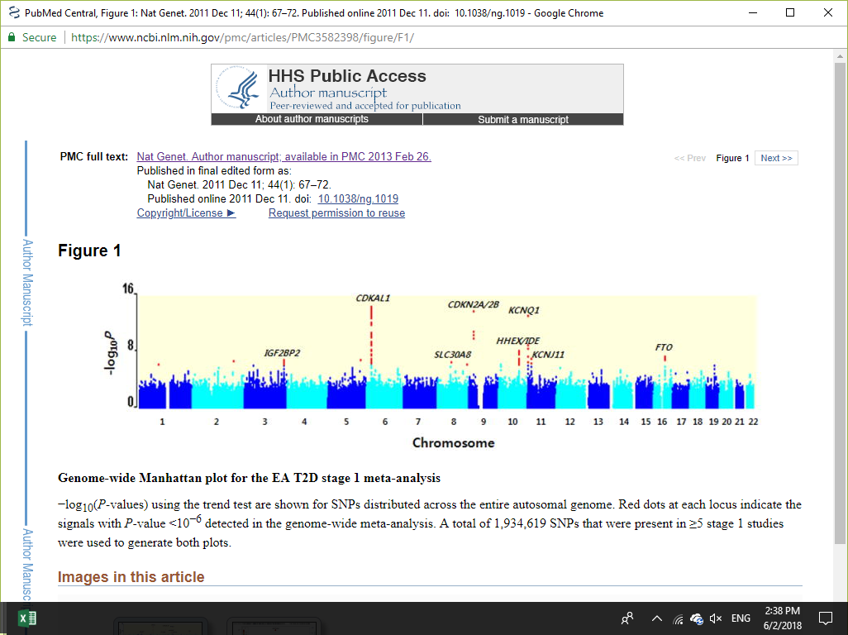
Figure 1. Genome-wide Manhattan plot for genes that were associated with T2D (Cho et al. 2011)

Genome wide association study helps identify genetic variants that are potentially associated with T2D where one allele will be significantly more common in cases than in controls. Figure 2 shows a typical GWAS workflow in identifying SNP associations with complex diseases (Kingsmore et al. 2008; Bush and Moore 2012).
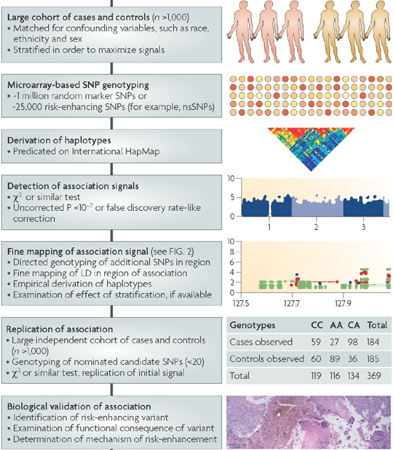

Figure 2. GWAS workflow to find SNP-disease associations (Kingsmore et al. 2008).

An intermediate aim of this study is to conduct a systematic review of the literature of GWAS reporting the validity and reliability of the outcome data. A systematic review is a research study that collects, selects, and summarizes multiple studies. According to pre-specified criteria, a systematic review is created after reviewing and combining all the information from prior published literature studies and then summarizing the relevant findings (Uman 2011). In this project, a systematic review of literature on world-wide GWAS will be used to identify genes that have been found to be associated with T2D.

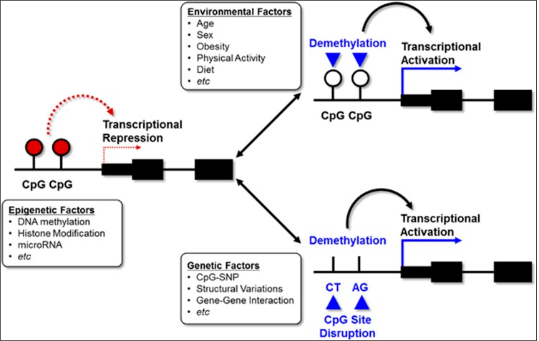

Figure 3. The complex interaction between epigenetics, genetics, and environment. The figure shows how environmental factors, genetic factors, and epigenetic regulations could influence T2D (Kwak and Park 2016).

Type 2 diabetes is a polygenic diseases and both environmental factors and a combination of genetic factors modify the risks (Das and Elbein 2006). Since T2D is only 10–15% heritable, environmental exposures play a major role in T2D (85-90%) (Karachanak-Yankova et al. 2016). One of the biggest mediator for environmental exposure are epigenetics. Thus, epigenetic modifications might be a possible mechanism for the increased prevalence of T2D among the immigrant population to high income country that occurs following exposure to different environments and lifestyles.
Epigenetics is the study of heritable changes of DNA, not involving in the DNA sequence, that regulates gene expression (Karachanak-Yankova et al. 2016). Epigenetic modifications provide additional instruction on how, when, and where genes should be expressed. Figure 4 shows the pairing of cytosine and guanine, and also shows cytosine methylation at the 5′ to a guanosine (commonly annotated as CpGs, where the intervening ‘p’ represents the phosphodiester bond linking cytosine (C) and guanine (G) containing nucleotides) (Gibney and Nolan 2010).

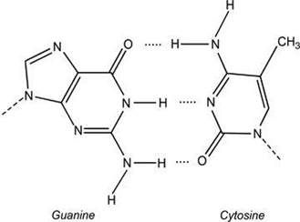
CH₃

Figure 4. Cytosine and guanine bonding and cytosine methylation at CpG sites (Gibney and Nolan 2010).

The expression of specific genes can be influenced by adding methyl groups to cytosine by the enzymes DNA methyltransferases (DNMTs). As shown in figure 5, DNA methylation is catalyzed by DNMT to the 5-carbon of cytosine in a CpG island sites. So far, four DNMTs have been identified: DNMT1, DNMT2, DNMT3a and DNMT3b. While DNMT1 maintains the parent DNA methylation pattern during replication, DNMT3a and DNMT3b target unmethylated CpG sites (de novo DNA methylation) (Gibney and Nolan 2010). When methyl is added to the 5’Cytosine, the DNA becomes inaccessible to transcription factors. Therefore, the genes are not transcribed.

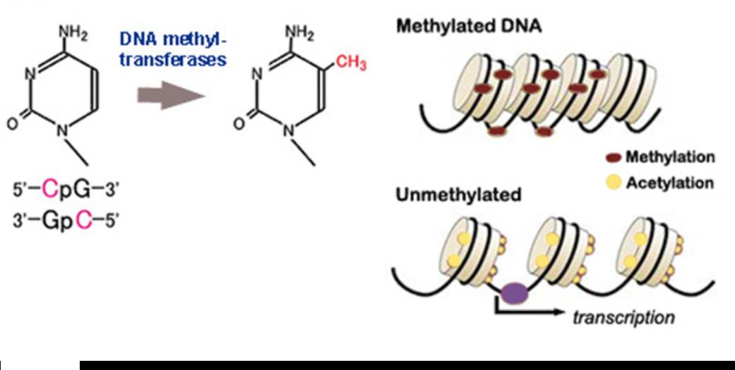
Figure 5. Conversion of cytosine to 5-methylcytosine by DNMT (Gibney and Nolan 2010).

Bisulfite assays are used to identify and detect the degree of methylation at the CpG islands (Chung et al. 2010). As shown in the following figure, DNA is denatured and then treated with sodium bisulfite at specific CpG sites of the promoter region to convert unmethylated cytosine to thymine while methylated cytosine stays the same. Bisulfite-treated DNAs are amplified using Polymerase Chain Reaction (PCR) and sequenced to detect methylation at specific sites.

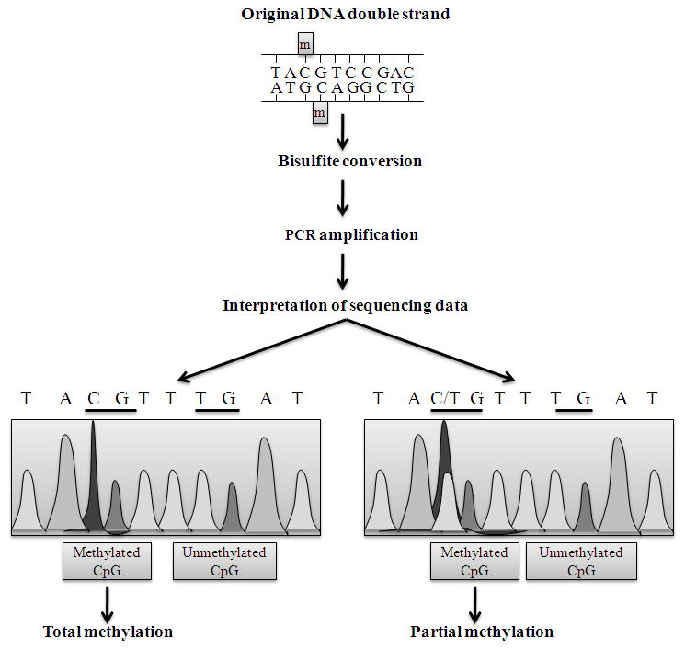
Figure 6: Bisulfite conversion (Li and Tollefsbol 2011)

Following bisulfite conversion, the DNA strands are no longer complementary, and primers are designed to assay the methylation status of a specific strand (Zilberman and Henikoff 2007; Li and Tollefsbol 2011). DNA methylation status can be interpreted by comparing the sequencing results and the original DNA sequence. All unmethylated cytosines convert to thymine and the presence of a C-peak indicates the presence of 5-methylcytosine (5mC) in the genome. If both C-and T-peaks appear, this indicates partial methylation or potentially incomplete bisulfite conversion has occurred (Zilberman and Henikoff 2007).
RESEACH DESIGN / METHODS

In this study, I am going to determine whether the prevalence of T2D is different in native Ethiopians (2.1%) compared to that in the Ethiopian immigrants who have been living in the United States for more than five years. Next, I will do a systematic review of literature on worldwide GWAS to identify the genes that are associated with the predisposition of T2D. Finally, I will compare the degree of epigenetic modifications of those genes between the native and immigrant Ethiopian populations for both case and control groups.
Aim 1: Examine the prevalence of T2D among the Ethiopian immigrant population who has been living in the United States for more than five years and compare it with the prevalence in native Ethiopian
The purpose of this aim is to examine the prevalence of T2D among Ethiopian immigrant population 18 years old and above who have been living in the United States for more than 5 years and compare the result with native Ethiopian individuals 18 years old and above. Prevalence is the number of cases of a disease that are present in a particular population at a given time. In Ethiopia, the prevalence of T2D among the whole adult population (18 years and older) was estimated 2.1% in 2015 (Alemu 2015).
The prevalence of T2D among Ethiopian immigrants in the United States is unknown. Tareen et al. (2005) reported that the prevalence for African Americans in the United States was 15% (Ethiopian immigrants are part of this data) (Tareen et al. 2005).
The total Ethiopian immigrant population in the United States in 2012 was 187,000. Most of the Ethiopian immigrant population live in Washington DC, Seattle, Minneapolis, and Atlanta. According to the 2012 United States Census Bureau, the highest number of Ethiopian immigrants, an estimated 37,924 adult, age greater than 18 and older, live in the Washington DC metro area (Ogunwole et al. 2017).
In the Washington DC metro area, the Office of Minority Health System (OMHS) provides and utilizes health care services for the Ethiopian residents and other minorities.
I will take a representative sample of from the medical records access through this organization. Then, from the sample, I will abstract T2D data to estimate the deidentified prevalence of the Ethiopian immigrants in the United states using the following formula:

Prevalence = Number of people diagnosed with the disease X 100
Total population

I am hypostasizing that the expected estimate prevalence for the Ethiopian immigrant population will vary between 2% (native Ethiopian) and 15% (African American).
Aim 2: Systematic review of literature on world-wide Genome Wide Association Studies (GWAS) to identify genes that have been found to be associated with T2D more frequently
The purpose of this aim was to conduct a systematic review to examine the literature reporting the genes that were associated with T2D researchers identified using GWAS. According to the 2009 PRISMA guidelines checklist (PRISMA, 2009), I searched PubMed and used MeSH (Medical Subject Headings) terms to retrieve relevant articles. A search constraint for articles published between January 2009 and January 2017 was applied. I searched PubMed using MeSH terms for all published studies: ((Genome-Wide Association Study[MeSH Major Topic]) AND type 2 diabetes[MeSH Major Topic]). The work-flow of the systematic review I used is as follow:
Identification Screening Eligibility Included

Table 1. The work-flow of the systematic review

PubMed T2D 962,038 January 2009 - 2017
PubMed GWAS 7,826 January 2009 - 2017
Identification

118 Articles excluded after title/abstract screen
185 Citations screened

Screening
67 Articles were retrieved

Eligibility
51 Articles excluded after full screen
Inclusion/exclusion criteria applied

Included
16 Articles included

Table 2: Inclusion and Exclusion criteria
Parameter | Inclusion
Language | English
Population | All
Age | Adults
Topics | GWAS and T2D
Date of publication | 2009 – 2017

I searched PubMed for all published studies that reported the genes that were associated with T2D using GWAS. Studies were included if they have both GWAS and T2D. I excluded models that did not have both GWAS and T2D, and studies investigating a complication of diabetes (like cardiovascular diseases) as the outcome. I extracted data from GWA studies and T2D study including information on: study characteristics (the author’s name, year of publication, country, and number of cases and population sample size), and the genes that were associated with T2D diagnosed patients. I reviewed the abstracts to select 65 potentially relevant abstract articles for the full text review, and I included sixteen articles in this systematic review.

Table 3. The included studies from the GWAS in T2D

Article numbers | Genes identified that were associated with T2D | Country/ethnic groups studies happened | Number of people who participated Case/control | Author lists
1 | FAF1 | Northern Han Chinese | 461/434 | Rao et al. 2016
2 | TOMM7 | Chinese Dong Population | 209/209 | Liu et al. 2015
3 | TCF7L2, CDKAL1 | Lebanese | 1384/1902 | Ghassibe-Sabbagh et al. 2014
4 | IGF2BP2, CDKAL1, TCF7L2, COL8A1, KCNQ1, ALX4, HNF1 | Lebanese Arabs | 995/1076 | Almawi et al. 2013
5 | MIR129-LEP, GPSM1, SLC16A13 | Japanese patients | 5976/20,829 | Hara et al. 2014
6 | IGF2BP2, KCNQ1, WFS1, TCF7L2 | African Americans | 1,554/2,734 | Long et al. 2012
7 | KCNQ1, VPS26A | Chinese | 498/402 | Lu et al. 2012
8 | GLIS3, PEPD, FITM2-R3, HDML-HNF4A, KCNK16, MAEA, GCC1-PAX4, PSMD6, ZFAND3 | East Asians | 12,284/13,172 | Cho et al. 2011
9 | MTNR1B, GCK, IRS1, PROX1, BCL11A, ZBED3, KLF14, TP53INP1, KCNQ1, CENTD2, HMGA2, ZFAND6, PRC1 | Japanese | 2,839/2,125 | Ohshige et al. 2011
10 | GRB14, ST6GAL1, VPS26A, HMG20A, AP3S2, HNF4A | South Asian | 5,561/14,458 | Kooner et al. 2011
11 | CDKN2A/2B, HNF1A, KCNQ1, IGF2BPs | Mexico-American | 967/343 | Below et al. 2011
12 | PPARG, TCF7Ls, FTO, CDKN2A/2B, KKEX/IDE, IGF2BP2, SLC30A8, KCNQ1, IRS1, KLDI4, CHCHD9, DUSPG | Pakistani Population | 1,678/1,584 | Rees et al. 2011
13 | GIPR, ADCY5, TCF7L2, VPS13C, DGKB, MADD, ADRA2A, SLC30A8, IGF1 | Chinese | 3,410/3,412 | Hu et al. 2010
14 | UBE2E2, C2CD4A/4B | Japanese population | 4,470/3,071 | Yamauchi et al. 2010
15 | KCNQ1 | Han Chinese | 995/894 | Tsai et al. 2010
16 | CDKAL1, CDKN2A/2B, KCNQ1, TCF7L2,  IGF2BP2, SLC30AB, HHEX, KCNJ11 | Japanese | 519/503 | Takeuchi et al. 2009

After reviewing all the sixteen articles, I chose six genes associated with T2D that showed up more frequently in the articles: CDKAL1, CDKN2A/2B, KCNQ1, TCF7L2, IGF2BP2, and SLC30A8. All six genes were involved with regulation and secretion of insulin or insulin sensitivity. On the following table, I have listed the roles of the six genes that I have selected.

Table 3: Role of the genes that are associated with T2D worldwide

Genes associated with T2D | Chromosome location | Role/mechanism | References
CDKAL1 | 6p22.3 | Associated with reduced β-cell function and insulin release | Brambillasca et al. 2012
CDKN2A/2B | 9p21.3 | Reduced insulin sensitivity | Kong et al. 2016
KCNQ1 | 11p15.5-15.4 | Play a role in regulation of insulin secretion of pancreatic β-cells | Sun et al. 2012
TCF7L2 | 10q25-25.3 | Affects insulin secretion | Gloyn et al. 2009
IGF2BP2 | 3q27.2 | Stimulation of insulin action | Zhao et al. 2011
SLC30A8 | 8q24.11 | Insulin processing and secretion | Salem et al. 2014

Aim 3: Compare the degree of epigenetic modifications possibly result in altered gene expressions of the identified genes
Having identified the most frequent genes that were associated with T2D from the systematic review, I will sequence and compare the degree of epigenetic modifications and gene expression of the selected genes in both native Ethiopians and the Ethiopian immigrant population in the United States diagnosed with T2D, as well as, control groups. Thus, will find out if the identified genes are subjected to epigenetic modifications, possibly resulting in altered gene expression. Bisulfite assay will be used to identify and detect the regions of methylation at the CpG islands (Chung et al. 2010).
Samples of Ethiopian immigrants represent the whole immigrant population in the United States will be recruited using the OMHS records. Furthermore, a sample of native Ethiopians will be collected in collaboration with Gonder University in Ethiopia. A brief questionnaire about medical history will be administrated including: sex, age (> 18), age at T2D onset, if any family history of T2D, and where in Ethiopia are they from (rural/urban). Ethiopian immigrants will also be asked for how long they have been living in the United States and will participate in the study if they said ≥ 5 years. Biospecimen for bisulfite assay will be collected in both groups. This study is going to be done by collaborating with Gonder University in Ethiopia. The school has an ongoing cohort, so I can recruit a representative sample nested inside cohort. Also, the participants in both groups have to be comparable. In each group, a sample of T2D patients and a control sample will be recruited. Cases and controls will have to be exchangeable except for the diagnoses of T2D.
The reason why the genes will not be expressed would be because of hyper-methylation at CpG island sites causing the Ethiopian immigrant population to have a higher prevalence and more susceptibility to T2D compared to the native Ethiopians. Individual genes will be sequenced for both native Ethiopian and the Ethiopian immigrants diagnosed with T2D, and the expression and methylation frequency of those specific genes that are associated with T2D will be compared. I am hypothesizing that the genes associated with T2D will be more expressed (less methylated) in native Ethiopians compared to the Ethiopian immigrant population in the United States diagnosed with T2D. I hypothesis that this would be correlated with the lifestyle differences between the two groups.

SUMMARY

Prevalence of T2D likely is rising among the Ethiopian immigrant population in the Western countries compared to native Ethiopia. Factors contributing to the hypothesize increase of T2D prevalence among Ethiopian immigrants might include modifiable (diet, obesity, and sedentary lifestyle) and non-modifiable (aging and genetics). Type 2 diabetes is associated with multiple genes, and data suggested that epigenetics may be involved. Epigenetic modifications might be one of the factor contributing to a possible increase of T2D prevalence among Ethiopian immigrants in the United States. Therefore, identifying and understanding the epigenetic changes specific to Ethiopian immigrant population diagnosed with T2D might help to develop better strategies to intervene and/or to prevent the onset of the disease.

INFORMED CONSENT DOCUMENT

Before collecting data, an informed consent will be obtained from the respondent (both T2D patients and healthy individuals) in native Ethiopians and Ethiopian immigrants in the Washington DC metro area. The participants will provide a written informed consent to be a part of the study. According to the principle of autonomy, participants are free to decide independently not to participate in this study and also have the right to withdraw at any point during the research process (Gupta 2013). The participants will be assured that any information they would disclose will not be made accessible to parties other than those involved in the study. The obligation of confidentiality will be maintained throughout the study, and a written research plan will also be provided to the participants. Institutional review board (IRB) in the USA as well as in Ethiopia will be monitoring this study. The purpose of IRB is to facilitate human subjects research by ensuring the rights and welfare of human subjects are protected during their participation (protecting human subjects in research).
Study location: Holy Cross Hospital, Silver Spring, MD, collaborating with Gonder University, Ethiopia.
Introduction: Participation in this study is completely voluntary and you may choose not to take part, or you may withdraw from the study at any time.
The purpose of this study: The purpose of this study is to understand/explore a possible increased prevalence on T2D within Ethiopian immigrant population in Western countries (United States) compared to native Ethiopian populations, and to find the degree of methylation on genes that are associated with T2D.
What will the study involve?
I am going to collect samples for each participant by swabbing buccal (cheek) cells. A brief questionnaire about medical history will be administrated to you including: your sex, your age (> 18), your age at T2D onset, if you have any family history of T2D, and where in Ethiopia you are from (rural/urban), and if Ethiopian immigrants: how long have you been living in the United States?
Inclusion criteria:
Eligibility criteria for the study included being an Ethiopian immigrant, permanently and legally resident for more than 5 years in the Washington DC metro area region aged 18 and above, or native Ethiopian, and being able to provide informed consent.
What tests will be performed on your samples?
We will examine six genes to determine if there functioning is different in Ethiopian immigrant and native Ethiopian in such way that it may increase the risk of T2D in immigrant Ethiopian.
How long will this study last? This study is expected to last 24 months.
Risks associated with this study? Some of the risks that are associated with this study are inconvenience, discomfort at sample collection, and possible loss of privacy.

REFERENCES

Alemu F. 2015. Prevalence of Diabetes Mellitus Disease and its Association with Level of Education Among Adult Patients Attending at Dilla Referral Hospital, Ethiopia. J Diabetes Metab. 6. doi:10.4172/2155-6156.1000521. https://www.omicsonline.org/open-access/prevalence-of-diabetes-mellitus-disease-and-its-association-with-levelof-education-among-adult-patients-attending-at-dilla-referral-hospitalethiopia-2155-6156-1000521.php?aid=50808.
Almawi WY, Nemr R, Keleshian SH, Echtay A, Saldanha FL, AlDoseri FA, Racoubian E. 2013. A Replication Study of 19 GWAS-Validated Type 2 Diabetes at-Risk Variants in the Lebanese Population. Diabetes Res Clin Pract. 102:117–122. doi:10.1016/j.diabres.2013.09.001.
American Diabetes Association. 2013. Economic Costs of Diabetes in the U.S. in 2012. Diabetes Care. 36:1033–1046. doi:10.2337/dc12-2625.
Andersen G, Jørgensen M, Søberg S. 2015. Ethnicity, Migration and T2DM (revision number 16). In: Diapedia. Diapedia.org. http://www.diapedia.org/3104465162/rev/16.

Below JE, Gamazon ER, Morrison JV, Konkashbaev A, Pluzhnikov A, McKeigue PM, Parra EJ, Elbein SC, Hallman DM, Nicolae DL, Bell GI, Cruz M, Cox NJ. 2011. Genome-Wide Association and Meta-Analysis in Populations from Starr County, Texas, and Mexico City Identify Type 2 Diabetes Susceptibility Loci and Enrichment for Expression Quantitative Trait Loci in Top Signals. Diabetologia. 54:2047–2055. doi:10.1007/s00125-011-2188-3.
Black SA. 2002. Diabetes, Diversity, and Disparity: What Do We Do With the Evidence? Am J Public Health. 92:543–548.
Brambillasca S, Altkrueger A, Colombo SF, Friederich A, Eickelmann P, Mark M, Borgese N, Solimena M. 2012. CDK5 Regulatory Subunit-associated Protein 1-Like 1 (CDKAL1) Is a Tail-anchored Protein in the Endoplasmic Reticulum (ER) of Insulinoma Cells. J Biol Chem. 287:41808–41819. doi:10.1074/jbc.M112.376558.
Bush WS, Moore JH. 2012. Chapter 11: Genome-Wide Association Studies. PLoS Comput Biol. 8. doi:10.1371/journal.pcbi.1002822. https://www.ncbi.nlm.nih.gov/pmc/articles/PMC3531285/.
CDC. 2017 Aug 8. Diabetes Statistic Report. Cent Dis Control Prev. https://www.cdc.gov/features/diabetes-statistic-report/index.html.
Chawla A, Chawla R, Jaggi S. 2016. Microvasular and Macrovascular Complications in Diabetes Mellitus: Distinct or Continuum? Indian J Endocrinol Metab. 20:546–551. doi:10.4103/2230-8210.183480.
Cho YS, Chen C-H, Hu C, Long J, Ong RTH, Sim X, Takeuchi F, Wu Y, Go MJ, Yamauchi T, Chang YC, Kwak SH, Ma RC, Yamamoto K, Adair LS, Aung T, Cai Q, Chang LC, Chen YT, Gao Y, Hu FB, Kim HL, Kim S, Kim YJ, Lee JJ, Lee NR, Li Y, Liu JJ, Lu W, Nakamura J, Nakashima E, Ng DP, Tay WT, Tsai FJ, Wong TY, Yokota M, Zheng W, Zhang R, Wang C, So WY, Ohnaka K, Ikegami H, Hara K, Cho YM, Cho NH, Chang TJ, Bao Y, Hedman ÅK, Morris AP, McCarthy MI; DIAGRAM Consortium; MuTHER Consortium, Takayanagi R, Park KS, Jia W, Chuang LM, Chan JC, Maeda S, Kadowaki T, Lee JY, Wu JY, Teo YY, Tai ES, Shu XO, Mohlke KL, Kato N, Han BG, Seielstad M. 2011. Meta-Analysis of Genome-Wide Association Studies Identifies 8 new Loci for Type 2 Diabetes in East Asians. Nat Genet. 44:67–72. doi:10.1038/ng.1019.

Choukem SP, Fabreguettes C, Akwo E, Porcher R, Nguewa JL, Bouche C, Kaze FF, Kengne AP, Vexiau P, Mbanya JC, Sobngwi E, Gautier JF. 2014. Influence of Migration on Characteristics of Type 2 Diabetes in Sub-Saharan Africans. Diabetes Metab. 40:56–60. doi:10.1016/j.diabet.2013.07.004.
Chung CAB, Boyd VL, McKernan KJ, Fu Y, Monighetti C, Peckham HE, Barker M. 2010. Whole Methylome Analysis by Ultra-Deep Sequencing Using Two-Base Encoding. PLOS ONE. 5:e9320. doi:10.1371/journal.pone.0009320.
Commodore‐ Mensah Y, Ukonu N, Obisesan O, Aboagye JK, Agyemang C, Reilly CM, Dunbar SB, Okosun IS. 2016. Length of Residence in the United States is Associated With a Higher Prevalence of Cardiometabolic Risk Factors in Immigrants: A Contemporary Analysis of the National Health Interview Survey. J Am Heart Assoc. 5:e004059. doi:10.1161/JAHA.116.004059.
Cui M, Wu X, Mao J, Wang X, Nie M. 2016. T2DM Self-Management via Smartphone Applications: A Systematic Review and Meta-Analysis. PLoS ONE. 11. doi:10.1371/journal.pone.0166718. https://www.ncbi.nlm.nih.gov/pmc/articles/PMC5115794/.
Das SK, Elbein SC. 2006. The Genetic Basis of Type 2 Diabetes. Cellscience. 2:100–131. doi:10.1901/jaba.2006.2-100.
Deshpande AD, Harris-Hayes M, Schootman M. 2008. Epidemiology of Diabetes and Diabetes-Related Complications. Phys Ther. 88:1254–1264. doi:10.2522/ptj.20080020.
Ghassibe-Sabbagh M, Haber M, Salloum AK, Al-Sarraj Y, Akle Y, Hirbli K, Romanos J, Mouzaya F, Gauguier D, Platt DE, El-Shanti H, Zalloua PA. 2014. T2DM GWAS in the Lebanese Population Confirms the Role of TCF7L2 and CDKAL1 in Disease Susceptibility. Sci Rep. 4. doi:10.1038/srep07351. https://www.ncbi.nlm.nih.gov/pmc/articles/PMC5376673/.
Gibney ER, Nolan CM. 2010. Epigenetics and Gene Expression. Heredity. 105:4–13. doi:10.1038/hdy.2010.54.
Gloyn AL, Braun M, Rorsman P. 2009. Type 2 Diabetes Susceptibility Gene TCF7L2 and Its Role in β-Cell Function. Diabetes. 58:800–802. doi:10.2337/db09-0099.
Gupta UC. 2013. Informed Consent in Clinical Research: Revisiting Few Concepts and Areas. Perspect Clin Res. 4:26–32. doi:10.4103/2229-3485.106373.
Hara K, Fujita H, Johnson TA, Yamauchi T, Yasuda K, Horikoshi M, Peng C, Hu C, Ma RCW, Imamura M, Iwata M, Tsunoda T, Morizono T, Shojima N, So W, Leung T, Kwan P, Zhang R, Wang J, Yu W. 2014. Genome-Wide Association Study Identifies Three Novel Loci for Type 2 Diabetes. Hum Mol Genet. 23:239–246. doi:10.1093/hmg/ddt399.
Hopkins R, Shaver K, Weinstock RS. 2016. Management of Adults With Diabetes and Cognitive Problems. Diabetes Spectr. 29:224–237. doi:10.2337/ds16-0035.
Hu C, Zhang R, Wang C, Wang J, Ma X, Hou X, Lu J, Yu W, Jiang F, Bao Y, Xiang K, Jia W. 2010. Variants from GIPR, TCF7L2, DGKB, MADD, CRY2, GLIS3, PROX1, SLC30A8 and IGF1 Are Associated with Glucose Metabolism in the Chinese. PLoS ONE. 5. doi: 10.1371/journal.pone. 0015542. https://www.ncbi.nlm.nih.gov/pmc/articles/PMC2984505/.
Hurt RT, Kulisek C, Buchanan LA, McClave SA. 2010. The Obesity Epidemic: Challenges, Health Initiatives, and Implications for Gastroenterologists. Gastroenterol Hepatol. 6:780–792.
Jaffe A, Giveon S, Wulffhart L, Oberman B, Freedman L, Ziv A, Kalter-Leibovici O. 2016. Diabetes among Ethiopian Immigrants to Israel: Exploring the Effects of Migration and Ethnicity on Diabetes Risk. Tordjman KM, editor. PLOS ONE. 11:e0157354. doi:10.1371/journal.pone.0157354.
Karachanak-Yankova S, Dimova R, Nikolova D, Nesheva D, Koprinarova M, Maslyankov S, Tafradjiska R, Gateva P, Velizarova M, Hammoudeh Z, Stoynev N, Toncheva D, Tankova T, Dimova I. 2016. Epigenetic Alterations in Patients with Type 2 Diabetes Mellitus. Balk J Med Genet BJMG. 18:15–24. doi:10.1515/bjmg-2015-0081.
Kingsmore SF, Lindquist IE, Mudge J, Gessler DD, Beavis WD. 2008. Genome-Wide Association Studies: Progress and Potential for Drug Discovery and Development. Nat Rev Drug Discov. 7:221–230. doi:10.1038/nrd2519.
Kong Y, Sharma RB, Nwosu BU, Alonso LC. 2016. Islet Biology, the CDKN2A/B Locus and Type 2 Diabetes Risk. Diabetologia. 59:1579–1593. doi:10.1007/s00125-016-3967-7.
Kooner JS, Saleheen D, Sim X, Sehmi J, Zhang W, Frossard P, Been LF, Chia K-S, Dimas AS, Hassanali N, Jafar T, Jowett JB, Li X, Radha V, Rees SD, Takeuchi F, Young R, Aung T, Basit A, Chidambaram M, Das D, Grundberg E, Hedman AK, Hydrie ZI, Islam M, Khor CC, Kowlessur S, Kristensen MM, Liju S, Lim WY, Matthews DR, Liu J, Morris AP, Nica AC, Pinidiyapathirage JM, Prokopenko I, Rasheed A, Samuel M, Shah N, Shera AS, Small KS, Suo C, Wickremasinghe AR, Wong TY, Yang M, Zhang F; DIAGRAM; MuTHER, Abecasis GR, Barnett AH, Caulfield M, Deloukas P, Frayling TM, Froguel P, Kato N, Katulanda P, Kelly MA, Liang J, Mohan V, Sanghera DK, Scott J, Seielstad M, Zimmet PZ, Elliott P, Teo YY, McCarthy MI, Danesh J, Tai ES, Chambers JC. 2011. Genome-Wide Association Study in People of South Asian Ancestry Identifies Six Novel Susceptibility Loci for Type 2 Diabetes. Nat Genet. 43:984–989. doi:10.1038/ng.921.

Kwak SH, Park KS. 2016. Recent Progress in Genetic and Epigenetic Research on Type 2 Diabetes. Exp Mol Med. 48:e220. doi:10.1038/emm.2016.7.
Li Y, Tollefsbol TO. 2011. DNA Methylation Detection: Bisulfite Genomic Sequencing Analysis. Methods Mol Biol Clifton NJ. 791:11–21. doi:10.1007/978-1-61779-316-5_2.
Ling C, Groop L. 2009. Epigenetics: A Molecular Link Between Environmental Factors and Type 2 Diabetes. Diabetes. 58:2718–2725. doi:10.2337/db09-1003.
Liu L, Chen L, Li Z, Li L, Wang M, Qu J, Xue J. 2015. [Association of Genetic Variants in TOMM7 Gene and Gene Environment Interaction with Type 2 Diabetes in Chinese Dong Population]. Zhong Nan Da Xue Xue Bao Yi Xue Ban. 40:31–38. doi:10.11817/j.issn.1672-7347.2015.01.006.
Long J, Edwards T, Signorello LB, Cai Q, Zheng W, Shu X-O, Blot WJ. 2012. Evaluation of Genome-wide Association Study-identified Type 2 Diabetes Loci in African Americans. Am J Epidemiol. 176:995–1001. doi:10.1093/aje/kws176.
Lu S, Xie Y, Lin K, Li S, Zhou Y, Ma P, Lv Z, Zhou X. 2012. Genome-Wide Association Studies-Derived Susceptibility Loci in Type 2 Ciabetes: Confirmation in a Chinese Population. Clin Investig Med Med Clin Exp. 35:E327.
McDonald JT, Kennedy S. 2004. Insights into the “healthy immigrant effect”: Health Status and Health Service Use of Immigrants to Canada. Soc Sci Med 1982. 59:1613–1627. doi:10.1016/j.socscimed.2004.02.004.
Ogunwole, Stella U., Karen R. Battle, and Darryl T. Cohen, “Characteristics of Selected SubSaharan African and Caribbean Ancestry Groups in the United States: 2008–2012,” American Community Survey Reports, ACS-34, U.S. Census Bureau, Washington, DC, 2017.

Ohshige T, Iwata M, Omori S, Tanaka Y, Hirose H, Kaku K, Maegawa H, Watada H, Kashiwagi A, Kawamori R, Ryuzo Kawamori, Kazuyuki Tobe, Takashi Kadowaki, Yusuke Nakamura, Shiro Maeda. 2011. Association of New Loci Identified in European Genome-Wide Association Studies with Susceptibility to Type 2 Diabetes in the Japanese. PLoS ONE. 6. doi:10.1371/journal.pone.0026911. https://www.ncbi.nlm.nih.gov/pmc/articles/PMC3202571/.
Peek ME, Cargill A, Huang ES. 2007. Diabetes Health Disparities. Med Care Res Rev MCRR. 64:101S-156S. doi:10.1177/1077558707305409.
Prasad RB, Groop L. 2015. Genetics of Type 2 Diabetes—Pitfalls and Possibilities. Genes. 6:87–123. doi:10.3390/genes6010087.
Rao P, Zhou Y, Ge S-Q, Wang A-X, Yu X-W, Alzain MA, Veronica AK, Qiu J, Song M-S, Zhang J, Andrea Katherine Veronica, Jing Qiu, Man-Shu Song, Jie Zhang, Hao Wang, Hong-Hong Fang, Qing Gao, You-Xin Wang, Wei Wang. 2016. Validation of Type 2 Diabetes Risk Variants Identified by Genome-Wide Association Studies in Northern Han Chinese. Int J Environ Res Public Health. 13. doi:10.3390/ijerph13090863. https://www.ncbi.nlm.nih.gov/pmc/articles/PMC5036696/.

Rees SD, Hydrie MZI, Shera AS, Kumar S, O’Hare JP, Barnett AH, Basit A, Kelly MA. 2011. Replication of 13 Genome-Aide association (GWA)-Validated Risk Variants for Type 2 Diabetes in Pakistani Populations. Diabetologia. 54:1368–1374. doi:10.1007/s00125-011-2063-2.
Salem SD, Saif-Ali R, Ismail IS, Al-Hamodi Z, Muniandy S. 2014. Contribution of SLC30A8 Variants to the Risk of Type 2 Diabetes in a Multi-Ethnic Population: A Case Control Study. BMC Endocr Disord. 14:2. doi:10.1186/1472-6823-14-2.
Sears B, Perry M. 2015. The Role of Fatty Acids in Insulin Resistance. Lipids Health Dis. 14. doi:10.1186/s12944-015-0123-1. https://www.ncbi.nlm.nih.gov/pmc/articles/PMC4587882/.
Shipp MP-L, Francis SA, Fluegge KR, Asfaw SA. 2014. Perceived Health Issues: A Perspective from East-African Immigrants. Health Cult Soc. 6:13–32. doi:10.5195/hcs.2014.113.
Sobngwi E, Mauvais-Jarvis F, Vexiau P, Mbanya JC, Gautier JF. 2001. Diabetes in Africans. Part 1: Epidemiology and Clinical Specificities. Diabetes Metab. 27:628–634.
Stokes A, Preston SH. 2017. Deaths Attributable to Diabetes in the United States: Comparison of Data Sources and Estimation Approaches. PLOS ONE. 12:e0170219. doi:10.1371/journal.pone.0170219.
Sun Q, Song K, Shen X, Cai Y. 2012. The Association between KCNQ1 Gene Polymorphism and Type 2 Diabetes Risk: A Meta-Analysis. PLOS ONE. 7:e48578. doi:10.1371/journal.pone.0048578.
Takeuchi F, Serizawa M, Yamamoto K, Fujisawa T, Nakashima E, Ohnaka K, Ikegami H, Sugiyama T, Katsuya T, Miyagishi M, Nakashima N, Nawata H, Nakamura J, Kono S, Takayanagi R, Kato N. 2009. Confirmation of Multiple Risk Loci and Genetic Impacts by a Genome-Wide Association Study of Type 2 Diabetes in the Japanese Population. Diabetes. 58:1690–1699. doi:10.2337/db08-1494.

Tareen N, Zadshir A, Martins D, Pan D, Nicholas S, Norris K. 2005. Chronic Kidney Disease in African American and Mexican American Populations. Kidney Int. 68:S137–S140. doi:10.1111/j.1523-1755.2005.09723.x.
Tsai F-J, Yang C-F, Chen C-C, Chuang L-M, Lu C-H, Chang C-T, Wang T-Y, Chen R-H, Shiu C-F, Liu Y-M, Chang CC, Chen P, Chen CH, Fann CS, Chen YT, Wu JY. 2010. A Genome-Wide Association Study Identifies Susceptibility Variants for Type 2 Diabetes in Han Chinese. PLoS Genet. 6. doi:10.1371/journal.pgen.1000847. https://www.ncbi.nlm.nih.gov/pmc/articles/PMC2824763/.
Tucker KL, Buranapin S. 2001. Nutrition and Aging in Developing Countries. J Nutr. 131:2417S–23S.
Uman LS. 2011. Systematic Reviews and Meta-Analyses. J Can Acad Child Adolesc Psychiatry. 20:57–59.
Walaszczyk E, Luijten M, Spijkerman AMW, Bonder MJ, Lutgers HL, Snieder H, Wolffenbuttel BHR, van Vliet-Ostaptchouk JV. 2018. DNA Methylation Markers Associated with Type 2 Diabetes, Fasting Glucose and HbA1c Levels: A Systematic Review and Replication in a Case-Control sample of the Lifelines Study. Diabetologia. 61:354–368. doi:10.1007/s00125-017-4497-7.
Witte JS. 2010. Genome-Wide Association Studies and Beyond. Annu Rev Public Health. 31:9–20. doi:10.1146/annurev.publhealth.012809.103723.
Yamauchi T, Hara K, Maeda S, Yasuda K, Takahashi A, Horikoshi M, Nakamura M, Fujita H, Grarup N, Cauchi S, Ng DP, Ma RC, Tsunoda T, Kubo M, Watada H, Maegawa H, Okada-Iwabu M, Iwabu M, Shojima N, Shin HD, Andersen G, Witte DR, Jørgensen T, Lauritzen T, Sandbæk A, Hansen T, Ohshige T, Omori S, Saito I, Kaku K, Hirose H, So WY, Beury D, Chan JC, Park KS, Tai ES, Ito C, Tanaka Y, Kashiwagi A, Kawamori R, Kasuga M, Froguel P, Pedersen O, Kamatani N, Nakamura Y, Kadowaki T. 2010. A Genome-Wide Association Study in the Japanese Population Identifies Susceptibility Loci for Type 2 Diabetes at UBE2E2 and C2CD4A-C2CD4B. Nat Genet. 42:864–868. doi:10.1038/ng.660.

Zhao Y, Ma Y-S, Fang Y, Liu L, Wu S-D, Fu D, Wang X-F. 2011. IGF2BP2 Genetic Variation and Type 2 Diabetes: A Global Meta-Analysis. DNA Cell Biol. 31:713–720. doi:10.1089/dna.2011.1400.
Zilberman D, Henikoff S. 2007. Genome-Wide Analysis of DNA Methylation Patterns. Development. 134:3959–3965. doi:10.1242/dev.001131.

