An Assessment of Nutrition Education in Public Schools and
How It Has Impacted Childhood Wellness
Special Focus: Baltimore County Public Schools
_______________________________________
A Capstone Project
presented to
the Faculty of the Graduate School
at Goucher College
_______________________________________________________
In Partial Fulfillment
of the Requirements for the Degree
Master of Arts in Environmental Studies
_____________________________________________________
by
JULIA ERBE

Capstone Committee
Thomas Walker, Ph.D.

Ann Daniels, MBA

Karen Levenstein, RD, LD

Table of Contents

Acknowledgements 3
Preface 4
Chapter 1 – Health Disparities among the Youth 7
Chapter 2 – Evolution of Food Education: School Meal Programs 16
Chapter 3 – Successful Food Programs in U.S. Public Schools 29 Chapter 4 – Special Focus: Baltimore County Public School System 39
Chapter 5 – Future of Nutrition Education: Parent Involvement 54
Chapter 6 – Commitment to a Healthier Future 64
References 70

Acknowledgements

I would first like to give thanks to my three capstone advisors, Dr. Thomas Walker, Ms. Ann Daniels, and Ms. Karen Levenstein. You all have provided the guidance and encouragement I needed to get to this final stage of my graduate career. At any point throughout this process, each one of you was available and eager to offer help. Your constant support and reassurance truly helped me achieve this milestone in my education. I thank you for that.

I would also like to thank my friends and family for their unfailing support, words of wisdom, and source of comfort. This accomplishment would not mean nearly as much if I didn’t have you all to share it with. Thank you for always being there when I needed some encouragement, advice, or a simple pat on the back. You all mean more to me than you know. Thank you for everything.

Preface
Over the past few years, nutrition has become an absolute passion of mine and continues to play a dominant role in the way I live my life. As the youngest of three children growing up in a busy household, proper nutrition was not a part of our daily lives. We always had food on the table and in our lunchboxes, but they were not the healthiest. My parents bought groceries that were affordable and well liked among all three of us. Each of us played sports and were heavily involved in school activities, making weeknight dinners at the table a tough task. Food needed to be convenient and quick. I see this same theme in households today. Although I understand the thought process many parents go through in terms of food choice, I wanted to know more about the factors that affected their decisions. With my eagerness to educate myself on the matters in which nutrition exists in our society, as well as the ways in which it is perceived, I found a great need for discussion and improvement in public school nutrition education. As a former student within the Baltimore County Public School system, I had a strong desire to examine how nutrition education has evolved in comparison to how it subsists in schools present-day.

In order to do this successfully, I first assessed the issues that school-aged children are faced with, including obesity and type II diabetes. Much of this is heavily science-based. With illustrations and recent data from surveys and studies, it became quite obvious how these health disparities have negatively affected children over time. Once I laid out this foundation, I then gave support as to why nutrition education is so important in school curricula. An overview of how nutrition education has evolved over the past 75 years, in addition to recent major legislation that revamped nutrition in schools nationwide, are major factors within this chapter. With this detailed information, I continued to research success stories from schools across the country that are paving the way for others to make similar improvements in overall food choice and healthy habits. These include notable schools/programs such as The Ross School in New York and The Edible Schoolyard in California.

Once discovering all of the techniques employed to create such a positive, effective learning environment, I sought ways in which Baltimore County Public Schools were making similar efforts. In conversation with the Director of the Office of Food and Nutrition Services for Baltimore County Public Schools, Ms. Karen Levenstein, it became apparent that the desire to create positive change in nutrition education exists, yet issues with cooperation, funding, and accessibility produce obstacles for her team. Further improvements are on the horizon as the problems are being acknowledged and corrected. Likewise, the future of nutrition education looks optimistic as more and more information circulates about childhood health and its impact on their overall well-being. Of all the parties that can have a positive impact on today’s younger generation, I deemed the most essential to be that of the parents/guardians. The divide that exists between school and home must be tightened to ensure the nation’s children are learning how food choice and healthy habits can lead to a longer, happier future.

In discussion of these issues, I always kept in mind the link to environmental studies and how this topic related. Over the two years I’ve spent studying material ranging from cultural influences, economic impacts, social norms, and more, there are major themes that have traveled through each subject. The most memorable theme is that of overconsumption. Not only does this apply in terms of overuse of fossil fuels and energy, but also in relation to food. Americans, especially, consume large amounts of food that also require large amounts of energy to produce. Due to this, we are operating under unsustainable conditions. Our planet simply cannot continue to support the way in which we live our lives. Another theme I found useful in this project is the role of authority. It is important to question who has the authority in any given situation and what makes them authoritative. We must know background information in order to fully assess one’s right or position to be the authority figure. Who gives them this power? Why should we listen to them? This goes hand in hand with the idea of skepticism and why it is important to question others. We need to have all of the information before making an informed decision; it is not enough to take someone’s word as truth before assessing all factors. I found this very helpful when researching the current trends in obesity and type II diabetes, as well as implementation of current school food standards.

The Environmental Studies program is multi-disciplinary and encompasses a wide range of topics. As a student who appreciates holistic learning and understanding how concepts intertwine with one another, I was able to write about an issue that is not only important to me on a personal level, but is also significant on a much larger scale – much larger than myself.

CHAPTER 1
Health Disparities among the Youth

Childhood is the period in which we learn to coexist with each other, as well as our surrounding ecosystem. We learn how to be decent human beings, live in a civilized society, and communicate effectively. We enter phases of cognitive development, in which we learn language, simple concepts, and develop fine motor skills. All of this occurs within the first few years of life and is highly influenced by those who surround us. Children are malleable individuals, easily morphed and molded by those around them. They learn by doing and seeing; therefore, they generally mirror the actions and behaviors of those in their closest social circle, typically parents/guardians and peers. As a result, there is a correlation between the child’s diet and that of their parents’. Parental Influence on Eating Behavior by Savage et al (2007), make the claim that the first five years of a child’s life are marked by rapid physical growth. It is within this period that learned eating behaviors become the basis of future eating patterns; thereby paving the way toward either a healthy or unhealthy life. The authors also state that caregivers act as “powerful socialization agents,” modeling eating behaviors, providing food for their children, and cultivating their diet. Without much thought, these adults are directly affecting the very relationship these children will have with food for the rest of their lives. The idea being that if parents make healthier food choices, so will their children.

It is an unfortunate reality that many children today are living with very serious health issues as a result of their poor diet and lack of activity. Since the early 1980s, countless studies have been conducted to analyze the increasing trends in childhood obesity and type II diabetes among the youth (Skinner and Skelton, 2014). As decades passed, society experienced drastic changes that have all had lasting effects on the well-being of our nation’s children. Technological advances and the prevalence of social media have made it easier for children to become stagnant and inactive. In addition, more women are full-time working mothers, making family time, meals at the table, and time spent grocery shopping much more difficult. Faster-paced lifestyles have made it more difficult to spend time focusing on our food choices, health, and well-being. In turn, the health of our children has declined dramatically; childhood obesity being the leading problem. The definition of childhood obesity is linked directly with BMI, or Body Mass Index, which is calculated by dividing an individual’s weight (kg) by the square of height (m) (CDC, 2015).

Body mass index = weight (kg)/height (m2)

It is important to note that BMI takes a person’s height and age into account because it varies based on these specific characteristics. For a child to be considered obese, he/she must be at or above the 95th percentile for children of the same age and sex. Below is the current scale used by the Center for Disease Control and Prevention to determine the weight range and classification for children:

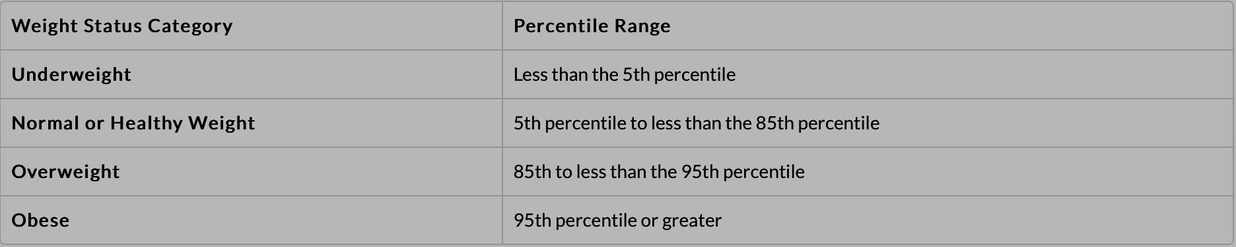
Figure 1: Center for Disease Control and Prevention (2015)

With this scale, it is possible to quantify how many children fall within each given range. According to Skinner and Skelton (2014), there is great concern with the prevalence of severe obesity, which may not be well represented in recent obesity studies. There is still reason to believe that those already classified as obese are only getting worse (Skinner and Skelton, 2014). Most studies do not examine severe obesity, which should be a part of the discussion. It is important to acknowledge this difference as more severe obesity cases give way for even more severe cardiometabolic risks later in life.

Looking at data and trends concerning childhood obesity, Ann Cooper and Lisa M. Holmes in Lunch Lessons: Changing the Way We Feed Our Children, presented valuable and groundbreaking lessons that will serve a great deal throughout this analysis due to its detail and purpose. Although this piece was published over 10 years ago, its numbers remain significant in the field. At the time, more than 35% of U.S. children were deemed overweight, while 25% were characterized as obese (remember, according to BMI calculations). It is a distressing fact that obesity rates among American children have more than doubled since the 1970s (Cooper and Holmes, 2006). The latest figure according to the CDC states that as of 2012, more than 1/3 of children are defined as overweight or obese. Between the years of 1980 and 2012, obesity rates for youth aged 6-11 increased from 7% to 18%, respectively. In a 30-year span, American youth gained not only an unhealthy amount of weight, but also a great deal of health problems, all of which can lead to further complications.

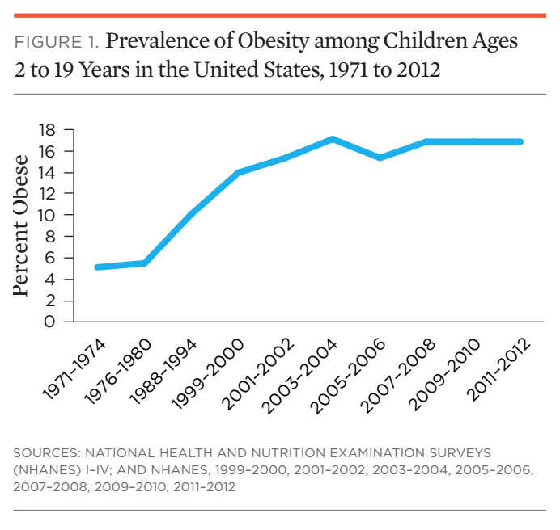

To break down every cause linked to childhood obesity would be exhaustive and endless. However, it is essential to point out the most notable ones in order to fully understand its scope. Cooper and Holmes (2006) claim that processed foods both in schools and at home have had a major negative impact on childhood wellness. They also attribute these increased trends to a lack of nutrition education and knowledge about general health. They state, “…most parents don’t even know what constitutes good childhood nutrition…” (Cooper and Holmes, 2006). The authors place much of the responsibility on the parents/guardians, which further reinforces the link between parental eating patterns and that of their offspring. Fast food, convenience meals, meal replacements, and snack foods have overwhelmed the diet of children all around the country, leading to a nutrition epidemic. Cooper and Holmes bring attention to the lack of effort and time put into making healthier decisions about food. Simply put, people do not do their research or make time to figure out how to eat healthier (Cooper and Holmes, 2006). Today’s society is characterized as fast-paced, on the go, and on the run. There has been a decline in home-cooking and family meals. Because of this, food is generally less of a priority. How does this support a generation of healthy children? The authors make a point to remind their readers that food is indispensable, not a luxury (Cooper and Holmes, 2006); it must be treated with respect and appreciation.

Aside from these factors that reside in the home, there are also many biological and circumstantial factors that influence childhood obesity. These are factors that lie outside of the child’s control; rather, they are a result of biological predispositions. For example, children who are born malnourished and then enter “energy-dense” diets later on in life are much more likely to become obese (WHO, 2016). Essentially, the “overcompensation” due to being underweight at birth can lead to a childhood categorized as overweight or obese. This is what the World Health Organization calls the “mismatch pathway” to childhood obesity because it is has the opposite effect than what is assumed (2016). A contextual factor that is important to note is that children adopt the same socioeconomic status as their caregivers, thereby inheriting similar cultural norms and behaviors (2016). They do not necessarily have a choice in this matter, and so they succumb to what their surrounding environment provides.

Another factor in childhood nutrition-related health is diabetes. Diabetes encompasses multiple types, all of which are characterized differently. In general, diabetes is classified by above normal levels of blood glucose that our bodies use for energy. The pancreas is responsible for producing insulin, which breaks down this glucose. However, those suffering from diabetes either don’t produce enough insulin or can’t use it effectively. In turn, the glucose builds up in the blood system, putting these individuals at risk for heart disease, kidney failure, blindness, and more. Diabetes is a major concern as it has been named the seventh leading cause of death in the U.S (PubMedHealth, 2014).

Although there are multiple varieties, Type 2 diabetes is the main area of focus for our needs. Also called non-insulin-dependent diabetes mellitus (NIDDM) or adult-onset diabetes, Type 2 means the body does not use insulin properly. It is the most common form as it accounts for about 90-95% of diagnosed cases of diabetes. More and more overweight, obese, and sedentary adolescents are being diagnosed with this deadly disease. It is developed in part due to poor lifestyle choices, including diet and exercise. Dr. Silva Arslanian, a pediatric endocrinologist at the Children’s Hospital of Pittsburgh, stated, “We don’t even entertain the possibility of type 2 when a child isn’t overweight” (Gebel, 2012). According to the CDC, over 5,000 people younger than 20 years were diagnosed with Type 2 diabetes between 2008 and 2009. The rates were highest among those aged 10-19. From 2001-2009, the rate of Type 2 diabetes increased by 21% within this youth group (CDC, 2016). Type 2 diabetes is incurable, but can be treated and controlled through proper diet, exercise, and overall better decision-making.

So, what does all of this tell us? Firstly, it is an undeniable sign that we must change our relationship with food. There is an urgent need to not only alter the way the younger generations view food, but how their role models perceive it, as well. As mentioned above, children are more likely to follow the lead of those around them; so if one person’s habit changes, then another’s might, too. Secondly, food must be treated with more respect and greater recognition for what it provides. Without it, we wouldn’t be able to survive. We would suffer from much more illness and disease if we neglected to eat foods naturally high in nutrients and vitamins. The Earth provides us with what we need to sustain life. This needs to be emphasized if we wish to create lasting, effective change, particularly in the future of younger generations. Their health, both present and future, should be just as important as everyone else’s. In addition, we must fight for better food choices in school systems. Children should have the option of choosing healthy, nutritious food. If agencies with granted authority, such as the school board and the school superintendent, are making important decisions about which food and beverages are sold in schools, then they are simultaneously responsible for supplying children with healthier options within financial means. It is more of an obligation and imperative now as obesity and Type 2 diabetes are lingering at very alarming rates. Lindsey Haynes-Maslow and Jeffrey O’Hara, authors of Lessons in the Lunchroom (2015), say it best:

Children spend more time at school than any other place outside the home. Investments in healthier school food today will yield better health, greater productivity, and lower healthcare costs tomorrow. (Haynes-Maslow and O’Hara, 2015)

It is critical to be concerned with and focused on the health of current and future generations. If we take the time to teach and introduce children to healthy habits now, they will carry it into their future and, hopefully, to their children. Schools are given a unique opportunity to be the drivers of change, but only if given proper resources and tools to do so. If we make this a top priority – providing schools with a curriculum for nutrition education, effective resources, toolkits, and sufficient funding – we could witness decreased rates of weight-related illnesses in the youth, as well as in improvement in our overall health system in America.

CHAPTER 2
Evolution of Food Education:
School Meal Programs

There is no doubt that nutrition, health, and education are intertwined with one another. They are all essential to human development and it is important to acknowledge how they complement each other. Without proper nutrition, living a healthy lifestyle is nearly impossible (Nutrition Education in Primary Schools, 2005). A healthy lifestyle is essential to human growth and development. In order to achieve the first two of the three aforementioned pillars, it is necessary to receive basic nutrition education starting at a young age (Nutrition Education in Primary Schools, 2005). In general, receiving an education creates a generation of independent, cognizant, and cultured individuals. It promotes personal growth and enables these individuals to be confident in their own voices, thoughts, and ideas. It also gives them greater opportunity to make decisions that better their lives, instead of leaving it to others. Education creates a strong foundation for nutrition and health in the lives of our future generations. “Without proper health, good education is not possible; and without proper education, health suffers” (Nutrition Education in Primary Schools, 2005). However, a positive change in one pillar can result in positive changes in another. This is why nutrition education in schools is more important than ever.

It is vital for nutrition education to start at a young age. Primary schools are ideal for this new curriculum for a number of reasons, mostly relating to the fragility and malleability of young children. Nutrition education in the curriculum is the best way to reach the largest number of children (Nutrition Education in Primary Schools, 2005). The majority of children ages 5 and older attend school daily. Stemming from this, these children are already in an environment intended for learning and development; therefore, the introduction and application of nutrition education would be more readily accepted. Because schools are intended to promote development, teaching children about health and nutrition is a large part of that responsibility. As mentioned previously, children are highly influenced by those around them, which means that their teachers, guidance counselors, and peers can make a difference in their relationship with food. Whichever behaviors they adopt in school will most likely rollover into their adult years, making it all the more important to develop healthy habits during this sensitive time. If schools offer a healthy environment and teach healthy habits, there is more reason to believe that these children will benefit in the long-run.

Another key reason is that schools reach children of all races, ethnicities, and socioeconomic status (Nutrition Education in Primary Schools, 2005). Due to the fact that schools receive funding for after-school programs and strive to be cost-effective, they are able to provide homogenous education for all, despite background. That being said, a child on free and reduced lunch would have the same opportunity to be a part of an innovative food program as a child who does not participate in free and reduced lunch. They would receive the same education; the goal being simply to implement healthy habits for all.

I mentioned two very subtle, yet overarching reasons above that explain why nutrition education is necessary to integrate into schools: greater reach of students, as well as greater inclusivity. Yes, the alarming rates of weight-related illnesses described in Chapter 1 are good enough reason to warrant change; but it is important to consider the argument over basic human instinct, in which we protect and provide for our own. As such, it is our responsibility to ensure the safety of our offspring and those with whom we coexist. If we do not make the changes we know are needed, then we will fail our future generations. Their life expectancy will decrease, their measure of happiness will diminish, their food supply will be jeopardized, their health expenses will rise dramatically, and their overall health will weaken. We are currently, and have been for quite some time, digging deeper and deeper a hole that these generations will have no choice but to dig themselves out of. So, we conclude that we mustn’t leave them without the proper tools and resources to continue fighting for change. School food programs have come a long way, but there is still a very long road ahead.

School lunch programs have existed for quite a long time now, dating back to the early 1700s in Europe when educators noticed poor focus and mental concentration among the poor, malnourished children (Gunderson, 2014). Programs were implemented over time to combat this issue, but most were privately funded. The goal was to provide nourishment in the most affordable way possible and has not changed much throughout the following centuries. Major cities began implementing food programs to better provide for their students. Philadelphia organized the very first penny lunch program, as well as the Lunch Committee of the Home and School League – later to be referred to as the modern-day Parent Teacher Association (PTA). Lunch programs expanded even more so with the onset of the First World War, as it became very obvious that many young boys willing to enlist were unable due to malnourishment (Gunderson, 2014).

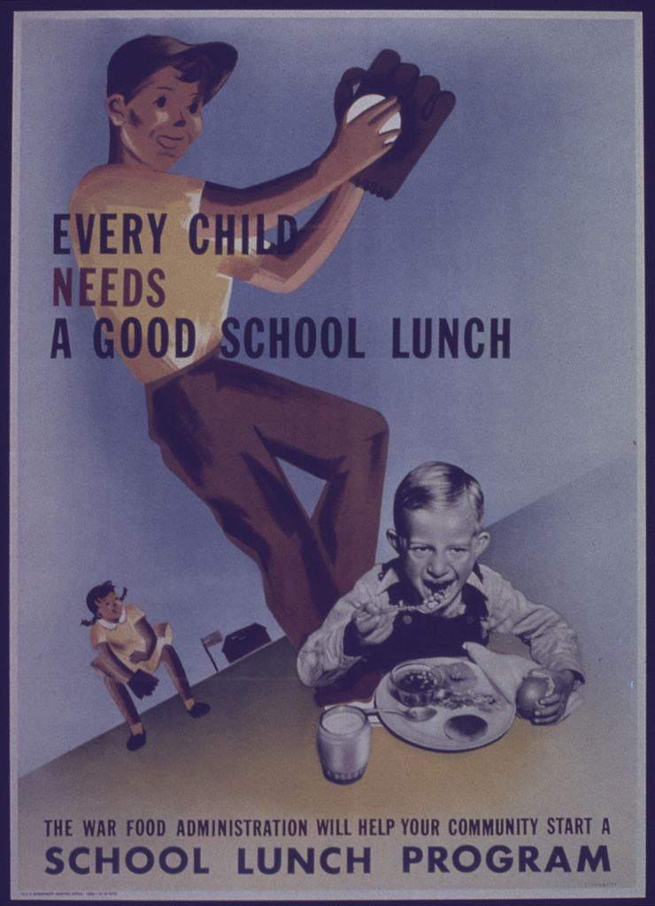
Figure 2: Every child needs a good school lunch: the War Food Administration will help your community start a school lunch program. Poster 1944. (Gunderson, 2014)

The government’s role became key during the 1930s with the devastation of the Great Depression. With people unable to purchase food and farmers with surplus goods, Congress passed the Agricultural Act of 1935, which created a mutually beneficial relationship between farmers and the government (Gunderson, 2014). Malnutrition was declared a “national security risk” during this turbulent time, making the need for government intervention imperative. In 1946, President Truman signed the National School Lunch Act to improve the health of children, in addition to ensuring a market for farmers. This was the very beginning of minimum school food standards and free and reduced meals. This act still exists today, but has been amended over time, and likely will again with constant updates to nutrition guidelines. Other regulations born during this era were the Child Nutrition Act of 1966, the Special Milk Program of 1966, and a Pilot Breakfast Program of 1966 – a precursor to the current School Breakfast Program.

Since its inception, the National School Lunch Program has undergone numerous modifications as nutritionists took issue with the quality of food being served in schools (USDA, 2013). The intrinsic health of the food was being questioned, as well as the variety. Nutritionists were first concerned that children of different stature, size, and metabolism were not getting the nourishment they required to perform well. This problem still exists today, as high-school athletes on free and reduced lunch receive the same meal as the non-athletes on the same program. It cannot be denied that each child requires a different amount of calories, fat, protein, and carbohydrates. Over time, the program received even more scrutiny as it continued to fall short of meeting the dietary guidelines in the school system. Recognizing the lack of proper nutrition in school lunches, Ellen Haas and Mike Espy, Assistant Secretary and Secretary of Agriculture, created the School Meals Initiative for Healthy Children in 1994 (Portner, 2016). This initiative required that, by 1998, every school must meet the USDA Federal Dietary Guidelines. Although this was the first major amendment to the NSLP in over fifty years, it proved quite difficult for many schools. Children were still choosing the less healthy options. The emergence of fast food chains directly exhibited major influence on students’ food choices. Cash-poor schools were unable to acquire the type of nutritious foods necessary to meet the standards. There was little push at home to have any kind of effect on these children while in school. By 2006, when Cooper and Holmes wrote Lunch Lessons, about 78% of U.S. schools failed to meet the nutritional guidelines set forth by the USDA. A 2007 study conducted by the Office of Research, Nutrition, and Analysis within the U.S. Department of Agriculture revealed that although many schools are meeting the standards for individual macronutrients, only a small percentage of schools are meeting all standards, as seen below.
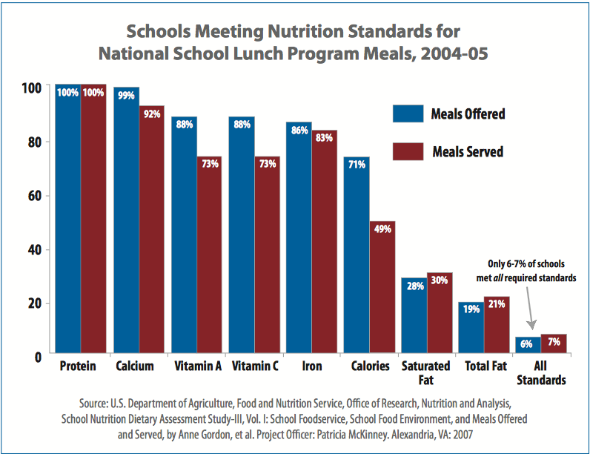

In recent years, more legislative action has been taken to meet these standards on a more consistent basis, while also improving child nutrition programs in schools. Championed by former First Lady Michelle Obama, the Healthy, Hunger-Free Kids Act of 2010 reauthorized funding and policy for the USDA’s child nutrition programs, including the National School Lunch Program, School Breakfast Program, Special Supplemental Nutrition Program for Women, Infants and Children (WIC), Summer Food Service Program, and Child and Adult Care Food Program (USDA, 2013). This marked the first time in over 30 years that the USDA could make reforms to these food programs by “improving critical nutrition and hunger safety net for millions of children.” When signed on December 13, 2010, this legislation provided $4.5 billion in new resources. A beneficial change was the increase in school lunch and breakfast reimbursement by six cents per meal (2013). However, schools had to meet the nutrition standards in order to receive the increase. The goals of this act were simple:

- Improve health of children in the U.S.
- Increase consumption of healthy food in school
- Reinforce healthy eating habits

With these in mind, certain provisions were implemented to ensure these goals were attainable. The nutritional quality of all school food would be improved, which included lunch line, vending machines, and school stores. Also, the number of children eligible for the program would increase. By using Medicaid data, about 115,000 new students entered the food programs. The act would also ensure universal meal access to children in food deserts or high poverty areas through elimination of paper applications; rather, census data would be applied (NCSL, 2011). In addition, by allowing the Child and Adult Care Food program to be reimbursed for providing a meal to at-risk children after school allowed for 21 million more meals to reach these children, annually. From an educational standpoint, this act required schools to publicize information about the nutritional quality of school meals to any parents or guardians through proper labeling. It would also allow the USDA to continue its work to further improve nutrition in schools.

Through this act, major improvements in school meals have been made for the first time in over 15 years. In alignment with the most up-to-date nutritional requirements, Michelle Obama and Agricultural Secretary, Tom Vilsack, implemented standards for school meals in 2012 (USDA, 2015). With the hope of improving the health of over 32 million children participating in school meal programs, these standards made certain that specific items were offered in schools, including:
- Fruits and vegetables everyday
- Whole grain-rich foods
- Fat-free and milk/chocolate milk
- Foods low in or absent of saturated fat, trans fat, and sodium

Below is a sample lunch menu for the week comparing food prior to and after implementation of the Healthy, Hunger-Free Kids Act (USDA, 2013).

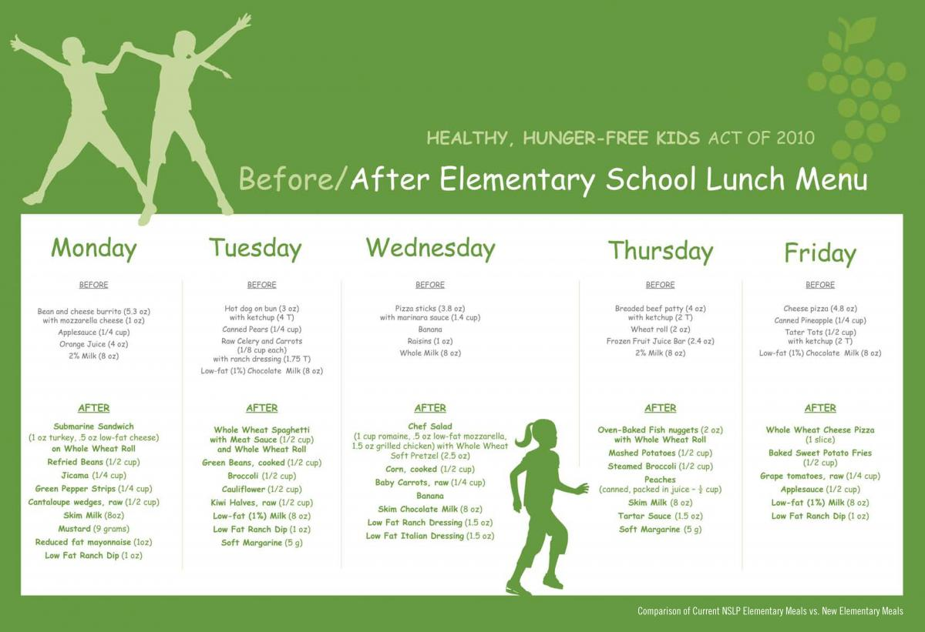

One can see noticeable changes in portion size and variety, as well as nutritional content of the food offered. For example, the new menu for Monday would result in longer and more sustained energy levels in children (USDA, 2013). Eating a well-balanced meal of carbohydrates, protein, fat, and fiber will satisfy a child’s hunger much longer than a meal full of added sugar and high levels of sodium. Further improvements have been made in nutrition standards as noted in the 2013 revision of the USDA Meal Pattern Chart, which can be seen below.
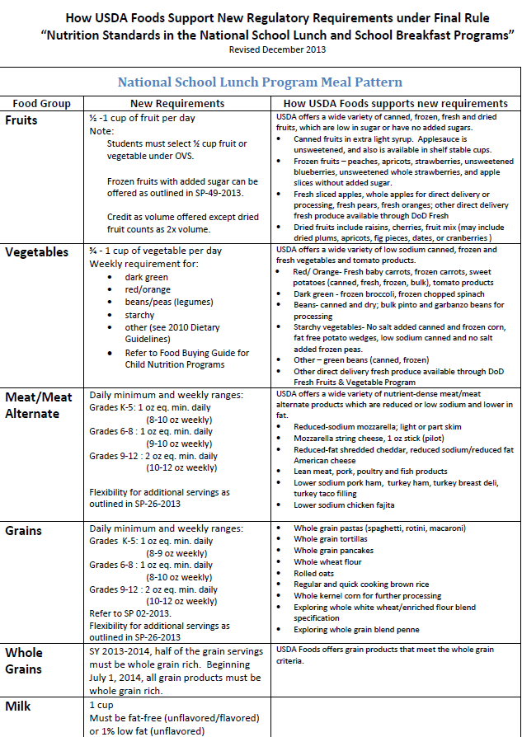
The most important takeaways from this table are:
- Prioritization of fresh fruits and vegetables
- Decrease in added sugars
- Increase in low-fat or nonfat options
- Decrease in sodium content
- Transition to whole grain rich foods
- Difference in caloric intake levels for varying age groups

As recommended by an expert panel from the Institute of Medicine, these standards made healthier foods more accessible and routine for students (USDA, 2015). Once these standards were set, schools were required to meet at least the very minimum. It became the responsibility of each individual school and its county to abide by these regulations. However, as these new standards were implemented in partnership with the Healthy, Hunger-Free Kids Act of 2010, many schools experienced financial roadblocks.

Upon release of these standards in 2012, schools began withdrawing from the National School Lunch Program in large part due to economic concerns. The cost of food increased, sales started to decrease, and competitive food sales resulted in a loss of revenue in schools (Gunderson, 2014). The Network for Public Health Law noted that over 90% of schools experienced an increase in foods cost, enough to create an imbalance between food sales and food costs. Essentially, the increased rate in meal reimbursement (6 cents) did not sufficiently cover the increased cost of foods. The National School Board Association claimed these new standards as an “‘unfunded mandate’ that cannot be maintained” (Network for Public Health Law). This may seem as though policymakers passed an unattainable set of standards, however, it is very important to take into account the level of accuracy and reporting that plays a part in this controversial matter.

According to the 2013 School Nutrition Association survey, it was made clear that out of the more than 100,000 schools that participate in the NSLP annually, less than 1% of schools actually withdrew. This survey also provided pertinent information about continuing nutrition education in these schools. The majority of schools that withdrew still maintained certain standards, or made their own improvements in lieu of participation in the NSLP. Several have voluntarily maintained the free and reduced lunch program as part of their own financial plan. In addition, many schools that withdrew from the program had the least economic incentive to participate due to higher food sales than their counterparts (SNA, 2013). It is also important to understand that the students no longer participating in the program generally had the highest accessibility of healthier foods, as well as the financial ability to purchase fresher, more nutritious foods.

CHAPTER 3
Successful Food Programs throughout U.S. Public Schools

With the implementation of nutrition education in schools becoming more pertinent, it is helpful to look into specific examples of successful food programs around the country. These programs are tackling the very issues that are fueling the alarming health rates among children. They exist both inside and outside of the school, reaching the community, as well as the children. Each of these programs has been successful particularly due to the dedication of those in charge, in addition to the acknowledgement of necessary change. Some have been in practice for years at this point, while others are more recent. From them, it is possible to successfully implement similar programs in Baltimore County Public Schools, which we will see later in Chapter 4.

Ann Cooper and Lisa Holmes nicely describe a wide range of school systems around the country that have gone a long way to reform school food. They focus heavily on one specific program, known as The Ross School in East Hampton, New York, as it was their main inspiration for large-scale school lunch reform. This private boarding school is remarkably different than many other schools in that it employs trained chefs who design, cook, and serve the food to the students. These chefs have complete control over the school lunch program and have taken great interest in feeding their students wholesome meals. Ann Cooper was executive chef for some time at the Ross School and saw firsthand how food cooked fresh by trained individuals made a significant impact on the students’ desire to eat well (Cooper and Holmes, 2006). Lunch was void of any and all fried food high in sodium and saturated fats. Similarly, there was no such thing as reheated, packaged foods. Cooper claimed that if delicious food were placed in front of students, they would eat it, even if it were all vegetables. The staff has a profound love of cooking and crafting delicious, healthy food, which makes all the difference in this school.

A typical Café menu at the Ross School looks like this (The Ross School, 2017):

Wednesday, March 1, 2017
BREAKFAST
Avocado, Cereal, Fruit and Yogurt, Mango Lassi, Assorted Muffins, Steamed Eggs with Spinach, Rice Congee with Salmon, Gluten Free Rolled Oats

LUNCH
Upper School
Chicken Soup, Watercress Radish Carrot Ginger Dressing, Brick Oven Pizza Traditional and Ricotta Roasted Pepper, Green Curry Pork Stew, Sweet and Sour Pork Meatballs, Kofta Lamb Meatballs, Vegetarian Moroccan Chick Peas, Roasted Carrots and Parsnips, Jasmine Rice, Tofu Du Jour
Lower School
Chicken Soup, Tuna Fish Salad, Arugula Feta Cheese Salad, Brick Oven Pizza Traditional and Ricotta Broccoli, Beef Stew, Polenta, Swiss Chard, Brown Rice, Tofu Du Jour

DINNER
Greek Salad, Smoked Ham and Pea Salad, Fish Cakes with Tartar Sauce, Lemon and Ponzu, BBQ Grilled Chicken Thighs, Boston Baked Beans, Roasted Potatoes, Sautéed Kale, Rice Pudding

The Ross School admitted experiencing difficulty when it came to issues of the supply chain, particularly in terms of quality consistency and spoilage. Producing good food was the goal, but to do this on a daily basis while committing to sourcing locally was a tricky task. When Cooper was Executive Chef, she created high-quality supply chains with many local farmers and small businesses (Cooper and Holmes, 2006). Strong relationships between both entities were a direct result of this. The Ross School’s commitment to these producers helped encourage the commitment of the producers in supplying to the Ross School.

The Ross School does not stop there. Teaching the students about nutrition is just as important as supporting their health in the cafeteria. Along with lesson plans, Ross incorporates a fully integrated curriculum. For example, while studying the Renaissance, ancient Greece, and India, the students were able to recreate historically traditional food. In addition, the Café at Ross is located in the Wellness Center, where children are given lessons in nutrition, health and sustainability. The interesting part is that they are graded on what they know about their food choices and what they put on their plate at lunch. Ross also requires cooking as a part of the graduation requirement and each student must participate in the school garden or at one of the local farms (2006). They see the impact that hands-on learning has on the health of their students. Even today, The Ross School ensures that the cuisine is fresh, local and healthy. As part of the Wellness curriculum, healthy food lessons are available for students, as well as options for gardening and composting on campus (Wellness, 2017). It is important to note that this school is a private boarding school requiring annual tuition from its attendees. Therefore, they are able to implement these programs and practices more easily than schools that don’t have similar funds. Although their model is very different and may not be affordable for some, by adopting a similar version of their transformative, hands-on nutrition education, other school systems can be just as successful.

Cooper and Holmes also give great praise to the widely renowned program that was created in 1995 by Alice Waters, known as The Edible Schoolyard (Cooper and Holmes, 2006). Founded in the vacant lot of Martin Luther King, Jr. Middle School in Berkeley, California, this project was designed to put gardens in all California schools in order to reform the school food program. Its mission was and still is simple: to promote awareness and appreciation of food through farming, harvesting, and preparing healthy meals. Complete with interactive garden and kitchen classrooms, The Edible Schoolyard works diligently to create a national edible education curriculum for all students. Their goal is succinct and clear, as it encourages students to make healthier food choices simply by giving them the necessary knowledge and experience. As part of the curriculum, every incoming sixth grader harvests the crops planted by the previous sixth grade class (The Edible Schoolyard, 2017). This begins their first experience in the school garden and after ten weeks, they move into the kitchen, where the real magic happens. Here, they examine the harvest, learn about its structure, nutrient content, and use. In the kitchen, teachers take notice of how happy the students are and how cooking increases their creativity and imagination.

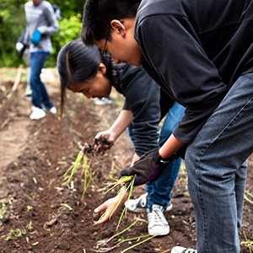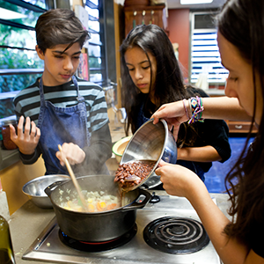

Esther Cook, a chef/teacher at the school, stated that in the beginning, she was petrified at the task of getting kids excited about food. However, after some time, she realized that “when kids are happy and enjoying what they’re doing, the learning is easy and the food tastes good” (2017). This is what The Edible Schoolyard has done so well. These students learn about food and nutrition in a fun atmosphere along with their peers. They are able to express themselves as individuals, share their likes and dislikes, work with others, and build a community around the love of food.

“Right there, in the middle of every school day, lies time and energy already devoted to the feeding of children. We have the power to turn that daily school lunch from an afterthought into a joyous education, a way of caring for our health, our environment, and our community.”
Alice Waters, Edible Schoolyard: A Universal Idea (2017)
Alice Waters, known to many as the passionate, fearless leader of school food reform, founded the Chez Panisse Foundation in 1996. This foundation wished to create a school curriculum that included learning in gardens, kitchens, and lunchrooms, as well as nourishing students with fresh food. After inception, Waters partnered with the Berkeley Unified School District and the Center for Ecoliteracy to implement The School Lunch Initiative (Cooper and Holmes, 2006). After three years of dedicated work, this initiative delivered healthier food options for breakfast and lunch to over 10,000 Berkeley public school students. With such a large-scale reach, evaluation of this initiative was essential to see whether or not it was making a lasting impact or a fleeting one. In 2010, a report written by the Center for Weight and Health at UC Berkeley validated exactly what Waters hoped for from this initiative – when children are happily engaged in growing, harvesting, and cooking their own food, they are far likelier to eat it. The initiative changed the way children thought about food, health, and their own well-being. The School Lunch Initiative is nationally recognized and continues to serve as an example of successful school lunch reform.

The Edible Schoolyard Project offers even more opportunity to expand nutrition education through its Edible Schoolyard Academy, which is specifically designed to strengthen and build sustainable edible education programs throughout the country. The Academy offers a five-day course for participants to discuss curriculum integration, effective strategies, classroom techniques, and leadership skills. Each student of the academy learns how to integrate these methodologies in ways that would benefit their unique school environment and location. The Edible Schoolyard Academy provides them with the necessary tools and know-how to implement similar strategies within their own food programs (2017). It is just another example of how The Edible Schoolyard Project is working toward a better, healthier future for the nation’s children and school systems.

Within the structure of the Academy, educators learn more about the type of curriculum that the ESY promotes within schools. With edible education at the very heart of the curriculum, the classes and lessons are very hands-on, experiential, and fruitful. The students are quite literally bringing “academic subjects to life,” as well as fostering an interest in the natural world (2017). All of these lessons are applicable to the real-world and their surrounding environment. They are learning social skills, how to nurture and care for other living organisms, provide their own nourishment, develop a relationship with the environment, and bring their knowledge to their homes. The Edible Schoolyard Project insists on holistic and inclusive learning in which the child benefits in more ways than one. The goal is to broaden their knowledge both in and outside of the classroom, stengthen their individuality, and encourage creativity (2017). Academic classes, such as Mathematics, Biology, and English are just as important as Life Skill Development, Sustainability, Nourishment, and Communication (2017).

Since its inception, The Edible Schoolyard has created material for their training program and school-based curriculum. To date, more than 62 lessons have been created for middle school students, grades 6-8, in order to meet the goals of the Edible Education Framework (2017). The lessons within the curriculum are designed to develop:

- “A sense of curiosity and dignity
- The ability to work as a team to complete a job well
- Respect for oneself and others
- An appreciation for diversity
- An understanding of how the ritual of eating together at the table connects families and communities”

A sample lesson for eight grade students is exhibited below (2017):

Kitchen Lessons
Fall Rotation
- K8-1: Independence Series Lesson #1: Soft Pretzels with Mustard and Chai Tea
- K8-2: Independence Series Lesson #2: Roasted Vegetables with Yogurt Sauce
- K8-3: Independence Series Lesson #3: Chow Mein

Spring Rotation
- K8-4: Debate Plate #1: Health & Nutrition Spiced Red Lentil Stew and Indian-Spiced Cabbage Slaw
- K8-5: Debate Plate #2: Environment Frittata and Green Salad with Vinaigrette
- K8-6: Debate Plate #3: Justice and Labor In the Academic Classroom
- K8-7: Debate Plate #4: Justice and Labor Broccoli Macaroni and Cheese
- K8-8: Debate Plate #5: Cost and Access Chili and Cornbread
- K8-9: Pizza Celebration

Debate Plate
In this eighth grade humanities lesson, students make frittata and a green salad with vinaigrette and discuss various environmental impacts of food choices, focusing specifically on the issue of food waste. This is the second of five Debate Plate lessons, which is a series that focuses on factors and considerations that influence personal food choices.

Objectives
After this lesson, students will be able to:
- Discuss how all food choices have some form of environmental impact
- Articulate and give examples of the concept of “waste as a resource”
- Consider how their personal consumption behaviors and food choices impact the environment and propose ways to mitigate negative impacts

Assessments
During this lesson, students will:
- Discuss composted kitchen scraps as a vital resource in building the soil in the garden
- Brainstorm creative ways to repurpose common disposable items
- Identify examples of waste in the kitchen or their personal lives, analyze their potential causes, and propose ways to mitigate them

With each lesson, whether it is given in the kitchen or garden, there is also a set of materials, procedures, vocabulary, connections to the Edible Education Framework, Academic Standards, and Edible Schoolyard Standards (2017). In addition, a list of resources is provided for further learning. The curriculum is diverse, stimulating, thorough, and comprehensive. The Edible Schoolyard has made nutrition education a daily part of the school curriculum, encouraging other school districts to adopt similar models. Sister programs have reached various schools throughout New Orleans, Los Angeles, San Francisco, and Brooklyn, implementing kitchen and garden techniques first developed in Berkeley. With community, government, and school support, edible education, just like the Edible Schoolyard, can be implemented in Baltimore County Public Schools. By using similar techniques and tools easily accessible to the public, Baltimore County schools could better integrate edible education in its curriculum.

CHAPTER 4
Special Focus:
The Baltimore County Public School System

Baltimore is a food desert – it has been defined as “an area where the distance to a supermarket or supermarket alternative is more than 1/4 mile, the median household income is at or below 185% of the Federal Poverty Level, over 30% of households have no vehicle available, and the average Healthy Food Availability Index (HFAI) score for all food stores is low” (Buczynski, A., Freishtat, H., & Buzogany, S., 2015). These residents continue to suffer from poor nutrition due to the lack of access and sufficient financial means to purchase healthier food (JHU, 2015). The problem of food access is an undeniable and obvious one in these communities (JHU, 2015). One of the many unfortunate, yet accurate outcomes is that children are disproportionately affected by these factors. In Baltimore alone, 30% of children are affected by living in an area deemed a food desert. In 2015, The Johns Hopkins Center for a Livable Future claimed that 1 in 4 residents of Baltimore live in a food desert (2015). With such food distress and lack of resources, nutrition education fails to make their list of top priorities.
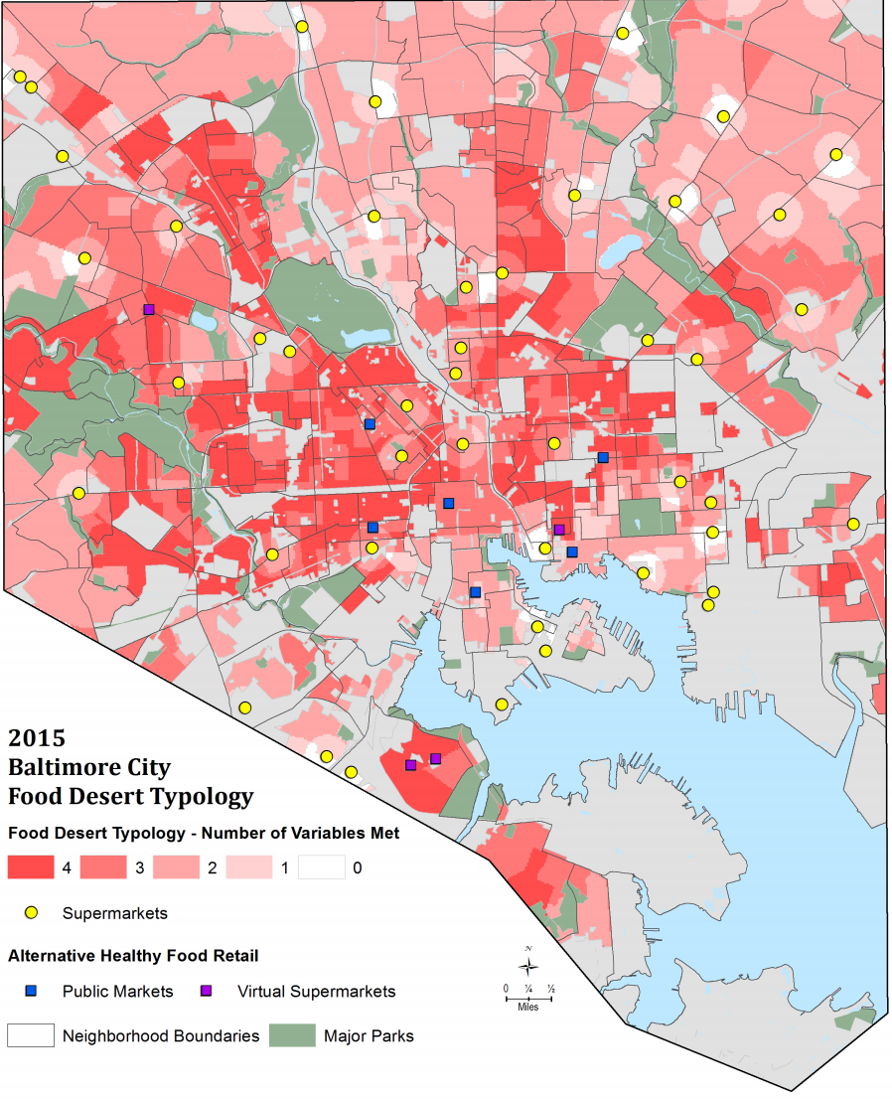
Figure 4: Food Map, 2015
Baltimore County and Baltimore City are close neighbors to one another. Baltimore City faces more issues with food accessibility and affordability; however, Baltimore County has its own set of problems, as well. Many residents of the county experience hardship when it comes to affording healthier foods, especially since the economic recession, as prices for goods soared and continue to fluctuate. There is a significant number more grocery stores in the county than in the city, but when looking at the Baltimore County Food Systems Profile compiled in 2016 by The Johns Hopkins Center for a Livable Future, there is almost an equal amount of convenience stores and fast-food chains, with a fewer amount of grocery stores. With this information, it is reasonable to believe that unhealthier, ready-made food is generally more popular than fresh foods found in grocery stores, despite its larger presence. It seems that despite the amount of access, if the educational aspect is lacking, then people will still be less inclined to make healthier food choices.

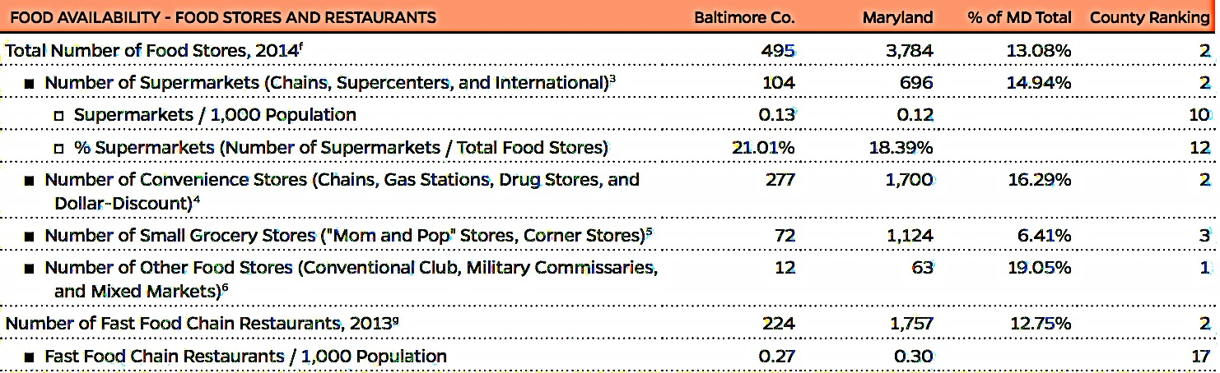
Figure 5: Maryland Food System Profile II, Baltimore County (2016)

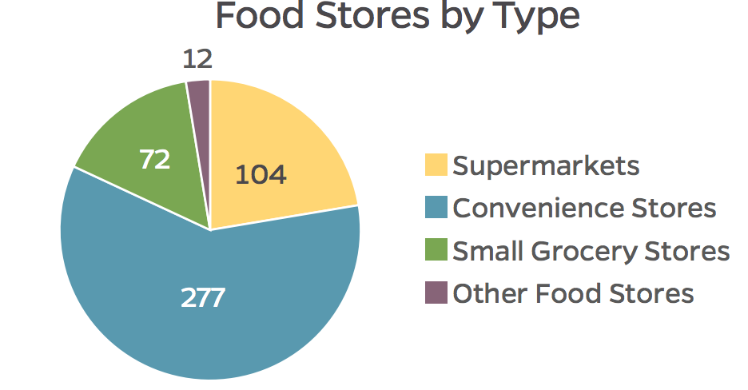

Figure 6: Maryland Food Systems Profile II, Baltimore County (2016)

The same sort of disproportionate pattern exists in Baltimore City, simply on a larger scale. However, it is important to note that as of 2010, 31.90% of Baltimore County residents were classified as living in a food desert. That is compared to the total of 27.34% in all of Maryland (JHU, 2016). About 12.9% were deemed food insecure, meaning they lack reliable access to a necessary amount of affordable, nutritious food. All of this directly affects the school systems and their ability to provide nutritious, affordable food for the students. Many students depend on their school food programs to provide their meals for the day, but in cities like Baltimore, supplying healthier food items does not come easily. With the help of government organizations and non-profits, students are able to go through the school day with a satisfied stomach.

Families in Baltimore County have to send their children to school unsure of what exactly they will be eating, or how much. Josh Sanders, a Baltimore County resident, sends his children to school often times with the hope that the Maryland Food Bank will visit with its pantry program. Like any caring father, he states, “I can go without [food]. They need to eat. This is a lifesaver" (McDaniels, 2015). Programs like these not only provide children with better access to food options while in school, but also a sense of relief for the parents, knowing that their children will be properly fed. President and CEO of the Maryland Food Bank, Deborah Flateman, proudly states, “We are bringing the food and the access to food to the families” (McDaniels, 2015). With greater acknowledgement of these food issues in Baltimore, schools and officials are working harder to create healthier habits both inside and outside of the classroom.

There is no one more willing and hopeful for the future of these children than the Director of the Office of Food and Nutrition Services for Baltimore County Public Schools. Ms. Karen Levenstein has been working to improve the food choices in Baltimore County Public Schools for many years. She states that it has taken a while to get to where we are now – schools with gardening programs, “share” tables for unwanted food, and 100% whole-grain rich foods. After an informal conversation about past and current Baltimore County Public School food programs, Levenstein noted that major changes occurred in 2010, after legislation reformed the USDA’s nutritional guidelines in schools. Regular milk was replaced with skim or low-fat, every meal required a fruit and vegetable on the plate, whole-grain rich products replaced processed, white flour foods, and “low-sodium” items superseded the once sodium-saturated (2017). Once these guidelines went into effect, Baltimore County went full throttle and committed to a 100% whole-grain rich menu. Baltimore County jumped ahead to the end goal and then took time to review where and how improvements could be made. Others eased their way into the newly structured standards.

Challenges arose as these new guidelines went into effect. As Director of Food and Nutrition Services for the county, Levenstein was responsible for adhering and implementing these standards in every school. She noted that the schools that seemed to best adapt were the ones with stronger science curricula and invested, passionate educators. If a school lacked a palpable science curriculum, so did any sort of consistency of nutrition programs. If the science program excelled, so did gardening, nutrition, and wellness (2017). The rate of success for each of these pillars was, and still is, a direct result of hard-working, enthusiastic teachers who see merit in nutrition education. If teachers see the importance of living healthier lives and have the desire to improve their own, then there is a better chance of their students adopting the same mantra. There are some incredible teachers that just have the natural ability to get students excited about things they wouldn’t have found interest in before. The problem is that these teachers do not exist in every classroom, in every school, in every county. Many teachers do not want to put in the extra time and effort to give nutrition education a greater role in the curriculum. From the conversation with Levenstein, it seemed as though many parents aren’t pushing hard for this change, either (2017).

Overall, parents want to ensure their children are being taken care of while in school. It is supposed to be a positive and safe place for their children to learn, grow, and socialize. However, their diet is not necessarily of major concern – at least not on the same level as development, social skills, and cognition. Levenstein spoke about issues with the students adapting to the food changes in schools, but also on the need for greater involvement from the parents of these students (2017). As mentioned before, cost is a determining factor in what children consume. If their parents can’t send them to school with a packed lunch or enough money for the school-provided lunch, then the children have little choice in what they eat. The free and reduced meals help, but only so much. Parents pose a big challenge for the Office of Food and Nutrition Services (2017). If parents don’t see the importance and necessity of nutrition education, then it is even harder to instill healthier eating habits in the minds of these malleable children. If a child’s experience at home is completely different than his/her experience in school, then he/she may have a tougher time understanding what is best for their general well being. This is why educating the parents is just as essential as educating the students. If there is homogeneity between school and home, these nutrition programs will be all the more successful.

Another challenge when converting to healthier foods is its appearance. Often times, the color, shape, and/or texture of the item changes with the supplementation of healthier ingredients. This alone can affect a students’ willingness to even try the product. Children are often known to be pickier eaters, so it is safe to assume that a product they once loved may not be as highly regarded after alteration. For example, bread choices in the cafeteria have changed since 2010. Previously, white dinner rolls or sliced white bread was served to the students. With the full commitment to 100% whole-grain rich products, Baltimore County Public Schools stopped serving this starchy, simple carbohydrate. Instead, whole-grain rolls and bread took its place. The challenge was that it was brown – and students noticed. This was an immediate turn-off. Levenstein said that the county had to go back to its supplier, H&S Bakery, and ask for an alternative that still met the whole-grain standards (2017). The solution was a different type of flour much lighter in color, but still packed with fiber, protein, and nutrients – white whole-wheat flour. This made all the difference and students were less apprehensive to consume. In situations like this, BCPS had to go back and make some changes to ensure food was not being wasted, and that their commitment to whole-grain was still intact.

In another sense, giving these children more color, variety, and flavor in their food choices also meant giving them more freedom. It became apparent that these students enjoyed the raw carrots and snap peas because they were vibrant, crunchy, and sweet. The different types of salads, whether it was Caesar, Asian-Sesame, or House, gave them the ability to choose what sounded most appealing that day. It was about making healthy “cool.” The desire to eat healthier has to be present, which means the food has to taste good. The students should still be able to choose what they want, but altogether have better access to all varieties of food. BCPS has made this possible by asking their produce suppliers to find and send in more seasonal fruits and vegetables, like nectarines, peaches, plums, apples, squash, and leafy greens. It’s fresh, healthy, colorful, and tasty – everything needed to convince that student to give it a try.

With greater freedom of food choice, students must also understand the science behind why eating these healthier foods is important to their well being. Why eat more whole-grain rich products, low-sodium foods, and reduced-sugar items? What difference does it make anyway? Since the USDA implemented food programs in schools, the food guide (or food pyramid) has changed drastically (USDA, 2011). In the early 1940s, there were seven different food groups that made a well-balanced diet. Notice that one of the major food groups was butter and margarine – an important food group at the time, but not necessarily the best depiction of healthy eating. Yet, this is where we see major differences in a span of 75 years. Food habits change, products change, health rates change, demands change, supplies change, and food science changes.

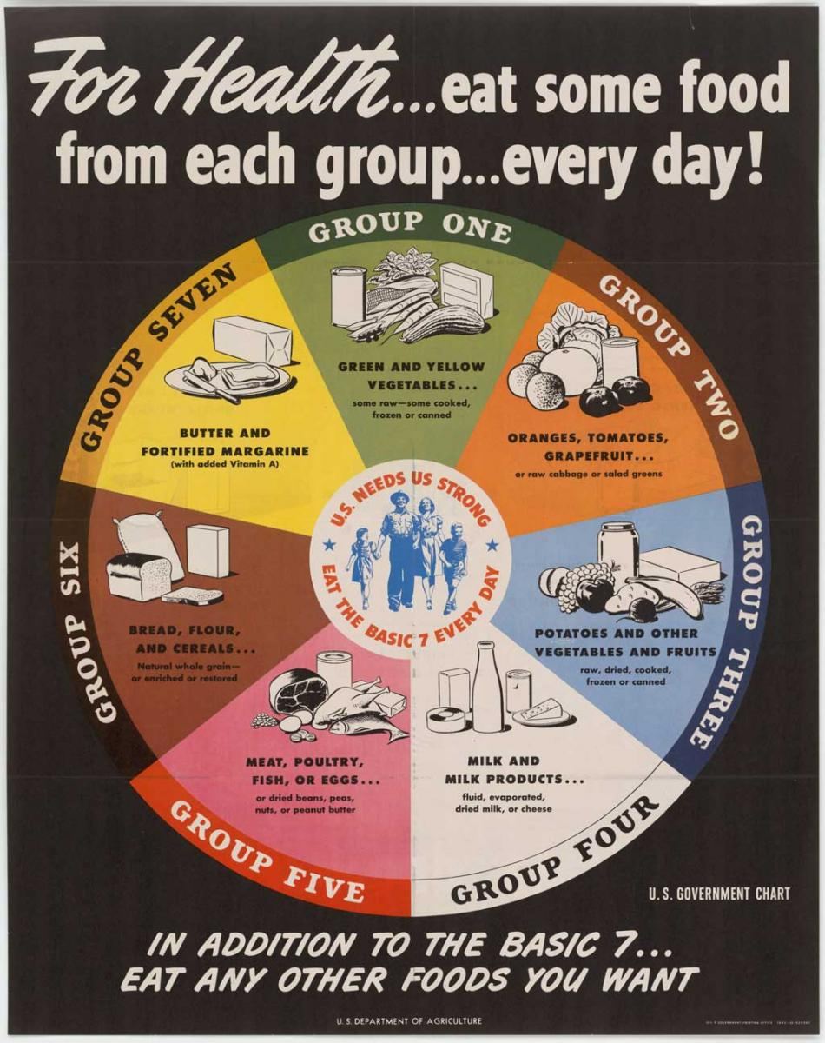
Figure 8: Food Guide Circa 1940s (USDA, 2011)

By the early 1990s, the food guide took the shape of a pyramid, with each ascending level marking a smaller food group (2011). Portion size and visualizations of added fats and sugars were depicted throughout the guide, urging Americans to be more aware of hidden ingredients in their foods. The category that once belonged only to butter now included all dairy products. However, the largest category of food was bread, cereal, rice and pasta, encouraging 6-11 servings per day. Interestingly enough, health experts today are urging consumers to reduce the amount of starchy carbohydrates in our diets, unless whole-grain. Nonetheless, no one is encouraging 6-11 servings of starch each day. MyPlate, the current food guide, recommends 5 ounces of grains per day for elementary-aged children, and 5-8 ounces for middle-school aged children (USDA Choose MyPlate, 2017).

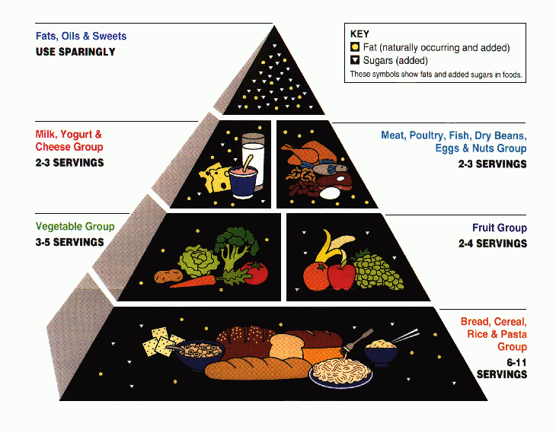
Figure 9: 1992 Food Guide Pyramid (USDA, 2011)
The food pyramid introduced in 2005 became the first to incorporate activity along with eating responsibly. Although this was a step in the right direction, this new pyramid lacked serving size suggestion and mention of sugars and fats. It was less detailed and harder to understand.

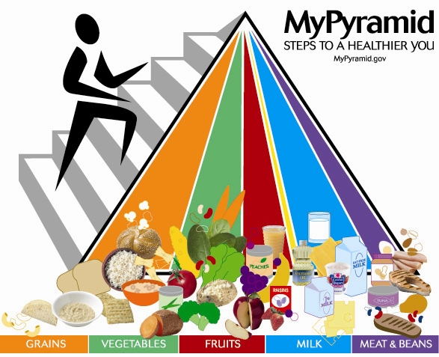
Figure 10: 2005 MyPyramid Food Guidance System (USDA, 2011)

The current food guide, MyPlate, is in accordance with the USDA’s 2010 Dietary Guidelines for Americans. It visually represents how a typical plate should look at mealtime and instead of promoting specific messages, it encourages healthy eating from a more holistic approach. From its homepage, the goals of MyPlate are to:
- “Focus on variety, amount, and nutrition.
- Choose foods and beverages with less saturated fat, sodium, and added sugars.
- Start with small changes to build healthier eating styles.
- Support healthy eating for everyone” (USDA Choose MyPlate, 2017)

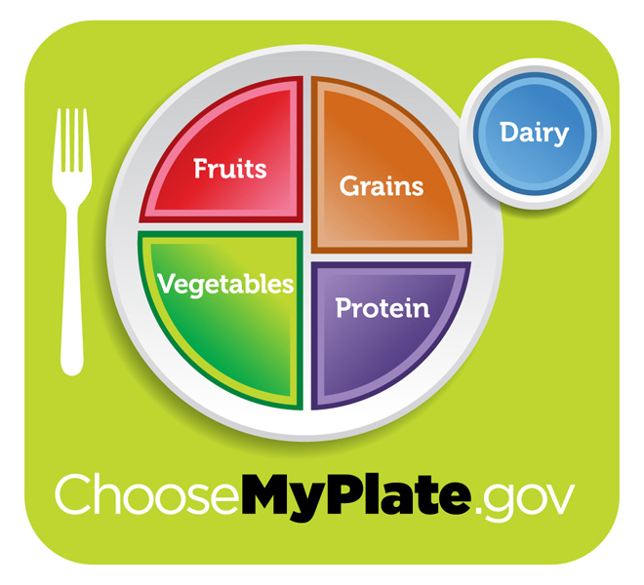
Figure 11: 2011 MyPlate (USDA, 2011)

This new food guide offers a wide variety of tips, advice, and information on how to live a healthier lifestyle. Rather than just a simple infographic, MyPlate houses a large inventory of materials available to all users. It breaks down healthy living into subcategories based on age, activity level, pace of life, and body composition (2017). It gives the user the ability to move at one’s own speed and comfort level, urging him/her to focus on small wins instead of looking too far into the future. One of the best aspects of this food guide in relation to nutrition education is its attention on family. MyPlate supports healthy eating and lifestyles inside, as well as outside of the home. Along with recipes and printable guides, MyPlate offers helpful tips on how parents can help their children make better food choices. Simultaneously, they are learning how to improve their own diets, in turn. Eating on a budget can be very difficult, as seen in Baltimore, however, MyPlate works to ease the burden as much as possible by providing valuable information to these families. Planning, searching for deals, meal prepping, and cutting back on eating out are all listed as ways to save money while eating better.

With all of the food changes occurring in Baltimore County Public Schools, it is important to understand why these changes are necessary. Why make such major changes in school cafeterias when the children aren’t really asking for it? The answers may be varied, but in the end, it simply supports healthier, longer, and happier lives for the younger generations. The main pillars of the newly renovated school lunch include grains, vegetables, protein, fruits, and milk. The switch to 100% whole-grain was a bold move for Baltimore County, but it proved successful as students began consuming and enjoying these fiber-rich products. Whole grains are excellent at keeping us fuller longer, which is great for school-aged children because they are in class for over 6 hours each day. The less hungry a student is, the more focused he/she will be in the classroom. Whole grains also contain an abundance of vitamins and nutrients, including protein, B vitamins, antioxidants, magnesium, and zinc (USDA Choose MyPlate, 2017). In addition to these health benefits, whole grains assist in regulating blood sugar levels, cholesterol, and blood pressure. These nutrient-dense grains help students stay alert during the school day, which leads to greater learning!
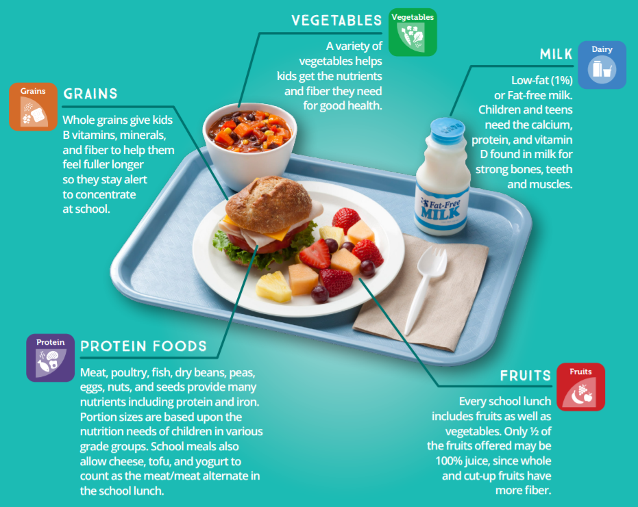
Figure 12: MyPlate School Lunch (2017)

Diets rich in vegetables are also rich in fiber, potassium, folate, and Vitamins A and C. They are generally low in both calories and fat, hence its large presence on the MyPlate depiction. Baltimore County is doing a greater job at incorporating vegetables in every meal while also making them appealing to students. This is just another example of children making healthier food decisions all because healthy food is easily accessible. Similarly, fruits are very popular during mealtime, as well as snack time in schools. Levenstein stated that with seasonal fruits, some cafeteria workers make hallway rounds, passing out the freshest picks for students to enjoy while in class (2017). These fruits are packed with natural sugars, making them sweet without being inundated with artificial enhancements. In school, the serving size of fruit is based on caloric needs, age, sex, and activity level. Overall, the serving size is about 1 cup, but only ½ cup of dried fruit, as these have a higher percentage of sugar (USDA Choose MyPlate, 2017). Students are given a wide range of choices, including apples, oranges, watermelon, cantaloupe, peaches, and bananas. The more a child is exposed to healthy, tasty treats, the more likely they will be to ask for them at home.

The science of food and nutrition has undoubtedly changed over time, and it will continue to do so for years to come. Countless factors affect the way we eat, how much we eat, what we choose to eat, and why we think we need to eat. Cultural, social, psychological, and physiological factors all play a key role in the decision-making process. The more we are willing to learn and talk to one another about nutrition, the healthier we will be in the long-run. Baltimore County Public Schools is committed to creating healthier habits for students, as well as families. Levenstein has an important responsibility to continue researching, learning, and developing innovative ways to encourage healthy lifestyles in and out of the classroom. She already has a running list of what she and her team can be doing better to make schools healthier spaces. Greater food marketing and advertising to parents, incorporating more taste-testing in cafeterias, as well as emphasizing MyPlate on the BCPS website are all areas of improvement that the Office of Food and Nutrition Services will be working on the next few years (2017). Talking with parents more often, engaging with faculty and staff to get them on board and excited about nutrition education, and creating better lines of communication among all parties are areas in which BCPS plans on making improvements. As food changes, so will the conversation. It is important to keep up-to-date with new information and find ways to make healthy living a trending topic.

CHAPTER 5
Future of Nutrition Education:
Parent Involvement

Throughout this research and upon talking with Ms. Karen Levenstein, one major component kept showing up as somewhat of a roadblock, or obstacle, one could say. In many cases, the parents and/or guardians are not highly educated in nutrition, diet, and exercise. This is not to say some do not take an interest or make an effort at home, but many are simply uninformed of the changes that need to be made to better serve their children later in life. For instance, if a child in Baltimore County goes to school and eats the standard school lunch, complete with fruits, veggies, protein, and whole grains, but then goes home to pizza, French fries, and Coca-Cola, there is an obvious disconnect happening here. Firstly, the child is being taught two very different styles of eating. Secondly, the positive change occurring in schools is being completely countered by what is taking place at home. Thirdly, there is an indisputable lack of communication between school and home. Each of these factors makes it difficult to instill lasting healthy habits in the child’s life.

Defining the Gap: Home and School
The issue for Baltimore County Public Schools is that they cannot control what takes place outside of school grounds; they cannot oversee what parents feed their children or how they make their meals. Levenstein noted this as a recurring problem for her team, as they try to find ways to close the divide (2017). How do we, as a community, create a balance between schools and home; one that teaches similar values and lessons? Unfortunately, we have learned that there is not one single solution. But, having many solutions is not necessarily bad. It allows us to work in many capacities, think in different ways, brainstorm ideas, and see which work better. Some solutions are simpler than others, while some require more time and effort. In the end, it is about creating a level playing field in which the education in schools is parallel to the education at home.

“The biggest change maker for getting individuals to eat more fresh fruits
and vegetables, especially children, is to have them actively participate in growing the food either at home with a home garden or at school.
That's what I did as a child, and that's what I do with my own children.”
– Scott, Colorado (USDA Choose MyPlate, 2017)

With the increased attention on childhood nutrition since 2010, there are more resources and tools aimed toward helping parents instill healthy habits at home. Parents, like Scott, who made changes at home after realizing how essential fruits and vegetables are in his child’s diet, can make small changes that will create long lasting effects. Starting at an early age, a child’s diet is heavily influenced by their parents. A child is much likelier to ask for certain foods if they have experience and exposure to them from a young age (Cooke, 294). If parents consistently expose their children to a variety of foods, they are helping create an openness to try many different flavors and foods. Consider the “mere exposure” theorem presented by Scaglioni et al (2008), in which the more exposure to a stimulus, the greater tendency to develop a liking for it. The more a child eats the specific food item, the better likelihood that he/she will enjoy it. In a study designed by Skinner et al, data supported the hypothesis that frequent exposure to a range of fruits within a child’s first two years of life would have a positive impact on their food choices once school-aged (Cooke, 296). The concept behind mere exposure is simple and effortless. It does not require a great amount of time from the parents. It is just about giving children more healthy options at a younger age, with the hope that it will correlate with greater consumption of healthy foods once given freedom of choice.

Children are generally picky eaters, or apprehensive to try new foods altogether. This is explained by Rozin’s concept of food neophobia, defined as the fear or reluctance of eating new and unfamiliar foods (Dovey et al, 181). Food neophobia exists in younger children and generally decreases with age. However, a child who suffers from food neophobia will reject many foods simply because they don’t “look right,” or they don’t “smell right.” This immediate classification prohibits the child from even trying the item. There is no taste test or sense of curiosity. This sort of explicit rejection can pose a tough barrier for parents to overcome if trying to expose their children to healthier foods, particularly fruits and vegetables. Note, according to Scaglioni, the more exposure the child experiences, the greater likelihood that he/she will give that item a chance. Yet, aestheticism plays a major role in food consumption at a young age. If a particular food looks good, then it must taste good, too. The same must be true for the opposite. That is how food neophobics think. However, food neophobia can be overcome by continuous positive experiences with the food item, supporting the “mere exposure” theorem discussed previously. It may take more trial and error than with a non-neophobic eater, but it is possible to expand the child’s desire and willingness to try new foods (Dovey et al, 181).

Age is essential to overcoming neophobia. After surveying 600 2-6 year-old children, Cooke found that neophobia had a significant negative association with fruit, vegetables, and meats. For a very young child, it may take only 2 or 3 exposures, but could take up to 8 or 10 exposures for an older child. This is likely due to increased autonomy. Cooke and Wardle (2005) claim that older children become less fearful due to more frequent and varied food experiences; fewer items are unusual to them. The table below shows the drastic incline of food neophobia during early childhood, then the decreased progression as the individual ages.

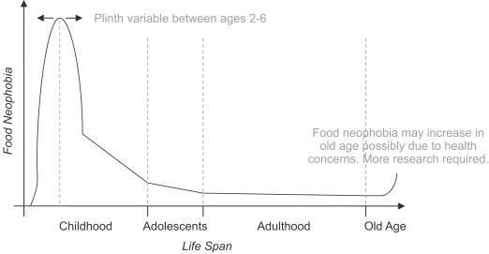
Figure 13: Increase in Neophobia in younger children and decrease with progressing age. Cooke and Wardle (2005)

The good news for parents with children who suffer from picky eating or food neophobia is that it can be combated with simple strategies. Keep in mind that positive parental role modeling can drastically improve a child’s diet; it is necessary to maintain a comfortable and open atmosphere at all times. Strategies to overcome food neophobia are very similar to that of improving overall childhood nutrition. They include, but are not limited to:

- Try new, unfamiliar foods in a comfortable setting, such as the home kitchen
- Eat the same foods as the child – “Do as I do” (Scaglioni et al, 2008)
- Talk about the particular food and why it is important to try it
- Involve children in the cooking and preparation
- Relate the food to a childhood figure (Batman loves broccoli)
- Pair the less desired with the most desired (i.e. spinach and mac ‘n cheese)
- Make food tasting fun with a game or story
- “Craft” with food – broccoli stars, fruit faces, Alphabet peas
- Offer these foods more often, in varying forms
- Don’t put too much pressure on the child to like the particular food
- Thank the child for trying, even if the attempt was unsuccessful

Resources for Parents
Helping children make healthier food choices is about consistency and effort. When parents see firsthand how these healthy decisions impact their child’s life, they will put more energy and enthusiasm into the process. It is key to also educate and inform these parents so they can better teach their children at home. By offering education sessions after school, one-on-one conferences with teachers, nutrition classes, group brainstorming meetings, and informative pamphlets, schools can make great progress in educating parents, as well. Changing eating habits at home doesn’t have to be dull or tasteless. Small changes can lead to big results and this is one direct result of parents taking a lead in their children’s nutrition education. One of the most accessible and informative tools is the MyPlate, MyWins for Families (USDA Choose MyPlate, 2017). The goal is to find a healthy lifestyle that works for everyone in the household. Tips, resources, and tools can be found all throughout the site for both parents and children. Social media and technology are a part of the daily lives for most American families. By using these outlets to promote healthy habits, offer assistance, and provide useful resources, parents may have an easier time implementing techniques at home. Videos of families talking about their experience, recipe books filled with healthy, low-budget meals, information about food grown in one’s home state, and more are available to the public at no cost. By taking advantage of such an extensive, detailed bank of information focused on healthy living, then parents and children have the ability to make simple changes at home and in school. Buying a cookbook, picking weekly meals, and cooking together are simple ways to make positive use of this resource.

Yet, some parents may still feel lost or unsure of how to get their children to eat healthier, while still working within a given budget and busy schedule. MyPlate offers so many simple, inexpensive, and fun ways to change eating habits at home. For younger children, games and activities keep them entertained, while also teaching them important lessons about food. Printing out coloring pages online of food items allows the child to have fun without feeling like they are back in school. It also gives them the opportunity to decipher between various fruits and vegetables based on color, size, and shape. Creating art with food is another easy technique to engage children. Instead of plating the strawberries, cucumber and orange, cut it into different shapes and let the child draw a picture with them. Giving them freedom of expression not only makes snack time more fun, but it will also make it more enjoyable.
For older children, one of the best ways to get them engaged in their own nutrition education is to give them more freedom in the kitchen. If they are part of the mealtime process and encouraged to help in the kitchen, there is more possibility that the child will develop a liking toward cooking. The notion is that if a child starts to enjoy cooking, then he/she may be more apt to try new foods, flavors, spices, and combinations (Ghezzi, 2017). MyPlate offers tips for the menu, as well as area dedicated to drawing and visualizing what the end result will look like (2017). Placing children in the kitchen also results in more family time and dinners together around the table. This is one of the best ways to create change as a unit – remove technological devices, engage in conversation, discuss what’s on the plate, let everyone choose their own food, and cleanup as a team. Healthier choices are much easier to make when everyone is involved rather than trying to do it alone.

Closing the Gap: Methods and Strategies
Parents and school faculty can promote healthy habits in fun, educational ways so that the children are entertained, while also putting their brains to work. Simple strategies to jump start this type of learning include (Ghezzi, 2017):

- Food Journals. Children log what they eat and drink every day, then write about what they liked, disliked, etc. They have the freedom to write about anything they choose. One of the goals could be whether or not they met the MyPlate serving size standards. This could be implemented as a weekly task due each Friday afternoon.

- Food Friday. Every Friday, teachers bring in a new, fresh item to taste test. Children can help prepare and serve, then enjoy a sample. The item could vary based on season, such as peaches in June or grapefruit in December. Afterward, they can discuss its nutrition, benefits, and even recipes for future use.

- Tuesdays at the Market. Once in-season, classrooms can visit the local farmer’s market to see the colorful fruits, vegetable, and herbs. They can talk to the farmers and learn how certain items grow. They can touch, smell and taste different foods to see they like best. With funds, the children could pick out one item to take home and share with their family.

“We have gone together to the supermarket to see and touch fruits and vegetables, and then associate them with colors, shapes, sizes, taste and smell. For example, I bought a pineapple and had the children find a palm bush nearby that matched the leaves on the pineapple. After cutting it, the children enjoyed the color, taste and smell of the fruit.” – Brenda, Georgia (Let’s Move! Child Care, 2017))

- Ready, Set, Recipe! Each week, children can take home a simple recipe that uses an ingredient discussed in the classroom. This gives the child the chance to experience preparing, cooking, and serving food. It also encourages families to work and eat together at the end of the day. After, children can come back to the classroom and talk about the meal with their peers.
When a team is able to work together amiably and effectively, they can do so much more than any one person. This type of teamwork is necessary between schools and home to ensure they are working toward the same goal. In order to bridge this gap, it is necessary to develop strategies and techniques that both entities can put to use in an effective manner. If the mission is to teach similar lessons about food both at home and in school, then both parties need to have a clear path to success. More hands-on activities, after-school workshops, online tutorials, informational pamphlets, take-home exercises, and teacher-parent communication are all useful ways to break the barrier. Back-to-school night or parent-teacher conferences are the perfect time to explore these techniques. They are dedicated, planned times in which both entities are present and focused on the children. During this time, they could discuss ways in which they could better help each other or define areas in need of improvement. It offers a time and place for open conversation; an opportunity for purposeful dialogue and brainstorming.

CHAPTER 6
Commitment to a Healthier Future

The culture and science surrounding food is fast moving and ever changing. The way in which our society views food will forever have a great impact on how we nourish our bodies and those of our children. It is uncommon and frankly unrealistic to believe that our future will be one in which every person sees the importance, necessity, and possibility of living in an entirely healthy society. We have tools in place to continue bettering the health of our citizens, both present and future. We must use these tools the best way we know how, and learn from those around us. More and more, we are witnessing children garner a love of food, cooking, and gardening. Children are taking interest in where their food comes from, how it is grown, and what they can do with it in the kitchen. They are finding that they have more energy and greater attentiveness in class because they have been properly fed. They are getting more nutrients and vitamins from their food than ever without noticing a major change in their lives. All of this has been a result of improving food in school systems around the country.

Creating lasting change in schools is not an easy task. There are obstacles that will need to be overcome, but with a positive attitude, determination, and sense of urgency, nutrition education can become an integral part of the curriculum. In light of the research and data presented throughout this project, there first must be a desire to implement this new age curriculum on a macro-level scale. Faculty, staff, parents/guardians, students, and the school board must be working toward the same goal. Those involved need to keep in mind the objective: to improve the health of the youth and decrease the rates of weight-related illnesses by increasing nutrition education in schools. If this is made clear to each of the stakeholder groups, then they can use their own knowledge and experience to achieve this shared objective.

One recommendation to achieve this is to bring all of these individuals together in one space and allow thoughts, ideas, questions, and creative processes to flow. The more these parties interact with one another, the clearer the lines of communication will be in the future. It must be understood from the start that each party has a unique perspective and can offer a different mode of thinking. For example, parents may be more concerned with the quality of food offered at meal times, whereas the school board may be more focused on food cost. Each is an important component, but they all need to be acknowledged equally. Another recommendation for implementation is to examine successful programs around the nearby area, perhaps talk to those whom had a hand in making it happen, and tailor the information to suit the school’s specific needs. Community gardens are a great example of this as many visit neighboring gardens to get a better sense of technical aspects, such as proper layout, design, and space, in addition to social factors like communal work and interaction. The same idea can be used to adopt nutrition education in schools.

The Benefits of School Gardens
A more in-depth method, but one that has proven to be extremely beneficial in improving nutrition education in schools, is gardening. School gardens present themselves as a perfect vessel for hands-on learning. Numerous studies have been conducted over recent years that examine the effect of fruit and vegetable consumption in school-aged children upon participating in a school gardening project. McAleese and Rankin (2007) found that after participating in garden-based activities, in combination with the nutrition curriculum, that students significantly increased their servings of fruits and vegetables; more-so than their peers who did not participate in the garden activities. Within the study, they measured intake of vitamins and nutrients, such as vitamins A and C, as well as fiber. Their findings supported the hypothesis that with the addition of school gardening to the nutrition curriculum, students increased their consumption of fruits and vegetables. This also supports the notion that hands-on activities in the curriculum have a positive impact on a child’s willingness to try new, healthier foods. Both school faculty and parents can use this to further their nutrition education both at school and at home, perhaps by having a garden in each.

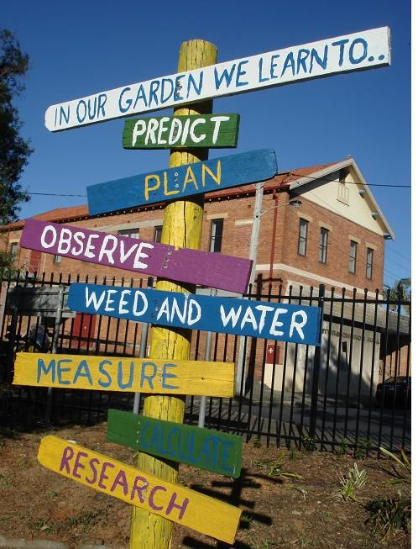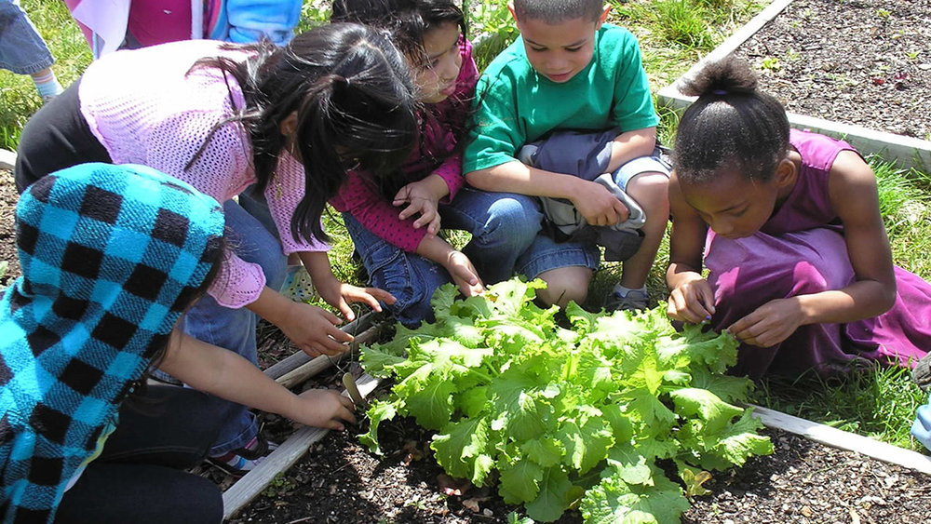

Another study conducted by Parmer et al (2009) concluded that the gardening component within nutrition education actually strengthened the probability of children consuming more vegetables (216). They found that with the inclusion of a school garden, participants showed a stronger desire and liking for vegetables over those who did not participate. It even resulted in greater likelihood of choosing vegetables over unhealthier options in the school cafeteria. Both articles support school-based gardening as an effective, positive tool to promote healthy eating habits in young children. Gardening also promotes life skills taught in the classroom, as well. Students learn how to think critically, observe change over time, research different species, and make predictions about the future of the garden. It is a prime example of a “living classroom,” in which students learn in a hands-on, outdoor environment. They are able to draw from real-life experiences and learn through doing rather than reading. Gardening provides a space to collaborate with others and bring lessons from the classroom to the natural world.

There is always more we can do to make greater strides in nutrition education. Nutrition education needs to start in primary school and continue through upper school, with modifications in lessons and activities. Schools must continue to find effective ways, like school gardens, to captivate children and keep them interested in healthy habits. In Baltimore County, this dedication could help bring to an end the food desert concern. With strong communication and the commitment to help the nation’s children live healthier lives, we have the ability to see positive change in our future, especially in the rates of childhood obesity and type II diabetes. Schools around the country continue to work on research and development in this area, hoping to make even greater strides over the next decade.

References

A Brief History of USDA Food Guides. (2011, June). Retrieved 2017, from https://faculty.mccneb.edu/CVanRiper/Unit%201/ABriefHistoryOfUSDAFoodGuides.pdf
About Child & Teen BMI. (2015, May 15). Retrieved May 03, 2017, from https://www.cdc.gov/healthyweight/assessing/bmi/childrens_bmi/about_childrens_bmi.html
Bialo, S. R. (Ed.). (2016, October). Weight and Diabetes. Retrieved January, 2017, from http://kidshealth.org/en/parents/weight-diabetes.html?WT.ac=p-ra
Buczynski, A., Freishtat, H., & Buzogany, S. (2015). JHU Center for a Livable Future: Mapping Baltimore City’s Food Environment. Retrieved April, 2017, from http://www.jhsph.edu/research/centers-and-institutes/johns-hopkins-center-for-a-livable-future/research/clf_publications/pub_rep_desc/mapping-baltimore-city-food-environment.html
Centers for Disease Control and Prevention. National Diabetes Statistics Report: Estimates of Diabetes and Its Burden in the United States, 2014. Atlanta, GA: U.S. Department of Health and Human Services; 2014.
Childhood Obesity Facts. (2017, April 10). Retrieved April 01, 2017, from https://www.cdc.gov/obesity/data/childhood.html
Cooper, A., & Holmes, L. M. (2006). Lunch lessons: changing the way we feed our children. New York: Collins.
Cooke, L., & Wardle, J. (2005). Age and gender differences in children's food preferences. PubMed, Retrieved from https://www.ncbi.nlm.nih.gov/pubmed/15975175.
Diabetes. (2016, July 25). Retrieved May 03, 2017, from https://www.cdc.gov/chronicdisease/resources/publications/aag/diabetes.htm
Dovey, T., Staples, P., Gibson, E. L., & Halford, J. (2007, September 24). Food neophobia and ‘picky/fussy’ eating in children: A review. Retrieved from https://www.researchgate.net/publication/5850115_Food_neophobia_and_'pickyfussy'_eating_in_children_A_review
Food Environment Map. (2015). Retrieved May 04, 2017, from http://www.baltimoresustainability.org/projects/baltimore-food-policy-initiative/food-environment-map/
Gebel, E. (2012, November). More Kids Than Ever Have Type 2 Diabetes. Retrieved December 18, 2016, from http://www.diabetesforecast.org/2012/nov/more-kids-than-ever-have-type-2-diabetes.html?referrer=https%3A%2F%2Fwww.google.com%2F
Ghezzi, P. (2017, March). 10 Ways To Promote Healthy Eating. Retrieved June 01, 2017, from https://www.ptotoday.com/pto-today-articles/article/895-10-ways-to-promote-healthy-eating
Gunderson, C. (2014, August 12). The Potentially Negative Consequences Associated with the Healthy, Hunger-Free Kids Act. Retrieved February 03, 2017, from http://policymatters.illinois.edu/the-potentially-negative-consequences-associated-with-the-healthy-hunger-free-kids-act/
Gunderson, G. W. (2014). THE NATIONAL SCHOOL LUNCH PROGRAM Background and Development . Retrieved January, 2017, from https://www.fns.usda.gov/sites/default/files/NSLP-Program%20History.pdf
Haynes-Maslow, L., & O'Hara, J. K. (2015, February). Lessons from the Lunchroom. Retrieved January 03, 2017, from http://www.ucsusa.org/food-agriculture/expand-healthy-food-ac
Healthy Food in Schools. (n.d.). Retrieved February, 2017, from https://letsmove.obamawhitehouse.archives.gov/sites/letsmove.gov/files/TFCO_Healthy_Food_in_Schools.pdf
JHU Center for a Livable Future: 1 in 4 Baltimore Residents Live in a Food Desert. (2015, June). Retrieved April, 2017, from http://www.jhsph.edu/research/centers-and-institutes/johns-hopkins-center-for-a-livable-future/news-room/News-Releases/2015/1-In-4-Baltimore-Residents-Live-Food-Desert.html
Karen Levenstein - Baltimore County Public Schools [Personal interview]. (2017, April 11).
Let's Move! Child Care. (2017). Retrieved March 01, 2017, from https://healthykidshealthyfuture.org/
Maryland Food System Profile II: Baltimore County, MD. (2016, January). Retrieved April, 2017, from http://mdfoodsystemmap.org/wp-content/uploads/2016/02/Baltimore.pdf
McAleese, Jessica D., and Linda L. Rankin. "Garden-Based Nutrition Education Affects Fruit and Vegetable Consumption in Sixth-Grade Adolescents." Journal of the Academy of Nutrition and Dietetics, Apr. 2007. Web. Feb. 2017.
McDaniels, A. K. (2015, March 31). More Md. schools opening food pantries. Retrieved April 04, 2017, from http://www.baltimoresun.com/health/bs-hs-food-pantry-20150316-story.html
NCES: Nutrition Education in the School Curriculum. (1996, July). Retrieved May 04, 2017, from https://nces.ed.gov/surveys/frss/publications/96852/index.asp?sectionid=3
NCSL – Healthy, Hunger-free Kids Act of 2010 (P.L. 111-296) Summary. (2011, March 24). Retrieved March 15, 2017, from http://www.ncsl.org/research/human-services/healthy-hunger-free-kids-act-of-2010-summary.aspx
Network for Public Health Law. Update on Implementation of 2012 Standards for the National School Lunch Program. (n.d.). Retrieved March, 2017, from https://www.networkforphl.org/_asset/qkqnmb/National-School-Lunch-Program-Issue-Brief.pdf
Nutrition Education in Primary Schools. (2005). Retrieved January 15, 2017, from http://www.fao.org/3/a-a0333e.pdf cess/lessons-lunchroom-childhood-obesity-school-lunch#.WQoipVXyvn8
Nutrition Education in America's Schools: A Policy Brief. An Act to Improve the Health of America's Youth through Nutrition Education in Schools (H.R. 3800). (n.d.). Retrieved 2017, from http://media.mchtraining.net/nutrition/documents/ENL-Policy-Brief-Nutrition-Education-in-Schools.pdf
Nutrition Standards for School Meals. (2017). Retrieved May 03, 2017, from https://www.fns.usda.gov/school-meals/nutrition-standards-school-meals
Office of Food and Nutrition Services. (n.d.). Retrieved April, 2017, from https://www.bcps.org/offices/ofns/
Ogden CL, Carroll MD, Kit BK, Flegal KM. Prevalence of Childhood and Adult Obesity in the United States, 2011-2012. JAMA. 2014;311(8):806-814. doi:10.1001/jama.2014.732

Parmer, S. M., Salisbury-Glennon, J., Shannon, D., & Struempler, B. (2009). School Gardens: An Experiential Learning Approach for a Nutrition Education Program to Increase Fruit and Vegetable Knowledge, Preference, and Consumption among Second-grade Students. Journal of Nutrition Education and Behavior, 41(3), 212-217. doi:10.1016/j.jneb.2008.06.002
Portner, J. (2016, May 01). School-Meals Rules Lauded as Healthy Shift. Retrieved March 03, 2017, from http://www.edweek.org/ew/articles/1994/07/13/41lunch.h13.html
PubMedHealth. Type 2 Diabetes: Overview. (2014, June 04). Retrieved May 03, 2017, from https://www.ncbi.nlm.nih.gov/pubmedhealth/PMH0072693/
Savage, J. S., Fisher, J. O., & Birch, L. L. (2007). Parental Influence on Eating Behavior: Conception to Adolescence. The Journal of Law, Medicine & Ethics : A Journal of the American Society of Law, Medicine & Ethics, 35(1), 22–34. http://doi.org/10.1111/j.1748-720X.2007.00111.x
Scaglioni, S., Salvioni, M., & Galimberti, C. (2008). Influence of parental attitudes in the development of children eating behaviour. British Journal of Nutrition, 99(S1), S22-S25. doi:10.1017/S0007114508892471

Skinner AC, Skelton JA. Prevalence and Trends in Obesity and Severe Obesity Among Children in the United States, 1999-2012. JAMA Pediatr. 2014;168(6):561-566. doi:10.1001/jamapediatrics.2014.21

SNA Survey Indicates Continued Challenges for School Meal Programs. (2014, August 11). Retrieved May 03, 2017, from https://schoolnutrition.org/5--News-and-Publications/2--Press-Releases/Press-Releases/SNA-Survey-Indicates-Continued-Challenges-for-School-Meal-Programs/

Statistics About Diabetes. (2013, March). Retrieved February, 2017, from http://www.diabetes.org/diabetes-basics/statistics/

The Edible Schoolyard Project. (2017). Retrieved April, 2017, from http://edibleschoolyard.org/

USDA Choose MyPlate. (n.d.). Retrieved April 04, 2017, from https://www.choosemyplate.gov/

USDA Proposes Standards to Provide Healthy Food Options in Schools. (2013, February 1). Retrieved May 03, 2017, from https://www.fns.usda.gov/pressrelease/2013/001913

USDA Unveils Historic Improvements to Meals Served in America's Schools. (2015, April). Retrieved May 04, 2017, from https://www.fns.usda.gov/pressrelease/002312

Wellness. (n.d.). Retrieved April, 2017, from https://www.ross.org/academics/wellness
World Health Organization. Commission on Ending Childhood Obesity. (2016). Retrieved January 03, 2017, from http://www.who.int/end-childhood-obesity/en/

