Eden Gardens Farm:
A Series of Lessons on Aquaponics

By: Ashley Pritchard

Table of Contents
Introduction 3
What is Aquaponics? 4
How is Aquaponics used in Education? 6
Glodev 8
Eden Gardens 9
Jacksonville Florida Demographic 11
Curriculum 12
Overview: 14
Pre-field trip lesson: 15
The Field Trip: 15
Post Field Trip Visit: 17
Program Standards 17
Reflection 18
Conclusion 25
Appendices 27
Appendix A 27
Appendix B 29
Appendix C 30
Appendix D 32
Appendix E 34
Appendix F 36
Appendix G 38
Appendix H 39
Appendix I 42
Appendix J 45
Appendix K 48

Introduction
Have you ever been inspired by an experience? A day of volunteering at Eden Gardens brought me to be a part of one of their field trips. They had a group of younger homeschoolers come for a two-hour field trip to learn about all of the ways the farm operates as well as get the opportunity to get their own hands dirty planting some vegetables. The students even got to plant their own herbs to take home with them in used water bottles. The students were all split into groups and rotated learning about aquaponics, composting, and planting their own vegetables. I was able to help with the planting. It was inspirational talking to the students about repurposing the plastic bottles, what plants need to grow, as well as pointing out how a tiny seed can grow into food to feed many. All of the students were engaged with the activities, asking questions, answering questions, and absorbing all of the information being shared with them. The moments that we get to inspire children and make a difference in their lives are priceless. This inspired me to develop a more in-depth curriculum for Eden Gardens that incorporates the mission of Eden Gardens as well as the basics of aquaponics.
Aquaponics is a modern farming practice that combines fish production and growing plants to create a sustainable way to garden. Glodev, a global development non-profit organization in Florida, is a not for profit that is focused on transforming communities in the poorest regions through relief and development projects. They take sustainable projects, such as aquaponics to developing nations, by training and empowering the individuals of that nation.i Glodev (which stands for global development) has a United States based project called Eden Gardens, which has 120 acres of land in Northwest Jacksonville, Florida.i The project has multiple purposes: a training space for aquaponics, a community garden for the Jacksonville community, and a recreational space for all to enjoy nature.
Among the many things that Eden Gardens provides to its community, it also offers field trip opportunities for local public schools and homeschool groups. These field trips give students the opportunity to get their first look into aquaponics and gardening through a tour of the farm and greenhouses. Field trips are a benefit to students so that they can travel outside of the classroom and gain hands-on knowledge and experience with something they may be seeing for the first time. Aquaponics in education such as field trips and in the classroom lessons provide many benefits to children from interdisciplinary subjects such as S.T.E.M. (science, technology, engineering, and math), to increased environmental awareness. Through the enhancement and creation of an aquaponics curriculum Eden Gardens could expand their field trip options and opportunities to the local community.
In order to create an aquaponics curriculum, background research needed to be obtained on aquaponics, the use of aquaponics in education, the demographic of Jacksonville, and curriculum development. Research through the form of interviews was also being obtained. Interviews with organizations that have established educational aquaponics programs provided background and guidance on the successes and failures of developing a program. Interviews with the staff at Eden Gardens helped to guide a conversation of what is needed and desired from a new educational program surrounding the topic of aquaponics. The curriculum consists of a collective mission statement with goals and objectives for the curriculum as a whole. Following that is a series of lesson plans that create a field trip experience that can be adapted for students from kindergarten through 12th grade. The lessons and information within this curriculum can be adapted to other optional programs Eden Gardens wishes to create. Finally, one or more lesson plans were implemented at Eden Gardens for observation and reflection of the curriculum as a whole, with potential future changes.

What is Aquaponics?
Aquaponics is a combination of aquaculture and hydroponics, coming together to create a symbiotic system, in which, the plants and the fish provide a benefit to one another. The three most important components of an aquaponics system are fish, water, and bacteria.ii The fish produce waste, which moves through the system.ii Bacteria “eat” the ammonia from the fish waste, the fish waste is then turned into nitrites.ii Ammonia in this case comes from the tilapia’s waste and is a compound of nitrogen and hydrogen. Both ammonia and nitrites are deadly to fish, but luckily there is another population of bacteria in the biofilter that “eat” the nitrites and produce nitrates.ii Nitrates are not harmful to the fish and are extremely beneficial to the plants.ii Plants then can easily take up and metabolize the nitrates without the need for soil.ii The water then funnels back to the fish clean. This process is beneficial in that it recirculates water and produces clean protein, fruits and vegetables to feed a family. It can do all of this in a closed sustainable system that doesn’t affect the environment. Although aquaponics is its own little ecosystem, it is important to be able to keep it balanced and running.
Modern day aquaponics has only been around since the 1980’s. In ancient times, the Aztecs had their own method of aquaponics with the use of islands and canals to raise both fish and plants.iii Issues such as population growth, climate change, over-fishing, and deforestation are all affecting our planet as well as how we grow and produce the food that we eat.iii Aquaponics is possibly a more effective form of producing both protein and plants that can be beneficial to the environment and people. The stress currently on the agricultural industry will continue to grow as the demand for food grows, it is a system of increasing costs and decreasing returns.iii Aquaponics is a system that can help our global food supply, through decreased oil, increased sustainability, and growing food locally.iii
There are different kinds of aquaponics systems. There are backyard systems that can be made out of almost anything that you can get your hands on.ii There have been systems made out of refrigerators, bathtubs, IBC totes, and much more. Commercial systems are much more intense systems that are larger and meant to produce food on a large scale to be sold.iii A large focus of a commercial system is put to the growing, harvesting, and selling process.iii They give detailed steps on the growing process in a commercial aquaponics system, from germination to multiple stages of transplanting. Harvesting plants to sell is also a different process, whether selling fresh or making a salad mix.iii A commercial aquaponics system is a great business in which food and fish can be grown and sold in a sustainable closed system environment.
A major difference between a backyard and commercial aquaponics system is the size. Backyard systems cannot compare to a huge thousand-gallon system. Another difference is its purpose. A backyard system is good for growing food for a family and any major issues wouldn’t cause much damage. However, in a commercial system one major issue could cost thousands of dollars in fish or produce loss. Commercial systems are designed in their own way to be able to produce a large yield of crops. They use floating Styrofoam boards to grow their plants in multiple waterbeds that all connects back to the same fish tanks. These different forms of aquaponics systems allow for different uses for different people. These uses can consist of hobbyists, agriculturalists, businesspersons, as well as its use for educational purposes for individuals of all ages.

How is Aquaponics used in Education?
Aquaponics is a form of sustainable agriculture that combines different forms of knowledge, such as emotional, social, and intellectual. Farming and gardening are known to be very therapeutic, providing a space for thought and social structures to be built.iv Aquaponics is a unique form of gardening that provides these benefits and many more. This allows for aquaponics being a tool for education in primary, secondary, and higher education. Aquaponics has not been widely studied in an educational setting but is being used and practiced by many educators.v Some of the benefits that aquaponics provides to students academically are STEM (science, technology, engineering, and math).v Aquaponics combines all four of these subjects to provide a well-rounded hands-on learning environment. Other benefits that aquaponics provides to students are environmental. Aquaponics provides a sustainable source of agriculture and can teach students about environmental awareness, eating local and organic foods, composting, and starting their own gardens at home.v With all of these benefits it is easy to select aquaponics as an agricultural educational tool.
One example of aquaponics in an educational setting is the AgriScience Education project through the University of Arkansas.vi The project provides teachers the opportunity to house an aquaponics system in their classroom for an allotted period of time. The program provided participating teachers with a classroom-scaled aquaponics system, instructional material, and laboratory activities.vi The program however, only has 16 aquaponics units, which they give on loan to teachers for specific periods of time.vi Some of the activities included, “Determining Water Cycle Rate” and “Plant Structures and Functions.” In order to determine the success of this program, feedback from teachers and students was collected in the form of surveys.vi Most of the teachers strongly agreed with the use of aquaponics in the classroom, students’ interest in it, and recommending it to colleagues.vi Many teachers have extended their use on the loaner aquaponics units for its many benefits.vi Teachers were also seen to use the units within their own curriculums, on top of the printed activities and labs.vi Aquaponics in the classroom is being found to be very popular among teachers and students. However, challenges are still being faced and figured out, such as the high cost in building the aquaponics unit for the classrooms.vi If prices could be lowered and better ways of building these units cheaper, more units would be available to give out to more teachers and students.vi
Even though aquaponics looks great on paper, it is important to be fully aware of the expectations before entering into using aquaponics as an educational tool in a classroom. Cost, time, size, and knowledge are all factors to consider when venturing into aquaponics. Aquaponics can be costly if there is little funding available, for a system, the start up, and maintaining the system properly.vii Time is also an important factor to keep in mind. Extra time is needed for care and upkeep, teachers and educators have weekends, holiday and summer vacations that could interfere with the growth and care of a system.vii It is also important not to jump into aquaponics with a system that is too large to maintain. There are many learning opportunities and benefits that can come from a smaller aquaponics system that fits perfectly in a classroom.vii One of the most important expectations to take into consideration is knowledge; it is important to know exactly what an individual is getting into and how to properly care for, and use a system. Having a network and community of people who practice aquaponics can be a great tool and source of knowledge when starting up an aquaponics system.vii
There are many examples of organizations that provide educational opportunities to students of all grade levels to learn about aquaponics hand-on through field trip opportunities. The Plant, located in Chicago, is an example of an organization teaching aquaponics to today’s youth. The Plant is an indoor aquaponics farm located in what was an abandoned 93,500 square foot pork processing facility (Appendix H). Today The Plant reaches its community through visits, educational programs, farmers markets, and research.viii Its mission, “is to cultivate local circular economies.”viii Its educational programs consist of field trips for all ages, K-12, college, and adults. The Plant focuses on education for all. These field trips are hands-on learning that teaches aquaponics, sustainability and food production. When schools visit they receive a tour of the facility and aquaponics systems and than get to participate in one of four lessons.ix The lessons are aquaponics system design, circular economy, native pollinators, and water chemistry.x One of the major goals that The Plant looks to gain from their educational program is, “teaching urban students about where their food comes from, how urban areas are impacted by our food system, instill a love for ecological systems, and how to support the environment.”ix
Gyo Greens is another example of an organization that grows and sells food to local restaurants using the farming technique of aquaponics but also offers educational opportunities to its local community in North Florida. Its mission is, “to grow fresh, natural organic and delicious produce while educating our community about aquaponics and sustainable farming.” Gyo Greens offers field trips to its local community starting at 2nd grade up through high school. The organization also offers and schedules private tours for others interested in their community.xii Some of their field trip topics consist of basic principles of aquaponics, water chemistry, nutrition and healthy eating, and sustainable and green practices.xii All of their lessons are adapted based off of grade level. A typical Gyo Greens 2nd grade field trip consists of a tour of their greenhouses to learn about aquaponics and a scavenger hunt to learn about plant biology. At the end of the trip students were able to plant their very own vegetable seed to take home with them.
Whether in the classroom or on a school field trip aquaponics is an effective way of teaching an array of subjects at once, creating an environment for interdisciplinary learning. The classroom allows for students to interact with aquaponics on a daily basis, learning and interacting with the system in some of their normal lessons. A field trip to a farm that practices aquaponics creates an experience for students to go somewhere they have never been and experience a place where they are learning and gaining an understanding of what else these organizations are doing for their communities.

Glodev
Glodev is a non-profit organization that works to transform communities in some of the poorest regions in the world by bringing them sustainable practices.i Glodev works in partnership with other organizations such as AquaVast, the University of North Florida, and Go To Nations. Go To Nations is a religious organization that works closely with Eden Gardens. Eden Gardens acts as “the relief and development arm of Go To Nations.” They have several missionaries that work alongside Glodev and their many projects. I have the privilege to work with Glodev’s founder and CEO, Tim Lovelace at Eden Gardens, “the U.S. based expression of Glodev.” The idea for Glodev came to Lovelace in 2005 when he was working at a medical clinic in the Guatemalan jungle. He had worked there several different times, “…thinking why do we keep doing the same thing expecting different results.”xv He wanted to build an organization that would teach people how to help themselves, and also teach and train others how to work with the poor, whether in this country or globally. In 2005, Lovelace had only been working with the poor for about 8 years.xv Today through Glodev and other efforts to transform communities; Lovelace has worked in 33 countries.xv
The mission of Glodev consists of the 4 E’s. These are to envision progress, empower people, encourage genius, and to end poverty. The four principles of Glodev, along with its mission, help with the hands-on work that happens when Glodev goes to these poor communities. They want to teach these communities a trade, currently being aquaponics, and show them that it can be a sustainable way to produce both plants and protein. Communities are able to learn and gain the skills to build and run their own aquaponics system out of the materials that they have in their countries and communities.xvi Some communities that Glodev has been a part of are “Hope for Life Childrens Home” in Mai Sai, Thailand and the House of Mercy Orphanage in San Pedro Sula, Honduras. Aquaponics, sustainable, and organic gardening are all extremely beneficial tools to give to poor communities. Food is a universal language and a human right. By providing communities the skills to grow and sell their own food, they can become empowered to do anything they set their minds to.xv

Eden Gardens
Eden Gardens, Glodev’s training center, is in the early stages of production. Glodev purchased it in August of 2016 in the Northwest of Jacksonville, Florida.xvi It consists of 120 acres of land that will be converted over time to create a self-sustaining eco-farm to train and feed thousands.xvi Eden Gardens is a training center for those from all over the world to come and learn from experts about aquaponics so that they are able to take what they learned back to their communities whether in the United States or another country. It has two greenhouses, an orchard, and a garden.xvi They are in the process of clearing land for a community garden and a farmers market, as well as other phases that consist of 8 total greenhouses, campgrounds, beehives, and walking trails for the community.xvi
The current greenhouses consist of a commercial greenhouse and an innovation greenhouse with aquaponics systems that individuals in their training classes have built, i.e. backyard systems.xvi The commercial greenhouse is the first of eight that will all consist of different forms of sustainable and organic farming practices from aquaponics, permaculture, and hydroponics. The innovation center consists of smaller, backyard built aquaponics systems made out of different materials. These consist of a rock bed system and a flood and drain system that was all built by aquaponics trainees at Eden Gardens. The aquaponics training that Eden Gardens offers is a weeklong training geared towards adults and those individuals interested in aquaponics and taking the practices back to their communities.
Eden Gardens also invites groups to come out and learn about the farm. These groups consist of church, public school, and homeschool groups.xviii When school groups come out, they get a tour that introduces them to all of the agricultural practices that are offered at the farm. The field trips that Eden Gardens offers consist of a two-hour visit where students rotate between four to five stations.xviii Some stations focus on aquaponics such as learning about basic aquaponics, and the different types of aquaponics systems.xviii Other stations focus on topics such as how to plant seeds, composting, and citrus tree farming.xviii The current role of the field trips at Eden Gardens is to perk the students’ interests and introduce them to an array of topics around gardening and aquaponics.xviii
A field trip that focuses strictly on aquaponics and the many features and subjects surrounding it (with a focus on STEM) will not only introduce students to aquaponics but it will also spark a desire to continue to learn more. The staff at Eden Gardens are interested in more than just a one-time field trip; they want students to continue to explore the practice of aquaponics (Appendix J). The curriculum will start with a field trip and then by working along side the students and teachers will provide a school visit to show students they do not need a large system, even by providing classes interested with their own small systems. When asked what factors of aquaponics they would to see in an educational program most of them listed off subjects such as science, biology, construction, water chemistry.xix Julie Linneman, a missionary through Go To Nations at Eden Gardens, stated her thoughts on an educational curriculum, “one of the things I would really like to see is maybe even 4-12 grade program, because in fourth grade you really start to learn more biology and all of that (Appendix I). I think it is a good opportunity to come out and learn how fish and vegetables work together in a system.”xviii These are all subjects that encompass STEM along with food production and environmental awareness. When asked what they wanted students to gain from an aquaponics educational program most of the staff stated that they want students who come out to the farm to gain a sense of community and to know that they can get involved in their communities in so many ways.xix It is extremely important to gain the feedback of those with in an organization when developing any sort of programing. Everyone’s interests as well as the mission and goals of the organization should be strived for before development even begins.

Jacksonville Florida Demographic
Jacksonville is a fast growing metropolitan city located in Northeast Florida that has a population size of roughly 850,000 residents. It is known as the largest city in the continental United States by area.xx It is rich in different natural areas such as beaches, waterways, and forests. It is a popular destination for relocation, businesses, and cultural and recreational activities for all.xx Unfortunately, Jacksonville is also home to individuals of low-income households living at or below the poverty line. Families living as low-income or below the poverty line include all members of the family and these numbers continue to grow every year. Between 2014 and 2018 the number of Duval County students living within the low-income bracket had grown by 12.2%. Of these individuals there are over 200,000 residents in Jacksonville using food stamps. Food stamps or the Supplemental Nutrition Assistance Program (SNAP) is the most widely served anti-hunger program in the country that serves over 40 million Americans annually at or below the poverty line.xxi This allows residents to provide their families with a healthy source of nutritional food. Children within low-income and poverty families also could receive aid by receiving free or reduced price school lunches. In Duval County, in 2018 49.1% of students are identified as needed and/or receiving free or reduced lunch.xxi Food stamps and free and reduced lunches are just some ways that the federal and state governments are able to provide aid and support to families living in poverty.
Unfortunately, for those who use food stamps within Jacksonville there is not always a healthy source of food. Many parts of Jacksonville consist of “food deserts.” A food desert is an economically distressed area where members of the community rely only on convenience stores. These food deserts lack access to sources of food that comprise of a healthy diet.xxi Jacksonville, Florida’s Duval County has 29 different areas defined as food deserts.xxi Of the individuals within these food deserts 18.5% are considered low-income.xxiii The city lawmakers are working hard to make changes to the food deserts on Jacksonville. Organizations like Eden Gardens are also hoping to help communities within these food deserts to have a healthy and sustainable source of food.

Curriculum
A curriculum can have many definitions such as a planned program, planned and guided learning experiences, and the life and program of a school. When creating an educational curriculum there are essential elements in the development process. Substance, structure, and strategy are all needed when going through the development process. First, it is important to establish a value, norm, or criteria needed to further guide the process. A value is something of great importance or worth within a curriculum. For Eden Gardens curriculum, the value and criteria that guides the decision making process is environmental awareness. That environmental awareness is focused into the topic of aquaponics. After a value is established the practitioner is able to layout a map, that map contains all of the important elements and decisions that will need to be made. These elements consist of a mission statement, goals statement, objectives, program design, standards, curriculum alignment, and content and structure.xxiii
The first part of the map is to establish a mission statement; this will create a more focused statement of the overall purpose for the curriculum. Eden Gardens Educational mission statement focuses on the students and what learning about aquaponics could provide to the health of the earth as a whole. Next a curriculum needs a goals statement, this is the overall goals the curriculum will reach for.xxiii These goals can be either comprehensive or behavioral goals.xxiii Goals for Eden Gardens will focus on environmental awareness, community involvement, and a sense of comfort in nature. Following the goals statement are the objectives. Objectives are different than goals in that they create an accountability of the curriculum, defining its true educational purpose.xxiii The objectives for this curriculum will encompass components from all of its individual lesson plans focusing on learning and understanding aquaponics and helping and providing for others.
Once the goals and objectives of the curriculum have been established it is time to create a design for the program. A program design lays out the entire design of a curriculum like a package.xxiii The design includes a curriculums philosophy, structure, organization, and strategy for implementation (Table 2).xxiii By laying out a design it allows you to see your curriculum before it gets broken down into individual pieces. One of the last and most important pieces of your curriculum map is the program standard. Each state has a set of educational standards that public and private schools follow for different subjects and grade levels.xxiii Lessons are created and structured around these state standards. Once a map is laid out the content of the curriculum can be created in the form of lesson plans. Lesson plans contained detailed information, objectives, activities, and even worksheets on a given lesson and topic of teachable information.xxiii Teachers use these to guide learning.
Table 1: Eden Gardens’ educational curriculum components: mission statement, goals statement, and objectives.
Mission Statement | To inspire a generation of students to explore the field of aquaponics through hands-on learning and critical thinking skills, while becoming a steward for their community and environment around them.
Goals Statement | - Spend time in nature  - Gain an understanding of aquaponics  - Be inspired to work and provide a hand in ones community  - Develop a sense of environmental awareness
Objectives | - Demonstrate an understanding of aquaponics  - Identify key elements of aquaponics  - Identify the life cycle of a plant and fish  - Design and imagine a working aquaponics system  - Aid Eden Gardens in planting and growing a variety of food for the local community

Overview:
The educational curriculum at Eden Gardens’ farm consists of a field trip experience that can be adapted for students from kindergarten through 12th grade. This specific field trip will be for students in the 5th grade, aligning with the 5th grade Florida state standards. It will encompass aquaponics as a whole system with educational subjects such as STEM (science, technology, engineering, and math). These subjects will help to meet the designated Florida state standards making Eden Gardens a more appealing field trip destination. The curriculum will consist of a pre-field trip lesson, the field trip, and a post classroom visit from a staff member at Eden Gardens if the teacher so desires. This design will help to not only peak students’ interest in aquaponics but also create and develop the opportunity for them to work with aquaponics and Eden Gardens in the long term. Field trips help to provide an experience that students would not otherwise gain in the classroom. Aquaponics, however, can be an amazing tool both in and out of the classroom. This will allow teachers to incorporate aquaponics into their own lesson plans, expanding the knowledge and environmental impact aquaponics will have on students.
Table 2: Program design for Eden Gardens’ field trip curriculum.
Philosophy | - Student engagement  - Knowledge structure is developed  - Realistic goals/objectives  - Environmental awareness
Curriculum | - Florida State Standards  - Academic success  - Personal Development  - Use of critical thinking skills
Organization | - Interdisciplinary structure  - Stations/rotations  - Real world scenarios
Implementation | - Team learning  - Interdisciplinary teaching  - Hands-on learning

Pre-field trip lesson:
The pre-field trip lesson, “What is Aquaponics?” consists of an introductory look at aquaponics and Eden Gardens (Appendix A). This lesson answers questions such as; what is aquaponics, what is Eden Gardens, and what do they do. Components of this lesson consist of teaching students the elements of aquaponics and the many parts of an aquaponics system. By answering these introductory questions for students before they arrive to Eden Gardens for their field trip, it allows them to be more engaging, ask more questions, and spark an interest and excitement about what they will learn during the trip. The pre-field trip lesson consists of a PowerPoint that introduces aquaponics and Eden Gardens followed by a worksheet for students to complete to help reinforce what they learned in the PowerPoint. The “Aquaponics Worksheet” is a blank map of an aquaponics system that students will label with its elements and parts (Appendix B). This lesson and worksheet prepared students with a basic knowledge of aquaponics before arriving to the farm to dive even deeper.

The Field Trip:
The Field Trip consists of diving further into aquaponics and what Eden Gardens’ goals are. Students have the ability to go to several stations that will further develop their understanding of what aquaponics is. The stations that students go to each consist of a lesson with a hands-on educational component. These lessons are:
- Plant Biology and Aquaponics Transplanting – Students learn all about how a seed turns into a plant as they follow along with the life cycle of a plant in an aquaponics system through the “Plants and Aquaponics” lesson plan (Appendix C). Students have the opportunity to view plants in the different stages of their life and taste some herbs and vegetables out of Eden Gardens aquaponics systems. They have the ability to assist the staff at Eden Gardens in one of the stages of the plant lifecycle; planting seeds, transplanting young plants into the aquaponics system, or even harvesting plants that are ready to be eaten. Students also have the opportunity to plant their own seed to take home with them as they watch it grow.
- Fish Biology – Students learn all about the biology of fish and how they contribute to an aquaponics system in the “Fish and Aquaponics” lesson plan (Appendix D). Students learn about the different species of fish that can grow in an aquaponics system. They also have the opportunity to see tilapia in its different stages of life and have the opportunity to help with their feeds.
- Water Chemistry – Students have the opportunity to learn the science behind how aquaponics works in the “Water Chemistry” lesson plan (Appendix E). They learn about the nutrients that plants and fish need to survive such as iron, nitrates, ammonia, and a consistent pH. Students have the opportunity to run several of these water quality tests multiple times. This gives students the ability to draw comparisons as well as trial and error of these tests. This lesson teaches students about how science and experimentation are up for interpretation.
- Building and Design of Aquaponics – Students learn about the different kinds of aquaponics systems that can be built and the different materials that are used to build them in the “Building Aquaponics” lesson plan (Appendix F). Eden Gardens’ innovation center has several different types of aquaponics systems for students to walk around and observe first hand the versatility of aquaponics. Students have the opportunity to use what they have learned and their creativity to design their own aquaponics system with the “Building Aquaponics” worksheet (Appendix G). This worksheet provides them with a key of all the elements they will need to include in their designs.
Following the stations, students have the opportunity to ask questions of the employees at Eden Gardens of anything else they still may be curious about. They also have the ability to discuss the potential of having their own aquaponics system in their classroom.

Post Field Trip Visit:
The post field trip visit is optional. Based off of the student’s designs that they made for their own aquaponics systems, an Eden Gardens staff member will come out to the classroom and help the students to design and build their very own classroom sized aquaponics system. They will be able to care for and run the system based off the many things that they learned during their field trip and will continue to learn by having their very own system. Teachers will have the aid of Eden Gardens to keep the system up and running.

Program Standards
To develop a well-received educational field trip curriculum it is beneficial to connect lessons to the Florida state standards (Table 3). This will allow lessons to be connected to what students are learning at school. The field trip curriculum at Eden Gardens focuses on STEM (or science, technology, engineering, and mathematics). STEM programs in the state of Florida must contain several features. Some of these features are the integration of engineering and technology in math and science, the use of problem solving, discovery, exploration, and active engagement to find a solution, and the use of systems and critical thinking. The Florida standards for science and math are broken down by grade level and contained a number of different standards that teachers aim to teach. For the field trip each lesson plan will contain one or more state standard that it pertains too.
Table 3: The Florida state standards that meet the pre-field trip and field trip lesson plans.
SC.5.L.17 | Interdependence  A. Plants and animals, including humans, interact with and depend upon each other and their environment to satisfy their basic needs.  B. Both human activities and natural events can have major impacts on the environment
SC.5.L.14 | Organization and Development of Living Organisms  A. All plants and animals, including humans, are alike in some ways and different in others.  B. All plants and animals, including humans, have internal parts and external structures that function to keep them alive and help them grow and reproduce.  C. Humans can better understand the natural world through careful observation.
VA.5.F.1 | Creating, interpreting, and responding in the arts stimulate the imagination and encourage innovation and creative risk-taking.
SC.5.N.1 | The Practice of Science  A: Scientific inquiry is a multifaceted activity; The processes of science include the formulation of scientifically investigable questions, construction of investigations into those questions, the collection of appropriate data, the evaluation of the meaning of those data, and the communication of this evaluation.  D: Scientific knowledge is based on observation and inference; it is important to recognize that these are very different things. Not only does science require creativity in its methods and processes, but also in its questions and explanations.
“Browse and Search Standards.” Search Standards | CPALMS.org, 2019, www.cpalms.org/Public/search/standard.

Reflection
I developed an educational curriculum for Eden Gardens built upon what the organization already had established for their present field trips. This allowed me to pull parts of their current field trips that worked well as well as develop and add new material to better strengthen Eden Gardens’ field trip program. Creating a program is not as simple as just writing lesson plans; in order to create the greatest success for this curriculum it was essential that I teach the lessons to a group at Eden Gardens. This allows me to review the things that are not included in a lesson plan, such as students’ reactions and responses. I am able to determine what works well and what can be improved in the lessons and students and teachers experiences moving forward. A trial run also allows for the staff at Eden Gardens to observe the lessons and provide feedback. This can provide further insight of things I may have not picked up on while in the midst of teaching the lessons.
On April 24, 2019 Eden Gardens had a small homeschool group of about 10 students and 5 parents ranging in grades from 5th-9th grade. There were some students that were much younger among the group as well. When I arrived at Eden Gardens I came prepared and ready with copies of my lesson plans and worksheets for the students. My task before the group arrived was to set everything up. The staff at Eden Gardens set a table and chairs out for the students outside of the commercial greenhouse before I arrived. I set up a transplanting station with Holly lettuce in the back of the commercial greenhouse, chemistry kits and a white board in the front of the commercial greenhouse, and made sure that the fish had not been fed for the day yet. As a homeschool group, this group was unique. This meant sending the pre-field trip lesson was harder to manage. So instead, I decided to include the “What is Aquaponics?” lesson as part of the field trip. This lesson would be first followed by “Plants and Aquaponics,” “Fish and Aquaponics,” “Water Chemistry,” and finally “Building Aquaponics.”
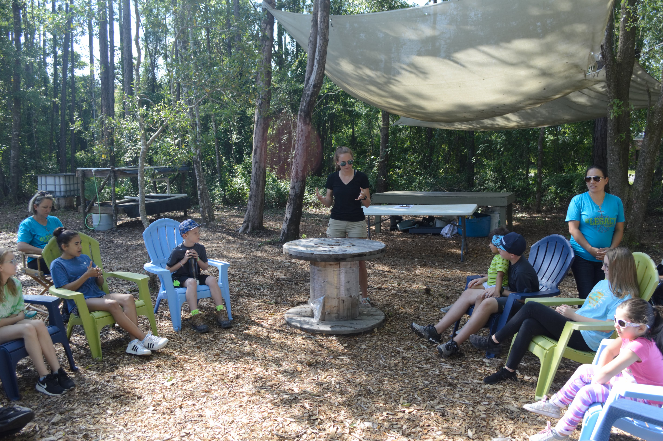
When the group arrived they were met by a few of the staff members at Eden Gardens. Tim Lovelace, founder and CEO did introductions and spoke to the group about the mission, purpose, and future of Eden Gardens. Lovelace introduced Hannah, a member of Eden Gardens, who would be taking photos during the field trip. Then I was introduced to the group, where I took the time to explain who I was, about my capstone, and what we would be doing in our field trip for the day. Before we started our field trip it was essential to have the parents sign waivers that allowed me to use the photos taken as part of my capstone project.
Introduction to students outside of the commercial greenhouse.
Kentch, Hannah. “Introduction.” 2019. JPEG file.
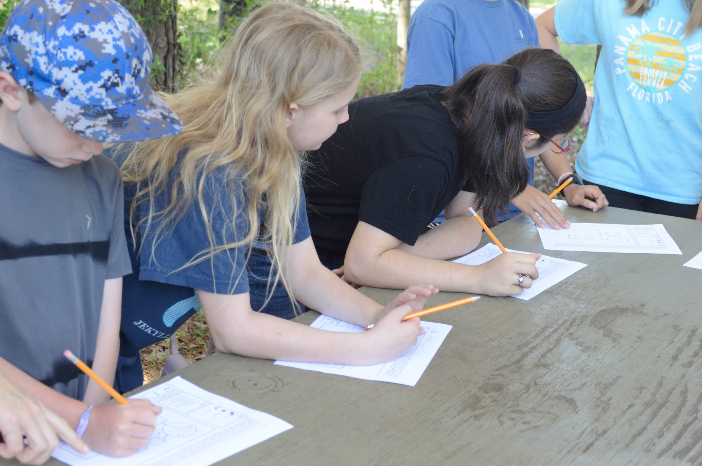
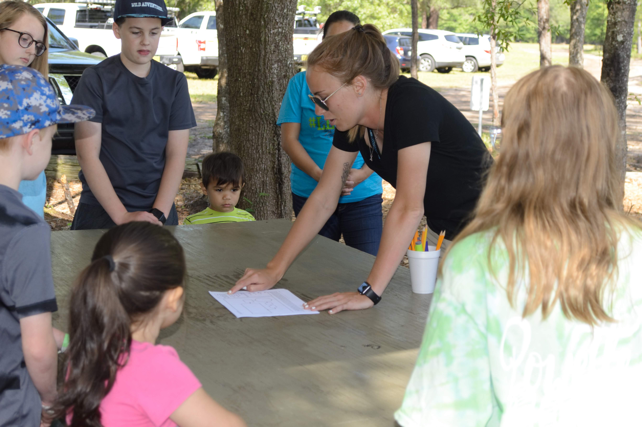
The pre-field trip lesson, “What is Aquaponics?” focused on the basics of aquaponics, consisting of an overview of what aquaponics is and the essential elements and parts that make up an aquaponics system. We started outside the greenhouse in the chairs, where I asked students if they knew or had ever heard of aquaponics before. No one raised his or her hands, which I was not surprised of. I then asked students if they could remember what we do here at Eden Gardens. One student raised their hand and stated that we grow food. This was a great way for me to engage the students and as we started the lesson. Knowing that Eden Gardens grows food, I was able to continue to ask questions that could lead them to an understanding of the different ways in which food can be produced. Moving into the commercial greenhouse, the students had the opportunity to walk around and take in a new integrated way of farming that they had never seen before. I talked with students about aquaponics pointing out the fish, plants, bacteria, and all of the different parts of an aquaponics system and their names. At the end of the lesson, students completed a worksheet that helped them to better understand and reinforce the different parts and pieces of an aquaponics system. While students completed the worksheet, some had questions. Questions are essential for students to further wonder, learn, and reinforce ideas they may be unsure of. This lesson took about 15 minutes to complete including the worksheet. After teaching, I realized that more visual aids such as posters up in the greenhouse could be an extremely beneficial learning tool. When this lesson is used as a pre-field trip lesson a presentation can be send along with the lesson to the teachers. This would provide a tool to show images, diagrams, and possibly even videos to better prepare the students for their field trip.
Students working on their “What is Aquaponics” worksheet.
Kentch, Hannah. Worksheet.” 2019. JPEG file.
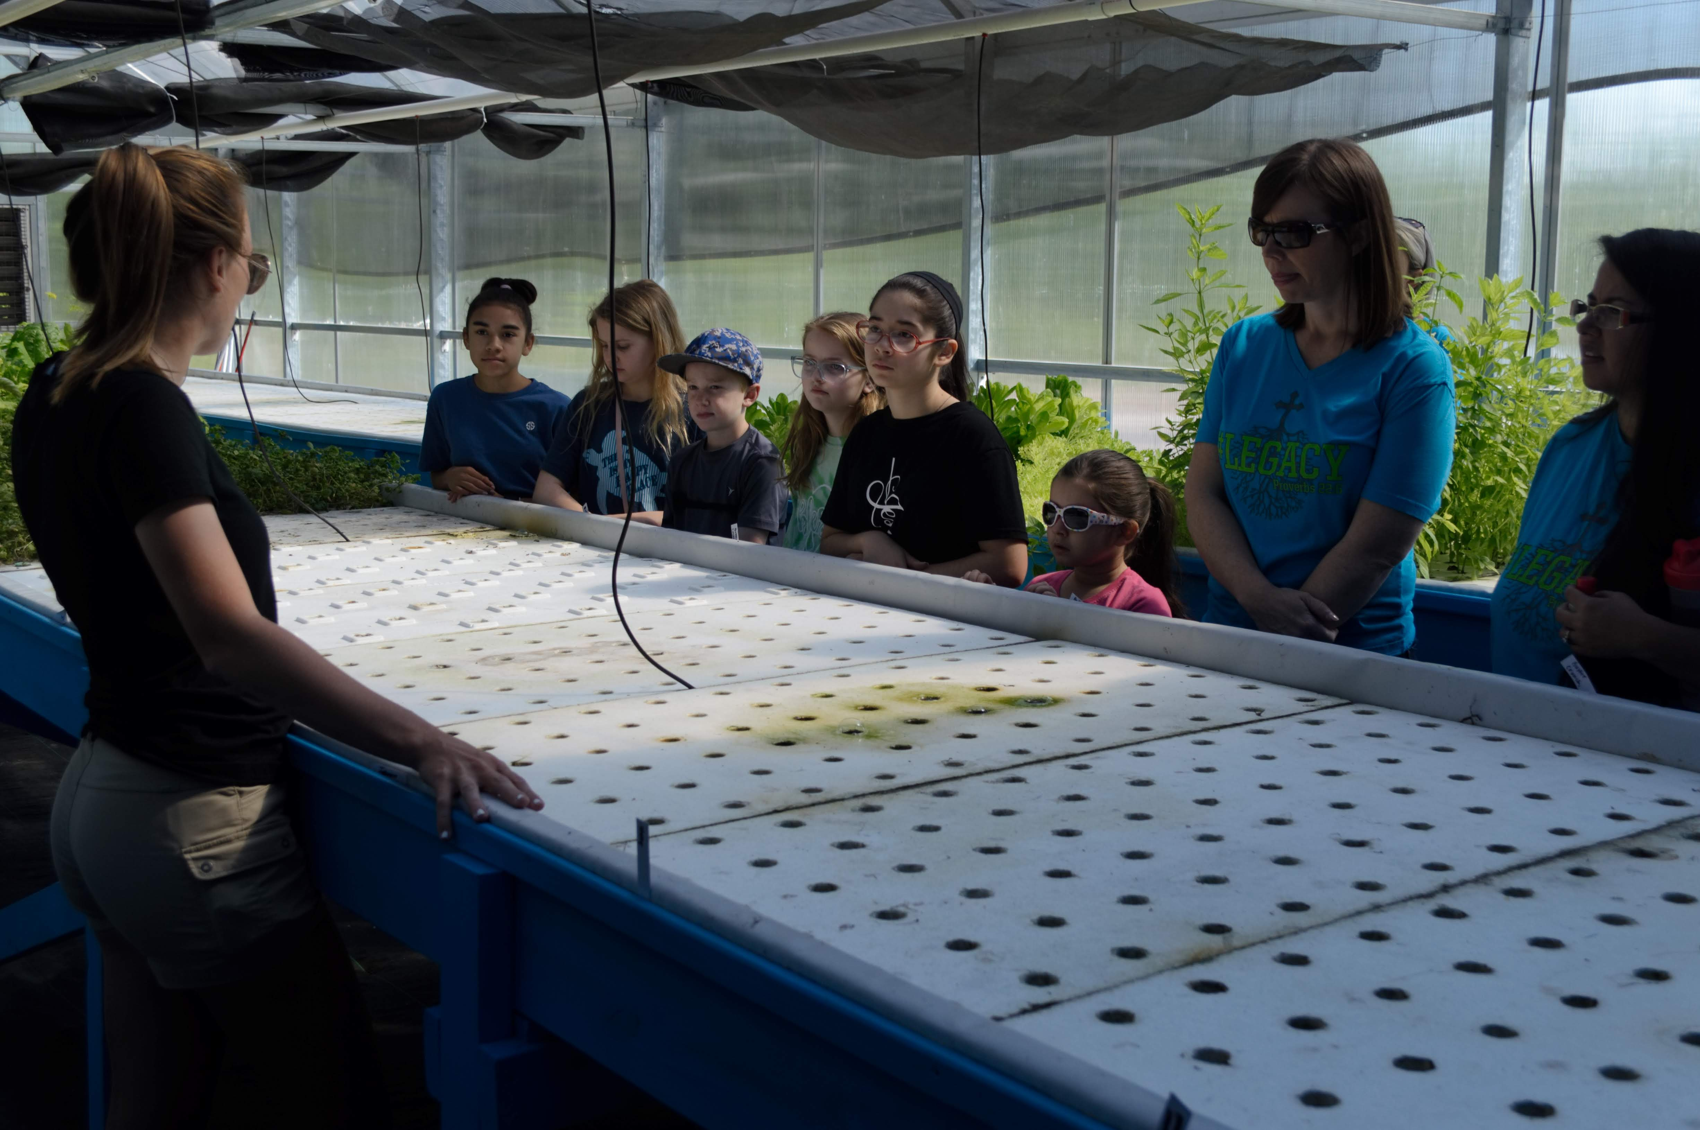
After the activity, it was time to move on to the first lesson, “Plants and Aquaponics.” I started the lesson in the commercial greenhouse asking the students about the life cycle of plants. They were all quick to answer and tell me the steps involved in the life cycle of a plant. When asked how that life cycle may change within an aquaponics system all of the students drew a blank. I was able to teach and explain to the students how the life cycle changes just slightly in an aquaponics system. As the lesson progressed students had the opportunity to try some food out of our aquaponics systems in the commercial greenhouse and innovation center. They were able to try foods such as tomatoes, basil, and lettuce. All of the students enjoyed eating foods that they have had before as well as trying something new. Some students had sour faces as they tried new things, and some enjoyed the taste of all the food available.
Kentch, Hannah. “Greenhouse.” 2019. JPEG file.
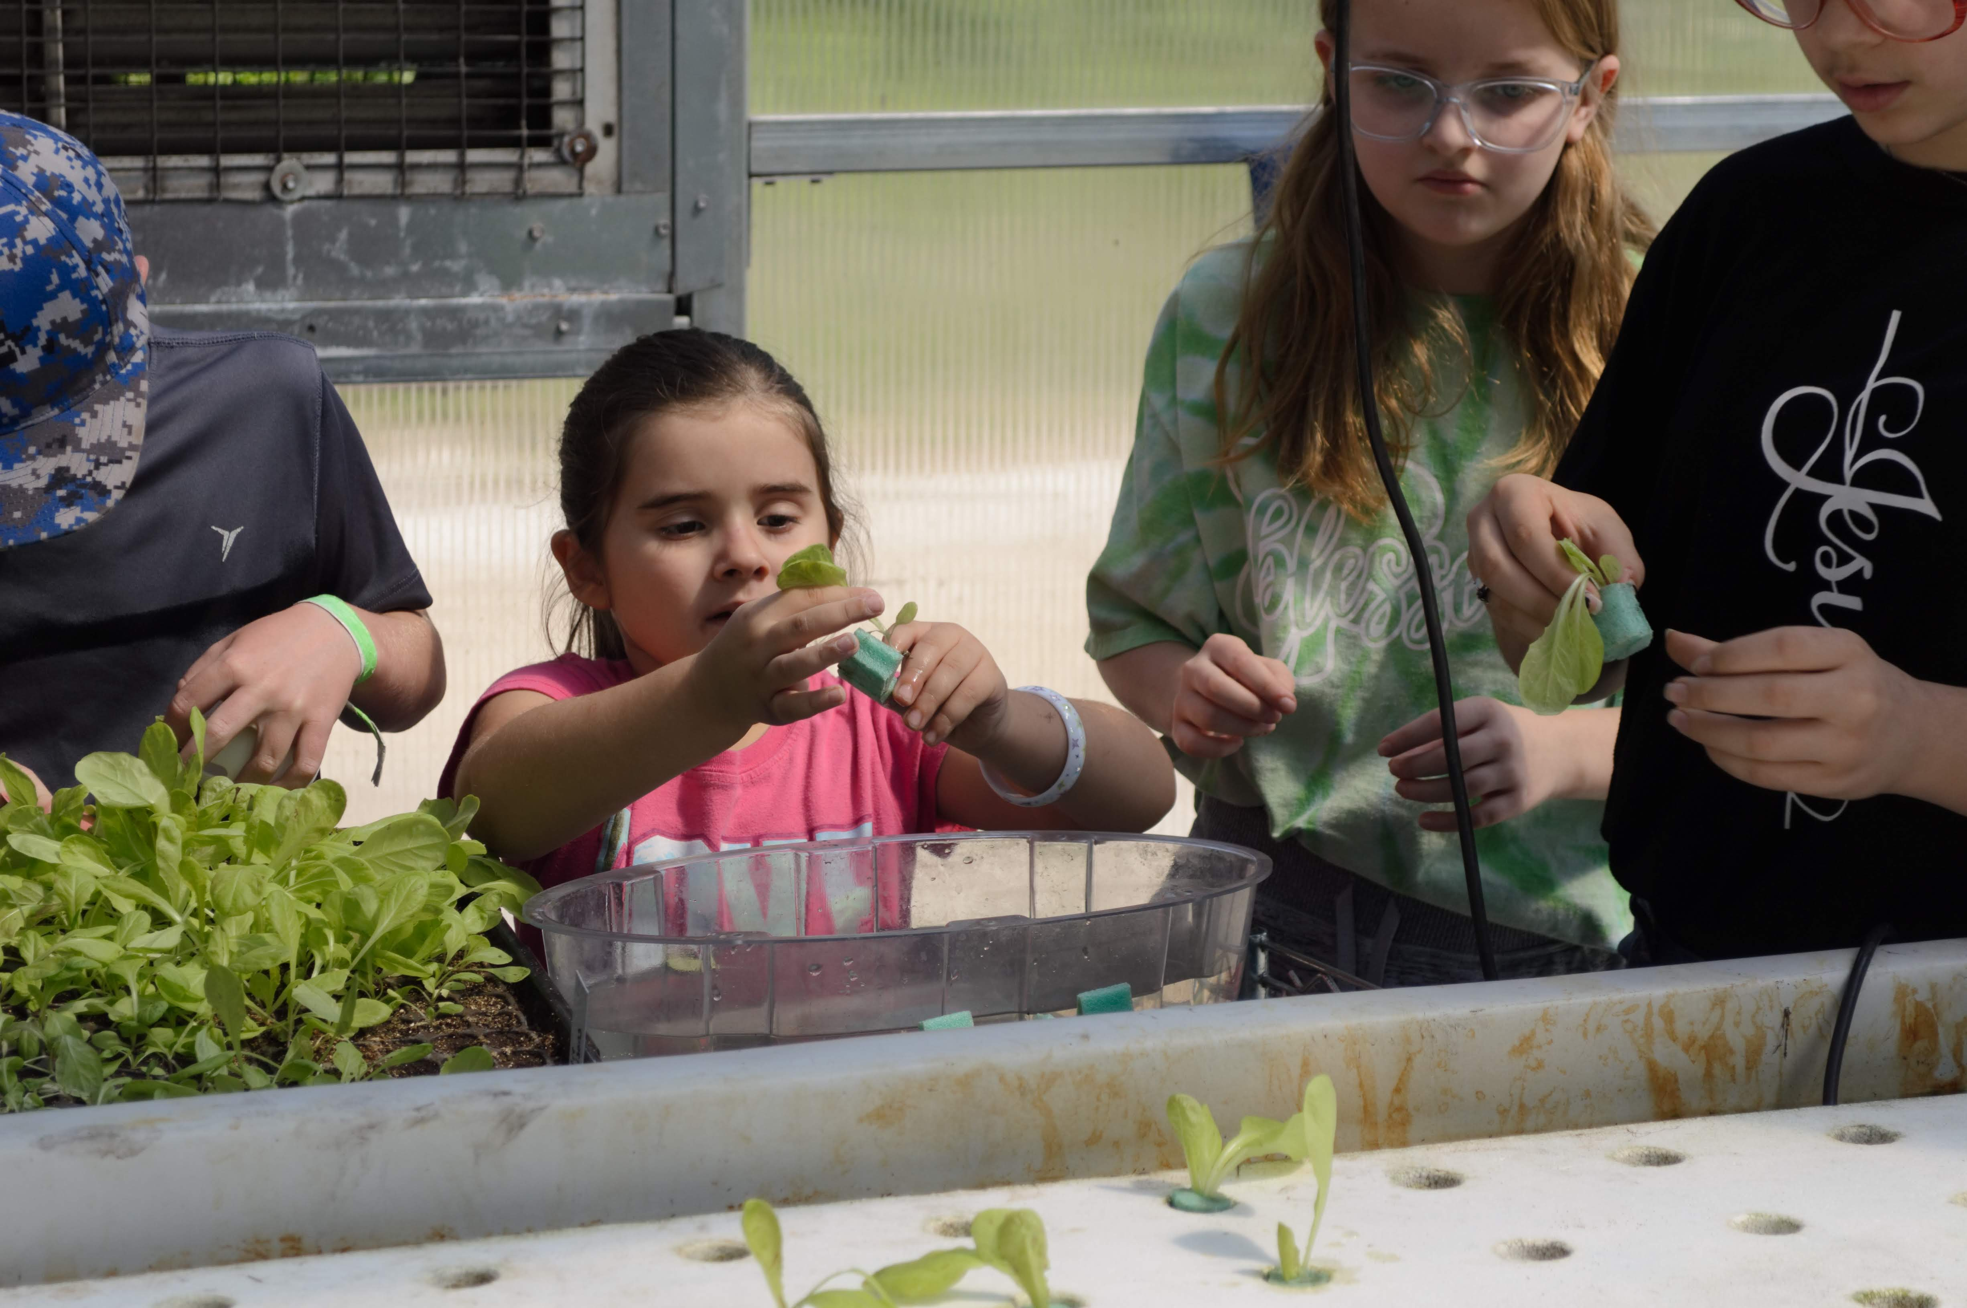
The last part of the lesson was by far my favorite portion of the field trip. I demonstrated to the students how to transplant holly lettuce. After, all of the students had the opportunity to transplant holly into the aquaponics system themselves. The students enjoyed it so much that they transplanted multiple holly plants each, covering an entire floating raft full of lettuce. The students all enjoyed the lesson, but there were a few small changes that I would make. To make the lesson better in the future I would add visual aids of the plant life cycle. I would also keep the lesson in one location instead of moving students around the farm. In the future I would have the ability to collect food for sample ahead of time to share with the field trip.
Kentch, Hannah. “Transplanting.” 2019. JPEG file.
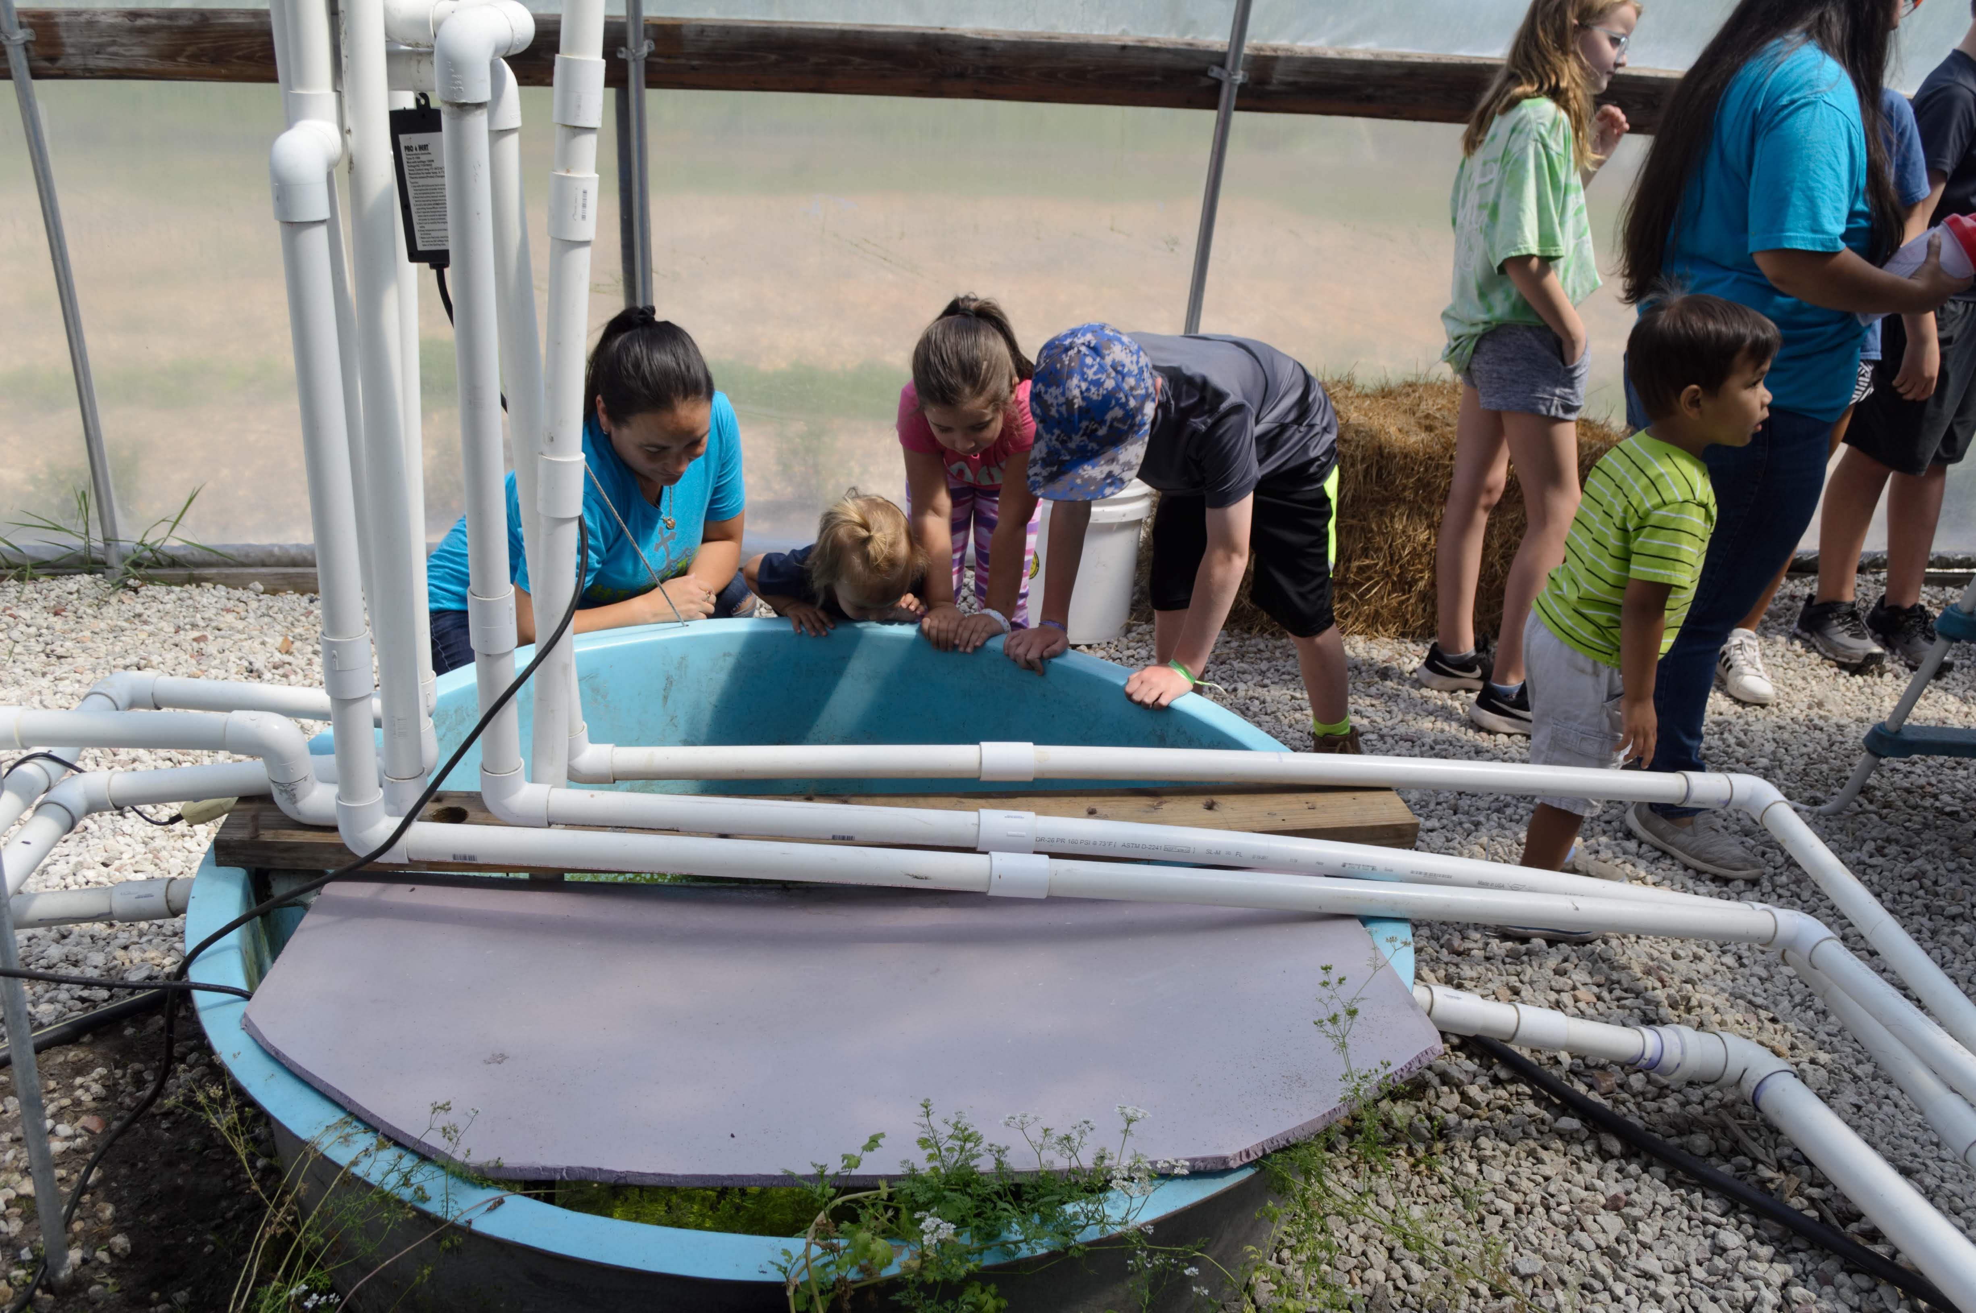
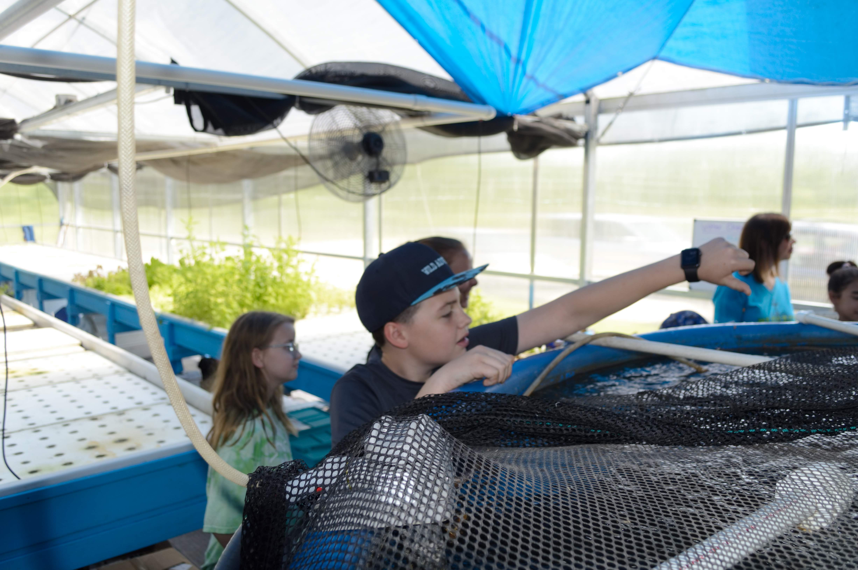
Through the field trip students were extremely interested in learning about the fish. One student did not believe that there were fish at Eden Gardens. I was able to show him inside of the fish tank to look at dozens of tilapia. As we continued with the second “Fish and Aquaponics” lesson, students learned all about fish, their purpose in an aquaponics system, the species that work well in an aquaponics environment, and the life cycle of tilapia. Some students were excited about tilapia because it is a fish that they eat at home. Students were able to observe and feed the fish in their different stages of growth throughout life. The students were eager and engaged as some of the fish even splashed water at them while they ate. Students asked questions about the fish and engaged in the lesson. Overall, the lesson was about 20 minutes. There are a few changes I would make for the future such as visual aids, a reoccurring theme with many improvements in the field trip. I also took the students into both the commercial greenhouse and the innovation center to feed the fish. They are not extremely far from one another but the Florida heat could become a future concern.
Kentch, Hannah. “Feeding Fish.” 2019. JPEG file.
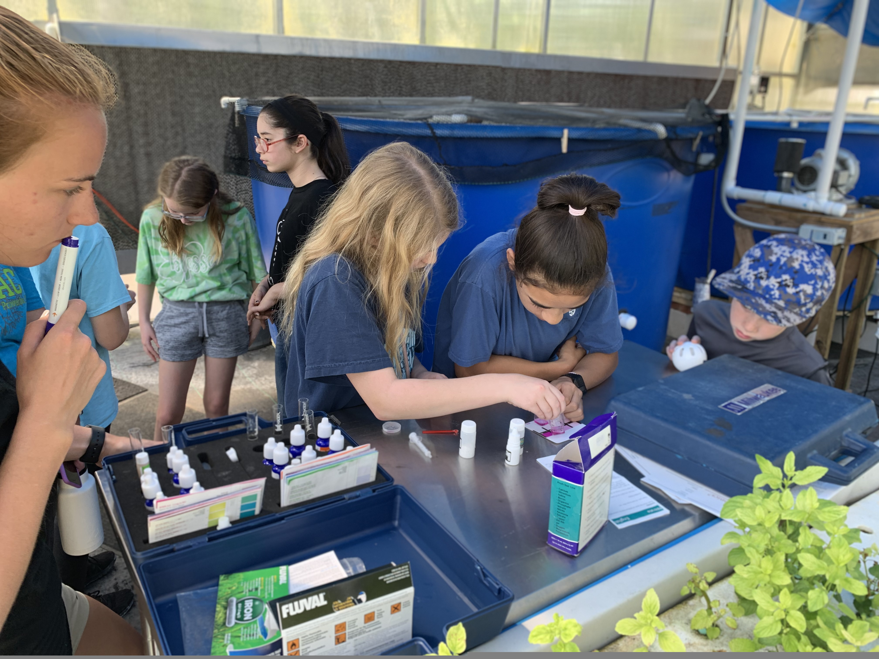
By the third lesson I could tell that the students were starting to lose a little bit of focus. So to get them working with their hands I combined the lecture type portion of the lesson with the activity, running them simultaneously. In the commercial greenhouse students were able to get hands-on and run water quality tests such as pH, iron, and nitrates in the aquaponics system. I walked students through each test, discussing what it was and why it was important. Students ran the tests twice to check for accuracy. Students enjoyed the small steps it took in completing the tests and watching as the colors changed. All together this lesson took about 15-20 minutes. Some of the more complicated parts of water chemistry seemed to be harder for the students to understand. A way to make this a better lesson for future use could be visual aids on the tests and looking into simpler chemistry tests that are student friendly and easier to understand.
Kentch, Hannah. “Observations.” 2019. JPEG file.
Kentch, Hannah. “Water Chemistry.” 2019. JPEG file.
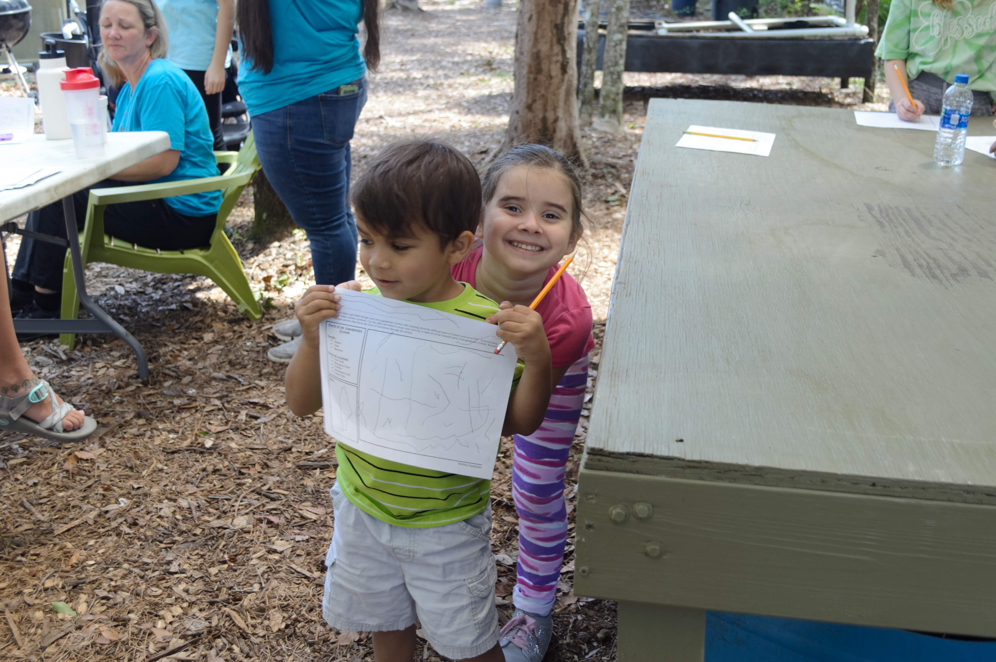
The fourth and final lesson was my personal favorite. It allowed students to use what they have learned in the other lessons about aquaponics and their own creativity to create their own aquaponics systems. Students were able to walk around the innovation center that contains multiple different types of aquaponics systems built out of different materials. This provided students with the knowledge that aquaponics systems come in all different shapes, sizes, and structures as well as the inspiration needed to complete the worksheet in designing their system. Some students copied off of systems at Eden Gardens, while a few more creative students designed their own unique systems. Students all showed and shared their systems while they drew and after they had finished.
The last lesson took about 15 minutes but by creating more time for a more formal discussion at the end could extend the lesson to 20-25 minutes. By labeling all of the systems at Eden Gardens by name with a small description of the system I think it could provide better information to students as they learned and observed. I also would provide students with colored pencils or crayons in the future; I believe that it would spark more inspiration and creativity when designing their own systems. After the last lesson we brought all of the students back together at the chairs outside of the greenhouse. I asked students if they had any final questions and brought everyone together for a group photo. While families depart we chatted with them as they thanked us for the day.
Kentch, Hannah. “Building Aquaponics.” 2019. JPEG file.
I was extremely happy with how the field trip went over all. A homeschool group can be very different than a public school group. I was able to target the main age group and adapt the lessons and information given to any younger students. The younger students still enjoyed the field trip and having the ability to see the plants and fish while participating in the hands-on activities. I, as well as other staff at Eden Gardens picked up on small changes that could be made to each lesson. The biggest change for all of the lessons would be including more visual aids to students in the forms of photos, diagrams, and more. These visual aids would not only be a benefit for field trips but could also be a benefit for those who tour, or volunteer at the farm as well. This field trip was small enough to stay as one group and rotate from lesson to lesson. With other field trips this will not always be the case and stations will be required for the different lessons. Not only the students enjoyed it, the parents did as well. Many parents during the field trip were asking just as many questions as the students. They were interested in the process, structure, and what it would take if they had their very own small systems as home. It was wonderful to see the students and parents engage, ask questions, and spark an interest and basic understand of aquaponics and its importance. Many of the families discussed coming back to Eden Gardens on one or several of their volunteer days.
Creating and teaching these lessons allowed me to grow as an educator. It takes a lot more then developing a curriculum to be a good educator and implement lessons. It takes creativity, patience, the ability to think on your feet, and a whole lot of passion. Through teaching these lessons I learned that even though Eden Gardens is a hands-on learning experience, supplemental and additional material is still needed as educational tools for a better learning experience. Being passionate about informal teaching and aquaponics allowed me to enjoy what I was doing. When you enjoy teaching about something students are much more engaged and interested because of your excitement and positivity. Having the opportunity to test these lessons a few more times with different groups of different sizes would provide more insight and potentially unveil more challenges that need to be worked out. I look forward to the future of these lessons at Eden Gardens and continuing to work with the staff to develop lessons that work with all age groups within the Florida state standards.

Conclusion
The educational curriculum for Eden Gardens focuses on aquaponics and breaking it down further into its different elements. Eden Gardens’ aquaponics systems provide hands-on learning experiences for students of all ages to gain skills and knowledge in subjects such as STEM and environmental awareness. Compared to their original field trip offerings this curriculum builds upon the old, connecting to the Florida state standards and provides more hands-on activities for students. This will help Eden Gardens be a more popular and desirable location for school groups, while allowing them to provide the best educational experience possible.
The lessons were a success with the test group. The staff at Eden Gardens enjoyed the new lessons and what the future of their field trips look like. Tim Lovelace spoke of having all of the lessons translated into different languages so that they are able to take the lessons on overseas trips when they are working with communities in other countries. This would allow the educational curriculum to be more than just a field trip curriculum but a curriculum that Eden Gardens and Glodev can use in different capacities and locations. Having this curriculum go to different countries and be an educational tool to those in the poorest regions adds greater value to this curriculum. We would not just be teaching the next generation but those all over the world the skills to practice a sustainable way of agriculture.
I will continue to work alongside Eden Gardens in different capacities. First by continuing to volunteer, learn, and participate in all that Eden Gardens does as they continue to grow as an organization. Second, to continue to test the curriculum further. Implementing changes from the first test such as purchasing and creating visual aids to go up around Eden Gardens for not just field trips but the public. By testing the curriculum I will be able to observe more challenges after making adjustments from the first test and what new adjustments need to be made. I will also help Eden Gardens in finding the best way to implement a rotation system for groups of any size. Groups of different sizes can cause their own challenges group by group. I will also continue to create and expand the curriculum with new lessons for Eden Gardens that meet the needs and standards of different ages and grade levels (Appendix K). Providing my time to Eden Gardens will allow me to use my professional skills and gain new skills along the way.

Appendices

Appendix A
What is Aquaponics?
Subject: Science

Level: 5th Grade

Time: 15-20 minutes

Overview  Students will learn the basics of aquaponics, all of the factors involved in an aquaponics system, and the benefits of a closed-loop system. Students will participate in an activity to map out an aquaponics system.  Objectives  - Students will identify and define the essential parts of an aquaponics system.  - Students will identify the cycle of an aquaponics system, and the purpose of the different parts  - Students will participate in an activity to map out an aquaponics system.  Background  Aquaponics is a modern farming practice that combines aquaculture and hydroponics. Aquaculture is the raising of fish. Hydroponics is the raising of plants in nutrient-rich water. Together they create aquaponics the raising of both fish and plants in a controlled closed-loop environment. A closed-loop system is where the output of a system goes back into the system as an input. In aquaponics the most important features are fish, plants, and bacteria. The fish produce ammonia-rich waste. When fish grow to market size they can be sold and replaced with new fish. Naturally occurring bacteria will convert ammonia into nitrates. Plants, in floating rafts absorb nitrates as nutrients and the water is funneled back into the fish.  Aquaponics systems also need to be built and designed with the correct parts. These key parts are:  - Fish Tank  - Biological Filter – Collects fish waste  - Clarifier – Removes the waste from the water  - Hydroponic unit (growbeds)– where the plants take up nutrients  - Sump tank with pump – to push water back to fish tank  Aquaponics systems are unique in that they have the ability to be built out of a multitude of different material such as:  - Stock tanks  - Barrels or drums  - IBC Totes  - Pond liner  - Aquariums  - Bathtubs  Activity  On their own or in groups, students will receive an “aquaponics” worksheet that contains a blank aquaponics system for them to fill in and label of all the important aquaponics parts. |  | Location:  - Classroom or Commercial Greenhouse  Materials  - “What is Aquaponics?” PowerPoint  - Aquaponics Worksheet  - Colored Pencils  Key Words  Aquaculture, Hydroponics, Closed-loop, Biological Filter, Clarifier, Hydroponic Unit, Sump Tank  Standards  - SC.5.L.14  - SC.5.L.17  Resources  Bernstein, Sylvia. Aquaponic gardening: A step-by-step guide to raising vegetables and fish together. New society publishers, 2011.  Southern, Adrian, and Whelm King. The Aquaponic Farmer: A Complete Guide to Building and Operating a Commercial Aquaponic System. New Society Publishers, 2017.

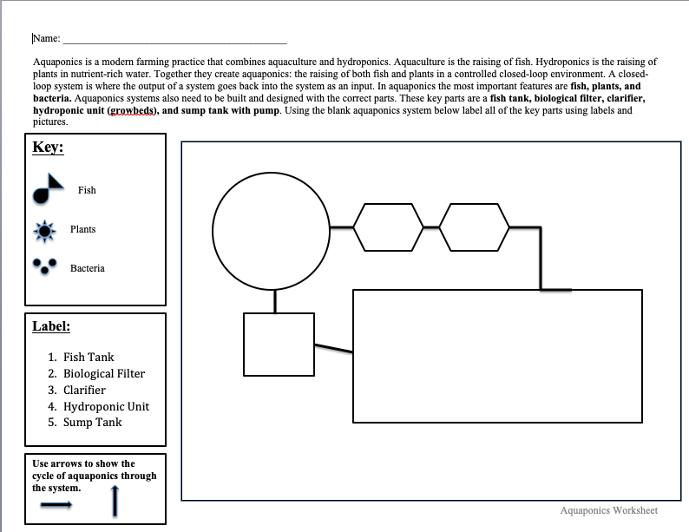
Appendix B

Appendix C
Plants and Aquaponics
Subject: Science

Level: 5th Grade

Time: 25 minutes

Overview  Students will have the opportunity to review the life cycle of a plant and see how that life cycle changes in an aquaponics system. In this lesson, students will have the ability to work hands on in one of the stages of a plants life cycle.  Objectives  - Students will identify and define the different stages of a plants life  - Students will observe and identify a plants life cycle in an aquaponics system and explain its differences from standard farming  - Students will participate in planting, transplanting, or harvesting in Eden Gardens commercial greenhouse  - Students will participate in planting their own seeds to take home with them  Background  Plant Life Cycle  Plants start out as seeds planted into the ground, those seeds with proper water, nutrients, and temperatures will germinate. Germination is the process of a seed breaking open and starting to grow roots. Those roots will grow into the ground and a stem on the plant will start to grow out of the soil, this is a seedling. With plenty of water, sunlight and nutrient-rich soil plants will continue to grow to a mature adult plant producing flowers, fruits, and vegetables.  Plants in Aquaponics  A plants life cycle within an aquaponics system is similar to the normal life cycle. Seeds are planted in soil, germinate, and then begin to sprout. Once the sprouts are strong enough they will be transplanted into the aquaponics system. Transplanting is the process of removing the plants out of the soil, cleaning the roots, and inserting it into a floating raft of the aquaponics system. In the aquaponics system plants will grow with the help of nutrient-rich water until they are harvestable. Once harvested plants can be eaten or sold.  Plants are an extremely important piece of an aquaponics system. Plants absorb nutrients from the water that allow it to grow to harvest. Almost any plant can be grown in an aquaponics system. Some plants growing at Eden Gardens are:  - Papaya Trees  - Lettuce  - Tomatoes  - Peppers  - Strawberries  - Herbs  Activity  Part A  Students will have the opportunity to assist the staff at Eden Gardens in whatever stage of plant production that they are working on. This could be:  - Planting seeds for germination,  - Transplanting plants into the aquaponics system,  - Or harvesting plants  Part B  Students will be able to plant their own seeds in a discarded plastic bottle to take home with them.  - Take your plastic bottle, in the bottom half fill it ¾ of the way with soil  - Make a hole in the soil based off the directions on the seed package  - Insert 2-3 seeds in the hole and fill over with soil  - Water your seeds  - Place top half of plastic bottle back, and you’re ready to take it home! |  | Location  - Commercial Greenhouse  - Seeding Station  Material  - Copies of Life Cycle handout  - Plastic bottles (cut in half)  - Soil  - Seeds  - Water  Key Words  Germination, Transplanting  Standards  - SC.5.L.14  - SC.5.L.17  Resources  Bernstein, Sylvia. Aquaponic gardening: A step-by-step guide to raising vegetables and fish together. New society publishers, 2011.  Southern, Adrian, and Whelm King. The Aquaponic Farmer: A Complete Guide to Building and Operating a Commercial Aquaponic System. New Society Publishers, 2017.

Appendix D
Fish and Aquaponics
Subject: Science

Level: 5th Grade

Time: 20-25 minutes

Overview  Students will learn about the life cycle of fish and the contributions that fish make to an aquaponics system. They will have the opportunity to get up close and see tilapia and help with fish feeds.  Objectives  - Students will identify and define the different stages of fish life  - Students will identify the different fish used with in an aquaponics system  - Students will observe and identify a fish’s purpose in an aquaponics system  - Students will participate in feeding the fish in the different aquaponics systems at Eden Gardens; while also determining how much feed they need  Background  Tilapia Life Cycle  Tilapia is a freshwater fish native to Africa that has been a popular fish for farming. Fish farming is the raising of fish as a source of food. Tilapia is grown at Eden Gardens. They live in warmer temperatures and are omnivores (eat plants and animals). They mature quickly, and reproduce at high levels. Their life cycle consists of:  - Males and females mate  - Females carry hundreds of eggs in her mouth for 10-12 days and then will release all of her young at once  - Tilapia will mature within a few months  - Can live 6-8 years  Fish in Aquaponics  There are a wide variety of fish that can be grown in an aquaponics system. You can grow fish for harvest or not at all. Fish for harvest can be tilapia, catfish, trout, bass, and pacu. Fish that are used in aquaponics systems but not harvested are goldfish and koi fish.  Fish are extremely important in an aquaponics system. They produce nutrient-rich waste that moves through the aquaponics system and is then taken up by the plants roots to grow.  Activity  Students will help the staff at Eden Gardens feed the fish in the Innovation Center and Commercial Greenhouse being able to see tilapia of all sizes. |  | Location  - Innovation center  Materials  - Fish Feed  Key Words  Farming, Omnivores, Life Cycle  Standards  - SC.5.L.14.2  - SC.5.L.14  - SC.5.L.17  Resources  Bernstein, Sylvia. Aquaponic gardening: A step-by-step guide to raising vegetables and fish together. New society publishers, 2011.  Southern, Adrian, and Whelm King. The Aquaponic Farmer: A Complete Guide to Building and Operating a Commercial Aquaponic System. New Society Publishers, 2017.

Appendix E
Subject: Science

Level: 5th grade

Time: 20 Minutes
Water Chemistry

Overview  Students will learn that aquaponics is not completely self-sustaining as they learn about the basic water chemistry in an aquaponics system. In this lesson students will have the ability to run different water chemistry tests on Eden Gardens commercial aquaponics system.  Objectives  - Students will identify and define what plants need to grow  - Students will observe and identify the different water chemistry tests that are run for an aquaponics system to run  - Students will participate in taking water samples and testing its water chemistry for: pH, Nitrates, Ammonia, and Iron  Background  Aquaponics is a modern farming practice that combines aquaculture and hydroponics. Aquaculture is the raising of fish. Hydroponics is the raising of plants in nutrient-rich water. Together they create aquaponics the raising of both fish and plants in a controlled closed-loop environment. A closed-loop system is where the output of a system goes back into the system as an input. In aquaponics the most important features are fish, plants, and bacteria. The fish produce ammonia-rich waste. When fish grow to market size they can be sold and replaced with new fish. Naturally occurring bacteria will convert ammonia into nitrates. Plants, in floating rafts absorb nitrates as nutrients and the water is funneled back into the fish. High levels of ammonia and nitrates are needed to grow plants. It is important to test for these regularly to make sure that the aquaponics system is running properly.  Ammonia – a chemical compound found in fish waste  Nitrates – a chemical compound that plants take up by their roots as nutrients  Plants need more than just nitrates to grow. They also need a standard pH, as well as iron. pH is a scale of acidity from 0-14. A pH of 0-6 is acidic, 7 is neutral, and 8-14 is basic. Plants in an aquaponics system need a pH range 6.8-7.0. Iron is a micronutrient that is essential to plants in small amounts, helping provide plants with their green color. Iron deficiency can be spotted when young leaves turn yellow. Unfortunately iron is not present in aquaponics system and must be manually added. When running an iron test the optimal range is 2-3 parts per million (ppm), if it drops under that iron is needed in the system. Parts per million can be visualized by putting four drops of ink in a 55-gallon barrel of water and mixing it thoroughly. This procedure would produce an ink concentration of 1 ppm.pH and iron tests are run regularly in an aquaponics system to make sure that the system is running properly.  Activity  Students will work as a group to test the water chemistry of Eden Gardens commercial aquaponics system.  - Students will test for either pH, Nitrates, ammonia, or iron  - After receiving their test, they will follow the necessary directions to collect water samples and run the desired test  - Students will run the test more than once to compare their answers for best possible results  - All answers will be recorded on the white board and discussed |  | Location  - Commercial Greenhouse  Materials  - Test Kit  - White board for tracking recordings  Key Words  Aquaculture, Hydroponics, Closed-loop, Ammonia, Nitrates, pH, Iron, Parts per million  Standards  - SC.5.N.1.3  - SC.5.L.17.1  Resources  Bernstein, Sylvia. Aquaponic gardening: A step-by-step guide to raising vegetables and fish together. New society publishers, 2011.  Southern, Adrian, and Whelm King. The Aquaponic Farmer: A Complete Guide to Building and Operating a Commercial Aquaponic System. New Society Publishers, 2017.

Appendix F
Building Aquaponics
Subject: Science

Level: 5th Grade

Time: 20 minutes

Overview  Students will learn about different ways of building aquaponics systems, while observing and learning about the different aquaponics systems in Eden Gardens Innovation Center. In this lesson, students will have the opportunity to design their own aquaponics system.  Objectives  - Students will identify and define the basic parts of an aquaponics system  - Students will identify and define different types of aquaponics system  - Students will identify different materials used to build an aquaponics system  - Students will participate in designing their own unique aquaponics system  Background  Aquaponics need three basic things to function, fish, plants, and bacteria. Aquaponics systems also need to be built and designed with the correct parts. These key parts are:  - Fish Tank  - Biological Filter – Collects fish waste  - Clarifier – Removes the waste from the water  - Hydroponic unit (growbeds)– where the plants take up nutrients  - Sump tank with pump – to push water back to fish tank  As long as an aquaponics system contains its key parts they can be designed and built out of different material. Different types of aquaponics systems can be:  - Flood and Drain – this is considered an ebb and flow, the growbeds are filled with water from the fish tank followed by a period of draining that draws air into the roots. This cycle runs continuously.  - NFT (Nutrient film technique) – this is a system of aquaponics where the roots of the plants have contact with both air and water.  - Deepwater Culture – this is the most commonly used aquaponics system. This system used a floating platform with holes to support the plants and the roots stay submerged in the water.  Aquaponics systems are unique in that they have the ability to be built out of a multitude of different material such as:  - Stock tanks  - Barrels or drums  - IBC Totes  - Pond liner  - Aquariums  - Bathtubs  Activity  On their own or in groups, students will design their own aquaponics systems while needing to include all of the important parts of an aquaponics system.  - Hand out “building aquaponics” activity sheets and pencils  - Give students 10 minutes to design an aquaponics systems while following the directions on the activity sheet  - Bring students back together and allow them to share their designs |  | Location  - Innovation Center  Materials  - Building aquaponics activity sheet  - Colored Pencils  Key Words  Biological Filter, Clarifier, hydroponic unit, sump tank, Flood and Drain, NFT, Deepwater Culture  Standards  - VA.5.F.1  - SC.5.L.14  Resources  Bernstein, Sylvia. Aquaponic gardening: A step-by-step guide to raising vegetables and fish together. New society publishers, 2011.  Southern, Adrian, and Whelm King. The Aquaponic Farmer: A Complete Guide to Building and Operating a Commercial Aquaponic System. New Society Publishers, 2017.

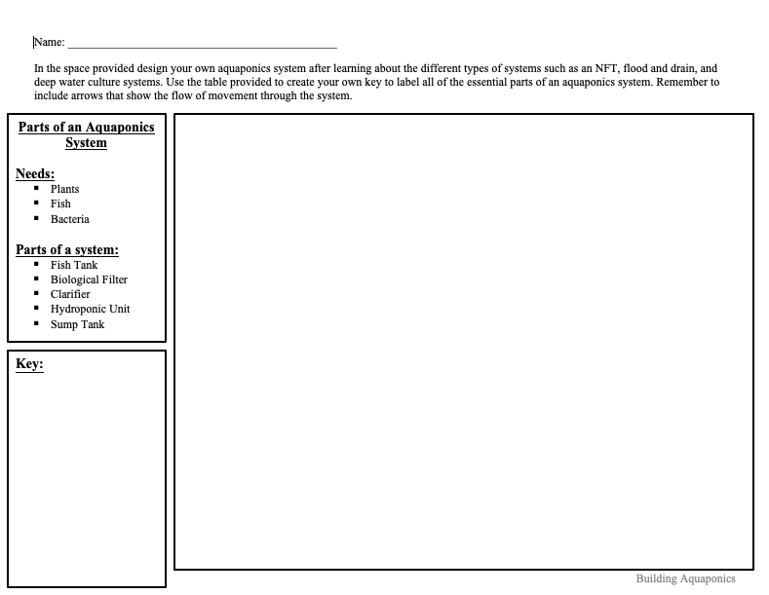
Appendix G

Appendix H

Plant Chicago: Stef Funk

Stef Funk is the education associate at Plant Chicago.

Ashley: Tell me a little bit about your programs?

Stef: We offer hands on, inquiry based STEM education programming. All of our programming is offered to our zip code (60609) free of charge, with additional sliding scale options for under funded schools/organizations.

Ashley: What educational programs does your facility offer?

Stef: We offer workshops on Aquaponics System Design, Circular Economy, Native Pollinators, Water Chemistry.

Ashley: Can you describe to me what your educational programs consist of? What does a typical day look like?

Stef: All of our programing’s include an in depth look at our demonstration aquaponics farm, then transition into a hands on/engaging activity. Typically, we'll have 1-2 workshops per day. The rest of our time is spent developing curriculum, doing community outreach, and aligning curriculum with teacher lesson plans, next generation science standards, and common core.

Ashley: What are the objectives and desired outcomes of your educational programs?

Stef: We want to provide affordable and accessible STEM educational programings to schools all over the city, but particularly our neighborhood. We aim to be a community stakeholder through teaching urban students about where their food comes from, how urban areas are impacted by our food system, instill a love for ecological systems, and how to support the environment.

Ashley: Do your programs consist of specific age groups? If so do you separate among age groups or keep age groups intertwined?

Stef: We work with all ages! K-12, college, graduate, and adult. Most of our programs can be modified to suit any age group.

Ashley: Why did you take that path?

Stef: Accessible education means education for everyone! Any age, any background, any location is welcome to come join us for STEM programming.

Ashley: Do your programs consist of more formal or informal education?

Stef: Our educators are all informal educators. We work with many teachers to make sure our programming supports them, but we do not consider ourselves as teachers.

Ashley: How did you go about creating an educational program--what resources did you draw on, how much was it an iterative process or collaborative with the community you wanted to reach?

Stef: As the most junior employee, I am not able to adequately answer this. You can reach out to Kassie, our Education and Outreach Manager at kassandra@plantchicago.org

Ashley: how do you measure success # of students reached?

Stef: We track everyone from number of students/adults, age range, which programs are most popular, etc.

Ashley: Something deeper than that?

Stef: We also track how many free programs we provide with an aim to have 25% be free.

Ashley: Do you use any pre-/post-surveys?

Stef: We send all of our teachers introductory and exit materials, and ask them to fill out a survey after programming to inform any modifications we need to make. Personally, I measure my success on teacher satisfaction, but the entire organization also focuses on this.

Ashley: Why do you think educational programs and curriculum with a focus on aquaponics is important?

Stef: In urban areas, food sovereignty is so important! Since we can't grow food all winter, it's important we have indoor farming options so we aren't relying entirely on other locations for food. Aquaponics also has many sustainable benefits in comparison to outdoor farming. It's much easier to be organic, nutrient levels are consistent without excess fertilizer, and it uses up to 90% less water than outdoor farming. Teaching urban youth about these options is very important, since younger children are more receptive to new concepts.

Ashley: Why do you feel like an education program is important and essential for youth?

Stef: Informal programs that introduce ideas outside of traditional curriculum (English, math, science, etc.) are so important for the development of young minds. Showing all the various options allows them to think outside the box! Having hands on workshops that avoid lecture style learning allows kids to take learning in to their own hands (puuuun intended ;) ).

Ashley: Do you have any inspiring stories of students who have been apart of your program?

Stef: We have lots of students who go on to build aquaponics systems for their science fair projects!! Which is such a flattering result of our programming. Additionally, many teachers have become interested in building their own aquaponics systems and having us help them engage their students in the process.

Appendix I

Eden Gardens: Julie Linneman

Julie is a missionary, she and her husband work for Glodev and at Eden Garden farm, caring for the farm and facilitating field trips and groups who come to the farm.

Ashley: This interview will be all about what educational programs you already have and what you would like for the future. It will help me to develop a program that the staff at Eden Garden will want to use as an educational tool. What educational programs does Eden Garden currently offer?

Julie: We offer aquaponics training, a one week training, for people to come to. We also are doing a mini aquaponics training for people who want to come and do a short term, quick overview of aquaponics. We have school groups that come out; homeschool groups and public school groups are coming out for a two-hour field trip. We have stations when they come. Each station teaches something different, we have 4-5 stations depending on how many students come out. Would you like me to tell you what the stations are?

Ashley: Yes please!

Julie: okay, we have a station here (prep area) where we teach them how to plant seeds. They also get to make a little water bottle and a few seeds that they can take home with them as a little terrarium. One person will teach on composting, on how to properly compost. And also about the worm bin, how we can save our kitchen scraps for the worm bin is another place that they can go to. They go out into the field and plant seeds/plants into the garden. We also teach them about citrus trees, and how to take care of citrus trees. Another station is in the innovation center and they just help feed the fish and learns about four different types of aquaponics systems. Single tote, IBC tote, FT, or flood and drain are four types of aquaponics system that we have out there. Another station is in our commercial aquaponics system, where we teach them about what aquaponics basically is, and how it all functions and how the fish and the vegetables work together.

Ashley: How much community engagement do your programs currently have?

Julie: Well, we have had a few churches come out and bring teams out to volunteer. We have had a gentleman from the YMCA come out and meet with us about what we are doing. He wants to bring kids from the inner city out to do work with some leadership program and us. We have another gentleman that is in the inner city doing a leadership program at his house and he wants to bring his kids out to learn. GRACE it is like compassion international sponsors another gentleman we met with, it gets people to sponsor children in Jacksonville monthly. It is another leadership program in the inner city teaching students leadership skills and they want this to be a place where they have to volunteer two hours a week for community service and this will be one of their options.

Ashley: What type of k-12 program would you like to see at Eden Garden?

Julie: One of the things I would really like to see is maybe even 4-12 grade program, because in fourth grade you really start to learn more biology and all of that. I think it is a good opportunity to come out and learn how fish and vegetables work together in a system. Also the composting end of it, mixing manure and leaves and everything together and how that all works so that you can change your soil wherever you live. So that kids can know that no matter where they go in the world they can help them change their soil to grow vegetables. And of course you know that we are Christians so we try to share God’s love with people and that they are loved unconditionally no matter where they have been in their life.

Ashley: Is there anything specific that you would like to have students gain from this sort of program?

Julie: The biggest thing to know that throughout their life they should give back to their community. They should be involved somehow in making their community a better place for everyone to live and to help those who maybe do not have good resources to have food to eat, that they can tell them and help them and bring them out to the farm or wherever they are at. That they can help people have a better lifestyle.

Ashley: What factors of aquaponics would you like to see?

Julie: In our innovation center in out IBC tote system, which is a system that we take over seas, I would like is to be growing enough vegetables to be feeding 20 people daily on going. That everyday they can pick something out of the system to eat and sustain 20 people everyday.

Ashley: What specific subject matter do you think is important for a program like this? Like in terms of a school group coming out because you will be able to attract more school groups of we are aligning a program with school standards.

Julie: I really don’t know on that one.

Ashley: More science. STEM is a really big one; it is science, technology, engineering, and math, which aquaponics does a really good job of encompassing all of them.

Julie: Right, like even the testing that you do, things like that for biology. They can actually run tests and see where they are at and see if everyone gets the same results. They can come in a right down their answers and see if it is the same as what someone else got. Testing correctly and how to test and things like that. But also just feeding fish, and Mitch just learned a lot of the biology of composting and the importance of the microbes. And you do not even realize that dirt needs microbes, that dirt, sugars in the dirt. Plants take up sugars and put different things in the ground. What do they put in, what do they take out, and what do they need.

Ashley: Last question, why do you think that an educational program surrounding aquaponics is important for today’s youth?

Julie: Because there is so much poverty in the world. 2.8 billion people live on 2 dollars a day and a lot of people do not even have that. A lot of people are figuring out what they are going to eat. If you have aquaponics all you need is water and seeds and you can have plans. It is important because it is a sustainable system that you can have anywhere in the world, so people have sustainable food to eat. You do not need good soil you just need water. You can collect rainwater, which is perfect pH 7, and use that.

Ashley: Perfect! Thank you so much!

Appendix J

Eden Gardens: Mitch Linneman

Mitch is a missionary, he and his wife work for Glodev and at Eden Garden farm, caring for the farm and facilitating field trips and groups who come to the farm.

Ashley: This interview will focus on Eden Gardens education programs and what you hope to see in a new educational program. So what education programs does Eden Garden currently offer?

Mitch: Educational Programs? Well we have aquaponics training and that’s about all we have right now, we are looking to expand. We are fairly new, only been here a little over two years. We spend a lot of time developing the project. So the academic part we are looking at growing also but it will be a while. Right now it is just aquaponics training.

Ashley: What about the field trips? Can you tell me a little bit about those?

Mitch: Schools can come out here and kind of just enjoy the farm. We do teach them basic aquaponics, how it works and stuff. Basic composting, what we do about composting. How to plant stuff. So a little bit of basic farming and kind of peak their interest and hope that they come out and get involved or do a little more.

Ashley: How much community engagement do your programs currently have?

Mitch: Not as much as we would like. We have had a number of churches come out which has been really good. We have had pretty good volunteers but it is kind of depends on the season, the weather and stuff. We have gotten our name out there some. This summer we are looking, now that we have it developed a little bit more of getting more churches and more people involved.

Ashley: Has the school group interest gone up?

Mitch: Yes it has. We actually got contacted by the Duval public schools and they are interested in bring kids out. We are talking about that and how much we can handle. We do have a small crew right now and we want to be able to keep moving the farm forward and not just do field trips. So we are discussing how many more. We have had some additional homeschools come and school groups. Next week we have Baldwin, their leadership class is coming out and that will be fun.

Ashley: What type of k-12 program would you like to see at Eden Gardens?

Mitch: I think something where we start with the field trips to get their interest, but than we can work alongside them so that if they have an interest that we can work some kind of program so that they can get involved more beyond just coming out on Saturdays. I would love to see kids develop and interest in this because I think farming is a good background to have. I grew up on a farm and I think it teaches a great work ethic and it helps you to figure things out in life. You can experiment out here and do different things and not be limited.

Ashley: So field trips to kind of peak the interest and then some kind of afterschool program. Another thing that I was reading was allowing them to build and have their own small aquaponics system in their classrooms.

Mitch: That would be awesome, we have a single tote system but that is something we have here. I would love to go to schools and teach them it doesn’t have to be a big system. You could make it out of a fish tank. An aquarium and some PVC and stuff. You can do a simple system and it would definitely get them interested.

Ashley: Is there anything specific that you would like students to gain from one of these programs?

Mitch: Yeah, I would say that they could come out here because we are a community transformation project. We are also involved in overseas projects for the poor. I would like them to know that they can make a difference in the world.

Ashley: What factors of aquaponics would you like to see in a program?

Mitch: The factors?

Ashley: The factors, like science. So a lot of reading that I have done, students that deal with aquaponics in a classroom setting a lot of it is STEM related which is science, technology, engineering, and math. Because aquaponics does a really good job of encompassing all four of those things. But it could be anything from the fish or planting.

Mitch: No, I think it is a whole unit thing. Like all of the things it involves. I don’t think about it but it involves a lot of different things. Science and construction, and the things as a whole really open up kids minds. Being able to do something themselves.

Ashley: Why do you think an educational program surrounding aquaponics is important for today’s youth?

Mitch: I think that it is important because a lot of today’s youth think that the chicken comes from the grocery store. I think that they are more and more with social media and stuff becoming isolated at home. They think that this is there little world. By coming out to the farm here they can learn so many things like we just said, science and all of that stuff. They can make a difference in the world. I think a lot of people do not realize that one person can make a difference. So that I think, Aquaponics as a whole does that. We have seen it in Honduras the kids started with aquaponics and them they expanded started doing other gardening and stuff. So you went from kids who were starving to kids going to college.

Ashley: What kind of environmental awareness do you think that it provides?

Mitch: Well I think that we teach along with doing the aquaponics. You learn how many chemicals are used in traditional farming and than you learn about the depetion of the soil and the way things should really operate. I understand, I come from the Midwest so I understand corn farming. It is a business. They are making money. But it is really not the best way to grow things and do things. We really do not know what all of the chemicals and stuff are having on our bodies and what it is doing to us. And I have to believe that growing naturally, like this is way better for us.

Ashley: Thank you!

Appendix K

Lesson Adaptations

In order to show the full potential of the Eden Gardens educational curriculum it is important to adapt and expand the lessons to other age groups. Eden Gardens has a field trip group of people in their twenties. The original field trip, designed for 5th graders, can be easily adapted to fit the educational level of individuals in their twenties. Some of the lessons do not need major changes. These lessons are “Plants and Aquaponics,” “Fish and Aquaponics,” and “Building Aquaponics.” The main changes that can be made to these lessons are the way in which they are taught such as the terminology and language used while explaining things. The one lesson that could benefit from the most adapting is the “Water Chemistry” lesson. For an older group the lesson should act more as a formal lab lesson. Creating a “lab report” worksheet (Figure 1) to go along with the lesson will provide a more complicated component to the lesson for those of a higher knowledge range.
Other changes to this lesson will be the duration in which the lessons take as well as rearranging the order in which the lessons are taught during the field trip. The lessons will take more time and consist of a much longer field trip over all for an older age group. The original order provided a flow of information to build upon one another to reach the final product (Building Aquaponics). For this lesson it will be important to change the order to allow time for the water tests to sit and run before results are recorded. The new order will consist of “Water Chemistry,” “Plants and Aquaponics,” “Fish and Aquaponics,” and “Building Aquaponics.” The results of the water chemistry tests can be recorded and discussed after the “Fish and Aquaponics” lesson. These new changes and adaptations will allow for these lessons to be taught to an older age group. By practicing these lessons with a group, new challenges will be discovered and new adaptations explored for future groups. The more practice given to these lessons the better they can be established. It is possible that these lessons may always need slight adaptations depending on the size, age, and response of the group.

Figure 1
Name:__________________________________

Students will use the graphs below to record the data for several water quality tests and drawing conclusions of what the results mean for the aquaponics system.

Test 1: pH

pH Quality
Test 1 | Test 2 | Test 3

What conclusions can be drawn about the pH results?

Test 2: Iron

Iron Quality
Test 1 | Test 2 | Test 3

What conclusions can be drawn about the Iron results?

Test 3: Nitrates

Nitrate Quality
Test 1 | Test 2 | Test 3

What conclusions can be drawn about the Nitrate results?

Test 3: Ammonia

Ammonia Quality
Test 1 | Test 2 | Test 3

What conclusions can be drawn about the Ammonia results?

References:

Who We Are. (n.d.). Retrieved from https://www.glodev.org/about/
Bernstein, Sylvia. Aquaponic gardening: a step-by-step guide to raising vegetables and fish together. New society publishers, 2011.
Southern, Adrian, and Whelm King. The Aquaponic Farmer: a Complete Guide to Building and Operating a Commercial Aquaponic System. New Society Publishers, 2017.
Fulford, Stephanie, and Shirley Thompson. "Youth community gardening programming as community development: The youth for ecoaction program in Winnipeg, Canada." Canadian journal of nonprofit and social economy research 4.2 (2013).
Jon Schneller, Andrew, et al. "A case study of indoor garden-based learning with hydroponics and aquaponics: Evaluating pro-environmental knowledge, perception, and behavior change." Applied Environmental Education & Communication14.4 (2015): 256-265.
Wardlow, George W., et al. "Enhancing student interest in the agricultural sciences through aquaponics." Journal of Natural Resources and Life Sciences Education 31 (2002): 55-61.
Hart, Emily R., et al. "Managing expectations for aquaponics in the classroom: enhancing academic learning and teaching an appreciation for aquatic resources." Fisheries 39.11 (2014): 525-530.
Who We Are. (2019). Retrieved April 13, 2019, from https://plantchicago.org/who-we-are/
Funk, Stef. Personal Interview. 14 March 2019.
K-12 Programs. (2019). Retrieved April 13, 2019, from https://plantchicago.org/learning/
OUR MISSION. (n.d.). Retrieved April 13, 2019, from http://gyogreens.com/about
Education. (n.d.). Retrieved April 13, 2019, from http://gyogreens.com/education
“Partners.” Global Development, 2016, www.glodev.org/partners.
“Transform Communities - Go To Nations.” Transform Communities - Go To Nations, gotonations.org/transform-communities.
Lovelace, Tim. Personal Interview. 07 November 2018.
Eden gardens. (n.d.). Retrieved from https://www.edengardensjax.org/
“Projects.” Global Development, 2016, www.glodev.org/projects.
Linneman, Julie. Personal Interview. 16 March 2019.
Linneman, Mitch. Personal Interview. 16 March 2019.
“About Jacksonville.” COJ.net - About Jacksonville, 2018, www.coj.net/about-jacksonville.aspx.
Amos, Denise. “Duval Schools See Poverty Grow in Student Population.” The Florida Times-Union, The Florida Times-Union, 20 Mar. 2018, www.jacksonville.com/news/20180319/duval-schools-see-poverty-grow-in-student-population.
Waite, Bruce, et al. An Examination of Northeast Florida Food Desert Areas: Geographic & Demographic Descriptors, SNAP Expenditures, & Purchasing Behaviors. www.rcinef.org/NE_FL_Food_Deserts_EDIS_Final.pdf.
“USDA Defines Food Deserts.” American Nutrition Association, 2019, americannutritionassociation.org/newsletter/usda-defines-food-deserts.
Wiles, Jon, Marc B. Parlange, and Jan W. Hopmans. "Curriculum essentials: A resource for educators." (2005).
Wiles, Jon W., and Joseph C. Bondi. Curriculum development: A guide to practice. Prentice Hall, 2010.
Athman, Julie, and Martha C. Monroe. "Enhancing natural resource programs with field trips." Forest Resources and Conservation,(FOR105) Florida Cooperative Extension Service, University of Florida, Gainsville, FL (2002): 1-4.
Solodev. “Mathematics, Science & STEM Programs.” Www.fldoe.org, 2019, www.fldoe.org/academics/standards/subject-areas/math-science/stem/.
“Big Idea 17: Interdependence.” SC.5.L.17 - Interdependence, 2019, www.cpalms.org/Public/PreviewIdea/Preview/546.
“Big Idea 14: Organization and Development of Living Organisms.” SC.5.L.14 - Organization and Development of Living Organisms, 2019, www.cpalms.org/Public/PreviewIdea/Preview/544.
“Enduring Understanding 1: Creating, Interpreting, and Responding in the Arts Stimulate the Imagination and Encourage Innovation and Creative Risk-Taking.” VA.5.F.1 - Creating, Interpreting, and Responding in the Arts Stimulate the Imagination and Encourage Innovation and Creative Risk-Taking., 2019, www.cpalms.org/Public/PreviewIdea/Preview/1299.
“Big Idea 1: The Practice of Science.” SC.5.N.1 - The Practice of Science, 2019, www.cpalms.org/Public/PreviewIdea/Preview/535.

