IMPACTS OF THE REPRESSION OF STUDENT ACTIVISM ON THE TRANSITION TO UNIVERSAL HIGHER EDUCATION THROUGH CASE STUDY AND EXAMINATION OF 4-YEAR GRADUATION, 6-YEAR GRADUATION, AND RETENTION RATES AT THREE LARGE PUBLIC RESEARCH UNIVERSITIES

by

Samuel Anderson

A Thesis
Submitted to the Political Science Department
Goucher College
In partial fulfillment of the requirements
for the degree of Bachelor of Arts
May 2021
Chapter 1: Introduction
Higher education in the United States is an older system than the nation itself with the first colonial colleges being founded in the 17th century. Over time, that system has evolved to meet the needs and expectations of society. One of the most notable needs and aspirations of the American people over that time has been the pursuit of upward social mobility, a piece of what is colloquially known as “The American Dream.” Given the recognition of that aspiration by policymakers and stakeholders of institutions of higher education, growth and change have been constants for more than 300 years. This growth was characterized by Martin Trow, a renowned sociologist, as the shift from elite to mass to universal higher education (Trow 1973 1). This characterization recognizes the history of higher education as a system created by Christian elites to educate and produce future ministers through a curriculum meant to free their minds. The purpose of Trow’s work was to investigate the state of that transition, and in doing so he identifies a suite of problems facing the system of higher education, all stemming from growth. These problems include challenges in governance and administration as the system grows, difficulty forming community if growth is rapid, and growth making serving such a large population of students challenging. The last problem is especially relevant to this thesis because while the percentage of the total population of the United States participating in higher education has increased, the group reaping the benefits has largely not changed. This thesis sets out to answer the question, if the shift from elite to mass to universal higher education identified by Martin Trow has failed, what role does the repression of student activism play in that failure? The central argument in the thesis that follows is that the shift from elite to mass higher education has failed because the increasingly diverse and large population who were able to access colleges and universities overwhelmingly did not have the supports necessary to persist and graduate. As is explained in the causal model used in this thesis, this may be because the impacts of student activism calling for increased student supports on social stratification were minimized due to repressive responses by universities. In many cases, students have advocated for such supports and in cases where that advocacy is repressed less, they are more successful in having those supports implemented, leading to higher graduation rates and increased social mobility.
This thesis builds upon and synthesizes two areas of scholarship. The first is upon the work of Martin Trow and the scholars who have followed his work with their own examinations of the relationship between higher education, the American Dream, and social mobility. In addition to Martin Trow, these scholars include Simon Marginson, Barrett J. Taylor and Brendan Cantwell. Each of these academics has made notable contributions to societal understanding of the state of higher education and the closeness of reality to the vision that is collectively held by society of what colleges and universities serve to do and for whom. The other area of scholarship that this work will build upon is research on student activism and the repression of that activism. This work requires constant maintenance due to the persistence of student activism within the United States. The most valuable works for this thesis are those by scholars who are able to understand the tactics of recent student activism, including the use of technology and who view the actions of college administrators and the state with nuance to recognize repression as more than traditional police violence or physical harm. These scholars include Wesley Strong, Rose M. Cole, Walter F. Heineke, and Christopher Broadhurst. Finally, in order to identify the successfulness of measures that administrators adopt or do not adopt, potentially as a result of the repression of student activism, it is necessary to consider recent literature surrounding best practices and suggestions for policy and programming from experts in student affairs and higher education administration. Some of the scholars, professionals, and organizations who are doing this work include the U.S. Department of Education, Dafina Lazarus Stewart, Z Nicolazzo, and Lucas L. Schalewski. Other scholars, including Mata and Haveman explain what student support programs should be implemented and at what stage in a student’s undergraduate career. These policy and programming suggestions will enable assessment of colleges' responses to student activists’ demands.
The research questions are examined through historical analysis and a comparative case study of three colleges/universities. The three cases are protests at University of Cincinnati, Towson University, and the University of Missouri from 2014-2015. Each case was selected based on their similarities with one another. The consideration of which cases to study should consider the size of the university, the percentage of students receiving pell grants, and the selectivity of each institution. These factors were important to consider given the increased likelihood of student protests at larger, more selective universities in 2015 (Kelleher 2017). Additionally, each case institution is located nearby to a location of significance to the 2014-2015 Black Lives Matter protests. The framework of repressive tactics employed by educational institutions developed by Strong (2013) will be used to analyze the cases. This framework includes legal repression, repression through policy, police violence, and harassment. This classification work assists in the identification and determination of which institution practiced more repressive policies than the others. Understanding these factors of repression and utilizing data on retention rates, graduation rates, and the implementation of student support services enables me to test several hypotheses. These hypotheses are each formulated to better understand the impact of repression across many functional areas and constituencies of large research-based public institutions of higher education.
Understanding how the repression of student activism relates to the successful implementation of student success initiatives is important for college administrators, as a contribution to the literature on the subject, and to society as a whole. Society will benefit from a greater understanding of this subject because there is an interest in higher education serving as a tool for upward social mobility. This understanding of higher education as a bastion of social progress underpins the foundational vision of an American Dream that is core to the political, cultural, and social environment of the United States. This research will enable higher education administrators and other key stakeholders to better understand the repercussions of the use of repressive tactics on student activists. This can have broad implications for the brand of the institution which drives corporate investment, public opinion, and enrollment and in student success measured in retention and graduation rates along with social mobility metrics. Additionally, for student activists, this research will shed light on the tactics used by administration to repress activism on campus. The three cases will provide examples of the events of student activism and the aftermath on campuses.
The first section of this thesis following the introduction is a review of the literature. This includes an overview of Martin Trow’s (1973) argument about the shift from elite to mass to universal higher education, relevant literature concerning student activism and the repression of student activism, and literature identifying best practices in student support programs and services that provides useful context for the demands of student activists in the three cases studied. Following that, an outline of the methodology used to conduct the historical case study analysis of this paper will illuminate the process followed to ascertain results. That methodology builds upon the work of Wesley Strong on repression of student activism. An evaluation of the three cases studied in this thesis will follow, succeeded by a section dedicated to findings and concluding thoughts.

Chapter 2: Literature Review
The history of higher education has been one shaped by only one constant, change. Some of the most notable changes have come as answers to the questions of who has access to higher education and to what they have access. One of the most notable conceptualizations of this transformation is the notion of a shift from elite to mass to universal higher education raised by esteemed University of California, Berkeley sociologist Martin Trow. His 1973 essay, “Problems in the Transition from Elite to Mass Higher Education,” proposed that the issues within higher education at the time were all manifestations of the same overarching change that was occurring. Trow identified this as “a transition… from elite to mass higher education and subsequently to universal access” (Trow 1973 pp. 1-2). While Trow identified these three types (elite, mass, and universal) as hypothetical Weberian ideal types as opposed to distinct eras of higher education that had occurred or were occurring, they correlate with the history of higher education in the United States.
Originally, the system of higher education in the United States was founded in order to serve elites exclusively. Drawing on the work of many other scholars, Roger L. Geiger synthesizes the historical shifts of higher education in a chapter for American Higher Education in the Twenty-First Century: Social, Political, and Economic Challenges. The chapter frames the history of higher education as ten generations, all defined by change and most shaped by growth. The first three generations, concerning the development of higher education from 1636-1800, detail how colleges were established as elite-serving institutions by the religious leadership to educate future ministers (Bastedo 39). The growth of the system to serve the masses began after 1800 with the introduction of professional schools which aimed to serve medical and law students. These institutions still served primarily, if not exclusively white Christian men. In this way, even as populations enrolled in higher education increased, it would be challenging to argue that the elite-serving status and role of the system had actually changed. Notably, violence between students and administration was present around 1800 as institutions changed and struggles over how and what students should be taught and treated emerged. As the centuries have passed since 1800 and as the system of higher education in the United States has continued to expand both in population and the scope of universities, the lines between elite, mass, and universal higher education have become increasingly blurry.

Elite to to Mass to Universal Higher Education
While acknowledging the potential that a system of higher education can hold multiple ideal types at once, Martin Trow, also in his 1973 essay, identifies the problem of “the continuing existence of forms of higher education based on fundamentally different principles and oriented to quite different kinds of functions” (Trow 1973 pp. 20). When multiple forms of higher education, such as elite and mass higher education, are present in the same system, addressing these multiple systems requires an adaptive and complex solution. This continual problem that might lessen the success of universal higher education is foundational to what this thesis seeks to address. While on a surface level the system of higher education has moved much closer to universal access in the last one hundred years, the elite principles and functions are still very much extant. Trow’s identification of a continual problem and a pattern of conflict aligns with the historical presence of violence between students and colleges during periods of growth and change in the system. This was true in the 1800’s and during the 1960’s and through case studies evidenced in this paper it is clear that violence was present as recently as the mid 2010’s.
Trow’s work also underlies the statement this thesis makes in saying that the transition from elite to mass to universal access to higher education has failed. In his essay, he explains the three ideal types and the characteristics that would be indicative of the presence of each. Trow returned to his seminal work in 2005 and in doing so cites British academic John Brennan’s 2004 summarization of his three types: “(1) elite—shaping the mind and character of a ruling class; preparation for elite roles; (2) mass—transmission of skills and preparation for a broader range of technical and economic elite roles; and (3) universal—adaptation of the ‘whole population’ to rapid social and technological change” (Trow 2005 pp. 1). Each type can be present simultaneously within the system of higher education. For example, while institutions like Harvard, Yale, and Princeton have pivoted from their roles preparing young Christian men for ministerial work, they still serve mostly wealthy individuals and prepare those individuals for elite roles in society. Each of these three types hit directly at the questions of who accesses higher education and what they get out of it. These questions are foundational to this thesis.
Trow’s 2005 chapter which revisits the shift from elite to mass to universal higher education is titled, “Reflections on the Transition from Elite to Mass to Universal Access: Forms and Phases of Higher Education in Modern Societies since WWII.” As the title suggests, much of the focus is on the six decades since the conclusion of World War II and how higher education has changed with population growth since then. He says, “the higher the proportion of the age group going on to higher education, the more the democratic and egalitarian concerns for equality of opportunity come to center on the increasingly important sector of tertiary education” (Trow 2005 pp. 4-5). He goes on to say that the elite serving institutions in higher education have increasingly come at odds with the egalitarian ideals of Western society (Trow 2005 pp. 5). These affirmations by Trow of the problems he identified in his 1973 essay point toward the crisis in higher education that recent student activism, like that of the cases this thesis examines, is targeted at. Higher education’s original incarnation was that of an elite serving system and even as the proportion of society that engages in tertiary education expands, that reality has not changed.

Social Mobility
Simon Marginson, professor of higher education at the University of Oxford in England has contributed to the literature with a couple works that are relevant to this thesis. The first of these two works is an analysis of Martin Trow’s conceptualization of the three ideal types in the book, The Dream Is Over: The Crisis of Clark Kerr’s California Idea of Higher Education. In the chapter, Marginson seeks to relate Trow’s work to the university system of the state of California. In doing so, he is effective in demonstrating what made Trow’s work significant at the time he was writing it. One of Marginson’s points says that, “for Trow the motor that drives the rising demand for participation is not economic rates of return but family aspirations to maintain and improve social position” (Marginson 32). He draws this conclusion because higher education has no guaranteed outcomes. Graduation is viewed as a means to an end, that end being social mobility, but there are no guarantees. Marginson sees Trow’s view as being that families view being a graduate as being better off than not (Marginson 32). This point highlights the demand for higher education that not only serves the elites of society but also that which transforms the socioeconomic stratification of a nation by providing real universal opportunities for economic growth. In the eyes of Marginson and Trow, this is evidenced by the continued growth in enrollment in systems of higher education despite the fact that graduate employment is less and less secure and that the enrollment growth has outpaced job creation (Marginson 33). In concluding the chapter, Marginson highlights the links made by Trow between the yearning for social mobility that excites people about expanded higher education access with the American dream. He explains that this yearning is what makes the pursuit of universal access and participation in the system of higher education in the United States so uniquely linked with the social and political system of the country (Marginson 35). As a whole, Marginson’s chapter reinforces the reading of Trow’s work as identifying that the shift from elite to mass to universal higher education being just as much, if not more, about the outcomes for graduates as it is about population growth within the system.
Marginson (2016) provides evidence of a growing stratification in higher education outcomes in line with Trow’s diagnosis of the problem decades earlier. Primarily, Marginson’s focus in his 2016 article is on access to higher education rather than a focus on outcomes.What makes this article particularly relevant to this thesis is Marginson’s assertion that the growing stratification experienced in access to higher education is not a matter of necessity or circumstance but rather an intentional decision by policy makers to not change the policies that failed to yield substantive change. Through an explanation of the links between socioeconomic stratification and the quality of educational institutions, he argues that this failure of policy matters impacts a large portion of society, including those who are not participants in higher education. As funding drops for those institutions serving the masses and remains plentiful at elite institutions, this gap expands (Marginson 2016). The question of access to education is relevant to this thesis because a student must get into the door in order to have a shot at a successful socially mobile outcome. In order to demonstrate and validate this argument, Marginson cites many studies regarding the social stratification of higher education. One such study that he cites is Suzzane Mettler’s (2004) work that explains that much of the population growth in those achieving a degree in higher education has been concentrated in the top income quartile. Whereas in the bottom income quartile there has been just a three percent increase in degree ascertainment by the age of 24 over 43 years since 1970 (Marginson). In a way, the inability to access higher education is the first potential point at which the system has failed to provide. Marginson relies on a metric developed by Soares (2007) to demonstrate a strong majority of students at Tier 1 private universities come from families with earnings in the top 10 percent. Going beyond access, one barrier to non-traditionally elite student success coming through increasingly hierarchical educational institutions is the growing importance of institutional smarts rather than a focus on “solid learning content” (Marginson 2016). This is a significant barrier for students without the social and cultural capital that comes from wealth developed over time.
The relationship between student experience and student outcomes is examined closely by Taylor and Cantwell (2019). The two acknowledge that access to education is an important first step with a reminder that, “an opportunity one cannot access is not an opportunity at all (Taylor and Cantwell 128).” They go further than Marginson in exploring the importance of specific aspects of the student experience on student outcomes. The pair draw upon the work of economists David Demings and Christopher Walters (2017) in substantiating a positive causal relationship between student degree attainment and the total resources expended by the educational institution. This causal relationship is what they identify as evidence that access alone is not enough for student success, opportunities after enrollment must follow (Taylor and Cantwell 126). Taylor and Cantwell determine that retention and graduation rates are good indicators of student success because they cut beyond access and can speak to the ability of a student not just to access higher education but to attain a degree. Student persistence and degree attainment is what can eventually lead to the social mobility that is associated with Trow’s understanding of universal access (Taylor and Cantwell 120). In their conclusion, the scholars point out that Pell Grant recipients are few and far between even at the public universities who might be able to provide the most resources to support low-income students. After articulating that lower income students are especially scarce at elite private institutions they say, “While Multiversities and Typical Universities enroll many low income students, it is because their overall enrollments are large. The share of total enrollments at these campuses indicates they are not especially friendly to low ­income individuals” (Taylor and Cantwell 138). This demonstrates that mass and universal higher education are still developing and certainly not what is happening around the country. Only a portion of the battle to reach universal higher education is related to access, and in universalizing both access and the experience a student has at a university, equity will be a crucial achievement.
The links between graduation rates and social mobility are complicated to ascertain given the inequities in who is allowed to access higher education in the first place. However, the literature points to a connection between social mobility and graduation rates, especially for those born in the lowest socioeconomic quartile. According to the Pew Charitable Trusts (2012), “A college degree makes individuals much less likely to become stuck at the bottom of the family income and wealth ladders” (Pew Charitable Trusts 25). 47% of those raised in the lowest socioeconomic quartile without 4-year degrees remain there as adults compared to 10% who graduated with a 4-year degree. Graduating college is not the only key to social mobility for low-income students but it is clearly impactful as demonstrated by this research. A college education also protects against downward mobility (Pew Charitable Trusts 25). This is where access to higher education plays such an important role. Tough (2014) explains that accessing higher education is easier the higher up the socioeconomic ladder you are. This means those with higher socioeconomic status are more likely to retain that status whereas fewer members of the lowest socioeconomic bracket will climb the ladder.

Student Support Services
Recent developments in the field of higher education and the subfield of student affairs have begun to point to specific student supports that can improve equity within institutions and in turn increase social mobility outcomes. A report from the U.S. Department of Education in 2016 proposed a set of practices related to student support services and diversity on college campuses. This thesis will demonstrate that in each of the three cases studied, students were calling on the institutions they attend to pursue these best practices. Specific programs or initiatives recommended of note are: cultural and socio-emotional support systems; diversity training; bridge programs; diversity across all levels of the institution; and enhanced transparency (Dept. of Edu. 36-47). This work by the Department of Education speaks to practical changes that colleges and universities can make to better serve students from historically marginalized backgrounds. Some scholars suggest that there must be a transformation of already existing practices in order to better serve students from a lower socioeconomic background. According to Robert Haveman and Timothy Smeeding (2006), policies and supports aimed at supporting students from a lower socioeconomic background should be targeted not at just the transition from secondary to tertiary education but throughout the entire education journey which begins in kindergarten (128). They say by increasing graduation rates for students from a lower socio-ecomonic status, social mobility will be enhanced. In his doctoral dissertation, Lucas L. Schalewski (2020) identifies the ways in which administrators, staff, and faculty should self-investigate the services they provide and alter their practices to centralize serving students from a lower socioeconomic background. Specifically, he identifies the importance of examining the role of classism in order to unlock pathways to upward mobility. In a chapter in Closing the Opportunity Gap, Eric Mata and André Bob (2016) point out that programs around identity-consciousness rather than identity-centered programming, have been shown to support increased graduation rates. These programs seek to support the full individual and take into consideration all of the factors that contribute to a student’s success or lack thereof. The programming and services suggested by the Department of Education and called for by student activists fits this model. They suggest empowerment, leadership development, and mentorship as positive supports that increase graduation rates (Mata and Bob 30-33). Schalewski also points to the work of Dafina Lazarus Stewart and Z Nicolazzo (2018). In their work, “High Impact of [Whiteness] on Trans* Students in Postsecondary Education,” they coin a new approach to student success in higher education called “trickle up high impact practices.” They invision trickle up high impact practices (TUHIP) as, “recognizing the central importance of working alongside multiply marginalized populations in higher education praxis as well as a process through which educators can redistribute human and financial resources toward those who are most vulnerable” (Stewart and Nicolazzo 138). Their critical scholarship, like that of Schalewski and the policies proposed by the Department of Education, line up with what student activists have demanded from their administrations.

The Repression of Student Activism in the United States
Given its frequency and centrality to the growth and development of higher education, it is not surprising that many scholars have studied student activism in the United States. What is less frequently investigated however is the question of repression of student activism. This question becomes especially challenging in the post-1960’s era wherein colleges and universities seem to generally have learned their lesson on the use of traditional forms of violence against their students and the public. These colleges and universities noticed the damage to the public’s perception of them (Strong 16). Thus, they learned to avoid public showings of physically violent repression. A set of scholars offer important literature that will provide a foundation for the work of this thesis. Wesley Strong’s (2013) work identifies a wide range of ways that students can be repressed by the state and the universities and colleges they attend. Strong explains that repression of student activism can be broken into four categories. These are policy, non-violent police action, police violence, and legal action (Strong 17). These categorizations will be very useful in the evaluation of the three major cases in this thesis. In addition to Strong’s work categorizing and providing examples of types of repression, what he says about student activism, its relationship to free speech, and the pursuit of social mobility is very important. He says, “Free speech and assembly are central to the exercise of working class political power” (Strong 25). He highlights the relationship between university branding and the suppression of free-speech, noting that sometimes choices about what kinds of assembly are appropriate are made to appease donors (Strong 23). He says, “corporation of free education requires repression of free speech be used as a political tool to threaten working class power and limit opposition to neoliberal reforms” (Strong 25). He notes that the social conceptualization of education is one of benevolence. In other words, people think of higher education as a means for social mobility, even if that is not the case. Strong’s work combines the history of student activism, social mobility, and the corporatization of higher education into a compelling piece. The interesting connections he raises between working class power and the limitation of free-speech and assembly for students builds a causal relationship between the repression of student activism and social mobility. This politically motivated control of speech is in his words, “at odds,” with the societal concept of education as, “an avenue for social advancement, a path towards self-improvement” (Strong 25).
Another pair of scholars who have studied the relationship between repression and student activism are Rose M. Cole and Walter F. Heineke (2020), both from the University of Virginia. In their article, “Higher education after neoliberalism: Student activism as a guiding light,” they explore the potential lessons to be taken from student activism and how a different approach by university and college administrators to student activism might lead higher education to a better place. Their work studies cases of student activism from the mid-2010’s, the same wave of student activism that the cases in this thesis are drawn from. As described in the case studies in this thesis, the student demands of the mid-2010’s were aimed at addressing systemic and structural racism on campus through the implementation of student support services and programs. Cole and Heineke conclude by saying that “with their demands, students are thinking about what could and should be, and translating those thoughts into concrete actions” (Cole and Heineke 110). These points are developed by Cole and Heineke through a thorough analysis of the protests and their outcomes and the sentiment that student protesters are changing the discourse around what ought to be, and are successful in imagining how to get there. Christopher Broadhurst’s 2014 work compares modern student activism to that which took place over the course of the history of higher education in the United States. Because of his focus on historical movements, he is able to make conclusions about modern activism. He says, “As students engage in activism in the 21st century, they are building upon tactics and traditions that have existed throughout the history of American higher education” (Broadhurst 12). With this statement Broadhurst aligns the work of recent activists with those pushing for equity in decades and centuries prior. This student activism, focused on what could or should be, serves to move higher education towards it’s ideal of social mobility for all, as described by Trow’s universal type.
The literature illustrates the links between student activism and social mobility as described by Martin Trow in his diagnosis of the system of higher education’s transition from elite to mass to universal higher education. Throughout the history of a system of higher education constructed to prepare the elite of society to fulfill elite roles, students and scholars have pushed back and pointed out the clear structural inequities that are present. As students have done so, they have faced repressive responses from state and university leaders. Despite this repression, they have continued to pursue advocacy for student supports that would address structural and systemic racism within the system in hopes of boosting retention and graduation rates. The literature demonstrates that raising graduation rates for students of low economic status would contribute to boosting social mobility. It is this combination of literature which forms the theoretical basis for the research questions evaluated in this thesis.

Chapter 3: Data and Methods
This thesis examines the impacts of the repression of student activism on the implementation of student support services. The findings of this research may enhance institutional responses to protest and in turn, improve retention and increase graduation rates. Understanding the extent to which repression of activism alters university policy enactment can offer administrators insight into how their choices impact the success of students at their institutions for years to come as measured through retention and graduation rates. For student activists, this research might provide a concise framework for negotiation with colleges. They may be able to convince administrators that repressive tactics will do more harm than hearing the demands of activists and acting on them.

Research Model and Hypotheses
The scholarship laid out in the previous section provides the theoretical grounding for the following causal model. Student activism acknowledged by institutions of higher education aimed at addressing systemic and structural racism will lead to more student support services for non-elite students, leading to higher graduation rates, which in turn lead to greater social mobility.The causal model relied upon in this thesis to support the connection between the repression of student activism and the failed transition from elite to mass to universal higher education is that student support services lead to higher graduation rates and in turn lead to greater social mobility. The diagram below visually illustrates this causal relationship.
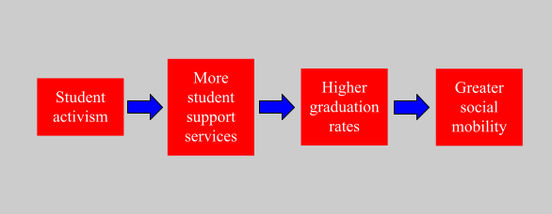
Based on the research question, data, and methods examined in this thesis, I am expecting a few key findings to emerge. These hypotheses are driven by experiences as an undergraduate political science major and are based in the literature reviewed in preparation for this thesis.
Hypothesis one: The more repression of student activism there is, the less successful the implementation of student support services is.
An important caveat within the hypothesis is that there must be at least some response by the university to student protests, whether repressive or not, in order for the implementation of student support services as a result of student activism to have any chance of success. This is not to say that student support services could not be implemented through means other than as a result of student activism.
The second and third hypotheses being tested relate to the effects of student support services on retention metrics.
Hypothesis two: The less repression of student activism there is, the more 4-year and 6-year graduation rates improve after the implementation of student support services demanded by student activists.
Given that the impetus for the implementation of student support services is to improve the experience for students, the goal of those services from an institutional perspective would probably be increasing the graduation rate. Graduation rate is an important indicator of how the university is performing to increase social mobility as demonstrated in the literature and the causal model.
Hypothesis three: The less repression of student activism there is, the better retention rates are in subsequent years.
Similarly, this hypothesis builds upon the expectation that student support services would enhance the experience of marginalized students and their ability to succeed at the institution. For these reasons, if hypothesis two is true, it would be reasonable to expect the institutional retention rate to improve in the years following the change.

Methodology
The hypotheses outlined above will be tested through the use of historical analysis to study three cases. The three cases examined in depth in this thesis are Towson University, the University of Cincinnati, and the University of Missouri, Columbia. These institutions were chosen based on a multitude of similarities including the percentage of students receiving Pell Grants, each school’s method of education, the size of the undergraduate student population of the institution, demographic characteristics, and of course, the presence of student protests focused on racial justice during 2015. This campus activism occurred as protests calling for racial justice and an end to police brutality took place around the country. In many cases the movements on campus and in cities were interconnected. The three colleges selected as cases for this thesis are all located near cities that had major protests for racial justice as part of the Black Lives Matter movement after Black men were killed by police officers in each city. Towson University is outside of Baltimore, Maryland, the University of Missouri, Columbia campus is near St. Louis and Ferguson, and University of Cincinnati is located in Cincinnati, Ohio.
The data used in this thesis comes from three cases of student activism that took place during the nationwide campus protests of 2015 surrounding racial justice. Demographic data is sourced from the Integrated Postsecondary Education Data System (IPEDS) from the National Center for Education Statistics. Data relating to the repression of student activism comes from 2015 in the form of newspaper articles, primary source documentation from the colleges, universities, and student organizations, and academic articles written between 2015 and 2020. Data relating to the implementation or lack thereof of student support services and programming that was demanded by student activists is sourced from reports generated by the three case universities and contemporaneous reporting from between 2015 and 2020.
For the 2015-2016 academic year the percentage of students who received Pell grants at each institution was 27% at Towson University, 23% at the University of Cincinnati-Main Campus, and 20% at the University of Missouri-Columbia (IPEDS 2015-2016). These three similar percentages of students receiving Pell grants are all lower than the 2015-2016 national average of 34.5% at 4-year or more public universities (IPEDS 2015-2016). Each of these institutions are public, 4-year, research universities. The University of Missouri-Columbia is a flagship institution, meaning that it bolsters the university system of its state, in this case, the University of Missouri System. Both the University of Missouri-Columbia and the University of Cincinnati received Carnegie classifications as doctoral universities with very high research activity. Towson University received a Carnegie classification as a doctoral/professional university. Carnegie classifications are determined by the size and scope of each institution and the primary factors for classification are the population of the undergraduate community and the total number of degrees conferred to undergraduate, masters, and doctoral students.
Given this thesis’ focus on undergraduate student activism and the yields or lack thereof as a result of that activism and the repression of the same, it is important to note the demographic characteristics of the undergraduate population at each of the case institutions. In Fall 2015 there were 18886 undergraduate students enrolled at Towson University, 25009 undergraduate students enrolled at the University of Cincinnati-Main Campus, and 27791 undergraduate students enrolled at the University of Missouri-Columbia (IPEDS 2015). Chart 1 (below) displays the percentage of the undergraduate population during the 2015-2016 academic year who were male or female at each institution based on data from IPEDS (2015).

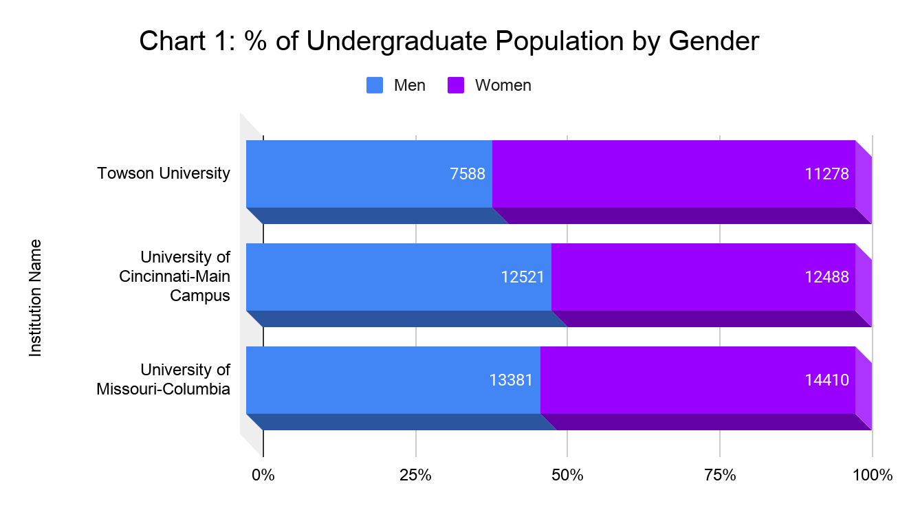

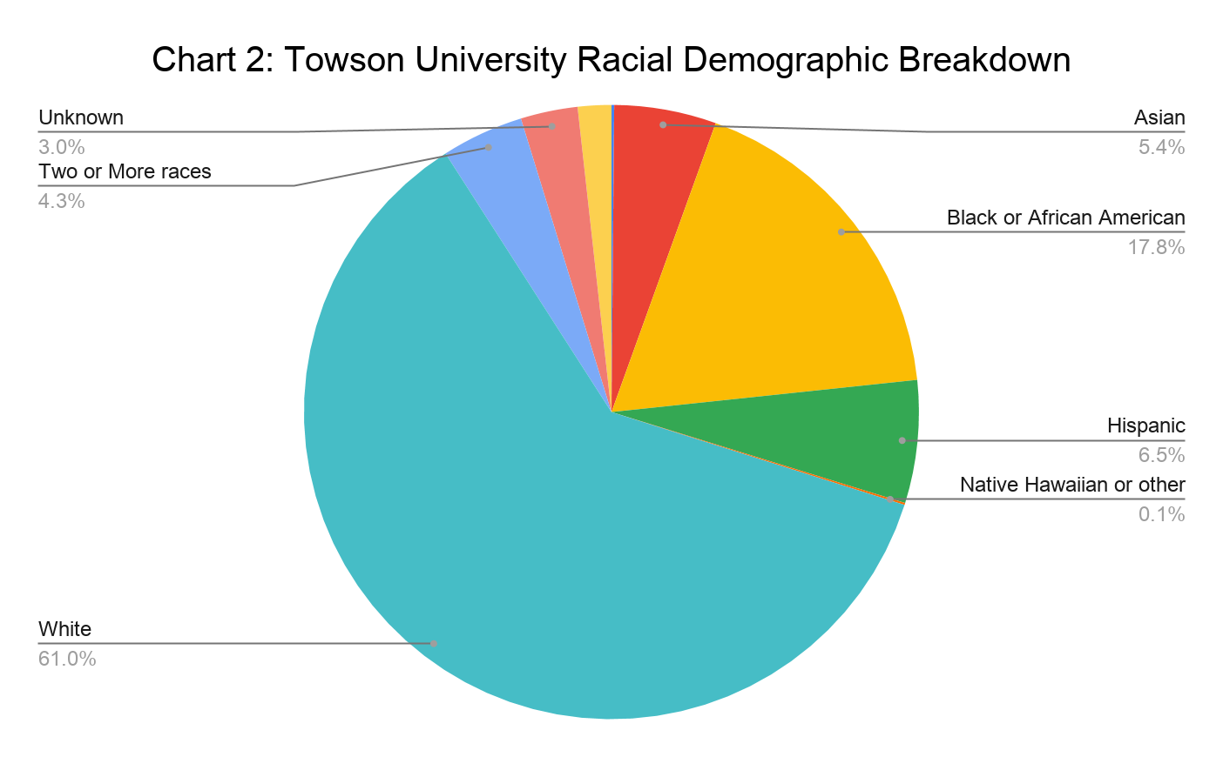
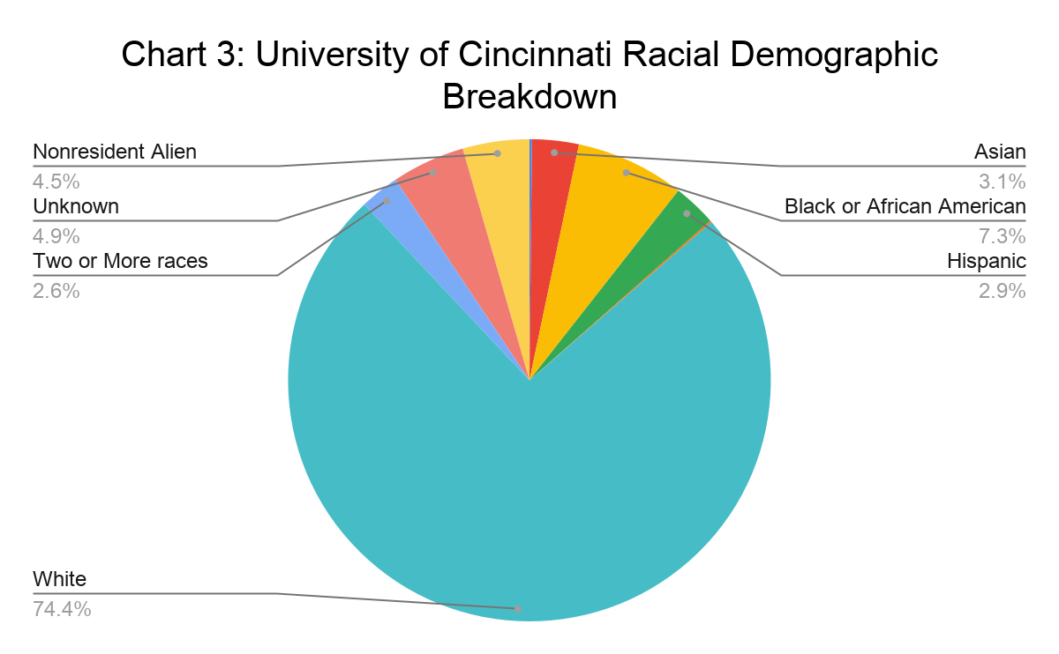

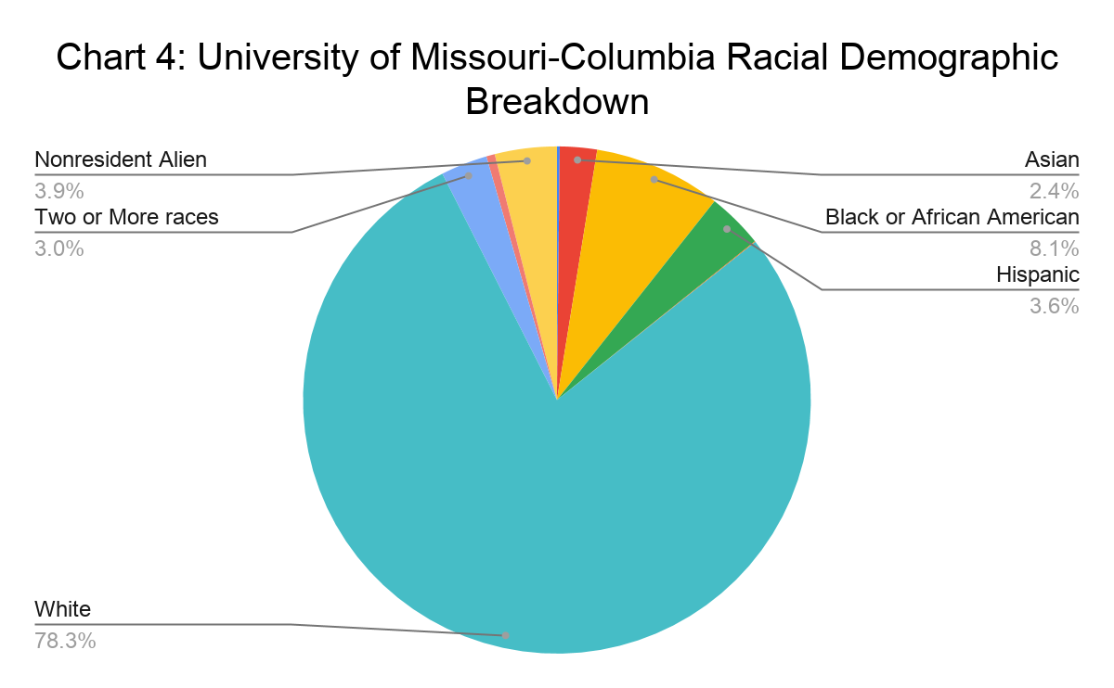

As demonstrated in the above charts, each of the universities are predominantly white institutions. White students made up at least 60% and as high as 78% of each institution’s undergraduate population in Fall 2015. At each institution Black and African American students were the second most prevalent racial grouping. Between 7-8% of undergraduate students in 2015 at the University of Cincinnati and the University of Missouri-Columbia were Black along with 18% of undergraduate students at Towson University. Additionally, in 2015, 6% of undergraduate students at Towson University were Hispanic and 5% were Asian. At the University of Cincinnati and the University of Missouri-Columbia neither Hispanic nor Asian students composed more than 5% of the total undergraduate population, nor did any other racial group.
The first limitation set in the search for cases utilized in this research was one of time. The colleges hosting nationwide campus protests of 2015 were selected as the population of cases due to their national media coverage, the high number of campuses that hosted protests, and the similar demands made by activists around the country. Focusing on the protests of 2015 offers an opportunity to contrast the institutional response to protests with the violently repressive institutional responses of the late 1960’s. Another notable factor that was not present during the campus protests of the 1960’s was the influence of technology. Modern student activists communicate using social media and email whereas those technologies were not available to the student activists decades ago. Additionally, this means universities have a new landscape to deal with and more potential avenues for policies of repression including digital surveillance.
Another reason that the campus protests studied in this thesis are significant is that they took place at a time where protesters in cities nearby were taking to the streets to protest police brutality and to call for racial justice. These protests swept the nation as part of the Black Lives Matter movement for racial justice. The protests in Missouri and Maryland drew significant national media coverage and the protests and events in Cincinnati, Ohio were directly connected to the campus activists. Each city's protests were driven by the killing of Black men at the hands of police officers. In Ferguson, Missouri, a suburb of St. Louis located one hour away from the University of Missouri-Columbia, protests erupted in August 2014 following the murder of Michael Brown Jr. This civil unrest was significant due to what escalated into riots and the militarization of the police response. The National Guard was deployed to quell protests. In Baltimore, Maryland, just 20 minutes from Towson University, protests and rioting took place following the death of Freddie Gray while in the custody of Baltimore police officers in April 2015. In the case of the Baltimore protests the National Guard was once again deployed and a state of emergency was declared in the city of Baltimore allowing the government to enforce a nightly curfew. The protests in July 2015 near the University of Cincinnati were sparked by the killing of Samuel Dubose by a University of Cincinnati police officer. These protests led to a low number of arrests and were relatively non-violent compared to the riots and successive mobilization of large groups of law enforcement personnel in Ferguson and Baltimore. These protests across the country set the stage for the campus organizing to occur at University of Missouri-Columbia, Towson University, and the University of Cincinnati in the Fall of 2015. The proximity of protests to the three universities in each case is another factor that makes the cases of student activism similar.
The socioeconomic composition of each university was another important factor in selecting cases for study. It was important to take into account the students who attend each institution in order to understand whether the responses of university administrators were driven by the socioeconomic status of student activists. This was important given the disproportionate and different repression experienced during the campus protests of the 1960’s by students at institutions like San Francisco State University compared to those at elite institutions like Cornell University in Ithaca, New York. It is also important to consider the socioeconomic composition of a university’s undergraduate student body when investigating the implications of student activism on social mobility. This thesis is investigating whether the repression of student activism impacts the university’s enactment of policies which would enhance social mobility through increased graduation and persistence rates. For this reason, it is important to note the similar Pell Grant allocation statistics of the three universities studied in this thesis. As noted earlier, between 20 and 27% of students received Pell Grants at Towson University, University of Missouri-Columbia and the University of Cincinnati in 2015-2016. Given that this is lower than the national average, it may indicate that most students have a higher than average ability to pay for schooling. The similarity between each school allows for student finances to be a mostly controlled variable in this research.
Finally, each of the cases chosen for this research are large public research universities. Selecting institutions that have similar characteristics in terms of the size and scope of the institution is important in order to make findings that might be applied to an entire subsection of the higher education system. Each of the case universities was serving more than 18,000 undergraduate students in Fall 2015. These institutions also are governed in similar ways with a direct reliance on the state for funding and with strong relationships with local police agencies and with the state’s police or National Guard. This can lead to the state intervening on the university’s behalf in order to quell protests that are perceived as endangering the state or local populations. Given the reliance on state appropriated funds, these universities also seek contributions from corporations and foundations in order to meet the needs of their community. These financial contributions from donors, which are prevalent at large research universities, can be impacted by the branding and media attention received based on the response to a protest. Public universities offer more access and insight into their decision-making processes and finances than private institutions do, making them more suitable for study.
The literature indicates the importance of including measures of the selectivity and size of institutions of higher education, the percentage of students receiving pell grants, and other demographic information including race when selecting cases. For this reason, another important characteristic of the cases selected in this thesis in addition to the size of the institution is the university’s acceptance rate. Kelleher also found that a distinction was necessary between the cause of the majority of campus protests in 2015 and those that took place at University of Missouri-Columbia, which she says were the protests that sparked those on other campuses. This distinction was that the protests at the University of Missouri-Columbia were sparked by racial events outside of campus which motivated students to act in protest of grievances experienced on campus. As noted above, the proximity to notable racial events is also true in the case of Towson University and the University of Cincinnati. The other two universities in this study share a similarly high selectivity rate compared to other universities who saw large protests. In 2015 the acceptance rate at each university was between 75 and 80% (IPEDS 2015). Wesley Strong (2013) offers a classification structure for the different types of repression that student activists might face. He creates four categories of repression that are useful in creating a method for coding the repression that each case university exerted on student activists during the protests of 2015. Importantly, these forms of repression are both overt and covert. Compared to analysis of repression of 1960’s activism which mostly focuses on police violence and other forms of overt repression. This classification structure will allow me to conduct a more thorough analysis of each case. I will indicate whether repression is overt or physically violent, covert through either verbal or written repression, or whether there is no repression.
The research design is set up to answer the question of what impact, if any, the repression of student activism has on the university’s implementation of student success programming targeted at supporting students from marginalized backgrounds and in turn boosting graduation and persistence rates. In order to begin to answer that question, after selecting the cases using the criteria identified above, the first step was identifying the demands and main actions of the student activists. These demands were sourced from thedemands.org and from news reports from the time of the protests. Ranging from the addition of course requirements in race relations to the creation of new organizations and offices on campus addressing diversity and to calling for the resignation of the University president, the demands provide insight into what the student activists believed would increase equity and justice on their campuses. The demands also create a baseline for research into what the universities have achieved in student support initiatives and in racial justice and diversity work since the protests. In investigating the implementation of these programs, I will be able to track when the programs were implemented and if there were significant changes in retention rates afterward.
Second, I investigated the repressive tactics of each institution through media reports and academic articles. As mentioned earlier, I use the work of Strong (2013) in order to classify and identify repression. The four categories of repression mentioned in the analysis of each case will align with his work. They are policy, non-violent police action, police violence, and legal action. Dividing the repression exhibited in each case into these four categories of repression also enables me to test hypotheses focused on which types of repression inhibit the implementation of student success initiatives the most and which types have the greatest impact on the success of protests, whether positive or negative. This evaluation and these findings might enable future researchers to attach weights to specific types of repression as more or less influential.

Chapter 4: Cases
Towson University, the University of Cincinnati, and the University of Missouri-Columbia are very similar in characteristics, demographics, and in that each hosted student activism in the fall of 2015. What separates these institutions was the response each had to protests and demands by student activists. This section breaks down the three cases and highlights the context, protests, important actors, institutional response, to what extent that response was repressive, and the aftermath of protests for each case. Each of these examples demonstrate how different levels of repression by the state and universities in response to student activism impact the implementation of programs and supports demanded by activists which are linked to increased graduation and retention rates.

Towson University
The student activism at Towson University in Towson, Maryland was preceded by two major events that made national headlines. The first was the death of Baltimore resident Freddie Gray in the custody of the Baltimore Police Department. Freddie Gray was arrested on April 12, 2015 for possession of a knife. He was injured during the incident and died a week later on April 19. The controversy surrounding Gray’s death led to protests and riots in the streets of Baltimore beginning April 25, 2015. These protests culminated in dozens of arrests, numerous injuries and the deployment of Maryland National Guard members by Gov. Larry Hogan after he declared a state of emergency. The National Guard remained deployed in Baltimore until May 3, 2015. In addition to the proximity of the Baltimore uprising after Freddie Gray’s death, what makes these events especially germane to the student activism at Towson University is the participation of local university students in the protests. In April 2015, Towson University students joined their peers from other Baltimore-area institutions including Johns Hopkins University and Goucher College in protesting the killing of Freddie Gray and the brutal treatment of Black people by police. These protests stretched from the Homewood Campus of Johns Hopkins University to downtown Baltimore and City Hall. The second major event preceding student protests at Towson University was the student activism that took place at the University of Missouri-Columbia described later in this chapter.
On November 18, 2015, in solidarity with protesters at the University of Missouri-Columbia and the #StudentBlackOut campaign composed of student activists on campuses around the country, a group of Towson University students called the Black Students at Towson University staged a sit-in protest in the office of Interim President Timothy Chandler (Cornish). The night before, student activists had staged a takeover of the Towson Student Government Association (SGA) meeting to demand the SGA president sign their list of demands. The SGA president, Kurt Anderson agreed to sign the demands and a motion to do so was agreed to by a vast majority of student representatives (Boteler et al.). According to an article in The Towerlight, Towson University’s campus news source, Anderson said, “We’re committed to ensuring that all Towson students, including our students of color are represented fairly and equally, and we’re going to work with administration to ensure that all of these issues are addressed. This is something that we take very seriously.”
Students entered the office of the Interim President holding signs including one that read, “TowsonIsMizzou.” This was a reference to the protests at the University of Missouri-Columbia. The students chanted “Black students matter,” and, “We have nothing to lose but our chains, it is our duty to fight for our freedom, it is our duty to win.” After physically sitting down in the office to make their occupation of the space known, students presented Interim President Chandler with a list of demands. The students made it clear to Interim President Chandler that they would not leave until their demands were acknowledged and agreed to. According to a Baltimore Fishbowl article documenting the sit-in, the hashtag “OccupyTowson” became associated with the action and began trending on social media (Babcock). Students cited “oppressive occurrences” including physical and verbal attacks along with a lack of Black professors and cultural competency training for peers and personnel as their impetus for taking direct action (Herzing). The NAACP’s official Twitter account boosted the visibility of the protest at Towson through a post on their page citing the students taking action. The protest lasted eight hours and attracted attention from several local media outlets in addition to students and other community members.
In response to the presence of the protestors, Interim President Timothy Chandler came out of his office to engage with them in the office lobby. After the protestors presented their demands, Interim President Chandler began working with the protestors to address the demands. The dialogue between protesters and school officials lasted eight hours and ended around 12:40 AM, just after midnight (Boteler et al.). The main administrators who addressed the protestors and engaged them in a dialogue on the demands were the Interim President, General Counsel Traevena Byrd, and Deputy Chief of Staff Marina Cooper. Significantly, a police or security presence was not mentioned or visible in the primary documentation examined for this thesis nor in any other documentation of the sit-in examined. During the sit-in, activists worked with the Interim President and other administrators to reach an agreement on the demands they brought. The General Counsel was consulted by Interim President Chandler to ensure that he could enter an agreement with the protestors. At the end of the night, Chandler had signed a revised set of demands. He said that the process of negotiation and dialogue was, “a long and very, very important process that we went through both learning from each other and I think putting the University in a better place in terms of understanding and appreciating their problems” (Boteler et al.)
Protestors reflected the same sentiment and felt on that night that Chandler and the University staff had truly heard and sympathized with them. The student activists said that sitting-in at the President’s office was out of love for the University and their fellow students. One student said, “it’s all love, but it’s radical love” (Boteler et al.). In addition to citing their intentions to demonstrate their love, they also saw the agreement they reached with Interim President Chandler as a victory. To this effect, a different student said, “...I feel like I am going to celebrate today and yesterday’s victory because I do see it as a victory. As a person who is committed to mental and emotional health on this campus, it’s nice to see that we have staff on our side and people on our side committed as well” (Boteler et al.).
Table 1: Towson Student Demands and Outcomes
Demand | Demand Implemented? | Outcome
Increase the tenured and tenure-track Black faculty and retaining them by 10% by Fall 2018 | Partial | It does not seem that the metric was achieved, however as a result of the demands specific efforts were undertaken to recruit Black faculty. This included work to build relationships with HBCUs in Maryland to attract recent PhD graduates.
Require the President to work with the provost to ensure that every college or department has one meeting per semester dedicated to CSD cultural competency content approved by a student representative that works in the CDSO by Fall 2016 | Yes | Each department/college was directed to have at least one meeting per semester dedicated to cultural competency.
Advocate for IFC Fraternities and Pan-Hellenic Sororities to have a Diversity Chair who will promote diversity within their respective organizations and interact with multicultural organizations on campus by Spring 2016 | Yes | All of the predominantly-white fraternities had created diversity chairs and most sororities had as well as of April 2016.
Send a letter to the President of USM Student Council regarding the review and termination of the contract, vendoring, and purchasing of appliances, tools, furniture and any other items produced within Maryland State and Federal prisons. Given the status of the prison-industrial complex and the criminalization of Black bodies, along with the school-to-prison pipeline, we find it problematic that we finance the same institutions that profit off of Black bodies. By Spring 2016. | Partial | A letter was sent to the President of USM Student Council. However, as of 2016, Towson had not divested from items produced within Maryland State and Federal prisons. This was justified by the president of USM Student Council by explaining the prisoners he interacted with on a research visit to a Maryland prison enjoyed the work they were doing in producing the goods (Towerlight).
Advocate to require the SGA to maintain communication with the Diverse Organizations and their leaders on campus through physical contact, wherein bills and policies that will effect the Black student body will be made known and aware to them. By Fall 2015. | Yes | The SGA revamped their communication tools and techniques in response to this demand.
Require the President’s Diversity Coordinating Council and other institution-wide diversity committees to have diverse (including multi-cultural) representation on the committee that reflects the underrepresented cultures of the student body by Fall 2016. | Yes | The President of Towson University, Dr. Kim Schatzel, who succeeded Interim President Chandler was committed to restructuring the council to ensure different voices are represented.
Set an expectation to diversity the representation of the committees determining tenure at Towson and require college deans to report on their efforts and results. Such efforts could include but are not limited to: Encourage students to complete course evaluations in course syllabi; Invite student feedback for pending tenure cases; Provide the opportunity for faculty tenure candidates to identify an advocate to serve on any level of their choosing in the tenure process. By Fall 2016. | Partial | The tenure process was under review as of 2016.
Advocate for the Director Positions in the SGA to be elected by the people of this university instead of appointed, hired, and/or interviewed by the President. The Diversity Chair is a direct representative of the minority students and should be elected directly by and for minority students by Spring 2016. | Yes | This change was made as a result of the demands and advocacy from the student organizers and Interim President Chandler.
Return the Towson University Debate Team to a traveling debate team as soon as possible and no later than Fall 2016. The Debate Team is an intellectual fixture in the Towson University Black community where Black students have been nationally successful and active contributors to bringing justice to Black people at this institution. | Yes | The Debate Team was revived in time for Fall 2016.
Honestly and strictly enforce the university’s policies on non-discrimination. Proactively work to create a marketing campaign to educate and communicate our Hate/Bias procedures and response. Distribute a public statement on Towson University’s response on those issues when they occur. Publicly. The mental and emotional health of this University’s Black students across all intersections need to be taken as seriously as their physical health. By Fall 2015. | Yes | Student Government and the student affairs divisions of the college made commitments to enforcing hate/bias procedures. This included integrating the hate/bias policy into documentation that goes into the hands of students including syllabi.
Require that policing practices be equitable for Black events and white events alike by Spring 2016. | Unclear | It’s not clear whether this was achieved or not and if there is an assessment tool in place to make a determination.
Advocate for the establishment of a course requirement in American race relations for students by meeting with the necessary and appropriate entities (such as the Curriculum Committee, University Senate, MHEC, USM, etc.) By Fall 2016. | Yes | Chandler agreed to advocate for the establishment of a course requirement in American race relations and he brought this idea to the academic restructuring process that was underway at the University.

The table above displays the demands of the student activists of Towson University as they were agreed to by Interim President Chandler in November 2015. Towson University has met or partially met the most demands out of the three cases studied in this thesis. This is likely due in part to the less pointed nature of the twelve demands compared to those at the two other institutions. However, it is also probable that the efforts undertaken by Interim President Chandler, General Counsel Traevena Byrd, and Deputy Chief of Staff Marina Cooper to work with the student activists to agree upon a list of demands made it more possible for the university to achieve them. Based on the success that Towson University had implemented the student activists demands and the charts above showing the changes to 4- and 6-year graduation rates after 2015, it seems that Towson University benefited from implementing these demands and from not repressing the student activism expressed in a sit-in at the Interim President’s office in November 2015.

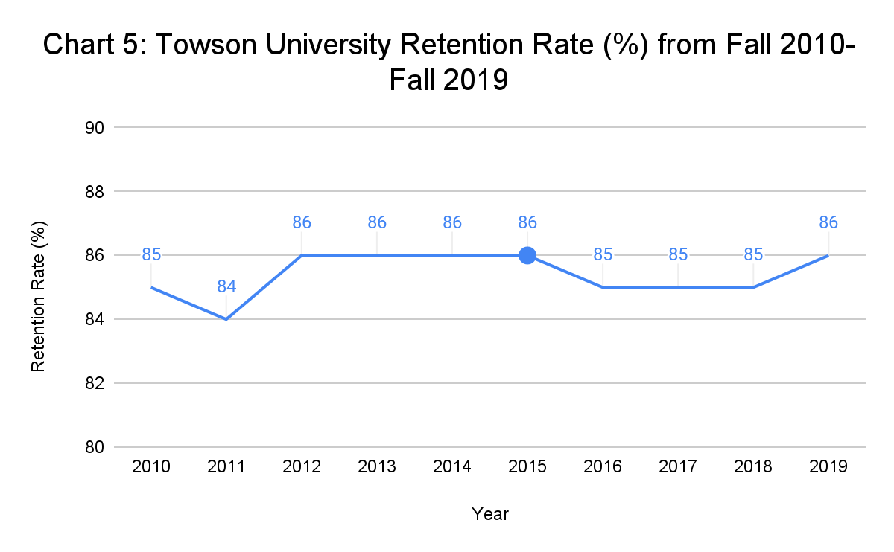
In contrast with the hypotheses laid out in this thesis, the retention data at each institution is fairly similar. As the chart above shows, the retention rate only varied two percentage points over the nine year period between 2010 and 2019. Due to this low variance it is not possible to make any significant findings as to the impact of the repression of student activism on the retention rate at Towson University.
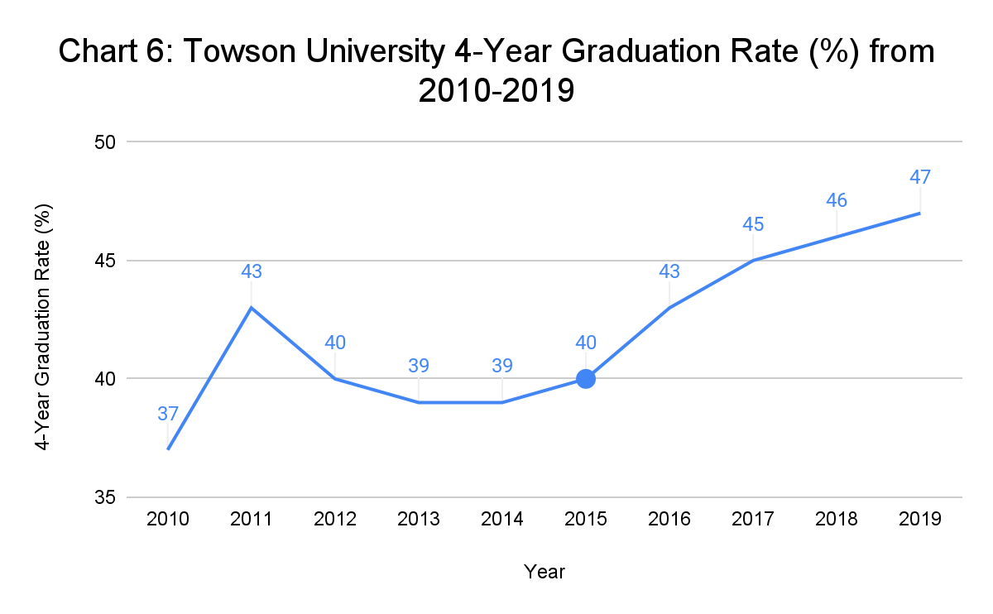
The 4-Year graduation rate data displayed in the chart above makes it clear that prior to 2015 there was a slightly positive correlation between graduation rate and time but after the student activism of 2015 that correlation was heavily positive. From 2011 through 2015 the 4-year graduation rate at Towson University was trending downward but after 2015 it increased steadily. This suggests that the lack of repression of student activism and concurrent action on the part of Towson University to meet student activists demands may have had the effect of positively impacting the 4-year graduation rate of the university.

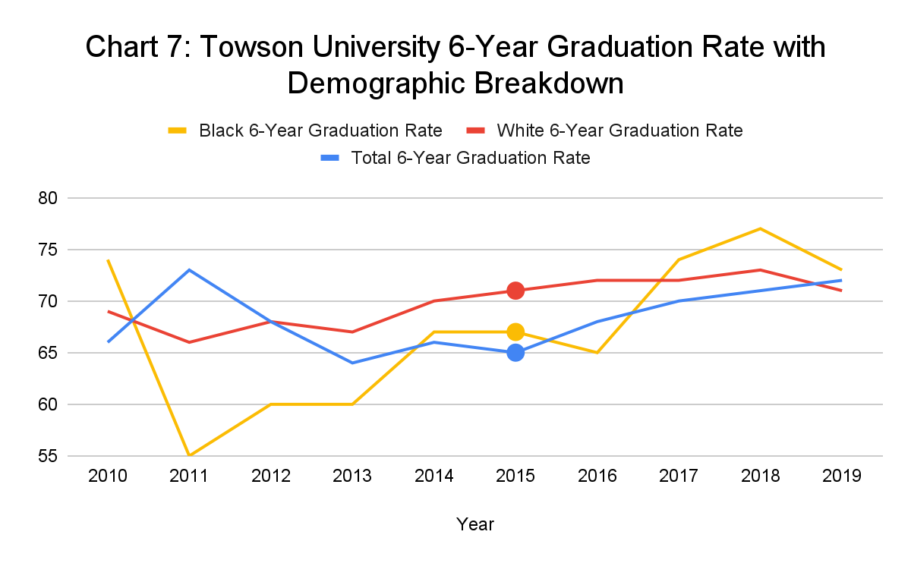The same effect present in the chart displaying the 4-year graduation rate at Towson University is present in this chart with the Total 6-Year Graduation rate. Prior to 2015, the 6-year graduation rate had a neutral or negative trend, but since the student activism in fall 2015 and the lack of repression of that activism, the retention rate has had a positive trend over time. Like the 4-year graduation rate, this suggests that the lack of repression in the case of Towson University and the efforts by the university to implement student activists’ demands may have had a positive correlation with the 6-year graduation rate. Unlike 4-year graduation rate and retention rate data, 6-year graduation rate data from IPEDS is broken down by racial demographics. As seen in this chart, the 6-year graduation rate for white students at Towson University has been somewhat consistent in it’s positive correlation with time since 2010. On the other hand, the 6-year graduation rate for Black students at Towson University rose from 2011-2014, was flat 2014-2016, and then rose. By 2017, the 6-year graduation rate for Black students had surpassed the 6-year graduation rate with white students. These trends correlate with the student activism of 2015 and the implementation of student demands afterwards into 2016. This chart suggests that the impacts of the implementation of student demands through a lack of repression of student activism might have a stronger effect on the 6-year graduation rate for Black students than for white students.

University of Cincinnati
Similar to the case of Towson University protests, the student activism at the University of Cincinnati was influenced significantly by local and national events. Students at the University of Cincinnati were sometimes acting in solidarity with students at the University of Missouri-Columbia just like student activists at Towson University. What makes the activism at the University of Cincinnati unique among the three cases studied here is the direct relationship between the University and the death of a Black man at the hands of police. Samuel DuBose was fatally shot by a University of Cincinnati police officer on July 19, 2015. He had been pulled over for a missing front license plate and a suspended driver’s license. Coming after the shooting of Michael Brown by Ferguson, Missouri Police, and the death of Freddie Gray in the custody of Baltimore, Maryland police, Samuel DuBose’s shooting and subsequent death sparked protests in the city of Cincinnati, Ohio. Several vigils were held during July of 2015 to honor the life of Samuel DuBose along with protests attended by his family, community members living in Cincinnati, and students at the University of Cincinnati that aligned with the Black Lives Matter movement. The proximity to and direct role of the University of Cincinnati in this shooting influenced student protestors in their activism later in 2015.
In late August 2015, a group of students at the University of Cincinnati organized themselves as a group called The Irate 8. The name referred to the percentage of Black students attending the University of Cincinnati as a proportion of the total population at the time, eight percent, and the “frustration” the group had with their “quality of life” on campus (The Irate 8). In their introductory messaging to the campus community, the group specifically cited the death of Samuel DuBose and subsequent University response as an example of the University of Cincinnati’s failures to support their quality of life as students. They also offered themselves as an empowering force for the Black students of the University of Cincinnati. The President of the University of Cincinnati at the time, Dr. Santa J. Ono, responded to their initial social media rollout by tweeting, “I respect and support the work of The Irate 8. Together we will work to make UC a more inclusive and even greater university” (Graves). Between August and October 2015, The Irate 8 organized several social media campaigns aimed at publicizing their grievances with the University of Cincinnati amongst the student body and providing several opportunities for students at the University to ask questions about race and about what actions The Irate 8 was taking. In late September, The Irate 8 hosted a week of events called Samuel DuBose week. This included a forum highlighting the University’s response to Samuel DuBose’s killing, a privilege walk, wearing ribbons, and a fundraiser for the DuBose family. On October 6, 2015, The Irate 8 hosted a teach-in in partnership with several University of Cincinnati departments and offices focused on oppression, racism, privilege, inclusion, access, and more. The teach-in was centrally located on campus and offered 20-minute sessions that students could rotate between.
The Irate 8 published and issued a 21-page document containing ten demands to the University of Cincinnati on October 15, 2015. The ten demands included the implementation of racial awareness curriculum, doubling the amount of Black students on campus, and changes to the representation of underrepresented communities in student government along with several other changes. It also provided substantial research and justification for each demand. Thirteen days later, on October 28, 2015, The Irate 8 received a reply from the University of Cincinnati Undergraduate Student Government and the University of Cincinnati. The response from the Undergraduate Student Government came first. Signed by the president of the organization, the letter expressed a desire to collaborate with The Irate 8 to make the changes requested in the fifth demand. The letter noted a meeting later that week that would include discussions of improving the representation of underrepresented students in the body (The Irate 8).
Later on October 28, the University of Cincinnati released its official statement regarding the demands. The letter from the University included an introductory paragraph of thanks and recognition for raising the issues featured in the demands and for, “stepping up, speaking out, and making your [The Irate 8’s] voices heard.” The letter went on to emphasize the complexity of the issues raised in the demands and the need to engage in ongoing dialogue in order to make change. It concluded by highlighting five points where the University was taking action or committing to take action as a, “demonstration of good faith.” The Irate 8 issued a nuanced response to the University’s letter on October 29, 2015. They explained that the 21-page document containing demands, justification, and research was met with what they deemed, “vague university talking points which failed to even acknowledge the specificity of each demand” (The Irate 8). The Irate 8 also disagreed with the University’s plan to hold private conversations with the group in order to come to agreement on the necessary change that would occur. The group advocated for public dialogue and a public position from the University regarding the concerns of Black students.
Feeling unheard and that their concerns and demands were not being treated with the appropriate weight, The Irate 8 continued direct action in the months following October 2015. This included a silent protest held on Wednesday November 18, 2015. Note that this is the same date as the Towson University sit-in. As documented by The Cincinnati Enquirer, students duct-taped their mouths shut and gathered on the University Cincinnati campus holding signs in support of the ten demands from the month prior (Murphy). An organizer of the protest and member of The Irate 8 was quoted saying the University’s response to the demands was, “lackluster.” The student activist also described the reason for the silent protest saying, “We are out here to put a form of pressure on the university to meet our demands or at least have a better response and move quicker” (Murphy). The protest was organized in solidarity with Concerned Student 1950, the group of student activists organizing at the University of Missouri-Columbia, and in partnership with the Black Liberation Collective’s worldwide Day of Action. According to The Cincinnati Enquirer, the Black Liberation Collective, which is a coalition of student activism groups at campuses worldwide, had the goals of, “Black students and Black faculty to be reflected by the national percentage of Black people in the country, free tuition for Black and indigenous students, and a divestment from prisons and an investment in communities” (Murphy). Members of The Irate 8 present at the protest indicated they were moderately satisfied with the University’s facilitation of conversation but that their dialogue lacked a sense of urgency which is why further action was justified. Dialogue between the University of Cincinnati and The Irate 8 continued in 2016. Unlike at Towson University, it is not clear that the University ever agreed to specific terms with the student activists. Instead, over time the University released statements to the community outlining what steps the institution would take to address issues related to diversity and inclusion. On their website, The Irate 8 claims credit for the promises the University made in October 2016 which were wide reaching and included staffing changes, additional student support services, and other reforms. By the time the University released these commitments in 2016, President Ono had resigned to take another role and Dr. Beverly J. Davenport had taken the role of interim president.
The work of the Irate 8, as documented on their website, continued into 2018. More recently, in 2020, WCPO Cincinnati, the local ABC affiliate, reported that two student-led groups delivered two sets of demands to the current President of the University of Cincinnati, Dr. Neville Pinto (Francisco). President Pinto has served as President of the University since March 2017. The new set of demands came from the Undergraduate Student Government and from a group called Black Round Table which is a coalition of campus organizations with a shared objective. The leader of Black Round Table said, “There is an overall disconnect when you speak of the different initiatives, community policing initiatives that the administration has tried to enact” (Francisco). Likewise, the Undergraduate Student Government’s director of African American Student Affairs said that, “silence will not be taken lightly,” as a response from the University (Francisco). Many of the new demands are the same or similar to demands levied by The Irate 8 in 2015. The comments from these student organizers and the reemergence of several demands from 2015 suggests that students remain dissatisfied with the progress the University of Cincinnati has made in the past six years.

Table 2: Demands and Outcomes of University of Cincinnati Student Activists
Demand | Demand Implemented? | Outcome
We demand that the University of Cincinnati immediately restrict Phillip Kidd  and David Lindenschmidt from patrolling on or off of campus. | No | This demand was rejected by the University in 2016 and as of February 2017 the two officers had not been fired from the University of Cincinnati police force. An investigation into whether they had committed any wrongdoing was paused during ongoing prosecution of the officer who shot Samuel DuBose (FOX19).
We demand that the University of Cincinnati enforces a fully funded  comprehensive racial awareness curriculum that is mandatory for all students,  faculty, staff, and police structured by a caucus comprised of students, community  members, and administrators of diverse backgrounds to be put in place by the start  of the 2017­-2018 academic year. | Partial | A steering committee and working groups were formed to meet this demand.
We demand that the University of Cincinnati conducts holistic profiles including  extensive background checks, mental evaluations, and accounts of past  misbehaviors of all faculty/staff/police hired at the University of Cincinnati,  starting immediately. | Yes | As of summer 2016, all new applicants were required to submit a statement explaining their intended contribution to and understanding of diversity and inclusion at the University of Cincinnati.
We demand a recurrent substantial monetary allotment to go to all offices and  initiatives that directly support and impact the recruitment, retention, and  matriculation of Black students on this campus, starting in the Fiscal Year 2017. | Yes | A committee was formed to review the programs that could utilize funding and to make a recommendation for the budgeting process.
We demand that the University of Cincinnati allocate appointed voting student  senate seats in Student Government from selected representatives from  underrepresented communities (race, sexuality, and gender). Additionally,  Student Government must report their composition each year including race,  gender, sexual orientation, and other self-­identifying information for each faction. | Yes | Student government made adjustments to their voting seats in order to be more representative.
We demand that the University of Cincinnati hire at minimum 16 staff and senior  Black faculty over the next 3 years, starting today, October 14th 2015. | Partial | This effort was ongoing, with a significant investment of $40 million bolstering efforts as of 2016.
We demand the University of Cincinnati doubles the amount of Black students on  main campus over the next 3 years, starting today, October 14, 2015. | No | This did not occur, however specific efforts were made as a result of the demands to target diversity in recruitment.
We demand that the University of Cincinnati builds a stand alone AACRC or  renovates in order for all of 60 W. Charlton to belong to the AACRC by August 1,  2018. | Yes | This was completed in the Fall of 2016 according to a demands status report from the University of Cincinnati’s Office of Equity and Inclusion.
We demand that there exist a SACUB funded student organization devoted to  diversity initiatives and programming that promote cultural awareness, sensitivity,  and competence by the start of the 2017-­2018 academic year. | Partial | This demand was in progress as of 2016.
We demand that the University of Cincinnati divest from any companies involved  in the operation of private prisons and establish a Socially Responsible  Investment Committee (or at least adopting a socially responsible investment  policy) for all investment transactions by the start of the 2017­-2018 Academic  Year. | No | The University indicated that a financial reason would take precedence over a social/ethical one in terms of divestment. This did not occur.

This table lists the demands issued by The Irate 8 to the University of Cincinnati as they were issued in 2015. It also lists whether the demand was successful or not and some details of that process. Unlike in the Towson University case but like the University of Missouri case, the University of Cincinnati never came to an agreement with protestors on demands. This likely harmed the implementation of the demands and the relationship between protesters and administrators. Additionally, the University of Cincinnati used repressive tactics that were identified by the student activists including false promises and statements of support without follow through. An example of this was the University of Cincinnati’s official response to The Irate 8 demands released on October 28, 2015 which expressed support for the group and their work but explained the complexity of the issues meant the University could not make commitments then. Student activists responded to this by explaining that the University of Cincinnati was not acting with the urgency they were calling for and while they appreciated the support they were seeking action. The table shows that some of the demands were implemented in 2015 or 2016. It also shows several demands were not implemented and were outright rejected by the university. The University of Cincinnati exercised moderately repressive measures including messaging that only delayed the conversation between student activists and administrators and a lack of public communication on the issues raised by student activists compared to Towson University which met with protestors and agreed to an altered version of their demands on the night they were first issued and followed up on those demands publicly as time went on.
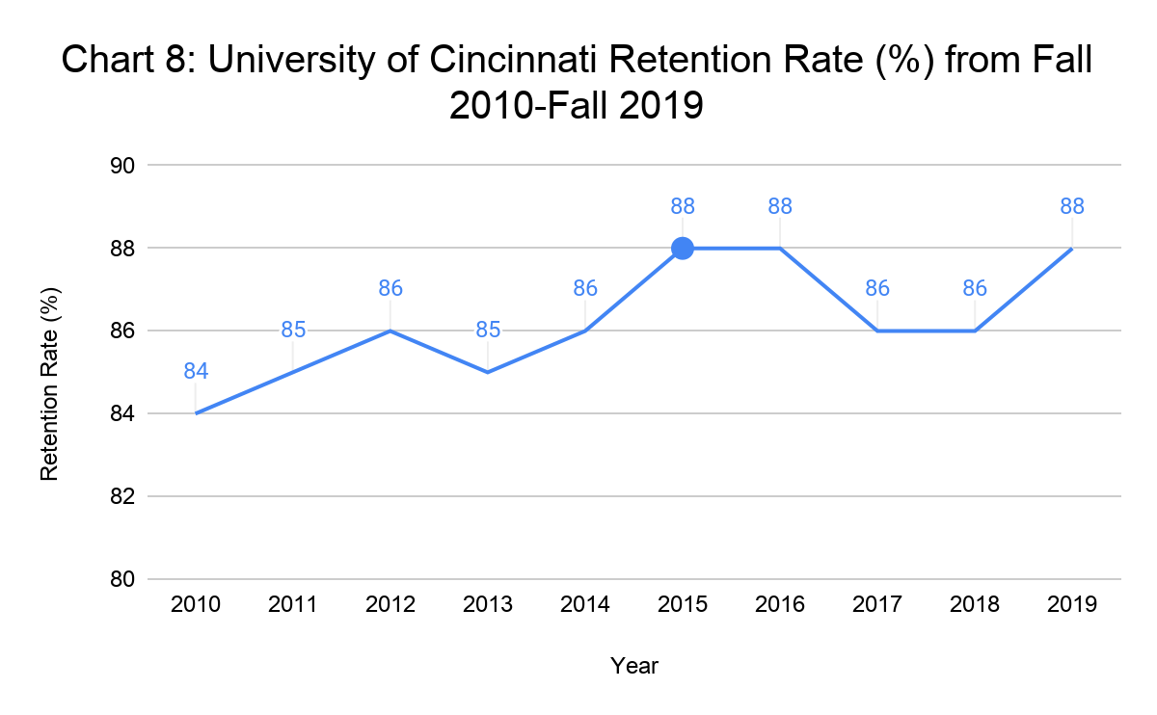
Just as in the other two cases, the retention rate data does not yield any significant findings other than that it does not seem to be linked to the repression of student activism or the implementation of student activists’ demands. There is low variance in the retention rate over the nine year period studied and there is a positive trend overall.
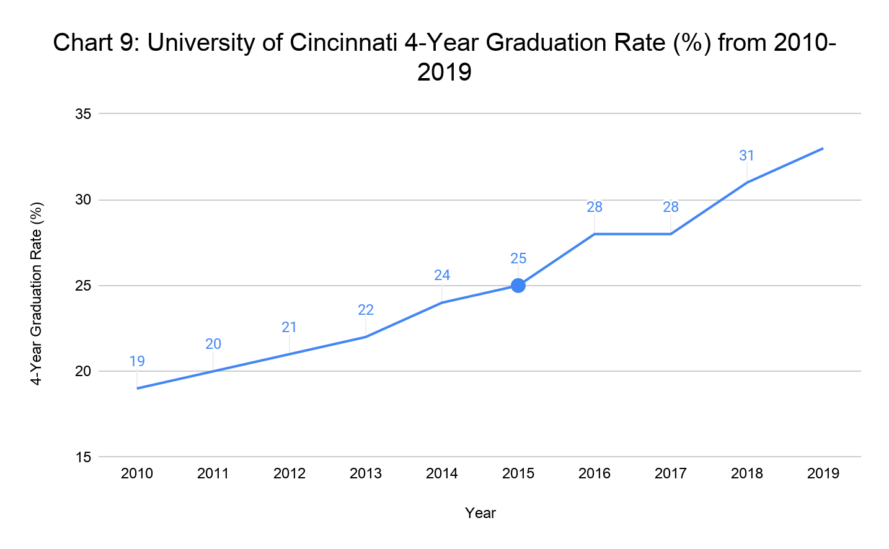
The chart above shows that the 4-year graduation rate was positively correlated with time from 2010 to 2019. The blue dot represents the year wherein The Irate 8 organized and protested on campus in support of the demands they issued to the University of Cincinnati. For the period 2010-2015 the correlation between the 4-year graduation rate and time could be expressed as r=0.9921609338. After the moderate repression of student activism by the University of Cincinnati in 2015 and subsequent moderate success implementing the Irate 8’s demands, for the period 2015-2019 the correlation between the 4-year graduation rate and time could be expressed as r=0.9746794345. This means that the correlation between the 4-year graduation rate and time was slightly less positive after the moderate repression of student activism than before. This suggests that the repression of student activism through verbal and written messaging without physical repression may have a slightly negative impact on the 4-year graduation rate of large public research institutions.

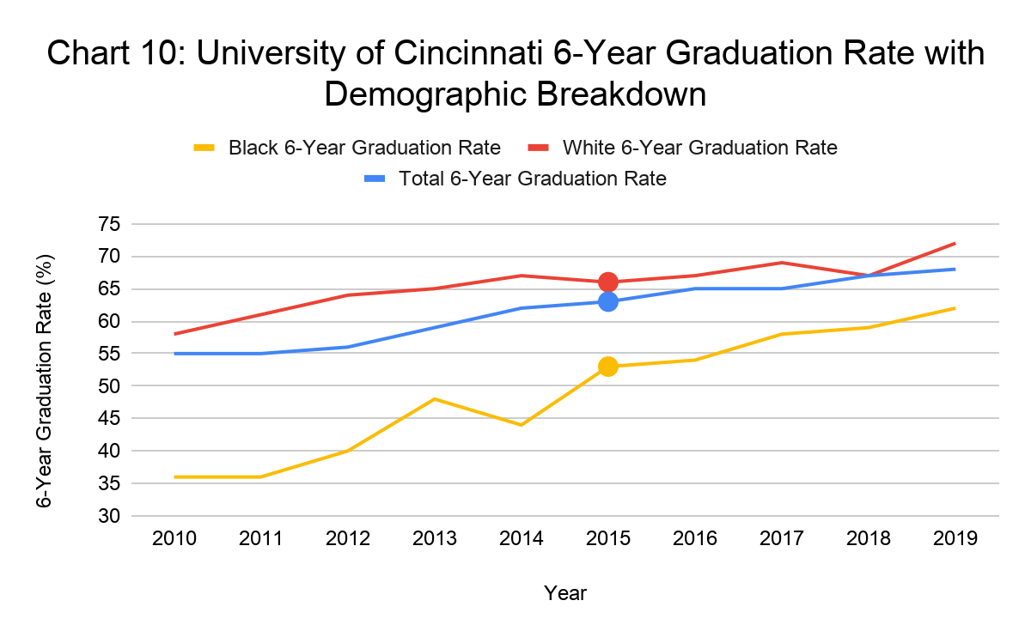
The same trend observed in the chart showing 4-year graduation rates at the University of Cincinnati is observable in this chart demonstrating 6-year graduation rates over the same time period. Throughout the 9-year period from 2010 through 2019, the University of Cincinnati’s 6-year graduation rate is positively correlated with time. However, it is less positively correlated with time after the moderate repression of student activism in 2015 than in the years prior. Just as earlier, this suggests that the repression of student activism had a harmful effect on the 6-year graduation rate. When broken down by racial demographics, the 6-year graduation rate data for Black students shows that the gains in total 6-year graduation rate after 2015 came mostly from the increase in 6-year graduation rates for Black students. After 2015, the 6-year graduation rates for white students did not rise as much. This, just like in the case of Towson University, suggests that the impacts of the repression of student activism and implementation of student activists demands might have more of an effect on the 6-year graduation rate for Black students.

University of Missouri
The student activism at the University of Missouri is the most notable case featured in this thesis. The actions by students and the reaction by University administrators was reported heavily in national newspapers. The University of Missouri was at the center of the student activism movement of 2015. Preceding the student activism in fall 2015 were several events. The first which provides important context is an anti-black hate crime which occured in 2010 at the University of Missouri. Two white students dropped cotton balls at the Black culture center on campus. They were prosecuted for a hate-crime but eventually were only convicted of littering. After this event, the University of Missouri began an initiative called One Mizzou in support of diversity on campus.
The second event or series of events that preceded student activism at the University of Missouri was the deadly shooting of Michael Brown by police in Ferguson, Missouri. Ferguson is approximately two hours east of the University of Missouri’s Columbia campus. This is the flagship campus of the University of Missouri system and it is the campus where student activism was concentrated in 2015. Michael Brown’s killing sparked riots and protests in Ferguson, Missouri beginning August 10, 2014. These protests became a part of the ongoing, larger, Black Live Matter movement. Many protests remained peaceful in the aftermath of Michael Brown’s killing however some businesses in Ferguson were subject to looting and destruction. The police response was repressive and included many arrests. The police were criticized for military-style tactics used as a response to the protests. Protests continued throughout the month of August and the National Guard was activated by the Governor, Jay Nixon, on August 18, 2014. That night, 78 individuals were arrested. The proximity of these events to the University of Missouri-Columbia was a contributing influence for the student activists.
The last notable event that preceded the student activism of fall 2015 at the University of Missouri was a Facebook post made by the student government president, Payton Head, describing his experiences facing bigotry, homophobia, and transphobia on campus. He explained how these events made him feel not included at the University of Missouri. His post garnered the attention of many students and of the administration on campus. On September 17, 2015, University administration responded by denouncing the recent bigotry called out by Head (Pearson). A week later, students protested based on the viewpoint that the administration was not doing enough to address Head’s comments and that the University needed to act with more urgency.
In the aftermath of these events, several students formed Concerned Student 1950, a group with the goal of advocating for Black students at the University of Missouri and raising awareness of the experience of Black students amongst the student body and to the administration. In early October 2015, protests continued and another incident of hate occurred which caused the Chancellor of the University, R. Bowen Loftin to order diversity and inclusion training for students and staff starting in 2016. This move was supported by students as a step in the right direction but called out by graduate student Jonathan Butler in a open letter published in The Maneater as problematic because they did not acknowledge the work of Black students in crafting diversity trainings and did not acknowledge those students affected by the climate at University of Missouri who do not belong to organizations with influence on the institution such as the student government (Butler).
Only a few days after the statement by Chancellor Loftin ordering diversity and inclusion training, members of Concerned Student 1950 blocked University of Missouri System President Tim Wolfe’s car during the homecoming parade. As the protesters chanted in front of Wolfe’s car, they were physically pushed back, first by members of the public and then by police. The use of physical force to control or repress student activists is unique to this case out of the three studied in this thesis. In video footage taken of the incident and featured in the documentary film with the same name as the student protest group, Wolfe can be seen smiling as protestors were forcibly removed from blocking the road (Dietrich et al.). According to CNN, Head, the student government president, posted, “He laughed, in our faces. This is your President. This is America. 2015” (Pearson). Just as in the cases of Towson University and the University of Cincinnati, members of Concerned Student 1950 explained that the reason they were protesting and taking direct action was out of love for the institution they attend but also because they felt change needed to occur urgently. Later, on October 20, ten days after the encounter described above, Concerned Student 1950 issued a list of demands to the University of Missouri. One of these demands was an apology from Wolfe and his removal or resignation from his role as President of the university system. The other demands are similar to those presented at the University of Cincinnati and Towson University including changes to the curriculum, increasinging the percentage of Black students and faculty, and creating a more safe and inclusive campus. Wolfe met with the group a week later but did not commit to the demands.
On November 3, 2015, Jonathan Butler, the graduate student who addressed Chancellor Loftin’s diversity training move in an open letter in early October 2015 and who was one of eleven founding members of Concerned Student 1950, launched a hunger strike to protest the Universities failure to meet the group’s demands. At the outset of the strike he said, “Mr. Wolfe had ample opportunity to create policies and reform that could shift the culture of Mizzou in a positive direction but in each scenario he failed to do so” (Pearson). He explained that the strike would go on until President Wolfe resigned or was removed from office. The hunger strike drew considerable attention from local and national media to the movement Concerned Student 1950 had organized. Several students began boycotting classes in support of Butler’s strike. Butler explains in the “Concerned Student 1950” documentary that days into his hunger strike he had heard unofficially that the administration was willing to let him die because they did not intend on removing President Wolfe from his position (Dietrich et al.). On November 6, Wolfe issued an apology to Concerned Student 1950 but later that night when asked by protestors to define systematic oppression, he stated to the protesters that it is, “because you don’t believe that you have the equal opportunity for success” (Pearson). This led protestors to charge that he was blaming them, Black people, for systematic oppression. Two days later, the University of Missouri football team made the decision to go on strike in support of Jonathan Butler’s hunger strike. They announced that they would not practice or participate in games until President Wolfe resigned or was removed. This presented major financial implications to the University system, including the potential for a $1 million cost to the institution if they were forced to forfeit their next game. Notably, the athletic department leadership voiced their support for the student athletes on strike. On November 9, 2015 President Tim Wolfe resigned from the Presidency of the University of Missouri System. He explained in his resignation speech that he believes the emotions that the student activists are experiencing are real and valid, but also that change should not occur the way it had (Dietrich et al.). Members of Concerned Student 1950 and their supporters celebrated the news of Wolfe’s resignation as a victory for their movement and they pledged to continue working to improve the University of Missouri. Wolfe’s resignation was followed by the departure of other senior leadership of the University. It does not appear that Concerned Student 1950 and the University of Missouri ever agreed to terms on the demands raised in October 2015.

Table 3: Demands and Outcomes of University of Missouri Student Activists
Demands from Concerned Student 1950 | Demand Implemented? | Explanation
We demand that the University of Missouri System President, Tim Wolfe, writes a handwritten apology to the Concerned Student 1-9-5-0 demonstrators and holds a press conference in the Mizzou Student Center reading the letter. In the letter and at the press conference, Tim Wolfe must acknowledge his white male privilege, recognize that systems of oppression exist, and provide a verbal commitment to fulfilling Concerned Student 1-9-5-0 demands. We want Tim Wolfe to admit his gross negligence, allowing his driver to hit one of the demonstrators, consenting to the physical violence of bystanders, and lastly refusing to intervene when Columbia Police Department used excessive force with demonstrators. | Partial | Tim Wolfe issued an apology statement on November 6, 2015 (CNN). In the statement he acknowledged that racism exists at the University of Missouri and that it is a systemic problem. He stated that he regretted his reaction to the protestors blocking his car at the homecoming parade. Later that day he told protestors systematic oppression exists because they do not believe they have the equal opportunity for success. This made members of Concerned Student 1950 and the public question the honesty of his earlier apology.
We demand the immediate removal of Tim Wolfe as UM system president. After his removal a new amendment to UM system policies must be established to have all future UM system president and Chancellor positions be selected by a collective of students, staff, and faculty of diverse backgrounds. | Partial | Tim Wolfe was not removed but instead resigned from the Presidency of the University of Missouri System on November 9, 2015.
We demand that the University of Missouri meets the legion of Black Collegians’ demands that were presented in 1969 for the betterment of the Black community. | No | These demands were not addressed by the university in 2016 as demanded by Concerned Student 1950.
We demand that the University of Missouri creates and enforces comprehensive racial awareness and inclusion curriculum throughout all campus departments and units, mandatory for all students, faculty, staff, and administration. This curriculum must be vetted, maintained, and overseen by a board comprised of students, staff, and faculty of color. | Partial | Many departments created racial awareness and inclusion curriculum and diversity training was mandated starting with the Class of 2020.
We demand that by the academic year 2017-2018, the University of Missouri increases the percentage of Black faculty and staff campus-wide to 10%. | Yes | This was successful.
We demand the the University of Missouri composes a strategic 10 year plan by May 1, 2016 that will increase retention rates for marginalized students, sustain diversity curriculum and training, and promote a more safe and inclusive campus. | No | This demand was not met by the deadline of May 1, 2016.
We demand the the University of Missouri increases funding and resources for the University of Missouri Counseling Center for the purpose of hiring additional mental health professionals; particularly those of color, booting mental health outreach and programming across campus, increasing campus-wide awareness and visibility of the counseling center, and reducing lengthy wait times for prospective clients. | Partial | This was partially met, the University of Missouri made investments in staff of color for the Counseling Center but did not meet specific quotas and metrics laid out in Concerned Student 1950’s document.
We demand the the University of Missouri increases funding, resources, and personnel for the social justices centers on campus for the purpose of hiring additional professionals, particularly those of color, boosting outreach and programming across campus, and increasing campus-wide awareness and visibility. | Partial | Some investments were made in the social justice centers on campus but larger capital investments demanded by Concerned Student 1950 were not met.

Table 3 shows the demands as issued by Concerned Student 1950 in October 2015. Of the three cases studied in this thesis, the University of Missouri has done the least to meet the demands of student activists. Just as in the case of the University of Cincinnati, the University of Missouri never agreed to terms with Concerned Student 1950. Only one demand was fully achieved based on the updates provided by Concerned Student 1950 and the university. Even after Concerned Student 1950’s direct activism tapered off, they were still receiving negative comments from university administrators. This included a reprimand in February 2016 from the former interim vice chancellor for diversity, inclusion and equity who said that Concerned Student 1950 was creating, “threats and arbitrary deadlines.” He stepped down in Fall 2016 and was replaced by a permanent vice chancellor for diversity, inclusion and equity. It is possible that the turnover forced by Concerned Student 1950’s activism contributed to the University of Missouri’s failure to implement students' demands. It is also likely that the repression of Concerned Student 1950 and the failure on the part of the university to agree to terms with the student activists contributed to the lack of successful demand implementation.

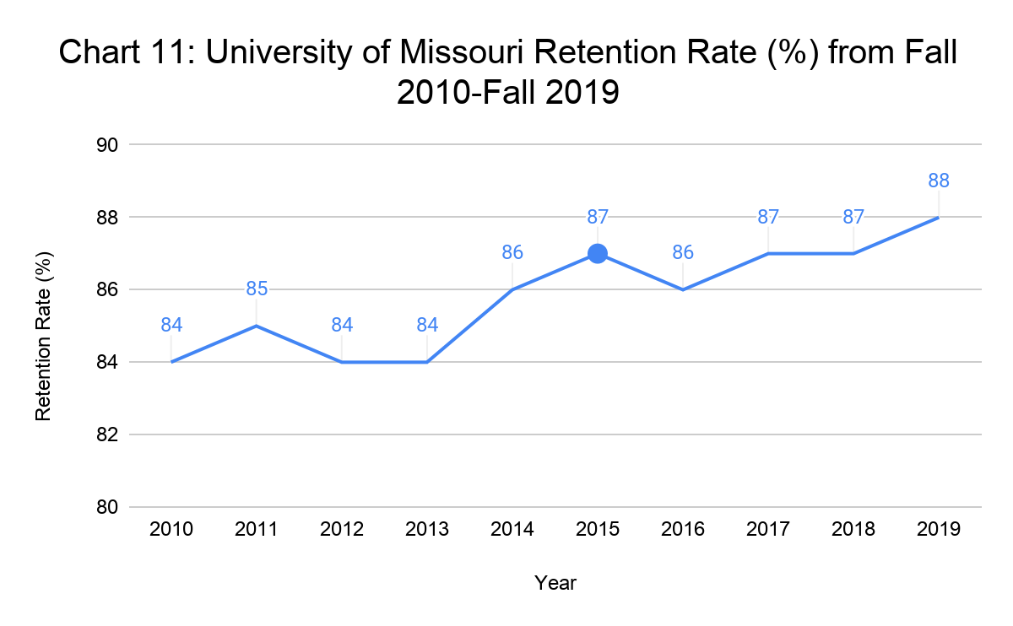
Just as with the two other cases, the retention rate data from the University of Missouri-Columbia does not seem to be related to the repression of student activism in 2015. This chart shows that from fall 2010 through fall 2019 the retention rate varied by four percentage points and overall was positively correlated with time. It does not appear that the repression of student activism in 2015 impacted the retention rate significantly at the University of Missouri or at the other two case institutions.
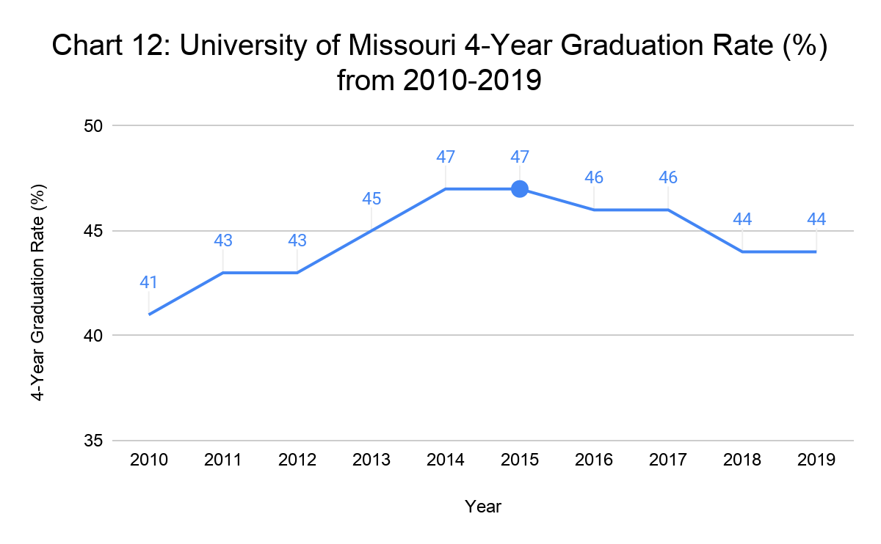
The above chart shows that during the period between 2010 and 2019 the University of Missouri’s 4-year graduation rate was positively correlated with time. However, the chart also shows that from 2010 to 2015 there was a positive correlation and from 2015 to 2019 there was a negative correlation. This turning point in 2015 coincides with the emergence of Concerned Student 1950’s student activism at the University of Missouri and the University of Missouri’s physical, verbal, and written repression of that activism. The positive correlation between 2010 and 2015 can be represented numerically as r=0.9710083125. The negative correlation between the University of Missouri’s 4-year graduation rate and time from 2015 through 2019 can be represented numerically as r=-0.9428090416. This negative correlation demonstrates that the physical, verbal, and written repression of student activism in 2015 may have significantly harmed the 4-year graduation rate at the University of Missouri.

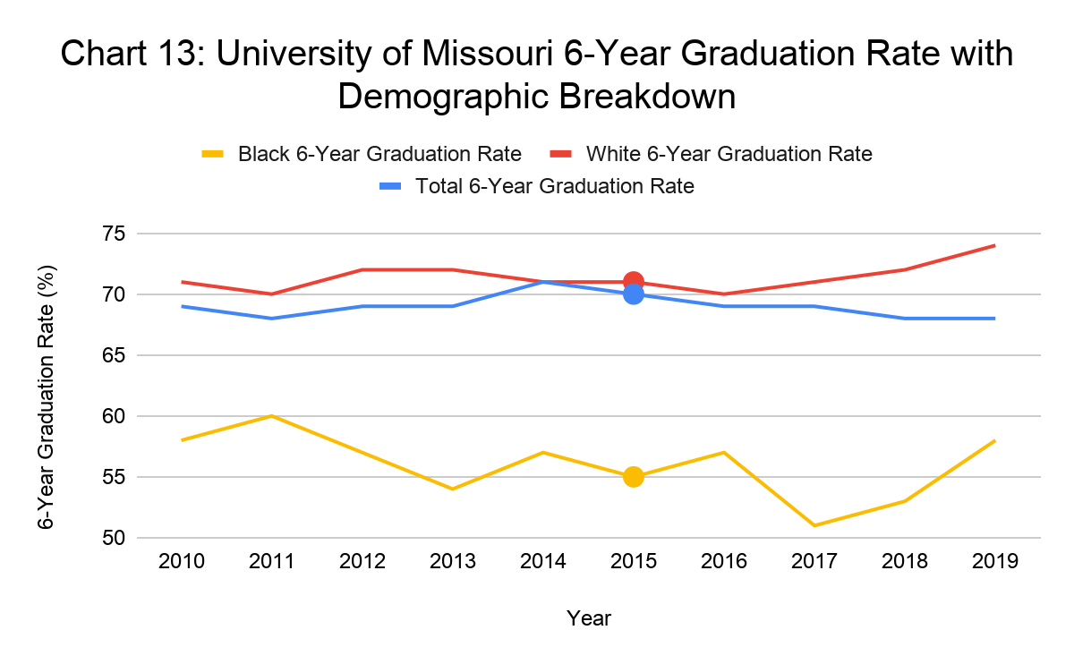 The 6-year graduation rate chart for the University of Missouri shows a similar trend as the 4-year graduation rate chart. However, because the variance in total 6-year graduation rate was only three percentage points over the nine year period between 2010 and 2019, it is potentially less significant that the period from 2015 to 2019 had a negative correlation whereas the period from 2010 to 2015 had a positive correlation. What is clear in this chart is that the University of Missouri was the only university studied with a negative correlation between the 6-year graduation rate and time between 2015 and 2019. Just as with the last chart, this correlation suggests that further research might show that the repression of student activism might have negatively impacted the graduation rate at the University of Missouri. When the 6-year graduation rate data for the University of Missouri is broken down by racial demographics, a more distinct change after 2015 emerges. For Black students, there was a sharp decline in the 6-year graduation rate between 2016 and 2017. This decline did not recover to its previous level until 2019. It also did not occur for the 6-year graduation rate of white students. Instead, the 6-year graduation rates of white students rose from 2016-2019. This disparity demonstrates that the physical, verbal, and written repression and lack of demand implementation at the University of Missouri correlates with the decrease in graduation rates for Black students and slow increase in graduation rates for white students. Further research might show that 6-year graduation rates for Black students dropped because of the physical, verbal, and written repression of student activism combined with the failure of the university to enact many of Concerned Student 1950’s demands in the years following 2015.

Contrasting These Cases to National 6-Year Graduation Rates
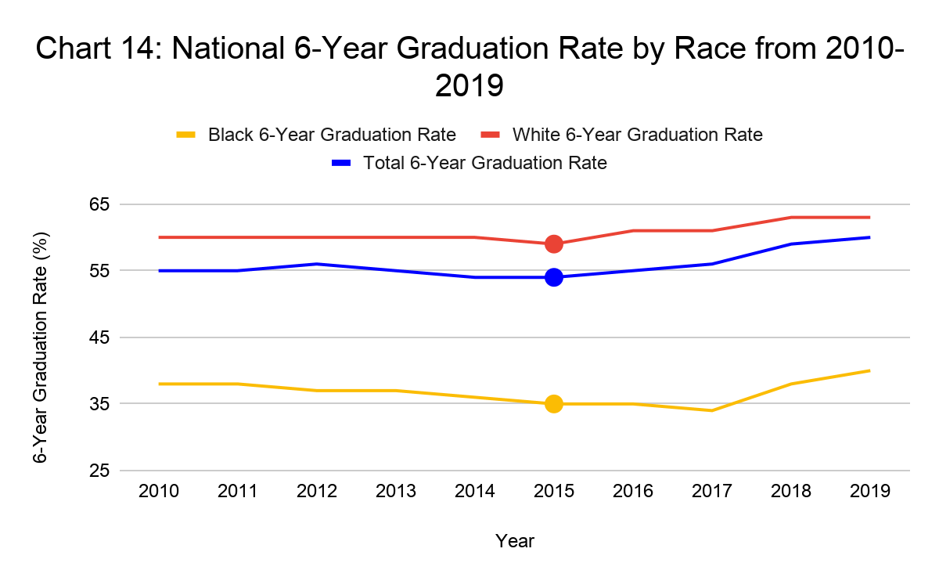
For the purpose of comparing and contrasting the 6-Year graduation rates at each case institution with the national average 6-Year graduation rate, the above chart displays the 6-Year graduation rate averages in total and broken down by race for white and Black students attending 4-year institutions of higher education in the United States. Each case institution is a 4-year institution of higher education. By looking at this chart, it is evident that the Black 6-Year graduation rate is significantly lower than the 6-Year graduation rate for white students and the total 6-Year graduation rate nationwide. The trough for 6-year graduation rates for Black students in 2017 aligns with the low point of 6-year graduation rates for Black students at the University of Missouri as shown in Chart 13. Based upon this thesis, a few potential explanations which could be tested with further research emerge for this correlation. First, it is possible that a series of factors unrelated to the student activism of 2015 caused this nationwide drop and the drop at the University of Missouri. Second, it is possible that the repression of student activism at the University of Missouri and other institutions created challenges to student success for Black students across the country, driving down 6-year graduation rates nationwide and at the University of Missouri. It is notable that Towson University and the University of Cincinnati, both institutions which did not physically repress student activists and who implemented some, if not most of the student activists’ demands, not only exceeded the negative nationwide 6-year graduation rate trends for Black students but actually had increasing 6-year graduation rates for Black students from 2016-2019.

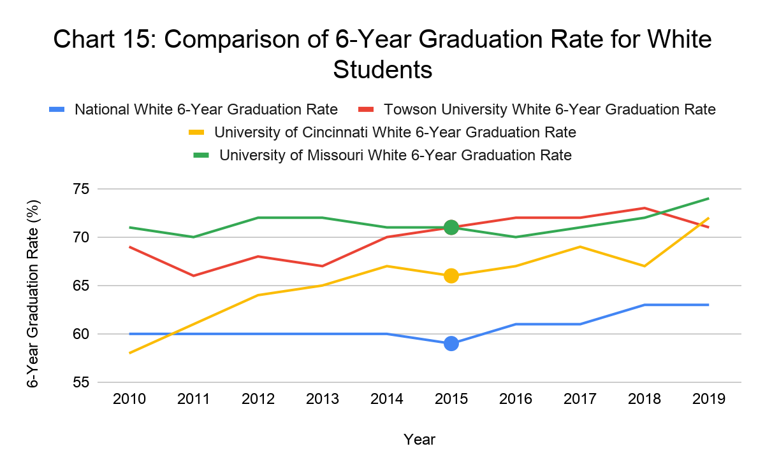
Chart 15 shows the 6-year graduation rates for white students at the three case institutions and nationwide at 4-year institutions of higher education. Upon first inspection of the chart, it is apparent that each case institution significantly outperformed the national average of 6-year graduation rates, especially in the latter half of the decade. What is most striking about the 6-year graduation rates for white students compared to the total 6-year graduation rate at each case institution is that there was a much less significant correlation between the student activism of 2015 and the graduation rates.
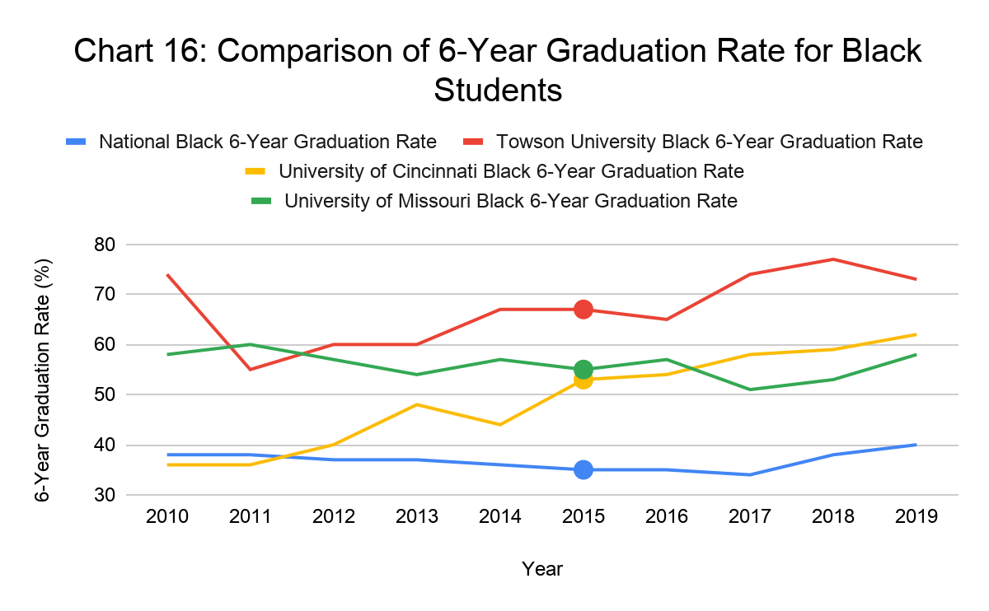 Chart 16 displays the 6-year graduation rates for Black students at the three case institutions and nationwide at 4-year institutions of higher education. This chart shows the disparities between each case institution between 2010 and 2019. As expressed above, Towson University saw an increase in 6-year graduation rates for Black students following the 2015 protests, subsequent lack of repression of student activism, and implementation of student support services demanded by student activists. The University of Cincinnati similarly yielded an increase in 6-year graduation rates for Black students following 2015. However, and potentially due to the verbal and written repression of student activists and failure to come to terms with the student activists on the student support services demanded, this increase was less positively correlated with time than prior to 2015. The University of Missouri yielded a decrease in 6-year graduation rates for Black students and finished the decade with a lower 6-year graduation rate for Black students than the other two case institutions after having the highest in 2011. After the 6-year graduation rate for Black students at the University of Missouri remained consistent from 2012-2016, it dropped significantly in 2017. This decline might have been due to the tactics of physical, verbal, and written repression used on student activists in 2015. Further research might be able to determine whether the correlation between the repression, or lack thereof, of student activism and 6-year graduation rates for Black students at these case institutions is actually causation. As noted above, the 2017 drop in 6-year graduation rate for Black students at the University of Missouri coincides chronologically with the lowest average 6-year graduation rate nationally. Further research might investigate whether this correlation is evidence of the repression of student activism at the University of Missouri causing negative impacts for Black students nationwide specifically related to their chance to graduate within 6-years.

Chapter 5: Findings and Concluding Thoughts
Beginning with the assertion that Martin Trow’s described transition from elite to mass to universal higher education has failed and continuing through the synthesis of multiple areas of existing literature, I have been able to begin to demonstrate the potential validity of the relationship between student activism and social mobility. This thesis proposes a causal model which states that student activism aimed at addressing systemic racism in higher education and which garners an institutional response from the university leading to the implementation of student support programs and services, will boost graduation rates and in turn increase social mobility. Through careful case study of the response of three large 4-year public research institutions of higher education in the United States to student activism centered on the harm caused by systemic racism, this thesis introduces a compelling foundation upon which further research might determine the extent to which 4-year and 6-year graduation rates are linked causally to the repression of student activism. The central finding of this thesis is that at each institution studied, there was correlation between 4-year and 6-year graduation rates and the level of repression faced by student activists in response to their activism. In this concluding section, I will specifically address the most significant findings of this thesis, suggest possible explanations for these findings, and propose several next steps for researchers, higher education leaders, student activists, and others who might be interested in this work.

Significant Findings
Upon beginning focused analysis of the three case institutions, I proposed to test three hypotheses to answer my thesis question. Building on the existing literature on social mobility, access to higher education, student support services, the transition from elite to mass to universal higher education, and student activism and the repression thereof, I sought to understand what the impact of the repression of student activism was on the failed transition from elite to mass to universal higher education. Examining the cases of student activism and subsequent repression of that activism at Towson University, University of Cincinnati, and University of Missouri presented an opportunity to do so. Data from the Integrated Postsecondary Education Data System (IPEDS) on 4-year and 6-year graduation rates and retention rates provided insight into the correlation between student success metrics and the repression of student activism. News reports and other documentation of the student activism at the three case institutions illuminated divergent institutional responses to student activism and the successful and failed implementation of student support services and programs demanded by student activists.
In order to provide a clear explanation of the findings for each hypothesis, I will reiterate each one followed by a statement of the conclusions which the cumulative body of research collected for this thesis enables me to draw.

Hypothesis one: The more repression of student activism there is, the less successful the implementation of student support services is.

Testing this hypothesis relied upon the descriptive case studies authored for this thesis based upon media reports. The demands posed by the major student activism group at each case institution served as a framework to test the success or failure of the universities to implement student support services. I consolidated multiple media and institutional updates to present three tables with explanations of whether the student activists’ demands had been implemented or not. Given that Towson University, the case with the least repression of student activism, was the most successful at implementing the student support services demanded by student activists and the University of Missouri, the case with the most repression of student activism, was the least successful at implementing student support services in the aftermath of student activism, hypothesis one was correct. This finding is important because it establishes that at these three case institutions, university administrators were more successful or more likely to implement student support services which are linked to improved graduation rates if they limited their repression of student activists and instead partnered with students. Towson University was the only case in which student activists and the university administration came to an agreement on demands. This likely influenced the capability of the university to implement the student support services demanded by protestors given that Towson University’s Interim President Chandler negotiated these demands alongside the University’s general counsel.
When considering the implementation of student support services demanded by student activists, it is important to keep in mind that the student body is not a monolithic group. In each case, there were students who did not agree with students' demands and would likely disapprove of the university’s implementation of student support services. However, as explained in the literature review of this thesis, many of the student support services demanded by student activists in these case studies are viewed as emerging best practices in higher education by scholars linked to higher student success. So, despite the student activists only representing a small portion of the total undergraduate student population, the implementation of student support services can have a much broader reach.

Hypothesis two: The less repression of student activism there is, the more 4-year and 6-year graduation rates improve after the implementation of student support services demanded by student activists.

Testing hypothesis two yields arguably the most significant findings of this thesis and the greatest opportunity for further research which will be explained later. Through the use of IPEDS data on the 4-year and 6-year graduation rates at each case institution, compelling correlations emerge between the repression of student activism and these measures of student success. In the case with the least repression of student activists, at Towson University, there is a positive correlation between 4-year and 6-year graduation rates after the 2015 protests, compared to a negative correlation between the same metrics prior to the protests between 2010 and 2015. In stark contrast, at the University of Missouri, the institution studied which repressed the student activists the most by being the only case institution to physically repress student activists in addition to utilizing verbal and written repression, 4-year and 6-year graduation rates were substantially negatively correlated after the activism in 2015 despite being positively correlated prior. Adding weight to the significance of the cumulative findings, at the University of Cincinnati, where the institutional response to student activists in 2015 included written and verbal repression but not physical repression of students, there was a slightly less positive correlation between 4-year and 6-year graduation rates after 2015 than prior to the repression of student activism.
Cumulatively, the finding of correlation between 4-year and 6-year graduation rates and repression at every case institution studied in this thesis is significant. If only one of the three cases studied showed correlations between 4-year and 6-year graduation rates and the repression of student activism, that would indicate that the correlation is very probably a non-finding and that other variables not being studied are likely the cause. It is extremely significant that each case presents this correlation, especially when paired with the literature on the connections between student support services demanded by student activists and graduation rates.
These correlations become potentially even more interesting and important when considering the disparities exposed through examination of the racial breakdown of 6-year graduation rates at each institution. For white students at each institution studied, the repression of student activism and all that came along with it, did not seem to have a significant impact on 6-year graduation rates. However, for Black students the opposite was true. At Towson University, 6-year graduation rates spiked significantly after 2016 having remained steady from 2014-2016. At the University of Cincinnati, 6-year graduation rates for Black students continued to rise faster than 6-year graduation rates for White students, which was the same as prior to the student activism. At the University of Missouri, 6-year graduation rates for Black students dropped significantly after 2016, while remaining consistent and high for white students at the university. In each case, the 6-year graduation rate for Black students closely mirrors the 6-year graduation rate for all students as opposed to the 6-year graduation rate for white students which remains consistent from 2010-2019 and seems to be unaltered by the repression of student activism. What this indicates is that the correlation between the repression of student activism and graduation rates is driven by increases or decreases in graduation rates for Black students and that consideration of the implications of institutional responses to student activism should focus specifically on this connection.

Hypothesis three: The less repression of student activism there is, the better retention rates are in subsequent years.

The final hypothesis tested in this thesis yielded a non-finding. Although I expected the same trends present in the 4-year and 6-year graduation rate data to emerge in retention rate data, this was not the case. Each institution’s retention rates from 2010-2019 remained fairly consistent and did not seem to be correlated with the student activism and repression of student activism of 2015. As explained later in this thesis, further research might determine why retention rates were not correlated with impactful events on campus like the presence and repression of student activism. Potentially, this is indicative of the heterogeneity of the student body. While student activists might be heavily impacted by the response of a university to their activism, the student body at large, especially at large research universities like those studied here, may not be impacted by or even aware of the presence and repression of student activism. It is also possible that the student support services demanded by student activists and implemented in some of these cases may have a greater impact on graduation rates than on retention rates. This non-finding is significant for those interested in how the repression of student activism impacted the cases featured in this study, but I would caution university administrators, especially at institutions characteristically different from the three case universities to draw conclusions and build policy based on this non-finding. Unlike 6-year graduation rates, IPEDS does not offer demographic breakdowns of retention rate data. It is possible that a breakdown of the retention rate changes based on racial demographics at each institution would indicate that there are actually hidden impacts on retention from the repression of student activism that did not emerge in this thesis.

Possible Explanations
Working on this thesis revealed to me the complexities of the study of higher education and the amazing interconnectedness of so many different fields of thought as demonstrated in this thesis’ literature review. When I initially decided to pursue this project, I could speculate but I was generally uncertain whether links between Martin Trow’s transition from elite to mass to universal higher education and the repression of student activism would emerge. The first connection, and the first of many possible explanations for the evidence of correlation documented in this thesis, was what Trow (1973) explained as the only constant in higher education, change. Higher education has simultaneously remained a system aimed at preparing elites for elite roles while some parts of the system have shifted to a more specific focus on training a broader population for professional roles or to bringing as many people into the fold as possible. The three types Trow described, elite, mass, and universal, are all still present in the system of higher education in the United States. It is this ongoing change between the three types, and the ever-present conflict between the three coexistent types within the system that serves as the first explanation for the correlation between the repression of student activism and student success as measured by graduation rates.
The second link between Trow’s work and the findings of correlation identified in this thesis is Trow’s focus on social mobility and higher education as an essential component of the myth of the American Dream. As explained in the literature review section, higher education is viewed in American society as a key, or even often the key to social mobility. While it is true that successful degree completion from institutions of higher education impacts social mobility, especially for those raised in the lowest income brackets, it is also not the only factor for an individual’s successful movement up the socioeconomic ladder. While the size of the population attending institutions of higher education has expanded over the past half-century, access to higher education for low-income individuals and people of color has not changed to reflect that. What this population growth does mean, however, is that as Trow (2005) identified, “the higher the proportion of the age group going on to higher education, the more the democratic and egalitarian concerns for equality of opportunity come to center on the increasingly important sector of tertiary education” (Trow pp. 4-5). This would provide another explanation for why students were activated in 2015 to advocate for student support services which are linked by experts to graduation rates, or in other words, “equality of opportunity.” Just as according to Taylor and Cantwell, “an opportunity one cannot access is not an opportunity at all,” access without sufficient opportunity attached is not much better than not having access at all (Taylor and Cantwell 128). Student activists, through their demands, present a vision of higher education that is more akin to the societal notion of the system as a bastion for social mobility for all.
Both of the explanations presented above center on the notion that the causal model proposed in this thesis is correct. However, it is possible that the correlation between graduation rates and the repression of student activism which, as evidenced, is especially present for Black students, may not be causally related. Despite the significance of the correlation explained above which in my view warrants careful consideration and further research to test for causation, other factors might explain the changes in graduation rates over the period of time studied. One is that the killing of several Black men which sparked the Black Lives Matter movement, including those Black men killed, Freddie Gray, Samuel DuBose, and Michael Brown, whose killings were context that influenced the cases studied in this thesis, probably impacted Black students nationwide by burdening them and making it more challenging to graduate in 4 or 6 years. This explanation would not explain the difference in the changes to graduation rates between the institutions after 2015, but likely contributed to the change nationwide.
Another two factors are the institutional and statewide politics at play in each case. Institutional politics were present and probably impacted the responses of each university. Towson University was governed by an Interim President at the time of the student activism. His decision making was probably influenced by this distinction and the charge he had been granted by the board who hired him to either keep the policies of the university on track or to make necessary corrections prior to the onboarding of a permanent leader. Likewise, in the case of the University of Cincinnati, President Ono was in his last few years as the leader of that institution at the time of the student activism. If he knew he was going to exit the institution, he may have responded differently than if he felt especially accountable to the board he reported to. Finally, in the case of the University of Missouri, the board refused to remove the university system President despite national media attention and pressure in the form of lost athletics revenue and demands from protestors. This led to President Wolfe holding his position for long enough for graduate student Jonathan Butler to launch a hunger strike and for the brand of the university to face potential harm because of prolonged media attention.
The internal institutional politics of the University of Missouri may have been impacted by the politics of the state of Missouri. Missouri, unlike the other states where the other two case institutions are located, is a solidly conservative state. The influence of state politicians who control funding and support for the university likely played a role in the repression of the student activism and potentially the downturn in graduation rates after 2015. The University of Cincinnati, which had a moderate amount of repression through a verbal and written form, is located in a moderate state whose voters elect leaders falling on both sides of the political spectrum. Towson University is located in Maryland, a solidly liberal state who at the time, had elected a moderate Republican governor and a state legislature solidly in the control of the Democratic party. Just as with the University of Missouri, these political contexts in Ohio and Maryland might have influenced the response to student protests, the implementation of student support programs, and, in turn, 4-year and 6-year graduation rates.

Next Steps for Researchers, Higher Education Leaders, and Student Activists
One of the motivating factors for me in choosing to pursue this thesis was the potential to build upon my experiences in and around higher education governance, student activism, and scholarship in political science and higher education in order to produce research that could spark other research, support higher education leaders in their assessment of institutional responses to student activism, and provide student activists with a compelling argument to pose to their universities as to why cooperation on student demands is more fruitful than the repression of student activism. Based on my thesis, I would like to propose a set of next steps for researchers, higher education leaders, and student activists.
Researchers can find many interesting opportunities for further research within this thesis. The most direct opportunity is to study the correlation between 4-year and 6-year graduation rates and the repression of student activism in order to determine whether there is a causal relationship between those variables. The significance of the presence of correlation in each of the cases studies provides a suitable foundation for a more advanced research project. My exposure to research methodology as an undergraduate has not yet prepared me for the work of determining causation. Another opportunity for further research would be to expand the sample size beyond the three case studies investigated here. This would provide insight into each of the hypotheses studied and could speak to the systemic failures of higher education to transition to universal higher education and whether that is related to a system-wide policy decision gone wrong in repressing student activists. Third, further research might access data which breaks down retention rates and 4-year graduation rates by racial demographic in order to evaluate if the same trends documented in this thesis regarding 6-year graduation rates by racial demographic are also present with the other variables studied. Lastly, there is significant opportunity to explore the related political and financial implications of the repression of student activism based on this thesis. Due to time constraints on this thesis and a lack of publicly available data, I was unable to address the financial side of this thesis question to the extent that I had originally hoped. It would be interesting to contrast the financial implications of the modern repression of student activism as it relates to fundraising with the considerations when institutions repressed student activism in the 1960’s.
It is my hope that this research, combined with the further research described above, demonstrates to higher education leaders that their institutions are better served in terms of student success metrics when they partner with student activists to negotiate and agree to the students demands rather than to verbally, physically, or in written form repress those students. The case of Towson University presents an excellent example of cooperation on the part of the Interim President and his senior staff. It should be noted that the Towson University administrators had the benefit of observing the failings of the University of Missouri and preparing to engage student protestors in a more productive manner. Elite interviews of those university administrators might reveal the strategies and tactics which other leaders should take up. Leaders in higher education should also note that physical repression was not the only kind of repression studied in this thesis. Verbal and written repression in the form of acknowledging the work of student activists without engaging them in earnest about their demands, might be harmful to student success metrics.
Student activists committed to dismantling systemic racism should feel validated by this research. In the case where their demands were agreed to and the student support services they called for were implemented, the university’s students graduated in 4-years and 6-years at higher rates than before. At the institution where student activists were physically repressed, graduation rates dropped significantly. Student activists should continue to advocate for themselves and other students. Their work serves as a guide for higher education to move toward a more just future that better matches the societal understanding of higher education as a key to social mobility. Student activists can present the results of this thesis as a portion of their advocacy work in order to convince administrators to negotiate with them, rather than to repress them whether through written, verbal, or physical means. It is my hope that this thesis provides the foundation for further research and either directly or indirectly reduces the harm done by institutions of higher education to student activists through repression.

References
Advancing Diversity and Inclusion in Higher Education: Key Data Highlights Focusing on Race and Ethnicity and Promising Practices. U.S. Department of Education, Office of Planning, Evaluation and Policy Development, Nov. 2016, https://www2.ed.gov/rschstat/research/pubs/advancing-diversity-inclusion.pdf. Accessed 21 Nov. 2020.
Babcock, Stephen. “Towson University Protesters Stage Sit-In, and President Agrees to Demands.” Baltimore Fishbowl, 19 Nov. 2015, baltimorefishbowl.com/stories/towson-university-sit-in-protest/.
Bastedo, Michael N., Phillip G. Altbach, and Patricia J. Gumport, eds. 2016. American Higher Education in the Twenty-First Century: Social, Political, and Economic Challenges. Baltimore: Johns Hopkins University Press.
Boteler, Cody, et al. “Chandler Signs List of Demands from Black Students.” The Towerlight, 19 Nov. 2015, thetowerlight.com/chandler-signs-list-of-demands-from-black-students/.
Broadhurst, Christopher J. 2014. “Campus Activism in the 21st Century: A Historical Framing.” New Directions for Higher Education 167 (Fall): 3-15. EBSCOhost (April 19, 2020).
Butler, Jonathan. “Letter to the Editor: Dear Chancellor Loftin: It Isn't Enough.” The Maneater, 14 Oct. 2015, www.themaneater.com/stories/opinion/dear-chancellor-loftin-it-isnt-enough.
Cole, Rose M., and Walter F. Heinecke. “Higher Education after Neoliberalism: Student Activism as a Guiding Light.” Policy Futures in Education, vol. 18, no. 1, Jan. 2020, pp. 90–116, doi:10.1177/1478210318767459.
Cornish, Stephanie. “Students Protest at Towson University as Part of Nationwide 'Student Blackout Movement'.” Afro News, 21 Nov. 2015, www.afro.com/students-protest-at-towson-university-as-part-of-nationwide-student-blackout-movement/.
Dietrich, Adam, et al., directors. Concerned Student 1950. Field of Vision, 21 Mar. 2016, fieldofvision.org/concerned-student-1950.
Francisco, Courtney. “Two Student-Led Groups at University of Cincinnati Issue Calls to Action for Racial Equity.” WCPO, 23 July 2020, www.wcpo.com/news/education/higher-education/uc-news/two-student-led-groups-at-university-of-cincinnati-issue-calls-to-action-for-racial-equity.
Graves, Chris. “Graves: Irate 8 a New Generation of Activist.” The Enquirer, 30 Oct. 2015, www.cincinnati.com/story/news/2015/09/19/irate-activist-group-uc/72425400/.
Haveman, Robert, and Timothy Smeeding. "The role of higher education in social mobility." The Future of children (2006): 125-150.
Herzing, Meredith. “Towson University President Responds to Protests About Racial Tensions.” Baltimore Magazine, 19 Nov. 2015, www.baltimoremagazine.com/section/community/towson-university-president-responds-protests-about-racial-tensions/.
Kelleher, Kaitlyn Anne, "It's Not Black and White: An Empirical Study of the 2015-2016 U.S. College Protests" (2017). CMC Senior Theses. 1620. https://scholarship.claremont.edu/cmc_theses/1620
Marginson, Simon. 2016. “Higher education and growing inequality.” Academic Matters: The Journal of Higher Education (January). https://academicmatters.ca/higher-education-and-growing-inequality/
Marginson, Simon. 2016. “Martin Trow: Higher Education and Its Growth.” In The Dream is Over: The Crisis of Clark Kerr’s California Idea of Higher Education. Oakland: University of California Press.
Mata, Eric, and André Bob. “Retaining and Graduating Empowered Men of Color.” Closing the Opportunity Gap: Identity-Conscious Strategies for Retention and Student Success, edited by Shaun R Harper and Vijay Pendakur, Stylus Publishing, LLC, 2016, pp. 25–40.
Murphy, Kate. “The Irate8 Stage Silent Protest at UC.” The Enquirer, 18 Nov. 2015, www.cincinnati.com/story/news/2015/11/18/irate8-stage-silent-protest/75989138/.
National Center for Education Statistics. IPEDS. Washington, D.C.: National Center for Education Statistics, 2015.
Pearson, Michael. “A Timeline of the University of Missouri Protests.” CNN, 10 Nov. 2015, www.cnn.com/2015/11/09/us/missouri-protest-timeline/.
“Pursuing the American Dream: Economic Mobility Across Generations.” Pew Charitable Trusts, July 2012, www.pewtrusts.org/~/media/legacy/uploadedfiles/pcs_assets/2012/pursuingamericandreampdf.pdf.

Schalewski, Lucas. Student Engagement and High-Impact Practices: Pathways to Social Reproduction or Social Mobility? 2020. University of Arizona, PhD Dissertation. UA Campus Repository, http://hdl.handle.net/10150/642049
Stewart, Dafina-Lazarus and Z Nicolazzo. 2018. “High Impact of [Whiteness] on Trans* Students in Postsecondary Education,” Equity & Excellence in Education, 51:2, 132-145, DOI: 10.1080/10665684.2018.1496046
Strong, Wesley. “CHAPTER TWO: Repression of Student Activism on College Campuses.” Counterpoints, vol. 410, 2013, pp. 15–27. JSTOR, www.jstor.org/stable/42981731.
Taylor, Barrett J., and Brendan Cantwell. 2019. Unequal Higher Education: Wealth, Status, and Student Opportunity. New Brunswick: Rutgers University Press.
“The Irate 8 Timeline: University of Cincinnati.” The Irate 8, www.theirate8.com/timeline.
Tough, Paul. “Who Gets to Graduate?” The New York Times, The New York Times, 15 May 2014, www.nytimes.com/2014/05/18/magazine/who-gets-to-graduate.html.
Trow, Martin A. 1973. “Problems in the Transition from Elite to Mass Higher Education.” Berkley: Carnegie Commision on Higher Education. https://files.eric.ed.gov/fulltext/ED091983.pdf
Trow, Martin A. 2005. “Reflections on the Transition from Elite to Mass to Universal Access: Forms and Phases of Higher Education in Modern Societies since WWII.” August 5. https://escholarship.org/uc/item/96p3s213.
“UC Holds off on Probe of 2 Officers in Tensing Case.” FOX 19, 8 Feb. 2017, www.fox19.com/story/34457727/uc-holds-off-on-probe-of-2-officers-in-tensing-case/.

