Supporting Information.

This file includes:

Figures S1 – S4
Tables S1 – S7
SI References

Figure S1. Distributions of average annual temperature (a), relative flood frequency (b), relative flood duration (c), relative overall inundation (d), and relative catchment attenuation (e) for assemblages from six river-valley segment types used in this study. Colored boxes bound the first and third quantiles with whiskers extending to 1.5 times the interquartile range, black points represent outliers beyond the extremes of the whiskers, and white points represent medians. Non-overlapping notches are strong evidence that the two medians differ. Variables are derived from catchment hydrologic models driven by topography, land use, soil type, and surficial geology. See Baker and Wiley (2009) for a full description of the climate and hydrology variables and their derivations. WPU=Warm Prolonged Uniform, WRM=Warm Regular Moderate, WFV=Warm Frequent Variable, SHP=Stable High Power, CSL=Cold Stable Low Relief, CSH=Cold Stable High Relief.

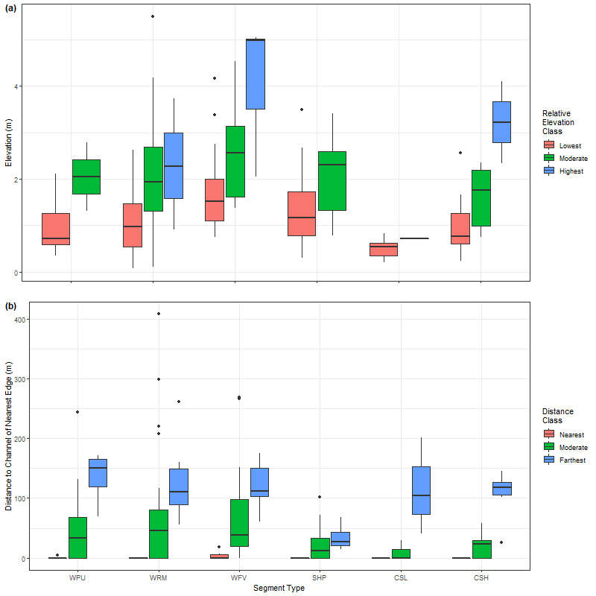
Figure S2. Distributions of relative elevations of landforms above the channel (panel a) and distances to the channel based on a landform’s nearest edge (panel b) across landform classes and segment types. Colored boxes bound the first and third quantiles with whiskers extending to 1.5 times the interquartile range, black points represent outliers beyond the extremes of the whiskers, and thick black horizontal lines represent medians. WPU=Warm Prolonged Uniform, WRM=Warm Regular Moderate, WFV=Warm Frequent Variable, SHP=Stable High Power, CSL=Cold Stable Low Relief, CSH=Cold Stable High Relief.

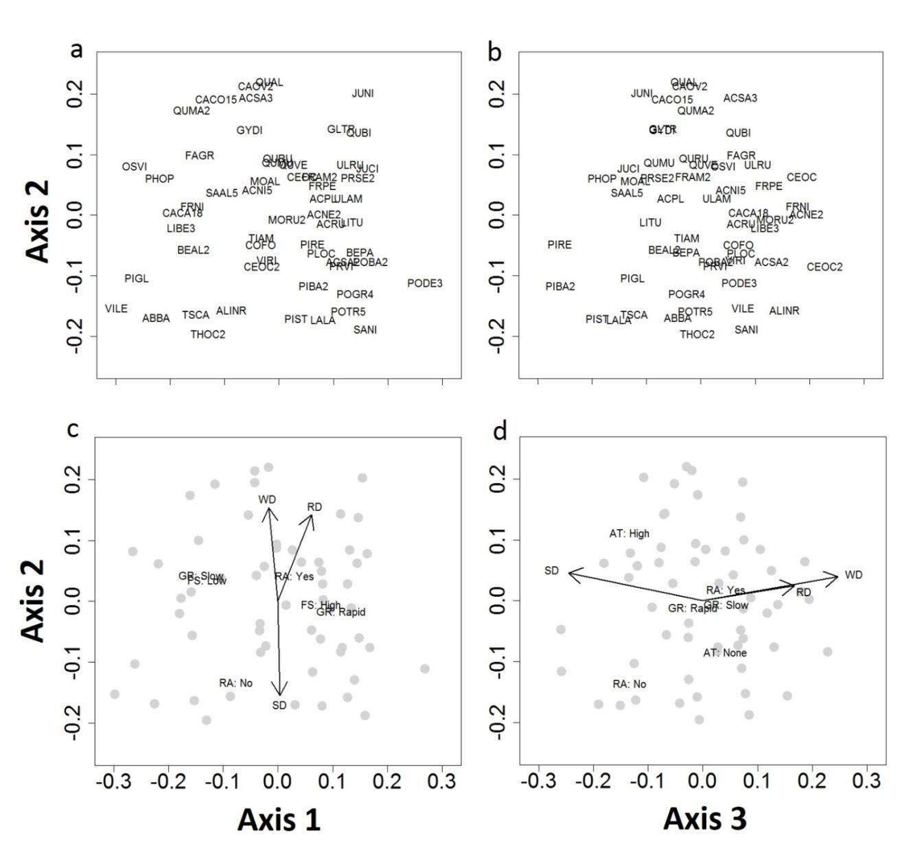
Figure S3. Non-metric multidimensional scaling (NMDS) ordination of 63 species from both floodplain and upland assemblages (stress =0.163). In the top panels, species are labeled with U.S. Department of Agriculture (USDA NRCS 2016) plant database codes (a, b; see also Table S2); lower panels are biplots of functional traits significantly related to NMDS axes (c, d). Continuous traits are plotted as vectors; centroids of factor variables are plotted as text of trait name (AT=anaerobic tolerance, FS=fruit/seed abundance, GR=growth rate, RA=re-sprout ability, RD=rooting depth, SD=seed density, WD=wood density). Positive values of Axis 1 were associated with high abundances of fruit and seeds, and rapid growth rates. Greater values of Axis 2 were associated with increasing wood density and rooting depths. Species with negative Axis 2 values tended to lack the ability to re-sprout and had smaller numbers of seeds per pound. Axis 3 was driven by a negative correlation with maximum mature height – positive Axis 3 values were associated with shorter height, whereas taller trees tended to have negative Axis 3 values.

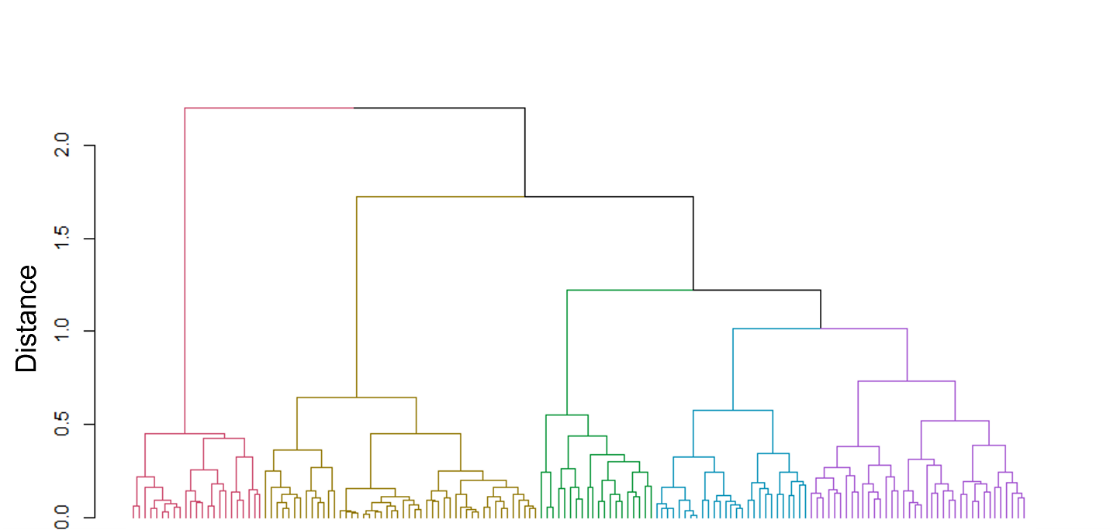

Figure S4. Dendrogram of Ward’s hierarchical cluster analysis of community weighted mean (CWM) trait values. Colors depict five-cluster solution.

Table S1. Functional traits, type of variable, source and rationale for use. Ecologically relevant traits were chosen to represent variation in growth, competition, and regeneration, as well as floodplain-specific disturbance resistance.
Functional Trait | Variable Type | Data Source | Rationale
Growth Rate | Ordinal | USDA NRCS 2016 | Growth; Competitive Ability ^{4, 5, 22}
Moisture Use | Ordinal | USDA NRCS 2016 | Competitive Ability ⁵
Shade Tolerance | Ordinal | USDA NRCS 2016 | Competitive Ability ^{1, 6}
Maximum Height at Maturity | Continuous | USDA NRCS 2016 | Competitive Ability ^{5, 23, 24}
Seedling Vigor | Ordinal | USDA NRCS 2016 | Competitive Ability; Regenerative Processes ^{9, 22}
Fruit/Seed Abundance | Ordinal | USDA NRCS 2016 | Competitive Ability; Regenerative Processes ^{3, 4, 5}
Minimum Rooting Depth | Continuous | USDA NRCS 2016 | Disturbance Resistance ^{7, 10}
Drought Tolerance | Ordinal | USDA NRCS 2016 | Disturbance Resistance ^{14, 19, 20}
Anaerobic Tolerance | Ordinal | USDA NRCS 2016 | Disturbance Resistance ^{2, 11, 12}
Wood Density | Continuous | Zanne et al. 2009 | Disturbance Resistance; Dispersal Ability ^{9, 15, 18, 25}
Re-sprout Ability | Binary | USDA NRCS 2016 | Disturbance Resistance; Regenerative Processes ^{8, 9, 16, 17}
Seeds per Lb. | Continuous | USDA NRCS 2016;  RBG KEW 2016 | Regenerative Processes; Competitive Ability ^{13, 21, 22, 24}

¹ Battaglia et al. (2000) | ⁹ Karrenberg et al. (2002) | ¹⁷ Sigafoos & Sigafoos (1966) | ²⁵ Wittmann et al. (2006)
² Blom & Voesenek (1996) | ¹⁰ Karrenberg et al. (2003) | ¹⁸ Sparks & Black (1999)
³ Eschtruth & Battles (2011) | ¹¹ Kozlowski (1984) | ¹⁹ van Splunder et al. (1995)
⁴ Grime (2002) | ¹² Kozlowski (1997) | ²⁰ Stromberg et al. (2011)
⁵ Grime (1988) | ¹³ Moles & Westoby (2006) | ²¹ Stromberg & Boudell (2013)
⁶ Hall & Harcombe (1998) | ¹⁴ Orians et al. (1999) | ²² Streng et al. (1989)
⁷ Henry et al. (1996) | ¹⁵ Rood et al. (2000) | ²³ Thomson et al. (2011)
⁸ Hupp (1988) | ¹⁶ Sigafoos (1964) | ²⁴ Westoby (1998)

Table S2. Species used to generate non-metric multidimensional scaling (NMDS) with U.S. Department of Agriculture (USDA) codes and occurrence in river-valley segment types. See Baker and Wiley (2004) for additional information about species’ associations with segment types. Species with asterisks were only observed in communities of three or fewer species, which were excluded from the final dataset. Nomenclature follows USDA PLANTS Database (USDA NRCS 2016). WPU=Warm Prolonged Uniform, WRM=Warm Regular Moderate, WFV=Warm Frequent Variable, SHP=Stable High Power, CSL=Cold Stable Low Relief, CSH=Cold Stable High Relief.

USDA Code Scientific Name Segment(s) Present
ABBA Abies balsamea (L.) Mill. WPU, WRM, SHP, CSL, CSH
ACNE2 Acer negundo L. WPU, WRM, WFV, SHP, CSH
ACNI5 Acer nigrum Michx. f. WRM, WFV, SHP
ACPL Acer platanoides L. WFV
ACRU Acer rubrum L. WPU, WRM, WFV, SHP, CSL, CSH
ACSA2 Acer saccharinum L. WPU, WRM, WFV, SHP, CSH
ACSA3 Acer saccharum Marshall WPU, WRM, WFV, SHP, CSL, CSH
ALINR Alnus incana (L.) Moench SHP, CSL, CSH
spp. rugosa (Du Roi) R.T. Clausen
AMAR3* Amelanchier arborea (Michx. F.) WPU
Fernald
ASTR* Asimina triloba (L.) Dunal WFV
BEAL2 Betula alleghaniensis Britton WPU, WRM, SHP, CSL, CSH
BEPA Betula papyrifera Marshall WPU, WFV, SHP, CSL, CSH
CACA18 Carpinus caroliniana Walter WPU, WRM, WFV, SHP, CSH
CACO15 Carya cordiformis (Wangenh.) WPU, WRM, WFV, SHP, CSH
K. Koch
CAGL8* Carya glabra (Mill.) Sweet WPU, WFV
CAOV2 Carya ovata (Mill.) K. Koch WPU, WRM, WFV, SHP
CEOC Celtis occidentalis L. WPU, WRM, WFV, SHP, CSH
CEOC2 Cephalanthus occidentalis L. WPU
COFO Cornus foemina Mill. SHP, CSH
FAGR Fagus grandifolia Ehrh. WRM, WFV, SHP, CSL, CSH
FRAM2 Fraxinus americana L. WPU, WRM, WFV, SHP, CSL, CSH
FRNI Fraxinus nigra Marshall WPU, WRM, WFV, SHP, CSL, CSH
FRPE Fraxinus pennsylvanica Marshall WPU, WRM, WFV, SHP, CSH
GLTR Gleditsia triacanthos L. WRM, WFV, SHP
GYDI Gymnocladus dioicus (L.) K. Koch WFV, SHP
HAVI4* Hamamelis virginiana L. WRM, SHP
JUCI Juglans cinerea L. WRM, WFV, SHP, CSH
JUNI Juglans nigra L. WPU, WRM, WFV, SHP
LALA Larix laricina (Du Roi) K. Koch CSL
LIBE3 Lindera benzoin (L.) Blume SHP
LITU Liriodendron tulipifera L. WPU, WRM, WFV, SHP
MOAL Morus alba L. WFV
MORU2 Morus rubra L. WFV, SHP
OSVI Ostrya virginiana (Mill.) K. Koch WPU, WRM, WFV, SHP, CSL, CSH
POGR4 Populus grandidentata Michx. WPU, WRM, SHP, CSL, CSH
PHOP Physocarpus opulifolius (L.) Maxim. CSH
PIBA2* Pinus banksiana Lamb. WFV, CSH
PIGL Picea glauca (Moench) Voss WRM, CSL, CSH
PIMA* Picea mariana (Mill.) Britton, WFV, CSL
Sterns & Poggenb.
PINI* Pinus nigra Arnold WPU
PIRE Pinus resinosa Aiton SHP, CSL, CSH
PIST Pinus strobus L. WRM, WFV, SHP, CSL, CSH
PLOC Platanus occidentalis L. WPU, WRM, WFV, SHP
POBA2 Populus balsamifera L. WPU, WRM, SHP, CSL, CSH
PODE3 Populus deltoides W. Bartram WPU, WRM, WFV, SHP, CSH
ex Marshall
POTR5 Populus tremuloides Michx. WPU, WRM, WFV, SHP, CSL, CSH
PRSE2 Prunus serotina Ehrh. WPU, WRM, WFV, SHP, CSL, CSH
PRVI Prunus virginiana L. SHP
QUAL Quercus alba L. WPU, WRM, WFV, SHP, CSH
QUBI Quercus bicolor Willd. WPU, WRM, SHP
QUMA2 Quercus macrocarpa Michx. WPU, WRM, WFV, SHP, CSH
QUMU Quercus muehlenbergii Engelm. WRM, SHP
QURU Quercus rubra L. WPU, WRM, WFV, SHP, CSL, CSH
QUVE Quercus velutina Lam. WPU, WRM, WFV, SHP, CSL, CSH
SAAL5 Sassafras albidum (Nutt.) Nees WPU
SANI Salix nigra Marshall WPU, WRM, WFV, SHP, CSL, CSH
THOC2 Thuja occidentalis L. WPU, WRM, SHP, CSL, CSH
TIAM Tilia americana L. WPU, WRM, WFV, SHP, CSL, CSH
TSCA Tsuga canadensis (L.) Carriére WPU, WRM, WFV, SHP, CSL, CSH
ULAM Ulmus americana L. WPU, WRM, WFV, SHP, CSL, CSH
ULRU Ulmus rubra Muhl. WFV, SHP
VILE Viburnum lentago L. WRM, WFV, SHP, CSH
VIRI Vitis riparia Michx. WRM, CSH

Table S3. Values of functional traits extracted from publicly available databases (see Table S1 above) for each species listed by USDA Code. For descriptions of how trait values were determined, see documentation provided by RBG KEW (2016), USDA NRCS (2016), and Zanne et al. (2009). USDA Species Codes described in Table S1.

USDA Species Code | Moisture Use | Growth Rate | Drought Tolerance | Anaerobic Tolerance | Re-sprout Ability | Minimum Rooting Depth (in) | # Seeds / Lb. | Wood Density (g/cm^3) | Maximum Mature Height (ft) | Fruit/Seed Abundance | Shade Tolerance | Seedling Vigor
ABBA | Medium | Slow | Low | None | No | 20 | 59840 | 0.33 | 60 | Medium | Tolerant | Low
ACNE2 | Medium | Rapid | High | Medium | Yes | 40 | 11360 | 0.416 | 60 | High | Tolerant | Low
ACNI5 | Medium | Moderate | Medium | Low | Yes | 30 | 7030 | 0.52 | 100 | Medium | Tolerant | Medium
ACPL | Medium | Rapid | Low | None | Yes | 40 | 2640 | 0.508 | 50 | High | Intermediate | Low
ACRU | High | Rapid | Medium | Medium | Yes | 30 | 22720 | 0.49 | 68 | High | Intermediate | Medium
ACSA2 | Medium | Rapid | Low | High | Yes | 32 | 1610 | 0.44 | 90 | High | Intermediate | Low
ACSA3 | Medium | Slow | Medium | None | Yes | 40 | 6540 | 0.56 | 100 | High | Tolerant | High
ALINR | Medium | Moderate | Low | High | Yes | 24 | 1084250 | 0.439 | 16 | Low | Intermediate | Low
AMAR3 | Medium | Slow | Low | Medium | Yes | 20 | 79832 | 0.66 | 36 | Medium | Tolerant | Low
ASTR | Medium | Slow | Low | Low | Yes | 20 | 697 | NA | 25 | Medium | Tolerant | Medium
BEAL2 | Medium | Slow | Medium | Low | No | 30 | 446400 | 0.55 | 75 | Medium | Intermediate | Medium
BEPA | High | Rapid | Low | Low | Yes | 24 | 1380800 | 0.48 | 70 | High | Intolerant | Medium
CACA18 | Medium | Slow | Low | Low | Yes | 20 | 35000 | 0.58 | 30 | Medium | Tolerant | Low
CACO15 | Medium | Slow | High | Low | Yes | 50 | 156 | 0.6 | 75 | Medium | Intolerant | Low
CAGL8 | Medium | Slow | High | None | Yes | 50 | 200 | 0.66 | 80 | Medium | Intermediate | Low
CAOV2 | Medium | Slow | Medium | None | Yes | 48 | 96 | 0.64 | 75 | Medium | Intermediate | High
CEOC | Low | Rapid | High | Medium | Yes | 36 | 43000 | 0.49 | 60 | High | Tolerant | Medium
CEOC2 | High | Moderate | Medium | High | Yes | 14 | 134000 | NA | 15 | Medium | Tolerant | High
COFO | Medium | Moderate | Low | Medium | Yes | 16 | 12000 | NA | 16 | Medium | Intermediate | Medium
FAGR | Medium | Slow | High | Low | Yes | 32 | 1600 | 0.56 | 80 | Medium | Tolerant | Low
FRAM2 | High | Moderate | Low | Low | Yes | 40 | 10000 | 0.55 | 90 | High | Intolerant | Medium
FRNI | High | Slow | Low | Medium | Yes | 40 | 9730 | 0.45 | 65 | Low | Intolerant | Low
FRPE | Medium | Rapid | Medium | Medium | Yes | 40 | 14320 | 0.53 | 80 | High | Tolerant | Medium
GLTR | Medium | Rapid | High | None | Yes | 48 | 2800 | 0.6 | 70 | High | Intolerant | Medium
GYDI | Medium | Slow | Medium | None | Yes | 36 | 230 | 0.53 | 100 | Medium | Intolerant | Medium
HAVI4 | Medium | Slow | Low | Low | Yes | 20 | 11000 | 0.56 | 20 | Low | Intermediate | High
JUCI | Medium | Rapid | Low | None | Yes | 40 | 30 | 0.36 | 80 | Medium | Intolerant | High
JUNI | High | Rapid | Low | None | Yes | 40 | 40 | 0.51 | 100 | Low | Intolerant | High
LALA | Medium | Rapid | Low | Low | No | 12 | 292615 | 0.49 | 80 | High | Intolerant | Medium
LIBE3 | Medium | Slow | Low | Medium | Yes | 18 | 4500 | NA | 12 | Low | Intermediate | Medium
LITU | Medium | Rapid | Low | None | Yes | 32 | 14000 | 0.4 | 120 | High | Intolerant | Medium
MOAL | Low | Moderate | Medium | None | Yes | 24 | 235000 | 0.578 | 50 | High | Intermediate | High
MORU2 | Medium | Moderate | Medium | Medium | Yes | 24 | 344667 | NA | 70 | High | Tolerant | High
OSVI | Low | Slow | Medium | None | Yes | 16 | 30000 | 0.63 | 45 | Low | Tolerant | Medium
POGR4 | High | Rapid | Low | Low | Yes | 20 | 3000000 | 0.36 | 65 | High | Intolerant | Medium
PHOP | Low | Slow | High | None | Yes | 14 | 1045000 | NA | 10 | High | Intolerant | Low
PIBA2 | Low | Rapid | Low | None | No | 20 | 131040 | 0.4 | 80 | High | Intolerant | High
PIGL | Medium | Slow | High | None | No | 30 | 1864000 | 0.33 | 100 | Low | Intermediate | Low
PIMA | High | Slow | Low | Low | No | 16 | 4048000 | 0.38 | 65 | Medium | Tolerant | Medium
PINI | Medium | Moderate | Medium | None | No | 40 | 26080 | 0.414 | 120 | High | Intolerant | Medium
PIRE | Low | Rapid | Low | None | No | 40 | 52160 | 0.41 | 80 | Medium | Intolerant | High
PIST | Medium | Rapid | None | None | No | 40 | 27040 | 0.34 | 150 | Medium | Intermediate | Medium
PLOC | High | Rapid | Low | Medium | Yes | 30 | 192000 | 0.46 | 100 | Medium | Intermediate | Medium
POBA2 | High | Rapid | Low | Medium | Yes | 30 | NA | 0.31 | 80 | High | Intolerant | Medium
PODE3 | High | Rapid | Medium | High | Yes | 24 | 425000 | 0.37 | 190 | High | Intolerant | High
POTR5 | High | Rapid | Low | Low | Yes | 32 | 3248000 | 0.35 | 65 | High | Intolerant | Low
PRSE2 | Medium | Rapid | Medium | None | Yes | 36 | 48000 | 0.47 | 80 | High | Intolerant | High
PRVI | Medium | Rapid | Medium | Medium | Yes | 20 | 4971 | NA | 25 | High | Intolerant | Medium
QUAL | Medium | Slow | Medium | None | Yes | 48 | 128 | 0.6 | 100 | High | Intermediate | High
QUBI | High | Rapid | Low | Medium | Yes | 40 | 120 | 0.64 | 100 | Medium | Intermediate | High
QUMA2 | Medium | Slow | High | None | Yes | 28 | 75 | 0.58 | 100 | Low | Intermediate | Medium
QUMU | Medium | Moderate | High | None | Yes | 28 | 400 | NA | 70 | Medium | Intolerant | Medium
QURU | Medium | Moderate | Low | None | Yes | 36 | 125 | 0.56 | 81 | Medium | Intermediate | Medium
QUVE | Medium | Moderate | Low | Low | Yes | 40 | 245 | 0.56 | 80 | High | Intermediate | Medium
SAAL5 | Low | Moderate | High | None | Yes | 18 | 5000 | 0.42 | 75 | Medium | Intolerant | Low
SANI | High | Rapid | Low | High | Yes | 32 | 2500000 | 0.36 | 100 | High | Intolerant | Low
THOC2 | Medium | Slow | Low | Medium | No | 30 | 345600 | 0.29 | 50 | Medium | Intermediate | Medium
TIAM | Medium | Moderate | Low | None | Yes | 30 | 4765 | 0.32 | 100 | High | Tolerant | Medium
TSCA | Medium | Slow | Low | None | No | 28 | 187200 | 0.38 | 105 | High | Tolerant | Medium
ULAM | High | Rapid | Medium | Low | Yes | 42 | 70900 | 0.46 | 120 | High | Intermediate | Medium
ULRU | High | Rapid | Medium | Low | Yes | 40 | 41000 | 0.48 | 85 | High | Tolerant | High
VILE | Medium | Slow | Low | Medium | No | 14 | 7843 | NA | 28 | Low | Tolerant | Low
VIRI | Medium | Moderate | Medium | Medium | Yes | 16 | 14500 | NA | 45 | High | Intermediate | Low

Table S4. Results of multi response permutation procedure (MRPP) tests used to determine five-cluster solution.

Cluster solution | Chance corrected within-group agreement | Observed delta | Expected delta | Delta significance
3 | 0.2830 | 0.2195 | 0.3062 | 0.001
4 | 0.3348 | 0.2037 | 0.3062 | 0.001
5 | 0.3802 | 0.1898 | 0.3062 | 0.001
6 | 0.4023 | 0.1830 | 0.3062 | 0.001
7 | 0.4254 | 0.1760 | 0.3062 | 0.001

Table S5. Estimated marginal means (diagonal, in brackets) and p-values from pairwise comparison tests with Tukey adjustment across six segment types for three measures of functional diversity (CVH, TOP, and FDis). Bolded p-values indicate significance at a<0.05 level. Units for CVH and TOP estimated marginal means are in non-metric multidimensional scaling (NMDS) units. CVH=convex hull volume, TOP=trait onion peeling, FDis=functional dispersion, WPU=Warm Prolonged Uniform, WRM=Warm Regular Moderate, WFV=Warm Frequent Variable, SHP=Stable High Power, CSL=Cold Stable Low Relief, CSH=Cold Stable High Relief.

 |  | WPU | WRM | WFV | SHP | CSL | CSH
CVH | WPU | [0.0013] | <0.0001 | <0.0001 | <0.0001 | <0.0001 | <0.0001
CVH | WRM |  | [0.0027] | 0.4974 | 0.1531 | 0.3886 | 0.0003
CVH | WFV |  |  | [0.0039] | 0.9907 | 0.9942 | 0.0710
CVH | SHP |  |  |  | [0.0044] | 1.0000 | 0.1632
CVH | CSL |  |  |  |  | [0.0046] | 0.7836
CVH | CSH |  |  |  |  |  | [0.0076]
TOP | WPU | [0.0929] | 0.9511 | 0.8430 | 0.4228 | 0.4445 | 0.2210
TOP | WRM |  | [0.1221] | 0.9956 | 0.5524 | 0.6735 | 0.1865
TOP | WFV |  |  | [0.1388] | 0.9289 | 0.9210 | 0.6232
TOP | SHP |  |  |  | [0.1808] | 0.9997 | 0.9746
TOP | CSL |  |  |  |  | [0.02033] | 0.9999
TOP | CSH |  |  |  |  |  | [0.2226]
FDis | WPU | [0.0568] | 0.1562 | 0.0003 | <0.0001 | 0.0335 | <0.0001
FDis | WRM |  | [0.0760] | 0.0408 | 0.0131 | 0.7453 | 0.0008
FDis | WFV |  |  | [0.1049] | 1.0000 | 0.9931 | 0.9321
FDis | SHP |  |  |  | [0.1054] | 0.9900 | 0.9098
FDis | CSL |  |  |  |  | [0.0943] | 0.8305
FDis | CSH |  |  |  |  |  | [0.1200]

Table S6. Summary statistics by valley segment type of species richness, two functional richness metrics (convex hull volume [CHV] and trait onion peeling [TOP]), and functional dispersion (FDis). min=minimum, med=median, max=maximum, cv=coefficient of variation. WPU=Warm Prolonged Uniform, WRM=Warm Regular Moderate, WFV=Warm Frequent Variable, SHP=Stable High Power, CSL=Cold Stable Low Relief, CSH=Cold Stable High Relief.

 |  | Species Richness | Functional Diversity Metrics
 |  | Species Richness | CHV | TOP | FDis
WPU | n=18
WPU | min | 4.000 | 0.0001 | <0.0001 | 0.026
WPU | med | 5.000 | 0.0007 | 0.059 | 0.050
WPU | mean | 5.444 | 0.0013 | 0.093 | 0.057
WPU | max | 9.000 | 0.0078 | 0.271 | 0.108
WPU | cv | 0.335 | 1.4545 | 0.928 | 0.406
WRM | n=45
WRM | min | 4.000 | <0.0001 | <0.0001 | 0.021
WRM | med | 6.000 | 0.0013 | 0.096 | 0.065
WRM | mean | 6.911 | 0.0027 | 0.122 | 0.077
WRM | max | 13.000 | 0.0083 | 0.280 | 0.156
WRM | cv | 0.389 | 0.9417 | 0.647 | 0.517
WFV | n=27
WFV | min | 5.000 | 0.0003 | 0.034 | 0.048
WFV | med | 8.000 | 0.0024 | 0.125 | 0.107
WFV | mean | 8.222 | 0.0039 | 0.139 | 0.108
WFV | max | 16.000 | 0.0199 | 0.305 | 0.171
WFV | cv | 0.299 | 1.0292 | 0.521 | 0.251
SHP | n=35
SHP | min | 4.000 | 0.0004 | <0.0001 | 0.032
SHP | med | 8.000 | 0.0050 | 0.195 | 0.108
SHP | mean | 7.657 | 0.0044 | 0.181 | 0.105
SHP | max | 13.000 | 0.0108 | 0.452 | 0.178
SHP | cv | 0.269 | 0.6137 | 0.466 | 0.370
CSL | n=8
CSL | min | 4.000 | 0.0004 | 0.087 | 0.072
CSL | med | 6.000 | 0.0046 | 0.208 | 0.097
CSL | mean | 6.250 | 0.0046 | 0.203 | 0.097
CSL | max | 9.000 | 0.0102 | 0.327 | 0.116
CSL | cv | 0.280 | 0.6707 | 0.388 | 0.158
CSH | n=23
CSH | min | 4.000 | 0.0009 | <0.0001 | 0.051
CSH | med | 8.000 | 0.0061 | 0.230 | 0.122
CSH | mean | 8.130 | 0.0076 | 0.223 | 0.122
CSH | max | 15.000 | 0.0205 | 0.468 | 0.172
CSH | cv | 0.328 | 0.6274 | 0.525 | 0.265

Table S7. Pearson’s r correlation coefficients and results from one-sided significance tests (H_{A}: correlation greater than 0) for landform relative elevation and distance to channel across valley segment type. WPU=Warm Prolonged Uniform, WRM=Warm Regular Moderate, WFV=Warm Frequent Variable, SHP=Stable High Power, CSL=Cold Stable Low Relief, CSH=Cold Stable High Relief.

 | r | t | p
WPU | 0.65 | 3.40 | 0.002
WRM | 0.51 | 3.89 | <0.001
WFV | 0.50 | 2.88 | 0.004
SHP | 0.62 | 4.52 | <0.001
CSL | 0.09 | 0.23 | 0.414
CSH | 0.40 | 1.99 | 0.030

Table S8. Median and interquartile range (IQR) of community-weighted mean trait values by valley segment type. WPU=Warm Prolonged Uniform, WRM=Warm Regular Moderate, WFV=Warm Frequent Variable, SHP=Stable High Power, CSL=Cold Stable Low Relief, CSH=Cold Stable High Relief.
 |  |  | WPU | WRM | WFV | SHP | CSL | CSH
Moisture Use | Low | Median | 0.000 | 0.000 | 0.000 | 0.000 | 0.000 | 0.000
Moisture Use | Low | IQR | 0.000 | 0.017 | 0.042 | 0.022 | 0.000 | 0.016
Moisture Use | Medium | Median | 0.827 | 0.899 | 0.592 | 0.770 | 0.831 | 0.794
Moisture Use | Medium | IQR | 0.232 | 0.154 | 0.295 | 0.236 | 0.117 | 0.157
Moisture Use | High | Median | 0.155 | 0.086 | 0.386 | 0.209 | 0.169 | 0.174
Moisture Use | High | IQR | 0.232 | 0.150 | 0.276 | 0.209 | 0.117 | 0.197
Growth Rate | Slow | Median | 0.020 | 0.061 | 0.078 | 0.365 | 0.786 | 0.639
Growth Rate | Slow | IQR | 0.047 | 0.305 | 0.167 | 0.335 | 0.138 | 0.319
Growth Rate | Moderate | Median | 0.000 | 0.014 | 0.040 | 0.183 | 0.016 | 0.037
Growth Rate | Moderate | IQR | 0.031 | 0.115 | 0.194 | 0.224 | 0.096 | 0.172
Growth Rate | Rapid | Median | 0.968 | 0.905 | 0.841 | 0.397 | 0.155 | 0.218
Growth Rate | Rapid | IQR | 0.044 | 0.480 | 0.454 | 0.302 | 0.070 | 0.345
Drought Tolerance | None | Median | 0.000 | 0.000 | 0.000 | 0.000 | 0.010 | 0.000
Drought Tolerance | None | IQR | 0.000 | 0.000 | 0.000 | 0.000 | 0.052 | 0.013
Drought Tolerance | Low | Median | 0.749 | 0.494 | 0.457 | 0.591 | 0.896 | 0.720
Drought Tolerance | Low | IQR | 0.275 | 0.280 | 0.395 | 0.333 | 0.047 | 0.388
Drought Tolerance | Medium | Median | 0.228 | 0.322 | 0.343 | 0.350 | 0.034 | 0.102
Drought Tolerance | Medium | IQR | 0.193 | 0.257 | 0.256 | 0.231 | 0.084 | 0.298
Drought Tolerance | High | Median | 0.015 | 0.056 | 0.176 | 0.000 | 0.020 | 0.036
Drought Tolerance | High | IQR | 0.051 | 0.249 | 0.168 | 0.066 | 0.037 | 0.155
Anaerobic Tolerance | None | Median | 0.017 | 0.051 | 0.190 | 0.271 | 0.087 | 0.287
Anaerobic Tolerance | None | IQR | 0.048 | 0.299 | 0.254 | 0.377 | 0.052 | 0.280
Anaerobic Tolerance | Low | Median | 0.067 | 0.071 | 0.117 | 0.133 | 0.107 | 0.041
Anaerobic Tolerance | Low | IQR | 0.083 | 0.147 | 0.267 | 0.214 | 0.048 | 0.109
Anaerobic Tolerance | Medium | Median | 0.191 | 0.273 | 0.273 | 0.409 | 0.807 | 0.599
Anaerobic Tolerance | Medium | IQR | 0.202 | 0.282 | 0.321 | 0.404 | 0.183 | 0.190
Anaerobic Tolerance | High | Median | 0.692 | 0.358 | 0.059 | 0.018 | 0.000 | 0.000
Anaerobic Tolerance | High | IQR | 0.293 | 0.394 | 0.483 | 0.083 | 0.096 | 0.015
Re-spout Ability | No | Median | 0.000 | 0.000 | 0.000 | 0.000 | 0.727 | 0.500
Re-spout Ability | No | IQR | 0.000 | 0.000 | 0.000 | 0.165 | 0.160 | 0.451
Re-spout Ability | Yes | Median | 1.000 | 1.000 | 1.000 | 1.000 | 0.273 | 0.500
Re-spout Ability | Yes | IQR | 0.000 | 0.000 | 0.000 | 0.165 | 0.160 | 0.451
Rooting Depth |  | Median | 0.664 | 0.672 | 0.671 | 0.658 | 0.557 | 0.600
 |  | IQR | 0.069 | 0.064 | 0.062 | 0.076 | 0.057 | 0.074
Seed Density |  | Median | 0.418 | 0.417 | 0.483 | 0.517 | 0.781 | 0.676
 |  | IQR | 0.083 | 0.110 | 0.121 | 0.126 | 0.038 | 0.123
Wood Density |  | Median | 0.511 | 0.546 | 0.565 | 0.509 | 0.149 | 0.253
 |  | IQR | 0.049 | 0.107 | 0.124 | 0.192 | 0.112 | 0.229
Maximum Height |  | Median | 0.458 | 0.455 | 0.461 | 0.427 | 0.295 | 0.358
 |  | IQR | 0.029 | 0.035 | 0.053 | 0.085 | 0.040 | 0.059
Fruit/Seed Abundance | Low | Median | 0.018 | 0.036 | 0.111 | 0.068 | 0.161 | 0.135
Fruit/Seed Abundance | Low | IQR | 0.050 | 0.147 | 0.143 | 0.184 | 0.252 | 0.339
Fruit/Seed Abundance | Medium | Median | 0.019 | 0.033 | 0.083 | 0.228 | 0.716 | 0.426
Fruit/Seed Abundance | Medium | IQR | 0.062 | 0.167 | 0.272 | 0.278 | 0.197 | 0.247
Fruit/Seed Abundance | High | Median | 0.953 | 0.891 | 0.774 | 0.608 | 0.133 | 0.385
Fruit/Seed Abundance | High | IQR | 0.085 | 0.369 | 0.363 | 0.334 | 0.059 | 0.372
Shade Tolerance | Intolerant | Median | 0.052 | 0.035 | 0.246 | 0.147 | 0.146 | 0.154
Shade Tolerance | Intolerant | IQR | 0.150 | 0.097 | 0.195 | 0.239 | 0.107 | 0.160
Shade Tolerance | Intermediate | Median | 0.704 | 0.562 | 0.330 | 0.146 | 0.806 | 0.433
Shade Tolerance | Intermediate | IQR | 0.256 | 0.259 | 0.244 | 0.241 | 0.137 | 0.435
Shade Tolerance | Tolerant | Median | 0.167 | 0.345 | 0.385 | 0.595 | 0.035 | 0.216
Shade Tolerance | Tolerant | IQR | 0.176 | 0.282 | 0.403 | 0.293 | 0.041 | 0.456
Seedling Vigor | Low | Median | 0.685 | 0.437 | 0.139 | 0.311 | 0.178 | 0.237
Seedling Vigor | Low | IQR | 0.260 | 0.271 | 0.373 | 0.400 | 0.311 | 0.350
Seedling Vigor | Medium | Median | 0.258 | 0.458 | 0.592 | 0.558 | 0.822 | 0.624
Seedling Vigor | Medium | IQR | 0.230 | 0.256 | 0.406 | 0.342 | 0.332 | 0.353
Seedling Vigor | High | Median | 0.026 | 0.000 | 0.192 | 0.051 | 0.000 | 0.000
Seedling Vigor | High | IQR | 0.072 | 0.074 | 0.172 | 0.122 | 0.004 | 0.026

References:

Baker, M. E., and M. J. Wiley. 2004. Characterization of woody species distribution in riparian forests of Lower Michigan, USA using map-based models. Wetlands 24:550–561.
Baker, M. E., and M. J. Wiley. 2009. Multiscale control of flooding and riparian-forest composition in Lower Michigan, USA. Ecology 90:145–159.
Battaglia, L. L., S. A. Foré, and R. R. Sharitz. 2000. Seedling emergence, survival and size in relation to light and water availability in two bottomland hardwood species. Journal of Ecology 88:1041–1050.
Blom, C., and L. Voesenek. 1996. Flooding: the survival strategies of plants. Trends in Ecology & Evolution 11:290–295.
Eschtruth, A. K., and J. J. Battles. 2011. The importance of quantifying propagule pressure to understand invasion: an examination of riparian forest invasibility. Ecology 92:1314–1322.
Grime, J. P. 1988. The CSR model of primary plant strategies—origins, implications and tests. Pages 371–393 in Plant Evolutionary Biology. Springer.
Grime, J. P. 2002. Plant strategies, vegetation processes, and ecosystem properties. John Wiley & Sons. Chinchester, UK.
Hall, R. B. W., and P. A. Harcombe. 1998. Flooding alters apparent position of floodplain saplings on a light gradient. Ecology 79:847–855.
Henry, C. P., C. Amoros, and G. Bornette. 1996. Species traits and recolonization processes after flood disturbances in riverine macrophytes. Plant Ecology 122:13–27.
Hupp, C. R. 1988. Plant ecological aspects of flood geomorphology and paleoflood history. Pages 335–356 Flood geomorphology. Wiley & Sons, New York, NY.
Karrenberg, S., P. J. Edwards, and J. Kollmann. 2002. The life history of Salicaceae living in the active zone of floodplains. Freshwater Biology 47:733–748.
Karrenberg, S., J. Kollmann, P. J. Edwards, A. M. Gurnell, and G. E. Petts. 2003. Patterns in woody vegetation along the active zone of a near-natural Alpine river. Basic and Applied Ecology 4:157–166.
Kozlowski, T. T. 1984. Plant responses to flooding of soil. BioScience 34:162–167.
Kozlowski, T. T. 1997. Responses of woody plants to flooding and salinity. Tree Physiology Monograph 1:1–29.
Moles, A. T., and M. Westoby. 2006. Seed size and plant strategy across the whole life cycle. Oikos 113:91–105.
Orians, C. M., D. I. Bolnick, B. M. Roche, R. S. Fritz, and T. Floyd. 1999. Water availability alters the relative performance of Salix sericea, Salix eriocephala, and their F1 hybrids. Canadian Journal of Botany 77:514–522.
Rood, S. B., S. Patiño, K. Coombs, and M. T. Tyree. 2000. Branch sacrifice: cavitation-associated drought adaptation of riparian cottonwoods. Trees 14:248–257.
Royal Botanic Gardens (RBG KEW). 2016. Seed Information Database (SID). Version 7.1 Available from: http://data/kew.org/sid
Sigafoos, R. S. 1964. Botanical evidence of floods and flood-plain deposition. U.S. Geological Survey Professional Paper 485-A, U.S. Government Printing Office, Washington, D.C.
Sigafoos, R., and M. Sigafoos. 1966. Flood history told by tree growth. Natural History 75:50–5.
Sparks, J. P., and R. A. Black. 1999. Regulation of water loss in populations of Populus trichocarpa: the role of stomatal control in preventing xylem cavitation. Tree Physiology 19:453–459.
Streng, D. R., J. S. Glitzenstein, and P. A. Harcombe. 1989. Woody seedling synamics in an east Texas floodplain forest. Ecological Monographs 59:177–204.
Stromberg, J. C., and J. A. Boudell. 2013. Floods, drought, and seed mass of riparian plant species. Journal of Arid Environments 97:99–107.
Stromberg, J. C., L. Butler, A. F. Hazelton, and J. A. Boudell. 2011. Seed size, sediment, and spatial heterogeneity: post-flood species coexistence in dryland riparian ecosystems. Wetlands 31:1–11.
Thomson, F. J., A. T. Moles, T. D. Auld, and R. T. Kingsford. 2011. Seed dispersal distance is more strongly correlated with plant height than with seed mass. Journal of Ecology 99:1299–1307.
USDA NRCS. 2016. The PLANTS Database. National Plant Data Team, Greensboro NC 27401-4901 USA. http://plants.usda.gov
van Splunder, I., H. Coops, L. Voesenek, and C. Blom. 1995. Establishment of alluvial forest species in floodplains: the role of dispersal timing, germination characteristics and water level fluctuations. Acta Botanica Neerlandica 44:269–278.
Westoby, M. 1998. A leaf-height-seed (LHS) plant ecology strategy scheme. Plant and soil 199:213–227.
Wittmann, F., J. Schöngart, J. C. Montero, T. Motzer, W. J. Junk, M. T. Piedade, H. L. Queiroz, and M. Worbes. 2006. Tree species composition and diversity gradients in white-water forests across the Amazon Basin. Journal of Biogeography 33:1334–1347.
Zanne, A.E., G. Lopez-Gonzalez, D.A. Coomes, J. Ilic, S. Jansen, S.L. Lewis, R.B. Miller, N.G. Swenson, M.C. Wiemann, and J. Chave. 2009. Data from: Towards a worldwide wood economics spectrum. Dryad Digital Repository. https://doi.org/10.5061/dryad.234

