The Effects of Parent Engagement on Student Achievement

By

Krista D. Wallingford

Submitted in Partial Fulfillment of the Requirements for the
Degree of Master of Education

May 2021

Goucher College

Graduate Programs in Education

Table of Contents

Table of Contents ii

List of Figures iv

Abstract v

I. Introduction 1

Overview 1

Statement of the Problem 2

Operational Definitions 2

II. Literature Review 4

Overview 4

Impact of Parent Engagement 6

Consequences of a Lack of Parent Engagement 7

Obstacles to Effective Parent Engagement 9

Effective Strategies to Improve Parent Engagement 10

Conclusion: What this Means for the Future 10

III. Methods 12

Design 12

Participants 12

Instrument 13

Procedure 13

IV. Results 14

V. Discussion 18

Implications of Results 18

Theoretical Consequences 19

Threats to Validity 19

Connections to Previous Studies/Existing Literature 20

Implications for Future Research 21

Summary 21

References 22

List of Figures

Figure 1 Parent Engagement on Student Achievement of Math Skills 15

Figure 2 Parent Engagement on Student Achievement of Reading Skills 16

Abstract

The purpose of this case study was to examine whether increasing the frequency, quantity and quality of parent engagement would increase student performance on skills deemed essential through their Individualized Education Program (IEP). The measurement tool was a teacher-created activity that was sent home twice a week for three weeks to the parent with the intention of it being completed by the student with the parent’s support. Findings of this case study demonstrated that when the level of parent engagement increased during the course of the three weeks, the student’s performance and skill acquisition also increased. Given the importance of the findings of this study, increasing the frequency and/or length of time of the study in the future would yield more accurate and applicable results.
CHAPTER I

INTRODUCTION

Overview

It is the job of the school system, teachers, and parents to provide students with the tools necessary for success (CEC, 2017). However, an obstacle is presented when the school system and teachers do not work in conjunction with parents and do not present opportunities for their engagement. A student’s future is incredibly impacted by parent support and engagement. As such, it is irresponsible for their schools to not develop a structure to maximize the potential for growth. These students, especially students in the special education system who are furthest from opportunity, are at a disadvantage when they are not receiving academic support and reinforcement at home.
It has been my experience as a special educator in the District of Columbia that many students living in poverty, in a single-parent household, or in a home where English is not the language being spoken often are not granted the same educational experience that their classmates are (Latunde, 2017). While the schools I have worked for have implemented tools to enhance parent engagement, they have not truly developed culturally responsive strategies. In other words, a “Parent’s Night” is only helpful for the parents who have the time, means, and resources to attend (Fenton, Ocasio-Stoutenburg & Harry, 2017).
The benefits of increasing parent engagement are too great to procrastinate any longer on implementing an effective strategy. Studies show that by implementing strategies to increase parent engagement, schools were able to increase student test scores by 4% over two years (Redding, Langdon, Meyer, & Sheley, 2004). Research also demonstrates the significant impact that parent support has on student social-emotional growth and wellbeing. By having a clear line of support and communication between home and school, students feel protected, secure, and advocated for by all involved stakeholders (Pham, Murray & Good, 2018).
However, with wavering and inconsistent parent engagement, students have suffered. Year after year, Individualized Education Program (IEP) goals are being repeated due to lack of mastery. Year after year, parents remain at a loss from not knowing how to support their children. The goal of this research is to explore how student achievement can be influenced through increasing parent engagement. One such strategy for such is sending home individualized, user-friendly weekly activities. By doing so, teachers, parents, and administration will have access to an intervention that has been proven to be effective in improving the success of their students.
While the researcher’s incentive for completing this study was to gain insight on the relationship between parent engagement and student achievement within their own school, the research that already exists to demonstrate a correlation between the two variables is vast. The following analysis of related literature (Chapter II) helped to paint a detailed picture on the true weight and importance of this topic.
Statement of Problem

The purpose of this study was to supplement teaching with parent engagement. The researcher sought to identify if any correlation exists between the level of parent engagement and the amount of skill acquisition in alignment with the child’s IEP goals that the child experiences during a defined period of time.
Operational Definitions

Operationally, the independent variable was parent assistance in the completion of activities that were sent home twice a week. The activities were presented in a way that provided step-by-step instruction for the parent administering the practice, information on how to record the results, as well as what the ultimate objective for the student is. In doing so, the activities provided one student with additional practice in essential skills that are reflected in the goals that were developed on her IEP. The dependent variable was the growth in the student’s performance of four skills that were addressed between February and March, 2021.

CHAPTER II

REVIEW OF THE LITERATURE

Overview

The ultimate responsibility of a special education teacher is to create a plan that will reflect the needs of each individual student. It is very difficult to do so without parent input and communication. In other words, developing a structure to maximize parent engagement, input, understanding, and collaboration plays an unparalleled role in the effectiveness of a special education teacher (CEC, 2017).
There is a great deal of literature that supports the idea that parent engagement has an influence on the success of their child - especially if that child receives special education services. In order for schools, teachers, and parents to observe the full effect of parent engagement, it is essential they understand what exactly “parent engagement” means and what it entails. Parent engagement can be defined as the “dynamic, interactive process in which parents draw on multiple experiences and resources to define their interactions with schools and among school actors” (Stoner & Angell, 2006). In other words, parents engaging in the school community, does not include checking off boxes each year and simply being present. Instead, it is the ongoing, reciprocal process between teachers and parents that allows parents to feel like a true stakeholder and influencer in the school community and in their child’s academic achievement. This idea also recognizes the differences between parent engagement and parent involvement. The latter suggests that parent activity is initiated on a somewhat shallow level by the school instead of being perpetuated by the parents themselves (Fenton et al., 2017).

In order to pinpoint how to engage all families effectively, teachers and administration must look beyond the school building and observe the roles of the families, churches, and communities that work in conjunction with each other to raise each child. Seeking to increase parent engagement cannot be a one size fits all approach. In doing so, teachers and administration must strive to be culturally inclusive and responsive. This idea goes against the traditional measures of identifying parent engagement levels: helping with homework, attending school functions, etc. Culturally inclusive measures may include: speaking with parents about engaging students at home, parents visiting the school, being active in parent groups, school inclusivity of faith-based organizations, and providing encouragement to students to instill optimism, determination and motivation. In other words, by combining the efforts of the community, family, and school, teachers and administrators will find they are much more successful in improving the levels of parent engagement than if they worked independently on the cause (Latunde, 2017).
Regardless of the evidence supporting the benefits of parent engagement on student progress, parents have reported having little to no involvement in the IEP progress including developing goals, objectives, interventions and evaluations. Additionally, verbiage used during IEP meetings or throughout the school year is often not parent-friendly and is not explained or modified in a way to ensure parents have a complete understanding of what is being discussed. Another concern is inconsistent and unproductive communication between parent and school or teacher. Such disconnect only further deters the parent from taking initiative to collaborate and work toward becoming an engaged member of the school community (Stoner & Angell, 2006).
The following Literature Review expands upon the definition of parent engagement, the impact of parent engagement, the consequences of the lack of parent engagement, obstacles to effective parent engagement, and provides effective strategies for improving parent engagement. This Literature Review is concluded with a statement that provides an overview of how and why stakeholders should proceed in order to enhance parent engagement.
Impact of Parent Engagement
The initiative to increase parent engagement throughout schools is understandable considering its many positive influences on student growth. Not only does having parents engaged impact student achievement on test scores, but it also provides additional support to students. These gains are more than worth schools going the extra mile to ensure parents see the benefit of their own engagement and activity.
In a study that was conducted by the Harvard Graduate School of Education, student achievement on state-wide standardized test scores was measured against parent engagement. After a two-year research period, results showed that students who were impacted by parent engagement strategies including parent participation in decision making at school, implementation of best practices as it pertains to homework policy, parent involvement in discussions around the roles of parents, teachers, and students about learning standards and homework, parent education around home reading and study habits, and outreach initiatives such as home visits and family nights benefited by having scores jump more than 4%. This transformation demonstrates the great improvement that can be made on something as critical as student achievement by implementing very doable and measurable strategies to improve parent engagement (Redding et al., 2004).
In addition to the apparent benefit of increasing student academic achievement, parent engagement also serves students by giving them additional support at home as well as in the school building. By having the line of communication between parents and teachers open, both parties have more frequent opportunities to share questions, updates, concerns, and celebrations about the child. Not only does this give both teachers and parents access to important information, but it also gives them the additional time to be proactive and come together to problem solve and develop solutions to any conflict instead of being in a reactive position. This collaboration serves the child by feeling the cohesion between the parent and teacher. They feel protected, they feel advocated for, they feel relevant, and they feel like their role as the student matters within their community (Pham et al., 2018).
Consequences of a Lack of Parent Engagement

Just as is true for the benefits of high parent engagement, the negative consequences for a lack thereof are just as prevalent. Among these disadvantages is the increasing achievement disparity between students whose families are engaged in their education and those that are not, the disproportionate identification for special education services, and the increased rate of burnout in teachers which, as a result, impacts their effectiveness. When communicating the importance of parent engagement, it is important to remind stakeholders of the potential costs of not increasing parents’ roles in their child’s academic process.
Arguably the costliest consequence of minimal parent engagement is the effect it has on student achievement. Not only is this relevant for the average student and their academic achievement, but this is also a major concern as it pertains to the achievement gap between races. When schools develop initiatives to increase parent engagement, they often follow structures and implement strategies that seem familiar and safe to them. However, this often disregards the needs of African American and Latino families over White and Asian families. In turn, these populations of students suffer from the lack of opportunity for having their parents engage in their education that, as a result, affects their academic success. In order to minimize the disparity between academic achievement due to parent engagement, it is imperative to develop initiatives that consider students of all races and backgrounds (Latunde, 2017).
Another alarming note is that minority students (mostly African American students) are disproportionally referred to receive special education services as compared to their peers. As a way to begin to minimize this act of negligence, teachers and staff must develop strategies to give parents a voice in expressing their experiences and interpretations of any disabilities their child might possess. This access to their child’s educational experiences allows them to observe the classroom first hand and give their own perspective and suggestions during the evaluation and referral process. By opening the lines of communication, teachers and parents will have a much greater understanding of the child’s current circumstances as well as provide any possible suggestions or interventions. These preventative measures will not only keep students in least restrictive environments, but it will also ensure they are provided with the most appropriate educational services (Fenton et al., 2017).
A third major related consequence of weak or inconsistent parent engagement is that teachers tend to burn out more quickly. By teachers not having opened a line of communication with parents, they lack important information that could help them to develop helpful strategies and interventions to improve behavior and academic performance. In other words, low parent engagement affects teacher performance that impacts the quality of services they are receiving in school. This can be an ongoing cycle as low student performance may result in teachers working overtime to find alternative solutions. Teachers who take the proactive approach and establish parent and family connections early on find they are able to avoid a lot of unnecessary stress by working as a united front to effectively meet the needs of each student (Wong, Ruble, Yu & McGrew, 2017),

Obstacles to Effective Parent Engagement
While it important to stress parent engagement, it is just as important to recognize and take into consideration the many obstacles that parents and families may face that interfere with their ability to engage with schools to the fullest extent. One obstacle that parents might encounter is the lack of support and outreach a community might initiate with the school in urban or under-funded communities. This impacts a parent’s ability to access important information and does not foster a feeling of understanding or consideration on the behalf of the parent (Fenton et al., 2017).
Similarly, the reverse problem exists as well. Often in under-funded schools and low-income communities, there often exists a lack of understanding or empathy between parents and teachers. This has a lot to do with teachers not doing their due diligence to connect in and with the community or taking the initiative to engage with the parents in a way that makes them feel heard and regarded. This deters parents’ desires to take the steps necessary to become engaged members of the school community (Ijalba, 2015).
A third factor that impacts the extent to which parents engage in their child’s education is their own ethnicity, education level, or socio-economic level (Zhang, Hsu, Kwok, Benz, & Bowman-Perrott, 2011). While these factors do not indicate causation, there are consistencies that indicate certain races and levels of education or SES status can help anticipate how engaged parents might be. Additionally, research suggests that families in a higher socio-economic position are a lot more equipped and inclined to provide the necessary supports in cases where their child has a disability and requires special services or medical attention. While this might be a factor outside of a parent’s control, it can affect their child’s ability to fully access the curriculum (Szumski, & Karowoski, 2012).
Effective Strategies to Improve Parent Engagement
Being that low parent engagement has been tied to lower student academic achievement, teachers and administrators would find it in their best interest to examine and implement strategies in an attempt to lower the risk of their own students. A study yielded a handful of recommendations for teachers to incorporate including encouraging parents to take on multiple roles within the education setting as well as recognize that parents will vary in their levels of engagement. Instead of holding the highest expectation for all parents, accept their circumstances, encourage when necessary and, otherwise, meet them where they are at. Doing so will foster trust (Stoner & Angell, 2006).
Another way to foster trust between parents, schools, and communities is to develop initiatives that encourage school, home, and community-based involvement. Providing parents with expectations and information they can use to have conversations at home about curriculum as well as hold their children accountable for school and home responsibilities helps to establish a united and fluid connection (Zhang, et al. 2011). Additionally, developing collaborative relationships between parent, school, and community helps to provide multiple avenues to not only reach the parent, but to reach the student as well (Latunde, 2017). By having multiple streams of influence, the students and families will feel supported, heard, and advocated for.
Conclusion: What this Means for the Future
Research shows that parent engagement affects student academic achievement. As a result, stakeholders need to put the work in to ensure initiatives aimed at increasing parent engagement are being implemented across communities, ethnicities, and backgrounds in order to maximize the opportunity for the success of each child (Zhang, et al., 2011). It is equally necessary for teachers to take note of research-based initiatives in an attempt to increase the parent engagement in their own classroom. They are ultimately responsible for reaching out to parents, hearing their concerns, providing suggestions, and being the face of the school that is in charge of their child’s education. By providing parents with caring, understanding, and compassionate interactions, they can work to enhance parents’ desire to engage and take part in their child’s learning experiences (CEC, 2017). Ultimately, parent engagement is a potentially manipulated factor that contributes to such a critical component that holds great weight in determining the future and success of each and every child.

CHAPTER III

METHODS

Design
This study was a descriptive correlational case study of one, sixth grade student at a public school in the District of Columbia Public School system. The study measured the impact of parental engagement on the academic progress of a student with IEP goals between the second academic quarter and third academic quarter. The independent variable is the parent’s level of engagement. The dependent variable is the student’s progress on her IEP goals by the end of the academic quarter.
Both the pre-and post-test were composed of the student’s IEP Progress Reports that were submitted at the end of each quarter. The pre-test was administered to obtain a baseline measure of the participants’ performance. IEP Progress Reports note specifically how a student is performing as it pertains to the goals on their IEP. For example, a student has an IEP goal to answer five two-digit addition problems with 80% accuracy 4 out of 5 times. The IEP Progress Reports notes the accuracy the student has demonstrated by the end of the academic quarter.
Participants
The participant in this case study is a sixth-grade student at a public school in Washington, D.C. She has a diagnosis of OHI (Other Health Impairment) that has granted her eligibility to attend River Terrace, a school for students with severe disabilities who live within the city.

Instrument
Each week, twice a week, the student was sent a teacher made assessment that she completed with her parent’s support. This assessment was not validated and was used for the sole purpose of this study. The second and third quarter IEP Progress Notes that were used for comparison in growth are data driven quantitative statements about the student’s progress. While these are objective statements written by the same person, they were not cross-referenced for accuracy.
Procedure
The student and her parent were consulted on February 23, 2021 about their interest in this study. With the parent’s approval, the student was sent home with two separate Nearpod activities a week for three weeks that align specifically with her four IEP goals. The first activity required the parent to show the student five numbers between one and ten and ask the student to identify them. The second activity required the student to identify a specified shape from a choice of two five times. The third activity asked the parent to read a preferred story to the student. After reading, the parent asked the student one “why” question and one “how” question. The final activity asked the parent to show the student five letters. The student was asked to identify them correctly. The parent was instructed on how to present the activities and how to measure the data that was received. This information was collected.
The student’s third quarter IEP Progress Report was written apart from this intervention and focused specifically on the student’s ability at the end of the third quarter, March 29, 2021. The statements that were made on the third quarter IEP Progress Report were compared to the statements that were made on the second quarter IEP Progress Report.

CHAPTER IV

RESULTS

The results collected in this case study reaffirmed existing theories and research that by increasing the level of parent engagement a student can increase their overall scores and academic performance. The student was provided with two additional assignments a week over the course of three weeks that she would complete with the help of her parent. These assignments were intended to expose the student to more practice time outside of the classroom on skills that were in alignment with her IEP goals. She was tested before, during, and after the intervention in five skill areas to assess her progress. The results are as follows:
As shown in Figure 1, in the area of Number Identification, the student scored 40% before the intervention, 56% during the intervention, and 80% after completing the intervention. In the area of Shape Identification, the student scored 60% before the intervention, 84% during the intervention, and 80% after completing the intervention. In other words, the student’s performance on math essential skills improved by an average of 30% over the course of just three weeks of having increased parent engagement.

Figure 1: Parent Engagement on Student Achievement of Math Skills
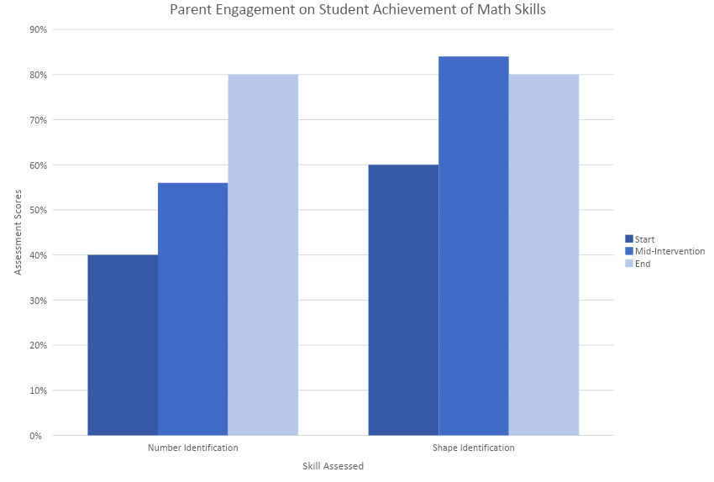

As shown in Figure 2, in the area of Reading Comprehension (specifically in answering “how” questions, the student scored 0% before the intervention, 60% during the intervention, and 100% after completing the intervention. In the area of Letter Identification, the student scored 40% before the intervention, 56% during the intervention, and 80% after completing the intervention. Ultimately, her achievement improved by an average of 70% over the course of the three weeks during which she experienced increased parent engagement.
In the four areas listed above, the student’s overall performance and progress on the skills addressed in her IEP increased by an average of 25% in three weeks. This improvement demonstrates a relationship between the level of parent engagement she experienced and a dramatic increase in scores. While there were four skill sets in which the student greatly increased her performance, there was one in which she remained the same. In the area of Reading Comprehension (“why” questions) the student scored 0% before the intervention, 60% during the intervention, and 0% after completing the intervention.

Figure 2: Parent Engagement on Student Achievement of Reading Skills
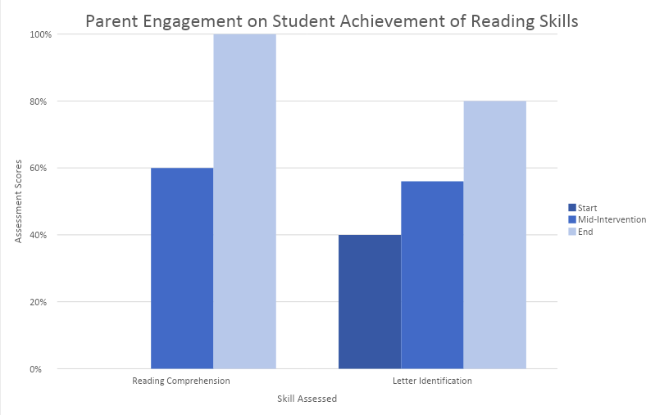

As mentioned above, the results that were obtained during the course of this study indicate a relationship between the level of parent engagement and the growth a student may achieve in their academic performance- even in the short amount of time during which this study was executed. The implication of this study and the benefit that could come from future implementation should be taken seriously by all stakeholders invested in the academic success of a child.

CHAPTER V

DISCUSSION

The research that was conducted in conjunction with this study indicated that by increasing parent engagement, schools and teachers could increase student performance. The results collected from this three-week study maintained this theory and supported the research that was done prior to organizing the study.
Implications of Results

The results of the study imply that by having a structured way to engage parents, students are more likely to perform better and make more progress on their annual IEP goals. By providing a very clear-cut way to give additional support to their children and by explaining to parents how to collect and record responses, students will have more controlled exposure to the critical skills that have been deemed essential to their academic success.
There were four separate IEP goals that were attended to during this study. Two were Math focused and reinforced skills around number identification (the number one) and shape identification (triangle). Two goals were reading comprehension focused, and reinforced answering “how” and “why” questions. If this study were to have lasted longer than three weeks, the numbers, shapes, and comprehension questions would have been adjusted after mastery.
The one skill area that the student did not improve upon was in answering “why” questions. This might be because of how the questions were presented, how the answer choices were presented, or because these are advanced questions that often require additional discussion and reinforcement. Additionally, because the student is non-verbal, it can often be difficult to express more complex thoughts or responses.
Theoretical Consequences

As mentioned in Chapter II, parent engagement is defined as the “dynamic, interactive process in which parents draw on multiple experiences and resources to define their interactions with schools and among school actors” (Stoner & Angell, 2006, p. 180). By providing the parent in this study with a tangible activity to reinforce content, they were able to engage in an on-going reciprocated dialogue with the teacher about the student’s progress. They were able to see first-hand what the student was learning and how they were progressing. This opened up doors for communication with the school and teacher and gave the parent an additional opportunity for them to feel involved in their child’s educational process.
As a result of opportunity for dialogue and additional exposure to relevant content, the student made very clear substantial gains in just three weeks. However, when considering that parent engagement techniques cannot be a single blanket strategy, it is reasonable to assume that the strategy that was used for this one student might not work for each child and their family. Nonetheless, it opens the door for a conversation to be had between teachers, administrators, and parents on how a very small amount of intervention can have very lucrative impact on their child’s success.
Threats to Validity

There are a few threats to validity in the execution and organization of this study. First, the teacher did not work with the parent to outline appropriate verbiage, possible reinforcement or modeling strategies. Additionally, the parent recorded data without proof of accuracy. While there would be no benefit to falsifying responses, there is no way to ensure the responses are accurate representations of how the student responded to questions. There is no way to be certain that these interventions were administered when both parties were in a mental or physical space to be able to put forth their best efforts. In other words, the environment in which these interventions were administered was not controlled. Finally, the study took place over the course of three weeks. The study would likely be more accurate and comprehensive if it could have been executed over a longer period of time.
Connections to Previous Studies/Existing Literature

Although research indicates that parent engagement positively impacts student achievement, it is important to note the difference between parent engagement and involvement (Stoner & Angell, 2006). The researcher attempted to reflect the significance of the engagement component by creating activities that open up the lines of communication between the parent and teacher. By providing a method for the parent to ask questions, give feedback and share concerns, a reciprocal relationship was able to begin forming. In other words, instead of sending a survey for parents to answer and submit, the teacher and parent were able to have conversations about student progress in real time.
In addition to the significance of developing effective engagement strategies, it was also important for the researcher to create a strategy that was considerate of the level of availability the parent had. By tailoring the activities directly to the student and parent, the researcher was able to continue to build a relationship that felt mutual and considerate of one another. Similarly, it would be important to note that if such an activity were to be administered to a different family altogether, factors such as time, resources, skill sets, and environment would need to be considered in order to effectively create an appropriate intervention tool (Latunde, 2017).
Finally, because the IEP process often isn’t parent friendly, the parent engagement strategy that was utilized in this study attempted to increase parent knowledge of relevant skills and how they can be an active stakeholder in their child’s success (Stoner & Angell, 2006). By having the parent review the child’s IEP goals twice a week and engage in practice activities with the child, the parent was able to see on a consistent basis what goes into developing appropriate IEP goals, how the student is progressing, and how they can hold power in the process.
Implications for Future Research

Due to the short amount of time available to complete the study, a reasonable next step for future research would be to implement the same parent engagement strategies over a longer period of time and with multiple students. The data collected during a more comprehensive study would provide more information on the effectiveness of this parent engagement strategy and its potential impact on student achievement.
Additionally, feedback from the parent involved in this study would be helpful in developing a blueprint for future parent engagement strategies involving IEP skill practice at home.
Summary

Based solely on the research done in preparation for the study and the data that was collected during the implementation of the study, it appears that each source supports the idea that by increasing parent engagement, schools and teachers can effectively increase student achievement. By developing similar engagement strategies and conducting similar studies, teachers can work to find how best to engage the parents in their own classroom. The lives and futures at stake are worth far too much to ignore the responsibility.

REFERENCES

CEC (2017). High-leverage practices in special education. Teaching Exceptional Children, 49(5), 355–360.
Fenton, P., Ocasio-Stoutenburg, L., & Harry, B. (2017). The power of parent engagement: sociocultural considerations in the quest for equity. Theory Into Practice, 56(3), 214–225. https://doi-org.goucher.idm.oclc.org/10.1080/00405841.2017.1355686
Ijalba, E. (2015). Understanding parental engagement in hispanic mothers of children with autism spectrum disorder: Application of a process-model of cultural competence. Journal of Multilingual Education Research, 6, 91–110.
Latunde, Y. (2017). The role of skills-based interventions and settings on the engagement of diverse families. School Community Journal, 27(2), 251–273.
Pham, Y. K., Murray, C., & Good, R. H. (2018). Grades, behavior, and engagement of adolescents with disabilities: an examination of social relationships among students, parents, and teachers. School Community Journal, 28(2), 47–62.
Redding, S., Langdon, J., Meyer, J., & Sheley, P. (2004). The effects of comprehensive parent engagement on student learning outcomes. Paper presented at the Annual Meeting of the American Educational Research Association, San Diego, CA.
Stoner, J. B., & Angell, M. E. (2006). Parent perspectives on role engagement: An investigation of parents of children with ASD and their self-reported roles with education professionals. Focus on Autism and Other Developmental Disabilities, 21(3), 177-189. Retrieved from https://goucher.idm.oclc.org/login?url=https://www-proquest-com.goucher.idm.oclc.org/docview/205004117?accountid=11164
Szumski, G., & Karwowski, M. (2012). School achievement of children with intellectual disability: The role of socioeconomic status, placement, and parents’ engagement. Research in Developmental Disabilities: A Multidisciplinary Journal, 33(5), 1615–1625.
Wong, V. W., Ruble, L. A., Yu, Y., & McGrew, J. H. (2017). Too stressed to teach? Teaching quality, student engagement, and IEP outcomes. Exceptional Children, 83(4), 412–427.
Zhang, D., Hsu, H., Kwok, O., Benz, M., & Bowman-Perrott, L. (2011). The impact of basic-level parent engagements on student achievement: Patterns associated with race/ethnicity and socioeconomic status (SES). Journal of Disability Policy Studies, 22(1), 28. doi:http://dx.doi.org.goucher.idm.oclc.org/10.1177/1044207310394447.

