The Effect of Les Mills GRIT™ Small Group Personal Training on Running Endurance

by

Katherine Essel

Submitted in Partial Fulfillment of the Requirements for the

Degree of Master of Education

July 2018

Goucher College

Graduate Programs in Education

Table of Contents
List of Tables i
Abstract ii
I. Introduction 1
Overview 1
Statement of Problem 2
Hypothesis 2
Operational Definitions 2
II. Literature Review 3
HIIT Training Background and Considerations for a Successful Program 3
Les Mills GRIT™ 5
Key Studies 6
Summary 9
III. Methods 10
Design 10
Participants 10
Instrument 10
Procedure 11
IV. Results 13
V. Discussion 18
Implications of Results 18
Threats to Validity 18
Connections to Existing Literature 19
Suggestions for Future Research 20
Summary 21
References 22

List of Tables

- Figure 1: Mean Performance Times | 13
- Figure 2: Mean Waist Measurements | 14
- Figure 3: Mean Hip Measurements | 15
- Table 1: Survey Results | 16

Abstract
The purpose of this study was to determine whether the Les Mills GRIT™ exercise program had an effect on the running endurance of its participants. Participants underwent a pre- and posttest on a treadmill in order to determine their 5k performance times before and after their six-week exercise program respectively. It was determined that the exercise program did benefit its participants with a reduction of their 5k performance times. More research needs to be conducted in order to study whether the GRIT™ exercise program is effective in reducing the performance times of endurance runners.

CHAPTER I

INTRODUCTION

Overview
The American College of Sports Medicine (ACSM) and the United States Department of Health and Human Services established the Physical Activity Guidelines for Fitness to provide direction for healthy individuals. They suggest that adults engage in cardiovascular exercise of moderate-intensity for 30 to 60 minutes at least five days per week, or vigorous-intensity for 20 to 60 minutes at least three days per week, or a combination of these moderate- and vigorous-intensity regimens three to five days per week. In addition, the ACSM recommends that adults engage in a full body muscular strength routine two days per week as well as flexibility exercises one to two days per week (Gottschall, Jones, Mills, & Hastings, 2013).
High-intensity intermittent training (HIIT) is considered to be one of the most effective forms of exercise for improving the performance of athletes and its effectiveness has been widely studied in endurance runners (García-Pinillos, Molina-Molina, Párraga-Montilla, & Lattore-Román, 2016). Typically, HIIT is performed in activities involving dynamical work with large muscle mass (such as brisk uphill walking, running or cycling), at intensities close to peak heart rate (HRpeak: 85%–95%) or VO2peak (80%–90%) for four minutes. The recovery periods consist of walking or “jogging” at considerably lower intensities (60%–70% of HRpeak of the intensity during the high-intensity interval) for approximately two to three minutes (Karlsen, Aamot, Haykowsky, & Rognomo, 2017).
Many endurance runners across the globe use HIIT training as a means of cross training in their training programs. This study is an endeavor to review the HIIT training class, Les Mills™ GRIT™ in order to specifically to determine whether this program could effectively increase the running endurance of its participants. The research behind this study is necessary, as many endurance runners seek new methods in order to enhance their performance in a safe and efficient manner. The researchers themselves were interested in this problem to see if the class would be able to enhance the performance times for themselves and their clients in order for these runners to run faster in their daily routines.

Statement of Problem
The purpose of this study was to determine whether the GRIT™ exercise program had an effect on the running endurance on the participants.

Hypothesis
For the purposes of this study, the null hypothesis was proposed. The Les Mills™ GRIT™ exercise program will have no effect on the running endurance of the participants.

Operational Definitions
The independent variable for this study was the training program. The training program that was implemented was the Les Mills™ GRIT™ program. This is a program that focuses on high intensity interval training (HIIT), a style of training that emphasizes short bouts of intense activity while alternating with less intense rest intervals that gives gym goers a workout in 30 minutes or less. The dependent variable was the endurance of the participants. Endurance was measured by the time it took the participants in the study to complete a 5k on the treadmills utilized at the fitness center where they take their GRIT™ classes. The length of the 5k distance used in the pre- and posttests was 3.1 miles.

CHAPTER II

LITERATURE REVIEW
This literature review examines the effect GRIT™ small group personal training and other high intensity interval training (hereafter known as “HIIT”) classes have on the running endurance and cardiovascular health of its participants. The first section will focus on the science behind HIIT programs; subsequent sections will feature an introduction to Les Mills™ GRIT™ and examine the results of key studies on the effects HIIT programs have on endurance running and sport.

HIIT Training Background and Considerations for a Successful Program
The American College of Sports Medicine (ACSM) and the United States Department of Health and Human Services established the Physical Activity Guidelines for Fitness to provide direction for healthy individuals. They suggest that adults engage in cardiovascular exercise of moderate-intensity for 30 to 60 minutes at least five days per week, or vigorous-intensity for 20 to 60 minutes at least three days per week, or a combination of these moderate- and vigorous-intensity regimens three to five days per week. In addition, the position stand recommends that adults engage in a full body muscular strength routine two days per week as well as flexibility exercises one to two days per week (Gottschall et al., 2013).
High-intensity intermittent training (HIIT) is considered to be one of the most effective forms of exercise for improving the performance of athletes and its effectiveness has been widely studied in endurance runners (García-Pinillos et al., 2016). Typically, HIIT is performed in activities involving dynamical work with large muscle mass (such as brisk uphill walking, running or cycling), at intensities close to peak heart rate (HRpeak: 85%–95%) or VO2peak (80%–90%) for four minutes. The recovery periods consist of walking or “jogging” at considerably lower intensities (60%–70% of HRpeak of the intensity during the high-intensity interval) for approximately two to three minutes (Karlsen et al., 2017).
The benefits of HIIT are numerous and are key in the fight against cardiovascular disease. Classic studies on high intensity interval training have proven that vigorous training significantly lowers one’s risk for cardiovascular disease (Gottschall, Bopp, & Hastings, 2014). Regular physical activity has numerous benefits associated with decreasing the risk of cardiovascular disease such as the reduction of total body fat mass, low density lipoprotein cholesterol (LDL-C), triglycerides, blood pressure, and elevation of maximal oxygen consumption, high density lipoprotein cholesterol (HDL-C) and glucose tolerance (Gottschall et al., 2013). Aerobic interval training may promote greater metabolic improvements than continuous moderate exercise in individuals with metabolic syndrome (Aparicio et al., 2016). Long-term aerobic exercise training conducted at higher intensities is associated with a reduced risk of future cardiovascular disease compared to lower intensities, suggesting that the former may confer greater cardioprotective benefits (Karlsen et al., 2017). HIIT has been found more beneficial for improving VO2peak in healthy individuals, heart failure, coronary heart disease, heart transplant recipients, individuals with the metabolic syndrome, hypertension, obese individuals, and in patients with Type II diabetes (Karlsen et al., 2017).
Plyometrics is an exercise that is frequently used in group exercise classes or sports drills in athletics in order to achieve the changes in heart rate that HIIT training requires. Plyometric training (PT) is a form of explosive strength training that uses explosive movements to develop muscular power, which is the ability to generate a large amount of force quickly (Lum, Tan, Pang, & Barbosa, 2016). Typically, these exercises tend to involve variations of jumps, as jumps tend to be explosive in nature.
Besides plyometrics, HIIT can be performed with different exercise modalities such as running, cycling, or swimming (Gayda, Ribeiro, Juneau, & Nigam, 2016). The choice of HIIT protocol with respect to exercise intensity, interval duration, and the use of active or passive recovery has a profound influence on acute physiological responses, exercise tolerance, and RPE (rate of perceived exertion) (Gayda et al., 2016). It always best for the certified exercise professional to evaluate their participants in order for them to safely perform any HIIT-style of training.
A key factor for any exercise response to occur over time is the principle of increasing exercise workload as training adaptation progresses (Karlsen et al., 2017). Karlsen et al. (2017) informed their participants in their study of ensuring that they had an appropriate warm-up, adjusting the workload, use of the BORG scale for the rate of perceived exertion, and correct measures of their peak heart rate. These are all considerations that exercise participants should use in their exercise programs, especially HIIT programs. Although HIIT training temporarily increases the risk of a participant to have a cardiovascular event such as a heart attack, the benefits of this training technique outweigh the risks (Karlsen et al., 2017). Caution must be taken when prescribing HIIT to patients with cardiovascular disease. Although HIIT benefits patients with cardiovascular disease, there is insufficient evidence that this program could replace a moderate-intensity program.

Les Mills GRIT™
Les Mills™ GRIT™ is a fairly new exercise program that is based in the same vein as the HIIT style. The Les Mills™ GRIT™ series is a unique 30-minute HIIT program that incorporates explosive plyometric training and dynamic strength exercises (Cook, Hastings, & Gottschall, 2014). This 30-minute class has one cardio, one strength, and one plyometric workout in each release; instructors choose whether they would like participants to take GRIT™ two or three times per week. Instructors of the program typically teach both the strength and cardio workout one time per week, later replacing the cardio workout with the plyometric workout in order to challenge GRIT™ participants. The Les Mills GRIT™ series is typically comprised of five to six tracks with a focus on various performance variables (warm-up, agility, upper and lower body conditioning, plyometric speed intervals, core) (Cook et al., 2014).

Key Studies
Gottschall et al. (2014) studied the effects of the GRIT™ program on the cardiovascular risk factors of its participants. Their study involved a GRIT™ group that took two GRIT™ classes per week along with two cardiorespiratory and two strength classes, while the FIT group participated in three cardiorespiratory and two strength classes each week (Gottschall et al., 2014). Their study concluded that on average the GRIT™ participants increased their maximum number of push-ups in a minute from 37.4 to 44.8, yielding a 19.8% increase (p < 0.0001). These same participants demonstrated a 21.9% increase in back strength with an isometric deadlift improvement from 74.6 kg to 90.9 kg (p < 0.05). Finally, cardiovascular fitness improved by 6.4% in the GRIT™ group with an increase in estimated VO2 max of 2.8 ml/kg/min (p = 0.05) (Gottschall et al., 2014, p.278). These results reveal the significant changes in exercise performance over the FIT group that the GRIT™ program facilitated in six weeks.
Cook et al. (2014) studied the effects of GRIT™ on the performance of women’s soccer athletes from the Pennsylvania State University. The team completed two GRIT™ and three Les Mills BODYPUMP™ strength training classes each week for six weeks. The researchers concluded that body fat percentage decreased 2.5% (p < 0.05) while the participants’ body weight increased slightly (1.0% gain) with a mean lean body mass gain of about 1.0 kg (2.2 lbs) throughout the study (p < 32 0.05). Fifteen of the 18 participants gained lean body mass over the course of the six-week training intervention (Cook et al., 2014). Participants’ cardiovascular health improved, with V02 peak decreasing by 2.6% (p ≤ 0.05) in a 2.4 km running test. These results are significant and show how much potential GRIT™, or any other HIIT intervention has on the performance for any sport.
There have been myriad studies that have investigated the relationship between HIIT and the sport of endurance running. The appeal of such research stems from runners’ beliefs that a large volume of training at a low or moderate intensity is required to achieve any gains; runners train consistently in order to improve their athletic performance and to maintain their health in order to be able to keep training. (García-Pinillos, Soto-Hermoso, & Latorre-Román, 2017). Runners have the tendency to gravitate towards HIIT programs when training in order to reduce their risk of injury, as injuries occur in an estimate of 40-50% of runners annually; HIIT programs call for a reduction in mileage with an increase in the intensity of the work intervals (García-Pinillos et al., 2017). It can be expected that from previous findings, plyometric training can improve running performance by improving running economy through an increase in musculotendinous stiffness (Lum et al., 2016). There have been studies that have shown plyometric training to be effective in improving running performance for distances up to five kilometers, but no studies have been conducted regarding plyometric training for distances greater than five kilometers.
Lum et al. (2016) randomly assigned runners in their study to either complete plyometric training or intermittent speed training (control). Both groups underwent six weeks of intervention training twice per week. The researchers concluded that after a ten kilometer treadmill pre- and posttest, no differences were found between groups in both evaluation moments. No between-group differences were observed for pre- and posttests results for the ten kilometer time trial. Both groups showed significant reductions with large effect sizes in the ten kilometer time trial from pre- to post-training (Lum et al., 2016). Both groups had a significant reduction in weekly mileage and in their times for the ten kilometer time trial; however, the results could not prove that either group had a significant advantage over the other.
García-Pinillos et al. (2017) discovered in their systemic review of the topic that (1) HIIT-based training programs are effective in improving athletic performance in recreational endurance runners; (2) exercise bouts at an intensity close to or above the intensity corresponding to VO2max appear to be more effective in improving performance and VO2max compared with moderate-intensity exercise training; (3) HIIT-based running plans appear to be effective in improving RE in trained endurance runners; and (4) HIIT causes an increased oxidative capacity of a greater number of muscle fibers and a reduced plasma K+ (potassium) concentration, which contributes to the maintenance of muscle function during intense exercise and delays the appearance of fatigue. The authors do caution that there is heterogeneity in study protocols.
Tolson (2010) asserts that an effective training plan for runners requires an adequate amount of rest days, efficient planning, and a gradual increase in training volume. It is also noted that runners must account for burnout and fatigue when training. High mileage training is a high risk/high reward type of training strategy. The athletes who can endure this type of tremendous success, but those who get injured or burned out mentally or physically, do not enjoy the benefits of the training style (Tolson, 2010). Tolson assigned students from a male high school cross country team to either a high intensity, low mileage or a lower intensity, high mileage intervention on the performance of these athletes during the in-season. The results showed no significant difference between the two interventions (Tolson, 2010). There was, however, a difference between athletes’ first and their best race times during the season which reveals that both interventions are effective for runners (Tolson, 2010).

Summary
The review of the literature suggests that high intensity interval training (HIIT) will more than likely enhance the performance of athletes and group exercise participants, although the hypothesis of the study was null. While most of the literature concluded that HIIT programs improve the running times of their participants, there have been studies that have rejected this hypothesis, such as the Tolson (2010) study. Both the Cook et al. (2014) and the Gottschall et al. (2014) studies concluded that the Les Mills GRIT™ class was effective in increasing V02max in its subjects, thus effectively increasing their cardiovascular health in a six-week program.

CHAPTER III

METHODS

Design
The study consisted of a quasi-experimental, pre/posttest design. The 5k performance times were measured at the start and end of the study utilizing the treadmills at the fitness center. The independent variable was the GRIT™ fitness program. This fitness program was run in eight-week sessions; however, the study was conducted over a six-week period.

Participants
Participants were selected as a result of convenience sampling; there were 11 participants in total. These participants have consistently taken the GRIT™ fitness program together since its inception in September 2016. Participants were Caucasian females as well as one Caucasian male who were considered to be middle class in their socioeconomic status. Participants all lived in the Nottingham, Maryland area.

Instrument
The performance times were measured on the two Life Fitness treadmills provided at the fitness center. The treadmills were brand new as the facility opened in the summer of 2017. These treadmills have the ability to increase or decrease the speed and incline controls. The researcher recorded each participant’s time once he or she had run 3.1 miles on the treadmill. The use of treadmills was selected to maintain the integrity of the distance covered in the run. For the pre- and posttests, participants were given a signup sheet which allowed them to select a time during testing day that was convenient. The treadmill is a reliable measure as it can be replicated with similar results whereas a distance run of 5k outdoors would be difficult to duplicate due to weather and consistency errors before and after the treatment. Participants were given a survey at week one, week three, and week six to account for any extraneous variables such as the amount of sleep participants had on average each night, how many days of additional exercise they had completed, how many days each week they ate a healthy diet, and their perceived stress level on a scale of one to ten.

Procedure
Participants selected a time slot for the pretest in which they would complete their 5k on the treadmill. These time slots were given in half-hour increments from 7:30 a.m. until 11 a.m. Participants could select the speed of the treadmill, but they were told to keep the incline of the machine at level 0.0 throughout both tests in order to maintain consistency. Participants were required to show up on time at their scheduled session on testing day. If participants were unable to meet at a scheduled time, they were required to meet with the instructor as soon as the individual was able to. Participants’ hip and waist measurements in inches were taken as additional means for assessment. Participants were given three questionnaires between the pre- and posttest: one after the first week, one three weeks into the study, and one during the last week of the study. This form was emailed and completed by the participants at their earliest convenience.
The Les Mills™ GRIT™ program offers high-intensity interval workouts that will increase aerobic capacity and accelerate fat burning while building strength, muscular endurance and power. Sessions are only 30 minutes long and focus on explosive movements that are designed to maximize workout time and allow the client to burn up to 400 calories in under an hour (empoweredMD-taken from the fitness center’s website). Trainers typically teach the current GRIT™ Strength workout one time per week while rotating between the GRIT™ Plyo and cardio workouts as instructed during the Les Mills GRIT™ certification courses; there are two GRIT workouts per week in a session of six weeks or more. The Strength workout focuses on building lean muscle mass through strength exercises with a Les Mills™ barbell and some weight plates. Plyo focuses on building muscular endurance and stamina through plyometric exercises, and Cardio focuses on burning fat through athletic drills and cardiovascular interval training.
Throughout the study, participants were allowed to complete any additional exercise as they deemed fit such as strength- or cardio-based training. The participants were discouraged from taking any additional high-intensity interval training (HIIT) classes in order to prevent any interference with the independent variable of the study.
Post-study endurance testing was conducted in the same manner at the fitness center. Participants signed up for time slots and completed their tests two at a time in approximate half-hour increments. Hip and waist measurements were also taken at the end of the study.
CHAPTER IV

RESULTS
The hypothesis that the GRIT™ exercise program had no effect on the 5k performance times for its participants was rejected based on the results of the study. Nine out of the original eleven participants completed both treadmill tests. Figure 1 describes the mean in performance time (in seconds) of the participants in the pre- and posttest.
Figure 1
Mean Performance Times
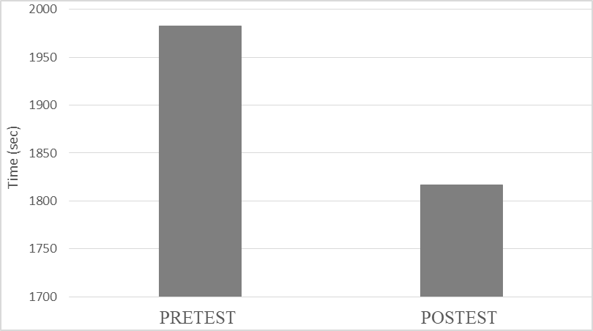
The mean performance time in the pretest data was 1982.3 seconds with a standard deviation of 348.9. The mean performance time in the posttest data was 1816.8 seconds with a standard deviation of 316.7. The t-test analysis revealed showed that there was a significant difference in the mean of the pretest and posttest performance times, t(8)=5.51, p˂.05.

Figure 2
Mean Waist Measurements
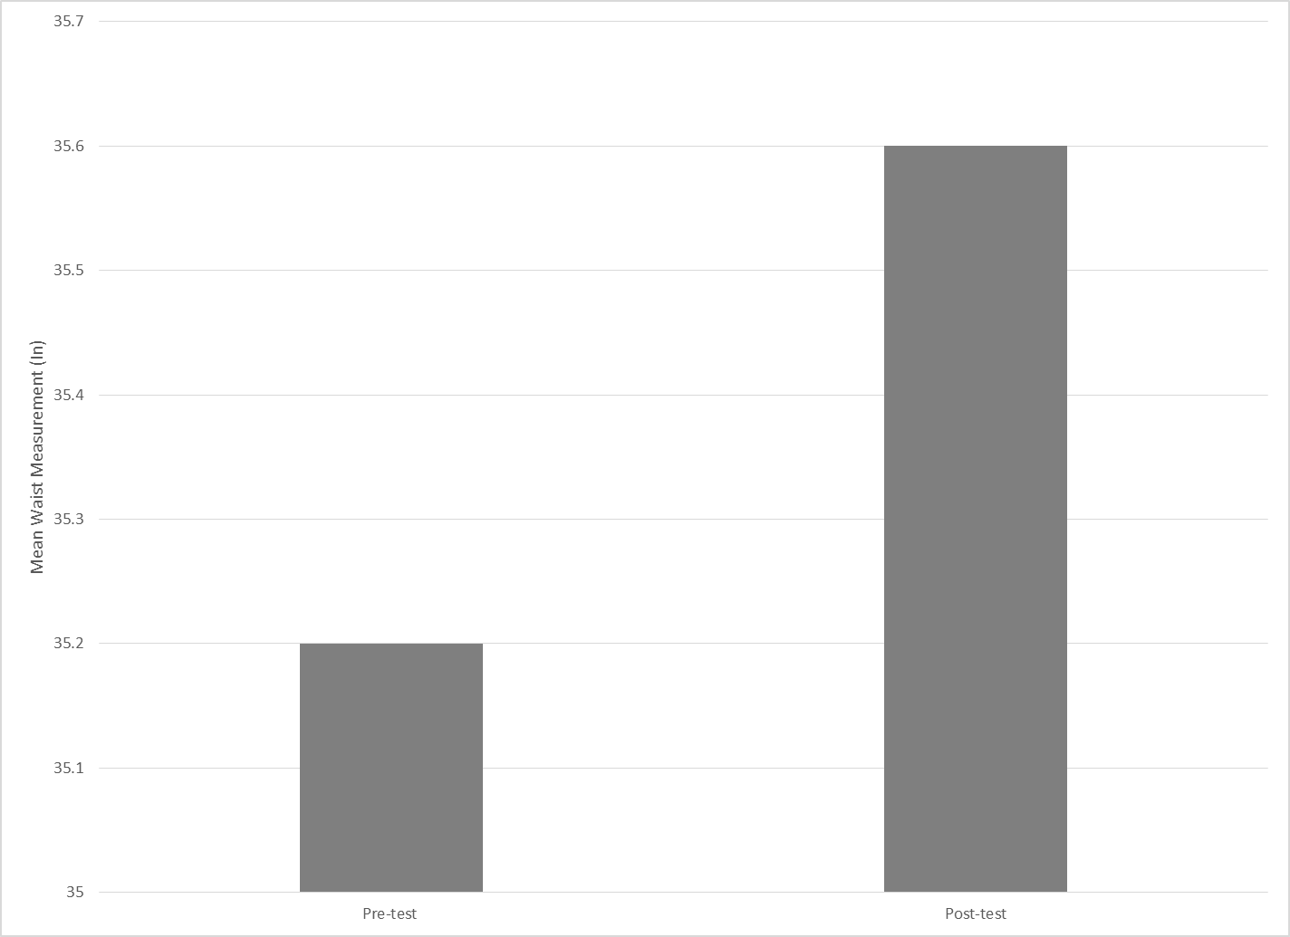
Measurements were also taken as an extraneous variable. As displayed in Figure 2 and 3, the participants gained a mean of 0.4 inches in the waist, while losing a mean of 0.4 inches in the hip. However, these differences were not significant. This possible change could be attributed to a change in body composition for most of the participants; participants could have gained muscle mass while losing body fat throughout the study.

Figure 3
Mean Hip Measurements
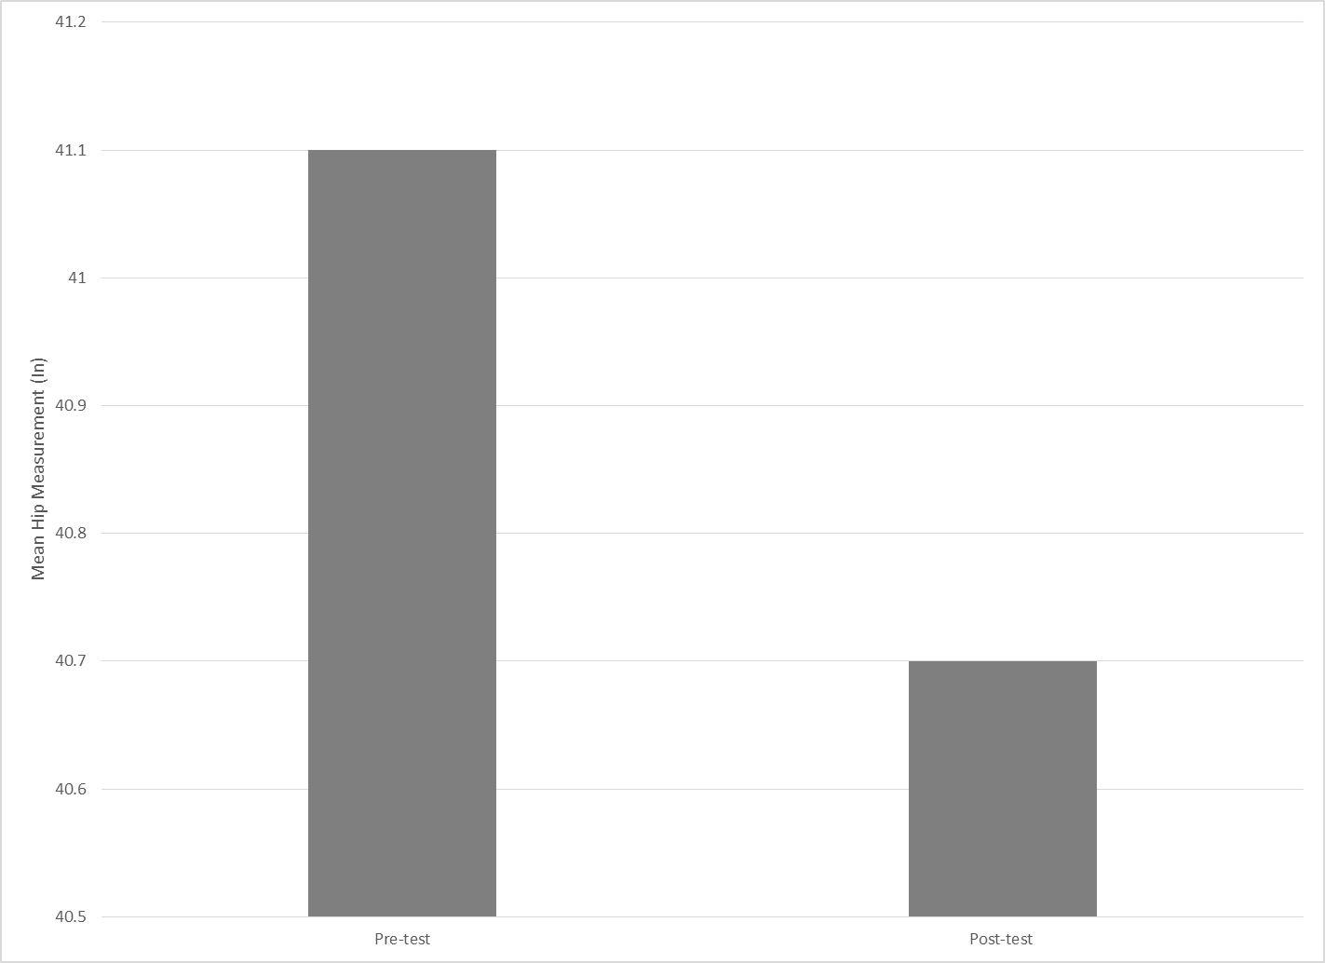
Each participant was asked to complete a survey on weeks one, three, and five to account for any underlying variables such as sleep, diet, stress, and their number of GRIT™ and cross-training sessions per week (Figure 4). Four out of the nine participants were able to submit answers to all three of the surveys. At least half of the participants were able to complete both GRIT™ sessions each week throughout the study; the majority was able to complete workouts up to two additional days outside of their GRIT™ sessions. The group was divided in terms of eating a healthy diet; however, the participants were able to consistently eat a healthy diet for at least three days each week. The majority of the participants were able to sleep for six to eight hours each night, with a perceived stress level of five (on a perceived scale of one to ten).
Table 1
Survey Results
 |  | Week
 |  | 1.00 | 2.00 | 3.00
How many GRIT sessions did you attend this week? | .00 | 20% | 0% | 25%
How many GRIT sessions did you attend this week? | 1.00 | 20% | 50% | 25%
How many GRIT sessions did you attend this week? | 2.00 | 60% | 50% | 50%
How many days of additional exercise did you complete? | 0-2 | 40% | 50% | 75%
How many days of additional exercise did you complete? | 3-4 | 40% | 25% | 0%
How many days of additional exercise did you complete? | More than 4 | 20% | 25% | 25%
How many days did you eat a healthy diet? | .00 | 0% | 0% | 25%
How many days did you eat a healthy diet? | 3.00 | 20% | 25% | 25%
How many days did you eat a healthy diet? | 4.00 | 40% | 25% | 0%
How many days did you eat a healthy diet? | 5.00 | 0% | 0% | 50%
How many days did you eat a healthy diet? | 6.00 | 40% | 50% | 0%
What was your average number of hours slept per night? | 2-4 | 0% | 25% | 25%
What was your average number of hours slept per night? | 4-6 | 40% | 25% | 25%
What was your average number of hours slept per night? | 6-8 | 60% | 50% | 50%
On a scale of 1 to 10, what was your perceived stress level this week? | 3.00 | 20% | 0% | 0%
 | 4.00 | 20% | 0% | 25%
 | 5.00 | 0% | 75% | 25%
 | 6.00 | 20% | 0% | 0%
 | 7.00 | 20% | 25% | 25%
 | 8.00 | 20% | 0% | 25%

Based on the results above, the hypothesis must be rejected, as there was a significant difference between the pre- and post-treadmill tests. These results will be discussed in the next chapter.

CHAPTER V

DISCUSSION
The hypothesis that the GRIT™ exercise program would have no effect on the 5k performance times of its participants was rejected. All of the participants of the study showed reduction of their performance times between the pre- and posttest treadmill tests. The hip and weight measurements of the participants showed little change between the pretest and posttest.

Implications of Results
There was a significant difference between the performance times in the pre- and posttest results of the participants in this study. This means that it is highly likely that anyone who participates in GRIT™ at their nearest gym could see a reduction in their running endurance; this could also suggest that some competitive endurance runners at the professional or collegiate level may see a reduction in their performance times, thus giving these athletes and the casual exerciser a more competitive edge with their training. The athletes and the casual exerciser would most likely not see a change in their measurements; however, their body composition is likely to change by losing fat and gaining muscle mass.

Threats to Validity
The primary threat to this study was differential selection. All of the participants were volunteers and not selected at random. This is problematic, as an ideal study on this subject would call for randomization of all participants in a control and treatment groups.
There was also speculation as to whether participants were using their maximum effort on both the pre- and posttest. Even though the results of the pre- and posttest were not self-reported, there was a possibility that the participants could have run slower than their maximum effort on both tests. This is problematic, as this study attempted to gather the most authentic results on each of the participants.

Connections to Existing Literature
This study contributes findings to a body of literature that focuses on high intensity interval training (HIIT) and whether this training technique can be used as a tool in order to improve running endurance. García-Pinillos et al. (2016) concluded that both HIIT and continuous running must be part of training programs for endurance runners to maximize adaptations to training. The inclusion of two to three HIIT sessions in a running plan, accumulating work periods longer than ten minutes and working at close to or above vVO_{2max} per session, lets recreational endurance runners improve their athletic performance (García-Pinillos et al., 2016. This means that endurance runners should include HIIT training in their runs, as well as include continuous runs that do not vary as much in intensity levels. For the average gym attendee, such as the participants in this study, HIIT training techniques can still be used for effective training.
It has also been discovered that intermittent speed training and plyometric training have been able to improve 10-kilometer time trials in moderately trained endurance runners despite reduction in weekly training mileage (Lum et al., 2016). The improvement was suggested due to an increase in muscular power, which had also led to an increase in peak jumping power (Lum et al., 2016). Although the GRIT™ study did not measure peak jumping power, the similar training techniques had also led to a reduction in running performance times.
This study had a stark contrast in body measurements of the participants than those of the study conducted by Gottschall et al. (2014). Though both studies involved the measurement of the GRIT™ exercise program, the Gottschall et al.’s (2014) study focused on Body Mass Index, mean body mass, and body fat percentage whereas this study examined waist and hip measurements. In hindsight, it would have been more beneficial to measure mean body mass and body fat percentage in addition to the circumference measurements; this would be to gain a better understanding of the change in body composition throughout the six-week duration. The Gottschall et al. (2014) study serves as a basic guideline for anyone who wishes to study any HIIT or Les Mills™ exercise program and how it relates to exercise performance.

Suggestions for Future Research
The aforementioned threats to the validity of the study hinder the progress of the research in this field. The ideal study would have randomized human participants from a fitness center placed in a control and treatment groups as they undergo a six-week study. The treatment group would take the GRIT™ exercise program two times per week; the control group would take three cardiorespiratory classes and two strength classes per week, all of which would be Les Mills™ group fitness classes. These classes would be offered frequently throughout the week between 5:45 am until 6:45 pm in order to create more accessibility of these classes to the participants in both the control and treatment groups. These participants would also be asked to not change their eating habits and would have to submit a food log two days per week in order to determine whether food intake was altered for the study (Gottschall et al., 2014). Food intake would need to be isolated in order to determine the effectiveness of each treatment. Both of these treatment groups would also complete a pre- and posttest in order to observe any change in the participants’ 5k performance times. This test would be conducted on a treadmill in a controlled laboratory setting.
There are already very few reviews on high intensity interval training (HIIT), so a systemic review that uses old research with new findings could enhance the body of literature that already exists by using a multidisciplinary approach (biomechanical, neuromuscular, and physiological) in a short-term and long-term (García-Pinillos et al., 2016). This research is necessary, as many fitness enthusiasts seek to find programs that will effectively give them results in terms of weight loss and performance.

Summary
In summary, this study probed whether Les Mills GRIT™ would have an effect on the running endurance of participants. The original hypothesis that GRIT™ would not have an effect on the participants was rejected based on the results of the study. A few threats to the validity of the study were noted to have implications on future research in this field.

References
Aparicio, V., Coll-Risco, I., Camiletti-Moirón, D., Nebot, E., Martínez, R., López-Jurado, M., & Aranda, P. (2016). Interval aerobic training combined with strength-endurance exercise improves metabolic markers beyond caloric restriction in Zucker rats. Nutrition, Metabolism and Cardiovascular Diseases, 26(8), 713-721. doi:10.1016/j.numecd.2016.01.005
Cook, R. A., Hastings, B., Gottschall, J.S. (2014). Heart rate zones and high intensity interval training in collegiate women soccer athletes (Unpublished master's thesis). The Pennsylvania State University, State College, Pennsylvania. Retrieved November 18, 2017, from https://etda.libraries.psu.edu/files/final_submissions/10140.
García-Pinillos, F., Molina-Molina, A., Párraga-Montilla, J. A., & Latorre-Román, P. A. (in press). Kinematic alterations after two high-intensity intermittent training protocols in endurance runners. Journal of Sport and Health Science. doi:10.1016/j.jshs.2016.11.003
García-Pinillos, F., Soto-Hermoso, V. M., & Latorre-Román, P. A. (2017). How does high- intensity intermittent training affect recreational endurance runners? Acute and chronic adaptations: A systematic review. Journal of Sport and Health Science, 6(1), 54-67. doi:10.1016/j.jshs.2016.08.010
Gayda, M., Ribeiro, P. A., Juneau, M., & Nigam, A. (2016). Comparison of different forms of exercise training in patients with cardiac disease: Where does high-intensity interval training fit? Canadian Journal of Cardiology, 32(4), 485-494. doi:10.1016/j.cjca.2016.01.017
Gottschall, J. S., Bopp, C. M., & Hastings, B. (2014). The addition of high intensity interval training reduces cardiovascular disease risk factors and enhances strength in active, healthy adults. Open Journal of Preventive Medicine, 04(05), 275-282. doi:10.4236/ojpm.2014.45034
Gottschall, J. S., Jones, J. L., Mills, J., & Hastings, B. (2013). Group fitness is effective in reducing cardiovascular disease risk factors in healthy adults. Open Journal of Preventive Medicine, 03(01), 132-140. doi:10.4236/ojpm.2013.31017
Karlsen, T., Aamot, I., Haykowsky, M., & Rognmo, O. (2017). High intensity interval training for maximizing health outcomes. Progress in Cardiovascular Diseases, 60(1), 67-77. doi:10.1016/j.pcad.2017.03.006
Lum, D., Tan, F., Pang, J., & Barbosa, T. M. (in press). Effects of intermittent sprint and plyometric training on endurance running performance. Journal of Sport and Health Science. doi:10.1016/j.jshs.2016.08.005
Tolson, J. (2010). A comparison of training methods for male cross country runners (Unpublished master's thesis). Goucher College, Baltimore, Maryland.

