< Appendix: Supplementary data>
Investigation of the relationship between the fine mode fraction and Ångström exponent: cases in Korea

Ja-Ho Koo¹, Juhee Lee², Jhoon Kim¹, Thomas F. Eck³, David M. Giles³, Brent N. Holben³,
Sang Seo Park⁴, Myungje Choi¹, Najin Kim¹, Jongmin Yoon⁵, and Yun Gon Lee^{2,*}

¹Department of Atmospheric Sciences, Yonsei University, Seoul, Republic of Korea
²Department of Atmospheric Sciences, Chungnam National University, Daejeon, Republic of Korea
³NASA Goddard Space Flight Center, Greenbelt, MD, USA
⁴School of Urban and Environmental Engineering, Ulsan National Institute of Science and Technology
⁵Climate and Air Quality Research Department, National Institute of Environmental Research
* Corresponding author e-mail: Yungon Lee (yglee2@cnu.ac.kr)

Table S1. Data periods of six AERONET sites in the Korean peninsula considered in this study.

Sites | Data period
Anmyon | 1999-2007
Baengnyeong | 2010-2013
Gangneung_WNU | 2012-2013
Gosan_SNU | 2001-2014
Gwangju_GIST | 2004-2012
Yonsei_Univ | 2011-2013

Table S2. Coefficients of MLR models at each site to estimate FMF_{500nm} from the SDA algorithm version 3 (y) using AE_{440-870nm} (x₁) and AER (x₂): y = a₀ + a₁x₁ + a₂x₂.

Sites | a₀ | a₁ | a₂
Anmyon | 0.00 | 0.36 | 0.27
Baengnyeong | -0.01 | 0.34 | 0.29
Gangneung_WNU | -0.03 | 0.34 | 0.31
Gosan_SNU | -0.03 | 0.39 | 0.27
Gwangju_GIST | -0.06 | 0.35 | 0.32
Yonsei_Univ | -0.06 | 0.35 | 0.33

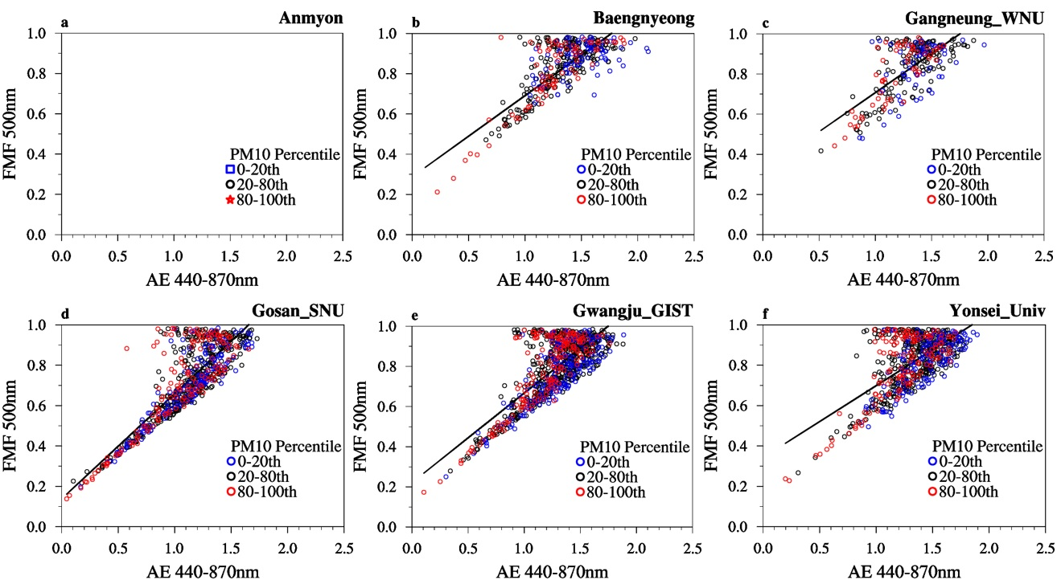

Fig. S1. Same as Fig. 2, but considering the surface observed PM₁₀ mass density simultaneously: lower percentile (0-20th, blue dots), middle percentiles (20-80th, black dots), and higher percentiles (80-100th, red dots) of PM₁₀ level. There is no available data at Anmyon.

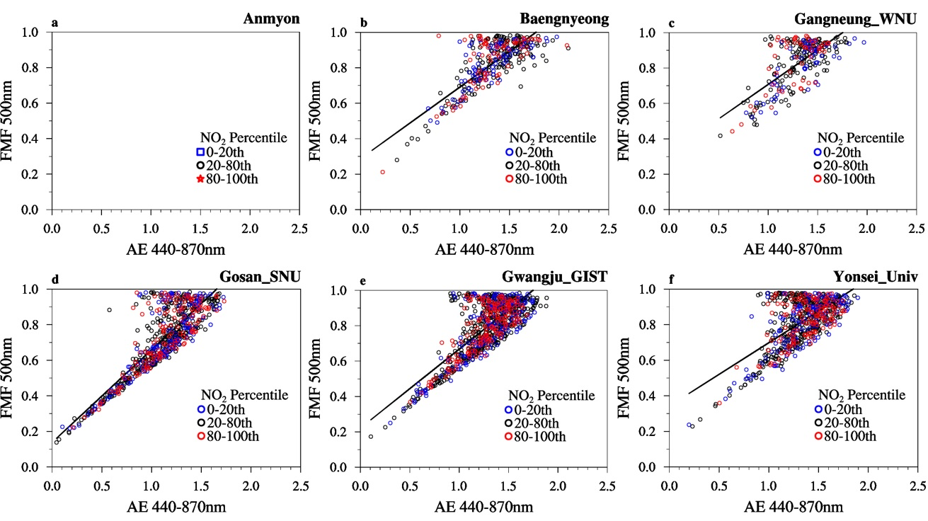

Fig. S2. Same as Fig. 2, but considering the surface observed NO₂ mixing ratio simultaneously: lower percentile (0-20th, blue dots), middle percentiles (20-80th, black dots), and higher percentiles (80-100th, red dots) of NO₂ level. There is no available measurement at Anmyon.

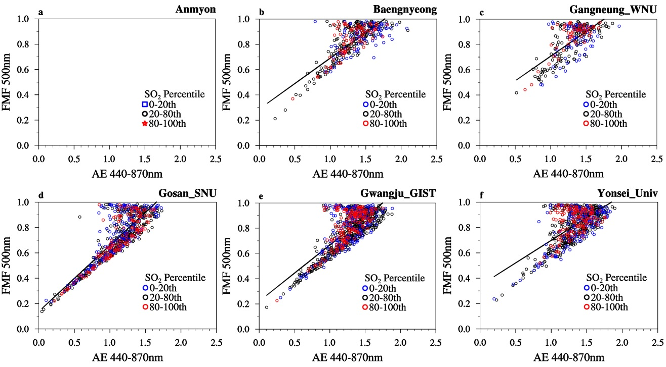

Fig. S3. Same as Fig. 2, but considering the surface observed SO₂ mixing ratio simultaneously: lower percentile (0-20th, blue dots), middle percentiles (20-80th, black dots), and higher percentiles (80-100th, red dots) of SO₂ level. There is no available measurement at Anmyon.

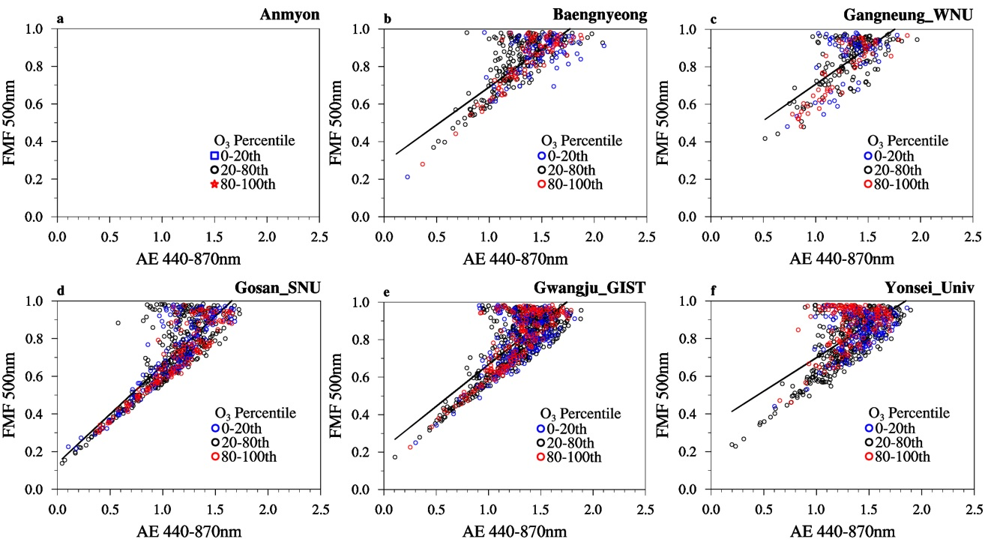

Fig. S4. Same as Fig. 2, but considering the surface observed O₃ mixing ratio simultaneously: lower percentile (0-20th, blue dots), middle percentiles (20-80th, black dots), and higher percentiles (80-100th, red dots) of O₃ level. There is no available measurement at Anmyon.

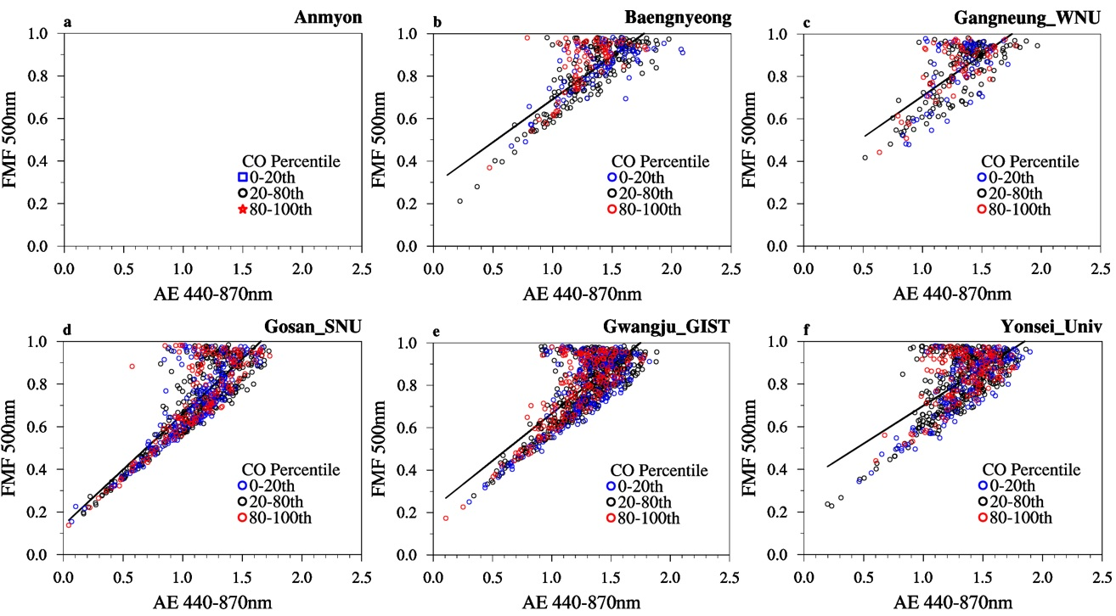

Fig. S5. Same as Fig. 2, but considering the surface observed CO mixing ratio simultaneously: lower percentile (0-20th, blue dots), middle percentiles (20-80th, black dots), and higher percentiles (80-100th, red dots) of CO level. There is no available measurement at Anmyon.

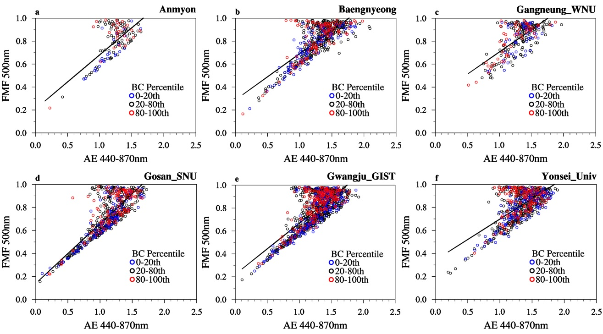

Fig. S6. Same as Fig. 2, but considering the MERRA-2 black carbon (BC) mass density simultaneously: lower percentile (0-20th, blue dots), middle percentiles (20-80th, black dots), and higher percentiles (80-100th, red dots) of BC level.

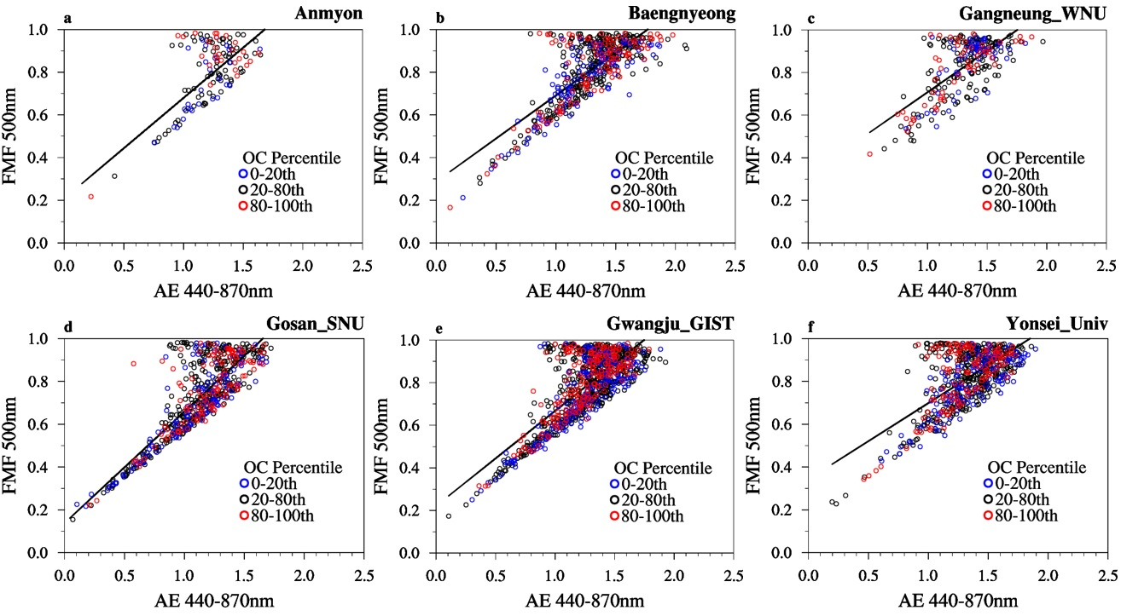

Fig. S7. Same as Fig. 2, but considering the MERRA-2 organic carbon (OC) mass density simultaneously: lower percentile (0-20th, blue dots), middle percentiles (20-80th, black dots), and higher percentiles (80-100th, red dots) of OC level.

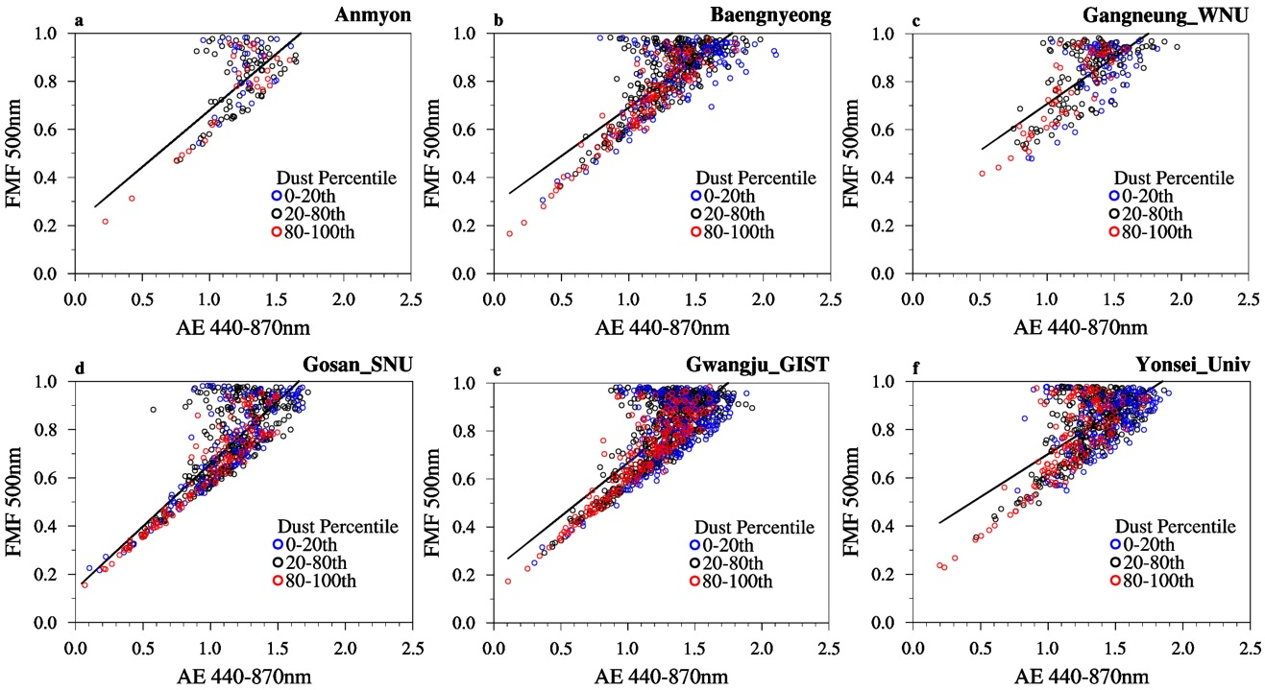

Fig. S8. Same as Fig. 2, but considering the MERRA-2 mineral dust mass density simultaneously: lower percentile (0-20th, blue dots), middle percentiles (20-80th, black dots), and higher percentiles (80-100th, red dots) of mineral dust level.

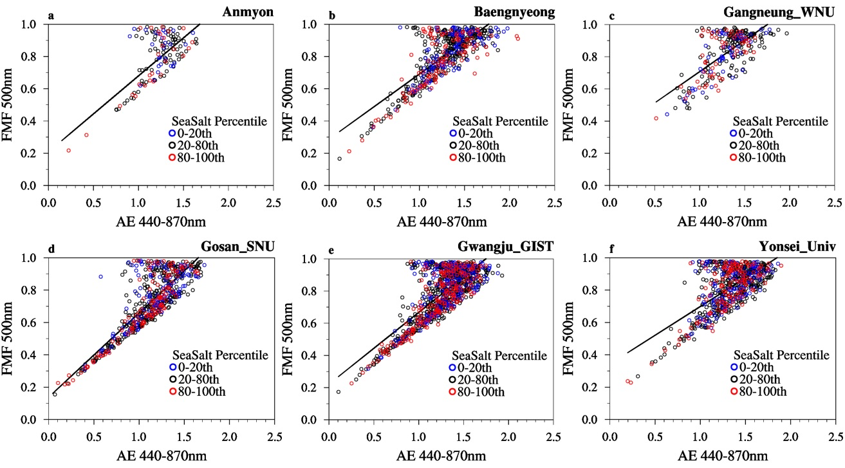

Fig. S9. Same as Fig. 2, but considering the MERRA-2 sea salt mass density simultaneously: lower percentile (0-20th, blue dots), middle percentiles (20-80th, black dots), and higher percentiles (80-100th, red dots) of sea salt level.

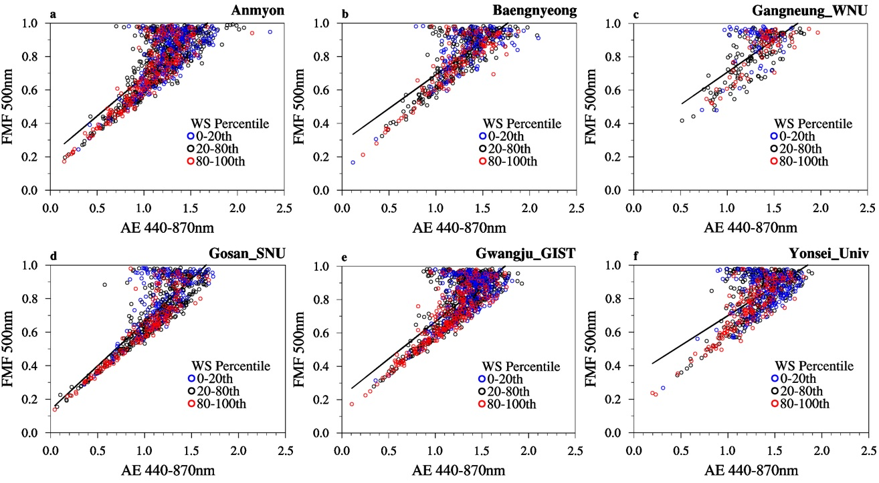

Fig. S10. Same as Fig. 2, but considering the surface observed wind speed simultaneously: lower percentile (0-20th, blue dots), middle percentiles (20-80th, black dots), and higher percentiles (80-100th, red dots) of wind speed.

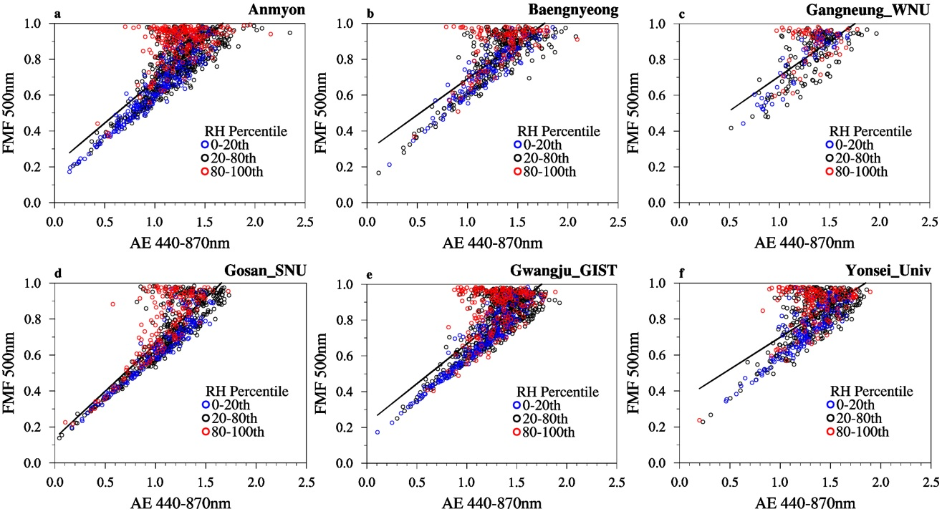

Fig. S11. Same as Fig. 2, but considering the surface observed relative humidity simultaneously: lower percentile (0-20th, blue dots), middle percentiles (20-80th, black dots), and higher percentiles (80-100th, red dots) of relative humidity.

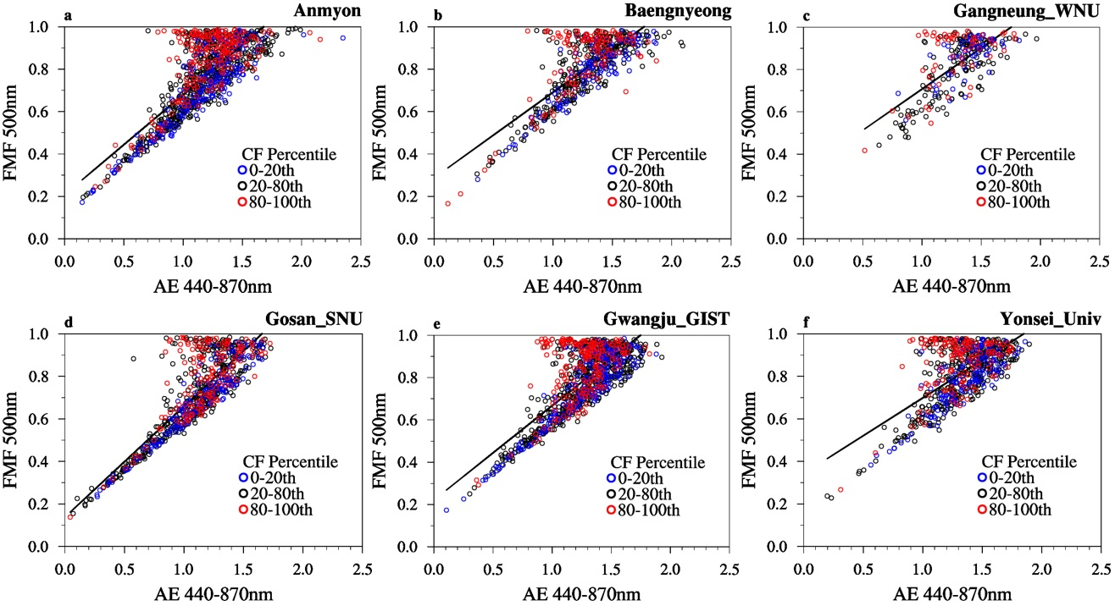

Fig. S12. Same as Fig. 2, but considering the surface observed cloud fraction simultaneously: lower percentile (0-20th, blue dots), middle percentiles (20-80th, black dots), and higher percentiles (80-100th, red dots) of cloud fraction.

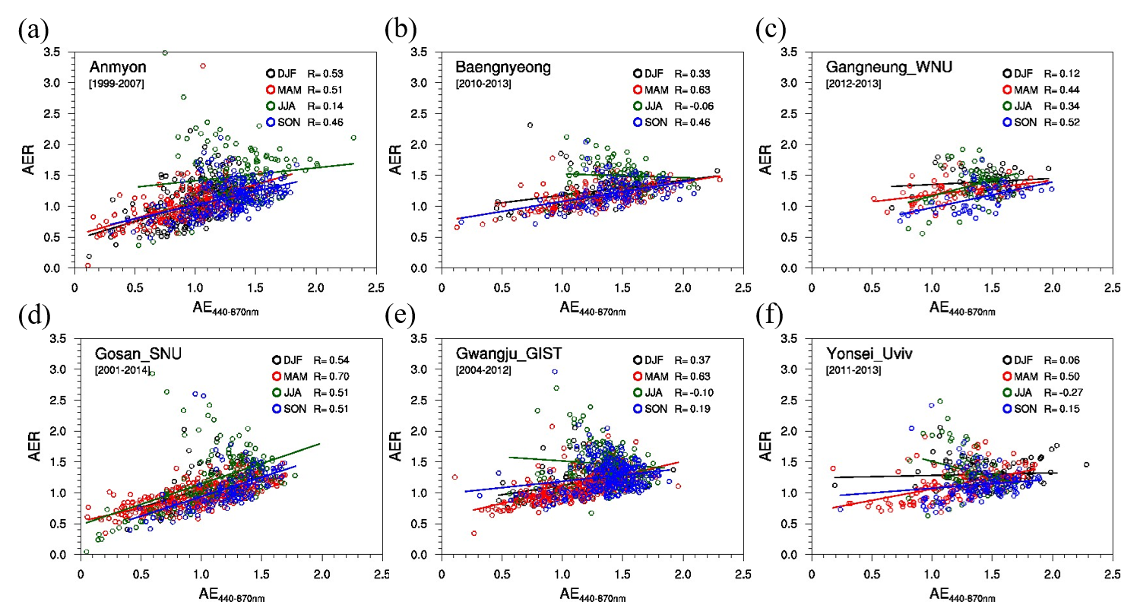

Fig. S13. Scatter plots showing the relationship between AE_{440-870nm} and AER for six sites: (a) Anmyon, (b) Baengnyeong, (c) Gangneung_WNU, (d) Gosan_SNU, (e) Gwangju_GIST, and (f) Yonsei_Univ. Correlation coefficients (R) are calculated for each season: December-January-February (DJF, black), March-April-May (MAM, red), June-July-August (JJA, green), and September-October-November (SON, blue).

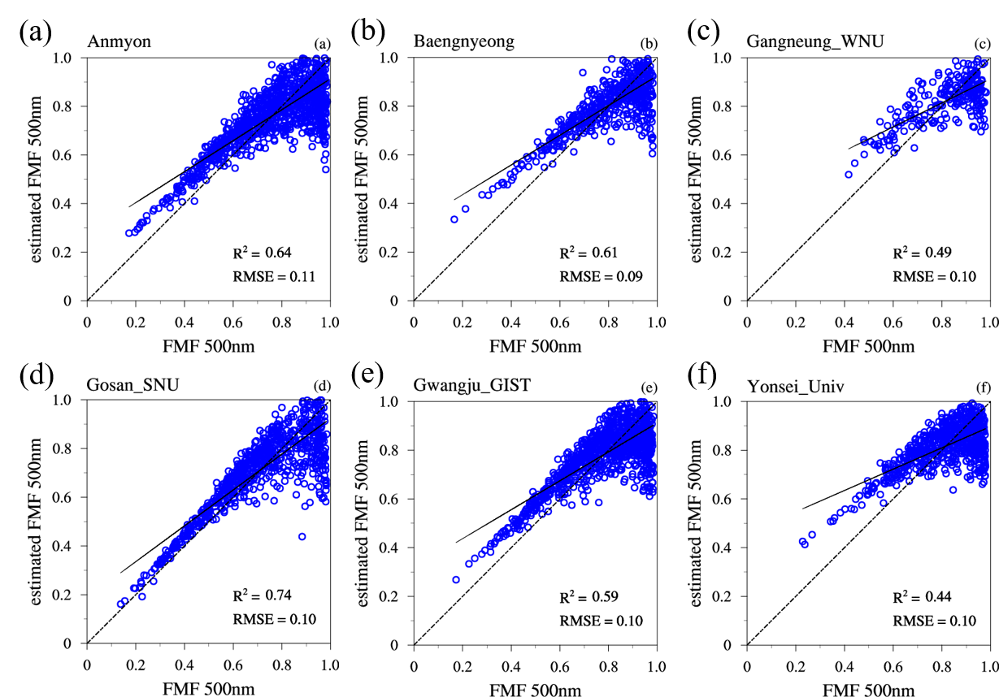

Fig. S14. Linear regression patterns between the AERONET (version 3) FMF_{500nm} and estimated FMF_{500nm} based on the single-variable regression model (using AE_{440-870nm}) at six sites: (a) Anmyon, (b) Baengnyeong, (c) Gangneung_WNU, (d) Gosan_SNU, (e) Gwangju_GIST, and (f) Yonsei_Univ. R² and RMSE values are provided for each site.

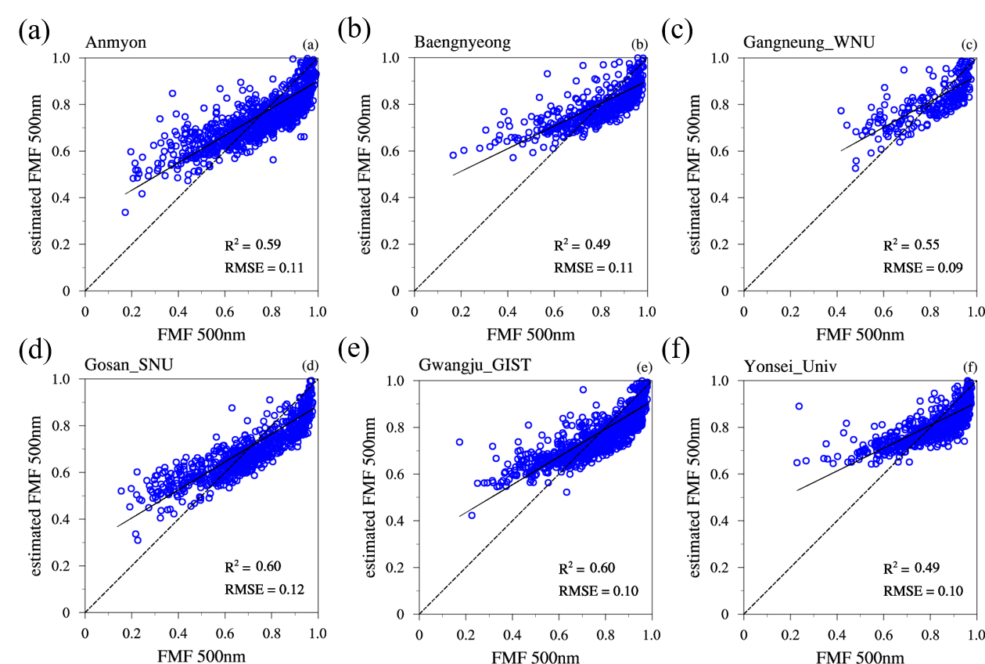

Fig. S15. Linear regression patterns between the AERONET (version 3) FMF_{500nm} and estimated FMF_{500nm} based on the single-variable regression model (using AER) at six sites: (a) Anmyon, (b) Baengnyeong, (c) Gangneung_WNU, (d) Gosan_SNU, (e) Gwangju_GIST, and (f) Yonsei_Univ. R² and RMSE values are provided for each site.

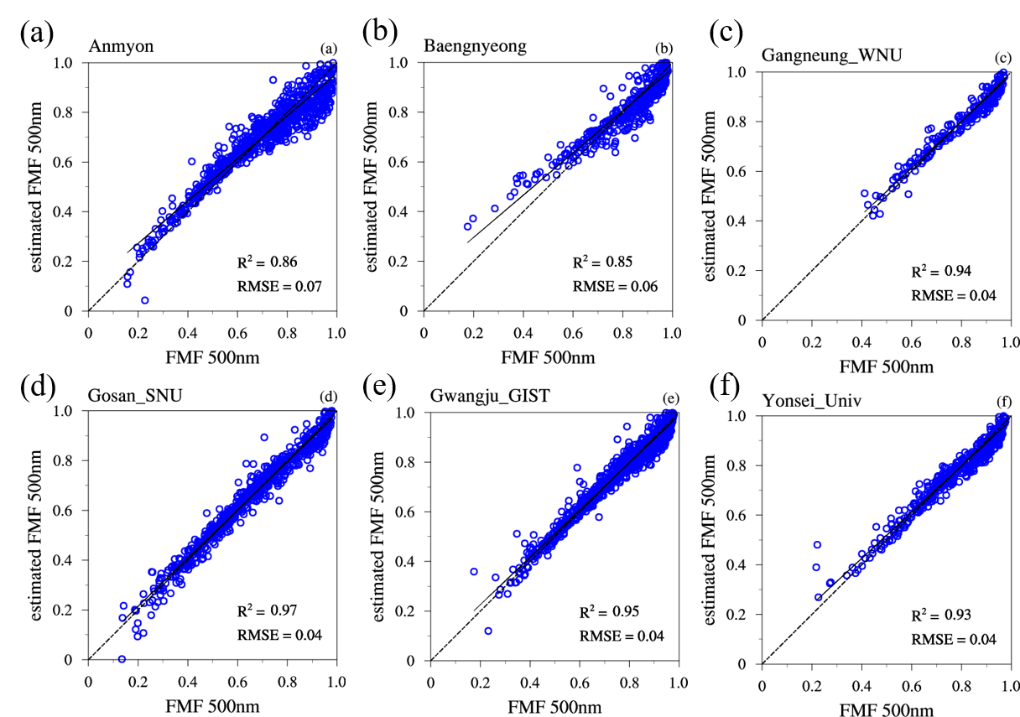

Fig. S16. Linear regression patterns between the AERONET (version 2) FMF_{500nm} and estimated FMF_{500nm} based on the MLR model (using AE_{440-870nm} and AER) at six sites: (a) Anmyon, (b) Baengnyeong, (c) Gangneung_WNU, (d) Gosan_SNU, (e) Gwangju_GIST, and (f) Yonsei_Univ. The coefficient of determination (R²) and RMSE values are provided for each site.

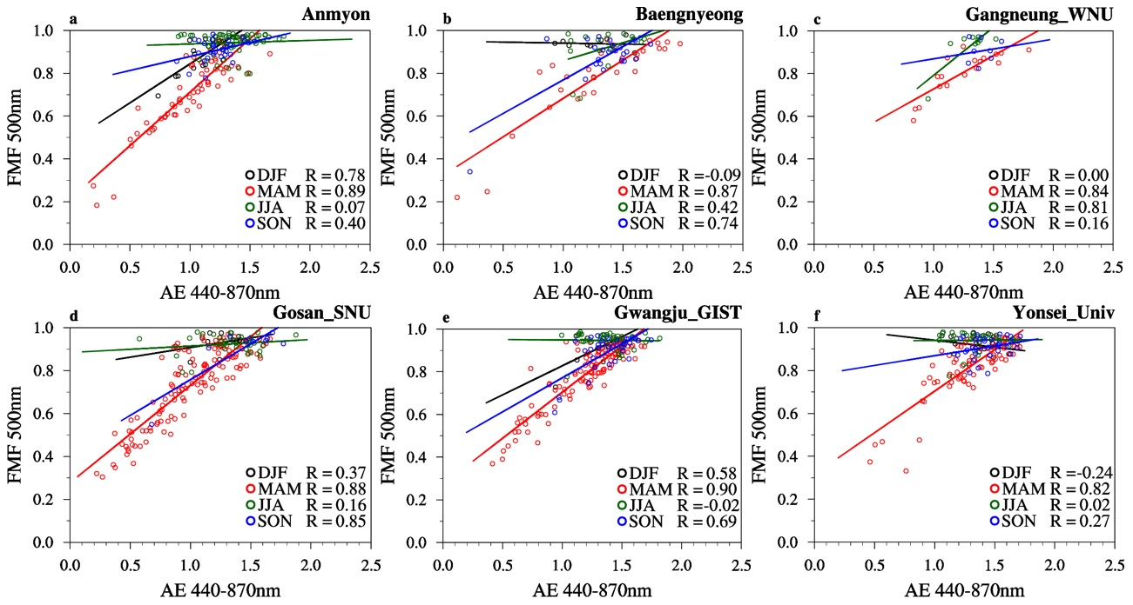

Fig. S17. Scatter plots showing the relationship between AE_{440-870nm} and FMF_{500nm} from the AERONET inversion algorithm (version 3) for six sites: (a) Anmyon, (b) Baengnyeong, (c) Gangneung_WNU, (d) Gosan_SNU, (e) Gwangju_GIST, and (f) Yonsei_Univ. Correlation coefficients (R) were calculated for each season: December-January-February (DJF, black), March-April-May (MAM, red), June-July-August (JJA, green), and September-October-November (SON, blue).

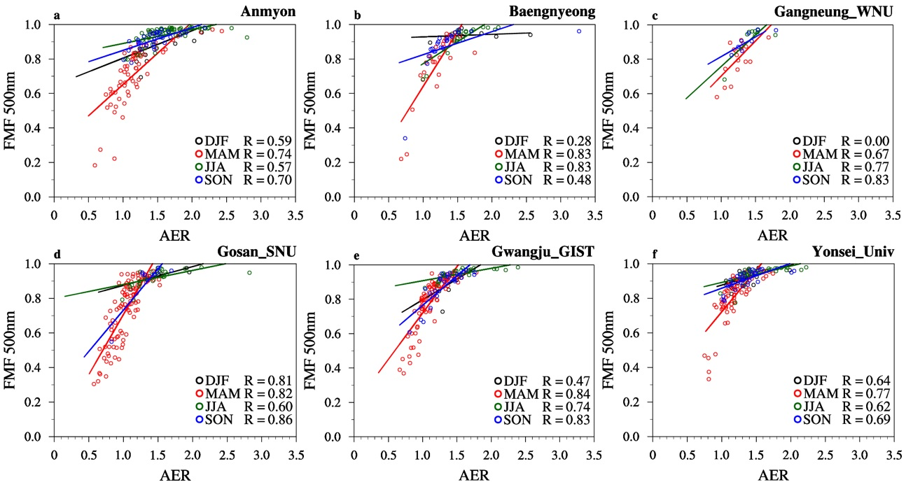

Fig. S18. Scatter plots showing the relationship between AER and FMF_{500nm} from the AERONET inversion algorithm (version 3) for six sites: (a) Anmyon, (b) Baengnyeong, (c) Gangneung_WNU, (d) Gosan_SNU, (e) Gwangju_GIST, and (f) Yonsei_Univ. Correlation coefficients (R) were calculated for each season: December-January-February (DJF, black), March-April-May (MAM, red), June-July-August (JJA, green), and September-October-November (SON, blue).

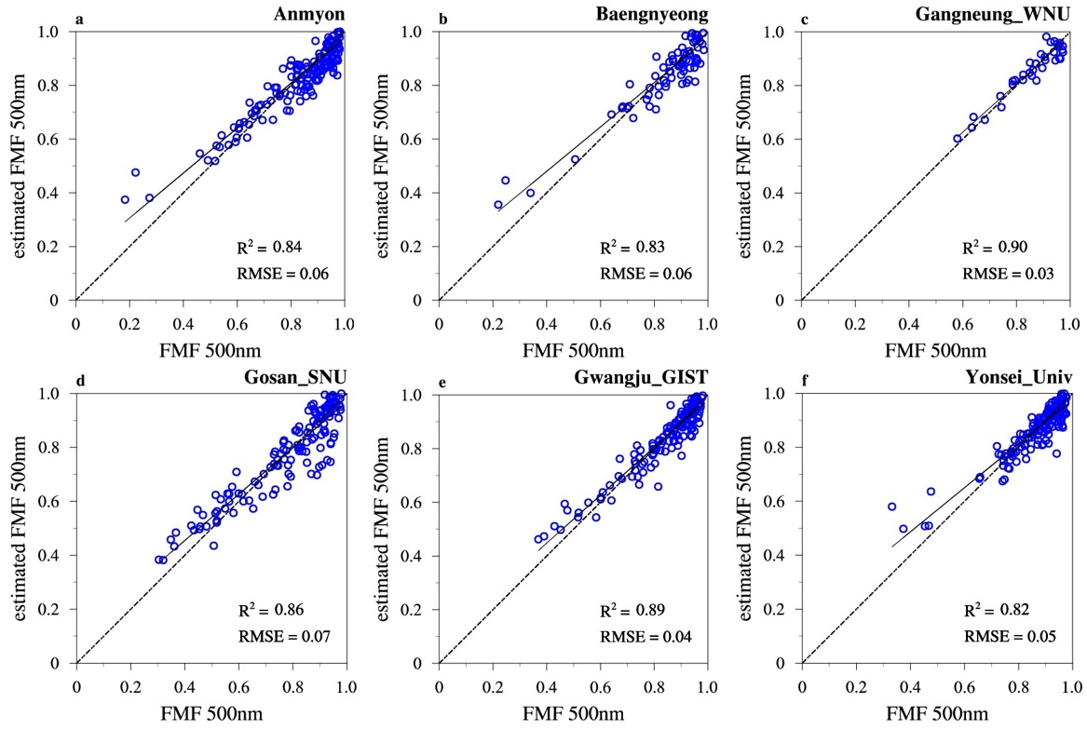

Fig. 19. Same as Fig. 6, but compared to the FMF_{500nm} from the inversion algorithm.

