
Earth and Space Science
Supporting Information for
An Examination of the Recent Stability of Ozonesonde Global Network Data
Ryan M. Stauffer¹, Anne M. Thompson^{2,1}, Debra E. Kollonige^{3,1}, David W. Tarasick⁴, Roeland Van Malderen⁵, Herman G. J. Smit⁶, Holger Vömel⁷, Gary A. Morris⁸, Bryan J. Johnson⁸, Patrick D. Cullis^{9,8}, Rene Stübi¹⁰, Jonathan Davies⁴, and Michael M. Yan^{11,1}
¹Atmospheric Chemistry and Dynamics Laboratory, NASA/GSFC, Greenbelt, MD, USA
²Joint Center for Earth Systems Technology, University of Maryland Baltimore County, Baltimore, MD, USA
³Science Systems and Applications, Inc., Lanham, MD, USA
⁴Environment and Climate Change Canada, Downsview, ON, CA
⁵Royal Meteorological Institute of Belgium, Uccle (Brussels), Belgium
⁶Institute for Energy and Climate Research: Troposphere (IEK8), Jülich Research Centre, Jülich, Germany
⁷National Center for Atmospheric Research Earth Observations Laboratory, Boulder, CO, USA
⁸Global Monitoring Laboratory, NOAA Earth System Research Laboratory, Boulder, CO, USA
⁹Cooperative Institute for Research in Environmental Sciences, University of Colorado, Boulder, CO, USA
¹⁰Federal Office of Meteorology and Climatology, MeteoSwiss, Aerological Station, Payerne, Switzerland
¹¹Kellogg Brown & Root, Fulton, MD, USA
Contents of this file

Text S1
Figures S1 to S6

S.1 Input from the EnSci Manufacturer
The original EnSci company was purchased in 2011 by Droplet Measurement Technologies (DMT; Longmont, CO, USA), with production beginning at S/N 20052 in February 2011. Prior to this, each model of EnSci ozonesonde (Z, 1Z, 2Z; only the radiosonde interface board varies) had its own independent sequential serial numbering system. The repeated EnSci numbering for the three different models is the reason for the increased number of ECC/OMI TCO comparisons prior to S/N 20052 in Figure 7. Beginning with 20052, all Z, 1Z, and 2Z models began counting up from that point with no repeated numbers (see also the gap in S/N in Figure S6).
The manufacturer has indicated that there were changes made to the ECC cell ion bridge material/amount of material and ozonesonde pump motor prior to the purchase of EnSci by DMT in 2011. However, the exact timing of these changes is unknown. The ASOPOS 2.0 Task Team is gathering previously flown and recovered EnSci ozonesondes to perform laboratory tests and forensic analyses of the ECCs to narrow down the timing of these manufacturing changes, and to determine if and what effects they could have on the measurements. The company changed hands again in 2016 to its current ownership beginning with EnSci S/N 30265. No other changes, other than the plating of the ECC metal frame occurring at approximately S/N 28000, which altered the color of the frame from gold to silver, have been noted. As the main text discusses, the new Nakano and Morofuji (2022) EnSci pump efficiency data set offers a promising path to investigate the role of changing stratospheric pump characteristics at TCO drop-affected stations. Based on the abruptness of the TCO drop occurring near EnSci S/N 25250 (Figure 9), efforts will be focused on tests with S/Ns in this proximity.

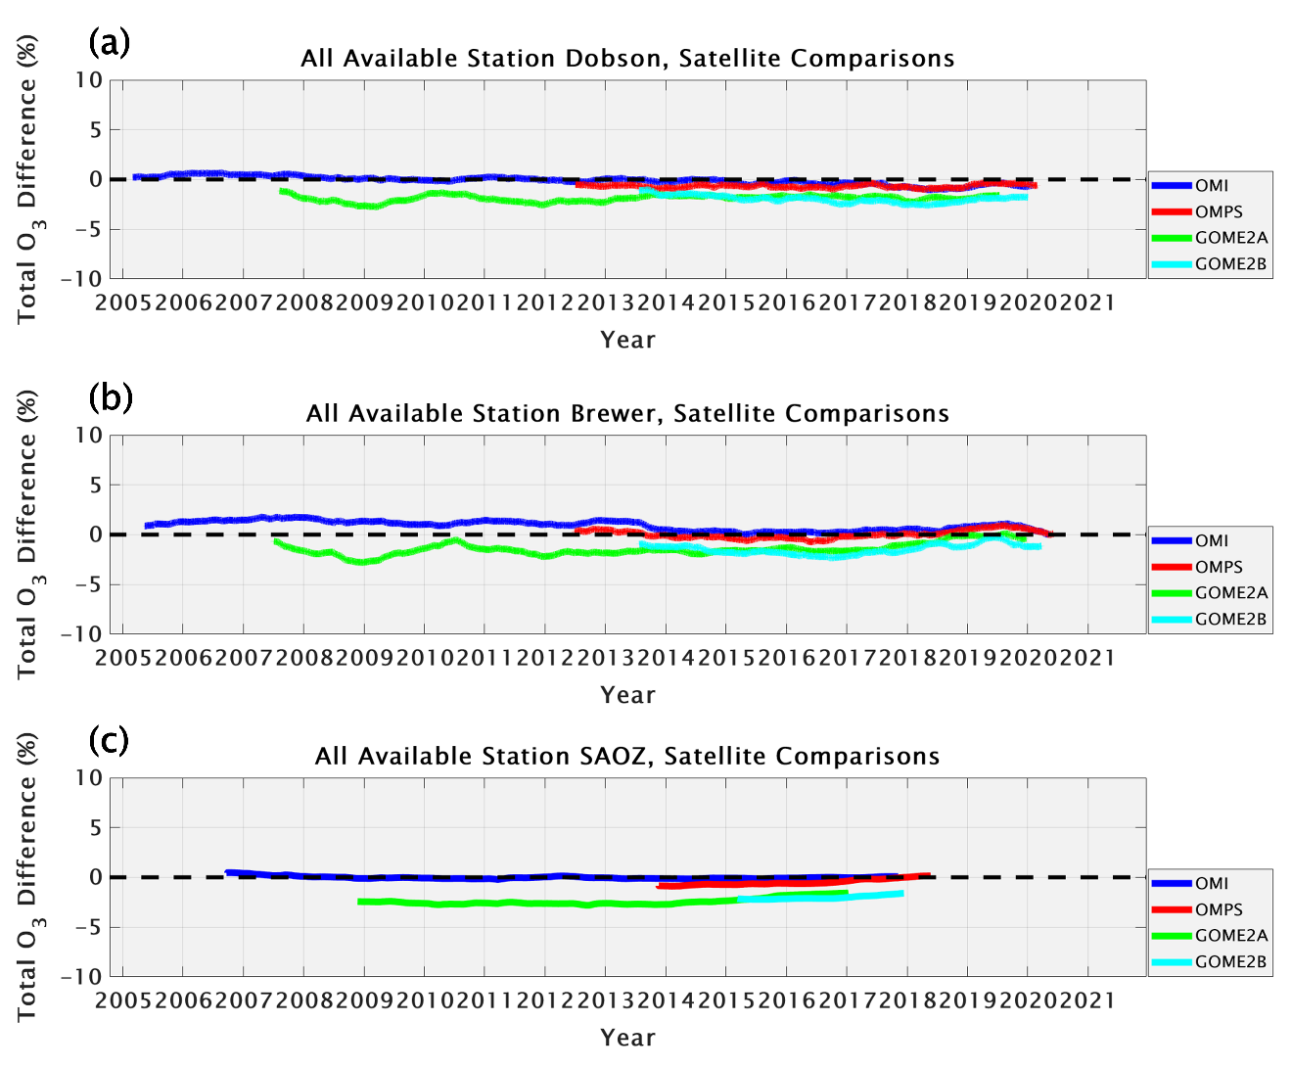

Figure S1. Comparisons in percent difference (ground-based minus satellite) among ground-based (a: Dobson, 21 sites; b: Brewer, 19 sites; c: SAOZ, 5 sites) and satellite TCO at the 40 stations where ground-based TCO data are available (see Table 1). The solid lines represent 500-point, centered moving averages. The lines are not plotted for the first 250 and last 250 comparisons. Note that some stations have multiple types of instruments.
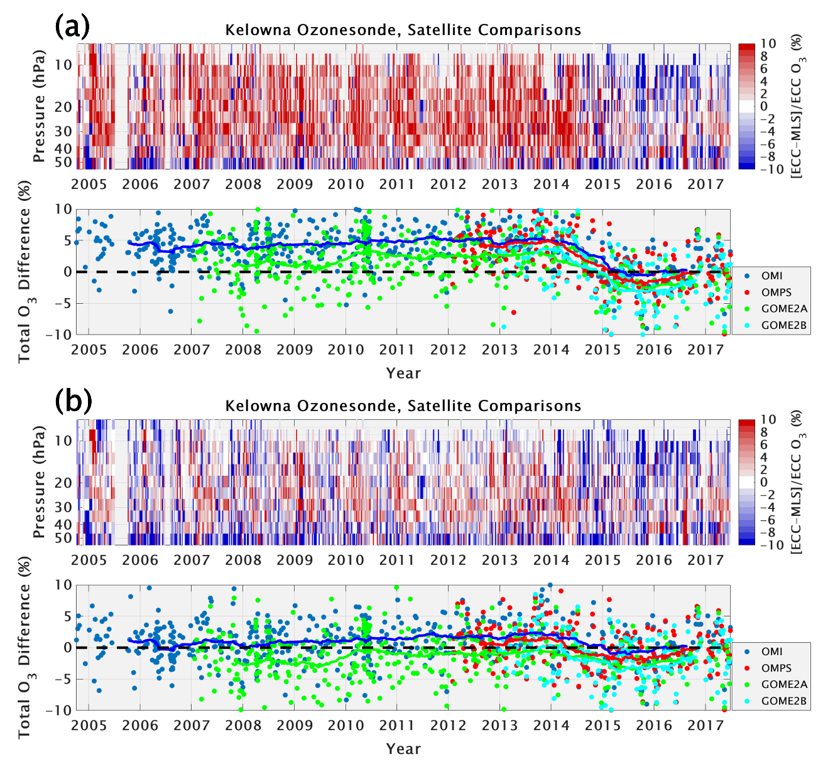

Figure S2. Time series of comparisons at Kelowna among ozonesondes and MLS ozone profiles (top panels), and OMI (blue dots), OMPS (red dots), GOME-2A (green dots), and GOME-2B (cyan dots) TCO (bottom panels). Solid lines corresponding to each TCO satellite instrument on the bottom panels indicate 50-ozonesonde centered, moving averages. No average lines are plotted for the first 25 and last 25 comparisons. Horizontal dashed lines on the bottom panels indicate the 0% line for TCO comparisons. Red or blue colors on the top panels indicate where the ozonesonde ozone is greater or less than MLS. Panel (a) shows the ozonesonde data used in S20, and Panel (b) shows the corrected data used for this study.
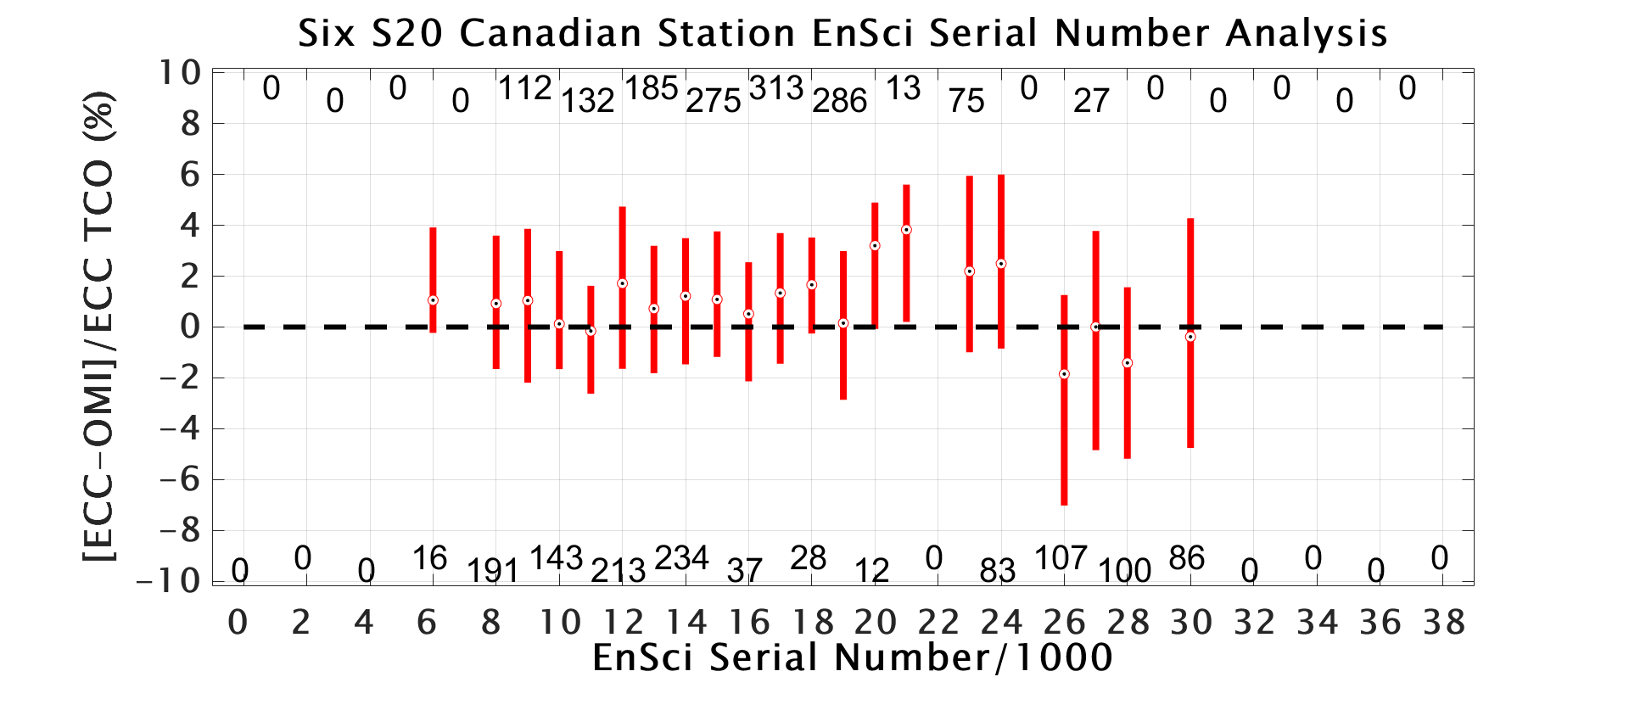

Figure S3. Comparisons of EnSci ozonesonde TCO with OMI from the six Canadian S20 stations in percent difference (using corrected Kelowna and Yarmouth data). EnSci S/Ns are grouped into bins of 1000 (26 = 26000 to 26999) for analysis. The bars show the 25th to 75th percentiles for each bin, with the dots representing the median value. The total number of valid ozonesonde/OMI comparisons for each bin are shown by the numbers along the top and bottom, aligned with the bars.

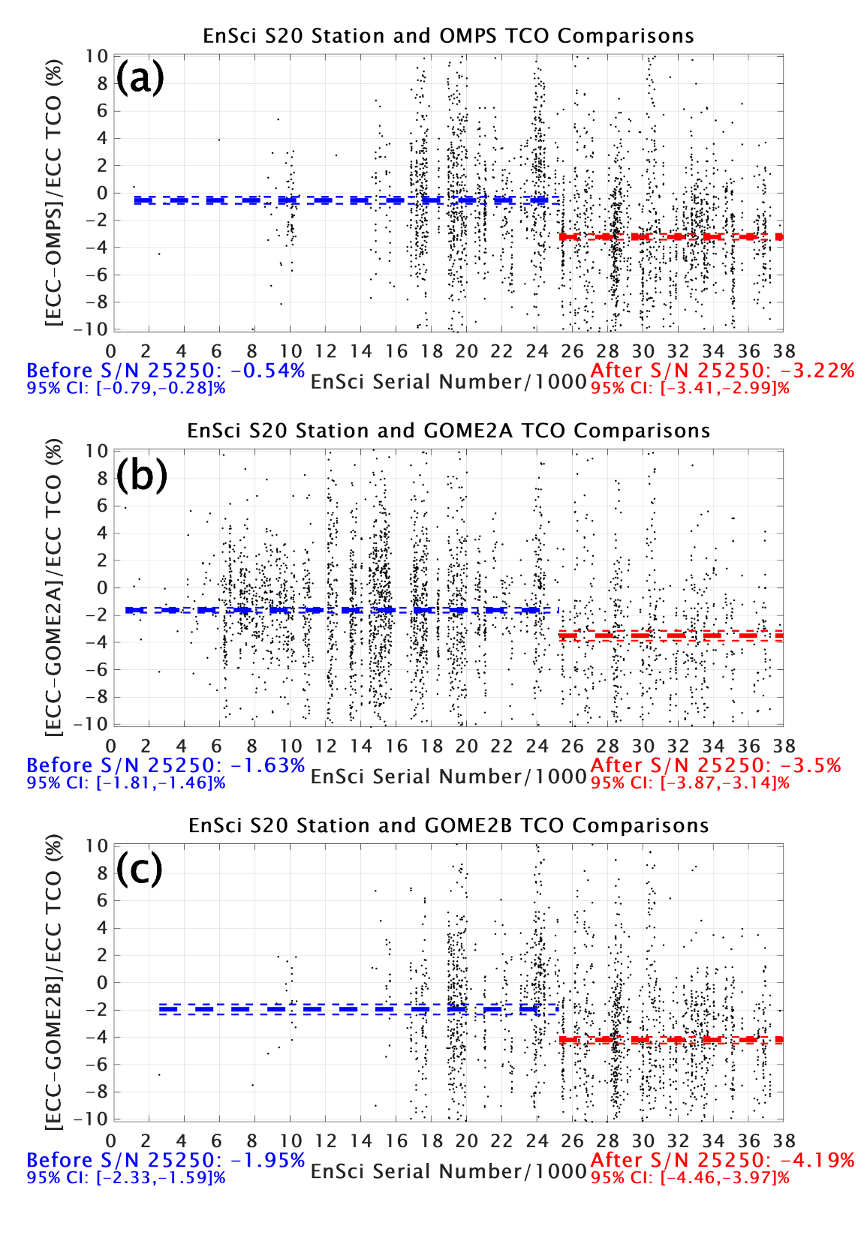

Figure S4. Comparisons in percent difference between ozonesonde and satellite TCO for all 14 S20 station EnSci S/Ns (a: OMPS; b: GOME-2A; c: GOME-2B). The blue dashed lines indicate the mean value for S/Ns prior to 25250, and the red dashed lines indicate the mean value after S/N 25250. The mean values and their 95% confidence intervals are shown in text below both figures and are indicated by the thin dashed lines.

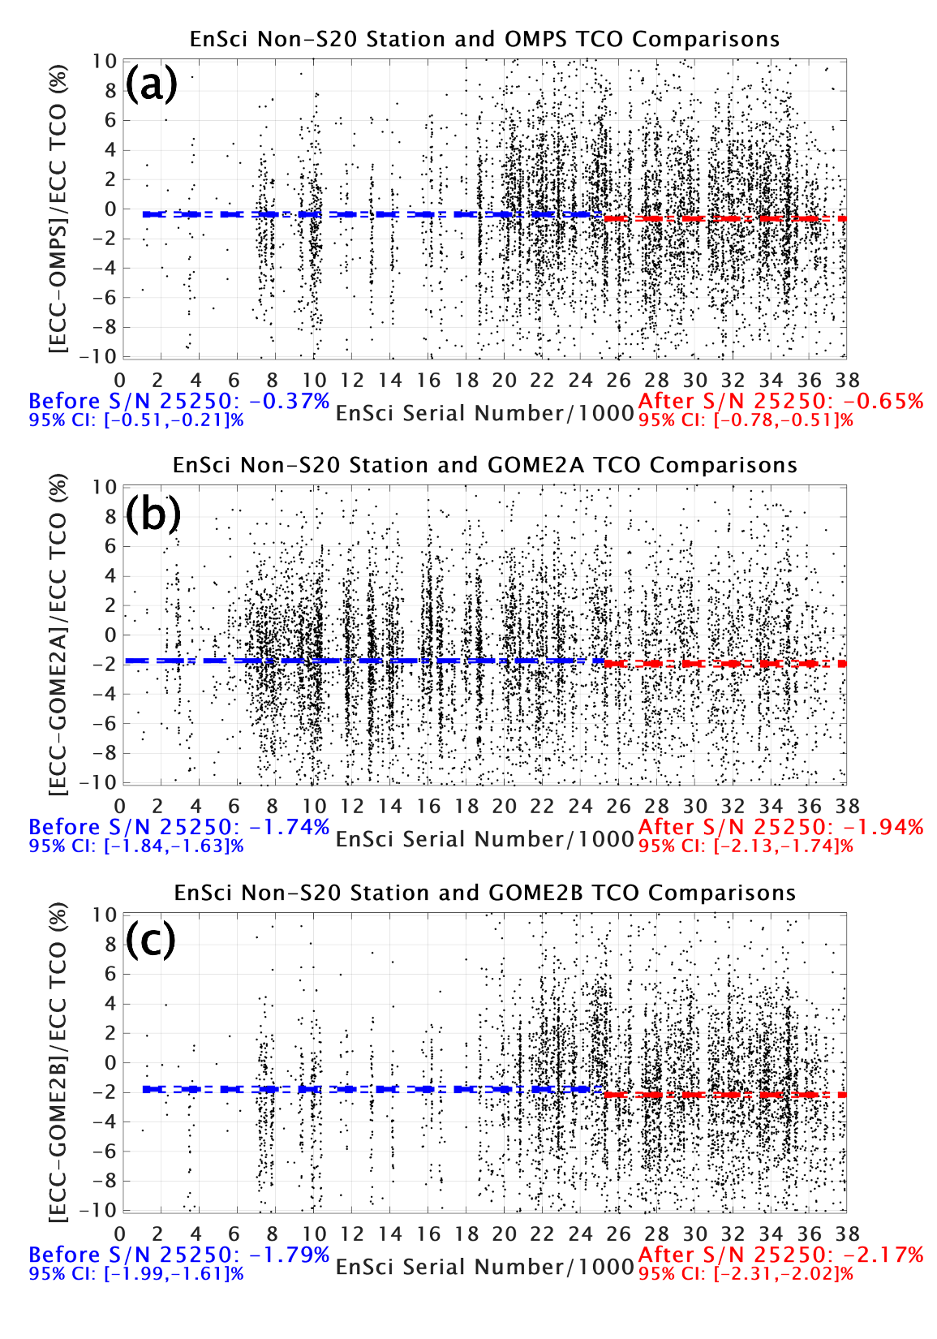

Figure S5. As in Figure S4, but for the 46 non-S20 stations.

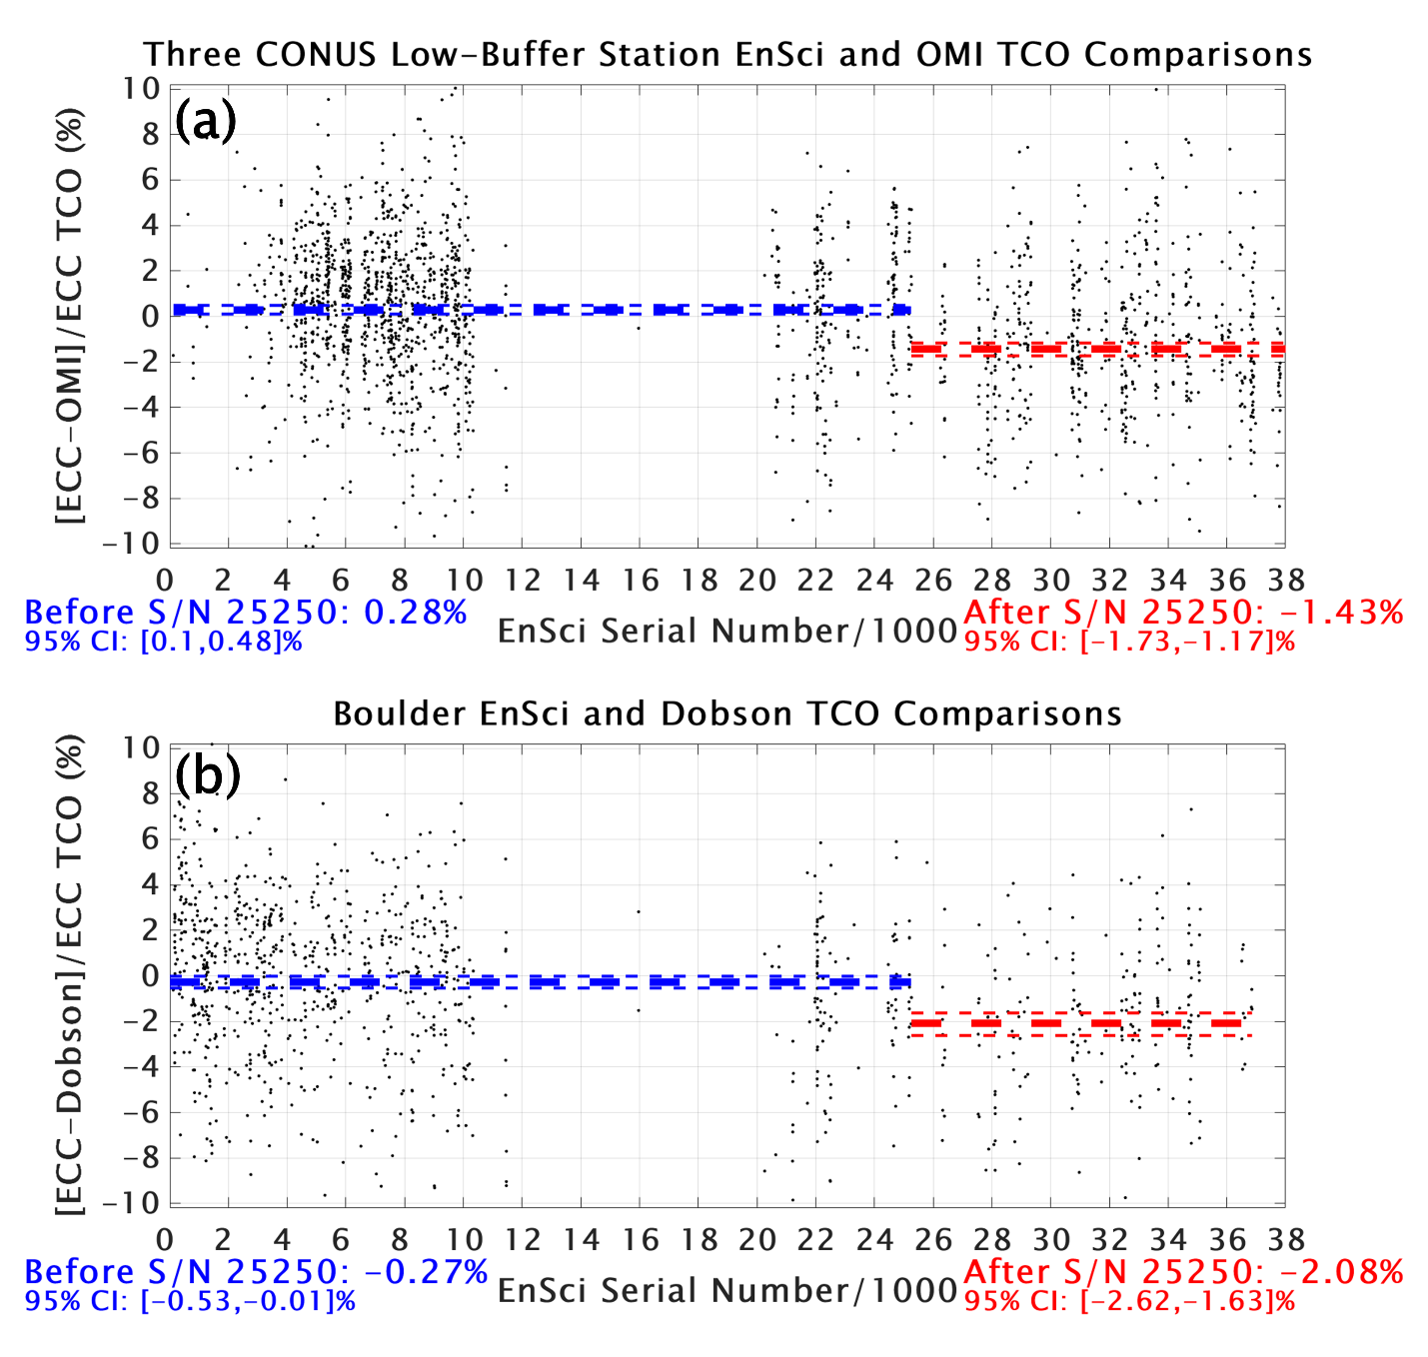

Figure S6. As in Figure 9, but for (a) three Contiguous United States (CONUS) stations (Trinidad Head, Boulder, and Huntsville) that use the low-buffered SST0.1 ozonesonde sensing solution, compared to OMI TCO, and (b) Boulder EnSci S/N comparisons with the co-located Dobson spectrophotometer TCO.

