Google Domination: Is Privacy Over?

Nakiya Booker
Margaret-Alice Tree
Cassidy McSweeney
Colin Marshall
Salisbury University

Author Notes:
CMAT 297 Communication Research Course
Salisbury University
Dr. Chrys Egan, Advisor
Fall Semester 2018

Contact: mtree1@gulls.salisbury.edu

Abstract

The purpose of this study was to research and evaluate the privacy policies of Google and the company’s overall impact in today’s society. More specifically, the researchers looked into the policies placed within Google and everyday users’ opinions on the use of their information to third parties. In order to gather information, researchers sent out a SurveyMonkey link to the undergraduate students at Salisbury University on October 31st, 2018. The purpose of the survey was to understand the general public’s opinion on their information being used and if they are already known of these Google policies. Researchers gathered the findings by looking into use of formal language and Google’s impact on society as a whole. Through this method of using a survey, researchers obtained more evidence on the general public’s opinion of third party usage of data. By completing research on the corporation of Google and the third parties’ involvement with exchanging of the public’s information, we can have a better understanding of the impact Google has had on society and the public’s view of this impact.

Keywords: Google, Privacy

Introduction
Background
Google has the capacity to be a wonderful tool for the world, giving access to free-flowing information. But is the trade-off of having little to no privacy worth it to the current generation? The definition of privacy has changed as technology has evolved. People now have less privacy by choice, as they enjoy sharing pictures of meals and family members. However, most people are not thinking about where this information and data is going. The data is being sold to companies to increase product sales and target individuals personally for a more personalized internet experience. Anything a person posts or shares online is being collected by Google and sold to third party companies. This can be viewed as both a good thing and bad aspect of the website. The good side is that personalized products are more likely to be beneficial to consumers, but do companies have the right to sell you a personalized product before you even think about needing it?
Rationale
This study looks at how college students feel about privacy and data collection, by looking at the most used site that is tracking them: Google. Today, Google is one of the most popular search engines and company that most people use. While Google as a web browser is collecting data, they also own various social media sites that collect data on its users. It is believed that most students are unaware of this. By conducting a survey, we will both inform students of what’s going on and get a perspective into how they feel about the way they process data. This study is important because it will allow researchers to gain perspective into how college students feel about internet privacy. Once the students are informed, the research team will see what their opinion is on their information being sold without their knowledge. Researchers are interested in knowing if they will continue to use Google or switch to another search engine.

Review of Literature
In 2011, an article titled “Google ads and Blindspot debate” discussed how Google makes a profit off of selling three commodities from their users. By selling the users keywords, statistics of keywords, and search results to third parties, this “creates an ideology that the world’s information is at the users’ fingertips” (Lee, 2011). Thus, making the users search more and view more advertisements closer to their own interests, creating more ad revenue.
A study taking place in 2008 called “Advertisements and Privacy: Comparing For-Profit and Non-Profit Web Sites for Children” found that non-profit websites would have ads linked to the webpage that would go to a for-profit website, making the non-profit website show that they also collect your information and keyword searches. The websites used were geared towards younger aged children, with the companies knowing this they have developed new ways to make children understand and be interested in their advertisements (Cai, 2008). These tech and marketing branches of companies found that “children exhibit higher click-through rates than adults on online ads, and more often click on web advertisements by mistake because they did not know they were actually ads” (Cai, 2008). Using information like this, businesses can easily figure out what makes you want to click on an ad, or even what type of ads you will like because of previous search engine keywords.
In another article, “Mediating the public/private boundary at Home: Children’s use of the internet for privacy and participation was published under Journal of Media Practice. In this article, it talks about how new media changes the social dynamic. As the new media of online communication grows, so does that blurred line of private/public boundaries that are connected to children. More adolescents than ever before have a platform to be heard and understood by their peers (Livingstone, p. 42). Yet, there is still this fine line of public vs private information that younger generations are more willing to put out in order to connect with those around them.
The internet is used for young adults to explore their identity and self-development away from parents and other adults, this then leads to the lack of private information that children feel the need to keep. Older teens are at a standstill in wanting to express their private information to their peers and the community online and wanting to keep their private life still private.
Two researchers, Denise E. Agosto and June Abbas, open up the topic of lack of privacy within teens through surveys. When looking through the overall data that they have collected, they seemed to find a pattern in that youth’s online interactions usually mirror their offline activities (Agosto & Abbas, 2015). A majority of participants had given a thought towards the issue of online privacy and showed concern of maintaining their online privacy (Agosto & Abbas, 2015). With 98 participants, only two found no concern in hiding private information, viewing it in a way that they have nothing to hide. Many teens know the consequences of going online and sharing private information, knowing their privacy would be at stake. However, knowing this information, they trust sites even if their private matters are used for profit.
Research Question/Hypothesis
Are we as a society slowly accepting the loss of our privacy or are we just unaware of these policies that companies put out for their own personal gain?
Google has implemented themselves within society to a point that many cannot go a day without needing to use the search engine. Having Google’s privacy policies laid out for the public to see, many would believe that the general public has a solid grasp of these policies because of the tremendous everyday use of the platform. Even with the understanding that Google does use the users’ information, an everyday person does not know just how much of their information is taken and where it goes. By bringing up the policies and informing society of how their information is being used will lead people to be more informed and aware of the potential risks that lay in front of them while using these platforms.

Methods
Participants
On October 31st, 2018, an email was sent out to the students at Salisbury University. Within the email was a link to the researcher’s survey that asks questions about how aware the student is on the private policies of online websites, especially Google. Located on the Eastern Shore of Maryland, participant requirements included current enrollment as a student at Salisbury University over the age of 18. Once the results came in, a total of 100 out of 8,714 students took the online survey in which 69 were female and 31 being male.
Procedures
A survey was created on SurveyMonkey, a survey creating website. The survey consisted of multiple-choice questions and open-ended response questions. By using SurveyMonkey, the participants identities were anonymous, so their answers could not be traced back to them. The survey was then sent via email to students enrolled at Salisbury University. After receiving the responses, their answers were compiled into data charts and graphs to then be analyzed.
Measurement
The study utilized quantitative and qualitative data collection methods from the multiple choice and free response answers. Researchers used the data that was received and made visual graphs for easier viewing of the data. The researchers concluded that college students seem to have a moderate to high level of concern about the use of private policies and how it affects their day to day life.

Results

Listed below are the responses of Salisbury University students in an online survey (see Appendix A)

- Gender

Male | 30.00% | 30
Female | 69.00% | 69
Non-Binary | 1.00% | 1
Other | 0.00% | 0

2. On a regular basis, how often do you use Google? (Check one answer only)

less than 2 hours a week | 13.00% | 13
2-4 hours a week | 33.00% | 33
4-6 hours a week | 27.00% | 27
more than 6 hours a week | 27.00% | 27

3. Is privacy an important factor in how you view your quality of life? On a scale from 1-10 how private of a person would you say you are? 1 2 3 4 5 6 7 8 9 10
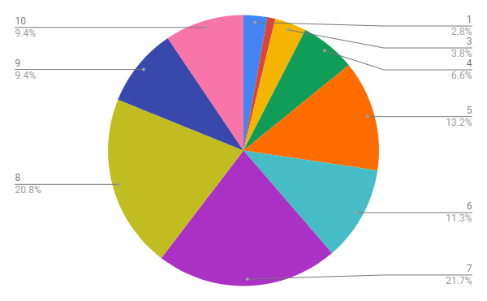

4. Did you know that Google sells your data? Example: videos you watch, things you search, your personal information. How much does this concern you? Rate from 1 - 10, 10 being extremely concerned. 1 2 3 4 5 6 7 8 9 10
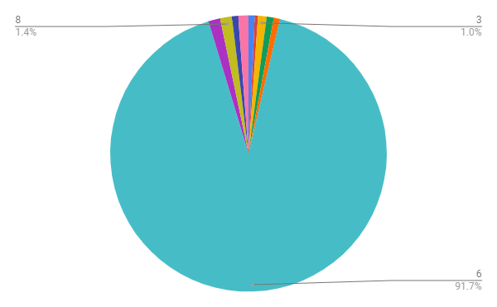

5. Would you be more willing to provide personal information for online advertising purposes if the website compensated you for your information?
(select answer) Yes No

Yes | 73.00% | 73
No | 27.00% | 27

6. When questioned about the use of collecting private information, the CEO of Google, Eric Schmidt said “I think judgment matters… If you have something that you don’t want anyone to know, maybe you shouldn’t be doing it in the first place.” What are your thoughts on this statement?

- I shouldn’t be in a situation where my information is compromised if I release it

- People should be able to do what they want without worrying about privacy

- So, I feel as if this statement is a slap in the face. It is almost as if Schmidt knows what he’s doing and is blaming his audience rather than himself of the process Google uses

- It would be nice to know what’s going on with my information

- It isn’t necessarily the sharing of information that is wrong, so I understand his statement. However, it is wrong to be secretive about the fact that information is being saved. If Google were open about the fact that they sell personal data, I’d respect them more as a corporation

7. Microsoft, the owner of “Bing”, also collects data from you such as how you use it and interact specifically with this website. Microsoft’s policies say that their products “require some personal data” to provide the user with a service, and if that data is not provided then their service will be unavailable. What are your thoughts on the matter? Should private information be required from users?

- I don't think any private information should be a requirement. If your service can't run without invading the privacy of your users than that's an issue for the company to fix, not the people

- I think sharing personal data without an individual's permission is unethical

- Bing operates on private data to personalize the experience, so private information is the core of the design. However, that doesn't mean users must supply private data. There are alternate solutions which shouldn't require personal data.

- Private information allows the search engine to learn your habits and searches, this creates a better user experience. It also helps Google or Bing to further improve their search engines.

- I think it should be a choice and we should be compensated.

8. Do you think that the generation from ages 18-24 has a problem with setting boundaries for privacy on the internet? For those who have concerns relating to Google, there are alternative web search tools like DuckDuckGo, WolframAlpha, and Startpage, that don’t sell your data Rate 1-10, ten being the most concerned. 1 2 3 4 5 6 7 8 9 10

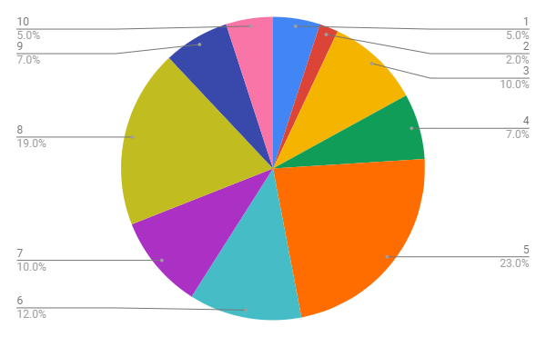

9. If you had a choice of whether or not all of this data was collected and stored, would you want it stored? Would you be willing to give up key features of apps and websites in order to protect your privacy?

- I believe I would be willing to give up key features of apps/websites to protect my privacy. However, it depends on what the "key features" are.

- I don’t mind them knowing my information. My problem is with them selling my information like when I google something and then an ad then pops up on my Facebook, I have a problem with that

- No I wouldn't want it stored, but depending on the app I wouldn't want the functionality or services degraded. For me it's finding a balance between what I deem acceptable info to provide.

- No, some data kept by companies is helpful for me in the long term with searches or advertising. I just don’t believe that they should be able to without directly informing users.

- I would not want my private data stored simply because it’s an invasion of my privacy to store/sell it without my explicit consent.

10. Will you continue to use Google after learning this information?
- DuckDuckGo is my main browser, and I only use Google when I don’t have another alternative. I am trying to cut back the time I spend on Google, and if they weren’t as integrated as they are, I could easily say no.

- I was already aware that Google sold my information to third parties and I still use Google to this day.

- Yes. While they are unethical, they are on top and so much of I do is connected to them. I will be mindful while using it but I can’t say I’ll stop....at least not yet.

- Unfortunately, until something better comes along I probably will. I did not know about the others

- Probably, it's the most reliable search engine

Discussion
Significance
The results show that of the 100 participants who answered that 87% used Google for 2 or more hours a week. Of the participants, 69% identified as female, while 30% identified as were male and 1% identified as non- binary. Of those participants, 72.6% marked that they were either moderately or highly private people, while 91.7% said they were at least moderately concerned about their data being sold. 73% of participants would be willing to provide more information for advertising purposes.
In addition, 76% of participants thought that the generation X had at least moderate or high issues with privacy and keeping things private. Most participants felt as though there was no real alternative to Google. While they thought the use of their personal data was unethical or an invasion of privacy, the majority of participants stated they would continue to use Google. This research is significant because, as internet use increases so will the use of search engines. It is important know, how the generation that will have the most impact on the internet feels about privacy issues.
Limitations
Some of the limitations of this research would be that the research team did not get to directly interact with participants, so they were unable to explain any questions that participants had. The survey also only allowed for a sample size of 100 participants, so the survey is not representative of the student population as a whole. The survey would also only allow a certain amount of characters when participants were entering their responses for a short answer question as well. It is possible that some participants may have felt that their message was unable to be conveyed completely.

Future Research
Future research into this matter could be focus groups or more comprehensive research surveys which would allow participants to fully voice their concerns and feedback about privacy and data selling. As the issue of data collection, storage, and sale is a topic that will continue to impact future generations it is important to continue research on it. This way people know what is happening to their personal data and can voice their opinions on it appropriately.

References

Agosto, D. E., & Abbas, J. (2017). “Don’t be dumb—that’s the rule I try to live by”: A closer look at older teens’ online privacy and safety attitudes. New Media & Society, 19(3), 347–365. https://doi.org/10.1177/1461444815606121
Cai, X. (2008). Advertisements and Privacy: Comparing For-Profit and Nonprofit Websites for Children. Communication Research Reports, 25(1), 67–75. https://doi.org/10.1080/08824090701831826
Lee, M. (2011). Google ads and the blindspot debate. Media, Culture & Society, 33(3), 433–447. https://doi.org/10.1177/0163443710394902
Livingstone, S. (2005). Mediating the public/private boundary at home: children’s use of the Internet for privacy and participation. Journal of Media Practice, 6(1), 41–51. https://doi.org/10.1386/jmpr.6.1.41/1
Saif, S. (2016). Right to be forgotten. Journalism and Mass Communication Quarterly, 93(2), 360-382. doi:http://dx.doi.org/10.1177/1077699016638835

Appendix A
- What is your Gender? Male, Female, Non-Binary, Other

2. On a regular basis, how often do you use Google? (Check one answer only)
❏ less than 2 hours a week
❏ 2-4 hours a week
❏ 4-6 hours a week
❏ more than 6 hours a week

3. Is privacy an important factor in how you view your quality of life? On a scale from 1-10 how private of a person would you say you are? 1 2 3 4 5 6 7 8 9 10

4. Did you know that Google sells your data? Example: videos you watch, things you search, your personal information. How much does this concern you? Rate from 1 - 10, 10 being extremely concerned. 1 2 3 4 5 6 7 8 9 10

5. Would you be more willing to provide personal information for online advertising purposes if the website compensated you for your information?
(select answer) Yes No

6. When questioned about the use of collecting private information, the CEO of Google, Eric Schmidt said “I think judgment matters… If you have something that you don’t want anyone to know, maybe you shouldn’t be doing it in the first place.” What are your thoughts on this statement?

________________________________________________________________________________________________________________________________________________________

7. Microsoft, the owner of “Bing”, also collects data from you such as how you use and interact specifically with this website. Microsoft’s policies say that their products “require some personal data” to provide the user with a service, and if that data is not provided then their service will be unavailable. What are your thoughts on the matter? Should private information be required from users?

________________________________________________________________________________________________________________________________________________________

8. Do you think that the generation from ages 18-24 has a problem with setting boundaries for privacy on the internet? For those who have concerns relating to Google, there are alternative web search tools like DuckDuckGo, WolframAlpha, and Startpage, that don’t sell your data Rate 1-10, ten being the most concerned. 1 2 3 4 5 6 7 8 9 10

9. If you had a choice of whether or not all of this data was collected and stored, would you want it stored? Would you be willing to give up key features of apps and websites in order to protect your privacy?
________________________________________________________________________________________________________________________________________________________

10. Will you continue to use Google after learning this information?
________________________________________________________________________________________________________________________________________________________

Appendix B
