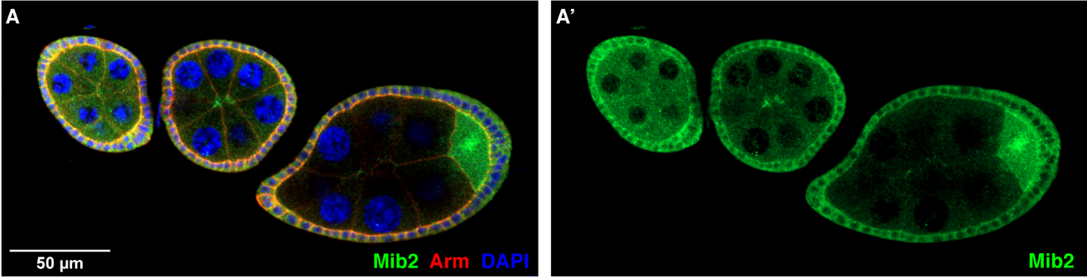

Fig. S1. Mib2 expression in early stage egg chambers. A) The wild-type egg chambers are fluorescently stained with antibodies directed against Mib2, shown in green (A’), and Arm, shown in red; nuclei are shown with DAPI staining in blue.
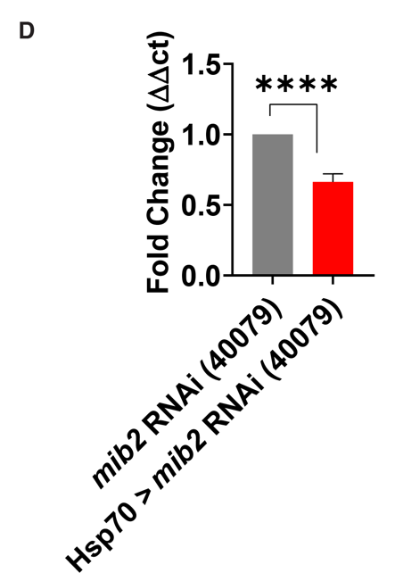
Fig. S2. Expression of tagged Mib2 and mib2 knockdown. A-C’’) The Mib2 tagged fly line egg chambers are fluorescently stained with antibodies directed against FLAG, shown in red (B), and GFP, shown in green (C); nuclei are shown with DAPI staining in blue. The (B’) and (C’) show the insets for the border cell cluster. D) The knockdown of mib2 RNAi (V40079) in anterior follicle cells is confirmed by significantly lower mib2 expression compared to the control measured by qRT-PCR analysis. Statistical analysis was performed using a t-test, **** represents p ≤ 0.0001.

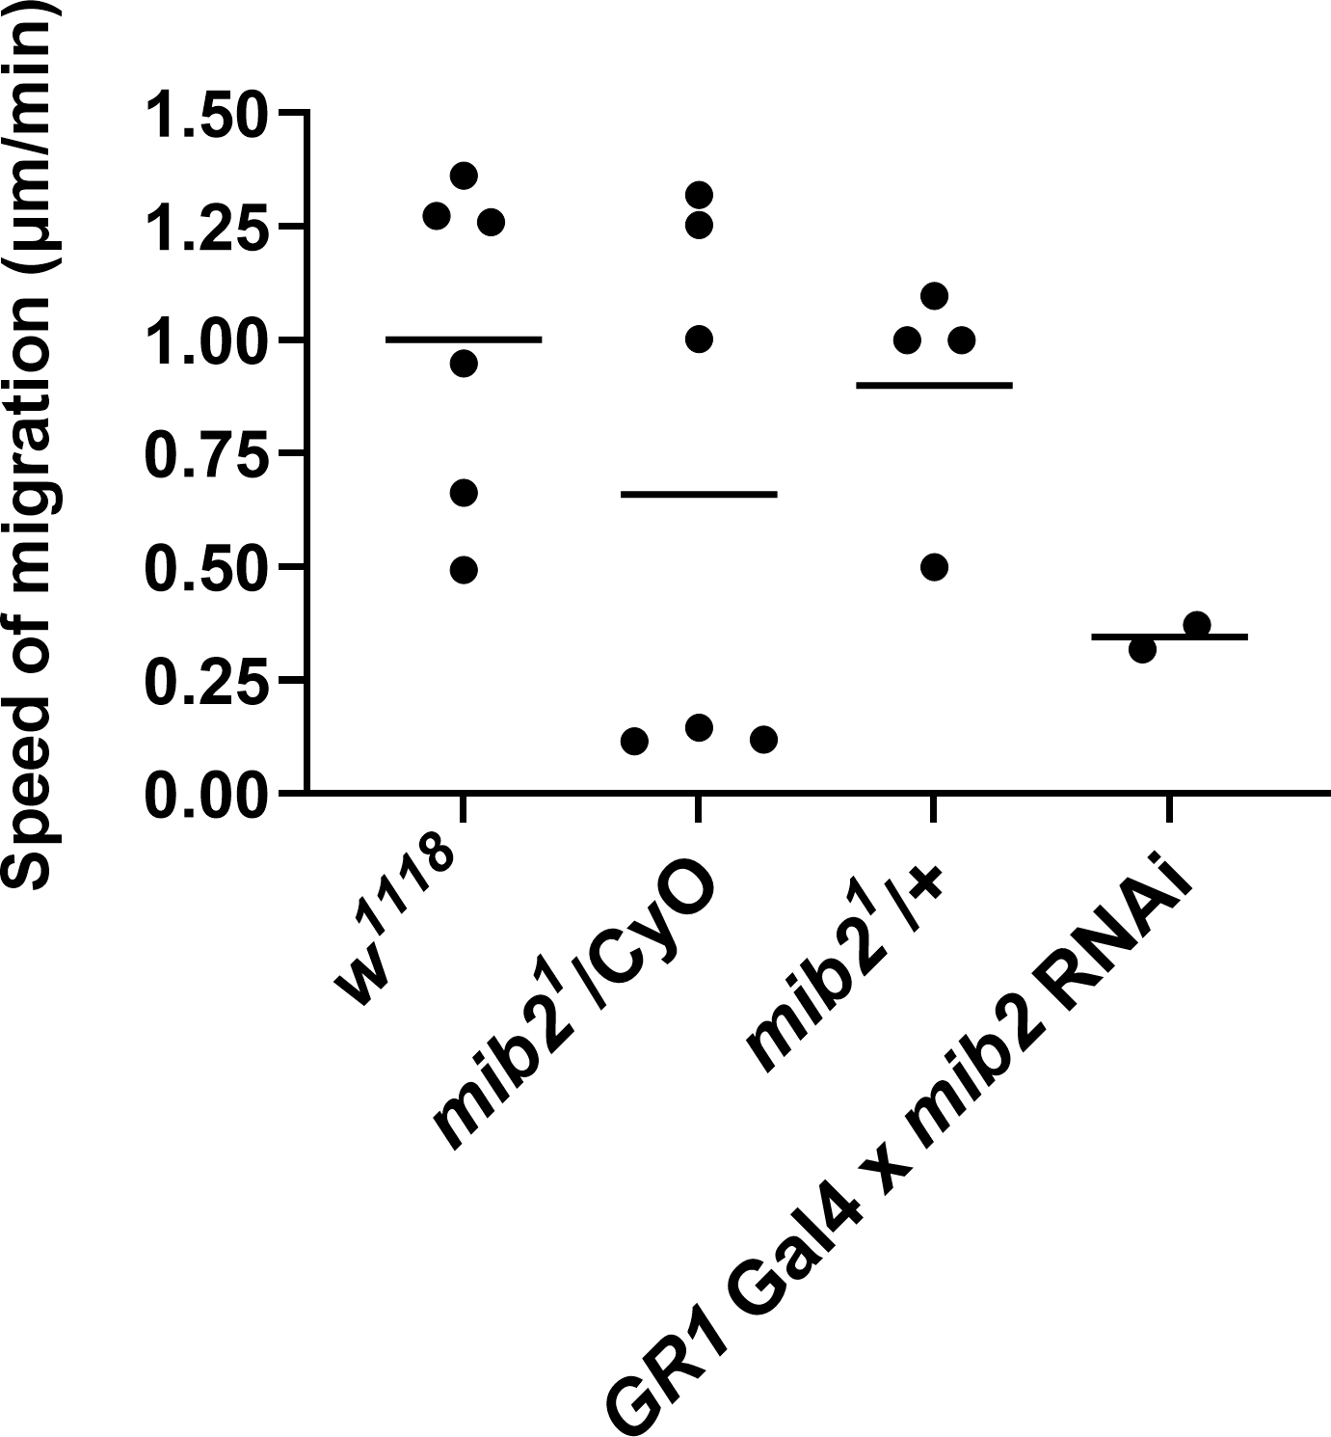
Fig. S3. Collective cell migration is slower in mib2¹ heterozygous mutants and when mib2 is disrupted by RNAi. The graph shows the border cell cluster velocity difference between control egg chambers (w¹¹¹⁸) and mib2¹ heterozygous egg chambers either in heterozygosis with a CyO balancer or +. Consistent with the analysis in fixed tissue (Figure 2B, F), only about half of mib2¹ heterozygous egg chambers show delays in migration at stage 9. In addition, GR1-Gal4 was used to knockdown mib2 in follicle cells, which also resulted in slower speeds and migration delays. See also supplementary videos 1 and 2.

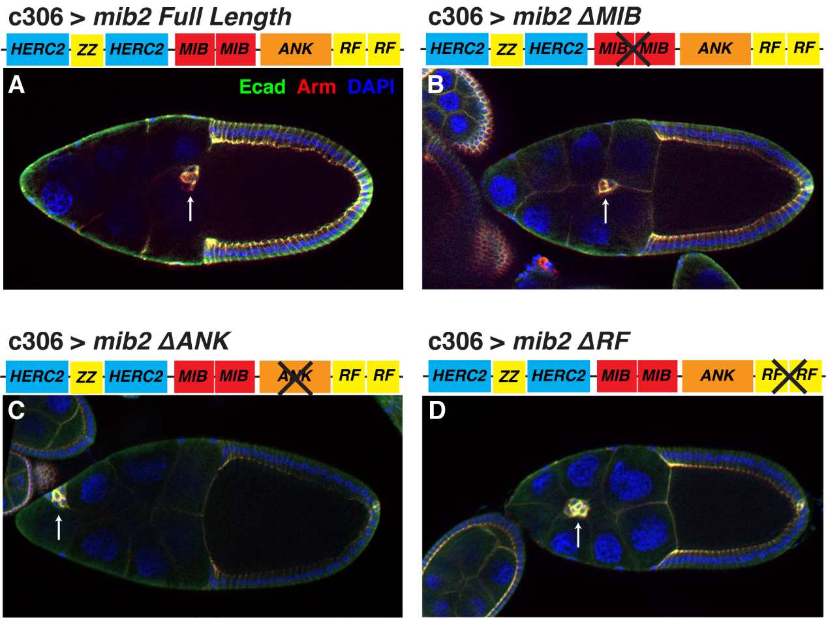

Fig. S4. The ANK, MIB, and RF domains of Mib2 are involved in border cell migration. A) Overexpression of mib2 shows no border cell migration defects evident by the cluster reaching the oocyte by stage 10. B, C, D) Expression of the domain deletions constructs mib2(∆MIB), mib2(∆ANK), or mib2(∆RF) results in significant migration defects in ~20%, ~18%, and ~32% of the stage 10 egg chambers, respectively. These defects may be due to dominant-negative effects of the remaining domains. Expression of full-length Mib2 or expression of constructs with ZZ, HERC2a, or HERC2b deleted did not disrupt border cell migration (see Fig. 2G).

Fig. S5. The Mib2 domain deletion proteins are expressed in border cells. All panels show stage 9 egg chambers stained with antibodies directed against Mib2 (green) and Hts (red), and the DNA dye DAPI; genotypes are indicated for each panel. c306 Gal4 drives expression in border cells. All insets are magnified views of the border cells. A) A control genotype shows endogenous Mib2 expression. B) Expression of Mib2 in border cells is reduced when mib2 RNAi is expressed with c306. C-H) Each transgene shows expression in border cells. The oocyte Mib2 expression should not be affected by the c306 Gal4, and can be used for reference.

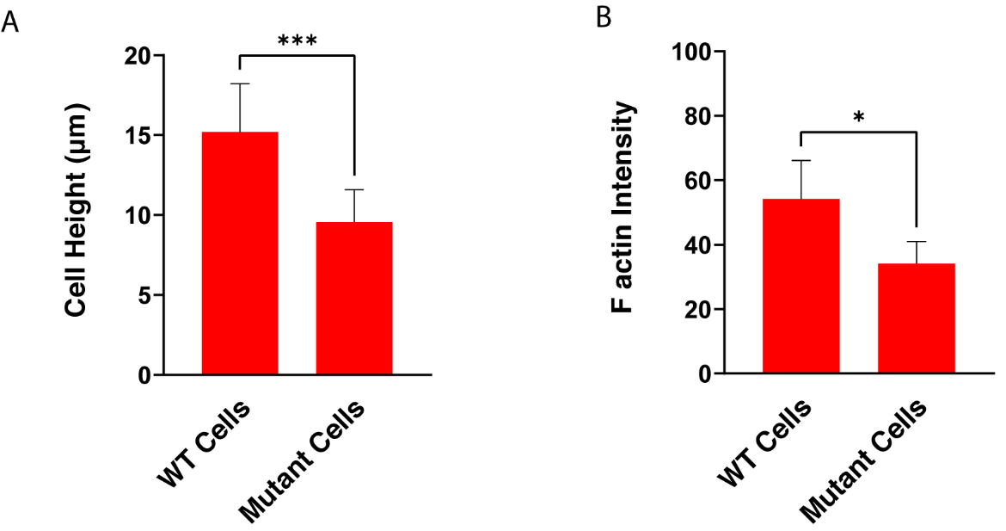
Fig. S6. mib2¹ homozygous mutant follicle cells are shorter and have lower cytoplasmic F-actin levels compared to neighboring wild-type cells. A) Cells clonally mutant for mib2¹ are significantly shorter compared to their neighboring wild-type cells (n = 27 cells) located at similar lateral regions near the oocyte at stage 10. B) The F-actin intensity is significantly lower than neighboring wild-type cells measured in arbitrary fluorescent units after fluorescent phalloidin staining (n = 4 egg chambers, images taken under the same exposure settings). Statistical analysis was performed using paired t-test, * is p< or equal to 0.0332 and *** is p<=0.0002.

Supplemental Movie Legends
Supplemental video 1. Live imaging of a control egg chamber (w¹¹¹⁸ / w¹¹¹⁸) with wild-type border cell migration. The cluster clearly migrates posteriorly towards the oocyte. Egg chambers were stained with the lipophilic fluorescent dye FM4-64 to visualize cell membranes in vivo (left panel, right panel is DIC), and images were acquired every 3 minutes. Anterior is to the left. Video is rendered at 15fps.
Supplemental video 2. Live imaging of a heterozygous mib2¹ /CyO mutant egg chamber with delayed migration. The cluster is motile but migrates more slowly towards the oocyte. (For quantification of speed, see Fig S3.) Egg chambers were stained with FM4-64 to visualize cell membranes in vivo (left panel, right panel is DIC), and images were acquired every 3 minutes. Anterior is to the left. Video is rendered at 15fps.

Table S1. Drosophila strains
w¹¹¹⁸ | BL3605 | (Levis et al., 1985)
Canton-S | BL64349 | (Lindsley & Grell, 1968)
c306 (Gal4 - anterior follicle cells) | BL3743 | (Manseau et al., 1997)
slbo-Gal4 (border cells) | BL6458 | (Rørth, 1998)
GR1 (GawB-Gal4 expression in follicle cells after stage 4) | BL36287 | (Tran and Berg, 2003, Gupta and Schüpbach, 2003, Queenan et al., 1997)
Hsp70-Gal4 | BL2077 | (Brand & Perrimon, 1993)
UAS-hopTum-l | BL8492 | (Harrison et al., 1995)
mCherry RNAi | BL35785 | Transgenic RNAi Project 2011
mib2 RNAi (1) | V40079 | (Dietzl et al., 2007)
mib2 RNAi (2) | V108947 | (Dietzl et al., 2007)
mib2¹/CyO | BL5387 | (Nguyen et al., 2007)
mib2⁴/CyO | BL3229 | (Nguyen et al., 2007)
αCatenin RNAi | BL38197 | (Ni et al, 2011)
UAS RhoGap19D | BL66167 | (Harris, Flybase communication 2016)
mhcl RNAi (1) | BL51456 | (Ni et al, 2011)
mhcl RNAi (2) | BL62973 | (Ni et al, 2011)
svil RNAi | BL 28914 | (Ni et al, 2011)
Stat92E RNAi | BL31317 | (Ni et al, 2011)
shg²/CyO | BL3085 | (Tepass et al, 1996)
Tagged Mib2 | V318178 | (Sarov et al., 2016)
Tagged ImpL2 | BL59778 | (Nagarkar-Jaiswal et al., 2015)
UAS-mib2^{FL} | Gift from Reim Lab | (Domsch et al., 2017)
UAS-mib2^{ΔHERC2A+ZZ} | Gift from Reim Lab | (Domsch et al., 2017)
UAS-mib2^{ΔZZ} | Gift from Reim Lab | (Domsch et al., 2017)
UAS-mib2^{ΔHERC2B} | Gift from Reim Lab | (Domsch et al., 2017)
UAS-mib2^{ΔMIB} | Gift from Reim Lab | (Domsch et al., 2017)
UAS-mib2^{ΔANK} | Gift from Reim Lab | (Domsch et al., 2017)
UAS-mib2^{ΔN-termANK} | Gift from Reim Lab | (Domsch et al., 2017)

Table S2. Antibody and stain list.
Primary Antibodies:
mouse anti-Armadillo (Arm) | 1:40 immunofluorescence, 1:500 Western blot (N2 7A1, DSHB)
mouse anti-E cadherin (Ecad) | 1:25 immunofluorescence, 1:500 Western blot (DCAD2, DSHB)
Rabbit anti-GFP | 1:500 (A-1112)
Guinea pig anti-Mind bomb2 (Mib2) | 1:150 (gift from Gomez Lab)
mouse anti-Discs large (Dlg) | 1:100 (4F3, DSHB)
Anti-Qua antibody | 1:50 (6B9, DSHB)
Anti-catenin alpha | 1:50 (DCAT1, DSHB)
Anti-Hts | 1:50 (1B1, DSHB)
Anti-spectrin-alpha | 1:50 (3A9, DSHB)
Mouse anti-FLAG | 1:1000 (F1804, Sigma)
Secondary antibodies:
Alexa Fluor 488 (Goat anti Rabbit) | 1:400 (A-11008, ThermoFisher)
Alexa Fluor 488 (Goat anti Rat) | 1:400 (A-11006, ThermoFisher)
Alexa Fluor 568 (Donkey anti Mouse) | 1:400 (A-11037, ThermoFisher)
Alexa Fluor 488 (Goat anti Guinea pig) | 1:400 (A-11073, ThermoFisher)
Horse Radish Peroxidase (anti Rat) | 1:10,000 (31470, ThermoFisher)
Horse Radish Peroxidase (anti Mouse) | 1:10,000 (A-16011, ThermoFisher)
Stains:
DAPI | 1:1000 (D1306, ThermoFisher)
Phalloidin | 1:500 (A12380, ThermoFisher)
FM4-64 | 5µg/ml (ThermoFisher)

Table S3. Primers
Target | F | R
rp49 | GTGAAGAAGCGCACCAAGCAC | ACGCACTCTGTTGTCGATACCC
mib2 | TACACCGCATCACGGACAAG | TTGCCGCCACTCATCACATC
mib2 | CGCCAGAAAACACTGTCGTG | GACGAACTCCAACTTGAGCATTA

Supplemental Table 4 (Excel file)
Extended list of all significant interacting proteins identified in Mib2-immunoprecipitation-mass spectroscopy analysis, sorted by GO terms.
This table shows all proteins identified by association with Mib2 at a higher level than either ImpL2 or Canton-S controls. Column information: ID is Uniprot ID; respective peptide counts; % difference in peptide counts; and associated GO terms. Sets of genes are grouped according to similarities in GO classification, which is listed at the top of each set in the ID column. For simplification, isoforms or peptides from the same gene are only listed once.

Supplementary references:
Brand, A.H., Perrimon, N. (1993). Targeted gene expression as a means of altering cell fates and generating dominant phenotypes. Development. 118(2) 401-15.
Dietzl, G., Chen, D., Schnorrer, F., Su, K.-C., Barinova, Y., Fellner, M., Gasser, B., Kinsey, K., Oppel, S., Scheiblauer, S., Couto, A., Marra, V., Keleman, K., & Dickson, B. J. (2007). A genome-wide transgenic RNAi library for conditional gene inactivation in Drosophila. Nature. 448(7150), 151–156. https://doi.org/10.1038/nature05954
Domsch, K., Acs, A., Obermeier, C., Nguyen, H. T., & Reim, I. (2017). Identification of the essential protein domains for Mib2 function during the development of the Drosophila larval musculature and adult flight muscles. PLoS ONE. 12(3), e0173733. https://doi.org/10.1371/journal.pone.0173733
Gupta, T., Schupbach, T. (2003). Cct1, a phosphatidylcholine biosynthesis enzyme, is required for Drosophila oogenesis and ovarian morphogenesis. Development. 130(24): 6075-6087.
Harrison, D.A., Binari, R., Nahreini, T.S., Gilman, M., Perrimon, N. (1995). Activation of a Drosophila Janus kinase (JAK) causes hematopoietic neoplasia and developmental defects. EMBO J. 14(12): 2857-2865.
Levis, R.W., Hazelrigg, T., Rubin, G.M. (1985). Effects of genomic position on the expression of transduced copies of the white gene of Drosophila. Science 229: 558-561.
Lindsley, D.L., Grell, E.H. (1968). Genetic variations of Drosophila melanogaster. Publs Carnegie Instn 627: 469.
Manseau, L., Baradaran, A., Brower, D., Budhu, A., Elefant, F., Phan, H., Philp, A. v, Yang, M., Glover, D., & Kaiser, K. (1997). GAL4 enhancer traps expressed in the embryo, larval brain, imaginal discs, and ovary of Drosophila. Dev Dyn. 209. https://doi.org/3.0.CO;2-L
Nagarkar-Jaiswal, S., Lee, P.T., Campbell, M.E., Chen, K., Anguiano-Zarate, S., Cantu Gutierrez, M., Busby, T., Lin, W.W., He, Y., Schulze, K.L., Booth, B.W., Evans-Holm, M., Venken, K.J., Levis, R.W., Spradling, A.C., Hoskins, R.A., Bellen, H.J. (2015). A library of MiMICs allows tagging of genes and reversible, spatial and temporal knockdown of proteins in Drosophila. eLife. 4: e05338.
Nguyen, H. T., Voza, F., Ezzeddine, N., & Frasch, M. (2007). Drosophila mind bomb2 is required for maintaining muscle integrity and survival. The Journal of Cell Biology. 179(2), 219–227. https://doi.org/10.1083/jcb.200708135
Ni, J.Q., Zhou, R., Czech, B., Liu, L.P., Holderbaum, L., Yang-Zhou, D., Shim, H.S., Tao, R., Handler, D., Karpowicz, P., Binari, R., Booker, M., Brennecke, J., Perkins, L.A., Hannon, G.J., Perrimon, N. (2011). A genome-scale shRNA resource for transgenic RNAi in Drosophila, Nat Methods. 8(5) 405-7.10.1038/nmeth.1592
Queenan, A.M., Ghabrial, A., Schupbach, T. (1997). Ectopic activation of torpedo/Egfr, a Drosophila receptor tyrosine kinase, dorsalizes both the eggshell and the embryo. Development. 124(19): 3871-3880.
Rorth, P., Szabo, K., Bailey, A., Laverty, T., Rehm, J., Rubin, G., Weigmann, K., Milan, M., Benes, V., Ansorge, W., Cohen, S. (1998). Systematic gain-of-function genetics in Drosophila. Development. 125(6): 1049-1057.
Sarov, M., Barz, C., Jambor, H., Hein, M. Y., Schmied, C., Suchold, D., Stender, B., Janosch, S., KJ, V. V., Krishnan, R., Krishnamoorthy, A., Ferreira, I. R., Ejsmont, R. K., Finkl, K., Hasse, S., Kämpfer, P., Plewka, N., Vinis, E., Schloissnig, S., Knust, E., Hartenstein, V., Mann, M., Ramaswami, M., VigayRaghavan, K., Tomancak, P., Schnorrer, F. (2016). A genome-wide resource for the analysis of protein localisation in Drosophila. eLife. 5. https://doi.org/10.7554/eLife.12068
Tepass, U., Gruszynski-DeFeo, E., Haag, T.A., Omatyar, L., Torok, T., Hartenstein, V. (1996). shotgun encodes Drosophila E-cadherin and is preferentially required during cell rearrangement in the neurectoderm and other morphogenetically active epithelia. Genes Dev. 10(6) 672-85
Tran, D.H., Berg, C.A. (2003). bullwinkle and shark regulate dorsal-appendage morphogenesis in Drosophila oogenesis. Development. 130(25): 6273-6282.

