Supplementary Information for

A systems-level analysis highlights microglial activation as a modifying factor in common epilepsies

Andre Altmann†, Mina Ryten†, Martina Di Nunzio†, Teresa Ravizza, Daniele Tolomeo, Regina H Reynolds, Alyma Somani, Marco Bacigaluppi, Valentina Iori, Edoardo Micotti, Rossella Di Sapia, Milica Cerovic, Eleonora Palma, Gabriele Ruffolo, Juan A. Botía, Julie Absil, Saud Alhusaini, Marina K. M. Alvim, Pia Auvinen, Nuria Bargallo, Emanuele Bartolini, Benjamin Bender, Felipe P. G. Bergo, Tauana Bernardes, Andrea Bernasconi, Neda Bernasconi, Boris C. Bernhardt, Karen Blackmon, Barbara Braga, Maria Eugenia Caligiuri, Anna Calvo, Chad Carlson, Sarah J. Carr, Gianpiero L. Cavalleri, Fernando Cendes, Jian Chen, Shuai Chen, Andrea Cherubini, Luis Concha, Philippe David, Norman Delanty, Chantal Depondt, Orrin Devinsky, Colin P. Doherty, Martin Domin, Niels K. Focke, Sonya Foley, Wendy Franca, Antonio Gambardella, Renzo Guerrini, Khalid Hamandi, Derrek P. Hibar, Dmitry Isaev, Graeme D. Jackson, Neda Jahanshad, Reetta Kalviainen, Simon S. Keller, Peter Kochunov, Raviteja Kotikalapudi, Magdalena A. Kowalczyk, Ruben Kuzniecky, Patrick Kwan, Angelo Labate, Soenke Langner, Matteo Lenge, Min Liu, Pascal Martin, Mario Mascalchi, Stefano Meletti, Marcia E. Morita-Sherman, Terence J. O'Brien, Jose C. Pariente, Mark P. Richardson, Raul Rodriguez-Cruces, Christian Rummel, Taavi Saavalainen, Mira K. Semmelroch, Mariasavina Severino, Pasquale Striano, Thomas Thesen, Rhys H. Thomas, Manuela Tondelli, Domenico Tortora, Anna Elisabetta Vaudano, Lucy Vivash, Felix von Podewils, Jan Wagner, Bernd Weber, Roland Wiest, Clarissa L. Yasuda, Guohao Zhang, Junsong Zhang, ENIGMA-Epilepsy Working Group, Costin Leu, Andreja Avbersek, EpiPGX Consortium, Maria Thom, Christopher D Whelan, Paul Thompson, Carrie R McDonald, Annamaria Vezzani*, Sanjay M Sisodiya*

Sanjay M Sisodiya
Email: s.sisodiya@ucl.ac.uk

Annamaria Vezzani
Email: annamaria.vezzani@marionegri.it

This PDF file includes:

Supplementary text
Figs. S1 to S15
Tables S1 to S3
Captions for datasets S1 to S6
References for SI reference citations

Other supplementary materials for this manuscript include the following:

Datasets S1 to S6

Supplementary Information Text

Detailed Materials and Methods

Section A: In silico histology

Allen Institute for Brain Science brain-wide gene expression data
We used brain microarray gene expression data generated by the Allen Institute for Brain Science (downloaded from http://human.brain-map.org/) referred to as Allen Human Brain Atlas (AHBA). This included a total of 3,702 samples from six post mortem donors (one female) covering the cortex, cerebellum and subcortical regions [1,2]. Each sample comprises 58,692 gene probes and provides coordinates in MNI (Montreal Neurological Institute)-152 space. The gene expression data were normalized and corrected for batch effects by the Allen Institute [3]. Due to markedly different gene expression profiles in cortex, cerebellum and subcortical regions, we restricted our analysis to cortical samples.

Mapping AHBA samples onto the FreeSurfer parcellation from ENIGMA-Epilepsy
The ENIGMA-Epilepsy results were reported for regions of interest (ROI) based on the Desikan-Killiany (DK) atlas [4]. In order to link DK ROIs to AHBA samples, we first registered the FreeSurfer average (FSA) subject to MNI152 space using non-rigid registration based on fast free form deformation implemented in NiftyReg (version 10.4.15) [5]. Next, the estimated transformation was applied to the cortical and subcortical parcellation of the FSA subject using nearest-neighbour interpolation to obtain the MNI coordinates for the parcellation. AHBA samples were mapped to the closest grey-matter FreeSurfer ROI. To this end updated MNI coordinates for the AHBA samples, obtained from https://github.com/chrisgorgo/alleninf/tree/master/alleninf/data, were used instead of the original coordinates provided by the Allen Institute. Samples were excluded if they were not a designated cortical sample (slab_type=’CX’; N= 954), if they were not mapped to a cortical FreeSurfer ROI (N= 931) or if the closest ROI was more than 4 mm away (N=90), thus leaving 1727 expression samples. Next, samples with a regional non-cortical label (e.g., CA1 field, CA2 field, …) as provided by the AHBA were excluded as well (N=99) leaving a total of 1628 samples. For the main analysis we retained only samples in the left hemisphere as these were available in all six donors. Thus, 1227 samples were mapped to one of the 34 cortical grey matter structures in the left hemisphere of the DK atlas used in the cortical thickness imaging analysis conducted by ENIGMA-Epilepsy [6].

AHBA gene expression data preprocessing
Each of the 1,227 AHBA gene expression samples comprised 58,692 probe signals. As part of the internal quality control pipeline, the AHBA probes were re-annotated with recent gene information using ReAnnotator [7]. Probes that were (i) not annotated using ReAnnotator, (ii) not mapped to any gene, (iii) mapped to intergenic regions or (iv) mapped to multiple genes, were excluded from further analysis. The reduced set comprised 49,113 probes, which each uniquely map to a single gene. Next we followed the protocol described by Miller et al. [8] to select one probe per gene using RNAseq data from a subset of the AHBA samples. Briefly, 45,147 probes could be linked to genes listed in the RNAseq dataset; 28,727 probes showed a sufficiently good correlation (Pearson’s r > 0 [i.e., positively correlated] and FDR-corrected p-value < 0.1). Next, among multiple probes capturing the same gene, the one with the strongest correlation to the RNAseq dataset was selected, resulting in 14,138 probes uniquely representing one gene. Finally, we used the re-scaling approach described in Miller et al. [8] to convert microarray intensities into Sequencing Scaled Microarray Intensities (SSMIs) that are better suited as input for the deconvolution method.

Deconvolution of AHBA gene expression data into brain cell-types
We employed Scaden [9], a recently developed method based on deep learning, to deconvolve the microarray gene expression data into brain cell type fractions. To this end, Scaden was trained with published human brain single cell RNAseq data [10,11] using 2000 artificially generated bulk RNAseq samples per dataset as described [9]. The final network used for the deconvolution of AHBA samples was trained for 5000 steps following the recommendations [9]. This setup allowed deconvolution of a given AHBA sample into fractions of seven brain-cell types (Astrocytes, Endothelial, ExNeurons, InNeurons, Microglia, Oligodendrocytes, OPC) and Unknown. The deep learning-based architecture of Scaden theoretically affords the deconvolution of microarray data. To verify this, we first compared the agreement per cell type based on 92 of our cortical samples where SSMI and RNAseq data were available. The Spearman rank correlation ranged from 0.64 to 0.97 (see Fig. S13). Furthermore, on the entire set of 1227 we compared the Scaden-estimated cell type fractions to the expression of cell-specific marker genes and found very good agreement for most cell types (see Fig. S14). Thus, supporting the reliability of microarray-inferred cell type fractions using Scaden.

AHBA cell type and gene expression statistical analysis
We aimed to investigate in the six ΑΗΒΑ subjects (who did not suffer from epilepsy) which cell types show different fractions in regions with reduced cortical thickness compared to regions with normal cortical thickness from the ENIGMA-Epilepsy data. Each of the 68 ROIs was labelled as either of reduced thickness or not, based on the corresponding P-value in the ‘all epilepsies’ analysis of ENIGMA-Epilepsy [6]. We adopted the Bonferroni-corrected threshold of P=1.47x10⁻⁴ [for 340 tests, 68 cortical ROIs in five analyses conducted in ENIGMA-Epilepsy [6]. Eighteen of 68 ROIs exhibited significantly reduced cortical thickness (Supplementary Table 15 in Whelan et al. [6]; reproduced here as Table S1). Given that due to the makeup of the AHBA data only the left hemisphere was considered, eight of 34 regions were considered affected, or ‘vulnerable’, whilst the others were considered unaffected, or ‘relatively protected’ (Left column in Table S1). Next, for each of the seven cell types, we tested for a significant effect of the vulnerability status (8 vulnerable compared to 26 relatively protected) on the regional estimated fractions using a linear mixed effects model [lmer function implemented in the R-package lme4 [12]] with the donor’s ID (i.e., from the six individuals in AHBA) as a random effect and thickness status as the fixed effect. The resulting P-values were FDR corrected [13]. Furthermore, we conducted a permutation test in addition to calculating the analytical p-value. In brief, for 1000 permutations, we randomly assigned 8 of the 34 regions to be vulnerable and repeated the analysis. The permutation P-value was based on the number of runs yielding a t-value of equal or larger value (in the same direction) as the original t-value. Next, in order to verify the associations with a given cell type and also to investigate further gene expression differences in vulnerable compared to relatively protected regions, for each of the 14,138 genes we tested for the effect of the regional vulnerability status on the gene expression level using the same linear mixed effects model as above. This process produced a ranked gene list where genes with large positive t-values showed higher expression in vulnerable regions and genes with large negative t-values showed higher expression in relatively protected regions. The resulting P-values were FDR corrected and genes with P_{FDR}<0.05 were considered to be differentially expressed. Both analyses were repeated using 1628 samples in both hemispheres with vulnerable ROIs defined as in Table S1 (i.e., 18 of 68 ROIs were considered vulnerable; 10 in the right hemisphere and 8 in the left hemisphere). The results were qualitatively similar to the analysis conducted only on the left hemisphere (Table S2 and Fig. S15).

Gene set enrichment analysis to identify cell types of interest
To verify the results of the cell type fraction analysis we tested for enrichment of cell type marker genes in the ranked gene list produced by the differential expression analysis. The FDR P-value threshold for significant expression, although widely applied, is rather arbitrary and, in this analysis, led to a very long list of significantly differentially expressed genes (5,405 of 14,138). Thus, we employed a threshold-free enrichment test based on the area under the Receiver Operating Characteristics (ROC) curve (AUC) to conduct the enrichment analysis [14,15]. In brief, this approach tests whether genes belonging to a given list (e.g., a pathway, GO term or cell type marker genes) accumulate at either end of the ranked gene list produced by the differential expression analysis. An AUC of 0.5 signifies no enrichment, whereas AUC values closer to 1.0 signify positive enrichment (in our context, equating to higher expression in vulnerable regions) and AUC values closer to 0.0 indicate a negative enrichment (equating to lower expression in vulnerable regions). A P-value for this test is based on the Wilcoxon-Mann-Whitney U-Statistic [16]. P-values were FDR corrected: gene sets with P_{FDR}<0.05 were considered significantly enriched.
To specifically verify the cell type fraction result, we collated lists of genes whose expression is enriched in specific brain cell types. These lists were based on the analysis of RNA-sequencing data from purified cells isolated from mouse and human cerebral cortex and covered astrocytes, neurons, oligodendrocyte precursors, newly-formed oligodendrocytes, myelinating oligodendrocytes, microglia and endothelial cells [17–19] (Dataset S5). Mouse gene names were converted to their human orthologues using the R package homologene [20].

Gene set enrichment analysis to identify cellular processes or pathways of interest
To identify cellular processes or pathways that may be enriched in the ranked gene list, we conducted an enrichment analysis using the same AUC-based test. We used the following gene sets and gene ontologies from the MSigDB database version 7.1 [21] (date accessed 07/11/2020): KEGG (N=185 pathways), REACTOME (N=1531 pathways) and Gene Ontology (N=6,544 ontologies). For GO we considered only terms featuring between 10 and 250 genes.
Furthermore, we collated, and in some cases generated, gene lists designed to capture distinct, but potentially overlapping, microglial states (N=15, Fig. S1, Dataset S6): age/neurodegeneration- and LPS-induced responses from mouse models in Holtman et al. [22]; healthy brain-region-specific mouse microglial modules from Grabert et al. [23]; homeostatic, early and late response signatures derived from a mouse model of neurodegeneration from Mathys et al. [24]; activation/de-activation mouse signatures from NeuroExpresso [25]; module 18, a microglial module driven by Csf1r and found to be significantly positively correlated with seizure frequency in a chronic epileptic mouse model [26]; and, finally, inferred microglia states from co-expression network analyses of bulk human RNA sequencing data. In the case of the latter, we used published network-based expression signatures [23,24] and generated our own signatures using gene expression data derived from human brain, provided by GTEx [27] following a previously established pipeline [28,29] (details in subsequent section). Gene overlaps between the gene lists were determined using GeneOverlap (https://github.com/shenlab-sinai/geneoverlap).
For all microglia lists, we used the AUC-based enrichment analysis to compute the P-value and P-values were FDR corrected: gene sets with P_{FDR}<0.05 were considered significantly enriched.

Construction of a consensus co-expression network and related modules
A consensus co-expression network, incorporating data covering all available 13 brain regions, was constructed using GTEx V6 gene expression. The raw FPKM (Fragments Per Kilobase of transcript per Million mapped reads) values were corrected for known batch effects, age at death, sex and post-mortem interval, as well as unknown effects. The unknown effects were detected with Surrogate Variable Analysis (SVA) R Package [30] and correction was performed using ComBat [31]. The resulting residuals were used to create a signed network using the blockwiseConsensusModules R function from the WGCNA R package [32]. Next, the clusters or modules obtained in this network were assigned to cell types using the userListEnrichment R function implemented in the WGCNA R package, which measures enrichment between module-assigned genes and defined brain-related lists [33–37] using a hypergeometric test. Among the 18 modules produced by WGCNA, we identified only two modules significantly enriched for microglial markers. The genes assigned to each of these modules with a module membership of ≥0.5 were allocated to a gene set, thus resulting in two separate sets for microglia.

Section B: EpiPGX GWAS analyses

Cohorts and phenotype definition. People with epilepsy were recruited within the EpiPGX consortium (www.epipgx.eu) from clinical centers in the UK, Ireland, Belgium, the Netherlands, Germany, and Italy. Patients were classified as resistant to treatment if they had seizures recurring at a frequency of ≥4 per year, over the year preceding the latest data entry, despite adequate trials of ≥2 tolerated and appropriately chosen anti-epileptic drugs, whether as monotherapies or in combination. Treatment response was defined as freedom from seizures for ≥12 months up to the latest recorded visit.

Genotyping and imputation. Genotyping was performed at deCODE Genetics using Illumina OmniExpress SNP arrays (Illumina OmniExpress-12 v1.1, Illumina OmniExpress-24 v1.1, Illumina Human610-Quad, Illumina HumanHap550v3). BeadStudio (Illumina; version 2.0) was used to call genotypes. STRUCTURE v2.2, with HapMap European (CEU) samples as the reference population, was used to derive European ancestry probabilities, based on genotypes for 2,766 ethnicity-sensitive SNPs common to all SNP arrays. Subjects with less than 90% European ancestry in all cohorts were excluded. Additional individual-level quality were performed using PLINK 1.9 [38]. First, we removed all samples with <0.98 call rate (CR) for all SNPs. Next, using a subset of uncorrelated SNPs (r²<0.1 in a sliding window of 100 SNPs per window and shifting the window by 25 SNPs each time), we calculated heterozygosity (HET), identity by state (IBS) and gender, and removed: a) HET outliers with >5 standard deviations (SD) from the median of the whole sample; ii) one individual from each pair of closely related individuals with >0.9 IBS; iii) all samples where sex determined from genotype did not match with the reported gender. SNP-level, pre-imputation quality controls were performed using PLINK 1.9 and custom scripts. Array-specific maps, retrieved at the website of Will Rayner at the Wellcome Trust (http://www.well.ox.ac.uk/~wrayner/strand/), were used to update all marker positions to the Genome Reference Consortium Human Build 37 (GRCh37). Ambiguous A/T and C/G markers were removed to avoid strand issues. Finally, we removed all SNPs with <0.95 genotype rate, <0.01 minor allele frequency (MAF), or deviation from Hardy-Weinberg equilibrium (with P<1x10⁻⁶) in samples from any site. We then split genotypes up according to chromosome arms (and in the case of chromosome X we split additionally into pseudo-autosomal regions (PAR) and non-PAR) and created phased haplotypes using SHAPEIT v215 [39] with recommended effective size setting (11,418), and using the 1000 Genomes phase 1 integrated (v3) map files as reference. Following haplotype phasing, we imputed genotypes into our dataset using IMPUTE version 2.3.016,17 [40] with recommended effective population size settings (20,000) and 1000 Genomes phase 1 integrated (v3) genotypes as reference [41]. The haplotype phasing and imputation was performed in separate batches for each of the genotyping datasets.

Post-imputation quality control and GWAS. Post-imputation quality control filters were applied first separately for every imputation cohort to remove genotyped variants with low concordance between observed genotype and masked, imputed genotype (IMPUTE2 r2_type0 score <0.90, concordance_type0 <0.90). We then performed further quality controls on the merged datasets for cases and controls separately, removing variants based on following criteria: i) SNPtest [42] info score <0.97; ii) SNPtest average_maximum_posterior_call <0.90; iii) MAF <0.01; iv) deviation from Hardy-Weinberg equilibrium (with P<1x10⁻⁶) in controls only. At individual level, we removed duplicate samples across datasets (same parameter as in the pre-imputation step) and population outliers, as identified by principal component analysis. Finally, genome-wide association analyses were performed using a linear mixed-model as implemented in FaST-LMM v2.07 [43]. We used a subset of uncorrelated SNPs (r²<0.4 in a sliding window of 150 SNPs per window and shifting the window by 10 SNPs each time) with high call rate (CR>0.99%), out of all quality filtered SNPs, to generate the relationship matrix for every pair of individuals, which is used by the linear mixed model to correct for population structure.

GWAS results. Over 12,500 individuals with epilepsy were recruited within the EpiPGX consortium. Sufficiently detailed drug response information was available for 4,876 individuals. After the review of the phenotypic data, SNP genotyping and imputation, 4,135 epilepsy cases (2,489 drug-resistant epilepsy and 1,645 with drug-responsive epilepsy) and 10,695 healthy controls were available for inclusion in the treatment response GWAS. After application of QC criteria, we included a total of 4,049 epilepsy cases (2,423 with drug-resistant epilepsy and 1,626 with drug-responsive epilepsy) and 10,645 healthy controls in the association analysis. After application of marker QC, 5,952,081 SNPs remained in the association analysis. Summary statistics are at http://www.epigad.org.

Partitioned heritability analysis for investigation of loci potentially involved in immune regulation in epilepsy
Enrichment of marker genes for specific brain processes or cells in vulnerable regions (i.e., with reduced thickness) in the epilepsies may indicate a causative role of these processes or cell types in the structural differences found on MRI. We hypothesized that this causality would also manifest in the subjects’ genetic sequence. GWAS summary statistics were obtained for susceptibility to epilepsy [44] as well as treatment response in epilepsy (from the EpiPGX Consortium, as above). Stratified LD score regression, a method for partitioning heritability across functional genomic annotations, was used to test for enrichment of susceptibility to epilepsy and treatment response, within immune-relevant annotations focusing on state-specific monocyte eQTL data [45]. Annotations were added individually to the ‘baseline’ model of 53 annotations provided by Finucane et al. [46], which comprises 24 different genome-wide annotations reflecting genetic architecture, such as conserved regions and histone marks. HapMap Project Phase 3 SNPs and 1000 Genome Project European population SNPs were used for the regression and LD reference panel, respectively. Only SNPs with minor allele frequency >5% were used for heritability partitioning. The HLA region was excluded. We report the regression coefficient P-value, which tests whether a given form of annotation contributes significantly positively to SNP heritability (i.e., is enriched) after controlling for the effects of the ‘baseline’ model.

Section C: Immunostaining of microglia in human brain tissue

Distribution of microglia in human brain tissue
Formalin-fixed paraffin-embedded tissue blocks were selected from 55 post mortem (PM) cases in the archives of UCL Epilepsy Society Brain and Tissue Bank, Epilepsy Research UK Corsellis Brain Collection and MRC Sudden Death Brain Bank (collected between 1978-2017; median 2015); the PM intervals and fixation times were noted. The project has ethical approval (under NRES 17/SC/0573) and cases had research consent, compliant with the UK Human Tissue Act 2014. The cases comprised three groups: (i) Epilepsy-non lesional (EP-NL, n=18), including cases with idiopathic generalised epilepsy, Dravet Syndrome and cases without a known genetic or syndrome classification but no identified symptomatic cause on detailed post mortem evaluation; (ii) Epilepsy-Lesional (EP-L, n=21), including cases with mesial temporal lobe epilepsy with hippocampal sclerosis (unilateral or bilateral), epilepsy due to malformations of cortical development or perinatal infarct, and post-traumatic epilepsy and (iii) non-epilepsy controls (NEC, n=16). The mean age of death was 47 years in the patients and 51 years in controls; 66% in each group were male. The mean age of onset and duration of epilepsy was 8.2 and 35 years respectively in EP-NL and 13 years and 42 years in EP-L.
A maximum of 14 regions of interest (ROI) were selected from each case from both hemispheres where available (Fig. 2; Fig. S16), as follows: ROI 1 medial perirhinal/transentorhinal cortex in parahippocampal gyrus (BA35); ROI 2 temporal pole (BA38); ROI 3 superior to middle temporal gyrus (BA21/22); ROI 4 insula (BA13/14); ROI 5 anterior cingulate cortex (BA24); ROI 6 parietal cortex (BA5/7); ROI 7 occipital cortex (BA17); ROI 8 anterior frontal cortex F1/F2 (BA6/8); ROI 9 medial thalamus; ROI 10 lateral thalamus; ROI 11 medial pulvinar; ROI 12 lateral pulvinar; ROI 13 fronto-basal cortex (BA10/12); and ROI 14 middle/inferior temporal gyrus (BA20/21). Sections were cut at 5 micron thickness from each block, immunostained with microglial marker Iba1 (1:250; Wako, 4 hour incubation, with swine anti-rabbit secondary, Dako E0353) on the Ventana Discovery XT instrument, using the Ventana DAB Map detection Kit (760-124). For pre-treatment, Ventana CC1 (950-124), equivalent to EDTA buffer, was used for 40 minutes. Slides were haematoxylin counterstained.

ROI selection. Immunostained slides were scanned with a Leica SCN400F digital slide scanner (Leica Microsystems, Wetzlar, Germany) at 40X magnification and ROI selection was carried out with Definiens Tissue Studio (Definiens AG Munich, Germany). The ROI was drawn at the midpoint of the gyrus 2.5mm along the pial surface to a depth of 2mm including only grey matter (Fig. S9). Equivalent area ROI were selected in lateral and medial thalamus and pulvinar. ROI selection was saved on each case.

Thresholding. Definiens software was trained to automatically detect immunostained structures corresponding to (i) nuclei (haematoxylin, blue) or (ii) cell body and dendrites (Iba1, brown; Fig. S10A). Prior to the final analysis, a set of image analysis algorithms (“solutions”) with specific parameters were tested and optimised on Definiens Tissue Studio in a pilot study. This fixed threshold was then applied to each ROI to identify the chromogen positive areas, which was then represented as a percentage of the total tissue/ROI area. DAB staining was detected and classified into high, medium and low as shown for Iba1 staining (Fig. S10B). High intensity labelling was considered representative of positive labelling and selected for analysis. Separate thresholds were set for haematoxylin staining, which allowed identification and exclusion of nuclei. Artefacts (e.g., breaks in the section) were excluded from the analysis. The total area of staining was then evaluated and expressed as a percentage of the whole region of interest stained for analysis.

Section D: Murine model of epilepsy

Microglial manipulation in an experimental murine model of epilepsy
Animal model of epilepsy. We used a well-established murine model of epilepsy induced by convulsive status epilepticus (SE) provoked by intra-amygdalar injection of kainic acid in C57/BL6N adult male mice (30 g; Charles River, Italy) (Frigerio et al.,2018; Jimenez-Mateos et al., 2012; Gu et al., 2015; Iori et al., 2017) to explore the importance of microglia in brain structural changes and pathologic outcomes developing in mice exposed to SE-induced epileptogenesis.
In accordance with the ARRIVE guidelines, procedures involving animals and their care were conducted in conformity with the institutional guidelines that are in compliance with national (D.L. n.26, G.U. March 4, 2014) and international guidelines and laws (EEC Council Directive 86/609, OJ L 358, 1, December 12, 1987, Guide for the Care and Use of Laboratory Animals, U.S. National Research Council, 1996), and were reviewed and approved by the intramural ethical committee.
Animals were housed at constant temperature (23±1°C) and relative humidity (60±5%) with a fixed 12 hour light-dark cycle and free access to food and water. Mice were housed four/cage until surgery, then they were kept one per cage in an enriched environment with nesting materials [51]. Briefly, mice were implanted under 1.5% isoflurane anaesthesia with a 23-gauge cannula unilaterally positioned on top of the dura mater for the intra-amygdala injection of kainic acid (from bregma, mm: nose bar 0; AP -1.0, L -2.8) (Frigerio et al., 2018.; Iori et al., 2017). A bipolar Teﬂon-insulated stainless-steel depth electrode (60 µm O.D.) was implanted in the dorsal hippocampus contralateral to the injected amygdala (from bregma, mm: nose bar 0; AP –1.8; L -1.5; -2.0 below dura mater). Additionally, a cortical surface electrode was implanted onto the ipsilateral somatosensory cortex. Finally, two screw electrodes were positioned over the nasal sinus and the cerebellum, and used as ground and reference electrodes, respectively. Electrodes were connected to a multipin socket and secured to the skull by acrylic dental cement (Frigerio et al., 2018; Iori et al., 2017).
One week after surgery, freely moving mice were connected to the EEG set up the day before beginning the experiment to record baseline EEG for at least 24 hours. In order to evoke SE, kainic acid (0.3 μg in 0.2 μl; Sigma-Aldrich, S. Louis, MO, USA, #K0250) was dissolved in 0.1 M phosphate-buffered saline (PBS, pH 7.4) and injected unilaterally into the basolateral amygdala using a needle protruding 4.1 mm below the implanted cannula [49,50]. SE developed after around 10 minutes from injection and was defined by the appearance of continuous spike activity with a frequency >1Hz intermixed with high amplitude and frequency discharges lasting for at least 5 seconds, with a frequency of >8Hz. Spikes were defined as sharp waves with amplitude at least 2.5-fold higher than the standard deviation of baseline signal and duration <100 ms, or as a spike-and-wave with duration <200 ms [49,52]. After 40 minutes from SE onset, mice were injected with diazepam (10 mg/kg, intraperitoneally, i.p.) to inhibit motor seizures and improve survival, although EEG-monitored SE was not interrupted. We previously showed in this model that all mice exposed to SE lasting for at least 3 hours develop spontaneous seizures that recur for more than 2 months [49]. SE onset, duration and severity were quantified (Clampfit 9.0, Axon Instruments, Union City, CA, U.S.A) as depicted in Fig. S4A. A group of sham mice was implanted with electrodes and guide cannulae and injected with PBS but were not exposed to SE (n=16). These mice served as controls for post-mortem analyses (see later).

Microglia depletion in naïve mice. The detailed experimental design is depicted in Fig. S1A,B and was based on previous well-established evidence of microglia depletion in mice fed with a diet supplemented with PLX3397 [53–56], a Csf1 receptor inhibitor [57]. In accordance, we measured >90% microglia depletion in hippocampus and entorhinal cortex of naïve mice (protocol in Fig. S1B) fed with medicated diet (standard chow diet AIN-76A, Research Diets, Inc., New Brunswick, NJ, USA supplemented with 290 mg/kg PLX3397; n=5) vs naïve mice fed with placebo diet (standard chow diet AIN-76A;n=6-8), as assessed by Iba-1 and CD11b quantitative immunohistochemistry (CD11b: P=0.0022; Iba-1: hippocampus P=0.0013, entorhinal cortex P=0.0008; Mann-Whitney test; Fig. S7A).
Analysis by flow cytometry of inflammatory cells within the brain confirmed that microglia number in PLX3397-supplemented diet fed mice was reduced to 6.5% of the cell number in placebo (non-medicated) diet fed mice (n=2-3; P=0.0001 Mann-Whitney test; Fig. S7B). Other immune cells present in the healthy brain in low numbers such as neutrophils, monocytes and lymphocytes, were not significantly affected by the PLX3397 diet (not shown), thus validating this treatment effectively causes microglial depletion (Fig. S7A,B). In the same mice, FACS analysis showed a modest effect on circulating macrophages whereas other peripheral leukocyte classes were unaltered [data not shown; see also ref. [53]]. Moreover, we found that the hippocampal neuronal excitability was unaltered in naive mice depleted of microglia, as assessed in acute hippocampal slices (Fig. S8A, n=5-6 mice/group) or in Xenopous oocytes transfected with hippocampal membranes from microglia depleted mice vs normal mice (Fig. S8B, n=2 mice/group). This is concordant with evidence of similar SE onset, severity and duration in microglia-depleted vs control mice (Fig. S4A).

The mice undergoing PLX3397 diet grew in weight similarly to placebo diet -ed mice during three weeks of treatment (Placebo, day 1, 25.1±0.2; day 21, 28.2±0.5; PLX, day 1, 24.7±0.5; day 21, 26.7±0.4, n=5-8).

Microglia depletion in mice exposed to status epilepticus and developing epilepsy. The detailed experimental design is depicted in Fig. S1A. Mice to be exposed to SE were fed for three weeks with either a standard chow (placebo non-medicated) diet (n=10) or with the medicated diet, i.e., supplemented with PLX3397 (n=11), as above described.
After two weeks of either placebo or medicated diet, mice were implanted with electrodes and injection cannula, and after one week from surgery they were exposed to SE (as described above) under the same placebo or medicated diet regimen. The medicated diet was continued for two additional weeks after SE (i.e., for one week after the onset of epilepsy which occurred 6.2±0.5 days post-SE; n=21). At this time, mice under the medicated diet were switched to the non-medicated diet until the end of the experiment (90 days after epilepsy onset). PLX3397 withdrawal allows microglia repopulation within 7 days [53] (and our own observations). Control mice were handled as experimental mice but they were exposed to placebo (non-medicated) diet throughout the whole experiment. The mice undergoing PLX3397 or placebo diet undergoing SE grew in weight similarly during 5 weeks of treatment (Placebo, day 1, 24.0±1.2; day 35, 25.7±1.4; PLX, day 1, 23.3±1.7; day 35, 26.2±1.1).
By 3.0 months post-SE, all experimental and control mice developed chronic motor spontaneous seizures as assessed by 35 days of 24/7 EEG monitoring [49] (Fig. S4B,C; Fig. 3C). At the end of EEG monitoring, mice underwent behavioural testing for memory deficit, then they were sacrificed for subsequent post mortem brain analysis as described below.

Novel object recognition test (NORT)
At the end of EEG analysis, cognitive performance was tested in epileptic mice fed with placebo or PLX3397-supplemented diet, and sham control mice (Fig. 3D). Considering the natural tendency of mice to explore novel objects for which they have an innate preference over a familiar one, their ability to recognize a set of novel objects in an otherwise familiar environment was measured as recognition memory (Ennaceur and Delacour, 1988; Iori et al., 2013). The test was performed in the open-square grey arena (40 x 40cm) surrounded by 30 cm high walls. Mouse behaviour was remotely monitored by video. All experiments began between 9:00 and 10:00 am. The experiment was run during three consecutive days. On the first day, named habituation, mice were allowed to explore the arena for 5 minutes to expose them to the unfamiliar environment. On the second day, referred to as familiarization, mice were placed into the open field for 10 minutes in the presence of two identical objects positioned in internal non-adjacent squares, both 10 cm from the centre of the arena and 20 cm one from one another. On the third day or test, mice were placed for 10 minutes in the open field, which contained one object presented during familiarization (familiar object, F), and a novel unfamiliar object (N). The following objects were randomly used: black plastic cylinders (4 x 5 cm); transparent scintillation vials with white caps (3 x 6 cm); metal cubes (3 x 5 cm); plastic black pyramids (4 x 5 cm). Cumulative exploration time for both objects and for each object separately was recorded. Exploration was defined as sniffing, touching, and stretching the head toward the object with a 2.5 cm maximum distance between the mouse’s nose and the object. During test, time spent exploring N versus F represents a measure of one-trial recognition memory. Time (seconds) spent exploring F and N was expressed as a discrimination index: (N - F)/(N + F). Mice displaying total exploration time <6 sec during the familiarisation phase were excluded from the test.

Post mortem brain MRI and image analysis in the experimental murine model of epilepsy
At the end of EEG recordings, mice in each experimental group were killed for post mortem MRI analysis and subsequent histological analyses. Mice were deeply anaesthetized by injecting ketamine (75 mg/kg, i.p.) and medetomidine (0.5 mg/kg, i.p.), then perfused via ascending aorta with 50 mM ice-cold PBS, pH 7.4 followed by chilled 4% paraformaldehyde (Merck, Darmstadt, Germany, #104005) in PBS. After transcardial perfusion, the electrodes were carefully removed from the brain, mice were decapitated and the head of the mouse was inserted in a plastic tube, fixed on the mouse-compatible MRI holder with tape, and then immediately scanned.
Neuroimaging was performed on a 7T small bore animal scanner (Bruker Biospec, Ettlingen, Germany). Two actively decoupled radio frequency coils were used: a volume coil of 7.2 cm diameter used as the transmitter and a surface coil as the receiver. A 3D rapid acquisition with relaxation enhancement (RARE) T2-weighted sequence was performed to assess anatomic changes. The morphologic images were obtained with a voxel size of 100 x 100 x 100 µm (matrix size 300 x 100 x 120 and field of view 3 x 1 x 1.2 cm); repetition time [TR] = 2500 ms, effective echo time [TE] = 50 ms, and a RARE factor of 16, for 1 average. At the end of MRI procedures, brains were post-fixed for 90 minutes at 4° C, then transferred to 20% sucrose in PBS for 24 hours at 4° C. Then, the brains were immersed in -45°C isopentane for 3 minutes and stored at -80°C until immunohistochemistry was performed.
MRI images were analysed to measure the volume of selected brain regions and the thickness of cortices involved affected by epilepsy. Measurements were undertaken in the hemisphere ipsilateral to the injected amygdala.
Brain region volume was quantified using the multi-atlas segmentation approach embedded in the ANTs software library [60,61] (Fig. S5). Specifically, five reference brains had 39 brain regions manually identified on every MRI section co-registered on the mouse brain histology atlas [62] by Franklin and Paxinos (http://www.bioeng.nus.edu.sg/cfa/mouse_atlas.html#_ftnref1).
The thickness of the temporal cortices was assessed by measuring the distance between the external capsule and the brain surface using atlas-based co-registered images covering the full antero-posterior extension of the specific cortical region (Fig. 3A; Fig. S6). In each mouse brain, values obtained from each MRI image (n= 45 images/area/mouse) were averaged, providing a single value for each area, and this value was used for statistical analysis.

Immunohistochemistry and Nissl staining in the experimental murine model of epilepsy
For each brain, serial horizontal slices were cut on a cryostat throughout the temporal extension of the hippocampus (-5.04 to -6.84 mm from bregma; http://www.mbl.org/atlas232/atlas232_frame.html). One slice every 8 sections was used for Nissl staining, Iba-1 or CD11b immunoreactivity (5 slices/brain/marker). The remaining sections were collected in PBS and stored at 4°C.
Quantitative analyses were performed in the hippocampus, entorhinal and perirhinal cortices ipsilateral to the injected amygdala since the histopathology is mainly restricted to the injected hemisphere [49,63]. Comparable antero-posterior sections were analysed in the various experimental groups. Nissl staining, Iba-1 (1:1000; Wako, Neuss, Germany, #019-19741) and CD11b (1:1000, Bio-Rad, Milano, Italy, #MCA711) immunostaining were carried out as previously described (Frigerio et al., 2018). Images of the whole hippocampus (Iba-1 and CD11b), entorhinal (Nissl and Iba-1) and perirhinal (Iba-1) cortices were captured in each slice at 20X magnification (Virtual Slider Microscope; Olympus, Germany) and digitized. Image processing was done using Fiji software [64] by an expert investigator blinded to the sample identity. An algorithm was created to segment and analyse every stained cell over the entire brain region considered, as previously described [65,66]. Briefly, images were scaled into microns, and the background subtracted. Then an optimised threshold selected in a pilot study was applied across all the experimental groups to identify the stained positive area, and the images were binarized (Fig. S3A). In order to unequivocally distinguish Nissl-stained neurons from glial cells and to count only neuronal cells, we excluded from the counting those cells with an area below the cut off value of 25 µm² by using Fiji software (Fig. S11), as previously described [66,67]. To count the number of Iba-1-immunoreactive microglia cells, we applied a threshold area >15 µm², since this cut off value allowed clear selection of their cell bodies (Fig. S3A). CD11b immunoreactivity is diffuse; therefore, the cell body is difficult to identify. Thus, the total immunoreactive area was quantified and expressed as percent of positive µm²/total µm². Once segmented, all cells positive for Nissl and Iba-1, and the total positive area for CD11b labelling were quantified. Data obtained in each slice/brain for each marker were averaged, providing a single value for each animal, and this value was used for statistical analysis.

Flow cytometry
Naïve mice were fed for three weeks with a placebo (non-medicated) diet (n=2) or medicated diet (supplemented with PLX3397, n=3). Then mice were anesthetized, perfused with saline and brain tissue removed (experimental design in Fig. S1B). The forebrain was mechanically dissociated, and incubated with 0.4 mg/ml collagenase type IV (Sigma- Aldrich) for 30 minutes at 37°C. After incubation and mechanical dissociation, the homogeneous cell suspension was loaded on a isotonic 90% Percoll gradient and centrifuged for 30 minutes at 4°C at 10,800 rpm to enrich for inflammatory cells and discard myelin debris, as previously described [68]. All harvested cells were then immediately stained and thereafter acquired on the Canto II (Becton Dickinson/BD Biosciences) flow cytometer and analysed with FlowJo software (Tree Star). The following antibodies were employed: CD11b-PE-Cy7 (1:300, BD, clone M1/70), CD45-PB (1:300, Biolegend, clone 30-F11), Ly6C-FITC (1:200, BD, clone AL-21), Ly6G–PerCP-Cy5.5 (1:200, BD, clone 1A8). Live viability was assessed by the Zombie NIR™ Fixable Viability Kit (1:500, Biolegend). Prior to detailed analysis, cells were always gated on single and live cells, by excluding dead cells with the live/dead Zombie NIR™ Fixable Viability Kit (Biolegend). Immune cells were identified as live microglial cells (CD45loCD11b+Ly6G-Ly6C-), monocytes (CD45hiCD11b+Ly6G-Ly6Chi), neutrophils (CD45+CD11b+Ly6G+) and lymphocytes (CD45+CD11b-) as detailed in the gating strategy (Fig. S12).

Statistical analysis of mouse model data
All efforts were made to minimize the number of animals used and their suffering according to the principles of the three Rs (Replacement, Reduction and Refinement; https://www.nc3rs.org.uk/the-3rs). Statistical tests were defined with the assistance of a biostatistician (L. Porcu).
Unpaired t test or nonparametric Mann Whitney test for two independent groups, or one-way ANOVA followed by Tukey’s post hoc test for more than two independent groups were used for statistical analyses of SE onset and duration, MRI data, microglial and neuronal cell count, discrimination index in NORT and for electrophysiology experiments in oocytes. Differences were considered significant with a P<0.05.
The temporal distribution of spikes during SE (Fig. S4) and PS amplitudes during extracellular recordings (Fig. S8) were analysed by two-way ANOVA for repeated measures. Friedman’s two-way nonparametric ANOVA followed by post hoc multiple comparison test with Bonferroni correction was used to detect the treatment effect on number of seizures and their duration (Fig. 3 and Suppl. Fig. S4). Data are presented as individual data points overlying box-and-whisker plots depicting median, interquartile interval, minimum and maximum (n=number of individual samples).
Data were analysed using GraphPad Prism 7.03 (GraphPad Software, USA) for Windows and SAS/STAT software, Version 9.4 of the SAS System for Windows. Copyright © 2016 by SAS Institute Inc., Cary, NC, USA.

Author lists for group authorships
EpiPGX Consortium: Pauls Auce, MD, Andreja Avbersek, MD, Felicitas Becker, MD, Bianca Berghuis, MD, Ellen Campbell, MB, Antonietta Coppola, MD, PhD, Costin Leu, PhD, Merel Wassenaar, PhD, Stefan Wolking, MD, Gianpiero L Cavalleri, PhD, John Craig, MD, Norman Delanty, FRCPI, Chantal Depondt, PhD, Michael R Johnson, FRCP, Bobby PC Koeleman, PhD, Roland Krause PhD, Wolfram S Kunz, PhD, Holger Lerche, MD, Anthony G Marson, FRCP, Terence J O’Brien, FRACP, Josemir W Sander, FRCP, Graeme J Sills, PhD, Pasquale Striano, MD, PhD, Federico Zara, PhD, Sanjay Sisodiya FRCP

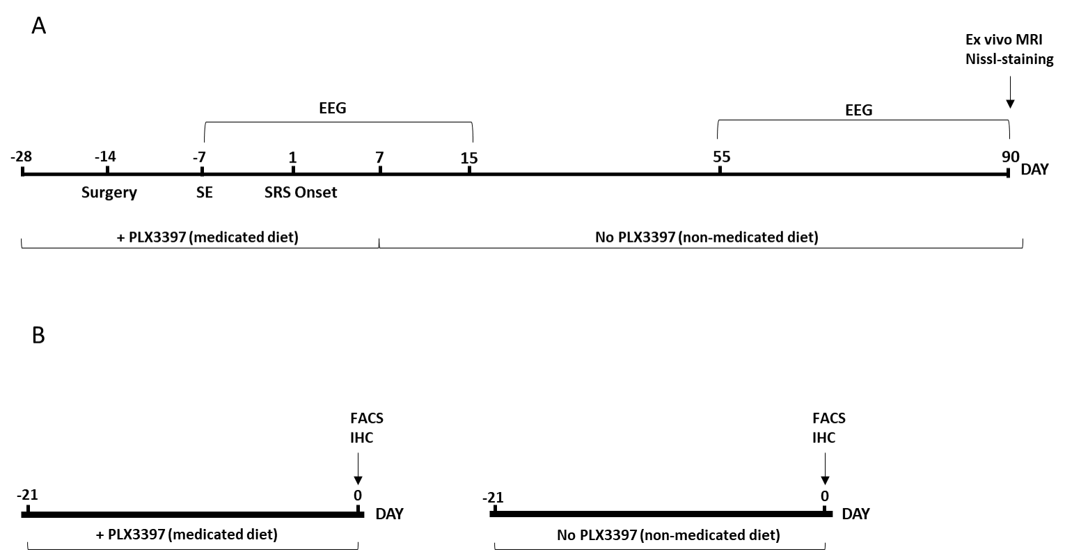

Fig. S1. Schematic representation of the experimental design.
Panel A depicts the time line of animal preparation for the longitudinal experiment considering DAY 1 as the time of spontaneous seizure (SRS) onset. The medicated diet (+PLX3397) was given to mice for 28 days before the onset of SRS (DAY 1): this time includes 3 weeks before the induction of status epilepticus (SE) and 1 week after SE onset (DAY 7). Then, the medicated diet was continued for seven additional days after SRS onset (until DAY 7), and thereafter the mice were switched to the non-medicated placebo diet (No PLX3397) until the end of the experiment (DAY 90). Control mice exposed to SE received a placebo non-medicated diet (No PLX3397) throughout the whole experiment. Surgery describes the time of electrode implantation for EEG recordings. EEG was monitored (24/7) at the time intervals indicated in brackets. At the end of the experiment (DAY 90) all mice were sacrificed and their brains were exposed to post-mortem MRI, then processed for histology (see Material and Methods for details). Mice were also exposed to the behavioural test (NORT) before sacrifice (see related text for details).
Corresponding data related to this protocol are shown in Fig. 3 and Fig. S4, S5 and S6.
Panel B depicts 21-day treatment duration with medicated (+PLX3397) or placebo non-medicated diet (No PLX3397) of naïve mice (not exposed to SE). At the end of the experiment, mice were sacrificed and their brains were used for immunohistochemistry (IHC) of microglia markers (Fig. S7A), FACS analysis (Fig. S7B) or for electrophysiological experiments (Fig. S8).

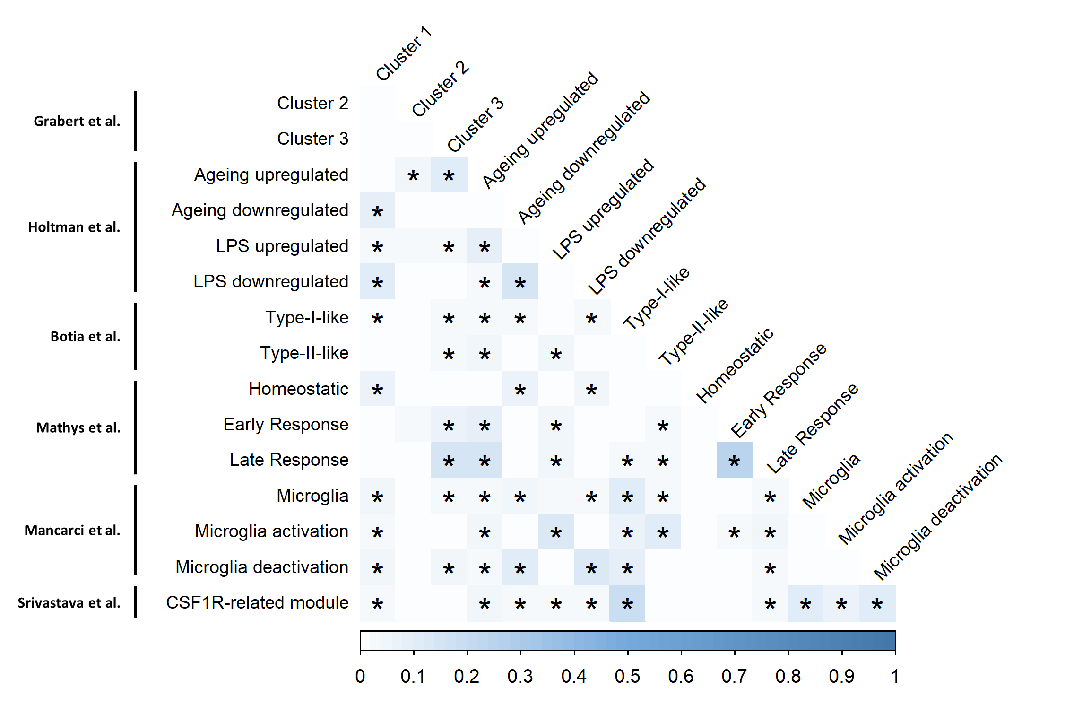

Fig. S2. Overlaps between microglial gene sets. The Jaccard index for each overlapping gene list was calculated by dividing the size of the intersection between two gene lists by the union of the two. Gene lists included modules from: age/neurodegeneration- and LPS-induced responses from mouse models in Holtman et al. [22]; healthy brain-region-specific mouse microglial modules from Grabert et al. [23]; homeostatic, early and late response signatures derived from a mouse model of neurodegeneration from Mathys et al. [24]; activation/de-activation mouse signatures from NeuroExpresso [25]; module 18, a microglial module driven by Csf1r and found to be significantly positively correlated with seizure frequency in a chronic epileptic mouse model [26]; and, finally, inferred microglia states from co-expression network analyses of bulk human RNA sequencing data. Asterisks denote a significant overlap between two gene lists (P<0.05/120). Gene overlaps between gene lists were determined using GeneOverlap (https://github.com/shenlab-sinai/geneoverlap).

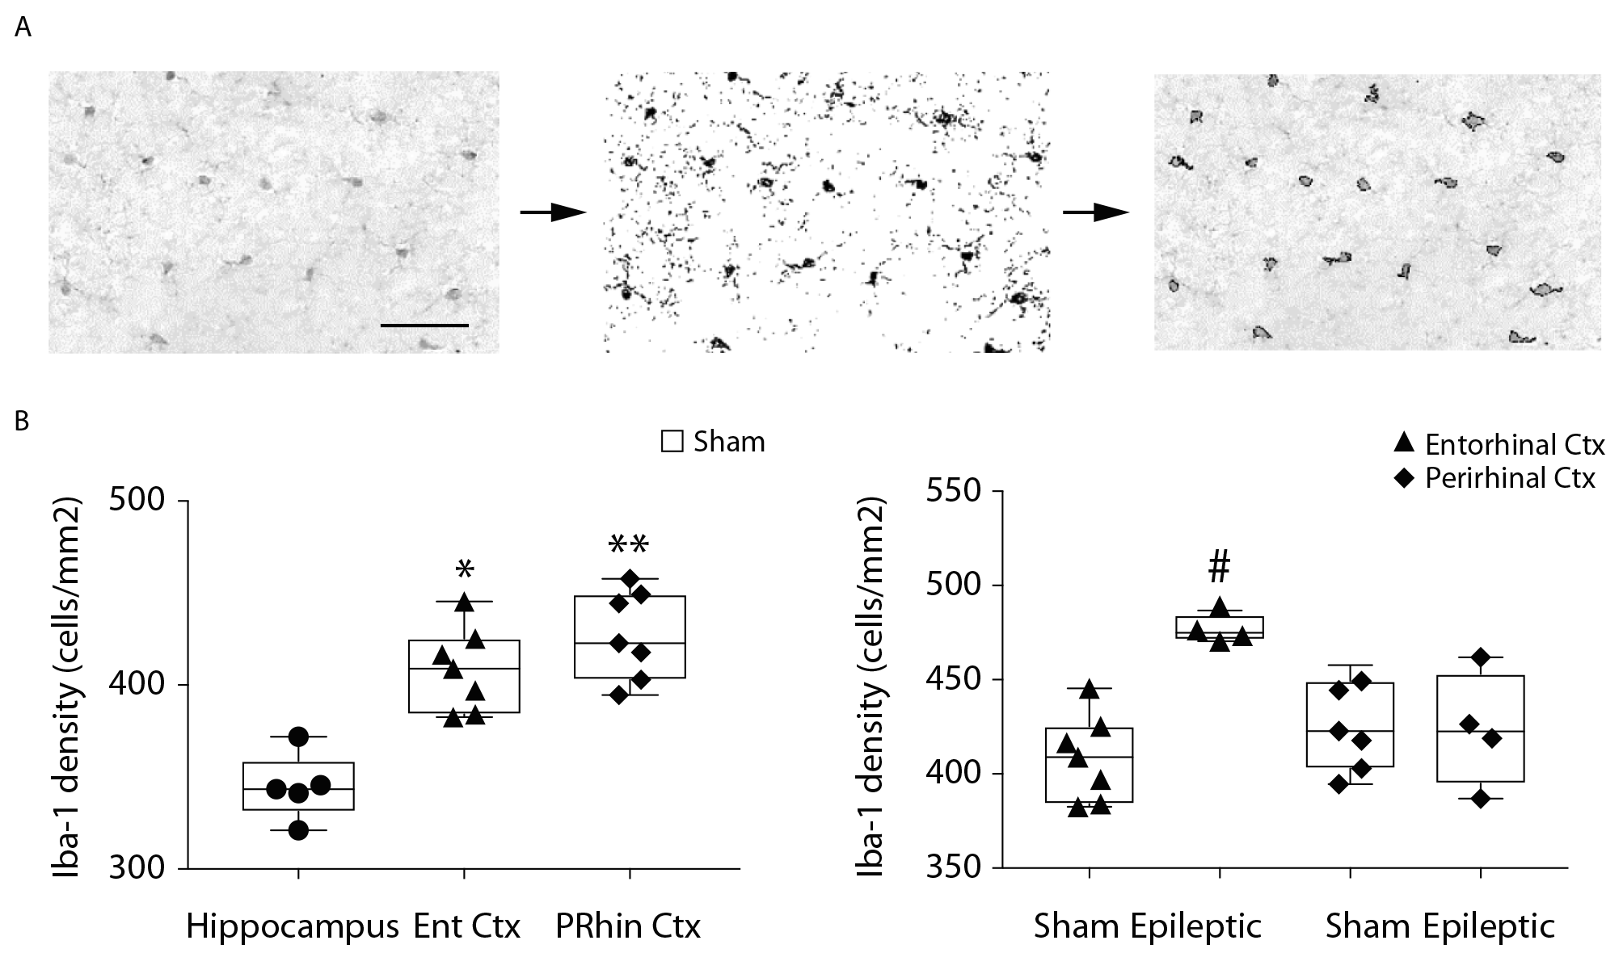

Fig. S3. Quantification of microglia by Iba-1 staining.
Panel A: Microphotographs of the entorhinal cortex of one representative sham control mouse showing the image analysis to quantify the number Iba-1-positive cells. The original image (left panel) was scaled to microns, binarized and segmented using Fiji (middle panel). Cells with >15 μm² area were selected and counted (profiles of selected cells for analysis in the right panel). Scale bar = 50 μm.
Panel B: Box-and-whisker plots show the number of Iba-1-positive cells, as depicted by median, minimum, maximum and single values in the hippocampus, entorhinal and perirhinal cortices in sham control (left panel), and placebo diet-fed epileptic mice (right panel) mice. Epileptic mice are those reported in Fig. 3B: only 4 out of 8 mice were analysed for Iba-1 staining based on slices availability. *P=0.0456, **P=0.0025 vs sham hippocampus by ANOVA followed by Tukey’s post-hoc test; #P=0.0061 vs respective sham by Mann-Whitney test. Ent Ctx = entorhinal cortex; PRhin Ctx = perirhinal cortex.

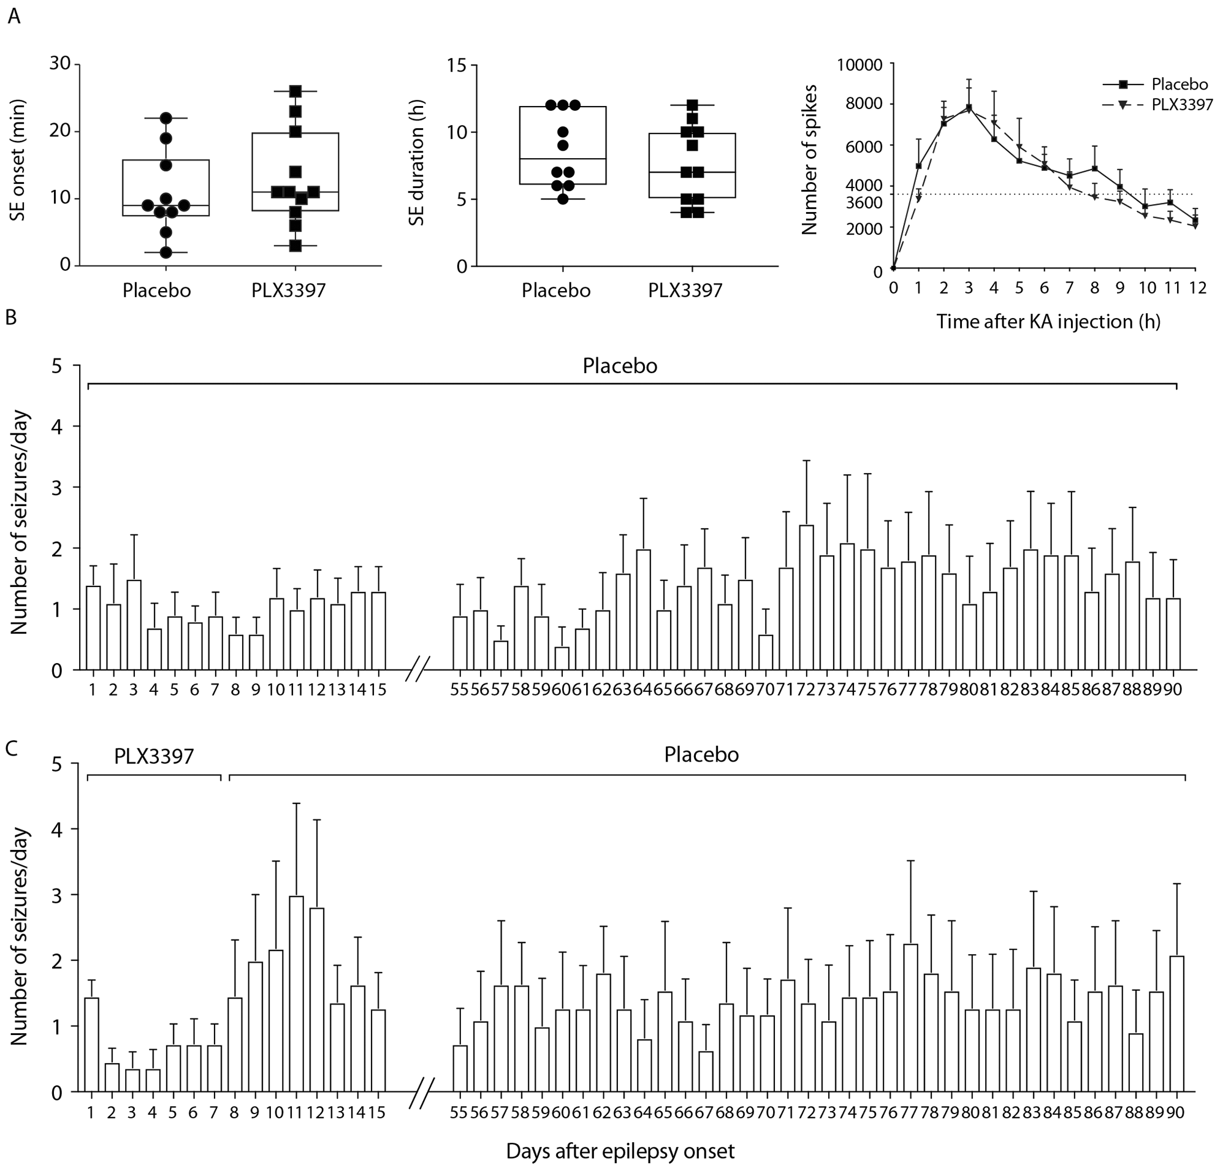
Fig. S4. Quantification of status epilepticus by EEG analysis. Panel A: box-and-whisker plots depicting median, minimum, maximum and single values of status epilepticus (SE) onset and total duration in mice fed with placebo, non-medicated diet (n=10) or PLX3397-supplemented diet (n=11) for 3 weeks before SE induction (same mice as in Fig. 3C). The third graph in Panel A shows the temporal spike distribution during SE. Each point represents the cumulative number of spikes during progressive 1-hour intervals. The dotted line represents the threshold number of spikes/hour (3.600) below which SE ends (inter-spike intervals longer than 1 second). No statistical differences were found between placebo and PLX3397 groups (unpaired t-test; two-way ANOVA for repeated measures).
Effects of PLX3397 on spontaneous seizures. Panels B,C report the average daily seizure number (SEM are reported) occurring in mice fed with non-medicated diet (B, Placebo) (n=10) or with the medicated diet supplemented with PLX3397 (C, n=11) (same mice as in Fig. 3C). Placebo and medicated diet had the same composition (a standard chow diet, AIN-763 76A, Research Diets, Inc., New Brunswick, NJ, USA) except for the addition of PLX3397 in the medicated diet (see Material and Methods for details). The placebo diet was given to control mice throughout the experiment duration (B). The medicated diet (C) was initiated 3 weeks before exposing mice to SE and was continued until each mouse experienced the first spontaneous seizure (DAY 1) and for 7 additional days thereafter (experimental design in Fig. S1A). Then, experimental mice were switched to the placebo diet until end of the experiments (day 90). The two experimental groups did not show statistical difference (see Fig. 3C for details).

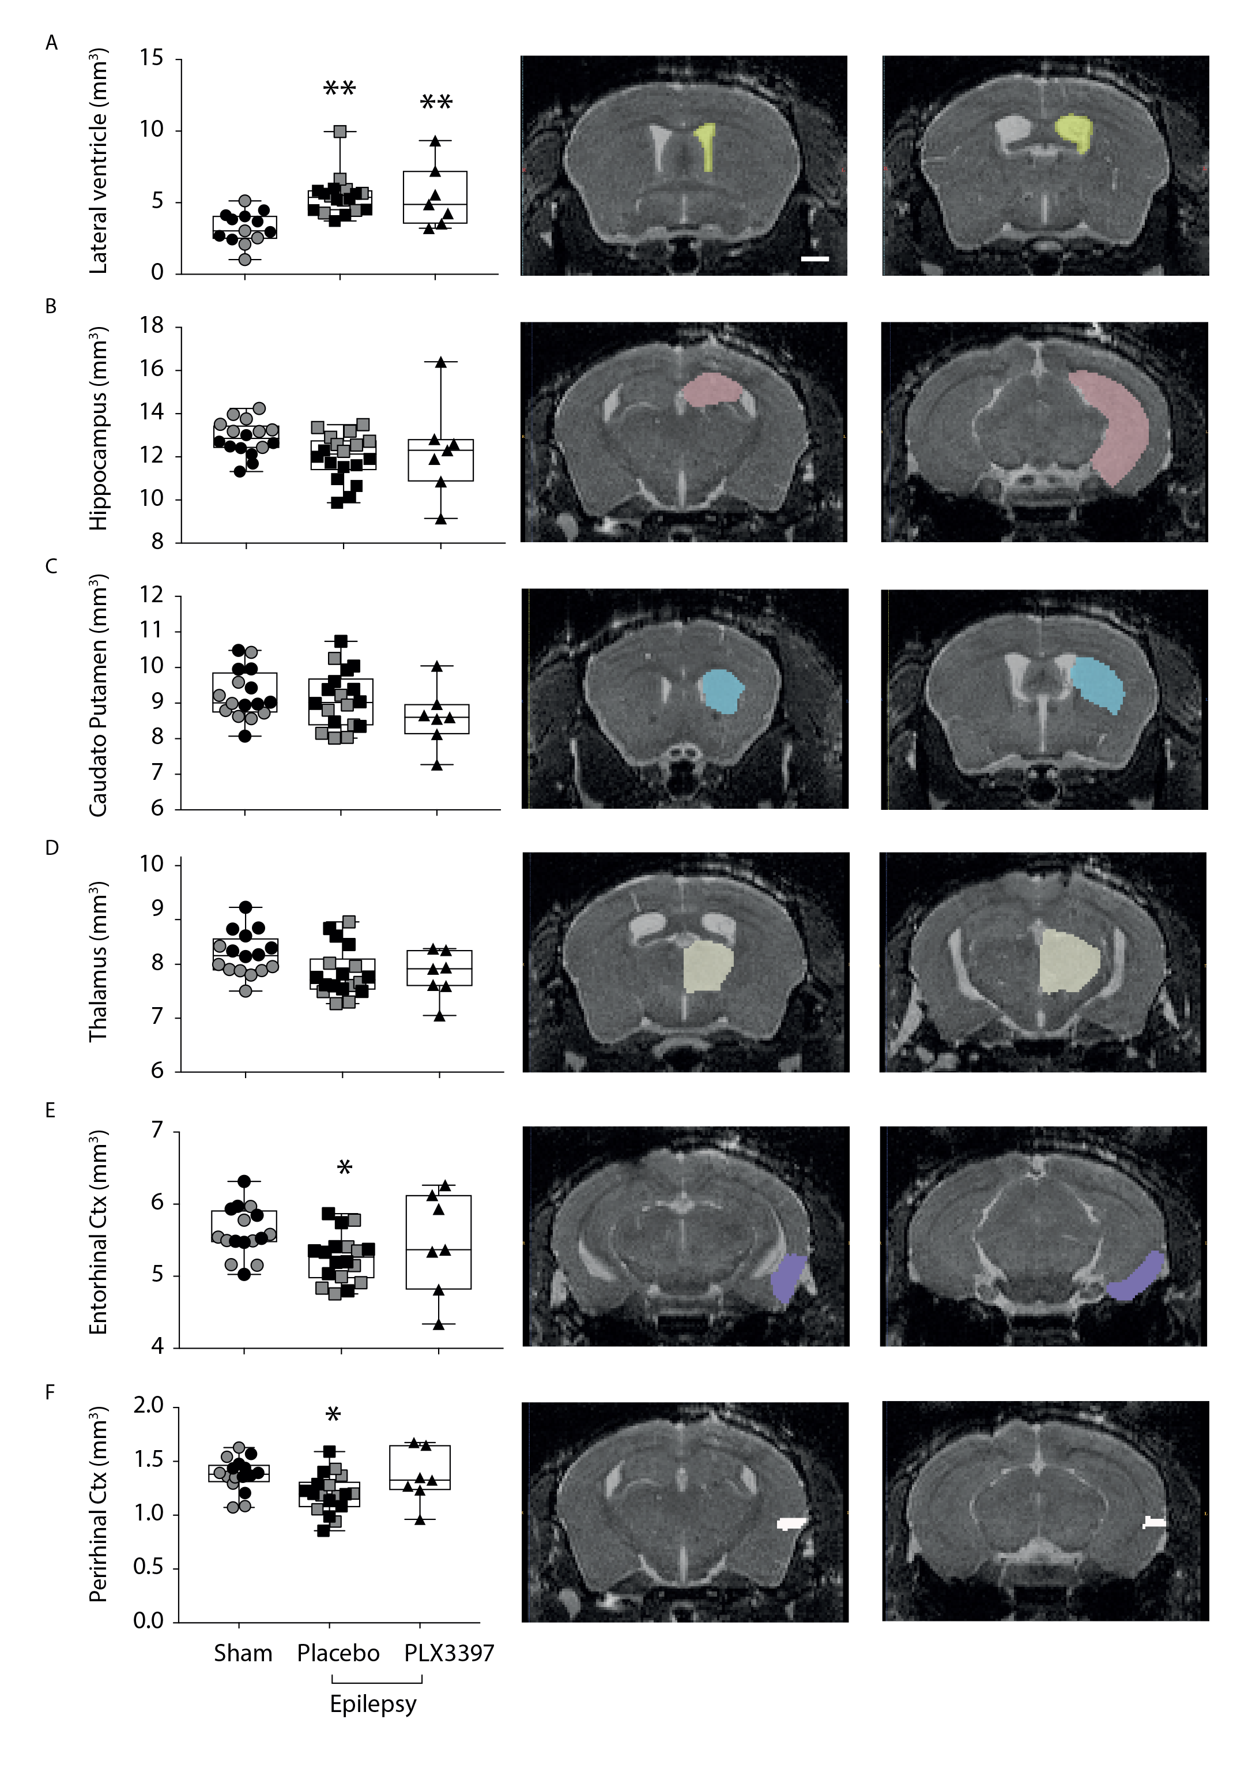

Fig. S5. Effects of PLX3397 on brain volumes in epileptic mice. Box-and-whisker plots depicting median, minimum, maximum and single values related to the quantification of the volumes of lateral ventricle (panel A, three sham mice values were discarded because of unusual ventricle enlargement), hippocampus (panel B), caudato-putamen (panel C), thalamus (panel D), entorhinal (panel E) and perirhinal (panel F) cortices, as assessed by quantitative post mortem MRI performed at the end of the longitudinal experiment (placebo: n=18; PLX3397: n=7), and in sham mice (n=13-16). Grey symbols represent sham (n=5-8) and epileptic mice fed with placebo diet (n=8) run in parallel with mice of Fig 3C (also depicted in Fig. S4). These additional mice were EEG recorded only at terminal disease state (between DAY 55 and 90): they had spontaneous seizure frequency similar to epileptic mice fed with placebo diet of Fig. 3C (see main text for details). MRI images depict representative slices showing the ROI used to quantify the volumes of the various brain regions. Placebo vs sham: lateral ventricle **P=0.0006; entorhinal cortex **P=0.043; perirhinal cortex *P=0.025. PLX3397 vs sham: lateral ventricle **P=0.008 by ANOVA followed by Tukey’s post-hoc test. Scale bars: 1 cm.

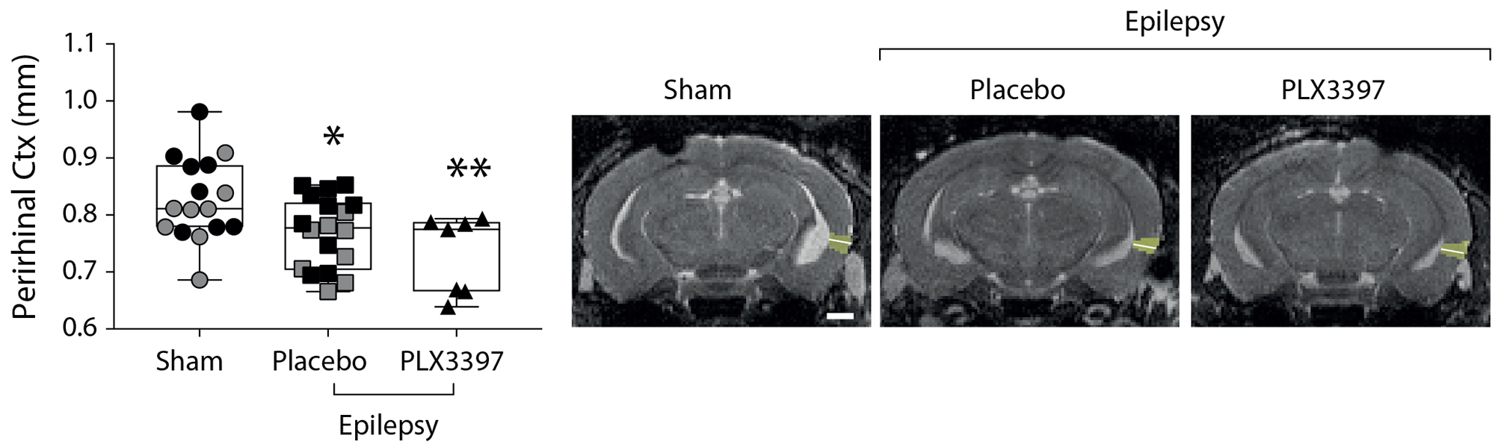

Fig. S6. Effects of PLX3397 on perirhinal cortex thickness in epileptic mice. Box-and-whisker plots depicting median, minimum, maximum and single values related to the quantification of perirhinal cortex thickness, as assessed by quantitative post-mortem MRI analysis in epileptic mice at the end of the longitudinal experiment in placebo non-medicated diet mice, n=18; PLX3397 medicated diet, n=7, and sham mice (n=16). Grey symbols represent sham (n=8) and epileptic mice fed with placebo diet (n=8) run in parallel with experimental mice of Fig 3C (also depicted in Fig. S4). These additional mice had EEG recorded only at terminal disease state (between DAY 55 and 90): they had spontaneous seizure frequency similar to epileptic mice fed with placebo diet of Fig. 3 (see main text for details). Mice were those described in Fig. S5 MRI images depict representative slices showing the ROI used to quantify the cortical thickness. The white line within the ROI was manually drawn to measure the cortical thickness. *P=0.046, **P=0.009 vs sham by ANOVA followed by Tukey’s post-hoc test. Scale bars: 1 cm. Ctx = cortex

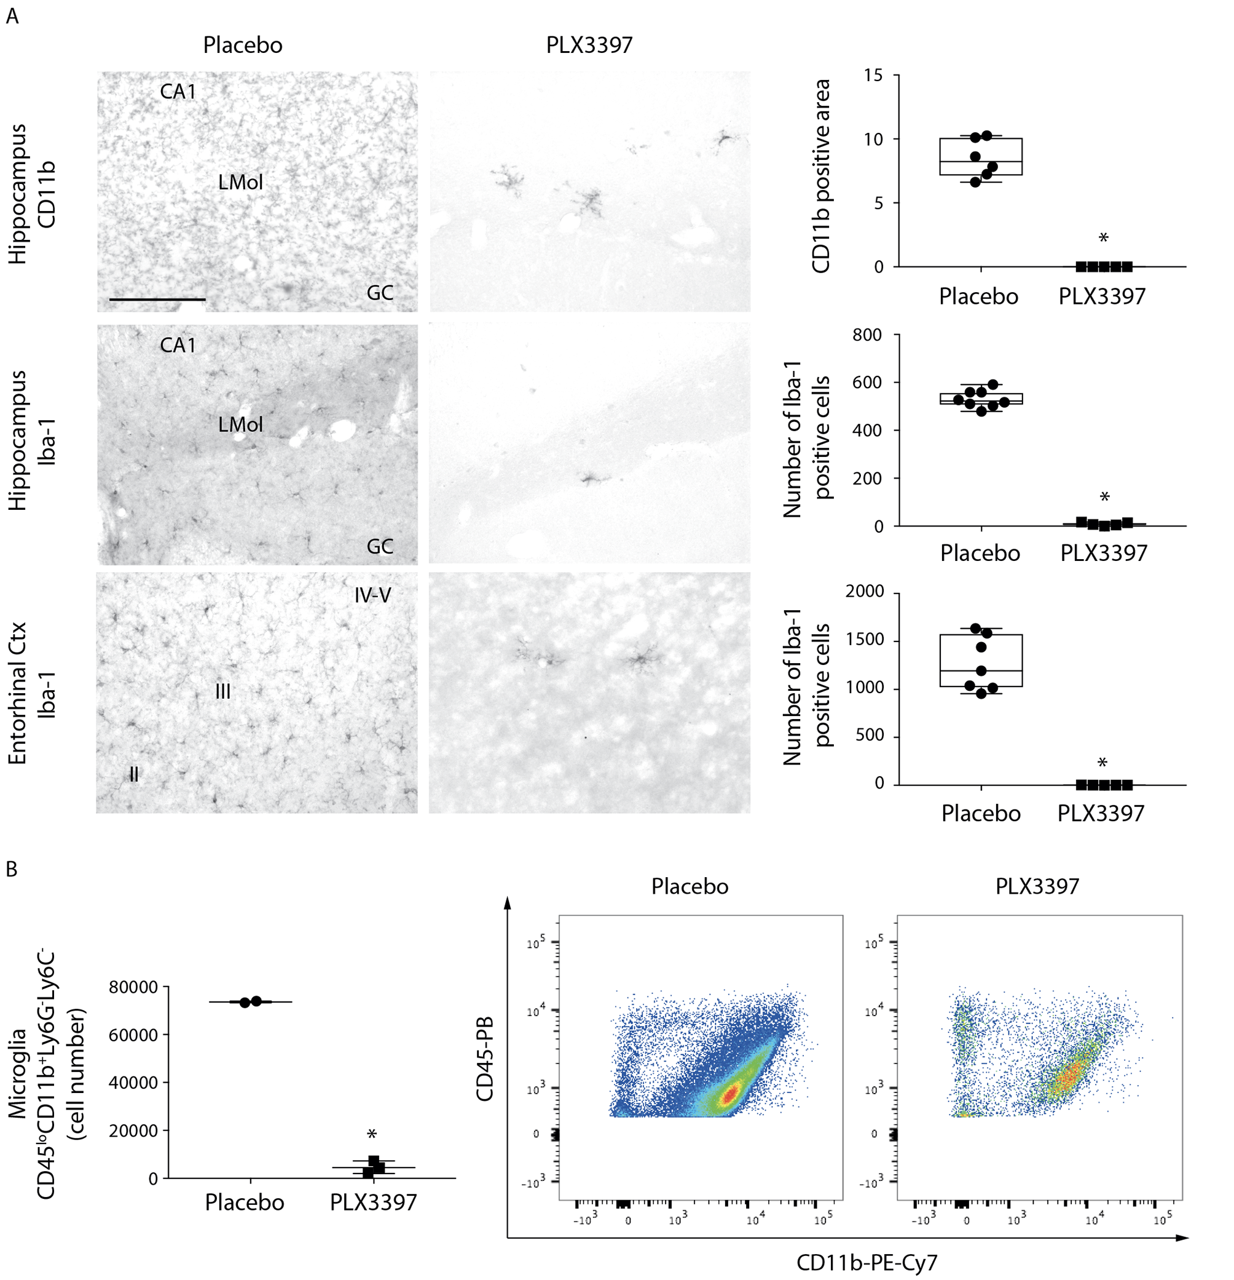
Fig. S7. Effects of PLX3397-supplemented diet on microglia cell number in the brain of naive mice. Panel A: Representative photomicrographs of CD11b immunostaining in the hippocampus (top row), and Iba-1 immunoreactivity in the hippocampus (middle row) and entorhinal cortex (bottom row) of mice fed with placebo non-medicated diet (n=6-8) or PLX3397-supplemented diet (n=5) for 3 weeks. Box-and-whisker plots show the quantification of the percent area occupied by CD11b signal and the number of Iba-1 positive cells, as depicted by median, minimum, maximum and single values in the hippocampus (top and middle) and entorhinal cortex (bottom). *P=0.0022 (hippocampus CD11b), *P=0.0013 (hippocampus Iba-1), *P=0.0008 (entorhinal cortex) vs placebo by Mann-Whitney test. Scale bars: 50 µm. Ctx = cortex; GC = granule cell layers; LMol = stratum lacunosum-molecolare; CA1 = CA1 pyramidal cell layer. Panel B: Flow cytometry analysis on brain immune cells after treatment with PLX3397-supplemented diet. The total cell number of live microglial cells (CD45^{lo} CD11b⁺ Ly6G⁻ Ly6C⁻) in the hippocampus (pooled hippocampi from the two hemispheres/mouse, n=2-3 mice) is quantified in the graph and shown in representative plots. Data are shown as box-and-whisker plots depicting the median, minimum, maximum and single values. *P=0.0001 vs placebo by Mann-Whitney test.

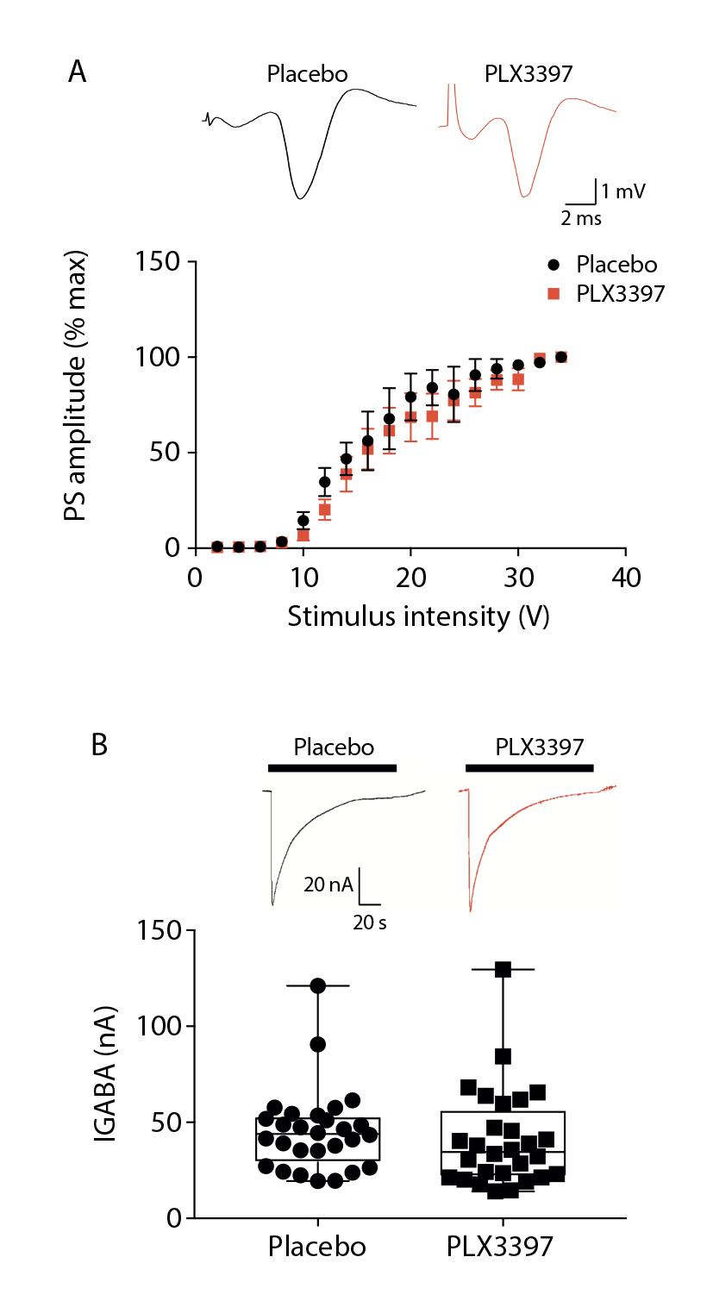

Fig. S8. Panel A: Extracellular recordings in acute hippocampal slices. Extracellular recordings of population spikes (PS) evoked in CA1 pyramidal neurons by electrical stimulation of the Schaffer collaterals. The relationship between stimulus intensity, i.e., current input, and PS peak amplitude, i.e., neuronal output, is considered as an index of neuronal excitability. Slices from microglia-depleted mice (experimental design in Fig. S1B) showed an input-output curve similar to slices from control mice fed with placebo diet indicating no changes in neuronal excitability. PS amplitudes are shown as percentage of maximal response (mean ± SEM; n=6 slices from 5-6 mice/each group). Representative traces of PS obtained in response to 24 V stimulation are shown. For methods see Iori et al. [49].
Panel B: Oocytes microtransplanted with hippocampal membranes from microglia-depleted mice (experimental design in Fig. S1B) or placebo-diet fed mice (n=2 mice/ group; 2 pooled hippocampi/mouse). Box-and-whisker plots depicting median, minimum, maximum and single values show that the GABA current (I_{GABA}) expressed as nA in Xenopus oocytes (n=28 each group) were similar in the two experimental groups. Traces represent currents evoked by GABA (500 µM, 120 s application) in two oocytes transplanted as indicated. The GABA current decay time showed no difference between the two experimental groups (placebo mice: T_{0.5} =15.1±1.1 s; microglia-depleted mice: T_{0.5} =14.8±1.3 s). For methods see Roseti et al. [69].
Statistical analysis of data was done using two-way ANOVA for repeated measures (A) and Mann Whitney test (B).

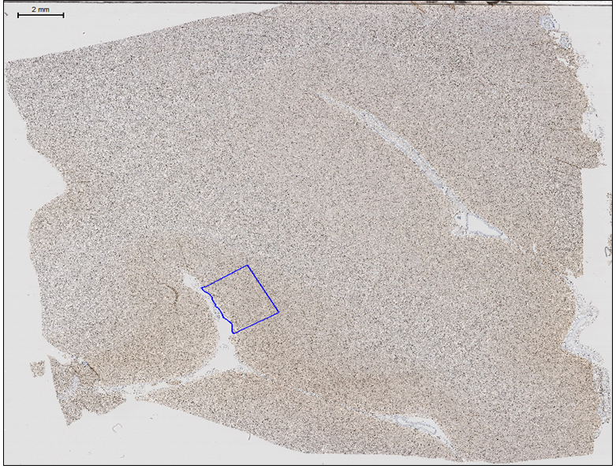

Fig. S9. Human immunolabelled post mortem tissue ROI placement. Temporal lobe T1-T2 section of a post mortem case immunostained with Iba1 (brown). ROI (blue region) was placed midway between the crown and the crest 2.5mm along the pial surface to a depth of 2mm including only grey matter avoiding tissue artefacts. Counterstain = haematoxylin. Scale bar = 2mm.

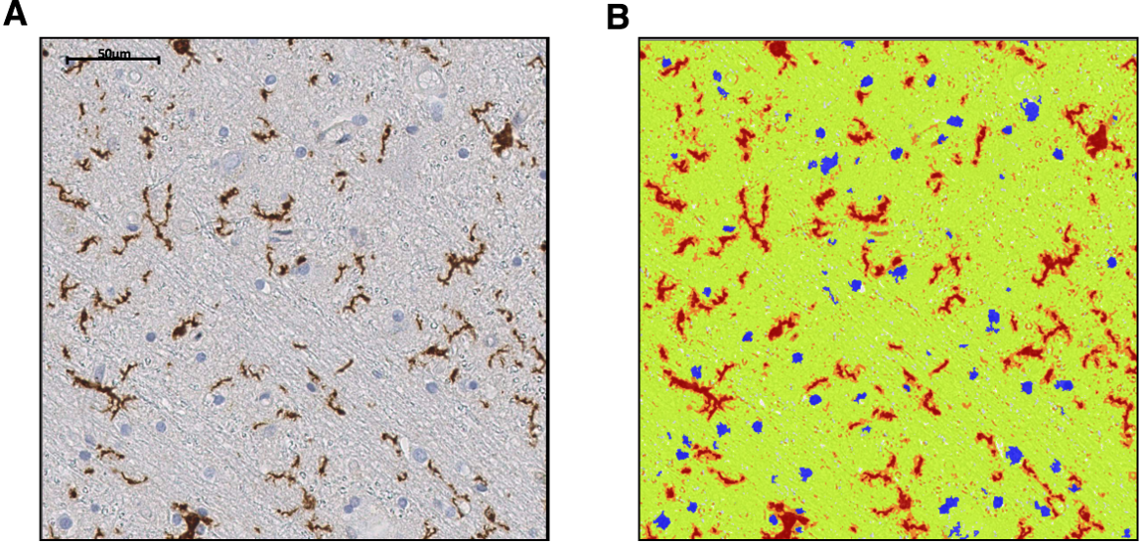

Fig. S10. Human immunolabelled post mortem tissue ROI analysis.
Panel A: Iba-immunostained (brown) slides were scanned with a Leica SCN400F digital slide scanner (Leica Microsystems, Wetzlar, Germany) at 40x magnification and analysed with Definiens Tissue Studio software 3.6 (Definiens AG, Munich, Germany).
Panel B: DAB staining was detected and classified into high (red), medium (orange) and low (yellow) as shown for Iba1 staining. High intensity labelling only (red) was selected for analysis as representative of positive labelling. Separate thresholds were set for haematoxylin staining which allowed identification and exclusion of nuclei. Artefacts were excluded from the analysis. Scale bar = 50µm.

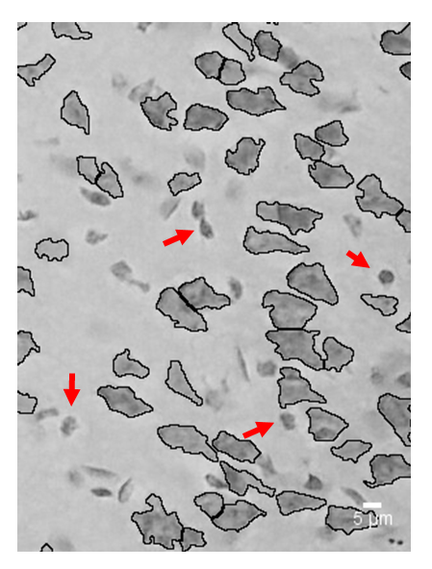
Fig. S11. Quantification of neuronal cell loss by Nissl staining. Representative microphotograph showing Nissl staining in the entorhinal cortex of a sham control mouse. To distinguish neurons from glia, we segmented every cell over the entire entorhinal cortex slice by excluding those cells with an area below the cut-off value of 25 µm², by using Fiji software. Using this procedure, only neurons were counted (black profile), while glial cells (red arrows) were excluded from the quantitative analysis.

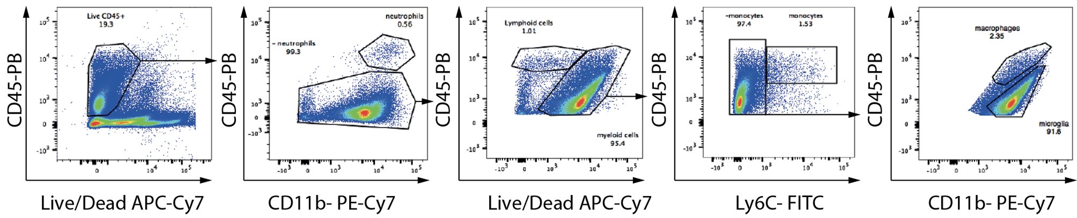

Fig. S12. Gating strategy for CNS-resident myeloid cells. Cells were first gated on size and singularity (not shown) followed by live/dead exclusion to identify live cells (Live/Dead APC-Cy7 negative) for further analysis. Live CD45+ cells were gated on co-expression of CD11b and Ly6G to identify neutrophils. Ly6G-CD45+CD11b+ cells defined as "myeloid cells" were gated on expression of Ly6C to identify monocyte-derived cells. CD45+CD11b+Ly6G-L6C- were gated for expression levels of CD45 and CD11b to identify CD45loCD11b+Ly6G-L6C (microglia) and CD45hiCD11b+Ly6G-L6C- (macrophages).

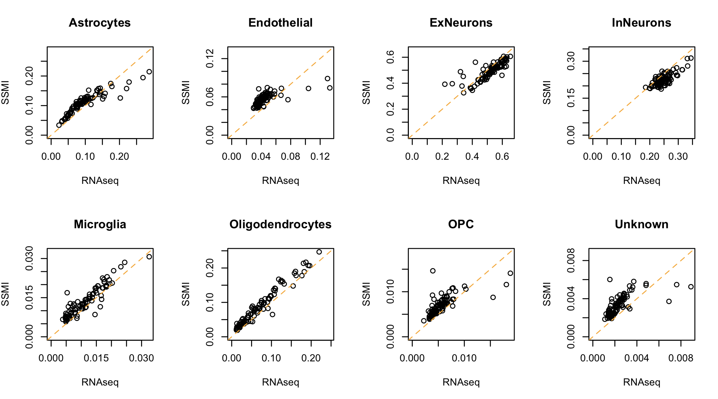

Fig. S13. Agreement between RNAseq and SSMI-based cell type deconvolution. The x-axis shows the Scaden-based cell type fraction estimate using RNAseq data, while the y-axis shows the estimate for the same 92 samples using re-scaled microarray intensities (SSMI) as input. Spearman rank correlations: Astrocytes (0.95), Endothelial (0.80), Excitatory Neurons (ExNeurons) (0.87), Inhibitor Neurons (InNeurons) (0.64), Microglia (0.90), Oligodendrocytes (0.97), OPC (0.83) and Unknown (0.82).

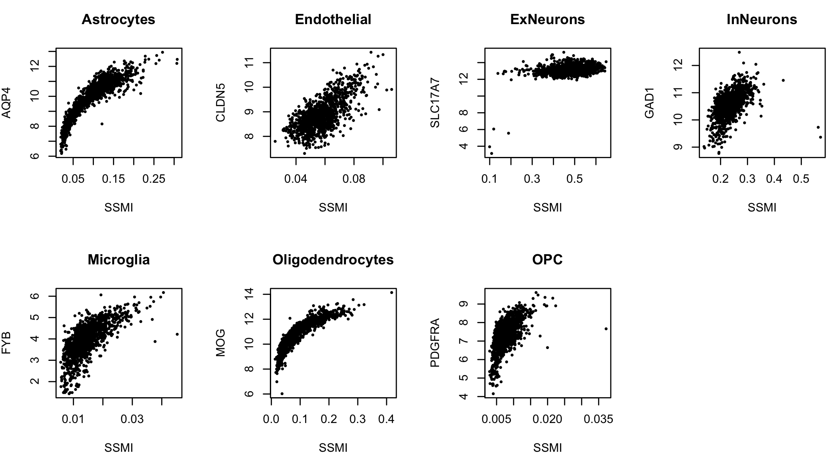

Fig. S14. Agreement between SSMI-based predicted cell type fractions and expression of cell type marker genes. The x-axis shows the Scaden-based cell type fraction estimate using SSMI data, while the y-axis shows the log2(SSMI) of cell type marker genes. Spearman rank correlations: Astrocytes (0.90), Endothelial (0.63), ExNeurons (0.28), InNeurons (0.58), Microglia (0.74), Oligodendrocytes (0.94) and OPC (0.58).

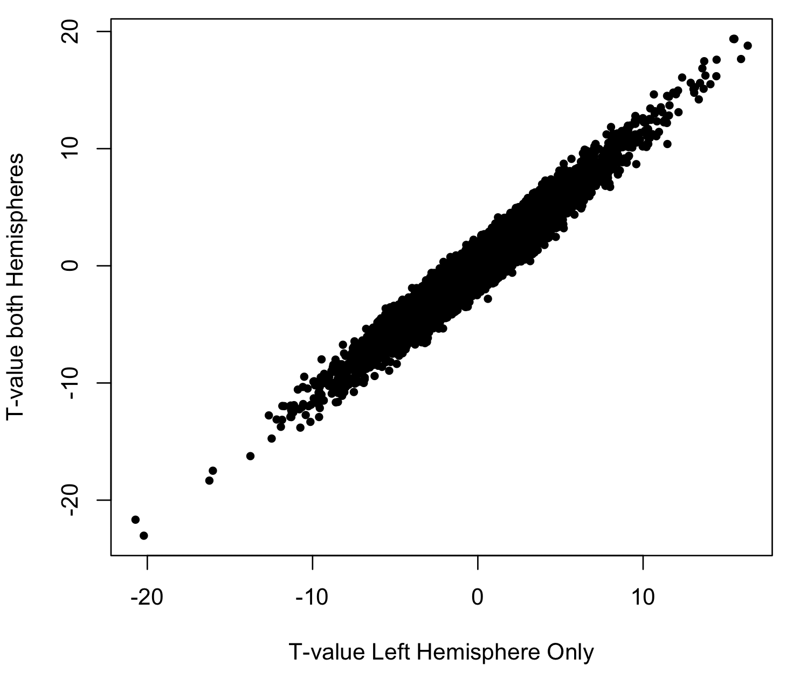

Fig. S15. Agreement between t-values when using only the 1227 samples in the left hemisphere (X-axis) and all 1628 samples in both hemispheres (Y-axis).

Fig. S16: Overlap of cortical regions and neuropathology ROIs.
Iba1 immunolabelling shown in 7 Brodmann areas in each hemisphere, colour coded for the mean percentage labelling index in the three groups: Epilepsy Non-Lesional (EP-NL), Epilepsy-Lesional (EP-L) and non-epilepsy controls (NEC). The cortex is shaded in different grey scales to indicate vulnerable (light grey) and relatively protected (dark grey) regions.

Table S1. Data from the original ENIGMA-Epilepsy study (Whelan et al. 2018), listing human brain regions categorized here as ‘vulnerable’ (red) or ‘relatively protected’ (green).
ROI | ENIGMA-Eps (left) | ENIGMA-Eps (right)
precentral | 1.82E-18 | 8.85E-20
caudalmiddlefrontal | 2.11E-15 | 2.09E-09
superiorparietal | 1.78E-04 | 8.13E-04
paracentral | 2.05E-06 | 2.19E-09
superiorfrontal | 1.51E-07 | 4.49E-06
precuneus | 2.66E-03 | 2.70E-05
entorhinal | 2.04E-05 | 4.24E-03
supramarginal | 9.87E-05 | 5.24E-05
rostralmiddlefrontal | 2.15E-02 | 5.94E-04
temporalpole | 7.49E-04 | 5.51E-04
cuneus | 7.27E-02 | 9.68E-08
parstriangularis | 1.29E-04 | 4.25E-08
middletemporal | 4.01E-03 | 3.02E-03
inferiorparietal | 5.29E-03 | 2.15E-02
lateraloccipital | 3.58E-02 | 1.77E-03
transversetemporal | 1.05E-05 | 2.81E-05
fusiform | 2.10E-03 | 8.56E-03
lingual | 3.50E-02 | 8.14E-04
parsopercularis | 7.12E-03 | 6.48E-07
superiortemporal | 2.62E-02 | 3.84E-02
parsorbitalis | 2.37E-03 | 8.27E-03
postcentral | 1.67E-01 | 2.49E-01
lateralorbitofrontal | 1.46E-01 | 3.87E-02
pericalcarine | 1.43E-01 | 9.15E-03
frontalpole | 1.04E-01 | 2.37E-02
parahippocampal | 1.83E-02 | 6.95E-03
posteriorcingulate | 6.01E-02 | 2.65E-01
bankssts | 2.45E-01 | 3.66E-01
inferiortemporal | 1.37E-01 | 8.36E-02
medialorbitofrontal | 8.82E-01 | 1.26E-01
isthmuscingulate | 1.72E-01 | 8.56E-01
insula | 7.73E-01 | 6.42E-01
rostralanteriorcingulate | 8.34E-01 | 8.64E-02
caudalanteriorcingulate | 3.59E-01 | 8.24E-01

Table S2. Association between inferred cell type fractions and reduced cortical thickness in both hemispheres.
Columns represent the cell type, the t-value from the association analysis and the corresponding P-value using all 1628 samples. The least column lists a P-value obtained from 1,000 permutations of the vulnerable/protected status of 68 ROIs in the left and right hemispheres.

Cell type | T-value | P-value | Pperm
Astrocytes | 1.270812 | 0.2038 | 0.28
Endothelial | 4.193236 | 2.80x10⁻⁵ | 0.026
ExNeurons | -3.803568 | 1.43x10⁻⁴ | 0.046
InNeurons | 0.520356 | 0.602815 | 0.40
Microglia | 3.465558 | 5.29x10⁻⁴ | 0.037
Oligodendrocytes | 3.097982 | 0.0019 | 0.019
OPC | 2.188713 | 0.0286 | 0.11
Unknown | 2.389963 | 0.0169 | 0.076

Table S3. Regional Iba1 labelling indices in brain tissue samples from healthy controls and people with epilepsy.

Group  Region | NEC |  |  | ALL EPILEPSY |  |  | LESION-ASSOCIATED EPILEPSY (ALL) |  |  | NON-LESIONAL EPILEPSY *
(Number of sections) | ALL | LEFT | RIGHT | ALL | LEFT | RIGHT | ALL | LEFT | RIGHT | ALL | LEFT | RIGHT
PHG  (n=90) | 2.6  (2.4) | 2.3  (2.1) | 3.0  (2.8) | 4.9  (2.7) | 4.3  (2.5) | 5.5  (2.9) | 4.9  (2.6) | 4.5  (2.6) | 5.5  (2.8) | 5.0  (2.9) | 3.9  (2.3) | 5.5  (3.1)
STG/MTG  (n=79) | 4.4  (2.2) | 3.0  (2.2) | 3.3  (2.3) | 4.5  (2.2) | 4.6  (2.4) | 4.4  (2.0) | 4.1  (2.2) | 3.8  (2.2) | 4.6  (2.2) | 4.9  (2.1) | 5.5  (2.2) | 4.3  (1.9)
INSULAR  (n=47) | 3.4  (3.2) | 5.1  (4.1) | 2.2  (2.2) | 4.8  (3.0) | 4.6  (3.4) | 5.0  (2.9) | 6.2  (2.8) | 6.9  (2.8) | 6.0  (3.0) | 4.1  (2.9) | 3.5  (3.2) | 4.6  (2.8)
ANT FRONTAL  (n=88) | 2.6  (1.3) | 2.7  (1.5) | 2.5  (1.3) | 3.6  (2.1) | 4.0  (2.5) | 3.4  (2.0) | 3.5  (2.3) | 3.4  (2.3) | 3.3  (2.4) | 3.7  (2.0) | 4.0  (2.4) | 3.6  (1.6)
ANT CING  (n=63) | 3.5  (2.3) | 3.8  (2.5) | 3.3  (2.1) | 4.6  (2.4) | 4.2  (2.8) | 4.7  (2.0) | 4.5  (1.9) | 4.1  (1.9) | 4.8  (1.8) | 4.8  (2.8) | 4.3  (3.6) | 4.5  (2.3)
PARIETAL  (n=58) | 2.4  (1.3) | 2.3  (1.3) | 2.7  (1.4) | 2.7  (1.9) | 2.6  (1.6) | 3.4  (2.2) | 1.7  (1.4) | 2.4  (1.7) | 1.6  (1.4) | 3.4  (1.9) | 2.8  (1.7) | 4.1  (2.0)
OCCIPITAL  (n=76) | 2.3  (1.5) | 2.2  (1.4) | 2.6  (1.7) | 2.9  (2.1) | 3.0  (2.0) | 2.8  (2.0) | 2.7  (2.0) | 2.7  (2.1) | 2.9  (2.1) | 3.2  (2.5) | 3.2  (2.0) | 2.6  (2.0)
THALAMUS-MEDIAL  (n=63) | 3.7  (2.8) | 3.9  (3.1) | 3.4  (2.7) | 5.5  (3.1) | 5.6  (2.6) | 5.7  (3.5) | 5.8  (3.9) | 6.2  (1.8) | 6.2  (5.0) | 5.4  (2.6) | 5.1  (3.0) | 5.5  (2.5)
THALAMUS-LATERAL  (n=66) | 2.9  (2) | 2.6  (1.8) | 3.4  (2.3) | 3.3  (2.2) | 3.4  (2.2) | 3.5  (2.3) | 3.0  (1.9) | 3.5  (1.7) | 3.1  (1.9) | 3.6  (2.4) | 3.4  (2.4) | 3.8  (2.6)
PULVINAR- LATERAL  (n=37) | 3.1  (3.0) | 2.9  (2.7) | 3.5  (3.6) | 6.4  (2.7) | 6.5  (2.9) | 6.4  (2.9) | 5.4  (1.8) | 4.0  (1.3) | 6.8  (0.6) | 6.7  (2.9) | 7.2  (2.9) | 6.2  (3.0)

Dataset S1 (separate file)

Results of the differential expression analysis between cortical regions relatively protected versus cortical regions vulnerable to reduced cortical thickness.
Columns represent the gene name, the t-value from the differential expression analysis, the corresponding P-value and the corrected P-value using FDR and Holm methods, respectively.

Dataset S2 (separate file)

Results of all enrichment analyses performed to investigate enrichment of brain cell type marker genes (see Dataset S5) in the ranked gene list (Dataset S1). Columns provide the gene set label, the brain cell type, the number of genes in the marker list, AUC, P-value and the FDR-corrected P-value.

Dataset S3 (separate file)

Results of all enrichment analyses performed to investigate enrichment of molecular pathways (KEGG and REACTOME) and Gene Ontology terms in the ranked gene list (Dataset S1). Columns correspond to the gene set name, the number of genes in the marker list, AUC, P-value and the FDR-corrected P-value.

Dataset S4 (separate file)

Results of all enrichment analyses performed to investigate enrichment of microglia state-related genes (Dataset S6) in the ranked gene list (Dataset S1). Columns correspond to the gene set name, the number of genes in the marker list, AUC, P-value and the FDR-corrected P-value.

Dataset S5 (separate file)

Cell type-specific genes based on purified cells isolated from mouse and human cerebral cortex.

Dataset S6 (separate file)

Genes associated with a range of microglial signatures.

References
1. Hawrylycz MJ, Lein ES, Guillozet-Bongaarts AL, Shen EH, Ng L, Miller JA, et al. An anatomically comprehensive atlas of the adult human brain transcriptome. Nature. 2012;489(7416):391–9.
2. Hawrylycz M, Miller JA, Menon V, Feng D, Dolbeare T, Guillozet-Bongaarts AL, et al. Canonical genetic signatures of the adult human brain. Nat Neurosci. 2015;18(12):1832–44.
3. TECHNICAL WHITE PAPER: MICROARRAY DATA NORMALIZATION [Internet]. 2013 [cited 2018 Jul 15]. Available from: http://help.brain-map.org/download/attachments/2818165/Normalization_WhitePaper.pdf?version=1&modificationDate=1361836502191&api=v2
4. Desikan RS, Ségonne F, Fischl B, Quinn BT, Dickerson BC, Blacker D, et al. An automated labeling system for subdividing the human cerebral cortex on MRI scans into gyral based regions of interest. Neuroimage. 2006;31(3):968–80.
5. Modat M, Ridgway GR, Taylor ZA, Lehmann M, Barnes J, Hawkes DJ, et al. Fast free-form deformation using graphics processing units. Comput Methods Programs Biomed [Internet]. 2010;98(3):278–84. Available from: http://www.sciencedirect.com/science/article/pii/S0169260709002533
6. Whelan CD, Altmann A, Botía JA, Jahanshad N, Hibar DP, Absil J, et al. Structural brain abnormalities in the common epilepsies assessed in a worldwide ENIGMA study. Brain. 2018;141(2):391–408.
7. Arloth J, Bader DM, Röh S, Altmann A. Re-Annotator: Annotation Pipeline for Microarray Probe Sequences. PLoS One [Internet]. 2015;10(10):e0139516. Available from: http://www.ncbi.nlm.nih.gov/pubmed?Db=pubmed&amp;Cmd=Retrieve&amp;list_uids=26426330&amp;dopt=abstractplus
8. Miller JA, Menon V, Goldy J, Kaykas A, Lee C-K, Smith KA, et al. Improving reliability and absolute quantification of human brain microarray data by filtering and scaling probes using RNA-Seq. BMC Genomics. 2014;15:154.
9. Menden K, Marouf M, Oller S, Dalmia A, Magruder DS, Kloiber K, et al. Deep learning--based cell composition analysis from tissue expression profiles. Sci Adv. 2020;6(30):eaba2619.
10. Darmanis S, Sloan SA, Zhang Y, Enge M, Caneda C, Shuer LM, et al. A survey of human brain transcriptome diversity at the single cell level. Proc Natl Acad Sci U S A [Internet]. 2015;112(23):7285–90. Available from: http://www.pnas.org/content/112/23/7285.long
11. Lake BB, Ai R, Kaeser GE, Salathia NS, Yung YC, Liu R, et al. Neuronal subtypes and diversity revealed by single-nucleus RNA sequencing of the human brain. Sci (New York, NY) [Internet]. 2016;352(6293):1586–90. Available from: http://science.sciencemag.org/content/352/6293/1586.long
12. Bates D, Mächler M, Bolker B, Walker S. Fitting linear mixed-effects models using lme4. J Stat Softw. 2015;
13. Benjamini Y, Hochberg Y. Controlling the False Discovery Rate: A Practical and Powerful Approach to Multiple Testing. J R Stat Soc Ser B [Internet]. 1995;57(1):289–300. Available from: http://www.jstor.org/stable/2346101
14. Weiner 3rd J, Domaszewska T. tmod: an R package for general and multivariate enrichment analysis. PeerJ. 2016;4.
15. Ritchie J, Pantazatos SP, French L. Transcriptomic characterization of MRI contrast with focus on the T1-w/T2-w ratio in the cerebral cortex. Neuroimage [Internet]. 2018;174:504–17. Available from: http://eutils.ncbi.nlm.nih.gov/entrez/eutils/elink.fcgi?dbfrom=pubmed&amp;id=29567503&amp;retmode=ref&amp;cmd=prlinks
16. Mann HB, Whitney DR. On a Test of Whether one of Two Random Variables is Stochastically Larger than the Other. Ann Math Stat. 1947;18(1):50–60.
17. Zhang Y, Chen K, Sloan SA, Bennett ML, Scholze AR, O&apos;Keeffe S, et al. An RNA-sequencing transcriptome and splicing database of glia, neurons, and vascular cells of the cerebral cortex. J Neurosci [Internet]. 2014;34(36):11929–47. Available from: http://www.jneurosci.org/content/34/36/11929.long
18. Zhang Y, Sloan SA, Clarke LE, Caneda C, Plaza CA, Blumenthal PD, et al. Purification and Characterization of Progenitor and Mature Human Astrocytes Reveals Transcriptional and Functional Differences with Mouse. Neuron [Internet]. 2016;89(1):37. Available from: http://dx.doi.org/10.1016/j.neuron.2015.11.013
19. Zeisel A, Muñoz-Manchado AB, Codeluppi S, Lönnerberg P, La Manno G, Juréus A, et al. Brain structure. Cell types in the mouse cortex and hippocampus revealed by single-cell RNA-seq. Sci (New York, NY) [Internet]. 2015;347(6226):1138–42. Available from: http://science.sciencemag.org/content/347/6226/1138.long
20. Mancarci O. Homologene: Quick access to homology information [Internet]. 2015. Available from: https://github.com/oganm/homologene
21. Subramanian A, Tamayo P, Mootha VK, Mukherjee S, Ebert BL, Gillette MA, et al. Gene set enrichment analysis: A knowledge-based approach for interpreting genome-wide expression profiles. Proc Natl Acad Sci. 2005;
22. Holtman IR, Raj DD, Miller JA, Schaafsma W, Yin Z, Brouwer N, et al. Induction of a common microglia gene expression signature by aging and neurodegenerative conditions: a co-expression meta-analysis. Acta Neuropathol Commun. 2015;3:31.
23. Grabert K, Michoel T, Karavolos MH, Clohisey S, Baillie JK, Stevens MP, et al. Microglial brain region-dependent diversity and selective regional sensitivities to aging. Nat Neurosci. 2016;19(3):504–16.
24. Mathys H, Adaikkan C, Gao F, Young JZ, Manet E, Hemberg M, et al. Temporal Tracking of Microglia Activation in Neurodegeneration at Single-Cell Resolution. Cell Rep. 2017;21(2):366–80.
25. Mancarci BO, Toker L, Tripathy SJ, Li B, Rocco B, Sibille E, et al. Cross-Laboratory Analysis of Brain Cell Type Transcriptomes with Applications to Interpretation of Bulk Tissue Data. eNeuro [Internet]. 2017;4(6):ENEURO.0212-17.2017. Available from: http://www.eneuro.org/content/4/6/ENEURO.0212-17.2017.abstract
26. Srivastava PK, Eyll J van, Godard P, Mazzuferi M, Delahaye-Duriez A, Steenwinckel J Van, et al. A systems-level framework for drug discovery identifies Csf1R as an anti-epileptic drug target. Nat Commun. 2018;9(1):3561.
27. GTEx Consortium. Human genomics. The Genotype-Tissue Expression (GTEx) pilot analysis: multitissue gene regulation in humans. Sci (New York, NY) [Internet]. 2015;348(6235):648–60. Available from: http://www.sciencemag.org/content/348/6235/648.long
28. Bettencourt C, Forabosco P, Wiethoff S, Heidari M, Johnstone DM, Botía JA, et al. Gene co-expression networks shed light into diseases of brain iron accumulation. Neurobiol Dis [Internet]. 2016;87:59–68. Available from: http://www.sciencedirect.com/science/article/pii/S0969996115301066
29. Botía JA, Vandrovcova J, Forabosco P, Guelfi S, D’Sa K, Hardy J, et al. An additional k-means clustering step improves the biological features of WGCNA gene co-expression networks. BMC Syst Biol. 2017;11(1):47.
30. Leek JT, Johnson WE, Parker HS, Fertig EJ, Jaffe AE, Storey JD. sva: Surrogate Variable Analysis. R package version 3.20.0. 2016.
31. Johnson WE, Li C, Rabinovic A. Adjusting batch effects in microarray expression data using empirical Bayes methods. Biostatistics [Internet]. 2007;8(1):118–27. Available from: http://biostatistics.oxfordjournals.org/content/8/1/118.long
32. Langfelder P, Horvath S. WGCNA: an R package for weighted correlation network analysis. BMC Bioinformatics. 2008;9:559.
33. Lein ES, Hawrylycz MJ, Ao N, Ayres M, Bensinger A, Bernard A, et al. Genome-wide atlas of gene expression in the adult mouse brain. Nature [Internet]. 2007;445(7124):168–76. Available from: http://www.nature.com/nature/journal/v445/n7124/full/nature05453.html
34. Cahoy JD, Emery B, Kaushal A, Foo LC, Zamanian JL, Christopherson KS, et al. A transcriptome database for astrocytes, neurons, and oligodendrocytes: a new resource for understanding brain development and function. J Neurosci [Internet]. 2008;28(1):264–78. Available from: http://www.jneurosci.org/content/28/1/264.long
35. Oldham MC, Konopka G, Iwamoto K, Langfelder P, Kato T, Horvath S, et al. Functional organization of the transcriptome in human brain. Nat Neurosci. 2008;11(11):1271–82.
36. Winden KD, Oldham MC, Mirnics K, Ebert PJ, Swan CH, Levitt P, et al. The organization of the transcriptional network in specific neuronal classes. Mol Syst Biol. 2009;5:291.
37. Miller JA, Horvath S, Geschwind DH. Divergence of human and mouse brain transcriptome highlights Alzheimer disease pathways. Proc Natl Acad Sci. 2010;107(28):12698–703.
38. Chang CC, Chow CC, Tellier LCAM, Vattikuti S, Purcell SM, Lee JJ. Second-generation PLINK: Rising to the challenge of larger and richer datasets. Gigascience. 2015;4(1).
39. Delaneau O, Zagury JF, Marchini J. Improved whole-chromosome phasing for disease and population genetic studies. Nat Methods. 2013;10:5–6.
40. Howie BN, Donnelly P, Marchini J. A flexible and accurate genotype imputation method for the next generation of genome-wide association studies. PLoS Genet [Internet]. 2009;5(6):e1000529. Available from: http://www.plosgenetics.org/article/info%3Adoi%2F10.1371%2Fjournal.pgen.1000529
41. Howie B, Marchini J, Stephens M. Genotype Imputation with Thousands of Genomes. G3. 2011;1(6):457–70.
42. Marchini J, Howie B, Myers S, McVean G, Donnelly P. A new multipoint method for genome-wide association studies by imputation of genotypes. Nat Genet [Internet]. 2007;39(7):906–13. Available from: http://www.nature.com/ng/journal/v39/n7/abs/ng2088.html
43. Lippert C, Listgarten J, Liu Y, Kadie CM, Davidson RI, Heckerman D. FaST linear mixed models for genome-wide association studies. Nat Methods. 2011;8(10):833–5.
44. The International League Against Epilepsy Consortium on Complex Epilepsies. Genetic determinants of common epilepsies: a meta-analysis of genome-wide association studies. Lancet Neurol. 2014;13(9):893–903.
45. Fairfax BP, Humburg P, Makino S, Naranbhai V, Wong D, Lau E, et al. Innate immune activity conditions the effect of regulatory variants upon monocyte gene expression. Sci (New York, NY). 2014;343(6175):1246949.
46. Finucane HK, Bulik-Sullivan B, Gusev A, Trynka G, Reshef Y, Loh P-R, et al. Partitioning heritability by functional annotation using genome-wide association summary statistics. Nat Genet [Internet]. 2015;47(11):1228–35. Available from: http://www.nature.com/ng/journal/v47/n11/full/ng.3404.html
47. Jimenez-Mateos EM, Engel T, Merino-Serrais P, McKiernan RC, Tanaka K, Mouri G, et al. Silencing microRNA-134 produces neuroprotective and prolonged seizure-suppressive effects. Nat Med. 2012;18(7):1087–94.
48. Gu B, Huang YZ, He XP, Joshi RB, Jang W, McNamara JO. A Peptide Uncoupling BDNF Receptor TrkB from Phospholipase Cγ1 Prevents Epilepsy Induced by Status Epilepticus. Neuron. 2015;88(3):484–91.
49. Iori V, Iyer AM, Ravizza T, Beltrame L, Paracchini L, Marchini S, et al. Blockade of the IL-1R1/TLR4 pathway mediates disease-modification therapeutic effects in a model of acquired epilepsy. Neurobiol Dis. 2017 Mar;99:12–23.
50. Frigerio F, Pasqualini G, Craparotta I, Marchini S, van Vliet EA, Foerch P, et al. n-3 docosapentaenoic acid-derived protectin D1 promotes resolution of neuroinflammation and arrests epileptogenesis. Brain. 2018;141(11):3130–43.
51. Hutchinson E, Avery A, Vandewoude S. Environmental enrichment for laboratory rodents. ILAR J. 2005;46(2):148–61.
52. Pitkanen A, Kharatishvili I, Narkilahti S, Lukasiuk K, Nissinen J. Administration of diazepam during status epilepticus reduces development and severity of epilepsy in rat. Epilepsy Res. 2005 Jan;63:27–42.
53. Elmore MRP, Najafi AR, Koike MA, Dagher NN, Spangenberg EE, Rice RA, et al. Colony-stimulating factor 1 receptor signaling is necessary for microglia viability, unmasking a microglia progenitor cell in the adult brain. Neuron. 2014;82(2):380–97.
54. Buttgereit A, Lelios I, Yu X, Vrohlings M, Krakoski NR, Gautier EL, et al. Sall1 is a transcriptional regulator defining microglia identity and function. Nat Immunol. 2016;17(12):1397–406.
55. Huang Y, Xu Z, Xiong S, Sun F, Qin G, Hu G, et al. Repopulated microglia are solely derived from the proliferation of residual microglia after acute depletion. Nat Neurosci. 2018;21(4):530–40.
56. Waltl I, Käufer C, Gerhauser I, Chhatbar C, Ghita L, Kalinke U, et al. Microglia have a protective role in viral encephalitis-induced seizure development and hippocampal damage. Brain Behav Immun. 2018;74:186–204.
57. Tap WD, Wainberg ZA, Anthony SP, Ibrahim PN, Zhang C, Healey JH, et al. Structure-Guided Blockade of CSF1R Kinase in Tenosynovial Giant-Cell Tumor. N Engl J Med. 2015;373(5):428–37.
58. Ennaceur A, Delacour J. A new one-trial test for neurobiological studies of memory in rats. 1: Behavioral data. Behav Brain Res. 1988;31(1):47–59.
59. Iori V, Maroso M, Rizzi M, Iyer AM, Vertemara R, Carli M, et al. Receptor for Advanced Glycation Endproducts is upregulated in temporal lobe epilepsy and contributes to experimental seizures. Neurobiol Dis. 2013;58(102):114.
60. Avants BB, Tustison NJ, Song G, Cook PA, Klein A, Gee JC. A reproducible evaluation of ANTs similarity metric performance in brain image registration. Neuroimage. 2011;54(3):2033–44.
61. Wang H, Suh JW, Das SR, Pluta JB, Craige C, Yushkevich PA. Multi-atlas segmentation with joint label fusion. IEEE Trans Pattern Anal Mach Intell. 2013;35(3):611–23.
62. Bai J, Trinh TLH, Chuang KH, Qiu A. Atlas-based automatic mouse brain image segmentation revisited: Model complexity vs. image registration. Magn Reson Imaging. 2012;30(6):789–98.
63. Mouri G, Jimenez-Mateos E, Engel T, Dunleavy M, Hatazaki S, Paucard A, et al. Unilateral hippocampal CA3-predominant damage and short latency epileptogenesis after intra-amygdala microinjection of kainic acid in mice. Brain Res. 2008 Jun;1213:140–51.
64. Schindelin J, Arganda-Carreras I, Frise E, Kaynig V, Longair M, Pietzsch T, et al. Fiji: An open-source platform for biological-image analysis. Nat Methods. 2012;9(7):676–82.
65. Zanier ER, Fumagalli S, Perego C, Pischiutta F, De Simoni M-G. Shape descriptors of the “never resting” microglia in three different acute brain injury models in mice. Intensive Care Med Exp. 2015;3(1):39.
66. De Blasio D, Fumagalli S, Longhi L, Orsini F, Palmioli A, Stravalaci M, et al. Pharmacological inhibition of mannose-binding lectin ameliorates neurobehavioral dysfunction following experimental traumatic brain injury. J Cereb Blood Flow Metab. 2016;37(3):938–50.
67. Longhi L, Orsini F, De Blasio D, Fumagalli S, Ortolano F, Locatelli M, et al. Mannose-binding lectin is expressed after clinical and experimental traumatic brain injury and its deletion is protective. Crit Care Med. 2014;42(8):1910–8.
68. De Feo D, Merlini A, Brambilla E, Ottoboni L, Laterza C, Menon R, et al. Neural precursor cell-secreted TGF-β2 redirects inflammatory monocyte-derived cells in CNS autoimmunity. J Clin Invest. 2017;127(11):3937–53.
69. Roseti C, van Vliet EA, Cifelli P, Ruffolo G, Baayen JC, Di Castro MA, et al. GABAA currents are decreased by IL-1β in epileptogenic tissue of patients with temporal lobe epilepsy: Implications for ictogenesis. Neurobiol Dis. 2015;82:311–20.

