Table S1. Aerosol chemistry commonly measured at five sites during 7-SEAS/ Dongsha Experiment. Both ions and OC/EC are for PM_{2.5}/PM₁₀. Mercury, elemental metals and dioxins are for PM₁₀.
Chemicals | Species | Instrumentation
Organic carbon (OC) | OC₁ (120°C), OC₂ (280°C), OC₃ (480°C), OC₄ (580°C), OP (pyrolyzed organic carbon), levoglucosan, dicarboxylates (oxalate, malonate, succinate, and glutarate) | Honeycomb denuder aerosol samplers; Mini-volume samplers
Elemental carbon (EC) | EC₁-OP (580°C), EC₂ (740°C), EC₃ (840°C) | Honeycomb denuder aerosol samplers; Mini-volume sampler
Water-soluble ions | Na⁺, NH₄⁺, K⁺, Mg²⁺, Ca²⁺, Cl⁻, NO₃⁻, SO₄²⁻, nss-SO₄²⁻, NO²⁻, F⁻ | Honeycomb denuder aerosol samplers
Toxics | Mercury, PCDD/Fs (dioxin) | Gold-coated quartz sad trap, High-volume samplers
Elemental metals | Al, Fe, Na, Mg, K, Ca, Sr, Ba, Ti, Mn, Co, Ni, Cu, Zn, Mo, Ag, Cd, Sn, Sb, Tl, Pb, V, Cr, As, Y, Se, Zr, Nb, Ge, Rb, Cs, Ga, La, Ce, Pr, Nd, Sm, Eu, Gd | High-volume samplers

Table S2. List of instruments and functions deployed at Dongsha Island Supersite.
Instruments | Measurements
NASA COMMIT
Weather sensors / VAISALA WXT520 | Pemperature, pressure, RH, wind, precipitation
PM monitor / R&P TEOM 1400a | PM₁₀, PM_{2.5} (mass concentration)
Trace gas analyzers / Thermo | CO, O₃, SO₂
APS (0.523-19.81 μm; 52 bins) / TSI  SMPS (19.5-881.7 nm; 107 bins) / TSI | Number concentration  Particle size distribution
PSAP (467, 530, and 660 nm)  Nephelometer (450, 550, and 700 nm) / TSI  Nephelometers (530 nm) / RR | Aerosol optical properties  (absorption coefficient, scattering coefficient)
EZLidar (355 nm) / Leosphere | Aerosol profiling  (normalized relative backscattering)
Taiwan EPA Air quality
monitoring mobile stations
Weather sensors | Temperature, RH, wind, precipitation
ECOTECH(ML) serious | NO NO₂ , NO_{x}, O₃, SO₂
HORIBA 360 | THC
RP1400 | PM₁₀, PM_{2.5}
Taiwan EPA Air quality
monitoring Dongsha site
Yankee MFR-7 | Six wavelengths: Aerosol Optional Depth and other parameters.
Sun photometer / Cimel | Aerosol Optional Depth

Table S3. List of instruments and functions deployed at LABS supersite.
Instrument | Measurements
Precipitation chemistry
Rain collect AR-02 | pH, conductivity, anions and cations
Wet deposition sampler | Hg and elemental metals.
Trace gases
TraceAnalytical TA-3000R | CO
Horiba APMA-360 | CO
LI-COR LI-7000 | CO₂
Agilent HP6890N | CFCs
Ecotech, ML9810B | O₃
ECOTECH 9841T | NO_{x}、NO、NO₂
ECOTECH 9842 | NH₄
ECOTECH 9843 | NO_{y}
ECOTECH 9850T | SO₂
Atmospheric aerosol
TEOM R&P 1400 | PM₁₀
R&P 3500 | Particulate mass, ions, organic acids
R&P 2025D (Dichot) | Particulate size distribution
TSI Model 3563 CNC | Cloud numbers of concentration
Radiance Research PSAP | Aerosol absorptivity
TSI Model 3010 Nephelometer | Aerosol astigmatism coefficient
Atmospheric Mercuy
Tekran 2537A | GEM
Tekran 1130 | RGM
Tekran 1135 | PHg
Radiation
Cimel CE-318 | Measurements are made at 8 wavelengths:  Retrieve columnar aerosol properties
Yankee MFR-7 | Measurements are made at 6 wavelengths: Aerosol optional depth and parameters.
MetOne 96-1 | Direct sun radiation
Solar Light MODEL 501 | Ultraviolet radiation with wavelengths above 280 nm.
Kipp&Zonen SOLYS-2 | UV-Biometer, Solar Light,
Weather sensors
Vaisala PWD22 | Visible
014A & 024A | Wind direct and Wind Speed
MetOne T200A | Atmospheric Temperature
MetOne, 083D | Humid
MetOne 092 | Atmospheric Pressure
MetOne 370 | Rain
TSI-880 | Sky image on day time

Table S4. Average and standard deviation of aerosol optical properties obtained from AERONET over northern SEA in March. Included are the aerosol optical depth (AOD; 500nm), Angstrom exponent (440-870 nm), fine mode fraction (FMF; 500nm), single scattering albedo (ω; 440nm for AODs>0.4), asymmetry parameter (g; 440nm for AODs>0.4), and retrieved effective radius (r_{eff}; μm). The AERONET level-2 quality assured product is used in this study.
Site | N | AOD | Angstrom | FMF | Ν | ω | N | g | N | r_{eff}
Chiang Mai/Thailand | 3221 | 0.95±0.54 | 1.59±0.11 | 0.89±0.07 | 310 | 0.86±0.03 | 326 | 0.68±0.03 | 326 | 0.23±0.03
Silpkron Univ/Thailand | 3393 | 0.65±0.31 | 1.51±0.20 | 0.84±0.11 | 264 | 0.89±0.03 | 308 | 0.70±0.03 | 308 | 0.25±0.03
Phimai/Thailand | 2806 | 0.70±0.30 | 1.53±0.18 | 0.90±0.09 | 163 | 0.91±0.02 | 172 | 0.71±0.03 | 172 | 0.27±0.02
Mukdahan/Thailand | 3823 | 0.80±0.32 | 1.60±0.13 | 0.93±0.06 | 306 | 0.91±0.02 | 316 | 0.70±0.02 | 316 | 0.24±0.02
Ubon Ratchathani/Thailand | 1332 | 0.83±0.34 | 1.66±0.16 | 0.86±0.11 | 36 | 0.93±0.02 | 36 | 0.69±0.02 | 36 | 0.21±0.02
Vientiane/Thailand | 576 | 0.53±0.31 | 1.58±0.23 | 0.87±0.12 | 41 | 0.91±0.03 | 49 | 0.69±0.03 | 49 | 0.22±0.03
Luang Namtha/Lao | 361 | 1.68±0.77 | 1.67±0.06 | 0.95±0.03 | 22 | 0.88±0.03 | 22 | 0.68±0.03 | 22 | 0.21±0.03
Son La/Vietnam | 175 | 1.68±0.50 | 1.64±0.09 | 0.96±0.02 | 8 | 0.89±0.02 | 8 | 0.70±0.02 | 8 | 0.23±0.02
Bac Giang/Vietnam | 344 | 0.89±0.39 | 1.38±0.34 | 0.86±0.08 | 31 | 0.88±0.03 | 31 | 0.70±0.03 | 31 | 0.28±0.03
Bac Lieu/Vietnam | 915 | 0.26±0.15 | 1.17±0.33 | 0.72±0.18 | 6 | 0.94±0.03 | 26 | 0.71±0.03 | 26 | 0.33±0.03
PolyU/Hong Kong | 1083 | 0.89±0.35 | 1.36±0.15 | 0.86±0.09 | 51 | 0.87±0.05 | 51 | 0.71±0.05 | 51 | 0.27±0.05
Dongsha/Taiwan | 410 | 0.37±0.30 | 1.73±0.50 | 0.92±0.15 | 21 | 0.94±0.01 | 20 | 0.73±0.01 | 20 | 0.28±0.01
Lulin/Taiwan | 1040 | 0.23±0.19 | 1.44±0.33 | 0.83±0.18 | 21 | 0.93±0.03 | 60 | 0.69±0.03 | 60 | 0.24±0.03
NCU/Taiwan | 701 | 0.72±0.26 | 1.34±0.22 | 0.86±0.12 | 76 | 0.91±0.02 | 78 | 0.72±0.02 | 78 | 0.30±0.02
CKU/Taiwan | 2700 | 0.82±0.40 | 1.34±0.19 | 0.91±0.11 | 212 | 0.93±0.03 | 226 | 0.73±0.03 | 226 | 0.30±0.03

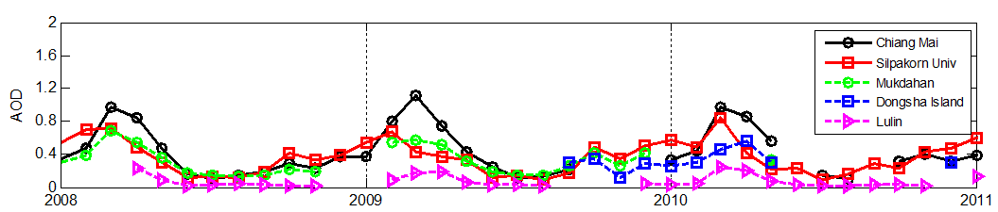 Fig. S1. Monthly variation of AOD at 500 nm for five selected AERONET sites during 2008-2010.
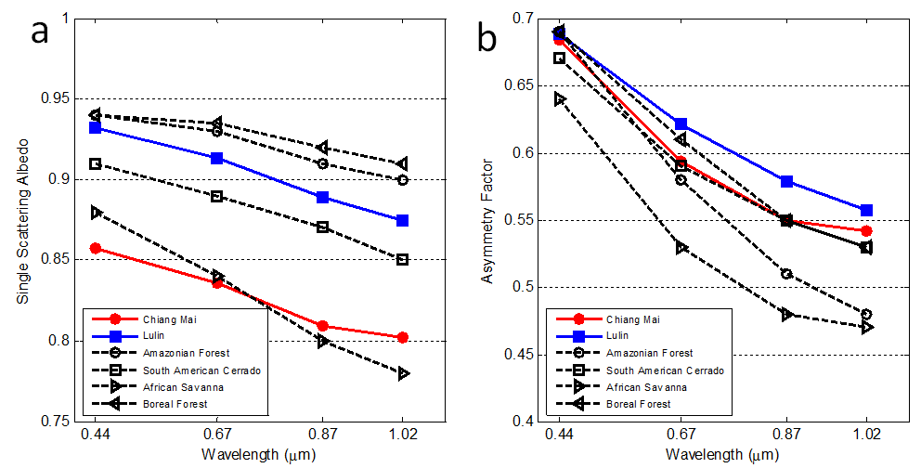

Fig. S2. The AERONET retrieved (a) ω₀ and (b) g at 440, 675, 870, and 1020 nm for worldwide biomass-burning source regions.

