Effect of Low Literacy on Password Formation Strategy as Impediment to Participation in Modern Life: Evaluation and Intervention Tutorial

by
Walter Livingston
May 2019

Presented to the
Division of Science, Information Arts and Technologies
University of Baltimore

In Partial Fulfillment
of the Requirements for the Degree of
Master of Science

Approved by ________________________________
Dr. Kathryn Summers, Ph.D. Thesis Advisor

_________________________________
Dr. Bridget Blodgett, Ph.D. Committee Member

Abstract
Despite widespread acknowledgement that they are an imperfect compromise, text passwords remain the most common method of authenticating user access to digital resources. Responsible stewardship of those resources, both for the protection of the user/accountholder, and for the protection of the agencies charged with the resources’ guardianship, has dictated that secure passwords evolve to near or beyond the practical limit for humans to compose and remember them. This thesis examines the degree to which low literacy interacts with these password requirements to create a barrier to participation in commerce and government safety net services. A tutorial video intervention was evaluated for effectiveness in creating more secure, more memorable passwords.

Acknowledgements
I would like to thank my director, Dr. Kathryn Summers for her inspiration, encouragement, and guidance on this project, and the rest of the Interaction Design faculty, for their many valuable lessons and insights great and small. Thanks also to Dr. Deborah Kohl for her help with statistical analysis in this project. Finally, I want and need to thank my wife, for her unflagging support and encouragement throughout this process, from its inception

Table of Contents

Table of Contents i

List of Tables ii

List of Figures iii

Chapter 1: Introduction 1

Chapter 2: Literature Review 2
Passwords 2
Literacy 9
Economic Benefits of Internet Access 13

Chapter 3: Methods 17
Participants 18
Materials 21
Survey of Requirements 21
Procedure 23

Chapter 4: Results 24

Chapter 5: Conclusion and recommendations 32
Appendix A: IRB Approval Letter – UB19-33 43
Appendix B Consent Form 44
Appendix C: Simulated Online Account Signup Forms 46
Appendix D: Collected Password Requirements ……..……………………………..48

Appemdix E: Screenshots of Password Requirements, Instructions and Security
Questions…………………………………………………………………………60

List of Tables
Table 1. Participant Characteristics…………………………………………………….20
Table 2. Key Findings…………………………………………………………………..24
Table 3. Complexity: Observed and Expected………………………………………….31

List of Figures
Figure 1. Password Length, in Characters………………………………………………27
Figure 2. Complexity: Observed and Expected…………………………………………30

Chapter 1: Introduction
Virtually every interaction between a consumer/citizen and what can broadly be called “business” can have a digital component. Even now, it is often still possible to engage these entities using non-digital methods; however, the ability to engage digitally has effectively become a necessity. A crucial factor to engaging in business using digital components is security. Further, ensuring access to digital content and features, but only that content and those features to which a specific user has a legitimate right, requires authentication.
Historically, the default authentication method has been the text password; experts agree that this shall remain so for the foreseeable future (Bonneau et al., 2012). Approximately 30 million people in the United States--11% of the current population of 328.9 million--have prose literacy below basic level (NCES.ed.gov, 2003); this figure represents those reading at or below third grade level. An even larger proportion read below seventh grade, the level that has been described as being “essential” to prevent severe diminishment of one’s employment prospects (Horne, 1997).
This project examines the degree to which people of low literacy face difficulty in participating in modern life as a result of passwords. The study’s participants included people 65 years of age and older, people who had not graduated high school, and people who have limited computer experience. A video tutorial was proposed for the purpose of helping people of low literacy to create more effective passwords: that is, passwords that are at once more secure and more easily remembered. Password requirements of several types of agencies were collected and were compared to the performance of research participants. Participants provided sample passwords to set individual benchmarks of pre-tutorial performance for several types of agencies; then they watched the video tutorial, after which they performed a post-test to create passwords for several other types of agencies. T-tests for statistically significant differences between pre-tutorial and post-tutorial password creation patterns were run, and recommendations made based on the results.

Chapter 2: Literature Review

Passwords
Current common password practices have two important negative impacts on people with low literacy and/or low levels of computer experience. The first impact is exclusionary--people with low literacy and/or low levels of computer experience may be unsuccessful at meeting complex password requirements; or, if they succeed in creating a password that meets complexity requirements, they may be unable to remember the password. The result is exclusionary--users in this group either cannot gain access to desired services, or cannot maintain their access to those services.
The second impact is related to security risk. The coping strategies for password creation that have been observed in people with low literacy and/or low computer experience are highly insecure (Adams & Sasse, 1999). Insecure passwords make their users vulnerable to a variety of dangers, such as direct theft of money from compromised bank accounts to identity theft, whose damage is longer term, harder to halt, and more difficult to recover from. Some victims of identity theft experience symptoms of ongoing trauma, and cyberattacks on people in the primary victim’s circle of associates (Wiederhold, 2014). Insecure passwords also pose dangers to the broader population. For example, a compromised account can become the “first domino” giving attackers a base from which to launch broader and larger attacks (Ives, et al., 2004). Attacks can take the form of self-proliferation via contacts list or gaining the owners’ confidence for socially engineered fraud. A compromised account can recruit its devices into a zombie computer network for use in staging DDoS assaults against larger targets. As the “Internet of Things” becomes more pervasive, weak passwords can leave devices open to malicious actors, with potentially catastrophic consequences (Haworth, 2018). The threat is serious enough that new laws have been passed to mitigate it (Arghire, 2018).
Historically, passwords have been part of computer security since computers began to see widespread civilian use in the early 1960s (Bonneau, 2012; A Short History of the Computer Password, 2017). Passwords identify and authenticate users: authentication is the process of determining whether a user should be allowed access to a particular system or resource (Adams & Sasse, 1999). Authenticating users is the step that grants them access; identifying them is a further step that forces accountability for content that they access, changes they make to that content, and with whom they share it (Burnett and Kleiman, 2006). The three main techniques for user authentication are knowledge-based systems; token-based systems; and systems based on biometric characteristics including iris, retina and voice patterns, fingerprints, and faces (Burnett and Kleiman, 2006). While text passwords are not the only authentication method, they are still the most prevalent (Pearman, 2017).
In recent years, some have suggested the time of, and for, passwords has ended (Carpenter and Naylor, 2016). As far back as 2004, Bill Gates predicted passwords’ demise, citing the same problems we face now: password reuse due to multiplicity of passwords (Kotadia, 2004). That belief is not held universally. In fact, Bonneau and his colleagues (2012) state that "Not only does no known scheme come close to providing all desired benefits [of passwords]: none even retains the full set of benefits that legacy passwords already provide."
In 1985, in Document CSC-STD-002-85, the U.S. Department of Defense created an early standard of best practices (Brotman, 1985). Although specific practices have evolved since then, they declared in that document the underlying needs and rationales that underpin what has come to be called identification assurance.
To protect the assets of an institution that stores information for people or organizations, the key to securing and controlling that information is controlling access. This means only allowing access to persons who should have access, and allowing those people access to only the information for which they have legitimate permission:
"Individual accountability is the key to securing and controlling any system that processes information on behalf of individuals or groups of individuals. . . .The first requirement is for individual user identification. Second, there is a need for authentication." (Brotman, 1985).
This is to say that only the right people are allowed “in”, and that of those allowed in, that the organization is to be certain they are who they say they are.
That 1985 publication decrees machine-generated rather than user-created passwords; in 2019, that seems draconian, as well as being (at least in a casual civilian context) doomed to failure. This is because when users are burdened with onerous security procedures, they behave in insecure ways (Adams & Sasse, 1999). In their landmark work, Adams and Sasse (1999) reported users sharing passwords; writing passwords down; creating weaker, more easily remembered passwords; and reusing or effectively reusing passwords. One example of reuse would be when a user increments an appended digit: pass2, pass3, pass4, and so on. Reasons for such behavior vary, but decades of thoughtful study of this phenomenon point to a consensus that many users have an underappreciation of the value of the assets being protected, have an underappreciation of the power of attackers, and are lacking a motivation to behave securely (Butler & Butler, 2018; Herley, 2009; Gaw & Felton 2006; Adams & Sasse, 1999).
Recently, researchers have turned their attention to revision of password length and complexity requirements to effect increases in security and usability (Shay, 2014), with the same needs that guided previous policies, but with greater usability built in. Pursuit of the ideal balance between usability and security has resulted in evolution of specific practices; in June of 2017, the National Institute of Standards and Technology (NIST) released Special Publication 800-63, a major revision of password guidelines. The new guidelines are easier on the user, but the goals and reasoning remain unchanged:
- Give instructions on how to use an authenticator
- Have backup procedures available
- Write instructions at 6th-8th grade level
- Use easily legible high contrast writing; sans serif for screens, serif in print
- Give option for visible (unmasked) text entry
- Give clear feedback on errors
- Allow enough attempts; long complex passwords increase likelihood of error
- Recognize that small form factor devices increase chance of entry error
NIST shows users a path to better security because of better usability (Garcia, 2017). Similarly to the mnemonic devices offered in the tutorial devised in this project, users are encouraged to leverage their powers of association, and rather than complicated but unassociated passwords, they should instead use memorable passphrases. In the pursuit of usability, some have noted performance decreases with increased cognitive load (Mujeye & Levy, 2013) and have proposed several alternatives, including narrative (Hoover, Werner & Cohen, 2014), and biometric components (Bhagavatula et al, 2015). Prabhakar et al. (2003) considered several biometric authentication schemes and noted that these methods were still quite a way from supplanting passwords.
Among the alternatives to conventional passwords, Bonneau et al. (2012) evaluated 11 types. Of those, password managers, graphical, SMS-based two-factor, biometric, and recovery are the most frequently encountered alternative authentication schemes likely to be experienced at the level of the consumer user (Bonneau et al., 2012). The others are unlikely to be encountered by persons of low literacy.
While current approaches to security are built predominantly around responses to what is dismally regarded as the inevitable breach, the future must be built around prevention. A high 63% of confirmed data breaches are the result of weak, stolen, or default passwords (Verizon, 2017). Historic and current practice look at user authentication as a binary transition from unknown to trusted, using a password; the future may be a more holistic idea of identity assurance, in which a user's identity is verified by several contextually interrelated considerations, such as historic patterns of use, geographic origin of the authentication request, type of device, and individually specific device, etc. Instead of a single point and moment of entry, as if walking through a door, users' identities will be repeatedly confirmed in small, relatively unobtrusive ways that will soon become second nature to them. These methods will likely be an amalgam of password, biometric factors, and soft tokens, commensurate with the level of service or information a user seeks (Zhao et al., 2017; Carpenter and Naylor, 2016). In contrast, Balthrop’s proposal of email or text-based two-factor authentication seems the more easily practicable, and in fact is in place with several services, though passwords have lost no ground (Balthrop, 2014). His scheme may yet exclude low literacy users, however, because the overlap between poverty, advanced age, and low literacy could lead to instances of a person who doesn’t have a mobile phone, or who might be unable to access email.
Non-text based methods will be especially important to password security, as they provide protection against unwanted observation when performing sensitive tasks such as banking by phone in public spaces (Bianchi et. al, 2011). Certain biometric user authentication methods, such as fingerprint scanners and face recognition on cell phones, have become not only convenient enough, but also inexpensive enough, to implement that their uses are becoming commonplace in consumer devices. However, even these methods are not impossible to spoof, and, unlike text passwords, biometric characteristics cannot be changed or reset (Prabhakar et al. 2013). For the purposes of this study, the obvious attraction is that by not being text based, these methods will likely pose less of a barrier to people who have low literacy when they seek access to and easy navigation of cyberspace. These boons do not come without risk, however. The question rises organically: “who monitors the monitors?” There is potential for significant and irrevocable damage to, and by individuals and corporations in the breach to the security of biometric data that history shows is probably inevitable, whether victim or malefactor. It is also possible—even likely—that for-profit companies could misuse their access to consumers’ biometric data.
In their 2001 study, Sasse et al. recognized the limits of working memory in coping with multiple passwords in an enterprise setting. Single Sign On (SSO) was one solution that they offered which, from the user’s view, operates much like what are now password manager apps. The user authenticates once, with one password (possibly in conjunction with other guarantors of trustworthiness) and is then granted access to the systems she needs. Indeed, studies over several decades show overwhelming and ongoing consensus that humans remain the weak link in the security chain; the best, most sophisticated security measures are for naught if people aren’t told about them, don’t engage them, don’t use them correctly, or intentionally defeat them (Adams & Sasse, 1999; Burnett, 2006; Weiderhold, 2014). A further barrier to user access are the additional complications that some providers require. Examples of the burdens some banking users can face, according to Mannan and van Oorschot (2008), is the stipulation that users install and maintain a firewall as well as anti-virus and anti-spyware programs on their own. It appears that banks oversell the ease and convenience of online banking; at the same time, they may gloss over the robust security measures customers need and may even be required to use to protect themselves, and for which the bank will hold them responsible. These measures would likely be challenging for anyone, but are especially so for a person of low literacy; this impact is exacerbated if the terms are presented unobtrusively, in small print, and in language pitched to a higher-than-average reading level.
Adams & Sasse's oft-cited study (1999) discusses the near impossibility of balancing the competing needs of usability and security. Passwords can become a barrier to users if the conditions for use approach or exceed a user’s ability to create, remember, or enter it. This can be especially problematic for lower literacy users. Medhi et al. (2011) report that in tests of online banking and health sites, lower literacy users’ performance proficiency was so badly impeded that none of the least skilled were able to accomplish anything at all on a mobile device using a text interface. This may be especially problematic for some people of color, as there is a sizable population of Blacks and Latinxs--who are more likely to be poor, which, in turn, makes them more likely to have low literacy--for whom mobile phones are their only access to the internet (Livingston & Livingston, 2014). Difficulty is further exacerbated by the cognitive tax levied by the changes in screen depth necessary to input the special characters many websites require (Greene et al., 2014). Greatest success was found using a graphical interface; correspondingly, task performance was worst with text, when both input method and output methods were least flexible. Further, a high correlation has been identified between low literacy and having novice level technological experience, as well as a high correlation with poverty, as is consistent with prior research (Comber, 2014). Some of the performance inhibition created by technological unfamiliarity could be mitigated by hour-long training sessions. Still, Medhi reports that in some instances, novice users had to be prompted to even press keys, as they were were afraid to "break” or “spoil” the phone.
In discussions of passwords and security one serious issue invariably emerges: reuse of passwords to cope with the large quantity of password accounts. Multiple password interference occurs when users must remember passwords for many systems, and when the memories of the different passwords interfere with each other (Chiasson et al., 2009). Usability and security compete in a battle ultimately decided by the user, and invariably in favor of usability. Reuse of passwords is well documented as the single most common password-related user error. Most security experts writing on this topic recommend combating password fatigue by using a password manager (Barrett, 2017). The benefits are that it permits a user to generate and store truly strong, truly random passwords. Password managers work across platforms, so a user can login securely on phone, pc, and tablet; password managers also store security questions, and some even store credit cards and other such information. The single biggest technical drawback is that a password manager can present as a single point of failure, although forgetting the master password means a user will have to go through password reset on all of the encrypted passwords at each of their sites, as well as with the password manager itself. Barrett mentions occasional hardware incompatibilities as a problem; however, the biggest major negative is user reluctance.
Barrett’s finding is confirmed by participants’ comments in the current study. Participants were asked how likely they would be to use a password manager in the future. Two participants responded that they would consider it; however, their nonverbal cues indicated otherwise. One user explicitly and emphatically stated that he would not be using a password manager going forward; instead, he preferred to rely on his current insecure habit of using a single password, even after discussing his objections. Users having faulty understanding of the password manager led to distrust (Chiasson, 2006).
Government policy has evolved since 1985's DoD Password Management Guidelines: the 2018 version (Grassi et al.) reverses some of the most draconian demands of the 2003 edition, including the requirement to change passwords at regular intervals. Overall, the broadest consensus on best practices among security professionals is to use a password manager and long text strings composed of memorable elements. Support for use of non-alphanumeric characters and various change intervals is less monolithic but never contraindicated if done at the user’s choice.
Butler & Butler (2014) looked closely at the kinds of errors made by specific groups of users. What they found was consistent with the single biggest point of consensus in previous research: the more accounts a user has, the more likely it is that password fatigue will set in and the user will resort to reuse of passwords. This is in line with the industry’s single most frequently advocated tactic for coping with the multiplicity of passwords required by modern life: use of a good password manager.

Literacy
Reardon et al. (2012) define literacy as "the ability to access, evaluate, and integrate information from a wide range of textual sources" (p. 18). Their study found that by third grade, most children are able to recognize letters and sound out words; however, at that level, reading for comprehension, which depends on integrating context and background knowledge, is less common. While reading, vocabulary, and analytical skills all continue to grow, the speed with which these new skills are added slows dramatically after the eighth grade. Only about a third of middle schoolers have the knowledge-based skills to read at the level of being able to incorporate knowledge-based competencies such as “demonstrating an understanding of the author’s style of cueing the reader in, and making connections between a problem in the narrative and related real-life experiences” (Reardon, 2012). Low literacy, then might be broadly described as reading below the level of late middle school--sixth, seventh or eighth grade (Bennett, 1998). The disadvantages of lower literacy may even linger and remain evident in persons who have failed to obtain a high school diploma or GED. This is not sufficient for participation in the modern economy.
A settled, authoritative definition of “low literacy” is elusive: in a paper titled “What Does Low Literacy Proficiency Really Mean?” (OECD, 2016), the authors answer that literacy is: "the ability to understand, evaluate, use and engage with written texts to participate in society, achieve one’s goals, and develop one’s knowledge and potential" (p.1 ), leaving a reader to extrapolate a definition from the negative space remaining. The authors go on to report a number of connected positive implications that better literacy has, both for individuals and for the societies in which they live, including lower unemployment and better wages when they are employed. People with higher literacy are more likely to report being healthy, volunteering, trusting others, and believing that people like themselves could have a say in government. Morgan, et al. affirmatively and explicitly claim that low literacy is reading at or below third grade level. (Morgan, et al., 2017)
Horne uses the term “employability literacy” to refer to the skill level below which a person’s likelihood of participation in the workforce is adversely affected. The functional abilities gained by seventh grade have been suggested as a bare minimum of this measure (Horne, 1997). Low literacy, then, might be defined by a specific level of educational attainment, but also in terms of function, specifically, a person’s suitability or perceived suitability for employment. The minimum reading proficiency standard for a child in sixth grade is the ability to interpret meaning in short, simple texts, by matching words and phrases completing a sentence; practical applications of mathematics were benchmarked as well (UIS-UNESCO, 2017).
Horne finds that persons with lower literacy are excluded from much of life. Lower literacy is associated with more frequent unemployment, and with lower wages when employed. They also found secondary social effects of lower literacy, such as poverty and its attendant ills, "including some social conditions associated with poverty, i.e., low birth weight babies, high infant mortality, child death, high teen violent death rates, large numbers of high school dropouts, high rates of teen pregnancy, and crime"
(p. 12). They cited secondary costs to the state and communities in the year prior to the report of $495 million per year in AFDC and food stamps, as well as a prison population of 20,000, costing $200 million per year, and rising by 1000 new prisoners per year. Finally, they found tertiary costs to the state, in the form of increased reliance on government assistance, and making the state less attractive to new business. Even the mere perception of a workforce with low literacy--whether or not it was verified--had a significant negative effect on a corporation’s decision whether to relocate to an area--in their case, the state of Alabama, but it would seem reasonable that a corporation would come to the same decision if the same factors were in place for any other locale (Horne, 1997).
Summers reports that lower literacy users may have an especially narrow field of view, forcing readers to consume cognitive resources just to process text, and making them less able to remember what they have just read, or to recognize cues for what may be coming (Summers, et al., 2014). This kind of cognitive tax that results from a narrow field of vision is compounded in low literacy users with lower working memory, as they are less able to form and remember passwords because of reduced ability to “chunk” information. They are further penalized because they have more errors and longer response times (Daneman & Carpenter, 1980), resulting in delays and frustration, possibly preventing timely access to a needed service or even freezing an account. This could be particularly problematic if it occurred outside of help desk hours of operation.
Low literacy Proficiency was determined in adults scoring at or below Level 1 on PIAAC’s 1-5 scale, based on number of errors made and time used to complete tasks in Vocabulary, Sentence Processing, and Passage Comprehension (OECD, “What Does Low Proficiency in Literacy Really Mean?” 2016). This is consistent with other research, tying lower literacy to smaller working memory (Daneman & Carpenter, 1980).
The National Assessment of Adult Literacy reported that low literacy is linked to greater rates of hospitalization and less frequent use of preventative services. According to the U.S. Department of Health’s Office of Disease Prevention and Health Promotion (ODPHP), low [health] literacy is highest among "older adults, racial and ethnic minorities, people with less than a high school degree or GED certificate, people with low income levels, non-native speakers of English, and people with compromised health status" (ODPHP, 2013). The same source also indicated that low literacy was also associated with higher healthcare costs. In addition to poorer access to health information, people of low literacy delay seeking treatment because screening and detection programs are in written form, and/or written at a higher level than a patient can read (Shalowitz & Wolf, 2004; Bennett et al., 1998).
Despite having some "reading" skill, weaker readers are often hampered by a smaller working memory capacity, effectively forcing them to read with tunnel vision (Daneman & Carpenter, 1980). Alternatively, when passages become difficult or dense, they skip words and even whole sections of text (Office of Disease Prevention, 2016). When they perceive the material to be of critical importance, they read one word at a time, making it harder to remember even the beginning of the material they had just completed, with a resulting loss of comprehension. In addition to skipping material, they often focus on the center of the page, making it highly likely that they may miss instructions included at the top or sides of the page or screen (Nielsen, 2005; Summers et al., 2005). Consequently, they may demonstrate more problems in creating effective passwords because of this difficulty understanding instructions, or keeping instructions in memory long enough to put them to effective use (ODPHP, 2016). Zarcadoolas, Blanco, Boyer, & Pleasant (2002) similarly point to the “digital divide”, noting interplay between sociocultural factors and actual cognitive and mechanical skill deficits: these are factors which increase the difficulties that lower literacy persons experience when they engage in online activity (Zarcadoolas et al., 2002; Rinn et al., 2015).
Observed behavior in the study at hand strongly concurs with these findings. Initial expectation was that each simulation would take approximately one minute, for a total engagement of between 15 and 20 minutes with each participant. In practice, just typing the characters proved to be a significant impediment for participants. A participant in Baltimore used only one hand to type, despite being observed using both for other relatively dextrous activity. Several other Baltimorean participants appeared hesitant and uncomfortable with the keyboard. A participant in UK experienced visual difficulty, as well as problems typing. Even a comparatively high-functioning participant in California reported an expectation that a given password would be too difficult to remember, and consequently incorporated use of password reset procedures into his usual creation strategy. Each of these people had unrestricted access to ICT (Informational & Communications Technologies) equipment that they owned, but they all experienced challenges that cannot be overcome by simply adding more technology; rather, any technology introduced will need to consider their physical and cultural difficulties during design (Shneiderman, 2001). Warschauser offers that “[w]hat is most important about ICT is not so much the availability of a computing device or the Internet line, but rather the people’s ability to make use of that device and line to engage in meaningful social practices.” In this way, low literacy users are hampered in their ability to benefit from internet access (Warschauer, 2002).

Economic Benefits of Internet Access
On the subject of a digital divide, Hilbert (2011) explores the topic through an explicitly gendered lens, finding that while much of the prior research consulted showed women's ICT use seriously lagging behind the men of their countries, that was only before controlling for (the usual) confounding variables associated with gender gaps. It was necessary to create a new category, "women on equal footing", in whom, when the factors of employment and enrollment in higher education were controlled (separately) women were the more frequent users of internet and mobile phones, and to greater efficacy. These findings raise an eyebrow when considering widely held assumptions about gender division in use of technology and the internet, especially in the developing world.
Yardi & Bruckman (2012) report that people with low socio-economic status (SES) are more likely to rely on mobile phones than on computers for their internet access, but that internet use in these households tends to focus on entertainment and social connection, rather than on work, job searching, or commerce. This focus may be a product of the services and products available in 2012. Abel et al (2018) concur, at least in the degree to which lower income homes are phone dependent: they found that low-income households are much more likely to rely on their mobile phones as their sole access to the internet, and very likely to use them for vital activities like searching for jobs, submitting job applications, researching housing and government services. There is a significant overlap among groups likely to have low literacy and groups who are smartphone dependent (Abel, Mutandwa, & Roux, 2018). Writing for Pew Research, Perrin corroborates the cell phone’s role as digital chokepoint, stating that 12% of adults report that their cell phones are their only way to access the internet (Perrin, 2016). Anderson and Kumar, also for Pew, state that in early 2019, only two years later, that for 26% of adults with cell phones living in households below $30,000, there was no broadband access at home (Anderson & Kumar, 2019). They note that despite their smaller screens, in these households smartphones are still the sole method of accessing the internet, which forces them to serve as the conduit for all things internet, including job searches, queries for health information and entertainment (Anderson, 2015).
Yardi & Bruckman (2012) also suggest that as the United States approaches minority majority composition, and ICT use is no longer the exclusive province of the comparatively wealthy, it will be necessary for Human-Computer Interaction (HCI) designers to consider the needs of consumers with a broader range of class, income, and culture. Yardi and Bruckman themselves note that their observations were likely affected by race, income, and class. In their comparison of several households, all categories of users preferred devices of their own over sharing them with family members, and in families of low SES, members are more likely to share devices. Despite the perceived benefit of that being that it is easier for those parents to monitor and regulate children's internet and communication activities, this also brings with it lowered security based on possible password sharing.
In reviewing literature on the economic value of internet connection, one must consider the so-called "Digital Divide" as it is historically depicted in terms of comparative access to equipment and infrastructure. On another level, it is also described by sociopolitical grouping including individual households, cities, states, or regions. Ștefăniță, & Ivan (2018) lay out four approaches:
- outright denial that such a thing exists
- "growth" which holds that internet is just another inequality determined by social differences
- the "disappearing digital divide"
- "digital differentiation."
The digital divide once meant unequal access to hardware and infrastructure; Stefanita & Ivan (2011) propose a social digital divide wherein internet use and the value derived from it are the result not only of people’s access to ICT hardware and line access, but also of their social and educational positioning to make use of them. This aligns with Schradie as well as Hilbert. Schradie finds that class dominates, and is bundled with income, information habits, "ownership" of devices, high level access and the freedom to make use of them, and going hand in hand with education, determines the degree of benefit one derives from, and contributes to the internet world.
Investopedia describes financial inclusion thusly:
"Financial inclusion is the pursuit of making financial services accessible at affordable costs to all individuals and businesses, irrespective of net worth and size, respectively. Financial inclusion strives to address and proffer solutions to the constraints that exclude people from participating in the financial sector It is also called inclusive financing." (Grant & Kagan, n.d.).

Nanda et al. provide this definition of financial inclusion:
"Financial inclusion is where individuals and businesses have access to useful and affordable financial products and services that meet their needs that are delivered in a responsible and sustainable way. Financial inclusion is defined as the availability and equality of opportunities to access financial services."
Abel, et al. are substantially similar in their definition, putting more specific emphasis on the kinder, pro-social aspects:
"...financial inclusion can be defined as the process of bringing the weaker and vulnerable members of society into the ambit of an organised financial system which ensures that they access timely and adequate credit and other financial products at affordable price" (p. 1).
They declare that "internet connection has a positive and significant impact on financial inclusion. This means that as internet connectivity increases in the country, the majority of people become financially included" (Abel, Mutandwa, & Roux, 2018). Abel observes that individual costs are reduced by reducing the distance one must travel to access services, and also notes that Zimbabwe, where the study was conducted, has seen a preference for online banking due to a scarcity of cash, as is typical of economies with less cash. Reducing or eliminating the need to travel or to be physically present effectively multiplies an individual’s power and ability to participate more fully in the economy as a more well-informed consumer; this is largely because of that person’s increased access to product information and price comparison, or to a greater ability to seek work (Abel, Mutandwa, & Roux, 2018). Abel goes further than other writers on this topic, stating that despite lack of a universal agreement on a single definition, "Financial Inclusion" means affordable access to money, credit and financial products, broadly. Such access, however, is an affordance only if and when the consumer can effectively log in to the service following the password and authentication constraints.
Internet access facilitates fuller participation in the global economy, with beneficiaries all along the chain: developing nations see a rise in creditworthiness (Federal Reserve Bank of Dallas et al., 2007); banks find mutual benefit when they attract and convert remitters to fully banked customers, as well as creating employment opportunities (Njau,2013). For any of these potential gains to materialize, though, people must be able to authenticate themselves and access available digital resources. Perhaps, then, the economic benefit of internet access to the less affluent end of the socioeconomic spectrum, where persons of lower literacy tend to be concentrated, can be seen as a blend
of direct income benefits and indirect benefits. These can take the form of access to information that can save money, such as price comparisons, or create access to money by learning of, and applying for government benefits, or time saved by being able to learn of, and apply to, jobs more easily.
As this brave new world rises and continues to take shape, there are substantial potential benefits available to users, including ability to bank remotely and ability to leverage available information to make fuller use of bank and financial products. Perhaps the greatest benefit is a diminished need for physical presence for certain transactions; a rise in password protected transactions increases the need for passwords that can be deployed with confidence and convenience.

Chapter 3: Methods
This study was a small-scale, within subjects, mixed methods study. Both qualitative and quantitative data were collected. Password requirements were collected from 207 websites, including banking, shopping, health care, and government benefit services. Observational data were also collected from 16 participants. Qualitative data were used to revise and refine the password tutorial. Relevant qualitative observations are also provided in the results section. Quantitative analysis of passwords created before and after the tutorial was also performed.

Participants
This study had 16 participants, ranging in age from 29 to 85. Participants were adults with low literacy, defined as: age 18 or older and having never completed 12th grade, or over 60, or self- reported as deficit in internet and computer use skills. Senior citizens were recruited from direct acquaintances and their acquaintances, out to the fourth degree, using what Biernacki and Waldorf called snowball sampling (1981). Participants were told that they were "helping with research about how people use computers." Table 1 lists participants and characteristics. Participants were rated 1 to 3 based on observed computer familiarity and skill. The participants who were rated below 1 had never created a password before, or had last created a password longer ago than they could remember. They required assistance with every aspect of computer interaction, including use of keyboard and mouse, e.g. use of mouse buttons and shift key to input uppercase letters. To prevent frustration from making them unwilling or unable to continue, they were allowed to use a helper as a scribe. They did not understand the idea of passwords at the outset. Participants rated 1 required assistance with scrolling, location and engagement with form fields, use of shift key. Some were unfamiliar with screen size controls, and were unable to toggle between screens. They were able to interact directly with the computer, with much less need for assistance, though haltingly and slow. Participants rated 2 exhibited basic competence, and were able to manage standard operations, , but still needed help when using unfamiliar programs. Level 3 participants were relatively skilled, despite their age or low REALM score. One user reported setting up passwords for other users as part of his employment; another having been involved in computer security in the job from which she had retired. The third was a 71 year old frequent user of multiple institutions and even before the tutorial video created “mangled” passwords, e.g. “F15hc4ke+!”, without prompting from the researcher. The participants are described in Table 1.

Table 1
Participant characteristics; names are fictional
User | Age | Sex | observed computer familiarity | Literacy (years of school) | REALM score
Gary | 63 | m | 1 |  | 53
Henry | 60 | m | 1 |  | 43
Annabel | 65 | f | 3 | 12+ | 66
Irving | 42 | m | 1 | 8 | 60
Jimmy | 46 | m | 3 | 11 | 66
Blanche | 85 | f | 1 | 12 | 65
Kevin | 71 | m | 3 | 11 | 66
Carlene | 44 | f | --- |  | 60
Louis | 29 | m | ---
Manny | 60 | m | 2 |  | 43
Ned | 31 | m | 3 |  | 54
Delaine | 75 | f | 1 | 8
Oscar | 75 | m | 1 | 8
Eleanor | 60 | f | 2 | 12+
Francie | 85 | f | < 1
Pete | 71 | m | < 1
Average age | 59.4 | 10m/6f

Materials
The project was a semi-automated series of four Google forms, in which participants demonstrated their password creation patterns before watching a short video tutorial showing how and why to make better passwords and use more secure password related behavior. Following the video, there were four more sample pages to practice and demonstrate new password creation strategies. Participants created passwords on eight Google forms made up to simulate creating accounts at various types of online services (Appendix C). These pages were all linked to a Google sheet: this permitted use of pre-existing programming and analytic software, as well as providing a modularity that allowed for rapid, on-the-fly customization in response to feedback from participants.
The tutorial consisted of a narrated slideshow which reflected a good faith effort to impart best user practices for security and memorability. Initially the slideshow was 10:42 minutes long. While user response to early pilot testing of the slideshow was positive, additional review of design guidelines, particularly with attention to low literacy readers, prompted substantial revisions including switching to sans serif typeface, revising for even shorter, simpler word choice, and certain artwork. These improvements were guided by the work of Colter and Summers (2014), and ODPHP (2016). Substantive content was gleaned from review of the relevant literature (Bonneau et al., 2015; N.I.S.T.). Some users exhibited nonverbal signs of frustration with the length and pacing of the video, like that observed by Mackert, et al. (2009). Two testers actually fell asleep during testing. Therefore, certain points were made less exhaustively, and the pace of the narration was substantially sped up. As a result of these changes based on both implicit and explicit feedback, and on further review of literature, the slideshow’s final run time is just over six minutes. Two female participants commented on the vocal timbre of the narration, so vocal pitch was raised to avoid distraction.

Survey of Requirements
Password requirements data were collected from a total of 207 sources:
- 17 large banks
- 4 nationwide major health plans
- Supplemental Nutrition Assistance Program (SNAP) signup in the states whose programs had online signup and generated a password protected account,
- Healthcare.gov signups for all 50 states
- large cities offering assistance and social services to residents that require a password protected account
- top online retailers as listed by National Retail Federation and augmented by RIS (Retail Infosystems).
These were selected because they represented a broad cross section of “value” to users, and at a broad level of real and perceived necessity. It was also suspected that the agencies themselves would collectively within their classifications impose different levels of rigor of authentication, based on their own needs, as well as the damage and penalties possible in event of error. The wrong customer claiming an unearned free soft drink is trivial; an unauthorized party benefiting from a fraudulent $5000 online banking transaction is a disaster in direct losses, punitive measures and reputational damage.
Banks were generally responsive to inquiry into password requirements until approximately September of 2018, when they became almost universally reluctant to divulge even the most basic information: minimum character count; maximum character count, if any; and number of required character sets (Uppercase, lowercase, numeric and special characters, and whether all keyboard characters were valid or only a subset). At no time was it possible for a non-customer to explore online account creation at any bank or health plan without speaking to a human customer service agent.
While banks and health plans were guarded about their password requirements, government sites were more forthcoming, and were largely self-service. In most cases, requirements were posted openly, and in explicit, if occasionally confusing language. Healthcare.gov sites had a high degree of uniformity in requirements, particularly among Republican-controlled states, which had closed down open enrollment. Democratically-controlled states were much more likely to refer an applicant to a state-specific portal. Of all categories investigated in this study, retailers were the group that had the loosest procedures of any category, in that they required fewer characters and fewer character sets in a password; they also much less frequently set an upper limit on the acceptable length of a password.
While not strictly bearing on this project, data was also collected regarding number and character of security questions, guidelines for username creation, supplemental information on institutions' progressive password strength bars, and examples of porosity of various sites' security procedures. This information was gathered to help gauge whether low literate people might be able to successfully use a site even if not immediately on direct approach, and how costly failure might be to them.

Procedure
During each session, a participant created passwords for four mock websites, then watched the password tutorial. After the tutorial, the participant created four more passwords, on similar mock websites. The simulated websites were labeled as employment; state services; school registration; vehicle registration; banking; health care; public utility; and shopping)
Observational data was collected in several similar settings:
- in University of Baltimore's Usability Lab, with participants seated at a computer, and observed, with their knowledge and consent through a one way mirror
- recorded on their own computers, in their own locations, in Berkeley Springs, WV; Davis, CA; Detroit, MI; Geneseo, KS; Myrtle Beach, SC; and Thetford, UK.
Except for one participant who used a tablet, all users were seated at desktop computers. All remote sessions were conducted using Zoom teleconferencing. Following the simulations, participants spoke with the researcher in brief interviews answering questions about what they had learned, if anything; what they found helpful; and if they had any suggestions for how to improve the presentation.

The mock passwords generated were analyzed for length and complexity, measured by how many character sets (uppercase, lowercase, numerals and special characters) were used on any given attempt.

Chapter 4: Results
This was an investigation into the degree to which people of low literacy are excluded from modern life as a result of password requirements. The study also explored whether a simple, educational intervention might improve password usability and security for this demographic. Participants’ initial and post-tutorial password creation results were compared with real-world password requirements typical of banks, healthcare services, online retail companies, and government benefits websites. Collected password requirements are listed in Appendix D. The key findings are presented in Table 2.

Table 2
Key findings.
User | Prevideo mean password length | Postvideo mean password length | Difference of means (length) | t Test (length) | Prevideo mean character sets used | Postvideo mean character sets used | Difference of means (charsets) | t Test (char sets)
Gary | 18.75 | 19.5 | 0.75 | 0.009 | 2.75 | 2.5 | 0.25 | 0.014
Henry | 9 | 9 | 0 |  | 2 | 2 | 0
Annabel | 11 | 11 | 0 | Critical t for 15 df | 3.75 | 3 | 0.75 | Critical t for 15 df
Irving | 8.5 | 13 | 4.5 | 2.13 | 1.5 | 3.5 | -2 | 2.13
Jimmy | 10 | 18.75 | 8.75 |  | 4 | 3.75 | 0.25
Blanche | 7.5 | 9.5 | 2 |  | 1.75 | 1 | 0.75
Kevin | 6.75 | 9.25 | 2.5 |  | 2.75 | 4 | -1.25
Carlene | 12.25 | 17.25 | 5 |  | 1.5 | 2.75 | -1.25
Louis | 9.5 | 12 | 2.5 |  | 1.75 | 3.75 | -2
Manny | 9 | 11.5 | 2.5 |  | 2 | 4 | -2
Ned | 10 | 10 | 0 |  | 1.5 | 2 | -0.5
Delaine | 8.5 | 13 | 4.5 |  | 2.25 | 3.25 | -1
Oscar | 10 | 9.5 | -0.5 |  | 2.5 | 3 | -0.5
Eleanor | 9 | 11.75 | 2.75 |  | 3.5 | 3.75 | -0.25
Francie | 14.75 | 10.5 | -4.25 |  | 1 | 1.5 | -0.5
Pete | 10.25 | 17.5 | 7.25 |  | 2 | 3 | -1
Average | 10.3 | 12.69 | 2.39 |  | 2.28 | 2.92 | -0.64

Participant password creation strategies were compared using a t test. Pre-tutorial password creation strategy echoes Bonneau's observations (2012), specifically that users tend to create passwords that are short, and they tend to avoid using non-alphanumeric characters unless prompted.
Based on minimum lengths and complexity requirements, it appears that government benefits sites present a nominally higher bar to people of low literacy than average. While Table 2 shows the most important findings, it must be said that there is considerable variation among websites, not only in actual requirements, but also in clarity of instructions and presentation. Average password length before the tutorial intervention video was 10.30 characters per attempt. Within these attempts, on average, users engaged 2.11 character sets out of 4 possible. The four character sets are uppercase letters A-Z, lowercase letters a-z, numbers 0-9 and special characters--the remaining printable typewriter characters. Across the four pre-video simulations, character set engagement ranged from a low of 1.94 character sets (DMV) to a high of 2.5 (Employment). Because these were all simulated logins, it is unlikely that the label attached to any given simulation made a material difference to the password created for it, though there may have been allusion to the type, e.g. “Connectmeup” for public utility. After watching the video, there were large increases in all password attributes measured, but none of the increases were statistically significant. Mean character count rose from 10.30 to 12.69, or 23.20%. Of particular note was that use of special characters rose from 19.95 to 58.46, a gain of 193.03%. In the exit interviews, when asked whether they had learned anything from the video, several users stated that they had learned, or been reminded of the availability of the special character set.
There were noticeable patterns of password formation strategies among the users, but seemingly without correlation. They were also sharply divided in their apparent benefit from the tutorial video. Three of the 16 used the exact same password from start to finish. Two of these were among the higher skilled users; the other was among the lowest. Two appeared to take the project seriously; the other appeared to be only interested in collecting the incentive. At the other extreme were Irving, Jimmy and Louis, all of whom made immediate changes to their strategies, in favor of mnemonic methods described in the video. Delaine and Oscar also improved in the same ways—longer passwords, with greater complexity, and use of mnemonics from the video, but their initial efforts were already closer to that point. Jimmy had used the same password for his first four attempts; Irving had used the first names of family members, and only used one character set. Gary also used names of family members; but spelled out completely as emails. Eleanor stood out as the lone user whose passwords were sensible to her but were without immediately discernible meaning to an external observer without knowledge of her life. Finally, most users showed strong, though not exclusive preference for passwords rather than authenticating phrases.
Initial expectation was that each simulation would take approximately one minute, for a total engagement of between 15 and 20 minutes with each participant. In practice, just typing the characters proved to be a significant impediment for participants. A participant in Baltimore used only one hand to type, despite being observed using both hands dexterously for other relatively precise tasks. Several other Baltimorean participants appeared hesitant and uncomfortable with the keyboard. A participant in UK experienced visual difficulty, as well as problems typing. Even a comparatively high-functioning participant in California reported an expectation that a given password would be too difficult to remember, and consequently incorporated use of password reset procedures into his usual creation strategy. These observations are reasonably foreseeable within the scope of the work of ODPHP (2016), Zarcadoolas et al. (2002), and .Daneman & Carpenter (1980). Each of these participants had unrestricted access to ICT (Informational & Communications Technologies) equipment that they owned, but they all experienced challenges that cannot be overcome by simply adding more technology; rather, any technology introduced will need to consider their physical and cultural difficulties during design (Shneiderman, 2001). Warschauser offers that “[w]hat is most important about ICT is not so much the availability of a computing device or the Internet line, but rather the people’s ability to make use of that device and line to engage in meaningful social practices.” In this way, low literacy users are hampered in their ability to benefit from internet access (Warschauer, 2002). 1
The participants in this study began slightly above the 6-8 character count range Bonneau reported. That may be due to Bonneau’s study having been done only two years after the advent of widespread use of smartphones. Seven years later, smartphones are no longer esoteric, but standard--and they have penetrated deep into less well-served markets. This study observed that on average, government agencies require 8.56 characters, as compared to 8 characters for non-government agencies for a difference of 0.78 standard deviations (See Figure 1)
Figure 1. Password Length in Characters

Government agencies required use of 2.76 character sets, vs. 2.39 in non-government agencies, for a difference of 0.40 standard deviations. While these differences are not statistically significant, nor is the difference trivial. Passwords for government sites may be somewhat more difficult for low literate people, or people with multiple concurrent complications, such as age, vision or dexterity issues.
Many subjects also experienced a sense of increased confidence and empowerment concerning password creation and use after watching the tutorial, as corroborated by interviews after the final set of passwords were created. As borne out by the quantitative data, the most frequent comment was that heretofore, many participants had been unaware 1) that special characters were permissible, or had not thought to include them in the passwords that they created; 2) that increased password length made for more secure passwords; or 3) that password security increased with each additional character set. Other frequent positive declarations by participants were appreciation for specific new mnemonic strategies, such as creation of fanciful emails or ersatz phone numbers as a method of “chunking” to reduce cognitive load, even as overall password length and actual complexity increased.
However, most of the participants were unconvinced, or even hostile, toward the use of password manager apps/programs, even after the researcher explained the likelihood of password re-use and the attendant dangers. Given the ongoing proliferation of internet accounts, two groups will likely emerge. One group will use password managers; the other will continue with insecure password behavior, such as re-use or near re-use of minimally compliant passwords, e.g. B@ckhand2, B@ckhand3 B@ckhand4 etc. Participants’ objections came from several directions. Their objections centered most frequently on cost concerns, even after reassurance that several free password managers are available. Participants had additional concerns, including perceived inconvenience of password managers; a further fear expressed by participants was distrust of either the apps themselves or of companies that have access to participants’ passwords. California participant Jimmy specifically cited the inconvenience of changing all of his passwords to more secure ones: “I like the idea of a password manager...but of course the problem with passwords isn’t passwords...it’s changing and remembering passwords. [his emphasis]” Even in face-to-face debrief, Maryland participant Henry said he was unlikely to abandon his current habit of writing his passwords down; his concerns appeared alleviated when the researcher assured him again that there are excellent free password managers. Maryland participant Gary expressed that he didn’t trust the idea. This thought endured even on the heels of the epiphany that use of weak passwords across several sites made him exactly as vulnerable as the weakest secured of those entities, some of whom may well still store passwords in plaintext. One senior UK woman, Blanche insisted that there was no need to consider a password manager, as the people on whose behalf she acted had given her the passwords, and there was no need for her to have any actual involvement with identity assurance, despite handling money on their behalf. Another UK woman, Delaine was content to continue to let her daughter be her electronic scribe.
This study observed that on average, government agencies require 8.56 characters, as compared to 8 characters for non-government agencies for a difference of 0.78 standard deviations. Government agencies required use of 2.76 character sets, vs. 2.39 in non-government agencies, for a difference of 0.40 standard deviations. Passwords for government sites may prove to be a slightly higher bar for low literate people, particularly with those sites’ more frequent and more consistent demand for use of special characters. (See Table 3) Special characters can impose an additional cognitive “tax”, because on many mobile devices, their use requires changing screen “depth”, and additional button pushes to access them, and then another to return to alphanumeric characters. “Screen depth changes are like mini task interruptions that seem to incur timing costs beyond simply the additional keystrokes. . .People are sensitive to the interruption cost of screen depth changes” (Greene, 2014).

Table 3
Complexity Observed and Required
 | Uppercase | Lowercase | Numeric | Special
Total | 56.52 % UPPER case required | 53.14 % lower case required | 71.98 % Numeric required | 17.39 % Special required
Gov't | 66.35 % UPPER case required | 64.42 % lower case required | 82.69 % Numeric required | 21.15 % Special required
Non Gov't | 45.71 % UPPER case required | 40.95 % lower case required | 60 % Numeric required | 13.33 % Special required
Expected Pre | 36.174 | 34.01 | 46.07 | 11.13
Observed Pre | 35 | 53 | 43 | 15
Observed Post | 44 | 62 | 51 | 36

The upper portion of Table 3 shows the breakdown of specific complexity requirements for government and non-government sites, as percentages. The lower portion of Table 3 shows the expected and observed counts of each kind of character used by participants, based on the total number of characters they used for their passwords. Table 3 is presented graphically in Figure 2.

Figure 2. Complexity: Observed and Expected

Participants exceeded current average requirements in all but one category, and made substantial gains in all categories following the tutorial video, but due to the small sample size, the gains were not statistically significant. While most participants appeared to make serious, good faith effort when creating passwords, as evidenced by passwords associated with the simulated agency, e.g. “LittleTot” for a school registration, they were also not invested in creating memorable passwords. Delaine stated representatively, “I hope you’re not expecting me to remember these later.”

Chapter 5: Conclusion and recommendations
The digital component of modern life continues to increase, and user authentication will remain a necessity. For the foreseeable future, despite growing availability of biometric authentication on user owned devices, the most common method of authentication will likely remain text passwords, as Bonneau predicted. As technology becomes more affordable and more widely available, it becomes increasingly likely that people of low literacy will be confronted with the need to create memorable, secure passwords. If people are prevented from creating good passwords, whether by their literacy, by age related complications or by website requirements that are beyond these users’ abilities, they will likely resort to insecure behavior. These insecure practices include writing passwords down; selecting easily guessed passwords derived from their lives, e.g. addresses and names of people or pets; and the one with the greatest potential for damage to the users, and even to the greater public, reusing passwords.
This study did not find that low literacy was a statistically significant barrier to creating passwords that fit within current password practice. but the results of this study reflected a very small sample; a larger sample may have a different outcome. The mathematical hurdle for statistical significance would certainly be lower. Also, the comparison benchmarks were collected shortly after a drastic revision of NIST password guidelines, including trends toward increases in length and complexity to increase security and usability. As these recommendations take hold and become more prevalent, our participants currently higher-than-required performance may become substandard in the password landscape of the future as minimum thresholds pass them.
This study demonstrates that users across the spectrum can resort to insecure password behavior, such as reusing passwords on multiple accounts, character counts very near the currently acceptable minimums, and passwords that are easily guessed from personally related information such as school mascots, or names of relatives. It also points to the ease with which those patterns can be improved. By showing users
some of the potential harm could befall them, and showing them ways to leverage familiar text structures such as phone numbers and email, some users will make drastic improvements immediately.
The limitations to this study were its small sample size, and the snowball recruitment technique. Six of the participants knew each other, or knew the researcher beforehand, which could have affected their attitude toward the project.
Similarly, the large gains demonstrating the tutorial’s effectiveness were not statistically significant, again due to the high bar created by the small sample size.
Where the tutorial needs improvement is in translating the security threats that users verbally acknowledged into a sense of urgency that changes their behavior. A future project might examine what factors permit a user to declare new awareness of security vulnerabilities, but make no effort to close them, and moreover, to specifically reject the purpose-built remedy of a free password management app, and how to counteract those factors.

References
Editors. (2017, May 4). A short history of the computer password.. Retrieved March 30, 2019, from https://www.welivesecurity.com/2017/05/04/short-history-computer-password/
Abel, S., Mutandwa, L., & Roux, P. L. (2018). A Review of Determinants of Financial Inclusion. 8(3), 8.
Arghire, I. (2018, October 08). California to Ban Weak Passwords [article]. Retrieved from
https://www.securityweek.com/california-ban-weak-passwords

Adams,I A., & Sasse, M. A. (1999). Users are not the enemy. Communications of the ACM, 42(12), 40–46. https://doi.org/10.1145/322796.322806
Anderson, M., Kumar, M., Anderson, M., & Kumar, M. (2019, May 07). Digital divide persists even as lower-income Americans make gains in tech adoption. Retrieved from https://www.pewresearch.org/fact-tank/2019/05/07/digital-divide-persists-even-as-lower-income-americans-make-gains-in-tech-adoption/
Balthrop, J. (2014, April 12). Passwords are Obsolete. Retrieved April 20, 2019, from Justin Balthrop website: https://medium.com/@ninjudd/passwords-are-obsolete-9ed56d483eb
Barrett, B. (2017, December 9). Take These 7 Steps Now to Reach Password Perfection. Wired. Retrieved from https://www.wired.com/story/7-steps-to-password-perfection/
Bennett, C. L., Ferreira, M. R., Davis, T. C., Kaplan, J., Weinberger, M., Kuzel, T., … Sartor, O. (1998). Relation between literacy, race, and stage of presentation among low-income patients with prostate cancer. Journal of Clinical Oncology, 16(9), 3101–3104. https://doi.org/10.1200/JCO.1998.16.9.3101
Bhagavatula, C., Ur, B., Iacovino, K., Kywe, S. M., Cranor, L. F., & Savvides, M. (2015). Biometric Authentication on iPhone and Android: Usability, Perceptions, and Influences on Adoption. Proceedings 2015 Workshop on Usable Security. Presented at the Workshop on Usable Security, San Diego, CA. https://doi.org/10.14722/usec.2015.23003
Bianchi, A., Oakley, I., Kostakos, V., & Kwon, D. S. (2011). The phone lock: audio and haptic shoulder-surfing resistant PIN entry methods for mobile devices. Proceedings of the Fifth International Conference on Tangible, Embedded, and Embodied Interaction - TEI ’11, 197. https://doi.org/10.1145/1935701.1935740
Biernacki P, Waldorf D. Snowball sampling: Problems and techniques of chain referral sampling. Sociological Methods & Research. 1981;10 (2):141–163.
Brotman, R. (1985). [government document]. Retrieved from https://fas.org/irp/nsa/rainbow/std002.htm
Burnett, Mark, K., Dave. (n.d.). Perfect Passwords: Selection, Protection, Authentication. Rockland, MA 02370: Syngress Publishing, Inc.
Butler, R, & Butler, M. J. (2014). An Assessment of the Human Factors Affecting the Password Performance of South African Online Consumers. 12.
Butler, Rika, & Butler, M. (2018). Some password users are more equal than others: Towards customisation of online security initiatives. South African Journal of Information Management, 20(1), 1–10.
https://doi.org/10.4102/sajim.v20i1.920
Carpenter, J & Naylor, J. (2016) The Death of Passwords: The Future of Identity [webinar]. Retrieved from https://www.infosecurity-magazine.com/webinars/death-of-passwords/
CHCS_Health_Literacy_Fact_Sheets_2013.pdf. (n.d.).
Chiasson, S., Forget, A., Stobert, E., van Oorschot, P. C., & Biddle, R. (2009). Multiple password interference in text passwords and click-based graphical passwords. Proceedings of the 16th ACM Conference on Computer and Communications Security - CCS ’09, 500. https://doi.org/10.1145/1653662.1653722
Chiasson, S., van Oorschot, P. C., & Biddle, R. (n.d.). A Usability Study and Critique of Two Password Managers. 16.
Colter, A., & Summers, K. (2014). Eye Tracking with Unique Populations: Low Literacy Users. In J. Romano Bergstrom & A. J. Schall (Eds.), Eye Tracking in User Experience Design (pp. 331–346). Waltham, MA: Morgan Kaufmann Publishers/Elsevier.
Comber, B. (2014). Literacy, poverty and schooling: what matters in young people’s education?: Literacy, poverty and schooling. Literacy, 48(3), 115–123. https://doi.org/10.1111/lit.12041
Daneman, M., & Carpenter, P. A. (1980). Individual differences in working memory and reading. Journal of Verbal Learning and Verbal Behavior, 19(4), 450–466. https://doi.org/10.1016/S0022-5371(80)90312-6
Display - Health Literacy Online - health.gov. (n.d.). Retrieved May 17, 2019, from https://health.gov/healthliteracyonline/display/
Federal Reserve Bank of Dallas, Hollifield, J. F., Orrenius, P. M., Osang, T., John G. Tower Center for Political Studies, Southern Methodist University, … Conference on Migration, T., and Development. (2007). Migration, trade, and development: proceedings of a conference. Dallas, Tex.: Federal Reserve Bank of Dallas.
Garcia, M. (2017, October 4). [blog post]. Easy Ways to Build a Better P@$5w0rd. Retrieved April 24, 2019, from NIST website:
https://www.nist.gov/blogs/taking-measure/easy-ways-build-better-p5w0rd
Gaw, S., & Felten, E. W. (2006). Password management strategies for online accounts. Proceedings of the Second Symposium on Usable Privacy and Security - SOUPS ’06, 44. https://doi.org/10.1145/1143120.1143127
Grant, M., & Kagan, J. (n.d.). The Aims of Financial Inclusion. Retrieved April 24, 2019, from Investopedia website: https://www.investopedia.com/terms/f/financial-inclusion.asp
Grassi, P. A., Fenton, J. L., Newton, E. M., Perlner, R. A., Regenscheid, A. R., Burr, W. E., … Theofanos, M. F. (2017). Digital identity guidelines: authentication and lifecycle management (No. NIST SP 800-63b). https://doi.org/10.6028/NIST.SP.800-63b
Greene, K. K., Gallagher, M. A., Stanton, B. C., & Lee, P. Y. (2014). I Can’t Type That! P@$$w0rd Entry on Mobile Devices. In T. Tryfonas & I. Askoxylakis (Eds.), Human Aspects of Information Security, Privacy, and Trust (Vol. 8533, pp. 160–171). https://doi.org/10.1007/978-3-319-07620-1_15
Haworth, J. (2018, December 31). OWASP: Weak passwords are biggest threat to IoT security [article]. Retrieved from https://portswigger.net/daily-swig/owasp-weak-passwords-are-biggest-threat-to-iot-security.
Health Literacy - Fact Sheet: Health Literacy Basics. (n.d.). Retrieved May 17, 2019, from
https://health.gov/communication/literacy/quickguide/factsbasic.htm.
Herley, C. (2009). So long, and no thanks for the externalities: the rational rejection of security advice by users. 12.
Hilbert, M. (2011). Digital gender divide or technologically empowered women in developing countries? A typical case of lies, damned lies, and statistics. Women’s Studies International Forum, 34(6), 479–489. https://doi.org/10.1016/j.wsif.2011.07.001
Hoover, C., Werner, S., & Cohen, R. (2014). Cognitive Authentication and Narrative Passwords. Proceedings of the Human Factors and Ergonomics Society Annual Meeting, 58(1), 1511–1515. https://doi.org/10.1177/1541931214581315
Horne, H. R. (1997). WORKFORCE ILLITERACY IN ALABAMA: REPORT OF THE SURVEY GROUP. 22.
Ives, Blake, Kenneth R. Walsh, and Helmut Schneider. “The Domino Effect of Password Reuse.” Communications of the ACM 47, no. 4 (April 1, 2004): 75–78. https://doi.org/10.1145/975817.975820.

Kenna, J. L., Russell III, W. B., & Bittman, B. (2018). How secondary social studies teachers define literacy and implement literacy teaching strategies: A qualitative research study. History Education Research Journal, 15(2), 216–232. https://doi.org/10.18546/HERJ.15.2.05
Kotadia, M. (n.d.). Gates predicts death of the password. Retrieved March 29, 2019, from CNET website: https://www.cnet.com/news/gates-predicts-death-of-the-password/
Levels of literacy. (n.d.). Retrieved May 14, 2019, from https://www.tlu.ee/~sirvir/Information%20and%20Knowledge%20Management/Concept%20of%20Information-related%20Competencies/levels_of_literacy.html
Lower-Literacy Users: Writing for a Broad Consumer Audience. (n.d.). Retrieved December 15, 2018, from Nielsen Norman Group website: https://www.nngroup.com/articles/writing-for-lower-literacy-users/
Mannan, M., & van Oorschot, P. C. (2008). Security and usability: the gap in real-world online banking. Proceedings of the 2007 Workshop on New Security Paradigms - NSPW ’07, 1. https://doi.org/10.1145/1600176.1600178
Morgan, K., Waite, D. P., & Diecuch, M. (n.d.). THE CASE FOR INVESTMENT IN ADULT BASIC EDUCATION. 13.
Mujeye, S., & Levy, Y. (2013). Complex passwords: How far is too far? The role of cognitive load on employee productivity. 1, 11.
NAEP - 2015 Mathematics & Reading at Grade 12 - Reading - National Results Overview. (n.d.). Retrieved May 17, 2019, from https://www.nationsreportcard.gov/reading_math_g12_2015/#reading?grade=12
Nanda, K., & Kaur, M. (2016). Financial Inclusion and Human Development: A Cross-country Evidence. Management and Labour Studies, 41(2), 127–153. https://doi.org/10.1177/0258042X16658734
National Assessment of Adult Literacy (NAAL). (n.d.). Retrieved May 17, 2019, from https://nces.ed.gov/NAAL/kf_demographics.asp#3
National University of Political Studies and Public Administration, Bucharest, Romania, Ștefăniță, O., Ivan, L., & National University of Political Studies and Public Administration, Bucharest, Romania. (2018). Characteristics of the Digital Divide in Romania and Differences in Internet Use in Comparison with Internet Use in Europe. Journal of Media Research, 11(2 (31)), 5–21. https://doi.org/10.24193/jmr.31.1
Nielsen, J. (2005). Lower-Literacy Users: Writing for a Broad Consumer Audience [article]. Retrieved from https://www.nngroup.com/articles/writing-for-lower-literacy-users.
Njau, C. K. (2013). ROLE OF INTERNET BANKING IN ENHANCING CROSS BORDER BUSINESS IN EAST AFRICA. 71.
Office of Disease Prevention and Health Promotion. (2016). Health Literacy Online [guide]. Retrieved from https://health.gov/healthliteracyonline/display
Office of Disease Prevention and Health Promotion. (n.d.). Quick Guide to Health Literacy [guide]. https://health.gov/communication/literacy/quickguide/Quickguide.pdf
OECD. (2016). What does low proficiency in literacy really mean? https://doi-org.proxy-ub.researchport.umd.edu/10.1787/5jm0v427jl9p-en
OWASP: Weak passwords are biggest threat to IoT security | The Daily Swig. (n.d.). Retrieved April 23, 2019, from https://portswigger.net/daily-swig/owasp-weak-passwords-are-biggest-threat-to-iot-security
Pearman, S., Thomas, J., Naeini, P. E., Habib, H., Bauer, L., Christin, N., … Forget, A. (2017). Let’s Go in for a Closer Look: Observing Passwords in Their Natural Habitat. Proceedings of the 2017 ACM SIGSAC Conference on Computer and Communications Security - CCS ’17, 295–310. https://doi.org/10.1145/3133956.3133973
Perrin, A., & Perrin, A. (2017, June 28). 10 facts about smartphones. Retrieved from https://www.pewresearch.org/fact-tank/2017/06/28/10-facts-about-smartphones/
Prabhakar, S., Pankanti, S., & Jain, A. K. (2003). Biometric recognition: security and privacy concerns. IEEE Security & Privacy, 1(2), 33–42. https://doi.org/10.1109/MSECP.2003.1193209
Reardon, S. F., Valentino, R. A., & Shores, K. A. (2012). Patterns of Literacy among U.S. Students. Future of Children, 22(2), 17–37.
Rinn et al. 2015. “Password creation strategies across high- and low-literacy web users.” In Proceedings of the 78th ASIS&T Annual Meeting: Information Science with Impact: Research in and for the Community (p. 52). American Society for Information Science.
Sasse, A. (2001). Transforming the “Weakest Link”: 25.
Schradie, J. (2011). The digital production gap: The digital divide and Web 2.0 collide. Poetics, 39(2), 145–168. https://doi.org/10.1016/j.poetic.2011.02.003
Shalowitz, D. I., & Wolf, M. S. (n.d.). and the Lower Literate Patient. 7.
Shay, R., Cranor, L. F., Komanduri, S., Durity, A. L., Huh, P. (Seyoung), Mazurek, M. L., … Christin, N. (2014). Can long passwords be secure and usable? Proceedings of the 32nd Annual ACM Conference on Human Factors in Computing Systems - CHI ’14, 2927–2936. https://doi.org/10.1145/2556288.2557377
Shneiderman, B. (2001). Design: CUU: Bridging the Digital Divide with Universal Usability. Interactions, 8(2), 11–15. https://doi.org/10.1145/361897.361905
Summers, K., & Summers, M. (2005). Reading and navigational strategies of Web users with lower literacy skills. Proceedings of the American Society for Information Science and Technology, 42(1), n/a-n/a. https://doi.org/10.1002/meet.1450420179
Unmasked: An Analysis of 10 Million Passwords. (n.d.). Retrieved May 1, 2019, from https://wpengine.com/unmasked/
UNESCO. (2017). More Than One-Half of Children and Adolescents Are Not Learning Worldwide (Fact sheet No. 46). Retrieved from http://uis.unesco.org/sites/default/files/documents/fs46-more-than-half-children-not-learning-en-2017.pdf
U.S. Department of Defense. (1985, April 12). Department of Defense Password Management Guideline CSC-STD-002-85. Retrieved from https://fas.org/irp/nsa/rainbow/std002.htm
Verizon-DBIR_2018-Main_report.pdf. (n.d.). Retrieved from http://www.documentwereld.nl/files/2018/Verizon-DBIR_2018-Main_report.pdf
Warschauer, M. (2002). Reconceptualizing the Digital Divide. First Monday, 7(7). https://doi.org/10.5210/fm.v7i7.967
What We Know - Health Literacy Online - health.gov. (n.d.). Retrieved March 12, 2019, from https://health.gov/healthliteracyonline/what-we-know/
Wiederhold, B. K. (2014). The Role of Psychology in Enhancing Cybersecurity. Cyberpsychology, Behavior, and Social Networking, 17(3), 131–132. https://doi.org/10.1089/cyber.2014.1502
Yardi, S., & Bruckman, A. (2012). Income, race, and class: exploring socioeconomic differences in family technology use. Proceedings of the 2012 ACM Annual Conference on Human Factors in Computing Systems - CHI ’12, 3041. https://doi.org/10.1145/2207676.2208716
Zarcadoolas, C., Blanco, M., Boyer, J. F., & Pleasant, A. (2002). Unweaving the Web: An Exploratory Study of Low-Literate Adults’ Navigation Skills on the World Wide Web. Journal of Health Communication, 7(4), 309–324. https://doi.org/10.1080/10810730290088157
Zhao, Z., Ahn, G.-J., Seo, J.-J., & Hu, H. (n.d.). On the Security of Picture Gesture Authentication. 17.

Appendix A: IRB Approval Letter – UB19-33

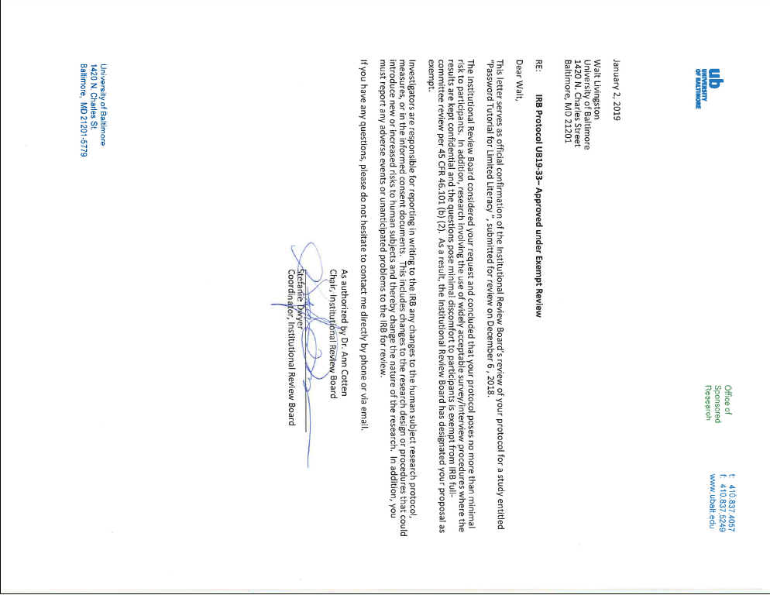

Appendix B Consent Form

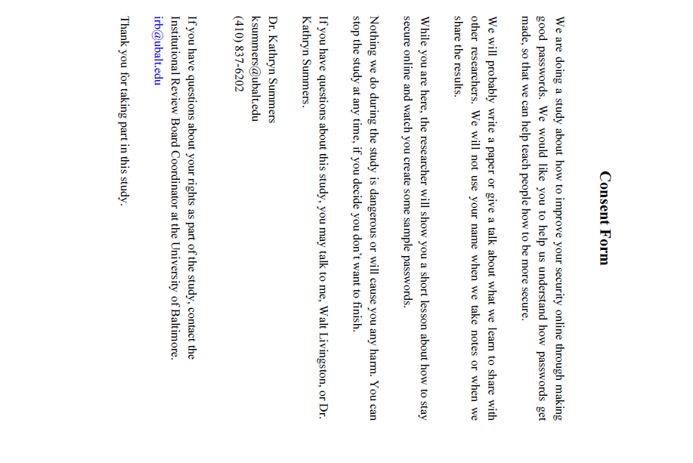

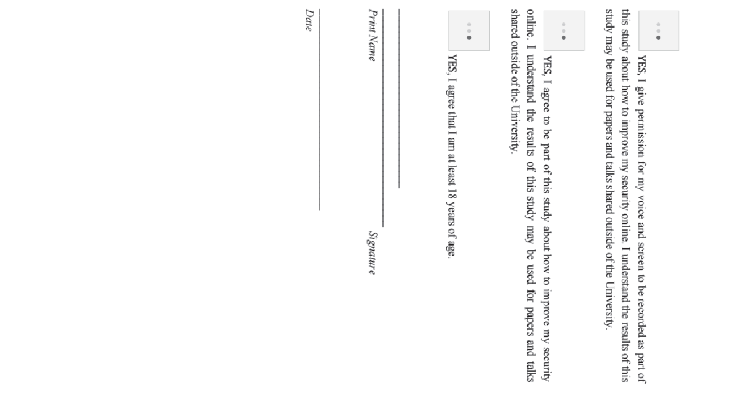

Appendix C: Simulated Online Account Signup Forms

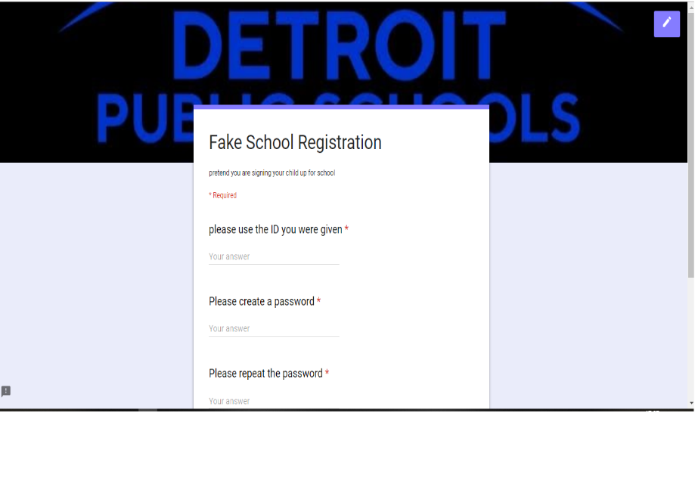
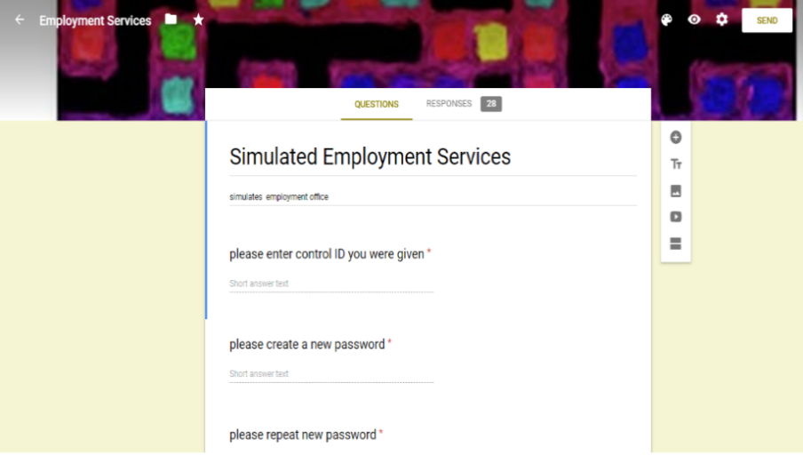

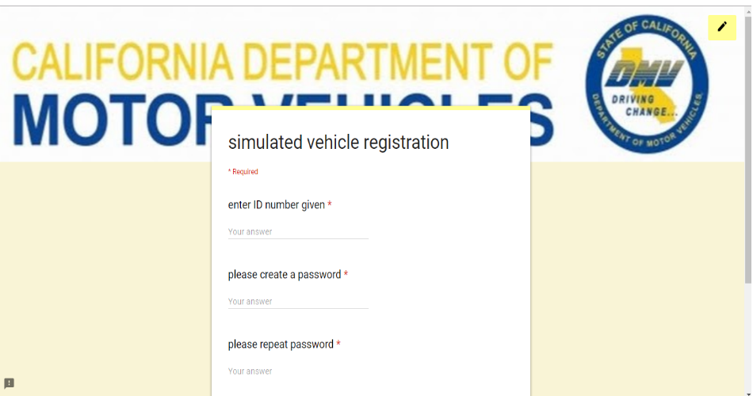
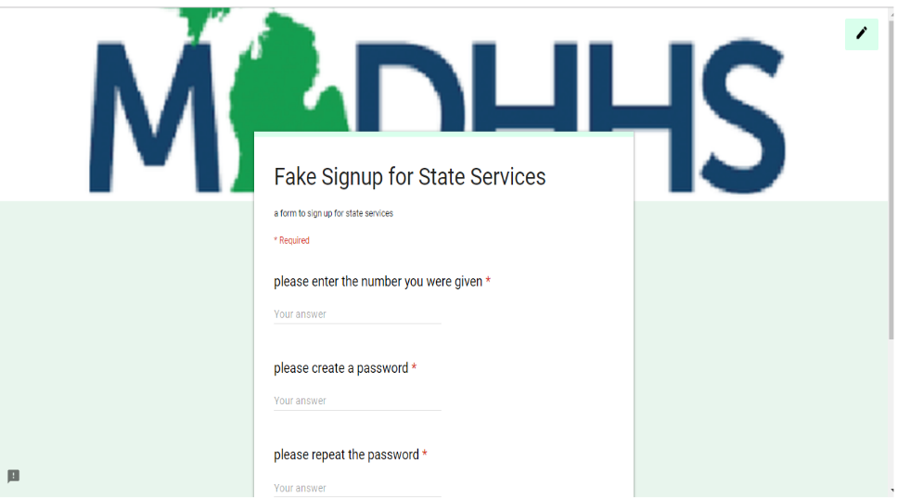
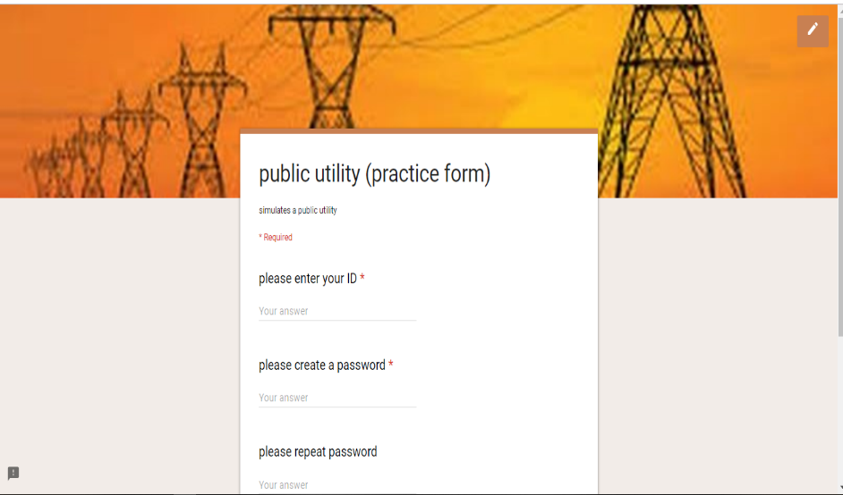
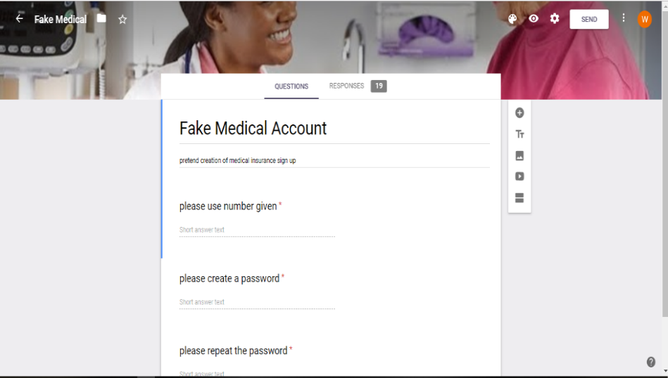
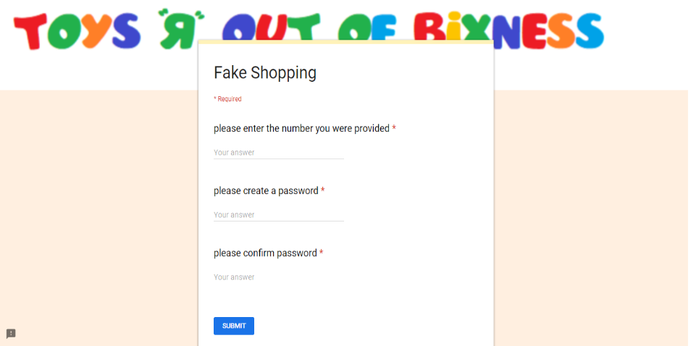
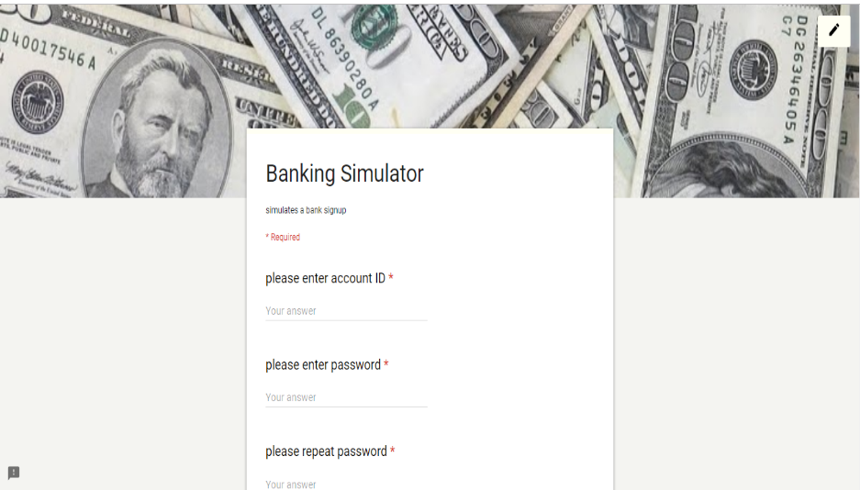

Appendix D: Collected Password Requirements

AGENCY | min. length | max. length | # Char Sets | At least 1 Alpha | UPPER REQ'D | lower reqd | Num reqd | Spec char REQ | Spec Chars OK? | # Security Qs | Agcy written Q? | User written Q?
Wells Fargo | 8 | 32 | 3 |  | y | y | y | y | p | 0
Discover Bank | 6 | 16 | 3 |  | y |  | y |  | p | 0
JPMorgan Chase | 8 | 32 | 3 | y |  |  | y |  | p | 0
Citigroup | 8 | x | 3 |  | y | y | y |  | r | 0
TD Bank, N.A. | 8 | 32 | 2 | y |  |  | y |  | p | 0
Capital One | 8 | 32 | 2 | y |  |  | y |  | p | 0
HSBC Bank USA | 8 | 30 | 3 | y |  |  | y |  | r | 0
SunTrust Banks | 6 | 20 | 2 | y |  |  | y |  | p | 0
American Express | 8 | 20 | 2 | y |  |  | y |  | r | 5 | y | n
Ally Financial | 8 | 32 | 2 | y |  |  | y |  | p | 0
Barclays | 8 | 16 | 3 |  | y | y | y |  | p | 0 |  | n
USAA | 8 | x | 3 |  | y | y | y |  | p | 0
Bank of Internet | 8 | 20 | 4 |  | y | y | y | y | r | 0
Citizens Financial Group | 8 | 15 | 4 |  | y | y | y | y | p | 0
M&T Bank | 8 | 20 | 3 |  | y | y | y |  | r | 3 | y | n
Huntington Bancshares | 8 | 16 | 3 |  | y | y | y |  | r | 5 | y | n
Synchrony Financial | 8 | 12 | 4 |  | y | y | y | y | p | 0

Appendix E: Screenshots of Password Requirements, Instructions and Security Questions,

CareFirst | 6 | 20 | 3 |  | y | y | y |  | p | 0
Kaiser Permanente | 8 | 50 | 3 |  | y | y | y |  | r | 3 | y | n
Anthem | 6 | 20 | 4 |  | y | y | y | y |  | 0
Cigna | 6 | 12 | 3 |  | y | y | y |  | r | 2 | y | n
BGE | 8 | 16 | 3 |  | p |  |  |  | p | 0
6PM | 6 | x | 1 |  | p |  |  |  | p | 0
A.C. Moore Arts & Crafts | 8 | x | 3 |  | y | y |  |  | p | 0
Ace Hardware | 6 | x | 2 | y |  |  | y |  |  | 0
Albertstons | 8 | 12 | 1 |  |  |  |  |  |  | 0
AliExpress | 6 | 20 | 2 |  | p |  |  |  | p | 0
Amazon | 6 | x | 1 |  |  |  |  |  | p | 0
Apple | 8 | x | 3 |  | y | y | y |  | p | 0
AutoZone | 8 | 15 | 2 |  | y |  | y |  |  | 0
Barnes & Noble | 8 | 50 | 3 |  | y | y | y |  | p | 0
Bath & Body Works | 8 | 50 | 4 |  | y | y | y |  | p | 0
Bed Bath & Beyond | 6 | x | 1 |  |  |  |  |  |  | 0
Best Buy | 8 | 20 | 1 |  |  |  |  |  |  | 0
BJ's Wholesale Club | 8 | x | 2 | y |  |  |  |  |  | 1 | y

AGENCY | min. length | max. length | # Char Sets | At least 1 Alpha | UPPER REQ'D | lower reqd | Num reqd | Spec char REQ | Spec Chars OK? | # Security Qs | Agcy written Q? | User written Q?
Cars.com | 8 | x | 4 |  | y | y | y | y |  | 0
Chick-fil-A | 6 | x | 2 | y |  |  | p |  | p | 0
Costco | 6 | x | 2 | y |  |  | p |  | p | 0
CVS | 6 | x | 1 |  | - |  |  |  | p | 0
Dick's Sporting Goods | 8 | 30 | 3 |  | y | y |  |  | p | 0
Dollar TRee | 8 | x | 1 |  | y |  |  |  |  | 0
Dunkin' Brands Group | 8 | x | 3 |  | p |  |  |  | p | 0
Ebay | 6 | 64 | 2 | y |  |  | y |  | p | 0
Etsy | 8 | 15 | 3 |  | y | y |  |  | p | 0
Federal Student Aid (fsaid.gov) | 8 | x | 3 |  | y | y | y |  |  | 0
Food LIon | 8 | x | 1 |  |  |  | y |  |  | 0
GameStop | 8 | 15 | 1 |  |  |  | y |  | p | 0
Gap | 8 | x | 3 |  | Y | Y | Y |  | p | 0
Giant | 8 | x | 3 |  | y | y | y |  | p | 0
Giant Eagle | 8 | x | 3 |  | y | y | y |  |  | 0
Granite State Management & Resrources | 8 | x | 2 |  | y |  | y | y |  | 0
H&M | 6 | x | 1 |  |  |  |  |  | p | 0
HEB Grocery | 6 | 20 | 3 |  | y | y | y |  | p | 0
Hobby Lobby | 8 | x | 2 | y |  |  | y |  | p | 0

AGENCY | min. length | max. length | # Char Sets | At least 1 Alpha | UPPER REQ'D | lower reqd | Num reqd | Spec char REQ | Spec Chars OK? | # Security Qs | Agcy written Q? | User written Q?
Hobby Lobby | 8 | x | 2 | y |  |  | y |  | p | 0
Hy-Vee | 8 | x | 4 |  | y | y | y | y |  | 0
IKEA Holdings US | 8 | x | 3 |  | y | y | y |  | p | 0
JC Penney | 6 | x | 3 | y | p |  | p |  | p | 0
Jo-Ann Fabric & Craft Stores | 8 | x | 2 | y |  |  | y |  |  | 0
Kohl’s | 8 | x | 3 | y | y |  | y | y |  | 0
kroger | 8 | x | 3 |  | y | y | y |  |  | 0
Lowe’s | 7 | x | 1 |  |  |  |  |  |  | 0
Macy’s | 8 | 64 | 3 |  | y | y | y |  |  | 0
McDonalds | 8 | x | 4 |  | y | y | y | y |  | 0
Meijer Supermarket | 9 | x | 3 |  | y | y | y |  | p | 0
Menards | 8 | x | 3 | y |  |  | y | y |  | 0
Michaels Stores | 8 | 12 | 2 | y |  |  | y |  |  | 0
Newegg.com | 7 | 16 | 1 |  |  |  |  |  |  | 0
Nike | 7 | 15 | 2 | y |  |  | y |  |  | 0
Nordstrom | 8 | 32 | 1 |  |  |  |  |  |  | 0
O'Reilly Auto Parts | 8 | x | 3 |  | y | y | y |  | p | 0
Office Max | 8 | 30 | 3 |  | p |  |  |  | p | 0
Overstock.com | 8 | x | 3 |  | y | y | y |  | p | 0

AGENCY | min. length | max. length | # Char Sets | At least 1 Alpha | UPPER REQ'D | lower reqd | Num reqd | Spec char REQ | Spec Chars OK? | # Security Qs | Agcy written Q? | User written Q?
Pier 1 Imports | 8 | 20 | 3 |  | y | y |  |  | p | 0
Pink | 8 | 30 | 3 |  | y | y | y |  |  | 0
Pizza Hut | 8 | 70 | 1 | y |  |  |  |  | p | 0
Publix | 8 | x | 3 |  | y | y | y |  |  | 0
QVC | 6 | x | 1 |  |  |  |  |  |  | 0
REI | 8 | 28 | 2 |  | p |  |  |  | p | 0
Rite Aid | 8 | x | 4 | y | y | y | y | y |  | 1 | y | n
Sally Beauty Holdings | 6 | 16 | 1 |  |  |  |  |  |  | 0
Sears | 8 | 15 | 3 |  | y | y | y |  |  | 0
Sears | 8 | 20 | 2 |  | y |  | y |  | p | 0
Sephora | 8 | ? | 2 | y |  |  | y |  |  | 0
Shop.com | 8 | x | 3 |  | y | y |  |  | p | 0
Staples | 6 | 12 | 1 |  |  |  |  |  | p | 0
Starbucks | 7 | x | 1 |  |  |  |  |  | p | 0
Steam | 8 | x | 3 |  | p |  |  |  | p | 0
Taco Bell | 8 | 25 | 4 |  | y | y | y | y |  | 0
Target | 8 | x | 3 |  | p |  |  |  | p | 0
Target | 6 | x | 1 |  | p |  |  |  | p | 0
The Home Depot | 8 | 20 | 1 |  |  |  |  |  |  | 0
Ulta Salon, Cosmetics & Fragrance | 8 | 20 | 4 |  | y | y | y | y |  | 0
Verizon Wireless | 8 | x | 2 | y |  |  | y |  | p | 0

AGENCY | min. length | max. length | # Char Sets | At least 1 Alpha | UPPER REQ'D | lower reqd | Num reqd | Spec char REQ | Spec Chars OK? | # Security Qs | Agcy written Q? | User written Q?
Victoria’s Secret | 8 | x | 3 |  | y | y | y |  | p | 0
Wal-Mart | 8 | 20 | 2 | y |  |  | y |  | p | 0
Walgreens | 8 | 32 | 2 | y |  |  | y |  |  | 0
Walmart | 6 | 12 | 1 |  |  |  |  |  |  | 0
Wegmans Food Market | 8 | x | 2 | y |  |  | y |  | p | 0
Wendy's | 6 | 12 | 1 |  |  |  |  |  | p | 0
Williams-Sonoma | 8 | 25 | 2 | y |  |  | y |  | p | 0
WinCo Foods | 8 | 2 |  | y |  | y |  |  |  | 0
Wish | 2 | x | 1 |  | p |  |  |  | p | 0
Zappos | 6 | x | 1 |  |  |  |  |  |  | 0
State reqs for healthcare.gov
AL password | 8 | 20 | 3 |  | y | y | y |  | p | 3 | y | n
AK password | 8 | 20 | 3 |  | y | y | y |  |  | 0
AZ password | 8 | 20 | 3 |  | y | y | y |  |  | 0
AR password | 8 | 20 | 3 |  | y | y | y |  | p | 3 | y | n
CA password | 8 | 50 | 4 |  | y | y | y | y |  | 1
CO password | 8 | x | 3 |  | y | y | y |  |  | 0

AGENCY | min. length | max. length | # Char Sets | At least 1 Alpha | UPPER REQ'D | lower reqd | Num reqd | Spec char REQ | Spec Chars OK? | # Security Qs | Agcy written Q? | User written Q?
CT password | 9 | 15 | 4 |  | y | y | y | y |  | 4 | y | n
DE password | 8 | 20 | 1 |  |  |  |  |  |  | 3 | y | n
FL password | 6 | 20 | 2 | y |  |  | y |  | p | 3 | y | n
GA password | 8 | 20 | 3 |  | y | y | y |  | p | 3 | y | n
HI password | 8 | 20 | 3 |  | y | y | y |  | p | 3 | y | n
ID password | 8 | 20 | 1 | y |  |  |  |  | p | 1 | y | n
IL password | 8 | 20 | 3 |  | y | y | y |  | p | 3 | y | n
in password | 9 | 20 | 3 |  | y | y | y |  | p | 3 | y | n
IA password | 10 | 20 | 3 |  | y | y | y |  | p | 3 | y | n
KS password | 11 | 20 | 3 |  | y | y | y |  | p | 3 | y | n
KS Medicaid PW | 8 | x | 1 |  |  |  | y | y |  | 0
KS Other Services PW | 8 | x | 1 |  |  |  | y | y |  | 2 | y | n
LA password | 8 | 20 | 3 |  | y | y | y |  | p | 3 | y | n
ME password | 8 | 20 | 3 |  | y | y | y |  | p | 3 | y | n

AGENCY | min. length | max. length | # Char Sets | At least 1 Alpha | UPPER REQ'D | lower reqd | Num reqd | Spec char REQ | Spec Chars OK? | # Security Qs | Agcy written Q? | User written Q?
MD password | 9 | 15 | 4 |  | y | y | y | y |  | 0
MA password | 8 | 100 | 3 |  | y | y | y |  |  | 0
MI password | 8 | 20 | 3 |  | y | y | y |  | p | 3 | y | n
MN Password | 8 | 20 | 1 |  |  |  |  |  | p | 0
MS password | 8 | 20 | 3 |  | y | y | y |  | p | 3 | y | n
MO passwor | 9 | 20 | 3 |  | y | y | y |  | p | 3 | y | n
MT password | 10 | 20 | 3 |  | y | y | y |  | p | 3 | y | n
NE password | 11 | 20 | 3 |  | y | y | y |  | p | 3 | y | n
NV password | 12 | 20 | 3 |  | y | y | y |  | p | 3 | y | n
NH password | 13 | 20 | 3 |  | y | y | y |  | p | 3 | y | n
NJ password | 14 | 20 | 3 |  | y | y | y |  | p | 3 | y | n
NM password | 15 | 20 | 3 |  | y | y | y |  | p | 3 | y | n
NY password | 8 | x | 2 | y | p | p | y |  | p | 0
NC password | 8 | 20 | 3 |  | y | y | y |  | p | 3 | y | n
ND password | 9 | 20 | 3 |  | y | y | y |  | p | 3 | y | n

AGENCY | min. length | max. length | # Char Sets | At least 1 Alpha | UPPER REQ'D | lower reqd | Num reqd | Spec char REQ | Spec Chars OK? | # Security Qs | Agcy written Q? | User written Q?
OH password | 10 | 20 | 3 |  | y | y | y |  | p | 3 | y | n
OK password | 11 | 20 | 3 |  | y | y | y |  | p | 3 | y | n
OR password | 12 | 20 | 3 |  | y | y | y |  | p | 3 | y | n
RI password | 8 | 15 | 3 |  | y | y | y |  | r | 0
SC password | 8 | 20 | 3 |  | y | y | y |  | p | 3 | y | n
SD password | 9 | 20 | 3 |  | y | y | y |  | p | 3 | y | n
TN password | 10 | 20 | 3 |  | y | y | y |  | p | 3 | y | n
TX password | 11 | 20 | 3 |  | y | y | y |  | p | 3 | y | n
UT password | 12 | 20 | 3 |  | y | y | y |  | p | 3 | y | n
VT password | 8 | x | 3 |  | y | y | y |  | x | 0 |  | n
VApassword | 8 | 20 | 3 |  | y | y | y |  | p | 3 | y | n
WV password | 8 | 20 | 3 |  | y | y | y |  | p | 3 | y | n
WI password | 9 | 20 | 3 |  | y | y | y |  | p | 3 | y | n
WY password | 10 | 20 | 3 |  | y | y | y |  | p | 3 | y | n
Franchise Tax Board | 8 | 32 | 4 |  | y | y | y | y |  | 3 | y | n

AGENCY | min. length | max. length | # Char Sets | At least 1 Alpha | UPPER REQ'D | lower reqd | Num reqd | Spec char REQ | Spec Chars OK? | # Security Qs | Agcy written Q? | User written Q?
State reqs for SNAP
Alabama | 8 | 14 | 3 |  | y | y | y |  |  | 3 | y | n
Alaska | 6 | 50 | 1 |  | p |  |  |  |  | 1 | y | n
Arizona | 8 | 20 | 1 |  |  |  |  |  |  | 3 | y | n
Arkansas | 8 | x | 3 |  | y | y | y |  |  | 0
California | 8 | x | 3 |  | y | y | y |  |  | 0
Colorado | 8 | 24 | 4 |  | y | y | y | y |  | 0
Connecticut | 9 | 15 | 4 |  | y | y | y | y |  | 4 | y | n
Delaware | 10 | x | 4 |  | y | y | y | y |  | 0
Florida | 6 | 20 | 2 |  | y |  | y |  | p | 3 | y | n
Georgia | 8 | 15 | 3 |  | y | y | y |  | p | 3 | y | n
Hawaii | 6 | x | 3 |  | y | y | y |  |  | 0
Idaho | x | x | x |  |  |  |  |  |  | 0
Illinois | 8 | x | 3 |  | p |  |  |  | p | 0
Kansas | 8 | 20 | 2 |  |  |  | y | y |  | 0
Kentucky | 9 | 20 | 3 |  | y | y | y |  |  | 0
Louisiana | 8 | 64 | 3 |  | y | y | y |  |  | 0
Maine | 8 | x | 2 | y |  |  | y |  | p | 0
Maryland | 8 | x | 2 | y |  |  | y |  | p | 0
Massachusetts | 8 | x | 3 |  | y | y | y |  | p | 0
Michigan | 8 | x | 3 |  | p |  |  |  | p | 0
Minnesota | 8 | x | 3 |  | p |  |  |  | p | 2 | y | n
Missouri | 6 | 15 | 1 |  |  |  |  |  |  | 0
Montana | 8 | x | 1 |  |  |  |  |  |  | 3 | y | y
Nebraska | 8 | 10 | 3 |  | y | y | y |  | x | 3 | y | n
Nevada | 8 | 15 | 4 |  | y | y | y | y |  | 0

AGENCY | min. length | max. length | # Char Sets | At least 1 Alpha | UPPER REQ'D | lower reqd | Num reqd | Spec char REQ | Spec Chars OK? | # Security Qs | Agcy written Q? | User written Q?
New Hampshire | 8 | 14 | 3 |  | y | y | y |  | p | 0
New Jersey | 8 | 15 | 2 |  | p |  | y |  | x | 1 | y | n
New Jersey | 9 | 15 | 2 |  | p |  | y |  | x | 1 | y | n
New Mexico | 8 | 16 | 2 |  | p |  | y |  | p | 2 | y | n
New York | 8 | 20 | 2 |  |  |  | y |  | p | 0
North Carolina | 8 | x | 4 |  | y | y | y | y |  | 0
North Dakota | 8 | x | 4 |  | y | y | y | y |  | 2
Ohio | 8 | x | 4 |  | y | y | y | y |  | 2 | y | n
Oklahoma | 8 | 20 | 2 | y |  |  | y |  |  | 3 | y | n
Oregon | 6 | 20 | 2 | y |  |  | y |  |  | 0
Pennsylvania | 8 | 14 | 4 |  | y | y | y | y |  | 3 | y | n
Rhode Island | x | x | x |  |  |  |  |  |  | 0
South Carolina | 8 | 20 | 3 |  | y | y | y |  | p | 0
South Dakota | 8 | x | 2 | y |  |  |  |  | p | 0
Tennessee | 8 | x | 1 |  |  |  |  |  |  | 0
Texas | 8 | x | 4 |  | y | y | y | y |  | 3 | y | n
Vermont | 8 | x | 3 |  | y | y | y |  |  | 0
Virginia | 8 | 16 | 4 |  | y | y | y | y |  | 0
Washington | 10 | x | 3 | y |  |  | y | y |  | 0
West Virginia | 7 | 20 | 2 | y |  |  | y |  |  | 3 | y | n
NYC | 8 | x | 2 | y |  |  | y |  |  | 3 | y | n
LA | 12 | x | 2 | y |  |  |  | y |  | 3 | y | n
Chicago | 8 | x | 1 |  |  |  |  |  | r | 0
Houston | 8 | x | 3 |  | p |  |  |  | p | 0
Philadelphia | 8 | 14 | 4 |  | y | y | y | y |  | 3 | y | n
Phoenix | 8 | x | 4 |  | y | y | y | y |  | 0
Columbus, OH | 8 | x | 2 |  |  |  | y | y |  | 0
Portland, OR | 8 | x | 3 |  | p |  |  |  | p | 0
OKC | 8 | x | 2 |  | y |  | y |  |  | 0

Appendix E: Screenshots of Password Requirements, Instructions and Security Questions

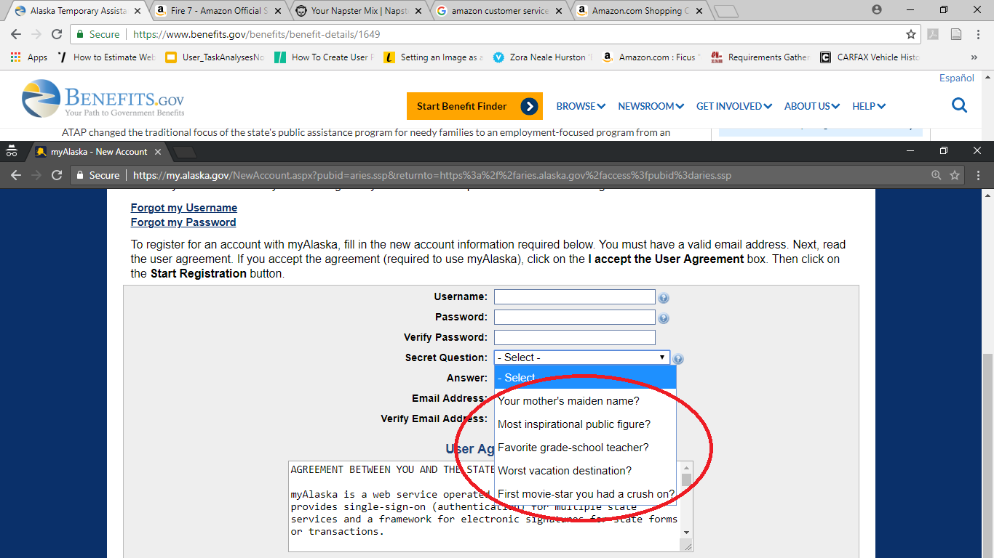
AK Security Questions

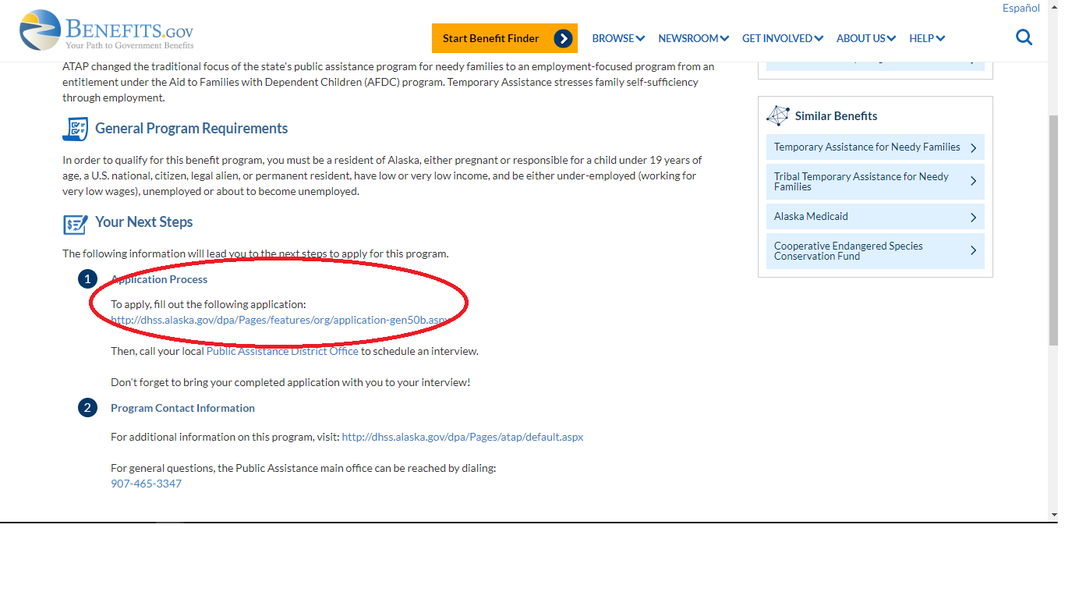

AK Application Instructions
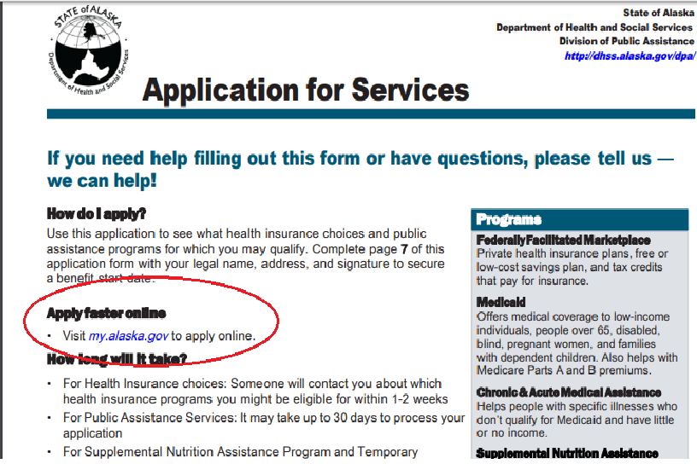
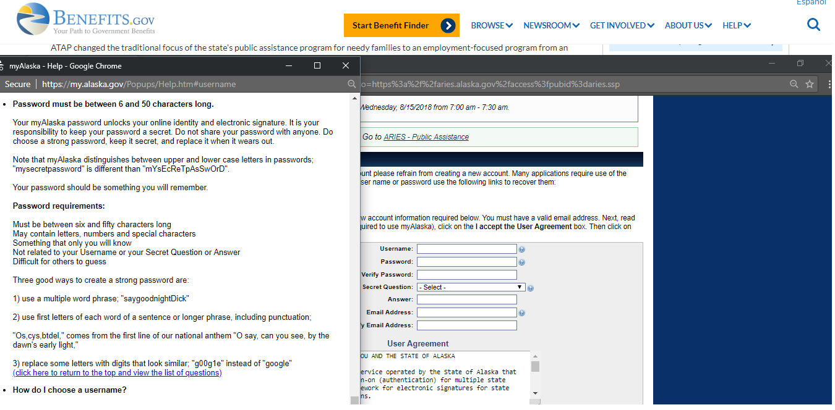

AK Password Instructions

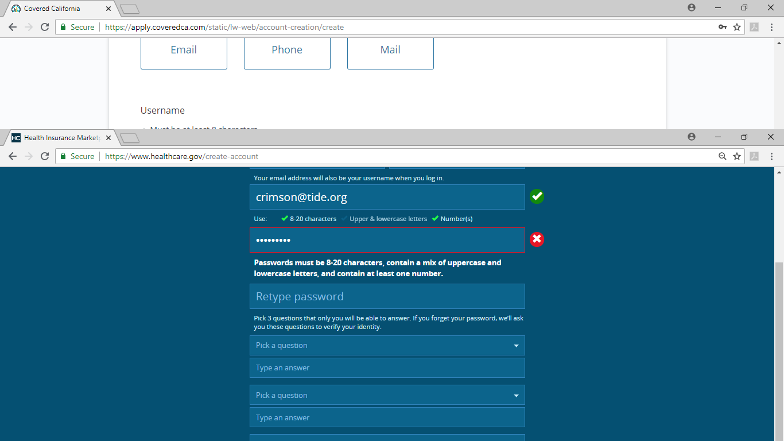

AL Healthcare.gov

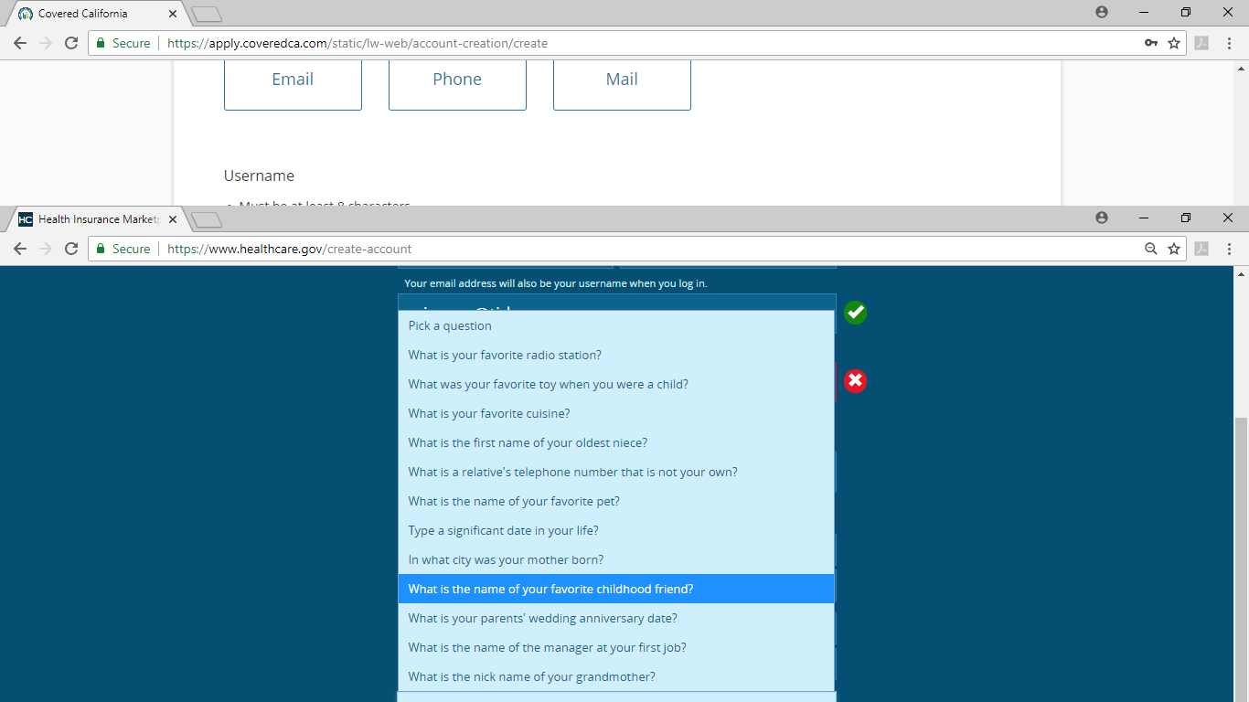
AL Healthcare.gov Security Questions
These are the generic healthcare.gov questions, and are the same for all states that have not set up their own site.

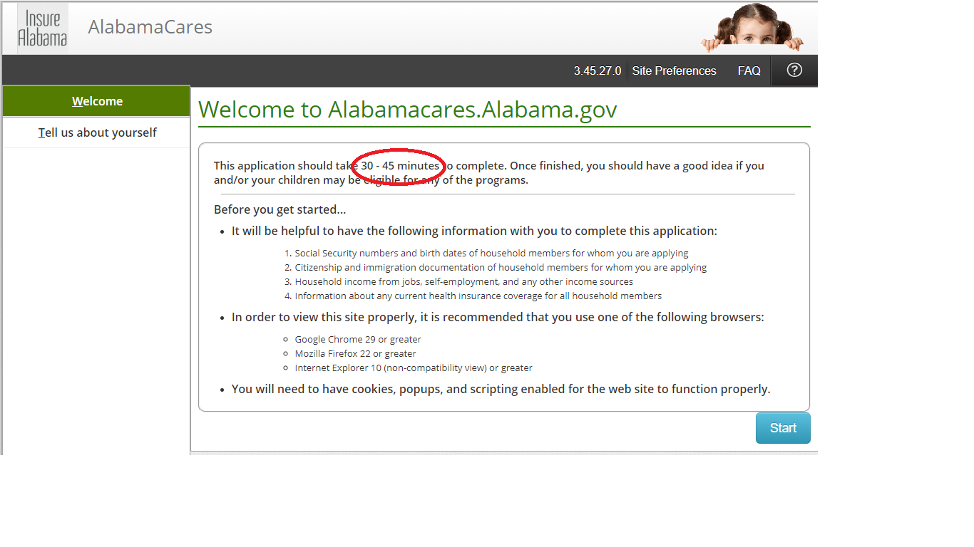
AL Application Preamble

Alabama Application, Password & Username
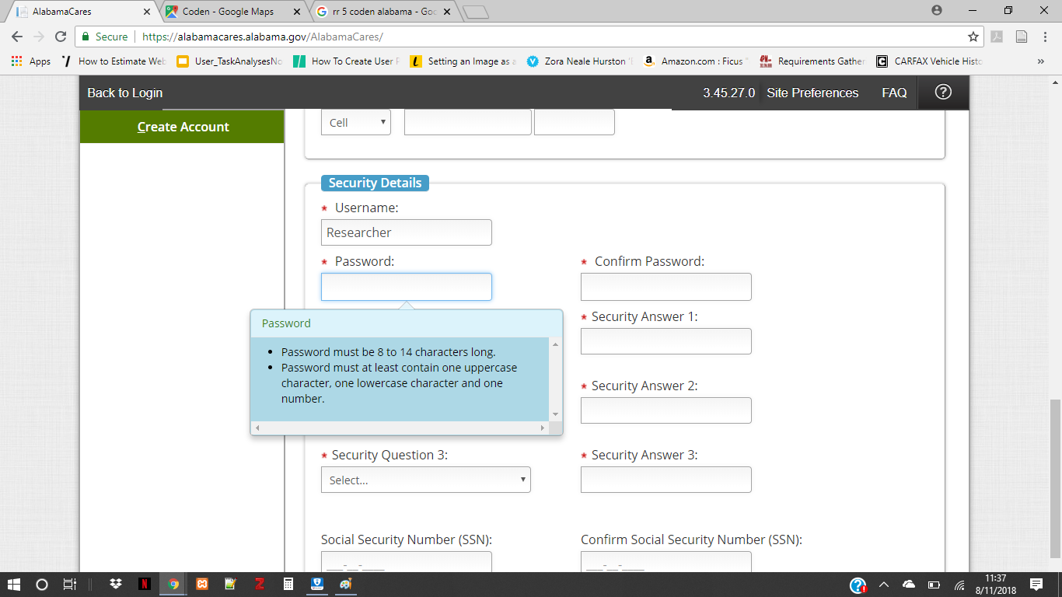
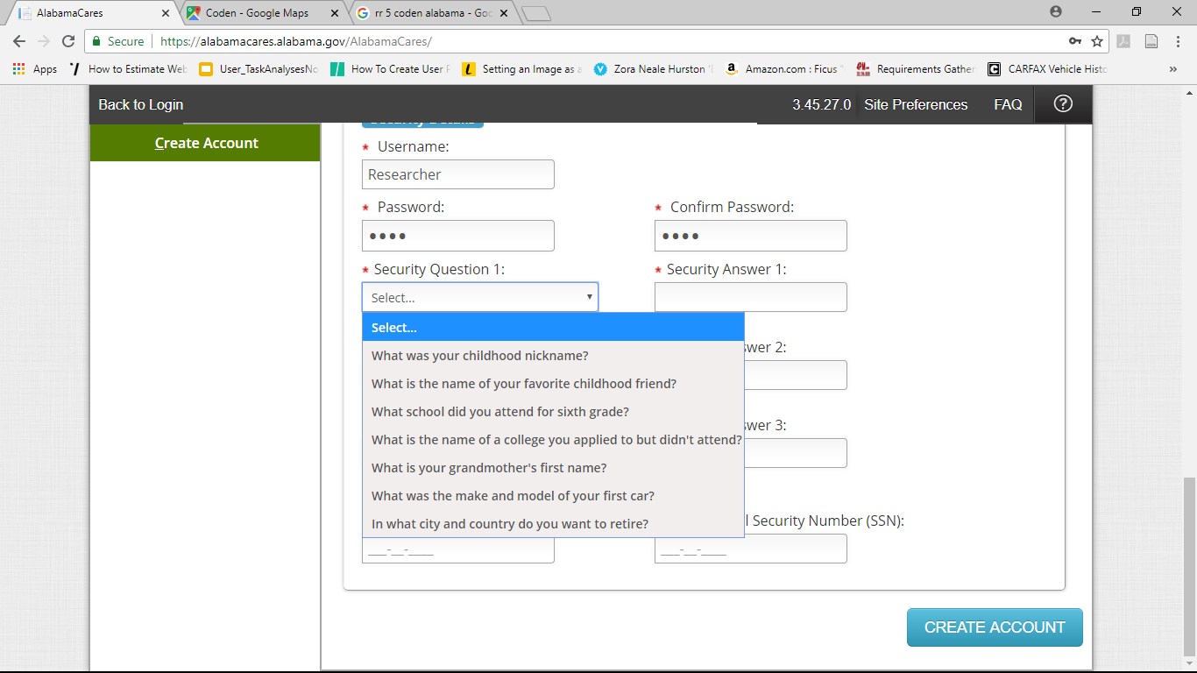

Alabama Application security Questions

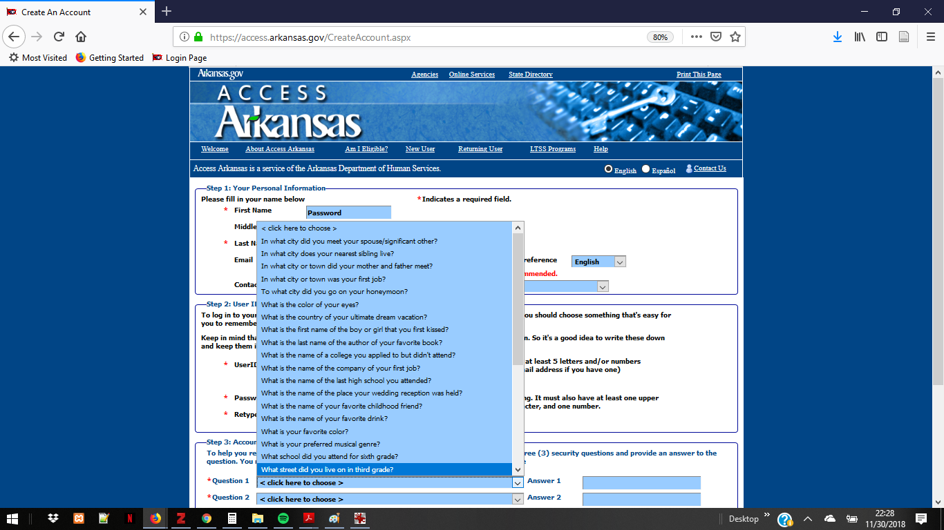
AR SNAP Application Security Questions

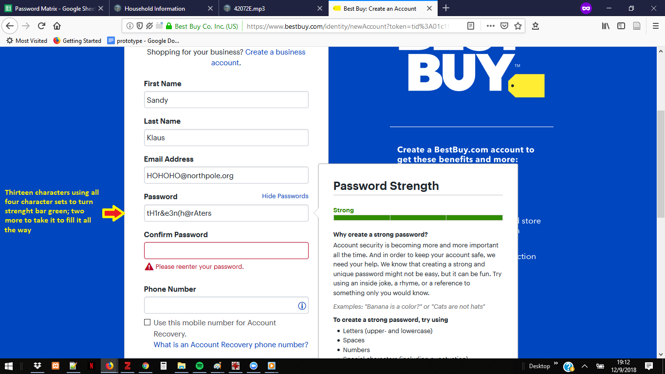

Best Buy’s strength meter has variable conditions of acceptance

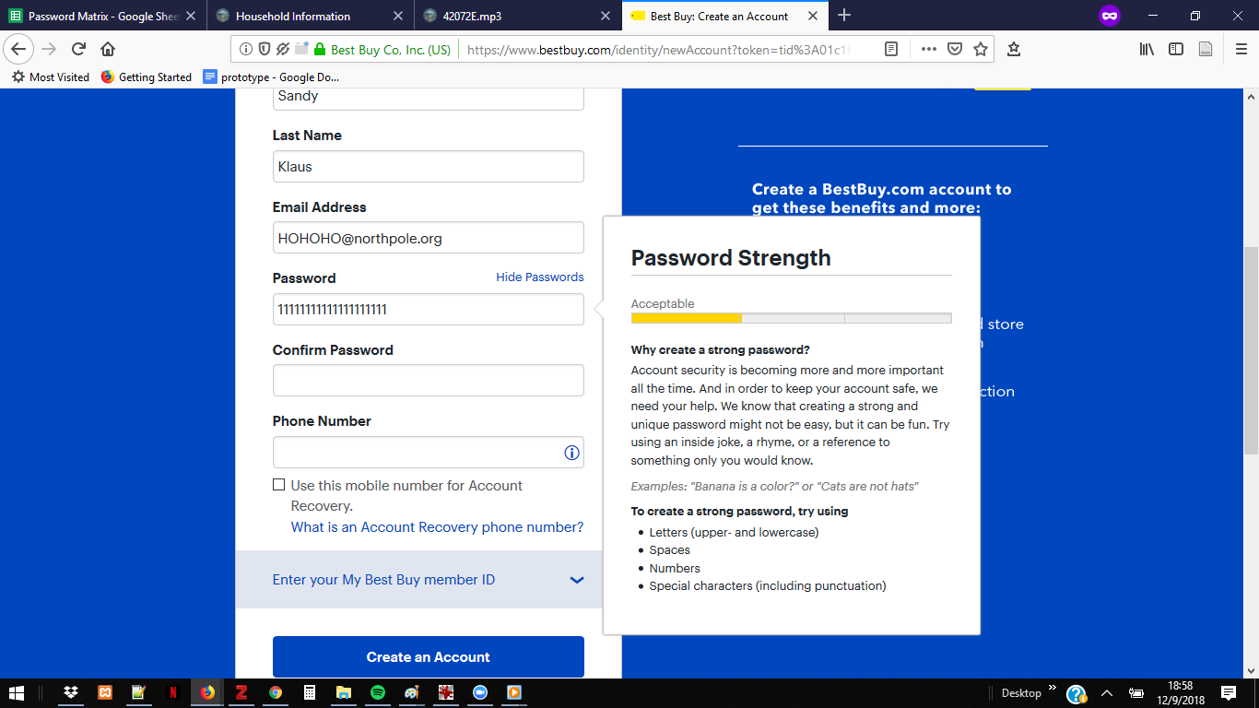Best Buy

Best Buy

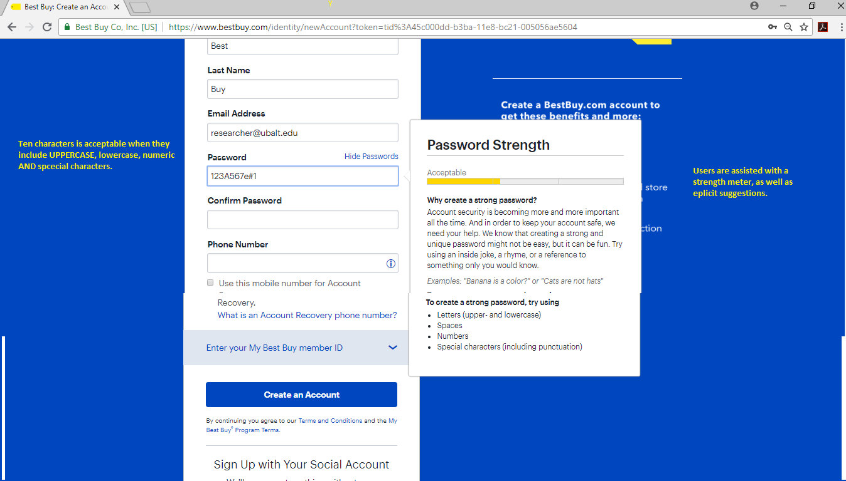

Best Buy

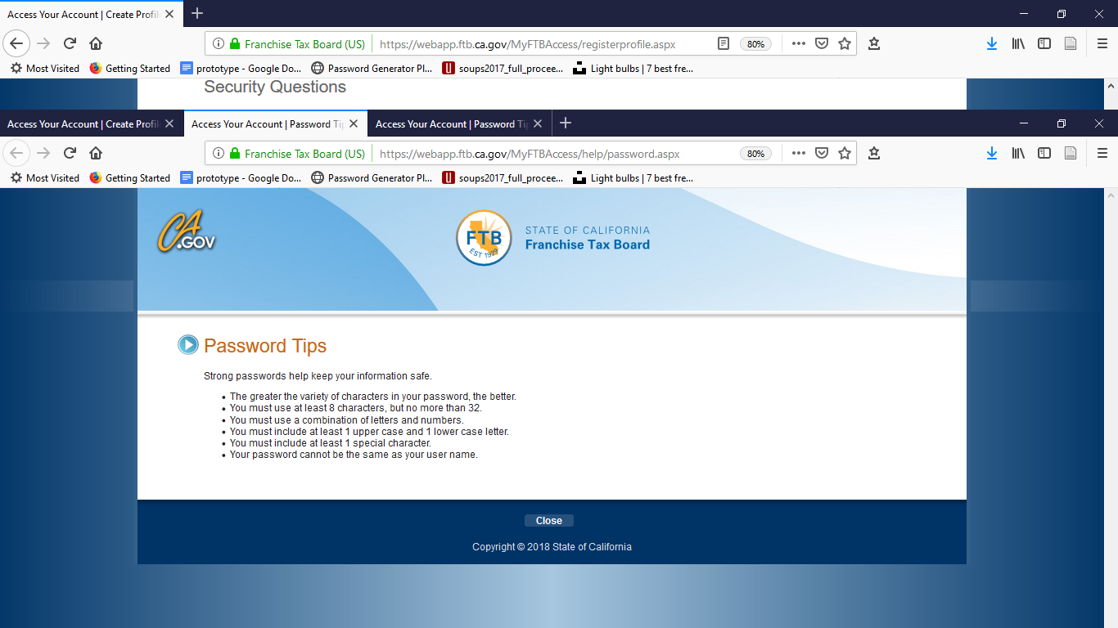CA Franchise Tax Board Password Tips
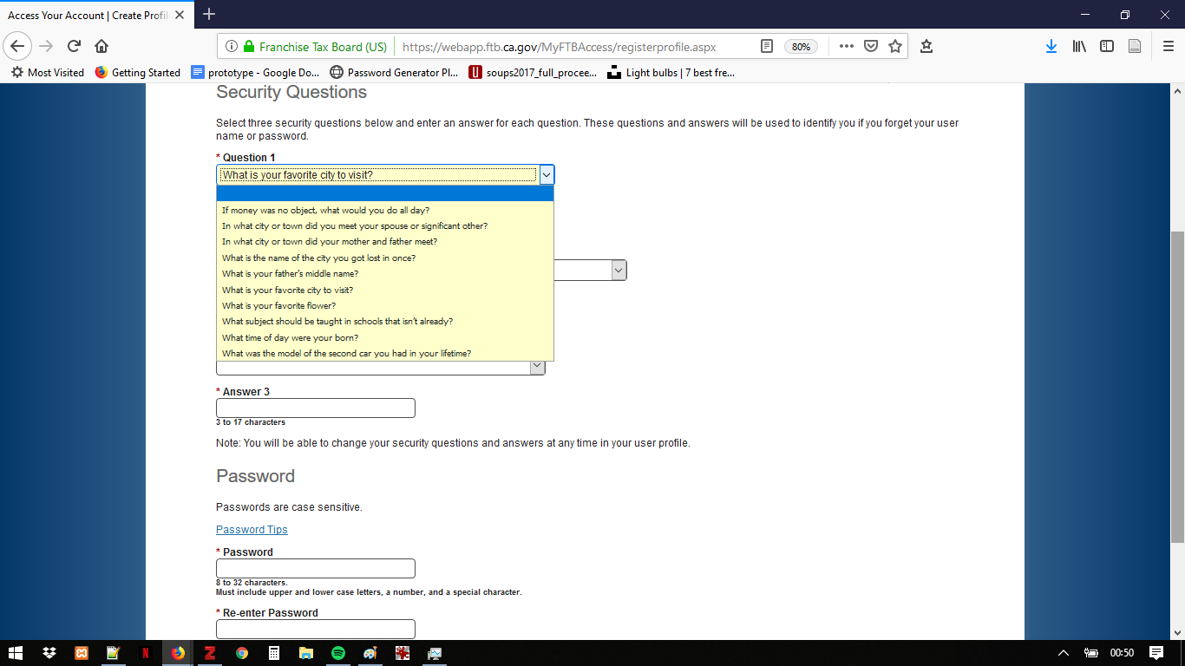

CA Franchise Tax Board has three banks of Security Qs 1
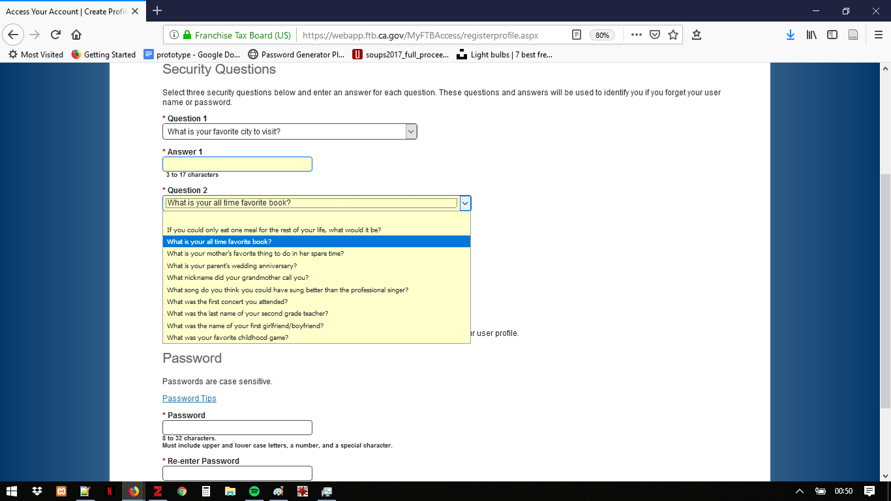

CA Franchise Tax Board Security Qs 2

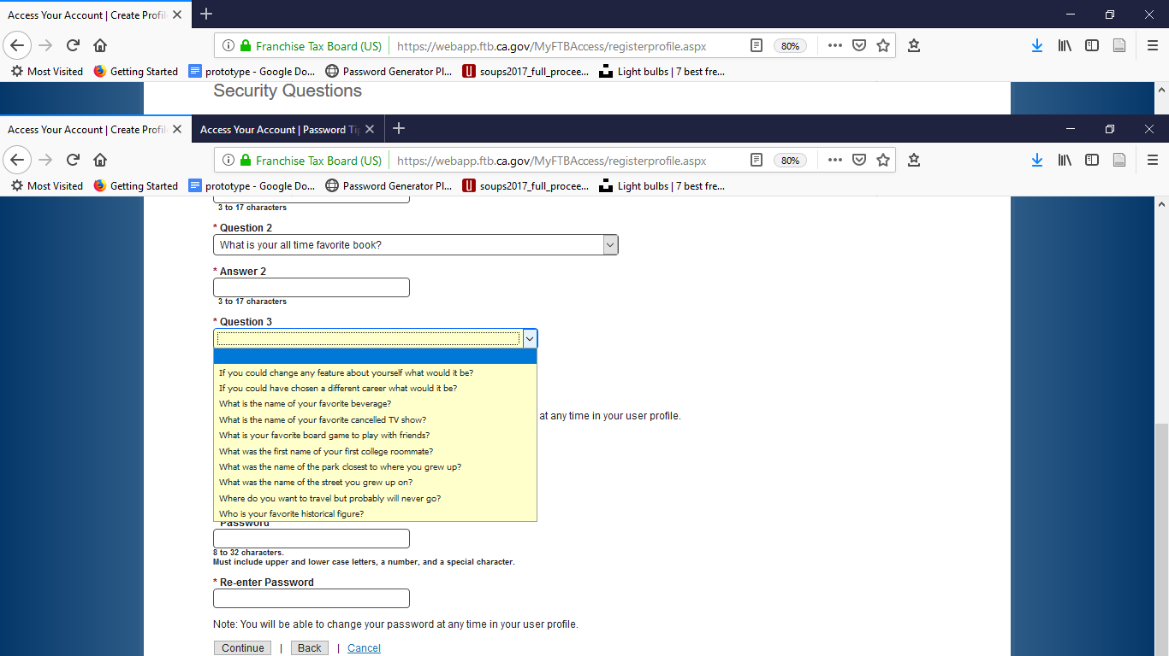

CA Franchise Tax Board Security Qs 3

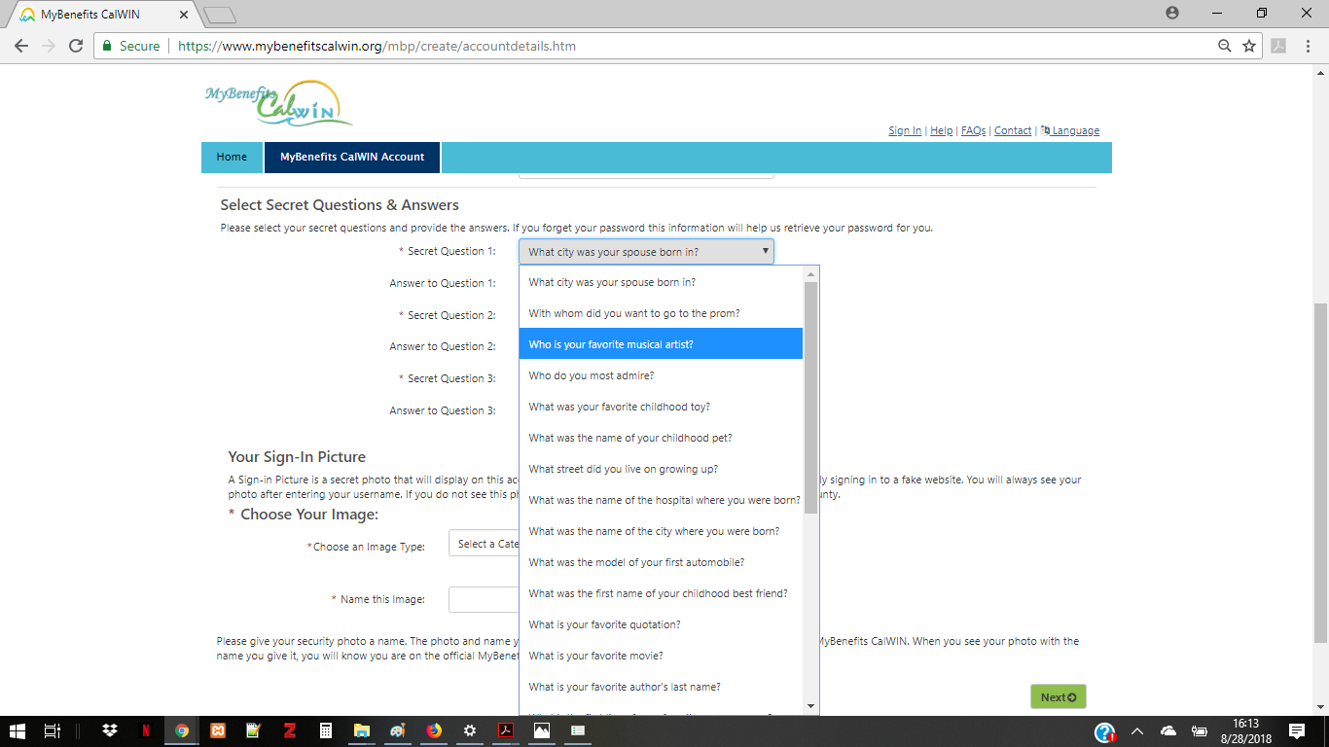

CA Security Qs
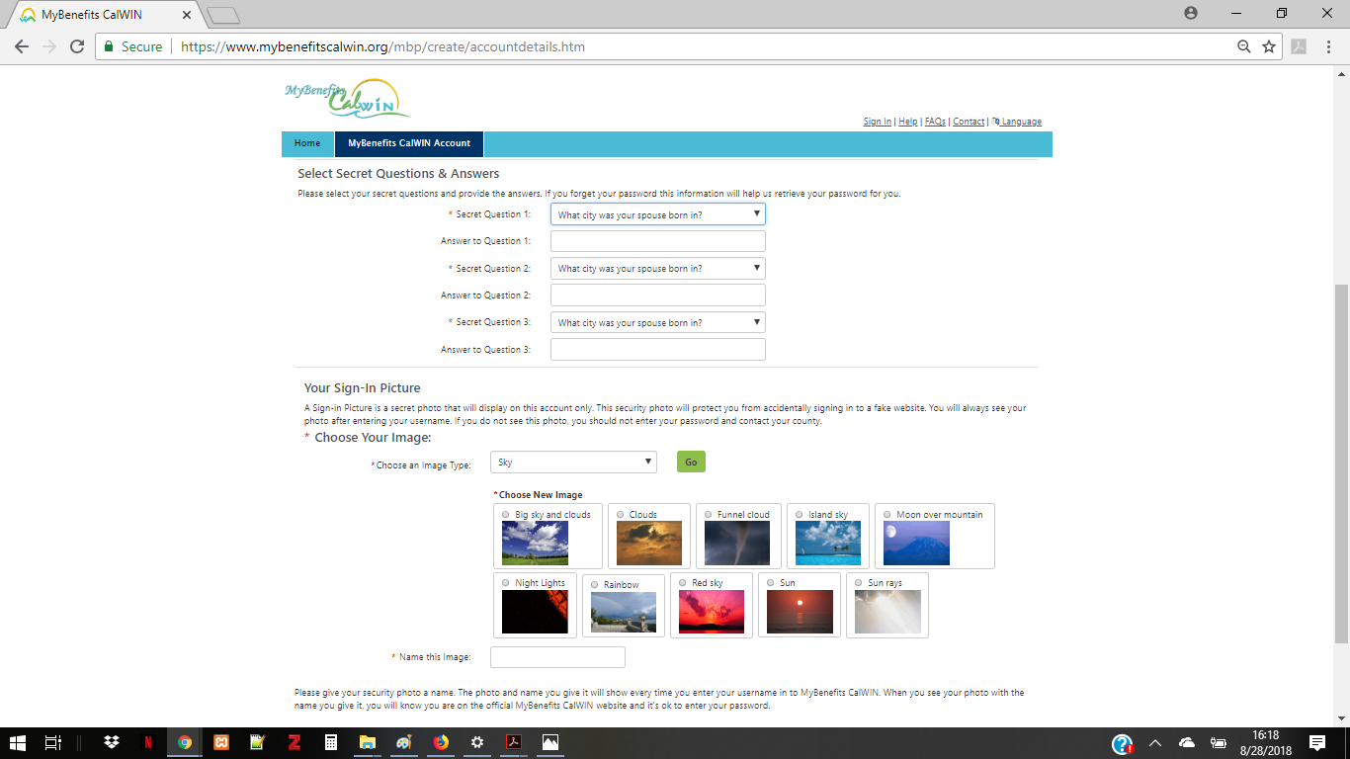

CA Security Qs2
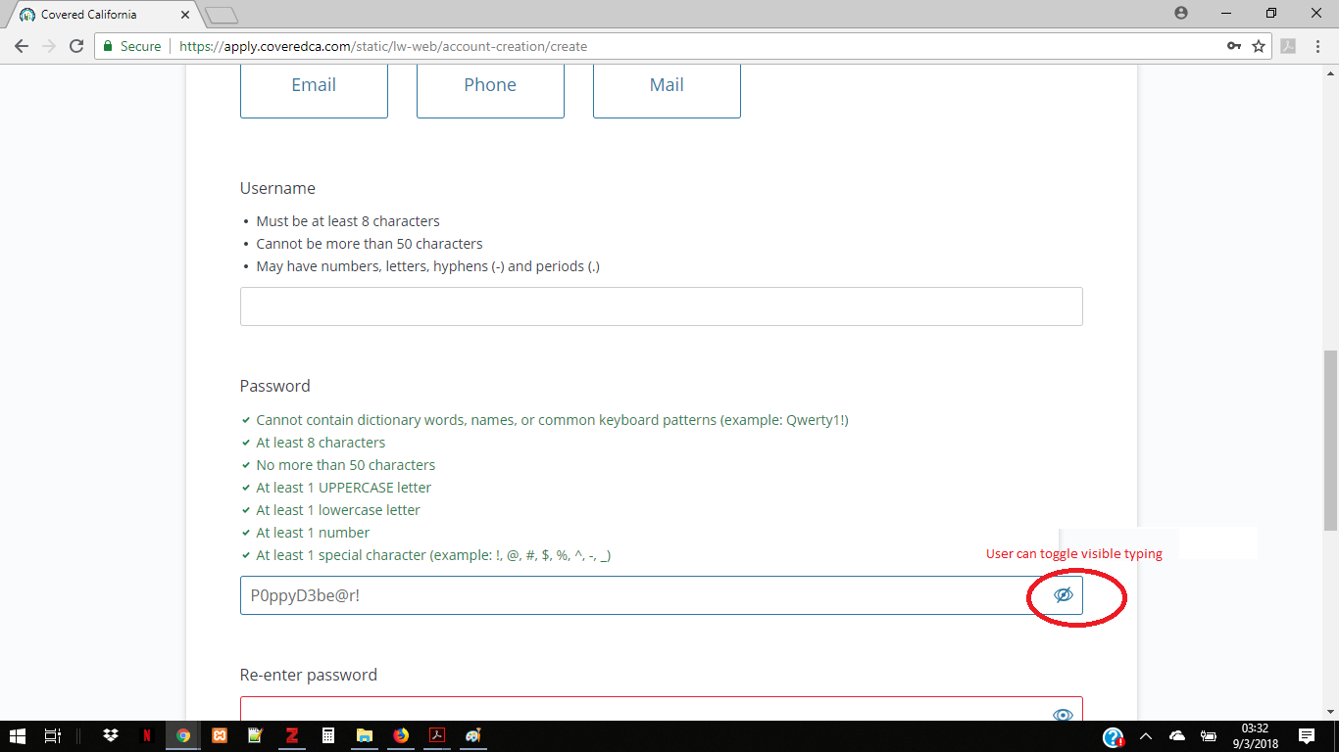

CAHealthcare.gov

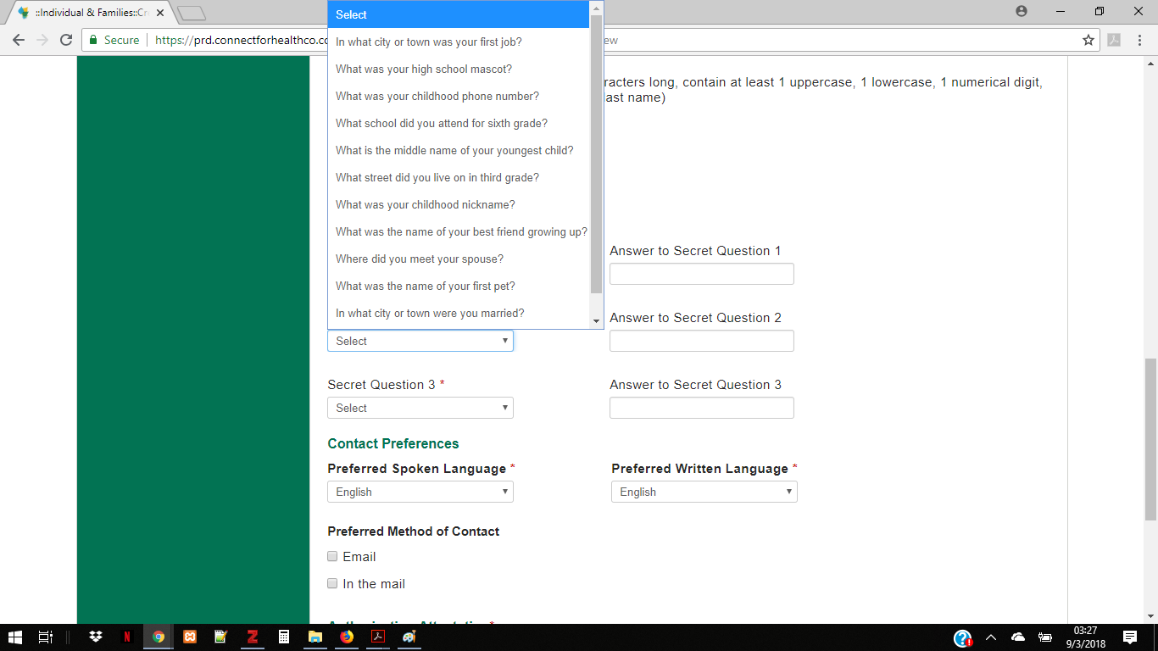

CO Healthcare.gov security

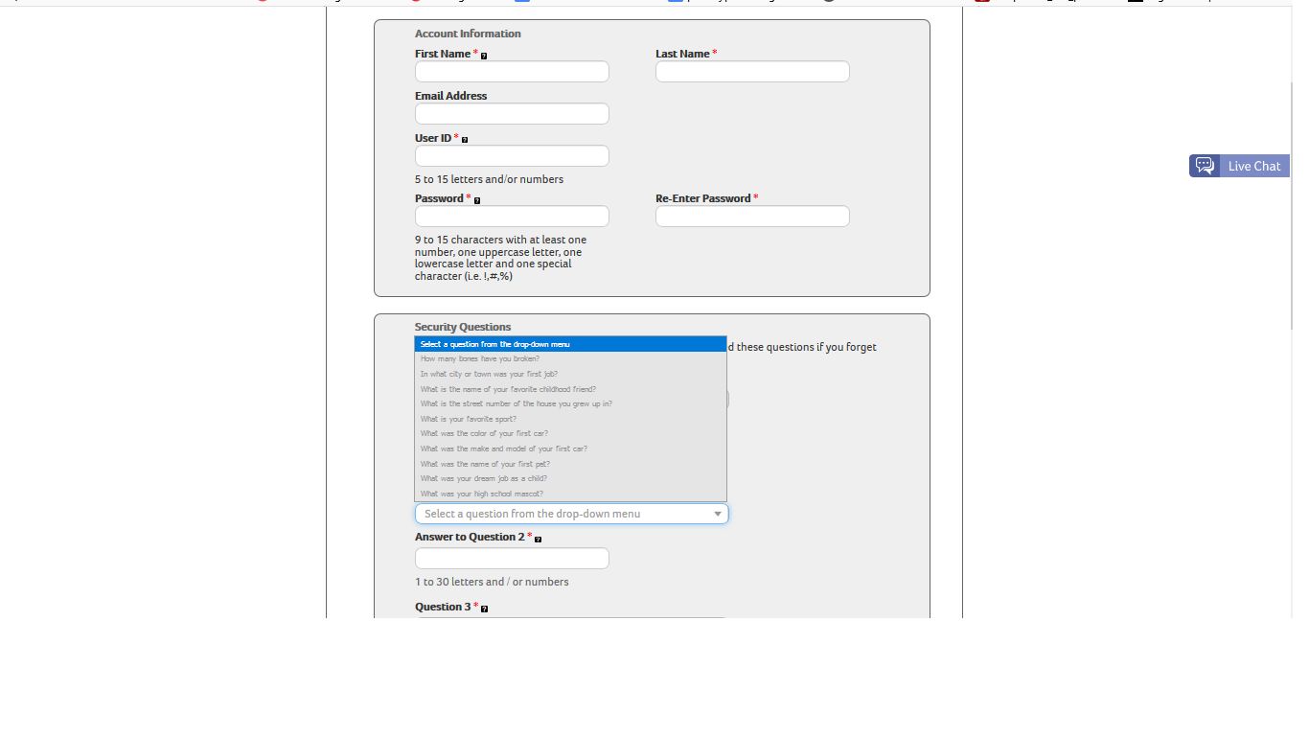

CT Health Security
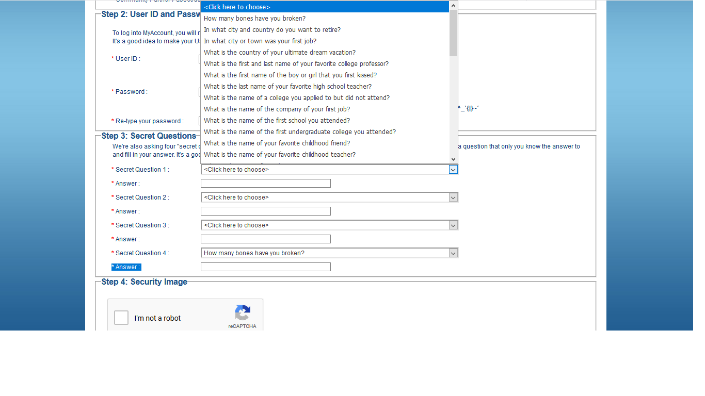

CT SNAP Security

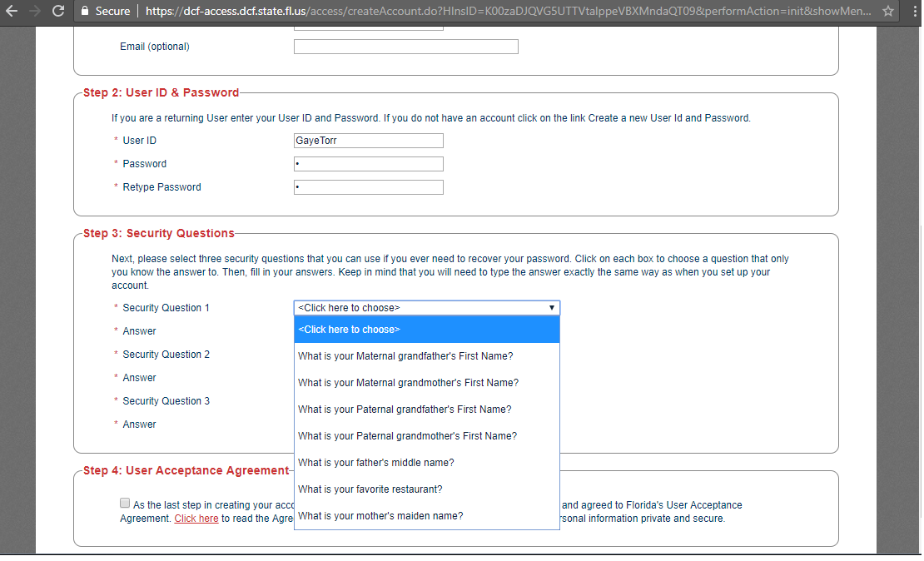

FL Security 1
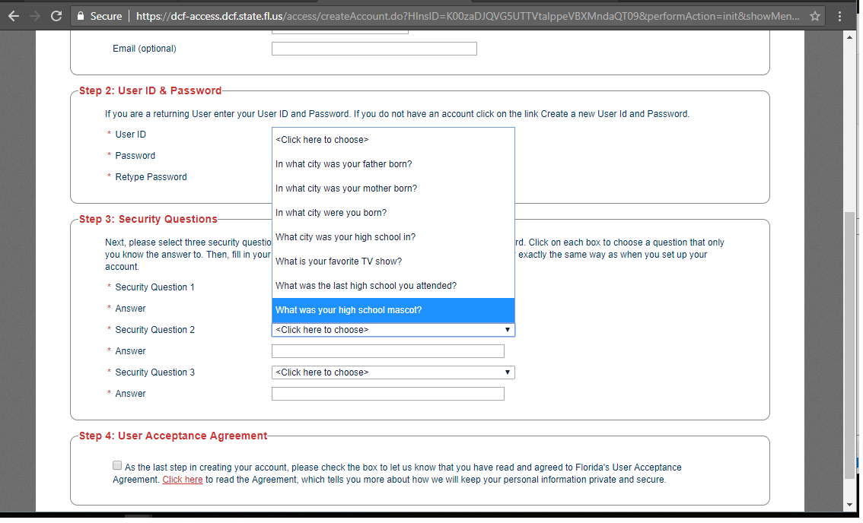

FL Security 2

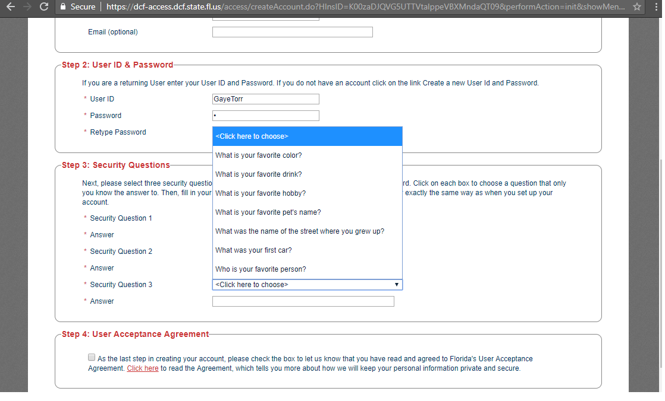
FL Security 3

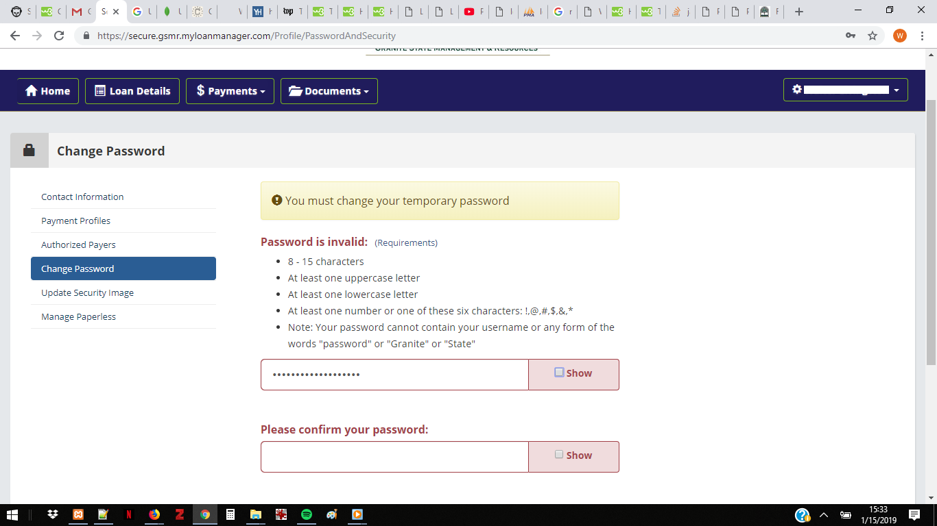
Granite State Student Loan Management
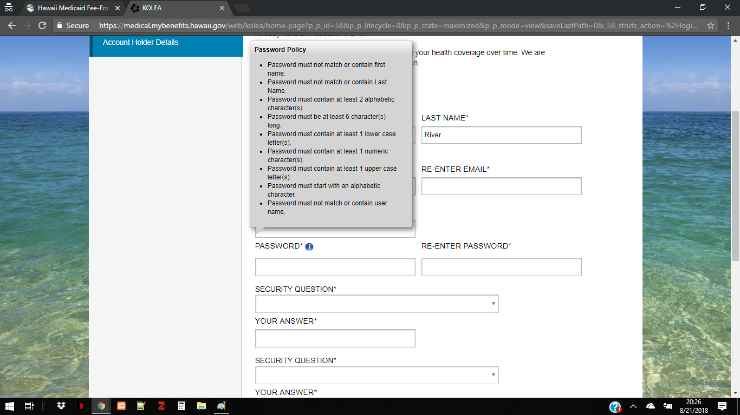
HI PASSWORD

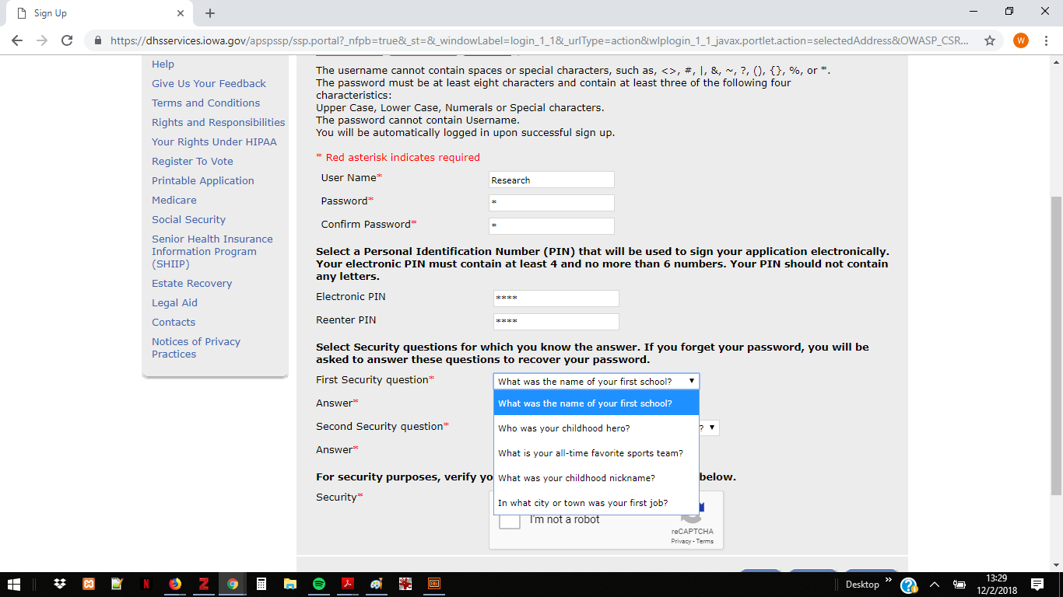

IA Benefits - Security Qs(1)

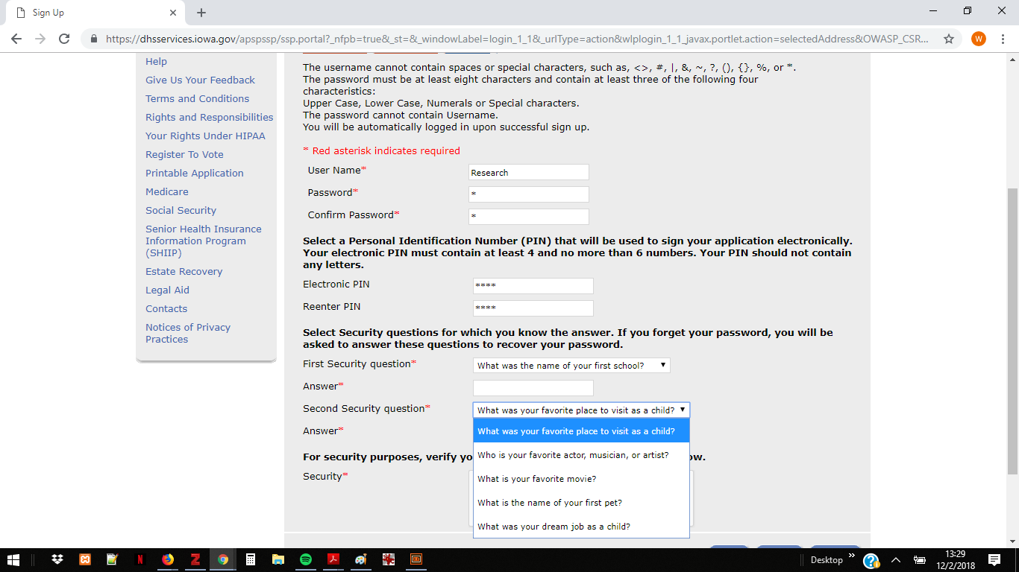

IA Benefits - Security Qs(2)

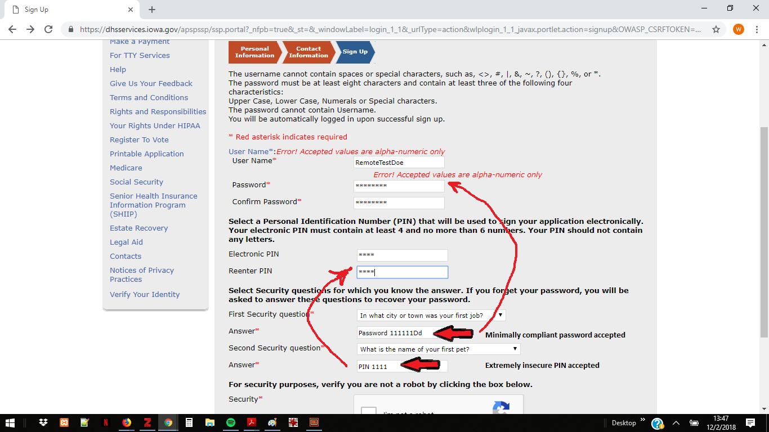
IA Benefits -minimal compliance

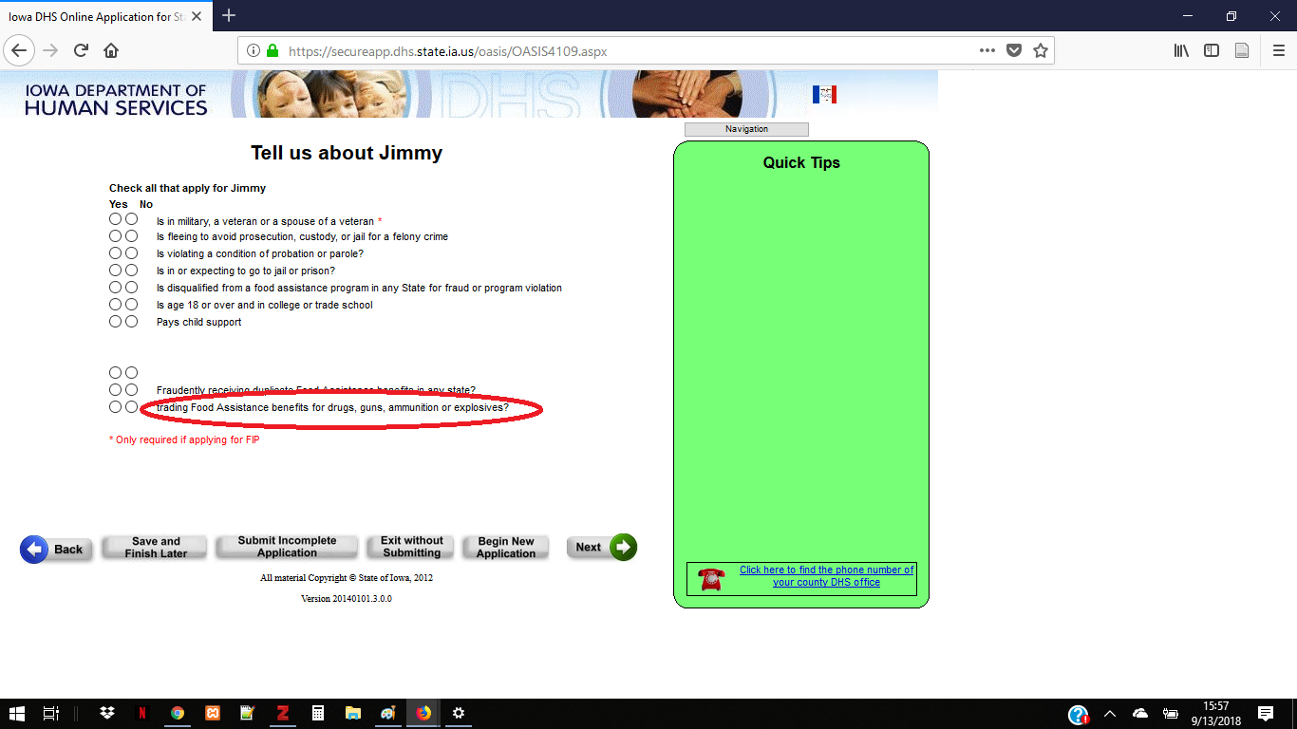
IA Password – notes

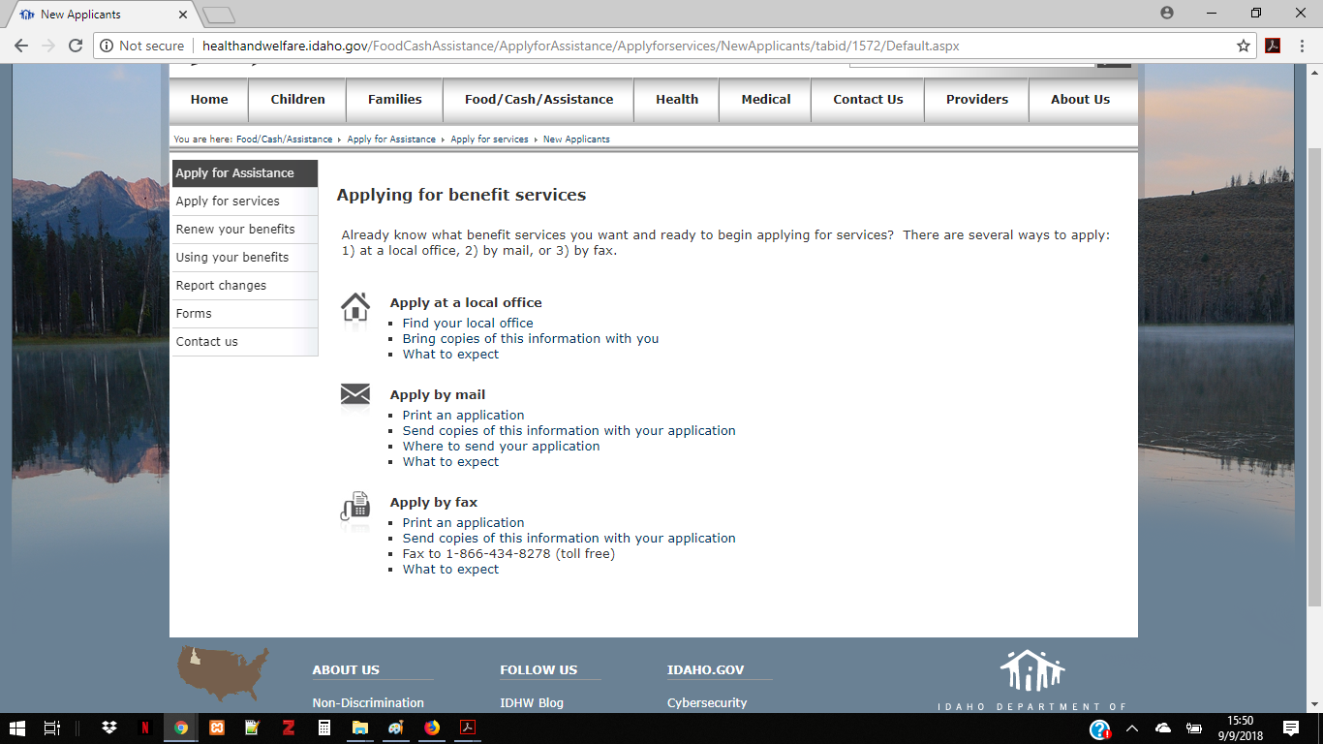
ID Benefits are paper only

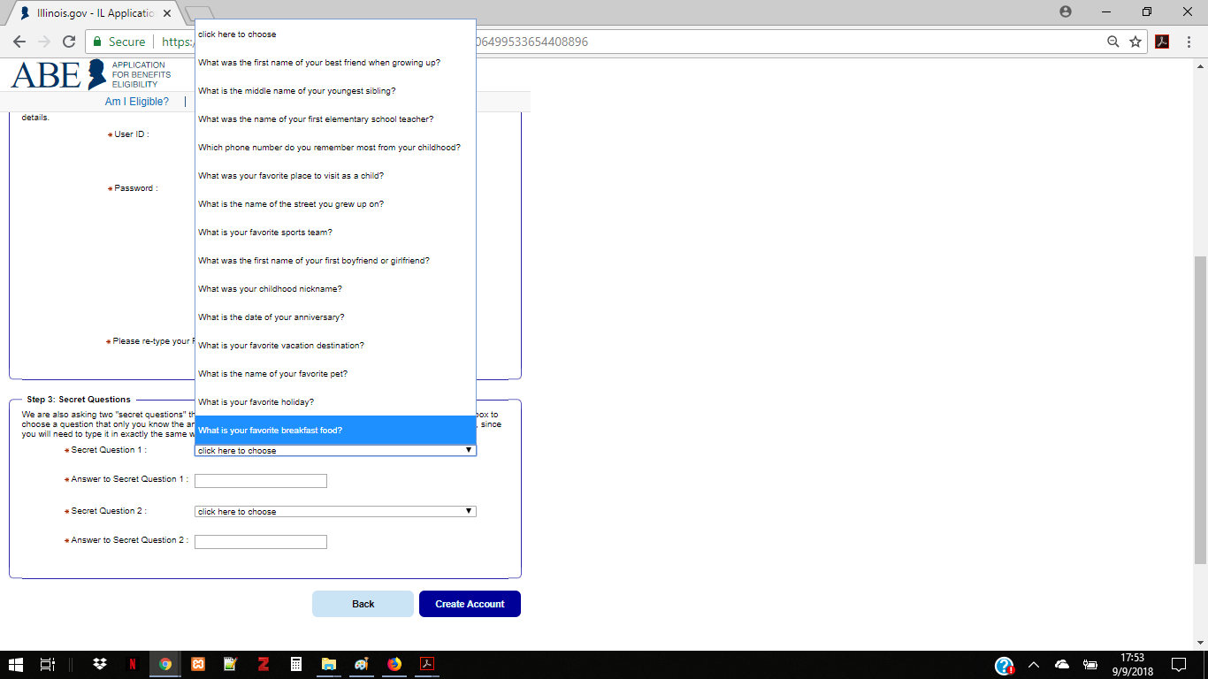

IL Security Qs

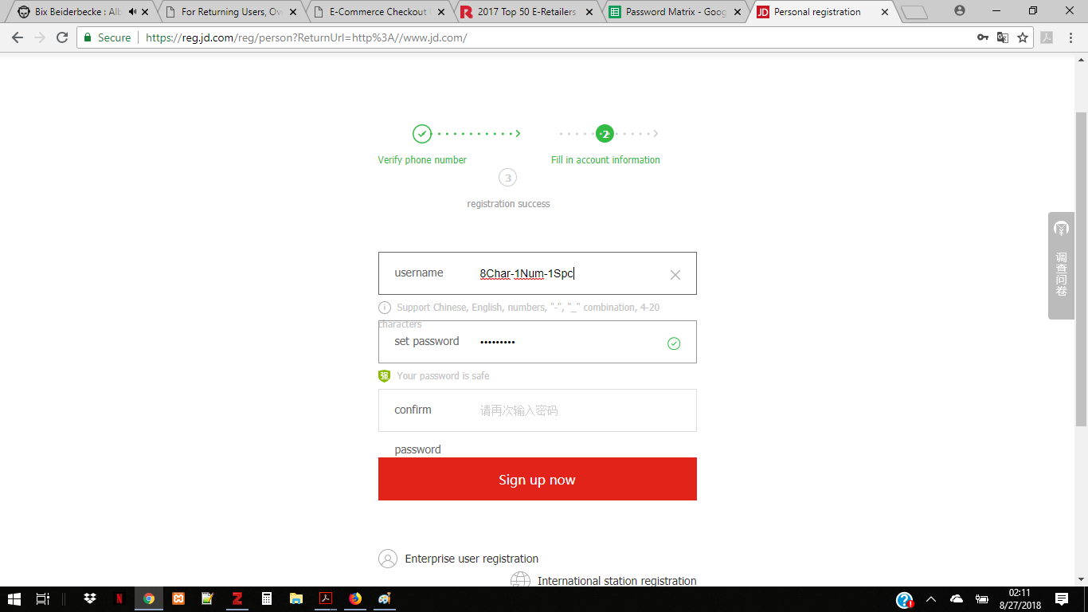
JD.comStrong-PW2

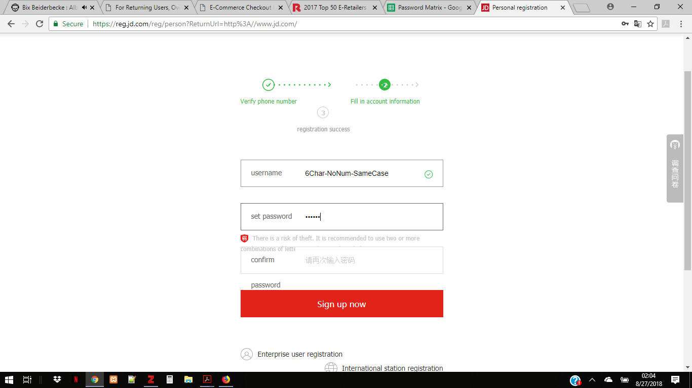

JD.comWeak-PW

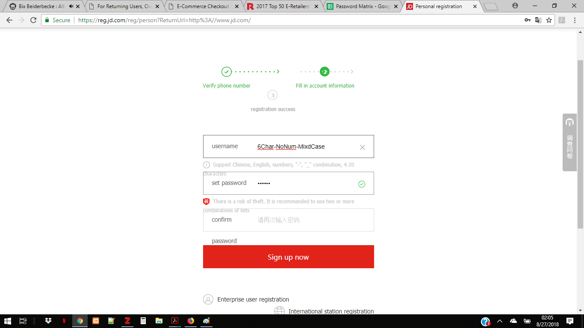JD.comWeak-PW2

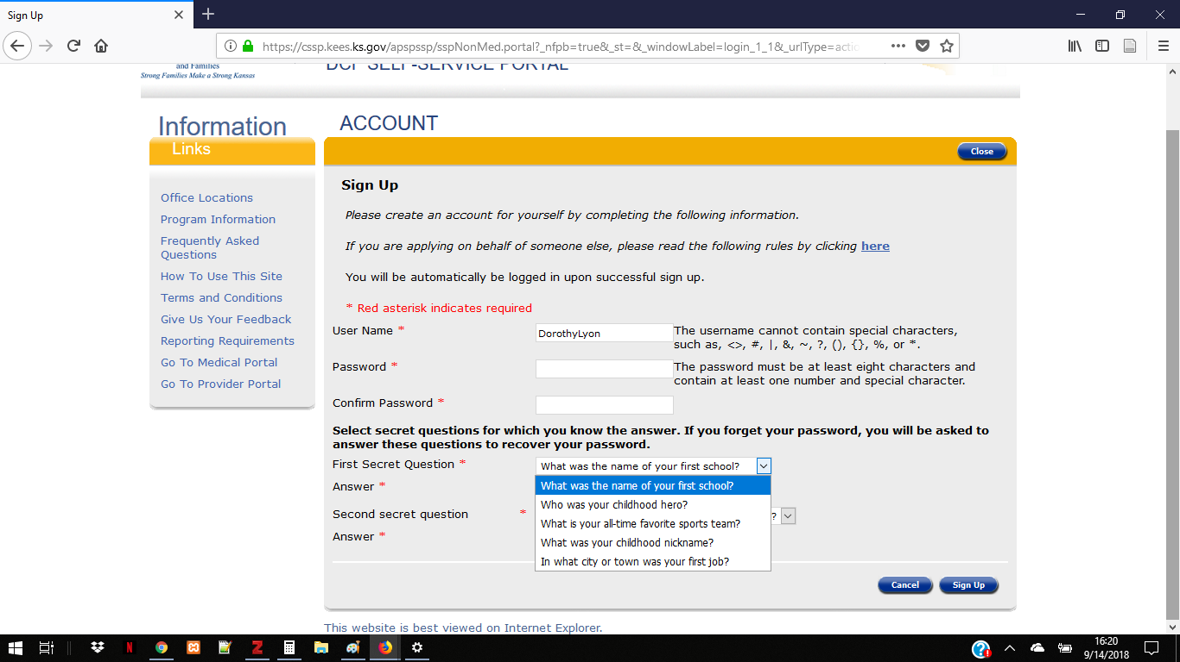
KS Other Services UserID & Password

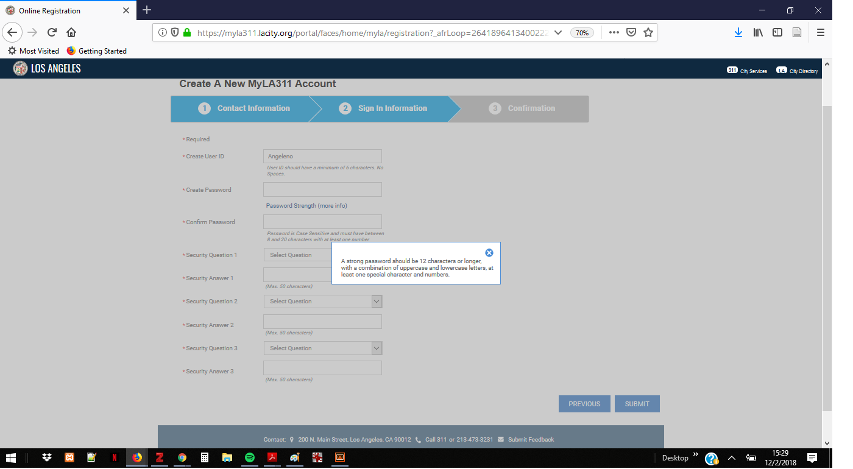
LA - Guidelines

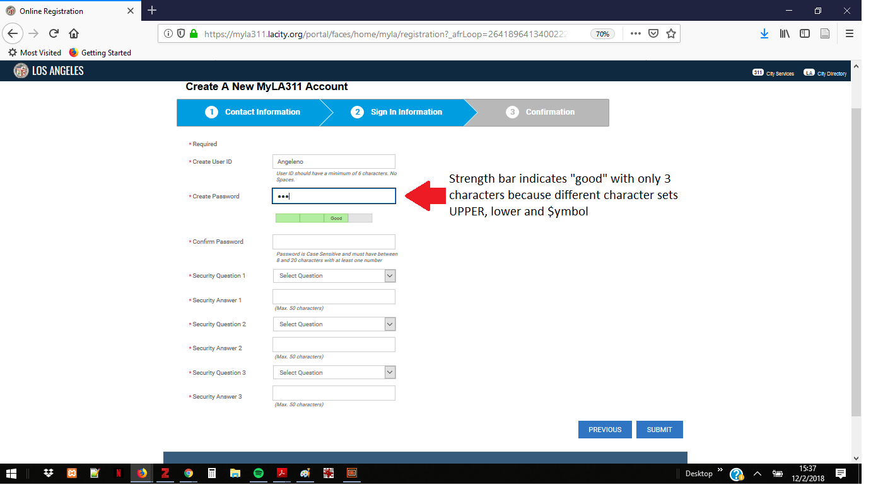
LA - progress (incomplete-early strong

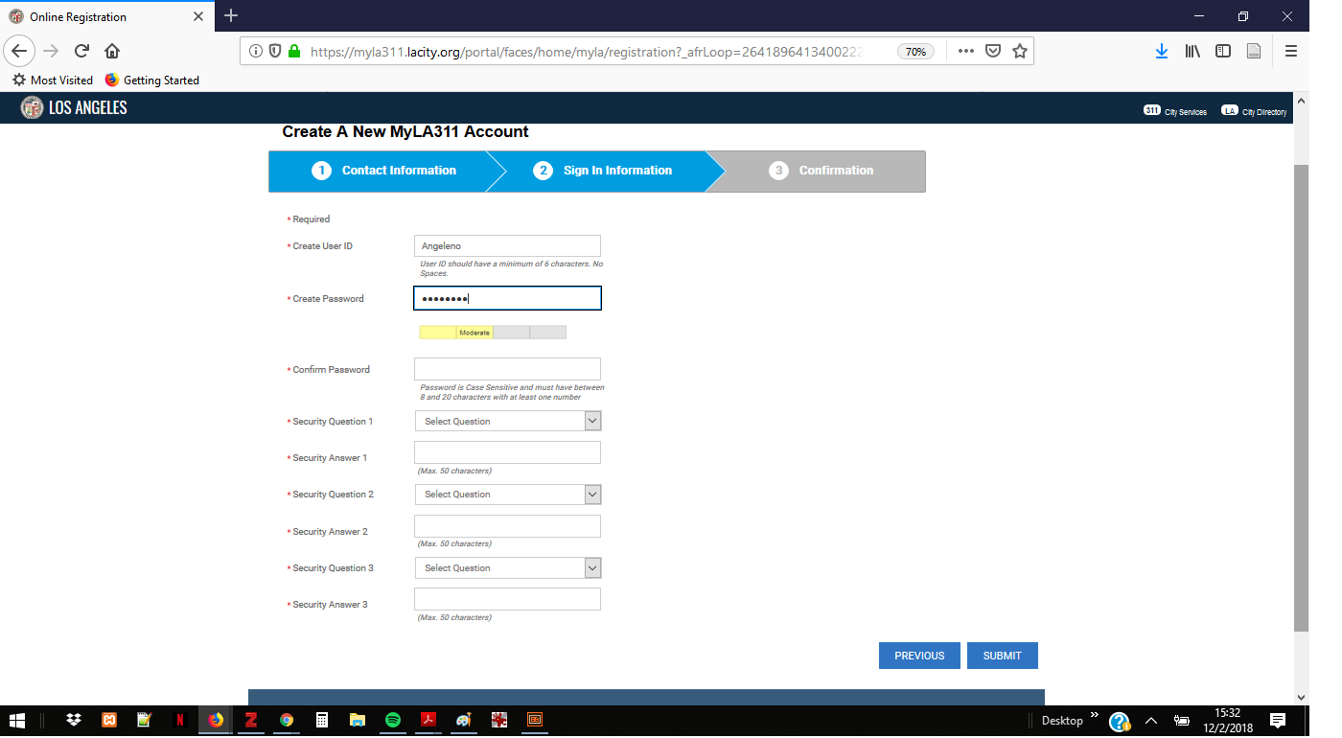

LA - progress (incomplete-med)

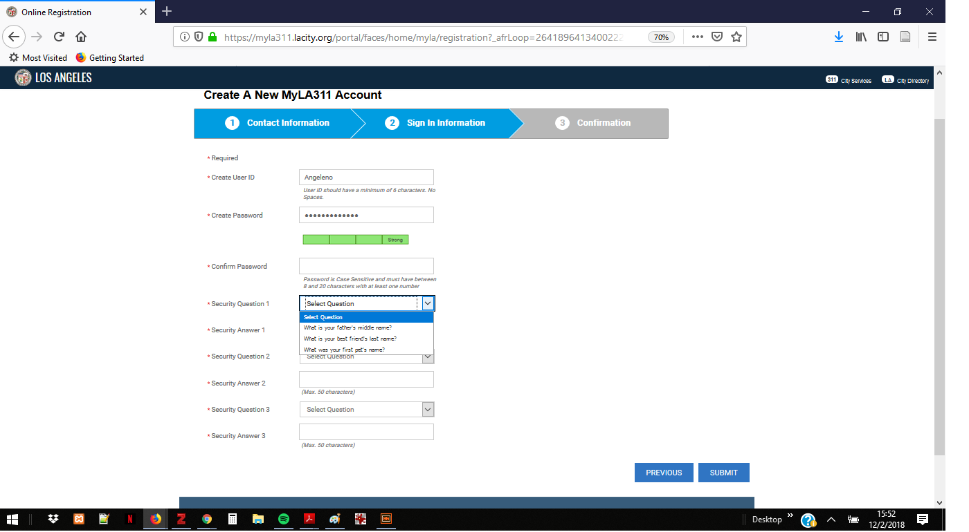
LA -Strong & 1st Q set

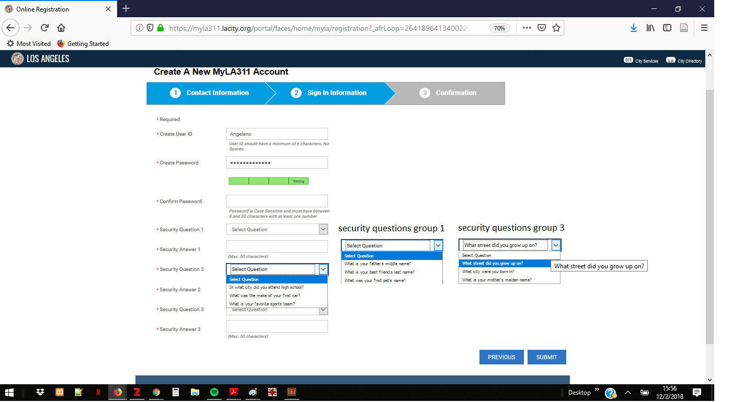

LA -Strong & all security Qst
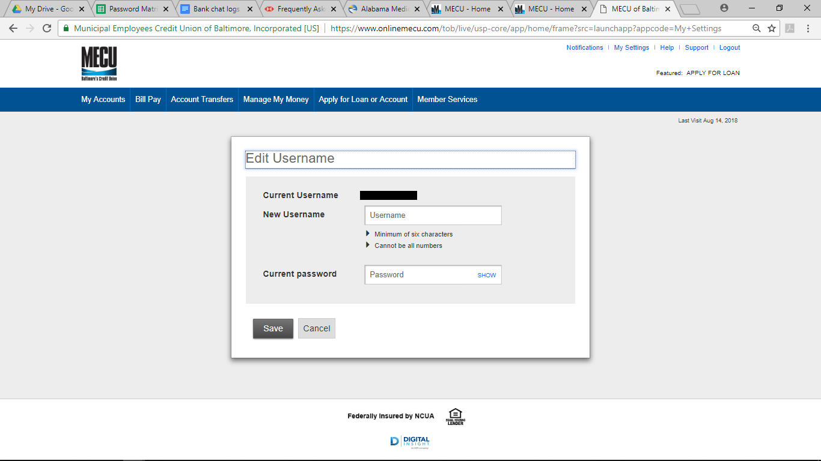MECU Username

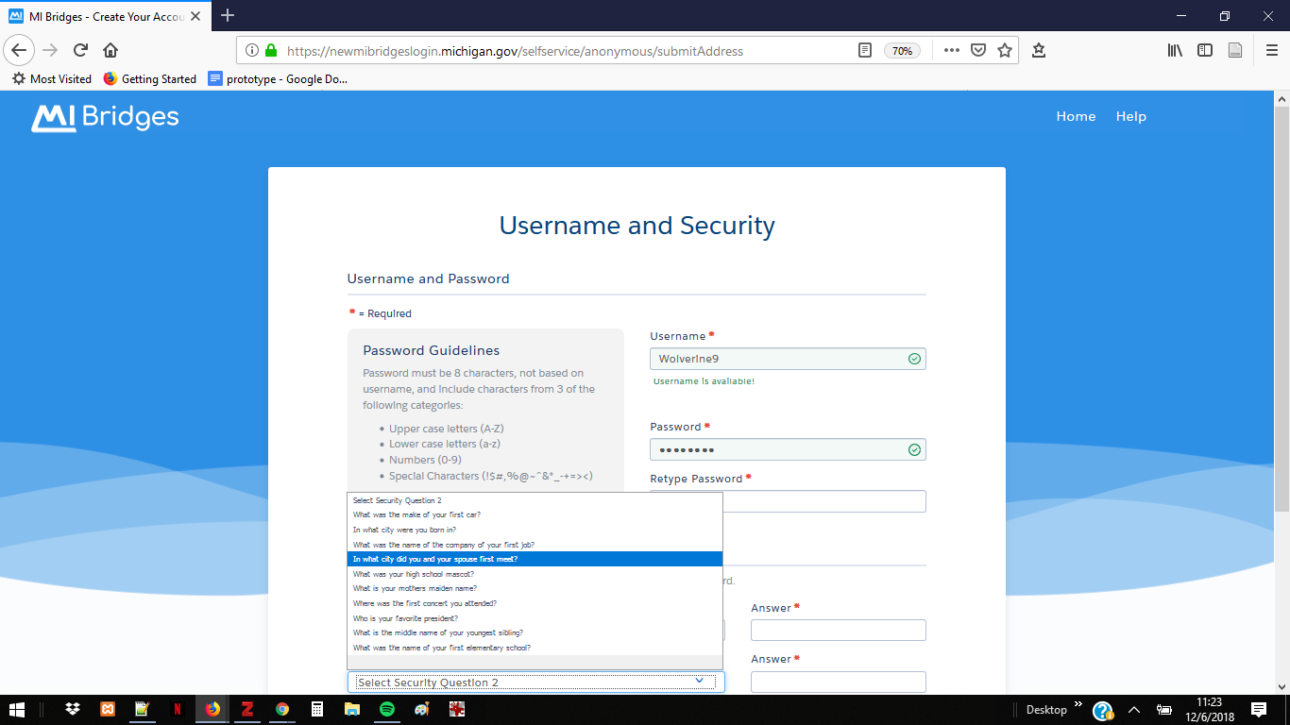

MI SNAP Security Q

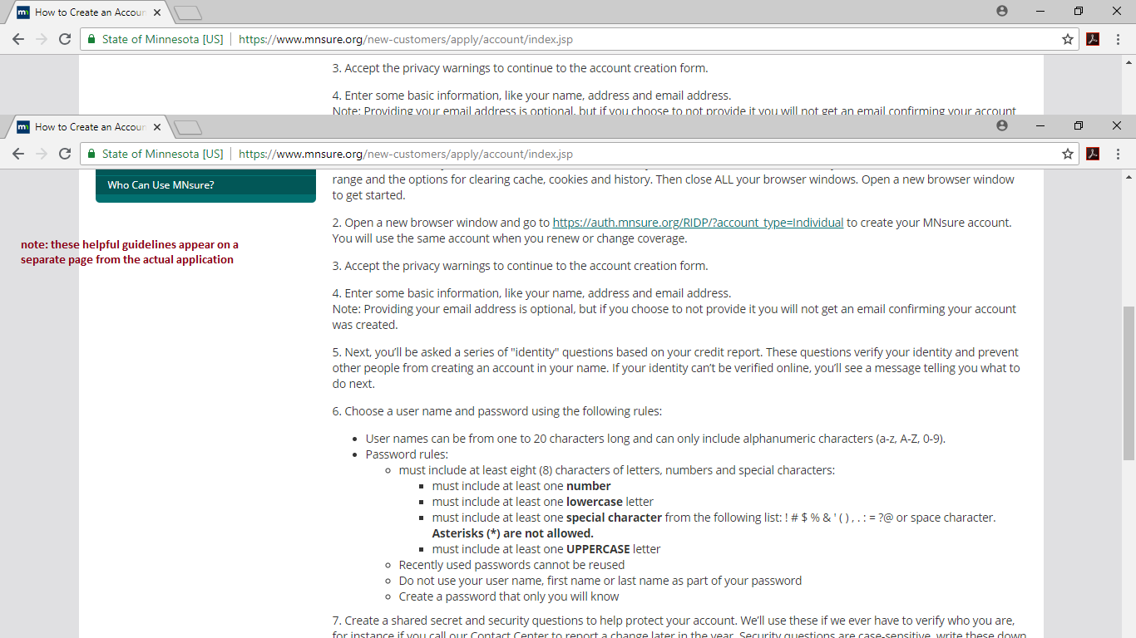

MN tutorial

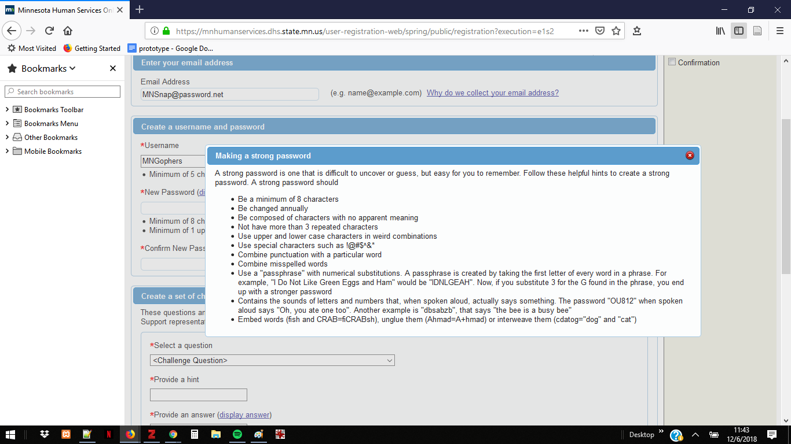MN SNAP Tutorial

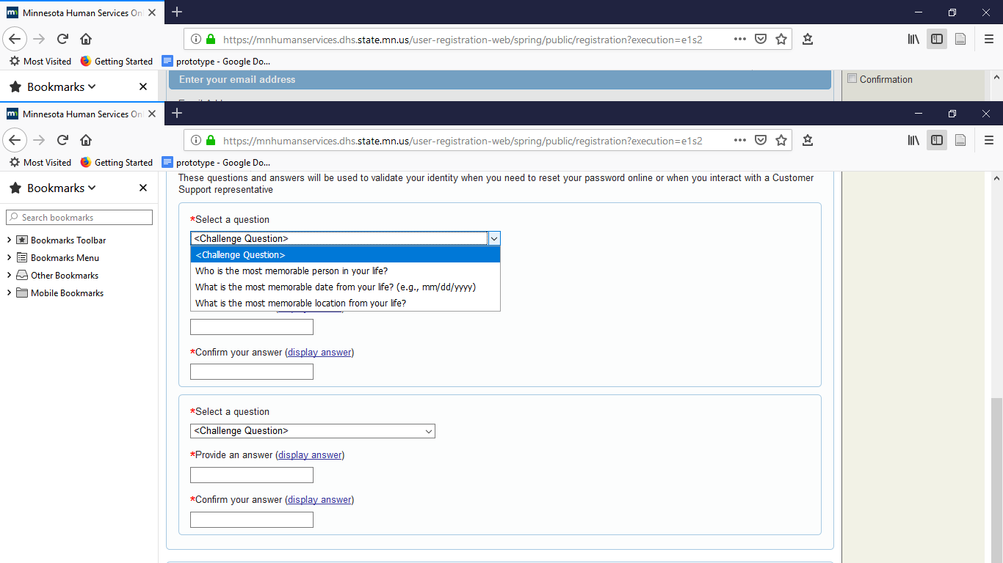

MN SNAP Security Qs

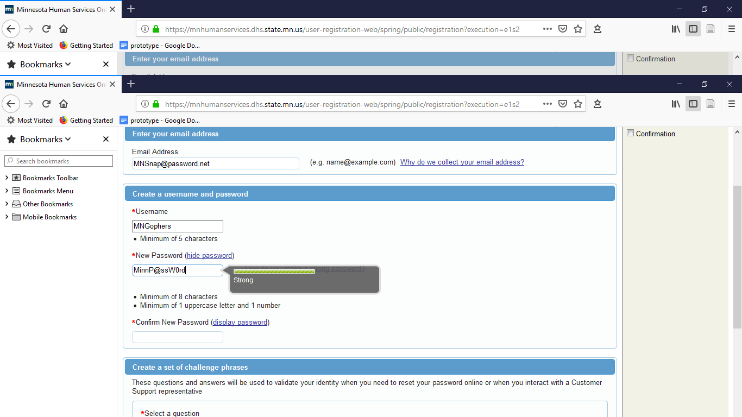
MN SNAP Strength Bar

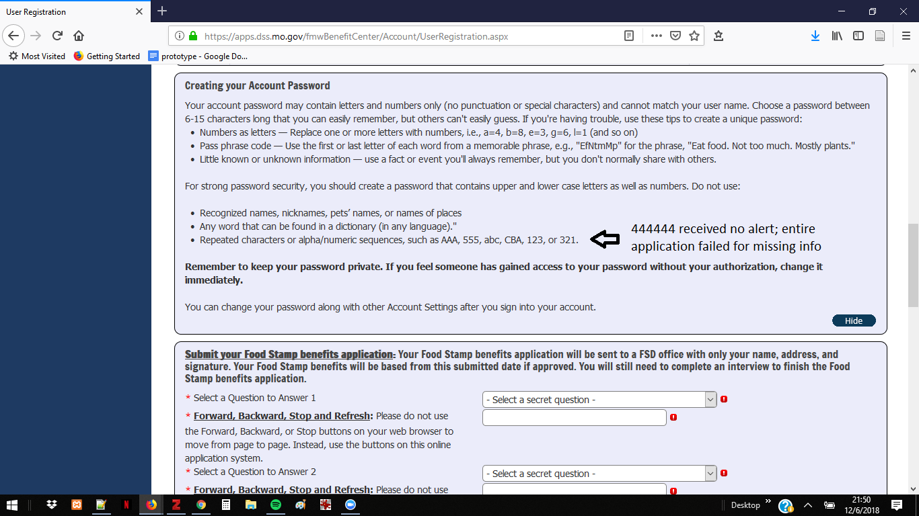MO SNAP Password tips

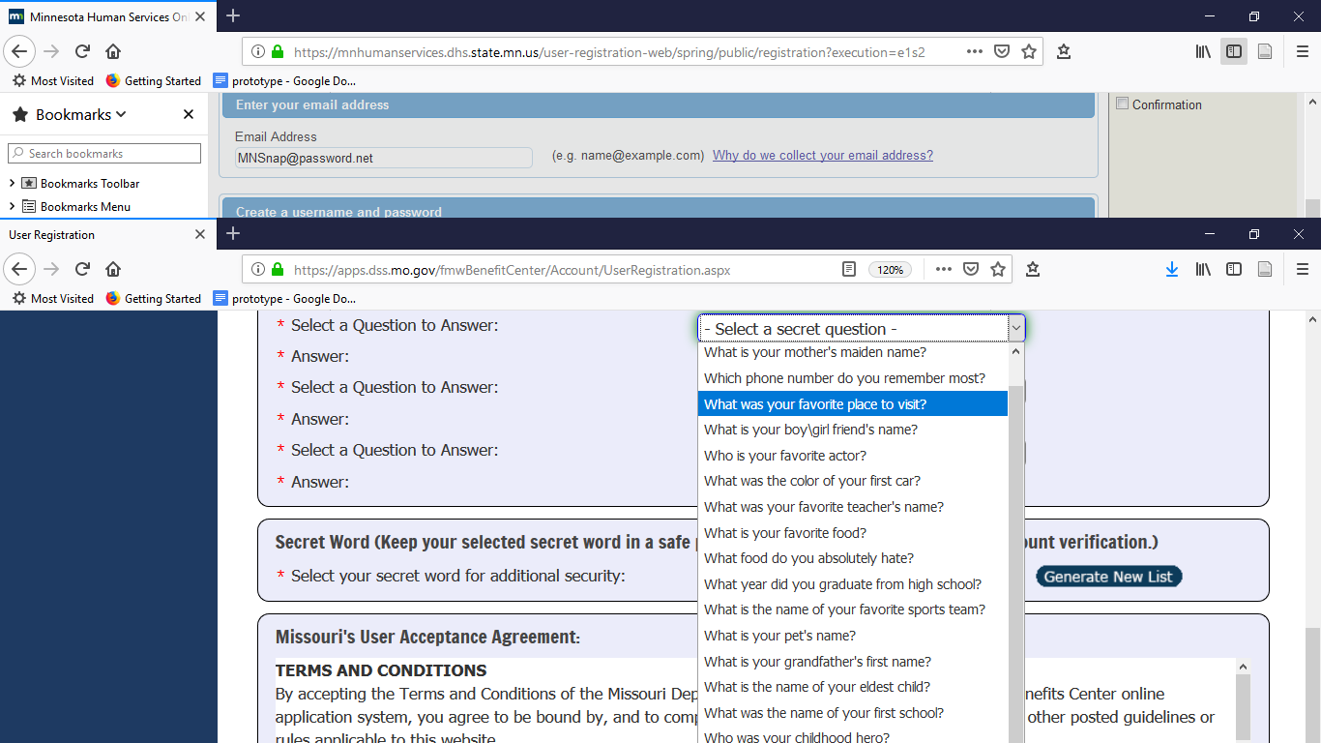

MO SNAP Secret Qs

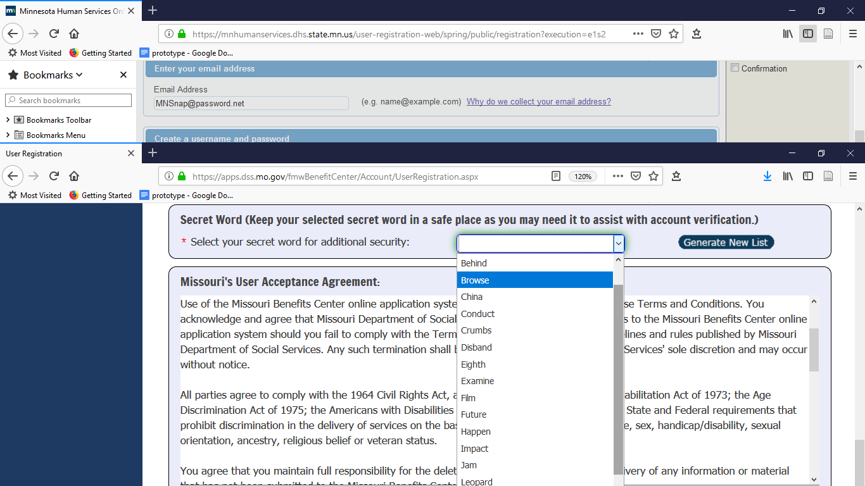

MO SNAP SecretAdd'lWord

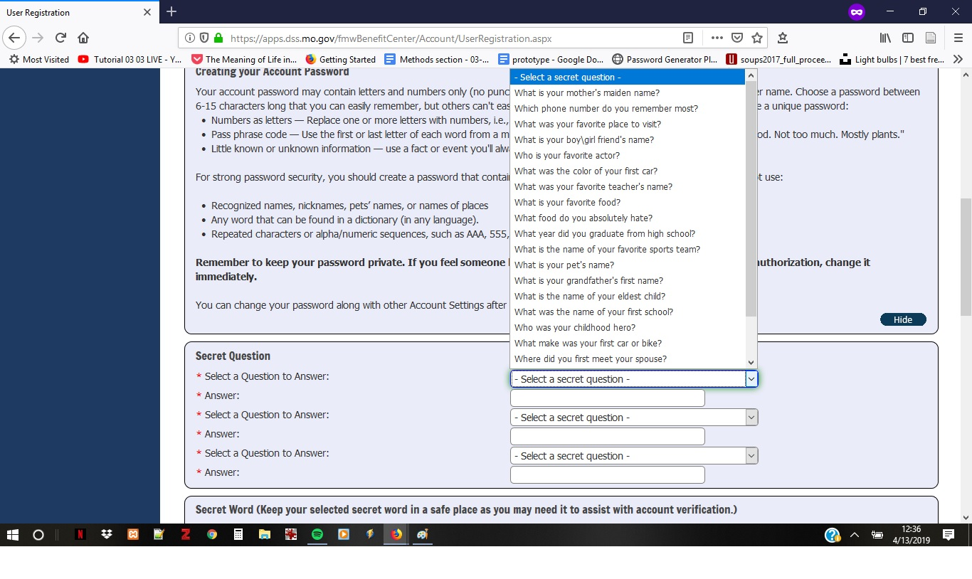
MO SNAP

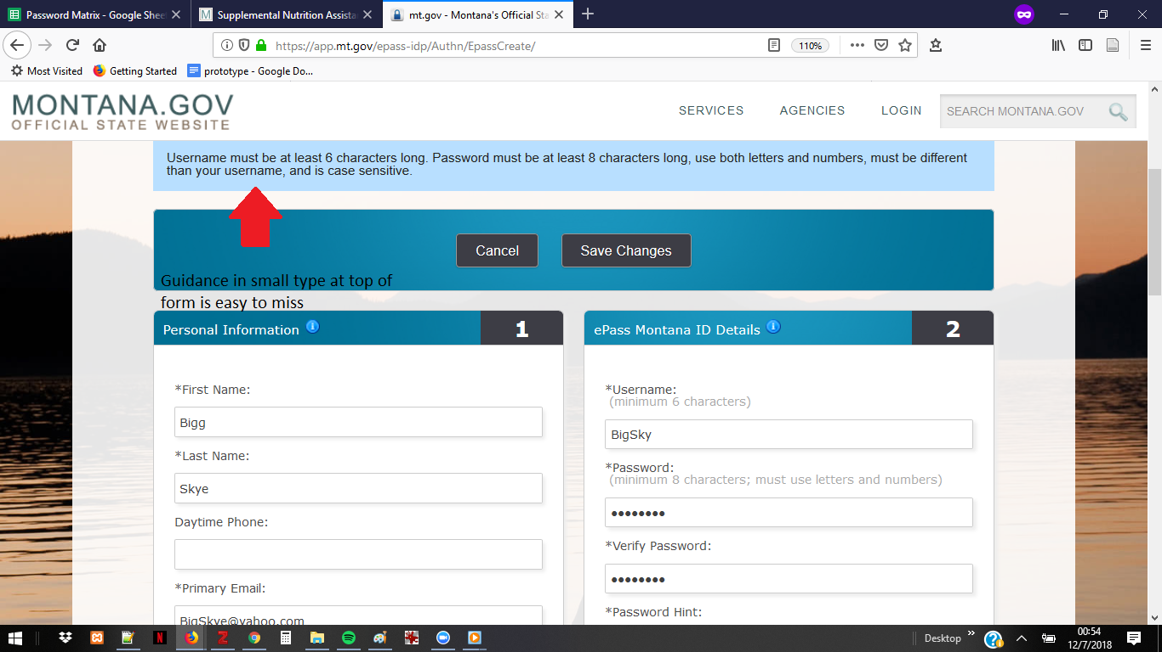MT SNAP guidance

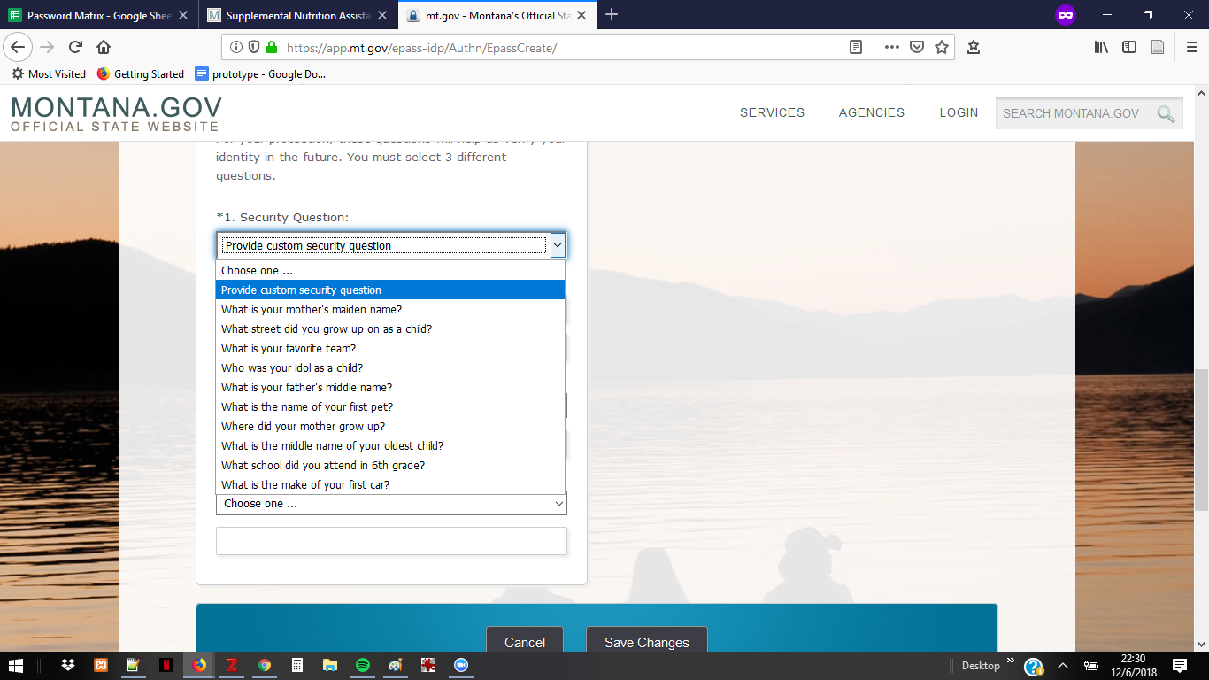

MT SNAP Qs

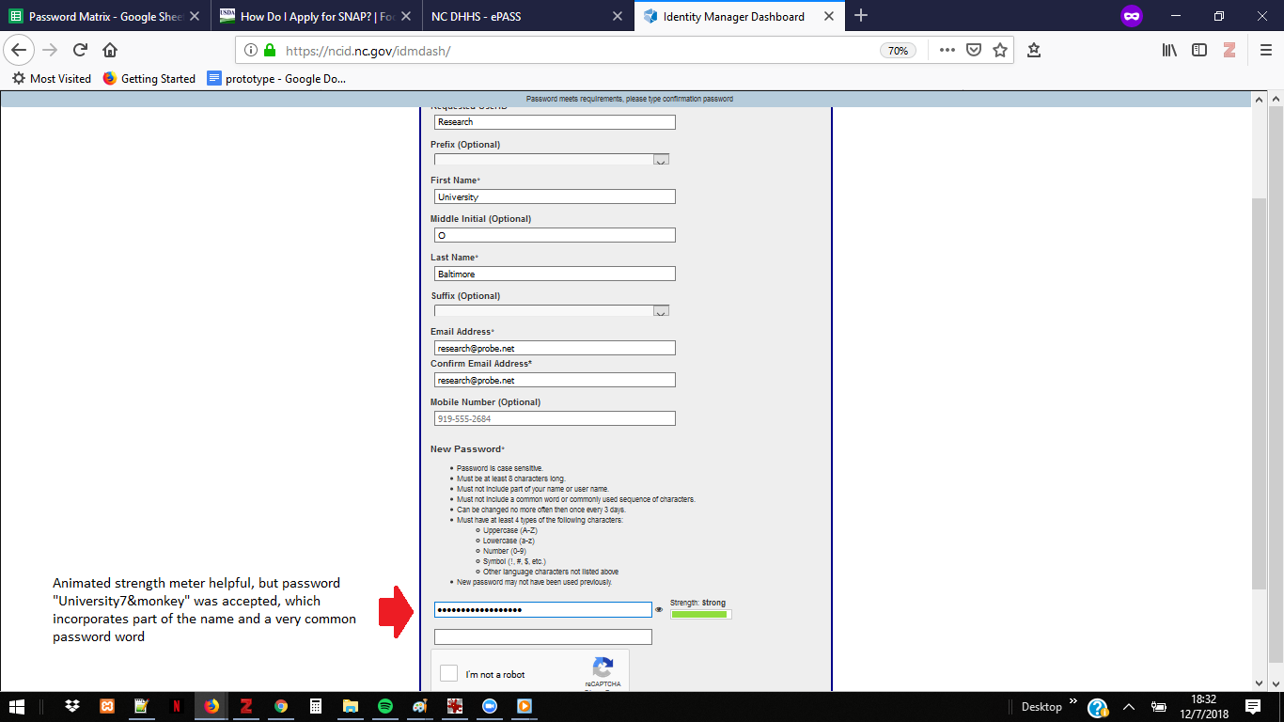NC SNAP

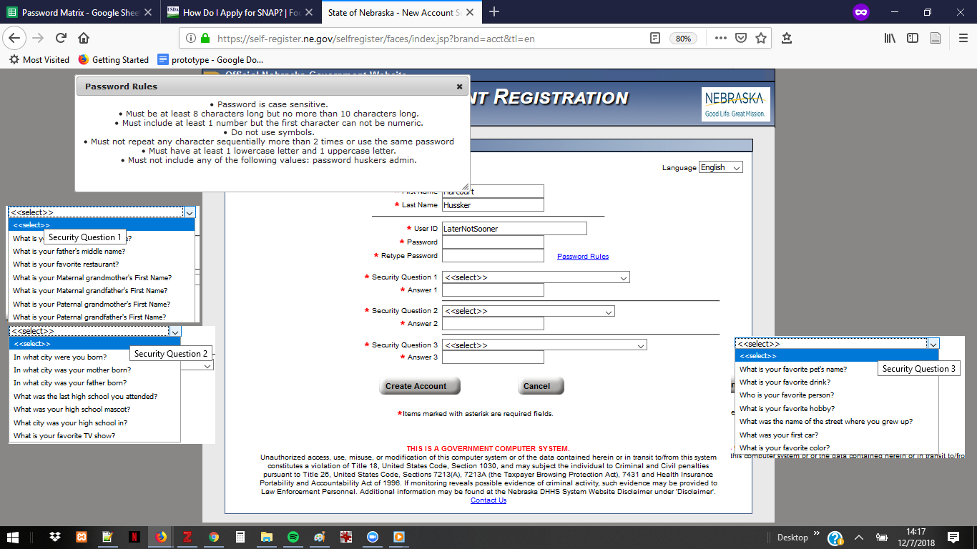

NE - instructions + Security Qs

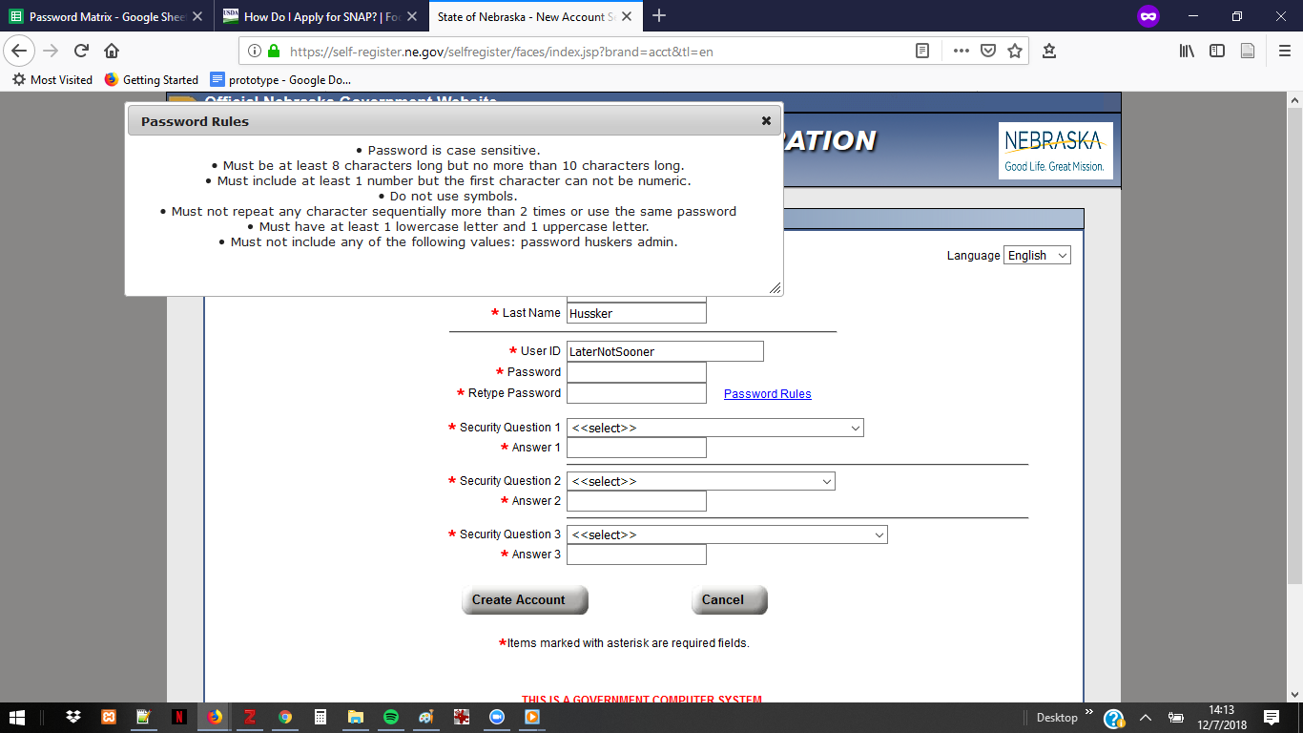
NE SNAP Password

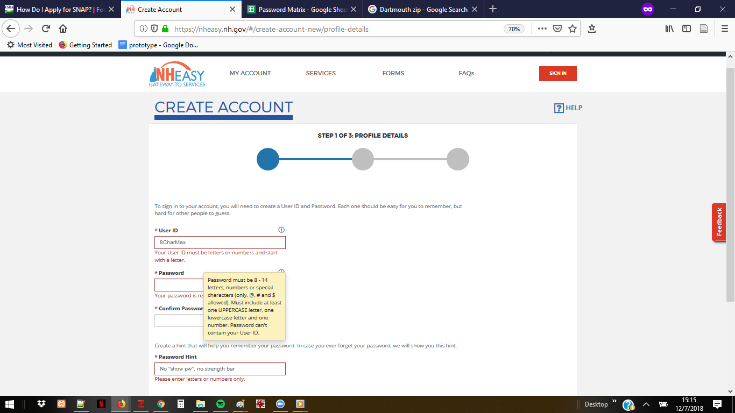

NH SNAP password
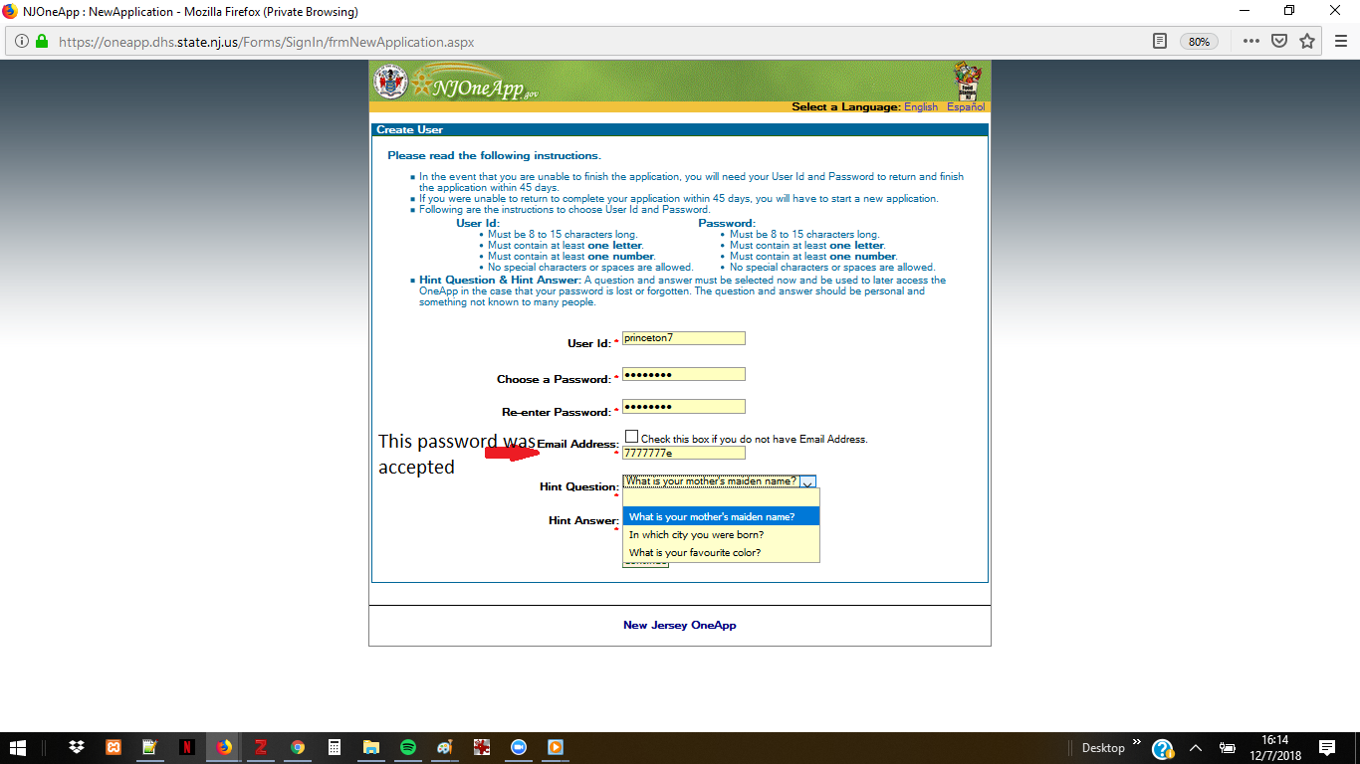

NJ SNAP

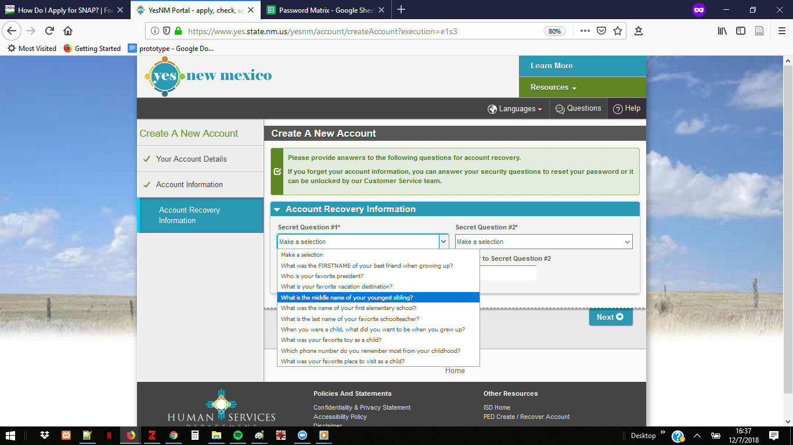

NM Security

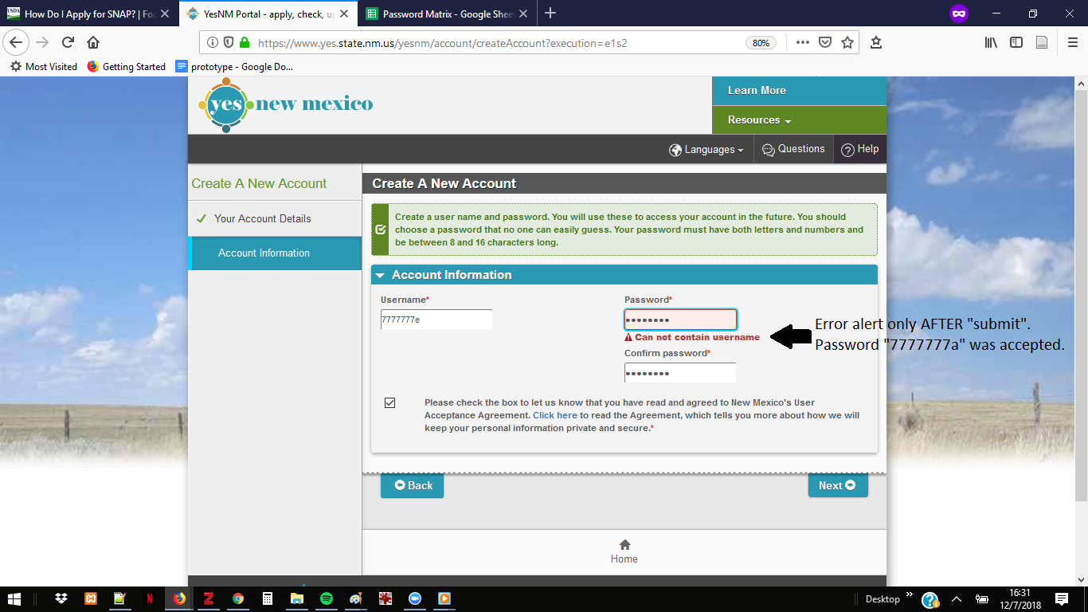NM SNAP Error

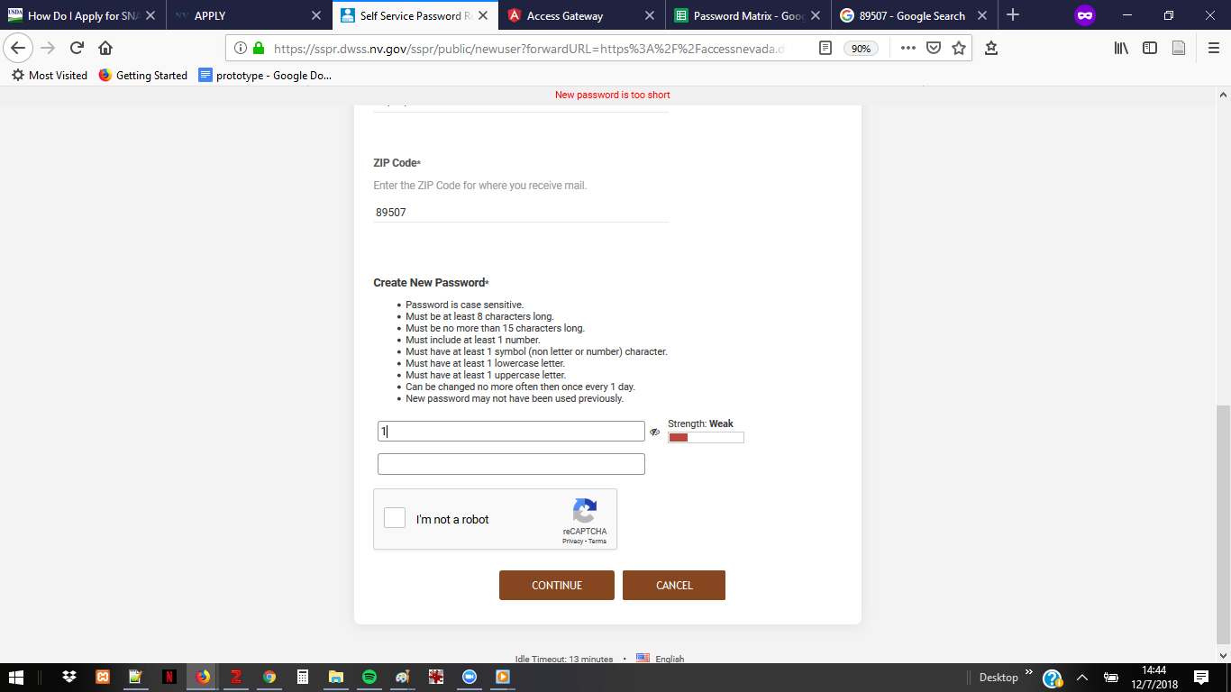

NV Password Instructions

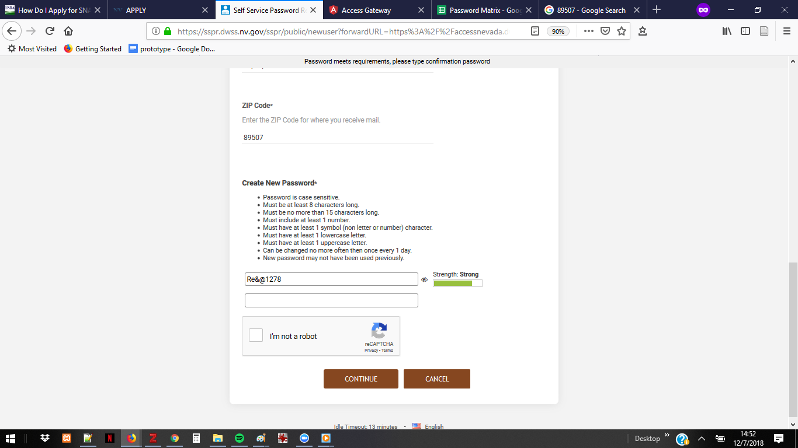

NV Stronger

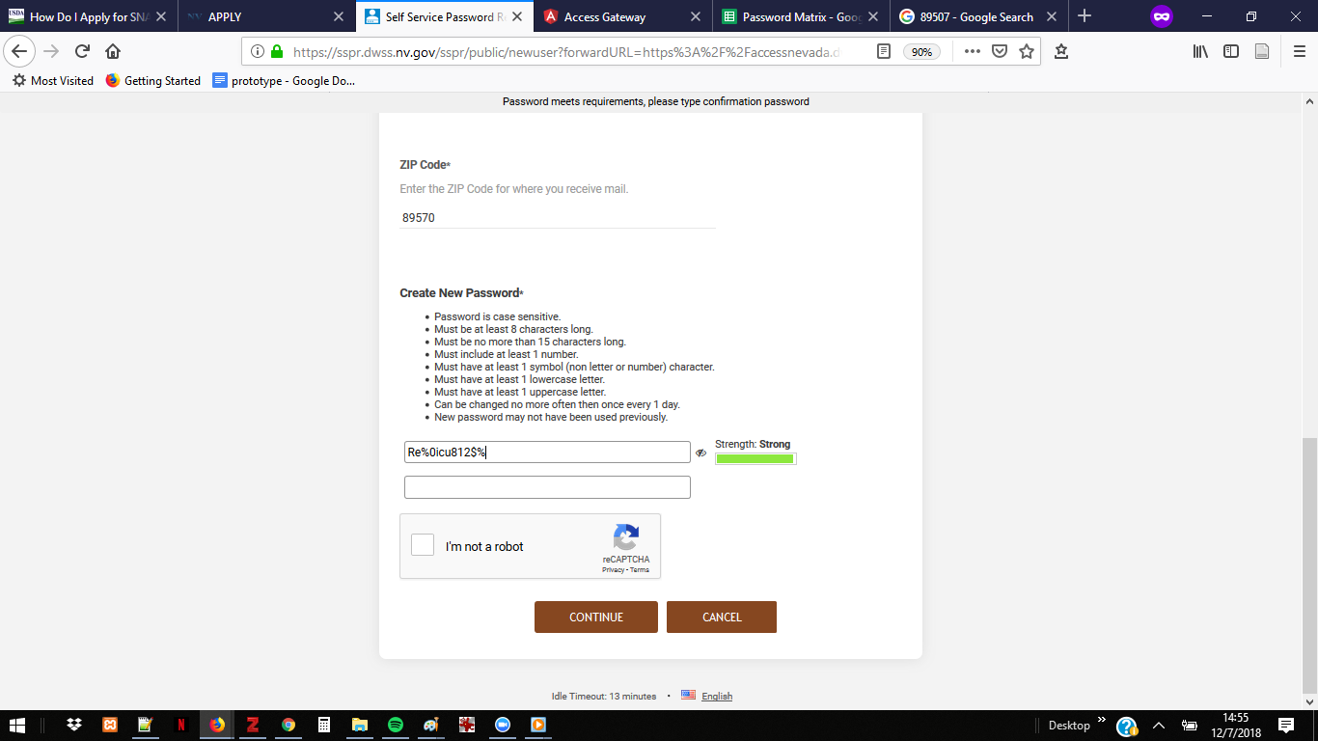NV Strongest

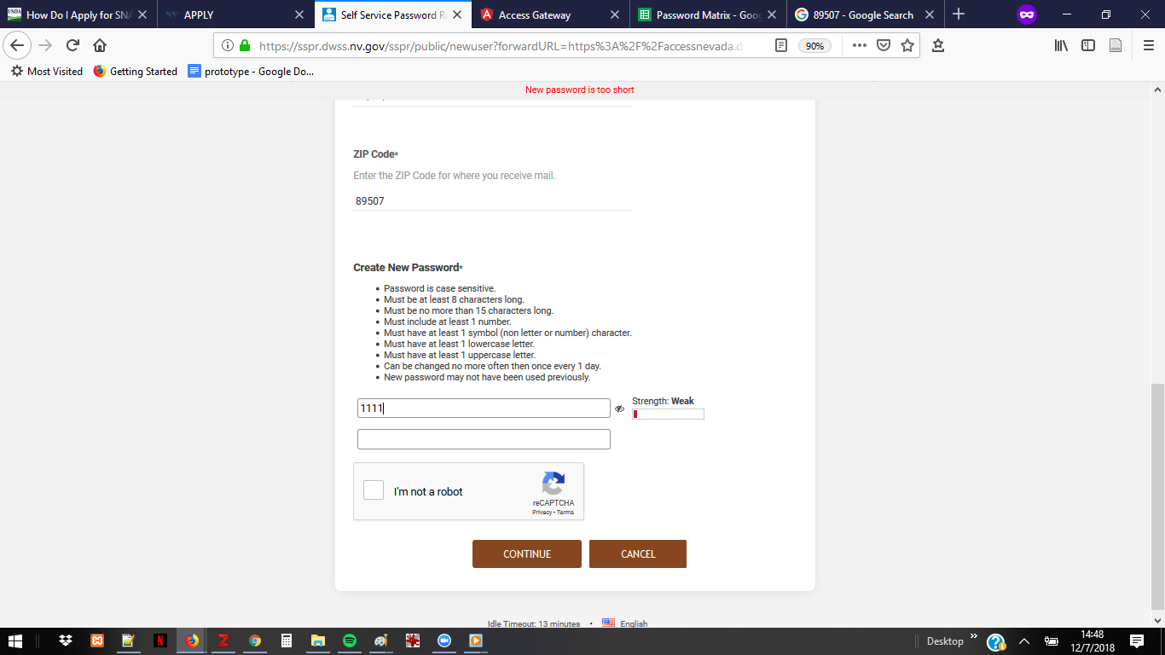

NV weaker

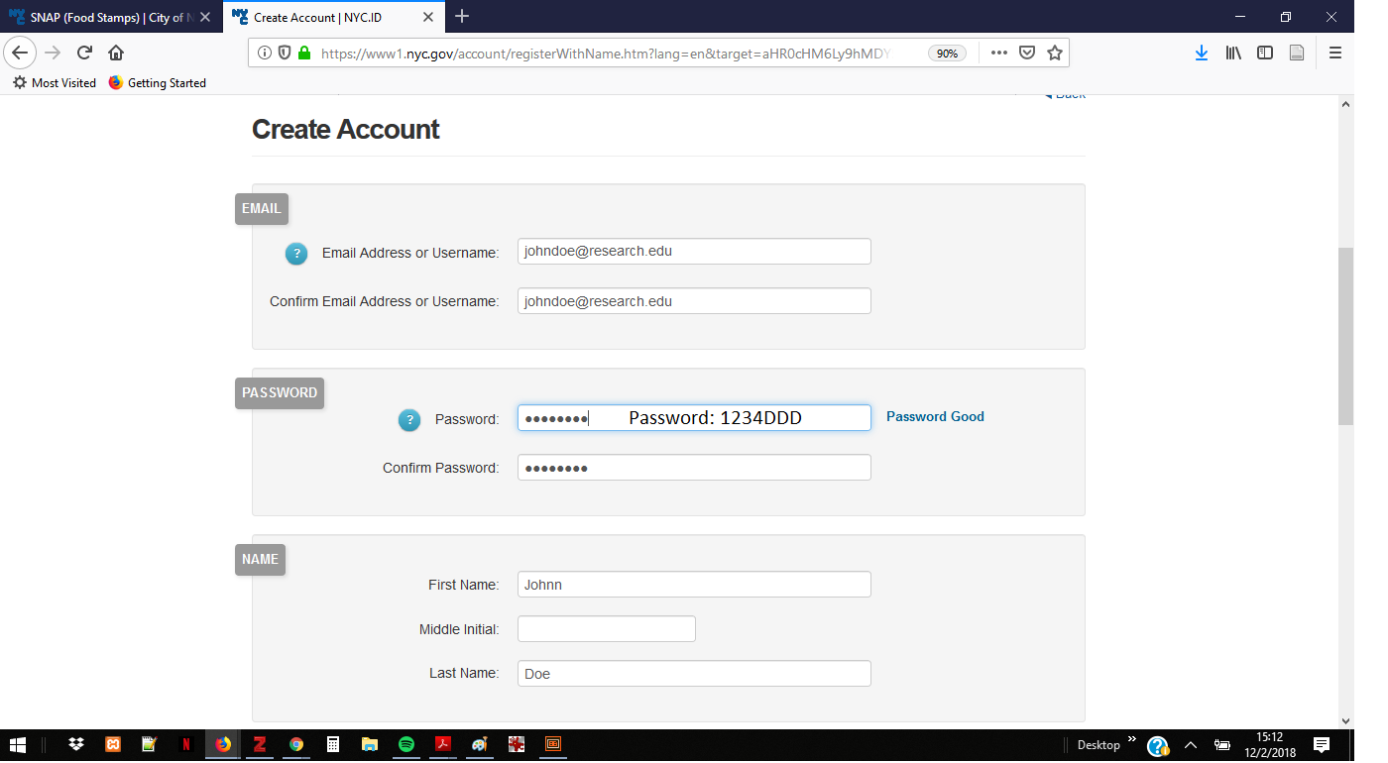

NYC Snap – Good

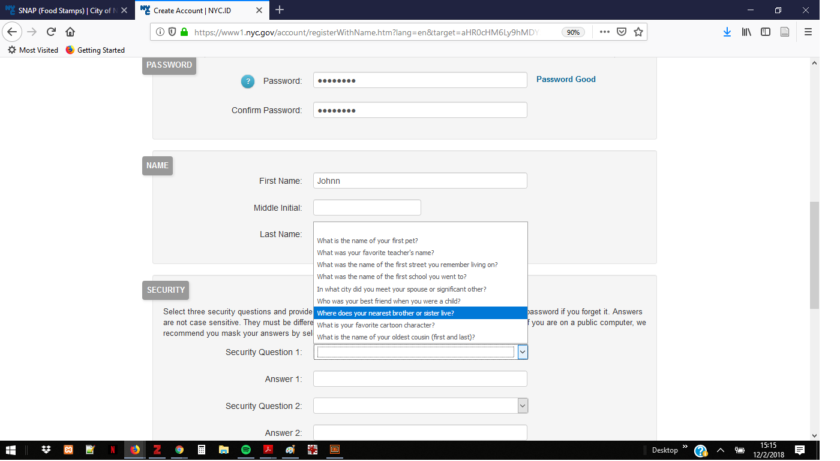NYC SNAP- Security Qs

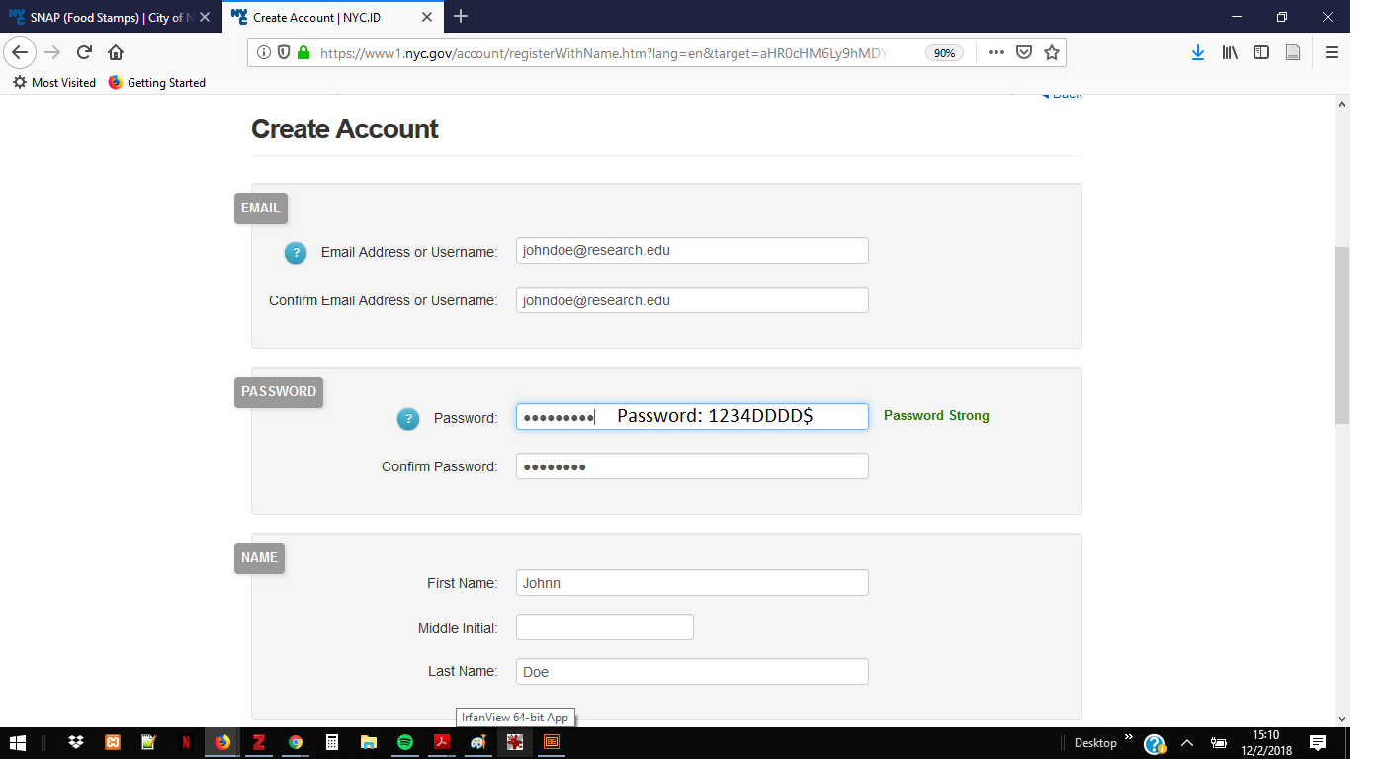

NYC SNAP – Strong

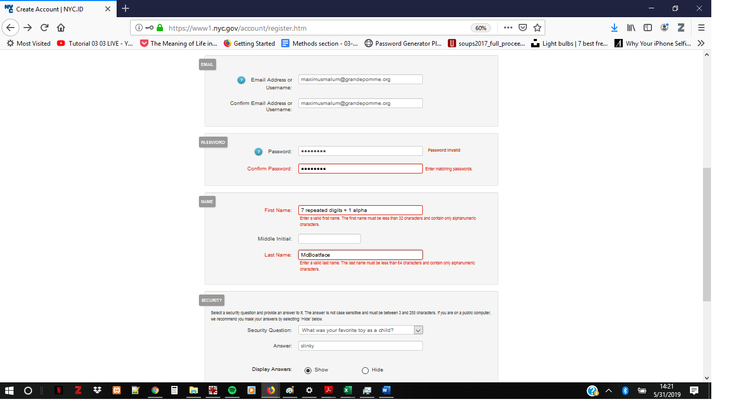

NYC SNAP Weak
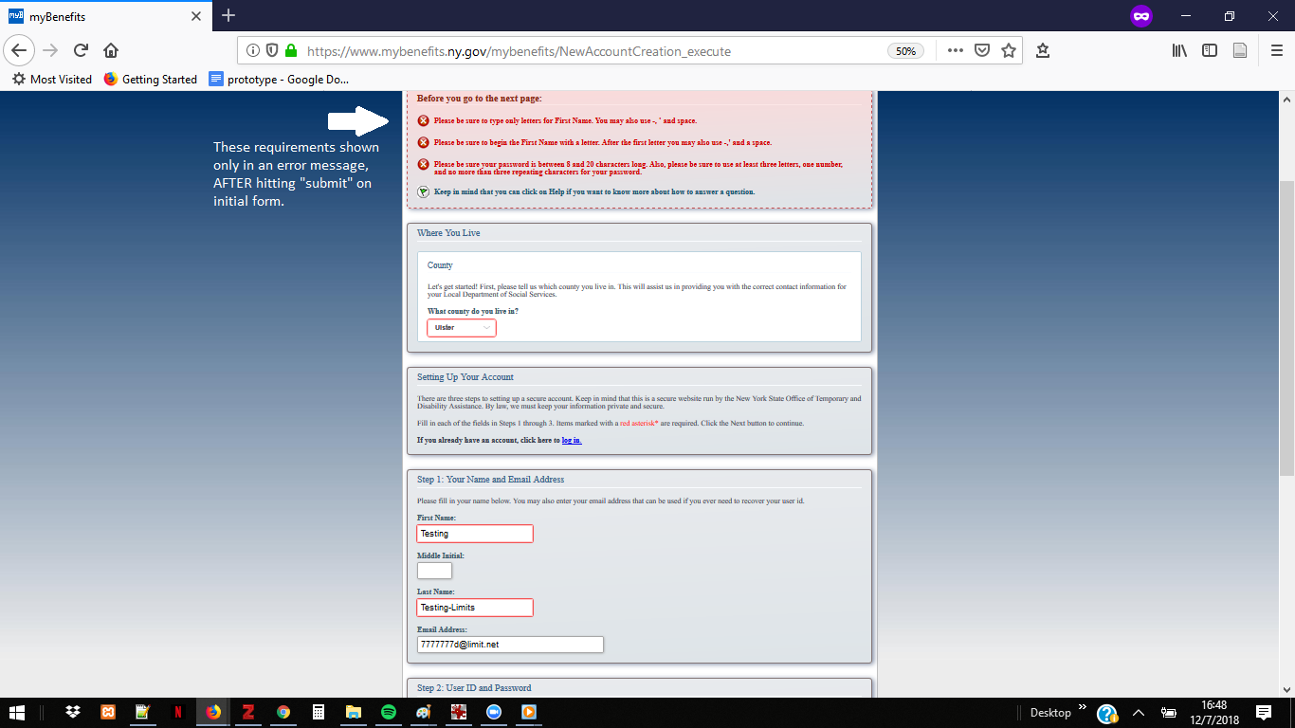NYState errors 1
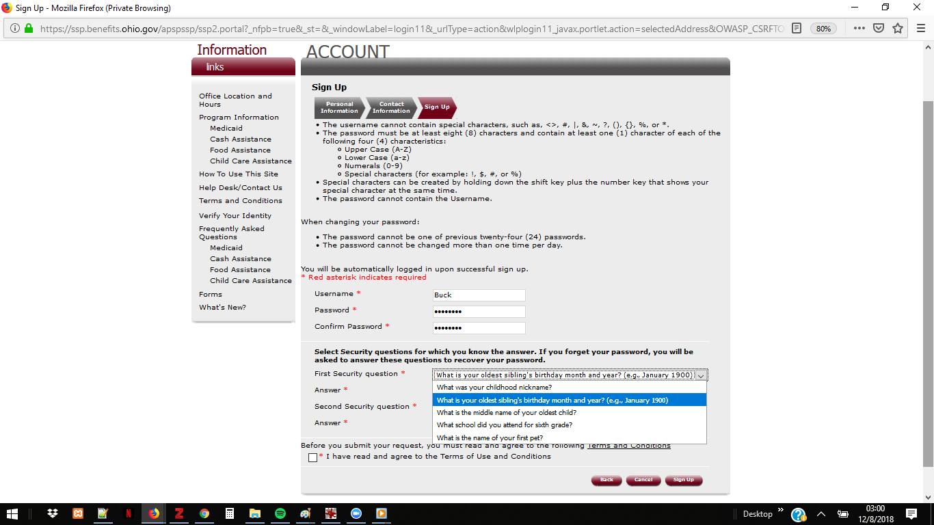

OH SNAP Security Q1

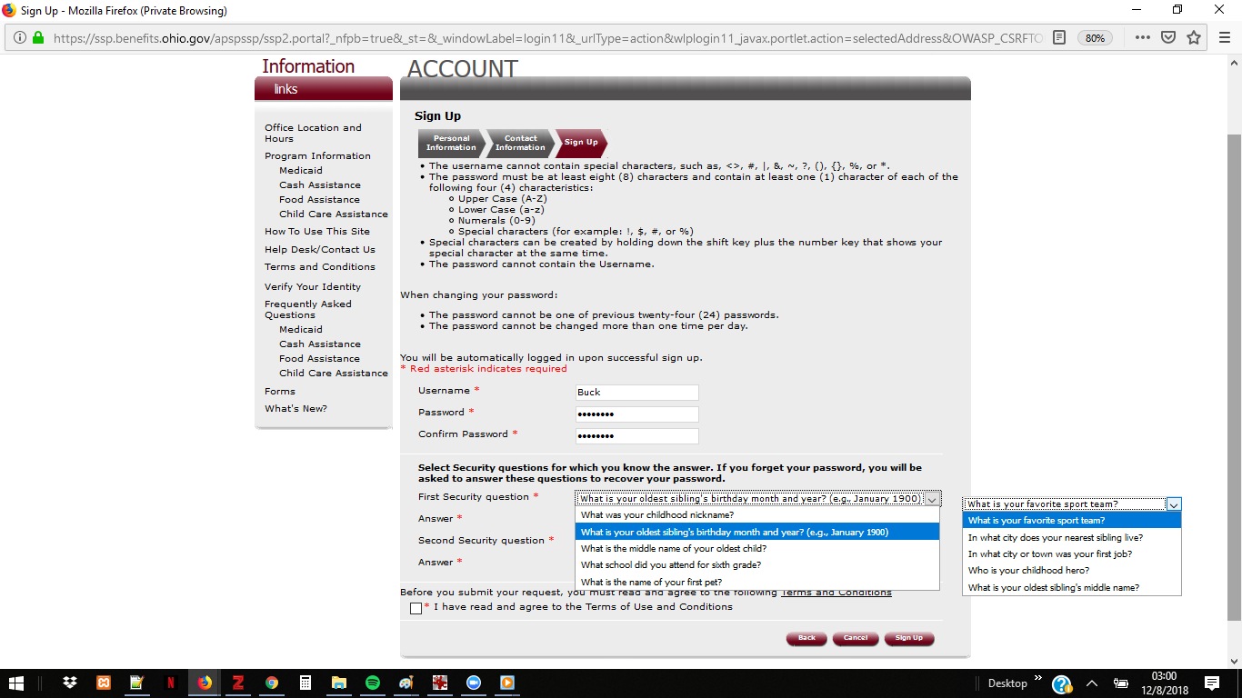OH SNAP Security Q2

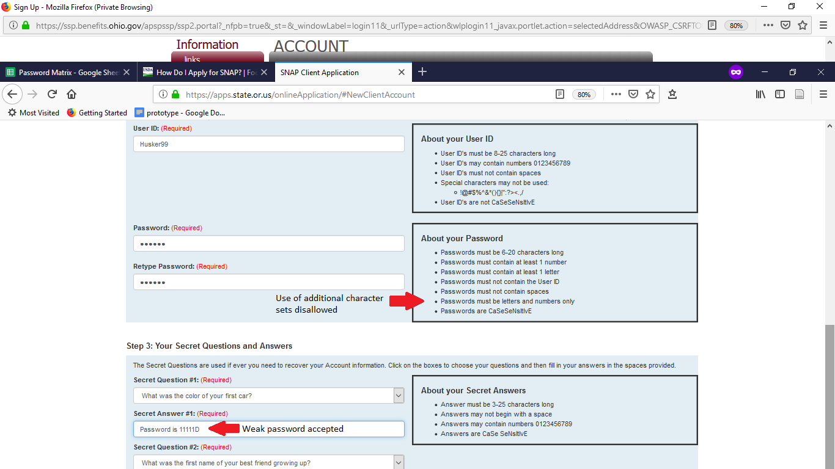

OK SNAP

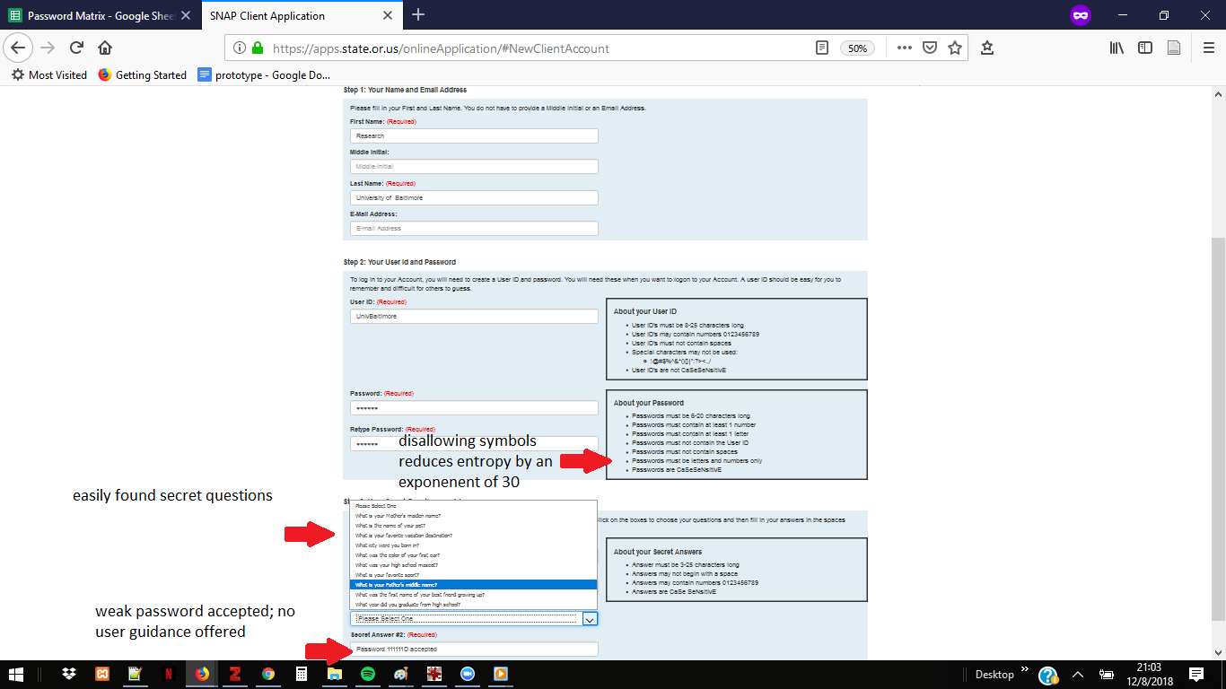OR SNAP

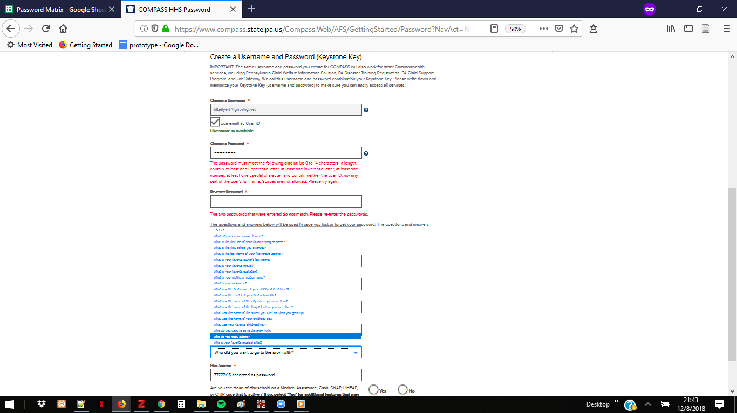

PA SNAP

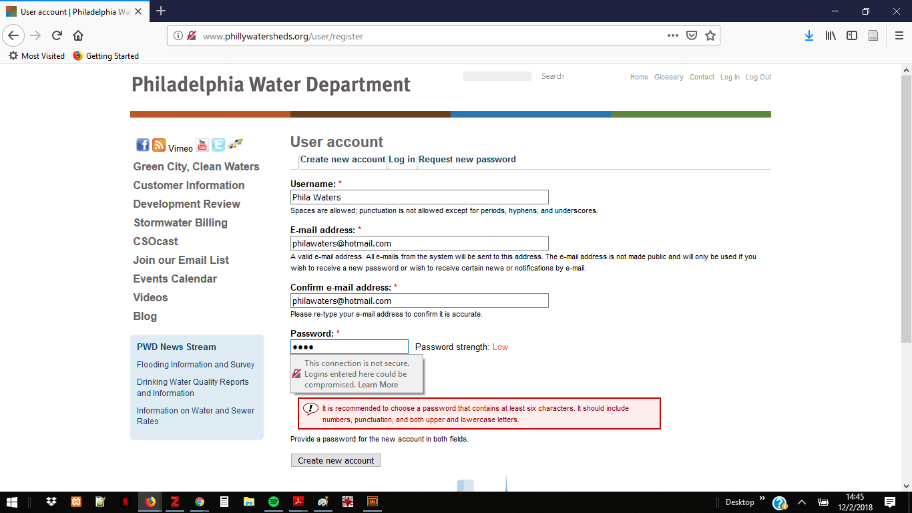

Phila Water incomplete

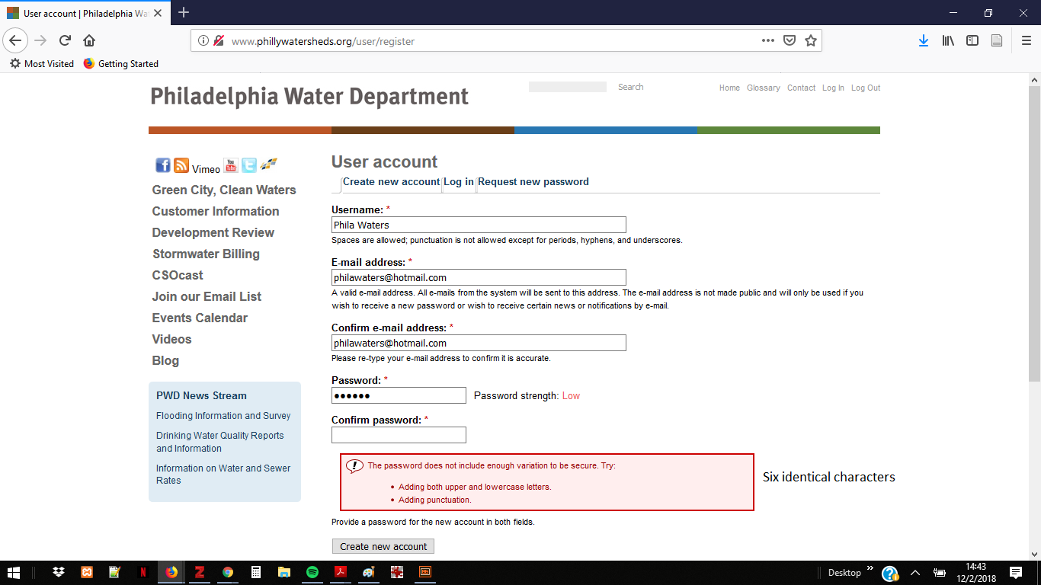Phila Water Lo

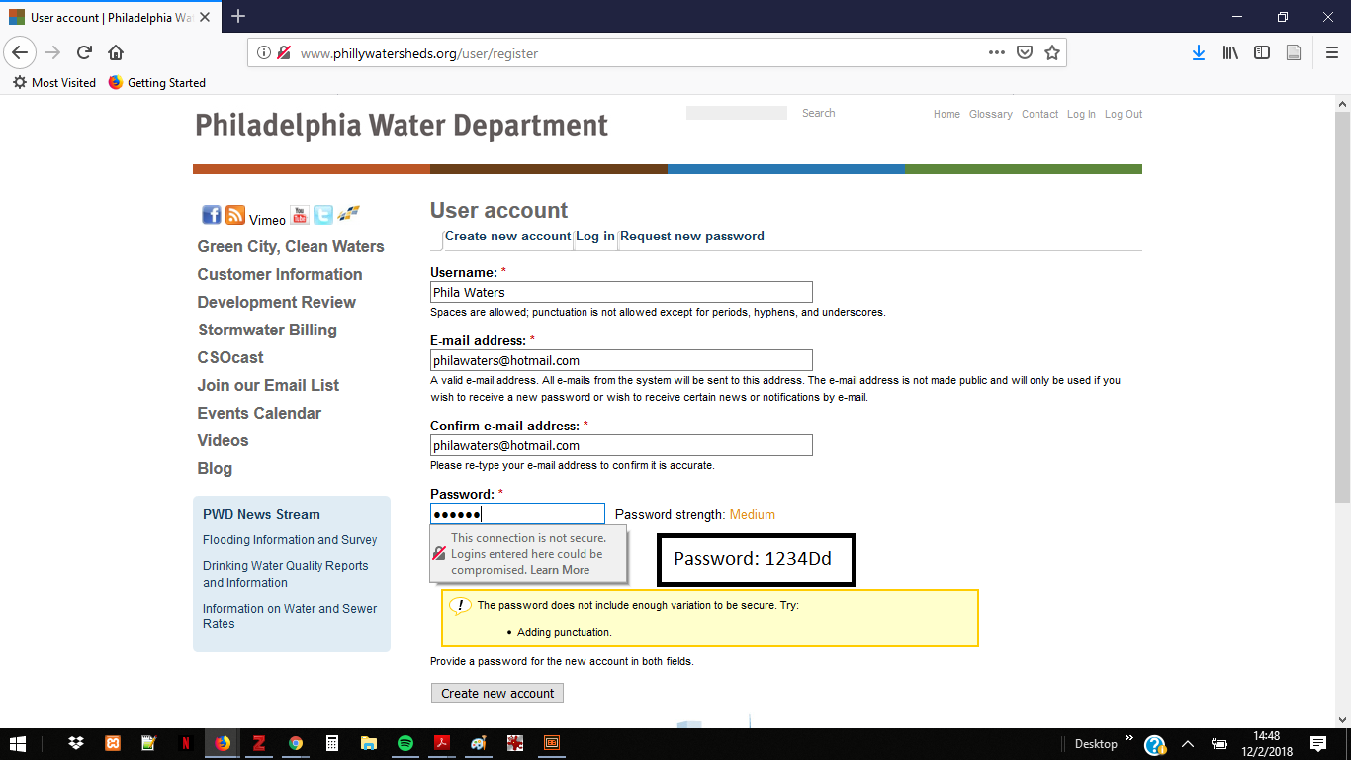

Phila Water Med (lo variability)

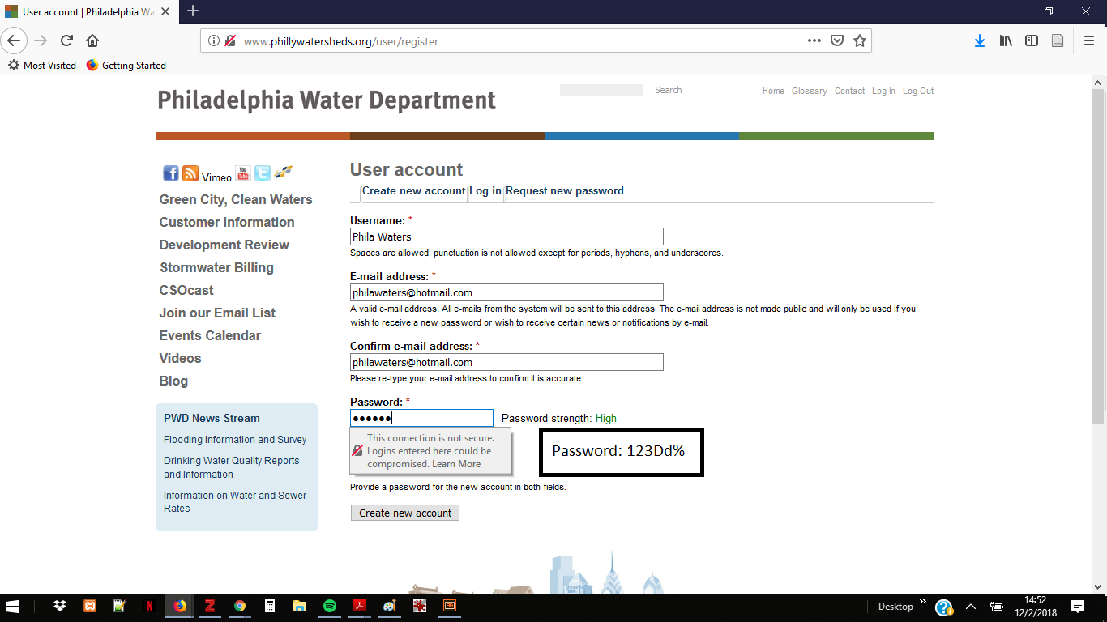

Phila Water OK 6 char

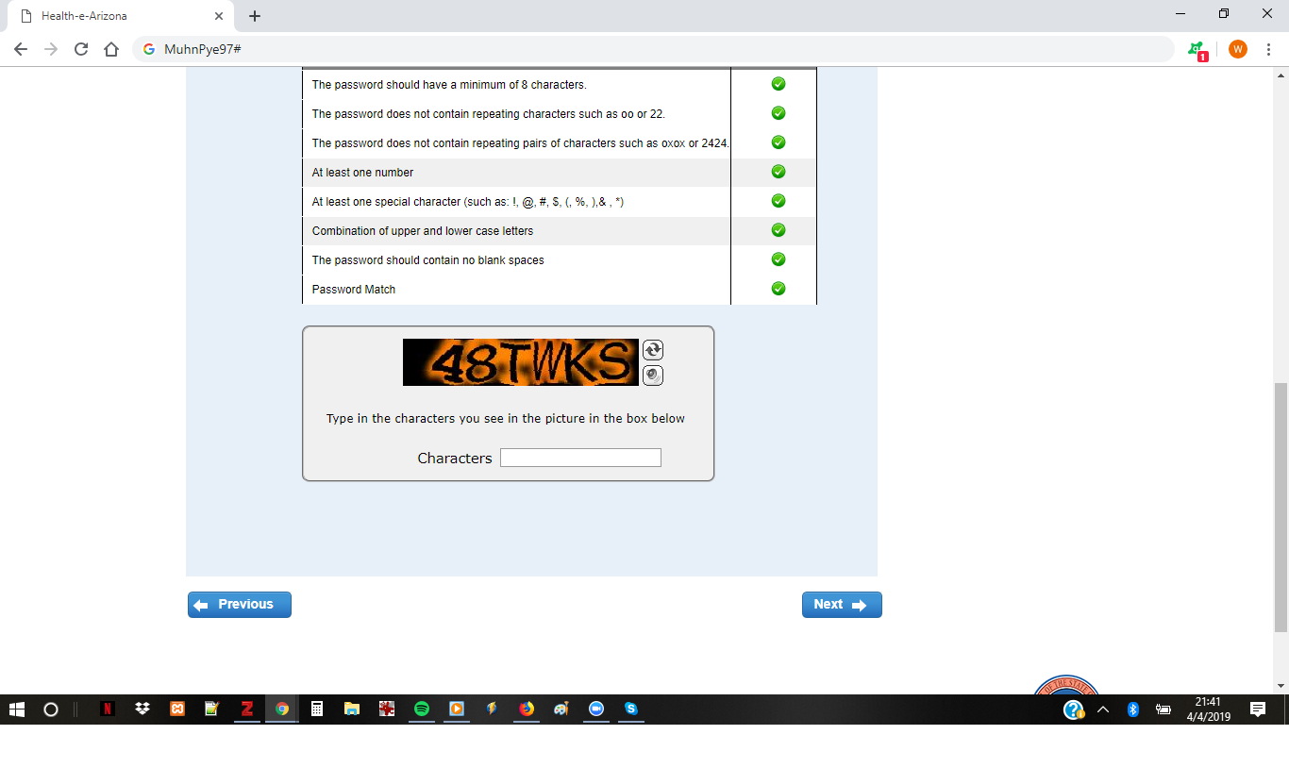
Phoenix – SNAP

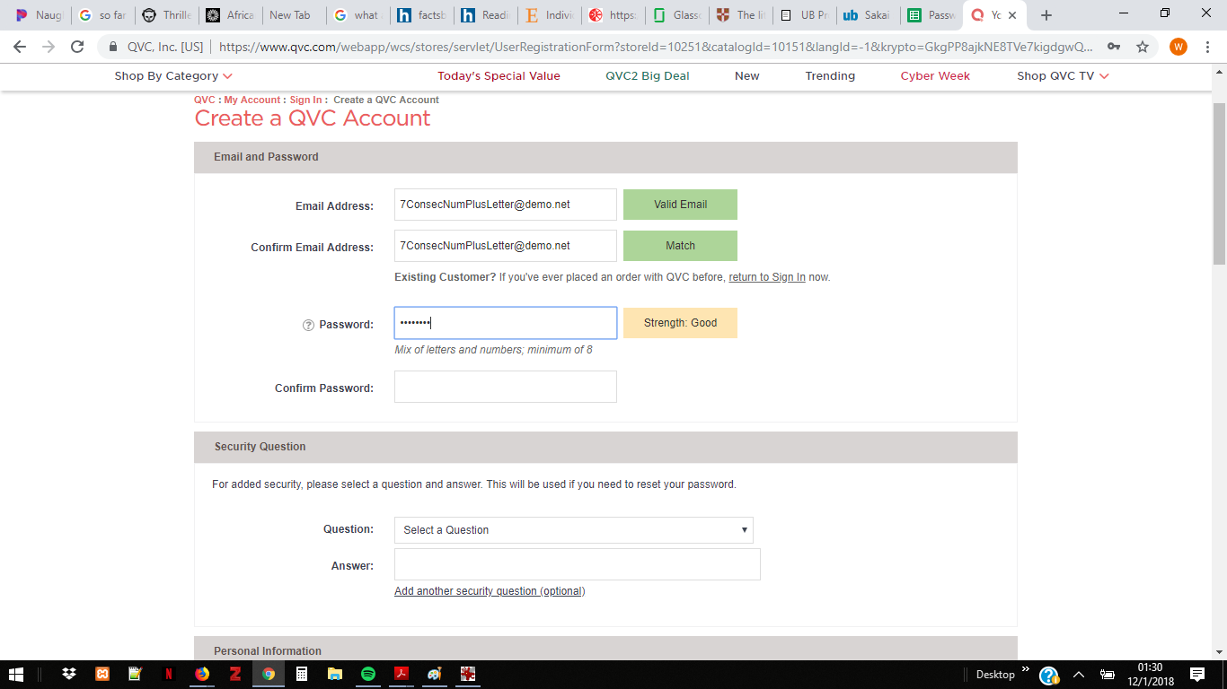QVC

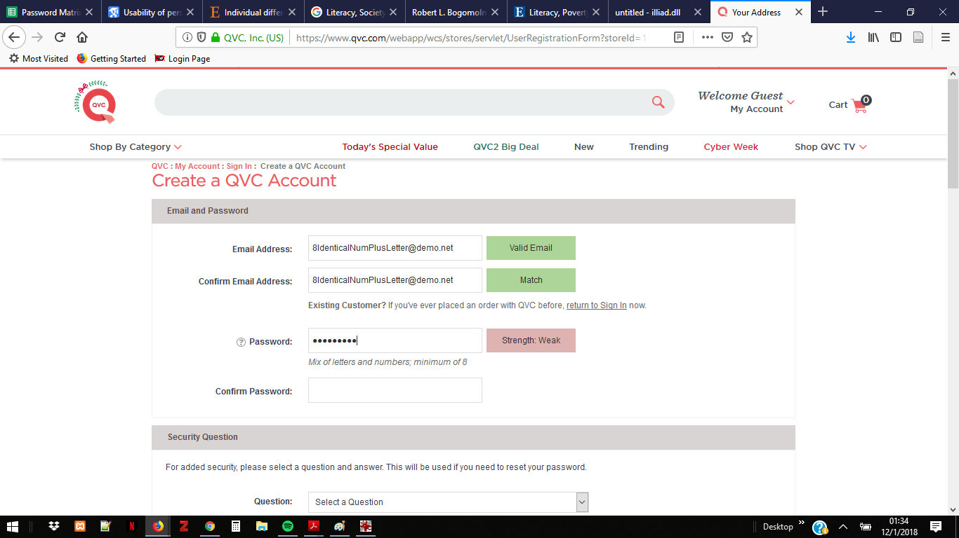

QVC 8+Weak

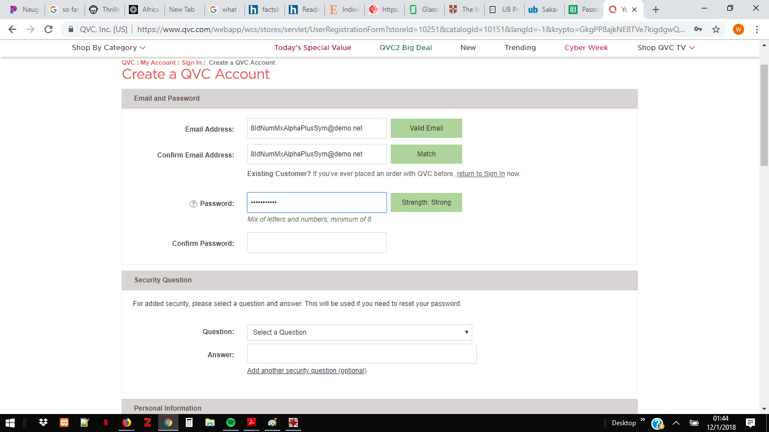

QVC 8 Mixed-Strong

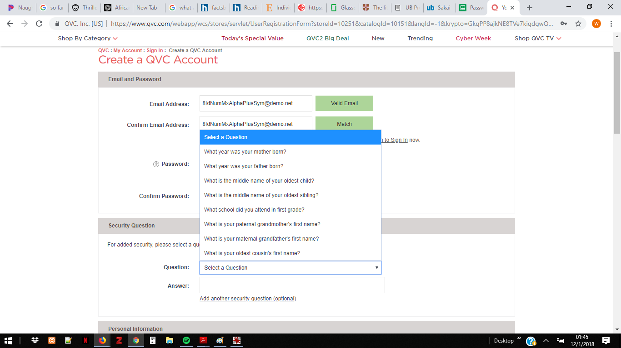QVC-Qs
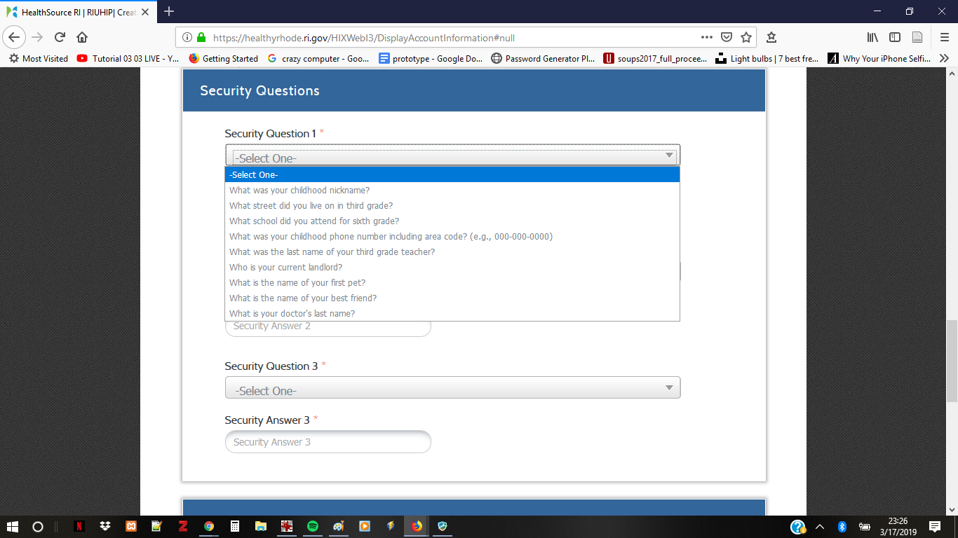

RI Security Qs

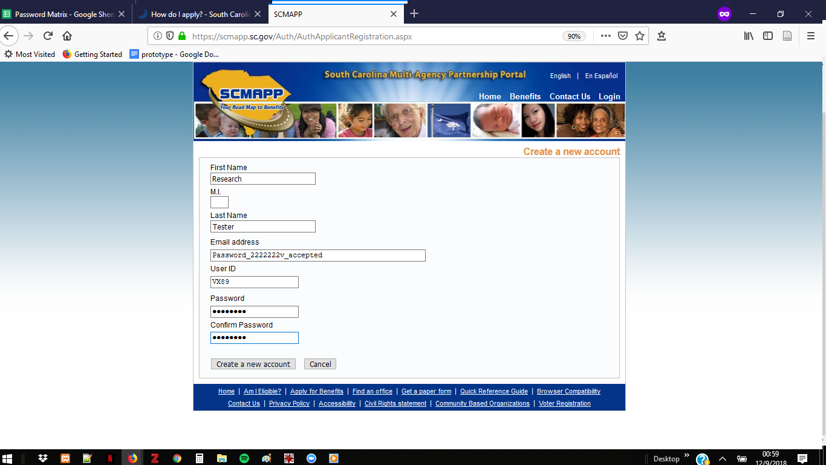

SC Acceptance

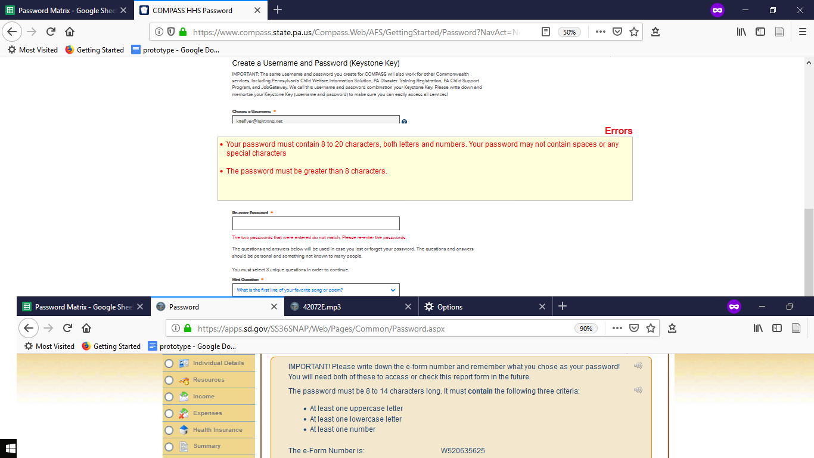SD SNAP

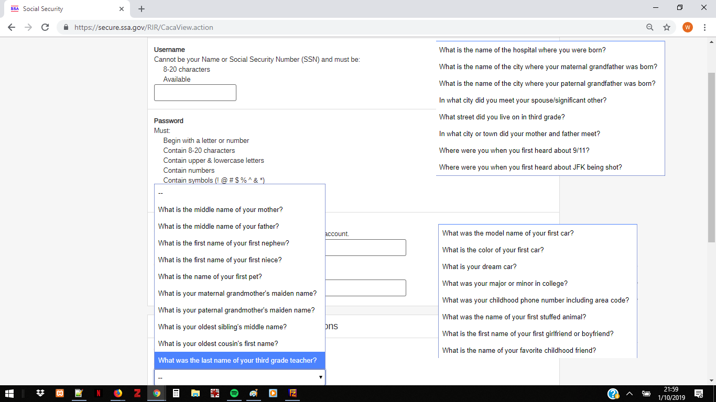

Social Security 1

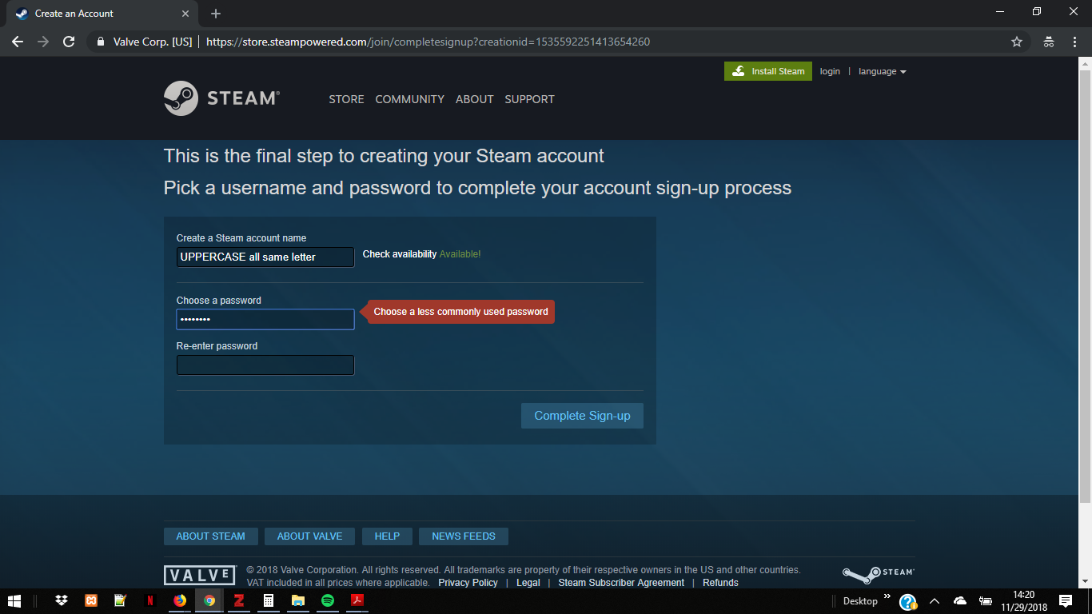Steam password rejection all same letter

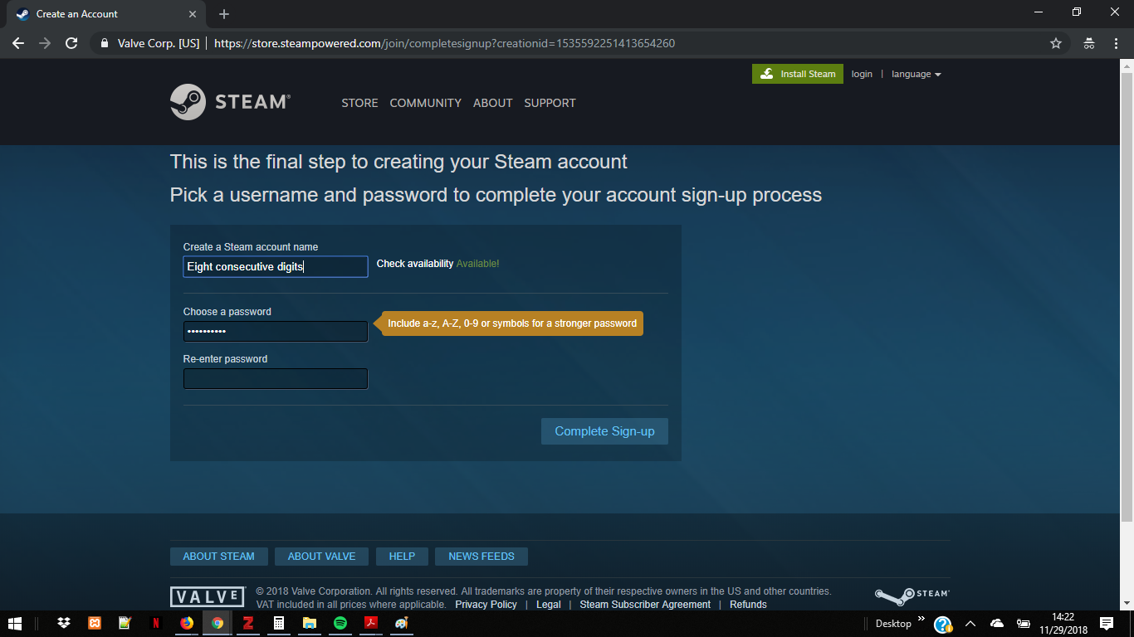

Steam password rejection consecutive digits

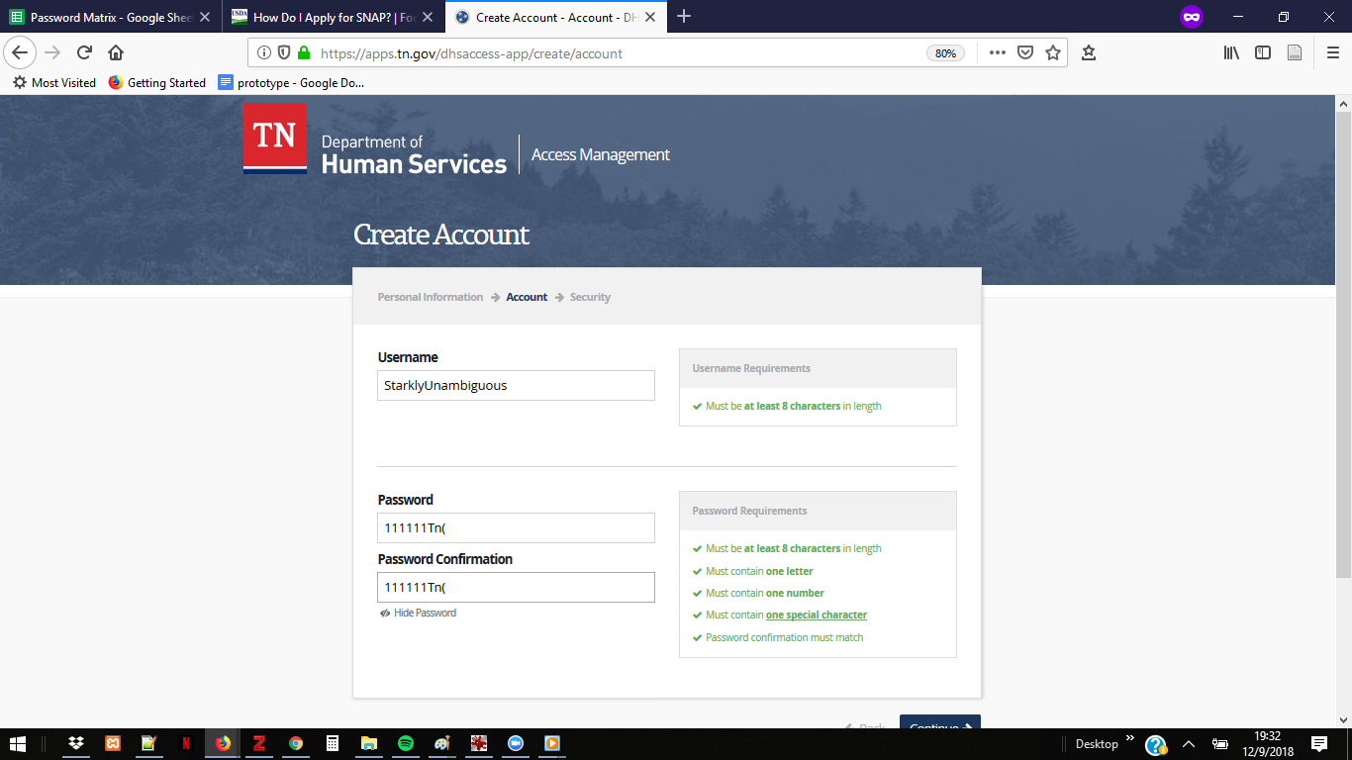

TN SNAP

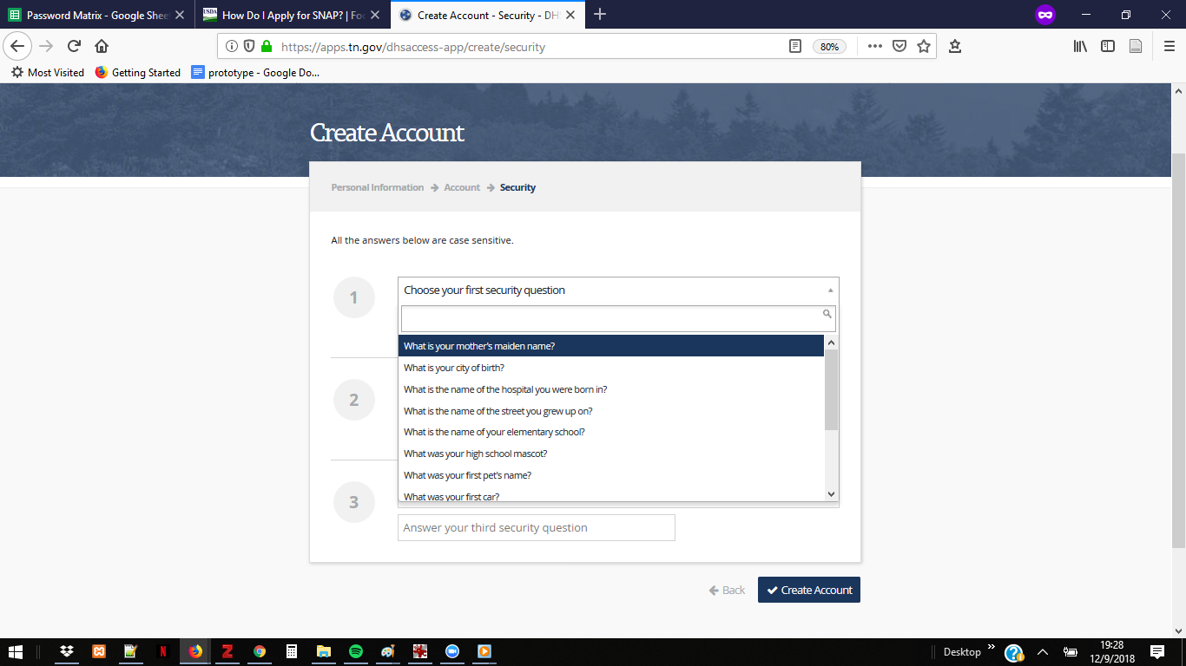TN SNAP 3 Security Qs

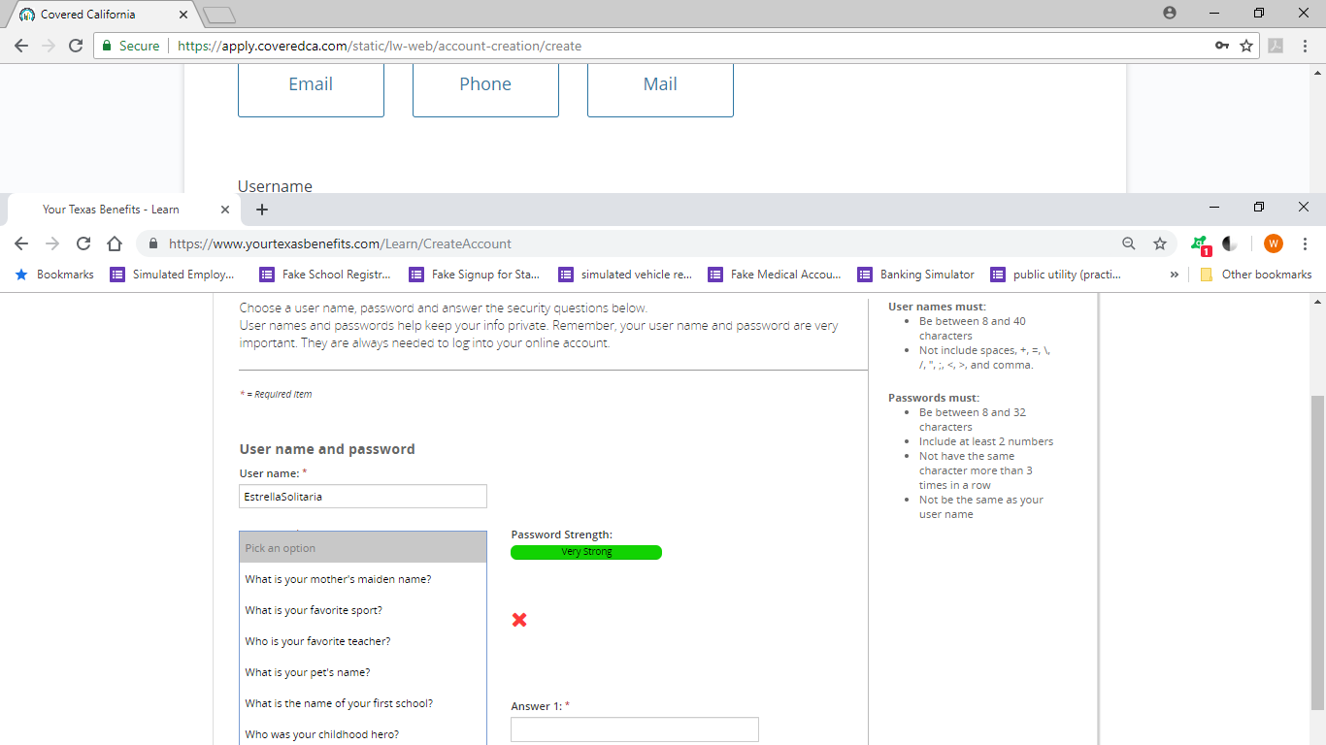

TX Benefits Password & Security Qs

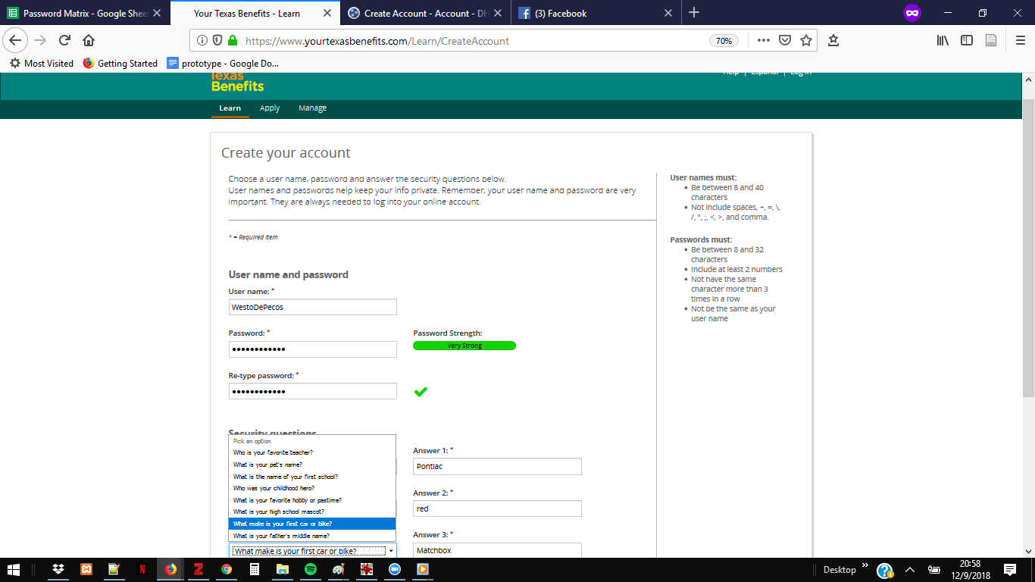

TX SNAP

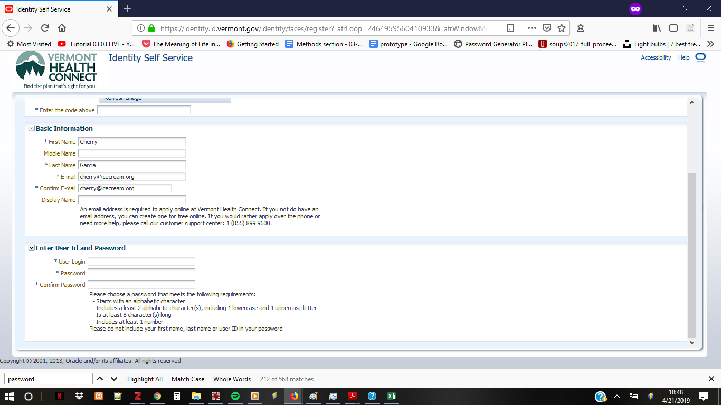VT signup

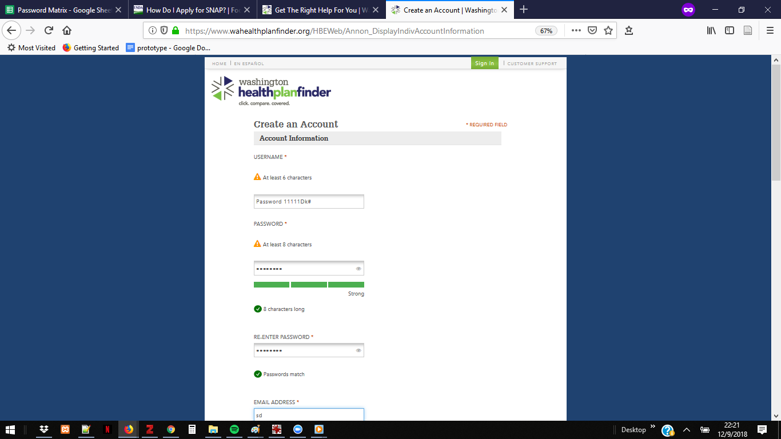

WA HealthcareGov-PW

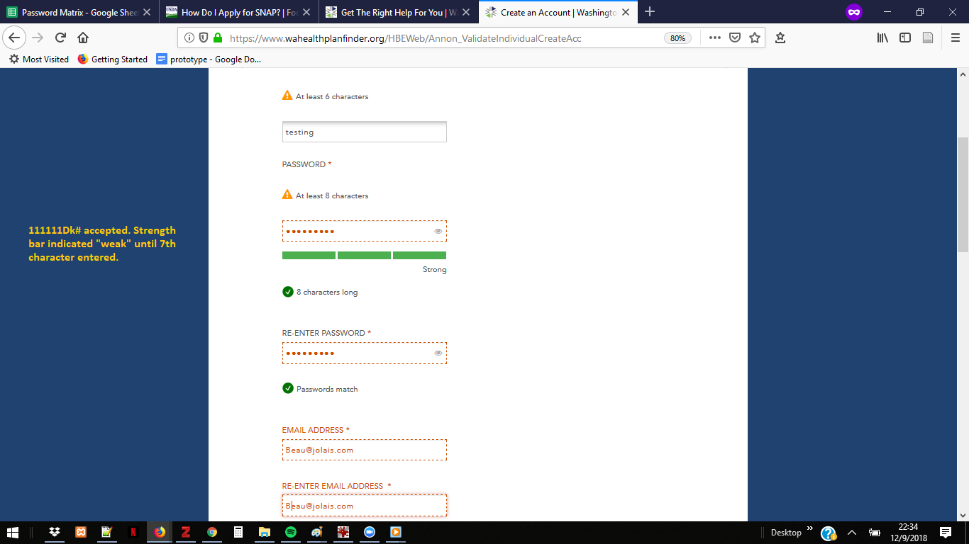

WA-HC,gov 2

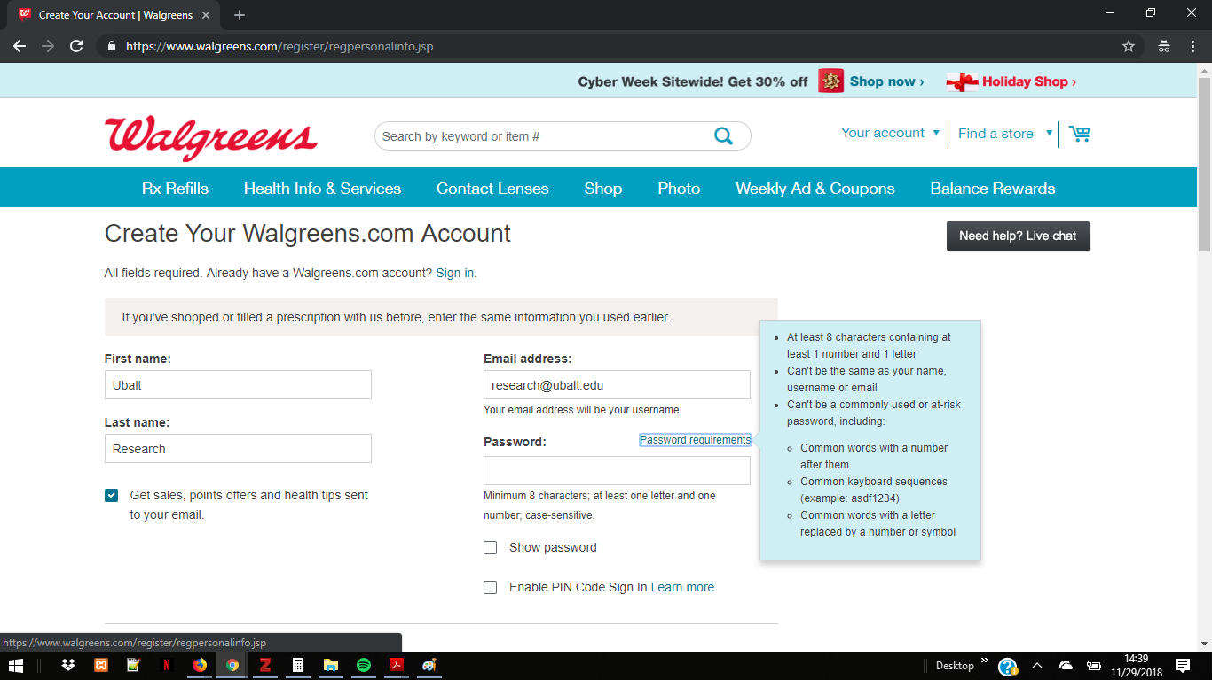Walgreens

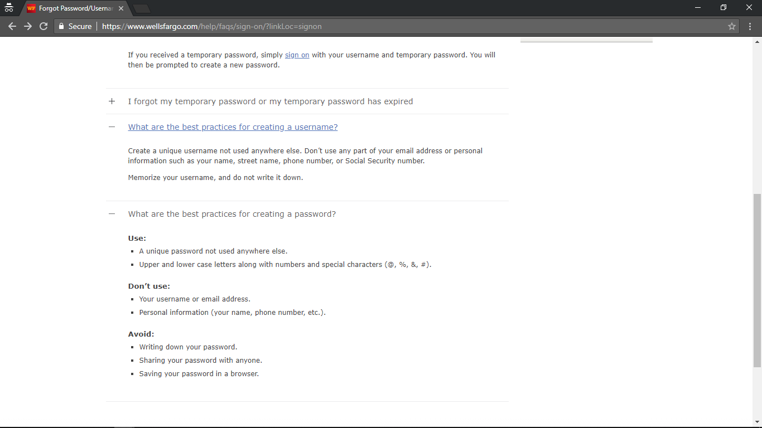

Wells Fargo Password Username Screen

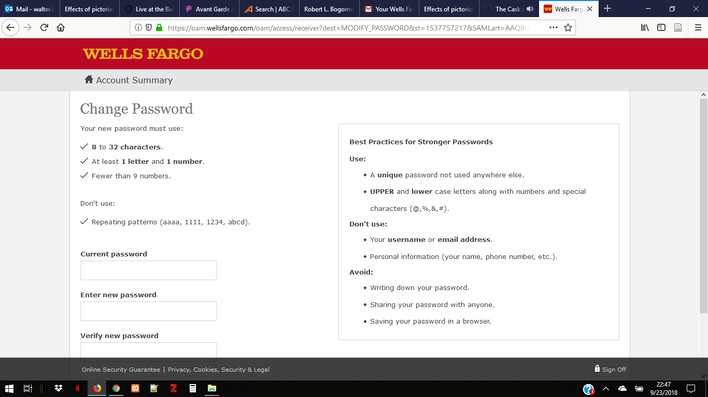
WellsFargoPasswordChange(9-23-18)

See Results chapter for details.
Despite knowledge of best password practices, both of these “insiders” used the same password for all eight simulations. Both also affirmatively decline use of password managers.

