
Journal of Geophysical Research - Biogeosciences
Supporting Information for
Simulating global dynamic surface reflectances for imaging spectroscopy spaceborne missions – LPJ-PROSAIL
Benjamin Poulter¹, Bryce Currey², Leonardo Calle³, Alexey N. Shiklomanov¹, Cibele H. Amaral⁴, Jack Brookshire², Petya Campbell¹, Adam Chlus⁶, Kerry Cawse-Nicholson⁶, Fred Huemmrich¹, Charles E Miller⁶, Kimberley Miner⁶, Zoe Pierrat⁷, Ann M. Raiho^{1,9}, David Schimel⁶, Shawn Serbin⁸, William K. Smith¹⁰, Natasha Stavros⁴, Jochen Stutz⁷, Phil Townsend⁵, David R. Thompson⁶ and Zhen Zhang⁹

¹NASA Goddard Space Flight Center, Biospheric Sciences Lab., Greenbelt, MD 20771
²Montana State University, Land Resources, Bozeman, MT
³Regrow Agriculture Inc., Durham, NH 03824
⁴Earth Lab, Cooperative Institute for Research in Environmental Sciences, University of Colorado, Boulder, Boulder, CO 80309
⁵University of Wisconsin, Madison, WI
⁶Jet Propulsion Laboratory, California Institute of Technology, Pasadena, CA
⁷University of California Los Angeles, Los Angeles, CA
⁸Brookhaven National Laboratory, Upton, NY
⁹University of Maryland, ESSIC, Greenbelt, MD
¹⁰ University of Arizona, School of Natural Resources and the Environment, Tucson, AZ

Contents of this file

Figures S1 to S4

Introduction
The following four supporting figures give context to the main text for the case study sites, the background reflectances, the model performance for site level and global benchmarks.

Figure S1: Global map of 550 nm reflectance for July 2020 (same as in Figure 3A, but global) with stars indicating location of the four intensive sites.

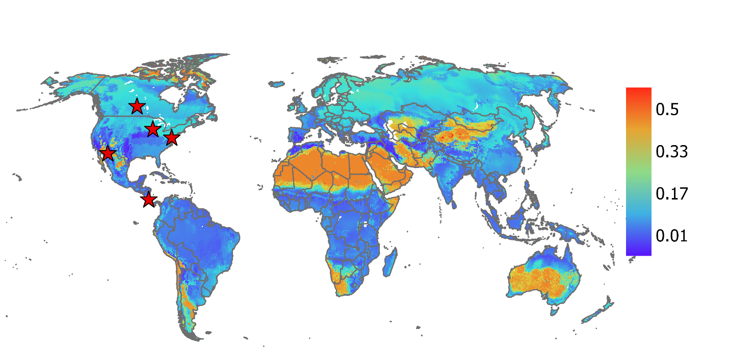
Figure S2: Representative spectra used for mixing (A) branch and (B) snow in Equations 10-14, (C) mineral spectra (quartz, tectosilicate GDS74) used when no PFTs are present.
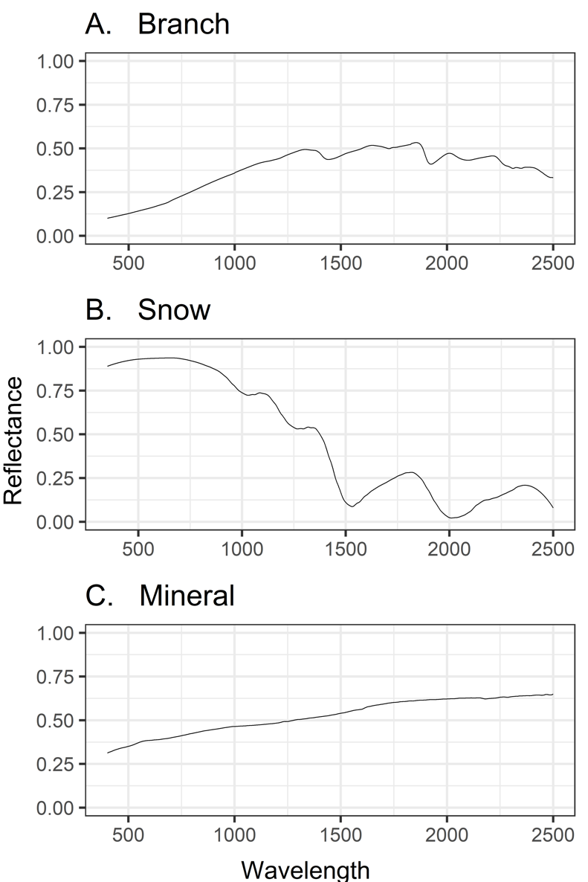

Figure S3: Difference between (July 2020) spectra for the five sites (A-D) and the available in-situ (e.g., PhotSpec, FieldSpec) and spaceborne observations (DESIS and PRISMA).
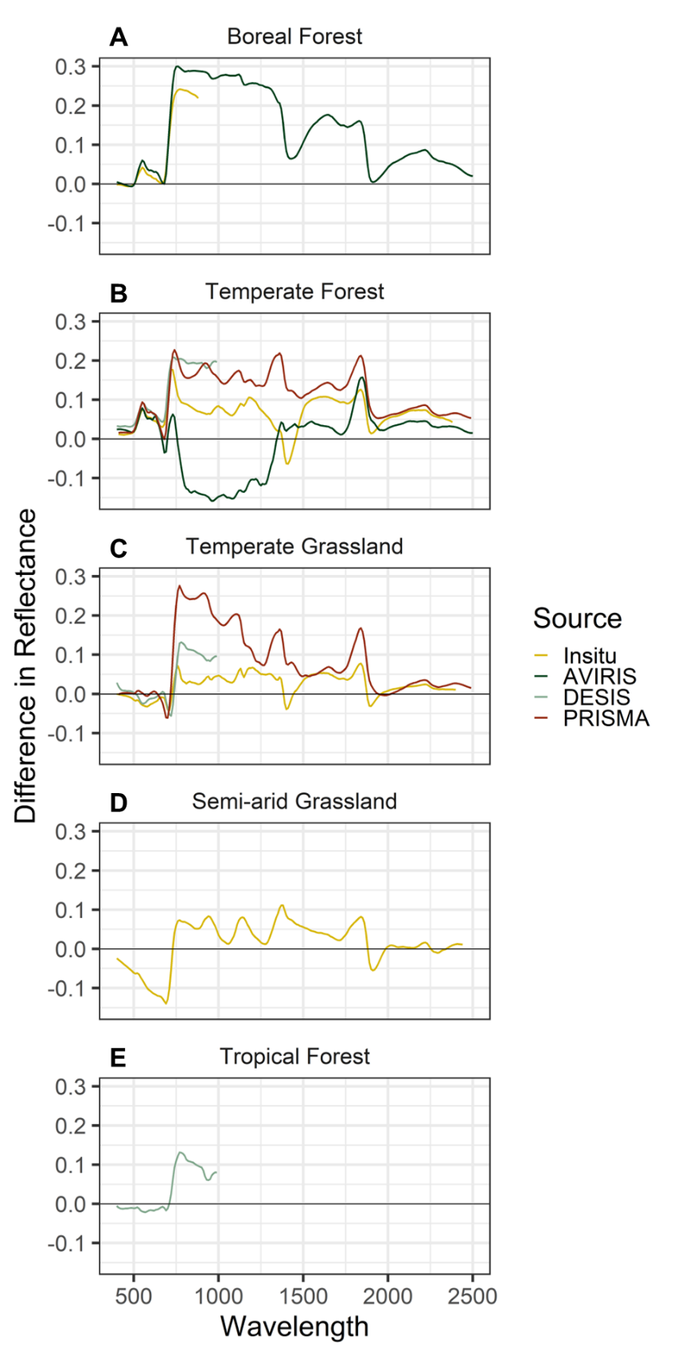

Figure S4: Density plot of January 2020 MODIS and LPJ-PROSAIL NDVI. From Figure 12.
