Center for the Study of Religion and the City (CSRC) Documentation of 2020 Relief and Restoration Work: Coding and Themes from the Oral History Interview 1 with Sogorea Te Land Trust


Topic 0

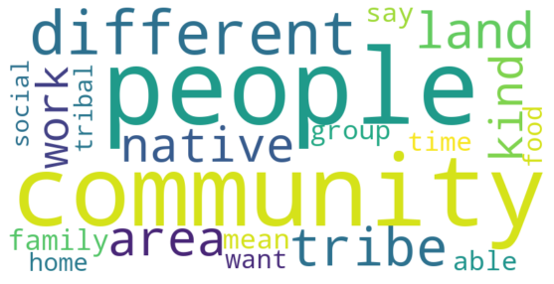
Sogerea Te Land Trust - Interview 1 -.txt, Nazshonnii Brown (03:33):
--------------------------
And then, people that may identify as settler or non-Ohlone, but may be another tribe or communities would be able to voluntarily give this tax. And another thing is when it comes to the community, when it comes to the home and how many different people call the Bay Area home, that's very important for us in recognizing that many people have been displaced. Different tribes have been relocated, different communities of color have been basically forced here in order to find better opportunities, or they're fleeing their homes from terror.

Topic 1

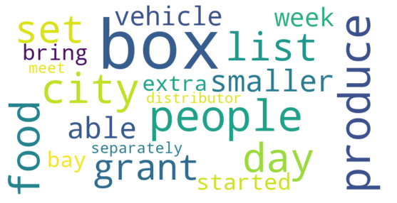
Sogerea Te Land Trust - Interview 1 -.txt, Nazshonnii Brown (19:13):
--------------------------
Yeah, definitely in a response to the shelter-in-place and increasing amount of COVID precautions and policies changing in public places as well as farm areas that we share with other organizations, so we started that, I believe in April or May. I think it's only... Actually, I think at the end of May, we started doing that. And the first day, we got almost 80 boxes. And then, there was only five people that could work that day. And then, we just started calling people. "Hey, do you need food?"

Sogerea Te Land Trust - Interview 1 -.txt, Nazshonnii Brown (19:44):
--------------------------
So the first day was just like a free-for-all. And then, we realized, "Okay. We could get boxes every week from Bay Cities," which was one of the grants or suppliers that has been doing a lot more, I think, discounted and also free food boxes. So right now, they're just looking for people to distribute. But I believe before COVID, they were selling a lot of their products, whether it was whole produce.

Sogerea Te Land Trust - Interview 1 -.txt, Nazshonnii Brown (22:09):
--------------------------
Yeah. So when we got more organized, I created this form that was a needs assessment. And I also did this for the Gill Tract farm because we have an area of land out there. And I'm also the person that represents Sogorea Te at the farm, and I sit in at a lot of their meetings. So they had a few distributions set up there on another day, and we'd get boxes from them. And then, we also had the Bay Cities' boxes.

Sogerea Te Land Trust - Interview 1 -.txt, Nazshonnii Brown (25:11):
--------------------------
So we've had a couple people, meet them at their work, or we'd meet them out wherever they had a little set up shop. Because some people were house-less, but they were able to vend at the Bart Station. So we'd bring them a box that way. I had neighbors that I had got on the list. And I specifically would bring them the fruit because they didn't have access to a kitchen.

Sogerea Te Land Trust - Interview 1 -.txt, Nazshonnii Brown (25:34):
--------------------------
At one of our sites, there's an encampment just beyond the creek on the other side of the freeway, and they were able to set up a kitchen. So we put them on the list. And then some people that just word-of-mouth, we heard they were in need. So we had those boxes, if you were okay with checking them, and just understanding that all that would be confidential. And it was just to see on our end, where's the highest need.

Sogerea Te Land Trust - Interview 1 -.txt, Nazshonnii Brown (27:00):
--------------------------
Yeah. We moved around a little bit. So the first day, we just had the boxes, and we just started driving around in our trucks and our personal vehicles. And then, the following few weeks, we were able to meet at the Gill Tract community where one of the box distributors dropped a bunch of boxes. So we'd go there.

Sogerea Te Land Trust - Interview 1 -.txt, Nazshonnii Brown (27:19):
--------------------------
And then, there'd be a crew preparing those boxes from the Farms-to-Family grant. And then, separately, we would have someone wake up earlier in the morning, go to Bay Cities and bring the other boxes. That way we could put a certain amount in each vehicle. And then from there, we would just go out and send it to people. And we started to make the pick-up list because some people were able to drive all the way to Albany.

Sogerea Te Land Trust - Interview 1 -.txt, Nazshonnii Brown (27:47):
--------------------------
But most of our families were in Oakland and surrounding cities, adjacent cities. So even for myself, having to drive to Albany for work days, it's a little bit of a hassle because there's traffic, and it's a longer distance. So we were thinking, "Oh, can we do it at a closer location or a central location?" That way, we could get boxes from both distributors and meet in the middle?

Sogerea Te Land Trust - Interview 1 -.txt, Nazshonnii Brown (28:14):
--------------------------
And we ended up deciding to go with our office which is near downtown. So from there, for the past month, we've been picking up produce from the distributors. And since then, we've also had the extra produce from the Cultural Conservancy. So then, we set up everything outside. There's a big parking lot outside. We set up everything, and we set aside the boxes that are going to bigger families.

Sogerea Te Land Trust - Interview 1 -.txt, Nazshonnii Brown (28:46):
--------------------------
And then, we start to make bags and smaller boxes for elders where there's probably only one or two people in the household or smaller household numbers. But now, it's probably five people picking up, and then, out of the whole list of maybe 110 or 120 people. And then the other thing that we did was we split up our list because we realized that there was too many people, and we wouldn't be able to pick up the stuff, pack it, and then deliver it within a reasonable amount of time.

Sogerea Te Land Trust - Interview 1 -.txt, Nazshonnii Brown (32:12):
--------------------------
So the past month has been great because at the new location, it's central. We're able to have some people get there early and begin packing and redistributing the produce that comes separately. And then, we've also been messing around with spreadsheets so we can have a count of how many boxes are going out, how many bags are going out. And since the list has split, now I've been able to look at when people are getting food. And when we ask them how many people are in the household, that helps us to distribute the food.

Sogerea Te Land Trust - Interview 1 -.txt, Nazshonnii Brown (32:51):
--------------------------
So if we have five extra food boxes that could go to a smaller family, instead of doing that, we'll just break them into boxes, redistribute them, add in extra produce. And then from that, we could make another 15 bags or another 15 smaller boxes.

Sogerea Te Land Trust - Interview 1 -.txt, Nazshonnii Brown (42:33):
--------------------------
Okay. Having more people, and safely having them in the same place, we'd be able to have a crew come in early and begin to do the repackaging and receive the produce from the person that comes in the morning. And then, we'd have some people in the afternoon moving the boxes around and getting ready to go out. And then, we'd have the drivers separately going and distributing.

Sogerea Te Land Trust - Interview 1 -.txt, Nazshonnii Brown (46:42):
--------------------------
Yeah. So one of them is Bay Cities. This is a new, not exactly a partnership, I think we just signed up to be one of the organizations to receive free food boxes from them. So our interaction has just been once a week, getting boxes, and the initial conversation that Ariel had to set that up. And I believe they've been around for maybe a decade or so. I've just heard of them, but I think they mainly focus on organizations and companies because it's a huge warehouse.

Sogerea Te Land Trust - Interview 1 -.txt, Nazshonnii Brown (48:48):
--------------------------
Alternatives in Actions is a high school and a non-profit organization. There's also an African Diaspora Center in North Oakland, so I signed up to contact there. And then, another one is Tuha, something like that. It's Trauma... It's like a trauma center that's based outside of or it's based inside one of the La Clinica offices. So we had 35 boxes, sometimes 40 boxes. It would always fluctuate. And we ended up just reshipping those boxes to other people and having them directly contact that grant.

Topic 2 – N/A For this group

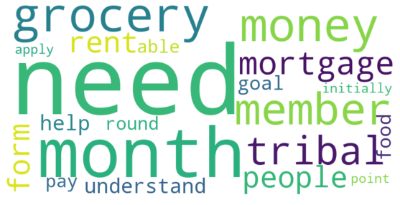

Topic 3

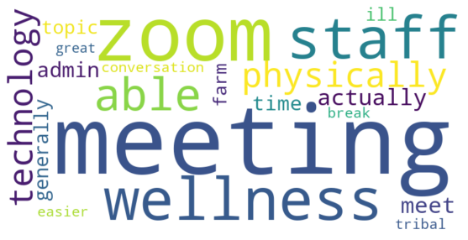
Sogerea Te Land Trust - Interview 1 -.txt, Nazshonnii Brown (39:19):
--------------------------
And then also, like I said, instructions for things that we do on the day of food distribution. So one thing for me is I would have hoped to have had these conversations earlier or begin to think about a lot of what they were saying and how I could apply it to this workplace. And then I guess, having meetings early on. Because we actually decided, probably a month into doing the food distribution, that we wanted to have meetings separate from our staff meetings. That way we give enough time and attention to how that day will go or certain needs.

Topic 4
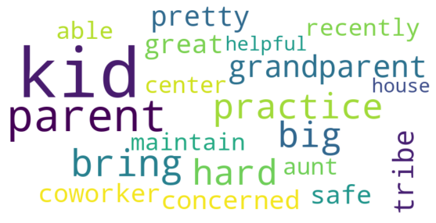
Sogerea Te Land Trust - Interview 1 -.txt, Nazshonnii Brown (26:06):
--------------------------
And the most boxes that were checked were people identifying Black, Brown, Indigenous, being a big house or kids in the house, being pregnant, and immunocompromised. So maybe because you're working or you have to take care of your kids or you're not healthy enough to be outside, having that need to get something delivered.

Sogerea Te Land Trust - Interview 1 -.txt, Nazshonnii Brown (40:02):
--------------------------
So there was actually a coworker that stepped back recently because they would have to bring their kids along with them, and it was being concerned about the kids always hugging people. So it's hard to maintain the safe distance practices, but they're kids are so cute that they want to hug everyone and be helpful.

Sogerea Te Land Trust - Interview 1 -.txt, Nazshonnii Brown (40:25):
--------------------------
And we did a few days of the kids with us which is great because another thing that we're able to do is if there are parents there that bring their kids with them, some people have grandparents. I'm an aunt. I brought my nephews to the office with me. I bring them to land with me when it was before March. So it's been great to be able to do that, but we also are responding to her specific need of, "Okay, I need to step back because it's hard to make sure that my kids are following the practices."

