Designing a Digital Timesheet System for YouthWorks Baltimore

by
Kiel McLaughlin
December 2017

Presented to the
Division of Science, Information Arts, and Technologies
University of Baltimore

In Partial Fulfillment
of the Requirements for the Degree of
Master of Science

Approved by: ________________________________
[Greg Walsh, Thesis Advisor]

________________________________
[Kathryn Summers, Committee Member]

Abstract
Baltimore YouthWorks is a program operated by the Baltimore City Mayor’s Office for Employment Development (MOED). Approximately 8,000 Baltimore City youth, aged 14-21, receive short-term summer employment at minimum wage with local government departments, nonprofits, and businesses. A significant challenge facing the YouthWorks program is an inefficient and outdated timekeeping process. The program seeks to develop a digital timesheet system to pilot with a small group of employment partners to evaluate the viability of a complete shift in payroll processing operations. This project reviewed industry best practices and academic research, along with application of the User Centered Design process to develop a proposed design for the pilot platform.

Table of Contents
Introduction 2
Literature Review 5
Trust by Design 5
Form Fundamentals 10
Clear Data Entry 12
Methods 18
Evaluation 18
Design and Testing 21
Discussion 31
Conclusion 35

References 37

Appendix: Final Screen Package 37

Introduction
Baltimore YouthWorks is a program operated by the Baltimore City Mayor’s Office for Employment Development (MOED). Approximately 8,000 Baltimore City youth, aged 14-21, receive short-term summer employment at minimum wage with local government departments, nonprofits, and businesses. The goal of the program is to introduce young Baltimore residents to the environments and expectations of a workplace in order to provide experience and preparation for future employment.
One challenge facing the YouthWorks program is an inefficient and outdated timekeeping process. In order to document a youth’s time worked and issue a paycheck, YouthWorks staff must process two separate timesheets. Both of these timesheets are paper-based and manually completed. First, a youth participant completes a daily timesheet that notes times in and times out, including a mandatory 30-minute lunch break. A site coordinator at the employment partner is responsible for distributing and collecting these timesheets to the youth participants each day. The youth participant signs the timesheet at the end of the pay period.
The site coordinator for the employment partner completes the second timesheet. This timesheet includes a full roster of all youth participants at the worksite during the pay period. In the same way as the first time sheet, the site coordinator must mark times in, times out for each day. The site coordinator tallies the total hours worked for the week for each youth participant and signs the timesheet. YouthWorks staff collect these timesheets at the end of each pay period. Management of these timesheets is a burden for both the employment partner and the YouthWorks staff responsible for picking up timesheets on site, transferring them to an online system, and submitting for payment processing.
For this project, the YouthWorks program staff have allowed me the opportunity to create a proposed design for a custom online timekeeping system to manage the employment partner timesheets. At the request of the YouthWorks staff, the proposed system will not include daily timesheets for youth participants. The system will only be for employment partners and YouthWorks staff to complete weekly timesheets. YouthWorks intends to use the designs produced for this project to begin a pilot program with a select group of experienced employment partners to examine the feasibility of a long-term shift to a digital timesheet process. Streamlining the timekeeping process will save time for YouthWorks staff, providing the organization with opportunities to expand its services to the youth participants. Less time spent processing paperwork gives staff more time to support participants.
As a program operated by the Mayor’s Office for Employment Development, a department within the Baltimore City government, there are additional considerations when implementing new systems to a critical operation such as payroll processing. The Baltimore City government, from City Council to short-term employees, such as YouthWorks participants, complete paper timesheets. The entire government payroll process relies on outdated technology, so implementing a digital system requires added complexity. City government is also required to maintain paper records for years after the disbursement of a paycheck in case of an audit. Careful consideration is necessary for how a digital system can seamlessly integrate with an existing structure without creating new challenges. The improvement of the timesheet data-collection process is only successful if it does not create new, inefficient steps on the backend.
Additionally, YouthWorks is a very small staff. There are only seven full-time staff for the program year round. There are several other administrative staff for the Mayor’s Office for Employment Development that are part of the payroll process and support YouthWorks over the summer during the two five-week sessions. Finally, seasonal employees complete the bulk of timesheet resolution and data processing for YouthWorks. Some of the seasonal employees return each year, but others are new hires trained on the process. A timekeeping system must be intuitive enough that seasonal employees can quickly learn and recall how to complete critical tasks. Efficiencies created by a digital system are only effective if staff must not complete extensive training or frequently require assistance from coworkers to process routine tasks.
Through a series of interviews with YouthWorks staff at all stages of the timekeeping and payroll process, I gained insight into the needs of the organization and challenges that may slow the implementation of a new system. Beyond technological restrictions and individual aptitudes for digital systems, the greatest challenge facing the adoption of an online timesheet is trust. Many of the full-time YouthWorks staff are long-time city government employees. Some have never completed a digital timesheet for their own work, so the transition to processing payroll using an online system for youth participants raised concerns. Some interviewed were wary of digital timesheets for record keeping and auditing purposes. Others questioned whether the larger government would allow for the introduction of a new system, as it would break from their longstanding norms. While most interviewed recognized the potential improvements and efficiencies offered by a custom-built digital timesheet system, there were uncertainties about the growing pains associated with a significant workflow transition. Any change must gain the user’s trust and confidence.
Fundamentally, a timesheet is a form with labels and fields for the user to complete. For this reason, I conducted academic research on industry best practices for online form completion. A payroll system requires several members of the team to complete or review various components throughout the process. The field of computer-supported cooperative work has long studied the transition from non-digital tasks into a digital framework. A strong understanding of the common challenges these transitions face provides the background necessary to skirt potential pitfalls as YouthWorks attempts to make this shift. Finally, the users of this system are critical to developing an effective design. YouthWorks small scale and focused vision for a pilot are advantageous to conducting successful user research. With a small pool of potential users, I was able to speak directly with individuals who will use or are representative of individuals who will participate in the pilot.

Literature Review

Trust by Design
Humans become entrenched in habits to the point it becomes mindless and routine (James, 1890). This extends to businesses and organizations who are too often willing to settle for established processes and systems when new options present a better result. This is the challenge facing the adoption of an online time-tracking system for the YouthWorks program. The current paper-based system ingrained in the daily workflow for many longtime staff fits the requirements for their human resources and payroll processing teams. Beyond demonstrating the value added by moving to an online process, the first step will be gaining trust among a skeptical group of users.
Application design can significantly affect user trust (Karvonen, Parkkinen 2001). If there is a credibility deficit, users will be hesitant to use the product. This can be applied to the needs of YouthWorks as an online timekeeping system would target a relatively small group of users. It would only require a few key users to reject the system and demand a return to the paper-based process for the effort to fail. True credibility takes a long time to cultivate. Market research in the early days of online shopping dug deep into understanding what drives a user’s willingness to trust an online application. In the late 1990s, online shopping had just begun and many users were unwilling to share sensitive financial information over the internet (Cheskin, 1999). “Consumers see the world of the Web as one of chaos, offering both possibilities and threats. Only after they believe they have secured control over their own personal data within the system, are they willing to begin to try out e-commerce. While trust develops over time, communicating trustworthiness must occur as soon as interaction with a site begins.” Almost two decades later, users have become accustomed to the internet being part of their everyday lives, but there remains a mistrust when it directly affects an individual’s ability to complete important tasks and to make that shift.
In the early days of web design, the most reliable form of information gathering was through books and newspapers Karvonen, Parkkinen, 2001). These long-standing print media were organized through consistent columns and formal text. Karvonen and Parkkinen associate the application of these same standards to the positive reactions users had to the most trusted sites in 1999. Yahoo, Walmart, and Excite organized information in columns with clear, easy to understand headers. This familiar layout comforted users in an unfamiliar medium, establishing trust. Alternatively, sites relying on illustrated, somewhat cartoonish logos with inconsistent layouts created discomfort for users. Before reading the material, users had already discounted the value of the information on the page. Unlike the trusted sites, information was crammed together without adequate white space to structure the information.
To modernize this take, a new site or application should take cues from existing systems that have already earned user trust. In the case of YouthWorks, an online timekeeping system is asking users to make a significant shift from a print timesheet to a digital experience. To create a new design, we can learn from Karvonen and Parkkinen’s assessment and attempt to build a system that utilizes elements familiar to the user in a print format. A clear, simple grid with names, titles and dates prominently displayed will be critical to user adoption.
Structure is critical to reader comprehension and comprehension is just as important to establishing trust. A time tracking system is goal-oriented. On one end, the users need to be able to input information and know the data is accurately correlating the correct amount of time on a specific day, to a particular staff member. On the other end, the administrative staff needs to be able to pull the data put into the system to create reports and process payments. If a user reviews the information on the page and is still unsure of what they are reading and how to process the information, they may reject the system.
While Karvonen and Parkinnen’s assessment of the Cheskin Research’s study of most and least trusted websites point to users accepting web design based on print style, there is not a direct correlation in reading comprehension when comparing print and web-based content. A reader does not retain information from an online reading device as well as they do printed document when the online presentation is the same as that of the printed version (Bartell, Schultz, Spyridakis, 2006). Readers do not only take on information by the words on a page, but also by the structure of the content. Eyes wander and the brain picks up nuances from the rest of the page in order to process the information. When presented with the same document in print form and online, individuals retain the information better on the printed document, potentially because they are able to see all of the information on the page at one time. By being able to see the entire page, readers understand the structure, length, and take cues from the overall presentation. Online, this information may require users to scroll to gain full context for the material. This makes headers and contextual information critical to give the user a sense of place on a page and understand the purpose of the information they are reading. Based on visual hierarchy, though, headers must only be used when critical, or else there are diminishing returns. Too many prominent headers decreases reading comprehension. When evaluating designs for the YouthWorks time tracking system, it will be important to recognize the most important information that is critical for a user to complete their task and highlight this through headers and placement.
To step further past simple grids and site structure, though, Karvonen suggests beauty and aesthetics play a role in user trust when interacting with a website or application (Karvonen, 2000). Karvonen displays frustration with the language often used to motivate website design such as usability and simplicity. These terms do not speak to aesthetics and focus entirely on task completion. She argues that simplicity is not enough without beauty for the user may be satisfied with task completion but personal enjoyment can enhance satisfaction.
Users may be attracted to use a site based on its visual presentation (Khaslavsky, et al. 1999). To extrapolate Karvonen’s assertion to a daily activity, people are willing to spend more money on a meal for a similar dish when displayed with bold presentation on a plate or in an aesthetically pleasing location. Creating a beautiful setting can enhance even a fundamental, necessary daily action such as eating food. This motivates the individual to come again to recapture the same experience. When a restaurant looks professional, it is trusted that food will be good, fresh, and safe to consume.
Citing the eCommerce Trust study by Cheskin Research, Karvonen challenges the statement that design quality enhances user trust. She probes for a deeper understanding of the phrase ‘design quality.’ She concludes from her research that users will often associate quality with clear, clean, and pleasant interfaces. Clarity and consistency are critical when developing a design because it allows the user to understand paths and find their own way through a product naturally, at their own pace. “Build confidence by staying out of the way and letting users discover on their own terms. Provide the path and then let users walk it.” (Cox, 2013).
A timekeeping system for YouthWorks and an e-commerce website share the need for a transactional interface. In both cases, the user expects to input data in order to generate the desired output. This is a two-way interaction. For an e-commerce website, the user expects to provide data related to payment and in exchange, the user receives a desired product. For the YouthWorks timekeeping system, the user expects to provide data related to time worked and in exchange, the user receives the desired result for paycheck disbursement. Both require a clean, clear data-entry form where users are confident they are inputting the proper information in the correct fields to complete their tasks. A simple, elegant design reassures the users they are placing information of time worked with the correct date and submitting.
Though it is 2017, there are fundamental shifts that would need to occur for YouthWorks to make this transition. The study of computer-supported cooperative work (CSCW) probes into these transitions (Grudin, 1994). There are certain advantages paper intrinsically offers that are not inherent to a digital application. Consider the common attachment to tangible, bound books over e-readers like Amazon’s Kindle. Readers like to dog-ear pages to hold spots, jot down in margins, highlight or underline key parts they want to remember and be able to jump back to quickly. These type of interactions are important to a user’s experience and must be considered when designing a digital experience.
In the mid-1990s, Brown of the University of Glasgow looked specifically at the timesheet of the Narajo Oil Company in southeast England as the business made the transition from paper timesheets to an online system (Brown, 2001). What he found, in some cases, is directly applicable to designing a system that would lead to the successful transition for YouthWorks to an online application.
Brown worked full-time for the company, part in the Information Systems unit developing the new online system and part on the research. This dual role provided him insight into both the product development thought process as well as the experience of staff being forced to make the switch.
Paper-based systems often represent far more than the face value interaction. Users may be unsatisfied and seek to return to the familiar if informal interactions are not considered. Poor requirements gathering emerged as a major issue in the early days of Narajo’s transition, Brown says. The computerized system implemented rigid restrictions in an effort to quicken the process of completing a timesheet. This rigidity sought to remove steps from the process, but without understanding the ramifications of these restrictions, the system handcuffed the users in a way the paper-based process offered greater flexibility. While flexibility can also lead to inconsistency as it relies on reliable user input, a well-constructed computerized system built on expert requirements can walk the fine line.
Though this transition was in the late 1990s, the lessons learned from this evaluation remain valuable to the creation of an online timekeeping system two decades later. YouthWorks continues to use an outdated method to complete a routine business task and any shift may bring unease. The lessons Brown learned as part of the team that programmed the new system and the oversights in requirements gathering remain informative to any design development. It is critical to understand the requirements in full before beginning any design. In order to build a successful design, it must not only be easy to use, it must also fill all of the necessary functions of the system it replaces. If the new system cannot accommodate those needs, and the outstanding needs are not satisfied through other means, users will either reject the new system or attempt to find workarounds that may cause unexpected complications down the line.

Form Fundamentals
A web form is a ubiquitous component of many sites. When implemented poorly, a web form is a burdensome hurdle for users to complete to fulfill a goal. When implemented well, a web form is a seamless experience that provides users a good or service. Users do not fill out forms because they enjoy typing information into fields. There is nothing inherently enjoyable about typing one’s name, the date, and hours worked into a box on the screen. Filling out a form must have a purpose (Bargas-Avila, et al., 2010). This purpose can be purchasing shoes, applying for financial aid, paying a credit card bill, or in the case of YouthWorks, recording time worked.
A timekeeping system is based on a form, which makes it unique from informational websites or other transactional applications like online shopping. Users are not trying to gain information, but rather input data into a system. Data entry is the purpose and this must be at the center of any design for YouthWorks.
Caroline Jarrett, a prominent UX researcher with a focus on web forms who supports the United Kingdom’s government in establishing best practices for their online data collection systems, and Gerry Gaffney, and experienced user experience designer, identify three types of form users: Readers, Rushers, and Refusers. (Jarrett, Gaffney, 2011).
Readers are often users who may be uncomfortable with using a new form, but are insistent on figuring out how to use it. These readers thoroughly examine every word on a page in order to understand how to complete the task. Unfortunately, in many cases this is detrimental to their user experience because the information surrounding the form entry fields is unclear, not written in plain language, and causes the user to question themselves. Ultimately, the Reader does their best to complete the form with all of the information presented, whether it is all helpful or not.
Rushers jump straight into field completion without reading important information. Rushers are often comfortable with forms and believe they know what they are doing. They may have used this form numerous times before and know what is required. The Rusher faces challenges if they are not familiar with the form, decide it is not worth their time to read instruction text, and then incorrectly fill out the information.
These two users demonstrate the need for simplicity and clarity in forms. This shows the importance of a key piece of information Jarrett gives to members of the U.K. government before they create a form for their sites and applications, “Choose a structure for your forms that most naturally fits the way people need to use them” (Jarrett, 2016).
Both Readers and Rushers need to complete the same form, so both of their needs must be met in the same frame. In order to prevent the Reader from being lost and overwhelmed by the form, it is critical to provide only the most pertinent information related to completing the task required. This way the Reader focuses on task completion and has the information necessary to do so. By only providing the most pertinent information to complete the task, this also helps the Rusher who may be trying to race through the process. If there is too much content surrounding the form, the Rusher will ignore it all. However, if there is only one sentence or a few short, important words on the page, the Rusher may see that message while racing to fill out the data entry fields. Additionally, for frequent users who may rush through a form, using fewer words makes the slightest change in copy on the page all the more impactful. Transferring information gathering from print to digital is not always a one-to-one shift. There are different opportunities and constraints attached both print and digital forms that must be considered when switching interfaces (Jarrett, 2016). This statement may sound contrary to previous research that suggests adoption of online forms by users experienced with paper-based systems is predicated on familiarity which often relies on close adherence to a design similar to their paper model. The creation of a successful system for YouthWorks relies on walking the tightrope of maintaining a sense of confidence from the users accustomed to a paper-based system and taking advantage of the opportunities allotted with digital service.
Users today routinely complete work with forms to shop online, apply for school or loans, or transfer money from savings to checking accounts. These experiences inform their ability to complete tasks in the workplace. There is a clear line, though, between accessing digital systems for personal use and for completion of work. Once the system steps into a use case that affects an individual’s ability to complete tasks that affect their livelihood, people can become more defensive. Employees who are confident in their ability to do their job and do it well are disrupted when their job now requires a new set of skills. A successfully implemented system includes a form that reduces the social costs. This means reducing or removing negative feedback can improve performance (Jarrett, Gaffney, 2016).
Utilizing something familiar when designing something new is not limited to transferring some properties of a paper-based timesheet to an online application. To improve the likelihood of quick acceptance of a new system, it is important to look to other systems that complete the same or similar tasks. Conventions are the friend of every designer because it helps a new user make sense of their surroundings (Krug, 2014)

Clear Data Entry
The central questions to completing a form are, ‘What is this asking me to do?’ and ‘How am I supposed to do it?’ Forms are composed of several familiar data-entry field types including text fields, radio buttons, checkboxes and drop lists. Each of these elements meet the needs for appropriate types of data entry in order to decrease errors and improve user confidence (Linderman & Fried, 2004). Using the appropriate field types is like giving a person the correct tools to complete a project. It is important, though, for the tools to be familiar. Users must not just have the correct tools, but they also must know how to use them.
The simple and straightforward text field is the most common of all form input types. This field is most useful for free form data entry. It accepts text and numerical data, allowing the user to enter words, phrases, addresses, or any type of information using the keyboard. With great versatility comes a unique set of challenges in producing the most effective field for data entry. First, where should the designer place the field label? Web form design may place the field label to the left of the text entry field. For example, when filling out a form providing personal information, the user sees ‘First Name’ to the left followed immediately by an open text entry field on the same row. In this layout, the form presents two columns with the field labels in the left column and the data entry fields on the right. In some cases, the field label aligns left with the edge of the form. In some cases, the field label aligns right, toward the center of the screen closer to the field entry. While this left-to-right arrangement remains common, the quickest and most effective location is actually on top of the field (Penzo, 2006).
By placing the label on top of the field, the user’s eye moved from the label to the field to begin text entry 60 percent faster than when the label is to the left of the field. This may be due to users viewing the label and the field as a single unit, one cohesive element on the page rather than separate columns (Penzo, 2006). Placing the label to the left of the field increases the user’s cognitive load, forcing the user to make the association between the label and the field by scanning across the page. By presenting the label on top of the field, the single unit is clearer and creates easier transition to form completion (Penzo, 2006).
In many instances, a designer can control the entry options for a user with preset selections. Checklists, radio lists, or dropdown menus accomplish this goal. The designer faces a different challenge when collecting free form entry where the user has less restrictions and less guidance. A text field offers near endless completion variations for users. Some of these solutions are programmatic. By limiting the number of characters in a box, the user can only provide so much information. This halts the user from entering an undesired amount of information into the field. Aside from programmatically mandating a character count for the input, the designer should visually present clues to the user for how much or how little input to expect (Couper, Traugott, Lamias, 2001). When users must provide longer responses, it is effective to present a larger text area with multiple lines that demonstrate visually that input should be a specified number of lines. Conversely, a user tends to fill the space with content as long as it is available. If a user expects to input a few characters, there should only be enough space afforded to do so. If a user sees a field labeled “Work History” and the space allotted is a large text area, the user may paste an entire resume. If the field only shows a small box with space for several lines of text, the user is more likely to enter an abbreviated summary. Field labeling is always a key consideration however, a designer should always assume the user will not always take the time to read all content on the page and thus incorporate contextual, visual cues that steer the user toward the desired action.
Selecting the best field type is critical to capturing the correct information. In many cases, users should not be allowed to enter free form information. Entering text, no matter how simple or routine, creates the opportunity for user error. In the case of a YouthWorks staff member completing a timesheet, the user may need to identify a youth participant to note hours worked. Using a text field would require the user to type in the youth’s name. This creates countless opportunities for user error. The user could spell the youth’s name incorrectly. The user could arrange the names differently. It could be ‘First Name, Last Name’ or ‘Last Name, First Name.’ Is the youth known by a nickname like AJ or Tony, which would conflict with human resources forms filled out with the full legal first name Anthony? In these cases, the best design presents the users with names to choose from or an alternate unique identifier such as Employee ID, in the case of YouthWorks. This assures the users associates hours worked with the correct item in the system’s database. There are several field types to select this information: checkboxes, radio buttons, and drop lists are the most common. With each of these field types, the potential information the user may select pre-populates by the system to maintain consistent data capture.
Continuing with the YouthWorks example, a staff member completing the form may note if the participant was present or absent. With these options, a checkbox would not be appropriate because checkboxes offer users the option for selecting more than one and a participant could not be both present and absent. This leaves two potential field types: radio buttons or drop lists. Sarah Miller and Caroline Jarrett evaluated the effectiveness of drop lists on web forms. Droplists often replace radio buttons because they require very little space on the screen. A list of any length condenses to a one-line box on a page that would not show the available options until clicked by the user. For extensive lists, droplists remain the best option for this space-saving reason. However, Miller and Jarrett challenged this presumption for smaller lists and determined radio buttons are the better option for an optimal user experience (Miller, Jarrett, 2001). As users complete a form, they are constantly scanning the page ahead to see what information they will be asked going forward. Drop lists only give the user one piece of information: the question they have to answer. Drop lists do not give the user any potential responses until clicking the arrow to open a menu of options. By using radio buttons, the user has a full array of options available without taking any action. The user can clearly see the potential choices and make a selection quickly. This is even more fundamental than improving scannability - it removes a click. Simply, an array of radio buttons requires one click from the user while the droplist requires two. Repeated over a form, this could make significant timesavings for the user by reducing the number of clicks by half with each array of radio buttons.
As noted before in this review, completing the web form is not the goal of the user. The goal of the user is the outcome generated from the form being completed. When shopping online, the user has already identified the item of interest and completing the form is the menial task that completes the process to obtain the desired item. When filling out a timesheet, the work associated with payment has already been completed. The purpose of the timesheet is to begin the payment process. Completion of a form is the last step in achieving the desired conclusion in these cases. While in many cases the user wishes to rush through this process, it is critical to capture the correct information to meet the desired conclusion. Without providing the correct credit card information, the purchase will not be processed. Without noting the correct date on the timesheet, the paycheck may not be disbursed. Forms can be optimized for speed and accuracy; however, sometimes one must be compromised for the other (Bargas-Avila, et al. 2011). For example, date selection can take many forms. A date could be collected numerically in a variety of formats, i.e., 5/7/17, 05/07/17, 05/07/2017, etc. A date could be collected with a combination of text and numbers, i.e., January 3, January 3rd, Jan 3, 3 Jan, etc. If the backend database does not include logic to reach these numerous variations and streamline into a consistent date format, the designer’s job is to assure all users consistently enter data.
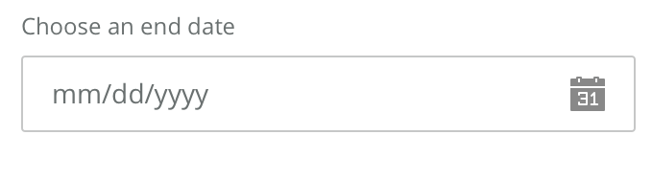
There are several design solutions to the challenge. A form may include help text (Example: MM/DD/YY) which assumes users understand the shorthand of these formatting requirements. A form may place the slash marks in the text entry field and force the user to enter in a specific format. The form may use these two solutions in tandem. Both of these solutions, however, still require the user to read instructions, type information, and potentially informs the user he or she committed an error, which could cause frustration. An alternative to date selection that removes the need for a user to input data is a calendar select. A calendar select is a much longer process requiring multiple clicks to open a drop menu, select month, date, and year. The benefit of this visual selection process is that it assures accuracy. When choosing between speed of completion and accuracy of data entry, a designer must weigh the benefits of both design solutions as well as the user completing the form. User learning is a critical component to the design decisions. If a user will only complete this form once in their life or sparingly over the course of several years, that user will not learn the requirements of the form through repetition, making the accuracy a critical consideration of the design. However, if the user is completing this form daily, weekly, or monthly, then speed becomes a greater concern. The user may commit an error the first time through the system, but will learn from that error and complete the form as required the second or third time encountering the query. At this point, the user has learned the desired behavior and speed of completion becomes the goal. To support accuracy, it is important to give clear, explicit instructions. This may mean using both instructional text and format restrictions in order to avoid errors and communicate the appropriate style to the user. (Bargas-Avila, et al, 2011)
Figure 1: Sample of Date Entry pattern help text

Methods

Evaluation
To begin to understand the existing process for YouthWorks timesheet and payroll process, I interviewed program staff and reviewed existing materials. The heuristic evaluation of the paper-based timesheet system raised a significant concern that risked the success of an online system. YouthWorks requires not one, but two timesheets for each participant.
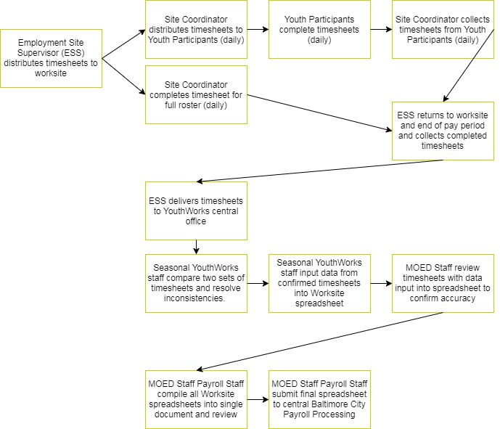
First, a youth participant is responsible for tracking his or her own time by signing in and out each day on a timesheet kept at the worksite by a supervisor. Youth sign in upon arrival, sign out for lunch, sign back in after lunch, and sign out at the end of each day. Youth are limited to 5-hour workdays and must take a 30-minute lunch break. At the end of the pay period, youth sign the timesheet and worksite staff collect it.
Figure 2: YouthWork Timesheet Distribution and Processing Flowchart
In addition to the youth-completed timesheet, worksite staff complete a single timesheet that includes all youth who worked at the location during a given pay period. The supervisor-completed timesheet includes a full roster of all youth who have worked for the location and the supervisor must record the same sign-in and sign-out times for each youth for each day of the pay period. A member of the YouthWorks staff called the Employment Site Supervisor (ESS) distributes both of these blank timesheets at the beginning of each pay period and returns at the end to collect the completed timesheets.
Once returned to the Mayor’s Office for Employment Development (MOED) central office, YouthWorks staff review each youth-completed timesheet and compare the time recorded with the supervisor-completed timesheet to assure accuracy. YouthWorks staff resolve any discrepancies by speaking with worksite staff and finally enter approved data into an Excel spreadsheet and send the document to MOED payroll processing staff. After a final review, the hours worked are sent to central the Baltimore City payroll for paycheck distribution.
While recognizing the inefficiencies connected to a paper-based system, MOED staff is hesitant to transition to an online timesheet system or remove one of the two timesheets from the process. Citing compliance concerns, MOED staff have opted for a pilot program to move one of the two timesheets online and introducing the new system to a small group of worksites to test the process. After conversations with MOED staff, we determined the supervisor-completed timesheet would be the better of the two documents to pilot. The smaller, more consistent user group of worksite supervisors who often oversee the program year-after-year would provide the staff with the experience necessary to evaluate the transition to the new system and make incremental improvements as needed before rolling out the changes program-wide.
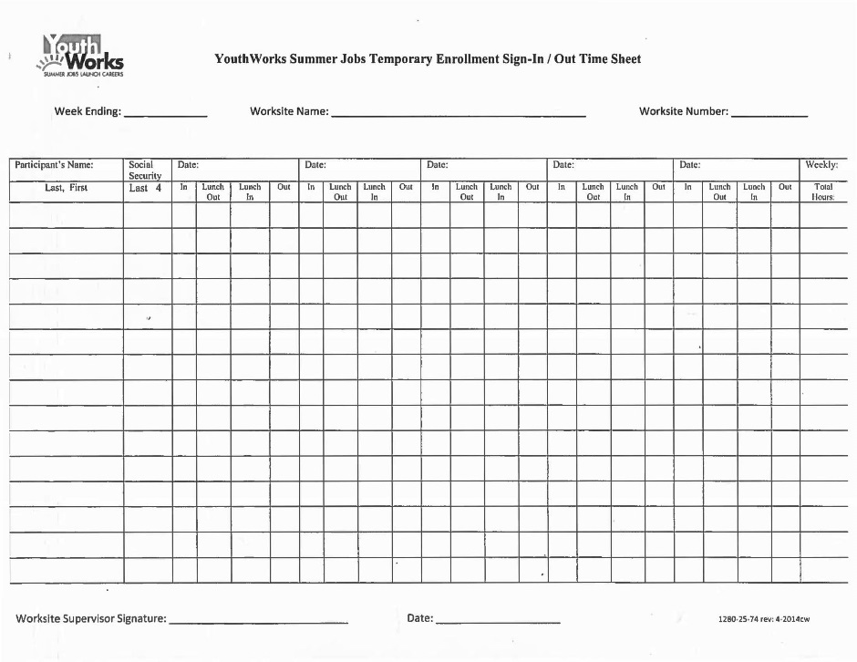
The official name of the supervisor-completed timesheet is the YouthWorks Summer Jobs Temporary Enrollment Sign-in/out Timesheet. Prior to each pay period, YouthWorks ESS distribute a package that includes a blank supervisor-completed timesheet and participant timesheets for each youth assigned to the worksite. Worksite staff are responsible for filling out the supervisor-completed timesheet, including populating the roster based on a separate list of participants.
Figure 3: YouthWorks Summer Jobs Temporary Enrollment Sign-In/Out Time Sheet
Each day, worksite staff document the time worked for each youth, including time in and time out for lunch. Based on interviews with several worksite supervisors, the daily completion of the timesheet is inconsistent at best. Supervisors report they fill out timesheets once every few days, or even once a week in many cases. One small worksite that only employs about a dozen youth on average may fill out the timesheet once a pay period. This results in generalized timekeeping where all participants are recorded as arriving and departing at the same time, including the lunch break. Supervisors who oversee YouthWorks participants have additional responsibilities to their employer beyond managing the summer program. Keeping track of additional paperwork, and completing documentation on a daily basis is an added burden to existing job responsibilities, as well as providing work and mentorship to the YouthWorks participants. All worksite supervisors interviewed expressed a clear preference for an online system that reduced paperwork and streamlined the submission process.
To gain feedback from YouthWorks staff at the central MOED offices, I created a survey using Google Docs and emailed it to those involved in payroll processing. Staff were slow to respond. Over several weeks and multiple emails, only two staff completed the survey to provide insight into their experience. Despite receiving minimal feedback, the responses were consistent and emphatic: The current timesheet system is inefficient and time-consuming. The paper-based system created opportunities for human error and keeping track of the dozens of individual sheets exchanged between individuals is complicated. These comments reinforced the initial overview I received from my primary contact who introduced me to the project. Using this initial feedback, along with the observations from the heuristic evaluation and analysis of popular timesheet software commonly available through online vendors, I began an initial design.

Design and Testing
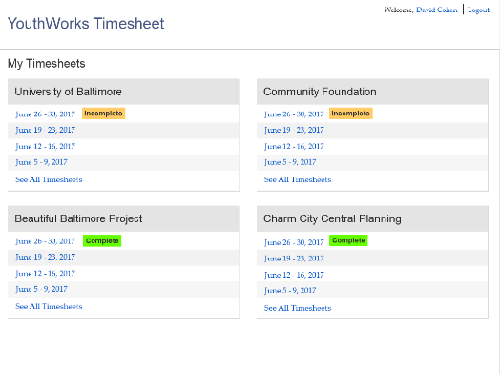
The timesheet system broke into two major user groups: YouthWorks staff and site supervisors with each employee partner. The YouthWorks staff need to be able to review all worksites, while a site supervisor only needs access to the roster and timesheets relevant to his or her location. This necessitated custom dashboards. A custom dashboard allows the user to see information pertinent to their job and role. First, I considered the needs of the YouthWorks staff. These users need to be able to review timesheets from numerous worksites. They need to be able to see both current timesheets and data previously reviewed from earlier in the program session. For these reasons, tables were the most effective way to display the materials. On the YouthWorks staff dashboard, the user would see tables that included the name of the worksite and list of the timesheets submitted or waiting for submission by the site supervisor. The status of the most recent timesheet is flagged based on whether or not it is ready for review. In my initial design, timesheet status for the current pay period was Complete or Incomplete. The goal is to improve the YouthWorks staff member’s workflow by allowing them to see quickly which timesheets were ready to review and which site supervisors may need a reminder. A tiled layout with large headers on each table allows the user to scan the page and quickly identify the worksite. Once the user has found the table he or she is looking for, they scan down the pay period links listed in reverse chronological order with the current pay period at the top. The user views the desired pay period by clicking on the date link.
Then I considered the site supervisor’s dashboard. This user does not need the access to the breadth of data required for the YouthWorks staff member. The site supervisor only needs to see his or her information. For this reason, the site supervisor’s dashboard would look identical to the design shown in Figure 4, except it would only show one box and table of links. The table header would display the worksite where the supervisor oversees youth participants.
Figure 4: YouthWorks Staff Custom Dashboard
This design was positively received by the YouthWorks staff during testing and users were able to complete necessary tasks, including identifying labels and accessing timesheets. During testing, though, users made recommendations and pointed out necessary changes to reflect business process. Regarding labels, staff said Complete/Incomplete did not accurately capture timesheet status. After discussing alternative terminology, we determined Submitted and Pending were the preferred field labels. Pending was defined as any current timesheet that was not ready for review, and Submitted was defined as a timesheet ready for review. Also, the users noticed the dates listed showed weekly timesheets. This did not meet the business process. YouthWorks processes timesheets over two-week pay periods. I changed the text links in the table to display two-week pay periods.
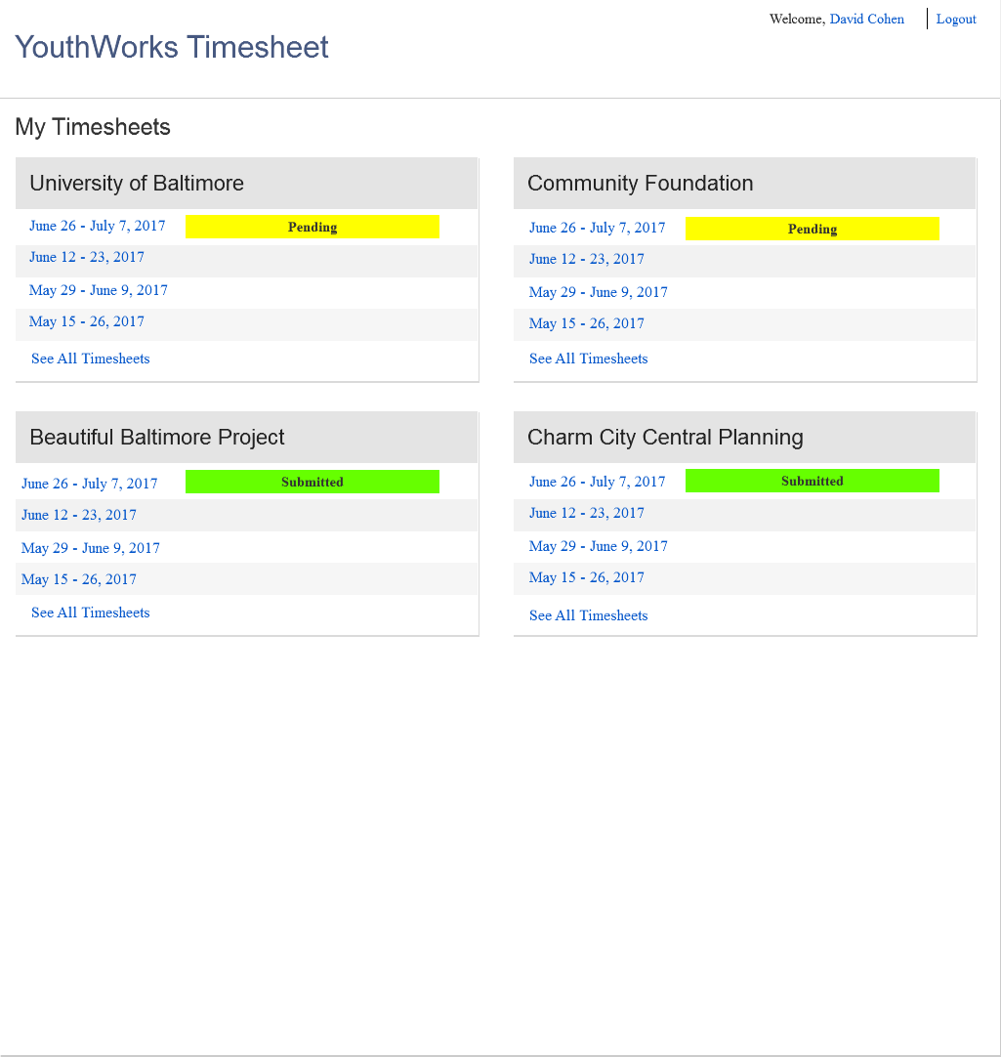
Figure 5: YouthWorks Staff Dashboard (Final)
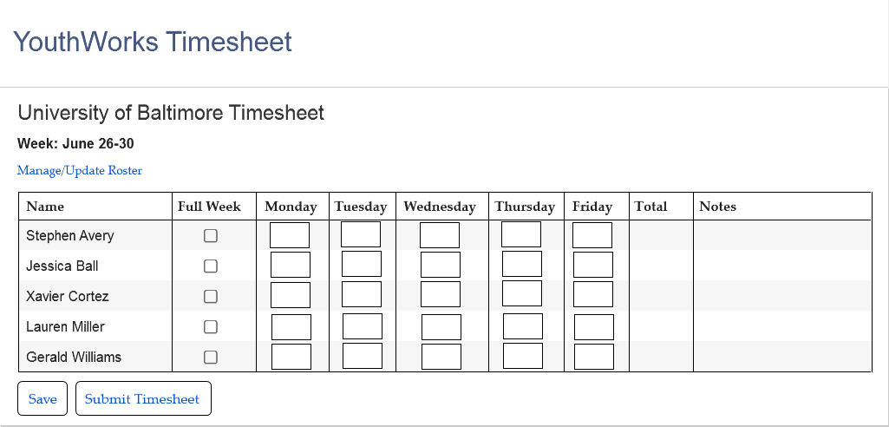
The most important page in the system is the time-entry screen. For the site supervisor, this page would display empty when first opened. The table is pre-filled with the assigned roster, however the time entered is blank. In the initial design, the site supervisor would type in the hours worked per day for the youth participant. The system automatically tallies the total and displays the hours worked per week at the end of the row. This design was a departure from the paper-based timesheet shown in Figure 3. Rather than requiring site supervisors to enter times in and times out, this only required the user to type in total hours worked per day. I also included a checkbox for the site supervisor to click if a youth participant was present each day of the week. These changes were made to streamline the process for site supervisors and simplify the timesheet.
The site supervisor submits this information to the YouthWorks staff who then reviews the hours logged. If this system were implemented without any other changes to the timesheet and payroll processing workflow, YouthWorks staff would compare the hours worked per day and totals for each student with the individual youth-prepared timesheets collected from the worksite at the end of the pay period by the Employment Site Supervisor. After reconciling any inconsistent timesheets, the YouthWorks staff moves the worksite data along to another round of approval by a full-time staff member dedicated to payroll processing. Finally, the lead payroll manager for the Mayor’s Office for Employment Development downloads a complete Excel spreadsheet with all YouthWork timesheet data for submission to the city government central processing center. Long-term, data could be digitally transmitted to the payroll center without requiring the download; however, the city government cannot accommodate such a data transfer at this time. For the purpose of the pilot, the Excel download is necessary to meet the needs of other stakeholders in the process.
Figure 6: Blank YouthWorks Timesheet
Once I had completed my initial design, I scheduled a full day of in-person interviews and paper-prototyping with the YouthWorks staff. I met with six members of the staff responsible for processing payroll, beginning with seasonal staff who are the first to receive and reconcile completed timesheets up to the YouthWorks director whose payroll-related responsibilities include oversight of records management. Due to the low engagement I received from the email surveys, I used the time with each member of the staff for both user testing, as well as deeper interviews and requirements gathering. Opening with standard questions, the interviews morphed into unrestricted conversation about the payroll process and the challenges staff faces in completing the tasks. All notes recorded were anonymous to protect interview subjects. Users were asked to complete several tasks using the paper prototype including:
• Login
• Identify components of dashboard
• Select submitted timesheet for specified worksite
• Identify components of full-roster view
• Select specified youth participant
• Identify components of youth timesheet
• Modify youth timesheet and save
• Approve full-roster timesheet
The users were able to complete these tasks successfully, but the discussion spurred by the prototype proved most valuable to the research. Comments related to the names of fields, unclear labels, and other terminology that did not fit the standards used already within the team. Most importantly, the team identified a problem with how the initial design collected time worked.
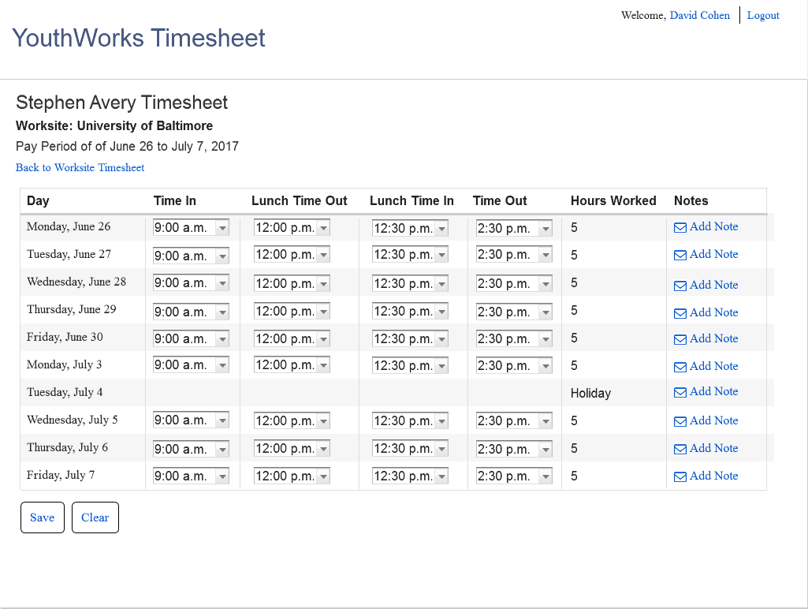
In my initial review of the paper-based timesheet, I considered the times in and times out recorded to be unnecessary and inefficient for the site supervisor to record. The youth-completed timesheet already collected this information and the duplicate entry appeared redundant. During the interviews, YouthWorks staff informed me the times in and times out were critical for record-keeping purposes and part of their timesheet reconciliation process. Were the program audited, investigators need to see the times in and times out on both timesheets to validate the payments processed. This data needs to meet compliance protocols drastically changed the requirements for data entry. To meet this need, I had to create a new path for detailed time entry.
Figure 7: Individual youth participant timesheet

The individual youth timesheet is modeled after the paper-based youth-completed timesheet. While this paper timesheet will not move online as part of the pilot, its design is instructive for the online version of the supervisor-completed timesheet. Rows represent the days of the pay period and columns represent time-in and time-out, including a lunch break. Based on interviews with YouthWorks staff and worksite supervisors, time-in and time-out rounds to the nearest quarter-hour. Therefore, the dropdown menus allow the supervisor completing the youth’s timesheet to select from a preset selection of times in 15-minute intervals. The system will automatically calculate the total time worked in a day when the end-of-day time-out is selected. The system keeps a running tally of time worked over the pay period.
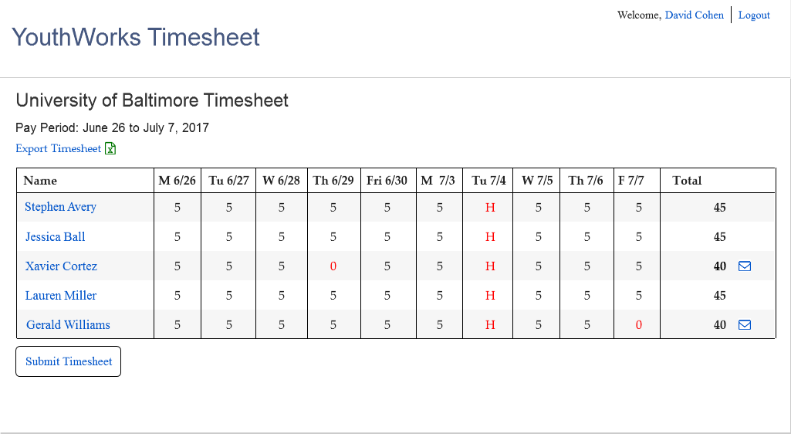
The full-roster timesheet view for the worksite supervisor as designed retains the general layout from the initial design because it tested well with the YouthWorks staff. In this new design, site supervisors cannot enter total hours worked for each day. These columns are read-only fields. Instead, the youth participant names in the first column are now links that bring the site supervisor into the individual youth participant timesheet shown in Figure 6.
Figure 8: Completed worksite timesheet
To reduce the cluttered paper-based timesheet, users enter time-in and time-out data on the individual youth participant screen. Only total hours worked each day will show on the full-roster page with the weekly totals automatically tallied. The YouthWorks staff can pre-set holidays as off, so the site supervisor does not accidentally mark time on these days. The zero for hours remains red to catch the attention of both the site supervisor entering the data, as well as the YouthWorks staff who receives the submitted timesheet. It is important to double check a student did in fact not complete any hours in the day and it was not a mere oversight when completing the form. In the far right column next to the weekly totals, an envelope icon appears when the site supervisor has included a note with the timesheet submission. This note is an open text entry field for the supervisor to communicate with YouthWorks staff and document any pertinent information related to a student’s work, such as an unapproved absence or a missed day due to doctor’s appointment or other scheduling conflict. Once all individual youth timesheets are complete, worksites may digitally submit to YouthWorks staff for review. By allowing worksite staff to submit timesheet data directly to the YouthWorks staff, the system removes the potential loss of timesheets and transfers the responsibility for data entry from YouthWorks staff to the worksite to reduce risk of user error.
Using this iterative design process, I made changes to the design and moved on to test with the other major user group: site supervisors. The planned pilot seeks to work with long established employment partners, which narrowed the scope of potential users for further testing. Following outreach the desired test subjects, three were willing to participate in the research. In the same format as the meetings with YouthWorks staff members, these sessions were used to both test for task completion, as well as open interview to best understand needs for the organization. Worksite staff completed the following tasks.
• Login
• Identify components of dashboard
• Select current pay period timesheet
• Identify components of full-roster view
• Select specified youth participant
• Identify components of youth timesheet
• Enter time worked by youth and save
• Submit full-roster timesheet
All users successfully completed nearly all requested tasks as part of testing. Similar to the YouthWorks staff, the most valuable information came in the discussion prompted by the screens. Most feedback pertained to the need for additional features, such as the ability to export data for local record keeping. In these conversations, I learned of the extensive record keeping organizations are required to maintain for YouthWorks participants because in most cases, their salaries are grant-funded. Grants require additional reporting, which includes timesheet data. For this reason, I incorporated the option for site supervisors to export all timesheet data to Excel for local records management.
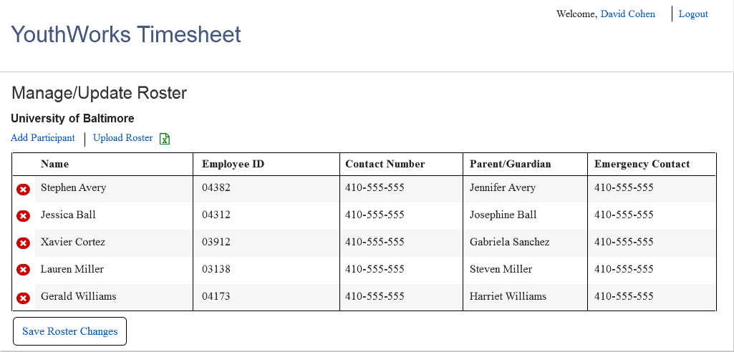
Additionally, the site supervisors need further control over the roster, because youth participants may join or leave a worksite during the pay period. A paper-based timesheet accommodates this use case as the site supervisor can simply add another line to the roster and continue recording time worked. After checking with YouthWorks staff to confirm this flexibility would not jeopardize their participant tracking and record keeping, I introduced a new screen that would allow the site coordinator to add or remove a youth participant from their roster.
Figure 9: Manage/Update Roster
This Manage/Update Roster screen would now be available to site supervisors to add new youth participants to their worksite in the occurrence of a new participant joining the worksite mid-pay period.
I created a final screen design package for YouthWorks based on these multiple rounds of design and testing with stakeholders and user groups. The most significant changes to the design related to field labels and business process, as outlined above. Conversations with both user groups shed light onto the terminology used by the organizations that informed the field labels. It is important for the system to speak their language and not expect users to re-learn terminology while also learning a new system. The business process for YouthWorks payment processing is complex, and only further complicated by the larger requirements for Baltimore City payment processing. The design does not anticipate any changes to the internal business process within the YouthWorks team and the Mayor’s Office for Employment Development. It does require the organization accept a digital signature, which is not currently permitted by Baltimore City government. The final screen package does not include a design for the digital signature because the requirements for this process are not yet known. The YouthWorks staff is exploring options and have expressed the need for this feature to city government. The final screen package is included in the Appendix. As part of the conversation with YouthWorks staff when delivering the screens, I made clear the user experience process is only beginning. As part of any pilot they implement, analysis of the user experience must be considered when evaluating or making changes to the software. Using an iterative design process, the YouthWorks staff and their development partners can evaluate the effectiveness of the initial designs developed for this project and refine as needed.

Discussion
The greatest challenge to developing a design for a YouthWorks digital timesheet system was gathering initial feedback to understand requirements for the program. YouthWorks only has seven full-time staff members who are responsible for oversight of the entire program. Seasonal staff complete most of the payroll process. Due to the inefficient and time-consuming nature of the current system, these seasonal staff have limited time to participate in any discussion related to a future pilot. In many cases, these staff are not concerned with a pilot or any plans because they will unlikely be employed by the program when it takes place. Gaining buy-in was difficult. My initial strategy was to send emails with online surveys meant to fit into the staff member’s workday. It did not require the staff to schedule a meeting or take much time away from their work. They could complete at their own pace. Unfortunately, I found this ineffective because staff ignored the surveys. Without a person present to provide a face for the project or allow the staff member to ask questions, the survey sat in an inbox. I knew I had to get into the office.
When I scheduled meetings, I was concerned I would run into the same type of indifference in person. The meetings were booked with the same people who received and ignored the emails. To my surprise and pleasure, the staff opened up and shared great information and detail in a face-to-face meeting. Removing the digital interface and meeting in person transformed the feedback collection process. Once the staff member had a person to speak to, rather than a text box to type into, they were willing and open to share their experiences and provide input into the process.
Staff members were also unable to visualize a digital timesheet that could replace the existing paper-based system. Full-time staff members who were at the forefront of the conversation had worked with the paper-based system for so long the transition to a digital system appeared overwhelming. I received little feedback from those early conversations of a direction or priority. Staff had not considered this a feasible transition. There was no vision for a system. I had to provide the vision, even if that meant taking a guess based on limited information and being completely wrong.
In speaking with seasonal staff, I asked questions to begin a general conversation about their needs and a system. I asked how they would envision a system that would work online. They offered few ideas without frequently referring to the paper-based version. When I showed the interview subjects the paper prototype, their demeanor changed and level of engagement shifted dramatically. With a basic structure in front of them, the staff could begin to visualize a program that could dramatically improve the way they work. Ideas and suggestions began to flow quickly as I wrote down everything they said about the prototype. I attempted to force the exchange back to the tasks for testing, but found the enthusiasm and conversation far more valuable. Qualitative data was more influential than task completion rates. At the early stages of the process, it was most important to gain buy-in from stakeholders and cultivate enthusiasm for the project. Site supervisors followed the same pattern. Opening with an initial explanation of the project and planned pilot, the interview subjects were skeptical. Each used digital timesheets for their own organization, but did not see how the cumbersome YouthWorks process would fit into an online platform. They voiced complaints about the paper-based timesheet that was difficult to maintain and track. Their tenor changed when shown a paper prototype of a potential digital system. The concept crystalized and they were able to see where to complete their tasks and began explaining small nuisances with the current process in hopes a new system would address their issues.
The value of a small visual can be the difference that opens the creativity in stakeholders’ minds. A wireframe or sketch can be the crack in the door that allows partners on the project to break through. As a user experience designer, sometimes the best course of action is to get something – anything – on paper to give collaborators a concept to begin the brainstorm. The goal is not to only find answers, but also develop the right questions. Without the initial paper prototype of time entry pictured in Figure 5, YouthWorks staff may never have explained the importance of detailed time entry. Staff had made the assumption this was a known issue without articulating the requirement.
This highlights the power for iterative design. When planning a project timeline, it is important to account for sketching, designing, and user testing at each step of the project. It’s never too early to put concepts on paper. In some instances, the existence of a visual concept will prompt stakeholders to further define requirements. On a larger project team UX designers should work with business analysts and product owners to define system requirements. For a project similar to the YouthWorks digital timesheet, it is advantageous to identify a core group of users to participate in the requirements gathering and brainstorming sessions. Their expertise matters not just in the formal business process, but many of the informal tasks that may not be included in preliminary documentation. The informal tasks possible using a paper-based system are critical to user adoption and project success, as seen by Brown when developing a timesheet system for the oil company. The initial software developed and released to the employees did not account for the informal tasks, such as scratching out and changing time codes and notes made in the margin for supervisors. These types of uses could not be identified by an outside consultant by reviewing paper documents. Had the development team incorporated users into an iterative design process earlier in the project, they may have identified these informal uses for the paper-based timesheet and been able to account for the needs before implementing an ineffective system.
When collaborating with fellow designers, project stakeholders, or product users, it is valuable to put ideas on paper. These ideas can be written or sketched. This action moves the design from intellectual to tangible and creates a baseline from which the group can build. Do not hesitate to put the earliest concept on paper. Do not wait for a fully form design to take shape in your mind before sketching. The presence of a physical, tangible representation of a design idea allows the project team members to realize a concept in the same way. When working from the same baseline, team members can add, subtract, and modify the design as they work from sketch to a functional, testable prototype. Without a drawing for all team members to view, this process may never move forward.
This experience reinforces the perspective that a UX designer should never work alone. There are some tasks that must be completed as an individual, but the project should always be collaborative. It is incumbent on the designer to build a team, even if that team is loosely defined as an informal group of stakeholders. Other members of this team may not realize the importance of their role. Providing thoughtful, constructive, and informative feedback is critical to the success of any project. It is the responsibility of the UX designer to evangelize the importance of this role, to build enthusiasm for the project in desired team members in order to generate useful feedback.
The staff members in the YouthWorks office were bursting with ideas and information. The employment partner representatives I spoke to offered great insights into the potential for an online digital timesheet system and were eager to share what they knew. Meeting with me was not part of their job description. They would likely not consider themselves to be designers or software developers, but they enthusiastically shared their knowledge with hopes of improving the way they work. All it required was someone to ask and open the channel of communication. By beginning this conversation, building this team, and providing an initial visual concept to build on, the design evolved to meet the needs of the organization. Requirements were clarified because of these conversations about the initial design. The time inputs were changed drastically, but in the end met the needs of the organization. Conversations with employment partners illuminated uses for this data for their organizations that would not have been considered without their involvement. By building a team, opening communication, and proposing an initial vision from which to spark conversation, we were able to develop a design that can be used for a pilot. Evaluation of the pilot program could allow the organization to further refine the requirements and identify opportunities from improving the business process and potentially free staff from time-consuming tasks, giving them more opportunity to serve the youth participants and support the employment partners.

Conclusion
There is a broad desire across internal and external stakeholders for an online, digital timesheet system for the YouthWorks program. The current paper-based system is time-consuming and error prone for internal staff to process, while also being burdensome for employee partners responsible for tracking time worked by youth participants. Numerous interview subjects, both internal YouthWorks staff and external employment partners, reported experience with online timesheet systems for other positions they favored to the paper-based system. While standardized third-party systems are widely available, the YouthWorks program requires a customized solution, barring a significant restructuring of the timesheet processing workflow. As is, the YouthWorks program’s requirements for roster management, time tracking inputs, and reviews and approvals, can only be met by a custom solution. This may be accomplished through partnership with an existing software company that supports a timesheet product with vast customization opportunities, or it must be built from scratch.
Major shifts in technology that transform an organization’s workflow must start with an evaluation of the business process. Technology is only as effective as the individuals and the structures that utilize its capabilities. A timesheet system is a tool staff use to complete their work. Computer supported cooperative work relies on an understanding of human behavior and needs. The prototype and screen package delivered assumes no change to organizational workflow. Business processes should be re-evaluated and the design of the technology modified to fit the needs of the most effective and efficient work process.
To begin, Baltimore City does not currently accept online timesheets across the government. From City Council to YouthWorks staff, all employees are required to complete paper timesheets that are manually entered into spreadsheets for processing. YouthWorks staff are dissatisfied with this requirement and make their best effort to keep it from impeding their work output. Unfortunately, it remains time-consuming and creates unnecessary opportunities for error. Until the City Government adopts a digital process for tracking time worked, accepting signatures, and storing reports, any online timesheet system for YouthWorks will not proceed.
Job responsibilities for permanent and temporary YouthWorks staff weigh heavily toward time tracking and payment processing. This includes timesheet distribution, collection, review and reconciliation, data entry, and ultimately consolidation and processing. Implementing an online timesheet system could significantly reduce time allocated to these tasks. Considering the tight budgets government agencies work within, the reduction of time spent on these menial tasks could create opportunities for other program improvements. When evaluating the value of the financial cost to developing an online timesheet system, the organization must consider the opportunity cost of not utilizing staff to improve the experience for youth participants and employment partners, as it currently allocates these dollars and hours to paper distribution, collection, and data entry. Once an ideal organizational chart and business process is in place, proper requirements could be gathered for an online timesheet system that meets the needs of the YouthWorks that could be, rather than the YouthWorks program as it is currently constructed.

References
Bargas-Avila, J., Brenzikofer, O., Roth, S., Tuch, A., Orsini, S., & Opwis, K. (2010). Simple but Crucial User Interfaces in the World Wide Web: Introducing 20 Guidelines for Usable Web Form Design. User Interfaces. doi:10.5772/9500

Bargas-Avila, J. A., Brenzikofer, O., Tuch, A. N., Roth, S. P., & Opwis, K. (2011). Working towards Usable Forms on the World Wide Web: Optimizing Date Entry Input Fields. Advances in Human-Computer Interaction,2011, 1-8. doi:10.1155/2011/202701

Bargas-Avila, J. A., Orsini, S., Piosczyk, H., Urwyler, D., & Opwis, K. (2011). Enhancing online forms: Use format specifications for fields with format restrictions to help respondents. Interacting with Computers,23(1), 33-39. doi:10.1016/j.intcom.2010.08.001

Bartell, Schultz, L., & Spyridakis, J. (2006). The effect of heading frequency on comprehension of online information. Proceedings. IEEE International Professional Communication Conference,53(4). doi:10.1109/ipcc.2002.1049136

Brown, B. A. (2001). Unpacking a Timesheet: Formalisation and Representation. Computer Supported Cooperative Work (CSCW), 10(3-4), 293-315. doi:10.1023/a:1012787304131

Cheskin Research and Studio Archetype/Sapient. Ecommerce trust study. Technical report, Cheskin Research and Studio Archetype/Sapient, January 1999.

Couper, M. P., Traugott, M. W., & Lamias, M. J. (2001). Web Survey Design and Administration. Public Opinion Quarterly,65(2), 230-253. doi:10.1086/322199

Cox, P. (2013, January 22). How to Build User Confidence in Your UI. Retrieved March 22, 2017, from https://www.webdesignerdepot.com/2013/01/how-to-build-user-confidence-in-your-ui/

Jarrett, C. (2015, August 13). No More Accordions: How to Choose Form Structure. Retrieved March 22, 2017, from https://userresearch.blog.gov.uk/2015/08/13/no-more-accordions-how-to-choose-a-form-structure/

Jarrett, C. (2016, December). Form Structure. Retrieved March, 2017, from https://www.gov.uk/service-manual/design/form-structure

Jarrett, C., & Gaffney, G. (2010). Forms that work: designing Web forms for usability. Amsterdam: Elsevier/Morgan Kaufmann.

Jarrett, C., & Miller, S. (2008, September). Should I use a drop-down? Four steps for choosing form elements on the Web. Retrieved March, 2017.

Karvonen, K. (2000, November). Beauty of Simplicity Retrieved March 11, 2017.

Karvonen, K., Parkkinen, J. (2001, May). Signs of Trust: A Semiotic Study of Trust Formation in the Web Retrieved March 11, 2017.

Khaslavsky, J. and Shedroff, N.: Understanding the Seductive Experience. Communications of the ACM, May 1999, Vol. 42, No. 5

Krug, S. (2014). Don't make me think, revisited: a common sense approach to Web usability. Berkeley, CA: New Riders Pub.

Linderman, M., & Fried, J. (2004). Defensive design for the Web how to improve error messages, help, forms, and other crisis points. Berkeley, CA: New Riders Publ.

Grudin, J. (1994). Computer-supported cooperative work: history and focus. Computer, 27(5), 19-26. doi:10.1109/2.291294

Penzo, M. (2006, July). Label Placement in Forms. Retrieved March, 2017, from http://www.uxmatters.com/mt/archives/2006/07/label-placement-in-forms.php
James, W. (1890). The principles of psychology. London: Macmillan.

Appendix: Final Screen Package

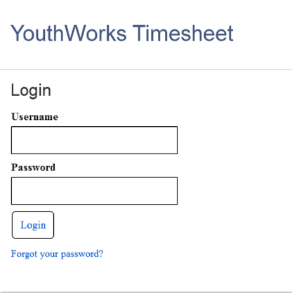
Figure 10: Login Page (zoom)

Figure 11: YouthWorks Staff Dashboard (Final)

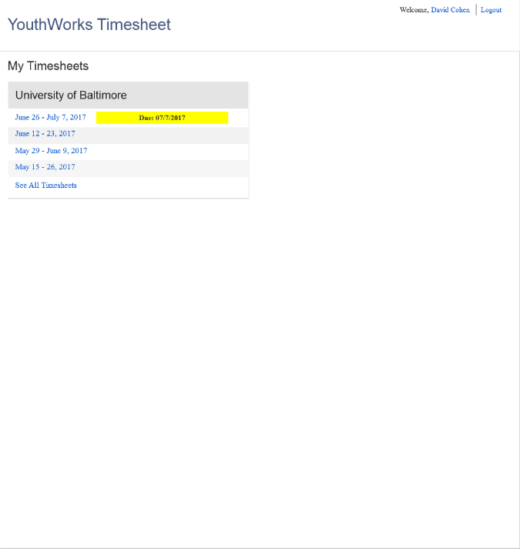
Figure 12: Employee Partner Dashboard (Final)

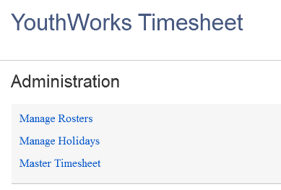
Figure 13: Administration Home (zoom)

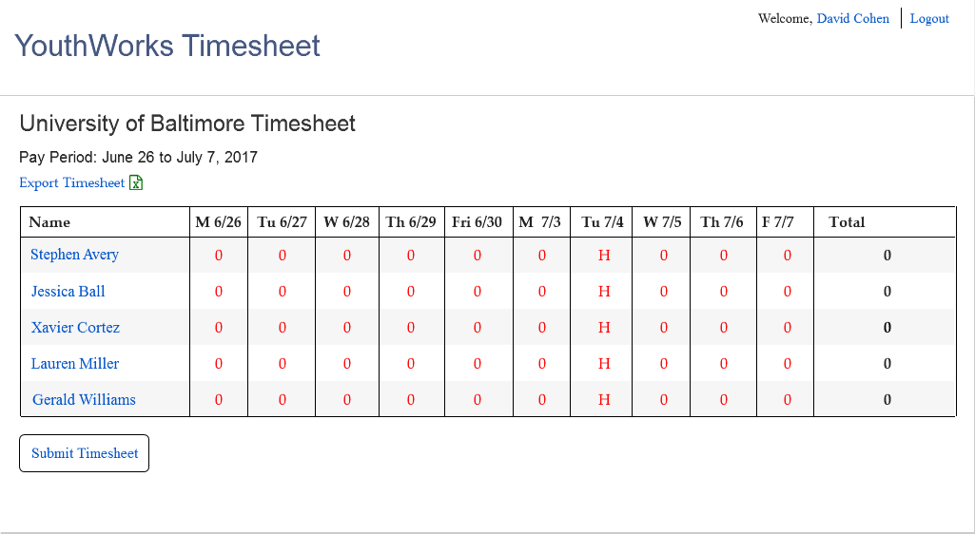
Figure 14: Blank Timesheet
Figure 15: Completed Timesheet

Figure 16: Participant Timesheet
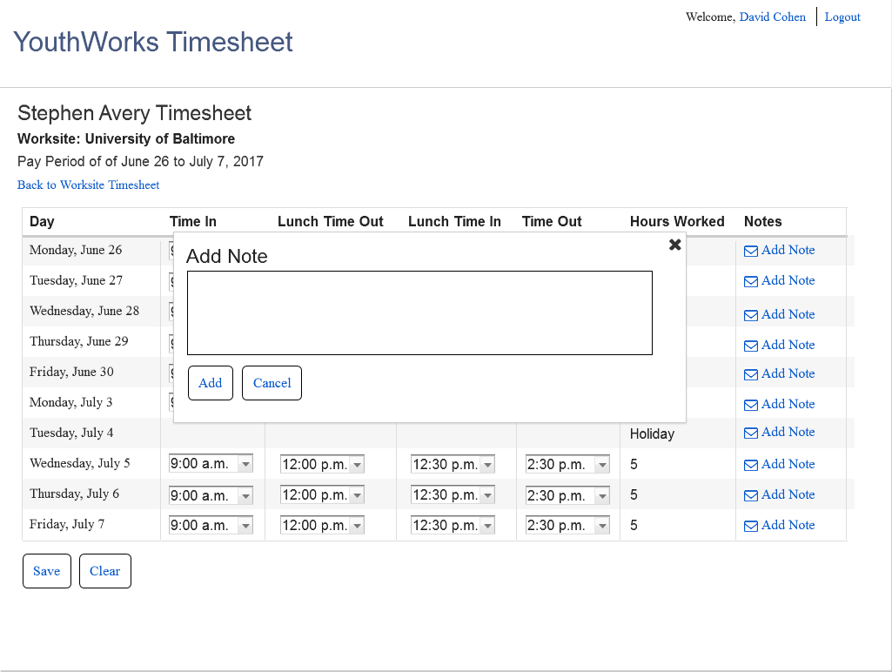
Figure 17: Add Note about Participant
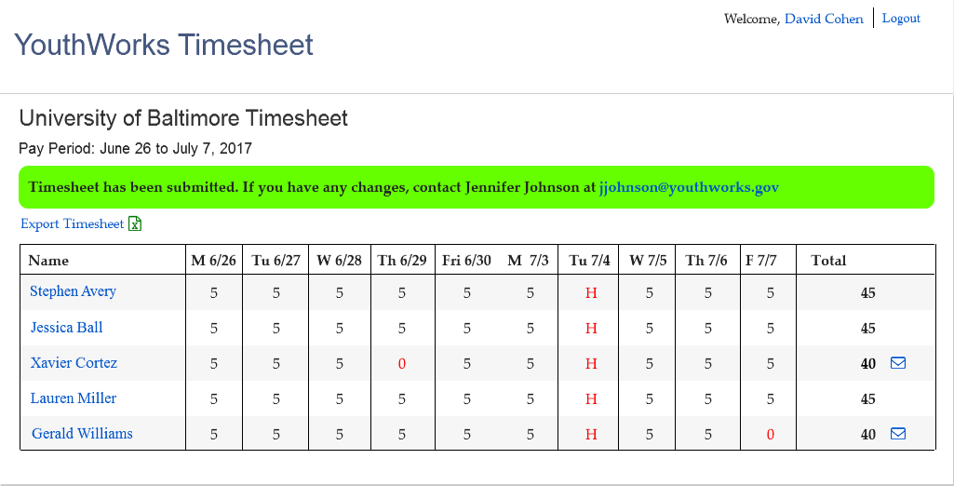
Figure 18: Submitted Timesheet

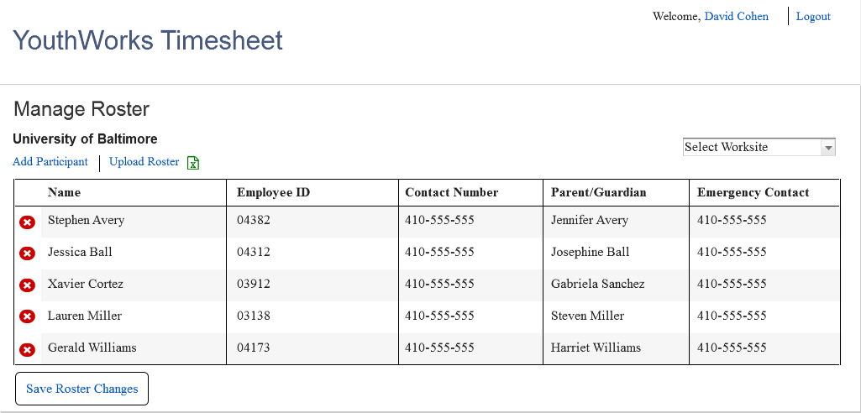
Figure 19: YouthWorks Staff Manage Roster

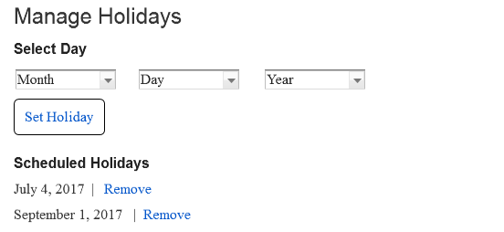
Figure 20: YouthWorks Staff Manage Holidays

