Supplementary Materials
Suppl. Table 1: Soil Analysis Results from Plasy and Nepomuk seed orchards from 1988 and 2015. The Forestry and Game Management Research Institute prepared data from 1988. For the 2015 data, n=6 (Nepomuk), n=7 (Plasy). The - symbol indicates that the analysis was not performed.
 | 1988 |  | 2015
 | Plasy | Nepomuk | Plasy | Nepomuk
exchange acidity of soil - pH | 3.3 | 3.6 | 3.7 | 3.8
Calcium content (mg Ca/kg) | 263 | 293 | 441 | 660
Magnesium content (mg Mg/kg) | 50 | 41 | 53 | 121
Phosphorous content (mg P/kg) | 11 | 36 | 19 | 9
Potassium content (mg K/kg) | 20 | 43 | 83 | 92
Carbon content (% C) | - | - | 1.7 | 1.3
Nitrogen content (% N) | 0.05 | 0.08 | 0.11 | 0.16
Hummus content (%) | 1.7 | 1.61 | 3 | 2.2
C:N ratio | 20 | 8 | 14 | 8

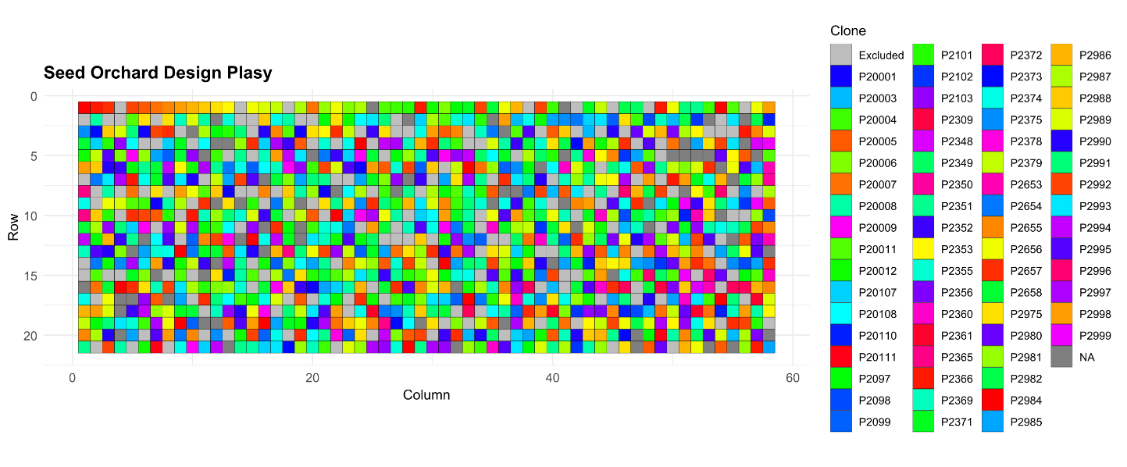
Suppl. Fig. 1: Spatial visualization of the Plasy seed orchard design and the clones utilized for the analyses.
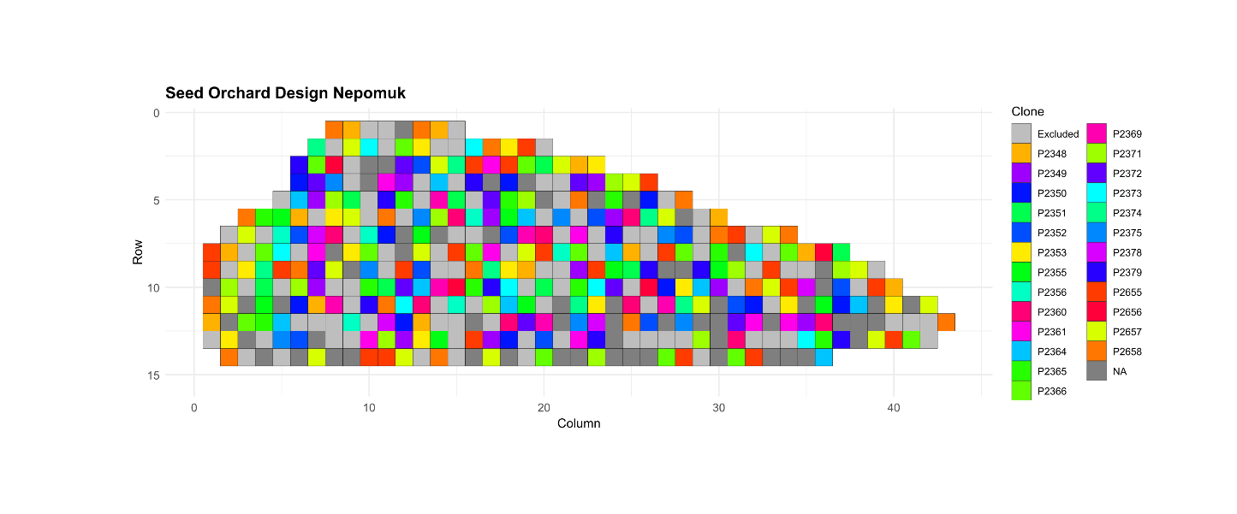
Suppl. Fig. 2: Spatial visualization of the Nepomuk seed orchard design and the clones utilized for the analyses.

