Strategic Business Plan
Christina Korenstra
In partial fulfillment of the MA in Cultural Sustainability
December 2021
Goucher College, Baltimore, Maryland
Capstone Committee
Darius Graham, Advisor
Amy Skillman, Reader
Robert Baron, Reader

Contents
Abstract 3
Introduction 4
1. Executive Summary 9
Literature Review and Theoretical Framework 10
Methodology 23
Ethical Considerations 26
Review of Ethnographic Data 27
2. Company Overview 32
3. Business Description 35
4. Market Analysis 37
5. Operating Plan 39
6. Marketing and Sales Plan 40
Reflection 42
Appendices 45
48

“We must accept finite disappointment, but we must never lose infinite hope”- Dr. Martin Luther King

Abstract
Communities on every level in the United States have been plagued by racism for two and a half centuries. The systems in place in our country perpetuate the racial injustice which continues to this day. Because the injustice and inequities in our country are rooted in our very structures and systems of functioning, systemic change is required. Ultimately, it would be ideal to maximize resources and provide education as to how to secure and access resources that have historically been unattainable for African American communities. Furthermore, identifying community networks of Black-owned owned businesses that can rely on each other for cohesion and support can in turn strengthen communities and aid them in becoming more sustainable and self-reliant. Understanding the dynamics of racial disparities becomes essential to finding solutions and achieving equality. Funding leaders of color then becomes an essential factor as African American leaders bring strategies that offer an intimate understanding of the racial experiences of communities of color and the associated issues these communities face. I have documented Black-owned side businesses, conducting ethnographic research through photographic and video documentation of some of the businesses and interviews. Due to the impact of COVID-19, observation and documentation of locations was modified to observe the current health and safety protocols of the business and community. It was preferable to interview as well as to actively observe the businesses but in some cases the only option was to rely solely on proprietor interview. The result has been the development of a comprehensive business plan for a resource center that will pool resources for business owners and offer networking support for mentorship to aid leaders of color to follow a trajectory for success to develop businesses, grow businesses or make their side hustle their main hustle.

Introduction
For approximately two hundred years Baltimore Maryland has been a major port city in the United States. Many people who passed through the port of Baltimore simply used it as a waystation on their journey to another destination. Others determined to put down roots. This created a city that is to this day full of diversity and a multitude of cultures. Baltimore has always been a predominantly blue-collar, working-class community, prospering from entrepreneurs and skilled laborers. Unfortunately, as is often seen, ethnic groups have struggled and had to fight for acceptance. Merging this diversity, cross-cultural cooperation, and creativity is also one of the city’s greatest strengths and what is most notable about the city. Despite this, the struggle for equal opportunity and access to resources continues. At the beginning of the 19th century, Maryland had the largest population of free African Americans in the country, which totaled forty percent of the country’s total African American population. Even though there was a substantial population of African Americans in Maryland, whose ratio was unmatched by any other area, Maryland still maintained a white majority which left the free black population largely unable to join the class of small business owners.
Employment discrimination kept many African Americans in poverty and life-threatening conditions. Many city departments refused to hire African Americans at all. Those who did hire people of color did not allow for any upward mobility. These discriminatory practices were condoned and reinforced with Jim Crow laws. The term “Jim Crow” itself not actually being one law but referencing a category of discriminatory laws coupled with extreme violence promoting the ability to limit earnings of African Americans and promote racial segregation which perpetuated the marginalization of the African American community. The terminology came from an actor who performed in blackface, reinforcing discriminatory stereotypes. The discriminatory hiring practices showed no signs of improvement until after the mid 1950’s. Against the odds, in antebellum society, free African Americans asserted an entrepreneurial spirit that was promoted by movements that had formed such as the National Negro Convention. The success and diversity of African American businesses established lead to Martin Delany a leading antebellum black intellectual in 1952 to refute the narrative of the time that black people were not useful members of society. He pushed a counternarrative to the mainstream rhetoric that the African American community was teeming with consumers and nonproducers that contributed nothing to the general progress of man.” Despite being successful, some of these businesses, remained marginalized and their earnings were significantly low. Due to the rampant bias and prejudice plaguing the country, the aftermath of this widespread discrimination ingrained into the fabric of American culture reverberates throughout our nation and can be seen in copious ways. According to corporate development and global strategy executive, Shawn Rochester, in the online marketplace the mere presence of Black skin, or an African American sounding name has the propensity to lower the value of a vendor’s product by 20-35%. Additionally, in the job market applicants with African American sounding names are called for interviews half as much as those with white sounding names and is estimated to require up to eight years of work experience to compensate for the perceived competency difference.
Between 1880-1910 Baltimore City’s population doubled to approximately 550,000 from European immigration. Approximately 88,000 of the City’s population was African American. Simultaneously development and transportation in the city lead to suburbanization. It is also noteworthy to mention that Maryland abolished slavery in 1864. The nature of the service industry and economy led to African American households becoming spread throughout the community in the second half of the 19th century. This consequently highlighted the disparities between poor African American households in alley houses and small houses set back from main streets and the wealthy white elites. The result became the first segregated African American neighborhood, “Old West Baltimore”. On the streets of Old West Baltimore, systemic and structural racism impacts generation after generation of families of color living in the area. This includes my partner, his family and many of our friends who were raised and struggled throughout their entire lives making this a critically important subject to me. They grew up surviving an epidemic of racial injustice, inequity, and lack of opportunity that others took for granted. They have demonstrated resiliency and made ends meet with creativity and ingenuity to devise streams of income through side work simply because they did not have access to the same opportunity as others. These side hustles they devised have the potential to be lucrative and more than a side job. The potential to flourish into a sustainable successful business if resources were available. The plight of needing income is not exclusive to this community, as roughly 57 million people engage in a side business that is not their main source of income, according to a survey from The Hartford. In the same study about twenty five percent of side business owners said their business could potentially become a full-time job or primary source of income, one third said that was incredibly unlikely.
If a resource center designed to meet their needs were available to aid, equitable economic opportunity would be more accessible and increase the likelihood of these businesses being successful. For my Capstone I have created a business plan for an outreach center that builds upon and consolidates existing resources to create ease of access as well as providing networking for individuals of color who own side businesses, who are in the process of developing and growing a business or are looking at starting a business from the ground up. A center of this nature would provide needed support to the Baltimore community for individuals looking to make their side hustle their main hustle. Investing in entrepreneurs who are creating economic opportunities for themselves and for their communities provides an empowering sustainable future for the community. Interviews with small business owners aided to identify their wants and needs within the community and specifically the side business owners, the proposed outreach center can honor and nurture the traditions and values of the community looking at economic development through a cultural lens. These interviews also helped to determine the level of awareness of existing resources and if they are felt to be satisfactory by the community as well as what can be done to improve upon what is currently being offered.
The United States has historically been wrought with racial divide and injustice. In the past few years there has been an upsurge in the headlines of racial inequities bringing issues of injustice to the forefront and causing a significant dissonance. Today across every socioeconomic level, African Americans have significantly less assets than whites. More than one third of African American families have negative wealth or no assets at all. An article by entrepreneurs Dorsey, Bradach, and Kim noted that in comparison to their non-minority counterparts, “African American business owners are 5.2 times more likely to be denied a loan. African Americans are 2.3 times more likely to experience infant death. African Americans are 2.7 times more likely to be searched on a traffic stop. On virtually every issue, holding all other factors constant, one’s race predicts outcomes better than anything else. The Racial Equity Institute (REI), a multiracial team that conducts workshops nationwide helping organizations and individuals understand structural racism, points out that these racial inequities look the same across systems whether it be healthcare, education, or finance.” Expanding to all minorities groups, the U.S. Department of Commerce reports that minority firms are more likely to be denied loans at a rate nearly three times higher than non-minority firms, minority firms are likely to pay higher interest rates; on average 7.8% while non-minority firms pay on average 6.4% and minority firms are less likely to receive loans; and when approved, receive lower loan amounts. This adds solidity to the previous information from Dorsey et al. Prior to the aforementioned studies in recent years, studies showed comparable patterns showing the systemic significance. In 1998 Dartmouth, Westley and Williams College embarked on a collective study that looked at discrimination in the small business credit market. The study established that at that time Black owned firms were twice as likely to be denied credit despite their credit worthiness which in turn meant that Black business owners had less access to capital than white entrepreneurs when starting a business putting them at a distinct disadvantage. This also extends to existing entrepreneurs attempting to grow an existing business. Consequently, the amount of available capital is a primary factor in the success or failure of the endeavor. In addition, the study found that the rates charged to Black business owners was close to 1% higher than that charged to white business owners. It is estimated that for their homes and businesses this generation of African Americans lose an estimate of one billion dollars in equity. The resounding negative impact of the hardship and discrimination faced in all areas of life echoes through community and society. Today across every socioeconomic level Black Americans have significantly less wealth than White Americans.
The goal of the proposed outreach center is to increase small minority owned businesses. By increasing the number of small locally owned minority businesses the community will be less reliant on larger conglomerate businesses. The financial stability of the community would theoretically increase as the income would remain more localized within the community. The proposed outreach center would promote networking and mentoring. By networking with each other the businesses would in turn support and mentor each other which would allow for income to remain in the local community and promote comradery. This sustains the community and provides self-reliance. For example, if a local restaurant buys produce from the local farmer, the money remains in the community. They then acquire meat from the local butcher. They order their menus from the local print press, and furniture from the local woodworker. They broker insurance through the local insurance agency, and so forth. All the local businesses are supporting one another and sustaining each other. Mentoring will be peer initiated to provide peer support and match experienced proprietors who have specific kinds of expertise with newcomers to the program.
Not only does an outreach center of this nature help to create individual financial independence but it also supports community financial wellness. Changing social stigmas, perceptions, and power structures through financial wellness is a platform for larger change. By developing minority owned business and strengthening support networks among local business owners, the community strengthens by becoming self-reliant, shifting the power structures, and dismantling stereotypes and stigmas. This assists communities in writing their own narrative instead of having others write it for them, without having other people determining their destination and path before they even start. Increasing wealth creation that secures individual financial independence is an accomplishment. With each person’s stability and security, the community becomes stronger; however, creating whole family well-being takes larger strides in reducing dependence on government resources and contributes to overall economic vitality of the community. Many perspective minority business owners are confronted by a situation where they are unable to dedicate fulltime effort to their business venture due to the lack of resources and financial constraints which leaves them dependent on working for others to support their needs while pursuing their goals. This leads to a perpetual cycle and results in their preferred personal business ending up as a side hustle. Others still are looking for second streams of income. Cultivating successful minority-owned businesses fosters economic activity in local communities and increases utilization of community benefits, such as infrastructure, education, transportation, and housing. The more frequently benefits can be locally sourced, instead of centrally controlled, the more self-sustaining a community will become. Additionally, there have been a small number of studies that have focused on the positive aspects of role models who minority individuals can identify with having positive impact and tends to be a source of inspiration.
The creation of an outreach center to provide and develop resources and networks for minority business owners and budding entrepreneurs will not only benefit those participating but will better the community as a whole and stabilize it for future generations.

Executive Summary
This capstone project concludes with the completion of a business plan for Main Hustle, a resource center designed to pool resources for business owners and offer networking support for mentorship to aid leaders of color who have lucrative ideas working as secondary streams of income that can blossom into main streams of income benefiting the community.
- Opportunity: To provide the community with an outreach center that provides networking and access to resources for individuals of color who own side businesses, who are in the process of developing and growing a business or are looking at starting a business from the ground up in the Baltimore community to stimulate and revitalize the community through financial wellness.
- Mission: “Leading the way in strengthening the partnership among leaders of color while improving small business development in the greater Baltimore area. Supporting economic development by organizing and providing resources and supports throughout our community while valuing and honoring cultural traditions.”
- Solution: To research cultural practices, articulate, and execute proper methodology through structured and unstructured interviews of small minority business owners to identify their wants and needs within the community. To recognize, consider, and account for ethical concerns while working with a marginalized population. To research the existing body of knowledge, and present it, in a comprehensive literature review. To incorporate the principals of cultural sustainability and learned knowledge into a business plan that honors and nurtures the traditions and values of the community. To analyze economic development and policy through a cultural lens with sustainability as a fundamental base.
Market focus: Individuals of color who own side businesses, who are in the process of developing and growing a business or are looking at starting a business from the ground up in the Baltimore, Maryland market.

Literature Review and Theoretical Framework
Our world faces complex challenges because our core systems on a macro and micro level are not geared towards sustainability. Shifting entire systems on a large or small scale is not a simple undertaking. It requires collaboration and pooling resources. Yet communities can make meaningful change on a local level to create systems that produce positive sustainable futures.
Since the inception of our country racism has affected our communities on every level. On August 20, 1619, the first enslaved Africans were brought to the Jamestown colony. More than twenty Angolans had been kidnapped by Portuguese and brought to the British governed colony in Virginia. That was the beginning of what became an economic force in the South and the foundation of institutional racism in America. The first U.S. Census reported 700,000 slaves in 1790, then the count raised to two million in 1830. In 1860 the US census reported 3,953,760 enslaved people in the United States which accounted for approximately thirteen percent of the population at that time. During this time America quickly grew from thirteen colonies to an immense independent country that was funded by producing one of the most valued commodities of the time, raw cotton. As a result of the coupling of expansive fertile land with a perpetually increasing supply of enslaved labor, the country accumulated wealth quickly. This boom of success however was built at the brutal cost of the freedom of millions of people over seventeen generations and the systematic extinction of tens of millions of indigenous people. The systems in place in our country perpetuate the racial injustices that began so long ago and has continued to this day. The federal government is a part of these systems that has not mitigated the inequities including access to resources, disparities in access to opportunities, and the distribution of wealth.
After emancipation on January 16, 1865, General William T. Sherman issued Special Field Order No. 15. This was an order to distribute a mule and forty acres of land to recently freed slaves. Fulfilling this order would have led to the redistribution of 160 million acres of land. It was proposed by abolitionist, Thaddeus Stevens, to impound 400 million acres of land and assets from former slave owners to be redistributed to people who had been freed during the emancipation. This, in theory, would have given the opportunity for the people to whom the land and assets were distributed, the ability to provide for their needs and potentially create a surplus. Unfortunately this is not how things took place. In 1865 Andrew Johnson was sworn in as president and was an avid supporter of the southern white supremacist establishment. He consequently overturned the field order and returned all confiscated lands to the former slave owners who for all intents and purposes were guilty of treason against the United States by supporting succession from and waging war against their own country. It should come as no surprise that while the effort to redistribute land to Black Americans was overturned another act came into play that moved forward to provide the same benefit to white families. In 1862 congress passed the Homestead Act. This was a redistribution of 246 million acres of land over 60 years to 1.5 million white families. To receive the land, families had to agree to work the land for five years. During the first eight years after the Homestead Act was passed over than one million former slaves got sick or died from disease and exposure. Jim Downes Associate Professor of History at Connecticut College refers to this situation as “the largest biological crisis of the 19th century”. This is just one example of the blatant inequitable distribution of resources. Rochester refers to the additional financial strain, and social burden experienced by Black Americans as the “Black Tax”. According to Rochester “The tax greatly reduces Black Americans ability to invest in new development, education, housing, employment, and other activities that lead to wealth stimulation. This is exemplified statistically, as African Americans make up thirteen percent of the U.S. population; yet they own less than two percent of small businesses with employees. According to Ibram Kendi, historian, professor, and activist, there is a spurious narrative in this country saying we are in a post racist society; however, there are three very distinct voices when it comes to race; “segregationists, assimilationists, and anti-racists”. The lack of equality alone indicates that the narrative of a post racist society is inaccurate at best. Saul Alinsky, community organizer and activist, noted that “The basic requirement for the understanding of the politics of change is to recognize the world as it is. We must work with it on its terms if we are to change it to the kind of world, we would like it to be. We must first see the world as it is and not as we would like it to be”
In a country where racial tensions have always been present, tensions have had a recent surge due to the ability to share episodes of racial injustice, violence, and even murder across social media and other platforms by means of advanced technology. Exemplifying this, is the egregious video footage of an unarmed black man, Ahmad Arbury, showing Arbury being gunned down and killed by two white men in February 2020 while he was jogging in a Georgia neighborhood. Twenty-one days later a Minneapolis police officer knelt on George Floyds neck for nine minutes and twenty-nine seconds, despite him calling out that he could not breathe, killing him, which caused outrage across the country and around the world among people of all ethnic groups. This consequently brought the Black Lives Matters Movement to the forefront and protests broke out across the country and the globe. The sheer fact of the matter is these occurrences are not new, these things have been going on for a very long time, now they are being recorded. Now there is documentation. There is an undeniable counter narrative to the “post racist culture”. As Alinsky asserted, we must look at the world through the lens of a political realists much like Machiavelli, by seeing “what men do and not what men ought to do”. Along with this ideology Alinsky asserts another conviction that my optimistic side aspires to embrace, “the belief that if people have the power to act, in the long run they will, most of the time, reach the right decision.” To decide if people will make the “right decision” their beliefs and attitudes need to be evaluated. In 2012, the Associated Press worked with researchers from Stanford University and the Universities of Michigan and Chicago to understand to what extent Americans harbor an anti-black bias, they also looked at the association of bias to political affiliation. The study yielded that 51% of Americans expressed explicit anti-black attitudes and 56% of Americans expressed implicit anti-black attitudes. Republicans held the highest rate of explicit (80%) and implicit anti-black attitudes (64%). 32% of Democrats expressed explicit anti-black attitudes and 55% expressed implicit anti-black attitudes. For the purpose of this study, explicit bias is expressed clearly with no room for confusion and directly impacts actions and ways of thinking. This is to the extent that the person holding the bias is fully aware of what is being said or done. Implicit bias, on the other hand, compromises attitudes or stereotypes that impact one’s actions or beliefs in an unconscious manner.
Since it is apparent that most Americans hold an anti-black bias, whether explicit or implicit, the next thing to evaluate is the level of impact. This bias manifests as a cumbersome financial impact that reverberates through the community to the tune of billions of dollars in resources unattainable to African American communities and reduces households’ ability to provide stability and security for their families now and in the future. Because the injustice and inequities in our country are rooted in our very structures and systems of functioning, making change, requires systemic change. That seems overwhelming, so many do nothing, feeling they cannot make such large-scale changes. In our world it is reasonable to question who determines what is good or bad? The stark reality is that it is value dependent. Alinsky points out that in the world as it is, the solutions we create to each problem will inevitably create a new problem. This does not leave a concreate right choice or golden road to follow. Alinsky continues to say, “In the world as it is, the stream of events surge onward with death as the only terminus. One never reaches the horizon, it is always just beyond, ever beckoning onward; it is in pursuit of life itself. This world as it is. This is where you start.” Micha Narberhaus, economist and activist, when writing on systemic change, pointed out that “Many of today’s crises (e.g., ecological, social) might be ameliorated if looked at in a sub-system, but to identify more effective leverage points we need to go deeper and beyond these system boundaries: ultimately the crises we face today are global and intensely cultural. They are tied up with our economic, political and social systems in the broadest sense.” Racial injustice is indeed applicable to this statement. It is certainly global and profoundly cultural as well as embedded in economics, politics, and our social system. While I feel compelled to note that all these sub-systems are intertwined intrinsically; a particular one of these sub-systems that would make a significant impact especially amidst the COVID-19 pandemic and its aftermath would be economics. There has been an upsurge and significant focus on the support of minority owned business, so it is a prime opportunity to build on that focus for systemic change. Culture is interwoven through all platforms of our society regardless of the aspect examined. Our culture is very much a part of who we are, what we do, and how we do it. Imagine business, infrastructure, politics, or any other aspect of our society and culture is an integral part. Our worlds are interlacing and connected; nothing is separate like the strands of a braid. The media and politicians tend to focus on the racial divide through its most conspicuous features like white supremacy, police shootings, crime. However, under all of this is a fissure that is deep and continually growing between black and white. It is the financial divide. The wealth gap is the bedrock that of many historic injustices that have grown and bred into present day suffering and needs to be addressed. Since culture is a driving force behind economic and social conditions business is an excellent platform for change. Culture can be identified in any business you select.
The food industry is an excellent example of the depth of culture and the impact of the industries reach. Our culture determines our choice in food and our customs surrounding food. This impacts restaurants, caterers, event planners, markets, agriculture, and livestock production. Additionally, it impacts industries that oversee the regulation, processing, wholesale, distribution, and logistics of the food we consume. Indirectly the impact can be seen on suppliers to these industries including manufactures for furnishings, equipment, packaging, shipping, advertisement agencies, the credit industry, research, and development, and so forth. To unpack this concept even a bit further culture determines food preparation and handling (kosher, halal, vegan, etc..). There are many specialties food markets and restaurants that cater to food preparation needs.
The automotive industry is also one that reflects culture. Often, vehicles are associated with the open road and freedom. However, adding a cultural lens for the African American community changes that association. Dr. Allyson Hobbs discussed this in Far from Sanctuary: African American Travel and the Road to Civil Rights. For black motorists cars were at one point a source of contention causing acts of aggression yet they were still seen as a desired commodity. Traveling by car often meant facing assaults and harassment from white members of society as well as law enforcement. Jim Crow laws restricted African American’s access to hotels, restaurants, roadside services, and restrooms. these laws were inconsistently enforced, meaning the threat of being denied access was ever-present. Hobbs said, “White service station operators might allow black motorists to purchase gasoline, but then they might refuse to sell a Coca-Cola or to open the bathroom to the driver, which could cause great humiliation, especially in front of one’s children.” There were attempts made to negate these experiences including relying on “The Green Book”. This book listed black-friendly businesses. According to Hobbs, “African-American women played a critical role in welcoming weary travelers into their homes, providing a place for them to stay, and a hot meal.” Even though car ownership attracted negative experiences during turbulent times, vehicle ownership also represented something that was at that time unattainable, belonging to mainstream consumer culture. For black women it represented a sense freedom in a time when the rights of women were extremely stifled. For black men it represented a sense of pride. For civil rights activists vehicles were an integral part of the movement because they provided the ability to move around and organize which was essential. On the other hand, providing mobility for African Americans manifested anxiety for the White Americans who sought to oppress them.
In the beauty industry culture is very prominent. Our perception of beauty is guided by cultural influences. Societal norms influence us as to what our ideas and beliefs are of beauty are. What is desirable is determined by what is popular in mainstream culture. What body type? How tall? What texture hair? Makeup or natural? The beauty industry follows these cultural influences. The beauty industry is constantly in flux meeting the needs of many different cultures. Cultural appropriation is big concern that is associated with the beauty industry.
Sharing the same fluidity and appropriation issues as the beauty industry would be the fashion industry. The clothing we wear certainly are influenced by our culture. not only do clothing tell the story of who we are but also of who our society is. It shows our technological advancements (are they sewn by hand, by machine, manufactured and mass produced). Our clothing can quite literally send messages (Black Lives Matter, company logos, sarcastic sayings, organizational support, tourist commodities, etc…).
Global strategy executive, Shawn Rochester refers to the cumulative effect of discriminatory forces and policies as the “black tax”. The black tax is a result of conscious and unconscious bias that is woven into our economy and the cultural fabric of American life. The fiscal impact has extended reducing communities’ ability to provide gainful employment, develop business, provide quality education, safe neighborhoods, and develop healthy families all while losing the ability to pass on the family inheritance and legacy often losing culture bearers throughout this process. Martin Luther King said it well, “All too often when there is mass unemployment in a black community it is referred to as a social problem, and when there is mass unemployment in a white community, it is referred to as a depression.”
The separate but equal doctrine established by the Supreme Court in 1896 upheld racial segregation and provided the perfect channel for funds to be diverted from black students and funneled into white schools. In 1920 South Carolina’s segregated school system spent $1.50 per African American child as opposed to the $66 dollars per white child spent in New York City school system. The ratio of white students in the New York school system was 97.1% whereas in North Carolina the African American population was 51.4% at the time. In 1964 the total count of public high schools for African Americans across the entire South only amounted to a total of 64 schools. The education of African Americans was further diminished by paying the educators of African American youth 25-34% of what the educators of White American children were making. In totality white students were four times more likely to finish high school and five times more likely to attend college. By 1940 only about 7% of Black Americans had completed high school which was a drastic increase from previous decades. Currently, statistically the numbers have improved to a 90% rate of high school completion for African Americans, however; the disproportionate allocation of resources has extended into today’s economy where in schools that are located in inner cities and areas that are predominantly attended by minorities, resources are scarce, lacking air conditioning and heat, have little to no supplies, and yielding low testing scores. To put in simply, the value of the education is not comparable, and the quality fell dramatically after the 1970’s. It is not a failure of the students, families, or their communities. It is a systemic failure of the systems in place perpetuating injustices that continue to stem from so long ago. The unfortunate reality of this 90% statistical success rate is that Black Americans earned degrees that barely prepared them for low skilled jobs that were swiftly disappearing from the inner cities, limiting their employment opportunities, and leading to increased unemployment and the hardships that accompany it.
Rochester asserts that wealthy White Americans are four times more likely to have business equity than wealthy Black Americans; to put into numerical perspective- 468k compared to 65k. Furthermore, White Americans are overrepresented in almost all high-income occupations and underrepresented in low-income occupations. In 1940 the median wage for an African American man was less than 75% of all white wage earners. Due to the propensity for African Americans to historically be relegated the lowest-wage positions in the work force, they have been disproportionately, negatively impacted by low paying jobs overseas.
According to Rochester, African Americans have fallen under 2% in many aspects of American economic and social vitality that facilitates wealth accumulation. He states that “Black Americans held less than 2% of U.S. wealth for 350 years, owned less than 2% of all U.S. land for 400 years (currently 1%), held less than 2% of almost all high-skilled, high-paying jobs in all industries for 150 years after emancipation, received less than 2% of 246 million acres distributed to 1.5 million American families (actually less than .27%), received less than 2% of the 95 billion dollars distributed via the G.I. Bill, received less than 2% of the $50 billion distributed to Americans in the New Deal, received less than 2% of agriculture subsidy payments distributed to American farmers, and less than 2% of the adult Black American population was allowed to attain college degrees as of 1950.” He further asserted his point about the less than 2% “equilibrium” by adding that currently, Black Americans themselves are contributing to this by “spending less than 2% of their combined $1.2 trillion dollar income on Black enterprises, depositing less than 2% of their combined $130 billion of deposits in black banks and spending less than 2% of their combined $1.2 trillion dollar income on education.” This has an enormous impact on business development, job creation and community wellbeing.
The sparse economic activity within small Black ventures lacks sufficient capital and effectively reduces the demand for their goods and services and in essence stifles the development and growth of the business. This extends into the community, suppressing the demand for skilled labor and employment opportunities and perpetuating the cycle of unemployment and the deterioration of the family and community structure. Black owned businesses that have established themselves have less than 2% of a presence in the following industries information technology, financial, insurance, manufacturing, agriculture, utilities, wholesale trade, oil, gas, and mining. Even a change in purchasing alone can make a difference in the economic force of a community. Purchasing products and services from within the community from local minority owned businesses drives up employment and the demand from suppliers. In turn the businesses will make purchases from their suppliers and drive up their business (hopefully local and minority owned as well to localize economic functions as much as possible). If this is kept locally every job created within the supply chain has more economic stability within the community and more local economic control.
Mehrsa Baradaran from University of Georgia has authored multiple books on the inequities of the United States banking system. She has stated that “A banking system supported by the people must serve all the people and not merely a subset” She noted that what has happened in our country was predictable; that banks became large and powerful. They stopped serving a large portion of the population, looking towards profitability over the needs of the public. To make an assertion that a bank should lend to less profitable borrowers would be seen as governmental intrusion on a private industry. Thus, the power of banks grew and accumulated into what we know today. Small community banks could not compete with the larger conglomerate banks and could not fulfill the needs of the poor in today’s economy. Any effort to bank for lower incomes must recognize that centralized nationwide banks have overpowered the efforts of localized community banks.
Baradaran asserts that for hundreds of years the leaders of our country were afraid of the accumulating and excessive bank power that we now see today. Many lawmakers and presidents fought against the tendency for banks to naturally evolve and become powerful favoring the few over the many in the name of profit. Then they stopped fighting. This has been impactful in the African American community so much that during the civil rights movement, Martin Luther King used language of credit and banking in his “I Have a Dream” speech. “In a sense we have come to our nation’s capital to cash a check. When the architects of our republic wrote the magnificent words of the Constitution and the Declaration of Independence, they were signing a promissory note to which every American was to fall heir. This note was the unalienable rights of ‘Life, Liberty and the pursuit of Happiness’. Its obvious today that America has defaulted on this promissory note, insofar as her citizens of color are concerned. Instead of honoring this sacred obligation, American has given the Negro people a bad check, a check which has come back marked ‘insufficient funds’”
Incorporated into the government’s response was twenty civil rights reforms being passed between 1968-1988. In these reforms it was declared that citizens had the right to bank without discrimination. Among them were the Fair Housing Act, the Fair Credit Act, the Home Mortgage Disclosure act, and the Community Reinvestment Act. In the 1970’s and 1980’s the banking industry began to suffer from capital markets and began to close branches in low-income neighborhoods. This was the rebirth of redlining. Black owned banks receive about $4 out of every $10,000 dollars deposited. This leaves Black banks with limited ability to fund the growth and expansion of Black business. Meanwhile Black businesses are receiving higher interest rates and denial rates than their white counterparts. Black owned banks receive less than 1.7% of all loan money distributed through the Small Business Association.
In 1780, the first free black mutual aid society on record, the African Union Society, was established in Rhode Island. This was accomplished by Black musician and businessman Newport Gardener. Initially the aid society was founded on the premise of providing aid to children and widows. The society provided apprenticeships to youth and made loans as well as some other functions in financial and supportive areas. Other mutual aid societies followed. The most significant of which was Philadelphia’s Free Aid Society. Richard Allen and Absalom Jones, two of the country’s most prominent religious leaders of the time, founded the society in 1787. In order to function, an entire year’s membership dues must be paid prior to any benefits being paid to a claimant. Benefits were also only paid if financial distress was not due to a claimant’s negligence. When a member died widows were paid benefits and children were educated and put through apprenticeships “under the care of the society” as part of the benefits. If membership fees went unpaid for three months, members were discharged. Members could borrow funds from aid societies to be used as venture capital in rotation for the establishment of businesses. The limitations due to rotation and amount available made this an extremely limited resource.
Ingenuity has never been in short supply in the African American community. Antebellum Blacks made important contributions to multiple industries and the development of our economic advancement. Sadly, and not surprisingly, very few of their inventions were patented. Undoubtedly, even fewer were able to capitalize from their efforts. There were a few exceptions. James Forten, for example, invented a devise to enhance sailing ship performance thus reducing the costs associated with ocean shipping, which was imperative while international trade was quickly expanding. Forten was a foreman in a shop that produced sails and riggings. He proceeded to purchase his employer’s shop and employ at any given time between 25-60 people, both black and white. Prior to his death he was considered the wealthiest Black man in the North. He had an estimated $300,000 that diminished to $67,000 at his death in 1842. His financial depreciation was partially attributed to advancements in the maritime industry, his inability to collect outstanding loans, and a substantial amount of funds being contributed to abolitionist efforts and community development activities. Henry Blair of Maryland was able to secure not only one, but two patents. One for a corn harvester in 1834, the other for a cotton planter in 1836.
Businesses generally fail from lack of capital and lack of demand for their services. Black owned businesses have an extremely limited access to capital and face extreme discrimination. There is however enough capital for those who are dedicated to form internal demand and consumption within the community to provide a secure economic base for millions of black businesses to flourish. This will in turn drive the demand for hiring and stabilize the community. This has proven successful before in Tulsa and Durham. Unfortunately, the Greenwood district and Hayti district were both destroyed. The Greenwood district was demolished by race riots and extreme violence that devastated the area, people’s homes, businesses, and lives. The Hayti district was wiped out with the development and insertion of a freeway that displaced residents and businesses from which the community was not able to rebound.
During this time, as western expansion was occurring, all-black towns emerged for several reasons. Some found security living amongst people they felt they could associate and connect with culturally amidst strangers in foreign lands. Others found that all-black towns opened doors for self-determination within their towns relating to politics, the economy, and a myriad of areas in society. Some sought refuge from discrimination and hate, as groups like the Ku Klux Klan was gaining in numbers and momentum. Segregation itself was a significant contributor to the development of the Greenwood district. Segregation forced African Americans to invest in their own community. An investment of this nature, coerced or voluntary, produces economic rewards. Investing in the community promotes self-sufficiency and self-determination. So even though this occurred as a byproduct of discrimination, it was a demonstration of the resiliency of the community and positive outcome of the negativity that the community was forced to endure. The past should always be something to provide lessons on how to move forward in the future.
Many Black Americans who were creative and tenacious established businesses in antebellum society. There were legal and illegal methods employed to deprive these individuals of success and drive their businesses into cessation. In 1833 in Louisville Kentucky an ordinance was established that made it illegal for Black Americans to obtain a liquor license. Later, in 1839, Louisville made it unlawful to keep a confectionary, victualling house, cellar, or sell fruits, or melons out of a store, house, or on the street on any other location. Free black entrepreneurs who established transportation enterprises often encountered violent competition from their white counterparts but also internal sabotage from their white employees. There were certainly free black merchants who lost their businesses to the dishonesty of white clerks who were charged with keeping their accounting records. An example of this occurred in Easton, MD in 1819. A shop that sold fruit, sporting goods, and whiskey was established by a black owner and employed white clerks. The owner was robbed by his clerks who drove him out of business.

Methodology
With the above academic research as a foundation, I chose to document black-owned businesses through ethnographic research, video documentation, photographic documentation, and through interviews. These methods were chosen to learn about the businesses I was exploring and to find out directly from the community in their own words what was important to them to provide accurate and detailed representation of the community.
I individually assessed each business depending on how they are operated. I conducted ethnographic research through photographic and video documentation of the businesses and interviews with entrepreneurs and former business owners. Some interviews were in person, other Interviews were held on zoom to ensure safety during the Coronavirus Pandemic and the usage of the recording feature on zoom or recording on a Galaxy Z Flip 5G phone for documentation purposes. I observed and documented in person at locations I was able to visit, but if that was not an option due to current COVID-19 policies and procedures, or the nature of the business, I relied on interviewing the entrepreneur and information obtained directly from them. It was my preference to conduct interviews as well as to actively observe the business. The interviews were guided by the following research questions (note these are the bigger questions guiding my research, these are not my actual interview questions):

- How do you think your business can contribute to the economic development and wellbeing the community?
- What challenges have you faced in business? What do you attribute to your status as a minority?
- What resources have you accessed or tried to access in your community for assistance in launching or sustaining your business?
- What resources do you think would be beneficial to new and developing businesses?
An example of some interview questions are as follows (note additional questions arose, depending on the interviewee or the direction of the conversation but these were my starting point):
- What made you decide to go into business?
- How long have you been in business?
- Tell me about your business.
- What interested you in this type of business?
- How did you start your business?
- Did anyone help you start your business? Is anyone helping you now?
- What resources were available to you when you first started?
- What things did you find you needed the most assistance with?
- What types of unforeseen things did you encounter while starting or executing your business? What would you do different if you had the opportunity to do it again?
- If you had the opportunity to assist someone else in starting a business what would be the most important advice you would provide?
- Do you feel your business could be your sole source of income? If so, what support would you need?
- What institutional changes need to occur to create a more equitable society?
- What markers in our society contribute to systemic, institutional, and structural racism?
- What is notably different about circumstances surrounding racially sensitive events during COVID (absences, changes, etc.)?
These research questions are a starting point. This research is intended to inform and should be furthered developed in future research. My equipment included a 2020 Dell Inspiron 10th Generation laptop for zoom sessions and recordings, transcription, and screenshots, pen and paper for note taking, and Galaxy Flip 5G, for telephone correspondences and potential interview follow up, recordings, and photographs.
The following written release form and oral informed consent was required prior to the interview. Additionally, I obtained oral consent at the onset of the interviews after requesting to record the interview. For each person interviewed, I explained in detail the purpose of the project in advance and at the beginning of the interviews. As part of this explanation, I listed the anticipated benefits of this research. I also expressed that in turn there is a hope this would spark societal change. I explained the timeline of the project and told the interviewees that I would provide them a copy of the final product if they wished upon completion to ensure integrity and openness with the interviewees. At the onset of the interview, I used the following, specific dialogue when gaining my oral consent. “As a student at Goucher College in its Master of the Arts in Cultural Sustainability Program, for my Capstone project, I am working towards developing an understanding of small minority owned business and how the relationship to structural and institutional racism in America and its impact on the community. For this project, I hope to benefit the community by adding to the body of knowledge about the subject and to raise awareness. I would like to document a record of oral histories and recent experiences. I will focus particularly on the knowledge shared throughout the community relevant to the experiences of small business owners and barriers faced due to the racism instilled by the structures and institutions of our nation; personal and shared functions of the activities related to striving for social equity and personal interpretations of the value of social equality. I will be documenting a range of small minority owned businesses from a variety of professions. I will learn as much as I can about minority owned business through ethnographic research methods including media research, photographic and/or video documentation of the businesses, formal and informal interviews, and recorded interviews. We do not foresee any specific benefits or risks to your participation in this study. There is no additional risk involved in this study for the research population beyond that encountered in daily life. There will be no payments made for your participation in this study. The names and identities of participants, including yourself, will not be anonymous or confidential. I will be identifying research participants by name. I will clearly identify the speaker and retain record of your name with the material. In cases where the interviewee asks to delete information, I will respect your wishes according to the following guidelines: If you ask that what you say remain confidential before you speak, I will stop recording; if you ask that the discussion of certain topics, be omitted after the interview has taken place, I will delete those entire sections on the tape and from my notes. If you do not want your image shared, I will refrain from documentation and erase any images or footage of you. The cultural documentation generated by this project can have intrinsic value to the groups that I am engaging with and to others interested in cultural sustainability. The original materials will therefore be retained by me, and with the consent of research participants, as indicated in this oral consent, may be made available to the public through the Goucher College Digital Archive and otherwise used for educational and non-commercial purposes. Are you in agreement to proceed?”

Ethical Considerations
I think it is important to distinguish that “minority” is an umbrella term that is intended to be inclusive of Black, however programs for minorities often underrepresent African Americans, further marginalizing the Black community. It is certainly my intent to make sure any result is inclusive and not excluding the African American community. While not looking to exclude other minorities at this time, I focused on the African American community and would like future research to be more expansive. When interviewing, it is important to consider the implications on the community, including the reflection and impact. The priority is not to do harm to the community. Alinsky stated “To me ethics is doing what is best for most.” Reality dictates that making everyone happy is just not feasible. To be human is to be individual yet be part of a community. Yet an individual’s ideals and goals do not always align with that of the greater community. Therefore, doing what is best for most is ethical; however, I think it is notable that this is how groups become marginalized when they are not the “most”, they become the minority and the best for them gets lost. This is where ethical conundrums can become very slippery slopes. Of course, each project and situation differs and must be evaluated on its own merits, but at this impasse creativity and compromise become essential to the success of a community. The challenge that lies in this work is to remain mindful of positionality. There is the ever-present danger of misrepresentation when working with communities that are marginalized. This sentiment was best stated by psychologist Gisala Schulte Agyeman in her article, “White Researcher-Black Subjects: Exploring the Challenges in Researching the Marginalized ‘Invisible’” when she says that “Accessing the Life Worlds of under-represented and marginalized groups presents a significant challenge for researchers who are not part of these life worlds and who want to be credible in their representation of [them]” The issues addressed by Agyeman that are particularly applicable when researching black business and need recognition during this work including institutionally racist thinking comprising assimilationism and cultural appropriation practices and policies. This spotlights the need to make the voice of the minority business owners the focal point of the research.
I am an outsider due to my ethnicity but have access due to my relationships and have a vested interest due to those relationships as well. Those relationships in turn also create a level of impact that is profound for me. Those relationships are not only friendships but familial as well. There is a good deal of thought that an outsider may not be totally capable of grasping the reality of living as a minority in America; yet a researcher of a different race will approach with a certain amount of objectivity and potentially different foci. With my personal investiture in the community, I believe I have a depth of insight into the community although I will never understand the full scope of the community’s experience. I also think that objectivity is a relative term. As human beings, we are never totally objective as our experiences and beliefs can never be fully extricated from our communication and interaction. Furthermore, often there is mistrust within the minority community due to historic trauma. Hopefully building relationships can start to bridge that gap; considering I already have a foundation through the pre-existing relationships, there is a start. There is always a challenge in balancing the role of researcher and activist.

Review of Ethnographic Data
I was able to interview three entrepreneurs and a former business owner totaling four interviews. All interviews gave differing perspectives but also demonstrated some commonalities in what they have seen as needs.
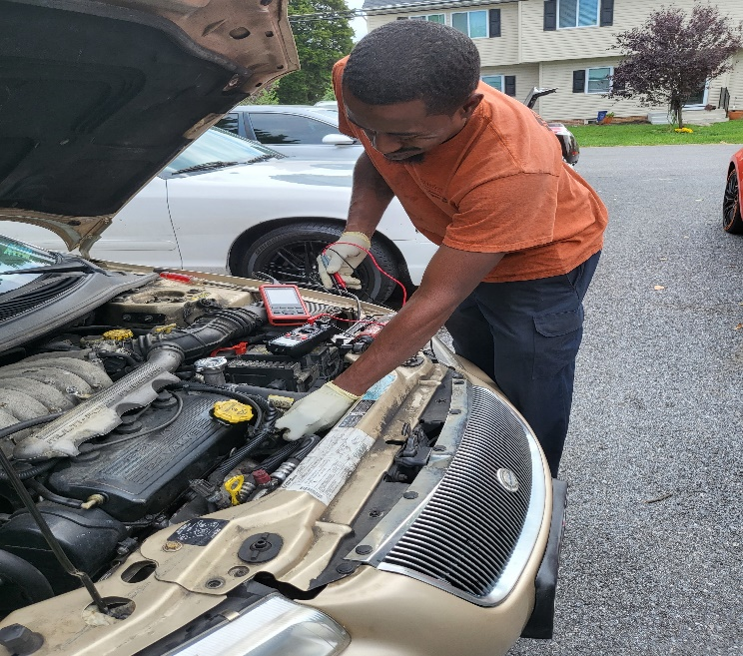
The first interview was Brian Brown who is a mechanic. He works at a shop and has a side hustle utilizing the knowledge he has gained from his primary job. He works on people’s cars at his home or at theirs outside his regular work hours. Brian has been a mechanic for nine years. He entered the field by going to school to become a diesel mechanic and working odd jobs. He ended up working on cars instead of diesel trucks. He never worked on a single diesel truck. His side business developed out of a desire for extra money and knowing people who needed work done and wanting to help. He often thinks about making his side business his sole source of income but isn’t ready to take that step. He thinks making it a mobile business may be the best option instead of having the overhead of a shop, additionally to have the convenience for the customers of not having to go to a shop.
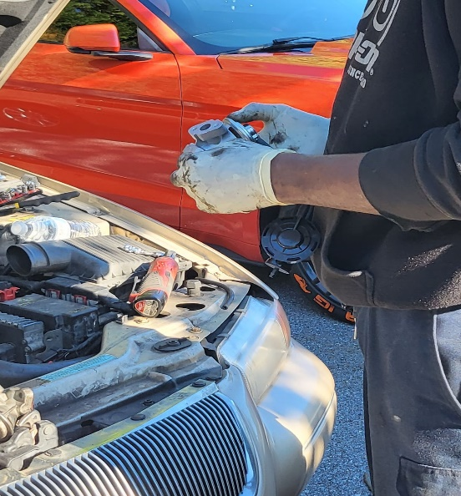
I was able to observe and record clips of Brain doing a diagnostic and a repair job on a 1998 Chrysler Cirrus. During the diagnostic he determined the EGR valve needed to be replaced. After the diagnostic, the part was ordered, and he scheduled the repair. The repair was somewhat of an ordeal as the first few times it was scheduled it had to be rescheduled due to various reasons. The first time he dropped a socket down into the engine and it was getting dark so he couldn’t see to find it. The second time, contrary to the weather forecast, it began to thunderstorm, so the repairs had to be put on hold again being that the work was being performed in an outdoor space. The third time was a charm, he was able to complete the repair and got the vehicle running.

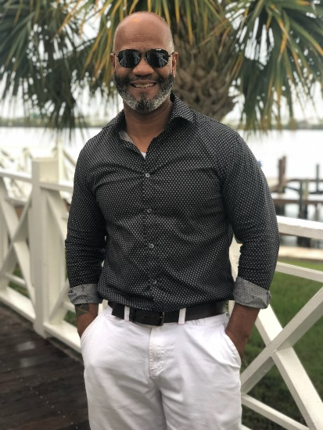
I then interviewed Arthur Williams who is a former colleague of mine and has initiated several business ventures. The most recent two businesses being a mental health and wellness facility and an online T-shirt business. Illusionary Space, the mental health and wellness clinic, was opened just prior to Covid. Itguso was his online clothing company. I was his first customer at Itguso purchasing a “power to the people” shirt advocating for racial equality. His website was creatively adorned with Jamaican colors and the story of the term “itguso” and its Patois origins. I was saddened to see that it failed. He was unfortunately one of the entrepreneurs who was unable to sustain themselves during the fiscal devastation of Covid. During his interview he pointed out his experience with racial disparities in the funding provided to assist business owners through the Covid business relief funds. Arthur made a comment about entrepreneurship running in families as it is a learned behavior. This happened to be a perfect transition for my next two interviews.
My following two interviews happened to be brothers, tying in with Arthur’s commentary of the family lineage of entrepreneurship. Antonio and Michael Willies are brothers from West Baltimore. Tony has a side hustle auto detailing business and does moving and hauling with his roommate. His brother Mike has two full blown businesses that are his sole focus. He not only has an auto detailing company, Meticulous Auto Reconditioning but also a vehicle acquisition business, www.motors.com. Mike employs three community members through his businesses.
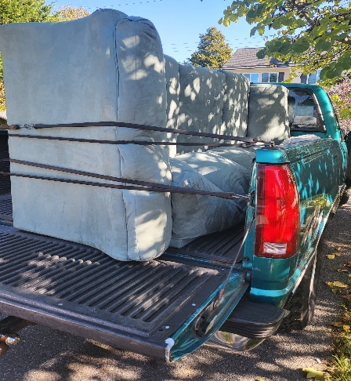
Antonio “Tony” Willies handled his automotive detailing and car washing at first outside his mother’s home then expanded to being more mobile. He also does moving and hauling jobs that are essentially based on the customer needs. He has been doing both types of jobs for approximately ten years. He started doing this type of work because of his love of cars and the need for extra money. His jobs range from whole house moves to running junk to the dump. I was able to accompany Tony on a moving and hauling run when he transferred a sofa from one residence to another. He uses an old four-wheel drive 1995 Chevy 1500 pickup truck that belongs to his roommate and some heavy-duty straps. He said that if needed they rent trucks for larger jobs like whole house moves or storage units. Last month they had done a whole house move and a storage unit into another home. They do moving jobs all over Baltimore and Maryland. That particular job was going from a home in Baltimore County to another in Carroll County. All their business comes from referrals.
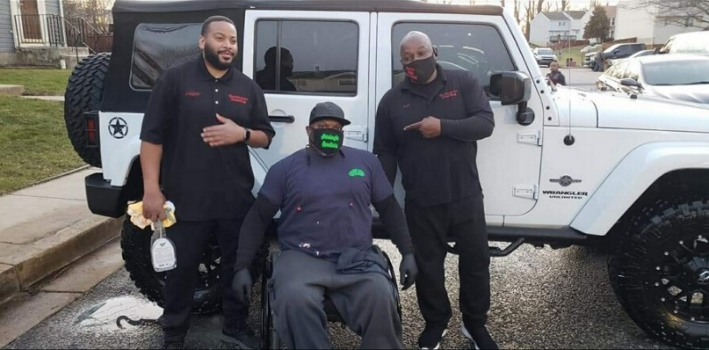
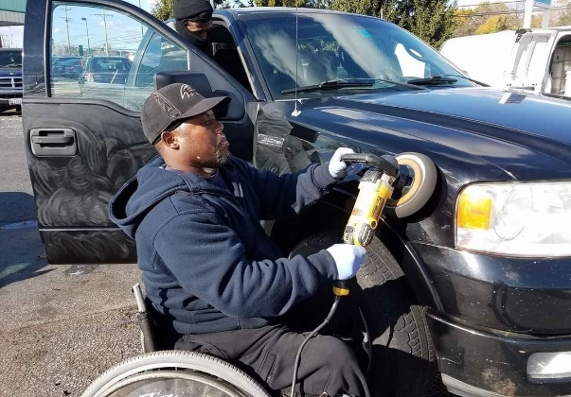
Michael “Mike” Willies had run some side businesses before while working full time jobs. In 2003 while working at a law firm in D.C. he decided to take the plunge and become a full-time independent business owner relying solely on his business to support himself. He and his partner started www.motors a vehicle acquisition company. The premise of this business is for Mike to go to vehicle auctions across all fifty states bidding on vehicles and then flipping these vehicles for resale. Often, he sells them on car lots of his associates. Mike has also developed his second business, Meticulous Auto Reconditioning. He has three employees from the community. This business is an automotive detailing company. Mike, who uses a wheelchair, does not allow being differently abled limit his participation in the businesses; he does not see the wheelchair as a disability, just a physical challenge that will not stop him from doing anything. With that outlook he not only runs the two companies but works alongside his employees.
Arthur and Tony had some significant experiences with racism that have impacted them. Mike however, when asked about discrimination, immediately responded in relation to his physical challenges, being in a wheelchair. Mike is a strong person with an exceptionally positive outlook and doesn’t allow for that barrier to stop him from doing anything. Other people make assumptions about his limitations or abilities based off his physical appearance. This accentuates the importance of the resiliency of the community despite negative experiences. None of the people I interviewed exhibited any indication of being defeated. Arthur has unfortunately lost his businesses due the timing, economic forces, and state of our country; he has faced unthinkable discrimination, yet he holds a hope for a future of moving forward as a unified country, and never discounts the possibility of what could be. Both Arthur and Mike show defining characteristics of unbreakable spirit defining that resiliency that is so important and in the world of business certainly makes identifiable leaders.
Everyone I interviewed thought access to capital was the most important resource that was lacking, followed by education and training. Brian was very clear that his biggest barrier was the cost of equipment. Specifically, his tools, as well as replacement if something happens to them, like recently when his van was stolen with his tools in them. His tools cost hundreds to thousands of dollars for each piece and become increasingly more expensive for specialty tools. I can only extrapolate that this dilemma is similar for other mechanical businesses that require trade equipment.
Brian discussed the need for assistance with hiring and training in areas he was unfamiliar with including employees like a service advisor and someone to keep the books and appointments. Tony also stated that if he were going to expand, he would need staff as well including assistance with payroll. He pointed out that often it is better to keep a side hustle just as that instead of leaving your main employment to keep health insurance. Both insurance for personal use and the cost of insurance for the business came out as things that seemed overwhelming to him where having professional assistance would be beneficial. He discussed the need for advisement when making decisions about legal matters as well like determining what type of business to register as.
I found it very intriguing when the discussion in Arthur’s interview addressed supporting black-owned businesses and putting money back into the community. He brought in an important point that would otherwise not have been addressed. In many of the scholarly readings the contention is that if you filter the money back into the community, instead of purchasing outside of the community, there is enough money to self-sustain. The important point he raised is that when someone is on a stringent budget and supporting a family, they must shop where they can stretch their money. Minority owned businesses are usually unable to price items at the discount rates of large conglomerate stores because they cannot afford the price cuts and cannot purchase at the large quantity discounts like the conglomerates can. His point, which was totally legitimate, was that for a family unit to sustain themselves, it is more feasible to shop at the large chain stores that tend to slash prices. `
Mentorship was touched on in some interviews. Arthur thought it was something that could be beneficial depending on how it was implemented. He mentioned that he would wonder what the mentor would be getting out of providing the mentorship; This made me think of a reciprocation model- if they had received the mentorship entering the program, so they in turn were obligated to provide it upon successful completion of the program, like a contractual agreement. He mentioned that the mentor would have to be matched based on their business knowledge. He certainly pointed out that the mentor should be doing this willingly.
Education was another area discussed among all the interviewees. Brian discussed a free business class through CCBC held on zoom during Covid. In Brian’s interview, we also discussed training for things such as doing payroll and taxes. Tony mentioned that he thought there were classes for business education but wasn’t certain what was available currently. Arthur recommended classes online, on YouTube, business school, and researching similar businesses to be as prepared as possible before launching a business.
Throughout all the interviews it was very clear that there were three areas that evidently need to be addressed in the community.
- Access to capital (Issue #1)
- Access to or knowledge of educational/training resources (Issue #2)
- Having connections within the community (Issue #3)
To address these concerns a community resource center outlined in the business plan below (solutions indicated by issue number) will assist in pooling these resources in a “one stop shop”. Where there are existing resources in Baltimore for entrepreneurs to have the resources easily accessible in one location with assistance would provide a great benefit especially to those who need guidance and have time constraints due to their need to work other jobs while trying to launch their business into a lucrative enough financial source to support themselves. The sheer time it takes to locate grants, loans, training offerings and so forth in exorbitant. During my research, I was able to locate scattered information that took a considerable amount of time, and it is worth noting that I am familiar with the research process. For someone who is a novice this would be overwhelming at best. Still other resources I continue to hear about that I was unable to locate. The singular most notable aspect of the resource center that will set it aside from others is the peer mentoring network. Connections within the community is the singular thing that was made very clear that will make or break you as an entrepreneur (and as a researcher!). Becoming part of a network and a community that will provide you with mentorship, referrals, and localize the business within the community making the community self-reliant, sustainable, and strengthened is the one aspect that is ultimately different. It is a community within a community.

Company Overview
- Company summary: Main Hustle will help you take your side hustle and make it your main hustle. Offering mentorship with business professionals and all the resources you need to take your dream to the next level.
- Mission statement: “Leading the way in strengthening the partnership among leaders of color while improving small business development. Supporting economic development by organizing and providing resources and supports throughout our community while valuing and honoring cultural traditions.”
- Markets and services: To provide the Baltimore community with an outreach center that offers networking and access to resources for individuals of color who own side businesses, who are in the process of developing and growing a business or are looking at starting a business from the ground up in the Baltimore community to stimulate and revitalize the community through financial wellness. We provide outreach to assist in forging strong business affiliations, expanding community wellness, accessing assistance, resolving problems with or barriers to companies seeking to do business with city agencies.
Services offered will include:
  - Entrepreneurship training
  - Business plan development
  - Coaching/mentorship
  - Payroll training
  - Social media networking training
  - Liaison supports for financial needs such as grants, microfinance, and loans
  - Financial advisement and financial management
  - Referrals for legal needs
  - Forums
  - Seminars
  - Annual events
- The operating structure will be a 501(3)c NPO. There will be a board of directors that will start with three board members initially and expand as needed. The three members will be the president, secretary, and treasurer. There are several types of work groups employed by a board of directors to preform tasks. To incorporate the members of the organization, this board will utilize task forces. Task forces are typically formed of experts in a particular area or subject related to the task at hand. With the array of business owners that should be invested in the network of community members the organization should have a wealth of experts as resources. This in turn will also have members more invested into the agency due to their own involvement in the functions of the organization.
  - President: The president is the leader of the board. This board member typically oversees key activities like signing contracts and hiring or firing employees. This role differs from the CEO/executive director position, which the board typically hires after assigning the president role. This person should have extensive leadership experience. They would preferably have a background in the non-profit sector. This person would demonstrate characteristics consistent with humility, integrity, and present with ethical conduct. They would preferably have an education (in business or similar) and experience in business development, as well as ties to the local community.
  - Secretary: The secretary organizes the board meetings. This would encompass scheduling and coordinating the meetings, planning the meeting agendas, and recording meeting minutes. This person should have a background in non-profits, strong oral and written communicative skills, the ability to prioritize, as well as have computer literacy skills.

  - Treasurer: The treasurer evaluates and reports on the financial health of the organization by keeping track of receipts and spending. This person would preferably have an educational and employment background in accounting/finance. The treasurer should have passed the CPA exam. This person should have exceptional computer literacy and organizational skills. This person should be detail oriented and capable of handling large sums of money.

The organization will consist of a CEO, Program Director, HR Director, three staff and utilize volunteers. Upon expansion and success further staff can be evaluated.

Business Description
Small businesses and the entrepreneurs that drive them have been wealth builders for generations in our communities. By supporting and growing black-owned businesses, you can help create opportunities for community development, property ownership, credit building, and generational wealth for black communities. Supporting small businesses assists communities in keeping their wealth within the community and localizing their economic control. If everyone does their part in supporting local black businesses, in turn it will strengthen many black communities. Supporting black businesses shouldn’t be a trend. This should be a normal way of life. Supporting entrepreneurs in our local communities builds our communities, relationships, and bolsters community morale. Showing your support helps contribute to creating entrepreneurial opportunities. Entrepreneurship can nourish the black community's economic prosperity and serve as a transition where low-income families can move up to middle-class status. The persistent racial wealth gap in the United States is a burden, or “tax” on Black Americans as well as the overall economy. It can be traced back prior to Jim Crow laws and redlining that prevented black people from accessing jobs and homeownership opportunities.
- Opportunity: Due to the racial tensions that have surged over events of the past few years there has been a focus on supporting black-owned business. Coupled with the opportunity presented by the open market created by the Covid-19 pandemic it appears to be an opportune time for black-owned businesses to flourish. With that a resource center would be right on time to provide the much-needed support for the visionaries behind these ventures. We are quite literally forging a new economy and a new normal after our world came to a screeching halt in March of 2020. We are slowly reacclimating to our new societal norms, presenting a prime opportunity for the ambitious to leverage the market.
- Product overview:
  - Entrepreneurship training: You will learn how to develop skills in leadership, communication, decision-making, teamwork, and the ability to prioritize. You will study the characteristics of successful entrepreneurs and learn the differences between classifications of business entities (Sole Proprietorship, LLC, LP, Inc, etc...) Once you have learned the ins and outs of entrepreneurship you will be on your way to success. Addresses (Issue #2)
  - Business plan development: You will learn how to create a business plan, including what material to include and how to develop a compelling presentation that will engage funders. You will be provided with template options and assistance throughout the process. Addresses (issue #2)
  - Coaching/mentorship: As part of entering the program you will agree that you will become a mentor. After five years in business, as a veteran, you will commit mentorship services to one budding entrepreneur every five years. In turn when you enter the program you will be matched with a veteran entrepreneur for mentorship services. Addresses (Issue #3)
  - Payroll training: Access to classes and study assistance for mastery of payroll operations and compliance. Options to earn one of the two payroll certifications the American Payroll Association (APA) offers. The Fundamental Payroll Certification (FPC) signifies a basic knowledge of payroll, and the Certified Payroll Professional (CPP) certification is a mastery level course. Addresses (Issue #2)
  - Social media networking training: This training gives you an overview of social media marketing, from why it benefits your business and how to define a target audience, to the steps needed to create a social media strategy and measure your success. Training includes publishing on social media, interacting with customers, selling on social media, and innovating with social media. Addresses (Issue #2)
  - Liaison supports for financial needs such as grants and loans: all the resources you need in one spot. Listings of available grants and loans. Assistance with reviewing written grant proposals, and loan applications. Addresses (Issue #1)
  - Financial advisement: Maximize the capital that goes into starting and running your business. Ensure you have considered all the overhead costs and thought of unexpected expenses. Make sure you are prepared to weather the storm. Addresses (Issue #1)
  - Referrals for legal needs: You will have access to our pre-approved listing of experienced professionals suited to meet the needs of your situation. Addresses (Issue #3)
  - Forums: Specialized forums available. Addresses (Issue #3)
  - Seminars: expert advice and training. Addresses (Issue #2)
  - Annual events: annual networking and learning opportunities. Addresses (Issue #3)
  - Miscellaneous services: assorted services such as assistance with low cost operating supplies, hiring assistance, employee training, and connecting small business owners in the community with each other to keep the supply chain local. Addresses (Issue #1, #2, & #3)
- Key participants: Our most important partners are our community members, the small business owners who will be working in tandem to make this system work. Additionally, we will rely on the Chamber of Commerce, Small Business Association, local banks, private foundations, and government entities.
- Funding: The proposed funding for this endeavor would be a nonprofit funding model deriving operating expenses at approximately 50% from grants, 30% through events and fundraising efforts, 15% through membership fees, and 5% through in-kind donations. Minimal membership fees would be charged for businesses who have joined the program to assist them in becoming established included in membership they be linked as networking members (assisting with providing customer base).

Market Analysis
- Industry type: Non-Profit Organization Management. To stimulate the local economy in the Baltimore area and striving for equality and equity by investing in the growth and development of local black-owned businesses. Providing access to resources to turn creativity and ingenuity into an opportunity for achievement.
- Market segmentation: Individuals of color who own side businesses, who are in the process of developing and growing a business or are looking at starting a business from the ground up in the Baltimore community to stimulate and revitalize the community through financial wellness.
- Competition: There is no specific organization in Baltimore that only supports business owners of color in the same manner as Main Hustle. The Minority and Women's Business Opportunity Office (MWBOO) that is part of the government, is responsible for the Certification of Minority Business Enterprises and Women's Business Enterprises, maintaining a directory of certified business enterprises, investigating alleged violations of Article 5, Subtitle 28, certifying compliance with Article 5, Subtitle 28 of the City code before contracts are submitted to the Board of Estimates for award, setting MBE and WBE participation goals on contracts, and establishing certain annual goals for MBE and WBE participation. Main Hustle would be working in conjunction with this office as a liaison to assist with the “red tape” of these processes.

- SWOT analysis:

STRENGTHS  - Low competition  - Low operating costs  - Limited staffing needs at startup  - Can utilize volunteers |  | WEAKNESSES  - Lack of industry contacts  - No base for mentorship program (will take time to build)
OPPORTUNITIES  - Can build mentorship through participation  - Economic development, social justice and cultural stewardship  - Post pandemic economy |  | THREATS  - Having a stable base of resources  - No guarantee of having a pool of volunteers

Operating Plan
Main Hustle cultivates and supports the growth and development of small businesses and entrepreneurs of color in the Baltimore area through pooling resources, technical assistance, training, counseling, workshops, and mentorship.
Once signing on with Main Hustle you become part of our member database and get assistance registering with the small business association and/or as a minority owned business. You will be connected to a mentor who has some experience that is matched to your needs. After establishing your business and being a member on your second year you will be responsible for an annual membership fee of $25 that year and every year after. First year membership fees are waived. You will also become a mentor in our network of mentors. As part of our network, you will be linked with other businesses who need your business expertise and likewise you will be networked with other businesses whose supplies or services you may need. This allows us to keep our hard-earned money in our community. As our members grow, our community strengthens and becomes more financially stable.
- Payment: membership dues are to be paid on your anniversary date of sign up on your second year and every year thereafter. First year membership fees are waived.
- Donations: anytime throughout the year donations to our cause are accepted to reinforce and strengthen our programming.
- Facilities: The business will be in a leased office space. TBD.

Marketing and Sales Plan
Promoting the business, whether through generating leads or traffic to a website or store, is one of the most important functions of any business. In this section of the plan, provide details of intended marketing of the business. Describe the key messages and channels used for generating leads and promoting the business. This section should also describe any sales strategy. Depending on the type of business, the following sections may or may not be necessary. Only include what is needed and remove everything else.
- Key messages: To build a better Baltimore, strengthen communities, close the wealth gap. To dismantle institutional and structural racism by changing the narrative through revitalization in the community and financial wellness. Forging strong business affiliations, expanding community wellness, and helping to build family legacies.
- Marketing activities:
  - Media Advertising (newspaper, magazine, radio)
  - Seminars & Business conferences
  - Word of mouth
  - Joint advertisement with partners
  - Digital marketing such as social media
  - Community events
- Sales strategy: Main Hustle will rely heavily on word of mouth, referrals, and networking.

Main Hustle Start-up Budget
COST ITEMS | COST/ MONTH | Start up cost | total first month
Advertising/Marketing | $500 | $2,000 | $2,500
Employee Salaries* | $20,400 | 0 | $20,400
Employee Payroll Taxes and Benefits | $7202 |  | $7202
Rent/Lease Payments/Utilities | $1500 | $3000 | $4,500
Communication/Telephone | $300 | $400 | $700
Computer Equipment | $0 | $1,500 | $1,500
Computer Software | $0 | $300 | $300
Insurance | $50 | $50 | $100
Interest Expense | $70 | $0 | $70
Bank Service Charges | $0 | $0 | $0
Supplies | $100 | $200 | $300
Equipment | $0 | $2,500 | $2,500
Furniture & Fixtures | $0 | $2,500 | $2,500
Business Licenses/Permits/Fees | $0 | $5,000 | $5,000
Professional Services - Legal, Accounting | $0 | $1,500 | $1,500
Cash-On-Hand (Working Capital) | $0 | $1,000 | $1,000
Miscellaneous | $0 | $2,000 | $2,000
ESTIMATED START-UP BUDGET | $30122 | $21950 | $52072

Reflection
I had always been determined that no matter what stood in my path, I would obtain the highest level of degree possible. I was driven towards achievement. At a young age, of course, you never imagine the things you will experience along the way. With each milestone, and degree along the way there were significant barriers that challenged my conviction and fortitude to this path as well as many other aspects in life. During the acquisition of my associate degree, I faced the change of my world through divorce and having to redefine myself. During the acquisition of my bachelor’s, I once again faced my world being overturned with the diagnosis of chronic illness. Now, with the master’s program, I have endured the entire world changing through Covid, the loss of so many loved ones, a significant increase in my child’s health needs, and a promotion at work that significantly consumed my attention and increased my responsibilities. I really didn’t think I was going to make it this time. I saw others fall out towards the end who I thought were way more put together than I was and really questioned “can I do this?”
The entire time I was moving through my coursework I had a plan of what I wanted to do for my capstone. I was going to draw up a program for children who live in food apartheids in Baltimore, something that certainly is meaningful to me. I was very passionate about it. Then the unthinkable happened. Our family friend, Rick, was murdered. He was the person who I could sit and have drinks with and talk about school. He had loved my capstone idea and wanted to participate in it. This loss was very impactful to my friends and family. This was the summer before I was due to start capstone. How was I supposed to regroup that late in the process? I just couldn’t stay on the same track without him.
I ended up in field lab that fall and tried something different for that class because I was frankly ticked all the way off by what was going on in the world around me. Every day I was getting new videos sent to my phone, another incident of racial injustice. I was terrified if I didn’t hear from my boyfriend at night for fear that he may have become subjected to all the sickening violence going on all around us. So many people I knew had experiences. I kept thinking back to Rick. He was a black business owner; he was shot leaving a job to go home. I decided to look at the development of minority businesses and its relation to structural and institutional racism. I knew he would have liked that, and I feel that this honors his memory. I was able to talk to the program director who was able to talk me through it a bit and get my thoughts organized for me to get it into a logical flow to become an actual topic for my capstone.
When the capstone implementation began, I was completely energized. After close to eighteen months of Covid, I was ready to move forward. I totally immersed myself in research for my literature review and researched black owned businesses in Baltimore. I found many applicable businesses and reached out. I was enthusiastic and thought I was on the right track. That enthusiasm slowly started to waiver as I reached out to business after business and realized no one was going to answer me. My advisor helped me to revise my wording on my email and I reached back out. I received one, just one, response and that person stopped following up after the second contact. I came to the realization that you really need to have connections to get interviews. I received a call one night from a family member. They told me about a scam they received. As they described the scheme, I realized that there are so many scammers out there and such elaborate schemes, that people are too apprehensive and that they most likely won’t respond to me reaching out for an interview. They probably think that it’s something fishy. My advisor introduced me to a person who works with businesses, and she reached out to her connections but that was not lucrative either.
I switched gears after meeting with my committee and reached out to a friend who was a previous business owner who agreed to an interview about his experiences. Then I sat with my partner and discussed what I needed, and he came up with the connections for my other interviews. Now, I was gaining momentum again! After the interviews were completed, I transcribed them. I do have to admit the one interview that was an hour was arduous. I do prefer the fifteen-to-twenty-minute ones. The release forms for these interviews were then added into the appendix section. I revisited what was already written and I was comfortable with the background and literature review with only making a few edits after working on the remainder of the paper, so I decided to circle back around to it. Per advisement, I needed to add a paragraph to the methodology section, which I did and a chapter to analyze the ethnographic data. I added the header and started the reflection paper. I decided I would jump back and forth between the two sections as the writing came to me.
I can at least say I have learned through this process that as the winds change, I need to adjust my sails and keep going. I think that all things considered I have persevered and done so despite the barriers that have been put in place.
After all my interviews had to be completed, just a few days before this was all due to be turned in, I had taken my son to a doctor’s appointment. At the appointment the nurse struck up a conversation with us which started by discussing my son’s artwork. She started to tell me about her son’s art and the business he started. Our conversation progressed and by the end, I had told her about my capstone. She told me about her wine business, she is “The Wine Diva” and about her boyfriend’s business. He has a steel mill and is now working on assisting others with resources. All I could say is why couldn’t we have met last month! She referred me to watch a movie called Uncorked on Netflix which I did, and it was really good. That entire experience again brought me back to Arthur’s comment about how entrepreneurship runs in families. I started to think about how my family and our circle of friends all have hustles, in one fashion or another, regardless of if it is current or past and realized that there are people who carry a type of mindset who tend to collaborate with each other because they are like minded and yes, we do tend to pass that on to our children as a learned behavior. We pass on the work ethic and the ambition, the desire to achieve. Now even though I unfortunately didn’t meet her early enough to add her into my capstone, I did get her very excited about the MACS program, we exchanged information and she may be looking into the program, so not a total loss!
To be totally honest with myself I enjoyed writing the literature review and doing research. I am just a pencil pusher by nature, I always have been. The difficulty for me came with the interviews. I don’t mind transcribing them either. I am just more of a researcher and writer than I am a conversationalist. Even this part eludes me as I am not much for putting the personal in, so to reflect is challenging. I am much better at factual writing. I attribute a good deal of this to my undergraduate education being in areas of science and not art. There were firm rules in writing not to include the first-person perspective at all. There could not be any interjection of personal option. All data had to be cross referenced from multiple sources and the credibility of the source had criteria to meet. It was drilled into my head. Even now as I write this, I am automatically thinking of how unnatural it is to express my own thoughts and not someone else’s which came from an applied science and a psychology degree. That’s truly ironic, if you think about it, that you are not condoned to unpack your own thoughts and feelings in psychology. What’s even more strange is that I never would have thought that was strange until after this coursework. Maybe a bit of deprogramming, but I digress. The point before my side tangent was that I am fascinated by the research, driven by the purpose, have passion for people; but I am simply not good at thinking on the fly. I tend to miss moments. When I am in conversation whether it is a structured interview or a conversation that naturally developed, I am one of those people who about three hours later is cursing myself because at that point I think of what I should have said or asked. No matter how many follow ups or interactions I have, it is always the same. Part of this is attributed to cognitive impairment from my health issues. I just tend to take time to process and do better when I can articulate on paper and pontificate. Suffice it to say it impacts my abilities and I am just not the best at interviews. I am just fine in social situations, my memory is terrible, but my finer skill is in the research and the writing.
In the end the process from start to finish of the MACS program was incredibly challenging and fulfilling. The capstone process was substantially stressful but all worth it. I do at this point think that creating a resource center is a worthwhile venture and something that would be significantly beneficial for the community. I think that I may not necessarily be the proper face for such an organization because of my status as an outsider but I certainly would love to be a part of it.

Appendices
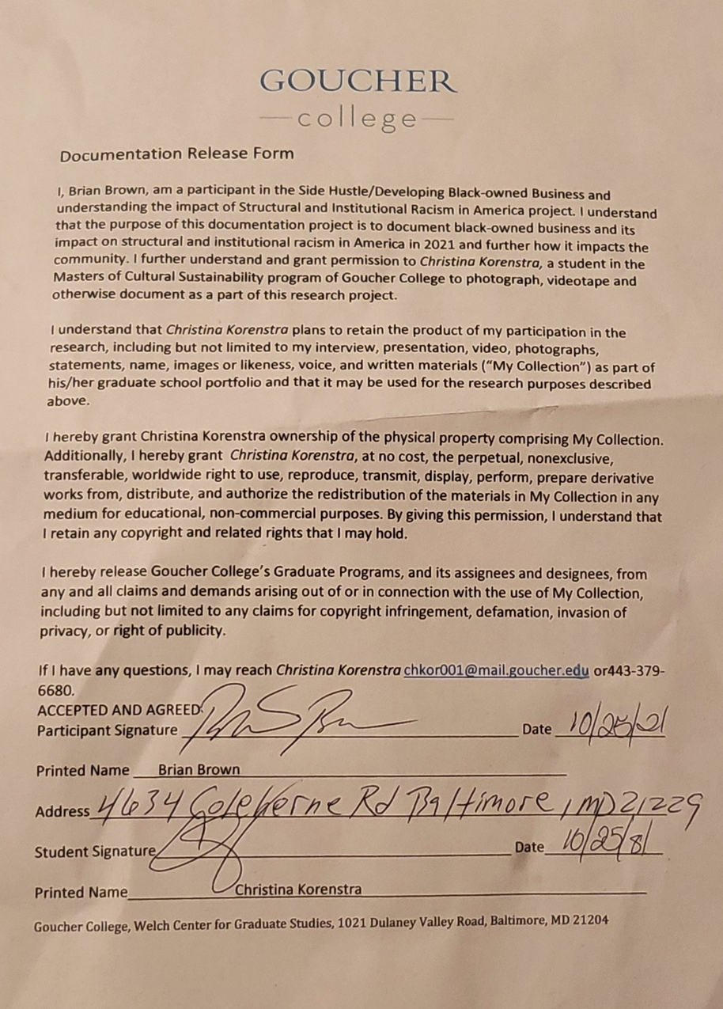
Release Form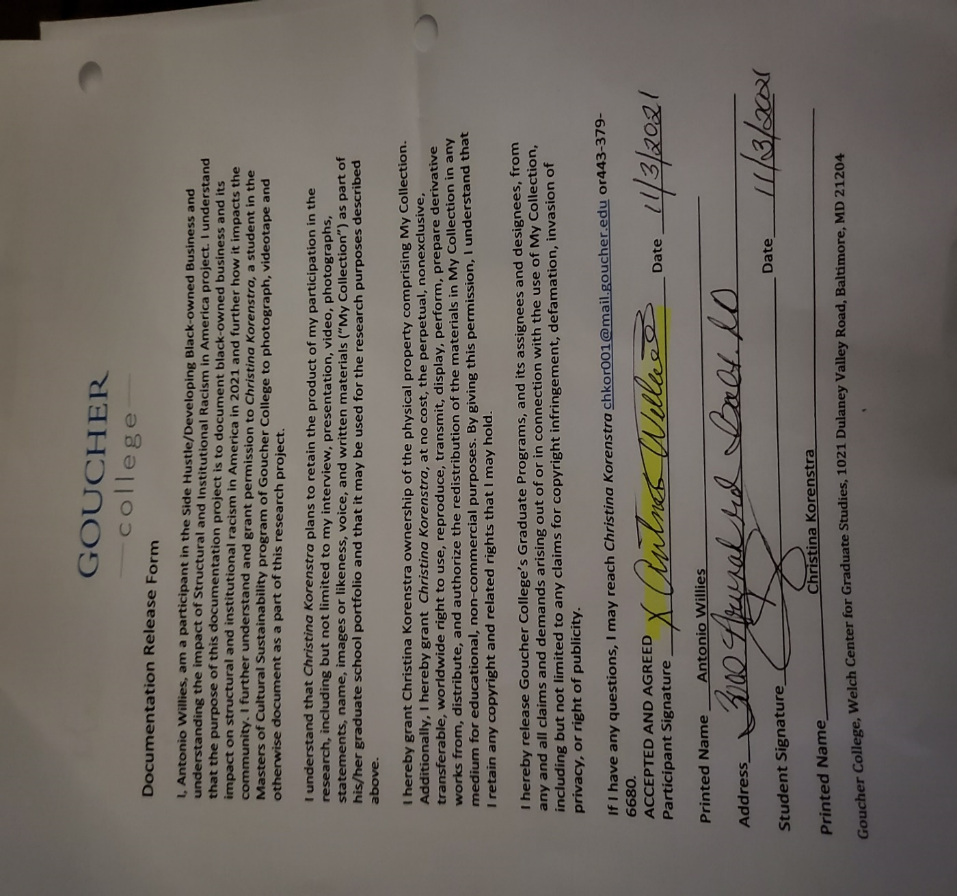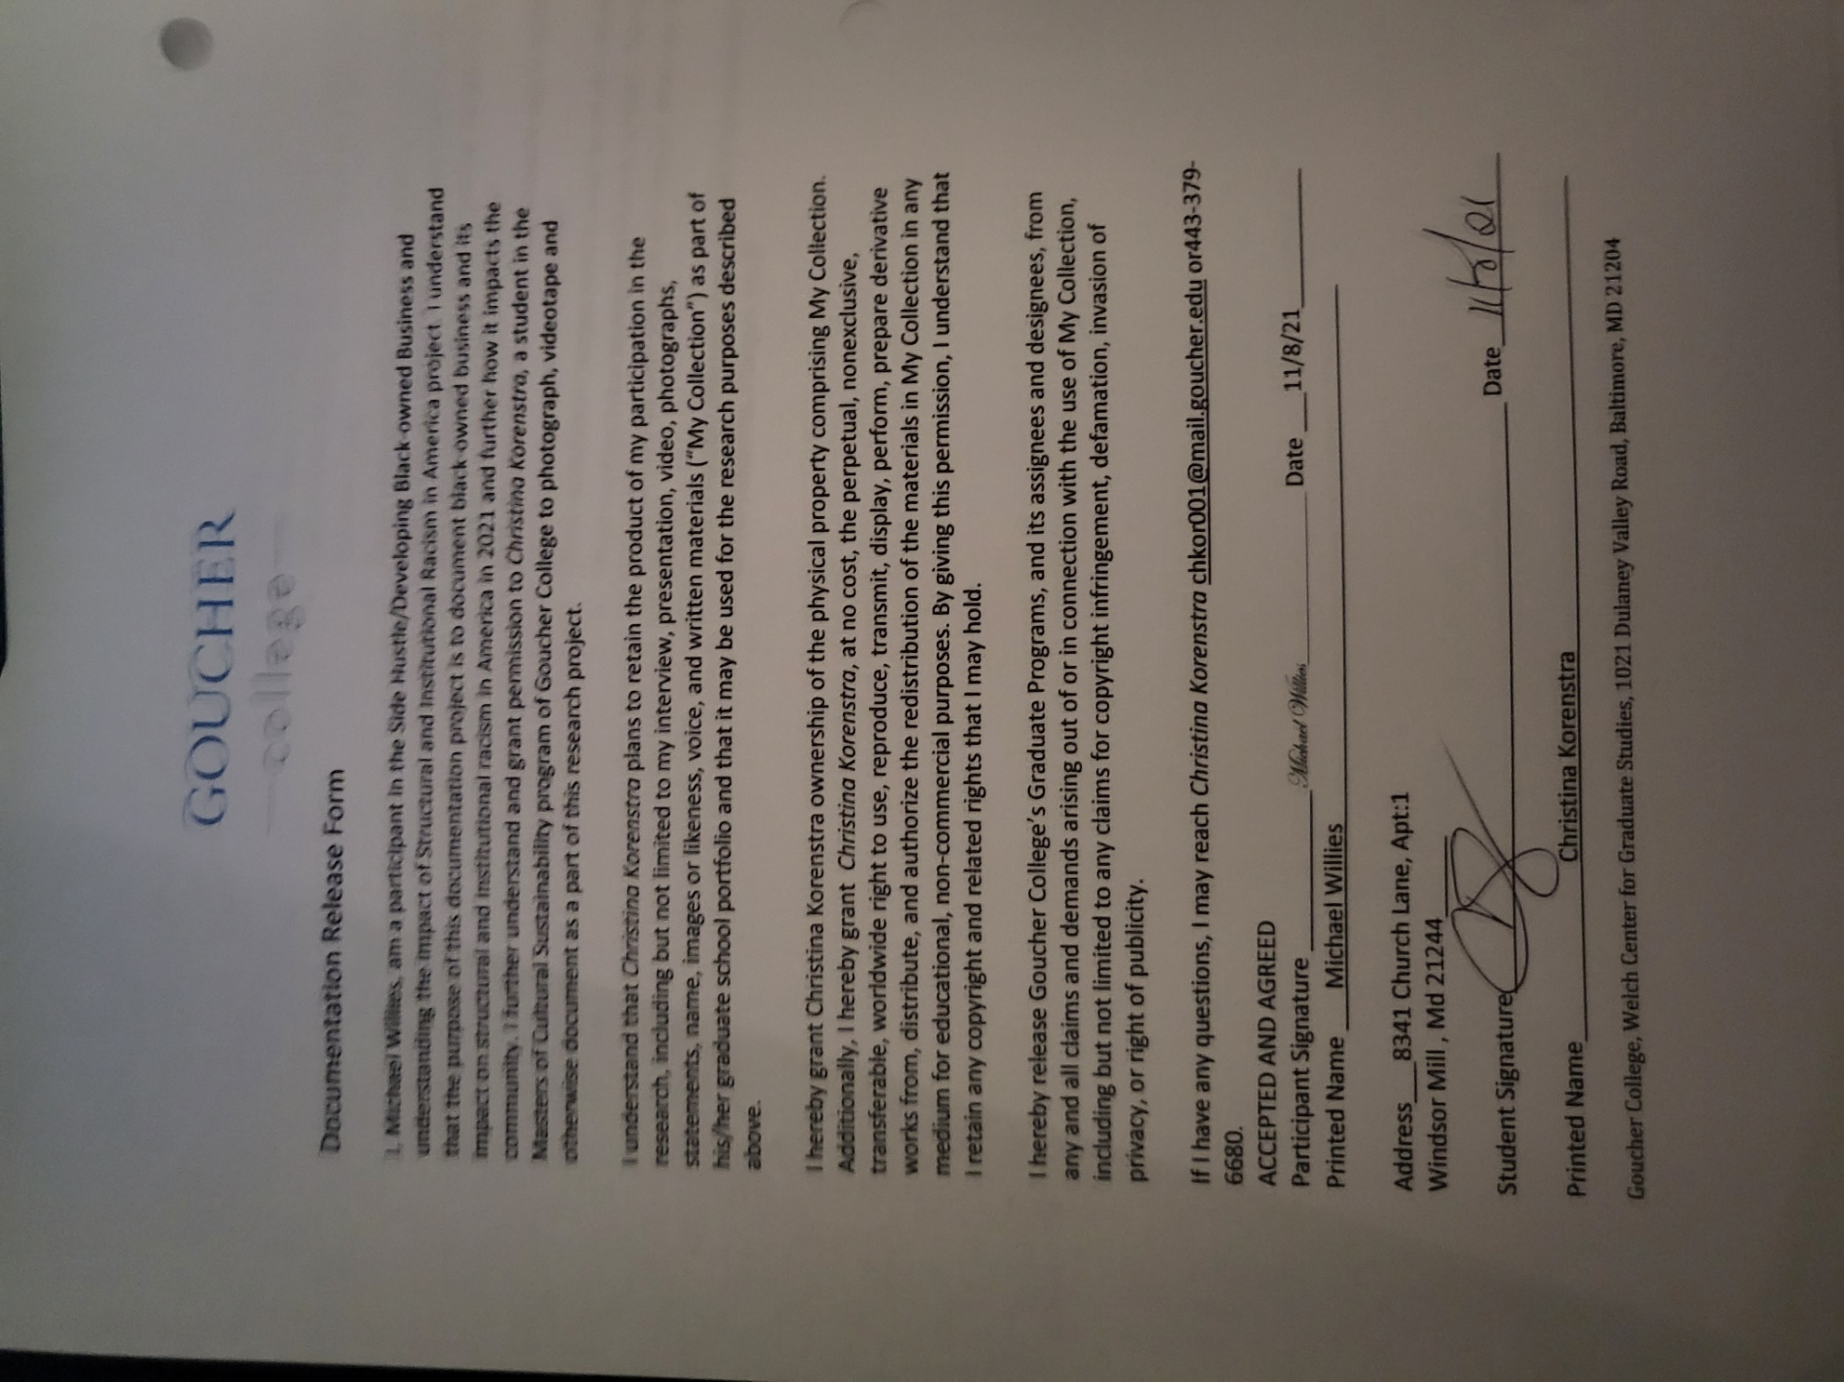

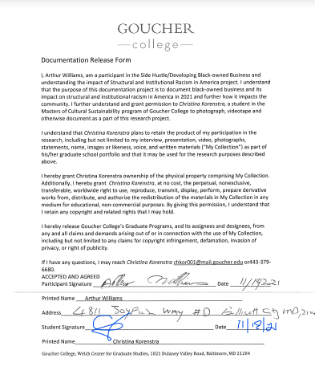

Video Log Worksheet

Researcher: Christina Korenstra Project Name: Side Hustle-Main Hustle
Date Logged: 11/18/2021

File Name: 2021.CMK.013

Format:
Format: MiniDV DVCAM MiniDVD DVD Digital File Other:
Digital file type: MPEG-2 MPEG-4 DV WMV MOV
x Other: MP-4
Digital file location:
Running Time: Hour(s): Minutes: 13 Seconds: 08

Date Recorded (YYYY-MM-DD): 10/28/2021 Location: zoom

Interviewee/Event: Brian Brown

Interviewer(s): Christina Korenstra

Subject: Black owned business
Copyright Owner: Christina Korenstra Restricted? X No, Yes, details:
Summary: Interview with Black business owner.
Key words, names, & places: Brian Brown, Automotive, mechanic, black owned business
Video Log (Page 1 of 2 )
Tape/Disk of
File Name: 2021.CMK.013
File of

TIME CODE CONTENT DESCRIPTION
(HH:MM:SS)
:54 Interviewer greeted interviewee.
:56 Working on technical difficulties.
1:21 Interviewee confirmed that the session was being recorded. Interviewee consented.
1:41 Interviewer asked interviewee to introduce himself.
1:47 Interviewee introduces himself.
1:52 Interviewer prompted interviewee to discuss his business.
1:54 Interviewee stated that he is an auto mechanic of nine years.
2:04 Interviewer asked what prompted him to pursue that type of work.
2:11 Interviewee discussed his history of entering the car industry.
2:39 Interviewer asked how he decided to branch off to do side work.
2:48 Interviewee discussed the financial benefit and personal satisfaction of the work.
3:06 Interviewer asked about making the side hustle his main hustle.
3:14 Interviewee discussed how it is something he thinks of often but discussed the implications and challenges.
3:48 Interviewer asked what type of resources he felt he would need.
3:55 Interviewee discussed resources such as equipment and funding.
4:20 Interviewer asked about the tools and expenses associated.
4:35 Interviewee stated that he purchased his own tools. He puts money he makes back into it.
4:52 Interviewer asked if there was anything available to him when he first started.
4:58 Interviewee talked about trade school and a tool allowance as well as tool trucks that allow payments.
5:40 Interviewer asked if mechanics supply their own tools working in shops.
5:43 Interviewee confirmed that mechanics supply their own tools in most circumstances.
5:58 Interviewer asked if funding was the most important area of assistance.
6:08 Interviewee confirmed that funding was primary but also hiring assistance.
6:35 Interviewer asked about trainings like payroll.
6:42 Interviewee confirmed that would be beneficial. He discussed a free entrepreneur class he took through CCBC on zoom.
7:26 interviewer asked what advisement he would provide to other entrepreneurs getting started.
Video Log (Page 2 of 2 )

Tape/Disk of
File Name: 2021.CMK.013
File of

TIME CODE CONTENT DESCRIPTION
(HH:MM:SS)
7:45 Interviewee said they need dedication and enjoy what you are doing.
8:21 Interviewer asked what challenges he has faced.
8:28 Interviewee stated getting the correct pay is sometimes a challenge. Getting certified to get paid well, working your way up.
9:03 Interviewer asked about ongoing education.
9:10 Interviewee discussed training and lack thereof. He talked about learning to “wing it”.
9:45 Interviewer asked about ongoing education if he were to make his side hustle full time.
9:51 Interviewee confirmed that is important.
10:24 Interviewer asked about barriers and racism.
10:29 Interviewee said he has not experienced racial issues.
10:47 Interviewer asked about differences since the onset of COVID.
10:57 Interviewee discussed the changes including the decrease in business then increase.
11:41 Interviewer asked about side job and if it has been steady.
11:48 Interviewee discussed that his workload is truly dependent on his motivation.
12:05 Interviewer asked about customer base and how he obtains ore customers.
12:11 Interviewee confirmed word of mouth and referrals from family and friends.
12:29 Interviewer asked if he had anything he wanted to add.
12:35 Interviewee discussed that it is a good field to get into.
13:08 Interview concluded.

Video Log Worksheet
Researcher: Christina Korenstra Project Name: Side Hustle-Main Hustle
Date Logged: 11/18/2021
File Name: 2021.CMK.016

Format:
Format: MiniDV DVCAM MiniDVD DVD Digital File Other:
Digital file type: MPEG-2 MPEG-4 DV WMV MOV
x Other: MP-4
Digital file location:

Running Time: Hour(s): Minutes: 17 Seconds: 25

Date Recorded (YYYY-MM-DD): 11/3/2021 Location: zoom

Interviewee/Event: Antonio Willies/Side Hustle-Main Hustle

Interviewer(s): Christina Korenstra

Subject: Black owned business

Copyright Owner: Christina Korenstra Restricted? X No, Yes, details:
Summary: Interview with Black business owner.

Key words, names, & places: Antonio Tony Willies, Automotive, Car wash, detailing, moving and hauling
Video Log (Page 1 of 2 )

Tape/Disk of
File Name: 2021.CMK.016
File of

TIME CODE CONTENT DESCRIPTION
(HH:MM:SS)
:01 Interviewer confirmed recording and asked interviewee to introduce.
:11 Interviewee introduced himself.
:17 Interviewer asked interviewee to talk about his business.
:22 Interviewee said he details cars and does moving and hauling.
:28 Interviewer inquired how long he has been in business.
:31 Interviewee responded over ten years.
:35 Interviewer asked what interested him in those businesses.
:41 Interviewee discussed his like of vehicles and just the need for extra cash.
:54 Interviewer asked how he got stared in the businesses.
1:00 Interviewee discussed how he happened into the business by washing someone’s car.
1:28 Interviewer asked about what he needs to keep his business going.
1:38 Interviewee discussed the supplies he requires.
1:52 Interviewer asked about location of work.
1:56 Interviewee discussed location for washing cars and moving and hauling.
2:51 Interviewer asked about assistance in starting his businesses.
2:59 Interviewee stated that he did it by himself and that washing cars is a skill.
3:16 Interviewer asked for some elaboration.
3:18 Interviewee described the difference between washing and detailing and types of soap, etc.
4:24 Interviewer asked about cost of wash vs. detail.
4:30 Interviewee clarified pricing.
4:46 Interviewer asked about the range of price with details.
4:54 Interviewee mentioned the vehicle size contributing to price.
5:01 Interviewer asked if the price varies on how dirty the vehicle is.
5:04 Interviewee confirmed. He then described the depth of a detail.
5:38 Interviewer asked about turning side hustle into main hustle.
5:55 Interviewee said he could maintain with the business as his sole income however the issue is insurance.
6:38 Interviewer asked about resources available to him when he started.
6:53 Interviewee said he didn’t have any resources.
7:14 Interviewer asked what resources he feels would have been beneficial.

Video Log (Page 2 of 2 )

Tape/Disk of
File Name:2021.CMK.016
File of

TIME CODE CONTENT DESCRIPTION
(HH:MM:SS)
7:23 Interviewee discussed having resources to expand to be able to have dealerships as customers.
7:36 Interviewee clarified that used car dealerships would be beneficial customers.
7:52 Interviewer prompted interviewee to continue.
7:56 Interviewee said he would need a crew.
7:59 Interviewer prompted interviewee to expand.
8:10 Interviewee said he would only hire friends or family.
8:48 Interviewer asked about administrative tasks.
9:05 Interviewee confirmed that he would need help with that. He discussed business insurance.
9:50 Interviewer asked about legalities.
10:03 Interviewee brought up getting bonded.
10:32 Interviewer asked about a legal resource.
10:45 Interviewee confirmed and said he wouldn’t know where to start.
10:57 Interviewer asked about a resource center.
11:10 Interviewee mentioned classes.
11:18 Interviewer inquired further about the classes; interviewee didn’t have further information.
11:23 Interviewer asked about barriers.
11:40 Interviewee discussed family and friends wanting work for free.
12:53 Interviewer asked about racial issues.
13:11 Interviewee discussed issues with being able to have autonomy in certain neighborhoods, even being chased out of neighborhoods.
14:59 Interviewer asked if he feels his business could or does contribute to the community.
15:24 Interviewee stated if he develops his business he could hire within the community and put money back into the community.
16:02 Interviewer asked about notable differences since COVID.
16:11 Interviewee said business slowed down and discussed government mandates.
17:20 Interview concluded.

Video Log Worksheet

Researcher: Christina Korenstra Project Name: Side Hustle-Main Hustle

Date Logged: 11/18/2021

File Name: 2021.CMK.017

Format:
Format: MiniDV DVCAM MiniDVD DVD Digital File Other:
Digital file type: MPEG-2 MPEG-4 DV WMV MOV
x Other: MP-4
Digital file location:

Running Time: Hour(s): Minutes: 49 Seconds: 04

Date Recorded (YYYY-MM-DD): 11/4/2021 Location: zoom

Interviewee/Event: Arthur Williams/Black Owned Business

Interviewer(s): Christina Korenstra

Subject: Black owned business/ resources

Copyright Owner: Christina Korenstra Restricted? X No, Yes, details:

Summary: Interview with Black business owner.

Key words, names, & places: Arthur Williams, Black owned business, structural and institutional racism, resources, Illusionary Space

Video Log (Page 1 of 2 )

Tape/Disk of
File Name:
File of

TIME CODE CONTENT DESCRIPTION
(HH:MM:SS)
:04 Interviewee introduced himself.
:24 Interviewer prompted to discuss businesses.
:28 Interviewee discussed businesses and impact of COVID-19 causing closure.
2:52 Interviewer asked about what started path to entrepreneurship.
2:59 Interviewee discussed family dynamics and drive for to work for oneself for sustainability.
6:39 Interviewer asked about availability of resources.
6:49 Interviewee discussed having to finance own business ventures and not being considered for loans.
7:24 Interviewer asked why interviewee thought they were not considered for loans.
7:26 Interviewee discussed racial disparities and needing networks to gain resources. COVID bailout funds were discussed, and the inequity attached to that regarding underserved communities.
9:30 Interviewer asked about awareness of grants or other types of resources within the community.
9:51 Interviewee discussed his partnership within the business and how COVID negated opportunity to access resources.
11:13 Interviewer asked if the interviewee would pursue business ventures in the future.
11:25 Interviewee responded that he is not looking at this moment but would be open in the event that the right opportunity presented itself.
13:22 Interviewer asked what advisement interviewee would pass on to future entrepreneurs.
13:30 Interviewee discussed time management, finding resources, seeking professional advice, and not expecting to make money right away.
15:08 Interviewer asked what contribution minority owned business offers to the community.
15:19 Interviewee discussed the value and contribution of black people and the inequity faced. He discussed the systemic injustices and what society should be. He discussed the way society operates and the way it should operate. He discussed big business and how it smothers small business. He discussed his own experiences with discrimination.
24:08 Interviewer mentioned an incident of discrimination they experienced together.
24:12 Interviewee confirmed that incident could have gone another way.
24:24 Interviewee discussed conforming.
25:19 Interviewee discussed politics, race, the wealth gap, ideology and power derived from money.

Video Log (Page 2 of 2 )

Tape/Disk of
File Name: 2021.CMK.017
File of

TIME CODE CONTENT DESCRIPTION
(HH:MM:SS)
27.55 Interviewer asked interviewee to expand on the discussion of power and money.
28:02 Interviewee discussed “old money” and spending habits that keep people in debt.
29:40 Interviewer suggested to cycle the money being spent back into black owned business to support the community.
29:47 Interviewee explained the negative side to that. How big business can undercut small business and people will shop where they can afford especially families who must make their money spread. He discussed acceptance, forgiveness, and the American education system.
39.10 Interviewer confirmed that he was defining systemic racism.
39:17 Interviewee discussed the development of the country and the racism that coincided with that development.
41:03 Interviewer asked what resources interviewee thought would be helpful to pool together.
41:28 Interviewee asked what kind of business.
41:31 Interviewer clarified to just generalize.
41:45 Interviewee discussed human resources training, grants, and interviewing similar business owners.
42:31 Interviewer asked if he was referring to mentorship.
42:34 Interviewee discussed mentorship.
43:14 Interviewer asked if he would engage in mentorship.
43:32 Interviewee discussed the particulars of mentorship, that the situation would be dependent on the conditions and the mentor.
48:56 Interview concluded.

Video Log Worksheet

Researcher: Christina Korenstra Project Name: Side Hustle-Main Hustle
Date Logged: 11/18/2021

File Name: 2021.CMK.018

Format:
Format: MiniDV DVCAM MiniDVD DVD Digital File Other:
Digital file type: MPEG-2 MPEG-4 DV WMV MOV
x Other: MP-4
Digital file location:

Running Time: Hour(s): Minutes: 14 Seconds: 42

Date Recorded (YYYY-MM-DD): 11/4/2021 Location: zoom

Interviewee/Event: Michael Willies/Side Hustle-Main Hustle

Interviewer(s): Christina Korenstra

Subject: Black owned business
Copyright Owner: Christina Korenstra Restricted? X No, Yes, details:
Summary: Interview with Black business owner.
Key words, names, & places: Black owned business, automotive, detailing, vehicle acquisitions

Video Log (Page 1 of 2 )

Tape/Disk of
File Name: 2021.CMK.018
File of

TIME CODE CONTENT DESCRIPTION
(HH:MM:SS)
:06 Interviewee introduces himself and his businesses.
:15 Interviewer asks for a description of both businesses.
:20 Interviewee describes vehicle acquisition business and automotive detailing businesses.
1:58 Interviewer asked for clarification on services between a full detail and maintenance detail.
2:03 Interviewee provided detailed description of both services.
3:36 Interviewer asked what got him into the businesses,
3:42 Interviewee discussed previous car wash business that he owned.
4:27 Interviewer asked what made him leave working for all other companies and become totally independent.
4:39 Interviewee discussed self-satisfaction and his love of vehicles.
5:28 Interviewer asked if he was the sole person involved or if there were any employees.
5:31 Interviewee discussed his employees and his partner.
6:13 Interviewer asked about resources available when he started.
6:20 Interviewee did not access any resources.
6:36 Interviewer asked what businesses starting out would need the most help with.
6:50 Interviewee discussed finances, and outlook with customers as well as customer service.
8:11 Interviewer asked what type of unforeseen things he encountered.
8:17 Interviewee discussed the challenges starting off with no customer base and how discouraging it was.
9:08 Interviewer asked where most of customer base came from.
9:13 Interviewee confirmed that word of mouth is his most successful advertisement with the backing of social media.
10:30 Interviewer asked about challenges faced due to status as a minority.
10:49 Interviewee talked about being in a wheelchair makes people underestimate him. They automatically assume he is not the owner. He said he doesn’t see his wheelchair as a disability and there isn’t anything he can’t do.
11:33 Interviewer asked about what resources would be beneficial to new business owners.
12:03 Interviewee discussed the importance of appearances, advertisement, and branding.
13:27 Interviewer asked about the differences with COVID.
13:33 Interviewee discussed sanitation practices and use of facemasks.
14:09 Interviewer asked if there was anything interviewee wanted to add.
14:14 Interviewee made a few comments on oping we get through the pandemic. And staying guarded.
14:36 Interview concluded.

Bibliography
Abrams, S. (2019). Lead from the outside: how to build your future and make real change. New York: First Picadored.
Adair, B., Filene, B., & Koloski, L. (2011). Letting Go?: Sharing Historical Authority in a User Generated World . Philadelphia, PA: The Pew Center for the Arts & Heritage.
Agyeman, G. S. (2008). White Researcher-Black Subject: Exploring the Challenges of Researching the marginalised and 'Invisible'. Journal of Buisness Research Methods, 77-84.
Alinsky, S. (1989). Rules for Radicals. New York : Vintage Books .
Ando, F. (1988). Capital Issues and the Minority-Owned Business. The Review if Black Political Economy, 77-109.
Ando, F. H. (Sping 1988). Capital Issues and the Minority-Owned Business. The Review of Black Political Economy; New Brunswick, N.J. Vol. 16, Iss. 4, 77.
Astor, M. (2020, June 20). What to Know About the Tulsa Greenwood Massacre. Retrieved April 26, 2021, from The New York Times: https://www.nytimes.com/2020/06/20/us/tulsa-greenwood-massacre.html
Babcock, S. (2020, May 12). Technically. Retrieved February 18, 2021, from PPP loans aren’t reaching women and minority-owned businesses. Baltimore entrepreneurs tell their stories: https://technical.ly/baltimore/2020/05/12/sole-proprietors-women-minority-owned-businesses-shut-out-federal-aid-entrepreneurs-ppp-loans/
Baltimore National Heritage Area. (2018). Retrieved February 15, 2021, from https://www.explorebaltimore.org/city-history/a-city-of-immigrants
Baradaran, M. (2015). How The Other Half Banks. Cambridge, MS: Harvard University Press.
Baradaran, M. (2017). The Color of Money Black Banks and the Racial Wealth Gap. Cambridge, MS: Harvard University Press.
Beackwith, S. (2020, December 23). How to Write a Nonprofit Business Plan. Retrieved March 8, 2020, from Legal Zoom: https://www.legalzoom.com/articles/how-to-write-a-nonprofit-business-plan
Betts, R. (1985). Commerce Department program aids minority-owned business. Business America(Vol. 8).
Bhachu, S. W. (1988). Enterprising Women : Ethnicity, Economy, and Gender Relations. London: Routledge.
Black Enterprise Editors. (2019, July 29). Despite challenges, Baltimore is a hotbed of black innovation and entrepreneurship . Retrieved February 18, 2021, from Black Enterprise : https://www.blackenterprise.com/baltimore-is-a-hotbed-of-black-innovation-and-entrepreneurship/
Bois, W. D. (2014). The Souls of Black Folks . Middletown, DE : Millenium Publications.
Bornstein, D., & Davis, S. (2010). Social Entrepreneurship What Everyone Needs to Know. New York: Oxford University Press .
Brown, B. (2021, October 28). Black Owned Busienss. (C. Korenstra, Interviewer)
Cheryl Dorsey, J. B. (2020). Racial Equity and Philanthropy Disparities in Funding for Leaders of Color. Collaborating to accelerate social impact, 1-19. Retrieved from https://www.bridgespan.org/bridgespan/Images/articles/racial-equity-and-philanthropy/racial-equity-and-philanthropy.pdf
Commerce, U. S. (2020). Minority Business Developement Agency . Retrieved February 15, 2021, from https://archive.mbda.gov/news/blog/2016/11/why-future-success-our-economy-depends-expansion-us-minority-owned-business.html
Connor Maxwell, D. H. (2020, July 31). A Blueprint for Revamping the Minority Business Development Agency. Retrieved September 19, 2020, from Center for American Progress: https://www.americanprogress.org/issues/race/reports/2020/07/31/488423/blueprint-revamping-minority-business-development-agency/
Cornfield, J. (2018, September 28). The top reason people start a side business may not be what you think . Retrieved May 17, 2021, from CNBC: https://www.cnbc.com/2018/09/28/people-start-a-second-business-for-a-lot-of-reasons-but-mostly-its-this-one.html
Cosby, A. E. (2014). The Man from Essence Edward Lewis . New York, NY: Atria Books .
Dilger, R., & Manuel, K. (2012). Small Business Mentor Protege Programs . Chicago: Congressional Research Service .
Fain, K. (2017, July 5). Jstor Daily . Retrieved April 26, 2021, from The Devastation of Black Wall Street: https://daily.jstor.org/the-devastation-of-black-wall-street/
Foster, W., & Bradach, J. (2005, February ). Should Nonprofits seek profit. Harvard Business Review .
Fritz W. Wagner, T. E. (2003). Human Capital Investment for Central City Revitalization. Contemporary Urban Affairs Series. New York : Routledge.
Gadsby, S. A.-G. (2017, January ). Social justice and Baltimore: A brief history. Association of College and Research Libraries, 78(1), 22-31. doi:https://doi.org/10.5860/crln.78.1.9603.
Griffin, C. E. (1999). Where's the dollar? Entrepreneur(Vol. 27, Issue 2).
Group, S. P. (2004). Bridging the Gap: An Analysis of Baltimore’s Minority- and Women Owned Business Communities. Baltimore, Maryland : Sage Policy Group .
Hawthorne, R. (2018, May 18). Earned Income for Nonprofits: What it is and How it Works. Retrieved March 8, 2021, from Nonprofit Hub: https://nonprofithub.org/fundraising/earned-income/
Herman J Russell, B. A. (2014). Building Atlanta: how I broke through segregation to launch a business empire. Chicago Illinois: Chicago Review Press.
Hines, C. J. (2004). Black Titan . New York, NY: Randomhouse Publishing Group .
History.com. (2020, August 18). Histoy.com. Retrieved August 26, 2020, from https://www.history.com/this-day-in-history/first-african-slave-ship-arrives-jamestown-colony
Hobbs, Dr. Allyson. 2019. Far From Sanctuary: African American Journeys and the Road to Civil Rights. Cambridge: Harvard University Press.
Jackson, G. N. (1994). Maggie Walker Business Leader . Toronto: Modern Circulum Press .
James Phillis, K. D. (2008, Fall). Rediscovering Social Innovation . Retrieved from Stanford Social Innovation Review : https://ssir.org/articles/entry/rediscovering_social_innovation
Johnson, H. (1998). Black Wallstreet . Ft. Worth, TX: Eakin Press.
Jr., T. H. (2020, July 4). ‘Black Wall Street’: The history of the wealthy Black community and the massacre perpetrated there. Retrieved April 2021, 2021, from Small Buisness Playbook: https://www.cnbc.com/2020/07/04/what-is-black-wall-street-history-of-the-community-and-its-massacre.html
Kendi, I. (2016). Stamped from the Beginning. New York: Bold Type Books.
Kurin, R. (1997). Reflections of a Culture Broker a View from the Smithsonian. Washington London: Smithsonian Institution Press.
Lewis, D. L. (1998). Black Reconstruction in America. New York City, NY: First Free Press.
MacMillan, I., & Thompson, J. (2000). The Social Entrepreneurs Playbook Pressure Test, Plan, Launch and Scale Your Enterprise. Philadelphia, PA: Wharton School Press.
Madison, S. (2005). Ethics. In S. Madison, Critical Ethnography: Method, Ethics, and Performance (pp. 79-108). Thousand Oaks: Sage Books.
Majors, D. M. (2015). Accomplished . Middletown, DE: Big Byte Books .
Merriam Webster's Dictionary . (2021). Retrieved April 12, 2021, from https://www.merriam-webster.com/dictionary/power?utm_campaign=sd&utm_medium=serp&utm_source=jsonld
Mia Bay, N. B.-D. (2015). Race and Retail: Consumption across the Color Line. Brunswick, NJ: Rutgers University Press.
Mondros, J., & Wilson, S. (1994). Organizing for Power and Empowerment. New York: Columbia University Press .
Narberhaus, M. (2016, August 30). Reimagining Activism. Retrieved April 5, 2021, from https://medium.com/virtual-teams-for-systemic-change/what-is-systemic-change-f1ae8cdf2f2a#:~:text=Systemic%20change%20means%20that%20change,tenets%20of%20the%20system%20itself.
Nembehard, J. G. (2021). Collective Courage. University Park, PA: Pensulvania University State Press.
Parrish, M. E. (2021). The Nation Must Awake. San Antonio, TX: Trinity University Press .
Patrick Casey, A. T. (2011). Implementing Race-Neutral Measures in State Disadvantaged Business Enterprise Programs. Washington DC: The National Academies Press.
Price, B. (2019). How Wealth Rules the World : Saving Our Communities and Freedoms from the Dictatorship of Property. Oakland: Berrett-Koehler Publishers, Incorporated.
Robert Jay Dilger, K. M. (2012). Small business mentor-protege programs. Washington, D.C: Congressional Research Service, Library of Congress.
Rochester, S. (2017). The Black Tax: The Cost of Being Black in America. Southberry. CT: Steward Publishing.
Roger Martin, S. O. (2015). Approach. In S. O. Roger Martin, Getting Beyond Better . Harvard Business Review Press.
Rouda, K. S. (2008). Real You Incorporated: 8 Essentials for Women Entrepreneurs. Hoboken, N.J.: John Wiley & Sons.
Russell, H. (2014). Building Atlanta. Nashville, TN: Chicago Review Press.
Scott, S. G. (2019). Banking on Freedom. New York, NY: Columbia Press.
Spain, M. J. (2015). Hispanic-Latino Entrepreneurship: Viewpoints of Practitioners. New York, New York: Business Expert Press.
Sunstein, B. S., & Chiseri-Strater, E. (2000). Fieldworking; Reading and Writing Research. Boston, MA: Bedford St. Martins.
Turner, T. (2020, August 7). Amid pandemic, Baltimore’s Black-owned businesses struggle — but some are finding new support. Retrieved February 18, 2021, from The Baltimore Sun : https://www.baltimoresun.com/maryland/baltimore-city/bs-md-black-businesses-find-support-amid-pandemic-20200807-tqh4ggx37nfuhe76x3fcbnyzxu-story.html
Walker, E. B. (2011). Beating the Odds. Hoboken, NJ: John Wiley and Sons Inc..
Walker, J. E. (2009). The History of Black Business in America. Middletown, DE: The University of North Carolina Press.
Weiss, E. (2007). Small Business Administration Programs for Women, Minorities, and Veterans. Chicago: Congressional Research Center.
Weiss, N. E. (2007). Small Business Administration Programs for Women, Minorities, and Veterans. Washington, District of Columbia: Congressional Research Service.
Williams, A. (2021, November 4). Black Owned Business. (C. Korenstra, Interviewer)
Willies, A. (2021, November 3). Black Owned Business. (C. Korenstra, Interviewer)
Willies, M. (2021, November 4). Black Owned Business. (C. Korenstra, Interviewer)
Wills, S. (2018). Black Fortunes. New York, NY: Harper Collins.

2018. Baltimore National Heritage Area. Accessed February 15, 2021. https://www.explorebaltimore.org/city-history/a-city-of-immigrants.
Gadsby, Sara Arnold-Garza and Joanna. 2017. "Social justice and Baltimore: A brief history." Association of College and Research Libraries 78 (1): 22-31. Accessed May 16, 2021. doi:https://doi.org/10.5860/crln.78.1.9603. Pg. 22
Ibid.
Ibid. Pg. 24
Walker, Juliet E. 2009. The History of Black Business in America. Middletown, DE: The University of North Carolina Press. Pg. 109
Ibid.
Rochester, Shawn. 2017. The Black Tax: The Cost of Being Black in America. Southberry. CT: Steward Publishing. Pg. 39
Kendi, Ibram. 2016. Stamped from the Beginning. New York: Bold Type Books. Pg. 204
Gadsby, Sara Arnold-Garza and Joanna. 2017. "Social justice and Baltimore: A brief history." Association of College and Research Libraries 78 (1): 22-31. Accessed May 16, 2021. doi:https://doi.org/10.5860/crln.78.1.9603. Pg. 24
Ibid. Pg. 23
Cornfield, Jill. 2018. "The top reason people start a side business may not be what you think." CNBC. September 28. Accessed May 17, 2021. https://www.cnbc.com/2018/09/28/people-start-a-second-business-for-a-lot-of-reasons-but-mostly-its-this-one.html.
Ibid.
Baradaran, Mehrsa. 2017. The Color of Money Black Banks and the Racial Wealth Gap. Cambridge, MS: Harvard University Press. Pg. 1
Ibid.
Cheryl Dorsey, Jeff Bradach, and Peter Kim. 2020. "Racial Equity and Philanthropy Disparities in Funding for Leaders of Color." Collaborating to accelerate social impact 1-19. https://www.bridgespan.org/bridgespan/Images/articles/racial-equity-and-philanthropy/racial-equity-and-philanthropy.pdf
Commerce, U.S. Department of. 2020. Minority Business Development Agency. Accessed February 15, 2021. https://archive.mbda.gov/news/blog/2016/11/why-future-success-our-economy-depends-expansion-us-minority-owned-business.html.
Rochester, Shawn. 2017. The Black Tax: The Cost of Being Black in America. Southberry. CT: Steward Publishing. Pg. 36
Ibid pg. 40.
Baradaran, Mehrsa. 2017. The Color of Money Black Banks and the Racial Wealth Gap. Cambridge, MS: Harvard University Press. Pg. 1
Ibid.
History.com. 2020. Histoy.com. August 18. Accessed August 26, 2020. https://www.history.com/this-day-in-history/first-african-slave-ship-arrives-jamestown-colony.
Rochester, Shawn. 2017. The Black Tax: The Cost of Being Black in America. Southberry. CT: Steward Publishing. Pg. 46
History.com. 2020. Histoy.com. August 18. Accessed August 26, 2020. https://www.history.com/this-day-in-history/first-african-slave-ship-arrives-jamestown-colony.
Rochester, Shawn. 2017. The Black Tax: The Cost of Being Black in America. Southberry. CT: Steward Publishing. Pg. 46
Ibid Pg. 48
Ibid.
Ibid. Pg. 49
Ibid.
Ibid. Pg.50
Ibid Pg 1-44
Connor Maxwell, Darrick Hamilton, Andre M. Perry, and Danyelle Solomon. 2020. "A Blueprint for Revamping the Minority Business Development Agency." Center for American Progress. July 31. Accessed September 19, 2020. https://www.americanprogress.org/issues/race/reports/2020/07/31/488423/blueprint-revamping-minority-business-development-agency/.
Kendi, Ibram. 2016. Stamped from the Beginning. New York: Bold Type Books. Pg2
Alinsky, Saul. 1989. Rules for Radicals. New York: Vintage Books. Pg. 12
Ibid
Ibid Pg. 11
Rochester, Shawn. 2017. The Black Tax: The Cost of Being Black in America. Southberry. CT: Steward Publishing. Pg. 12
Ibid.
Ibid Pg.14
Ibid
Narberhaus, Micha. 2016. Reimagining Activism. August 30. Accessed April 5, 2021. https://medium.com/virtual-teams-for-systemic-change/what-is-systemic-change-f1ae8cdf2f2a#:~:text=Systemic%20change%20means%20that%20change,tenets%20of%20the%20system%20itself.
Baradaran, Mehrsa. 2017. The Color of Money Black Banks and the Racial Wealth Gap. Cambridge, MS: Harvard University Press. Pg. 1
Hobbs, Dr. Allyson. 2019. Far From Sanctuary: African American Journeys and the Road to Civil Rights. Cambridge: Harvard University Press.
Rochester, Shawn. 2017. The Black Tax: The Cost of Being Black in America. Southberry. CT: Steward Publishing. Pg. 4-41
Baradaran, Mehrsa. 2017. The Color of Money Black Banks and the Racial Wealth Gap. Cambridge, MS: Harvard University Press. Pg. 1
Rochester, Shawn. 2017. The Black Tax: The Cost of Being Black in America. Southberry. CT: Steward Publishing. Pg. 64
Ibid pg. 65
Ibid pg. 78
Ibid.
Ibid.
Ibid.
Ibid pg. 44
Ibid pg. 45
Ibid pg. 76
Ibid pg. 78
Ibid pg.90
Ibid. pg. 91
Ibid Pg. 92
Ibid Pg. 94
Baradaran, Mehrsa. 2015. How The Other Half Banks. Cambridge, MS: Harvard University Press. Pg. 5
Ibid. Pg. 7
Ibid. Pg. 8
Ibid. Pg. 9
Ibid. Pg. 27
Ibid. Pg. 49
Ibid. Pg. 50
Rochester, Shawn. 2017. The Black Tax: The Cost of Being Black in America. Southberry. CT: Steward Publishing. Pg. 108
Ibid
Walker, Juliet E. 2009. The History of Black Business in America. Middletown, DE: The University of North Carolina Press. Pg. 111
Ibid.
Ibid.
Ibid. Pg. 112
Ibid. Pg. 131
Ibid.
Ibid.
Ibid.
Rochester, Shawn. 2017. The Black Tax: The Cost of Being Black in America. Southberry. CT: Steward Publishing. Pg. 120
Johnson, Hannibal. 1998. Black Wallstreet. Ft. Worth, TX: Eakin Press. Pg. 6
Ibid.
Ibid. Pg. 7
Ibid. Pg. 10
Walker, Juliet E. 2009. The History of Black Business in America. Middletown, DE: The University of North Carolina Press. Pg. 158
Ibid.
Ibid. Pg. 159
Alinsky, Saul. 1989. Rules for Radicals. New York: Vintage Books. Pg. 33
Agyeman, Gisela Schulte. 2008. "White Researcher-Black Subject: Exploring the Challenges of Researching the chnmarginalized and 'Invisible'." Journal of Business Research Methods 77-84. Pg. 78

