Improving Perceptions of Health Literacy Practices and Indicators of Metabolic Syndrome in Adults with Severe Mental Illness
By Deanna L. Schloemer

APPROVED BY:

_______________________________________________ _________________
Advisor/Chair Date

_______________________________________________ __________________
Committee Member Date

_______________________________________________ __________________
Graduate Program Director (if required) Date

Improving Perceptions of Health Literacy Practices and Indicators of Metabolic Syndrome in Adults with Severe Mental Illness

By

Deanna L. Schloemer

DNP Project submitted to the Department of Nursing
of Salisbury University in partial fulfillment of the requirements
for the degree of
Doctor of Nursing Practice
May 14, 2018

Copyright

By

Deanna L. Schloemer

2018

Dedication
To Ramsay Hunt Syndrome. Without such a diagnosis, I would not have slowed down enough to end up back in Salisbury, supported by my loving family, re-examining my path in life.
Acknowledgments
Thanks to my DNP committee chair, Dr. Mary DiBartolo and my committee member, Dr. Laurie Rockelli for all their hard work advising, editing, and perfecting. All of the faculty and staff at Salisbury University have been exceptional in helping to mold me into a doctorally-prepared advanced practice nurse.
A heartfelt thanks to my family and friends, particularly my parents, Mike and Dede Singleton, for supporting me, encouraging me, and putting up with me throughout this long process. Their love and encouragement know no bounds.
A sincere thank you to all the leadership and staff at the Lower Shore Clinic for taking a chance on a doctoral student with lofty goals for her final project. A special thanks to Dimitri Cavathas, CEO, Kristine Garlitz, clinic director, and Yeardly Green, Vice President of Terrapin Pharmacy, for helping to make these goals come true. A final thanks to Casie Wilson, Courtney Dennis, Rebecca Flanders, and Andy Karten for all of their hard work and dedication as members of this team.
Abstract
Low health literacy is a major problem in the U.S. which can negatively impact health and indicators of metabolic syndrome, particularly in the underserved population of those with severe mental illness. The purpose of this pilot project was to improve the health literacy in persons with mental illness at an outpatient mental health clinic utilizing the AHRQ’s Health Literacy Universal Precautions Toolkit with the goal of improving the indicators of metabolic syndrome. Medical records were reviewed to collect data about metabolic syndrome indicators pre- and post-intervention. Perceptions of health literacy-related practices among clients and clinic staff were also examined. The intervention consisted of a health literacy quality improvement team and implementation of select tools from the Health Literacy Universal Precautions Toolkit over a three-month period. Paired-sample t-tests were used to determine differences in metabolic syndrome indicators post-practice changes and Wilcoxon signed-rank tests were used to examine if perceptions in health literacy practices improved among clients and staff. There were no significant differences pre- and post-intervention with regards to improvement in metabolic syndrome indicators (n=18). For the 10 clients completing pre- and post-intervention health literacy surveys, only one item had statistical significance (p=.025). Two items the staff health literacy assessment showed significant improvement (p=.046; p=.041). While the results did not support that the intervention to improve health literacy was associated with improvements in metabolic syndrome indicators in persons with severe mental illness, more research is warranted in larger samples in this understudied population.

Table of Contents

List of Tables iv

List of Figures v

Project Overview 1
Introduction 1
Problem Statement 3
Purpose of Project 3
Clinical Question—PICO 4

Analysis of Related Literature 5
Review of the Literature 5
Search Strategy 5
Governmental Agencies 6
Health Literacy and Mental Illness 8
Improvement Strategies 10
Summary 12

Conceptual Framework 13
MAP-IT Framework 13

Project Design 16
Methodology 16
Participants 16
Setting 18
Tools and Intervention 19
Data Collection 22

Project Implementation 25
Summative Evaluation 25
Barriers and Facilitators 26
Barriers 26
Facilitators 27

Analysis and Outcomes 28
Analysis 28
Metabolic Syndrome Sample 28
Health Literacy Patient Survey Sample 29
Staff Primary Care Health Literacy Assessment 30
Outcomes 30

Recommendations 34
Significance 34
Sustainability 35
DNP Role Discussion 36

Dissemination Plan 41

References 42

Appendix A: PRISMA Flow Diagram 46

Appendix B: Literature Summary Table 47

Appendix C: Sampling Diagram 53

Appendix D: SWOT Analysis 54

Appendix E: Letters of Collaboration from the Lower Shore Clinic 55

Appendix F: Health Literacy Patient Survey 57

Appendix G: Primary Care Health Literacy Assessment 67

Appendix H: Descriptive Statistics on Pre-Intervention Primary Care Health Literacy Assessment 73

Appendix I: Paired Samples T-test on Metabolic Syndrome Data 75

Appendix J: Descriptive Statistics on Mental Health Diagnosis on Metabolic Syndrome Data 76

Appendix K: Descriptive Statistics on Level of Education on Metabolic Syndrome Data 77

Appendix L: Wilcoxon Signed-Rank Test on Health Literacy Patient Survey Data 78

Appendix M: Descriptive Statistics for Mental Health Diagnosis on Health Literacy Patient Survey Data 79

Appendix N: Descriptive Statistics for Level of Education on Health Literacy Patient Survey Data 80

Appendix O: Wilcoxon Signed-Rank Test on Staff Pre- and Post-Intervention Primary Care Health Literacy Assessment 81

List of Tables

Table 1. Literature Summary Table 47

Table 2. SWOT Analysis of the Lower Shore Clinic 54

Table 3. Descriptive Statistics on Pre-Intervention Primary Care Health Literacy Assessment 73

Table 4. Paired Samples T-test on Metabolic Syndrome Data 75

Table 5. Descriptive Statistics on Mental Health Diagnosis on Metabolic Syndrome Data 76

Table 6. Descriptive Statistics on Level of Education on Metabolic Syndrome Data 77

Table 7. Wilcoxon Signed-Rank Test on Health Literacy Patient Survey Data 78

Table 8. Descriptive Statistics for Mental Health Diagnosis on Health Literacy Patient Survey Data 79

Table 9. Descriptive Statistics for Level of Education on Health Literacy Patient Survey Data 80

Table 10. Wilcoxon Signed-Rank Test on Staff Pre- and Post-Intervention Primary Care Health Literacy Assessment 81

List of Figures
Figure 1. PRISMA Flow Diagram 46
Figure 2. Sampling Diagram 53

Project Overview

Introduction
Health literacy is defined as “the degree to which individuals have the capacity to obtain, process, and understand basic health information and services needed to make appropriate health decisions” (Institute of Medicine [IOM], 2004, p. 4). As many as nine out of 10 adults in the United States have difficulty using the health information that is available to them in health care facilities and various other outlets (U.S. Department of Health and Human Services, 2010). Furthermore, low health literacy is associated with poor management of chronic conditions, such as diabetes and high blood pressure.
Metabolic syndrome is a cluster of cardiac risk factors such as diabetes and prediabetes, abdominal obesity, high triglycerides, low HDL cholesterol, and high blood pressure (National Institutes of Health [NIH], 2016). Several studies in Europe, North America, and Australia have found an increased prevalence of metabolic syndrome in those with severe and persistent mental illness. These studies also found an overall lack of screening for physical health needs in mental health patients, particularly metabolic syndrome (Brunero & Lamont, 2009).
Severe mental illness is associated with deficits in concentration and memory, which can exacerbate difficulties understanding health-related information. Though there is a lack of research in this area in the U.S., it is not surprising that those with severe mental illness would have impaired health literacy (Galletly, Neaves, Burton, Liu, & Denson, 2012). A recent study by Clausen, Watanabe-Galloway, Baerentzen, and Britigan (2016) found that the prevalence of inadequate literacy among adults with serious mental illness was as high as 40-70%, much higher than the 26% of U.S. adults suggested by the national health assessment. Low health literacy among those with severe and persistent mental illness affects this population's abilities to effectively interpret health information which may result in poor self-care management, increased disability and morbidity, and adverse health outcomes (Krishan, von Esenwein, & Druss, 2012).
Reducing health disparities in a population involves changing the health system to meet its needs (U.S. Department of Health and Human Services, 2010). Implementing evidence-based strategies to improve health literacy in the population with severe mental illness is necessary. The goal of this project is to improve health literacy in a subset of this population, and subsequently, indicators of metabolic syndrome (hemoglobin A1C, abdominal circumference, triglycerides, HDL cholesterol, and systolic blood pressure). After implementation of this project, it is anticipated that the majority of clients will show a significant improvement in at least three out of five of these indicators.
The Lower Shore Clinic is a National Health Service Corps site in Salisbury, Maryland providing highly accessible integrated psychiatric and primary health care to adults. Many health literacy-related variables are apparent in the quality of care that is currently provided at the clinic. First, these strengths and weaknesses must be formally assessed through the use of a self-assessment instrument that includes an action plan for reducing literacy-related barriers (U.S. Department of Health and Human Services, 2010). The Health Literacy Universal Precautions Toolkit from the Agency for Healthcare Research and Quality (AHRQ) will be implemented at the Lower Shore Clinic. It may be necessary to redesign certain forms and provide health literacy training for health care professionals within the organization (U.S. Department of Health and Human Services, 2010).
Second, it is necessary to track goals and progress when planning a program designed to reach goals of Healthy People 2020 (U.S. Department of Health and Human Services, 2016). In order to assess whether or not improvements in health literacy in an organization improves indicators of metabolic syndrome in a subset of the population, one must measure these indices before and after implementation of the program. This will be done through record review.

Problem Statement
Low health literacy is a major problem in the U.S. which can lead to poor health outcomes (U.S. Department of Health and Human Services, 2010). Clients with severe mental illness may suffer from low health literacy and also metabolic syndrome (Galletly, Neaves, Burton, Liu, & Denson, 2012; Brunero & Lamont, 2009). Thus, it is important to implement strategies to enhance the health literacy of the population with severe mental illness to also try and improve health outcomes in metabolic syndrome. The Lower Shore Clinic has a large population of clients with both severe mental illness and metabolic syndrome. Therefore, there is a need for a project improving health literacy in this population at this facility.

Purpose of Project
A Doctor of Nursing Practice (DNP) project is designed for advanced nursing students to conduct rigorous scholarly inquiry in order to advance nursing knowledge and improve clinical practice (Moran, 2017). The purpose of this project is to improve the health literacy in the population with severe mental illness that utilizes the Lower Shore Clinic for both primary care and mental health care. Based on the aforementioned premise that health literacy is linked to the management of chronic conditions, it is hoped that implementation of selected items from the Health Literacy Universal Precautions Toolkit from the AHRQ into everyday practice will improve health indicators for metabolic syndrome while also improving client and staff perceptions of health literacy practices.

Clinical Question—PICO
Does implementation of the AHRQ Health Literacy Universal Precautions Toolkit in an integrated primary care and mental health clinic improve indicators of metabolic syndrome in clients with severe mental illness who are in a psychiatric rehabilitation program as well as client and staff perceptions of health literacy practices?

Analysis of Related Literature

Review of the Literature

Search Strategy
A systematic review of the literature was completed to answer the PICO question: Does implementation of the AHRQ Health Literacy Universal Precautions Toolkit in an integrated primary care and mental health clinic improve indicators of metabolic syndrome in clients with severe mental illness who are in a psychiatric rehabilitation program as well as client and staff perceptions of health literacy practices?
Several databases including CINAHL, MEDLINE, and Google were searched using key terms. Boolean combinations of the words health literacy, schizophrenia, health understanding, mental illness, health, understand, chronic, health information, mental, literacy, and Health Literacy Universal Precautions Toolkit were employed as search terms. Additionally, hand searches utilizing the ancestry method were performed. Databases were searched from September of 2016 to January of 2018.
In addition to the key terms, results were restricted to English language and peer reviewed whenever possible. Initially, 365 articles were identified in the search. Duplicate articles were eliminated. Studies whose abstracts were not relevant to the PICO question were excluded. Studies that measured outcomes that focused on mental health literacy and not general health literacy in those with mental illness were also eliminated. Studies that did not discuss the AHRQ Health Literacy Universal Precautions Toolkit were also eliminated. Included in the review were studies that focused on health literacy in those with mental illness, government documents that focus on the problem of and solutions to health literacy, and articles on the implementation of the AHRQ Health Literacy Universal Precautions Toolkit. This resulted in a total of 13 studies that helped in developing the doctoral project. The attached PRISMA diagram (Appendix A) illustrates this systematic review of the literature and the attached literature summary table (Appendix B) summarizes the literature that was reviewed (Moher, Liberati, Telzlaff, & Altman, 2009).

Governmental Agencies
The review of the literature illustrated the problem of limited health literacy as a nation. The Institute of Medicine (IOM, 2004) reported that there are approximately 90 million adults with limited health literacy in the U. S. In today’s complex healthcare environment, it is increasingly difficult for patients to seek information, understand their rights and responsibilities, and manage the healthcare of themselves and loved ones (IOM, 2004). Issues with health literacy are poorly recognized by policy makers and healthcare providers alike, thus making health literacy a hidden problem (IOM, 2004). Those with limited health literacy tend to have less ability to manage illness and disease, perform less health-promoting behaviors, report poorer overall health status, and are less likely to use preventative health services (IOM, 2004). Enabling clients to understand and act in their own interest remains a neglected pathway to high-quality healthcare, therefore it is necessary to make health literacy a priority in quality improvement strategies (IOM, 2004, p. xii).
The U. S. Department of Health and Human Services (2010) developed a National Action Plan to Improve Health Literacy which discusses many goals and strategies designed to create a health literate society. The seven goals to improve health literacy are (U.S Department of Health and Human Services, 2010):
1. Develop and distribute health and safety information that is accurate, accessible, and actionable;
2. Promote changes in the health care system that improve health information, communication, informed decision-making, and access to health services;
3. Incorporate accurate, standards-based, and developmentally appropriate health and science information and curricula in child care and education through the university level;
4. Support and expand local efforts to provide adult education, English language instruction, and culturally and linguistically appropriate health information services in the community;
5. Build partnerships, develop guidance, and change policies;
6. Increase basic research and the development, implementation, and evaluation of practices and interventions to improve health literacy; and,
7. Increase the dissemination and use of evidence-based health literacy practices and interventions.
These goals will help to achieve a society that provides every individual with access to accurate and actionable health information, delivers person-centered health information and services, and supports lifelong learning and skills to promote good health (U.S. Department of Health and Human Services, 2010, p. 1). There are many strategies that organizations can enact in order to achieve these goals.
The Agency for Healthcare Quality and Research (AHRQ, 2016) developed the Health Literacy Universal Precautions Toolkit, containing 21 tools that are designed to improve health literacy in primary care practices once implemented in a practice. By utilizing tools such as “creat[ing] a health literacy improvement plan”, “us[ing] the teach-back method”, and “us[ing] health education material effectively” along with a universal precautions approach to every patient every time, health practices can improve the health literacy in their client population (AHRQ, 2016). The Toolkit has over 30 resources such as sample forms, PowerPoint presentations, and worksheets that practices can utilize and adapt to suit their needs (AHRQ, 2016). After its implementation, a practice can help clients reduce the complexity of the healthcare environment, increase client understanding of health information, and enhance support for clients of all literacy levels (AHRQ, 2016, p. 1).

Health Literacy and Mental Illness
Those with a diagnosed mental illness are at higher risk for developing chronic diseases (Clausen, Watanabe-Galloway, Baerentzen, & Britigan, 2016). Upon closer examination of the literature addressing the population with mental illness, anywhere between 42% and 57% of a sample of that population is found to have limited literacy skills (Clausen et al., 2016). Lower generalized assessment of functioning scores were associated with inadequate health literacy according to one instrument, the single item literacy screener (p<0.001) (Clausen et al., 2016). Furthermore, they noted the proportion of individuals with inadequate health literacy and schizophrenia was higher than those with adequate health literacy and schizophrenia (14.5% versus 1.5%, respectively). Utilizing the newest vital sign assessment, both older age and having a schizoaffective diagnosis were significantly associated with lower health literacy rates. Although the results depended on the instrument used, these findings illustrated that those with severe and persistent mental illness tend to have much lower literacy rates than that of the general population.
In contrast, an Australian study found that 97% of those studied with schizophrenia have adequate levels of health literacy, which is comparable to the general Australian population (Galletly, Neaves, Burton, Liu, & Denson, 2012). They also found that health literacy is positively associated with years of education (r=0.29, n=60, P=0.023) and that there is no association between health literacy and medication adherence (r= -0.05, n=60, P=0.697) (Galletly et al., 2012). These studies contrast what has been found in the U.S., but it is possible that Australians maintain their higher levels of health literacy skills after the onset of mental illness (Galletly et al., 2012). More studies with larger sample sizes and other assessment tools for health literacy are needed to verify these findings.
A much larger study in the United States found that 46% of adults in an urban community mental health center have low health literacy (Krishan, von Esenwein, & Druss, 2012). Low health literacy in this study is associated with increased odds of inpatient medical hospitalizations when the analysis controlled for race, gender, age, education, and schizophrenia diagnosis (odds ratio = 3.71, 95% confidence interval =1.49-9.22, p=0.005) (Krishan et al., 2012). This study utilized the rapid assessment of adult literacy in medicine (REALM) tool and the average score was 55.18+/- 8.13, indicating a third to eighth grade reading level (Krishan et al., 2012).
Lincoln et al. (2008) found that out of 100 adults conveniently sampled at an urban mental health outpatient clinic, the mean REALM literacy score was 55.9, indicating below an eighth grade reading level. The researchers also found that psychotic disorder was associated with limited literacy (p=0.03) and those with a psychotic disorder were 2.7 times more likely (p=0.06) as those without psychotic disorder to meet criteria for limited literacy (Lincoln et al., 2008). When statistical analyses were performed on a subset of clients under the age of 50, the researchers found that those with psychotic disorders were almost five times as likely as those without to have limited literacy (p<0.05) (Lincoln et al., 2008).

Improvement Strategies
Several studies explored ways to improve health literacy. One study by Eckman et al. (2010) showed that knowledge of cardiovascular disease improved after educational interventions, such as video or text handouts (p<0.0001). Specifically, clients who received both printed material and video education had significant improvement in weight loss and exercise (p=0.05) (Eckman et al., 2010). They also found that patients with lower health literacy benefited as much as those with higher literacy.
In Australia, a partnership was formed between two universities, eight service organizations, and the regional government in order to identify and respond to health literacy issues and develop and pilot interventions to improve health outcomes and reduce inequalities (Batterham et al., 2014). The conceptual models that are best utilized to implement these large-scale community-based collaborative projects were intervention mapping, quality improvement collaboratives, and realist synthesis (Batterham et al., 2014). After this three-phase project, it is predicted that access, equity, and health outcomes will be improved (Batterham et al., 2014).
Many other studies utilized one or more tools from the AHRQ Health Literacy Universal Precautions Toolkit. The pilot testing of the Toolkit found ways to refine the kits so that they are more useful in practice and also found that the implementation of the kit is likely to take several months (DeWalt et al., 2011). Callahan et al. (2013) utilized two tools within eight pharmacies and found that there were positive experiences with learning events and the staff offered suggestions and revisions to the Toolkit to help manage patients with chronic diseases. Brega et al. (2015) had four outpatient practices implement Tool 11 from the Toolkit and found that the revised and newly developed documents had reading levels that were appropriate for most clients. Another study of 12 primary care practices utilizing parts of the Toolkit found that there were several barriers, which included competing demands or staff capacity, bureaucratic and technological challenges, limited quality improvement experience, and limited support from leadership (Mabachi et al., 2016). They also found that practices utilized the Toolkit flexibly, either using some portions of assigned tools or utilizing tools in tandem (Mabachi et al., 2016). At least 75% of the practices that were studied plan to continue use of the Toolkit as a quality improvement initiative (Mabachi et al., 2016).

Summary
This review of the literature revealed a significant dearth in the literature on general health literacy in those with schizophrenia or other mental illnesses. The majority of studies on health literacy in those with mental illness found that health literacy is limited or inadequate, including reading comprehension and general literacy skills. The one conflicting study that may not be generalizable to the population in the United States was from Australia. There is also very little research about implementation of the AHRQ Health Literacy Universal Precautions Toolkit. The few studies that were found focused on specific tools, utilized pharmacies as practice sites, or did not measure client health outcomes. For this reason, the doctoral project exploring whether the implementation of the AHRQ Health Literacy Universal Precautions Toolkit in an integrated primary care and mental health clinic improves indicators of metabolic syndrome in clients with severe mental illness who are in a psychiatric rehabilitation program is a valuable contribution to nursing science.

Conceptual Framework

MAP-IT Framework
The MAP-IT framework will be utilized as a guide for this Doctor of Nursing Practice project. This framework was developed by the U. S. Department of Health and Human Services Healthy People 2020 project (2014) and is essential in planning and evaluating health interventions to achieve Healthy People 2020 objectives, such as improving the health literacy of the population and the many objectives that relate to metabolic syndrome. Though the MAP-IT framework is designed for public health, it can be modified slightly to meet the needs of one organization. MAP-IT stands for mobilize, assess, plan, implement, and track.
The first step is to mobilize partners. The key individuals within the organization were mobilized into a coalition or task-force. The DNP student researcher first began by having a meeting with the chief executive officer (CEO), clinical director, and health home director. As the implementation phase of the project began, the student also invited other key individuals with broad representation within the practice to contribute to the coalition. Roles and responsibilities for these individuals were assigned, meetings and events were planned, and education and training programs were implemented (Healthy People 2020, 2014). This step in the framework is actually Tool 1 in the AHCoRQ Health Literacy Universal Precautions Toolkit (AHRQ, 2015).
The next step in MAP-IT is to assess. The coalition assessed the needs and resources in the practice and in the community. They then worked together as a coalition to consider important issues and their feasibility, effectiveness, and measurability to set priorities. The collection of baseline data is an important part of assessing where the organization stands before the Toolkit is implemented and allows the coalition to track progress (Healthy People 2020, 2014). The AHRQ Health Literacy Universal Precautions Toolkit includes a Primary Care Health Literacy Assessment that the researcher used to examine how the practice is performing in key areas that influence client understanding, navigation, and self-management that she will share with the coalition (AHRQ, 2015). The researcher also utilized client chart reviews to collect baseline data on indicators of metabolic syndrome.
The P in MAP-IT stands for plan. In this step, the coalition set specific objectives and created concrete steps in order to achieve them. These objectives were challenging, yet realistic. The coalition considered what interventions to make and planned out how they would track and measure progress (Healthy People 2020, 2014). This step in the framework is Tool 2: Create a Health Literacy Improvement Plan in the AHRQ Health Literacy Universal Precautions Toolkit (AHRQ, 2015).
The next step in this framework from Healthy People 2020 is to implement the plan. The coalition created and acted upon a detailed work plan with action steps. It was imperative in this step that each member of the coalition knew who was responsible for completing each step and had clear communication within the practice. A timeline for roll-out of each step of the work plan with deadlines was be helpful to stay on target (Healthy People 2020, 2014). This implementation step involved the implementation of several other tools from the AHRQ Universal Precautions Toolkit (AHRQ, 2015).
The final step in MAP-IT is to track progress. The coalition collected and analyzed data to ensure that the changes that are implemented in the previous step were working (Healthy People 2020, 2014). Each tool within the AHRQ Universal Precautions Toolkit has instructions for how to track your progress (AHRQ, 2015). This tracking was done with each new tool that was implemented. A three-month chart review was also done to collect and analyze indicators of metabolic syndrome in the research participants to interpret whether the implementation of the plan had any effect on these outcomes.

Project Design

Methodology
The goal of this DNP project is to answer the PICO question “Does implementation of the AHRQ Health Literacy Universal Precautions Toolkit in an integrated primary care and mental health clinic improve indicators of metabolic syndrome in clients with severe mental illness who are in a psychiatric rehabilitation program as well as client and staff perceptions of health literacy practices?

Participants
Convenience sampling was used to select participants that met the inclusion criteria of over 18 years of age, English-speaking, a diagnosis of severe mental illness, authority as own power of attorney or decision-maker, and utilization of the Lower Shore Clinic for primary and mental health care. Medical record reviews were also used to determine whether participants had at least three of the five indicators of metabolic syndrome. Participants were recruited from an outpatient psychiatric rehabilitation program that is affiliated with the Lower Shore Clinic. The researcher presented the research idea to possible participants at the psychiatric rehabilitation program prior to their wellness class and distributed informed consent forms and the Health Literacy Patient Survey. The researcher was then available in a nearby private room for individual explanations of informed consent. A total of 70 participants signed the informed consent. Of those 70, the researcher recruited 10 participants that completed both the pre- and post-intervention Health Literacy Patient Survey. Also, six staff members completed the pre- and post-intervention Primary Care Health Literacy Assessment. A total of 18 individuals met the diagnostic criteria for metabolic syndrome (Appendix C).
Once participants consented, the researcher compared the list of willing participants to a list of clients of the psychiatric rehabilitation program that do not have authority as their own power of attorney in order to ensure that these participants were not included in the project. The researcher then performed record reviews at the Lower Shore Clinic to ensure that participants were clients of this clinic and met the inclusion criteria of having a diagnosis of severe mental illness. Medical record reviews also determined if participants had at least three of the five indicators of metabolic syndrome such as: a waistline of 35 inches or more for women or 40 inches or more for men; a triglyceride level of 150 mg/dL or higher (or prescribed medication to treat high triglycerides); a high density lipoprotein (HDL) level of less than 50 mg/dL for women or less than 40 mg/dL for men (or prescribed medication to treat low HDL); a blood pressure of 130/85 mmHg or higher (or prescribed medication to treat hypertension); and, a fasting blood sugar level of 100 mg/dL or higher (or prescribed medication to treat hyperglycemia). Of the original 70 consenting participants, 18 clients met criteria for a diagnosis of metabolic syndrome (Appendix C). These are unique from the 10 clients that completed surveys (Appendix C). Consent forms for participants who did not meet inclusion criteria were shredded.
All clients in the practice benefit from changes to health literacy practice within the organization, regardless of consent to participate in the research, status regarding metabolic syndrome or mental illness, or current health literacy level. This is a practice-wide evidence-based change that affects everyone that comes through the doors of the Lower Shore Clinic.

Setting
Obtaining informed consent and distributing the Health Literacy Patient Survey took place at Go-Getters, Inc., an outpatient psychiatric rehabilitation program that is affiliated with the Lower Shore Clinic. All other aspects of the project, including medical record reviews and implementation of the AHRQ Health Literacy Universal Precautions Toolkit, occurred at the Lower Shore Clinic. Strengths of the Lower Shore Clinic (Appendix D) include the fact that it is an integrated psychiatric and primary care clinic that provides individual, family, and group counseling, family psycho-education, medication prescription, same day access, and pharmacy services to residents of the Lower Eastern Shore of Maryland (Go-Getters, Inc., 2017). While the Lower Shore Clinic sees clients with Medicare, Medicaid, or private insurance, it also qualifies as a National Health Service Corps site and accepts clients on a sliding scale basis if they are uninsured. Its mission is to provide treatment to people regardless of their ability to pay. The clinic employs a well-qualified, experienced, compassionate, interprofessional staff that works well together to meet the needs of their clients. There are no other clinics in the area that offer the convenience, integration, accessibility, expertise, and care that the Lower Shore Clinic can offer.
Analysis of the weaknesses and threats of the Lower Shore Clinic (Appendix D) reveals a challenging client population in a busy clinic that often does not produce enough revenue to cover its costs. The current political environment, including the possible repeal of the Affordable Care Act (ACA), large budget cuts, and poor reimbursement rates, has generated a great deal of uncertainty. There is also a lack of mental health and primary care providers in the area.
Despite the identified weaknesses and threats, the Lower Shore Clinic was ideal for the project due to the complex client population that is served. Those with multiple comorbidities, mental health diagnoses, and a lack of resources are in need of projects designed to increase health literacy, as previously discussed in this paper. The clinic also experiences unique opportunities (Appendix D) as a result of the recent passage of the Keep the Door Open Act in Maryland, such as receiving several grants from the Community Health Foundation and maintaining partnerships with larger corporations and community organizations. Despite a recent transition from using paper charts, the implementation of an electronic health record (EHR) was at first a challenge to staff, but it also presented an opportunity for ways to improve health literacy and overall care at this clinic.

Tools and Intervention
The implementation of the AHRQ Health Literacy Universal Precautions Toolkit within the Lower Shore Clinic was both the intervention to improve health literacy and indicators of metabolic syndrome in those with severe mental illness, as well as the tools used to perform the intervention. The Toolkit contains 21 tools addressing four focus areas that are important for improving health literacy within a practice (AHRQ, 2016). These areas are spoken communication, written communication, self-management and empowerment, and supportive systems (AHRQ, 2016).
Though it was not feasible for the researcher to implement every tool in the Health Literacy Universal Precautions Toolkit, the researcher strived to develop a culture of health literacy and quality improvement within the Lower Shore Clinic so that the practice can continue to make changes towards improving health literacy, quality, and ultimately client outcomes within the practice. The researcher began with Tool 1: Form a Team, Tool 2: Create a Health Literacy Improvement Plan, and Tool 3: Raise Awareness. The goal of the project was to implement at least 2 other tools from the Toolkit that are identified as key areas in need of improvement.
The AHRQ Health Literacy Universal Precautions Toolkit provides several instruments embedded within select tools that can be used to assess whether certain interventions were successful. One example of such an instrument is the Primary Care Health Literacy Assessment (Appendix G), which is embedded into Tool 2: Create a Health Literacy Improvement Plan. The researcher implemented this instrument with six staff members to obtain baseline and post-intervention health literacy data and practices within the Lower Shore Clinic. The instrument is designed to be used by one or more members of the health literacy coalition in a healthcare practice. Items on the instrument are based on the four aforementioned focus areas of the AHRQ Universal Precautions Toolkit as well as seven items on preparation for practice change (AHRQ, 2016). Possible answers on the Assessment are a modified Likert scale ranging from “doing well” to “needs improvement”, “not doing”, and “N/A”. The instrument also provides references to tools within the Toolkit that can help improve identified areas of deficiency (AHRQ, 2016). There is no reliability or validity data available on this particular instrument created by the AHRQ. Results from this instrument were used to direct the health literacy quality improvement team to identify areas in need of improvement (Appendix H).
Once areas that need improvement were identified, the team decided which tools within the Toolkit took priority for implementation within the Lower Shore Clinic. Each tool within the Toolkit contains an overview of the problem and why it is an important change, real-life examples of practice experiences, actions to take to implement the change, suggestions for how to track progress, and resources that are available for use. The health literacy improvement team had regular meetings to discuss aspects of tools chosen for implementation and the researcher assisted with the implementation and integration into everyday practice.
Due to the fact that the practice did not use any type of client satisfaction survey, it was necessary to implement this exercise in Tool 17: Get Patient Feedback. This particular tool provides several instruments that can be used to assess client perceptions of health literacy practices within the Lower Shore Clinic. In particular, the Health Literacy Patient Survey (Appendix E) was distributed to members of the psychiatric rehabilitation program at Go Getters before and after the AHRQ Health Literacy Universal Precautions Toolkit was implemented. In addition to the usual demographic information, this 42-item questionnaire explored client perception of staff and provider’s health literacy practices, staff and provider medication review practices, written health information provided by staff/provider, and client awareness of community resources (AHRQ, 2016). Though there is no validity or reliability data on this particular survey in the AHRQ Health Literacy Universal Precautions Toolkit, it was recently developed by the AHRQ for the second updated version of the Toolkit with several questions adapted from Consumer Assessment of Healthcare Providers and Systems (CAHPS®) surveys (AHRQ, 2016). CAHPS® surveys are validated instruments (AHRQ, 2016). This Health Literacy Patient Survey instrument was distributed before after the implementation of several tools in the Toolkit in order to measure satisfaction with health literacy practices.

Data Collection
Data. After obtaining Salisbury University Institutional Review Board (IRB) approval, informed consent was obtained from participants and the researcher began data collection. This process began in July of 2017 with distribution of the Health Literacy Patient Survey and medical record reviews to determine if inclusion criteria for participation were met. The researcher recorded pre-intervention data for participants on waistline measurements, triglyceride levels, HDL levels, blood pressure, and fasting blood sugar whenever it was available in the medical record. The researcher also examined medical records for simple, non-identifying demographic information such as age, gender, and race in order to better describe the sample.
After pre-intervention data was collected, the researcher began with Tool 1: Form a Team, Tool 2: Create a Health Literacy Improvement Plan, and Tool 3: Raise Awareness. As previously discussed, Tool 2 involves data collection using an instrument known as the Primary Care Health Literacy Assessment. This data was only completed by employees at the Lower Shore Clinic. It was completely anonymous and only served to direct the health literacy improvement team on which tools within the AHRQ Universal Precautions Toolkit should take priority to guide practice changes.
Other data that was collected during and after the implementation of the AHRQ Health Literacy Universal Precautions Toolkit was satisfaction data from the Health Literacy Patient Survey. Surveys were anonymous and provided during the informed consent process and again at the psychiatric rehabilitation program Go Getters three months after the Toolkit was implemented at the clinic. Due to attrition, there were nine surveys that were able to be compared on paired-sample Wilcoxon signed-rank tests.
Approximately three months after the implementation of selected tools from the AHRQ Health Literacy Universal Precautions Toolkit, the researcher again completed medical record reviews to record post-intervention data on waistline measurements, triglyceride levels, HDL levels, blood pressure, and fasting blood sugar whenever it was available in the medical record. After attrition, six staff members at the Lower Shore Clinic also completed post-intervention Primary Care Health Literacy Assessment to determine if the changes that they made to the practice have improved the score of this instrument.
Data security. Data was stored on a password-protected computer using a password-protected MyClasses Canvas® file that was only able to be accessed by the research team. Canvas® uses HTTPS for all communication, encrypts all inbound and outbound traffic using 128-bit TLS/SSL, and all data is stored on secure Amazon Web Services data centers (Canvas, 2017). To ensure anonymity, participant names were not on data sheets. Instead, data was kept in a separate codebook that was locked in the researcher’s file cabinet. Informed consent forms were also kept locked in the researcher’s file cabinet; the forms for those who did not meet inclusion criteria were shredded. All data will be kept for a minimum of six years after the research is completed and then destroyed.
Timeline. Informed consenting, distribution of the pre-intervention Health Literacy Patient Survey, distribution of the pre-intervention Primary Care Health Literacy Assessment, and record reviews began in July of 2017. Implementation of the first three tools from the Toolkit occurred in October of 2017. Other tools from the AHRQ Universal Precautions Toolkit were implemented October, 2017 through January, 2018. Post-intervention record reviews, Primary Care Health Literacy Assessment, and client satisfaction surveys occurred in February of 2018. Data analysis occurred after post-intervention data was collected in February of 2018. Summarizing the data, including plans for dissemination, occurred in March of 2018.

Project Implementation

Summative Evaluation
Due to staff constraints, salary concerns, and other issues that are involved with the daily operations of a healthcare organization, the health literacy quality improvement team (created during Tool 1 of the AHRQ Health Literacy Universal Precautions Toolkit) consisted of four members and the researcher. Members were interdisciplinary, from several areas of the clinic. The team consisted of a registered nurse, a licensed therapist, a front desk staff member, and a community outreach member. There was change with one member of the team due to staff turnover at the clinic. The team met once every two weeks for three months’ time.
After group analysis of the pre-intervention data from the Primary Care Health Literacy Assessment (Appendix H), the health literacy quality improvement team chose to work on four tools from the Health Literacy Universal Precautions Toolkit in addition to Tools 1, 2, and 3. Those tools were Tool 11: Assess, Select, and Create Easy-to-Understand Materials, Tool 12: Use Health Education Material Successfully, Tool 17: Get Patient Feedback, and Tool 9: Address Language Issues. The researcher, as the leader of the team, informally led the group through completion of Plan, Do, Study, Act (PDSA) cycles with each tool implemented from the Toolkit. Examples of improvements made as a result of this project include a patient education system on a television in the waiting room, after-visit summaries implemented in the EHR, organization of written materials, client feedback surveys in the waiting room, language warnings in the EHR, and staff buttons to encourage questions.

Barriers and Facilitators

Barriers
Very few participants had waist circumference measurements recorded in their patient charts. Even among the 18 participants that were included in the study, less than half had post-intervention data on triglycerides and HDL cholesterol for comparison purposes. The lack of data available in the charts severely limited the number of participants able to be included in the study. Not having a prescriber on the health literacy quality improvement team was a limit, as a prescriber would have had the ability to order labs to collect this data. During the time period of the project, there was attrition with both clients and staff members. This also limited the data available.
In a nonprofit organization, funds and resources can be very limited. The health literacy quality improvement team proposed several practice changes that were unable to be implemented during the course of this project due to limited resources or reliance on the very busy clinic director to apply some of the changes.
Another limitation to this project are the Health Literacy Patient Survey and Primary Care Health Literacy Assessment, themselves. Despite both of these surveys being developed by the AHRQ for use with the Health Literacy Universal Precautions Toolkit, they do not work well for a population with low health literacy or severe mental illness. The patient survey contained 42 items with a great deal of wording. Many of the items on the survey also contained skip patterns. It was evident on data entry that many participants did not understand the questions, as they did not follow the skip patterns built into the survey.

Facilitators
Despite the barriers identified throughout the quality improvement process, there were a great deal of facilitators, as well. The clinic leadership was very receptive to the project. The clinic director and chief executive officer signed on to be on the project as soon as the DNP student researcher presented the idea. They also invited leadership from the pharmacy to be included in the meeting. This led to the purchase of a large, 80 inch television screen for displaying health informational patient education videos in the lobby of the clinic. The clinic will continue displaying these videos in the lobby even after the completion of the quality improvement project.

Analysis and Outcomes

Analysis
Using the Statistical Package for Social Sciences® (SPSS) version 24, descriptive statistics were used to analyze the demographic data in order to describe the study sample. Pre- and post-intervention data on metabolic syndrome indicators were compared using paired sample t-tests. Answers from the Health Literacy Patient Survey were compared using related-samples Wilcoxon signed-rank tests. When analyzing data on staff answers on the Primary Care Health Literacy Assessment, descriptive statistics were used to analyze the central tendencies for each item on the instrument. This data was utilized by the health literacy team to guide quality improvement efforts within the organization. Paired sample Wilcoxon signed-rank tests were then performed on the pre-and post- intervention answers to the Primary Care Health Literacy Assessment.

Metabolic Syndrome Sample
Of the 18 participants with enough chart data to determine that they had metabolic syndrome prior to the implementation of the AHRQ Health Literacy Universal Precautions Toolkit, there was not significant evidence to conclude that the intervention had an effect on the indicators of metabolic syndrome (Appendix I). Of the 18 participants with metabolic syndrome, only one participant had waist circumference data to compare pre- and post- intervention, eight had data on triglycerides and HDL cholesterol, nine had hemoglobin A1C data, 12 had fasting blood sugar data, and 18 had systolic and diastolic blood pressures. This sample had an average age of 55.32. Demographically, this sample was 61.1% black and 38.9% white, and 42.1% female and 57.9% male. The mental health diagnoses were mostly schizophrenia and schizoaffective disorder, with the few remaining having diagnoses of bipolar disorder, major depressive disorder, or unspecified psychosis (Appendix J). The majority of the sample (53.3%) were high school graduates, while the rest were fairly evenly distributed with other levels of education ranging from less than high school to college graduates (Appendix K).

Health Literacy Patient Survey Sample
Upon analysis of the nine paired pre- and post-intervention health literacy surveys, only one question, item 20, on the Health Literacy Patient Survey showed significant improvement from pre-intervention data to post-intervention data (p=.025) (Appendix L). The question that corresponds to this item states “in the last 6 months, did anyone from this practice ask you to bring in all the prescription and over-the-counter medicines that you were taking”. The descriptive statistics for the ten participants completing pre- and post-intervention surveys were that the majority of clients had a mental health diagnosis of schizophrenia or schizoaffective disorder (30% and 40%, respectively), while the others had bipolar disorder, major depressive disorder, and other diagnoses, respectively (Appendix M). Forty percent of this sample were between ages 55 and 64, 60% were male, 40% were female, 50% were white, 30% were black, and 20% were other. A large portion (40%) of the sample had a high school diploma or GED, while the rest ranged from less than high school to four-year college graduates (Appendix N). Interestingly, 70% of participants self-identified as speaking English very well, 20% well, and 10% (1 person) not at all.

Staff Primary Care Health Literacy Assessment
Paired samples Wilcoxon signed-rank analysis of the pre- and post-intervention staff perception data from the Primary Care Health Literacy Assessment showed that there is significant evidence to conclude that the implementation of the AHRQ Health Literacy Universal Precautions Toolkit only improved in questions 20 (p=.046) and 28 (p=.041) (Appendix O). Item 20 states “our practice always uses appropriate language services (e.g., trained medical interpreters, trained bilingual clinicians, materials in other languages) with patients who do not speak English very well”. This relates to Tool 9: Address Language Differences. Item 28 states “our practice’s patient education materials are concise, use plain language, and are organized and formatted to make them easy to read and understand”. This relates to Tool 11: Assess, Select, and Create Easy-to-Understand Materials.

Outcomes
Based on the aforementioned premise that health literacy is linked to the management of chronic conditions, this project sought to illustrate that implementing selected tools from the AHRQ Health Literacy Universal Precautions Toolkit into everyday practice would improve health indicators for metabolic syndrome in persons with severe mental illness and increase client and staff perceptions of health literacy practices at the Lower Shore Clinic. Unfortunately, due to a minimal amount of data collected, these results cannot be concluded. There was no significant improvement in indicators of metabolic syndrome or client perceptions of health literacy practices. Despite the small n, there was significant improvement in two items related staff perceptions of addressing language differences and client education materials, both of which were tools that the health literacy quality improvement team implemented. However, these results are not generalizable due to the sample size.
As stated previously, only 18 of the 70 participants that consented to be in the research met inclusion criteria and had a diagnosis of metabolic syndrome prior to the implementation of the quality improvement project. As subjects must have three of the five indicators of metabolic syndrome [a waistline of 35 inches or more for women or 40 inches or more for men; a triglyceride level of 150 mg/dL or higher (or prescribed medication to treat high triglycerides); a high density lipoprotein (HDL) level of less than 50 mg/dL for women or less than 40 mg/dL for men (or prescribed medication to treat low HDL); a blood pressure of 130/85 mmHg or higher (or prescribed medication to treat hypertension); and, a fasting blood sugar level of 100 mg/dL or higher (or prescribed medication to treat hyperglycemia)] in order to be diagnosed, it became difficult to obtain a larger sample. The majority of clients did not have a waist circumference measured in their charts, thus leaving the researcher with only four indicators of metabolic syndrome for which data was available. Many clients did not have lab data in their charts, particularly for cholesterol levels, so this severely limited the number of participants that could be included in the study. Even among the 18 participants that were included, less than half had post-intervention data on triglycerides and HDL cholesterol for comparison purposes. The researcher suspects that a much larger percentage of consenting participants could have been identified as having metabolic syndrome, but unfortunately there was not enough data in the medical records to confirm this diagnosis.
Regarding the Health Literacy Patient Survey, while a large number of participants completed pre- and post- intervention surveys, very few were able to be paired. There were only 10 participants from the pre-intervention surveys that also completed post-intervention surveys. Despite this survey being developed by the AHRQ for use with the Health Literacy Universal Precautions Toolkit, it does not work very well for a population with low health literacy or severe mental illness. The survey contains 42 items with a great deal of wording. Many of the items on the survey also contained skip patterns. It was evident on data entry that many participants did not understand the questions, as they did not follow the skip patterns built into the survey. While this could have been mitigated with a computer-administered survey, this method of administration is also a challenge with a low-health literate population. Most likely, the length and difficulty of the survey contributed to the lack of significant results.
The Primary Care Health Literacy Assessment analysis did show significant improvement in one question related to Tool 11: Assess, Select, and Create Easy-to-Understand Materials. This is an interesting change. Despite the health literacy quality improvement team selecting Tool 11 as one of their focus-tools, very little was implemented regarding this tool. While the team researched and selected better written materials and organized the written materials that they had, they were unable to organize these in a central location, as the rack system had not yet been mounted at the practice at the time of the post-test. Though Tool 11 focuses largely on written materials, the team did make one large improvement with a patient education video system located in the waiting room, which could have affected the results of this question on the survey. The significant results in question 20, which are related to Tool 9: Address Language Issues, were also unsurprising given the efforts of the health literacy quality improvement team. Though the team was unable to find many high-quality written materials in Haitian-creole, they were able to implement language warnings in the EHR and educate the staff about how to create and view these warnings. This may have affected staff utilization of the language-line service when interacting with clients.
Though the statistical analyses of the items measured did not show much significance, the biggest outcome achieved was with the staff knowledge of the quality improvement process. Members of the health literacy quality improvement team came to meetings every two weeks with a positive outlook and suggested several creative solutions to improve health literacy practices at the Lower Shore Clinic. They informally learned how to complete PDSA cycles with every change that was implemented at the clinic. At the conclusion of the project, these staff members felt ready to take on another quality improvement challenge as a team; they chose improving communication between staff.

Recommendations

Significance
Three months of data to identify significant trends in health outcomes such as these is a very short period of time. Clients struggle with these illnesses for life and often it takes years of lifestyle changes and medications to impact certain health outcomes. The researcher was also limited by the fact that she is not a prescriber at this practice, so she is unable to order labs on these clients. Though there were no significant improvements in metabolic syndrome in those with severe mental illness in this short time period, given the n in this study, it still may be possible that improving the health literacy of a specific, challenging, underserved population can enhance health outcomes.
Improving health literacy and indicators of metabolic syndrome meets several Healthy People 2020 objectives. Implementing a health literacy intervention to subsequently improve knowledge about health issues could also potentially reduce client errors in taking medications, decrease emergency department utilization, increase utilization of preventive services, and decrease overall healthcare costs (AHRQ, 2016). Though the latter outcomes are not measured in this particular project, there is evidence that limited health literacy can negatively impact all of the above (IOM, 2004). Future research exploring this practice change intervention over a longer period of time with more control over data is needed to better examine these and other pertinent outcomes.
In summary, this practice project has the potential to positively impact the Lower Shore Clinic practice in many ways. First, implementing a health care literacy intervention specifically for clinic clients with severe mental illness is a significant step for this organization in terms of utilizing proactive strategies to enhance health outcomes in a targeted group. This practice change not only positively impacts this vulnerable population, but could also impact all clients served by the clinic. Evidence shows that interventions designed for those with limited health literacy also benefit those with stronger health literacy skills (AHRQ, 2016). Furthermore, implementation of an evidence-based, systematic quality improvement project, such as the AHRQ Health Literacy Universal Precautions Toolkit, will also help to educate staff about quality improvement and create a culture that values quality improvement initiatives and safety at the Lower Shore Clinic. Such a culture could assist the practice in meeting certain standards for accreditation that are examined by regulating agencies as well as guide related health literacy initiatives in the future.

Sustainability
The greatest economic considerations when assessing the sustainability of this evidence-based practice change at an organization such as the Lower Shore Clinic are time and cost. Five employees met for a total of two hours each month, and there is also a salary associated with this amount of time. All other pieces of this project were completed during the employees’ down time. Only one employee, the mental health counselor, lost two billable hours per month as a member of the health literacy quality improvement team instead of seeing patients during these hours. The television was no cost to the clinic, as it was paid for by Terrapin Pharmacy. The patient education system, ViewMedica, has a cost of 75 dollars per month. The Amazon FireStick that runs the ViewMedica videos was a one-time cost of 40 dollars. There is also a small cost associated with the printing of brochures and other written patient education materials.

DNP Role Discussion
The DNP Project is not only a required program deliverable, but also demonstrates doctoral competencies and lays the groundwork for future scholarship (Moran, 2017, p. 7). The DNP Project should demonstrate the student’s achievement of the eight DNP Essentials of Doctoral Education written by the American Association of Colleges of Nursing (AACN, 2006). Not only does the DNP Project need to meet the DNP Essentials, it can also meet many of the Nurse Practitioner Core Competencies set forth by the National Organization of Nurse Practitioner Faculties (NONPF, 2017). A DNP program graduate in an FNP concentration should be able to prove that they have met all Essentials and Core Competencies prior to commencement. This project on Improving Perceptions of Health Literacy Practices and Indicators of Metabolic Syndrome in Adults with Severe Mental Illness meets both the AACN Essentials and the NONPF Core Competencies, as evidenced below.
Essential I and Scientific Foundation Core Competencies
Essential I of the DNP Essentials is the scientific underpinnings of practice (AACN, 2006). This relates to the NONPF (2017) scientific foundation Core Competencies. The DNP Project included an extensive literature review in order to translate research into practice. Research was found on health literacy and health outcomes in populations with mental illness which helped to determine the nature and significance of the health phenomenon (AACN, 2006). Research was also found on strategies to alleviate the issue. As this project involves a quality improvement initiative, the DNP student relied on her knowledge of complex organizational structures and change theories in order to promote and incorporate the evidence-based practice change. The DNP student also analyzed outcomes of the DNP Project to evaluate its effectiveness.
Essential II and Leadership, Quality, and Health Delivery System Core Competencies
DNP Essential II and NONPF’s (2017) leadership, quality, and health delivery system Core Competencies relate to the organizational and systems leadership for quality improvement and systems thinking (AACN, 2006). The DNP student led her own multidisciplinary quality improvement team within a healthcare organization with the goal of improving health literacy. By doing this, she assessed an organization, identified systems’ issues, and facilitated an organization-wide change in practice delivery (AACN, 2006). The student applied key concepts of complexity science and change to recommend a systematic and innovative evidence-based practice change plan (NONPF, 2017). The DNP student not only implemented the quality improvement project, but also evaluated its relationship to cost and health outcomes.
Essential III and Practice Inquiry Core Competencies
Essential III is the clinical scholarship and analytical methods for evidence-based practice DNP Essential (AACN, 2006) which is most closely related to NONPF’s (2017) practice inquiry Core Competencies. As stated in the analysis of Essential I, the DNP student performed an extensive literature review in order to appraise literature and other evidence and help design the quality improvement practice change (AACN, 2006). The DNP student will also disseminate the evidence from this DNP Project to diverse audiences using multiple modalities in order to improve healthcare outcomes (NONPF, 2017).
Essential IV and Technology and Information Literacy Core Competencies
DNP Essential IV is information systems/technology and patient care technology for the improvement and transformation of health care (AACN, 206), which is very similar to NONPF’s (2017) technology and information literacy Core Competencies. The DNP student used the electronic health record (EHR), Credible, in order to gather client data and measure the outcomes of the project. The project also included inputting several tools into Credible, including a client summary printout to be given at the end of client visits to primary care providers. The DNP student also implemented and maintained a patient education system in the waiting room and programmed several unique text-based slides to make health and clinic information more accessible to the population of clients seen there.
Essential V and Policy Core Competencies
Health care policy for advocacy in health care, or DNP Essential V (AACN, 2006) is very similar to NONPF’s (2017) policy Core Competencies. The DNP Project included policy recommendations from such institutions as the Agency for Healthcare Research and Quality, the Institute of Medicine, and Healthy People 2020. This DNP Project focuses on a universal precautions approach to health literacy, which requires an “every client, every time” approach to imparting health information. This required an institutional-level policy change regarding communication and patient education materials. As a result of the DNP Project, all members of the organization use this approach to health literacy.
Essential VI
Interprofessional collaboration for improving patient and population health outcomes is AACN’s (2006) DNP Essential VI. The DNP student led an interprofessional quality improvement team and collaborated with many health professionals from different disciplines within the organization to create change in a healthcare delivery system (AACN, 2006). The health literacy quality improvement team consisted of a registered nurse, therapist, certified nursing assistant, and front desk personnel. The team also collaborated with the clinic staff, at large, which consists of a greater variety of healthcare professionals. The DNP student collaborated with the clinic director and chief executive officer to implement several of the practice changes identified in the AHRQ Health Literacy Universal Precautions Toolkit. For example, the DNP student met with the clinic director, health home director, CEO of the organization, and Vice President of the pharmacy in order to implement the waiting room patient education system.
Essential VII
AACN’s (2006) DNP Essential VII is clinical prevention and population health for improving the nation’s health. The entire DNP project was designed to improve the health literacy of all clients utilizing the clinic and specifically improve the health outcomes of clients with severe mental illness and metabolic syndrome.
Essential VIII and Independent Practice Core Competencies
Essential VIII is advanced nursing practice (AACN, 2006). This is similar to NONPF’s (2017) independent practice Core Competencies. Throughout this project, the DNP student demonstrated critical thinking abilities that required expertise, advanced knowledge, and mastery of nursing practice (AACN, 2006). The project required advanced levels of clinical judgment and systems thinking in order to design, implement, and evaluate the evidence-based practice change (AACN, 2006).
Ethics Core Competencies
The NONPF (2017) Ethics Core Competencies were clearly demonstrated in this DNP Project. The poor health outcomes related to low health literacy, particularly experienced in those with severe mental illness, is an ethical issue of inequity in healthcare. This DNP Project applied an ethical universal precautions approach to health literacy in order to try and address this inequity.
The AACN’s (2004) Position Statement on the Practice Doctorate in Nursing was a direct result of warnings and calls from the American Hospital Association, Institute of Medicine, and Joint Commission to move healthcare in the United States towards a focus on patient-centered care, interdisciplinary team care, evidence-based practice, quality improvement, and informatics (Chism, 2013). Through meeting the DNP Essentials and the Nurse Practitioner Core Competencies, a DNP graduate in a nurse practitioner program is well-positioned to not only participate, but to lead this change in healthcare. This project illustrates that the DNP student can meet these objectives in the future as a Family Nurse Practitioner with a Doctor of Nursing Practice degree and contribute towards advancing healthcare in the United States.

Dissemination Plan
Scholarly work is not complete until it has been disseminated. The above DNP Project, implemented at the Lower Shore Clinic in Salisbury, Maryland, will be made publicly available in many ways. The project was presented the Salisbury University and the public at the DNP Project Presentation. Bound copies of the project will be placed in the Salisbury University Department of Nursing and in SU Libraries. The project will be electronically submitted to ProQuest and SOAR@SU. Finally, a manuscript will be submitted to a scholarly nursing journal for publication.

References
Agency for Healthcare Research and Quality [AHRQ]. (2015). AHRQ Health Literacy Universal Precautions Toolkit (2nd ed.). Rockville, MD: AHRQ.
American Association of Colleges of Nursing [AACN]. (2006). The essentials of doctoral education for advanced nursing practice. Washington, DC: AACN. Retrieved from http://www.aacnnursing.org/Portals/42/Publications/DNPEssentials.pdf
Batterham, R. W., Buchbinder, R., Beauchamp, A., Dodson, S., Elsworth, G. R., & Osborne, R. H. (2014). The OPtimising Health LiterAcy (Ophelia) process: Study protocol for using health literacy profiling and community health engagement to create and implement health reform. BMC Public Health, 14(694), 1-10. http://www.biomedcentral.com/1471-2458/14/694
Brega, A. G., Freedman, M. A. G., LeBlanc, W. G., Barnard, J., Mabachi, N. M., Cifuentes, M., …West, D. R. (2016). Using the Health Literacy Universal Precautions Toolkit to improve the quality of patient materials. Journal of Health Communication, 20(Suppl 2), 69-76. doi: 10.1080/10810730.2015.1081997
Brunero, S., & Lamont, S. (2009). Systematic screening for metabolic syndrome in consumers with severe mental illness. International Journal of Mental Health Nursing, 18, 144-150. doi: 10.111/j.1447-0349.2009.00595.x
Callahan, L. F., Hawk, V., Rudd, R., Hackney, B, Bhandari, S., Prizer, L. P., …DeWalt, D. (2013). Adaptation of the health literacy universal precautions toolkit for rheumatology and cardiology—Applications for pharmacy professionals to improve self-management and outcomes in patients with chronic disease. Research in Social and Administrative Pharmacy, 9, 597-608. doi: 10.1016/j.sapharm.2013.04.016
Canvas. (2017). Canvas security overview. Retrieved from https://www.canvaslms.com/security
Chism, L. A. (2013). The doctor of nursing practice: A guidebook for role development and professional issues (2nd ed.). Burlington, MA: Jones & Bartlett Learning.
Clausen, W., Watanabe-Galloway, S., Baerentzen, M. B., & Britigan, D. H. (2016). Health literacy among people with serious mental illness. Community Mental Health Journal, 52(4), 399-405. doi: 10.1007/s10597-015-9951-8
DeWalt, D. A., Callahan, L. F., Hawk, V. H., Broucksou, K. A., Hink, A., Rudd, R., & Brach, C. (2010). Health Literacy Universal Precautions Toolkit. Rockville, Maryland: Agency for Healthcare Research and Quality [AHRQ].
Eckman, M. H., Wise, R., Leonard, A. C., Dixon, E., Burrows, C., Khan, F., & Warm, E. (2012). Impact of health literacy on outcomes and effectiveness of an educational intervention in patients with chronic diseases. Patient Education and Counseling, 87, 143-151. doi: 10.1016/j.pec.2011.07.020
Galletly, C., Neaves, A., Burton, C., Liu, D., & Denson, L. A. (2012). Evaluating health literacy in people with mental illness using the Test of Functional Health Literacy in Adults. Nursing Outlook, 60(5), 316-321. doi: 10.1016/j.outlook.2012.01.003
Go-Getters, Inc. (2017). Lower Shore Clinic, Inc. Go-Getters, Inc. Retrieved from: http://www.gogettersinc.org/Lower-Shore-Clinic.html
Healthy People 2020. (2014). MAP-IT: A guide to using Healthy People 2020 in your community. Program planning. Retrieved from https://www.healthypeople.gov/2020/tools-and-resources/Program-Planning
Institute of Medicine [IOM]. (2004). Health literacy: A prescription to end confusion. Washington, D.C.: National Academies Press.
Krishan, S., von Esenwein, S. A., & Druss, B. G. (2012). The health literacy of adults with severe mental illness. Psychiatric Services, 63(4), 397. doi: 10.1176/appi.ps.20120p397
Mabachi, N. M., Cifuentes, M., Barnard, J., Brega, A. G., Albright, K., Weiss, B. D., …West, D. (2016). Demonstration of the Health Literacy Universal Precautions Toolkit: Lessons for quality improvement. Journal of Ambulatory Care Management, 39(3), 199-208. doi: 10.1097/JAC.0000000000000102
Moher, D., Liberati, A., Telzlaff, J., & Altman, D. G., The PRISMA Group. (2009). Preferred reporting items for systematic reviews and meta-analyses: The PRISMA statement. PloS Med, 6(6): e1000097. doi: 10.1371/journal.pmed1000097
Moran, K. (2017). The doctor of nursing practice scholarly project: A framework for success (2nd ed.). Burlington, MA: Jones & Bartlett Learning.
National Institutes of Health [NIH]. (2016). What is metabolic syndrome? Metabolic syndrome. Retrieved from http://www.nhlbi.nih.gov/health/health-topics/topics/ms
The National Organization of Nurse Practitioner Faculties [NONPF]. (2017). Nurse practitioner core competencies with suggested curriculum content. Washington, DC: NONPF. Retrieved from http://c.ymcdn.com/sites/www.nonpf.org/resource/resmgr/competencies/2017_NPCoreComps_with_Curric.pdf
U.S. Department of Health and Human Services, Office of Disease Prevention and Health Promotion. (2010). National action plan to improve health literacy. Washington, D.C.: Author.
U.S. Department of Health and Human Services, Office of Disease Prevention and Health Promotion. (2016). Program planning. Healthy People 2020. Retrieved from https://www.healthypeople.gov/2020/tools-and-resources/Program-Planning

Appendix A: PRISMA Flow Diagram
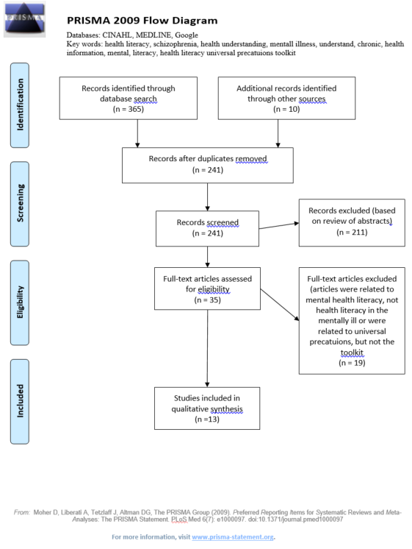
Figure 1. PRISMA Flow diagram.
Note. From “Preferred Reporting Items for Systematic Reviews and Meta-Analyses: The PRISMA Statement,” by D. Mohr, A. Liberati, J. Tetzlaff, & D. G. Altman, 2009, PLoS Med, 6(7). Publicly available.

Appendix B: Literature Summary Table
Table 1
Literature Summary Table
Year | Author, Title, Journal | Purpose | Design | Sample | Result
2016 | AHRQ. Health Literacy Universal Precautions Toolkit. | A Toolkit designed to provide evidence-based guidance to support primary care practices in addressing health literacy. | N/A | N/A | N/A
2014 | Batterham, Buchbinder, Beauchamp, Dodson, Elsworth, & Osborne. The Optimising Health LiterAcy (Ophelia) process: Study protocol for using health literacy profiling and community engagement to create and implement health reform. BMC Public Health. | To identify and respond to health literacy issues for people with chronic conditions in order to improve health outcomes and reduce health inequities. | Multi-phase: utilizing intervention mapping, quality improvement collaboratives, and realist synthesis. (Idea for a project). | 8 disparate health services. | This is a proposed project write-up. There are no results.
2015 | Brega, Freedman, LeBlanc, Barnard, Mabachi, Cifuentes, Albright, Weiss, Brach, & West. Using the Health Literacy Universal Precautions Toolkit to improve the quality of patient materials. Journal of Health Communication. | Examine how primary care practices implemented Tool 11 and whether written materials improved as a result. | Quantitative & qualitative. Evaluation study | 4 practices. | Many of the revised and newly developed documents had reading levels appropriate for most patients and better readability than the original materials. Readability, understandability, and actionability of lengthier patient education materials were poor and did not improve over 6 months.
2013 | Callahan, Hawk, Rudd, Hackney, Bhandari, Prizer, Bauer, Jonas, Mendys, DeWalt. Adaptation of the Health Literacy Universal Precautions Toolkit for rheumatology and cardiology—Applications for pharmacy professionals to improve self-management and outcomes in patients with chronic disease. Research in Social and Administrative Pharmacy. | Focuses on the adaptation, review, and use of 2 new health literacy toolkits for health professionals who work with patients with arthritis and cardiovascular disease. | Evaluation study | 8 practice sites (4 rheumatology, 4 cardiology). | Participating pharmacists & staff offered suggestions that helped shape revisions and reported positive experiences with brown bag events, suggestions for approaches with patients managing chronic diseases, and with concrete examples related to several medicines as well as to common problems.
2016 | Clausen, Watanabe-Galloway, Baerentzen, & Britigan. Health literacy among people with serious mental illness. | To investigate aspects of health literacy and identify factors associated with low literacy among adults with severe mental illness using 3 literacy assessment tools. | Cross-sectional study | n=71 | 42% had limited literacy with the Single Item Literacy Screener, 50% with the Rapid Estimate of Adult Literacy in Medicine-Short Form, and 67% with the Newest Vital Sign.
2011 | DeWalt, Broucksou, Hawk, Brach, Hink, Rudd, & Callahan. Developing and testing the Health Literacy Universal Precautions Toolkit. Nursing Outlook. | Reviews the development of the Health Literacy Universal Precautions Toolkit, including testing the tools and the toolkit. | Development process and qualitative observations from implementation (pilot) testing. (Evaluation study). | 6 practice-based research networks across the state of North Carolina. 4 practices plus 4 additional practices participated in prototype testing. | The development and pilot testing suggest that the study team has identified key content from current knowledge and resources in health literacy and configured the information in a way that practices find useful. The changes take a substantial commitment and implementation is likely to take several months.
2010 | Eckman, Wise, Leonard, Dixon, Burros, Khan, & Warm. Impact of health literacy outcomes and effectiveness of an educational intervention in patients with chronic diseases. Patient Education and Counseling. | To study the impact of health literacy on educational intervention for patients “Living with coronary artery disease” | Randomized control study | n=170 | There was a trend towards greater improvement in knowledge scores among patients in the video & text group compared with the text only group (1.41 vs. 0.81; p=0.07), but the results were not statistically significant. CAD knowledge scores improved significantly after either intervention (p<0.0001). Those receiving video and text intervention had a significant improvement in both exercise and weight loss (p=0.05), while the text only group did not. There was no significant difference in CAD knowledge score improvements or in changes in health behaviors and clinical outcomes between patients with lower and higher health literacy.
2012 | Galletly, Neaves, Burton, Liu, & Denson. Evaluating health literacy in people with mental illness using the Test of Functional Health Literacy in Adults. Nursing Outlook. | To investigate health literacy in people with mental illness and to evaluate relationships between medication adherence and health literacy. | Cross-sectional | n=30 in schizophrenia group. n=30 in depression group. | 93% of patients in the depressed group and 97% in the schizophrenia group scored within the “adequate” health literacy category. Health literacy was positively correlated with years of education (r=0.29, n=60, P=0.023). There was no association between health literacy and medication adherence (r=-0.05, n=60, P=0.697).
2004 | Institute of Medicine. Health literacy: A prescription to end confusion. | To document the problem of health literacy, and describe its origins, consequences, and solutions. Also lays out a comprehensive strategy to improve health literacy in America. | Case report | N/A | N/A
2012 | Krishan, von Esenwein, & Druss. The health literacy of adults with severe mental illness. Psychiatric services. | To examine factors related to health literacy in individuals with serious mental illness who are receiving care at an urban community mental health center. | Cross-sectional analysis of participants in a randomized control parent study. | N=256 | Overall, 117 (46%) had low health literacy and the mean REALM score was 55.18+/-15.60. Low health literacy was associated with increased odds of inpatient medical hospitalization when the analysis controlled for education, race, gender, age, and schizophrenia diagnosis (odds ratio=3.71, 85% confidence interval 1.49-9.22, p=0.005).
2008 | Lincoln, Espejo, Johnson, Paasche-Orlow, Speckman, Webber, & White. Limited literacy and psychiatric disorders among users of an urban safety-net hospital’s mental health outpatient clinic. The Journal of Nervous and Mental Disease. | To examine whether literacy varies by psychiatric diagnoses. | Cross sectional | Convenience sample of n=100 | The mean rapid estimate of adult literacy in medicine score was 55.9 which is below an 8th grade literacy level. Psychotic disorder was associated with limited literacy (p=0.03) and substance abuse (p=0.003) and PTSD (p=0.07) were associated with higher literacy in bivariate analyses.
2016 | Mabachi, Cifuentes, Barnard, Brega, Albright, Weiss, Brach, & West. Demonstration of the Health Literacy Universal Precautions Toolkit: Lessons for quality improvement. Journal of Ambulatory Care Management. | To present insights into practices’ experiences using the Toolkit, the utility of the Toolkit, opportunities for improving the Toolkit, and discuss implications for Toolkit use and enhancement. | Qualitative | 12 primary care practices. | Barriers included competing demands/staff capacity, bureaucratic challenges, technological challenges, limited quality improvement experience, and limited support from leadership. Practices use the Toolkit flexibly and did not always implement all portions of assigned tools. Practices found that some tools were best implemented in tandem. At least ¾ of the practices report that they plan to continue to use the Toolkit as a resource to guide their health literacy-related QI work.
2010 | U.S. Department of Health and Human Services. National Action Plan to Improve Health Literacy. | Seeks to engage organizations, professionals, policymakers, communities, individuals, and families in a linked, multisector effort to improve health literacy. | Case report | N/A | N/A

Appendix C: Sampling Diagram
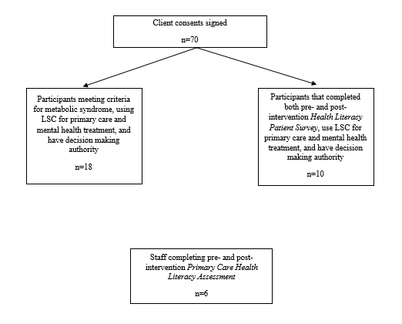
Figure 2. This is a diagram of the three different samples of participants analyzed in the project.

Appendix D: SWOT Analysis
Table 2
SWOT Analysis of the Lower Shore Clinic
Strengths | Weaknesses
- Integrated care  - Affiliated with psychiatric rehabilitation program  - Accessible  - National Health Service Corps site  - Sliding scale/Medicare & Medicaid/ and private insurance accepted  - Interprofessional, well qualified, enthusiastic staff  - Located near downtown Salisbury  - Assertive Community Treatment (ACT) mobile treatment team  - Joint Commission national quality approval  - Community ties  - PRMC-Care Wrap team  - Salisbury University-board of directors, students, projects  - CEO that is very involved politically and has received awards  - On-site lab services  - Pharmacy on-site  - Belongs to Community Behavioral Health Association of Maryland | - Paper charting  - Busy practice  - Little advertisement  - Budget often operating at a loss  - Poverty level of clients  - Clients with multiple comorbidities  - Clients with poor nutrition status  - Clients frequently noncompliant with treatment regimens
Opportunities | Threats
- In the process of implementing an electronic health record  - Possible partnership with PRMC’s accountable care organization (ACO)  - Pharmacy buy-out by larger corporation with more resources  - Frequent recipient of Community Health Foundation grants  - Possible partnership with the city of Salisbury for capital improvement projects  - Recent passing of the Keep the Door Open Act  - Few other integrated primary care and psychiatric clinics for adults in Wicomico or surrounding counties | - National political environment-possible repeal of Affordable Care Act  - Competitors that are able to expand to pediatrics, dental, and other specialty care areas  - Poor reimbursement rates  - Dearth of primary care and mental health providers  - Clients often unable to pay

Appendix E: Letters of Collaboration from the Lower Shore Clinic
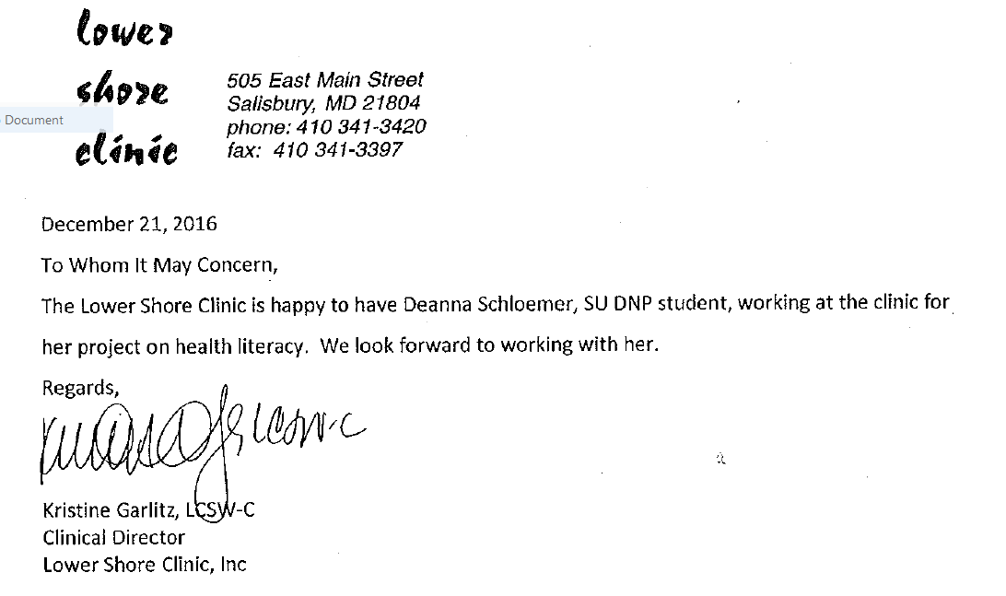
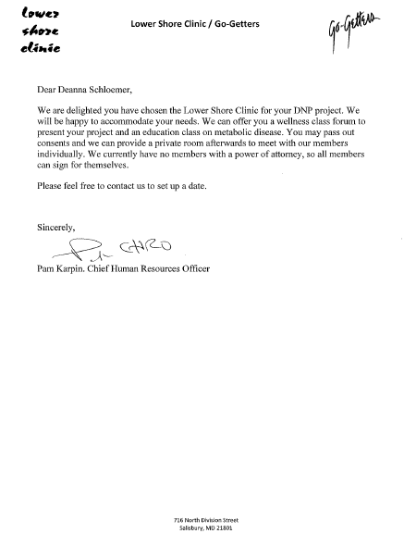

Appendix F: Health Literacy Patient Survey
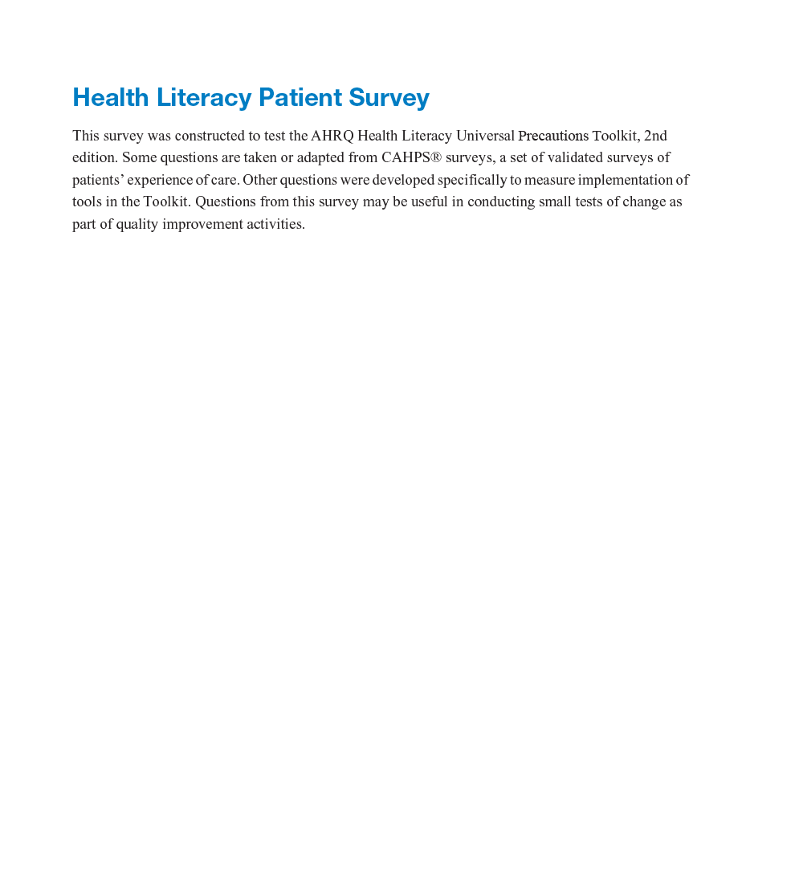
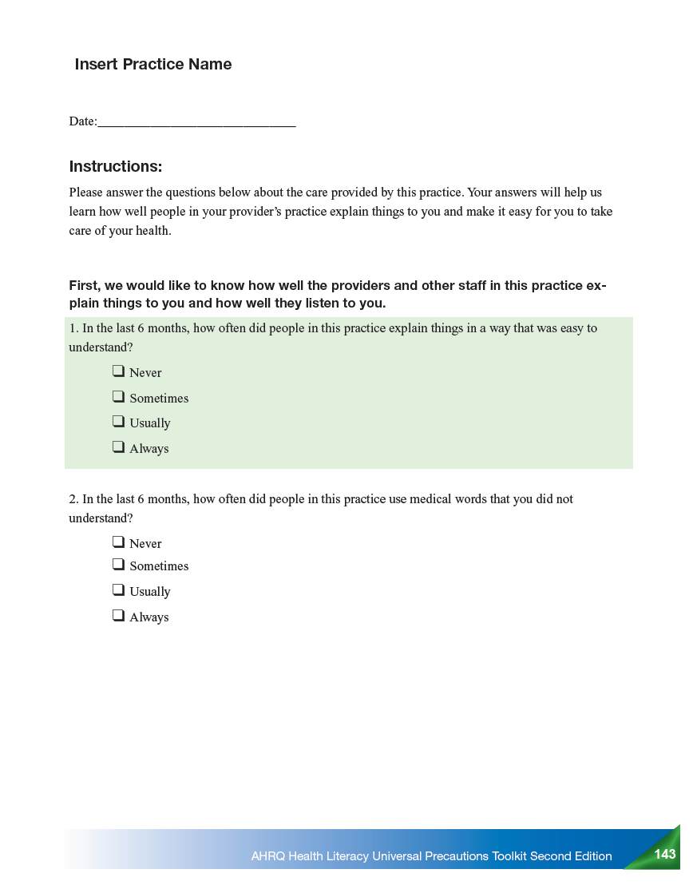
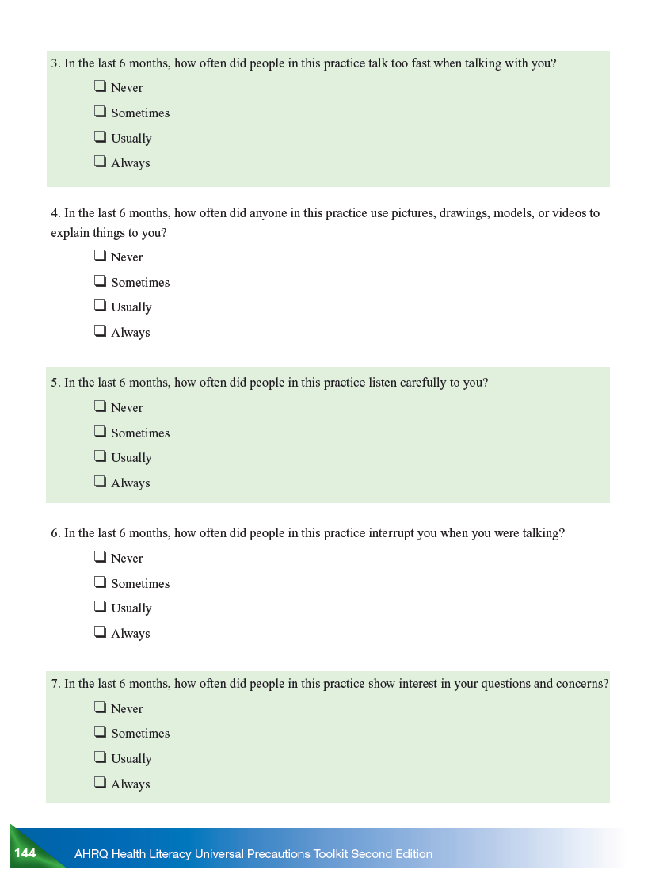
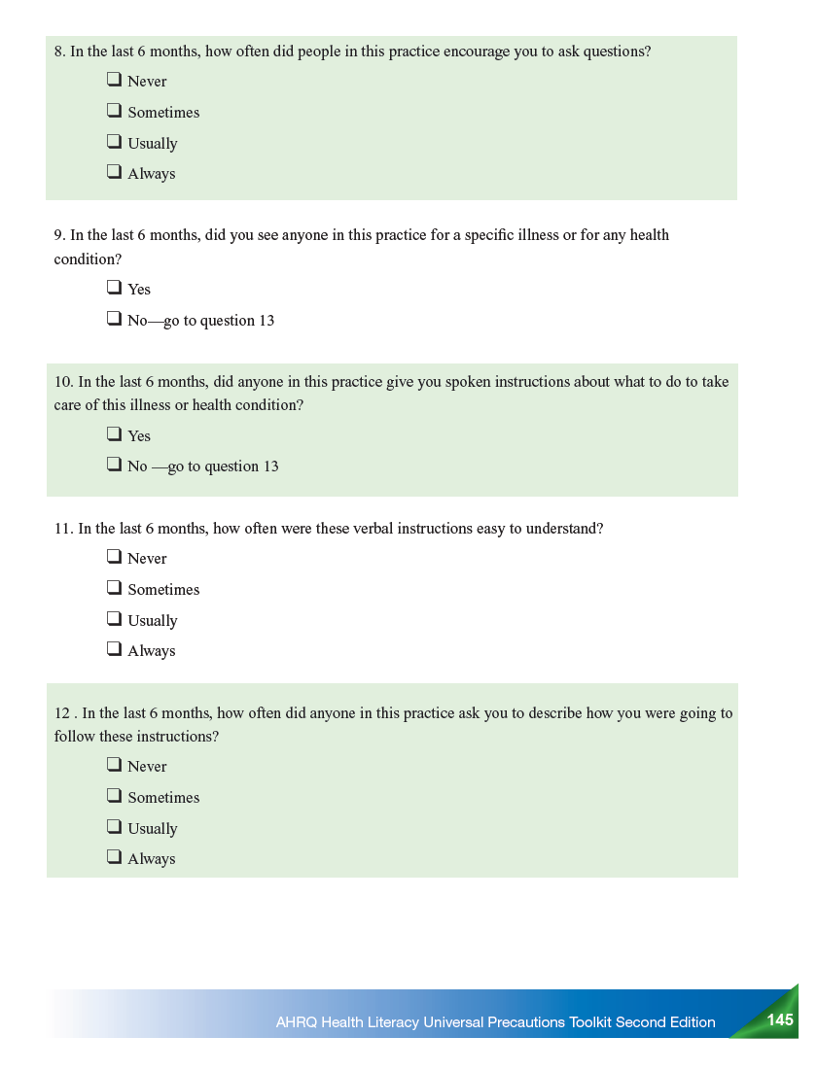
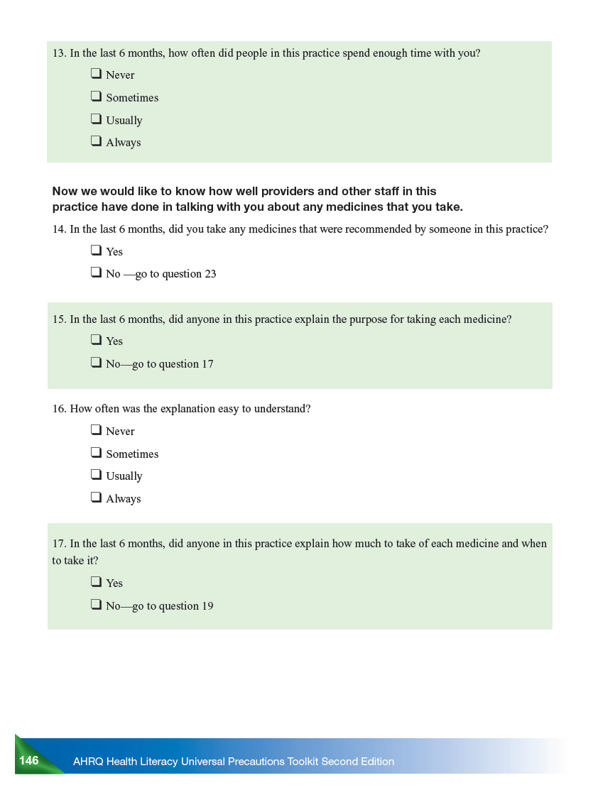
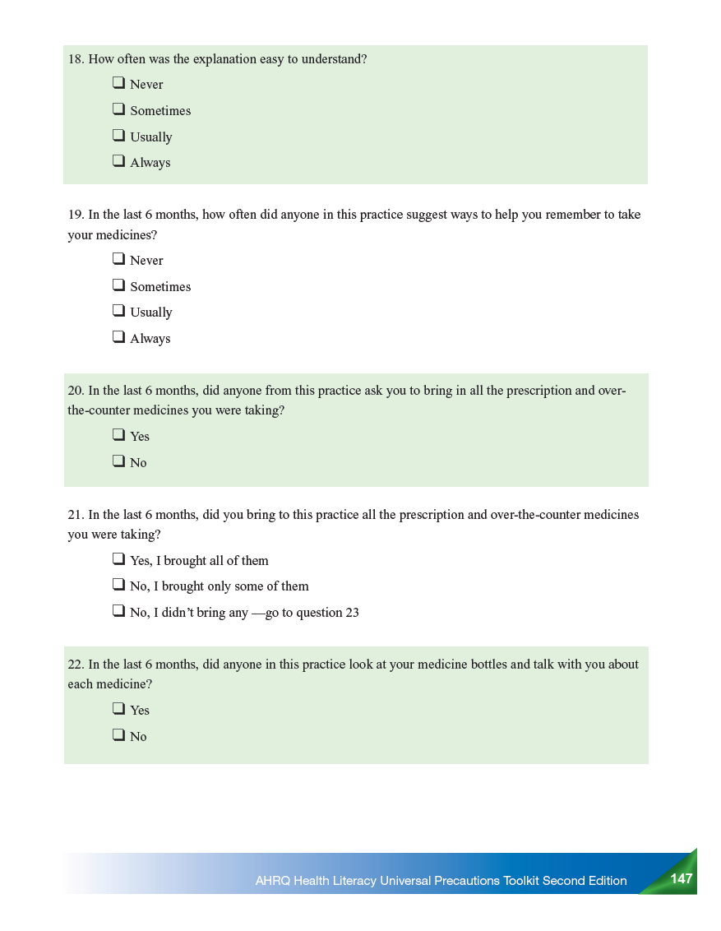
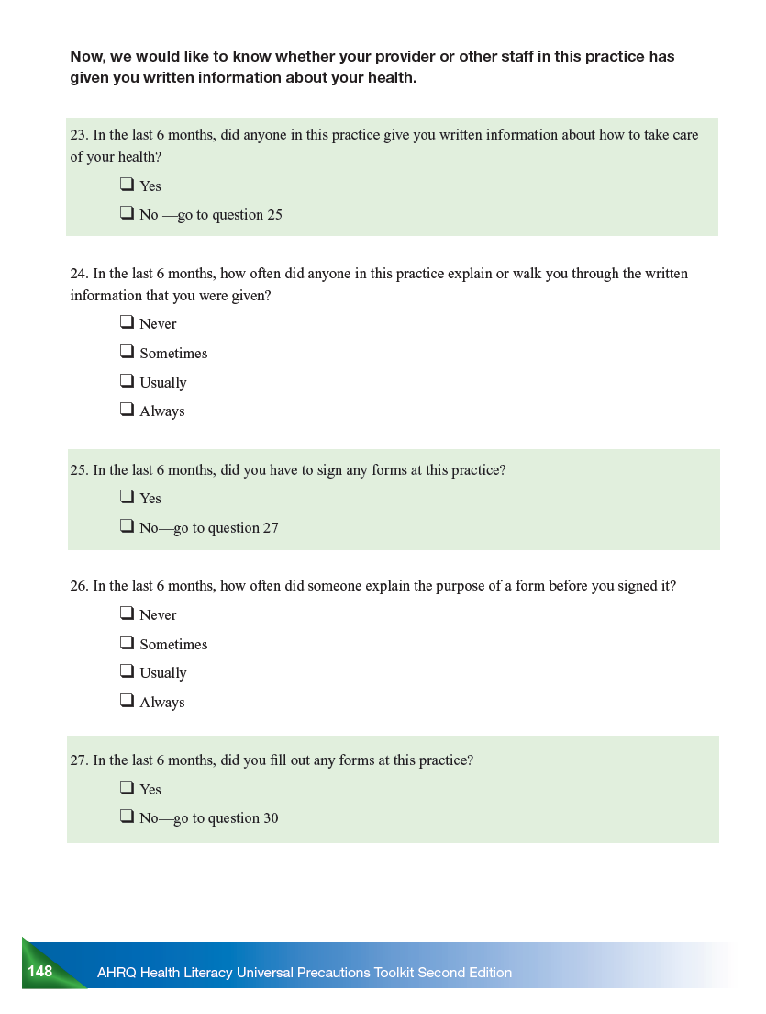
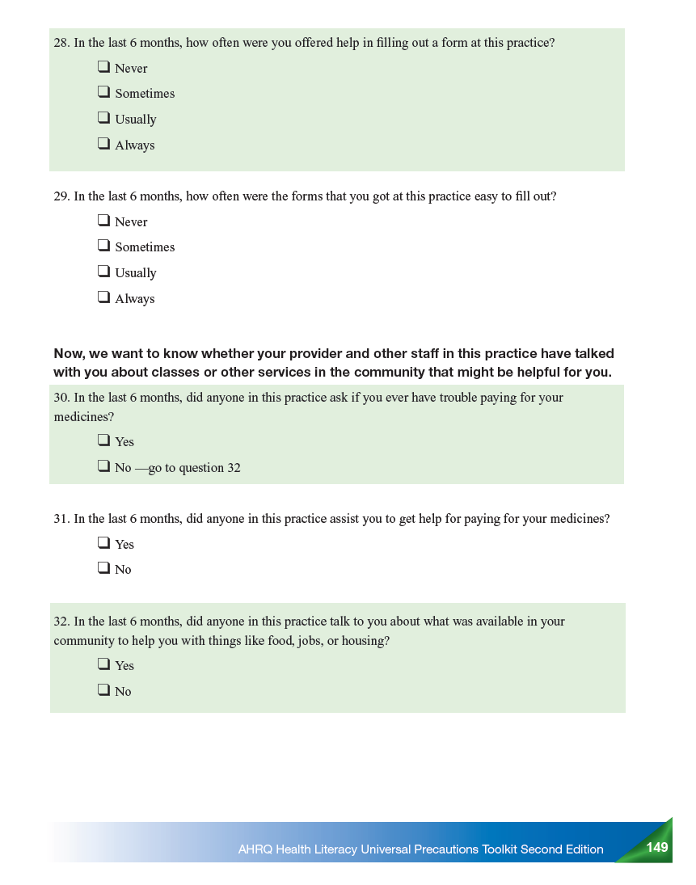
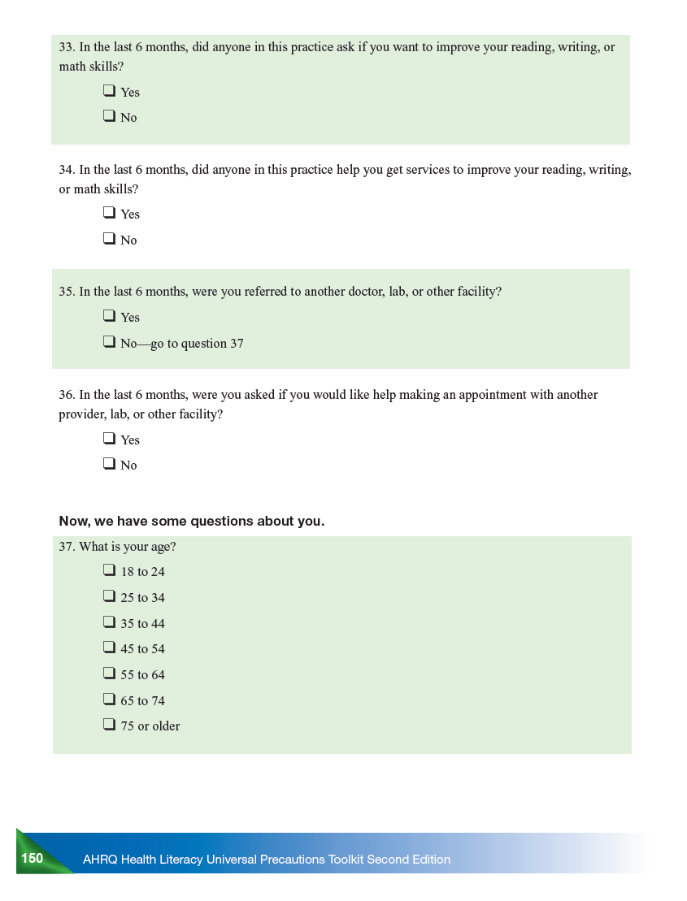
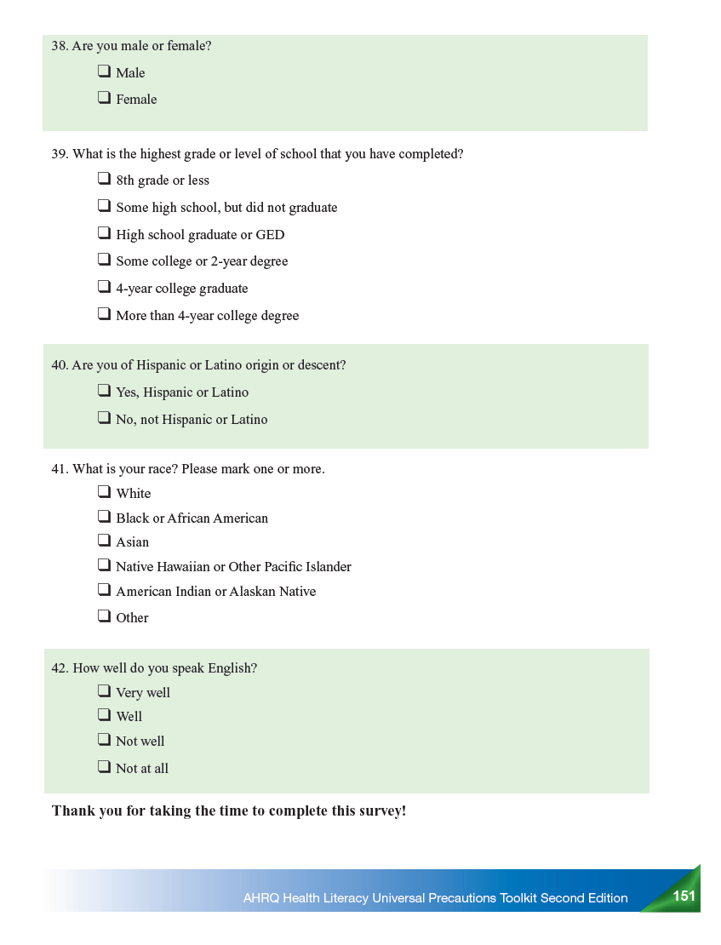
Note. From AHRQ Health Literacy Universal Precautions Toolkit (2nd ed.), by the Agency for Healthcare Research and Quality, 2015, pp. 142-151. Publicly available.

Appendix G: Primary Care Health Literacy Assessment
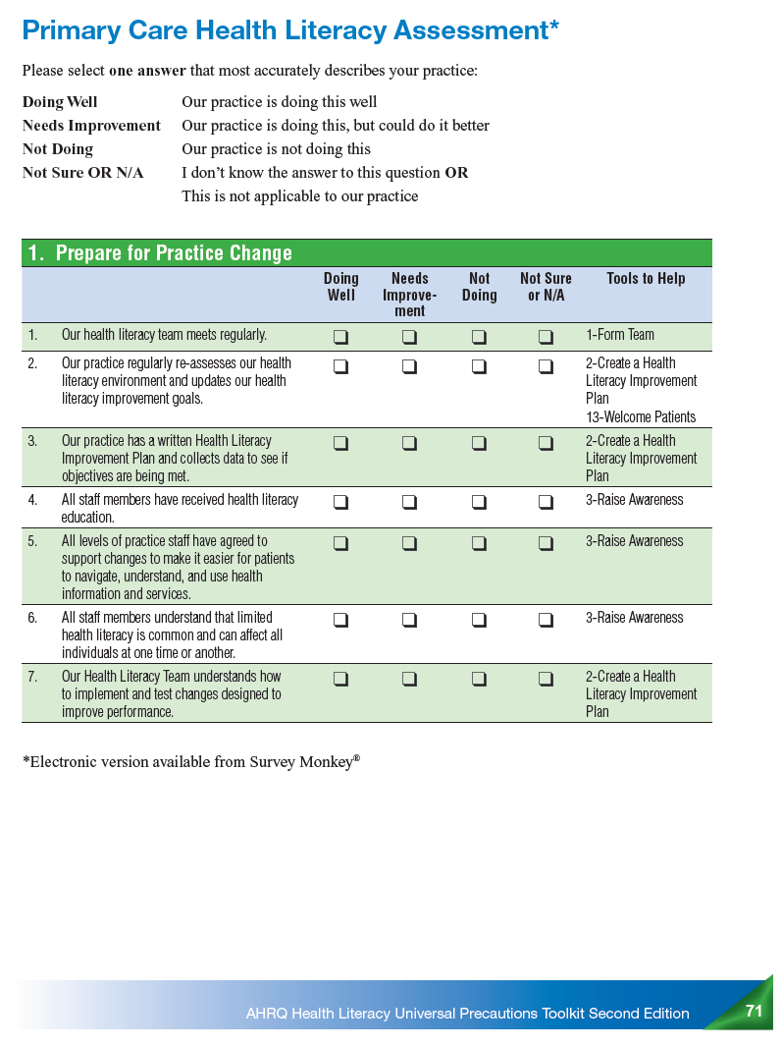
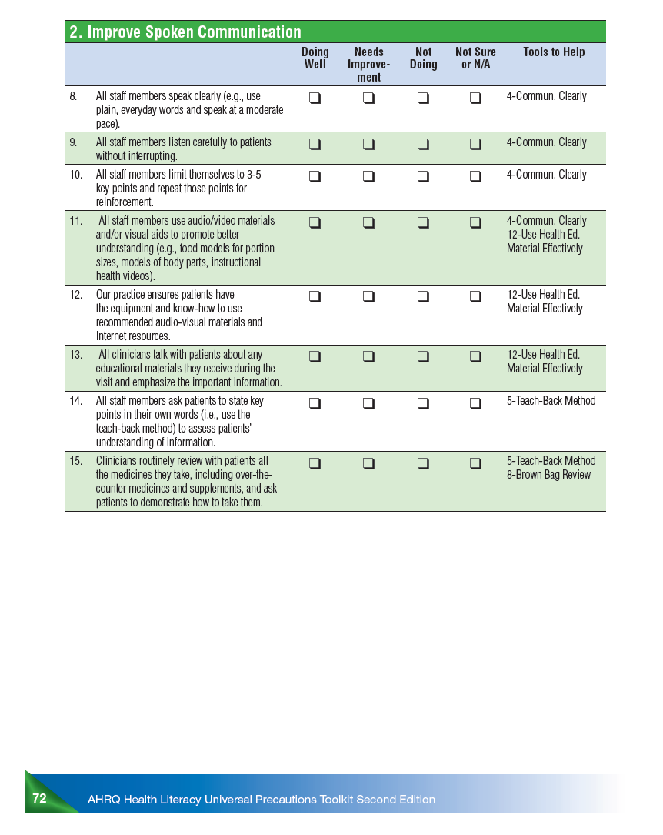
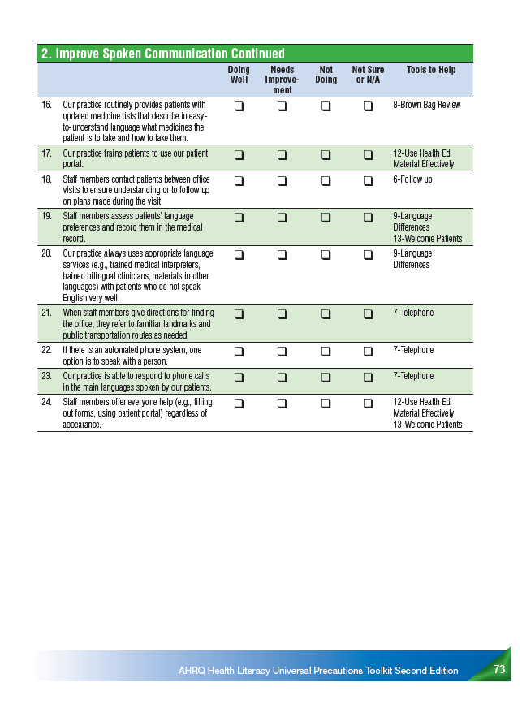
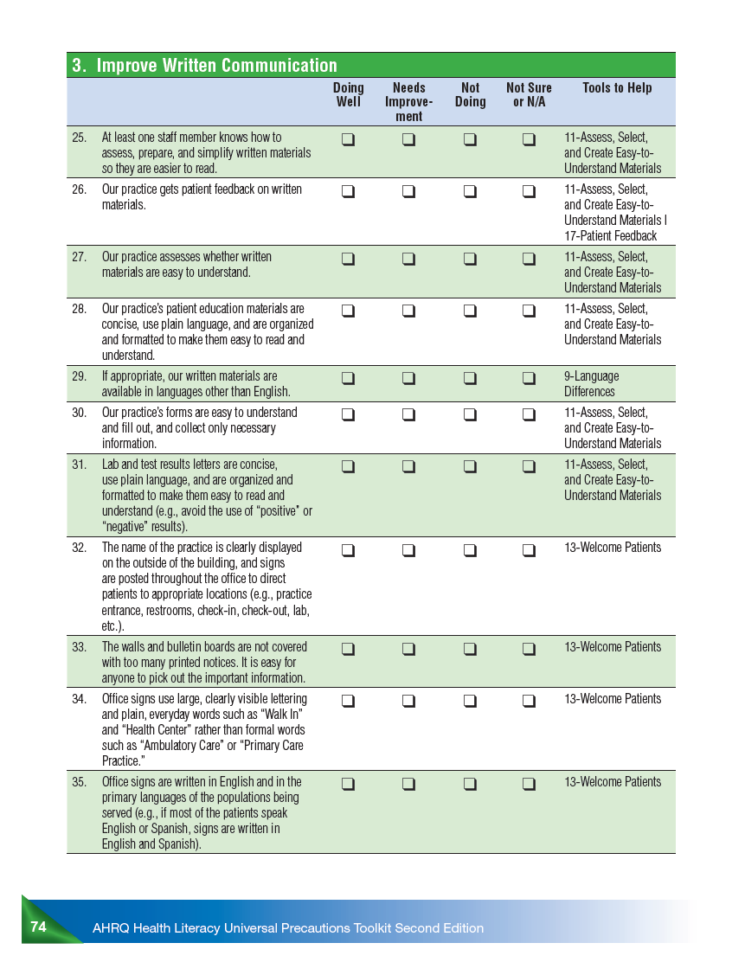
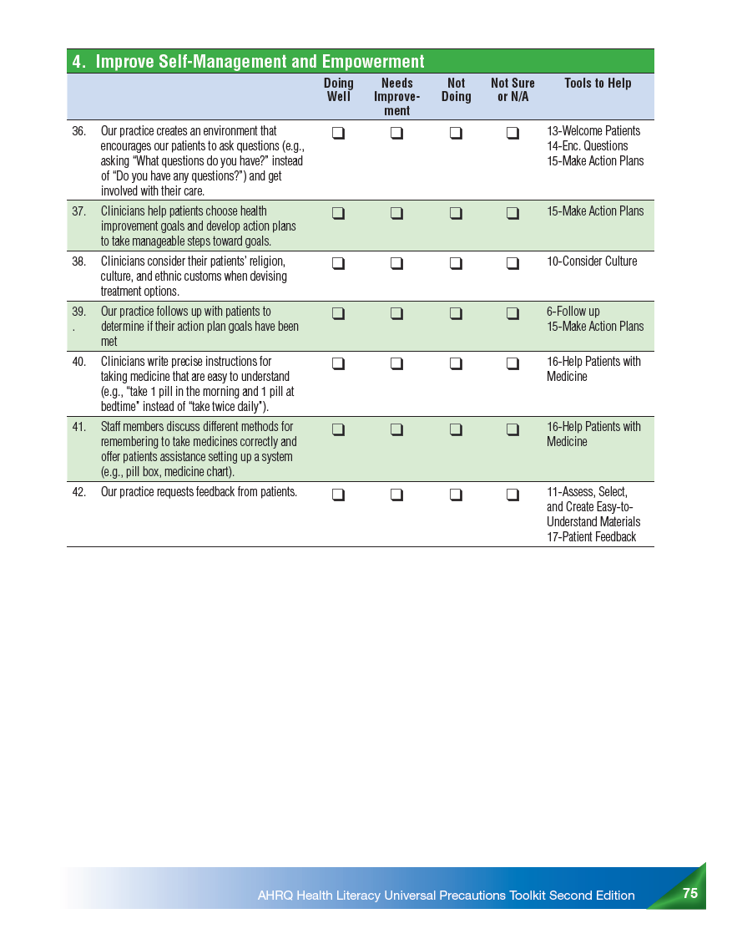
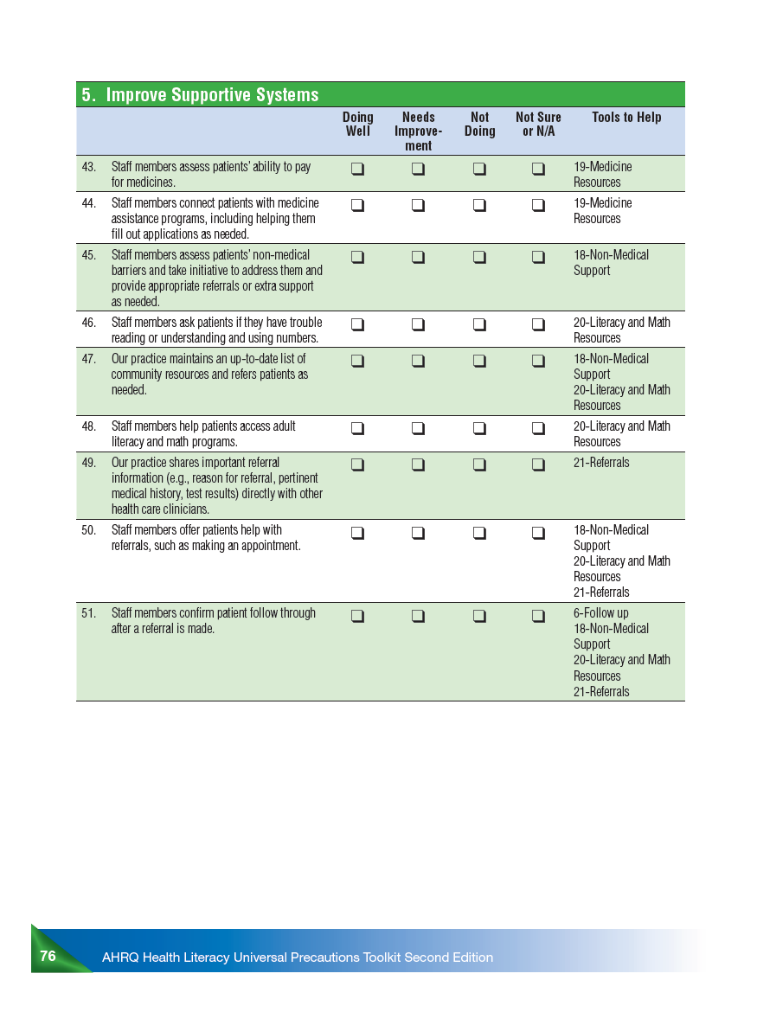
Note. From AHRQ Health Literacy Universal Precautions Toolkit (2nd ed.), by the Agency for Healthcare Research and Quality, 2015, pp. 71-76. Publicly available.

Appendix H: Descriptive Statistics on Pre-Intervention Primary Care Health Literacy Assessment
Table 3
Descriptive Statistics on Pre-Intervention Primary Care Health Literacy Assessment
 | N | Minimum | Maximum | Mean | Std. Deviation
Question 1-Tool 1 | 6 | 3 | 4 | 3.67 | .516
Question 2-Tool 2 | 6 | 3 | 4 | 3.50 | .548
Question 3-Tool 2 | 6 | 3 | 4 | 3.50 | .548
Question 4-Tool 3 | 6 | 1 | 4 | 2.67 | 1.033
Question 5-Tool 3 | 6 | 1 | 4 | 2.17 | 1.169
Question 6-Tool 3 | 6 | 1 | 4 | 1.83 | 1.169
Question 7-Tool 2 | 6 | 1 | 4 | 2.83 | 1.329
Question 8-Tool 4 | 6 | 1 | 4 | 1.83 | 1.169
Question 9-Tool 4 | 6 | 1 | 2 | 1.67 | .516
Question 10-Tool 4 | 6 | 1 | 4 | 2.50 | 1.225
Question 11-Tool 4 | 6 | 2 | 4 | 2.67 | 1.033
Question 12-Tool 12 | 6 | 2 | 4 | 3.00 | .894
Question 13-Tool 12 | 6 | 2 | 4 | 3.00 | 1.095
Question 14-Tool 5 | 6 | 1 | 4 | 2.17 | 1.169
Question 15-Tools 5 & 8 | 6 | 1 | 4 | 2.17 | .983
Question 16-Tool 8 | 6 | 2 | 4 | 2.33 | .816
Question 17-Tool 12 | 6 | 2 | 4 | 3.17 | .983
Question 18-Tool 6 | 6 | 1 | 4 | 2.67 | 1.211
Question 19-Tools 9 & 13 | 6 | 1 | 2 | 1.50 | .548
Question 20-Tool 9 | 6 | 1 | 2 | 1.67 | .516
Question 21-Tool 7 | 6 | 1 | 4 | 2.50 | 1.643
Question 22-Tool 7 | 6 | 1 | 4 | 3.00 | 1.549
Question 23-Tool 7 | 6 | 1 | 4 | 2.50 | 1.225
Question 24-Tools 12 & 13 | 6 | 1 | 2 | 1.33 | .516
Question 25-Tool 11 | 6 | 1 | 4 | 2.17 | 1.472
Question 26-Tools 11 & 17 | 6 | 1 | 4 | 2.67 | 1.211
Question 27-Tool 11 | 6 | 1 | 4 | 2.67 | 1.211
Question 28-Tool 11 | 6 | 1 | 4 | 2.83 | 1.169
Question 29-Tool 9 | 6 | 1 | 4 | 2.50 | 1.049
Question 30-Tool 11 | 6 | 1 | 2 | 1.33 | .516
Question 31-Tool 11 | 6 | 2 | 4 | 3.67 | .816
Question 32-Tool 13 | 6 | 1 | 2 | 1.50 | .548
Question 33-Tool 13 | 6 | 1 | 2 | 1.17 | .408
Question 34-Tool 13 | 6 | 1 | 4 | 1.67 | 1.211
Question 35-Tool 13 | 6 | 1 | 3 | 2.00 | .894
Question 36-Tools 13, 14, & 15 | 6 | 1 | 2 | 1.33 | .516
Question 37-Tool 15 | 6 | 1 | 4 | 2.17 | 1.472
Question 38-Tool 10 | 6 | 1 | 4 | 1.83 | 1.169
Question 39-Tools 6 & 15 | 6 | 1 | 2 | 1.17 | .408
Question 40-Tool 16 | 6 | 2 | 4 | 2.67 | 1.033
Question 41-Tool 16 | 6 | 1 | 4 | 2.33 | 1.366
Question 42-Tools 11 & 17 | 6 | 1 | 4 | 2.00 | 1.095

Appendix I: Paired Samples T-test on Metabolic Syndrome Data
Table 4
Paired Samples T-test on Metabolic Syndrome Data
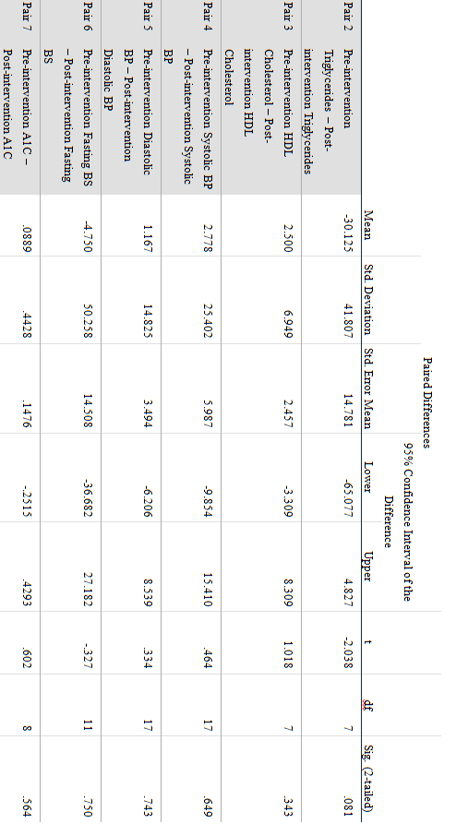

Appendix J: Descriptive Statistics on Mental Health Diagnosis on Metabolic Syndrome Data
Table 5
Descriptive Statistics on Mental Health Diagnosis on Metabolic Syndrome Data
Mental Health Diagnosis
 |  | Frequency | Percent | Valid Percent | Cumulative Percent
Valid | Schizophrenia | 7 | 36.8 | 36.8 | 36.8
Valid | Schizoaffective Disorder | 7 | 36.8 | 36.8 | 73.7
Valid | Bipolar Disorder | 1 | 5.3 | 5.3 | 78.9
Valid | Major Depressive Disorder | 3 | 15.8 | 15.8 | 94.7
Valid | Unspecified Psychosis | 1 | 5.3 | 5.3 | 100.0
Valid | Total | 19 | 100.0 | 100.0

Appendix K: Descriptive Statistics on Level of Education on Metabolic Syndrome Data
Table 6
Descriptive Statistics on Level of Education on Metabolic Syndrome Data
Level of Education
 |  | Frequency | Percent | Valid Percent | Cumulative Percent
Valid | Less than HS | 1 | 5.3 | 6.7 | 6.7
Valid | Attended some HS; did not graduate | 2 | 10.5 | 13.3 | 20.0
Valid | GED | 1 | 5.3 | 6.7 | 26.7
Valid | HS Graduate | 8 | 42.1 | 53.3 | 80.0
Valid | Some college | 1 | 5.3 | 6.7 | 86.7
Valid | College graduate | 2 | 10.5 | 13.3 | 100.0
Valid | Total | 15 | 78.9 | 100.0
Missing | System | 4 | 21.1
Total |  | 19 | 100.0

Appendix L: Wilcoxon Signed-Rank Test on Health Literacy Patient Survey Data
Table 7
Wilcoxon Signed-Rank Test on Health Literacy Patient Survey Data
Question | Z | Asymp Sig. (2-tailed)
1 | -1.190^{b} | .234
2 | -1.613^{b} | .107
3 | -1.0000^{c} | .317
4 | -.933^{b} | .351
5 | .000^{d} | 1.000
6 | -.378^{c} | .705
7 | -.577^{b} | .564
8 | -.343^{c} | .732
9 | .000^{d} | 1.000
10 | -1.414^{b} | .157
11 | -.333^{b} | .739
12 | -.966^{c} | .334
13 | -1.131^{b} | .258
14 | -.577^{c} | .564
15 | -1.000^{c} | .317
16 | -1.611^{b} | .107
17 | -1.000^{b} | .317
18 | -1.518^{b} | .129
19 | -1.633^{c} | .102
20 | -2.236^{b} | .025
21 | -1.890^{b} | .059
22 | .000^{d} | 1.000
23 | -.447^{b} | .655
24 | -1.633^{b} | .102
25 | -1.414^{c} | .157
26 | -1.000^{b} | .317
27 | -1.732^{c} | .083
28 | -.577^{c} | .564
29 | -.816^{c} | .414
30 | -1.000^{c} | .317
31 | -1.732^{b} | .083
32 | -1.414^{b} | .157
33 | .000^{d} | 1.000
34 | -1.732^{b} | .083
35 | -1.414^{c} | .157
36 | -1.000^{b} | .317
- Wilcoxon Signed Ranks Test
- Based on negative ranks
- Based on positive ranks
- The sum of negative ranks equals the sum of positive ranks

Appendix M: Descriptive Statistics for Mental Health Diagnosis on Health Literacy Patient Survey Data
Table 8
Descriptive Statistics for Mental Health Diagnosis on Health Literacy Patient Survey Data
MH Diagnosis
 |  | Frequency | Percent | Valid Percent | Cumulative Percent
Valid | Schizophrenia | 3 | 30.0 | 30.0 | 30.0
Valid | Schizoaffective Disorder | 4 | 40.0 | 40.0 | 70.0
Valid | Bipolar Disorder | 1 | 10.0 | 10.0 | 80.0
Valid | Major Depressive Disorder | 1 | 10.0 | 10.0 | 90.0
Valid | Other | 1 | 10.0 | 10.0 | 100.0
Valid | Total | 10 | 100.0 | 100.0

Appendix N: Descriptive Statistics for Level of Education on Health Literacy Patient Survey Data
Table 9
Descriptive Statistics for Level of Education on Health Literacy Patient Survey Data
Level of education
 |  | Frequency | Percent | Valid Percent | Cumulative Percent
Valid | 8th grade or less | 2 | 20.0 | 20.0 | 20.0
Valid | Some high school; did not graduate | 1 | 10.0 | 10.0 | 30.0
Valid | High school graduate or GED | 4 | 40.0 | 40.0 | 70.0
Valid | Some college or 2-year degree | 1 | 10.0 | 10.0 | 80.0
Valid | 4-year college graduate | 2 | 20.0 | 20.0 | 100.0
Valid | Total | 10 | 100.0 | 100.0

Appendix O: Wilcoxon Signed-Rank Test on Staff Pre- and Post-Intervention Primary Care Health Literacy Assessment
Table 10
Wilcoxon Signed-Rank Test on Staff Pre- and Post-Intervention Primary Care Health Literacy Assessment
Question | Z | Asymp Sig. (2-tailed)
1 | -1.890^{b} | .059
2 | -1.890^{b} | .059
3 | -1.890^{b} | .059
4 | -1.242^{b} | .214
5 | -1.000^{b} | .317
6 | -1.414^{b} | .157
7 | -1.289^{b} | .197
8 | -1.000^{b} | .317
9 | .000^{c} | 1.000
10 | -.272^{b} | .785
11 | -.272^{b} | .785
12 | -1.000^{b} | .317
13 | -.736^{b} | .461
14 | -1.069^{d} | .285
15 | -.535^{b} | .593
16 | -.707^{b} | .480
17 | -.557^{b} | .577
18 | -1.000^{b} | .317
19 | -1.089^{d} | .276
20 | -2.000^{b} | .046
21 | -.577^{b} | .564
22 | -1.000^{b} | .317
23 | -1.890^{b} | .059
24 | -.447^{d} | .655
25 | -1.633^{b} | .102
26 | -1.511^{b} | .131
27 | -1.857^{b} | .063
28 | -2.041^{b} | .041
29 | -.378^{b} | .705
30 | .000^{c} | 1.000
31 | -1.342^{b} | .180
32 | -1.000^{b} | .317
33 | -1.000^{d} | .317
34 | -1.414^{b} | .157
35 | -1.134^{b} | .257
36 | -1.414^{b} | .157
37 | .000^{c} | 1.000
38 | -.447^{d} | .655
39 | -1.342^{d} | .180
40 | -1.289^{b} | .197
41 | -.966^{b} | .334
42 | -1.890^{b} | .059
43 | -.272^{d} | .785
44 | -1.000^{d} | .317
45 | -.816^{d} | .414
46 | .000^{c} | 1.000
47 | .000^{c} | 1.000
48 | -1.342^{d} | .180
49 | .000^{c} | 1.000
50 | -.447^{d} | .655
51 | -1.089^{d} | .276
- Wilcoxon Signed Ranks Test
- Based on negative ranks
- Based on positive ranks
- The sum of negative ranks equals the sum of positive ranks

