Supplementary Material
For
Photocatalytic Degradation of GenX in Water Using a New Adsorptive Photocatalyst

Yangmo Zhu¹, Haodong Ji², Ke He³, Lee Blaney³, Tianyuan Xu^{4,}*, Dongye Zhao^{1,}*

¹ Department of Civil & Environmental Engineering, Auburn University, Auburn, AL 36849, USA
² School of Environment and Energy, Peking University Shenzhen Graduate School, Shenzhen, 518055, China
³ Department of Chemical, Biochemical, and Environmental Engineering, University of Maryland Baltimore County, MD 21250, USA
⁴ School of Resource and Geosciences, China University of Mining and Technology, Xuzhou 221116, Jiangsu, China
Contents:
Text sections:
S1. Density functional theory (DFT) calculation methods
S2. Chemical analysis with LC-MS/MS
Tables: 8
Figures: 12
* Corresponding authors:
E-mails: zhaodon@auburn.edu (D. Zhao), xutianyuan1988@126.com (T. Xu)

S1. Density functional theory (DFT) calculation methods
The Fukui function based on the density functional theory (DFT) was used to predict the regioselectivity of radicals (h⁺, •OH) acting on GenX. All of the calculations were performed using the Gaussian 16 C.01 software (Frisch et al. 2003). The geometry optimization and single-point energy calculations were carried out following the B3LYP method with the 6-31+G(d,p) basis set. Fukui function is an important concept in the conceptual density functional theory (CDFT), and it has been widely used in the prediction of reactive sites of electrophilic, nucleophilic, and general radical attacks (Parr and Yang 1984). Specifically, Fukui function is defined as:
$f\left(r\right)= {\left[\frac{∂ρ\left(r\right)}{∂N}\right]}_{V(r)}$ (S1)
where $ρ\left(r\right)$ is the electron density at a point r in space, N is the electron number in the system, and the constant term v in the partial derivative is the external potential. In the condensed version of the Fukui function, the atomic population number was used to represent the electron density distribution around an atom. The condensed Fukui function was calculated as follows:
Electrophilic attack: ${ f}_{A}^{-}=q_{N-1}^{A}-q_{N}^{A}$ (S2)
Nucleophilic attack: ${ f}_{A}^{+}=q_{N}^{A}-q_{N+1}^{A}$ (S3)
Radical attack: $f_{A}^{0}=\frac{q_{N-1}^{A}-q_{N+1}^{A}}{2}$ (S4)
where $q^{A}$is the charge of atom A at the corresponding state. The more reactive sites on a molecule usually have larger values of the Fukui index. h⁺, •OH, and O₂^{•−} have been classified as electrophilic, which are more likely to attack the sites that can readily lose electrons (De Vleeschouwer et al. 2007). Thus, we calculated the Fukui index of GenX for electrophilic attacks. The natural population analysis (NPA) was used to study the reactive sites, as it has been considered one of the most suitable methods to calculate the Fukui index (Oláh et al. 2002). A color gradient for a set of Fukui values was generated using the conditional formatting tool in Microsoft Excel 2019.

S2. Chemical analysis with LC-MS/MS
GenX analysis was performed on a Vanquish Flex Binary UHPLC system (Thermo Fisher) coupled with a quadrupole orbitrap mass spectrometer (Orbitrap Exploris TM120, Thermo Fisher) with electrospray ionization (ESI) in the negative mode and using the Xcalibur software (V4.4.16.14). A delay column was placed between the pump and autosampler (HypersilGOLD, 1.9 µm, 175 Å, 3 x 50 mm) and the system was enabled for PFAS analysis. Typically, 10 μL of the standard or sample was injected into a C18 column (Luna C18(2), 3 µm, 100 Å, 2 × 50 mm with 2 x 4 mm guard cartridge, Phenomenex) with a 200 μL/min flow rate of mobile phase of solution A (2 mM ammonium acetate in water) and solution B (100% acetonitrile) beginning at 15% B for the first 0.3 minute to 95% B at 9 min, held at 95% B for 2 min, back to 15%B in 1 min, and re-equilibration, resulting a total run time of 15 min. The MS scan range was 100-800 m/z with a resolution of 120,000, standard AGC target, 70% RF lens, maximum injection time auto, with EASY-IC run-start on. The negative spray voltage was 2500 V, ion transfer tube temperature was 320 °C, and the vaporizer temperature was 275 °C. The C5F11O in source fragment with m/z 284.9779±0.02 and 12C313C2F11O fragment with m/z 286.9846±0.02 were used for quantitation. M3HFPO-DA was used for quantitation analysis M3HFPO-DA (20 µg/L) as internal standard.
The calibration of the system was performed each time of analysis using at least five GenX standards in the linear concentration range of 1 to 90 µg/L. The relative standard deviation (%RSD) of the response factors (RFs) for all analysts must be within ± 20% or the linear regression R² must be ≥0.99, based on the initial calibration (ICAL) criteria and their true values. The second source standard was used after the ICAL for the initial calibration verification. The analyte concentrations were within ± 30% of their true value. After 10 samples or at the end of the sequence, two consecutive calibration verification standards were analyzed before next sample analysis with analyte concentrations within ± 30% of their true values from the Limit of Quantitation (LOQ) (0.5 µg/L) to the mid-level calibration concentration.
GenX and its photodegradation products, trifluoroacetic acid (TFA) and pentafluoropropionic acid (PFA), were further confirmed by an UltiMate 3000 LC coupled to a Thermo TSQ Quantum Access Max triple quadrupole tandem mass spectrometer. LC separation of GenX, TFA, and PFA was achieved with a Waters XBridge C18 column (2.1×150 mm, 2.5 µm) and a guard column (2.1×10 mm, 3.0 µm) containing the same material. The mobile phase was comprised of (A) LC-MS grade water with 10 mM ammonium acetate (pH 6.9) and (B) methanol with 10 mM ammonium acetate. The mobile phase flow rate was set to 200 µL/min under an isocratic elution with 40% A and 60% B. The column compartment was maintained at 40 °C. The overall method run time was 6 minutes, and 50 µL of sample was injected. The negative ESI mode was applied to GenX, TFA, and PFA. The spray voltage was 2500 V, capillary temperature was 350 °C, vaporizer temperature was 300 °C, sheath gas pressure was 35 (arbitrary units, nitrogen), auxiliary gas pressure was 10 (arbitrary units, nitrogen), and collision-induced dissociation pressure was 1.5 mTorr (argon). The precursor ion and at least one characteristic product ion were identified for each analyte. The optimized detector parameters and ion transitions are summarized in Table S2.

Tables
Table S1. Key properties of GenX.
Molecular Formula | C₆F₁₁O₃¯ | 2-D structure
Molecular Weight (g/mol) | 329.04
Synonyms | 2,3,3,3-Tetrafluoro-2-(1,1,2,2,3,3,3-hetafluoropropoxy)propanoic acid  FRE-903  H-28307  C3-dimer (acid)  GenX Acid
pK_{a} | 2.84 (20 ˚C)(USEPA. 2018)
pK_{b} | 8.1 (USEPA. 2018) | 3-D structure
Boiling Point | 129 ˚C (USEPA. 2018) | 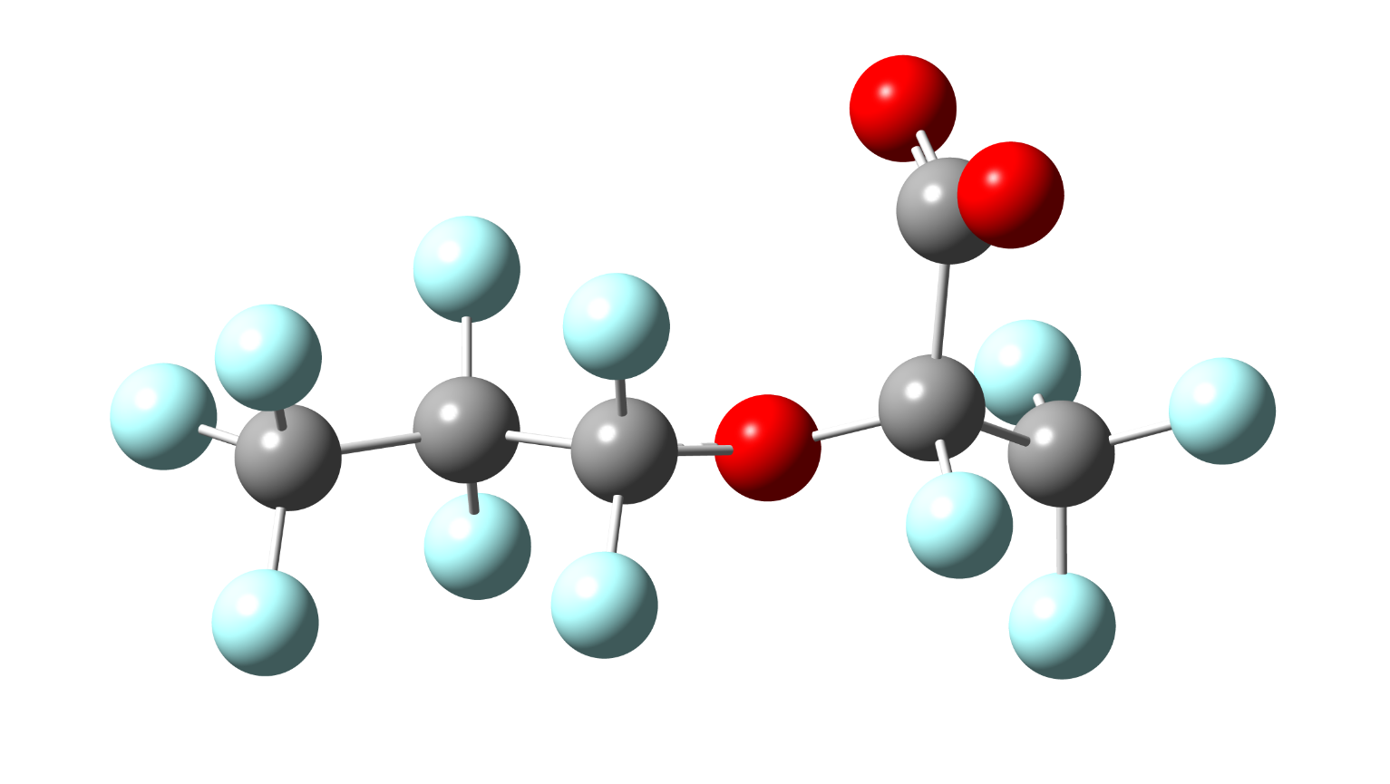

Table S2. LC-MS/MS operating parameters and instrument performance.
Analyte | Ion or Ion transition ª | Collision energy  (V) | Linear range  (µg/L) | R² | LOD ^{b}  (µg/L)
LC-MS/MS (orbitrap)
GenX | 284.9779 ± 0.02 | - | 1 – 90 | > 0.99 | 0.5
M3HFPO-DA | 286.9846 ± 0.02 | - | - | - | -
LC-MS/MS (tandem)
GenX | 284.9 → 168.9 | -8 | 1 – 50 | > 0.99 | 0.1
GenX | 328.9 → 284.9 | -5 | 1 – 50 | > 0.99 | 0.1
M3HFPO-DA | 286.9 → 168.9 | -8 | - | - | -
M3HFPO-DA | 331.9 → 286.9 | -5 | - | - | -
PFA | - |  | - | - | -
PFA | 162.9 → 118.9 | -10 | - | - | -
TFA | - |  | - | - | -
TFA | 112.9 → 68.9 | -10 | - | - | -
a: the first product ion (bold) was used for quantitation, and the second product ion (italics) was used
for confirmation if available
b: limit of detection

Table S3. EDS-based distribution of five elements on 3%Bi/TNTs@AC.
Element | Weight %
C | 19.2
O | 34.1
Ti | 36.2
Bi | 5.2
Na | 5.3

Table S4. BET-based specific surface area and pore volume of various composite materials.
Material | BET surface areaª (m²/g) | Pore volume^{b} (cm³/g)
AC | 591.38 ± 9.28 | 0.801
TNTs@AC | 243.77 ± 3.77 | 0.330
1%Bi/TNTs@AC | 307.50 ± 3.75 | 0.462
2%Bi/TNTs@AC | 279.60 ± 4.60 | 0.347
3%Bi/TNTs@AC | 289.84 ± 4.48 | 0.463
4%Bi/TNTs@AC | 285.26 ± 3.48 | 0.554
5%Bi/TNTs@AC | 269.78 ± 3.89 | 0.408
Notes: (a) BET surface area was calculated using the BET equation ± relative deviation from the mean; and (b) Pore Volume: total pore volume estimated at a relative pressure of 0.99.

Table S5. Crystal size and structure for Bi/TNTs@AC prepared at various Bi contents.
Material | Crystallite size (nm) | Crystal structure (wt.%)
1%Bi/TNTs@AC | 10.9 | Anatase (89%)
1%Bi/TNTs@AC | 2.4 | Metallic Bi (11%)
2%Bi/TNTs@AC | 14.5 | Anatase (69%)
2%Bi/TNTs@AC | 94.4 | Metallic Bi (31%)
3%Bi/TNTs@AC | 22.8 | Anatase (59%)
3%Bi/TNTs@AC | >100 | Metallic Bi (41%)
4%Bi/TNTs@AC | 18.7 | Anatase (58%)
4%Bi/TNTs@AC | >100 | Metallic Bi (42%)
5%Bi/TNTs@AC | 23.1 | Anatase (48%)
5%Bi/TNTs@AC | >100 | Metallic Bi (52%)

Table S6. Kinetic model parameters for adsorption of GenX by treated AC, TNTs@AC, and 3%Bi/TNTs@AC.
Model Parameter |  | Adsorbents
 |  | Treated AC |  | TNTs@AC | 3%Bi/TNTs@AC
Pseudo-first-order | $k_{1}$(min⁻¹) |  | 0.32 | 0.16 | 0.27
Pseudo-first-order | $q_{e}$(µg/g) |  | 99.30 | 96.21 | 98.40
Pseudo-first-order | R² |  | > 0.99 | 0.98 | 0.99
 | $k_{2 }$× 10⁻³(g(µg·min)⁻¹) |  | 17.82 | 3.46 | 9.20
Pseudo-second-order | $q_{e}$(µg/g) |  | 100.33 | 100.47 | 100.46
 | R² |  | > 0.99 | > 0.99 | > 0.99

Table S7. Best-fitted isotherm model parameters for adsorption of GenX by treated AC, TNTs@AC, and 3%Bi/TNTs@AC.
Model Parameter |  | Adsorbents
 |  | Treated AC | TNTs@AC | 3%Bi/TNTs@AC
Freundlich  model | K_{F} (mg/g·(L/mg)^{1/n} | 2.88 | 2.00 | 6.38
Freundlich  model | n | 0.77 | 1.14 | 1.67
Freundlich  model | R² | 0.988 | 0.997 | 0.973
 | Q_{max} (mg/g) | 120.26 | 79.96 | 101.77
Langmuir  model | b (L/mg) | 0.007 | 0.028 | 0.033
Langmuir  model | R² | 0.949 | 0.973 | 0.974

Table S8. Isotherm model parameters based on surface-area-normalized uptake of GenX by treated AC, TNTs@AC, and 3%Bi/TNTs@AC.
Model Parameter |  | Material
 |  | Treated AC | TNTs@AC | 3%Bi/TNTs@AC
Langmuir | Q_{max} (mg/m²) | 0.18 | 0.33 | 0.35
Langmuir | b (L/mg) | 0.002 | 0.028 | 0.033
 | R² | 0.996 | 0.973 | 0.974

Figures
Fig. S1. XRD patterns of uncalcined TNTs@AC and uncalcined 3%Bi/TNTs@AC.

（a）
(b) (c)
Fig. S2. (a) XPS survey spectra, (b) high resolution XPS spectra of O 1s, and (c) Ti 2p for 3%Bi/TNTs@AC before and after etching.

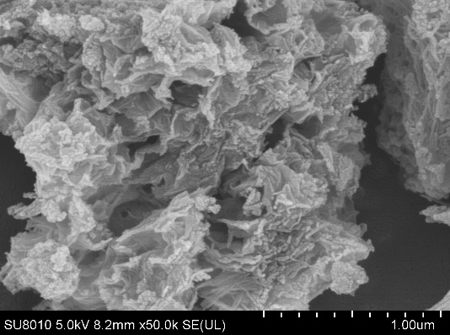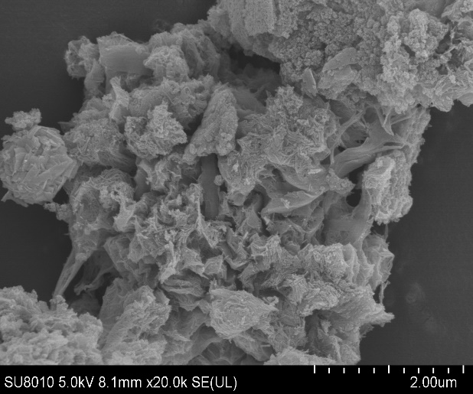
(a) (b)
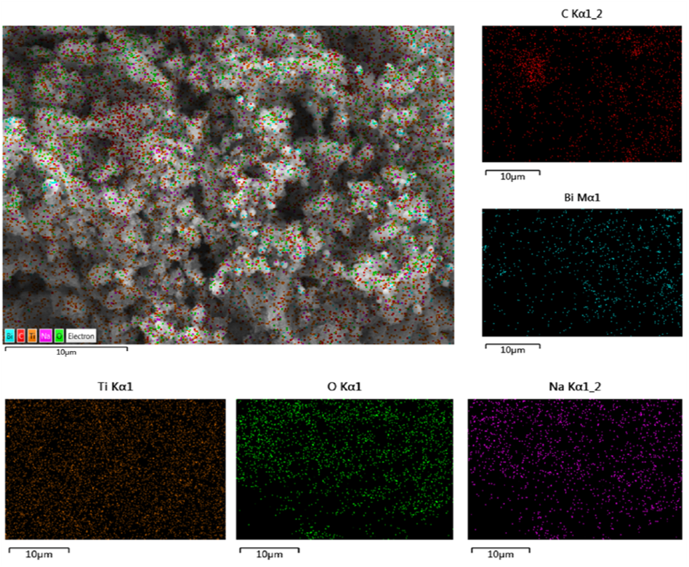
(c) (d)
Fig. S3. (a, b) FE-SEM images (scale bars = 1.00 and 2.00 µm, respectively), (c) EDS mapping, and (d) SEM-EDS spectra of 3%Bi/TNTs@AC.

(a) (b)

Fig. S4. (a) N₂ adsorption-desorption isotherms and (b) pore size distributions of TNTs@AC and Bi/TNTs@AC with various Bi contents calcined at 550 ºC.
Fig. S5. Adsorption kinetics of GenX by treated AC and 3%Bi/TNTs@AC. Experimental conditions for kinetic tests: initial GenX concentration = 100 µg/L, material dosage = 0.5 g/L, pH = 7.0 ± 0.1. Data are plotted as the mean of duplicates with error bars indicating relative deviation from the mean.

(a) (b)
Fig. S6. Adsorption equilibrium isotherms (Ce ≤ 2 mg/L) based on mass uptake (a) and unit surface-area uptake (b) of GenX by treated AC, TNTs@AC, and 3%Bi/TNTs@AC. Experimental conditions for kinetic tests: initial GenX concentration = 100 µg/L, material dosage = 1 g/L, pH = 7.0 ± 0.1; Conditions for isotherm experiments: initial GenX concentration = 0.1-100 mg/L, material dosage = 1 g/L, pH = 7.0 ± 0.1. Data are plotted as the mean of duplicates with error bars indicating relative deviation from the mean.

Fig. S7. Zeta potential of 3%Bi/TNTs@AC and 3%Bi/TNTs as a function of pH.

Fig. S8. Photodegradation and defluorination kinetics of GenX pre-adsorbed on 3%Bi/TNTs@AC under 8 h UV irradiation. Experimental conditions during adsorption: initial GenX = 100 µg/L, material dosage = 1 g/L, pH = 7.0 ± 0.1; Conditions for photodegradation: UV intensity = 210 W/m², pH = 7.0 ± 0.1. Data are plotted as mean of duplicates with error bars indicating relative deviation from the mean.

(a) (b)
Fig. S9. (a) EPR spectra of DMPO−O₂^{·−} adducts produced by TNTs@AC and 3%Bi/TNTs@AC upon UV irradiation for 20 min, and (b) EPR spectra of TEMP−¹O₂ adducts produced by TNTs@AC and 3%Bi/TNTs@AC upon UV irradiation for 20 min.

Fig. S10. Photoluminescence spectra of TNTs@AC and 3%Bi/TNTs@AC.

Fig. S11. LC-MS/MS chromatograms showing two major intermediate products (PFA (C₂F₅COOH) and TFA (CF₃COOH)) after 4 h of GenX photodegradation on 3%Bi/TNTs@AC. Experimental conditions during adsorption: initial GenX = 1 mg/L, 3%Bi/TNTs@AC = 2 g/L, pH = 7.0 ± 0.1; Conditions for photodegradation: UV intensity = 210 W/m², reaction time = 4 h, pH = 7.0 ± 0.1.

References
De Vleeschouwer, F., Van Speybroeck, V., Waroquier, M., Geerlings, P. and De Proft, F. 2007. Electrophilicity and nucleophilicity index for radicals. Org. Lett. 9(14), 2721-2724.
Frisch, M.J., Trucks, G.W., Schlegel, H.B., Scuseria, G.E., Robb, M.A. and Cheeseman, J.R. (2003) Gaussian 03, Revision C.02,
Oláh, J., Van Alsenoy, C. and Sannigrahi, A. 2002. Condensed Fukui functions derived from stockholder charges: assessment of their performance as local reactivity descriptors. J. Phys. Chem. A 106(15), 3885-3890.
Parr, R.G. and Yang, W. 1984. Density functional approach to the frontier-electron theory of chemical reactivity. J. Am. Chem. Soc. 106(14), 4049-4050.
USEPA. (2018) Human health toxicity values for hexafluoropropylene oxide (HFPO) dimer acid and its ammonium salt (CASRN 13252-13-6 and CASRN 62037-89-3): Also known as “GenX Chemicals”, https://www.epa.gov/sites/default/files/2018-11/documents/genx_public_comment_draft_toxicity_assessment_nov2018-508.pdf

