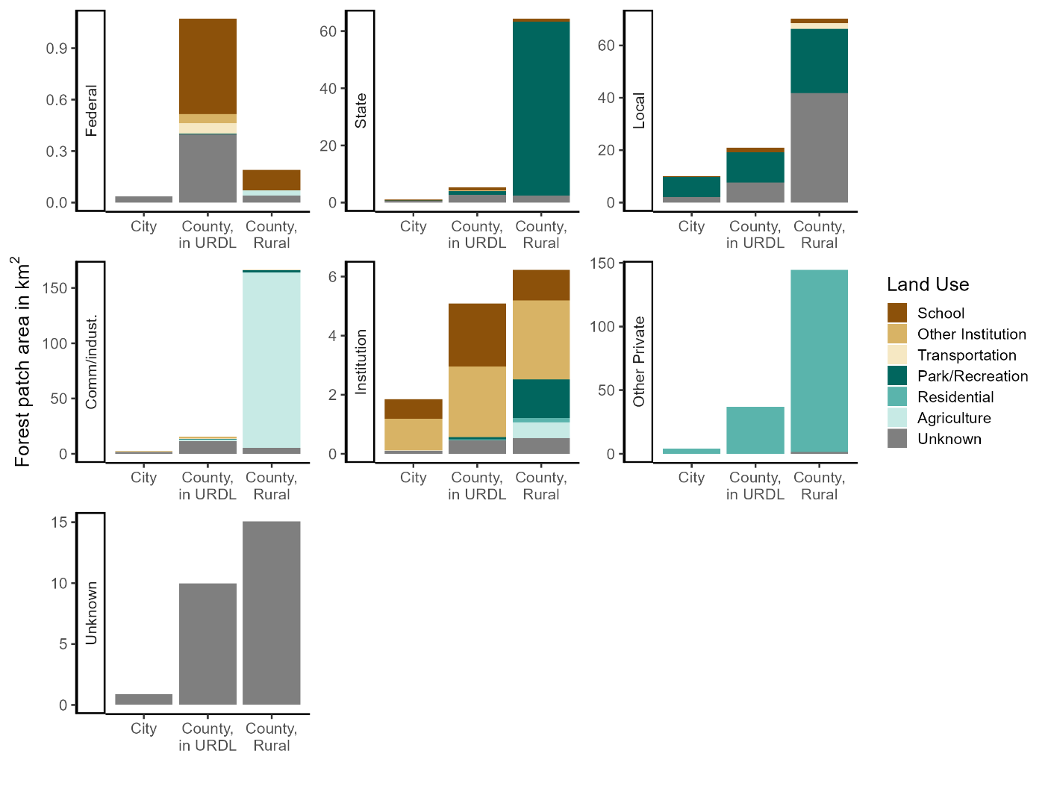
Supplemental Figure. Forest patch area by six types of ownership and six types of land use, with varying y axes. Publicly owned land includes land owned by federal, state, and local government. Privately owned land includes commercial/industrial ownership, institutions, and other private ownership. Institutional properties were those owned by educational, religious, and other non-profits, while commercial/industrial parcels were zoned separately. The other privately owned properties were zoned as residential. For land use, transportation includes infrastructure such as bus stations, railway, etc., park/recreation includes parks and open space, golf courses, pools, and recreational facilities, and other institutional use includes hospitals, nursing homes, churches, libraries, and cemeteries.

