A Self Prospective
By Tracy Staples

Senior Art Thesis 2016-2017
Thesis Director: Laura Burns
Committee members: Edward Worteck and Juliette Wells
May 9, 2017

CONTENTS

Perspectives......................................................................................................................1
Dear Me...........................................................................................................................21
Dear Camille....................................................................................................................23
Dear Bill...........................................................................................................................29
Dear Daniel......................................................................................................................31
Dear Elias.........................................................................................................................43
Dear Elora........................................................................................................................49
Appendix A: Images for Exhibition..................................................................................53

Perspectives
This is my story. Well, this is part of my story. No one can ever tell the whole of someone’s experiences; there are too many sides, too many layers, too many facets that can sometimes create the illusion of shallowness or depth. But this is the story I need to tell. It’s how I’ve seen things, how I’ve lived through them, and how I’ve come to look at them as a survivor—as someone who has survived to live on, to live a better life mostly free of what plagued me in my past.
Of course, I never thought I would consider myself a survivor. I thought that was for people who lived through cancer—or shark attacks. It strikes me as a word I am not allowed to use. I worry that calling myself a survivor is pretentious or presumptuous, like calling myself wise. I’m not wise. I have become wiser, to be sure, but I do not exist as an entirely wise being. And maybe that is what’s behind my hesitation about being a survivor, too; I know I am not done surviving.
But I’ve gotten this far. And this is, in fact, quite far. I am, during the writing of these words, quite far from my birthplace in southern New York. I am just as distant from many of my former friends and classmates. But I am even further from the community I became a part of as an adult, farther up in Vermont. I often feel too far from the people who have considered me a family member for nearly a decade now. And I am so far beyond the former limitations of my perspective as a struggling, depressed, and very ill teenager that I sometimes find myself speechless. Not wordless, of course, but relatively unable to speak in a way that will help people understand just what it means for me to be where I am now.
There’s a lot to see between then and now.
* * *
I have always been fascinated with the perspectives of others. From the first moment I considered someone else’s story, I wanted to know about other people’s points of view. I wanted to know the story of the woman I saw outside a grocery store with my mother when I was 12. Was that woman carrying all those grocery bags by herself feeding a house full of people? Why was nobody there to help her? Did she have two sons or three? I was sure she had sons. And I suspected her husband was lazy and unhelpful, if she still had one.
For a while, I was less interested and much more reluctant to consider different facets of who I have been and who I am now. Such vulnerability leaves me open to the cannibalistic predators circling within: shame, guilt, disgust, fear, depression, loneliness. They are the foul bacteria in my gut, further souring every negative experience and ensuring a physical and emotional weakness that perpetuates the cycle. I try to eat enough yogurt to combat them and remember to take deep, calming breaths when I feel them burning up toward my heart. I don’t like to imagine all of the damage they have done over the years.
But I have learned to look anyway. I have learned that the perspectives of others and the truths within me are edifying; they build upon a foundation that has survived everything thus far. Those realities make sure that I will not crumble entirely from the weight of those well-fed flesh-eaters. My foundation is stronger because of the fears I have already shed and the anxieties I have already battled.
And it is time again for me to consider what is buried within. It is not all bad in there, after all; because I am not altogether any one way of being. I am made up of mirrors that reflect and project, sponges that absorb and sometimes contract. Sometimes there is mold and rot; sometimes there is light and beauty.
* * *
Everyday forgiveness is key. That is, every day, I have to forgive myself. At one time, I thought that every day I had to ask for forgiveness; I had to beg for it, earn it, deserve it. But I’ve come to believe two things: First, true forgiveness has nothing to do with the person being forgiven. That person does not earn it or deserve it; the person doing the forgiving simply forgives them—or doesn’t. Second, and perhaps most importantly, nobody “deserves” anything. It’s an ideal—like peace or justice or logic—the belief that someone deserves something. You can say that someone should always deserve love, but that’s not an indicator of how likely you are to have love of your own in your life.
The beautiful result of this belief of mine, though, is that while I can’t righteously rage against someone not giving me what I deserve, it also means that I don’t deserve my self-loathing. It means that I don’t deserve being berated by the voices in my head. I still don’t deserve to be emotionally neglected by my parents, and never did.
In fact, I didn’t deserve to lose my first child before she ever took her first breath. I didn’t deserve the excruciating physical and emotional pain that led up to my holding her 12-inch, 12-ounce, unfinished body in my arms. I didn’t deserve to have a third, unexpected chance at having a child end in an emergency hysterectomy eleven years later, either.
And I don’t deserve to wake up every day, feeling the weight of all my faults and failures so fully that I don’t even want to get up. My aches and pains are real. My depression is real. But I don’t deserve to lose another moment of possible joy—not due to the fear of what might happen, but because I thought that I did not actually deserve such joy.
It’s all subjective and relative, of course. But if believing that no one deserves anything means that I can be more accepting and less likely to wallow, then I have a belief worth holding onto. And in holding onto that conviction, it means I am free to let go of all those fears. It means I am free to forgive myself. It simply means that I can be free.
* * *

I’ve been putting this off because it’s hard. It’s hard talking to you like this; as hard as it is easy, I suppose. People might read my words and ask, “Who is the ‘you’ in this piece?” They want to know if it’s a loved one, a friend or spouse, or maybe the spirit of the narrator. They’re digging for a truth they think I’ve hidden. And it feels strange to me, because each time I want to ask, “Don’t you know? Isn’t it obvious?” Don’t they talk to the same “you” too? Don’t they sit down from time to time, to write and talk to the “you” who knows exactly what they’re talking about?
It’s hard not to talk to you. It’s hard not to talk about you. You’re the subject I know best. You are me. You are who I am now, as well as who I was before, and who I will be in the future. The words I write are framed in this moment, but in the next moment they will become inanimate and unchanging. The words have become text. They are strung together this way and will likely stay forever this way—well, perhaps after some editing and revision.
But you are not stuck. You are not unchanging. You were once a child asking the same questions your own child now asks you. And you remember better than anyone how you have thought, how you have felt, and how you have gotten to this present, the now in this story. But the best part is that you will return to these memories, the really old ones as well as the newer ones, and you will take them with you. And they will continue to change with you. These words will not be stagnant in you.
That all applies to the other people in “you,” too: My “you” is not the only person in the world who understands what I’m talking about when I write about pain and fear, love and loss, joy and despair. Everyone understands confusion. We all know what it’s like to look back at something we’ve done or said and wonder just what the hell we were thinking. And that is why I write. I write to “you” because it includes all the other people who will read this as much as it is the “you” who I am now, or who I will be, someday soon. I write so that we can all look at what we’ve done and grow from the reflection. It sounds a little too noble in a way, maybe, but it’s the truth as best I can tell. And it’s a good truth to have, for someone with a lot of truths I don’t particularly care for or love. But this truth, whether honorable or not, is one I like to share; it’s a truth I can honestly say I am proud to have as part of my authentic self. Stories are everything; reflection is necessary; words matter—these are all true, and they are all part of my sense of reality.
So maybe now you can understand. All of you who are reading—those who are reflecting, right along with me, as well as my future self—all of us are learning as we go along. We are all trying to understand just a little more about ourselves. And I love that shared reflection. I love our shared journey. That is why we tell our stories. It is why we are compelled to tell someone about what we think of as our worst truths, as well as our noble ones. It is why we turn to the words and experiences of others: to be less alone with our own.
I am less lonely because of you—you are my dear reader, my confidante. My heart feels less burdened, knowing you are here to listen to my stories, to follow me to the dark places and hold my hand when I push open another heavy door, fearing what will be behind it as much as I am hoping it will not be as bad as my suspicions. I only need to remember that I am never alone; you will always be here for me. And you are here to help me reveal myself to others. You are here for all of us.
But first, you have to help me. You have to help me focus so that I don’t lose sight of why I am here. I’m doing this to turn myself inside out, after all, and I don’t want to half-ass it. I don’t want to get halfway through, get distracted, and end up raw and vulnerable, exposed without the benefit of consideration and acceptance, and maybe some closure. I’m doing this so that all those memories that I buried so deeply, so long ago, will see the light of day. It’s become too cold and dark in there and it’s time to dig out the mess and let some warmth and light in. The work is always hard, but it’s never as bad as I think it will be when I’m putting it off; and the results are often so beautiful, so valuable, that I can’t help but want to make some more progress.
Still, I have to be willing to look a little closer. I have to look back, not only at the little girl I once was in my general recollection—the one full of dreams and laughter and unshakeable sass—but also the girl who wondered why her father liked to chase her until she panicked. The girl who became terrified every time she woke up to an empty house, once again discovering that her mother had left her to sleep in and did the grocery shopping without her. I have to wonder why that girl was always on the verge of fear. I have to get very close to her again, without losing sight of the knowledge I’ve gained since then. I have to see more than just my memories, so that I can get closer to the larger truths.
I was always aware of being alone—and fearful of being alone, too. I did not trust the world to protect me, and I didn’t think I was all that strong or capable, either. Being alone meant that I was vulnerable—I could be preyed upon, just because I was innocent. At least, that was what I had learned.
I did not enjoy being an only child. I did not enjoy the silence that threatened to envelop me if there was not another person nearby. I knew I needed people to survive and I thought it was beyond strange, and perhaps a bit cruel, that my mother would not give me siblings. She didn’t seem to understand: I needed someone else. I needed more people who loved me; I needed more from the people who already did.
My mother was always saying she was too tired and too old to play with me. She just wanted to read her paperbacks, mysteries and romance novels. She just wanted to be somewhere else. And because that left me alone, I wanted to be somewhere else, too.
My father was always somewhere else, either working or at his hometown bar. When he came home, he just wanted to take his shoes off, unload from the day, and read the newspaper during commercial breaks. He had to read the whole paper before the end of the day. He needed information.
He was good at filling in spaces where his own experiences might coincide with the experiences of others. And I was always wondering why he never talked about when he was a kid, what it was like to grow up with a reckless gambler for a father, a harsh alcoholic for a mother, and a wild little brother that couldn’t be trusted. I wondered why none of his stories came from his childhood; why it seemed that he had so little share.
He never told me about how his father killed himself just a little more than a week before my father’s 17th birthday. He never told me about how his mother tied his brother Greg to a tree in the backyard because he was always wandering off. He never told me what it was like to grow up in a small town, everyone knowing that your father had committed suicide in his mistress’ garage. He didn’t tell me why his mother wanted to be called Pat, even though her name was Frances, or why she made sure nobody remembered how old she was, even though she never let anyone forget her birthday.
He didn’t tell me any of those things, but my mother did. And it would take almost three decades for me to find out how many of the details she got wrong. She had always told me that my grandfather had shot himself, but it was actually carbon monoxide poisoning from running his car with the garage doors closed. She had told me that Pat’s parents had spelled her name wrong and that her birth certificate said Francis, the masculine form of the name. But when I helped my father clean out her house after her death, there was no evidence of her name being misspelled. And it was there, too, in her drawers of important papers, that I learned how my grandfather died. All of which just makes me wonder now: Did my mother get the details wrong because she heard the stories from someone else? And if my father never told those stories to her, did he ever tell anyone about any of those things?
My mother told stories about her childhood, at least, and for that I was grateful; I thought she was an excellent storyteller. She told me about her favorite grandmother’s flabby underarms, the skin always softer and cooler than imaginable, even on the hottest summer days. She told me about developing a taste for stale toast in a house with four siblings, to the delight of the adults who had prepared it. She told me about running out in the rain with her brothers and sisters in their bathing suits to play in puddles. And she told me about how she and her siblings had believed that the fashionably baggy zoot suit pants my grandfather wore during their childhood provided extra protection and a better place to hide from their mother, who hadn’t been able to let go of a family tradition for corporal punishment. My mother told me how my grandmother, a woman less than five feet tall, held her oldest child, my uncle Fred, up against a wall when he declared, at 16, that he was now a man and she couldn’t tell him what to do anymore. My mother told me how her sister, Annette, the second oldest, was the most attractive; how her other sister, Susie, the third oldest, had the best hair; and her youngest brother, Willy, got away with everything because he was a surprise and my grandparents were tired.
Again, it would take me many years before I realized that there was something else to consider: So many of her stories never changed, no matter how many times she told them, not because she remembered the details so perfectly, but because she never reflected upon them or added any wisdom from the intervening years. Her siblings were the same to her in the present, when she was telling me her stories, as they were when those memories were unfolding in her past.
Fred was the funny one, but he was just as likely to be mean; it would be true of him until his death in his early sixties. Annette was always selfish and loud and aggressive; my mother didn’t see any changes in her from adolescence to her own years as a mother. Susie was a liar who only cared about her appearance; decades later, she still cared too much about her hair, had ridiculous high heeled shoes, and used vanishing cream, a clear sign of her endless vanity and superficiality. Willie was the spoiled brat who had everything too easy; as an adult, he was in the same field as my mother, yet he was pulling in a $100,000 salary each year while she looked for the best deals on used cars for less than ten grand. As for my mother, she was the practical, ugly, smart one. Not only the protagonist, she was also the victim in every story, every memory. She never had the upper hand. She never won a fight. She was always less than.
Her stories were the ones I heard the most and they had an effect on me that I wouldn’t be able to put my finger on for some time. My mother’s stories taught me how to fear people, how to be aware that trust was never unconditional. The people who were supposed to protect us couldn’t, or wouldn’t. In fact, sometimes they were the very enemy you feared. She also taught me how to look at life as a fellow victim: Bad things happened to us and it wasn’t our fault. We had be to kind, though, because there was already enough hardness and intolerance in the world. So you tried your best, but it was only ever a matter of time before someone let you down, hurt you, or left you. I learned to expect defeat.
My father had some friends: work friends, bar friends, hometown friends; they were more than acquaintances, but none of them were confidantes. My father didn’t have a best friend. My mother spoke of coworkers she liked and friends she had back in college, her best one becoming my honorary aunt and godmother, though Barbie never lived closer than 400 miles away from us.
But when we moved just before my fourth birthday to a small village twenty-five minutes from where my parents both grew up, they didn’t make new friends. I didn’t really notice, though, because I hadn’t learned how to make and keep friends either. Instead, I discovered that sometimes you were lucky enough to have people befriend you. And if you were really fortunate, they even stayed in your life for a good while. But more often than not, of course, they would drift away and there wasn’t much you could do about it. I learned that life was lonely, even if you did have siblings—they didn’t make anything better.
It seemed that because I was so desperate for a larger family, my mother directed a good amount of her meager energy toward showing me that having siblings did not equate having more love or having a better childhood. My uncle Greg was a great example: my father’s brother was too pathetic for words and just shy of useless. Of course, he had been raised abominably, but since my mother thought my father had turned out all right, Greg certainly could have been a better man. At the very least, he could have been a higher functioning alcoholic, like my father. If you were a workaholic first, you at least had the potential to be respectable. What could be worse than being an alcoholic, diabetic, out-of-work father of three? OK, sure, he was actually on disability, but he didn’t even take care of his diabetes correctly. Clearly, my mother got the better brother.
My mother’s siblings were also easy fodder for shedding a bleak light on having more kids. Annette was a selfish bitch. Susie was conniving. Fred always had to have the upper hand. Willie just got away with everything; there was no need for him to try to hide behind their father’s pants, even when he stole the car and got arrested at 14.
Siblings were hard. They weren’t nice to you. They didn’t play well. You didn’t grow up with a host of warm memories and an unbreakable bond. The connections were obligatory. You had to see each other, you had to share the same space, you had to make do before you got the hell out of there. Brothers and sisters were not there to make you a better person; they were just another aspect of your life that you managed to survive. That was it.
My mother was the first to go to college. That was what was truly important. She was the fourth child, the baby of the family for six whole years, but she made sure she stayed the good one. She only ordered the bare minimum of clothes for each school year. She only needed three sweaters and three skirts. She wasn’t like Susie or Annette; she was considerate and modest and frugal. She was sure that was why she was really her father’s favorite. He might have always given Susie money when she asked or given into any requests from Annette, but my mother knew that she had earned her father’s respect. That was what mattered: He saw that she was intelligent and valuable. He encouraged her to go to college; he told her she should pursue her interests in Biology, even though women in 1973 weren’t exactly flocking to the sciences.
She gave her father all the credit for all of her best decisions. Which was why it didn’t take long for me to wonder why he would ever have given his blessing for her to marry my father: Didn’t he recognize my father’s many faults? Didn’t this wise, sarcastic, brilliant man see how much my father was lacking in true awareness? Oh yes, he was always up to speed in current news. He always held opinions backed by reported evidence in the Daily News. He knew lots about baseball. He held a stable job as a manager at a family-owned hardware store in the town he grew up for years. He was hardworking, and therefore decent enough.
But my father was not kind. He could be funny, but too often he made my mother the butt of his jokes. He mocked her and ridiculed her, knowing that everyone thought she was too smart for him. His friends had warned him: She wouldn’t want to sit at the bar with him every night; she would want more; she was over his head. But he would show them; he knew how badly she wanted him, too.
Yet if his friends considered their intellects mismatched, then what did my grandfather see? Maybe he just saw his inverted daughter elated to have someone to love. Maybe he recognized their shared desperation—each of them afraid of never marrying and ending up alone—and wished them all the best. Maybe that’s all any father can do.
Except that, when it came time for my mother’s beloved husband to become a father, she had no idea how inadequate he would be. And at first, I suspect she didn’t really care. She could laugh at his holding out a little shirt to a six-month-old version of me, waiting for me to put it on. She could laugh at how poorly he handled the spit-up, projectile vomiting, and foul diapers. She didn’t mind doing it all for me, though; I was already the most precious person in her life. I still see her bliss in the pictures from those years. She adored me then.
But it was less funny or inconsequential that he still wanted to stay at the bar every night after work, even though he had his own family to go home to after a few years. It was ridiculous when he blamed some of his drinking habits on the fact that she didn’t make him breakfast in the morning. It was almost unacceptable that he wouldn’t push for a raise or help more with bills.
And in time, without my mother’s consent and certainly without her willingness to perceive it or name it, she became lonely, after all. She had a husband and a daughter. She had a good job. She made good money. But they were renting the second floor in a rich couple’s house and she felt them treating her like she was there to serve them. She felt the warm olive tone of her skin giving them permission to tell her to help with their laundry or work in the garden.
My mother knew that it had been months after they began dating before my father revealed to his mother that she was half Puerto Rican. And not just half Hispanic, but also Italian and Czechoslovakian; she was the daughter of immigrants, and worse, those who came from the wrong countries. Hers had been the darkest family in the neighborhood when they moved to the suburbs and left New York City behind. It was the early 1960s and they were exotic, but not exactly revered for it.
Of course, my father was a mutt, too. His mother was pure Irish, but his father was a little bit of everything, though predominantly Irish, as well. I had learned how miserably the Irish were treated when they began flooding American shores after the famine, so it seemed peculiar to me that my grandmother could afford so much disdain for other minorities within just a generation or two.
But then my mother told me how irate my maternal great-grandmother, my grandfather’s mother, had been when my 17-year-old grandfather, Alfred, fell for the little Puerto Rican beauty in the neighborhood. My great-grandmother had actually pointed her out to him from their window, the story goes, but she didn’t expect him to marry her. She just thought her handsome son would enjoy a little fling before going off to war.
My grandfather’s Czech mother and Italian father treated my little Puerto Rican grandmother like shit for years. My great-grandfather only relented a little when she continued to treat him with quiet respect, even after he lost control of his bodily functions on their couch in his later years. He told her she was a good woman then. My grandmother, Elsie, was reported to curtly nod and say, “I know.”
* * *
I have all these conflated, conflicting, and confusing perspectives of the people I come from. I know my grandparents only through weekend visits as a child, when my grandmother’s mind was already losing bits to Alzheimer’s and my grandfather divided his time between mowing the lawn with his shirt off, doing crosswords in pen, and scouring catalogs with my grandmother for the best spices and dried Chinese peppers for their next authentic meal. He could be rough with her, yelling at her for how forgetful she was, yet I always understood that he loved her dearly. She was his Elsie. She was his good woman.
And she could be abrasive, too, muttering under her breath and calling him names, only to turn to him ten minutes later with such tenderness that I easily believed that marriages that lasted that long needed to be witnessed by every other person alive; everyone should see such devotion between two people last for so many decades. Of course they could be grumpy. Of course they could still have a predilection for terse retorts and jokes at someone else’s expense. But if unconditional love was the undercurrent of every passing moment—as I believed it was for them—then that was a life and a marriage well lived. What I saw between Elsie and Al was exactly what I wanted for myself.
They were my favorite married couple. I loved them bickering. I loved them laughing. I loved their fiery passion for each other. I loved the sense of humor they passed on to me.
But I can’t think of a single thing I loved about my father’s mother. I can’t recall a single time I felt loved by her. If I consider what she might have passed on to me, I can only think of a willingness to eat shrimp salad before holiday meals and a fair amount of well-made furniture that my own family now uses with aplomb. And that is worth mentioning, to me anyway, because of just how strict she was with her possessions when she was alive. Chairs were meant to be sat upon, not bounced off of or climbed on. Coffee tables and end tables were for sedate affairs, with coasters and doilies to protect the finish. Pat didn’t have a living room as much as she had a front façade, an area to view her proffered ideals.
Her reality was saved for the TV room and the kitchen. The kitchen table was always overflowing with cards and stamps, flyers and bills, important phone numbers and countless other pieces of paper that had at some point been deemed worth saving. There was only ever a space clear for her, though she made it possible to make room for one or two more if need be. She didn’t live like a woman sharing her home with four other people. But of course, she didn’t really share.
Pat liked to share only things that made you aware of your position, which was always beneath her. She was always happy to share her opinion, or her condemnation. She always let us know how much money she spent on our gifts. She reminded us how much harder she worked than other women her age. She thought I should know when I was 10 that it was in my best interest to switch to diet soda, because I was clearly in need of a diet. And her expensive hearing aids, always on the fritz, made sure that everything she said, cruel or subtle, was heard by everyone.
I don’t know much about my father’s father, though, beyond his name and now, how he actually died and on what day of what year. I know he had a car dealership for a while, Byers Cadillac and Chevrolet. My father said Granville had a pilot’s license, and sometimes a plane to fly his family to movie premiers where they saw actual film stars on actual red carpets. I know he gambled away and mortgaged everything he ever had and killed himself, leaving my grandmother to raise two teenaged boys with two or three mortgages to pay off, forcing her to work at least two jobs. I know he started the golf course club across the road from my father’s childhood home. I know he liked to drink and play golf. I know his people came from Nova Scotia. But I don’t even know if he had siblings.
* * *
I still don’t know if I’m an introvert or an extrovert. I thought I was introverted as an adolescent, but I think I was confounding my sense of shame and with a desire to not be seen, and thus be shamed again. Though I had reveled in attention as a sassy grade school kid, I felt only aware of what was wrong with me after puberty began having her way with me.
Plenty of teenagers can list off the things they’re embarrassed about; maybe it’s the shape of their nose or the length of their second toe. Maybe it’s as obvious as severe acne or as hidden as uneven breasts. But as far as I was concerned, there was nothing right about me. Asked in a drawing class to depict the facial feature we liked most about ourselves as well as the one we didn’t, I was embarrassed. I wanted my eyes to be my saving grace, but the school picture I used to copy them into my sketch book only revealed something I hadn’t noticed before: one eye seemed to be more open than the other, and the corresponding eyebrow had an even more exaggerated difference in position. I didn’t have to draw the eyebrows too, but still, what was I to make of this new fact? Was there not even one redeeming quality about my appearance?
Obviously, my nose was the worst feature of my face, apart from my horrendous acne, and in some ways it was far easier to capture its bulbous end and ridiculous width. Why was my nose so wide? Who gave me that? My mother’s nose seemed similar, but she didn’t have the same bizarre slope at the end, as I did. My aunt Susie had told me when I was five or six that I had a witch’s nose. “Look how pointed the tip is,” she said, after tracing my silhouette on construction paper one afternoon. Adults so rarely recognize how simple phrases can forever mark and mar a child’s mind. I had a witch’s nose. That was wrong. That was no good.
Still, I thought I was fairly all right up until fourth grade. My body began to change then. Puberty had been whispered about and alluded to for months, but the pamphlets and information the school sent home with girls had led me to believe it wasn’t time yet. I had not ovulated; I had not discovered yet just what menstruation would do to me. So I didn’t need to worry about that stuff yet. My mother had told me I’d grow hair in my armpits and pubic area, but again, that was a ways off, so I was supposed to still be me. But instead, my hair became coiled in springy curls the summer before fourth grade. My torso thickened and my shoulders suddenly seemed too broad. My father said I had shoulders like a linebacker. He laughed, seemingly relieved, saying, “I shouldn’t have to worry too much about boys around you. You’re bigger than they are!”
I remember looking at him and wondering why he thought that sounded so great. And I would hear his words a couple years later when he complained about the way I wet my hair before combing it back into a tight ponytail during the summer. He said it made me look like a boy. He said he wished I wouldn’t do that. I stared at him then, too. I looked again in the mirror, wondering what it meant that I looked like a boy to him. I wondered what it meant to be a girl with broad shoulders and apparently masculine features. I didn’t stop wondering until long after I became a parent, myself.
I decided I had to be six feet tall after my father started commenting on my physical changes. I told him I planned on being taller than him, by at least two inches. I wanted to make him feel small. I wanted to show him that I would be the strongest, broadest, tallest daughter he never imagined having. I would not be fragile. I would not be delicate. I would body slam the first motherfucker who got in my way. And then it wouldn’t matter that I was not particularly feminine. Then it wouldn’t matter that I actually felt soft—it would be better to be hard.
* * *
I started writing to myself a lot during this period. I wrote to my future self. I hoped I would read what I wrote sometime in the future and see something important, a minor transformation from one sentence to the next. I hoped that I was making efforts to improve myself, to capture moments of my present self for preservation, while also making it possible for my future self to see my growth.
I still do it. I write to myself, because who else knows me better? Who else has known my innermost dreams and desires? Who else can fully understand what I mean when I think of my prospective self?
But all of this is to change the answer to those questions. I don’t actually think anyone who reads this will suddenly understand everything. But I can offer some snapshots of clarity, and even more images with a shallow depth of field and faces out of focus. That’s all I have, though. That’s all any of us have, I suspect. But that’s fine. I like to share; I need to share these pictures and memories. And I need to tell the others, the most important people in my life, just what they’ve mean to me. Later, we can read the words again, and maybe we’ll all understand a little more. We’ll see the blurred lines, glares and reflections, and we’ll all know a little better. It’s all about perspective, and whatever truth you have.

Dear Me,
We’ve been waiting a long time for something like this. We’ve been hiding and hoping, wavering and balancing, craving revelation and cowering from the truth.
But we want to share and we’ve been working for a long time now to create the best ways to do it. We’ve learned to tell our stories with silly voices or sober tones. We’ve learned how to connect to other people who have similar needs and abilities. We’ve grown closer to others because we have learned to be more honest with ourselves about what it takes to make and keep relationships.
And it’s the growing that’s been so important, necessary, painful, and productive. The despair was very real, very deep, and very hard to survive. But the hottest compost typically makes the best nutrition for big, beautiful growth—and that’s why we’re here, now. That’s why some people recognize us now as someone worth knowing. We’ve shed so much of that early shit and now people see some beauty, someone to respect, a friend to count on.
But we’re not yet. There’s still thinning and pruning to do. There’s the daily tending and periodic fertilizing to maintain. Maintenance can still be difficult to keep up with, but there’s more we’re cultivating now. We’re still looking to find that sense of grace, that ease that comes with strong roots and frequent blossoms.
I want to acknowledge all that we’ve been through, all that we once could not imagine surviving. But I’m also so eager to keep pushing upward, forward, outward. I feel larger than ever before and I am embracing it. It is such a relief, really.
I felt small for so long. I was sure I was inconsequential in the “grand scheme of things.” But I have come to see my worth on an individual basis, on a timeline that spans moments of the present, and not just the past.
My prospects are good now because my past was not. Who I was, was not who I wanted to be. Now, I want to be me—at least more often than I don’t. I want to be here, now. And I so look forward to what will come.
I’m ready for the full light of the sun now... OK, full sun with dappled shade; I still burn easily, you know.

Dear Camille,

Part of me wishes you could read this—because there’s still a little girl in me that loves her mother unconditionally and feels sufficiently adored, connected and grounded to the world through the woman that brought her into it. But that littler girl is as real and accessible to me as who you were to me then and reflects little on who we are now.
I have memories of you, of your perspective. We had our time. We had more than many mothers and children get; I did not lose you until I was 25, after all.
I still think of it that way: as having lost you. We used to talk about how we lost your mom to Alzheimer’s long before we lost her to death. I lost you to unchecked mental illness for what will likely be decades before your death. You are lost to me—by your own choice. You do not exist in my life as a mother figure, a source of support or wisdom or maternal instinct. You are not my touchstone.
But I’ve had enough time to recognize that such a situation is not terribly unique. And as much as it hurt at the time to have you willingly, willfully remove yourself from my life, I’ve come to appreciate the distance. Neither of us was particularly healthy at our parting, but I would consider myself much stronger and much more loved than I could have even imagined then.
Is it a sort of Greek tragic irony, then, that you are at your heaviest and have osteoporosis? I don’t revel in your suffering, though. I think I have a fair idea of your struggles as they seem fairly similar to the ones I grew up watching you battle—those cycles of extreme will power and followed by caloric abandon. Like your mother, your body couldn’t handle the excesses and is suffering. And once again, you have chosen to flee, to try to move on from what you cannot ever sever from your life.
* * *
I still have pictures of you and your adoration of me as a child. Was the love so strong that the other extreme was always destined to become reality? Or did you just have so little left to give that you chose the junkie over me?
I suppose I am still a bit bitter. It’s robbing him of his humanity to only refer to him as “the junkie.” But from what I’ve experienced, I’m not robbing him of much. Still, maybe I’d be less bitter if the man who took my place and your devotion was an esteemed man of learning, business, fucking anything other than the nurse who got caught stealing opiates from the OR and then moved into your home two weeks after you met him. I think I’m worth more than him. I’m pretty sure I have the right combination of hubris and resentment to say I know that I was more worthy of your loyalty at 25 than he was 20 days into getting to know you.
But it really is OK. You got what you said you wanted; me too. I’ve got a family and an education and a professional network and a social circle so wide and fulfilling that I don’t have the time or room to think about you much anymore. Mother’s Day isn’t a day for me to grieve, anymore—not because you could do anything to soothe me, but because I did. I survived my grief. And I have survived you, just as you had to survive your mother.
It’s not like I can’t conjure up sympathy or understanding for you, I can. But as much as I’ve found ways to let you go, I still can’t seem to accept your choices. You chose to clear me out of your life, yet you continue to email me every few weeks or months. Why? What do they do for you? Do they give you some sense of connection?
For me, each message is like getting caught on a fishing hook. I wince and take a deep breath as I get ready to take care of it, pull it out, clean the wound, try to breathe normally again.
For me, you are a source of continued pricks and snags, a series of droplets of blood drying against my clothes and sure to hurt again later, when I inevitably tear the fabric off my skin and open the wound up again. Do you do that on purpose? Do you have any awareness or perspective of your place in my life now?
I have let my heart grow cold when I think of you now. I cannot forgive you yet. You are still making the same painful choices, still pretending to be oblivious, deaf and blind while you force your fingers a little deeper into your ears. You’ll pop an eardrum before you ever open your eyes.
I can’t help but look forward to the day you are too old or too weak to keep up your willful ignorance. I want you to apologize. I want you to be sorry. I want you take responsibility for the pain that you caused, the pain that you continued to inflict year after year with your shallow entries into my consciousness. I want the weight and reality of all of your shitty decisions to rest directly on your neck and shoulders. I want the shame and sorrow to force your chin onto your chest. When you look like my father, when you own your deeds as he did on his 60th birthday, maybe then I could let you go completely. Maybe then I could feel fully free of you.
* * *

Dear Camille,
I still don’t know how to start a letter to you without thinking about your series of emails to me over the last decade or so. I don’t know you anymore, after all, so that makes it hard to say much of anything that would be meaningful, I guess. Except that’s not entirely true—I can write and say things that are meaningful to me. I might even write things that could be meaningful to other people who will read this one day. We all know you are no longer my intended audience, anyway.
You were my biggest fan, my audience of one, for most of my childhood and early adulthood. Whether you meant to or not, you were the person I interacted with the most. I resented it when I was younger, but I didn’t know how to express my frustration with being cooped up with just you all the time. I just knew that I wanted more time with friends and kids my age, and less time watching you read or watching TV with you at home.
I wondered why you were always so tired. I wondered why you didn’t tell me about all of the opportunities for fun with friends and extracurricular activities that other kids participated in and knew about from their parents. I wondered why you weren’t engaged or interested in helping me grow; I didn’t know that’s what was bothering me, but I have the language now. But I knew you weren’t really with me. I knew you’d rather not have me begging for your attention, your focus, your concentration.
Instead, in front of you my father, I grew fat and unhappy. My joy and vitality gave way to fear and anxiety. When I confided in you, you were dismissive, while also making it clear to me that asking for help was loaded with negative connotations. To you, struggling and despairing was just a part of growing up. To me, I heard an underlying message to turn inward, keep quiet, pretend everything was fine, and just pray you could wait it out—just like you had done.
But what other advice could you give? You didn’t think there was anything wrong with me following in your footsteps. You could only speak to your own experiences, your own form of survival. Because you did survive, didn’t you? You made it to and then through childhood, wifehood, motherhood, middle age. But you also didn’t know anything about thriving. You were still searching and flailing, reaching for a sense of fulfillment and hoping you could find it in yet another career, yet another position, from year to year.
Did you ever find it, that fulfillment you were seeking? It seems like you finally gave up on your diets and strange regimens to lose your belly and gain some personal strength—the kind not built from lifting your two-pound weights, though. And certainly you’ve climbed your professional ladder, gaining other kinds of power and respect in your final area of employment.
But are you fulfilled? Despite your osteoporosis and your second husband’s chronic problems; despite that you essentially cut your only child and grandchild out of your life; despite that most of your other family members don’t really hear from you or know you anymore either; do you consider yourself personally fulfilled? What did you fill yourself full of?
You made your bubble; you’ve been living in it almost solitarily now for nearly a decade. What’s it like in there? Last time Daniel and Elias saw you, they said it was smoky and messy and damp and off. I used to be curious about it because I didn’t understand why you didn’t want me to be a part of it anymore. Now I wonder because—because I’m afraid I’ll follow your lead someday. Dementia and Alzheimer’s run strong through our female forebears, after all. But I don’t want to end up like you, in a funky bubble of squandered dreams.
I look at my son, my only child, and I wonder if one day I will look at him and feel the need to sever him from myself, my daily life, to make sure he feels entirely separate from me—though maybe you were actually making sure you felt detached from me, regardless of how I felt. But to think of it creates incredible pressure in my chest; as if my heart must steel itself for what is to come. But is it preparing for impending pain or holding strong to prevent unnecessary grief?
I used to think that I would already be like you by now, telling my own child that I was too tired to interact, play, talk, or consider him in the present moment of his childhood. I used to think by the time he was six, he would have his parents’ ages memorized as I did so that he knew how much time there was before he would be too old to enjoy life. You didn’t mean to send me that message, I suspect, but I don’t think you realize just long you’ve been tired for reasons unconnected to age.
Now I think about how I will always be of you and I will always be like you in a myriad of ways that I am likely to be only minimally aware off—but none of that means that I am doomed to become you. At the very least, I think I’ve made my bubble much bigger than your was at this age. There’s room in mine for friends and help, personal growth and fulfillment, and even dreams and failures. And there will always be room for my son; I will always let him in.

Dear Bill,

You taught me the right way to throw a real baseball.
You taught me how to use my teeth to open a closed pistachio shell.
You taught me that people can change unexpectedly.
You taught me how to make an effort, even when it’s not in your nature.

You said you would take me to my first major league game.
You said you didn’t know if I could be trusted.
You said you were ecstatic when I called you on your 60th birthday.
You said you were over-the-moon proud as I earned my degree.

You liked to chase me until I cried.
You liked to tickle me until I begged.
You liked to present me to your friends.
You liked to make me laugh at bad puns.

You were the first person I ever loved and feared.
You were the first person to make me hide.
You were the first person I learned to forgive.
You were the first person to cry when you held my son.

You were the last person to go to bed at night.
You were the last person I expected to be at my wedding.
You were the last person I called in a good mood.
You were the last person I needed to thank for continued support.

But I still don’t want to hear about your digestive issues.
And I still don’t know how to forget it all.
* * *

Dear Bill,
You came around. You came through. I really wasn’t expecting it.
I wasn’t expecting to forgive you, either. I didn’t see that coming. I thought cutting you out of my life was the single best thing I had done for myself.
I thought I was better off without you, because then maybe the pain and resentment could finally fade away.
But after two years, I let you back in, and you surprised me.
Now it’s been almost ten years and you haven’t done anything to make me regret it.
All the same, it’s hard for me to say much to you.
I hope you understand.

Dear Daniel,
You remember the beginning. You remember all your favorite moments, the stories you’ve told repeatedly. You remember how we met, how our second date ended, how I embarrassed myself that night at Bobby’s trailer.
You thought you were saving me. You thought you were changing my life like the hero in every fairy tale. You thought your love for me lifted me up, beyond the remnants of my adolescence, my lost dreams—right into a whole new atmosphere.
Music helped bring us together. Music helped keep us together. You heard your past, and we listened to our present, imagined our future. Each period of despair was punctuated by the same songs, layered with your remembered pain. The feelings well up and flow over. Once again, you are vulnerable and bare.
Tonight you broke open and cried. But I didn’t look you in the eyes. I didn’t want to see that fleeting truth in you. I didn’t want to remember how little I see of it now. I didn’t want to feel my unconditional love for a soul that you don’t like to show too often.
You hide it all away now. You protect that fragile inner self with a barrage of blame, projectile misery, hazy phrases and mixed emotions.
I always clamored for you. I always wanted more. I thought I accepted everything and then tried to distill it into strong love. But now my throat is burning and I can hardly hear you. Everything is so blurry now. Didn’t I always have reservations? Didn’t I always suspect that it could be like this?
You say you’re committed—but not yet. What you mean is not what I’m saying. And I can’t figure out what you mean, but I keep hoping you mean to love me.
* * *

Dear Daniel,
Why don’t you ask for my forgiveness? Why is it expected, while you cannot offer me anything beyond resentment and the occasional, begrudging allusion to an apology? Your mother once suggested that it was because I had assured you of unconditional love—that you understood that you could do your worst and I would have to accept it as part of the person I loved. Your mother, chuckling while also sounding a little reproachful, said I shouldn’t have told you, that I should stop telling you I loved you no matter what. She said that maybe, if you didn’t expect forgiveness regardless of what you did, you might be a little more willing to be accountable for your actions, your words—everything that comes in the wake of your rages.
It seems like you only want to focus on me, what I do, what I do wrong. But that’s all wrong—your attention doesn’t help you see me any more clearly, let alone accurately. It’s as if you see someone still in need of your firm molding, your critical view, your hard-earned support. But I cannot align that perception with my own. At the very least, I have earned your support, and I should not have to enumerate the ways. At the very least, you can respect me, and all of my choices, because you love me as I am. And because it does not feel that way at all; because I do not feel that you love me despite my faults—those you count and those I don’t—I find myself considering alternative perspectives.
I can envision my best-lived life. Some nights, I stay out late with a dear friend and sleep late the next morning. Some days, I wake up inspired and full of energy, making sure to be active with my son while still accomplishing the tasks on my ever-present to-do lists. Sometimes I am spontaneous and ready for a day of adventure. Sometimes I am reflective and introspective and want to sit on the back deck, letting my mind create this stream of words that my fingers rush to capture on pages either tactile or virtual. I have spurts of dedication and momentum. It works for me. I like it just fine. It’s not the way you work; your energy is more sustainable, your mind set on endurance and completion. I opt for good enough, not because it is the best I can do, but because my tendency to put everything in terms of success or failure makes perfection a goal too ornery to contend with if I want any inner peace at all. It is the compromise I give myself almost daily; it is the result of years of impotence and failure and stagnation and despair, with a smattering of therapy and acceptance. I cannot give all or nothing. My all is often not very much, in the scheme of things, and the nothing that follows because I am depleted hurts me too deeply.
I thought you knew all of this, though. I thought that after ten years you understood the patterns, the reasoning, the still-painful sense of loss. I know I am slow. I have had to acknowledge and accept all of my short-comings and changes.
For a short time, I was an active and vivacious participant in life. Now, I try to enjoy the often fleeting traces of that existence. I am grateful to have survived years of suppression, both self-afflicted and circumstantial.
I am grateful. I feel the sun on my back and I am glad. I feel good music pumping through me and I am alive and aware and joyful. I dig my fingers into dirt to weed or plant and I feel purposeful and powerful and a part of life. I snuggle deeper into my pillow or closer to a beloved pet or person and I feel so wholly safe, secure, satisfied. I don’t feel a vast void begging to be filled. I don’t hear the critics and cries of my past, banshees of regret and resentment.
And yet, somehow, you look at me and want to spar. You want to jab with accusations of laziness and ineffectual efforts. You tell me how I have wronged you, how I keep coming up short of your expectations, how resentment so deeply embedded in your nerves has made it nearly impossible for you to accept my good enough, my gratitude, my preference for the path of least resistance.
But you’re so clearly wrong about that preference, at least: I chose you. I chose a partner comprised almost entirely of resistance. When you are closed to me, you resist my ideas, ideals, beliefs, values, logic, affection, compassion, concern—nearly everything I think I am. And you tell me to go find another partner, go find someone else who will respect me and not mind that I am slow, that I get sad, and that sometimes, I don’t try hard enough. Is it that you think that I can’t find someone else or is your greatest fear that I will? Is it all projection? Or is there a nucleus of lucidity somewhere inside you that recognizes how toxic that is? Which is it: that I absolutely deserve your conception and application of love? Or that I deserve to be loved and respected unconditionally?
It’s neither of those, you know—actually, do you know? Do you see the spectrum between black and white? Do you see the millions of shades and hues that exist between and beyond the two? I wonder if you think I am asking for too much. I wonder if you think I am asking for more than you are capable of, just as I know you typically ask more of me than I can give. I think we have both lost an accurate perception of each other. I think we both find it difficult to look at each other without seeing a thousand past moments of anger and pain.
But I sit here now, listening to the birds sing about the day, the weather somehow perfectly comfortable to me, and I realize how much I have learned from being with you, from relying on you. I was acutely aware of how much I needed you early in our relationship. I needed you to do all the hard jobs, in and out of the house—and under or on top of it. I needed your energy and exuberance. I needed your experience and abilities. I needed your strength to prop me up after every new hardship, every new hurt.
I used you. A lot. I just didn’t know that I was also using you up. Your patience for me seems to be gone. Your sense of humor has been drained. Your respect, compassion, and mercy are now typically absent. There is so little of what I fell in love with left in you—for me, anyway. I see your generosity still exists for others. I see your willingness to help and share and give to friends and family.
And I know you think that the ways you are now empty is because I didn’t make an effort to fill you back up. I have been hard on you, hard for you. I have hurt you. But I also thought that I kept trying to love you well. I tried to make sure that my efforts were acknowledged, so that when they were small they weren’t missed; so that you could be aware of an accumulation of small gestures, earnest affection, meaningful expressions, and know that I was doing what I could to keep you from running dry.
But we have always been different gardeners. You aim for extreme effort early, then minimal upkeep. You like a routine. You like to be able to stick to specific quantities with no need to diverge from your chosen course. I like flexibility and no deadlines. I enjoy sporadic, seasonal efforts rewarded by continued, perennial growth. I love the consistency of my blooming houseplants mixed with the waves of color and life in the world at large. I appreciate the cycles and you remind me to supplement them with periodic fertilization.
Yet the hibiscus is dead. The front garden is mostly bare. Where we have not both put in concerted effort, the failure is clear, and desolate.
* * *

Dear Daniel,
From the moment I realized I loved you, my goal became to love you better than Catherine had loved Heathcliff in Wuthering Heights; I just didn’t realize it at the time.
You see, all of the silent vows I made to myself as I grew up were exceedingly important to me—like thinking I had to have a baby by 27 so that I wouldn’t be as tired as my mom always said she was when I was little; or promising myself that if I was lucky enough to be so deeply, spiritually loved the way Heathcliff loved Catherine, I would not be so arrogant or crass as to throw it aside for someone easier to manage. I had to do better than she did. I had to avoid her pitfalls.
I began searching almost as soon as my adolescent hormones had begun throbbing through my erogenous zones to find him—my Heathcliff, my soulmate—but I didn’t know what he’d be like. I didn’t know what loving a living iteration of my imagined paramour would require of me. I thought I would know how to handle dark moods or passionate outbursts so long as I remembered the value of the love I was given. I could survive hard words or angry looks so long as my true love still wanted to kiss me all over and whisper his devotion to me afterward. I thought I could take a real person and align his facets with those of a character I seemed destined to love.
I thought I understood you through the lens of my literary interpretation. I felt sure that if I could just mold you ever so slightly, just here and there, my love would soften your sharpest edges over time. If I could wait out the smoothing process—something that’s called tumbling for a reason—the result would be smooth strength and beautiful indeed. Together, we would be a shining example of passionate lovers: dedicated, motivated, unified, edified, and truly loving of each other.
I had to read Wuthering Heights a third time, well into our marriage of metaphoric sharp outcroppings and gravel embedded into hands and knees, before a revelation began to unfold: You were my Heathcliff.
I was supposed to be a better Catherine; perhaps more like her daughter, Cathy Earnshaw. I was going to be playful but supportive, passionate but practical, loyal but rational. I would love you so well, you would become a new man. You had needed me, just as I had needed you. Together, we had planned to grow and become more than the sum of our parts.
But you are not Heathcliff. And I am not Catherine, let alone Cathy. You are Daniel. You have always been you. But I didn’t always see you before me. I too badly wanted to see my ideals embodied in you. I too desperately wanted you to see your ideals in me. And after we had both drained ourselves of patience and compassion for neither of us meeting the other’s expectations, we were left angry and fighting off despair. We were shells of our best intentions, our best attempts at fulfilling each other’s desires having left us exhausted.
It has taken us almost a decade just to begin to understand how to best communicate with each other. It has taken every ounce of our mercy and forgiveness to see beyond our built-up resentments, to lay down the crosses we’ve borne just to look each other in the eyes again. It has taken us weeks at a time to reflect and reconsider where we are going, and if we’re still going together.
Neither of us can downplay just how acute the agony has sometimes been. But the transformation, when it comes, is worth the growing pains. It doesn’t make us beautiful butterflies, but it makes it easier for us to feel more secure. We can see who we are now—better still, we can see each other again.
You are Daniel. You are the risk-taker, the project-starter, the big idea person, the muscle, the leader. You are also vulnerable to the sounds of beautiful music, the sights of injustice, the touch of self-doubt. You are all about crafting good smells and tastes, whipping up baked goods or creative entrees as effortlessly and confidently as you make love to your wife. Your irony is embodied in your skin, thick in reality but thin metaphorically. Your heart is easily wounded and your head keeps the records of who is to blame. Yet you are generous. Yet you have more love than any number of friends or family can ever use up. You get all of your joy from being with others; you get all of your fears from being alone.
And I am still here. Because I’m not like Catherine at all: I don’t leave. I don’t give up. And I don’t turn away from the other half of my love.
* * *

Dear Daniel,
There are so many things I want to say to you before you fully tune me out.
I see your pain. I see your struggle. I don’t know just how you feel, and if you could articulate just what you’re feeling, I know I can’t fully understand your perspective. But I keep trying—I keep trying to understand what you’re going through and exercise my empathy, focusing it on you. I don’t always do a great job, but I believe that I keep trying.
I don’t know if you think you’re empathetic toward me consistently or even enough, but I don’t feel it and I rarely hear it. Instead, I sense all the times you’ve struggled with trying not to hate me. I don’t understand why you feel justified in blaming me for your black moods or incredible rages. But I understand trying not to hate me all too well, which makes it all the harder for me to bear.
Oh yes, I have blame to bear, too. I have great mounds of remorse, much of it you’re probably unaware of or convinced I don’t really feel. I have hurt you, wounded you, cut you down. I have screamed in your face and told you to leave, repeatedly.
We have abused each other. We’ve assaulted each other. We have taken turns terrifying Elias and putting him in terrible positions of fear and confusion. We have been toxic to each other even as we also shared great passion for each other. The good stuff always felt really, really good. But we both ended up feeling like it was no longer enough.
Sometimes it felt like neither of us had the will power or motivation to do all the work that would be necessary for us to have a healthy relationship. I wasn’t sure either of us could do enough to make our marriage healthy. And though I always looked to your mother for hope, I didn’t think continuing that way was good for any of us, especially Elias.
And so we splintered and faltered and found ourselves trying gauge what we each wanted, what we though we deserved, what we thought Elias needed. We wanted the best for him; we knew he needed a home and family that he felt safe being in. We didn’t want him to be continually peppered by the shrapnel of our mutual anger.
The anger and apathy and deep wounds were too much for either of us to continue bearing. The cycle of abuse had to end. We couldn’t just keep giving lip service to doing better and becoming more.
We had to figure out how to go forward in the most respectful way possible. We knew that carrying torches for past hurts, behavior, failures, etc. wasn’t getting us anywhere. We wanted to move on and feel the difference in our lives, to finally get off our wheel of suffering.
It took weeks just to communicate our meaning, in fits and spurts, through calm reasoning and provocative persuading. It was like learning to ride a bike again—it’s not as easy as they say if you’ve lost your awareness, your inner balance, in between. But we kept making progress; enough at first just to be civil to each other, and even sometimes kind.
Now we’re still in the gentle stages, the ones that sometimes still include potholes of resentment or impatience to learn to avoid or get over. But neither of us wants to get back on that old cycle, that wheel of despair. We’ve seen the worst of trying to stay on something that’s disintegrating beneath us.
We’re ten years older now; getting off and walking is better for us, all around.

Dear Elias,

I wonder how old you will be when you first read this; I wonder if I can write anything here that could even come close to affecting you the way that raising you has affected me. Of course, my goals and expectations have always been a bit excessive, or at least exceeding that which is typically possible of me. To some degree, you already understand. You understand a lot—about me, your father, yourself, and the world around you.
I know your understanding won’t stop you from testing me, my love for you, and the boundaries you will inevitably discover as you grow up. But I’ve tried to prepare for your growth—having learned so much by struggling with my own. I want you to be clear about what is changeable in a person. I want you to know that working on your own behaviors and habits will likely be the most difficult undertaking of your life—just think of how hard it is has been for you not to bite on your finger when you’re excited or to remember to always cover your mouth when you cough! It seems like an infinite amount of practice, failure, and forgetting, but finally: Progress. It is attainable. It is possible to change the way you react; you have to be far stronger than you would imagine when transforming yourself, but it is absolutely something you can do. You are already strong enough. You know that your head does not have to get the best of you. And your heart is already so big, so full, so entirely capable of surviving and thriving—I hope I have at least helped you see that.
I know I should probably pass on some concrete wisdom, but I also want you to know how much you have taught me. Your perception is so clear. Your reasoning is so sound. Complexities seem not to faze you; you accept so much of life for what it is. You still struggle with a sense of fairness and justice that your logic tells you should apply to everyone; you wonder why some people have to suffer so much more than others. Unfortunately, baby, logic doesn’t create reasons that soothe and settle your heart, but your love will go a long way. And your natural clarity will bring you peace, just as your joy and vivacity keep you afloat during the turbulence.
If you are a vessel on an ocean of emotions and events, you are already fairly seasoned. I cannot regret how you have been tried and tempered by circumstances; because I think you would not be as strong or aware or understanding as you now are. And I cannot vow that no one will ever hurt you or that heart will never feel seized by seemingly unendurable pain. But I can assure you that I will always be with you. There is so much of me already in your heart. And always hold on to your happiness, your balance, your incurable curiosity, and your boundless imagination.
You are the most amazing person in my life and I am so incredibly honored to be your mother. Thank you for everything you are. Thank you for filling my heart with so much joy, so much hope, and so much honor. You have shown me the strength of my integrity and the depth of my capability. You are the product of all the best parts of me and I am unspeakably grateful to see them shining through you. I can never again feel like a complete failure, all because you exist.
You are my greatest success. The pure happiness of your spirit is the proof I once needed in order to believe that there was enough beauty and love in the world for me to forever hold off despair. You are that great and important in my mind. You are the greatest source of inspiration and faith that I have ever known.
Thank you.
* * *

Dear Elias,
I’ve been thinking about this a lot. I have to mention your eyes. Your eyes, my beloved child, are everything. Denim blues to hues of green to a ring of faceted brown: You have every color and layer of your genetic history in your eyes. The blues of your mother and both grandfathers; the greens of your maternal grandmother; the hazels and lager browns of your father, paternal grandmother, and many of the greats on all sides—these people all have a place in your eyes.
You have our laughter, our temper, our curiosity and ingenuity. You have our determination and resilience. You have our uncertainty and empathy, anxiety and confidence. You are as enigmatic as all of those before you, but to me, even better. You have the next generation of opportunities. You have the new frontier of success and awareness. You have a range of advantages and privileges unlike anyone before in your ancestry, going back for hundreds of years.
But baby, don’t see this as pressure or some nebulous set of expectations. If I were to admit to expecting anything of you at all, I would say that I anticipate that you will retain your joy. Don’t let the chaos of the real world dull your exuberance for life. Don’t think for a moment that anyone in the world would want you to give up your vitality for the sake of everyone else. Part of why you have always been so quickly and easily loved by those who meet you is because your joy is as clear and bright as your multi-colored eyes.
This is what I want you to remember: When you look in the mirror, take a moment to look into your eyes. Every fragment of color is layered around your pupil for you to see in your reflection. Every little bit you can see is part of the universe made up of your family—both the people you know and those you never will. All of the beauty and happiness that ever existed in the people you come from is reflecting and refracting the light of the world through your living eyes. It’s all in you; everything you need to know about love and joy and happiness is already in you. I hope that you never let those go.

Dear Elora,
I used to talk to you.
But now it’s been almost fourteen years since I lost you. A baker’s dozen of non-existent birthdays. You lived, but you were never born. And for a time, I could not bear it. Because you had been there; I had started to know you, and you already knew everything you could about me. And then I knew you were gone. But I could not make sense of it. And then she brought me to you; the nurse said it would be best. She said I should see you because you were so well “preserved.” I hated that word, just as I then hated concur and ambience. Nurses tainted those words just as that dick doctor tainted my trust and deference to medical doctors. Bedside manner is one thing, but programs should also train these people how to think before they speak, how to choose a different vocabulary with patients in anguish—how to have and utilize a very special, very gentle lexicon for a young woman with a dead fetus inside her.
I placed your small—too small—urn and accompanying purple velvet box in my window for a while. I wanted to see it, that little vessel, and remind myself of what kind of person I wanted to be for you, every day after. I promised you that I would brush my teeth twice a day; then my stomach muscles cramped and tightened each day that I forgot to do it in the morning.
I kept that purple velvet box in the window until the sun bleached the top. And then I felt guiltier. I felt like I couldn’t even be responsible for your ashes, let alone your final resting place. And I wanted to do something to honor you, but I was just 21 and more naïve than even that age would suggest. I was sure I should feel terrible guilt and that I should hold onto it as long as it would take, which would be until I became an adult—until I became worthy and wise enough to understand what I should do with what was left of your physical existence.
But after five years, after six, when my new husband gently suggested I consider a true final resting place for you, for my grief, for my guilt, I couldn’t conceive of how to proceed. I could conceive you, but I still couldn’t bear the loss of you. And I didn’t know how to resolve my shame, your death, your ashes, and the void in my spirit by reasonable suggestions alone. Opening up your urn and pouring your meager ashes into the wind seemed pointless, meaningless—a paltry show for the gritty grief that had become a part of my own constitution. I could not perceive myself without the guilt of your arrested development. How could I be anyone else than the deprived mother? The shameful waster who had lost you within moments of wanting you, feeling you, and being overcome by embodied love. I had wasted my adolescence on anxiety and depression and fear and shame. I had wasted my first pregnancy with much of the same, only to turn it around and then end up lost in unfathomable grief. I was mired in fatigue and cemented in my sorrow. And so I wasted a few more years. And I waited for inspiration; I waited for something, someone, some instinct to tell me what to do with what was left of you.
I moved you. I put your little bronze urn in your faded purple velvet box and then put that and your remembrances—the little quilt they put you in after the surgery, the memento letter with your tiny inked footprints, the unprocessed roll of film with Baby Byers on the canister that the nurse gave me—I put all of it into another box and moved you. And then again, to my first apartment. And again, but to storage. You stayed in storage as I moved about, trying to make my way into adulthood, into a life worth living. I took you out again when we had a little house to ourselves. When I had another place to put you, but this time in a drawer. And again my husband suggested I do something better than hide you away. And finally, I wrote about you for the first time. I cried wretchedly when I made the words appear. And I cried with relief for finally revealing to others the great open wound I had been carrying for a decade when I read those words aloud. And I cried with hope when another woman, a published author who had known trauma mixed with birth, read them and asked who I planned to have publish our story.
But I boxed you up again and brought you to Baltimore. I set you atop our shared dresser, in front of my Associate’s degree from Vermont. As if I hoped that such a pairing would show me something to be proud of, something to combat or defuse or discharge my guilt and grief and shame. But really, most days, I don’t look at the faded purple box. And I don’t think of you like I did, nearly fourteen years ago—that terrible sorrow that twisted my mind had been my secret cross to bear. The you-sized void in my heart was the price I was sure I had to pay; my ever-lasting grief was penance, retribution, for giving you up too easily.
But old grief, even the immense and traumatic kind, is replaceable—exchanged for new, immeasurable sorrow. Another wanted baby, another relinquishment of a life I could not keep alive. Eleven years after you were there and gone, another: Another set of hopes and fears and plans swapped out for another period of drowning in silence while swallowing and choking on new pain, new shame, new humiliation. But this time was different—not just physically, not just gestationally. I was eleven years older, true, but I also had more resources. I had more hugs to reach for, more tender voices to listen to, more solace in my own being, in my own recognition of who I had become.
Nonetheless, I sat in my sorrow. I breathed it in and out. I closed my eyes and felt the waves crash against me, wash over me, and leave me encrusted with parching salt, leaving me dehydrated, dried up.
But this time I could get up. I was not cemented in my grief. I was not mired in fatigue. So I survived just a bit more easily, and recovered sooner. And this time, I recognized it: I had survived; I was a survivor. It was not a term I ever wanted, nor thought I should use. It seemed to mock my experiences; I had not beaten cancer or even a so-called reality show game. I had not won anything. My life did not seem more precious because I was still alive, while you, and now another, were gone before ever opening your eyes.
And then there was David’s play, almost fourteen years later. How did he know? How did he know what the pain was like? How did he know to have his character despair at never knowing what color her son’s eyes were? He brought the grief up to wash over me again, to spray in my mouth and streak down my cheeks. And that’s what it’s like, you know: I sat there, feeling something rising, feeling something begin to tickle my throat and prick my eyes. I kept wiping at my cheeks and taking steadying breaths. This was just a play; these were just characters temporarily embodied and sort of alive, but never real. But it didn’t matter what I tried to tell myself; it only mattered what I heard and saw and felt. And I felt the loss. I felt the unutterable sense of losing something I hadn’t been sure I wanted, only to want it all the more once it was gone.
I didn’t want to lose you. As much as I didn’t want to be 32 and brought to my knees by the revelation that I had been pregnant three times, only to have one child; that I would never have another chance to try again; that my body was never meant to give me a house full of healthy children; that my uterus had had an incubation survival rate of one-third; that a part of me was also entirely relieved to not have a uterus anymore; that I tried to sell myself on the convenience of not having to menstruate anymore or wear underwear anymore as weak salve for my raw, livid grief; that the shame and guilt that sometimes wracked my body would take years to abate.
But my self-pity is already briefer now. I have my son. I am lucky. I am grateful. I already have so much more than other women, other families who have tried and lost. And my child is so alive, so vital, so full of love and joy. I cherish him. He feels it, too; he acknowledges it. Our love for each other is boundless, unconditional—it does not negate, but reconciles every loss or pain than I have thus far survived. He brings me back. He reminds of what I have been given after what was lost. He is my solace, for I have gained more than I could have ever imagined nearly fourteen years ago.
And I talk to him. I talk to him a lot. He hasn’t replaced you as much as he has replaced my need to punish myself. If I forgot to brush my teeth in the morning, I was to blame and your memory was somehow lessened by my weakness. But blame doesn’t allow for joy and growth. I talk to him to hear myself say important things, sound advice and helpful know-how, trivial tidbits and profound concepts. I talk to him to hear my care, my concern, my love.
I used to talk to you.
But I had to let you go. I had to set myself free. I had to honor your memory with better expressions, better language, better gestures. I had to tell our story.

Appendix A

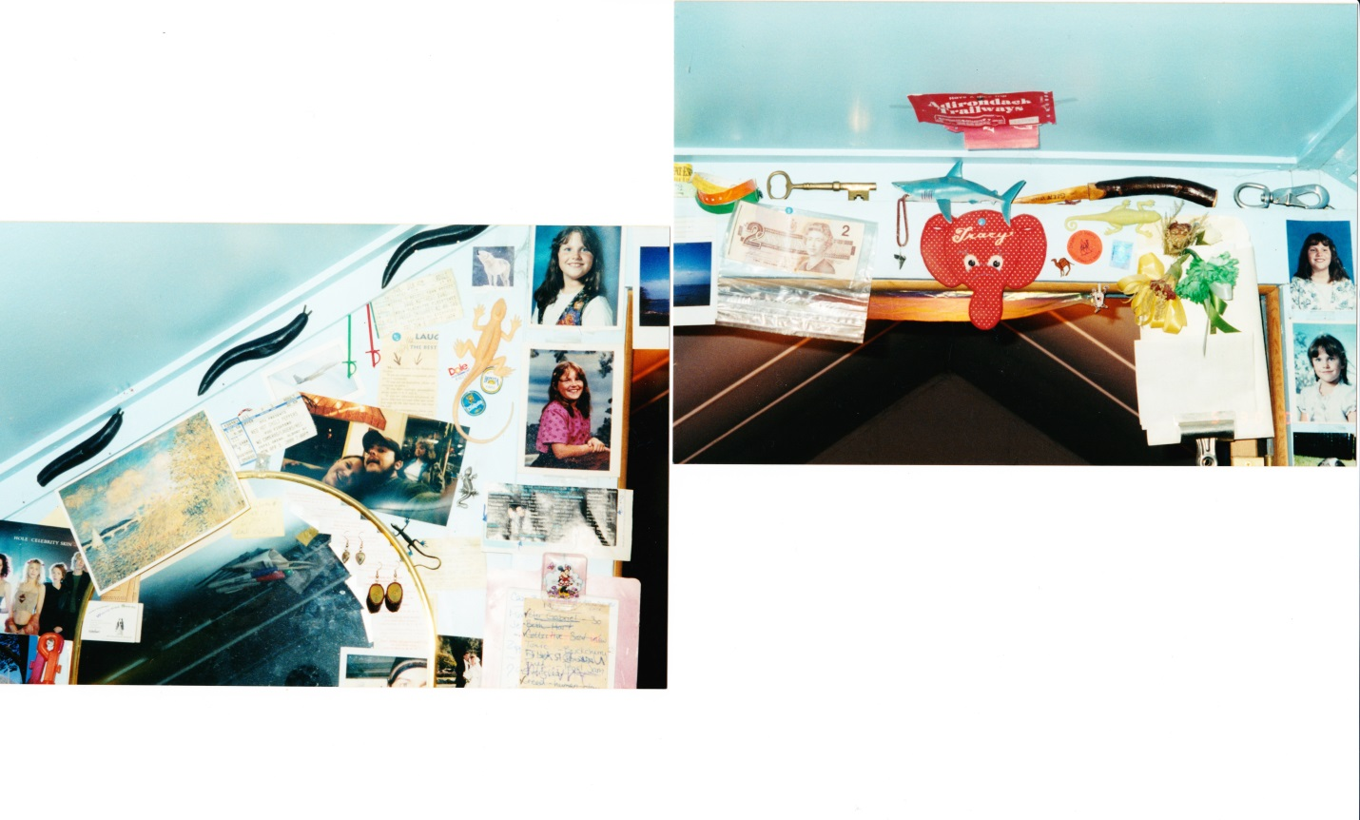
Figure 1: Inspiration for gallery exhibition based on photographs of my childhood bedroom.

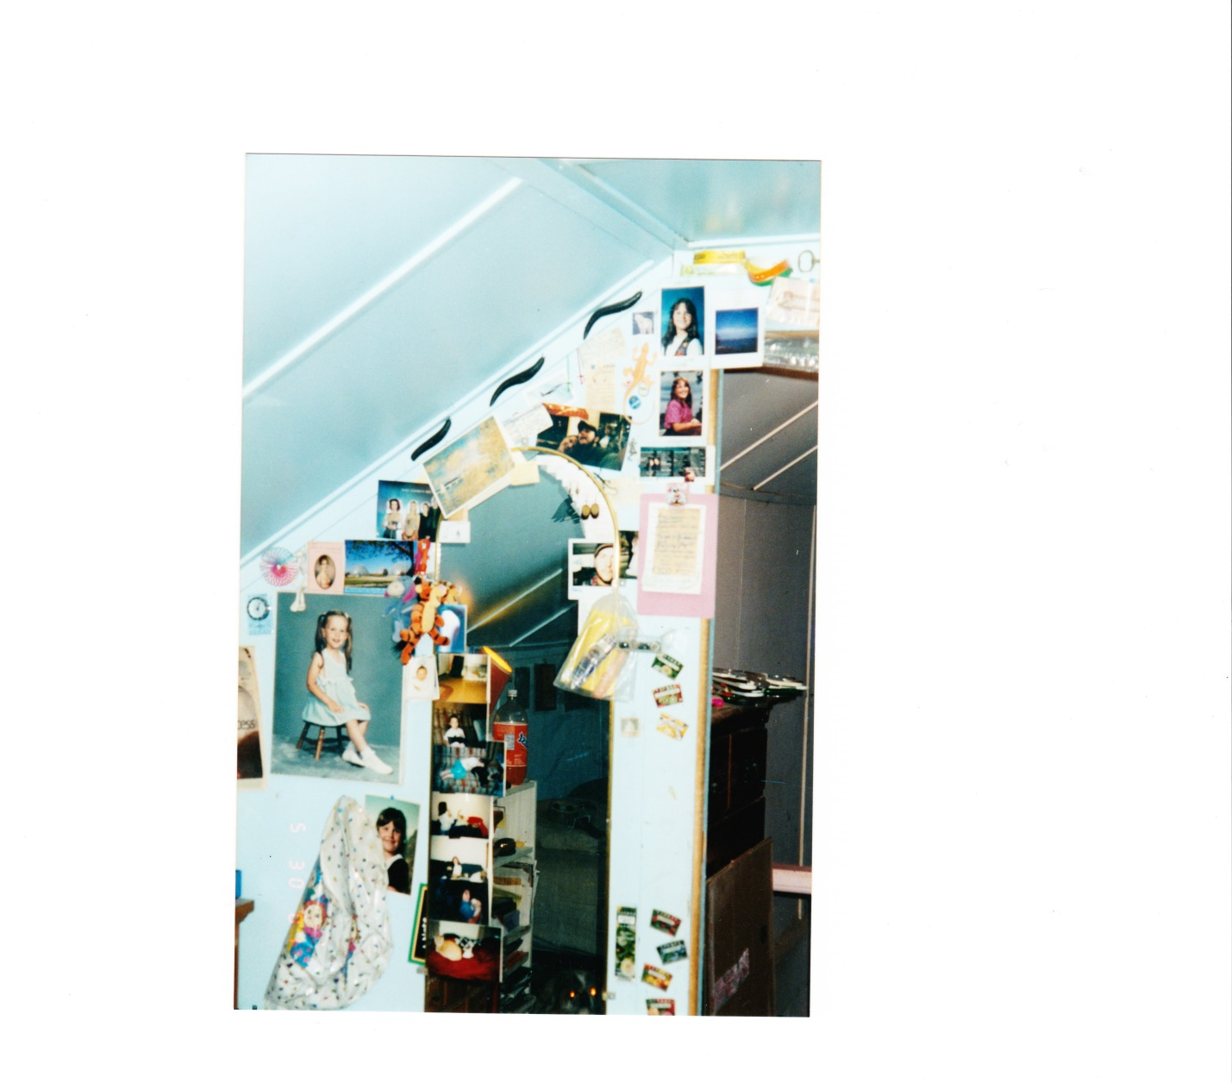

Figure 2: Another photograph of my childhood bedroom and a prime example of the collaging and curating of my life’s memorabilia.

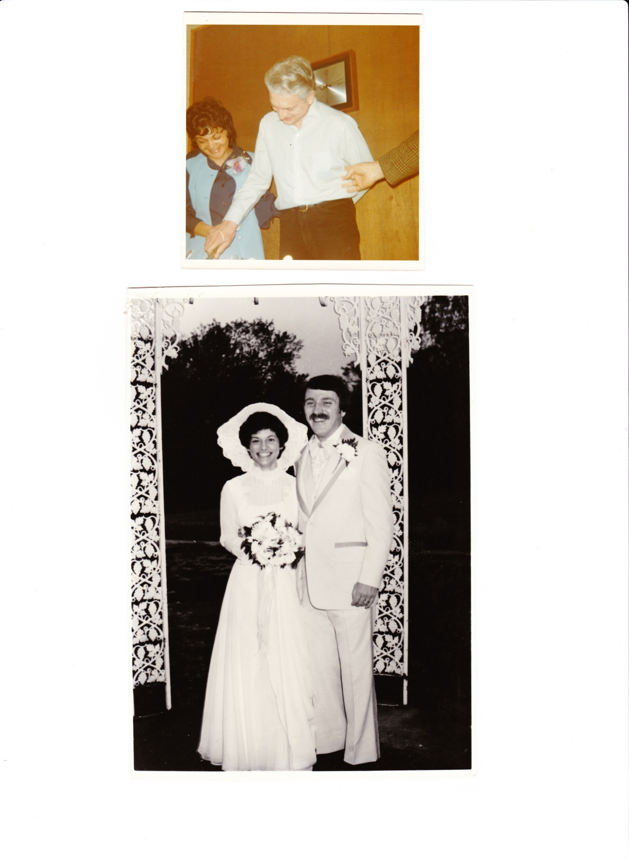
Figure 3: Photographs of my maternal grandparents and my parent’s wedding day.

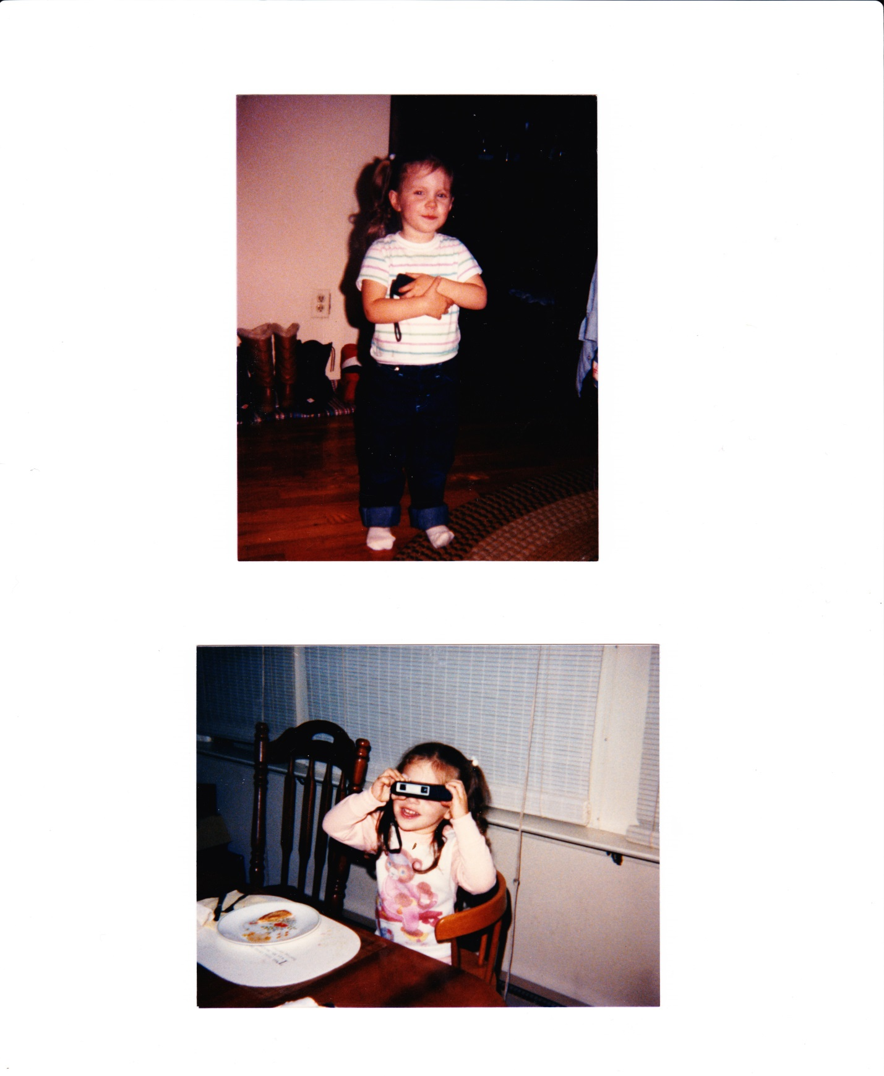
Figure 4: Photographs documenting my early love of cameras and photography.

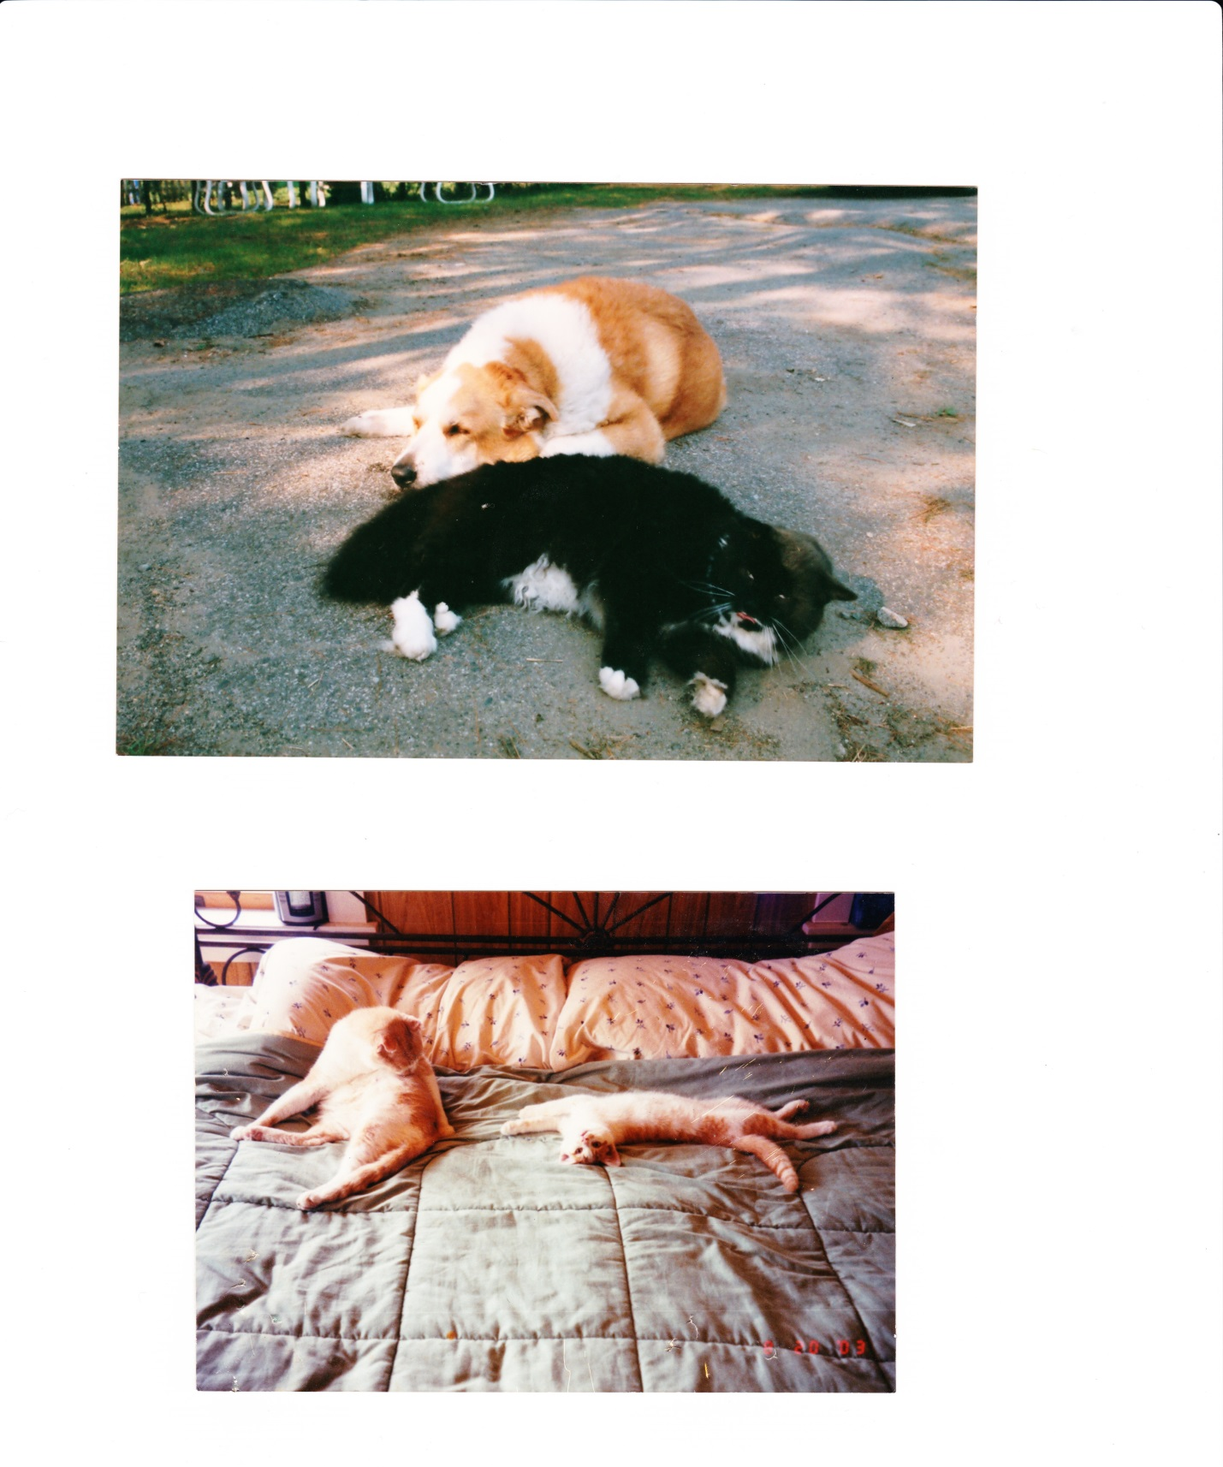
Figure 5: Images of just some of the important pets in my life, including Shelby the dog and Mr. Pooh the cat who thought he was a dog, on top, and Cinnamon, later known as Sexy, the old cat with Ugly, also known as Booger, the kitten, below.

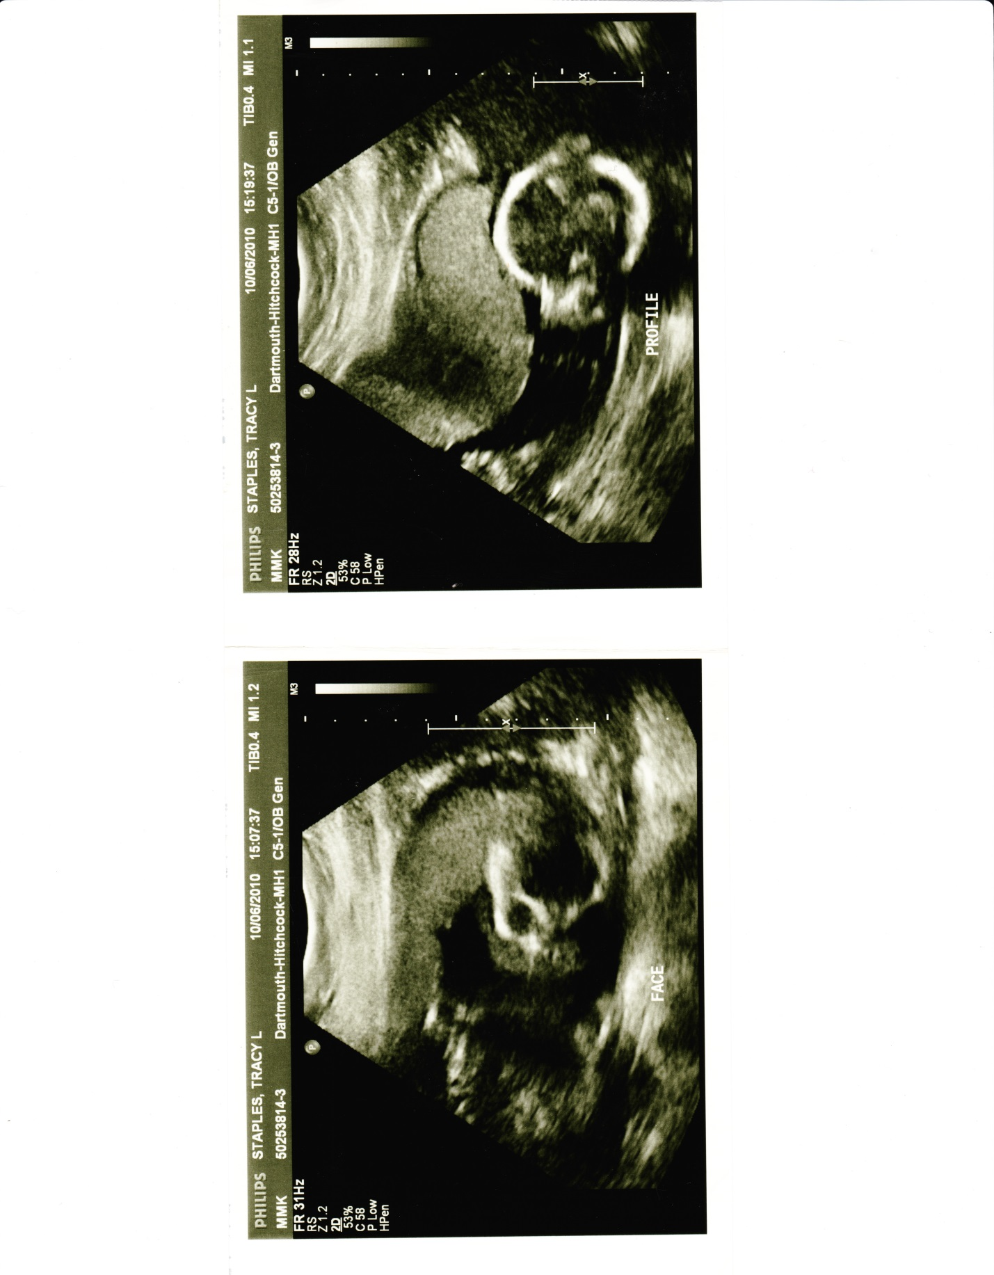
Figure 6: Just a couple of the many ultrasound images of my son, Elias, in utero during my high risk, and singularly successful, pregnancy.

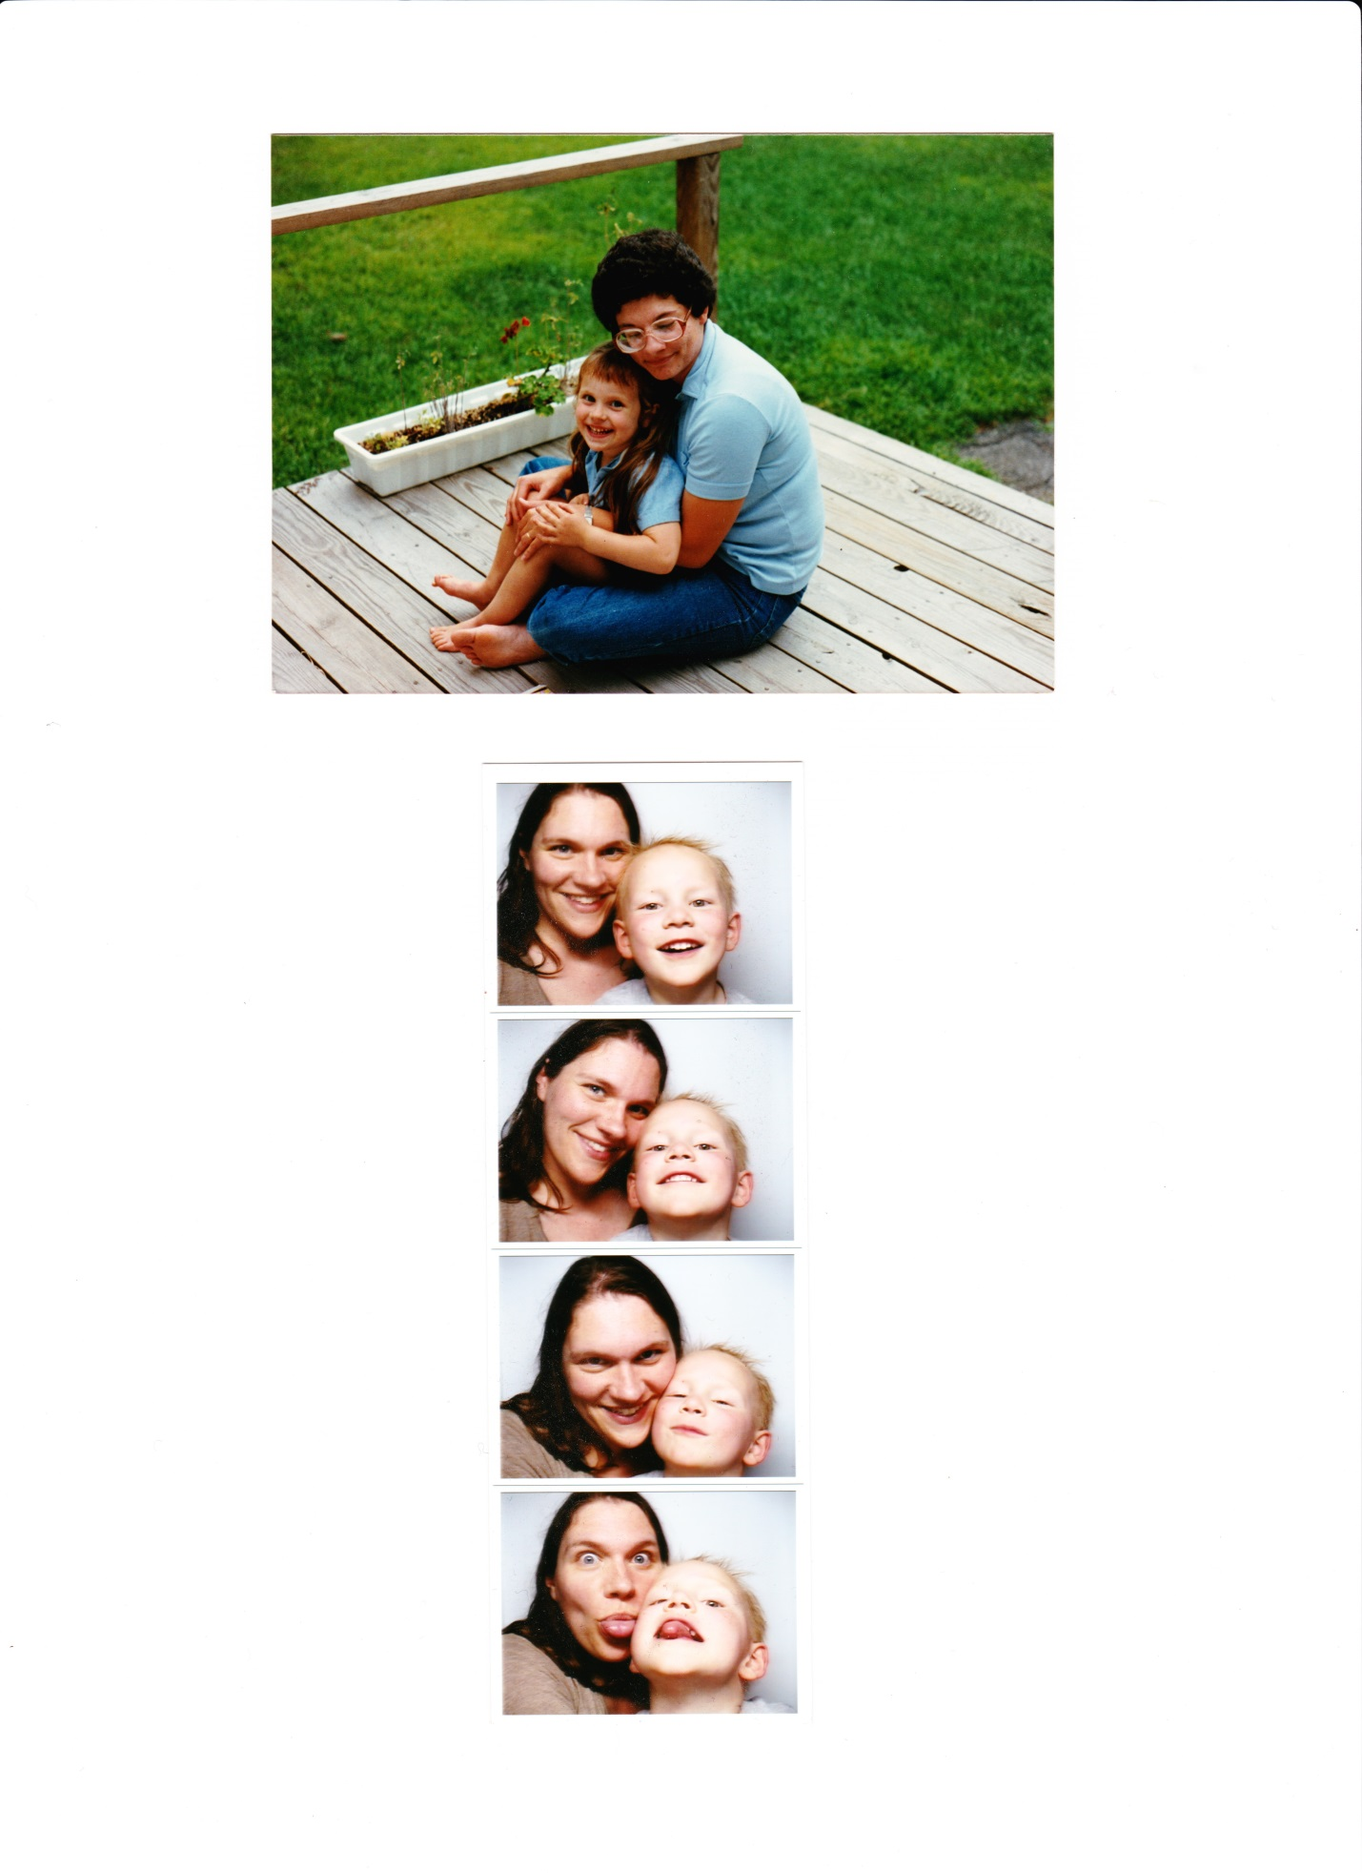
Figure 7: My mother’s favorite picture of us when we were younger and happy, on top, and one of my favorite photo boot strips of Elias and I at our first Get Into Goucher (GIG) celebration.

