Heaven and Hellscapes: Exploring Altered Mind States through Procedural Environments
Aaron Oldenburg
University of Baltimore
Baltimore, USA
aoldenburg@ubalt.edu

Keywords
videogame, neurosciences, spirituality, psychedelic, artgame, simulation, landscape, docugame, dream, abstract

Abstract
This paper discusses the results of several original digital game design experiments where generative landscapes are created to reference states of consciousness. Their designs take inspiration from hypnagogic states, geographically-located psychic trauma and dream-states, unconscious player input, dissociative worlds, and landscapes as autonomous, emotional entities. This series is a work-in-progress that points to future paths in expressive generative landscape design.

Introduction

Algorithms for procedural generation of videogame environments often draw from evolutionary science and artificial intelligence theory to construct levels that are functional and challenging for players. [1] Rarely are they used to create environments that cause players to reflect on states of mind and draw connections between the creations of the brain and creations of the external natural world. The following are descriptions of completed videogames where I explore states of mind through interactions with and explorations of generative landscapes. They are inspired by psychedelics, spiritual encounters, everyday hallucinations, and the uncontrollable natures of interpretation and memory.

Projects

Islid (2016): Hypnagogic State as Landscape
The world of the videogame Islid is one that emulates the ephemeral images of hypnagogia, the visions passing before one’s eyelids before sleep. [2] On a two-dimensional plane, the player guides a flickering speck through randomly-arranging visions. I created these visions by shining a light into my eyes, closing them, then drawing and animating the mutating shapes from memory. The world the player is traversing has the texture of the dark inner lining of the eyelid, and the shapes come in and out of vision with the peripheral persistence of the hypnagogic state.
Although this is inspired by a landscape that one encounters internally, the patterns formed by the brain in a state of play mirror those that the outside, natural world produces in its own procedural generation. Neuroscientist Oliver Sacks draws a comparison between the “spontaneous self-organization” of populations of visual neurons as a part of perception, and the geometric formation of snow crystals. In the latter example, “self-organization can produce geometries and patterns in space and time very similar to what one may see in a migraine aura. In this sense, the geometrical hallucinations of migraine allow us to experience in ourselves not only a universal of neural functioning but a universal of nature itself”. [3] Whether creating hypnagogic visions or migraine auras, our brains produce geometric landscapes in a manner similar to that of the physical world. In a nod to its connection to external, earthly formations, the title of the game is a combination of “island” and “eyelid.”

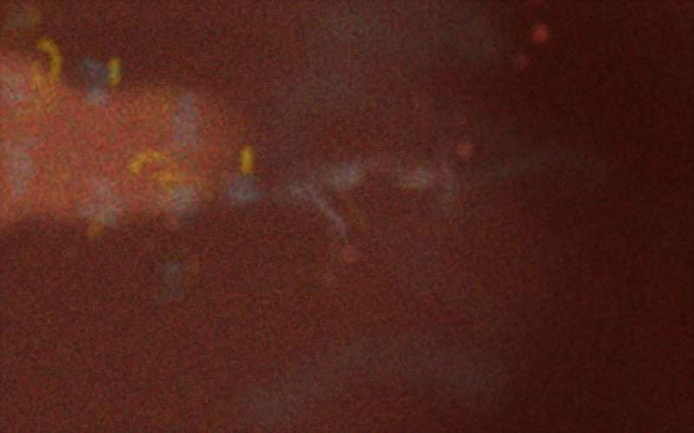

Fig 1. Islid, 2016, screenshot, ©Author.
The medium of digital play-spaces is also appropriate as a metaphor for this state, as hypnagogia is described as:
the visual cortex playing with every permutation, playing with no goal, no focus, no meanings—a random activity or perhaps an activity with so many microdeterminants that no pattern is ever repeated. Few phenomena give such a sense of the brain's creativity and computational power as the almost infinitely varied, ever-changing torrent of patterns and forms which may be seen in hypnagogic states. [4]
It is essentially interactive, procedural seeing, with little information required from the outside world. It is a reminder of how much of sight is created by the brain in a response to stimulus. In the case of hypnagogic sight, the required stimulus is essentially a random seed.

Cho-Am (2016): Navigating a World of Invisible Trauma
The videogame Cho-Am’s world is generated through parameters that are limited by a real-world referent. [5] It is based on the cremation site of Pol Pot in Cho-Am, northern Cambodia. In this game, based on documentation I collected from the site, the player controls the avatar of a sleepwalker, whom they imperfectly guide through the landscape. This sleepwalker, through their psychological presence in a world the player cannot see, explores the invisible history of the site, and the memories of those who passed through and were affected by the autogenocidal regime of the Khmer Rouge and Pol Pot.

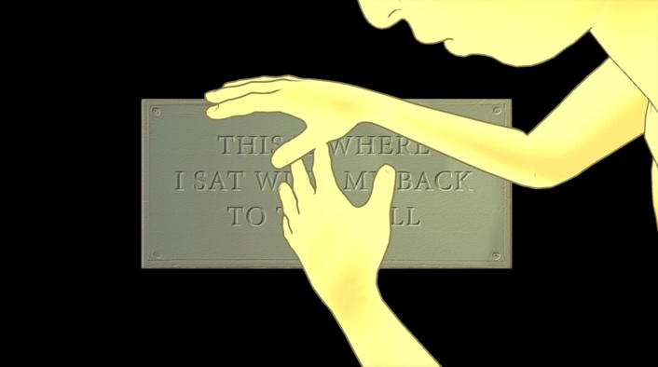

Fig 2. Cho-Am, 2016, screenshot, ©Author.

When this world is constructed upon execution of the software, with time of day based on the current local time in Cambodia, invisible encounters are placed throughout the world. When the avatar passes through one of these encounters, the player only sees what their avatar is experiencing through pantomime. Sometimes, the game gives the player a brief glimpse inside of the avatar’s head, with a vision of a mundane object from the life of Pol Pot. He and his victims are psychically present in this empty space, filled with the sounds of insects. The player is left to interpret vignettes as potentially related to survivor PTSD, or the spiritual presence of Pol Pot.

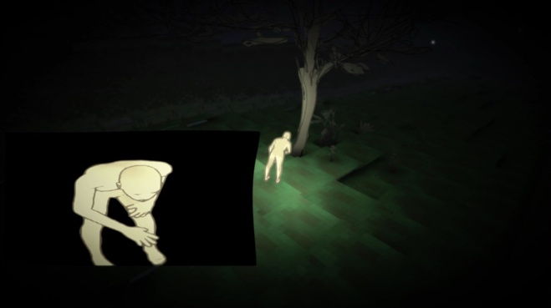

Fig. 3. Cho-Am, 2016, screenshot, ©Author.

Games critic Lana Polansky, writing on her blog Sufficiently Human, discusses the necessity of Cho-Am existing in a dream space:
It’s my belief that unresolved historical trauma has a sort of collective transference property. That is to say, the original pain doesn’t really go away. It just sort of gets moved somewhere else; attempts to rationalize or contain it usually burst at the seams, and all that latent hurt spills over into something that can freshly exploit it. [6]
One could imagine the physical space represented by the game as a sort of transit stop for this trauma, as it infests the ground and mundane environmental objects.

Brief Excursion (2016): Geography Reacts to the Unconscious
The landscape in Brief Excursion is altered by readings from a toy Mindflex neural headset, hacked to connect to the videogame via USB. [7][8] The player explores this environment, which is endlessly creating itself as they traverse it, while wearing the device. The data the device sends to the computer, according to the creators of Mindflex, corresponds to the player’s brain’s mid-gamma waves. There is debate as to what the device is actually reading, whether it is the brain waves themselves, or the forehead’s muscle movements. Regardless of how the device works, the game presents a way of thinking about neural game controls. Generally, these controls focus on the player intentionally manipulating the environment by controlling their own thought states, for a task such as moving an object. Brief Excursion, however, relies on the player’s lack of control. The player is exploring the unintentional creations of their subconscious, how their brain states, which they might try to control, change their perceived environment.
It was through accident that I chose gamma waves from the array of data that the Mindflex produces. I chose them due to the interesting fluctuations in the readings, not knowing the potential significance of these waves. These waves are thought to be responsible for the brain’s interpretation of individual parts as a coherent object, and likely ties back to the brain’s self-organizing patterns, its way of creating vision out of retinal data. This is the brain’s, unity of conscious perception, also known as “binding”. [9]

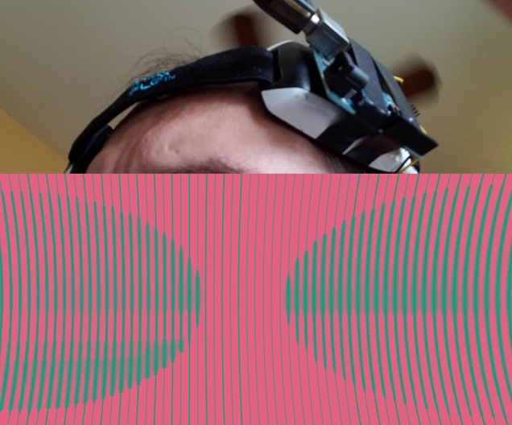

Fig. 4. Brief Excursion, 2016, headset and screenshot, ©Author.

This game points to the possibilities, with the use of more sensitive neural headset technologies, of generating worlds based on a variety of the player’s mental states, allowing the player to see and explore their minds from a distance.

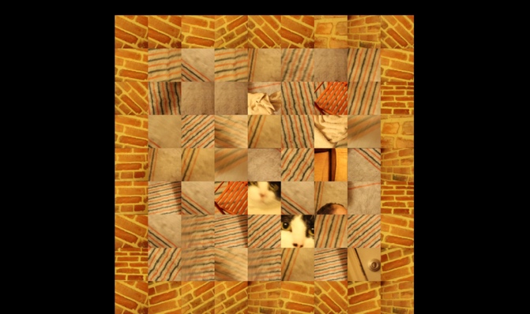

Fig 5. Thinning, 2016, screenshot, ©Author

Thinning (2016): A Dissociative Terrain
The world in Thinning curves and repeats, in a manner inspired by an encounter with the atypical psychedelic salvia divinorum. [10] The player, beginning as the protagonist in a game that appears to take the form of a standard “roguelike” procedurally-generated dungeon crawler, loses their sense of time and location, their context as an individual in space. It is an attempted simulation of depersonalization.
As one moves through the rooms of Thinning, the camera zooms out to show the same room repeated through twisting space. The player then traverses the space of the infinitely-repeating map, itself. It also resembles the world described by the patient “Miss R” in Oliver Sacks’s Awakenings:
I think of a map; then a map of that map; then a map of that map of that map, and each map perfect, though smaller and smaller . . . Worlds within worlds within worlds within worlds . . . Once I get going I can't possibly stop. It's like being caught between mirrors, or echoes, or something. Or being caught on a merry-go-round which won't come to a stop.' [11]
As a survivor of the sleeping sickness, encephalitic lethargica, this is a world in which she was trapped for decades. It is bleak and identity-less, dissociating from space as well as time.

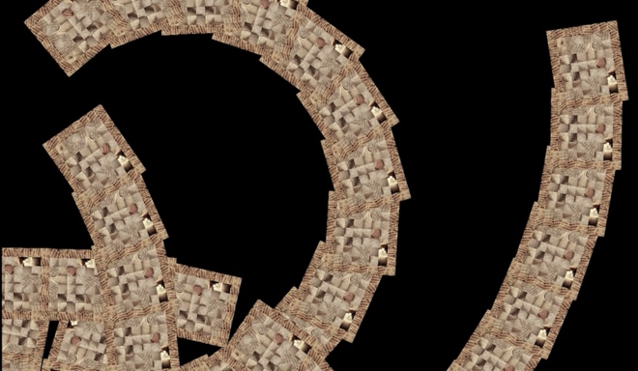

Fig. 6. Thinning, 2016, screenshot, ©Author

In his book, Spiritual Doorway in the Brian, neurologist Kevin Nelson describes the “introvertive” mystical experience as one where “the sense of being a separate self of thoughts, feelings, sensations, volitions, and memories is lost and transcends into the One. Time and space dissolve”. [12] The landscape in Thinning, created in an intradimensional repetition of the second dimension, is created through rules that disrupt the player’s sense of individuality and purpose. The world of Thinning creates a sense of space for the player, then removes that sense through iteration.

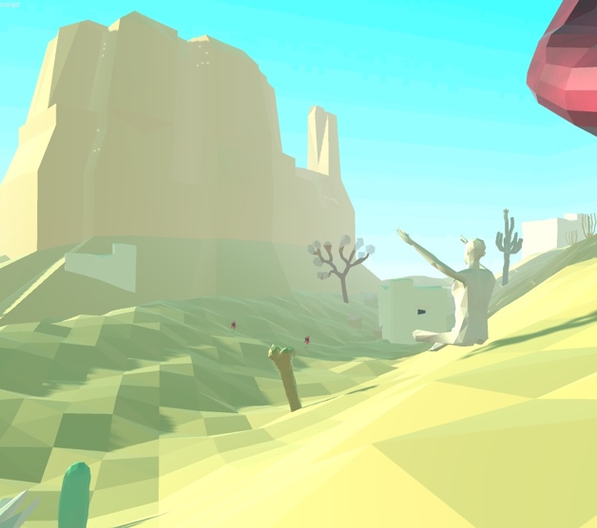

Fig. 7. Desert Mother, in process, screenshot, ©Author

Desert Mother: The Passionate Landscape
In his book, Phantoms in the Brain, neuroscientist V.S. Ramachandran breaks down the concept of self into eight characteristics: the embodied, passionate, executive, mnemonic, unified, vigilant, conceptual and social selves. One could categorize the procedural landscapes we are discussing as exploring some of these concepts of self. The mnemonic self, in its construction of self through memory, “as a single person who endures through space and time”, finds its representation in Cho-Am’s approach to distributed memory. [13] Though the landscape psychically embodies the collective memory of multitudes of people, it can be thought of as a being with a self that is created through memory.
In Brief Excursion, through its reliance on the brain’s gamma waves, the player’s own possible sense of unity and coherence, could be seen to be constructed by the player’s unified self. This is the self that is responsible for “filling in and confabulation”, the existential variation on the visual concept of binding.
My current work in progress, Desert Mother, creates a landscape that embodies the passionate self. [14][15] It is a landscape that responds emotionally to the player’s bodily actions. These actions are subtle, as the player sits in a desert environment, breathing, stretching, observing, in a circle with other players across a network. The landscape records the player’s actions in memory, which often trigger a change in the environment’s emotional state. This state controls all of the environmental objects, flora and fauna, with behaviors related to the environment’s emotion. The emotions revolve around spiritual states, as the personality of the landscape derives from the early Christian ascetic and hermitic desert mothers.
It is also partly inspired by a quote from Daniel Paul Schrieber’s account of his lifelong psychosis, Memoirs of My Nervous Illness:
I think one is entitled to assert that divine intelligence equals at least the sum total of all the intelligences of previous generations of human beings. For God assimilates all human nerves after death and thus unites the sum total of their intelligences in Himself while gradually divesting them of those recollections which are of interest only to the individual but of no use as part of a universally valuable intelligence. [16]
Desert Mother is a multiplayer game, where the environment records the actions of all players, assimilating one’s memory remains after they have left the game, or “died”. Here, divine intelligence is in the procedurally-generated natural world, activated by the people who have come and gone. Walter Pahnke, in his interpretation of William James’ 1898 Ingersoll Lecture on human immortality, suggests that “the physical brain is necessary only as a means to transmit a part of [a] Larger Consciousness into the dimension of ordinary realty perceived by individual normal waking consciousness. If an individual brain is damaged, disintegrates, or dies, this Larger Consciousness does not cease”. [17] The brain is essentially a filter for this larger consciousness, letting through only a fraction of the range of consciousness. Through this multi-user mnemonic environment, my intention is to simulate some of this give and take between the larger and individual consciousnesses.

Next Steps

As I continue this series of intelligent landscapes, the facets of altered states of consciousness to explore in generative environments are varied. There are potential landscapes that can simulate the way in which one psychically inhabits one’s own body, forests that can express fluid cognitive interpretations of time, and invisible gaseous worlds that express the consciousnesses of other animals—to go beyond external behavior and empathize with abstracted cognitive processes through game mechanics.
Perhaps one important potential of this field of exploration, is the ability to provide a space for empathy for a wide variety of neural types and experiences, in others and oneself.

References

- Julian Togelius, Noor Shaker, and Mark J. Nelson. (2016). Procedural content generation in games: A Textbook and an Overview of Current Research. New York, NY: Springer. Retrieved November 13, 2017, from http://pcgbook.com.
- Author. (2016). Islid. USA: Author.
- Oliver Sacks. (2013). Hallucinations. Waterville, Maine: Thorndike Press, 132.
- Oliver Sacks. (2013). Hallucinations. Waterville, Maine: Thorndike Press, 208.
- Author. (2016). Cho-Am. USA: Author.
- Lana Polansky. (2016, May 27). Notes on Cho-Am: The Myth of Closure [Blog post]. Retrieved November 13, 2017, from http://sufficientlyhuman.com/archives/1432.
- Mindflex (2009). Board game. El Segundo, CA: Mattel.
- Author. (2016). Brief Excursion. USA: Author.
- György Buzsáki. (2006). Rhythms of the brain. New York: Oxford University Press. Retrieved November 15, 2017, from https://neurophysics.ucsd.edu/courses/physics_171/Buzsaki%20G.%20Rhythms%20of%20the%20brain.pdf, 240-2.
- Author. (2016). Thinning. USA: Author.
- Oliver Sacks. (1999). Awakenings (1st Vintage Books ed). New York: Vintage Books, 76.
- Kevin Nelson. (2012). The spiritual doorway in the brain: a neurologist’s search for the God experience. New York: Plume, 227-8.
- V. S.Ramachandran & Sandra Blakeslee. (1999). Phantoms in the brain: probing the mysteries of the human mind (1st Quill ed). New York: Quill, 247.
- Author. (in preparation). Desert Mother. USA: Author.
- V. S.Ramachandran & Sandra Blakeslee. (1999). Phantoms in the brain: probing the mysteries of the human mind (1st Quill ed). New York: Quill, 251.
- Daniel Paul Schreber, (2000). Memoirs of my nervous illness. New York: New York Review Books, 265.
- Walter Pahnke. (1969). The Psychedelic Mystical Experience in the Human Encounter with Death. Harvard Theological Review, 62(1), 2–21. Retrieved from http://csp.org/docs/PahnkeIngersoll1969.pdf, 5.

Author Biography

The author is a game designer and new media artist whose primary interest is in game rules as an expressive medium. His video and interactive work has exhibited in festivals and galleries in New York, Johannesburg, São Paulo and Los Angeles, including SIGGRAPH, A MAZE. International Games and Playful Media Festival, and FILE Electronic Language International Festival. His work has been written about in Kill Screen, Baltimore City Paper, and Rock, Paper, Shotgun.

