Supporting Information
Mechanistic insights into peracetic acid activation by iron-biochar composites prepared at low and high temperature for enhanced contaminant degradation: selective reactive species generation

Guilong Peng¹*, Yuting Yan^{1,2}, Chengdu Qi³, Junhua Chen⁴, Xukun Meng¹, Lee Blaney^{5,}*, Wenwen Gong^{2,}*

¹State Key Laboratory of Resource Insects, College of Sericulture, Textile and Biomass Sciences, Southwest University, Chongqing 400715, China
²Institute of Quality Standard and Testing Technology, Beijing Academy of Agriculture and Forestry Science, Beijing 100097, China
³School of Environment, Jiangsu Province Engineering Research Center of Environmental Risk Prevention and Emergency Response Technology, Jiangsu Engineering Lab of Water and Soil Eco-remediation, Nanjing Normal University, Nanjing, 210023, China
⁴School of Pharmacy, Guizhou Medical University, Guiyang 550025, Guizhou, China
⁵University of Maryland Baltimore County, Department of Chemical, Biochemical, and Environmental Engineering, Baltimore, MD 21250, USA

*Corresponding authors:
E-mail addresses: pengguilong@swu.edu.cn (G. Peng), gong_ww@126.com (W. Gong), blaney@umbc.edu (L. Blaney)

Text S1. Chemicals
Peracetic acid (PAA, 14.4%) (PAA:H₂O₂ = 2.6:1(molar ratio)) was purchased from Tianjin Oubokai Chemical Co., Ltd (Tianjin, China). Iron(III) chloride hexahydrate (FeCl₃⋅6H₂O, ≥ 99%), sodium hydroxide (NaOH, ≥ 98%), and sodium persulfate (Na₂S₂O₈, ≥ 99%) were provided by Sinopharm (Shanghai, China). Acetonitrile, acetaminophen (ACT, 99%), bisphenol A (BPA, ≥ 99.8%), benzoic acid (BA, >99.5%), carbamazepine (CBZ, ≥ 98%), dimethyl sulfoxide (DMSO, 98%), ethanol (EtOH, 99.9%), methyl phenyl sulfone (PMSO₂, 98%), methanol (MeOH, 99.9%), nitrobenzene (NB, >99%), p-nitrobenzoic acid (p-NBA, ≥ 99%), naproxen (NPX, ≥ 98%), p-chlorobenzoic acid (p-CBA, ≥ 99.8%), phenol (≥ 99%), phenyl methyl sulfoxide (PMSO, 98%), sulfuric acid (H₂SO₄, 96%), sulfamethoxazole (SMX, ≥ 98%), tert-butanol (TBA, >99.5%), and other chemicals were purchased from Sigma-Aldrich (Shanghai, China). All chemicals were used as received, and the stock and working solutions were prepared in ultrapure water produced by a Milli-Q system (EMD Millipore, Billerica, MA, USA). Solution pH was measured with an FE28-Standard pH meter (Mettler Toledo, Switzerland).

Text S2. Preparation and characterization of Fe-BC composites
Fe-BC composites were prepared according to our previous methods [1]. Specifically, pruned waste mulberry branches were collected and used as a feedstock. A mixture of 4.8 g FeCl₃•6H₂O and 5.0 g dried mulberry branch powder was soaked in 50 mL of ultrapure water, and the mixture was continuously stirred for 12 h then dried at 80 °C. The resultant mixture was pyrolyzed in a tube furnace at 300 °C or 800 °C for 2 h with a heating rate of 10 °C min⁻¹ under a nitrogen atmosphere; the final composites were labeled Fe-BC-300 and Fe-BC-800, respectively.
X-ray powder diffraction (XRD; Bruker D8 ADVANCE, Germany) was used to characterize the crystal structure of the Fe-BC composites. The morphology of the Fe-BC composites was characterized by scanning electron microscopy (SEM) (SU8010, HITACHI, Japan). The surface composition of the Fe-BC composites was characterized by X-ray photoelectron spectroscopy (XPS) (Thermo escalab 250XI, USA). The specific surface area, pore volume, and pore size of Fe-BC was measured using N₂ adsorption isotherms at 77 K with an automated gas sorption system (AUTOSORB-1, Quantachrome Instruments, USA).

Text S3. Determination of second-order rate constant for Fe(IV) reaction with ACT
The second-order rate constant for the reaction between ACT and Fe(IV) was determined by competition kinetics. The experiments were conducted with the Fe²⁺/persulfate (PS) process using an initial PS dose of 1.0 mM and initial pH of 3.7. These conditions generate Fe(IV), •OH, and SO₄•– [2]; therefore, degradation of ACT and PMSO can be expressed according to Eq. (S1) and (S2), respectively.
$\frac{d\left[ACT\right]}{dt}=-\left(k_{{}_{}^{•}{OH},ACT}^{''}\left[{}_{}^{•}{OH}\right]+k_{{SO}_{4}^{•–},ACT}^{''}\left[{SO}_{4}^{•–}\right]+k_{Fe\left(IV\right),ACT}^{''}\left[Fe\left(IV\right)\right]\right)\left[ACT\right]$ (S1)
$\frac{d\left[PMSO\right]}{dt}=-\left(k_{{}_{}^{•}{OH},PMSO}^{''}\left[{}_{}^{•}{OH}\right]+k_{{SO}_{4}^{•–},PMSO}^{''}\left[{SO}_{4}^{•–}\right]+k_{Fe\left(IV\right),PMSO}^{''}\left[Fe\left(IV\right)\right]\right)\left[PMSO\right]$ (S2)
Integrating Eq. (S1) and (S2) yields Eq. (S3)–(S4) and Eq. (S5)–(S6), respectively.
$\ln{\frac{\left[ACT\right]}{{\left[ACT\right]}_{0}}}=-\left(k_{{}_{}^{•}{OH},ACT}^{''}{\left[{}_{}^{•}{OH}\right]}_{ss}+k_{{SO}_{4}^{•–},ACT}^{''}{\left[{SO}_{4}^{•–}\right]}_{ss}+k_{Fe\left(IV\right),ACT}^{''}{\left[Fe\left(IV\right)\right]}_{ss}\right)t$ (S3)
$k_{obs,ACT}^{'}=k_{{}_{}^{•}{OH},ACT}^{''}{\left[{}_{}^{•}{OH}\right]}_{ss}+k_{{SO}_{4}^{•–},ACT}^{''}{\left[{SO}_{4}^{•–}\right]}_{ss}+k_{Fe\left(IV\right),ACT}^{''}{\left[Fe\left(IV\right)\right]}_{ss}$ (S4)
$\ln{\frac{\left[PMSO\right]}{{\left[PMSO\right]}_{0}}}=-\left(k_{{}_{}^{•}{OH},PMSO}^{''}{\left[{}_{}^{•}{OH}\right]}_{ss}+k_{{SO}_{4}^{•–},PMSO}^{''}{\left[{SO}_{4}^{•–}\right]}_{ss}+k_{Fe\left(IV\right),PMSO}^{''}{\left[Fe\left(IV\right)\right]}_{ss}\right)t$ (S5)
$k_{obs,PMSO}^{'}=k_{{}_{}^{•}{OH},PMSO}^{''}{\left[{}_{}^{•}{OH}\right]}_{ss}+k_{{SO}_{4}^{•–},PMSO}^{''}{\left[{SO}_{4}^{•–}\right]}_{ss}+k_{Fe\left(IV\right),PMSO}^{''}{\left[Fe\left(IV\right)\right]}_{ss}$ (S6)
The steady-state concentrations of •OH ([•OH]_{ss}) and SO₄•– ([SO₄•–]_{ss}) were obtained by competition kinetics using NB and BA, according to our previous methods [3]. The rate expressions and integration steps are shown in Eq. (S7)–(S12). The steady-state concentrations of the •OH and SO₄•– reactive species are defined as Eq. (S13) and Eq. (S14), respectively.
$\frac{d\left[NB\right]}{dt}=-k_{{}_{}^{•}{OH},NB}^{''}\left[{}_{}^{•}{OH}\right]\left[NB\right]$ (S7)
$\ln{\frac{\left[NB\right]}{{\left[NB\right]}_{0}}}=-k_{{}_{}^{•}{OH},NB}^{''}{\left[{}_{}^{•}{OH}\right]}_{ss} t$ (S8)
$k_{obs,NB}^{'}=k_{{}_{}^{•}{OH},NB}^{''}{\left[{}_{}^{•}{OH}\right]}_{ss}$ (S9)
$\frac{d\left[BA\right]}{dt}=-\left(k_{{}_{}^{•}{OH},BA}^{''}\left[{}_{}^{•}{OH}\right]+k_{{SO}_{4}^{•–},BA}^{''}\left[{SO}_{4}^{•–}\right]\right)\left[BA\right]$ (S10)
$\ln{\frac{\left[BA\right]}{{\left[BA\right]}_{0}}}=-\left(k_{{}_{}^{•}{OH},BA}^{''}{\left[{}_{}^{•}{OH}\right]}_{ss}+k_{{SO}_{4}^{•–},BA}^{''}{\left[{SO}_{4}^{•–}\right]}_{ss}\right) t$ (S11)
$k_{obs,BA}^{'}=k_{{}_{}^{•}{OH},BA}^{''}{\left[{}_{}^{•}{OH}\right]}_{ss}+k_{{SO}_{4}^{•–},BA}^{''}{\left[{SO}_{4}^{•–}\right]}_{ss}$ (S12)
${\left[{}_{}^{•}{OH}\right]}_{ss}=\frac{k_{obs,NB}^{'}}{k_{{}_{}^{•}{OH},NB}^{''}}$ (S13)
${\left[{SO}_{4}^{•–}\right]}_{ss}=\frac{k_{obs,BA}^{'}-k_{{}_{}^{•}{OH},BA}^{''}{\left[{}_{}^{•}{OH}\right]}_{ss}}{k_{{SO}_{4}^{•–},BA}^{''}}$ (S14)
[•OH]_{ss} and [SO₄^{•−}]_{ss} were then used to calculate the steady-state concentration of Fe(IV), namely [Fe(IV)]_{ss}, and the second-order rate constant for the reaction between ACT and Fe(IV) using Eq. (S15) and (S16), respectively.
${\left[Fe\left(IV\right)\right]}_{ss}=\frac{k_{obs,PMSO}^{'}-\left(k_{{}_{}^{•}{OH},PMSO}^{''}{\left[{}_{}^{•}{OH}\right]}_{ss}+k_{{SO}_{4}^{•–},PMSO}^{''}{\left[{SO}_{4}^{•–}\right]}_{ss}\right)}{k_{Fe\left(IV\right),PMSO}^{''}}$ (S15)
$k_{Fe\left(IV\right),ACT}^{''}=\frac{ k_{obs,ACT}^{'}-\left(k_{{}_{}^{•}{OH},ACT}^{''}{\left[{}_{}^{•}{OH}\right]}_{ss}+k_{{SO}_{4}^{•–},ACT}^{''}{\left[{SO}_{4}^{•–}\right]}_{ss}\right)}{{\left[Fe\left(IV\right)\right]}_{ss}}$ (S16)
Based on the competition kinetics data for BA and NB (Fig. S16a), we obtained the pseudo-first-order rate constants for BA and NB degradation (Fig. S16b) and calculated [•OH]_{ss} and [SO₄•–]_{ss} to be 1.42×10⁻¹³ M and 9.02×10⁻¹⁴ M, respectively. According to the competition kinetics data for ACT and PMSO (Fig. S16c), we obtained the pseudo-first-order rate constants for ACT and PMSO degradation (Fig. S16d) and calculated [Fe(IV)]_{ss} to be 6.77×10⁻⁹ M. The [•OH]_{ss}, [SO₄•–]_{ss}, and [Fe(IV)]_{ss} values were substituted into Eq. (S16), and the calculated second-order rate constant for ACT reaction with Fe(IV) was determined to be 2.54×10⁵ M⁻¹s⁻¹.

Text S4. Detection of PAA
For PAA analysis, 0.2 mL of 0.6 M potassium iodide and 1.4 mL of 0.5 M phosphate buffer were added to a 10-mL cuvette containing a certain volume of sample solution. The cuvette was shaken and then absorbance at 350 nm was recorded after 1 min [4] and used to inform PAA concentrations.

Text S5. 1,10-phenanthroline spectrophotometry for determination of Fe(II) and total dissolved iron
The dissolved Fe(II) and total dissolved Fe concentrations were determined by the 1,10-phenanthroline colorimetric method [5] using a DR6000 UV-visible spectrophotometer (Hach, Loveland, CO, USA). First, 10% hydroxylamine hydrochloride and 0.5% 1,10-phenanthroline were prepared in ultrapure water. A buffer solution was prepared by mixing 40 g ammonium acetate and 50 mL acetic acid, then that solution was diluted to 100 mL. To measure total dissolved Fe, 0.1 mL 1,10-phenanthroline solution, 1 mL buffer solution, and 0.2 mL hydroxylamine hydrochloride solution were added to a 10-mL cuvette, then 5 mL of sample solution was added to the cuvette, and the absorbance was measured at 510 nm. The same method was used to measure dissolved Fe(II) with one exception, no hydroxylamine hydrochloride solution was added.
To achieve a lower detection limit, atomic absorption spectrophotometry (Shimadzu AA-6300C) was employed to measure the concentrations of leached iron for treatment of ACT at variable initial pH conditions.

Text S6. Density functional theory (DFT) calculations
All DFT calculations were conducted using the Gaussian 16 software, Revision A.03. Geometry optimizations were performed using the B3LYP method with the 6-31+G (d, p) basis set. Frequency calculations were carried out to exclude the influence of virtual frequency to ensure system stability configuration. A self-consistent reaction field (SCRF) based on the solvation model density (SMD) implicit solvent model was used to address solvent effects of water during analysis.
The condensed Fukui function (CFF) based on DFT results was calculated to predict sites vulnerable to electrophilic, nucleophilic, and radical attack [6]. Condensed dual descriptors (CDD) were introduced to explain attacks on the ACT molecule. The CFF and CDD were calculated as follows for each atom:
Nucleophilic attack: $f_{A}^{+}=q_{N}^{A}-q_{N+1}^{A}$
Electrophilic attack: $f_{A}^{-}=q_{N-1}^{A}-q_{N}^{A}$
Radical attack: $f_{A}^{0}=(q_{N-1}^{A}-q_{N+1}^{A})/2$
Condensed dual descriptors: $∆f_{A}=f_{A}^{+}-f_{A}^{-}$
In the above expressions, q^{A} and N represent the charge on atom A at the corresponding state and the number of electrons in the system, respectively. Higher Fukui indices indicated that the corresponding atom was more vulnerable to attack.

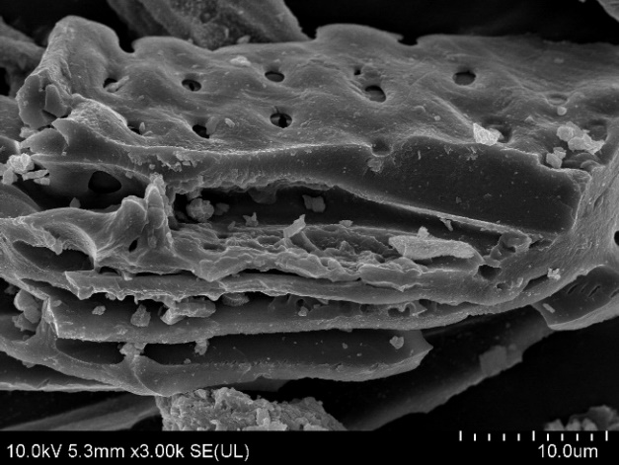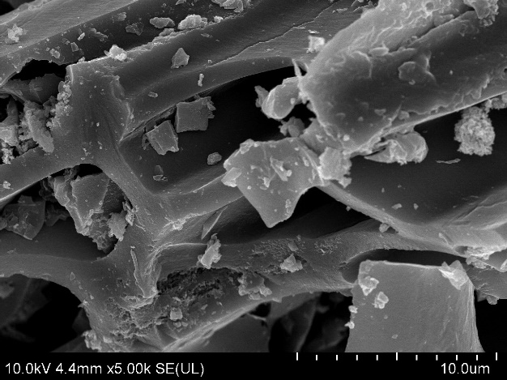
(a)
(b)
Fig. S1. SEM images of (a) Fe-BC-300 and (b) Fe-BC-800.

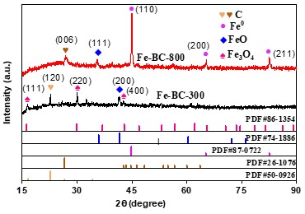
Fig. S2. XRD patterns of the Fe-BC-300 and Fe-BC-800.

Fig. S3. (a) Wide-scan XPS scan of Fe-BC-300 and Fe-BC-800; high-resolution Fe 2p spectra for (b) Fe-BC-300 and (c) Fe-BC-800.

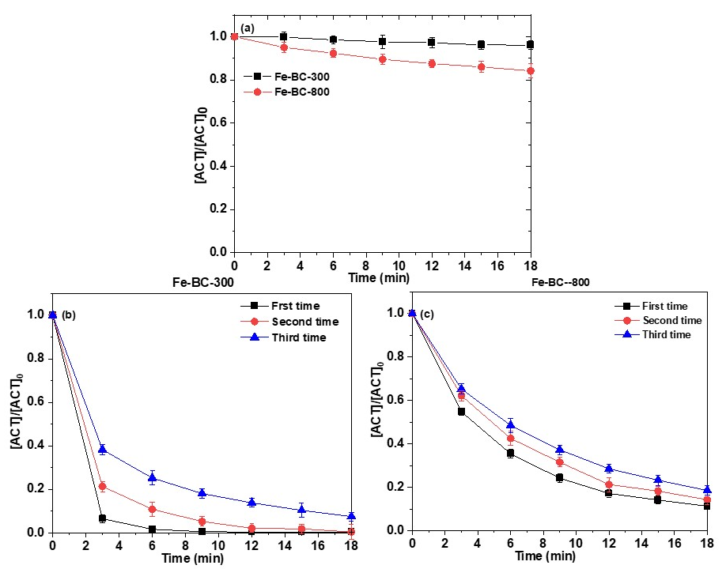

Fig. S4. (a) Adsorption of ACT by Fe-BC-300 and Fe-BC-800; and performance of the (b) Fe-BC-300/PAA and (c) Fe-BC-800/PAA processes for three consecutive cycles of ACT treatment. Experimental conditions: [Fe-BC] = 0.2 g/L; and [ACT]₀ = 50 μM.

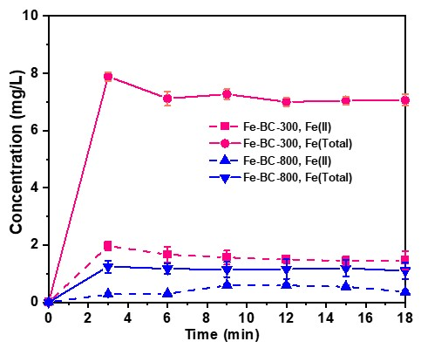
Fig. S5. Fe(II) and total dissolved iron concentrations during treatment with the Fe-BC/PAA process. Experimental conditions: [PAA]₀ = 0.5 mM; [Fe-BC] = 0.2 g/L; [ACT]₀ = 50 μM; and pH₀ = 3.71.
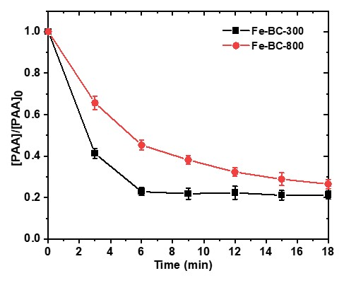
Fig. S6. Decomposition of PAA in the Fe-BC-300/PAA and Fe-BC-800/PAA processes. Experimental conditions: [PAA]₀ = 0.5 mM; [Fe-BC] = 0.2 g/L; [ACT]₀ = 50 μM; and pH₀ = 3.71.
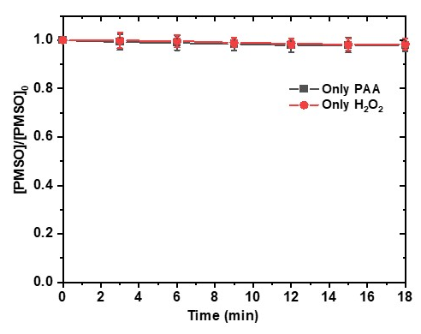
Fig. S7. Degradation of PMSO by PAA and H₂O₂ alone. Experimental conditions: [PAA]₀ = [H₂O₂]₀ = 0.5 mM; [PMSO]₀ = 200 μM; and pH₀ = 3.71.

Fig. S8. HPLC chromatograms showing PMSO degradation and PMSO₂ formation for 0-18 min treatment by the (a) Fe-BC-300/PAA and (b) Fe-BC-800/PAA processes. The (c) degradation kinetics of PMSO and (d) yield of PMSO₂ in the Fe-BC-300 and Fe-BC-800/PAA processes. Experimental conditions: [PAA]₀ = 0.5 mM; [PMSO]₀ = 200 μM; and pH₀ = 3.71.

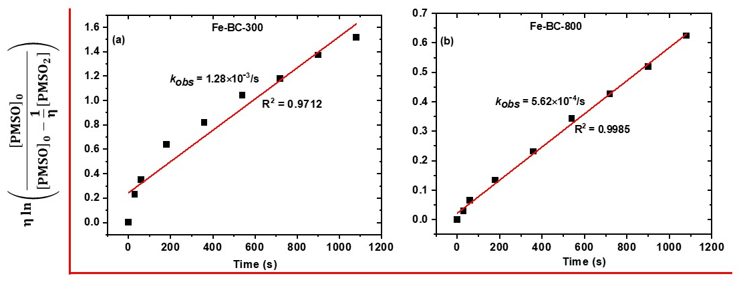
Fig. S9. Plots of $η\ln\left(\frac{{\left[PMSO\right]}_{0}}{{\left[PMSO\right]}_{0}-\frac{1}{η}\left[{PMSO}_{2}\right]}\right)$ vs. time in the (a) Fe-BC-300/PAA and (b) Fe-BC-800/PAA processes. Experimental conditions: [PAA]₀ = 0.5 mM; [PMSO]₀ = 200 μM; and pH₀ = 3.71.

Fig. S10. Adsorption of (a) PMSO and (b) PMSO₂ by the Fe-BC-300 and Fe-BC-800. Experimental conditions: [PMSO]₀ = [PMSO₂]₀ = 200 μM; and [Fe-BC] = 0.2 g/L.

Fig. S11. Effect of catalase on PMSO degradation and PMSO₂ yield for the (a) Fe-BC-300; (b) Fe-BC-800 processes; and degradation of ACT by (c) Fe-BC-300 and (d) Fe-BC-800 activation of PAA and H₂O₂. Experimental conditions: [PAA]₀ = 0.5 mM; [PMSO]₀ = 200 μM; [Fe-BC] = 0.2 g/L; and pH₀ = 3.71.

Fig. S12. HPLC chromatograms showing BA degradation and p-HBA formation in the (a) Fe-BC-300; (b) Fe-BC-800 processes; and (c) removal of other contaminants by Fe-BC-300 and Fe-BC-800. Experimental conditions: [PAA]₀ = 0.5 mM; [BA]₀ = 50 μM; [Fe-BC] = 0.2 g/L; [other contaminants] = 50 μM; and pH₀ = 3.71.

Fig. S13. The concentration of leached iron for (a) Fe-BC-300 and (b) Fe-BC-800 under different initial pH conditions. Experimental conditions: [PAA]₀ = 0.5 mM; [BA]₀ = 50 μM; [Fe-BC] = 0.2 g/L; and pH₀ = 3.7-9.1.

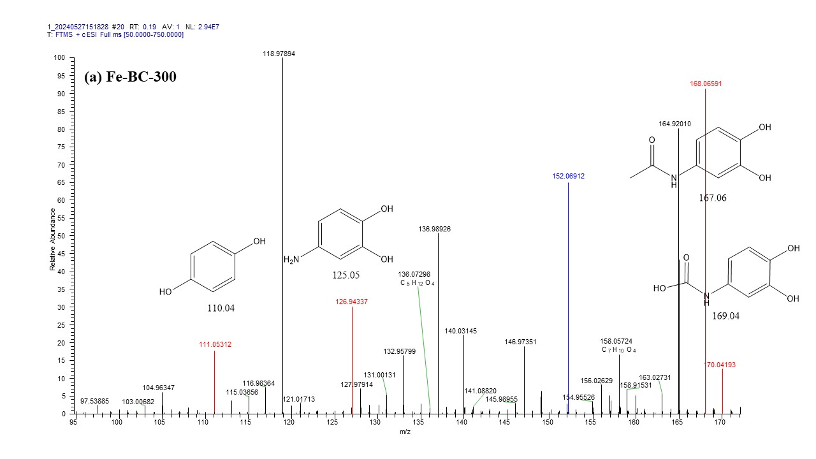
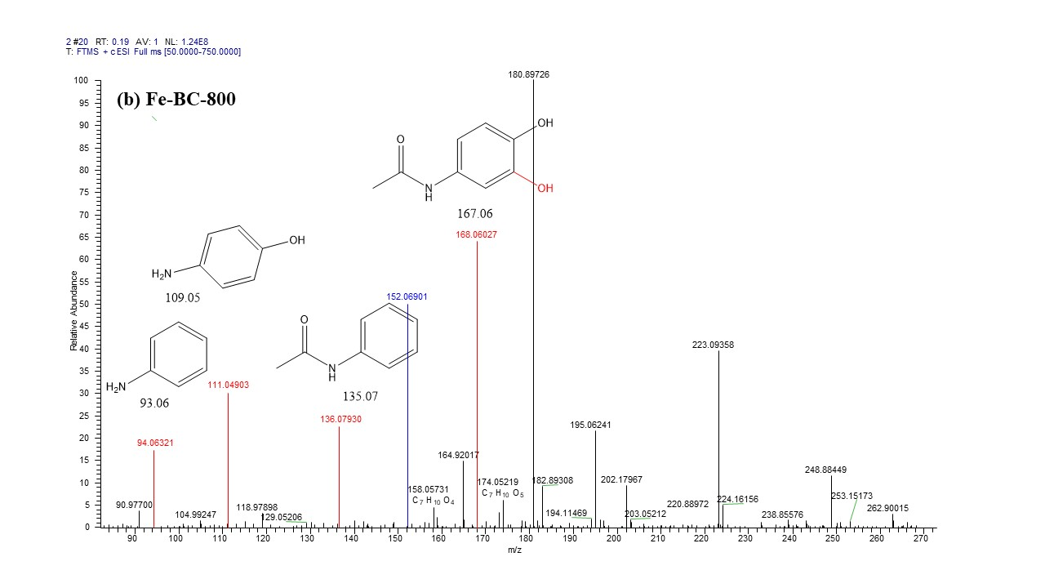
Fig. S14. MS spectra showing ACT degradation products formed in the (a) Fe-BC-300 and (b) Fe-BC-800 processes.

Fig. S15. Effect of Phen and EDTA on the degradation of ACT in the in the 300 ºC Fe-BC/PAA (a) and 800 ºC Fe-BC/PAA (b) processes. Experimental condition: [PAA] = 0.5 mM, [Fe-BC] = 0.2 g/L, [ACT] = 50 μM, pH₀=3.71.

Fig. S16. (a, c) Competition kinetics data and (b, d) pseudo-first-order kinetics models for (a, b) BA and NB and (c, d) ACT and PMSO. Experimental conditions: [Fe²⁺] = 1.0 mM; [PS]₀ = 2 mM; [BA]₀ = [NB]₀ = 20 μM; [ACT]₀ = [PMSO]₀ = 50 μM; and pH₀ = 3.71.

Table S1. Second-order rate constants for the reactions between probe compounds, quenching agents, and contaminants with different reactive species.
Compound | •OH  (M⁻¹s⁻¹) | SO₄^{•-}  (M⁻¹s⁻¹) | CH₃C(O)O•  (M⁻¹s⁻¹) | Fe(IV)  (M⁻¹s⁻¹) | Ref.
BA | 1.2×10⁹ | 5.9×10⁹ | -ª | 80 | [7, 8]
p-CBA | 5.0×10⁹ | 3.6×10⁸ | -ª | -ª | [9]
p-NBA | 2.6×10⁹ | ≤ 10⁶ | -ª | -ª | [2, 10]
NB | 3.9×10⁹ | ≤ 10⁶ | -ª | (1.05 ± 0.3)×10³ (pH 1.0) | [2, 7]
PMSO | 3.61×10⁹ | 3.17×10⁸ | -ª | 1.23×10⁵ (pH 1.0) | [2]
DMSO | 7.0×10⁹ | 2.7×10⁹ | -ª | 1.26×10⁵ | [2]
PMSO₂ | 3.08×10⁹ | -ª | -ª | -ª | [11]
ACT | 1.7×10⁹ | 1.3×10⁹ | 5.44×10¹⁰ | 2.54×10⁵ (This study) | [7, 12]
2,4-HD | 9.16×10⁹ | -ª | -ª | -ª | [13]
TBA | 6.0×10⁸ | 4.0×10⁵ | -ª | 6.0×10¹ | [9, 14, 15]
MeOH | 9.7×10⁸ | 1.1×10⁷ | -ª | 2.3×10³ | [9, 16]
EtOH | 2.8×10⁹ | 7.7×10⁷ | ^{-a} | -ª | [9]
p-BQ | 1.2×10⁹ | 1.0×10⁸ | -ª | -ª | [17, 18]
NPX | 8.99×10⁹ |  | -ª | -ª | [19]
Phenol | 1.8×10¹⁰ | 8.8×10⁹ | -ª | (1.5 ± 0.2)×10⁴ | [20, 21]
CBZ | 8.8×10⁹ | 8.27×10⁸ | -ª | -ª | [1]
a: not kinetically relevant or unknown.
Table S2. Details of the mobile phase composition and detection wavelengths for HPLC analysis of organic contaminants and probe compounds.
Chemicals |  | Mobile phase composition | Wavelength (nm) | Flow rate (mL/min)
ACT |  | Methanol : 0.2% acetic acid = 60 : 40 | 245 | 1.0
NPX |  | Methanol : 0.2% acetic acid = 80 : 20 | 235 | 1.0
BA |  | Methanol : 0.2% acetic acid = 60 : 40 | 228 | 1.0
p-CBA |  | Methanol : 0.2% acetic acid = 80 : 20 | 239 | 1.0
NB |  | Methanol : 0.2% acetic acid = 60 : 40 | 264 | 1.0
BPA |  | Methanol : 0.2% acetic acid = 80 : 20 | 275 | 1.0
CBZ |  | Methanol : 0.2% acetic acid = 60 : 40 | 286 | 1.0
SMX |  | Methanol : 0.2% acetic acid = 60 : 40 | 270 | 1.0
Phenol |  | Methanol : 0.1% acetic acid = 60 : 40 | 273 | 1.0
p-NBA |  | Methanol : 0.1% acetic acid = 80 : 20 | 270 | 1.0
PMSO | Acetonitrile : 0.1% acetic acid = 50 : 50 |  | 230 | 1.0
PMSO₂ |  |  | 215 | 1.0

Table S3. Mobile-phase gradient for multi-solute HPLC analysis of ACT and probe compounds.
Time (min) | Water with 0.2% acetic acid (%) | Methanol (%) | Flow rate (mL/min)
0.0 | 55 | 45 | 1.0
5.0 | 55 | 45 | 1.0
8.0 | 20 | 80 | 1.0
10.0 | 55 | 45 | 1.0

Table S4. Mass percentages of elements in the Fe-BC-300 and Fe-BC-800 measured by XPS.
Catalyst | C (%) | O (%) | N (%) | Fe (%)
Fe-BC-300 | 71.44 | 21.69 | 1.93 | 4.94
Fe-BC-800 | 84.33 | 12.94 | 0.89 | 1.84

Table S5. Physicochemical properties of the iron-biochar composites.
Iron-biochar composites | Specific surface area (m² g⁻¹) | Pore volume (cm³ g⁻¹) | Average pore size (nm)
Fe-BC-300 | 18.5 | 0.025 |  | 6.8
Fe-BC-800 | 115.6 | 0.37 |  | 16.5

Table S6. Chemical properties and structures of compounds investigated in this study.
Structure | Formula | Mol. W.t (Da) | Structure | Conformation
Sulfamethoxazole  (SMX) | C₁₀H₁₁N₃O₃S | 253.3 |  | 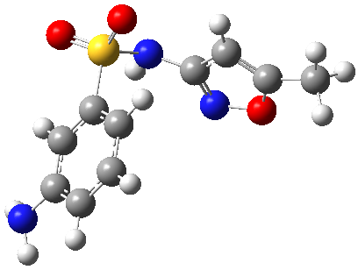
Nitrobenzene  (NB) | C₆H₅NO₂ | 123.0 |  | 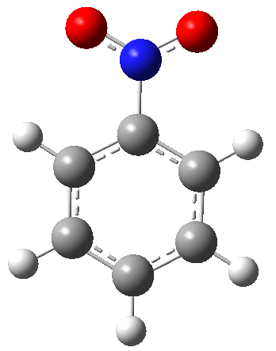
Benzoic acid  (BA) | C₇H₆O₂ | 122.0 |  | 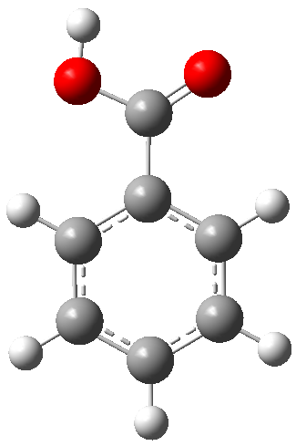
p-chlorobenzoic acid  (p-CBA) | C₇H₅ClO₂ | 156 |  | 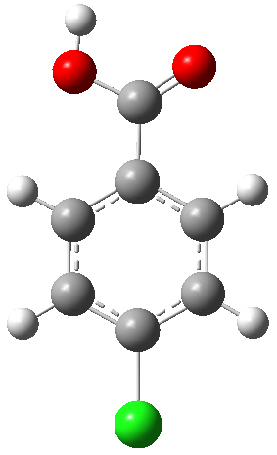
Phenol | C₆H₆O | 94 |  | 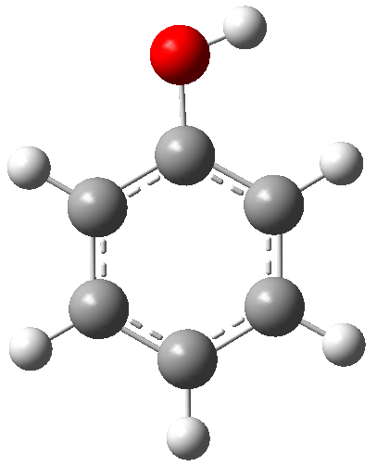
Naproxen  (NPX) | C₁₄H₁₆O₂ | 216 |  | 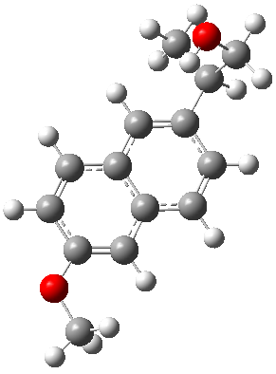
p-nitrobenzoic acid  (p-NBA) | C₇H₅NO₄ | 167.12 |  | 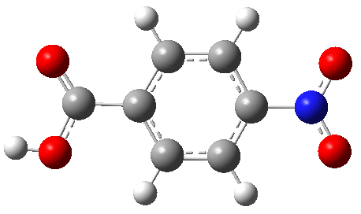
Bisphenol A  (BPA) | C₁₅H₁₆O₂ | 228.29 |  | 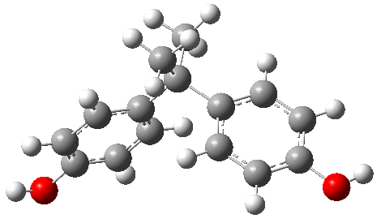
Carbamazepine  (CBZ) | C₁₅H₁₂N₂O | 236.09 |  | 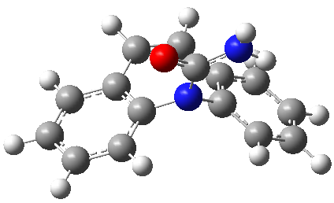
Acetaminophen  (ACT) | C₈H₉NO₂ | 151.17 |  | 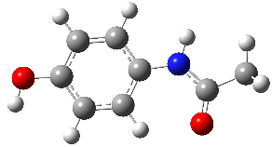

Table S7. The micromolecular descriptors calculated at the b3lyp/6-311+G (3df, 2p) level with the Solvation Model Based on Density (SMD).
Organic compounds | Descriptors
Organic compounds | E_HOMO (eV) | E_LUMO (eV) | LUMO-HOMO (eV) | Vertical IP (eV) | Vertical EA (eV) | Mulliken electronegativity (eV) | Chemical potential (eV) | Hardness (eV) | Softness (eV⁻¹) | Electrophilicity index (eV) | Nucleophilicity index (eV)
BPA | -5.9707 | -0.5412 | 5.4295 | 5.7381 | 0.8496 | 3.2938 | -3.2938 | 4.8885 | 0.2046 | 1.1097 | 3.1505
SMX | -6.1137 | -1.4789 | 4.6348 | 5.8614 | 1.7557 | 3.8085 | -3.8085 | 4.1057 | 0.2436 | 1.7664 | 3.0075
phenol | -6.3960 | -0.5445 | 5.8515 | 6.1343 | 0.9129 | 3.5236 | -3.5236 | 5.2214 | 0.1915 | 1.1889 | 2.7252
BA | -7.3227 | -1.8009 | 5.5218 | 7.1523 | 2.0961 | 4.6242 | -4.6242 | 5.0562 | 0.1978 | 2.1146 | 1.7985
p-NBA | -7.7713 | -3.0654 | 4.7059 | 7.5078 | 3.5668 | 5.7373 | -5.7373 | 3.9410 | 0.2537 | 3.8901 | 1.3499
NPX | -5.8446 | -1.2329 | 4.6117 | 5.5879 | 1.5305 | 3.5592 | -3.5592 | 4.0574 | 0.2465 | 1.5611 | 3.2766
p-CBA | -7.2416 | -1.9385 | 5.3031 | 7.0650 | 2.2117 | 4.6383 | -4.6383 | 4.8533 | 0.2060 | 2.2164 | 1.8796
NB | -7.5694 | -3.0616 | 4.5078 | 7.3000 | 3.3091 | 5.3046 | -5.3046 | 3.9909 | 0.2506 | 3.5254 | 1.5518
CBZ | -6.1961 | -1.6819 | 4.5142 | 5.9341 | 1.9645 | 3.9493 | -3.9493 | 3.9696 | 0.2519 | 1.9645 | 2.9251

Table S8. Solution pH before and after reaction in the Fe-BC-300/PAA process.
Initial pH | 3.71 | 4.92 | 6.92 | 9.09
Final pH | 3.53 | 3.99 | 4.83 | 5.20

Table S9. Solution pH before and after reaction in the Fe-BC-800/PAA process.
Initial pH | 3.71 | 4.93 | 6.93 | 9.11
Final pH | 3.63 | 4.85 | 5.76 | 7.50

Table S10. Solution pH before and after reaction in the presence of inorganic ions or NOM in the Fe-BC-300/PAA process.
Ions/NOM | Cl– | Cl– | HCO₃– | HCO₃– | NOM | NOM
Concentration | 1 mM | 10 mM | 1 mM | 10 mM | 1 mg/L | 20 mg/L
Initial pH | 3.93 | 3.92 | 5.08 | 7.13 | 3.75 | 3.73
Final pH | 3.53 | 3.60 | 4.36 | 7.11 | 3.47 | 3.20

Table S11. Solution pH before and after reaction in the presence of inorganic ions or NOM in the Fe-BC-800/PAA process.
Ions/NOM | Cl– | Cl– | HCO₃– | HCO₃– | NOM | NOM
Concentration | 1 mM | 10 mM | 1 mM | 10 mM | 1 mg/L | 20 mg/L
Initial pH | 3.79 | 3.77 | 4.91 | 7.09 | 3.78 | 3.75
Final pH | 3.73 | 3.83 | 5.01 | 7.12 | 3.75 | 3.73

Table S12. Molecular formula, m/z, and molecular structure of ACT and corresponding degradation intermediates.
Oxidation products | Proposed  formula | Mol. wt. (Da) | ESI(+) MS  m/z | Chemical structure
ACT | C₈H₉NO₂ | 151.06 | 152.0691
P1-2 | C8H₉NO₃ | 167.06 | 168.0659
P1-3 | C7H₇NO₄ | 169.04 | 170.0419
P1-4 | C₆H₇NO₂ | 125.05 | 126.9434
P1-6 | C₆H₆O₂ | 110.04 | 111.0531
P2-1 | C₈H₉NO₃ | 167.06 | 168.0659
P2-2 | C₈H₉NO₃ | 167.06 | 168.0603
P2-5 | C₆H₇NO | 110.04 | 111.0490

Table S13. Hirshfeld charges, condensed Fukui functions, and condensed dual descriptors of ACT.
Atom | q(N) | q(N+1) | q(N-1) | f ⁻ | f⁺ | f ⁰ | CDD
1(C) | 0.0594 | 0.0019 | 0.1588 | 0.0994 | 0.0575 | 0.0785 | -0.0419
2(C) | -0.0596 | -0.1859 | 0.0142 | 0.0737 | 0.1263 | 0.1000 | 0.0526
3(C) | -0.0596 | -0.1843 | 0.0086 | 0.0681 | 0.1247 | 0.0964 | 0.0566
4(C) | 0.0304 | -0.0228 | 0.1257 | 0.0953 | 0.0532 | 0.0743 | -0.0422
5(C) | -0.0480 | -0.1723 | 0.0191 | 0.0671 | 0.1244 | 0.0957 | 0.0573
6(C) | -0.0616 | -0.1941 | 0.0066 | 0.0682 | 0.1325 | 0.1003 | 0.0643
7(H) | 0.0582 | -0.0028 | 0.0917 | 0.0335 | 0.0609 | 0.0472 | 0.0274
8(H) | 0.0275 | -0.0262 | 0.0597 | 0.0321 | 0.0537 | 0.0429 | 0.0216
9(H) | 0.0586 | -0.0017 | 0.0902 | 0.0316 | 0.0604 | 0.0460 | 0.0288
10(H) | 0.0523 | -0.0128 | 0.0851 | 0.0329 | 0.0651 | 0.0490 | 0.0322
11(O) | -0.2161 | -0.2474 | -0.1098 | 0.1063 | 0.0313 | 0.0688 | -0.0750
12(H) | 0.1907 | 0.1698 | 0.2271 | 0.0364 | 0.0209 | 0.0287 | -0.0155
13(N) | -0.0514 | -0.0639 | 0.0157 | 0.0671 | 0.0126 | 0.0398 | -0.0545
14(H) | 0.1526 | 0.1361 | 0.1816 | 0.0291 | 0.0165 | 0.0228 | -0.0126
15(C) | 0.1720 | 0.1547 | 0.2119 | 0.0399 | 0.0173 | 0.0286 | -0.0226
16(O) | -0.3818 | -0.4051 | -0.3089 | 0.0729 | 0.0232 | 0.0481 | -0.0497
17(C) | -0.0825 | -0.0880 | -0.0690 | 0.0135 | 0.0055 | 0.0095 | -0.0080
18(H) | 0.0530 | 0.0484 | 0.0651 | 0.0121 | 0.0046 | 0.0084 | -0.0074
19(H) | 0.0533 | 0.0498 | 0.0618 | 0.0086 | 0.0035 | 0.0060 | -0.0051
20(H) | 0.0530 | 0.0484 | 0.0651 | 0.0121 | 0.0046 | 0.0084 | -0.0074

Table S14. The FED²HOMO, FED²LUMO, 2FED²HOMO, and FED²HOMO+FED²LUMO values of ACT.
Atom | FED²_{HOMO} | FED²_{LUMO} | 2FED²_{HOMO} | FED²_{HOMO}+FED²_{LUMO}
1(C) | 0.151 | 0.074 | 0.302 | 0.225
2(C) | 0.083 | 0.115 | 0.167 | 0.198
3(C) | 0.076 | 0.211 | 0.153 | 0.287
4(C) | 0.154 | 0.072 | 0.308 | 0.225
5(C) | 0.076 | 0.085 | 0.151 | 0.160
6(C) | 0.071 | 0.166 | 0.142 | 0.236
7(H) | 0.006 | 0.016 | 0.012 | 0.022
8(H) | 0.007 | 0.031 | 0.013 | 0.038
9(H) | 0.005 | 0.013 | 0.010 | 0.018
10(H) | 0.005 | 0.032 | 0.010 | 0.037
11(O) | 0.124 | 0.014 | 0.248 | 0.138
12(H) | 0.009 | 0.004 | 0.018 | 0.013
13(N) | 0.120 | 0.024 | 0.241 | 0.144
14(H) | 0.010 | 0.006 | 0.019 | 0.016
15(C) | 0.038 | 0.064 | 0.076 | 0.102
16(O) | 0.056 | 0.049 | 0.111 | 0.104
17(C) | 0.005 | 0.011 | 0.010 | 0.016
18(H) | 0.002 | 0.006 | 0.004 | 0.009
19(H) | 0.001 | 0.001 | 0.002 | 0.002
20(H) | 0.002 | 0.006 | 0.004 | 0.009
*The red font indicates that the site is vulnerable to free radical attack

References
[1] X. Wang, W. Gong, J. Zhu, G. Peng, New insights into the quantiffcation of Fe(IV) using methyl phenyl sulfoxide (PMSO) as probe in the iron-based heterogeneous catalyst activated persulfate process, Environmental Pollution, 362 (2024) 124924.
[2] H. Dong, Y. Li, S. Wang, W. Liu, G. Zhou, Y. Xie, X. Guan, Both Fe(IV) and Radicals Are Active Oxidants in the Fe(II)/Peroxydisulfate Process, Environmental Science & Technology Letters, 7 (2020) 219-224.
[3] X. Meng, G. Peng, Y. Yan, X. Wang, J. Zhu, C. Belver, W. Gong, L. Blaney, Analysis of the steady-state concentrations of reactive species and their role in contaminant degradation by the iron-biochar/persulfate advanced oxidation process: Comparison of probe compound and quenching agent methods, Separation and Purification Technology, 354 (2025) 128502.
[4] X. Wang, Z. Zheng, J.H.K. Man, I.M.C. Lo, Regulating charge transfer for enhanced PAA activation over sulfur-doped magnetic CoFe2O4: A novel strategy for simultaneous micropollutants degradation and bacteria inactivation, Water Research, 256 (2024) 121595.
[5] Y. Cheng, Z. Wang, J. Wang, L. Cao, Z. Chen, Y. Chen, Z. Liu, P. Xie, J. Ma, New insights into the degradation of micro-pollutants in the hydroxylamine enhanced Fe(II)/peracetic acid process: Contribution of reactive species and effects of pH, Journal of Hazardous Materials, 441 (2023) 129885.
[6] R.G. Parr, W. Yang, Density functional approach to the frontier-electron theory of chemical reactivity, Journal of the American Chemical Society, 106 (1984) 4049-4050.
[7] Q.-Y. Wu, Z.-W. Yang, Z.-W. Wang, W.-L. Wang, Oxygen doping of cobalt-single-atom coordination enhances peroxymonosulfate activation and high-valent cobalt–oxo species formation, Proceedings of the National Academy of Sciences, 120 (2023) e2219923120.
[8] F. Jacobsen, J. Holcman, K. Sehested, Reactions of the ferryl ion with some compounds found in cloud water, International journal of chemical kinetics, 30 (1998) 215-221.
[9] L. Gao, Y. Guo, J. Zhan, G. Yu, Y. Wang, Assessment of the validity of the quenching method for evaluating the role of reactive species in pollutant abatement during the persulfate-based process, Water Research, 221 (2022) 118730.
[10] Y.-J. Nong, Y.-L. Zhang, U. Hübner, W.-L. Wang, Q.-Y. Wu, N. Huang, J.E. Drewes, H.-Y. Hu, Roles of radical species in vacuum-UV/UV/peroxydisulfate advanced oxidation processes and contributions of the species to contaminant degradation at different water depths, Journal of Hazardous Materials, 446 (2023) 130660.
[11] B. Liu, W. Guo, H. Wang, S. Zheng, Q. Si, Q. Zhao, H. Luo, N. Ren, Peroxymonosulfate activation by cobalt(II) for degradation of organic contaminants via high-valent cobalt-oxo and radical species, Journal of Hazardous Materials, 416 (2021) 125679.
[12] M. Li, J. Sun, Q. Mei, B. Wei, Z. An, H. Cao, C. Zhang, J. Xie, J. Zhan, W. Wang, M. He, Q. Wang, Acetaminophen degradation by hydroxyl and organic radicals in the peracetic acid-based advanced oxidation processes: Theoretical calculation and toxicity assessment, Journal of Hazardous Materials, 416 (2021) 126250.
[13] J. Kim, P. Du, W. Liu, C. Luo, H. Zhao, C.-H. Huang, Cobalt/Peracetic Acid: Advanced Oxidation of Aromatic Organic Compounds by Acetylperoxyl Radicals, Environmental Science & Technology, 54 (2020) 5268-5278.
[14] Y. Zong, Y. Shao, Y. Zeng, B. Shao, L. Xu, Z. Zhao, W. Liu, D. Wu, Enhanced Oxidation of Organic Contaminants by Iron(II)-Activated Periodate: The Significance of High-Valent Iron–Oxo Species, Environmental Science & Technology, 55 (2021) 7634-7642.
[15] J. Lin, J. Zou, H. Cai, Y. Huang, J. Li, J. Xiao, B. Yuan, J. Ma, Hydroxylamine enhanced Fe(II)-activated peracetic acid process for diclofenac degradation: Efficiency, mechanism and effects of various parameters, Water Research, 207 (2021) 117796.
[16] O. Pestovsky, A. Bakac, Reactivity of Aqueous Fe(IV) in Hydride and Hydrogen Atom Transfer Reactions, Journal of the American Chemical Society, 126 (2004) 13757-13764.
[17] Z. Liu, S. Pan, F. Xu, Z. Wang, C. Zhao, X. Xu, B. Gao, Q. Li, Revealing the fundamental role of MoO2 in promoting efficient and stable activation of persulfate by iron carbon based catalysts: Efficient Fe2+/Fe3+ cycling to generate reactive species, Water Res, 225 (2022) 119142.
[18] Y. Zhao, M. Song, Q. Cao, P. Sun, Y. Chen, F. Meng, The superoxide radicals’ production via persulfate activated with CuFe2O4@Biochar composites to promote the redox pairs cycling for efficient degradation of o-nitrochlorobenzene in soil, Journal of Hazardous Materials, 400 (2020) 122887.
[19] M.M. Huber, A. GÖbel, A. Joss, N. Hermann, D. LÖffler, C.S. McArdell, A. Ried, H. Siegrist, T.A. Ternes, U. von Gunten, Oxidation of Pharmaceuticals during Ozonation of Municipal Wastewater Effluents: A Pilot Study, Environmental Science & Technology, 39 (2005) 4290-4299.
[20] G.V. Buxton, C.L. Greenstock, W.P. Helman, A.B. Ross, Critical Review of rate constants for reactions of hydrated electrons, hydrogen atoms and hydroxyl radicals (⋅OH/⋅O− in Aqueous Solution, Journal of physical and chemical reference data, 17 (1988) 513-886.
[21] D.O. Mártire, P. Caregnato, J. Furlong, P. Allegretti, M.C. Gonzalez, Kinetic study of the reactions of oxoiron(IV) with aromatic substrates in aqueous solutions, International journal of chemical kinetics, 34 (2002) 488-494.

